

Hub and Spoke Integration SAP® and Microsoft® Business Solutions – Navision® 4.0

This document is based on the integration between a SAP R/3 and a Microsoft Navision business system in a demo environment. In particular, it focuses on integration between Microsoft BizTalk Server 2004 with Microsoft Navision Commerce Gateway and the BizTalk SAP Adapter 2.0.

Created by Magnus Management Consulting and Qurius

Table of Contents
Introduction 2
Hub and Spoke Techniques Used 2
Process Integration in detail 3
Conclusion 3
About Microsoft Business Solutions 3

Introduction

The Hub and Spoke Concept
The hub and spoke concept refers to a parent or holding company that uses one business software system (the hub), which is integrated with the systems used by its individual subsidiaries or divisions (the spokes).

This document describes the hub and spoke concept with SAP R/3 at the hub (parent) and Microsoft Navision at the spokes (subsidiaries), as shown in figure 1 below. This document describes the integration scenario of the hub and spoke concept, the processes involved between the parent and the subsidiaries and the technical implementation of the integration in a demo environment.

In this paper, we concentrate on certain general processes carried out between the parent companies and the subsidiaries. These processes are:

- Exchange of master data: The parent company maintains all master data and distributes it to the subsidiaries. The master data in scope is customer master data, material master data, pricing information, and chart of accounts (financial consolidation).
- Purchase order process (replenishment): When a subsidiary wants to replenish its stock, it sends a purchase order to the parent company. The parent company delivers the goods, sends a delivery notification (or rejection), and finally invoices the subsidiary.
- Financial consolidation: At the end of a period, the subsidiary sends its financial consolidation to the parent company, which consolidates the changed G/L accounts (General Ledger accounts) of all subsidiaries.

Figure 1

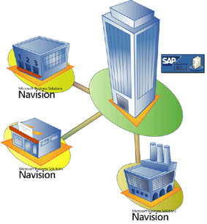

Hub and Spoke Techniques Used
To integrate the processes of a parent company and a subsidiary, a demo environment was set up as illustrated in figure 2. The parent company uses SAP R/3 version 4.7, and the subsidiary uses Microsoft Business Solutions Navision 4.0. The integration tool (integration broker) used to integrate Microsoft Navision with SAP is Microsoft BizTalk Server 2004.

Integration between SAP R/3 and Microsoft BizTalk Server 2004
Microsoft BizTalk Server 2004 has been chosen as an integration platform in this demo environment. This release enables you to connect diverse applications. It also allows you to create and modify graphical representations of business processes that use the services that those applications provide.  Furthermore, this release focuses more on the features of the BizTalk Server 2004 engine, including a mechanism for specifying business rules, better ways to manage and monitor the applications built on it, and support for single sign-on for those applications.  The BizTalk Adapter for SAP provides the integration between SAP and the Microsoft BizTalk Server 2004. The SAP Adapter 2.0 enables the sending, receiving and BizTalk Schema generation of SAP IDOCs (Intermediate Documents) and the usage of BAPIs (Business Application Programming Interface) via its RFC Interface.  An IDOC is a standard SAP document that contains business data. There are many standard IDOC message types available (for example, Material Master, Delivery Document, and Invoice).  A BAPI contains RFCs (Remote Function Call) that are able to perform actions in the SAP system, for example, to create an order or to upload a financial order. In the demo environment, the standard SAP interfacing (IDOCs and BAPIs) is used as much as possible.  IDOCs are used in this demo environment to interface from SAP to Microsoft Navision because SAP has standard functionality to generate an IDOC based on triggers within SAP. For example, when an order is handled by SAP, it can automatically generate an IDOC for notification purposes.  BAPIs are good for communication with SAP because the complexity of the input fields in a BAPI is less than what is required to fill an IDOC with all details.  Integration between BizTalk Server 2004 and Microsoft Navision  Microsoft BizTalk Server 2004 and Microsoft Navision communicate using XML documents and exchange data using Microsoft Commerce Gateway, XMLDOM and XML Port techniques.  The demo environment illustrates the different integration techniques. A starting point for Microsoft Navision interfacing is to use as much standard Microsoft Navision functionality as possible. | 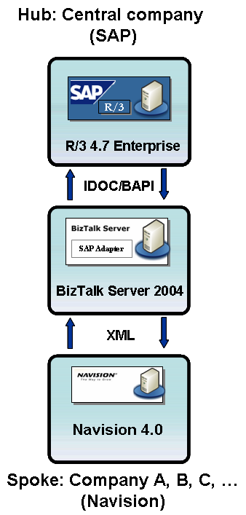    Figure 2

Process Integration in detail
This paper will now take a more detailed look at the following processes: Exchange of Master Data, Purchase Order Process and Financial Consolidation, including all sub processes.

Exchange of Master Data
The parent company manages all master data centrally, in order to use the same information organization-wide. In the demo environment, there are three types of master data that are interfaced from the parent company to the subsidiaries. These are customer master data, material master data, pricing information and the chart of accounts. The prices of the materials are sent separately to Microsoft Navision to keep the SAP interfacing as standard as possible.
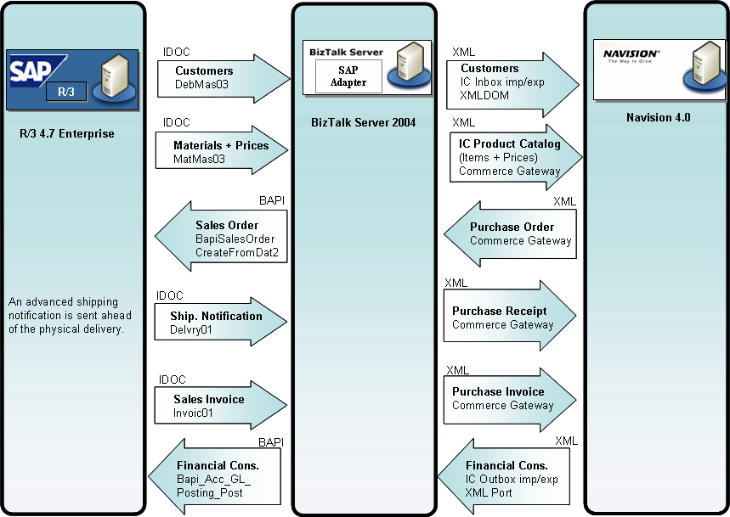

Figure 3

Customer Master Data
The end-customer master data will be interfaced from SAP to Microsoft Navision. The SAP Customer Master IDOC (DEBMAS03) is used with no modifications. Each end-customer will have a SAP customer number. This same number will be used in Microsoft Navision when an end-customer sale is made. Microsoft BizTalk Server transforms the data to a standard Microsoft Navision XML format. Microsoft Navision uses the XML DOM to import (create or update) the customer.

Material Master Data and Prices
The standard SAP product master structure is used for purchasing and sales activities. The purchase or transfer price of the material is included. The material master and its purchase (transfer) price data is sent to Microsoft Navision with help of the IDOC MATMAS03. Microsoft BizTalk Server transforms the data to a standard Microsoft Navision XML format. Microsoft Navision Commerce Gateway imports the XML file and creates a BizTalk Product Catalog document to update or create an item with pricing in Microsoft Navision.

For purposes of demonstrating an inter company relationship, the standard BizTalk Product Catalog Schema had to be extended to include extra fields such as Item Category, Valid End Date for Pricing and Product Category.

Chart of Accounts
The chart of accounts, as it is defined in SAP, is mirrored in Microsoft Navision. A Microsoft Excel file with all the BS/P&L accounts is integrated in Microsoft Navision. This makes end-of-month financial bookings and consolidation more straightforward. The file is transferred directly to Microsoft Navision for manual integration. This was done because it is a one-time setup and would be relatively time-consuming to process through system interfaces.

Purchase Order Process (Replenishment)
When a subsidiary wants to replenish its stock, it sends a purchase order to the parent company. The parent company processes and delivers the order. Finally, an invoice is created.

Purchase order
In the demo environment, demand planning is done locally at the sales office, and therefore the internal business rules of the sales office trigger purchase activities. A purchase order containing quantities, prices and a required delivery date is sent from Microsoft Navision to SAP. A standard SAP sales order is created upon receipt of a purchase order coming in from Microsoft Navision.

The system automatically creates a SAP sales order number if the transaction is successful. The sales order captures the Microsoft Navision purchase order number, which is used as a tracking reference number both by SAP (parent company) and Microsoft Navision (sales office) throughout the business process.

Microsoft Navision Commerce Gateway sends a BizTalk Purchase Order (XML) document to BizTalk with the order information. Microsoft BizTalk uses its RFC interface to initiate an RFC call to a BAPI function to create a sales order (BAPI_SALESORDER_CREATEFROMDAT2) in SAP.

Delivery notification
When the complete order can be delivered, a delivery is created after which a goods issue is done in SAP. The delivery note created in SAP acts as a pick request for the warehouse to pick the order. The picked quantities are then manually updated in the delivery note. A goods issue in SAP depletes the stock levels in the system and makes a financial posting to reduce the value of the stock. This usually happens when the actual physical goods leave the warehouse to be delivered.

A goods issue process results in material and accounting documents being created in SAP. The creation of the delivery note, updating the pick quantities and goods issue can be done directly in the delivery note. When the goods issue is done, the shipping notification message is automatically triggered and sent to Microsoft Navision. The shipping notification provides a due date to Microsoft Navision indicating when the complete order (total quantity of all requested items) will arrive at the sales office.

The mechanism for the interface uses a standard SAP IDOC (DELVRY01). Microsoft BizTalk maps this document to a standard Microsoft Navision XML document and the Microsoft Navision Commerce Gateway receives and processes a BizTalk Purchase Receipt document and updates the referenced Purchase Order in Microsoft Navision.

Invoice
Before the sales invoice can be created, the outbound delivery and goods issue will first have to be created in SAP since the sales invoice is delivery-based. The sales invoice message consists of the sales price for each item that has been ordered from the Microsoft Navision sales office. The total amount to be paid to the parent company is calculated in Microsoft Navision. The Microsoft Navision purchase order number is also recorded in the sales invoice. The invoice is created manually in SAP, referencing the Microsoft Navision purchase order.
The mechanism for the sales invoice interface uses a standard SAP IDOC (INVOIC01). The IDOC is generated via the print program in the sales invoice document as soon as the document is saved.
Microsoft BizTalk maps this document to a standard Microsoft Navision XML document and the Microsoft Navision Commerce Gateway receives and processes a BizTalk Purchase Invoice document and updates the referenced Purchase Order in Microsoft Navision.

Financial Consolidation
End-of-month consolidation takes place in SAP and is done by uploading the changed G/L accounts (General Ledger Accounts) from Microsoft Navision in an XML file to SAP. Microsoft BizTalk calls the BAPI BAPI_ACC_GL_POSTING_POST to do the postings on the G/L accounts.

Constraints Demo Environment
Although the demo environment was made with a real business scenario in mind, the following subjects do need to be addressed in a live implementation:

- No exceptions and error handling is implemented. No order rejections have been implemented (for example, partial delivery).
- In Microsoft Navision, both XML Ports and the XML DOM have been used to integrate with Microsoft BizTalk showing multiple techniques.
- A minimum of SAP and Microsoft Navision customization is required to implement this solution (for example, extended Material Master IDOC to include pricing in SAP, Microsoft Navision XML DOM).

Conclusion
The hub and spoke demo environment of the integration process between SAP R/3 and Microsoft Navision provides a realistic scenario. This demo can be used as starting point for Hub and Spoke implementations with SAP and Microsoft Navision.

About Microsoft Business Solutions
Microsoft Business Solutions, a division of Microsoft, offers a wide range of integrated, end-to-end business applications and services designed to help small, midmarket and corporate businesses become more connected with customers, employees, partners and suppliers. Microsoft Business Solutions' applications optimize strategic business processes across financial management, analytics, human resources management, project management, customer relationship management, field service management, supply chain management, e-commerce, manufacturing and retail management. The applications are designed to provide insight to help customers achieve business success. More information about Microsoft Business Solutions can be found at www.microsoft.com/BusinessSolutions.
Address:
Microsoft Business Solutions
Frydenlunds Allé 6
2950 Vedbaek
Denmark
Tel +45 45 67 80 00
Fax +45 45 67 80 01
www.microsoft.com/BusinessSolutions
© 2005 Microsoft Business Solutions ApS, Denmark. All rights reserved. Microsoft, Great Plains, Navision, Visual Studio, and Windows are either registered trademarks or trademarks of Microsoft Corporation, Great Plains Software, Inc., FRx Software Corporation, or Microsoft Business Solutions ApS or their affiliates in the United States and/or other countries. Great Plains Software, Inc., FRx Software Corporation, and Microsoft Business Solutions ApS are subsidiaries of Microsoft Corporation. The names of actual companies and products mentioned herein may be the trademarks of their respective owners. The example companies, organizations, products, domain names, email addresses, logos, people and events depicted herein are fictitious. No association with any real company, organization, product, domain name, e-mail address, logo, person, or event is intended or should be inferred.

Microsoft Navision Hub and Spoke Whitepaper (2004)

