
Operating System

Windows Server 2003
Terminal Server Capacity and Scaling
White Paper

Abstract
Microsoft Windows Terminal Server lets users run Windows®-based applications on a remote computer running one of the Windows Server 2003 family of operating systems. This white paper contains testing methodologies, results, analysis, and sizing guidelines for Microsoft Windows Server 2003 Terminal Server. Hewlett Packard worked in cooperation with Microsoft to perform the initial sizing tests and data collection in HP labs. Microsoft performed the final round of testing and analysis collection using Hewlett Packard equipment. The tests were performed using Windows Server 2003, Enterprise Edition, build 3790.
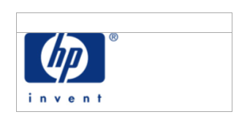
© 2003 Microsoft Corporation. All rights reserved.
The information contained in this document represents the current view of Microsoft Corporation on the issues discussed as of the date of publication. Because Microsoft must respond to changing market conditions, it should not be interpreted to be a commitment on the part of Microsoft, and Microsoft cannot guarantee the accuracy of any information presented after the date of publication.
This white paper is for informational purposes only. MICROSOFT MAKES NO WARRANTIES, EXPRESS OR IMPLIED, IN THIS DOCUMENT.
Microsoft, Outlook, Windows, the Windows logo, Windows Media, and Windows NT are either registered trademarks or trademarks of Microsoft Corporation in the United States and/or other countries.
NEC and PowerMate are U.S. registered trademarks of NEC Corporation. Express5800 is a trademark of NEC Corporation.
Other product and company names mentioned herein may be the trademarks of their respective owners.
Microsoft Corporation • One Microsoft Way • Redmond, WA 98052-6399 • USA

Table of Contents
Table of Contents 3
Introduction 5
Results Overview 6
Server Capacity 6
System and User Memory Requirements 8
Comparison with Terminal Services running on Windows 2000 8
Test Environment and Testing Tools 10
Test Environment 10
Testing Tools and Scripts 11
Testing Methodology 14
Analysis of the Results 16
Overview 16
Memory Requirements and Utilization 16
Network Usage 19
Effect of Increased Color Depth (16 bit) 20
Effect of File Redirection 20
Effect of Printer Redirection 21
Effect of Logon Activity on CPU Utilization 21
Effect of Kernel Address Space Limitations 22
Effect of Typing Rate on CPU Utilization 24
Effect of Background Spelling and Grammar Checking 25
Performing Your Own Scaling Tests 26
To Test or Pilot? 26
Determining Application Suitability 26
Characterization of Users 27
Network Environment 27
Appendix A: Test Script Flow Charts 28
Knowledge Worker Script 28
Data Entry Worker Script 29
Appendix B: Terminal Server Settings 31
Appendix C: HP Server Specifications 33
The ProLiant Advantage 33
ProLiant Server Models 34
ProLiant Servers in a SBC Environment 34
Tested Servers 36
SBC Solution Sizing 37
For More Information 39

Introduction
Microsoft Windows Terminal Server lets users run Microsoft® Windows®–based applications on a remote Microsoft® Windows® 2000 or Microsoft® Windows® 2003–based server. This white paper contains testing methodologies, results, analysis, and sizing guidelines for Windows Server 2003 Terminal Server. Hewlett Packard worked in cooperation with Microsoft to perform the initial sizing tests and data collection in HP labs. Final testing and data collection was performed at Microsoft using Hewlett Packard servers. The tests were performed using Windows Server 2003, Enterprise Edition, build 3790.
For information about Terminal Server features, licensing and architecture, see technologies/terminalservices Web site at http://go.microsoft.com/fwlink/?LinkId=18340
In a server-based computing environment, all application execution and data processing occur on the server. Therefore it is extremely useful and desirable for server manufacturers to test the scalability and capacity of their servers to determine how many client sessions a server can typically support under a variety of different scenarios. Microsoft, using multiple Hewlett Packard hardware configurations, tested Windows Server 2003 Terminal Server to provide customers with guidelines to choose the right server according to their needs.
The results and analysis contained here should not be interpreted in isolation. The client applications used in the test (components of Microsoft® Office 2000) are not easy to characterize without accounting for the features or data sets an individual uses or creates. Two different user scenarios are tested in accordance with Gartner Group recommendations (Knowledge Worker and Data-Entry Worker), but the actual applications, features, and data sets used in these user scenarios cannot precisely mimic the experience of a real-life user on a moment-by-moment basis. The tests assume a rather robotic quality, with users taking no prolonged breaks and essentially using the same functions and data sets during a ten- to thirty-minute period of activity. In brief, your results might vary.
The results are conservative, with a server considered to be at capacity when the server is 10 percent slower than it was with a single-user load. With this the analysis in mind, consider buying a server that will comfortably accommodate the required number of users under the expected peak workload, leaving room for expansion.

Results Overview
The results below include the number of users that a specific server configuration can support, the memory requirements, and comparisons with Windows 2000 Server.

Server Capacity
The actual number of users that a specific server configuration can support varies depending on several criteria such as the processor type, the amount of the memory, the hard disk, the network configuration, and the user type (such as typing speed, applications used, and frequency). See Table 1 for server configurations for types of users.
Table 1 Maximum Users by Scenario and Server Type

Server Configuration | Model Number | Knowledge Worker | Data Entry Worker
4 x Intel Xeon Processors MP  2 GHz  2 MB L2 Cache  4096 MB | DL560 | 270 Users, | 520 Users
2 x Intel Xeon Processors  2.4 GHz  2 MB L2 Cache  4096 MB | DL360G3 | 200 UsersError: Reference source not found | 440 Users
1 x Intel Xeon Processors  2.4 GHz  2 MB L2 Cache  4096 MB | DL360 G3 | 140 Users | 200 Users
2 x Intel Xeon Processors  2.4 GHz  2 MB L2 Cache  4096 MB | DL380 G3 | 200 UsersError: Reference source not found | 440 Users

2 x Intel Xeon Processors  2.4 GHz  2 MB L2 Cache  4096 MB | BL20pG2 | 200 UsersError: Reference source not found | 440 Users
1 x Intel Ultra Low Voltage Pentium III  900 MHz  1024 MB | BL10e | 50 Users | 120 Users
4 x Intel Xeon Processors MP  2.0 GHz  2 MB L2 Cache  4096 MB | BL40p | 240 UsersError: Reference source not found | Not Tested
x Pentium III Xeon  550 MHz  2 MB L2 Cache  4096 MB | ProLiant 6400R | 170 Users | Not Tested

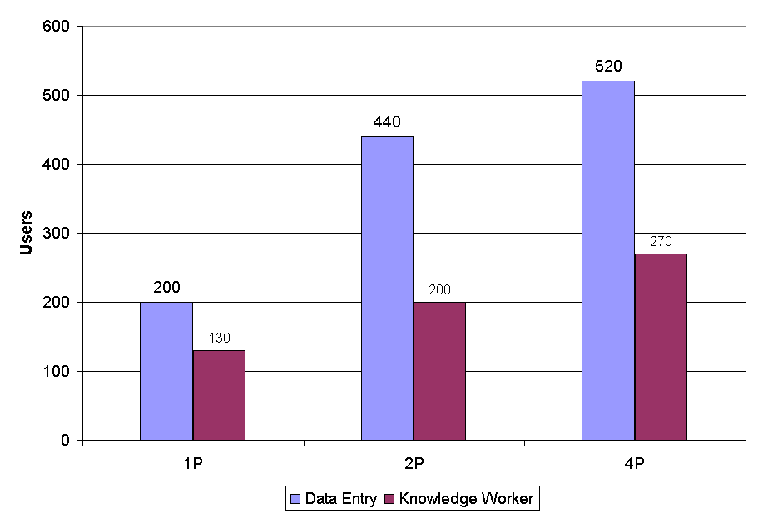
Figure 1 Maximum Users by Scenario and Processor Configuration
on Intel Xeon Systems

System and User Memory Requirements
Table 2 contains general guidelines for Windows Server 2003 Terminal Services memory requirements, based on the results achieved in the performance lab.
Table 2 Recommended Memory
 | Knowledge Workers | Data Entry Workers
Memory per user (MB) | 9.5 | 3.5
System Memory (MB) | 128
Total Memory | System + (# of Users x Memory per User)

Comparison with Terminal Services running on Windows 2000
By default, Terminal Server on Windows Server 2003 is tuned to accommodate approximately 80% more users than Windows 2000 Server. This is made possible because of better utilization of the limited 32-bit virtual address space by the kernel. The system must allocate virtual resources for logged in users, whether they are active or not, even when they are disconnected. These virtual limitations cannot be overcome by adding physical resources to a computer. Because of these constraints, Terminal Services on Windows 2000 Server is less effective at utilizing the faster hardware that is available today. For example, a computer running Windows Server 2003 Terminal Server that can accommodate 280 knowledge workers can only accommodate 160 knowledge workers if it is running Windows 2000 Server. Windows Server 2003 Terminal Server provides better default scaling for today’s hardware. Figure 2 shows the maximum number of users supported on Windows 2000 Server versus Windows Server 2003.

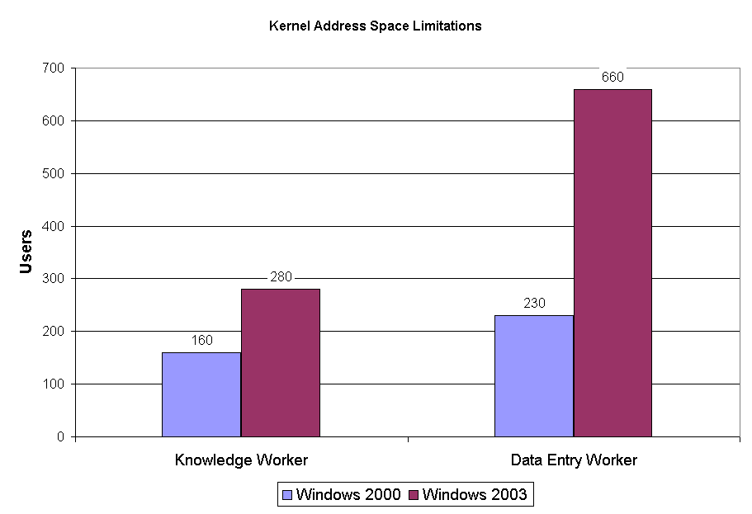
Figure 2 Maximum number of users supported before reaching kernel address space limitations

On the other hand, on a computer where the maximum number of users is limited by physical limitations, such as CPU saturation or physical memory availability, Windows Server 2003 Terminal Server scales to the same number of users as Windows 2000 Server. For example, if a 4 x 550 MHz processor computer running Windows 2000 Server scales up to 170 users running the Knowledge Worker scenario, Windows Server 2003 scales to the same number of users.

Test Environment and Testing Tools
The testing was completed by Hewlett Packard and Microsoft using specific test scripts and tools. The test laboratory used Hewlett Packard servers. All settings are defined in “Appendix B: Terminal Server Settings.” Overviews of the server specifications are included in “Appendix C: HP Server Specifications.”

Test Environment
The Terminal Services testing laboratory is shown in Figure 3. Windows Server 2003, Enterprise Edition build 3790, was installed on these servers.
The servers tested with Windows Server 2003 Terminal Services were:
- HP DL 360G3
- 2 x Intel Xeon 2.4GHz CPUs
- 4 GB RAM.
- HP DL 560
- 4 x Intel Xeon MP 2 GHz CPUs
- 6 GB RAM
Other components of the testing laboratory included:
- Domain Controller and Test Controller: HP DL360 with 2 x P III 800 MHz CPUs and 2 GB RAM running Windows Server 2003 Enterprise Edition. This server is the DHCP and DNS server for the domain. It manages the 35 workstations running Windows 2000 Professional (including script control), software distribution, and remote reset of the workstations.
- Workstations (35): Pentium III 800 MHz, 128 MB RAM, 8 GB hard disk with Windows 2000 Professional. Multiple Terminal Services Client sessions can be running on each of the 35 workstations
- Mail server and Web server: HP DL 360 with 2 x Pentium III 800 MHz CPUs and 2 GB RAM with Microsoft® Windows® 2000 Advanced Server and Microsoft® Exchange 2000 Service Pack 2. The server was used for the Knowledge Worker Tests.
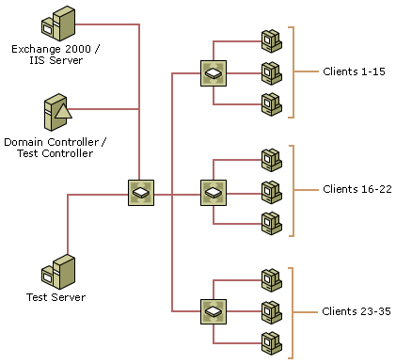
Figure 3 Testing Lab Environment

Testing Tools and Scripts
To assist with scalability testing, Microsoft developed the testing tools and scripts used on the client computers to closely simulate an actual user session.

Testing Tools
Terminal Services Scalability Planning Tools (TSScaling) is a suite of tools that assists organizations with Windows Server 2003 Terminal Server capacity planning. They allow organizations to easily place and manage simulated loads on a server. This in turn enables an organization to determine whether or not its environment is able to handle the load that the organization expects to place on it.
The suite includes the following automation tools:
- Robosrv.exe, the tool that drives the server side of the load simulation testing. Together RoboServer and RoboClient drive the server-client automation. RoboServer is typically installed on the test controller computer, and must be running before an instance of RoboClient can be started. After an instance of both RoboServer and RoboClient are running, RoboServer commands the RoboClients to run scripts that load the terminal server at operator-specified intervals.
- Robocli.exe, the tool that controls the client side of the load simulation testing. Together RoboServer and RoboClient drive the server-client automation. RoboClient is typically installed on the test client computers, and requires RoboServer to be running before an instance of RoboClient can be started. RoboClient receives commands from RoboServer to run scripts that load the terminal server at operator specified intervals.
The suite includes the following test tools:
- Qidle.exe Used in an automation environment, it determines whether any of the currently running scripts have failed and require an administrator to intervene. Qidle determines this by periodically checking to see if any of the sessions logged on to the terminal server has been idle more than a specific period of time. If there are any idle sessions, Qidle notifies the administrator with a beeping sound.
- Tbscript.exe is a script interpreter that drives the client side load simulation. It executes Visual Basic Scripting Edition scripts and supports specific extensions for controlling the terminal server client. Using these extensions, a user can create scripts that control keyboard/mouse input on the client computer and synchronize executions based on the strings displayed by the applications running inside the session.
The suite includes the following Help files:
- TBScript.doc: This file provides Terminal Server bench scripting documentation.
- TSScalingSetup.doc: this file provides a scalability test environment setup guide. It includes information on the following topics:
- Required Hardware
- Domain Controller Setup
- Exchange Server Setup
- Terminal Server Setup
- Client Computer Setup
- List of Required Files
- TSScalingTesting.doc: this file provides a testing guide. It includes information about the following topics:
- Procedure for installing Windows Server 2003
- Procedure for Installing Windows 2000
- Procedure for Configuring Windows 2000 after Install
- Procedure for Configuring Windows Server 2003 after Install
- Procedure for Installing and Configuring Office 2000
- Procedure for Installing and Configuring Office XP
- Setting Up Performance Counters
- Procedure for Deleting the Exchange Store
- Procedure for Running Config Scripts
- Selecting Test Configuration
- Special settings for Task Worker Test
- Procedure for Starting Test
- Evaluating the Response Time for User Actions

Testing Scripts
Two scripts were developed based on Gartner Group specifications for the Knowledge Worker and Data Entry Worker as defined below.

Knowledge Workers
Knowledge workers are defined as workers who gather, add value to, and communicate information in a decision-support process. Cost of downtime is variable but highly visible. These resources are driven by projects and ad-hoc needs. These workers make their own decisions about what to work on and how to accomplish the task.
Example job tasks include: marketing, project management, sales, desktop publishing, decision support, data mining, financial analysis, executive and supervisory management, design, and authoring.

Data Entry Workers
Data Entry Workers input data into computer systems, such as transcription, typing, order entry, clerical work, and manufacturing. Additionally, the Data Entry Worker script was tested in a dedicated mode, by not starting a Windows Explorer shell for each user.
Gartner defines another class of worker as the High Performance Worker. Workers of this type typically use specialized computing platforms and applications to perform their tasks, such as genetic engineering, chip designing, quantum physics, 3D modeling, 3D animation, and simulation. Because these types of applications are not suitable for running on a terminal server, this class of worker was not tested.
For a detailed flowchart describing the functions of the scripts, see “Appendix A: Test Script Flow ”.
The scripts developed at Microsoft for these tests are interpretations of the Gartner Group user definitions and are provided as is. They will not work in your test environment without some modifications, such as changing the various server names that are hard coded in the scripts to match those in your test environment. The test tools are available at: Microsoft.com/reskit Web site. See http://go.microsoft.com/fwlink/?linkid=18341.

Testing Methodology
Windows Server 2003, Enterprise Edition (member of the Windows Server 2003 family of operating systems) and Office 2000 were installed using settings described in “Appendix B: Terminal Server Settings.” An automated server and client workstation reset was performed before each test-run in order to revert to a clean state for all the components.
Response times, based on user actions, were used to determine when or if a terminal server was overloaded. Client-side scripts drive the user simulation and record the response times for a set of simulated user actions.
The scripts contain many sequences. A sequence starts with the test script sending a key stroke through the client to one of the applications running in the session. As a result of the key stroke, a string is displayed by the application. For example, Ctrl-F opens the File menu that would then display the Open string.
The response time is the time from the key stroke to the display of the string. To accurately measure the response time, this measurement is calculated by taking two initial time readings, ti1 and ti2, from a reference time source before and after sending the key stroke. Ti1 is the time when the test manager sends the instructions to the client, and ti2 represents the client sending the keystroke to the server. A third reading, tf3, is made after the corresponding text string is received by the client. Time is measured by milliseconds. Based on these values the response time is estimated as belonging to the interval (tf3 – ti2, tf3 – ti1). In practice, the measurement error (the time between ti1 and ti2) is less than 1 millisecond (ms), and the response values are approximated to tf3 – ti1.
For each scenario, the Test Manager workstation started groups of ten client sessions on the workstations with a 30-second interval between each session. After the group of ten client sessions was started, a 5-minute stabilization period was observed in which no additional sessions were started. After the stabilization period, the Knowledge Worker script starts the four applications it will use in the test within five minutes. This prevents any interference between each group of ten client sessions.
For each action, as the number of users log on, a degradation point is determined when the response times increase to a value that is deemed significant:
- For actions that have an initial response time of less than 200 ms, the degradation point is considered to be where the average response time is more then 200 ms and 110% of the initial value.
- For actions that have an initial response time of more than 200 ms, the degradation point is considered to be the point were the average response time increase with 10% of the initial value.
This criteria is based on the assumption that a user will not notice degradation in a response time while this is lower then 200 ms.
There are several reasons for response-time degradation. When degradation in response time is attained for approximately the same number of users, CPU saturation is the main reason. Response-time degradation that can be attributed to actions relating to file IO, such as opening a dialog box to select a file to open or save, is due to IO limitations. Also, some actions might exhibit a “noisy” degradation where a small number of response times randomly having values noticeable higher than average, without influencing the average value noticeably.
Figure 4 shows three examples of response-time degradation on a CPU saturated system.

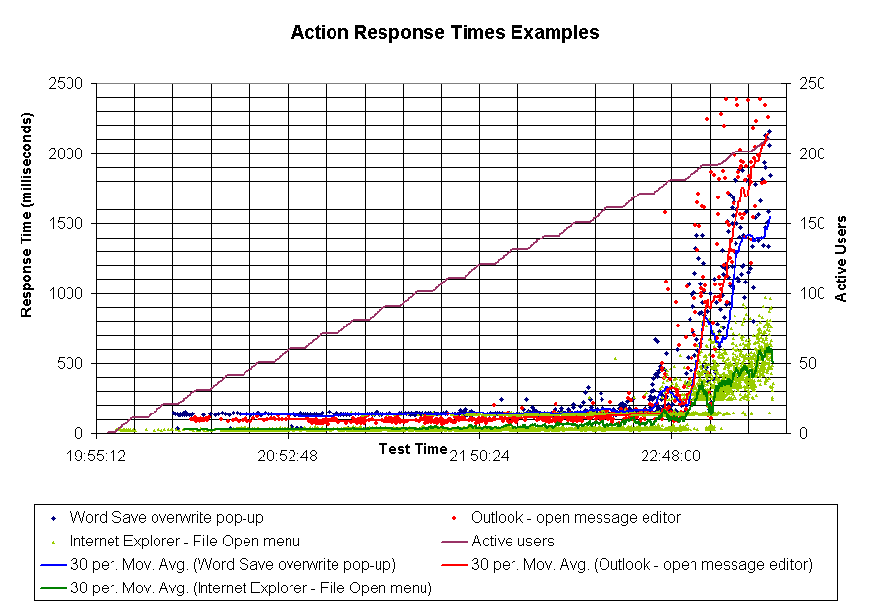
Figure 4 Example of Canary time by number and profile of users

The test harness supports the previous system of tests that determine system load threshold based on a canary script that is running between the logon groups while the system is stable. The canary script is run before any users are logged onto the system, and the time the script takes to complete (elapsed time) is recorded. This elapsed time becomes the baseline and is deemed to be the baseline response rate for a given configuration of server. This method would consider that maximum load was reached when the total time needed for running the canary script is 10% higher than the initial value. The response time method is considered to be more accurate because it measures the key parameter for the actual user experience, it takes into account the login period impact and provides a richer data support for decision making. The canary-script method can still be more efficient for setups that support a small number of users where the response time method will not provide a large enough sample of response time values.
One key parameter that is also monitored is the total cycle time for a work unit performed by a user. This must be a constant value especially for comparison tests (cross-platform or when testing for special features). Tests that would run with different cycle times are effectively performing a different amount of work in the same unit of time thus consuming more resources in the time unit and can not be compared directly.

Analysis of the Results

Overview
Although the scripts used in these scenarios simulate tasks that a typical user can perform, the users simulated in these tests are tireless—they never reduce their intensity level. The simulated clients type at a normal rate, pause as if looking at dialog boxes, and scroll through mail messages as if reading them, but they do not get up from their desks to get a cup of coffee, they never stop working as if interrupted by a phone call, and they do not stop for lunch. This approach yields accurate but conservative results.

Memory Requirements and Utilization
In addition to the 128-MB base-minimum memory requirements for a Windows Server 2003–based server, the amount of memory needed per user for these scenarios is shown in Figure 5
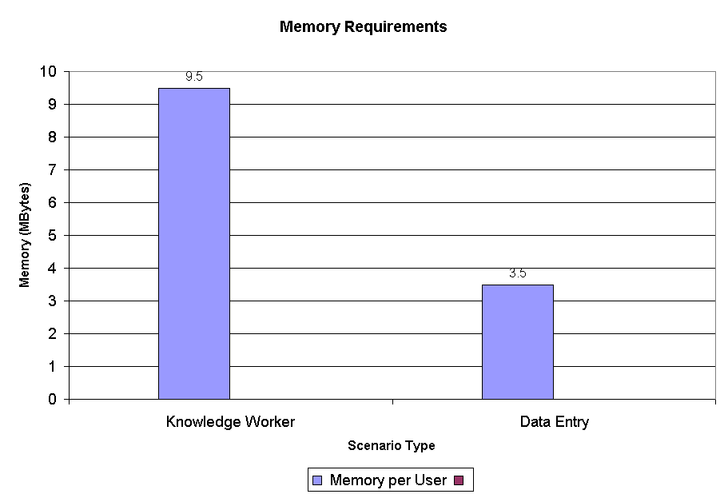
Figure 5 Memory requirements by scenario

Determining the amount of memory necessary for a particular use of a terminal server is complex. It is possible to measure how much memory an application has committed—the memory the operating system has guaranteed the application that it can access. But the application does not necessarily use all of that memory, and it never uses all that memory at any one time. The subset of committed bytes that an application has accessed recently is referred to as the working set of that process. Because the operating system can page the memory outside a process’s working set to disk without a performance penalty to the application, the working set, if used correctly, is a much better measure of the amount of memory needed.
The Process performance object's Working Set counter, used on the _Total instance of the counter to measure all processes in the system, measures how many bytes have been recently accessed by threads in the process. However, if the free memory in the computer is sufficient, pages are left in the working set of a process even if they are not in use. If free memory falls below a threshold, unused pages are trimmed from working sets.
The method used in these tests for determining memory requirements cannot be as simple as observing a performance counter. It must account for the dynamic behavior of a memory-limited system.
The most accurate method of calculating the amount of memory required per user is to analyze the results of several performance counters (Memory\Pages Input/sec, Memory\Pages Output/sec, Memory\Available Bytes and Process\Working Set (Total_)) in a memory-constrained scenario. When a system has abundant physical RAM, the working set initially grows at a high rate, and pages are left in the working set of a process even if they are not in use. Eventually, when the total working set tends to exhaust the amount of physical memory, the operating system is forced to trim the unused portions of working set until enough pages are made available to free up the memory pressure. This trimming of unused portions of the working sets occurs when the applications collectively need more physical memory than is available, a situation that requires the system to constantly page to maintain the working sets of all the processes. In operating systems theory terminology, this constant paging state is referred to as thrashing.
Figure 6 shows the values of several relevant counters from a Knowledge Worker test when performed on a server with 1024 MB of RAM installed.
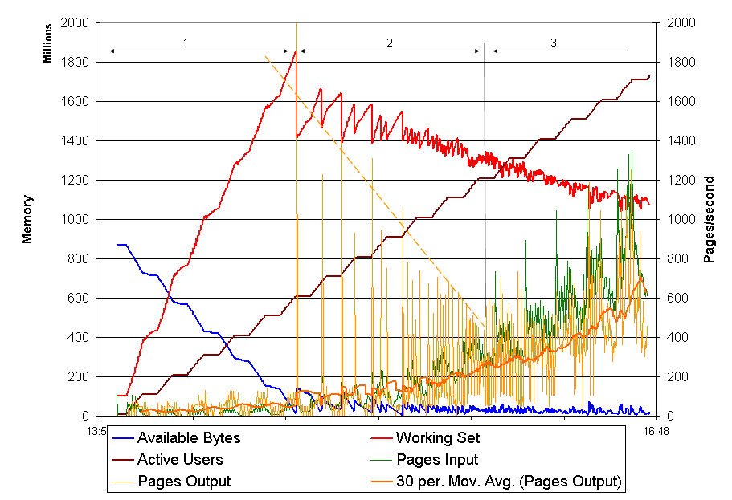
Figure 6 Stages of memory usage

The results are very close to what is expected.
Zone 1 represents the abundant memory stage. This is when physical memory is greater than the total amount of memory that applications need. In this zone, the operating system does not page anything to disk, even seldom-used pages.
Zone 2 represents the stage when unused portions of the working sets are trimmed. In this stage the operating system periodically trims the unused pages from the processes’ working sets whenever the amount of available memory drops to a critical value. Each time the unused portions are trimmed, the total working set value decreases, increasing the amount of available memory which results in a significant number of pages being written to page file. As more processes are created, more memory is needed to accommodate their working sets and the number of unused pages that can be collected during the trimming process decreases (as outlined by the dotted line). The pages input rate is mostly driven by pages required when creating new processes. The average is typically below the rate of pages output. This state is acceptable and applications typically respond well because only unused pages are being paged to disk.
Zone 3 represents the high pressure zone. The working sets are trimmed to a minimal value and mostly contain pages that are frequented by the greater number of users. Page faults will likely cause the ejection of a page that will need to be referenced in the future, thus increasing the frequency of page faults. The output per second of pages will increase significantly, and the page output curve follows to some degree the shape of page input curve. The system does a very good job of controlling degradation, almost linearly, but the paging activity eventually increases to a level where the response times are not acceptable.
In Figure 6, it seems that the amount of physical memory is greater than 1024 MB because the operating system does not start to trim working sets until the total required is well above 1600 MB. This is the due to cross-process code sharing, which makes it appear as if there is more memory used by working sets than is actually available.
The amount of memory needed can be determined from the number of users at the point where the page-out activity starts increasing significantly (end of Zone 2 in Figure 6). The amount of memory required per user can be estimated by dividing the total amount of memory in the system by the number of users at the end of Zone 2. Such an estimate does not account for the memory overhead required to support the operating system. A more precise measurement can be obtained by running this test for two different memory configurations (for example, 512 and 1024 MB), determining the number of users at the end of Zone 2 and dividing the difference in memory size (1024 – 512 in this case) to the difference of user number at end of Zone 2. In practice, the amount of memory required for the operating system can be estimated as the memory consumed before the test starts.
Although a reasonable amount of paging is acceptable, paging naturally consumes a small amount of the CPU and other resources. Because the maximum number of users that can be loaded onto a system are determined on systems that have abundant physical RAM, a minimal amount of paging occurred. The working set calculations assume that a reasonable amount of paging has occurred to trim the unused portions of the working set, but this only occurs on a system that is memory-constrained. If you take the base memory requirement and add it to the number of users, multiplied by the required working set, the result is a system that is naturally memory-constrained, and acceptable paging occurs. On such a system, expect a slight decrease in performance due to the overhead of paging. This decrease in performance can reduce the number of users who can be actively working on the system before the response time degrades above the acceptable level.

Network Usage
Network usage overhead tends to be quite low on Terminal Server, because of protocol efficiency and since, by default, the Terminal Services Client (mstsc.exe) uses data compression for all connections. Network usage for the two scenarios is shown in Figure 7. This includes all traffic coming in and going out of the terminal server for these scenarios.
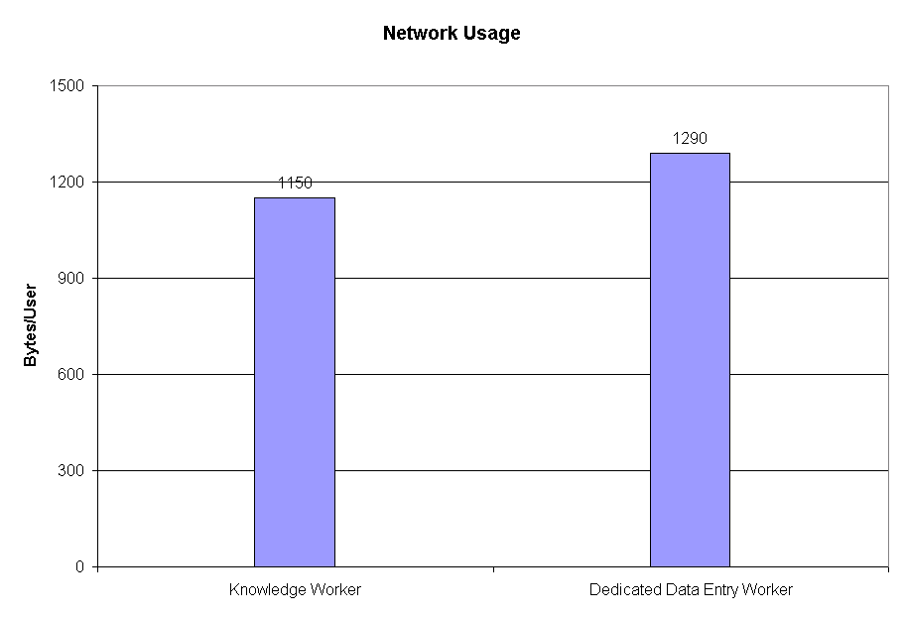
Figure 7 Total network usage (including RDP and all other network traffic)
scenario

Figure 7 shows network usage in bytes per user for the Knowledge Worker scenario. This is taken from the Bytes Total/sec counter in the Network Interface performance object. This graph illustrates how the bytes-per-user average was calculated, as it converges on a single number when a sufficient amount of simulated users are running through their scripts. The number of user sessions is plotted on the primary axis. The count includes both bytes received and sent by the terminal server, using any network protocol.

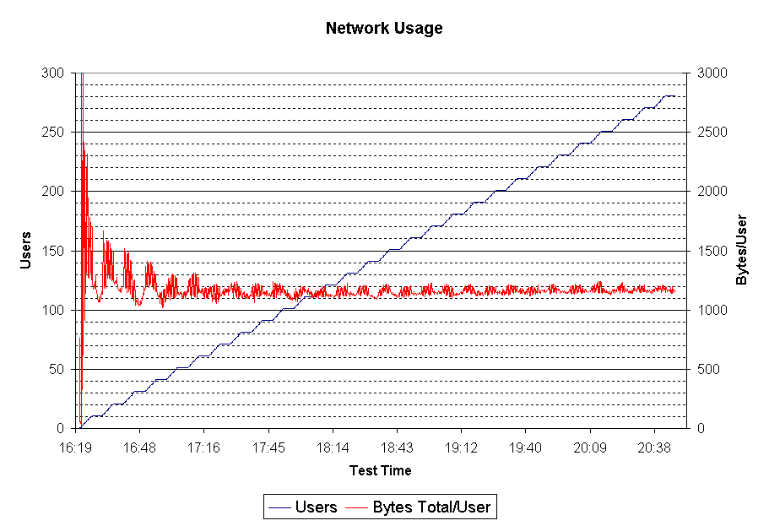
Figure 8 Knowledge worker scenario network usage per user
and number of users against time

The network utilization numbers in these tests only reflect RDP traffic and a small amount of traffic from the domain controller, Microsoft Exchange Server, IIS Server, and the test manager. In these tests, the terminal server’s local hard drive is used to store all user data and profiles. No roaming profiles or network home directories were used. In a typical terminal server environment there is more traffic on the network, especially if user profiles are not stored locally.

Effect of Increased Color Depth (16 bit)
Choosing 16-bit color depth for remote connection sessions instead of 8-bit slightly increases RAM usage (10% when compared to 8-bit remote sessions), increases network bandwidth usage from 1150 bytes total per user to 1450 bytes total per user, but does not significantly affect the CPU usage level or the kernel virtual space consumption.

Effect of File Redirection
Enabling file redirection has little impact in terms of CPU usage, memory consumption, or kernel virtual address consumption. When file redirection is enabled, the emulation scripts access the data files from the client computer’s hard disk, and as expected, this increases network bandwidth usage. This increase is proportional to the file size and frequency with which the files are accessed.
In this scenario, each user accesses three files. The user opens and reads a 250 KB Excel spreadsheet and saves a 16 KB Excel spreadsheet and a 23 KB Word file every 36 minutes. The impact on the total bandwidth usage was an increase from 1150 bytes total/user to 1450 bytes total/user.

Effect of Printer Redirection
Test results show network bandwidth usage is not significantly affected and the impact on other key system parameters (memory usage, paged pool, system PTEs area) is negligible. Test results also show that the printer redirection has a significant impact on the server CPU usage, especially during the login sequence when the new printer is detected and installed by the spooler service.
To assess the effect of enabling printer redirection on Terminal Server scalability, the Knowledge Worker script was run in a configuration where an HP LaserJet 6P printer was installed on the NULL port on each client computer, and the clients where configured to redirect to the local printer when connecting to the server. The script prints twice during the 36-minute work cycle: the first print job is a large 250-KB Excel spreadsheet, and the second print job is a 23-KB Word document. If a DL 6400R system is CPU saturated at 160 users, enabling printer redirection lowers the supported user number to 140 users.

Effect of Logon Activity on CPU Utilization
In each of the tests, the CPU utilization graphs are similar to the one in Figure 9, in that they consist of an ascending phase corresponding with the test scenario script starting on each client workstation, with a slight increase of CPU-intensive logon activity followed by a stabilization plateau after each set of 10 connections.
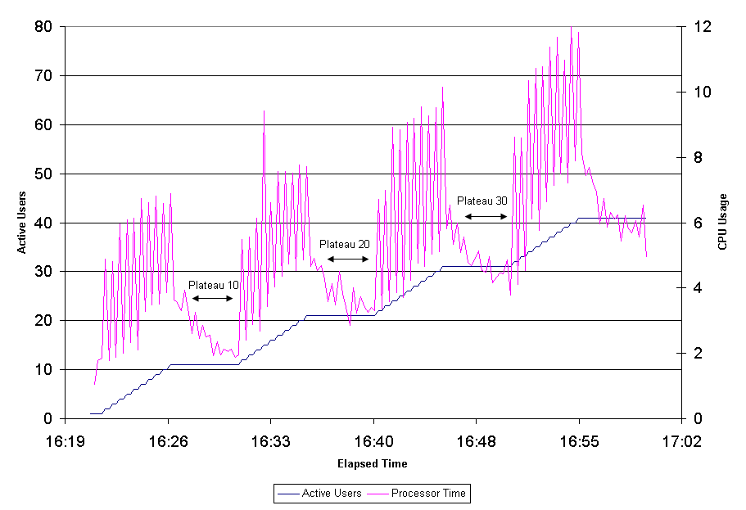
Figure 9 Example of plateau phases

Effect of Kernel Address Space Limitations
The 32-bit Windows platform is named after its 32-bit address space, meaning that up to 2³² bytes (4 GB) can be addressed at any one time, regardless of physical RAM. By default, 2 GB of this address space is allocated to user-mode processes, and 2 GB is allocated to the kernel. Although separate 2 GB regions of address space are used for user-mode processes in the system, most of the 2 GB kernel area is global and remains the same regardless of the user-mode process currently active.
The 2 GB of kernel area contains all system data structures and information. Therefore, the 2 GB kernel address space area can impose a limit on the number of system data structures and the amount of kernel information that can be stored on a system, regardless of physical memory.
There are three areas in the 2 GB kernel address space that have a significant impact on terminal server scalability: paged pool area, system page table entries (PTEs) area, and system file cache area. The paged pool area holds memory allocation from kernel components and drivers that are pageable. System PTEs hold kernel stack allocations — stacks created in kernel mode for each thread to be used when that thread makes kernel calls — and page table data structures and the system file cache holds mapped views to files opened in the system.
Although these different allocations share the same area, the partition between them is fixed when the system starts: If the system runs out of space in one of those areas, the other area cannot donate space to it, and applications might encounter unexpected errors. Therefore, when you see a system that is experiencing unexpected errors or is unable to accept new logins, without the system having some other resource limitation (such as CPU or disk limitations), it is probably due to the paged pool area or the System PTE area running out of space.
Tests for several scenarios showed that the ratio of System PTEs to paged pool areas is (2.9-4):1, where the smaller number is for the lightweight dedicated worker scenario that starts an application directly, and the larger number is for the complex Knowledge Worker scenario involving starting many simultaneous user applications in the session. Choosing a smaller number for System PTEs means that relatively more memory is allocated to paged pool area. Because each user consumes at least three times more System PTE memory compared to paged pool memory, choosing a smaller ratio lowers the number of users supported in a complex scenario. For each user lost in complex scenarios, three more are supported for simple ones. Based on these observations, the Windows Server 2003 default ratio was tuned to values closer to the low end of the range: 3.25. This accommodates both simple and complex user scenarios, to 90% of the optimal system configuration for each specific case. For specific scenarios, you can tune this through the Registry, using the DWORD value PagedPoolSize under HKEY_LOCAL_MACHINE\SYSTEM\CurrentControlSet\Control\Session Manager\Memory Management to specify the desired paged pool memory size in bytes. This key controls the paged pool size by changing the ratio between the paged pool and System PTEs areas while keeping their combined size unchanged.
The system file cache area is another key region of kernel address space. It holds data structures and data for files opened by various applications. When the system detects pressure on the paged pool area (either consumption is above a threshold value – by default, 80% of the total or large pool allocations are failing), it starts a process that reclaims some of the space from the system file cache to satisfy paged pool usage. If the file I/O activity on the system is high, the probability that requests finds the desired file data in memory decreases, thus affecting negatively the file access times. This can be monitored by using the performance object Cache with the Copy Read Hits % performance counter. The values for this counter should ideally not drop consistently under 99%. In Figure 10, you can see how the slope of paged pool consumption starts dropping right before point a, indicating that system cache mapped memory is reclaimed and used to satisfy the paged pool allocation request. After point a, the cache-hit ratio drops, and response times for opening the Save As dialog box in Excel increase from an average of 50 ms to 200 ms.

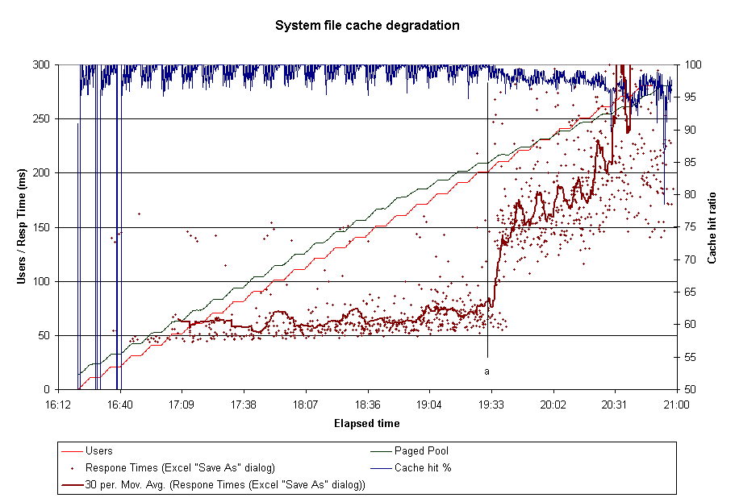
Figure 10 Example of cache-hit ratio degradation

Such a situation can be mitigated in two ways:
- You can provide plenty of memory for the system to allow pages that belong to the file mappings destroyed in the reclaim process to be kept in memory and reused on subsequent accesses. For the Knowledge Worker scenario, using the Physical Address Extension (PAE) to allow access to 6 GB delayed the cache hit ratio degradation from 200 to 270 users. This solution might involve trade-offs if PAE modes are required for memory above the 4 GB limit.
- Increasing the amount of memory allocated to paged pool delays the moment when the system starts reclaiming memory from the system cache to alleviate paged pool pressure. The trade-off in this situation is that the increased paged pool area size decreases the area of the System PTEs and might lower the maximum number of supported users.
Enabling Physical Address Extension (PAE) mode allows access to physical memory beyond the 4 GB space accessible through normal 32-bit addressing. Although the 2 GB user mode space available to each application does not increase, the total amount of memory available to applications does. The PAE mode is a benefit to Terminal Server configurations where application memory consumption is high. The normal 4 GB of addressable memory is not enough to accommodate the working set for all applications and the system while keeping the amount of page faults to acceptable values. PAE mode impacts the scalability in two ways:
- Because the Page Table Entries (PTEs) double in size, there is an initial increase in memory consumption from the System PTEs area. This cost is about 20 MB for a system with 8 GB of RAM.
- Because the paged pool area holds data structures that contain PTEs (typically memory sections), paged pool usage per user increases which can be an issue for paged pool limited systems.

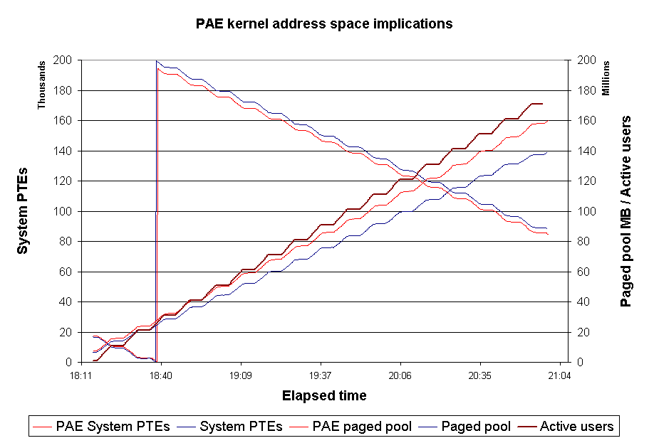
Figure 11 PAE impact on kernel address space

In Figure 11 System PTEs and paged pool consumption are compared for a regular and 6 GB PAE-enabled test using the Knowledge Worker scenario. The result is that the paged pool consumption increased with ~13% per user and the amount of available System PTEs dropped by ~15 MB.

Effect of Typing Rate on CPU Utilization
Changing the typing rate in these tests increases CPU utilization and has an effect on scalability, with higher typing rates corresponding to fewer users.
In real-world situations, the expected typing rate of users should be taken into consideration when sizing a system. In addition, users who open and close applications (instead of switching between them), and users who move quickly between tasks place a heavier load on a system.

Effect of Background Spelling and Grammar Checking
Based on the results of previous tests, background grammar-checking was disabled in Microsoft Word for the Knowledge Worker scenarios. Background grammar checking had a significant negative impact on scalability, reducing the number of users supported on the four-way Knowledge Worker scenario by about half. If you disable background grammar checking, you can use foreground checking by pressing F7 in Word.

Performing Your Own Scaling Tests

To Test or Pilot?
The purpose of this document is to give you a starting point from which to base your own sizing efforts. Unless you are prepared to spend large amounts of resources analyzing your users’ work habits and capturing these actions into a simulated script, you will find that it is more effective to go into a pilot mode after you have determined that your applications work in a Terminal Services environment.
After you have chosen a server configuration as a starting point (based on the findings discussed in this white paper), you can gradually add users to determine the maximum number that a system configuration (terminal server/network architecture/infrastructure servers) can support.
It is recommended that you add small batches of users to the server at a time (in a similar fashion to the testing methodology used in this paper) to determine when the system slows down to an unacceptable level. These batches of users should be added in intervals of hours or days, rather than minutes, as there is likely to be a delay in the performance of the system while each user becomes familiar with the new system.
After you have determined the terminal server configuration, you can expand the scenario by testing load balancing.
As an aid to understanding the various factors involved when running applications on a terminal server, you nee to take application suitability, characteristics of users, and network environment into consideration.

Determining Application Suitability
If some or all of your desktop computers are capable of running the application locally, consider using application distribution technology such as Windows XP Professional and IntelliMirror® management technologies, or Microsoft Systems Management Server. It is a better use of resources to run a frequently-used productivity application on a LAN-connected, Windows-based computer than on a terminal server attached to the same LAN. Applications that make extensive use of graphics or multimedia (such as Windows Media™ Player, voice recognition, or CAD applications), are not suited for running on a terminal server and might not scale effectively or even work at all. Other issues such as how the application writes to the screen, and whether the application uses large amounts of CPU while idle or when the user is typing will also determine its suitability for use on a terminal server.
However, if your application is frequently updated, needs to be accessed from a computer running an operating system other than Windows, or manipulates large amounts of data over a low-bandwidth connection, that application might be a good candidate for running on a terminal server.
If it is determined that a terminal server is the most practical method of distributing the application, consider just running the application on the terminal server, not on each desktop. This can save significant amounts of resources on the terminal server and can allow many more users to log on simultaneously.

Characterization of Users
User usage patterns have a significant impact on terminal server performance and should be considered carefully when sizing a terminal server. User usage characteristics will have a different effect on a terminal server than what is expected on a traditional Windows-based computer. In a computer-centric architecture, the speed at which a user inputs characters from the keyboard will not have a significant impact on CPU utilization. The same cannot be said for a terminal server. Because each character typed on the client requires processing on the terminal server, and many users can be typing at one time, the speed at which the users enter characters has a significant effect on scalability. Other factors such as whether all of your users log on at the same time of day or how often they take breaks will also have an effect on overall system responsiveness.

Network Environment
Understanding the network environment is especially important when designing a terminal server solution that involves WAN communications. Even infrequent network slowdowns can cause unacceptable performance to terminal server users. Both latency (the time it takes a packet to reach the other end of the network) and bandwidth (the amount of data that can travel over the network within a given period of time) are important factors. Because everything a user sees on their screen is generated by the terminal server, high latency has a serious impact on the perceived response of the system, while low bandwidth affects the time it takes to get large chunks of data like bitmaps) to the user’s screen. Therefore, variables such as the typing rate of the users, the amount of graphics used in an application, and how many users are working at any one time over a WAN connection all factor into the equation when asking, “How many users can I connect to a terminal server over a given connection?” The only reliable way of determining this is to test it in your actual network. Keep in mind that the user’s experience depends very much on there being sufficient bandwidth available when the application is writing large amounts of information to the screen. Connecting over a low-bandwidth connection has no significant impact on terminal server scaling.

Appendix A: Test Script Flow Charts

Knowledge Worker Script
Typing Speed = 35 WPM
Definition: a worker who gathers, adds value to, and communicates information in a decision support process. Cost of downtime is variable but highly visible. Projects and ad-hoc needs towards flexible tasks drive these resources. These workers make their own decisions about what to work on and how to accomplish the task. The usual tasks they perform are marketing, project management, sales, desktop publishing, decision support, data mining, financial analysis, executive and supervisory management, design, and authoring.

- Connect User “smcxxx”
- Start (Microsoft Excel) - Load massive Excel spreadsheet and print it
- Open File c:\documents and settings\smcxxx\Carolinas Workbook.xls
- Print
- Close Document
- Minimize Excel

- Start (Outlook) - Send a new, short mail message ( email2 )
- Minimize Outlook

- Start (Internet Explorer)
- URL http://tsexchange/tsperf/Functions_JScript.asp
- Minimize Explorer

- Start (Word) - Type a page of text ( Document2 )
- Save
- Print
- Close Document
- Minimize Word

- Switch To (Excel)
- Create a spreadsheet of sales vs months ( spreadsheet )
- Create Graph ( Graph )
- Save
- Close Document
- Minimize Excel

- Switch To Process, (Outlook) - read message and respond ( Reply2 )
- Minimize Outlook

Now, Toggle between apps in a loop
- loop(forever)

- Switch To Process, (Excel)
- Open File c:\documents and settings\smcxxx\Carolinas Workbook.xls
- Print
- Close Document
- Minimize Excel

- Switch To Process, (Outlook) - Mail Message ( email2 )
- Minimize Outlook

- Switch To Process, (Internet Explorer)
- Loop (2)
- URL http://tsexchange/tsperf/Functions_JScript.asp
URL http://tsexchange/tsperf/Conditional_VBScript.asp
URL http://tsexchange/tsperf/Conditional_JScript.asp
URL http://tsexchange/tsperf/Arrays_VBScript.asp
URL http://tsexchange/tsperf/Arrays_JScript.asp
- end of loop
- Minimize Explorer

- Switch To Process, (Word) - Type a page of text ( Document2 )
- save
- Print
- Close Document
- Minimize Word

- Switch To Process, (Excel)
- Create a spreadsheet of sales vs months ( spreadsheet )
- Create Graph ( Graph )
- Save
- Close Document
- Minimize Excel

- Switch To Process, (Outlook) - read message and respond ( reply2 )
- Minimize Outlook

- End of loop

- Logoff

Data Entry Worker Script
Typing Speed = 35 WPM
Definition: Workers who input data into computer systems including transcription, typists, order entry, clerical, and manufacturing.

- Connect User “smcxxx”
- OpenFile – Open File in Excel
- Loop (forever)
- Clear spread sheet
- Move to First Row
- Type Column headers
- Loop (10)
- Enter 10 Data Rows in spread sheet
- Select last 10 Rows
- Format Data
- Save File
- End Loop
- End Loop

Appendix B: Terminal Server Settings
- Operating system installation
- All drives formatted using NTFS
- Components
- Terminal Services enabled in Application-server mode
- All other components disabled except Accessories and Utilities, Network Monitor Tools, and SNMP under Management and Monitoring Tools
- Networking left at default with Typical Network settings
- Server joined as a member to a Windows 2003 domain
- Page file initial and maximum size set to 4092 MB
- Registry set to 256 MB
- RDP protocol client settings
- Clipboard mapping, printer mapping, and LPT mapping disabled
- Office 2000 settings
- Office 2000 installed using default Terminal Server transforms file from Office 2000 Resource Kit (termsrvr.mst)
- Outlook settings
- Mailbox on Exchange server
- Email options
- AutoSave of messages disabled
- Automatic name checking disabled
- AutoArchive disabled
- Word settings
- Background grammar-checking disabled
- Background saves disabled
- Save AutoRecover information disabled
- Printer settings
- HP LaserJet 6P created to print to NUL:
- Print notification messages disabled
- Spooler information event logging disabled
- User profiles
- Configuration script executed to pre-create cached profiles and run through Internet Connection Wizard
- Performance logger
- Performance counters are logged on the terminal server itself

Appendix C: HP Server Specifications

The ProLiant Advantage
In today’s online world, computing demands are less predictable than ever. Resources are constantly being redeployed and reconfigured, consolidated and integrated; customers are demanding increasingly customized services. Meanwhile, IT organizations are constrained by space and budget limitations and a shortage of the qualified staff needed to configure, deploy and troubleshoot their multiplying server farms.
HP understands that businesses must adapt to survive, doing more with less, responding faster with fewer resources. With the ProLiant Advantage, IT organizations can adapt, conserve and respond.
The ProLiant Advantage combines an adaptive infrastructure with solution integration and service expertise.
- Adaptive infrastructure
The ProLiant Advantage starts with an adaptive infrastructure consisting of versatile, industry-standard ProLiant servers, integrated Smart Array storage and ProLiant Essentials software.

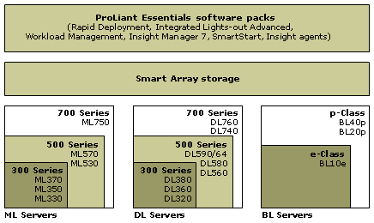
Figure 12 The three layers of an adaptive infrastructure
- Solution integration
An adaptive infrastructure is only as good as its ability to effectively run leading operating systems and applications. HP rigorously tests, optimizes and certifies ProLiant servers to run applications from the leading independent software vendors.
- Services expertise
From planning and design to implementation and management, professionals from
HP Services at: http://go.microsoft.com/fwlink/?LinkId=15435, can help customers achieve their business objectives quickly and cost-effectively.

ProLiant Server Models
Built on years of solid computing innovation, ProLiant servers form the foundation of an Adaptive Infrastructure. New-generation servers include:
- ML servers
ProLiant ML servers at: http://go.microsoft.com/fwlink/?LinkId=15436, are designed to provide maximum internal storage and I/O flexibility for rack or tower deployments. These workhorses can handle intensive applications ranging from ERP to e-commerce hosting. With up to eight processors, up to 11 PCI slots, next-generation PCI Hot Plug, and redundant power and cooling, ProLiant ML servers are ideal for high-volume, 24 x 7 datacenter environments.

- DL servers
ProLiant DL servers at: http://go.microsoft.com/fwlink/?LinkId=15436 deliver enterprise-class performance with robust, affordable multi-processors in a slim (1U – 7U) form factor that is ideal for multi-server rack environments. Optimized for clustering operations and attached external storage, ProLiant DL servers can handle jobs as large as data warehousing or as small as Web hosting. They have become the world’s most popular rack-mounted servers.

- BL servers
HP offers two families of ProLiant BL server blades: at: http://go.microsoft.com/fwlink/?LinkId=15437, e-Class and p-Class.
e-Class These ultra-dense server blades are optimized for rapid deployment and provisioning and, with up to 280 blades deployed in a single rack, they are ideal for space-constrained enterprises and service providers. e-Class server blades can handle a wide range of data center jobs, from front-end Web serving to other, more transaction-intensive applications.
Their industry-standard design ensures that these server blades can integrate seamlessly into an existing IT infrastructure. Drag-and-drop configuration and rip-and-replace servicing position these server blades at the cutting edge of adaptive computing.
p-Class The more powerful p-Class server blades deliver higher levels of performance and availability for high-performance front-end, mid-tier and back-end applications.

ProLiant Servers in a SBC Environment
Deploying ProLiant servers in a Server-Based Computing (SBC) environment offers many benefits to the customer:
- Lower application ownership costs
- Elimination of additional development, testing or deployment procedures for individual applications
- Accelerated application deployment
- Extended application availability
- Enhanced security
- Improved data backup and recovery
- Improved end-user support
- Uniform desktop experience from any network access point

Server Blades
Using ProLiant BL server blades to deploy a server farm in a SBC environment can offer additional benefits:
- Scalability
The server farm can be scaled out to distribute risk and load while minimizing the impact on users.
- Performance
ProLiant BL server blades provide the performance necessary to support the most demanding line-of-business applications.
- Rapid server deployment and redeployment
Rapid deployment capability allows the customer to save valuable time by quickly deploying the BC solution, then quickly and dynamically responding to changing business needs.
It takes only seconds to install server blades and power supplies once the rack infrastructure is in place. This allows dynamic scaling – without turning off the computer.
- There is single-sided access to most pluggable components.
ProLiant Essentials Rapid Deployment Pack at: http://go.microsoft.com/fwlink/?LinkId=15438, (RDP) software allows the administrator to pre-configure each server bay before installing server blades. After installation, server blades configure automatically, assuming the role assigned by the administrator.

RDP also provides rip-and-replace capability. When a server blade is replaced, the new server blade automatically assumes the role assigned to the original server blade.
- Anytime, anywhere access
Integrated Lights-Out (iLO) at: http://go.microsoft.com/fwlink/?LinkId=15439, Advanced management allows anytime, anywhere access to the server farm for remote management.
- Reduced total cost of ownership
ProLiant BL20p server blades can further reduce Total Cost of Ownership (TCO) in the following ways:
- Consuming less power per user, which reduces utility and air-conditioning costs.
- Supporting more users per rack, which reduces licensing and real estate costs.
- Reducing cabling complexity.

Tested Servers
For this white paper, HP tested a number of the latest ProLiant servers to determine Windows Server 2003 scalability. Table 3 provides overviews of these servers.

Table 3 Overview of Servers
Server Model | Description
ProLiant BL10e  http://go.microsoft.com/fwlink/?LinkId=15437 | Power-efficient, ultra-dense ProLiant BL10e server blades are ideal for light worker loads in SBC environment. Up to 280 of these blades can be installed in a standard 42U rack.
ProLiant BL20p  http://go.microsoft.com/fwlink/?LinkId=15437 | ProLiant BL20p high-performance, high-availability server blades are ideal for enterprise applications.
ProLiant BL40p  http://go.microsoft.com/fwlink/?LinkId=15437 | High-performance, four-way ProLiant BL40p server blades are ideal for mission-critical back-end applications.
ProLiant DL360 G3  http://go.microsoft.com/fwlink/?LinkId=15436 | The ProLiant DL360 G3 server offers essential availability and management features with the computing power required for space-constrained Internet and data center applications. With their unsurpassed ability to scale out, these servers are industry leaders.  Based on price and performance, the 1U ProLiant DL360 G3 server is an ideal solution for medium – heavy worker loads in a SBC environment.
ProLiant DL360 G1  http://go.microsoft.com/fwlink/?LinkId=15436 | The ProLiant DL360 G1 is a Generation One server, included in this testing as a legacy system.
ProLiant DL380 G3  http://go.microsoft.com/fwlink/?LinkId=15436 | ProLiant DL380 G3 servers with Integrated Light-Out management and enterprise-class uptime are optimized for a variety of applications – still in a 2U form factor.  Based on price and performance, the 1U ProLiant DL380 G3 server is an ideal solution for the SBC environment.
ProLiant DL560  http://go.microsoft.com/fwlink/?LinkId=15436 | Designed for enterprise computing, the highly available ProLiant DL560 server delivers high levels of four-way performance  Deployed in an innovative 2U form factor with optimal power and cooling efficiency, the ProLiant DL560 server is ideal for the data center environment.
Table 4 lists key features of the tested servers.

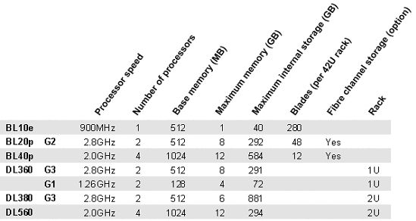

SBC Solution Sizing
To minimize risk, HP offers an automated, online tool Web site at http://go.microsoft.com/fwlink/?LinkId=18342, which can help the customer size a SBC solution. The algorithms and methodology used by the sizer are based on exhaustive testing and customer surveys.
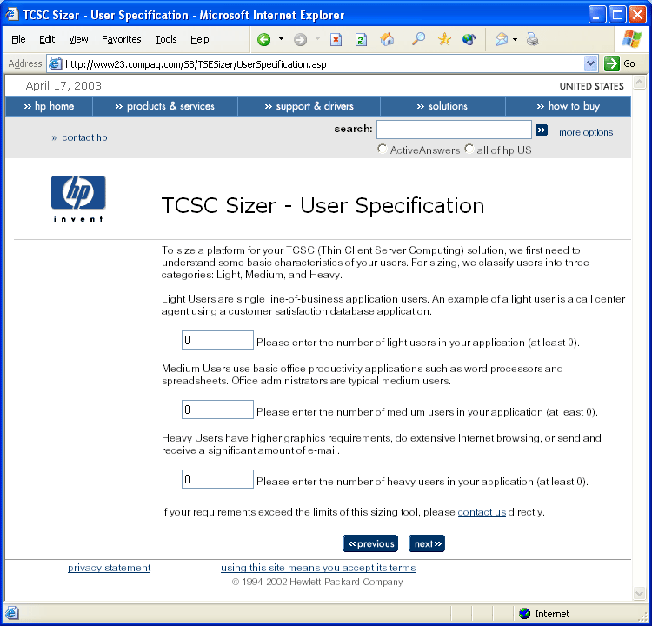
Figure 13 TSCS Sizer User Specification dialog box
The sizer offers a quick, consistent methodology for determining the “best-fit” server for a specific SBC solution. Based on information provided by the customer, the sizer generates a Bill of Materials (BOM) for the selected solution.

For More Information
For more information about Windows Server 2003 Terminal Server, technologies/terminalservices, Web site at http://go.microsoft.com/fwlink/?LinkId=18340

For the latest information about Windows Server 2003, see the Windows Server 2003 Web site at: http://go.microsoft.com/fwlink/?LinkId=18343

