

HPC Development using F#

Author: Jon Harrop, Flying Frog Consultancy Ltd.
Published: July 29, 2026

Abstract

The F# programming language is a high-performance statically-typed functional programming language for the .NET platform specifically designed for technical users such as scientists and engineers. F# provides a wide variety of state-of-the-art features that make it much easier to solve many important technical problems. These features include algebraic data types, pattern matching, first class functions and type inference as well as full support for high performance interactive use from sessions embedded in Visual Studio.
This tutorial introduces the F# programming language in the context of technical computing and demonstrates how F# can be used for both shared-memory parallel programming using the Task Parallel Library and distributed parallel programming using a Windows® HPC Server cluster and MPI.

Contents

Installing F# 3
Getting started with F# 4
Interactive use 4
Creating F# projects in Visual Studio 5
Type throwback 6
Standard Library 6
Third-party libraries for technical computing 7
The essence of F# programming 8
Immutable data structures 8
Task Parallel Library 9
Matrix Multiplication 9
Fibonacci 11
Message Passing Interface 16
MS-MPI 16
MPI.NET 16
Hello world example 16
Introducing message passing 17
Higher-level data parallel constructs 19
Scatter 19
Gather 20
Reduce 21
Complete example 23
Calling native code 27
Dropping down to C/C++ 27
Referencing unmanaged code from F# 30
Pinning 31
Testing 32
Performance considerations in F# 35
Bibliography 36
Feedback 37
More Information and Downloads 37

Contributors and Acknowledgements
Thanks to Don Syme, James Margetson and the F# group and Shahrokh Mortazavi, Robert Palmer, Dennis Crain and the HPC group at Microsoft.

Installing F#
The F# programming language and environment for Visual Studio® is easily installed. Simply download the Microsoft® Installer (.msi) file for the latest F# release from:

http://research.microsoft.com/fsharp/release.aspx

Shutdown any running instances of Visual Studio and run the .msi file to start installation.
The F# distribution includes:
- The F# compiler fsc.exe.
- The F# interactive mode fsi.exe that allows F# code to be evaluated interactively from a command line.
- The F# standard library, which includes many efficient data structures ideally suited to functional programming.
- A Visual Studio mode for editing F# programs with color syntax highlighting, Intellisense for API exploration and graphical throwback of type information.
- A Visual Studio add-in providing integrated support for F# interactive sessions.
- A suite of example programs to get you started.
Once installation is complete, restart Visual Studio and try a simple F# program to make sure everything is working.

Getting started with F#
Once the F# interactive add-in for Visual Studio has been started (using the Add-In Manager option from the Tools menu if necessary), Visual Studio will look like Figure 1.

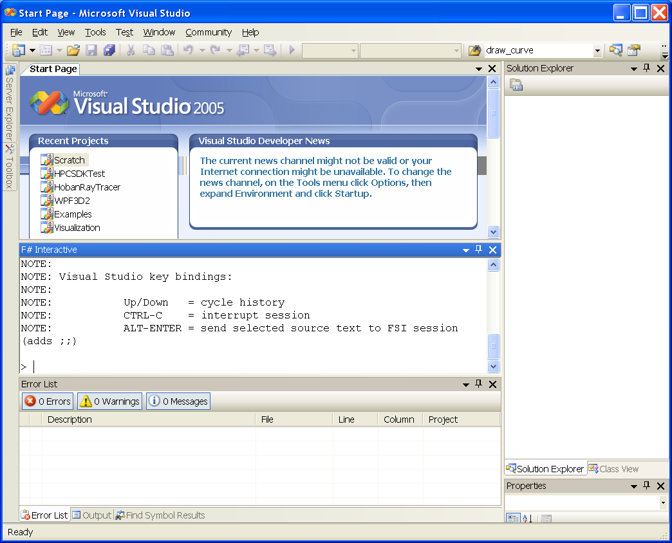
Figure 1 Visual Studio 2005 with an embedded F# interactive session (the central pane).

Note the new F# interactive window in the center, just below the source code editor. The F# interactive mode is one of the most powerful features of the F# programming language and is incredibly useful in the context of technical computing because it brings the interactivity typically only found in environments like MATLAB and Mathematica to a high-performance .NET programming language.

Interactive use
Simple F# definitions and expressions can be typed directly into the F# interactive session in Visual Studio. Try:

> let rec fib = function
| 0 | 1 as n -> n
| n -> fib(n - 1) + fib(n - 2);;

The ;; followed by a new line causes the interactive session to evaluate the definition. In this case, we have defined a simple Fibonacci function called fib and the F# interactive session responds by printing the signature of the function that was defined:

val fib : int -> int

This signature means we have defined a function called fib that accepts an int and returns an int. Note how the type of the function was inferred correctly without the need to specify any types in the source code at all. This is generally true of F# programs, which contain very few type annotations as a consequence.
This function can be invoked directly from the interactive session by feeding it an int:

> fib 30;;
val it : int = 832040

Even when used interactively like this, F# code is statically typed and compiled first to IL and then Just-In Time (JIT) compiled by the .NET CLR to native code. Consequently, the code is evaluated with excellent C#-like efficiency even though it was entered interactively.

Creating F# projects in Visual Studio
Typing directly into the F# interactive session quickly becomes tedious for all but the most trivial of definitions. Fortunately, the Visual Studio mode for F# allows code selected in the source code editor (just above the interactive session in Figure 1) to be evaluated in the current F# interactive session simply by pressing ALT+ENTER. Alternatively, source code may be evaluated one line at a time using ALT+’.
Evaluating F# code from a Visual Studio project has some important benefits:
- The same definition may be re-evaluated as many times as necessary.
- Definitions may be saved as ordinary source code.
- Development is aided by Intellisense and type throwback.
These benefits are best elucidated by example. Start a new F# project (illustrated in Figure 2).

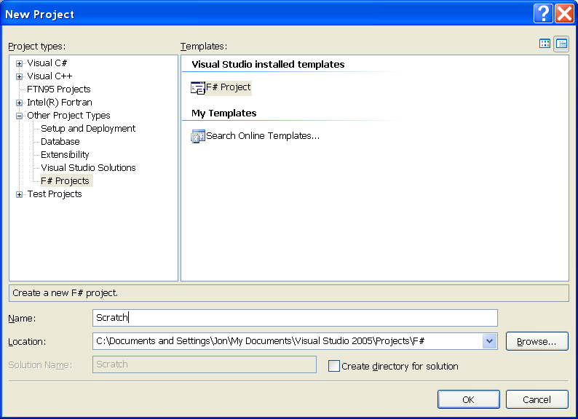
Figure 2 Creating a new F# project.

Add a new item to the project of the type “F# Source File” (illustrated in Figure 3).

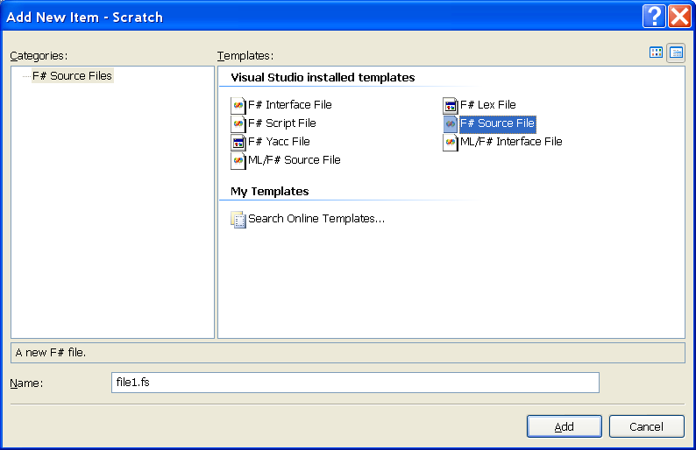
Figure 3 Adding a new source code file to an F# project.

Now enter the same source code into the project:

let rec fib = function
| 0 | 1 as n -> n
| n -> fib(n-1) + fib(n-2)

fib 30

Note how the code is immediately color syntax highlighted.

Type throwback
As we have seen, F# infers the type of this function without the programmer having to declare any types in the source code. This results in much shorter and clearer source code but the type inferred by the compiler for a given expression can be very useful, particularly when trying to comprehend error messages from the compiler. Fortunately, the F# Visual Studio mode provides automatic type throwback when you hover the mouse over a subexpression. For example, hovering the mouse over fib in the source code displays the signature of this function:

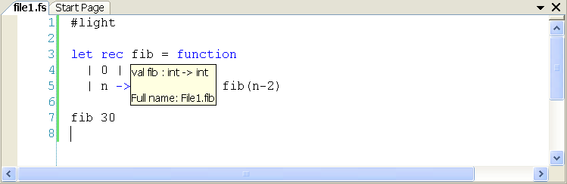
Figure 4 Graphical throwback of inferred types in Visual Studio.

Standard Library
The F# standard library provides a wealth of functionality for technical computing, including standard types for complex numbers, vectors and matrices and many functions for acting upon them, such as Cholesky decomposition.
Intellisense is great for API exploration and exploring the F# standard library is no exception. Simply type Math. and then press CTRL+J to obtain the sequence of options (illustrated in Figure 5).

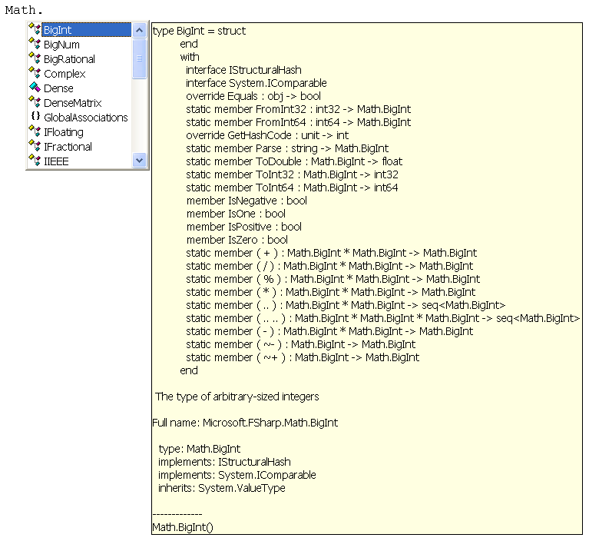
Figure 5 Using Intellisense to explore the F# standard library.

The entire standard library can be explored in this way.

Third-party libraries for technical computing
As a .NET programming language, F# benefits from easy high-level interoperability with .NET libraries. Many technical computing libraries are available for .NET, such as IMSL C# library (1) and the Extreme Optimization library (2), and these libraries can be used from F# programs although the vendor-specific implementations of types for complex numbers and vectors and so forth must be translated to and from the native F# representation. There are also a growing number of third-party libraries specifically for F# that use F#’s own types and integrate with Visual Studio to provide interactive visualization, such as F# for Numerics (3) and F# for Visualization (4).

The essence of F# programming
The productivity of the F# programming language stems from its unique combination of features. This section provides a basic introduction to each of these topics. For more detailed information, read Foundations of F# (2), Expert F# (6), F# for Scientists (7) and the F#.NET Journal (8).

Immutable data structures
Although F# allows mutable data structures, the use of mutable data structures is discouraged in favour of immutable data structures:
- Data structures are immutable by default and the mutable keyword must be used explicitly to define a mutable data structure.
- The standard library contains a wealth of well-implemented immutable data structures.
- Basic syntax is often more succinct for immutable data structures.
When sufficient support is provided for immutable data structures, as it is in F#, they can be used to replace mutable data structures in almost all circumstances. With the advent of multi-core computing, inherent thread safety is one of the most important advantages of immutable data structures. Large code bases written in impure functional languages are typically composed almost entirely of immutable data structures with mutable data structures and algorithms only used in performance critical sections. This culminates in a drastic reduction in the number of locks required to enforce determinism and the fewer potential interactions between locks makes multithreaded functional programs much easier to maintain.

Task Parallel Library
In December 2007, Microsoft released a community technology preview of the Task Parallel Library (TPL). The Parallel FX part of the TPL provides an intelligent scheduler and data parallelism routines designed to help programmers to leverage parallelism on multi-core and multi-CPU computers. Moreover, many of the functions provided by this library are already written in a functional style, often as higher-order functions.

The Task Parallel Library may be downloaded for free from:

http://go.microsoft.com/FWLink/?LinkId=85312

Once installed, this library can be used by referencing .NET 3.5 (for the System.Core.dll that provides standard delegate types for .NET) and the new System.Threading.dll library that is provided by the TPL:

#I @"C:\Program Files\Reference Assemblies\Microsoft\Framework\v3.5"
#I @"C:\Program Files\Microsoft Parallel Extensions Dec07 CTP\System.Threading.dll"

The Parallel.For loop is one of the most basic parallel constructs provided by the Parallel FX library:

> Parallel.For(0, 10, printf "%d ");;
8 9 0 1 2 3 4 5 6 7 val it : unit = ()

Note how the integers were printed out of order because the cycles of this loop are evaluated in parallel. In order to maintain determinism it is therefore essential for the cycles of this loop to be independent and this requires programmer's discipline because it is not checked (not even at run-time).

Matrix Multiplication
Many articles in magazines and journals have following the TPL documentation in using matrix-matrix multiply as an example of a simple function that can be effectively parallelized.
Rather than reusing the existing F# matrix implementation (which is in a state of flux), we shall write a new matrix multiply over the ordinary 2D .NET array type:

> let mul a b =
let an, am = Array2.length1 a, Array2.length2 a
let bn, bm = Array2.length1 b, Array2.length2 b
let c = Array2.zero_create am bn
for i = 0 to am - 1 do
for j = 0 to bn - 1 do
let mutable r = 0.0
for k = 0 to bm - 1 do
r <- r + a.[i,k] * b.[k,j]
c.[i,j] <- r
c;;
val mul : float [,] -> float [,] -> float [,]
> let n = 1000;;
val n : int
> let a = Array2.init n n (fun _ _ -> 1.);;
val a : float [,]
> let b = Array2.init n n (fun _ _ -> 1.);;
val b : float [,]
> let c = time (mul a) b;;
val c : float [,]
Took 23285ms

This algorithm is a perfect example because it can be parallelized simply and effectively by noting that the outer loop can be performed in parallel and converting the current use of the built-in for loop into an application of the Parallel.For higher-order function:

> let parmul a b =
let an, am = Array2.length1 a, Array2.length2 a
let bn, bm = Array2.length1 b, Array2.length2 b
let c = Array2.zero_create am bn
Parallel.For(0, am, fun i ->
for j = 0 to bn - 1 do
let mutable r = 0.0
for k = 0 to bm - 1 do
r <- r + a.[i,k] * b.[k,j]
c.[i,j] <- r)
c;;
> let c = time (parmul a) b;;
val c : float [,]
Took 12437ms

In this case, we have achieved a speedup of 1.9× on a dual core machine, which is near optimal. In fact, when the dimension “am” of the matrix “a” is large, this parallel implementation will always achieve near-optimal efficiency.

The Windows Task Manager can be used to visualize the CPU usage over time. The following chart illustrates the CPU usage on this dual core machine with the serial algorithm first followed by the parallel algorithm:

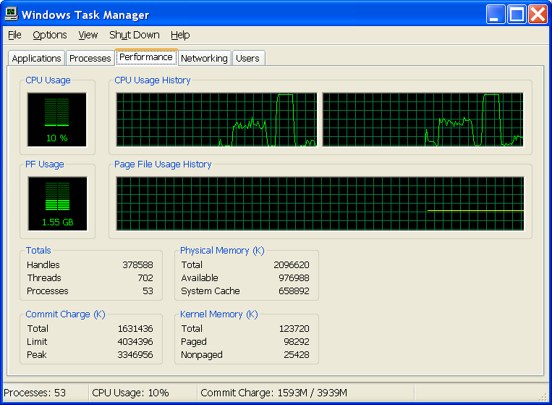
Figure 6 CPU usage on a dual core machine during serial and then parallel operations.

Note how the CPU usage is only 50% for the serial algorithm but rises to 100% for the parallel algorithm (that takes roughly half as long to complete).
However, not all algorithms are as easy to parallelize as a matrix-matrix multiply. The remainder of this article covers some design patterns that are commonly seen when parallelizing F# code.

Fibonacci
The trade-off between the overhead of spawning a concurrent computation compared to the benefit of performing computations in parallel is the single most important factor when parallelizing programs. This trade-off is well illustrated by the simple Fibonacci function:

> let rec fib = function
| 0 | 1 as n -> n
| n -> fib(n-1) + fib(n-2);;
val fib : int -> int
> time fib 30;;
Took 21ms
val it : int = 832040

This algorithm may be parallelized by creating a future that has one of the subproblems computed in parallel with the other at each stage:

> let rec fib = function
| 0 | 1 as n -> n
| n ->
let p = System.Threading.Tasks.Future.Create(fun () -> fib (n-2))
let q = fib(n-1)
p.Value + q;;
val fib : int -> int
> time fib 30;;
Took 11156ms
val it : int = 832040

Note how we are careful to factor out the subexpression fib(n-1) into a separate let binding to ensure that it is computed in parallel with the future before the results are combined in the final line.
This parallel version is extremely inefficient, taking 500× longer to complete in this case.
Fortunately, this parallel implementation can be made substantially more efficient in this case but it requires more effort than the matrix multiplication example even though this example is also embarrassingly parallel. The poor performance in this case is dominated by the creation of futures, which is much more expensive than the two function applications and addition that otherwise occur in this branch of the fib function.
A more efficient parallel implementation may be written by only parallelizing the evaluation of complicated subexpressions that take longer to compute. This amortizes the cost of spawning a parallel thread of execution. This is easily generalized over a parameter i in this case:

> let rec fib i = function
| 0 | 1 as n -> n
| n when n<=i ->
fib i (n-1) + fib i (n-2)
| n ->
let p = System.Threading.Tasks.Future.Create(fun () -> fib i (n-2))
let q = fib i (n-1)
p.Value + q;;
val fib : int -> int -> int

In this case, we find a parameter of i = 16 lies at the border where the overhead of spawning parallel computations is equal to the performance gain obtained through parallelism on this dual core machine. Consequently, for i > 16 we obtain a performance improvement of up to 2×:

> time (fib 16) 30;;
Took 22ms
val it : int = 832040

This parallel implementation can be up to 25% faster than the original serial implementation. The remaining inefficiency is largely due to the use of a single fib function for both serial and parallel use. Splitting this function into two separate functions and using the specialized serial implementation (which avoids a test per call) increases the performance improvement up to 80% faster over the serial version, as expected for a dual core system:

The following graph illustrates the speedup when computing the 30th Fibonacci number using the first and second parallel implementations compared to the original serial implementation:

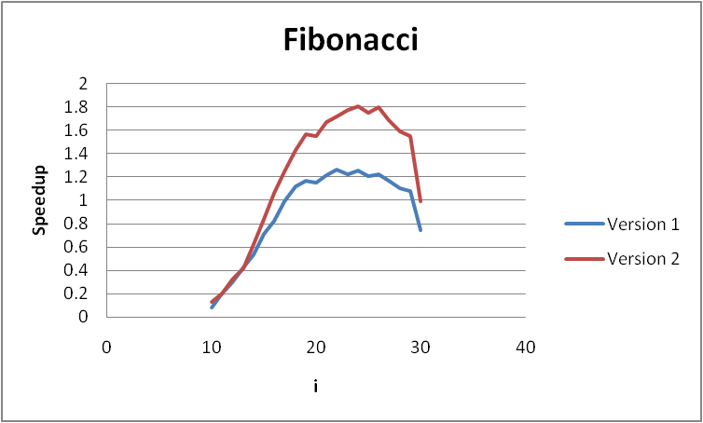
Figure 7 Speedup due to varying amounts of parallelism.

The performance improvement of the second version over the first is thanks to the use of a fully specialized serial function for quick calculations (when n is small) that avoids the overhead of the extra test n < i in the majority of calculations. This trick is generally applicable and it is often well worth splitting an algorithm into serial and parallel versions with the parallel version calling the serial version for sufficiently simple subproblems.
As i is increased the performance rapidly improves. The threshold i = 16 corresponds to the time spent spawning ~10 3 parallel computations being equal to the time spent performing ~10 6 additions and pairs of function calls. Therefore, as a rule of thumb at the very least 1,000 primitive computations (such as machine-precision arithmetic operations) should be performed per parallel unit of computation. For example, this predicts that moving the parallel loop in the matrix-matrix multiply example from the outer loop to the middle loop (which still has 1,000 multiply and accumulate operations in it) will not degrade performance much beyond that of the serial implementation and, sure enough, we find this is still 35% faster than the serial implementation.
The slight performance degradation at larger i is due to coarse-grained decomposition when the calculation is split into only a few parallel threads of different lengths that fail to fully exploit both cores. Eventually, for i = n = 30 , no parallelism remains and version 2 recovers the performance of the serial implementation by calling it directly.
Building parallel aggregate operators
Although the Parallel FX part of the TPL provides an elegant functional interface, a lot more functionality remains. For example, we are likely to want parallel replacements for the conventional higher-order init and map functions and so on.
One of the most common and productive data parallel operations is called map-reduce and is equivalent to the following serial implementation:

let map_reduce g f seq = reduce g (map f seq)

So map_reduce g f [1; 2; 3] computes:

g (g (f 1) (f 2)) (f 3)

For the parallel implementation, the operation g is assumed to be associative. So the above is considered to be equivalent to:

g (f 1) (g (f 2) (f 3))

This algorithm is of particular interest because it is extremely scalable and is used in some of the world's largest distributed applications, such as the Google search engine. Moreover, this algorithm is particularly well suited to the efficient parallelization of algorithms over hierarchical data structures, e.g. trees.
Consider the map-reduce algorithm acting upon an array. By splitting the array into slices of consecutive elements, map-reduce may be represented by a simple divide and conquer algorithm that can be implemented elegantly in F# as a recursive function:

> let serial_map_reduce g f (a : _ array) =
let rec of_slice i j =
match j - i with
| 1 -> f a.[i]
| 2 -> g (f a.[i]) (f a.[i+1])
| n ->
let m = i + (j - i)/2
g (of_slice i m) (of_slice m j)
of_slice 0 (Array.length a);;
val serial_map_reduce : ('a -> 'a -> 'a) -> ('b -> 'a) -> 'b array -> 'a

This serial implementation can be used as the template for a simple parallel implementation using futures:

> let map_reduce g f (a : _ array) =
let rec of_slice i j =
match j - i with
| 1 -> f a.[i]
| 2 -> g (f a.[i]) (f a.[i+1])
| n ->
let m = i + (j - i)/2
let l = System.Threading.Tasks.Future.Create(fun () -> of_slice i m)
let r = of_slice m j
g l.Value r
of_slice 0 (Array.length a);;
val map_reduce : ('a -> 'a -> 'a) -> ('b -> 'a) -> 'b array -> 'a

As discussed before, this will almost certainly benefit significantly from the ability to resort to a serial implementation for short runs of elements. So we write the following final implementation of a parallel map-reduce function over arrays built upon the Parallel FX library:

> let map_reduce chunk g f (a : _ array) =
let rec of_slice i j =
if j-i <= chunk then
let mutable accu = f a.[i]
for k=i+1 to j-1 do
accu <- g accu (f a.[k])
accu
else
let m = i + (j - i)/2
let l = System.Threading.Tasks.Future.Create(fun () -> of_slice i m)
let r = of_slice m j
g l.Value r
of_slice 0 (Array.length a);;
val map_reduce : int -> ('a -> 'a -> 'a) -> ('b -> 'a) -> 'b array -> 'a

For example, for a suitable chunk size (1024 in this case) we can immediately see a speedup on a simple operation:

> type 'a nested_list = Leaf of 'a | Node of 'a nested_list list;;
> let test_array = [|1 .. 65536|];;
> time (serial_map_reduce (fun l r -> Node [l; r]) Leaf) test_array |> ignore;;
Took 107ms
val it : unit = ()
> time (map_reduce 1024 (fun l r -> Node [l; r]) Leaf) test_array |> ignore;;
Took 84ms
val it : unit = ()

The map-reduce algorithm is one of a class of basic abstractions that can be used to make both shared-memory and distributed parallelism much easier. Consequently, we shall revisit this topic in the context of distributed parallelism using MPI.

Message Passing Interface
The Message Passing Interface (MPI) is the de-facto standard protocol for handling message passing in distributed compute clusters. Parallel F# programs can be written to run on a Windows HPC Server cluster using two libraries: Microsoft® Message Passing Interface (MS-MPI) and MPI.NET.

MS-MPI
The Microsoft® HPC Pack 2008 SDK provides a robust MPI implementation for writing distributed, parallel native-code programs to be run on a Windows HPC 2008 Server cluster.

The SDK may be downloaded for free from:

http://go.microsoft.com/FWLink/?LinkId=127031

MPI.NET
MPI.NET provides a safe high-level interface to MS-MPI for .NET programming languages. F# programs use MS-MPI via MPI.NET to obtain distributed parallelism.

The MPI.NET SDK may be downloaded for free from:

http://osl.iu.edu/research/mpi.net/software/

Hello world example
Once MPI.NET is installed, the following F# program hpcsdktest can be compiled to test it:

#light

#r @"C:\Program Files\MPI.NET\Lib\MPI.dll"

do
use mpi = new MPI.Environment(ref Sys.argv)
printf "Hello, from process number %d of 0..%d\n"
MPI.Communicator.world.Rank (MPI.Communicator.world.Size - 1)

This references the MPI.NET DLL, extracts the environment that the current process is running in and prints a string to the console giving the number of the current process and the total number of processes.

This program can be run directly from the DOS prompt, in which case it will run on a single node and product the following output:

> hpcsdktest.exe
Hello, from process number 0 of 0..0

MPI applications using multiple nodes must be run using the mpiexec.exe tool and the -n option to specify the number of nodes. As this is likely to be done repeatedly, it can be easier to start the MPI program using F# code invoked in an F# interactive mode. For example, the following F# code starts the MPI program with eight nodes:

let mpiexec = @"""C:\Program Files\Microsoft Compute Cluster Pack\Bin\mpiexec.exe"""
let test = @"-n 8 """ + __SOURCE_DIRECTORY__ + @"\hpcsdktest.exe"""
System.Diagnostics.Process.Start(mpiexec, test)

This spawns a console that displays the data printed by the program running on each of the eight nodes:

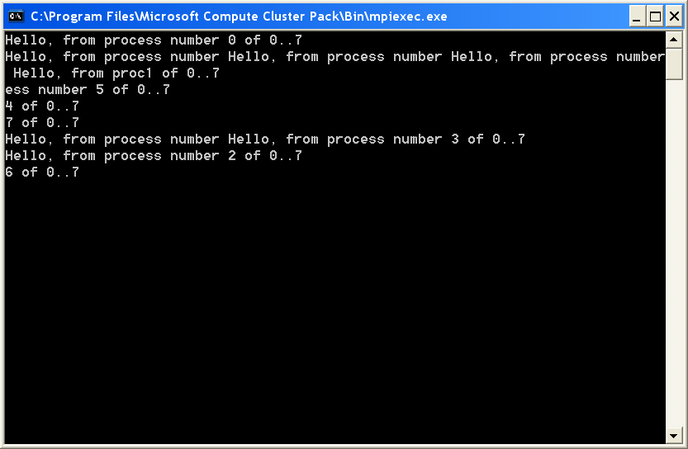
Figure 8 Hello world from multiple nodes in a cluster.

Note how the lines printed to the console do not necessarily appear in sequence one after the other but are occasionally printed during another print. This occurs precisely because the program is being executed several times in parallel.

Introducing message passing
The pedagogical example of message passing between the nodes of a cluster is to pass a simple message in a ring around each node in turn. The following F# program does exactly this, printing the message as it is passed:

#light

#r @"C:\Program Files\MPI.NET\Lib\MPI.dll"

let main (comm : #MPI.Communicator) =
let rank = comm.Rank
let succ = (rank + 1) % comm.Size
match rank with
| 0 ->
comm.Send("Rosie", succ, 0)
comm.Receive(MPI.Communicator.anySource, 0)
|> printf "%s\n"
| rank ->
let msg = comm.Receive(MPI.Communicator.anySource, 0)
printf "%s\n" msg
comm.Send(sprintf "%s, %d" msg rank, succ, 0)

do
use mpi = new MPI.Environment(ref Sys.argv)
main MPI.Communicator.world

There are several important aspects to this program:
- The MPI environment is kept alive during the call to the main function and then automatically disposed of by the F# use construct. Correct disposal upon completion of a program is essential for MPI to function correctly.
- The rank of the current node is used to dynamically dispatch using a pattern match to different functionality for the master zero node and all other slave nodes. This allows the master node to behave differently, in this case spawning the original message and completing upon receipt of the result.
- The message handled by this program is a string although the type never has to be declared explicitly thanks to type inference in F#.
Running this program produces the following output:

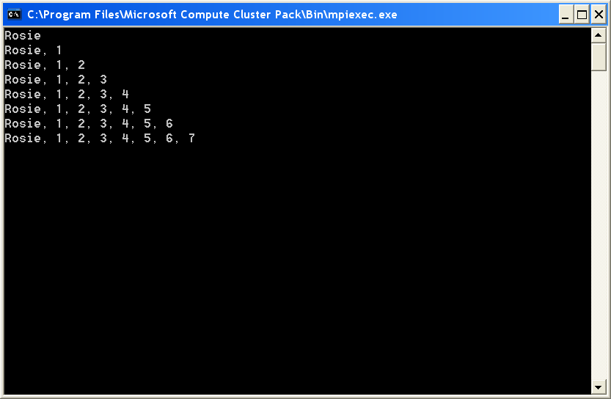
Figure 9 Accumulating a message as it is passed around a ring of nodes in a cluster.

Each slave node appended its rank to the string message, resulting in a final message “Rosie, 1, 2, 3, 4, 5, 6, 7” on this eight-node simulated cluster.

Higher-level data parallel constructs
In addition to basic message passing, MPI also provides some higher-level aggregate operations that allow computations to be farmed out across a cluster and the results collected again. These are scatter, gather and reduce.

Scatter
The scatter functionality allows data to be farmed out to each process in the cluster on an individual basis. The data are specified as an array with one element for each process. The MPI.NET implementation does not scatter data to the master node.
The following program demonstrates the use of scatter functionality by farming slices of an array out to the processes:

#light

#r @"C:\Program Files\MPI.NET\Lib\MPI.dll"

let partition (a : _ array) n =
[|for i in 0 .. n - 1 ->
let i, j = a.Length * i / n, a.Length * (i + 1) / n
Array.sub a i (j - i)|]

let slave rank (ns : int array) =
printf "%d got %A\n" rank ns

let main (comm : #MPI.Communicator) =
let rank = comm.Rank
System.Threading.Thread.Sleep(300 * rank)
match rank with
| 0 ->
let slices = partition [|1 .. 100|] comm.Size
slave rank (comm.Scatter(slices, 0))
| rank ->
slave rank (comm.Scatter(0))

do
use mpi = new MPI.Environment(ref Sys.argv)
main MPI.Communicator.world

The partition function slices an array of any length into an array of a given number of subarrays. The subdivision is uneven if necessary, as it is in this case with 100 elements divided between the eight processes of this cluster.
When run with eight processes in the cluster, this program produces the following output:

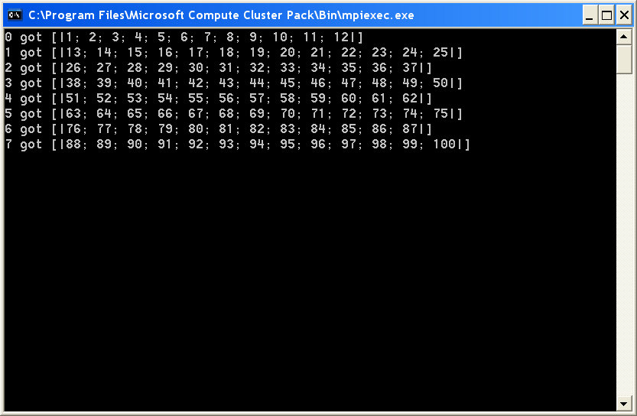
Figure 10 Scattering 100 elements of an array across eight nodes in an MPI clister.

Note how each node in the cluster received a different slice of the array.

Gather
The gather functionality is the converse of scatter, collecting a result from each node and collating them into an array for the master node to handle.
The following program uses the gather functionality to collate the results of computing a different Fibonacci number of each node:

#light
#r @"C:\Program Files\MPI.NET\Lib\MPI.dll"

let rec fib = function
| 0 | 1 as n -> n
| n -> fib(n-1) + fib(n-2)

let main (comm : #MPI.Communicator) =
let rank = comm.Rank
let result = fib rank
match rank with
| 0 ->
for i in comm.Gather(result, 0) do
printf "%d\n" i
| rank ->
comm.Gather(result, 0) |> ignore

do
use mpi = new MPI.Environment(ref Sys.argv)
main MPI.Communicator.world

Note that a result is computed on every node including the master node. This is slightly asymmetric in comparison with the Scatter function that did not scatter to the master node.
When run with eight processes, this program produces the following output:
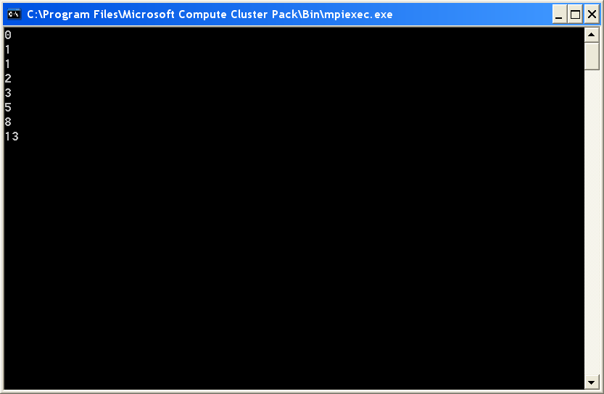
Figure 11 Gathering the results of eight computations done on separate nodes.

Note that the master node returned the first of the given results (the 0th number in the Fibonacci sequence).

Reduce
The reduce functionality folds an operation over the results from the processes.
The following program uses the Reduce function to accumulate the total number of random samples found to lie within the unit circle and uses the total to approximate the value of pi:

#light
#r @"C:\Program Files\MPI.NET\Lib\MPI.dll"

let main (comm : #MPI.Communicator) =
let rand = new System.Random()
let sqr x = x * x
let mutable count = 0
let iters = 1000000
for n=1 to iters do
if sqr(rand.NextDouble()) + sqr(rand.NextDouble()) < 1. then
count <- count + 1
let total = comm.Reduce(count, MPI.Operation.Add, 0)
if comm.Rank = 0 then
printf "pi = %f\n" (4. * float total / float comm.Size / float iters)

do
use mpi = new MPI.Environment(ref Sys.argv)
main MPI.Communicator.world

The Reduce member of the comm object is used to accumulate the sum of the results from each process. The return value total of this function call on the node with rank zero (in this case) is the total sum. On node zero, this sum is used to print the approximation to pi that was found.
When run, this program produces the following output:
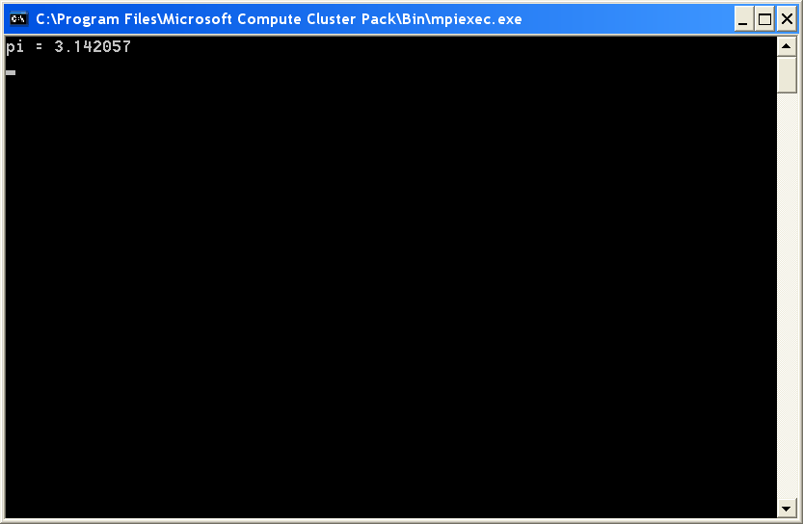
Figure 12 Reducing Monte Carlo simulations from every node in a cluster down to a single result, in this case approximating π.

The scatter, gather and reduce constructs are the bread and butter of MPI programming, automating the most common tasks easily and efficiently.

Complete example
The following serial Mandelbrot generator is a suitable candidate for parallelization:

#light

open System.IO
open System.Runtime.Serialization
open Math

let n = 1024

let norm (z : Complex) =
z.r * z.r + z.i * z.i

let rec f c i z =
if i < 255 && norm z < 4. then f c (i + 1) (z * z + c) else i

let lerp x0 x1 n i =
x0 + float i / float n * (x1 - x0)

do
let data =
Array2.init n n
(fun x y ->
let c = complex (lerp -2. 2. n x) (lerp -2. 2. n y)
f c 0 Complex.zero)
let file = __SOURCE_DIRECTORY__ + @"\..\mandelbrot.dat"
use out = File.OpenWrite(file)
let formatter = new Formatters.Binary.BinaryFormatter()
formatter.Serialize(out, box data)

Note the use of binary serialization as an easy way to store the resulting 2D array.
This program may alter to leverage distributed parallelism by distributing horizontal scans of the image across the available processes and gathering the results together:

#light
#r @"C:\Program Files\MPI.NET\Lib\MPI.dll"

open System.IO
open System.Runtime.Serialization
open Math

let n = 4096

let norm (z : Complex) =
z.r * z.r + z.i * z.i

let rec f c i z =
if i < 255 && norm z < 4. then f c (i + 1) (z * z + c) else i

let lerp x0 x1 n i =
x0 + float i / float n * (x1 - x0)

let main (comm : #MPI.Communicator) =
let rows =
[|for y in comm.Rank .. comm.Size .. n-1 ->
y,
[|for x in 0 .. n-1 ->
let c = complex (lerp -2. 2. n x) (lerp -2. 2. n y)
f c 0 Complex.zero|]|]
match comm.Rank with
| 0 ->
let data = Array2.zero_create n n
for rows in comm.Gather(rows, 0) do
for y, row in rows do
for x=0 to n-1 do
data.[x, y] <- row.[x]
let file = __SOURCE_DIRECTORY__ + @"\..\mandelbrot.dat"
use out = File.OpenWrite(file)
let formatter = new Formatters.Binary.BinaryFormatter()
formatter.Serialize(out, box data)
| rank ->
comm.Gather(rows, 0) |> ignore

do
use mpi = new MPI.Environment(ref Sys.argv)
main MPI.Communicator.world

In this case, the horizontal scans of pixels handled by each process are implicit. A more sophisticated implementation might run a scheduler on the head node that farmed out each scan in turn as processes became free until all scans were completed. However, computation is sufficiently evenly distributed in this case that such sophistication is not required.
The results may be visualized using the following Windows Forms application:

#light

open System.IO
open System.Runtime.Serialization
open System.Drawing
open System.Windows.Forms

let data : int [,] =
let file = __SOURCE_DIRECTORY__ + @"\..\mandelbrot.dat"
use out = File.OpenRead(file)
let formatter = new Formatters.Binary.BinaryFormatter()
formatter.Deserialize(out) |> unbox

let n = Array2.length1 data
let m = Array2.length2 data

let pixmap =
let format = Imaging.PixelFormat.Format24bppRgb
new Bitmap(n, n, format)

do
let pi = System.Math.PI
Array2.iteri
(fun x y i ->
let r, g, b =
if i=255 then -1., -1., -1. else
let t = float i / 255. |> sqrt |> sqrt |> sqrt |> sqrt
sin(2. / 3. * pi * t) / t,
sin(2. / 3. * pi * (t + 0.33)) / t,
sin(2. / 3. * pi * (t + 0.66)) / t
let clamp i j n = max i (min j n)
let f x = int(255. * (0.5 + 0.5 * x)) |> clamp 0 255
pixmap.SetPixel(x, y, Color.FromArgb(255, f r, f g, f b)))
data

let form =
{ new Form(Text="Mandelbrot", Width=1024, Height=1024) with
member form.OnPaintBackground _ = ()
member form.OnPaint e =
let r = form.ClientRectangle
let dest = new Rectangle(0, 0, r.Width, r.Height)
let src = new Rectangle(1, 1, n-2, m-2)
e.Graphics.DrawImage(pixmap, dest, src, GraphicsUnit.Pixel)
member form.OnResize _ = form.Invalidate()
member form.OnKeyDown e = if e.KeyCode = Keys.Escape then form.Close() }

#if COMPILED
Application.Run(form)
#endif

Note the use of an object expression to construct a Windows form with an appropriate paint method. In particular, the PaintBackground event is turned into a no-op in order to eliminate flicker and the Resize event is made to always invalidate the form to ensure that the display is updated when expanding the window as well as when shrinking it.
When run, this produces the following image:

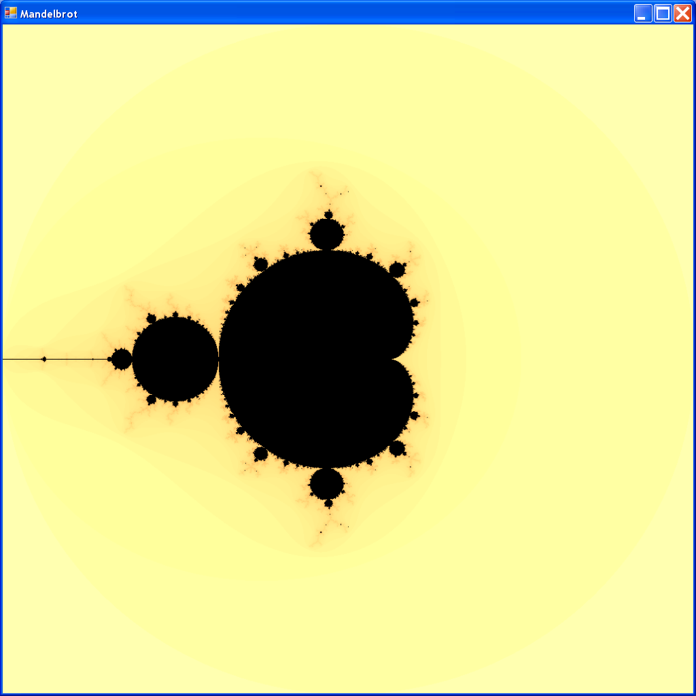
Figure 13 Visualizing results from a parallel computation using Windows Forms.

The overhead required to parallelize this program using MPI was larger than the overhead that would have been required to use the Task Parallel Library but, unlike the TPL, MPI facilitates the distribution of computation across many separate machines that do not have shared memory.

Calling native code
Although the F# programming language offers many improvements over older languages such as unmanaged C, C++ and Fortran the need to interoperate with native code can still arise. The two most important uses for native code interoperability are performance and legacy. This article describes how native code can be invoked from F# programs, including essential design advice for building robust interfaces in this otherwise error-prone task.
Unmanaged C, C++ and Fortran are compiled to machine code for direct execution by the CPU. The machine code is typically either in the form of a dynamically linked library (DLL) or a complete application (EXE). In the former case, the DLL can be used from other code including managed code through the use of a foreign function interface (FFI).
In contrast, managed code is compiled to an intermediate representation that conveys higher-level information than machine code. Managed code provides a multitude of hugely-productive improvements over native code:

- The high-level intermediate representation is verified before it is executed to provide security assurances.
- Easy interoperability between languages on the common language run-time, including a language-agnostic concurrent garbage collector that allows data structures to be shared between languages rather than copied.
- Safe execution environment where untraceable access violations and silent buffer overruns are a thing of the past.
- Easier parallel and concurrent programming.
- Platform independence (e.g. Windows® and Xbox®).

However, there are still two important reasons to use native code:

- Performance: unmanaged code can be faster.
- Legacy: A lot of functionality has already been implemented as unmanaged code and access to that code can save valuable development time.

This article describes how the FFI in F# can be used to invoke functionality from native code DLLs. Firstly by translating F# code into C++ code to improve performance, building an unmanaged DLL and using it safely from F#. Then by writing a more comprehensive interface to an existing high-performance native-code library.

Dropping down to C/C++
The phrase "dropping to C" is often heard in the context of high-level programming languages that impose a significant performance cost. Fortunately, the F# programming language is one of the most efficient high-level languages in existence and, consequently, the need to drop to C is greatly reduced.
This section examines a simple function written in F# taken from the earlier F#.NET Journal article on the SciMark2 benchmark, translates it into C++ to improve performance and uses the FFI to call the unmanaged DLL generated from the C++ for up to a 3.5× performance improvement over the original F#.
Translating F# into C++
We are going to study the lu function from the SciMark2 benchmark that computes the LU decomposition of a matrix using partial pivoting. The original F# implementation is:

> #light;;
> module FS =
let lu (a : float [,]) =
let a = Array2.copy a
let n = Array2.length1 a
let m = Array2.length2 a
let pivot = Array.create (min n m) 0
let minmn = min m n
for j=0 to minmn-1 do
let mutable jp = j
let mutable t = abs(a.[j,j])
for i=j+1 to m-1 do
let ab = abs(a.[i,j])
if ab > t then
jp <- i
t <- ab
pivot.[j] <- jp
if a.[jp,j] = 0. then invalid_arg "lu"
if jp <> j then
for i=0 to m-1 do
let t = a.[jp,i]
a.[jp,i] <- a.[j,i]
a.[j,i] <- t
if j < m-1 then
let recp = 1. / a.[j,j]
for k=j+1 to m-1 do
a.[k,j] <- a.[k,j] * recp
if j < minmn-1 then
for ii=j+1 to m-1 do
for jj=j+1 to n-1 do
a.[ii,jj] <- a.[ii,jj] - a.[ii,j] * a.[j,jj]
a, pivot;;
module FS : begin
val lu : float [,] -> float [,] * int array
end

This function is slightly different to the optimized F# implementation that was given in the previous F#.NET Journal article. Specifically, this implementation is simpler, uses .NET's 2D arrays rather than arrays of arrays and does not use inline functions or manually-unrolled loops.
Thanks to the absence of high-level constructs, this function is easily translated into C++:

#include <cmath>

extern "C"

__declspec(dllexport)
int lu(int M, int N, double *A, int *pivot)
{
int minMN = M < N ? M : N;

for (int j=0; j<minMN; j++)
{
int jp=j;
double t = abs(A[j*M + j]);

for (int i=j+1; i<M; i++)
{
double ab = abs(A[i*M + j]);
if (ab > t)
{
jp = i;
t = ab;
}
}

pivot[j] = jp;

if (A[jp*M + j] == 0) return 1;

if (jp != j)
{
for (int i=0; i<M; ++i)
{
double tA = A[j*M + i];
A[j*M + i] = A[jp*M + i];
A[jp*M + i] = tA;
}
}

if (j < M-1)
{
double recp = 1.0 / A[j*M + j];
for (int k=j+1; k<M; k++)
A[k*M + j] *= recp;
}

if (j < minMN-1)
for (int ii=j+1; ii<M; ii++)
for (int jj=j+1; jj<N; jj++)
A[ii*M + jj] -= A[ii*M + j] * A[j*M + jj];
}

return 0;
}

Note, in particular, the extern "C" used to instruct the C++ compiler to avoid name mangling and the __declspec(dllexport) qualification that instructs the linker to export this function from the DLL, making it accessible to users of the DLL.
The dumpbin.exe program provided with Visual Studio can be used to examine the definitions exported by an unmanaged DLL:
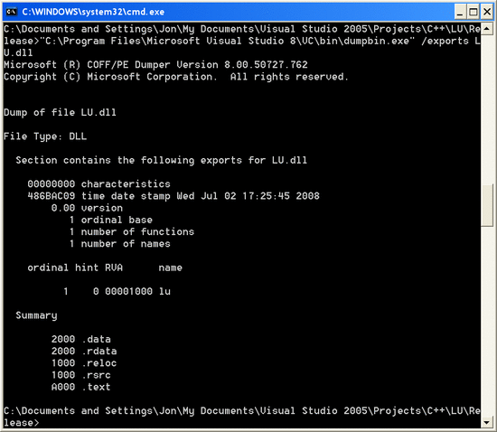
Figure 14 Examining the definitions exported by an unmanaged DLL using the dumpbin.exe tool.

In this case, we see a single function with the name lu exported as expected.

Referencing unmanaged code from F#
Once the above C++ code is compiled into a DLL it is easily referenced from an F# program.
We begin by opening the following namespace for the DllImportAttribute :

> open System.Runtime.InteropServices;;

The lu function exported from this DLL may be imported into F# as follows:

> module Primitive =
[<DllImport(@"C:\Documents and Settings\Jon\My Documents\Visual Studio
2005\Projects\C++\LU\Release\lu.dll")>]
extern int lu(int M, int N, double *A, int *pivot);;
module Primitive : begin
val lu : int * int * double nativeptr * int nativeptr -> int
end

The entry point exported by the DLL that is bound to this function is the same as the name of the function ( lu in this case) by default but can also be overridden with another value by specifying EntryPoint="..." in the DllImport .
Note how we have quarantined this unsafe function in the Primitive module. This whole module might be marked internal in a real project to ensure that external code is unable to use this unsafe interface directly. As program complexity grows it is absolutely essential to minimize the amount of unsafe code and this technique is both simple and scales well.
The C-like declaration syntax used in the previous line:

extern int lu(int M, int N, double *A, int *pivot)

resulted in the following F# type:

val lu : int * int * double nativeptr * int nativeptr -> int

In this case we have a matrix A represented as a contiguous array of floating point numbers and a pivot vector represented as an int array. These arrays are represented by pointers to their first elements in C/C++ and the size of the arrays is passed separately (it is even implicit in the case of pivot ). The F# representation of these pointers is the 'a nativeptr type where the type variable 'a denotes the type being pointed to.

Pinning
The 'a nativeptr type handled by the unsafe interface code in F# requires the caller to obtain a value of this type from a native F# type (1D and 2D .NET arrays of the float value type in this case). This is the only subtlety involved in using F#'s FFI and it arises when passing .NET reference types.
Specifically, the .NET garbage collector dynamically defragments the heap by moving data structures around. This requires the garbage collector to be aware of all pointers to managed data structures, ensure that they are not being accessed by user code during a move by any threads and update all of the pointers to a data structure whenever they are moved. This is an incredibly intricate procedure that is extremely difficult to implement correctly and Microsoft have spent a huge amount of time and effort building a reliable implementation of the compiler and run-time that cooperate to make this all transparent. However, direct use of unmanaged code breaks these fundamental assumptions and we must work to ensure that unmanaged code is not able to destabilize the rest of the system.
The solution is to pin the data structures in memory before they are passed by pointer to the unmanaged code. The garbage collector is not allowed to move pinned data structures and the unmanaged code is then free to read and write to these data structures without having to cooperate with the .NET run-time and safe in the knowledge that the data will not be moved while it is in use.
Pinning is very easy and may be used as follows:

> exception SingularMatrix;;
exception SingularMatrix
> let lu m =
let m = Array2.copy m
let rows, cols = m.GetLength(0), m.GetLength(1)
Array2.pin m (fun mPtr ->
let pivot = Array.create (min rows cols) 0
Array.pin pivot (fun pivotPtr ->
if Primitive.lu(cols, rows, mPtr, pivotPtr) <> 0 then raise SingularMatrix
m, pivot));;
val lu : double [,] -> double [,] * int array

This function begins by copying the input 2D array to ensure that the input is not destroyed. The number of rows and columns in the input is determined. Then the 2D array m is pinned in place using the Array2.pin higher-order function for the duration of its function argument. The anonymous function that is passed as an argument accepts the native pointer to m as its argument. A 1D pivot array is created and the same procedure is used to pin it, with the Array.pin function. Finally, the Primitive.lu function is called to perform the actual LU decomposition and the matrix and pivot vector and returned if the computation was successful.

Testing
The C++ routine is most easily tested by comparing its output to that of the original F# implementation. The performance of the two implementations may be assessed at the same time.
Consider a 1024×1024 random matrix:

> let n = 1024;;
val n : int
> let rand = System.Random();;
val rand : System.Random
> let m = Array2.init n n (fun _ _ -> rand.NextDouble());;
val m : float [,]

The performance of calling out to the unmanaged C++ implementation may be measured as follows:

> let time f x =
let t = System.Diagnostics.Stopwatch()
t.Start()
try f x finally
printf "Took %dms\n" t.ElapsedMilliseconds;;
val time : ('a -> 'b) -> 'a -> 'b
> let res1 = time lu m;;
val res1 : double [,] * int array
Took 3531ms

In comparison, the original F# implementation is around 30% slower for n=1024:

> let res2 = time FS.lu m;;
val res2 : float [,] * int array
Took 5308ms

Examining a wider variety of n using freshly allocated inputs and averaging over many runs produces the following results:

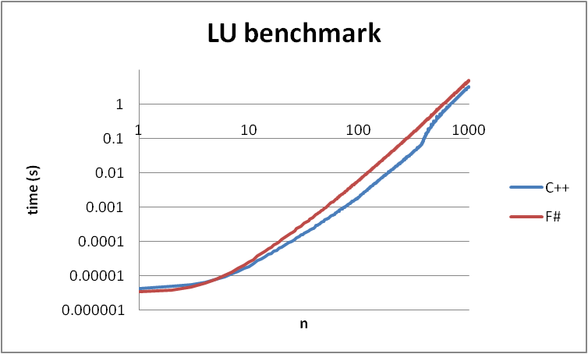
Figure 15 Absolute performance of C++ and F# for the LU decomposition of n×n random matrices.

For tiny matrices (n<5) the F# implementation is faster than calling the C++ implementation from F# because of the cost of invoking a native function from a managed language.
The following graph illustrates the speedup of calling C++ from F#:

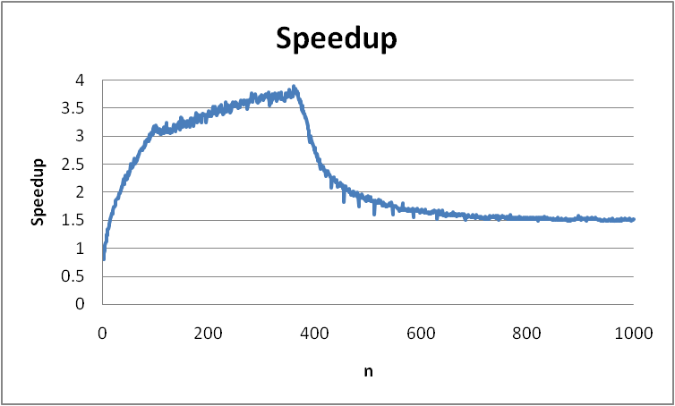
Figure 16 Relative performance of C++ and F# for the LU decomposition of n×n random matrices. C++ can be almost 4× faster than F# but the results vary enormously as a function of n.

This graph is very enlightening and can be naturally split into three separate sections:

- For n<100, the proportion of the time spent performing the foreign function call to native code decreases as the time spent performing the actual LU decomposition increases.
- For 100<n<400, the CPU-intensive LU decomposition dominates the time taken and the more efficient C++ version shows a marked performance improvement over the F# because it is inherently faster thanks to the avoidance of high-level issues such as garbage collection.
- Finally, for n>400, larger problem sizes shift the bottleneck from the CPU onto the memory subsystem where the difference between C++ and F# code is much smaller and the speedup falls to only 50%.

These results very clearly elucidate the basic properties of calling into high-performance unmanaged code from a managed language like F#. For more information on calling native code from F#, read the F#.NET Journal (1).

Performance considerations in F#
As a statically typed functional language with an exceptionally efficient implementation, the F# programming language has the wonderful property that concise code is often efficient code. However, there are some potential pitfalls that can be avoided during development or checked for during optimization that can make F# programs run more quickly:
- The .NET exception mechanism is very heavyweight and is intended to be used only in exceptional circumstances. Consequently, it is extremely slow and exceptions in F# are over 600× slower than similar languages like OCaml. So exceptions should be removed from all performance critical paths, particularly when translating programs from other languages.
- The common language run-time (CLR) provides a powerful concurrent garbage collector that makes parallel programming easy. However, this does increase the cost of allocation and, consequently, allocations should be amortized in order to reduce the stress on the garbage collector. This is particularly true in functional languages like F# because idiomatic functional code is prone to allocating huge numbers of very short-lived values.
- The F# standard library provides a wealth of immutable data structures that make high-level programming a dream come true, particularly in the context of parallelism thanks to their implicit thread safety. However, immutable data structures are often 10× slower than their mutable counterparts so they should be removed from performance critical portions of code.
- The F# programming language makes extensive use of reference types for its record and variant types. The .NET platform also allows compound value types called structs that are stored unboxed, avoiding a pointer indirection but increasing the cost of copying. The performance trade-offs between value and reference types is subtle but performance can sometimes be improved by representing complex and hypercomplex numbers and low-dimensional vectors and matrices with structs.

Bibliography
1. Syme, Don, Granicz, Adam and Cisternino, Antonio. Expert F#. New York : APress, 2007. ISBN-10: 1-59059-850-4.
2. Pickering, Robert. Foundations of F#. New York : APress, 2007. ISBN-10: 1-59059-757-5.
3. Flying Frog Consultancy. F# for Visualization. [Online] http://www.ffconsultancy.com/products/fsharp_for_visualization/.
4. —. F# for Numerics. [Online] http://www.ffconsultancy.com/products/fsharp_for_numerics/.
5. Visual Numerics. IMSL C#. [Online] http://www.vni.com/products/imsl/cSharp/overview.php.
6. Extreme Optimization. [Online] http://www.extremeoptimization.com/.
7. Harrop, Jon. F# for Scientists. New York : John Wiley & Sons, 2008. ISBN 978-0-470-24211-7.
8. Flying Frog Consultancy. The F#.NET Journal. [Online] http://www.ffconsultancy.com/products/fsharp_journal.

Feedback
Did you find problems with this tutorial? Do you have suggestions that would improve it? Send us your feedback or report a bug on the HPC developer forum.

More Information and Downloads
F#
http://research.microsoft.com/fsharp/fsharp.aspx

Task Parallel Library
http://go.microsoft.com/FWLink/?LinkId=85312

MPI.NET
http://osl.iu.edu/research/mpi.net/software/

This document was developed prior to the product’s release to manufacturing, and as such, we cannot guarantee that all details included herein will be exactly as what is found in the shipping product.
The information contained in this document represents the current view of Microsoft Corporation on the issues discussed as of the date of publication. Because Microsoft must respond to changing market conditions, it should not be interpreted to be a commitment on the part of Microsoft, and Microsoft cannot guarantee the accuracy of any information presented after the date of publication.
This White Paper is for informational purposes only. MICROSOFT MAKES NO WARRANTIES, EXPRESS, IMPLIED, OR STATUTORY, AS TO THE INFORMATION IN THIS DOCUMENT.
Complying with all applicable copyright laws is the responsibility of the user. Without limiting the rights under copyright, no part of this document may be reproduced, stored in or introduced into a retrieval system, or transmitted in any form or by any means (electronic, mechanical, photocopying, recording, or otherwise), or for any purpose, without the express written permission of Microsoft Corporation.
Microsoft may have patents, patent applications, trademarks, copyrights, or other intellectual property rights covering subject matter in this document. Except as expressly provided in any written license agreement from Microsoft, the furnishing of this document does not give you any license to these patents, trademarks, copyrights, or other intellectual property.
© 2008 Microsoft Corporation. All rights reserved.
Microsoft, Windows, the Windows logo, and Xbox are trademarks of the Microsoft group of companies.
All other trademarks are property of their respective owners.

Making F# what is known as an impure functional programming language.
A higher-order function is a function that accepts another function or a delegate as one of its arguments.
See http://www-unix.mcs.anl.gov/mpi for more information about MPI.

