 



**WHAT IS THE ORACLE E-BUSINESS SUITE ADAPTER?**

Oracle E-Business Suite Adapter, which is part of the upcoming Microsoft BizTalk® Adapter Pack 2.0 provides a single solution to easily and securely connect to the Oracle E-Business suite 11i and later from any custom-developed Microsoft .NET application or a Microsoft Office Business Application (OBA).

Key features of the Oracle E-Business Suite Adapter include:

* **Enables enterprise Service Oriented Architecture (SOA)**. Built on top of Windows Communication Foundation (WCF) technology using the WCF Line of Business (LOB) Adapter SDK, the Oracle E-Business adapter surfaces E-Business Suite artifacts as Web Services and gives end users a consistent approach to connectivity whether you are connecting to Oracle E-Business Suite from custom-developed applications or from rich Office applications. This simplified approach to interoperability lowers total cost of ownership and reduces training requirements.

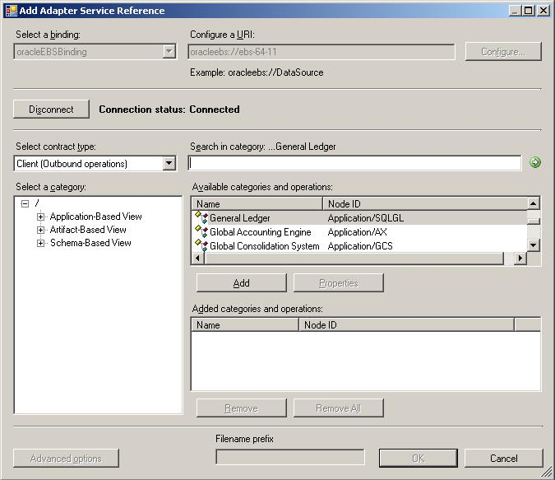

* **Provides an intuitive design-time user interface.** You can now browse, search and select the Oracle E-Business Suite artifacts you need for your business solution using the design-time interface. The design-time interface also provides different types of views to navigate to the underlying Oracle E-Business Suite artifacts.
* **Supports Open Interfaces and APIs**. Apart from conventional Oracle Database artifacts, the adapter provides access to Interface Tables, Interface Views, Concurrent Programs, Request Sets and PL/SQL APIs specific to Oracle E-Business Suite. The adapter also initializes application context prior to invoking operations.
* **Provides rich datatype support**. The adapter supports ODP.NET supported standard and user-defined types and additional datatypes required to access E-Business Suite artifacts.
* **Supports multi-org setups and multiple languages**. The adapter fully supports specifying the Organization ID for a business activity and leverages the multi-language support that Oracle E-Business Suite provides.
* **Supports event notifications**. You can get the adapter to poll for event data from tables or PL/SQL stored procedures at regular intervals or monitor table change events on your behalf. The adapter then notifies your application when the event occurs.

**SUPPORTED VERSIONS OF ORACLE E-BUSINESS SUITE**

* Oracle E-Business Suite 11.5.9
* Oracle E-Business Suite 11.5.10
* Oracle E-Business Suite 12

© 2008 Microsoft Corporation. All rights reserved. The information contained in this document represents the current view of Microsoft Corporation on the issues discussed as of the date of publication. Because Microsoft must respond to changing market conditions, it should not be interpreted to be a commitment on the part of Microsoft, and Microsoft cannot guarantee the accuracy of any information presented after the date of publication. This document is for informational purposes only. MICROSOFT MAKES NO WARRANTIES, EXPRESS, IMPLIED, OR STATUTORY, AS TO THE INFORMATION IN THIS DOCUMENT. Microsoft, BizTalk, Microsoft Dynamics, MSDN, SharePoint, Visual Studio, Windows, Windows Server, Windows Server System, and Windows Vista are trademarks of the Microsoft group of companies. All other trademarks are property of their respective owners.

 



**HOW CAN I LEARN MORE?**

**Visit the BizTalk Adapter Pack Web site at:**

http://www.microsoft.com/biztalk/en/us/adapter-pack.aspx

**Download a trial version of BizTalk Adapter Pack 2.0 at:**

<http://www.microsoft.com/downloads/details.aspx?displaylang=en&FamilyID=76736ba7-3c05-4436-9353-1c33f9005194>

**Learn more about developing adapters using the**

**WCFLOB Adapter SDK at:**

<http://msdn2.microsoft.com/en-us/biztalk/bb905478.aspx>

**BIZTALK® ADAPTER PACK 2.0**

As part of our continuing commitment to simplify interoperability, Microsoft will release the BizTalk® Adapter Pack 2.0 which includes the Oracle E-Business Suite adapter and the Microsoft SQL Server adapter in addition to the BizTalk Adapter Pack 1.0 adapters. The BizTalk Adapter Pack 1.0 includes adapters for SAP, Siebel and the Oracle Database.

The BizTalk Adapter Pack is offered separately from BizTalk Server, and does not require deployment of a middle-tier SOA or Business Process Management (BPM) infrastructure to connect to LOB applications, thus offering a focused solution to meet your initial needs.

As your solution evolves and you need more extensive business process orchestration or scale, you can easily migrate to a full BizTalk® Server implementation due to shared use of the WCF programming model.

**BIZTALK® ADAPTER PACK ARCHITECTURE**

© 2008 Microsoft Corporation. All rights reserved. The information contained in this document represents the current view of Microsoft Corporation on the issues discussed as of the date of publication. Because Microsoft must respond to changing market conditions, it should not be interpreted to be a commitment on the part of Microsoft, and Microsoft cannot guarantee the accuracy of any information presented after the date of publication. This document is for informational purposes only. MICROSOFT MAKES NO WARRANTIES, EXPRESS, IMPLIED, OR STATUTORY, AS TO THE INFORMATION IN THIS DOCUMENT. Microsoft, BizTalk, Microsoft Dynamics, MSDN, SharePoint, Visual Studio, Windows, Windows Server, Windows Server System, and Windows Vista are trademarks of the Microsoft group of companies. All other trademarks are property of their respective owners.