
ALLOCATOR

Microsoft Dynamics™ SL

Benefits
- Gain project-specific flexibility
Customize the system to reflect billing methods and rate agreements as unique as each customer or project.

- Take control of allocation processes
Set up and select from nearly unlimited combinations of rate hierarchies, allocation methods, and recognition rules for revenues and work-in-process.

- Save time in managing exceptions
Identify rate exceptions or markups as needed without affecting other accounts or rates; then process those exceptions automatically to ensure accurate invoicing without manual tracking or adjustments.

- Choose among convenient processing options
Choose scheduled processing for maximum control over project allocations and the timing of ledger entries, or automate accounting tasks, including exceptions that you have specified.

- Efficiently monitor and update distributions
Maximize profit potential by previewing distributions before they become final.
Easily make adjustments, reassign transactions to other cost categories or projects, or consolidate details without reentering or losing data.

- Speed up account maintenance
Enhance accounting productivity and keep books accurate and up to date with a solution that connects data from Microsoft Dynamics SL Allocator with other data sources and account information.

Gain precise control over project finances by creating flexible, multi-tiered hierarchies to reflect the spectrum of labor rates and billing structures you need. Then automatically allocate charges and revenues, account for work-in-process, transfer or consolidate transactions, and record accurate data
for billing and posting to general ledger accounts.

Allocate costs
with sophisticated, user-defined rates to produce accurate project profitability.

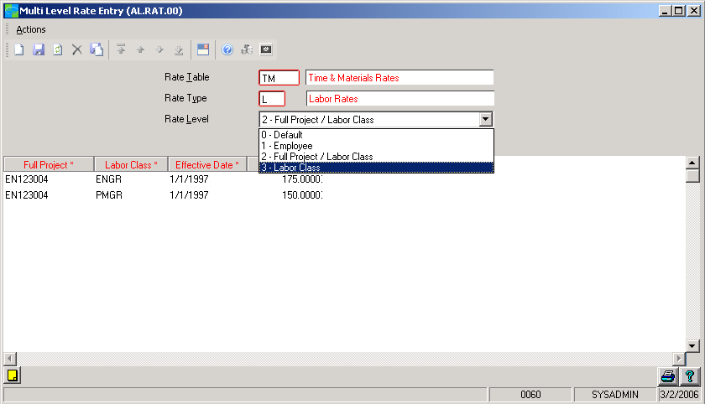



FEATURES

BENEFITS

Sophisticated Project Management  Support | Assign costs and revenues to projects to support timely billing and sophisticated budget management. Full integration with Microsoft Dynamics SL Time and Expense for Projects, as well as with purchasing and other project accounting functions, helps ensure accurate and streamlined processing.
Powerful Allocation Processing | Help ensure accurate distributions for even the most complex projects,  with the ability to select from and tailor a broad variety of billing and  allocation methods.
Customized Rate Tables | Create multi-level rate structures with calculations tailored to various  project types. Then quickly identify specific exceptions for automatic  calculation.
Flexible Revenue and WIP Handling | Revenues and work-in-process values are assigned to projects based on  the appropriate allocation method, timing, and accounting preferences.
Transaction Management Options | Capture the level of detail that you need. Consolidate transactions to  streamline documents. Reassign transaction values to different cost  categories or projects.
Convenient Distribution Previews | Review distributions in draft form to spot errors or make adjustments  prior to posting allocation updates.
Accurate Recalculation | Tailor recalculation processes to help ensure that changes, adjustments,  provisional and targeted rates cascade where, when, and how they  should.
Automated Allocation Ceilings | Meet commitments and prevent errors with automatic enforcement of  billing or revenue maximums.
Efficient Processing and Recording | Control postings to your Microsoft Dynamics SL General Ledger by using  automated processing for the ideal combination of efficiency and timing.

For more information about Microsoft Dynamics™ SL, visit: http://www.microsoft.com/dynamics/sl

This document is for information purposes only.
MICROSOFT MAKES NO WARRANTIES, EXPRESS, IMPLIED, OR STATUTORY, AS TO THE INFORMATION IN THIS DOCUMENT.

© 2005 Microsoft Corporation. All rights reserved.
Microsoft, The Microsoft Dynamics Logo, are either registered trademarks or trademarks of Microsoft Corporation or Microsoft Business Solutions ApS in the United States and/or other countries. Microsoft Business Solutions ApS is a subsidiary of Microsoft Corporation.

