Overview  Country or Region: United States  Industry: Software  Customer Profile  Microsoft Corporation is a leader in technology that transforms the way we work, play, and communicate. Its mission is to enable people and businesses, worldwide, to realize their full potential.  Business Situation  Anticipating new releases for Microsoft Dynamics™ SL business management software, the company wanted to provide the best possible experience for customers and for ISV partners.  Solution  In less than eight months, Microsoft migrated the code for the nearly 900 individual applications that make up Microsoft Dynamics SL from Microsoft® Visual Basic® 6.0 to Visual Basic 2005.  Benefits  - Reduced time and errors  - Lower costs  - New features  - Tools that empower people  - Flexible and modern application |  |  | “We proved that Microsoft Visual Basic 2005 empowers people to do what they are good at. Because the new development environment is so easy to use, people … can quickly be productive.”  Scott Tucker, Software Development Engineer Lead, Microsoft
 |  |  | Microsoft offers Microsoft Dynamics™ SL software to help companies manage their businesses successfully. Microsoft plans to support the business management solution for years to come and provide the best possible experience for customers and for the certified partners that develop applications that extend the software’s capabilities. In less than eight months, Microsoft programmers used Microsoft® Visual Studio® 2005 Team System to migrate Microsoft Dynamics SL from Microsoft Visual Basic® 6.0 to Visual Basic 2005. They also created a conversion utility that Microsoft partners can use to migrate their software applications built using Microsoft Dynamics SL Software Development Kit. The use of a modern, integrated development environment and programming language enables Microsoft and its partners to more quickly and cost-effectively develop software that has more sophisticated capabilities.
 |  |  | 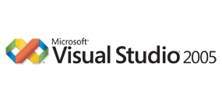

Situation
Microsoft Corporation is a leader in technology that transforms the way we work, play, and communicate. Microsoft Dynamics™ SL, is a business management application that enables people in small, midsize, and growing companies to track and manage time, resources, and financial information. It also helps improve profitability, efficiency, effectiveness, and customer service.
“From now on, our Windows Forms development and Web development will be in Visual Studio 2005. A single, integrated development environment lowers costs and saves considerable time.”
Scott Tucker, Software Development Engineer Lead, Microsoft

Microsoft Dynamics SL provides vast business management features such as time and expense tracking, invoicing, purchasing, and order management. Microsoft® Certified Partners with deep domain expertise develop and market solutions that extend the capabilities of Microsoft Dynamics SL for vertical industries.

Except for the Business Portal module, Microsoft Dynamics SL 6.5 was written in the Microsoft Visual Basic® 6.0 development system. The solution consists of approximately 900 individual applications written in Visual Basic, tied together with a kernel written in the Microsoft Visual C++® development system. In addition, partners typically use Visual Basic to program the software products that interface with Microsoft Dynamics SL.
Table 1. Comparison of Type of Code Used
 | Microsoft Dynamics SL 6.5 | Microsoft Dynamics SL 7.0
Visual Basic 6.0 | 68.7% | 2.3%
“Autogen” | 35% | 34%
Visual Basic 2005 | 0.01% | 64.5%
Visual C++ | 13.4% | 11.2%
Microsoft Visual C#® | 0.2% | 0.8%
T-SQL | 17.6% | 21.2%

Microsoft wanted to provide the optimum experience for customers and partners alike, and so the company considered the following factors, among others:

- Usability and customer experience. Microsoft enhances user experience by creating modern, best-in-class user interfaces (UI) across its line of Microsoft Dynamics business management software. Microsoft wanted to extend this modern look and feel to Microsoft Dynamics SL.
- Partner support. With Visual Basic 6.0, Microsoft partners found it difficult to hire fresh talent because recent graduates are trained in Microsoft .NET languages or other, new object-oriented languages.

Microsoft will support Microsoft Dynamics SL for years to come, and plans regular, periodic service pack and version releases. Anticipating the next major release of Microsoft Dynamics SL, Microsoft wanted to improve efficiencies for internal developers and support both customers and the independent software vendor (ISV) community by using the most modern coding patterns and development languages available.

Solution
In only eight months and using 5,000 developer hours, the migration team used Microsoft Visual Studio® 2005 Team System to migrate the 900 applications that make up Microsoft Dynamics SL to the Visual Basic 2005 development system. The conversion utility discussed below will work with a Visual Studio 2005 Professional Edition development system or higher.

The team saved time by using Interop for the controls. Table 1 compares the type of code in each version, including "Autogen" code generated by Visual Studio to host the Interop controls.

Conversion Utility
“Because we work with the Visual C++ kernel, our application programming tends to be fairly consistent,” says Scott Tucker, Software Development Engineer Lead at Microsoft. “We have a data layer API [application programming interface] and a set of user interface APIs that we always use internally and that our ISV community uses.”

This use of consistent patterns and practices made it possible for programmers to use the conversion utility that comes with Visual Studio 2005 as a basis for creating a customized utility.

“The Visual Studio 2005 conversion utility comes with documentation on how to extend it,” says Tucker. “We built processes that run before and after the conversion utility and wrapped it all into a custom conversion utility for our Microsoft Dynamics SL ecosystem.”
“We can add new features … with significantly less development time and cost than if we had continued to work with Visual Basic 6.0. And that translates into higher quality products …for Microsoft customers.”
Scott Tucker, Software Development Engineer Lead, Microsoft

When the team was ready to run the Microsoft Dynamics SL applications through the conversion utility, they quickly became familiar with compiler warnings and issues, and learned how to fix them. They then applied the knowledge gained when converting subsequent applications.

“We became quite fast—we averaged about one application converted per developer per eight-hour day,” says Tucker. “And that included converting the application and performing a basic unit test.”
Figure 1. Screen capture of Microsoft Dynamics SL 6.5 UI.

Part way through the conversion, the team held a workshop for ISV partners to unveil the conversion utility and train partners on it. The response was overwhelmingly positive. One workshop attendee’s response was indicative:

“The conversion utility was easy to use, and my applications converted almost flawlessly. I commend the Microsoft development group for their efforts!”

Pat Gibson, a development manager at Plumbline Solutions who worked on the conversion, remarks, “Because it was a workshop, ISVs actually brought their projects to convert. Two days were allotted, and most of the ISVs completed their application migration and testing in only one day. Some of them even completed all their projects, as many as 15 projects in one case.”

The Microsoft Dynamics SL migration team will be releasing the updated version of the conversion utility in Summer 2006.
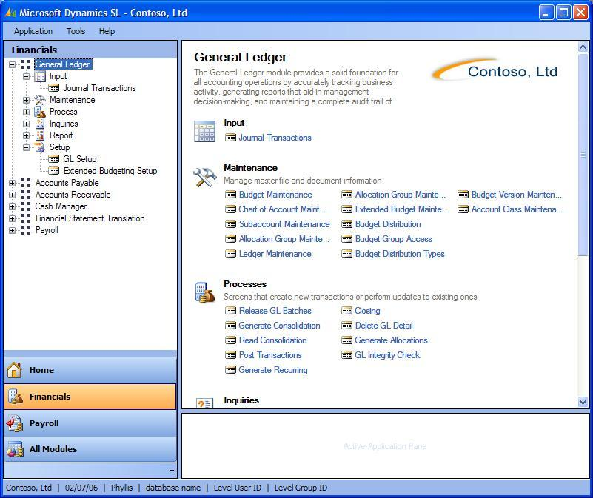
Figure 2. Prototype screen capture of Microsoft Dynamics SL 7.0 UI.

Modern Practices for a Quick Conversion
As for any development team, time and resource constraints were a factor.

“We couldn’t dedicate our whole team to the conversion, because we were working on service pack releases concurrently,” says Tucker.

Still, the team wanted to complete the conversion in less than eight months. The move to Visual Studio 2005 helped the team meet their goal. “We completed the majority of the conversion work within six months,” remarks Tucker.

Specifically, moving from user-defined types (UDT) in Visual Basic 6.0 to a class structure for the data layer in Visual Studio 2005 helped make the conversion go much faster. Once a class was defined, when developers converted an application that used that class, the conversion utility would not have to convert that program again. Instead, the utility would point to the common reference for that class.

Benefits
With this migration, customers, ISVs, and Microsoft developers alike gain a modern UI and the most modern coding patterns and development languages available today. They also gain a single code base across Microsoft Dynamics SL, which speeds the development of new features and applications.

Reduced Time and Errors
For Microsoft and ISVs who are converting applications from Microsoft Dynamics SL Tools for Visual Basic 6.0 to Visual Basic 2005, the conversion utility hastens the process by reducing conversion time and errors.

“Our goal with the utility was to require as little effort as possible from ISV programmers,” says Tucker. “We essentially want them to be able to pick the old source code, click ‘go,’ and have the utility spit out new source code that produces the same functionality. In Microsoft Dynamics SL, because we use a limited set of function calls, we were able to get the number of manual touch points down to about eight.”

Lower Costs
Now, nearly all of Microsoft Dynamics SL is captured in a single development environment and code base.

“From now on, our Windows® Forms development and Web development will be in Visual Studio 2005,” remarks Tucker. “A single integrated development environment lowers costs and saves considerable time because programmers don’t have to maintain separate development environments.”

New Features
The migration to Visual Basic 2005 provides direct benefits to customers, too, because Visual Basic 2005 supports compelling new features in Microsoft Dynamics SL 7.0. For example, because Microsoft SQL Server™ Reporting Services works natively with Microsoft Dynamics SL 7.0, customers will be able to launch SQL Server Reporting Services reports from within Microsoft Dynamics SL 7.0.

Perhaps the biggest benefit for customers will be the modern UI in Microsoft Dynamics SL 7.0. Figure 1 is an example of the Microsoft Dynamics SL 6.5 UI. The development team used standard Visual Basic 2005 controls to build a navigation pane for Microsoft Dynamics SL 7.0 that looks and feels like the navigation pane in Microsoft Office Outlook®. A prototype of this UI is shown Figure 2. Programmers also used the new My Namespace in Visual Basic 2005 to provide updated help. “We believe these features will reduce the training needed and cost for end users,” remarks Tucker.

Developers took advantage of the new tool strip control in Visual Basic 2005. This control gave developers an updated toolbar that could support Text and Image buttons using Microsoft Office styles.

Another new feature customers will benefit from is menu customization. The feature will allow users to customize the organization of items in the navigation pane and create role-based work flows that map to their business process and contain inline help.

Tools that Empower People
The UI designer for Microsoft Dynamics SL 7.0 was not a programmer. However, he was able to install Visual Basic 2005, teach himself how to use it, and build a working prototype in just one month.

“The designer re-did the old menu application in Visual Basic 2005, simply by pulling items out of the tool box and dropping them on a form—no in-depth training was needed, and he had only a minimal understanding of what has to go on under the hood,” enthuses Tucker. “We’ll take his prototype and implement it in our production code. He never would have been able to do that in Visual Basic 6.0.”

The new UI meets Microsoft’s goal of a modern user interface with common design schemes across its Microsoft Dynamics products. It also shows the power of Visual Studio 2005 and Visual Basic 2005 to empower people.

“We proved that Microsoft Visual Basic 2005 empowers people to do what they are good at,” says Tucker. “Because the new development environment is so easy to use, people with high levels of industry or business knowledge and minimal technical or programming knowledge can quickly be productive in this [Visual Basic 2005] environment.”

Microsoft partners often commented that they found it difficult to recruit new talent when Microsoft Dynamics SL was on Visual Basic 6.0.

“New grads are trained in Microsoft .NET languages or other modern object-based languages,” says Tucker. “We hope the migration will enhance the success of our partners by making it easier to hire new programming talent.”

Customers that have their own IT staff will benefit because they are empowered to extend and integrate their systems as needed, using the latest technologies. Mixing the old systems with the new technologies gives IT staff an incentive to stay with the organization they have knowledge about while expanding their individual skills by working with new technologies.

Partners looking to hire talent into their organizations will have a larger pool to select from because the products they are selling and supporting are built on the latest technologies.

Flexible and Modern Application
Visual Studio 2005 offers controls for working with SQL Server Reporting Services as well as access to code re-factoring features. The Microsoft Dynamics SL development team plans to take advantage of these controls to move toward an object-based design as they create the new features for future releases.

“We can add new features, including ones that take advantage of SQL Server Reporting Services, with significantly less development time and cost than if we had continued to work with Visual Basic 6.0,” Tucker concludes. “And that translates into higher quality products and more capabilities for Microsoft customers.”
Microsoft Visual Studio 2005
For More Information
For more information about Microsoft products and services, call the Microsoft Sales Information Center at (800) 426-9400. In Canada, call the Microsoft Canada Information Centre at (877) 568-2495. Customers who are deaf or hard-of-hearing can reach Microsoft text telephone (TTY/TDD) services at (800) 892-5234 in the United States or (905) 568-9641 in Canada. Outside the 50 United States and Canada, please contact your local Microsoft subsidiary. To access information using the World Wide Web, go to: www.microsoft.com

For more information about Microsoft Corporation products and services, call (800) 426-9400 or visit the Web site at: www.microsoft.com

© 2006 Microsoft Corporation. All rights reserved.
This case study is for informational purposes only. MICROSOFT MAKES NO WARRANTIES, EXPRESS OR IMPLIED, IN THIS SUMMARY. Microsoft, the Microsoft logo, Microsoft Dynamics, Visual Basic, Visual C++, Visual Studio, the Visual Studio Logo, and Windows are either registered trademarks or trademarks of Microsoft Corporation in the United States and/or other countries. The names of actual companies and products mentioned herein may be the trademarks of their respective owners.

Document published July 2006

Software and Services  - Microsoft Visual Studio  - Microsoft Visual Studio 2005  - Microsoft Visual Basic 2005  - Microsoft Visual Basic 6.0  - Microsoft Visual C++  - Microsoft Dynamics  - Microsoft Dynamics SL 6.5  - Microsoft Dynamics SL 7.0 | Services  - Microsoft SQL Server Reporting Services

Microsoft Visual Studio 2005 is the world’s most popular development environment for designing, developing, and testing next-generation Windows-based solutions and Web applications and services. By improving the development experience for Windows, the Web, mobile devices, and Microsoft Office, Visual Studio 2005 helps organizations deliver a variety of solutions more productively than ever before. Visual Studio Team System expands the product line with new software tools that enable greater communication and collaboration throughout the development life cycle. With Visual Studio 2005, businesses can deliver modern service-oriented solutions more efficiently.

For more information about Visual Studio 2005, go to:
msdn.microsoft.com/vstudio

