
Microsoft® Office 2000

Product Enhancements Guide

Published: October 1998

Table of Contents
Introduction 1
Overview of New Features 1
Web-Enabled Collaboration and Information Sharing 2
Rich Analysis Tools for Better Decision-Making 4
Software That is Easy to Use and Manage 7
Support for Customer Imperatives 10
Detailed Feature Descriptions 11
HTML Document Creation and Publishing 11
Internet-Based Collaboration 15
Analysis Tools 19
Office Web Components 20
Connectivity to Enterprise Data 22
Programmability 23
Installation, Deployment and Administration 26
Worldwide Usage 30
Personal Productivity 31
End User Assistance and Training 36
Support for Customer Imperatives 37

Microsoft Office 2000
Product Enhancements Guide

Published: October 1998
For the latest information, please see http://www.microsoft.com/office/

Introduction
This Product Enhancements Guide (PEG) is designed to assist in the evaluation of Microsoft® Office 2000 and focuses on the new and improved features throughout the desktop suite. The Office PEG describes enhancements that are shared across the Microsoft Office suite; each individual application PEG provides information on improvements to each individual application.

To assist in evaluating shared features across the Office 2000 suite, the information in this document is presented using the product’s design goals as a framework. These design goals are the result of extensive research and customer feedback including customer visits, in-depth interviews and collaboration with the Office Advisory Council. Development in the following key areas provides organizations with a significant upgrade over previous versions of Office:

- Web-enabled collaboration and information sharing. Office 2000 offers a new Web-productivity work style that integrates core productivity tools with the Web to streamline the process of sharing information and working with others.
- Rich analysis tools for better decision-making. Office 2000 makes it easier to use an organization’s intranet to access vital business information and provides innovative analysis tools that help users make better, more timely business decisions.
- Software that is easy to use and manage. Office 2000 delivers new levels of resiliency and intelligence, enabling users and organizations to get up and running quickly, stay working and achieve great results with fewer resources.

Overview of New Features
Microsoft Office has established a position as the most efficient suite of applications for document creation, communication and business information analysis. For many functions, the business platform has evolved from printed output to the Web. Office 2000 is the desktop suite for knowledge workers that makes the Web work for users, streamlining the process of working with people and information to get better results.

Office 2000 offers a multitude of new features. Many are specific to one of the applications that make up the suite, but of particular importance for this release are the features that affect the entire suite. These Office-wide, or shared, features hold the key to the new realm of functionality enabled by Office 2000.

Web-Enabled Collaboration and Information Sharing
Office 2000 truly makes the Web work for customers by integrating core productivity tools with the Web to streamline the process of sharing information and working with others. As intranets become the repositories for company-critical information, users look to Web servers to provide some of the same — or better — tools and functionality of regular file servers. Office enables intranets to be used as a two-way work space, where users can publish, share, collaborate and manage documents all in one place. To enable this new level of integration with the Web, Office 2000 has elevated HTML to be at the same level as its proprietary binary file formats. This means users will be able to easily create and share rich Web documents with the same Office tools they use to create printed documents. The most important benefit of this greatly enhanced integration with the Web is that rich Office content is universally viewable by anyone with a browser.

HTML Document Creation and Publishing

 | Feature |  | Description
New |  | HTML as Companion File Format |  | Office applications can save to and read from HTML files with high fidelity. HTML is elevated to the same level as the proprietary file formats (*.doc, *.xls, *.ppt, *.mdb).
New |  | Office Features Preserved in HTML |  | HTML can be used as the default file format while taking advantage of key Office features and functionality. Graphics are stored in the native format and the browser-displayable format (GIF or JPEG) for easy editing.
New |  | Save to the Web |  | This allows users to publish a copy of the current document in HTML format directly to a Web server.
New |  | Office Themes and Design Templates |  | Themes have been created and coordinated between some of the Office applications and the Microsoft FrontPage® Web site creation and management tool to make it easy to create consistent-looking Web pages. Microsoft Word and Microsoft Access provide themes; the Microsoft PowerPoint® presentation graphics program includes design templates consistent with the themes and the Microsoft Outlook™ messaging and collaboration client offers stationery.
New |  | Managing Embedded Files |  | Office applications intelligently manage companion files that cannot be stored in HTML, such as graphics and other objects.

 | Feature |  | Description
New |  | Office Web Editing |  | HTML files created in Office 2000 are easily edited using Office applications. Clicking on the Edit button in Microsoft Internet Explorer will intelligently launch the Office 2000 application that created the HTML file, making editing intranet documents seamless and easy.
Improved |  | Save as HTML Interface |  | Office applications have a consistent user interface (UI) method of saving documents in the HTML format.
New |  | HTML as Clipboard Format |  | Office 2000 makes HTML a premium Clipboard format, making data interchange between Office applications and the browser easy.
New |  | Web Page Preview |  | From Office 2000 applications, users can preview Web pages in their default browser, even without saving them first.
Improved |  | Hyperlink Handling |  | Office 2000 offers an improved hyperlink interface to make it easier to create, edit, follow and remove hyperlinks in documents.
New |  | Link Repair at Save |  | When users save documents, Office 2000 checks the links and repairs those that aren’t working.
New |  | HTML Encoding and Autodetect |  | Office 2000 saves files using the appropriate international text encoding so users on any language system are able to view the correct characters.
New |  | Web International-ization |  | Office 2000 supports new Web protocols being updated to handle languages throughout the world.
New |  | Automatic Graphic Format Selection |  | Office 2000 automatically selects the appropriate graphic format (like GIF or JPEG) based on the graphic’s content when saving a document to HTML.
New |  | Storage of Drawing Defaults/Color Defaults |  | Along with the graphics themselves, Office documents contain special formatting data. Defaults such as line and fill colors, and default formatting colors are stored with the document.
New |  | Auto-Grouping of Overlapping Graphics |  | Graphics that lay close together within the 2-D editing environment are automatically grouped as one graphic on export to HTML.

Internet-Based Collaboration

 | Feature |  | Description
New |  | Web Discussions |  | Users can anchor comments and conversations about documents to those documents. In addition, multiple users can collaborate in context by placing in-line comments in any HTML page.
New |  | Web Subscriptions and Web Notifications |  | Users can subscribe to a document or HTML page and indicate when they would like to be notified of changes to that document. This automates the process of being alerted to updates or changes of pages or documents that users are interested in.
New |  | Online Meeting |  | Integration with Microsoft NetMeeting™ conferencing software lets users start a conference and share any Office document with others for collaborative editing. Using Microsoft Outlook, users can also schedule online meetings, set up reminders and click a button to join the meeting.
New |  | Presentation Broadcast |  | Using Presentation Broadcast, users can deliver a presentation over an intranet, displaying presentation slides in HTML along with the narration as streaming audio and video (video requires a Microsoft NetShow™ server). Audience members require only an Internet Explorer 4.0 or higher browser to view the presentation, which can be saved for later playback. Using Outlook, users can also schedule online broadcasts, set up reminders and click a button to join the broadcast.
New |  | Web File Management |  | Adding, moving, or deleting files stored on a Web server can easily be done via the Windows Explorer as easily as one could with a file server.

Rich Analysis Tools for Better Decision-Making
Office 2000 makes it easier for an individual to access vital business information and provides innovative analysis tools that help people make better, more timely decisions. Companies want to provide their employees with better access to business information, and Office 2000 responds with tools that integrate with and leverage existing environments. Rich analysis tools, new Office Web Components and improved database connectivity in Office 2000 enable users to access, analyze, track and respond to changing information. Office 2000 has also been designed as an open platform to allow third-party or in-house developers to fully integrate their solutions.

Analysis Tools

 | Feature |  | Description
Improved |  | PivotTable® Dynamic Views |  | A new interface lets users easily create and manipulate the fields of a PivotTable directly in an Excel worksheet.
New |  | PivotChart™ Dynamic Views |  | Users can create charts tied directly to PivotTable data that can be refreshed instantly.
New |  | Data Access Pages |  | Data Access Pages extend database applications to the corporate intranet by creating a Web-enabled database hosted within the browser. This allows users to share information faster and more efficiently than ever, and enables database information to be included on any Web page.
New |  | Field List |  | The Field List enables users to easily add additional information to a Data Access Page view simply by dragging and dropping the field names from an easily accessible list. Each field is bound to the data by maintaining a direct live link to the data from the Data Access Page.
Improved |  | Enhanced Web Queries |  | A new dialog in Microsoft Excel 2000 makes it easy for anyone to bring data from the Web directly into Excel for tracking or analysis.

Office Web Components

 | Feature |  | Description
New |  | Spreadsheet Component |  | The Spreadsheet component is a COM component that provides basic spreadsheet functionality in the browser, allowing users to enter text and numbers, create formulas, recalculate, sort, filter and perform basic formatting.
New |  | Chart Component |  | The Chart component is a COM component that provides interactivity in the browser and automatically updates as the underlying data changes.
New |  | PivotTable Component |  | The PivotTable component is a COM component that is very similar to PivotTable views in Excel and provides a dynamic way to view and analyze database information in the browser.

Connectivity to Enterprise Data

 | Feature |  | Description
New |  | Microsoft SQL Server™ Interoperability | Microsoft Access 2000 natively integrates with Microsoft SQL Server through OLE DB, allowing users to combine the ease of use of the Microsoft Access interface with the scalability of SQL Server.
New |  | Microsoft Access Project | The Microsoft Access interface can create a new file type (.adp) that connects directly to the integrated data store available in Office, SQL Server 6.5, or SQL Server 7.0. This makes it easier for Microsoft Access users to create true client/server applications.
New |  | Client/Server Wizards | Many popular Microsoft Access wizards have been updated to support the new client/server tasks, such as creating a new database, report or form.
New |  | Large Data Stores | Excel 2000 uses a client/server approach to provide fast access to large server-based data stores. This includes support for Microsoft SQL Server OLAP Services, a new Online Analytical Processing (OLAP) capability that is provided as a component of Microsoft SQL Server 7.0. The benefits of analyzing large data stores and data warehouses will now be available to a much broader audience.
New |  | Simpler Connectivity | The new Data Link Properties dialog allows users to connect to Microsoft SQL Server with three simple pieces of information — server name, logon information and the server database.

Programmability

 | Feature |  | Description
New |  | Shared Add-In Architecture |  | Developers can create integrated Office solutions using Microsoft Office COM Add-ins with the new unified add-in model.
New |  | Microsoft Office Anti-Virus API |  | Office 2000 provides a virus scanning API tied to File Open. This new API allows third-party vendors to scan Office documents before they are loaded.
New |  | Digital Signing of Visual Basic® for Applications (VBA) Macros |  | To improve security and user confidence, developers can sign their macros to ensure they are virus-free.
Improved |  | VBA 6.0 |  | The latest version of VBA is included with Office 2000, making VBA consistent with Visual Basic language features.
Improved |  | Application-Level Events |  | New events have been added to improve custom solutions.
New |  | Microsoft Script Editor |  | Office 2000 can be used to develop HTML scripts and HTML-based client solutions.

Software That is Easy to Use and Manage
Office 2000 delivers new deployment and administration tools, enabling individuals and organizations to get up and running quickly, stay working and achieve great results with fewer resources. Customers repeatedly tell Microsoft they want their software to be easier to install, use and manage on an ongoing basis. Office 2000 introduces revolutionary new technology that brings new levels of intelligence to installation, software maintenance and personal productivity.

Installation, Deployment and Administration

 | Feature |  | Description
Improved |  | Microsoft Office Removal Wizard |  | During an upgrade, Office 2000 detects a previous version of Office and offers to completely remove that product to free up as much disk space as possible. This wizard can also be used as a standalone application and customized by users or administrators.
New |  | Install on Demand |  | Programs and components are installed as needed, saving space on a hard drive until users need the functionality. Shortcuts, icons or menu entries for some not-yet-installed Office 2000 programs or components are displayed, indicating their availability.
Improved |  | Settings Migration |  | When installing over a previous version, Office 2000 now migrates more user settings.
Improved |  | Microsoft Office Custom Installation Wizard (CIW) |  | The next generation of the Network Installation Wizard, the CIW is an administrator tool to help deploy customized versions of Office applications.
New |  | Remote Control of User Interface Options |  | Using the System Policy Editor, administrators can determine the settings in the Tools/Options dialog for users. This includes command bars, toolbars and menu items.
New |  | Self-Repairing Applications |  | Office 2000 automatically detects and fixes errors without users even knowing there was a problem. If necessary, Office 2000 automatically verifies and reinstalls the files and registry entries needed to run successfully.
New |  | Detect and Repair |  | A new tool on the Help menu, Detect and Repair finds problems with noncritical files, such as fonts and templates, and repairs them.
New |  | Customizable Alerts |  | Alerts in Office 2000 (e.g. “There is no printer installed”) can contain a button with customized text. These buttons link to a URL to take users directly to custom intranet information that administrators provide for their information, training or assistance.

 | Feature |  | Description
New |  | Roaming User Profiles |  | User-specific settings are stored in a single and safe location on the server in the User Profile Folder. User- and machine-specific settings are tracked distinctly.
New |  | Microsoft Office Profile Wizard |  | This new wizard is a standalone utility that allows administrators to back up and restore users’ Office 2000 applications settings and preferences for easy transfer to new machines or installations.
New |  | Template Manager |  | New or custom templates can be accessed in the File New dialog just as with Office default templates, even if the former are stored in another location.

Worldwide Usage

 | Feature |  | Description
New |  | Single Executable |  | Office 2000 applications are each created in a single worldwide executable for the United States, Europe, Far East, and bidirectional languages such as Hebrew and Arabic.
New |  | Global Interface |  | Users can change the language of the user interface without affecting the operation of the application and can write in any language without having to switch the interface language.
Improved |  | Unicode Support |  | All Office 2000 applications (including Microsoft Access) support Unicode better for easier multilingual document creation.
New |  | Euro Currency Support |  | Excel 2000 supports the new euro currency, both the symbol and the three-letter ISO code.
New |  | Multilingual AutoCorrect |  | Word 2000 and PowerPoint 2000 take advantage of AutoCorrect in multiple languages.
Improved |  | Multilingual Editing |  | Word 2000 makes creating multilingual documents easier by supplying formatting tools previously available only in foreign language versions, applying appropriate punctuation rules per language, and handling the layout of complex Asian and Middle Eastern languages properly. Features that used to be available for only one language per version, such as AutoSummarize, are now available for all languages.
Improved |  | Worldwide Thesaurus |  | Word 2000 exposes and improves the Thesaurus API to encourage third-party vendors to provide solutions.

Personal Productivity

 | Feature |  | Description
Improved |  | File Open |  | Users can see 50 percent more files in the Open dialog with less visual clutter.
New |  | Places Bar |  | In the File/Open dialog, users have one-click access to the places users go most. Like the Outlook Bar, the Places Bar provides easy access to commonly used folders and locations.
New |  | History Folder |  | The History Folder extends functionality of the Most Recently Used (MRU) list. This special folder contains links to the last 20 documents on which users have worked.
New |  | Back Button |  | Using the familiar Web browser “back” button, Open and Save dialogs in Office 2000 let users easily return to the folders they recently visited.
New |  | Collect and Paste |  | This new “multiple clipboard” functionality makes gathering information from multiple sources easier.
New |  | Personalized Menus |  | Menus automatically adjust to make it even easier for users to access the items they use most often. Menus are easily expanded to reveal all commands and also expand automatically based on IntelliSense® technology rules.
New |  | Personalized Toolbars |  | Toolbars automatically adjust to make it even easier for users to the items they use most often. In order to reduce screen clutter, toolbars intelligently share a single row on the screen based on usage and easily expand to display all commands. As a part of a toolbar is used, that is “promoted” and displayed in a hierarchical fashion.
New |  | Quick File Switching |  | Office 2000 supports quick file switching (like Single Document Interface) so each open Office document is easily accessible via the Windows Taskbar, independent of the application. This enables users to quickly switch between files.
New |  | Microsoft Office  E-mail |  | Office 2000 integrates e-mail with all applications for easier sharing of information. A new button added to the standard toolbar in each application inserts a mail header at the top of the file so users can easily send it as an e-mail message.
New |  | URLs in Command Bars |  | Enables access to a URL through normal command bar buttons. Administrators can customize the Office UI to link to company-specific content. End users can easily get to Internet resources for more information and content.
Improved |  | Quick Customize Toolbars |  | It’s quicker and easier than ever to customize toolbars with a simple check box and by dragging and dropping command controls on the toolbar.
New |  | Advanced ClipArt Searching |  | New search tools are included with the Clip Gallery in Office 2000, such as “Find More Like This.”
 | Feature |  | Description
Improved |  | Custom ClipArt Categories |  | Users can organize their pictures in custom groups.
New |  | Drag and Drop ClipArt |  | Users can drag images from the Clip Gallery and drop them in any Office document.
New |  | Remain on Screen ClipArt |  | Users can leave the Clip Gallery open while editing documents rather than having to reopen it several times.
Improved |  | Side Pane View ClipArt |  | The Clip Gallery in Office 2000 has a new, optional smaller window view that lets users see more of a document.
New |  | Rich Data Exchange With Office ClipArt |  | In Office 97 and previous versions, the Clip Gallery returned a bitmap with an OLE link for the ability to edit. In Office 2000 the Clip Gallery now passes the original file format from Clip Gallery to Office applications.
Improved |  | ClipArt User Interface Improvements |  | Users can assign clips to categories and add keywords from one simple user interface. A pop-up control enables users to choose from the most common tasks.
New |  | New AutoShapes in ClipArt |  | New AutoShapes shipped and stored in the Clip Gallery retain their OfficeArt native data. When inserted into Office applications from the Clip Gallery, they have all the properties of built-in AutoShapes.

End-User Assistance and Training

 | Feature |  | Description
Improved |  | Assistant Out of the Box |  | The Office 2000 Assistant functions outside of a window directly over the user’s work, providing a less distracting interface.
Improved |  | Help on the Web |  | If it can’t answer a question, the Assistant provides a link to more information on the Web and a way for users to inform Microsoft when it doesn’t answer a question.
Improved |  | Turn off the Assistant |  | Office 2000 allows users to completely turn off the Assistant for those users or companies who choose not to use it.
Improved |  | Natural Language Assistance |  | In Office 2000 when users ask questions to the Assistant or the help system directly, not only can they ask questions in their own words, but Office provides answers in the users’ own words as well.

Support for Customer Imperatives
Customer needs are continually changing and it is Microsoft’s goal for Office to evolve and continue to provide the necessary tools to help users be productive. Microsoft wants Office to be easy to use for all types of users, including those with disabilities. Microsoft Office 2000 improves its accessibility support in several critical areas, making it easier for people to use the software in ways that are easiest for them. Microsoft is also very cognizant of the year 2000 issue and provides new features in Office 2000 to help ensure users are ready for the new millennium.

 | Feature |  | Description
Improved |  | Accessibility Features |  | Office 2000 includes better support for users with disabilities, making features more accessible by improving keyboard support, better utilizing help features to point out accessibility features, and more.
Improved |  | Year 2000 Compliance |  | Office 2000 provides a new set of tools, features and safeguards for the new millennium, including support for an administerable four-digit year cutoff.

Detailed Feature Descriptions

HTML Document Creation and Publishing
Office 2000 makes HTML a companion format to its own native file formats. This is a new direction for Office that enables anyone with a browser on any platform to view Office-created content. In order to make HTML a viable file format people will use, Office 2000 delivers on two critical goals. First, Office 2000 makes HTML document creation simple by building it into the standard document open and save practices everyone is familiar with. Second, Office 2000 creates HTML documents with high fidelity, enabling the viewing experience to be the same for the browser user as it is for the Office user who created the document.

HTML as a Native File Format
HTML has been elevated to the same level as Office’s own proprietary file formats. This means HTML documents can be used in much the same way that Office binary files (*.doc, *.xls, *.ppt, *.mdb) are used today. Office 2000 can easily create high-quality HTML documents that maintain the rich formatting of Office documents while enabling universal viewing to anyone with a Web browser, regardless of platform. In addition to viewing, HTML documents preserve the functionality users expect in Office documents such as styles, PivotTable dynamic views, revision marks, OLE objects, command bar customizations, document properties and more. This enables the Office user to reopen the HTML document in the Office application that created it and receive the same functionality, formatting and edit state as when originally created (referred to as file “round-tripping”). Office 2000 accomplishes this by fully embracing existing Web technologies.

HTML File Management
Office customers today are used to having a single file contain all the content for their document. This has significant advantages when users want to share a file with others or move it around on their hard drive. It’s easy to attach a single file to e-mail or drag it from a hard drive onto a floppy disk. Due to the nature of HTML, an Office file saved in HTML format creates many individual files. For example, each graphic, worksheet, slide in a presentation or supporting data would each become a separate file. This could present challenges with file management, so Office 2000 makes this easier for users. Instead of saving many separate files into the My Documents folder, Office 2000 creates a single HTML file (i.e., workbook.htm) at the root of the location where the file is saved and then creates a folder in the same location that contains all the supporting files for that document (i.e., workbook files). So Office documents saved in HTML format consist of two parts: the HTML file and a folder with the same name containing all supporting files.

When working with HTML files, Microsoft expects that customers will move away from the concept of sending files, and instead send URLs that point to a Web server where the file is located. When moving an HTML file, customers need to be sure to move the primary HTML file and the folder of supporting files. Windows NT 5.0 will provide support for keeping these two components synchronized, so if a user deletes one, the other gets deleted as well, or if one is moved, the other moves with it.

It is also important to understand the difference in file size with HTML files. Typical Word documents will produce HTML equivalents of roughly the same size, and documents less than a few pages long will actually produce HTML files that are smaller in size. However, large HTML files will probably be larger files than their binary equivalents. The Office binary file formats have been optimized and fine-tuned for over ten years, and they do a great job of compressing file size. HTML files are represented as raw text files and are not compressed.

Office Features Preserved in HTML
To prepare Office documents for the Web, HTML serves as the base technology, Cascading Style Sheets (CSS) serves as the mechanism for specifying layout and formatting of the file, and Extensible Markup Language (XML) is the method of storing nonviewing data in the document. Office 2000 uses CSS extensively, both to ensure high-quality output in the browser and to add information to the file that helps Office applications preserve more information in the file than can be rendered by the browser. For example, Microsoft has created a new custom CSS property to specify border styles and created the closest visual representation for the browser. When the document is loaded into the browser, it is ignored and the “closest” formatting is used, but when it is loaded back into Word for editing, the rich border style information remains. Office 2000 uses XML as a way of capturing information that lives in a document that doesn’t have a visual representation in HTML. The data is primarily used at load time by the Office applications to re-create the editing experience a user had when the file was last worked on. Types of information captured in XML include file properties, document settings, the structure of the file and how the various HTML files relate to the Office document, and data to re-create charts and PivotTable dynamic views. The other way XML is used is in the data format for OfficeArt objects. This allows a rich data description for shapes and other objects to be included in the page and gives the author the option not to require that pictures be created and downloaded with the page. Instead, the browser reads the data format in the main HTML document and uses that information to draw the graphics directly.

Office 2000 is being built to support emerging Internet standards, including the Vector Markup Language (VML), which is a proposal submitted to the World Wide Web Consortium (W3C) for vector graphics. Microsoft and other companies including Visio Corp., Autodesk Inc., Macromedia Inc. and Hewlett-Packard Co. have jointly submitted this proposal to the W3C to make editing, sharing and displaying vector graphics on the Web much easier and faster. In Office 2000, Office Art objects are created using VML so other applications supporting VML can edit, reshape and resize an Office Art object (after cutting and pasting into another application). Another reason for saving Office Art objects in VML is so VML-enabled browsers can download and render the images more quickly. Microsoft anticipates Microsoft Internet Explorer 5.0 and other browsers will support the rendering of vector graphics in the future. Currently there is no native support in browsers for displaying vector graphics objects because an HTML standard doesn’t exist. Instead, applications today save all vector graphics objects as raster images to be viewable in the browser, thus causing a major file size increase and longer download time.

Save to the Web
Each of the Office 2000 applications allows users to easily save to a high-quality HTML format. Publishing HTML documents to a Web server is as simple as saving a file to a hard drive. Opening, browsing and saving files on Web servers is done within the same file Open/Save dialog box used for regular files. It is also now possible to preview published documents in the default Web browser right from Office. On the main command bar, the Print Preview button has been expanded to support Web Preview. The File menu also includes this command. Web Preview makes it easy to see the final result just the way others will view it.

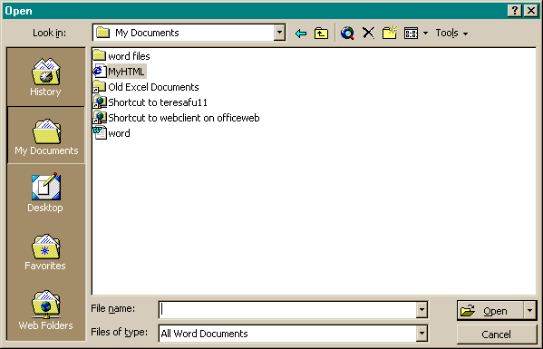
The new Office 2000 File Open and Save As dialog box makes it easy to save directly to a Web server.

Themes and Design Templates
To create compelling, graphically rich and consistent-looking Web pages, Office 2000 provides Themes and Design Templates. Office themes were selected from those included with FrontPage 98. Templates and other tools in the various applications use the Themes and Theme design elements including backgrounds, color definitions, bullets and text formatting, such as font type, size, format and color. Some themes also include animations. Each theme provides a dual color option, allowing users to select the default mix or a more vivid color scheme. The Office Themes can be shared with and edited by FrontPage 2000.

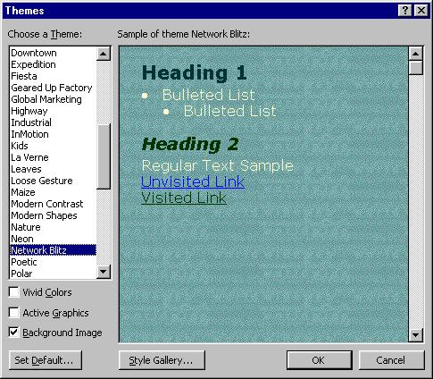
Office 2000 Themes and Design Templates make it easy to create formatted Web pages.

Hyperlink Handling
Office 2000 offers an improved and consistent hyperlink interface to make it easier to manage hyperlinks in Office documents. Users can create different kinds of links, such as jumps or e-mail triggers, without knowing HTML jargon. Users can easily specify the text displayed in hyperlinks and create links to new files as well as to multiple files from the same source. Hyperlink URLs can now include spaces, making it easier for users to create and link to specific files with spaces in the name.

When users save documents, Office 2000 checks the links and repairs those that aren’t working because of moved files or other conditions. Hyperlinks to other files are created as relative links rather than absolute links, which makes it easier for Office to maintain the link if the file moves.

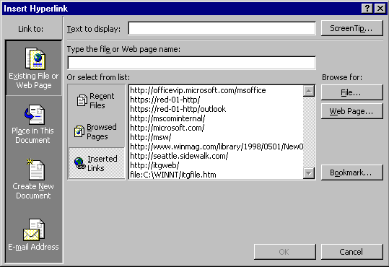
Office 2000 hyperlinking user interface makes it easy to manage hyperlinks in Office files.

Internet-Based Collaboration
Today, users commonly share files by saving them out to a file server; Web servers are generally used as a one-way, read-only means of distributing information. But Web servers are capable of two-way interaction and have many advantages over a normal file server. A file server is essentially a big hard drive — great for storing files, but not that intelligent about activity on the server itself. A Web server has a computational programming model, which allows the server to do “smart” things independent of or in conjunction with client-side input. This is what makes Web servers a much more powerful tool for collaboration and workgroup sharing than a typical file server. Some of these benefits include easy navigation, searching, indexing of files, subscription and notification.

Microsoft Office Server Extensions
Office 2000 uses Office Server Extensions (OSE) to provide a bridge between current Web technologies and the functionality needed to make the Web a friendly place to work with people and information. OSE are a set of features that makes it easy to work with Office files and collaborate in a Web-based environment. OSE empower users with the ability to publish documents to available Web servers, enable users to view contents of the Web server with Explorer, collaborate and exchange annotations on Web documents and receive notification when any document has been changed. Combined, these features provide users with power typically only available to IS managers and webmasters without requiring the users to become experts with Web servers.

Office Server Extensions are a superset of FrontPage extensions and other technologies that live on an Windows NT-based HTTP server to provide additional publishing, collaboration and document management capabilities. When OSE is present on the server, it enhances the functionality of Office 2000, the Windows Explorer and the Web browser. OSE does not replace existing Web server technologies. Rather, the extensions in Office 2000 are designed to enhance the user experience with Office in a Web-based environment. In fact, Office also includes client-side functionality that enables the applications to communicate directly with Web servers, providing a seamless experience for users.

Due to the extensive support for the HTML format in Office 2000, users may wonder if every document stored on the Web server should be converted to HTML. The answer is that it does not matter what format documents are stored in. Although HTML offers a convenient format for sharing across different platforms, the binary formats continue to offer Office-specific advantages including a rich and familiar editing environment. Users should decide for themselves which format is best suited for their needs. OSE features that make publishing and sharing documents on Web servers as easy as documents on file servers provide users with the choice to save documents in the most convenient format suitable for their need.

Security is also an important issue with Web servers, just as it is with any server. Moving to HTML doesn’t change the need to have control over network resources and administer them appropriately. Office 2000 and OSE do not introduce a new security model, but instead take advantage of the security already being used on the server (e.g., Windows NT Server permissions). Security can be set with HTML files just as it is with binary Office files, whether on a file server or Web server. For example, an administrator can give read and write access to the finance team folder only to specific members of the finance team while all other employees have read access only. One security difference to note between Office documents and HTML files is that passwords cannot be applied to HTML files.

Web Discussions
With the Office Server Extensions installed on a Web server, users can have discussions in both native Office 2000 documents and HTML files. Discussions can be added either through an Office application or through the browser using a special toolbar supplied by Office Server Extensions. The discussions can be made in-line in the document or as general discussions about the document, which are stored in the discussion pane at the bottom of the page (see Figures 4 and 5). Using the Discussions toolbar, users can insert new comments; navigate through, edit and reply to existing comments; subscribe to a particular document; and view or hide the Discussions window.

In Word 2000, the discussion will be placed at the end of a paragraph; in PowerPoint 2000, the discussion will be anchored to the active slide; and in Excel 2000, the discussion will be anchored to the current sheet. Web Discussions can also occur within the browser on both Office documents and on HTML files.

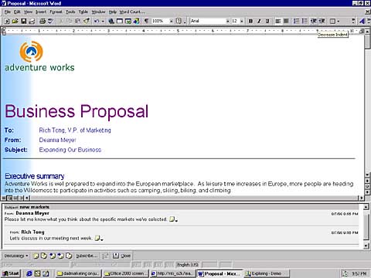
General discussion about the document appears in a pane at the bottom of the document.

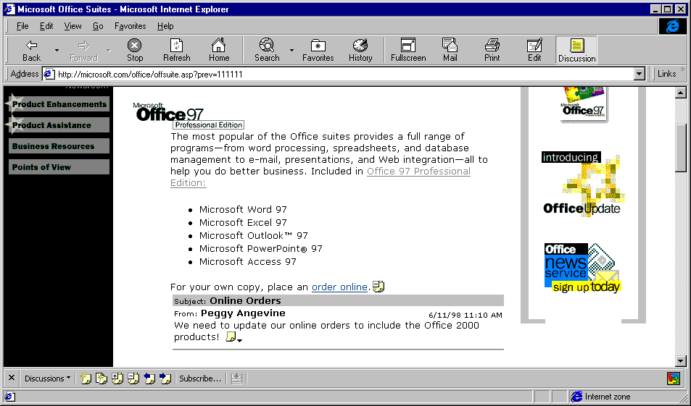

In-line discussions appear within the document and are anchored to paragraphs or other objects.

Web Subscription and Web Notification
Collaboration on the Web is much simpler with Web Subscription and Web Notification features. Office 2000 gives users an opportunity to “subscribe” to particular documents on a Web server and to be automatically “notified” by e-mail when status of selected documents changes. Users can choose to be notified when a document changes, is created or deleted. They can be notified immediately, once per day, or even weekly to prevent undue amounts of e-mail in cases where a document is changed several times in a short period. In addition to e-mail notification, users can also add a given document to an Internet Explorer channel to receive updates through a browser.

Web File Management
Office 2000 enables users to manage HTTP server file operations directly from the Windows Explorer. Users can create folders, view properties, and perform file drag-and-drop operations. Web folders are displayed as top-level folders within the Windows Explorer. In the Windows Explorer, users can drag and drop files on Web servers just as they would on normal file servers. In the browser, Office Server Extensions enables on-the-fly display of Web directory listings, files and HTML views of Web folders.

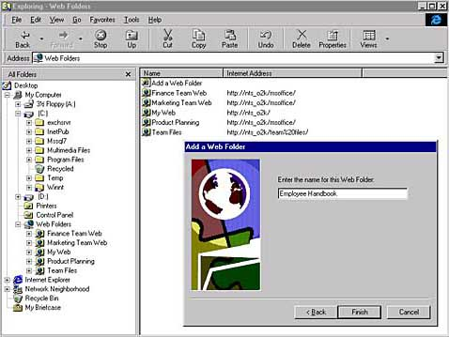

Office 2000 enables files on Web servers to be viewed and managed directly from the Windows Explorer and allows users to add Web Folders easily.

HTML Graphics Support
Graphics can be an especially challenging problem for HTML page creators for a number of reasons. Graphics are not stored with the HTML file but are linked to using HTML tags. Few HTML editors support graphics editing, and if they do it’s only through a separate application. Also, HTML only supports bitmap GIF and JPEG formats, though most graphic editors have native vector formats with enhanced abilities for manipulating shapes and objects in the files. This typically requires users to save graphic files in two formats, one for editing and another for display with the HTML page.

When users save a document with a graphic, Office automatically selects the most appropriate file format for the graphic. For example, a photograph would be saved as a JPEG and line art as a GIF. Office also chooses the correct color palette, and any of these items can be set manually by editing the object properties.

When converting an Office document to HTML, Office 2000 stores graphics in both the native format and the browser format. This makes it easy to edit non-bitmap graphics later with the appropriate tools. Office also stores special graphics formatting data with the document, such as line and fill colors. This helps keep graphic objects consistent by presenting users with preselected color and formatting choices. Graphics that are close together in the 2-D editing environment are automatically grouped for better display in HTML. Office 2000 also includes an updated version of the Photo Editor for easy manipulation of scanned images and other bitmap images.

Analysis Tools
Increasingly corporations are using Office as the preferred front end for their corporate reporting systems. Corporate data may be stored in IS-managed enterprise databases, such as Microsoft SQL Server, but Microsoft Excel and Microsoft Access give users the ability to receive, analyze, and report on that data without costly IS involvement. This places the ability to analyze the data into the hands of those who are making the business decisions. As corporations move to intranets for delivery of corporate information, Office 2000 also delivers tools that allow database developers and users to enjoy full access to important data through the common tool, the browser.

PivotTable and PivotChart Dynamic Views
PivotTable dynamic views have been a popular feature in Microsoft Excel, providing a powerful way to manipulate data. Excel 2000 improves PivotTable views in a number of ways. Most importantly, PivotTable views are much easier to create and use. In previous versions of Excel, users had to work with a dialog to make any changes to PivotTable views. Now fields can be added to and removed from the worksheet directly. Clear “drop zones” provide cues to help position the fields, and a tree view lets users expand and collapse specific data items. Another significant improvement is the addition of banded reports, which allow users to focus on and see details of PivotTable data while still providing a summary at the end.

PivotTable views can now also be charted. New PivotChart dynamic views are linked to PivotTable views and are automatically refreshed as fields in the PivotTable views are moved and managed.

Data Access Pages
Because of the increasing use of the Web, the Access team redesigned the concept behind Forms and Reports and built the ability to view and report on data from the ground up optimized for use on the Web. Although similar in function to the classic Forms and Reports, Data Access Pages are specifically designed to view, edit and report on data hosted within a browser. Users can easily design the pages in a similar manner to Forms and Reports but with new Web-enabled features and easy drag and drop capabilities. Data Access Pages are essentially HTML pages with the ability to maintain a live link to the data (i.e., the data is “bound”).

Unlike traditional Forms and Reports, Data Access Pages are stored as an HTML file outside the Microsoft Access database *.mdb file. This allows users to easily send Data Access Pages through e-mail or post them on the Web as static HTML pages. Other Office components, such as the Spreadsheet Component or Chart Component, can also be included in Data Access Pages. Users may also easily update their existing Forms by converting into Data Access Pages.

To create and work with a Data Access Page, users will want to take advantage of the latest Microsoft Access Web-enabled tools, such as a new DataPage Toolbox, Field List, and wizards. Some of these tools are mentioned below and all are described in more detail in the Microsoft Access 2000 Product Enhancements Guide.

Field List
The Field List enables users to easily add information from Microsoft Access or SQL Server to a Data Access Page simply by dragging and dropping the field names from an easily accessible list. Each field is bound to the data by maintaining a direct live link to the data from the Data Access Page. The Field List is now automatically displayed when creating a new, bound form or report, regardless of the default On/Off state of the Field List.

Enhanced Web Queries
Excel 97 introduced Web Queries, which helped customers retrieve data from the Web to bring into Excel for tracking and analysis. To use Web Queries, though, users had to write a few lines of code to define the query. Excel 2000 greatly improves this functionality with the new Web Query dialog. This dialog helps users create the query file without writing code. It walks through the process of choosing the Web page, the desired content and the type of formatting desired when the data is brought into Excel. This new approach simplifies Web queries so that all users can take advantage of them, not just users who understand how to write the query file on their own.

Office Web Components
Office users who create spreadsheets and databases have special challenges and opportunities when sharing documents on the Web. Unlike a word processing document, much of the value of sharing a spreadsheet or database lies in allowing other users to interact with the document and tailor it to their own needs. For example, if you create a spreadsheet to analyze a product’s profitability given various input costs, an important aspect of sharing that spreadsheet is enabling other users to enter new values and recalculate the results. Likewise, if you create an Excel PivotTable or Access form, report, or query, an essential part of sharing these documents is allowing other users to sort, filter, pivot or enter new values themselves. Publishing a spreadsheet or database document to the Web is only half the story. The other half is enabling other people to interact with the published document and garner information specific to the viewer, not just the publisher.
The new Office Web Components are a collection of COM controls for publishing spreadsheets, charts and databases to the Web, taking full advantage of the rich interactivity provided by Microsoft Internet Explorer version 4.01 and higher. When users browse a Web page containing an Office Web Component with Internet Explorer, they can interact with the page right in a browser, sorting, filtering, entering values for formula calculations, expanding and collapsing details, pivoting, etc. The COM controls provide the interactivity. The Web Components are fully programmable, enabling Office Solution Providers to build rich, interactive Web-based solutions.

Office 2000 includes three new Office Web Components — Spreadsheet component, Chart component and PivotTable component — that make data available through a browser. The Spreadsheet component provides basic spreadsheet functionality in the browser, allowing users to enter text and numbers, create formulas, recalculate, sort, filter and perform basic formatting. It supports frozen panes for keeping header rows and columns visible while scrolling through data, as well in-cell editing and resizable rows and columns. The Chart component provides interactivity and automatic updates as the underlying data changes. The PivotTable component is very similar to PivotTable views in Excel and provides a dynamic way to view and analyze database information in the browser. The PivotTable component is created in either Microsoft Access or Excel and resides on a Data Access Page. This component lets users browse report data, dynamically sort and filter it, group it by rows or columns, create totals and focus on the details behind the totals. It helps users work efficiently with large or small amounts of data. Though the author of the Data Access Page decides what will be the initial view, the user can access the Field List to drag and drop the dynamically linked fields directly onto the page.

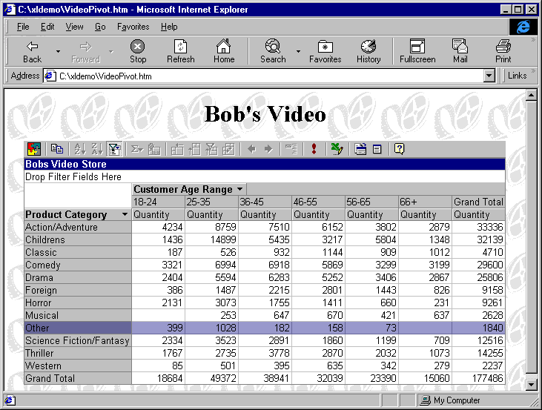

The Office Spreadsheet component allows users to interact with Excel data in a browser.
The Microsoft Office Web Components are tightly integrated with the Office 2000 applications to enhance Web publishing and browsing. They augment Excel and Access, enabling Office 2000 users to create new, interactive Web-based scenarios while preserving and enhancing their investment in Office training and expertise, and their existing Office documents. Specifically, users can take advantage of Office Web Components when they want to create Web pages from spreadsheets and databases that contain interactive regions to allow people viewing the pages to manipulate and explore the information, tailoring it to their own needs. Users can still save Web pages using static HTML when they want people to see the information they published but not be able to interact with it.

Customers must own an Office 2000 license in order to browse a Web page interactively using the Office Web Components. The Office Web Components were designed with Office users in mind and are a critical part of the Office suite. Not only do they allow users to publish data to an interactive Web page, but also enable the data to be brought back into the Office application for further analysis or tracking, providing a two-way experience.

Office Web Components require Office 2000 to be installed because they share core code with Office and because they are designed to work as part of the document creation, viewing and editing cycle. For large Office customers who purchase volume licensing it will be easy to distribute the components to desktops that have not yet been upgraded to Office 2000 but have already had a license purchased for them.

Connectivity to Enterprise Data
Connectivity to business-critical data is very important for organizations, and information technology (IT) professionals want to provide easier, more timely access to information for their users. Microsoft has made significant advancements in Office 2000 to address this issue and expand the capability of using Office as a front end to corporate data, no matter where it resides.

SQL Server Interoperability
Microsoft Access 2000 supports OLE DB, a standard for data access. This allows Microsoft Access 2000 to connect directly to SQL Server instead of going through the Jet engine, the default database engine in Microsoft Access. Power users and developers may now create solutions that combine the ease of use of the Microsoft Access interface (client) with the scalability and reliability of SQL Server. Processing occurs in SQL Server for a true client/server solution. Power users and developers will also appreciate the Microsoft Access interface, which end users who may be performing the data entry will find as easy to use as other Office applications.

Microsoft Access Project
Upon creating a new database, Microsoft Access 2000 provides users with the choice to determine the back-end data store: the traditional default database engine or a Microsoft Access Project. The defaults remain the same so newer database users will continue to have the same experience as they do today when simply selecting New Database under the File menu. However, power users and developers will be able to take advantage of the new alternative.
The Microsoft Access Project (or .adp file type) uses Microsoft Access as the front-end client with several alternatives to the back-end data store. When creating an .adp file, the user is presented with three options for the back-end data engine: an integrated store available in Office, SQL Server 6.5, or SQL Server 7.0. Thus, power users and developers may create a client/server application using Microsoft Access as the front-end interface with the SQL engine as the back-end data store. The Access Project contains no tables or queries, but instead is connected directly to a SQL Server database that contains tables, stored procedures, views and database diagrams (multiple relationships windows).

This lowers the bar for creating client/server applications. In addition, Microsoft Access power users and developers will be able to increase their value with knowledge of both Microsoft Access and SQL Server.

Microsoft Access 2000 Client/Server Wizards
Since Microsoft Access is renowned for the easy-to-use wizards, this functionality has similarly been extended into the client/server realm. Microsoft Access 2000 provides tools to design and modify tables, schema, views, and stored procedures against SQL Server databases. A variety of wizards make it easier for Microsoft Access power users and developers to create a client/server database.

Microsoft Access users will appreciate the ability to use popular Access wizards, such as the Report Wizard, Form Wizard, Control Wizard and Button Wizard while using the Microsoft Access interface against a SQL Server back end. These wizards have been updated to support the new client/server architecture.

Large Data Stores
Office 2000 provides support for Microsoft SQL Server OLAP Services, a new Online Analytical Processing (OLAP) capability in SQL Server 7.0 that allows users to perform sophisticated analysis on large volumes of data with exceptional performance. Since Office works tightly with SQL Server-based data marts and data warehouses, this allows a broader audience of users to access corporate information. SQL Server OLAP Services represents multi-dimensional, or cubed, data. Office 2000 users can access these data sources through the OLE DB for OLAP interface. For example, users can use a PivotTable dynamic view in Excel to create persistent local cubes of data from a SQL Server via the SQL Server OLAP Services feature. This provides a new method for high-performance data analysis of large amounts of data — right from within the familiar interface of Excel. Office also works with SQL Server OLAP Services through Office Web Components (discussed earlier in this document) to provide browsing and charting functionality from Excel to large data sources.

Programmability
Developers have come to rely on Office as a platform on which to build their solutions. Office 2000 focuses on two areas: improving the programming model and providing a solutions platform for Web-based applications. The programming model used in Office 2000 makes it an even stronger environment for the developer. With VBA found throughout Microsoft Office and third-party applications, developers can create solutions using Visual Basic code and Microsoft Office COM and other add-ins. Developers work in a single environment and fully utilize the power of Word, Excel, PowerPoint and Microsoft Access in their solutions.

Office Anti-Virus API
With the rise of viruses that are tied to macros, it is important for Office users to feel secure about their documents and to decrease anxiety and time spent by system administrators. Microsoft has responded with virus checking tools incorporated into the applications. However, customers have asked that we open this capability up to third parties for integrated virus-checking opportunities. Office 2000 responds with a virus-scanning API that lets developers tie into the File Open features of Office to scan Office documents before they are loaded. The benefit to users is that they can use any anti-virus software to supplement Office’s general macro warning tools.

Digital Signing of Macros
Office 2000 provides developers with a means to digitally sign their macros, certifying that they are virus-free. Office 2000 recognizes digital signatures and doesn’t display a macro warning screen unless the macro has been modified. Office users also have the ability to trust all signed documents by a particular author, allowing those documents to be opened in Office without the virus warning. This new functionality makes it easy for developers to distribute their products without constant worry on the part of customers that the solution might be infected.

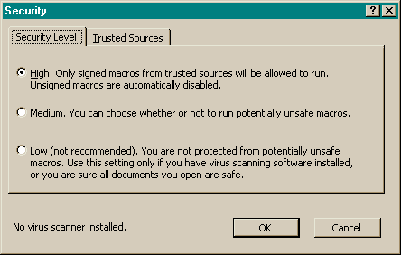

Office 2000 lets users decide what sources to trust for macros, including digitally signed macros.

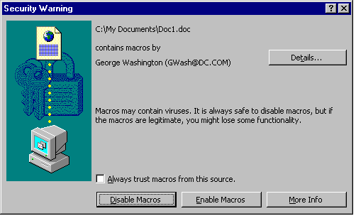
A new security warning dialog informs users about who has digitally signed the file, and allows them to always trust macros from this particular source and choose whether to enable or disable the macros.

Visual Basic for Applications 6.0
Office 2000 incorporates Visual Basic for Applications version 6.0, putting it on par and making it consistent with full language features of Visual Basic. This new VBA also gives Office 2000 features such as Modeless Userforms and support for additional ActiveX® Controls, top requests from Office developers and independent software vendors (ISVs).

Improved Application Event Model
Office 2000 exposes new events, which in concert with COM Add-ins will provide developers with almost unlimited programmatic control. New events are exposed in each of the applications.

HTML Script Authoring
Adding to the strong HTML support discussed earlier in this document is the capability to create HTML scripts and HTML-based client solutions in Office 2000. HTML scripts can be authored in Office based on script editing in the Visual Studio™ development system. There is full browser support for debugging, and script anchors are available in Office documents, including programmatic control in a document using the Scripting Object Model. These changes give developers the ability to create Office solutions to be used in the browser on the Internet or an intranet.

Office 2000 Developer
Over 1.5 million developers now write solutions using Microsoft Office and VBA. For these developers, Microsoft offers a version of Office containing the essential tools for building and deploying powerful solutions for the desktop and the Web. Office Developer includes everything in Office, plus resources to help developers use Office components more effectively. This edition contains advanced productivity features for developers working individually and in teams. Developers will also appreciate the addition of enhanced tools and components for accessing multiple data sources and integrating solutions with the Web.

Installation, Deployment and Administration
Office 2000 is designed to reduce the time, complexity and overall difficulty of the deployment process by streamlining installation without compromising the ability to customize and control Office for individual and work-group activities. With regard to installation and deployment, the primary goals for Office 2000 were to make end-user installation easier by creating a smarter Office setup and to enable easy deployment on a large scale for corporate customers. For some time, Microsoft has been developing a new breed of installer technology for software installation, which enables the company to deliver on its goals of resiliency, simplicity and manageability. The Microsoft Windows Installer, which is included with Office 2000 and in the next version of the Microsoft Windows NT® operating system, is the result of this vision.

Office Custom Installation Wizard
Office 97 allowed some customization with the Network Installation Wizard. Microsoft Office 2000 Custom Installation Wizard expands this capability by providing administrators the option to customize the applications with more granularity — at the individual feature, menu and toolbar level. The wizard steps an administrator through the process of creating profiles that can be established for all types of users based on their needs. For example, the finance department profile might include Excel with PivotTable views and Microsoft Access but not PowerPoint, whereas a marketing department profile might include everything but Microsoft Access. Network administrators can use the CIW to customize registry entries, shortcuts and files. They can also use the System Policy Editor to disable portions of the user interface, such as toolbar items or hot keys that they don’t want their users to see.

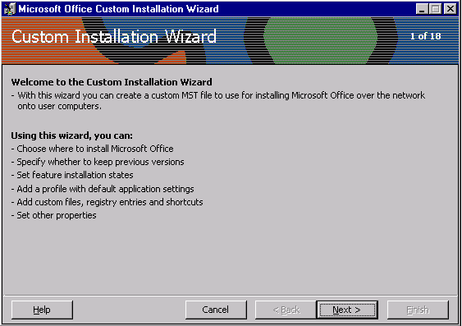

The Custom Installation Wizard helps network administrators customize registry entries, shortcuts and files.

Microsoft Windows Installer Support
Office 2000 uses the new Microsoft Windows® Installer technology to allow IT administrators to decide where each Office component or file will reside — the client, the server or a hybrid configuration. An administrator can design profiles that range from placing components on both the desktop and the server or even allowing components on the desktop to be Installed on Demand from the server:

- Run on Terminal Server (from a Windows-based terminal). Office 2000 has been optimized to run from a server-based terminal, using a Microsoft Windows-based terminal, giving administrators full control. This allows an administrator to maintain Office 2000 in one place - a central server location - rather than on individual users' desktops, helping to reduce desktop management costs as well as hardware demands.
- Run from network server (from a PC or Net PC). Another option, in which the IT administrator has full control, is to run the applications directly from a server location. The applications are stored centrally, but the processing occurs on the desktop, reducing the need for an extremely powerful server without compromising the centralized control.
- Run from desktop. To support laptops or desktop computers that are not always connected to a server, Office 2000 can be installed to run completely from a desktop or laptop computer. This allows the user to be completely self-sufficient.
- Install on Demand. Administrators can display shortcuts, icons or menu entries for not-yet-installed Office 2000 applications or components, indicating their availability without requiring their installation on the user's computer. When the user selects a not-yet-installed component, the code is available from a hierarchy of sources, determined by the administrator, ranging from different server locations to the CD-ROM. This allows for better resource management because the end user will not install additional features until they are needed. If users are running the Windows 98 operating system or Windows NT 5.0, they could get additional levels of Advertisement and Install on Demand. Shell-level advertisement, or shortcuts on the Start menu, is available on Windows 98 and Windows NT 5.0 or higher.

Self-Repairing Applications
Office 2000 is using the same Microsoft Windows Installer technology to enable each application to be self-repairing. It determines at launch if essential files are missing and where they can be found. It then reinstalls the missing files with little or no user intervention. Office 2000 also automatically checks related registry entries for missing or corrupted files and repairs them as needed. The goal is to get users working as quickly as possible, often without even knowing there was a problem.

In certain cases, Office will start fine but there might be another problem, such as a corrupted font file or missing template. These kinds of problems are confusing and can take many hours to track down and fix. Fortunately, Office 2000 handles these as well when users select the Detect and Repair tool on the Help menu. Detect and Repair scans non-critical Office files looking for discrepancies between the original installation state and the current state of a user’s machine and then fixes those problems wherever possible.

Binary File Format
Office 2000 file formats are compatible with Office 97, making it is easy to exchange binary Office documents between users running either version. Office 97 will be able to open any Office 2000 file without a converter. However, certain formatting options available in Office 2000 will not round-trip since Office 97 does not recognize these features. The only exception is Access due to new support of Unicode (Access did not previously support this file format). Access 2000 will be able to down-rev save to Access 97.

Compatible file formats eliminate the coexistence issues associated with running two versions of Office within an organization. For IT administrators, there is no need to convert files from the previous to the current format. For individual users, exchanging files with users who have not yet upgraded to Office 2000 is easy.

Customizable Alerts
Rolling out Office 2000 to groups of users with different configurations is easier than ever. Many corporate help desks provide information on the company intranet relating to Office issues and questions. With Office 2000, organizations can customize Office alert dialogs to link a button to any URL. This permits help desks to point users directly to customized information when they encounter a particular message in Office. For example, a company’s help desk may have a Web site where it keeps up-to-the-minute information on printer issues around the company. The administer could customize the Office printer alert to have a button that links to this URL on the corporate intranet. This enables administrators to set up presupport within Office, leveraging information that is already available.

Roaming User Profiles
IT administrators want better application management, including a set of tools to assign and control users’ applications. Through support of Zero Administration for Windows, Office 2000, in conjunction with Windows NT Server 5.0, facilitates centralized management with tools to manage applications and shared components as well as install, upgrade, repair and remove applications. Roaming usage covers three basic scenarios: users who move from computer to computer, users who share a computer, and users who roam with their computer to other locations. Frequently the latter computer is a laptop or other portable. Office 2000 supports all three scenarios for a much better user experience.

To allow IT administrators to centrally track and manage their users, Office 2000 with Microsoft Windows NT Server 5.0 allows user-specific settings to be tracked distinctly and stored in a single and safe location on the server. For example, suppose a user customizes the toolbar, creates a document within Word 2000 and saves it to the My Documents folder. Now, if the user logs on to a different computer, the customized Word 2000 toolbar will automatically appear and the user can access the document in the My Documents folder. Suppose another user has custom configured a company computer in the home office and then is assigned to go to an office in a foreign country for an extended time. Upon arrival, the user is assigned a new computer there. When logging into the company network for the first time at this site, the user is automatically connected to the network server nearest to this new geographic location. The user’s profile and desktop environment are also installed on the new computer so that everything looks and works as it did back at the home office.

Microsoft Office Profile Wizard
The Office Profile Wizard (OPW) is a tool for reading or writing a user’s Office 2000 settings and preferences to and from a single Office Profile Settings (*.ops) file. The individual *.ops file can be thought of as a “suitcase” containing a user’s personal preferences. If users need to move to a new machine or reconfigure an existing one, they can use the OPW to pack up their personal preferences in one location so they can “unpack” and personalize the new installation quickly and easily. Individuals could also use the OPW if a hard drive crashed and they wanted to get going again quickly, without having to recustomize personal Office settings. In the enterprise, OPW is primarily intended to be used for customizing the Office applications in conjunction with the Office Custom Installation Wizard.

Template Manager
Template Manager lets users point to templates at any location and have them treated just like the templates in personal folders. This is especially useful for companies that have standard corporate templates to which everyone needs access but that change from time to time. Now they can just point everyone to a central location on the server to access the templates. When the templates change, they only upgrade the server copies and everyone automatically has access to the new files. This makes it easy for administrators to manage and easy for users to access.

Worldwide Usage
As the use of Office spread globally, the demand to simplify cross-language document sharing increased dramatically. Multinational companies want it to be easy to deploy Office in multiple languages and use a single version of the program regardless of the native language of the user. Office 2000 responds to these needs with revolutionary new features, including some focused on the Far East market.

Single Worldwide Executable
Office 2000 reduces complexities and makes sharing files easier for multinational companies and users. Office 2000 uses a single code base, meaning that there is only one worldwide executable for each application. Users around the world can enter, display and edit text in all supported languages, including European languages, Japanese, Chinese, Korean, Hebrew and Arabic. Office 2000 has only one set of files to manage for any system, making deployment and administration much simpler. This means that all features for all supported languages are in any version of Office 2000. The enabling of localized features as well as features available in the operating system, is determined by settings in a separate resource dynamic link library (DLL). (The exceptions to the single executable feature are Thai, Vietnamese and Indian languages.)

Global Interface and Multilingual Editing
Office 2000 makes it easy to change the language of the user interface. Because all features of all languages are built into the single executable, changing the interface language doesn’t affect the operation of the applications. Users can also author documents in any language independent of the interface. In other words, if a corporation wants to roll out the standard English install of Office 2000 worldwide, users can easily adjust the Interface and Help language without incurring any overhead in management. Also, even if there is no IT department to roll out Office, any local user can switch to using the UI, proofing tools and Help in another language.

Unicode Support
Office 2000 applications now provide better support for Unicode, allowing users to enter and display text from any of the supported languages in a single version. Unicode also allows users to enter additional Asian characters beyond the old system code page limitation.

Unlike previous versions, Microsoft Access 2000 and the Jet database engine fully support Unicode. For example, using an appropriate font that supports the characters they want to use, users can read, write and store data from different code pages in the same field, table and database. In addition, Microsoft Access 2000 includes dual font support.

Input Method Editor Integration
Office 2000 applications support the new Input Method Editor (IME) version, MS-IME 98a. IME features supported in various ways by the different Office 2000 applications include reconversion, context feeding, keymap negotiation, mode bias, consistent IME interface and Unicode Input Method Manager (IMM). (Please note that different applications support IME in varying levels and Word 2000 supports all the IME improvements).

Far East Improvements
Beyond the more general changes noted in the previous sections, each of the Office 2000 applications has implemented specific improvements designed for users in the Far East. For details, please see the individual applications Product Enhancements Guides.

Personal Productivity
In addition to the new focus on providing business value to corporate customers through improved management and extending productivity to the Web, Office 2000 also makes great progress in enhancing user productivity and adapting to user habits and preferences. Usability studies indicate that users can often be overwhelmed by the complexity of application interfaces. Microsoft’s approach isn’t to simplify by removing features, but to continue innovating the user interface and make applications even smarter for users throughout the world. Improved IntelliSense in Office 2000 understands the meaning and context of the user’s actions and automatically produces the desired result.

File Open and Save
The most commonly used dialog boxes in Office, File Open and File Save, have undergone many improvements in Office 2000. This includes easier access to more files, decreased clutter and one-stop shopping to all of the files used most often. A command bar has been added for common file management tasks such as copying, moving and deleting files. The Places bar, an Outlook-like well of icons, is provided for often-used document folders to help insulate users from the persistent confusion of a hierarchical directory structure. One of these icons points to the Recent Files folder, a collection of shortcuts with up to twenty of a user’s most recently accessed documents. Web Folders points to Web servers for easy placement of files on an intranet or the Internet. The new dialog boxes also take a cue from the navigation method now familiar to millions of users through their Web browsers and include a Back button, which lets users easily return to recently visited folders, regardless of their location in the directory structure.

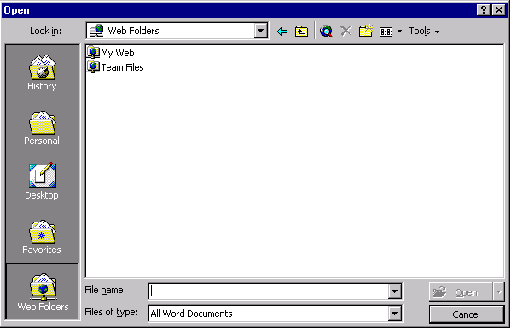

The new File/Open and Save dialogs make it easier for users to save, navigate and open files in various locations.

Collect and Paste
Gathering information from several sources has always been a common task. Now with the wealth of data on the Internet, users are demanding better integration with multiple sources of information and the ability to manage several pieces of information at once. Collect and Paste provides the means to manage multiple pieces of information in Office 2000 more easily, going beyond the single step Copy and Paste used with previous versions. Using the standard Clipboard in Windows, users typically copy information, switch windows, paste, switch windows, copy, switch windows, paste and so on. The Microsoft Office Clipboard allows users to easily copy up to twelve chunks of text or pictures from one or more documents, e-mail messages, Web pages, presentations or other files. Users can then paste these chunks into any Office application, either individually, or all at once using the handy Paste All feature.

Personalized Menus
Personalized Menus are a new solution to a long-term problem — how to focus on just the things a user needs and uses. When users first start Office, the application menus contain the commands that are used 95 percent of the time, while infrequently used commands do not immediately clutter the menu. At the bottom of each menu is a button that expands the menus to the full selection of choices so users can still easily find all menu commands. In addition, the menu will automatically expand based on IntelliSense rules (e.g., timing, hovering, etc.) As users access menu commands, they are “promoted” and displayed higher on the list. Unused menu commands are visually suppressed and not displayed on Personalized Menus. After a period of usage, menus display the commands used most often and visually suppress the ones never or rarely used. When users want to explore new features, they can quickly expand the menus to find them. In the meantime, they are only shown what they use, greatly simplifying the interface. Individual end users as well as IT administrators have the flexibility to customize or disable this feature.
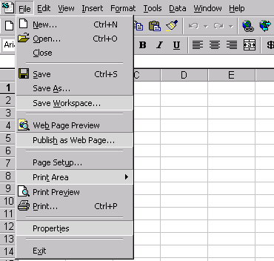
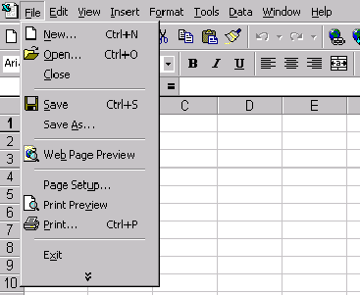

Personalized Menus adapt to usage patterns to give users easy access to the tools they use.

Personalized Toolbars
Personalized Toolbars work very similarly to Personalized Menus. Office 2000 Personalized Toolbars are displayed on a single row overlapped and are “rafted.” Users can click a chevron button to see and access the full toolbar. As users use buttons by clicking on them, buttons are promoted to the visible toolbar. Unused buttons are visually suppressed under the overlap, and users can drag the slider to see more buttons. Over time, the toolbars configure themselves to users needs. This provides for less screen clutter and increased accessibility to the functions that users access most commonly.

Quick Customize Toolbars
Customizing toolbars is now easier than ever by clicking the Toolbar Options button on any toolbar to display a list of the potential buttons on that toolbar. Users can select the ones they want to display and uncheck the ones they want to visually suppress.

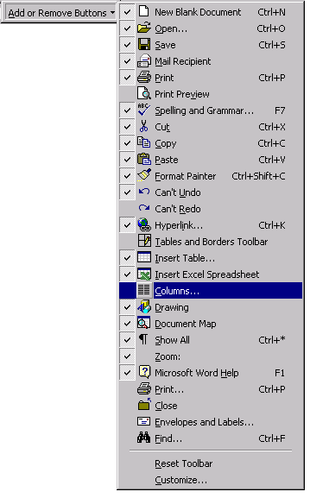
Users can easily customize toolbars using simple check boxes.

Quick File Switching
Quick file switching (like Single Document Interface) provides immediate access to any individual Office document, rather than the application itself. If a user has more than one document open in any Office 2000 application, each document will have its own button on the Windows Taskbar. This is a response to customers wanting an easy way to switch between open documents, especially during cut-and-paste or drag-and-drop operations. Note the example below: Each individual presentation is easily accessible via the Taskbar, rather than just switching files within PowerPoint (through the Windows Menu). Quick file switching requires the Web-aware user interface, provided in Windows 98, Windows NT Workstation 5.0 or Windows 95 with Microsoft Internet Explorer 4.0.

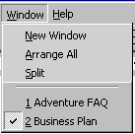

Office 2000 enables quick file switching to show a separate button on the Task Bar for each open document.

Microsoft Office E-mail
In Office 2000, e-mail functions are built right into all the applications through the Mail Header toolbar. This means that instead of having to launch an e-mail application and then attach a file, users can choose to send documents right from within the application. For example, instead of creating a sales report in Excel, saving it, starting Outlook and sending the report as an attachment, a user can create the report, send it right from Excel and continue working on the report.

Users could do something similar in Office 97, but because Office 2000 uses HTML as a companion file format, users can now also send files in HTML. This means users don’t have to worry whether the recipients have the right applications to read the material. So any recipient with an HTML-compliant e-mail reader will be able to view the mail with full fidelity. HTML-compliant e-mail readers include Microsoft Outlook and Outlook Express, Eudora, several Lotus clients and several Netscape clients.

Clip Gallery
As graphics are used more often in documents and Web pages, users need better tools to find and manage graphics files. The Clip Gallery in Office 2000 provides several advanced tools to make these tasks easier. By using a combination of keyword, color and wavelet algorithms, the Clip Gallery search tools help users locate the right graphic image, even without indexing. The Find More Like This tool locates images like the currently selected graphic. For example, if a user has a picture of a dog selected, Find More Like This displays more images of dogs, sorted by relevance.

The Clip Gallery supplies many standard categories for the built-in ClipArt. However, it also allows users to create custom categories for organizing images any way they would like. Images can be added to categories from virtually any source and include keywords to make finding them fast. Images are passed through to the applications in their original format rather than being converted to a bitmap.

Other improvements make the Clip Gallery easier to use. It now supports drag-and-drop functionality to move images from its gallery directly into Office documents. Users can leave the Clip Gallery open while editing documents, selecting graphics as they go rather than having to reopen it each time. The Clip Gallery can also optionally display in a much smaller window, letting users see more of a document while selecting an image. And when users click on any shape, a pop-up control provides the most common tasks, such as adding the clip to a document or searching for more like it. Office AutoShapes, including many new ones, are incorporated into the Clip Gallery for a centralized way to distribute and manage all Office graphics. When AutoShapes are inserted from the Clip Gallery into an Office application, they retain their native properties instead of a metafile.

End User Assistance and Training
Our approach for providing assistance and training in Office 2000 is based on extensive customer research and usability testing. The focus is two fold: first, to build an assistance platform and user interface that helps users get the result they want, when they want and without interrupting the flow of their work; second, engineering this assistance platform in such a way that it is customizable by IT administrators and extensible to the Web. Our research findings have guided us in making improvements in many areas including a more intuitive way to ask plain language questions, a more effective and less intrusive Office Assistant and a powerful engine that monitors user actions and produces the right help topic or tool automatically.

Office Assistant Out of the Box
Office 2000 improves the Office Assistant for users who love it as well as for those who choose not to use it. However, those who turned it off before may now appreciate the improvements and decide to keep it around. The Office 2000 Assistant works out of the box. This means it has no window around it, so it takes up less screen real estate, blends in more naturally with users’ work, and is more visually appealing.

In spite of these improvements, some users will still want to turn off the Assistant. Office 2000 improves this feature, so when a user says “off,” it really is off for good. Users who choose not to use the Assistant will still have access to the underlying help structure, including natural language questions and responses.

Help on the Web
While the Assistant’s ability to understand user questions has improved, Microsoft also recognizes that every question can not be anticipated. In an effort to offer users additional help and to assist in improving the Assistant, Microsoft provides Help on the Web. If the Assistant can’t answer a question, it provides the user with a link to a special Web site with additional information. This site also gives users the option of telling Microsoft what they were trying to ask and what kind of response was expected, so that Microsoft can improve the Assistant in the future. Administrators in organizations can also use this as a way to direct users to their own internal sites and capture information about their users.

Interactive Help
Interactive Help allows Office to complete a task automatically for a user. To eliminate unnecessary tasks, the Office Assistant in Interactive Help will automatically perform the task for users. For example, the Office Assistant would actually show a user how to create a PivotTable dynamic view in Excel instead of just explain how to do it.

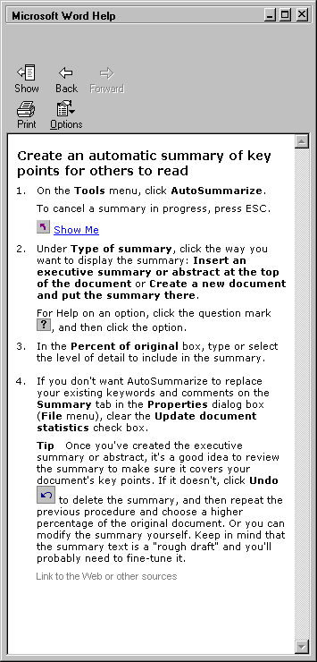

Interactive Help provides more intuitive assistance for users.

In Office 97 users could ask questions to the Assistant in their own words, but did not receive an answer back in words that necessarily made sense to them. In Office 2000, the help system improves its support for natural language technology and now responds to user inquiries in the user’s own words. For example, if a user asks “how do I add text to my star” Office will respond with a topic called “adding text to your star” instead of “adding text to an AutoShape.” This improved support for natural language makes it easier for users to find the information they need.

Support for Customer Imperatives

Increased Accessibility
With each successive version of Office, Microsoft is dedicated to removing barriers and delivering additional capabilities that increase the accessibility and usability of Office by all people, including those with disabilities. According to Dave Capozzi of the U.S. Access Board, government figures reveal that one in five persons has some functional limitation and 8 percent of all users on the Web have disabilities. In the United States alone, more than 30 million people with disabilities can be affected by the design of computer software. Microsoft has created a strategic initiative for continual accessibility improvement known as Microsoft Active Accessibility (MSAA). Office 2000 supports MSAA in a number of critical areas, and future versions of Office will continue to expand support for MSAA as the standard evolves to better handle complex documents.

Past versions of Office have included features to enhance its accessibility, making the software available to a wider range of users including those with disabilities. Office remains dedicated to increasing support for the disabled community. Specifically, Office 2000 increases accessibility support in two key areas:

- Features that are built right into Office
- Enhancements for third-party developers of accessibility hardware and software

The Office 2000 development team worked directly with users who have disabilities to find features that would make the software more accessible. Based on the feedback, Office 2000 includes improved accessibility features that fall into the following key areas:

- Improved keyboard support (e.g., Access relations and WordArt)
- Improved MSAA support (e.g., native support to dialogs)
- Improved high contrast support (e.g., PowerPoint slide view can toggle between high contrast and true color)
- Improved focus support (e.g., Excel cell ranges)
- Improvements to the native object model (e.g., screen location information now included)
- Increased ease of use for everyone

For more detailed information about accessibility features in Office, please see the Microsoft Office 2000 Accessibility White Paper at http://www.microsoft.com/office/. For more information on accessibility features in other Microsoft products, refer to http://www.microsoft.com/enable/.

Year 2000 Compliance
Since its inception, Microsoft Office was designed to work in and beyond the year 2000. With the many features and applications in the Office suite, there remain some issues, however, that are complicated by the coming millennium. Microsoft Office 2000 constitutes the most thorough design effort encompassing date-handling issues. Throughout the development process, any issues that dealt with date handling were automatically flagged as Year 2000 issues and given high priority.

Office 2000 is among the first applications to support an administerable four-digit year cutoff. This allows administrators or users to set whether the date 2/2/02 falls in 1902, 2002 or 9002, for example. This is accomplished using a setting found in Windows 98 and Windows NT 5.0 Workstation and higher. The setting is located in the Control Panel, Regional Settings, Date tab. Customers who are not running Windows 98 or Windows NT 5.0 can still set the cutoff date using a tool included in the Office Resource Kit or by editing the registry. The four-digit year cutoff setting will have the greatest impact on Excel, Access and VBA, but is referenced in every other application for settings like document properties.

The user benefit of this design change is that it gives flexibility to different industries and groups to set the cutoff date setting appropriate to their needs. For the insurance adjuster accustomed to entering birth dates, they can lower the cutoff so dates fall into the 20th century, while the analyst projecting cash flow streams can set it farther in the future.

For more information: http://www.microsoft.com/office/


This is a preliminary document and may be changed substantially prior to final commercial release. This document is provided for informational purposes only and Microsoft makes no warranties, either express or implied, in this document. Information in this document is subject to change without notice. The entire risk of the use or the results of the use of this document remains with the user. The example companies, organizations, products, people and events depicted herein are fictitious. No association with any real company, organization, product, person or event is intended or should be inferred. Complying with all applicable copyright laws is the responsibility of the user. Without limiting the rights under copyright, no part of this document may be reproduced, stored in or introduced into a retrieval system, or transmitted in any form or by any means (electronic, mechanical, photocopying, recording, or otherwise), or for any purpose, without the express written permission of Microsoft Corporation.
Microsoft may have patents, patent applications, trademarks, copyrights, or other intellectual property rights covering subject matter in this document. Except as expressly provided in any written license agreement from Microsoft, the furnishing of this document does not give you any license to these patents, trademarks, copyrights, or other intellectual property.
Unpublished work. © 1998 Microsoft Corporation. All rights reserved.
Microsoft, ActiveX, FrontPage, IntelliSense, NetMeeting, NetShow, the Office logo, Outlook, PowerPoint, PivotChart, PivotTable, Visual Basic, Visual Studio, Windows and Windows NT are either registered trademarks or trademarks of Microsoft Corporation in the U.S.A. and/or other countries.
The names of actual companies and products mentioned herein may be the trademarks of their respective owners.

