
Using Microsoft® Outlook™ 2000 for Contact Management

White Paper

Published: October 1998

Table of Contents
Introduction 1
About This Document 1
Contact Basics 2
Building a Contact Database 3
Contact Fields 8
Distribution Lists 11
Contact Folders as Address Books 13
Interacting with Contacts 14
Creating and Documenting Contact Activities 15
Tracking Activities 17
Mail Merge to Contacts 21
Printing Contact Information 22
Organizing Contacts 24
Finding a Contact 24
Organizing Groups of Contacts 25
Customizing Fields & Forms 29
Adding Fields 29
Customizing Forms 30
Sharing Contacts 32
Sending Contact Information by E-mail 32
NetFolders 32
Exchange Server 33
Synchronizing Contact Information with Hand Held PC’s 37

Using Microsoft Outlook 2000 for Contact Management
White Paper

Published: October 1998
For the latest information, please see http://www.microsoft.com/office/

Introduction
The Microsoft® Outlook™ 2000 messaging and collaboration client combines leading support for Internet standards-based messaging systems, including Exchange Server, with integrated calendar, contact, and task management features.

The integration of this information provides users with a very powerful contact management solution. Users can send e-mail or letters to their contacts. They can manage specific contact task lists. They can associate appointments in their calendar with their contacts. They can journal contact interactions. The contact can view a history of all activities in which they are associated. With one click from an associated item, like a task for a contact, the contact themselves can be opened.

This paper gives an introduction to Microsoft Outlook contact management capabilities. It demonstrates the powerful tools that Outlook provides to organize large contact lists. This paper illustrates how contacts can be customized to fit specific user needs. In addition, it shows how workgroups can share contact information.

People who are interested in using Microsoft Outlook as a contact manager or as an e-mail client should read this paper. Both seasoned Outlook users and users who have never used Outlook will find the information in this white paper useful because it combines on overview of basic functions as well as tips and tricks for the advanced user.

About This Document
This white paper is organized in five sections:

- Contact Basics. The first chapter introduces Outlook contacts and demonstrates how users can quickly build their own contact database. It describes specific contact fields in detail. The first chapter presents the new Outlook 2000 personal distribution lists and explains how Outlook contact folders serve as address books for e-mail.
- Interacting with Contacts. The second chapter shows how Outlook can be the place where all interactions with contacts are initiated and documented. Outlook users can send e-mail to their contacts and much more. They can create contact specific task lists, link documents to contacts and view all past interactions with a contact in an easy table format.
- Organizing Contacts. The third chapter gives valuable tips on how to find contacts quickly and how to organize large contact databases. This chapter also presents time management tips. It explains when it is better to use folders rather than Outlook messaging and collaboration client powerful views to group contacts.
- Customizing Fields & Forms. The fourth chapter presents how contacts can be customized to suit individual user needs. An insurance salesman will store slightly different contact data than a consultant or a lawyer. To provide the best contact management solution for them, Outlook can be easily adapted to fit a users exact needs.
- Sharing Contacts. The fifth chapter describes how users can share contact information in workgroups with or without Microsoft Exchange. It gives a clear example of how an Exchange public folder workgroup space can be setup to collaborate with a set of contacts. It explains how to share journal entries with the history of contact interactions, manage open tasks with work items and make e-mail messages send and received by those contacts accessible to a team.

Contact Basics
Outlook contact folders allow users to store contact information with which they interact in their lives-professional contacts like customers and vendors as well as friends, classmates and family members.

This chapter explains how users can build a contact database. It shows how existing contact information can be imported in Outlook and how contacts can be created within Outlook. This chapter then moves on to explain specific contact fields. It introduces new personal distribution lists for Outlook and shows how Outlook contact folders are used as address books for sending e-mail.
Outlook offers two ways to look at contacts:

- Contact folders. Contact folders can be displayed in the main window on Outlook. They can be shown in views as address cards-as shown below-or in list form.
- Contact item windows. Contact item windows display one contact at a time. They allow comfortable entry of contact data and use tabs to structure information that a contact item can hold.
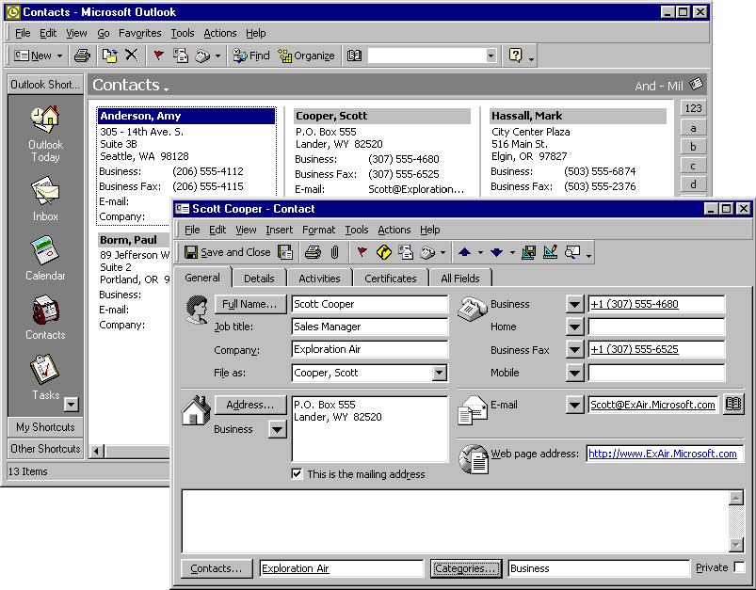

Building a Contact Database

Importing existing Contacts
Many users already have existing contact information on their personal computers. Outlook offers an easy way to import those contacts. Outlook provides an import/export wizard that can be started through the “Files➔Import and Export...” menu.

Supported Formats
Outlook imports from a variety of current contact managers such as Act, Ecco, Lotus Organizer, Sidekick and Schedule+. It also allows import of contact information from databases like Access and Foxpro and a variety of other file formats.
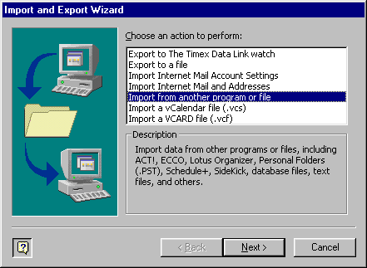

Mapping Fields
Outlook supports the mapping of import source fields to Outlook contact fields. Drag fields from the list box on the left and drop them on the Outlook contact fields on the right list box to match them upon import.

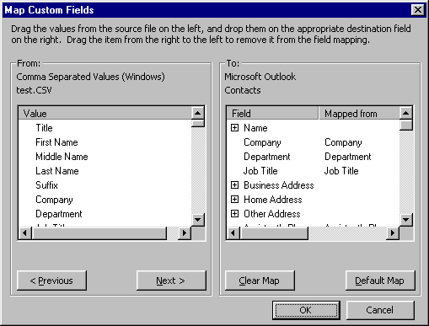

Creating Contacts in Outlook
Outlook provides multiple ways to create contacts-from entering a contact with a lot of information to quickly capturing an e-mail address or phone number.

New Contact
A new contact can be created through the contact’s “Actions” menus or the “New” toolbar button on the standard Outlook toolbar. This is the best option for a user who wants to enter detailed contact information from a business card, letterhead or paper address book.

New Contact from the Same Company-
This can be created using the contact’s “Actions” menu. The company name, business address and business phone numbers of the active contact are copied from the existing contact to the new one. This option can shorten the time needed to enter a contact if one from the same company already exists.

Views “New Row”
Outlook table views show a blank row at the top that allows direct entry of contact information. This is a good way to quickly enter a contact name and phone number.

A new contact can be added by typing in the view columns

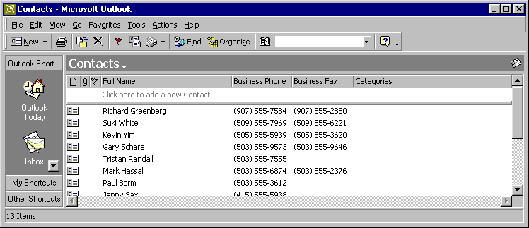

Forwarded Contacts and vCards
Contacts or vCards that have been forwarded as attachments of an e-mail message can be dragged from the message and dropped into contact folders. vCards present contact information as electronic business cards on an open Internet standard. This is the fastest way to enter a contact. A customer or friend can send his own contact information this way and colleagues can forward contact information from their own databases.

Drag & drop on a contact folder to add

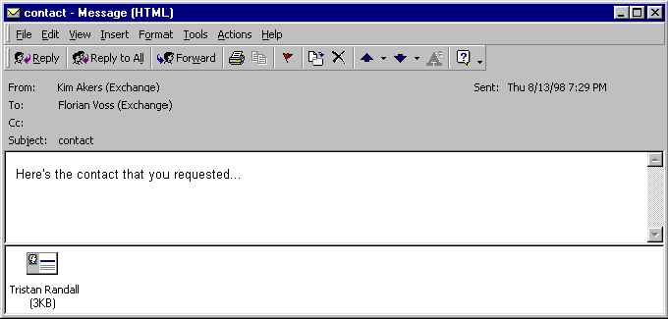

Create from Exchange Server Global Address Book Entries
Exchange e-mail users can add global address book entries by pressing the new add to “Personal Address Book” button. All fields will be copied in a new Outlook contact. This is a convenient way for a user to import selected colleagues information into a contact folder-for synchronization to a hand held device or for offline access.
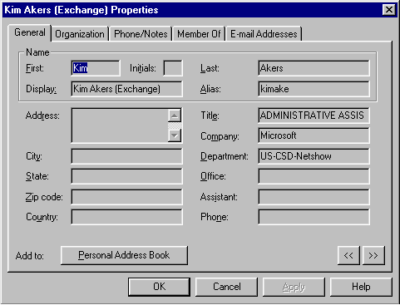
Press to create a new contact with all information.
Address book entries for a contact can be opened using the standard Microsoft Exchange address book. Users can also double-click or use the context menu on any recipient name in an e-mail message or a task/meeting request as shown in the following picture.

Create from E-mail
E-mail can be created by simply right-clicking on any name in the from/to/cc/bcc fields. This is a very fast way to enter the name of a person from whom the user received e-mail in the contact folder.

Open Properties dialog for exchange global address book entries.
Use “Add to Personal Address Book” button to add to contacts.
Select to create a new contact

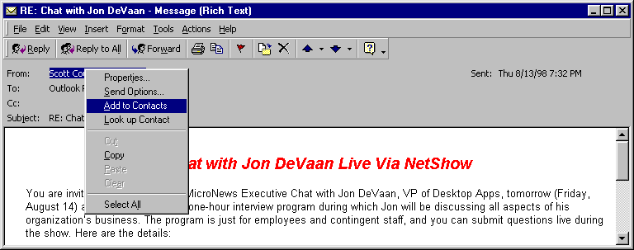

Auto Merge Contact Information
If a user maintains a large number of contacts it is possible that contacts are accidentally entered twice. If business partners send an electronic business card with their e-mail messages the danger of duplicates is even higher because it easy to drag the same business card in a contact folder twice. Therefore, Outlook 2000 checks every time a user adds a new contact for existing duplicates.

If a duplicate is detected, Outlook offers two options:

- Add the new contact as a duplicate-after all, a user might actually deal with two contacts that have the same name.
- Update the existing contact with all the fields that have a different value in the new contact file. This intelligent merge preserves existing field values and only updates new information. A user receives a new electronic business card (vCard) from John Doe. They can drag it on their contact folder, it already exists, the dialog is activated and they choose to update. John Doe’s new fax number will be added to his existing contact, but the notes that user made about John’s hobbies will not be touched.

Users can also choose to open the existing contact to verify its information.

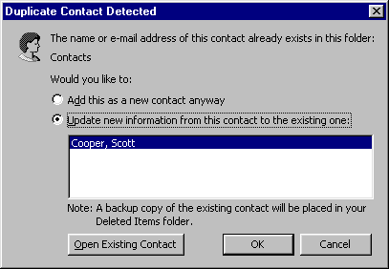
Open existing contact for verification
Choose how the duplicate is handled.

Contact Fields
The contact item window presents a row of tabs on the top that structure the fields that allow users to capture contact information.

General Tab
Store up to 19 phone numbers.
Tabs organize fields in logical groups.

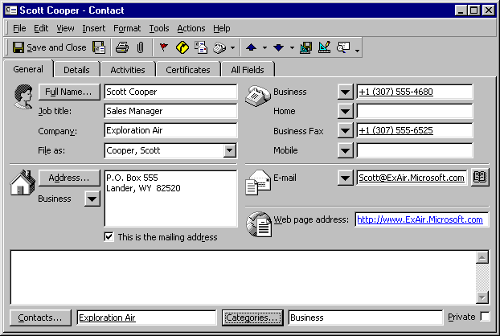
Button to activate “Check Full Name” dialog
Contacts field to associate with other contacts
Buttons to select address type and to activate “Check address dialog”
Store up to three
e-mail addresses
Notes field for free form text entry

Name
Outlook automatically parses the entered name into title-first, middle, last name and suffix. This makes it very easy to enter names, but still allows users to sort a contact list by last name only.

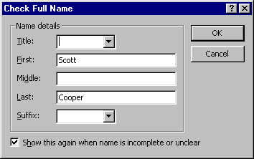

Company and Job Title
The company name and job title for the contact can be entered in these fields. Use the full-name dialog box to enter fields manually.

File As
The File As field displays a contact name in different combinations of last name, first name and company. Scott Cooper working for Exploration Air can be filed as “Scott Cooper,” “Cooper, Scott,” “Exploration Air,” “Cooper, Scott (Exploration Air)” or “Exploration Air (Scott Cooper).” You can also type in your own key, for example,. “Doctor.”

File As is very useful as a sort by field. Contacts from the same company can be shown together if they are filed as “Company (Name).” Contacts representing companies might not have a first, middle or last name. Just the company field will be filled in, so sorting the contact list by the last name would produce a list with all companies first-their full name is blank-and all contacts with a name. Sorting by File As solves this problem.

Address fields
Outlook offers three address fields: Business, Home and Other. One of these addresses can be selected as the default address-this address is used when a letter is created for the contact.

The address can be entered in one multi-line text field and is automatically parsed.
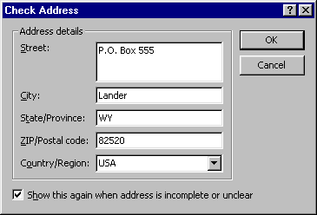

E-mail address and Web Pages
Outlook allows users to specify three e-mail addresses and one web page for each contact.

Phone Numbers
Outlook provides 19 fields in which to save phone numbers. The buttons next to the phone number field permit the user to select which numbers are displayed.

Contacts
This field allows contacts to be associated with other contacts-for example, the contact representing Mr. Cooper is associated with the contact representing his company “Exploration Air.” The contacts in the field can be opened using double-click or through the context menu. The secretary of a contact can be associated in this way as well. If Mr. Cooper is not picking up his phone, it is very easy to navigate to his secretary, see her phone number and give her a call.

Categories
The categories field allows organization of contacts in category groups like “Business” or ‘’Friends.” Views in Outlook can then be manipulated to show only contacts that belong to a certain category or to group by categories. Outlook provides a standard set of categories that can be freely changed and extended.

Private
Users can allow assistants access to their contact folder. This permits a user to give an assistant access to her contact folder. The user, however, might not wish to share the contact information of an old college friend or of a relative. With this field, they can mark those contacts as private and they will not be accessible to delegates.

Detail Tab
The detail tab allows additional contact information to be stored.

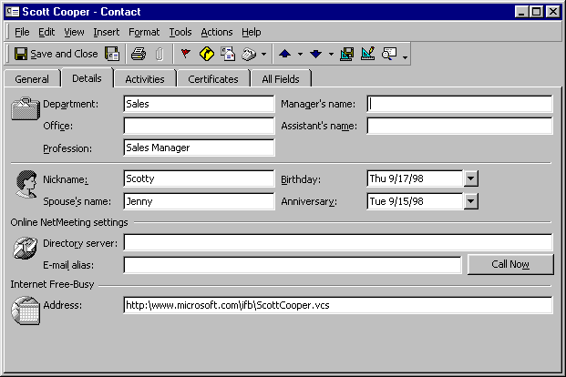
Dates entered here automatically create calendar entries.

Department, Office, Profession, Manager, Assistant, Nickname, Spouse
Additional information fields.

Birthday and Anniversary
Setting these fields automatically creates calendar entries with yearly reoccurrence that are excellent reminders.

Net Meeting Directory Server
The directory server stores the NetMeeting settings for with this contact. Microsoft NetMeeting offers a complete Internet and intranet conferencing solution that lets you easily communicate and collaborate with others on your company's intranet or the Internet. Users see and hear meeting participants, look at the same documents and folders or use a whiteboard to create simple illustrations. They can also exchange text, chat, message and share files. Check http://www.microsoft.com/windows/netmeeting/ for more information.

Other Tabs

Activities
Shows Outlook items that are associated with this contact-this tab will be explained in detail under Interacting with Contacts-Tracking Activities.

Certificates
Allows the registration of security certificates to send and receive encrypted e-mail from this contact.

All Fields
Shows a tabular listing of all contact fields.

Distribution Lists
Outlook 2000 supports personal distribution lists in contact folders. If a user sends e-mail regularly to the same group of people they can create a distribution list for this group. Future e-mails can then be addressed to the distribution list and will be send to all members. A good example of a personal distribution list is a project team-since a team member has to send regular updates to their group they can create one distribution list with their team members instead of entering the names every time they send e-mail.

Users can employ the “Actions” menu to send e-mail or meeting requests to distribution lists.

Creation of distribution lists
Distribution lists are created through the contact folder “Actions” menu or the “New” toolbar button.

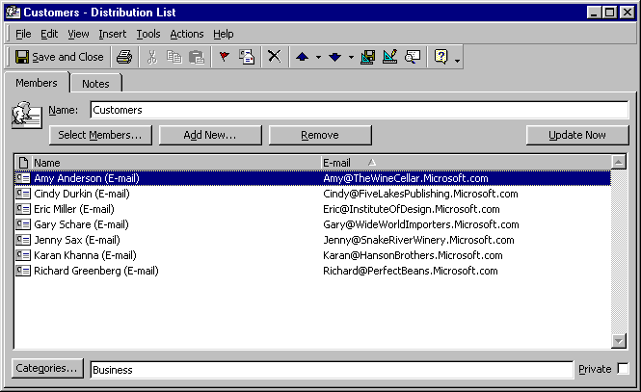

Adding Members
New distribution list members with existing address book/contact folder entries can be added using “Select Members” dialog.

Contacts that do not exist in any address book can be added using the “Add New” dialog.

Updating Member Addresses
Whenever e-mail is sent to a distribution list, Outlook automatically checks if the e-mail address of a distribution list member in the underlying contact or global address book entry has changed. If so, the new address is used to send mail. Users can visually update the e-mail addresses shown in the distribution list window by pressing the “Update Now” button.

Contact Folders as Address Books
Outlook uses the default contact folder as an e-mail address book. Other contact folders can be used as address books as well. This allows users to organize their contacts in multiple folders. Some users create one contact folder for business contacts and one for private contacts. Others share customer contacts with their teams in a public contact folder. All these contacts can be used to address e-mail. Outlook will try to resolve a name entered in the e-mail address field against contact entries in address books. Users can also select an address using the “Select Names” dialog that can be opened from e-mail messages.

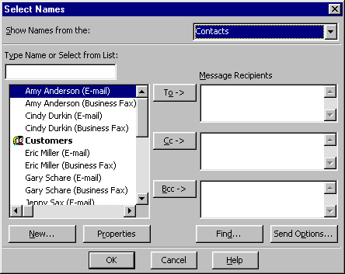
Select an address book

There are two steps involved in activating a contact folder to serve as an e-mail address book.

Setting the Folder Property
Open the “Contact Properties” dialog using “File➔Folder➔Properties” for “Folder’” or the contact folders context menu. Select the tab “Outlook Address Book” and check the “Show folder as an e-mail Address Book” check-box.

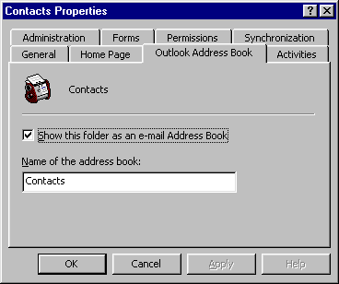

Adding the Folder to the Address Lists
Open the “Services” dialog using “Tools➔Services”. Adjust the order in which address lists are searched.

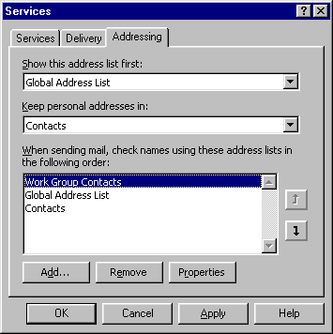
Opens “Add Address List” dialog
Arrows adjust search order

Press the “Add” button to show the “Add Address List” dialog and add a contact folder to the address books searched.

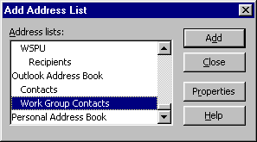

Interacting with Contacts
Entering contact information in Outlook contact folders and using contact folders as e-mail address books is only the first step to effective contact management. Outlook contacts serve not only as an address book for e-mail, but can be the place where all contact interactions are initiated. Outlook can be used to schedule appointments with contacts, to automatically dial and document phone calls, to write letters, to initiate NetMeeting conferencing software, to begin mail merge processes and to start many other activities.

Outlook also allows users to view a complete history of their interactions with a contact. For example, e-mails send to or received from a contact, journal entries created to log interactions, or tasks due can be quickly reviewed before another interaction-like a phone call-is started.

Creating and Documenting Contact Activities
Contact related actions are activated via the contact’s “Actions” menu. The most important contact actions can also be initiated using a right-click on the contact in the main window of Outlook.

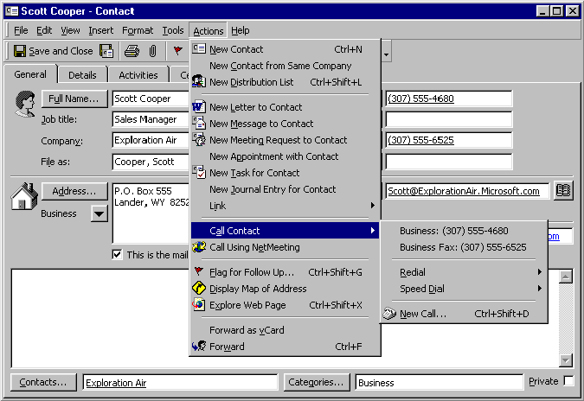

All Outlook items that are created from a contact are automatically associated with that particular contact.

New Letter to Contact
The Microsoft Word Letter Wizard is started and initialized with the contact’s mailing address. If the mailing address is also the business address, the contact’s job title and company name are included in the address.

New Message to Contact
A new e-mail message addressed to the contact is created.

New Meeting Request to Contact
A meeting request addressed to the contact is created. A meeting request is send as an e-mail message to the contact. A calendar entry in the user’s calendar is created as well.

New Appointment with Contact
A new appointment is created for the contact. This command does not send an e-mail to the contact and is the preferred way to create appointments that are not scheduled or confirmed by e-mail.

New Task for Contact
A new task item is created for the contact.

New Journal Entry for Contact
A new journal entry is created for the contact. Journal entries allow users to record notes about contact interactions like phone calls or meeting notes. The “Activities” tab on each contact allows them to see a history of all journal entries for the contact. The “Activities” tab is explained in detail in the section “Tracking Activities”.

Links
Links allow users to associate existing items, like tasks or appointments, as well as documents with a contact. Existing outlook items can be selected from dialog-their “Contacts” field will be set to the selected contact. To associate documents, Outlook offers the user a file-open dialog and creates a journal entry with a shortcut to this file. This is a great way to associate documents like sales proposals or letters with a contact.

Phone Calls
Outlook can automatically dial contact phone numbers if a modem is installed on the user’s computer.

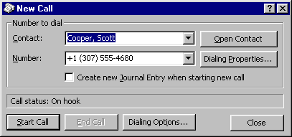

Call Using NetMeeting
Initiates a NetMeeting™ conference. To learn more about NetMeeting conferencing software, check http://www.microsoft.com/windows/netmeeting/.

Display Map of Address
Activates Microsoft Expedia Maps, a free web site. For US addresses the exact street address is mapped, for places in other countries a high level map of the city is shown.

Explore Web page
Will open the contact’s web page.

Flag for Follow Up
Setting a Flag on a contact is an excellent way for users to remind themselves of an action that needs to be taken for this contact. With the Flag users can enter a custom follow-up action or pick from standard text like “Follow up, Call, Send e-mail.” They can also set a reminder that will notify them at a specified time.

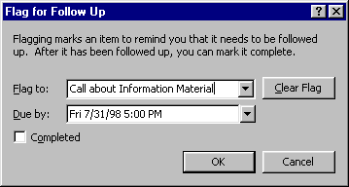
Choice of predefined or custom flag text.
Optional Reminder

Forward/Forward as vCard
Creates a new e-mail with the contact attached in Outlook or vCard format. This allows users to share their contact information with others.

Tracking Activities

The “Contacts” Field on Outlook Items
The “Contacts” field associates any Outlook item with a contact. A user can see a task to call a customer in his task list. One double-click on the contact’s name in the “Contacts” field and the contact is opened with the phone number visible and ready to be dialed. A meeting with a contact has to be rescheduled by telephone. Again, one click on the name opens the contact and presents the phone number.

The “Contacts” field is automatically set to the contact name when an item is created through the contact’s “Actions” menu. A contact name can also be manually entered or selected from a dialog activated by clicking the “Contacts” button.

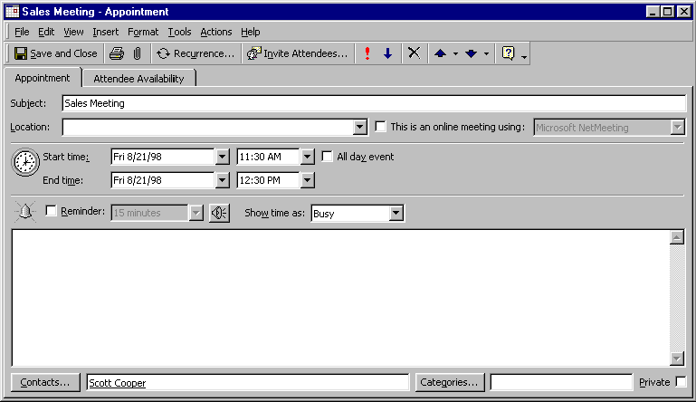
Contact Name – right click for context menu, double click to open

Showing Activities on the Contact Item Window
On the contact item window Outlook provides the “Activities” tab to show all items related to a contact. Outlook searches defined folders for matching entries in the “Contacts” field and for matching e-mail addresses in mail messages. Users can select different folder groups with the combobox in the upper left corner.

Pick different Views – Predefined or customized

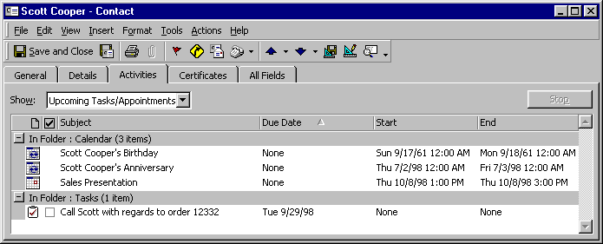
Full Outlook view – customize columns, sort, group by…

The Views
The views on the “Activities” tab are fully customizable Outlook views. Users can change the displayed fields, sort order, group by settings and other settings-like gridlines and fonts.

The items displayed in the table can be opened using their right-click menus, double click or acted on with the right click menu.

The Predefined Folder Groups
Outlook ships with six predefined folder groups: “Journal,” “Upcoming Tasks/Appointments,” “Contacts,” Notes,” “E-mail” and “All Items.” The first four folder groups are for searching Outlook default folders. E-mail searches the whole store, since Outlook can not know which folder structure users will employ to archive their e-mail.

Customizing Folder Groups
To customize the searched folder groups the user has to activate the “Contact Properties” dialog of a contact folder through the “File➔Folder➔Folder Properties” menu.

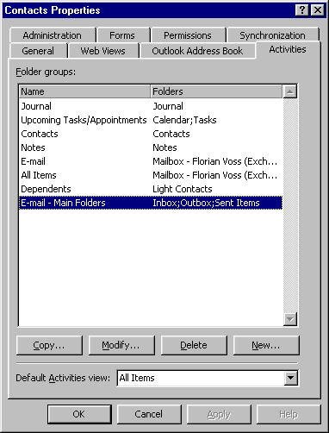

Recommended customizations:

- Searching the full mailbox of a user for e-mail can be time consuming. The search can be sped up if the user defines the exact e-mail folders that should be searched-like “Inbox, Outbox, Sent Items” in the example.
- Users can define folder groups in archive folders to be searched. Using archive folders is recommended since it minimizes the size of a mailbox.

Setting the Default Folder Group
This tab also allows users to set the default view that will be shown when the activities tab on the contact form is selected.

The Activities tab-an Evolution from the Outlook Journal
In Microsoft Outlook 97/98 the “Activities” tab was called “Journal”. It only displayed journal entries and it was not possible to see other items like tasks or calendar entries.

The journal can be configured to automatically create a journal entry for e-mail and meetings or task requests received by or sent to a contact. In Outlook 98, this was a good way to see past interactions with a contact. In Outlook 2000, e-mail messages, tasks and appointments can be show directly on the “Activities” tab and it is no longer necessary to create journal entries for them.

Outlook 2000 switches automatic journaling by default. We advise users who employed this feature in Outlook 98 or Outlook 97 to switch automatic journaling as well.

Mail Merge to Contacts
Microsoft® Word has powerful Mail Merge capabilities. Personalized letters can be send to many contacts, labels and envelopes can be printed for mass mailings and even personalized mass e-mails can be sent out from Word. While Word is providing the Mail Merge capabilities, Outlook allows the user to provide the contact information. Users can set a filter in the current view of contacts in an Outlook contact folder-for example, to show only contacts with the category “Prime Customers.” When they initiate the Mail Merge process through the “Tools➔Mail Merge” menu in contact folders, only contacts that match that filter are exported to Word.

This feature requires Microsoft Word 95 or higher.

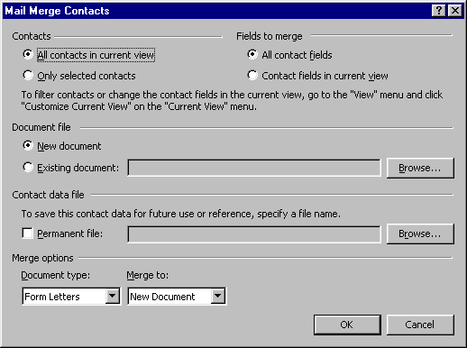

Selecting Contacts
Starting Mail Merge from Outlook takes advantage of the Outlook powerful view architecture. Users can filter on all fields of a contact-standard or user-defined.

Contact Fields
By default all contact fields are exported to Microsoft Word for use in the Mail Merge and again, custom fields are fully supported. Users can specify to employ only fields that are displayed in their current view-which speeds up the export process and creates smaller files.

Contact Data
Outlook exports selected contacts to a temporary file that is automatically cleaned up after use. Users can specify a file name if they want to reuse the exported contacts later or if the creation process of the Mail Merge document stretches over multiple days.

Main Document
Users can also specify to create a new document or to use an existing file.

Merge Options
Outlook supports all Microsoft Word merge types. Users can create form letters, catalog lists, envelopes or labels. The Mail Merge process can create a new document or output to a printer. It can also send faxes or e-mail messages.

Printing Contact Information
Even in the information age it is still important to print data on actual paper for use in a paper organizer or to bring to a meeting. Outlook can print contact information in many ways.

Standard Format
Outlook can print contact information on standard paper sizes supported by a user’s printer, but also on many different custom paper formats like Day-Timer, Day Runner, FiloFax, Franklin Day Planner and Avery.

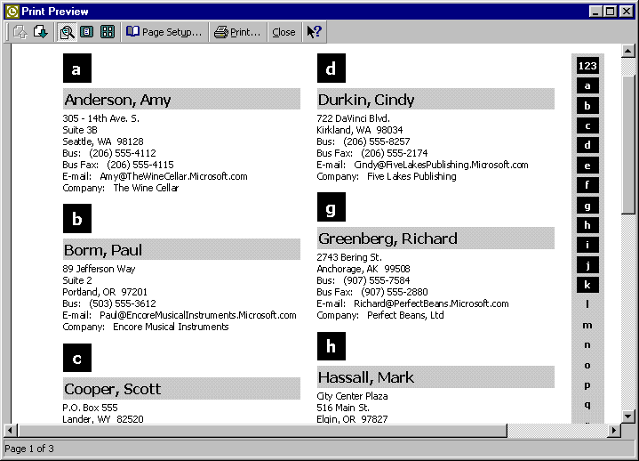

Single Contact
Users can also print the information of one contact in an Outlook specific format that shows all valuable properties.

Views
Views can be printed exactly as they are defined on screen. Fields visible in the view will be printed.

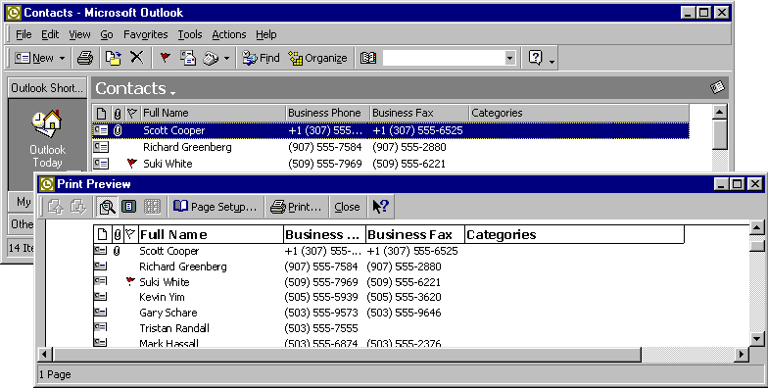

Organizing Contacts
A user can not work with a contact if they can not find it. This chapter will show how Outlook helps the user to find contacts. It will also illustrate how Outlook allows users to structure a large contact database to fulfill their individual needs.

Finding a Contact
Activate “Advanced Find”

QuickFind – enter name and hit return

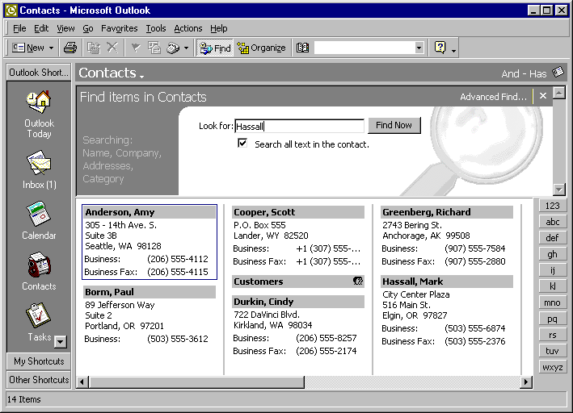
Find pane for quick filtering

Type ahead functionality on sort by field
Click to go to first contact starting with “M”

QuickFind
A combobox on the standard Outlook toolbar. Outlook searches contact folders and the Exchange global address book, then opens matching contacts. Since this combobox is visible in all modules, it allows users to find contacts without leaving the module they are currently using.

Find Pane
Activated through “Tools➔Find” or the “Find” toolbar button. Contact’s name, company, address, category fields and optionally the notes field are searched for text entered in the Find Pane edit field.

Type Ahead
Typing in non-editable views will scroll to the entry that matches the sort by field-In the picture typing “Bell” activated “Bellevue Community College”.

Index Tab in Card Views
Just like a real organizer, Outlook Card View displays letters of the alphabet on the right site-click the letter to navigate to the first entry starting with the respective letter.

Advanced Find
Activated using the menu “Tools➔ Advanced Find” or the folder context menu. Allows for complex searches of one or multiple contact folders.

Look up e-mail recipient
The context menu of e-mail recipients allows the look up of contacts.

Look up Contact

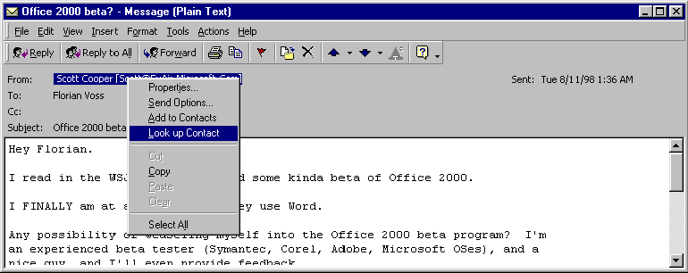

Organizing Groups of Contacts

Folders
Users can create as many contact folders as they like. It makes sense to clearly separate contacts in contact folders if their group membership will does not change. For example, a good use of contact folders would be to create a folder “Friends and Family” and a folder “Business”. It is very unlikely that a user will start to do business with his mother or will become a close friend with a customer contact. A bad use would be to create a folder “Contacts to call this week”-the user would end up copying contacts back and forth all the time.

Views
Views allow users to present contacts in one folder in a user defined form. Users can filter out specific contacts, decide which fields are shown, group by certain fields and set other formatting options. Views are the right tool to build contact groups when the group membership is based on frequently changing contact fields. The category of a customer might change from “normal” to “preferred,” a customer might be flagged for a follow up call one week and might be without a flag set the next.

The first big benefit of Views is that they are dynamic. As soon as the field of the contact is set, its group member ship is established. The following View is grouped by Flag Status. If the Flag Status of a contact is set, it will immediately appear in the “Flagged” group. The second big benefit of Views is that a contact can appear in multiple Views at the same time while it can only live in one folder. A user can use a View “Best Customers” to determine who gets the free baseball tickets and a View “Next Actions” to show the customers that are flagged for action. One customer can appear in both Views.

The users can create as many Views as they need and can customize a wide array of parameters. A View with all its settings can be saved under a name.

Sort by a field.

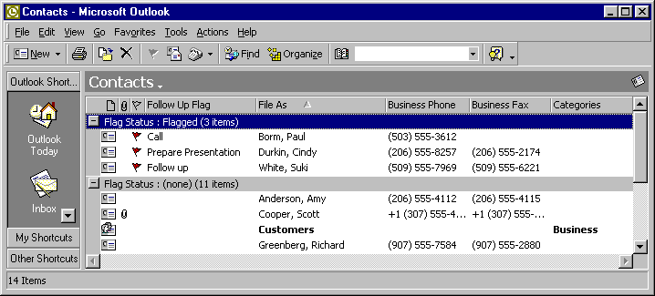
Group by Flag Status
Customize Gridline settings (none shown)
Added field “Follow up Flag”

View Type
Users can create Views of different type-for contact folders the two important ones are the card view and the table view. The Card View shows a small card for each contact, the Table View shows contacts in a list form.

Activating Views
Users can activate views through the “View➔Current View” fly-out menu or using the organize pane.
Show the “Organize” Pane

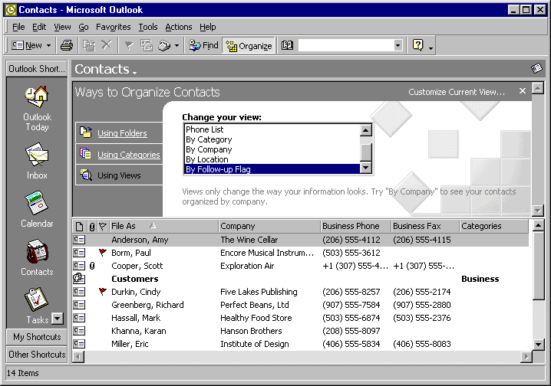
Customize the current view
Activate a View

Saving Views
Users can save views via the “Define Views” dialog activated by the “Views➔Current View➔Define Views” menu.

View Properties
The “View➔Current View➔Customize Current View” menu or a right click on the column headers of a table view activate the “View Summary” dialog.

Right click Context menu column headers
View menu

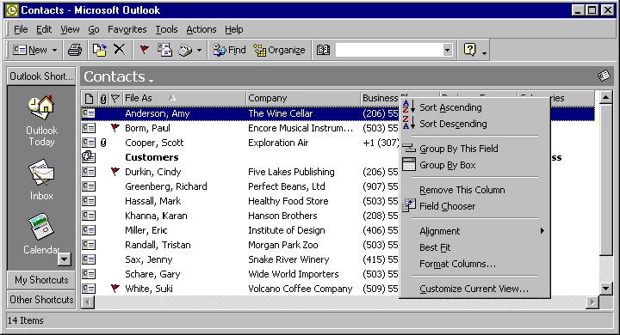

This “View Summary” dialog allows user to set view properties.

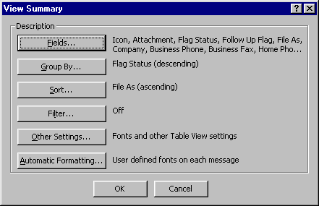

Fields
Users can freely pick which fields are displayed in any view type. It is possible to display standard Outlook fields as well as user-defined fields.

Group by
Contacts can be displayed in contact groups based on contact fields. Groups can be expanded or collapsed by clicking on their header rows. A view grouped by Flag Status would show all contacts that are flagged for a follow-up action in one group.

Sort
Views can by sorted by any field. Clicking on the column header sorts a view by this column.

Filter
Very powerful filters can be defined for a view. If a filter is set, the view will only display the contacts that satisfy this filter. For example setting the filter to “Categories = Business” will only show business contacts.

Other Settings
Users can define the font of the view, control whether or not gridlines are shown, or switch on a third pane that displays the note field of contacts.

Automatic formatting
Users can decide to define special formatting rules for the display of individual contacts. For example contacts of the category “VIP” could be displayed in red, bold font.

Customizing Fields & Forms
While Outlook provides many fields for contact information, it is not possible to satisfy every user. Therefore it is easy for users to create their own special fields, add them to views and contact forms.

Adding Fields
It is easy to add fields to contacts in an Outlook contact folder.

Type of field
Users can freely name their fields and choose from a large variety of data type and formatting options.

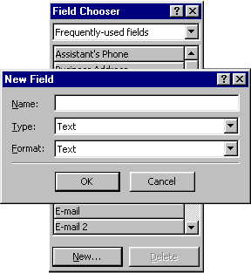

“New Field” button

Add new fields in the following ways:

- Field Chooser. Users can activate the Field Chooser through the column header’s context menu. The Field Chooser has a “New” button that shows the “New Field” Dialog. Newly created fields can be dragged from the field chooser into the active view. The Field Chooser can also be activated in the Forms Design view of a contact form.
- View customization. Users can activate the “Show Fields” dialog of the “View summary” dialog.

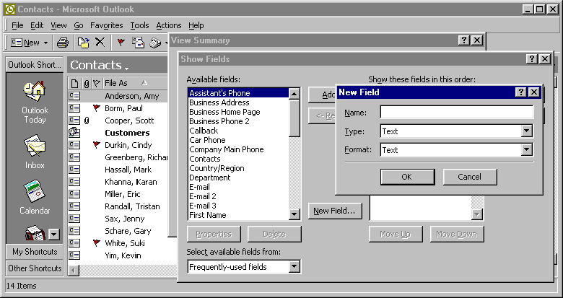
“New Field” button

Customizing Forms
Outlook allows full customization of contact forms, including customization of the first tab. Users can simply add additional fields to be displayed, but can also use the full power of the Visual Basic Script programming language to create complex custom forms. This section will give a quick overview. More detailed information can be found in the Forms Design Help file.

Step 1: Entering Design Mode
Enter design mode from any form in a contact folder using “Tools➔Forms➔Design This Form.”

Step 2: Making changes
Design the form by moving, removing and adding fields and pages in the form. All fields in the form and all fields added from the Field Chooser retain their built-in properties and functions.

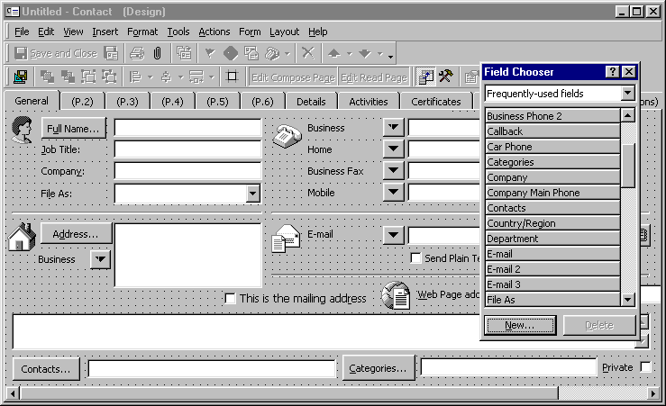

Step 3: Publishing the form
Publish the form to the contact folder using the “Tools➔Forms➔Publish Form” command.

Step 4: Creating a new contact with the custom form
- Make the new form the default form. On the “General” tab of the “Contacts Properties” dialog, the new form can be set as the default form for this folder. All commands that create a contact like the “Actions” menu or the new toolbar will now use this form to create new items.
- Use “Actions” menu. If the form was published in the contact folder a “New Form Name” command will be appended to the “Actions” menu for each custom form in this folder.

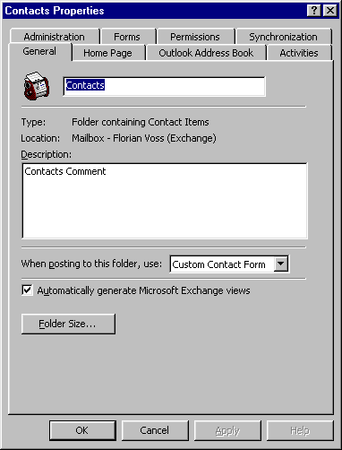

Note: Outlook saves a form design with each contact. That means that the form design of existing contacts is not changed when a new form becomes the default form for a contact folder.

This design is very powerful because it allows multiple form designs to coexist in one contact folder. However, this means that the forms of existing contacts do not automatically change when the folder’s default form is modified. A Component Object Model (COM) add-in that allows users to switch the forms of existing contacts will be available for download on the Outlook 2000 web site at http://www.microsoft.com/.

Sharing Contacts

Sending Contact Information by E-mail
Outlook makes it very easy to forward contact information through e-mail. Users can attach any number of Outlook contacts to an e-mail message using the “Insert➔Item” dialog. They can also directly forward a contact as a vCard or as an Outlook contact through a contact’s “Actions” menu.

NetFolders
NetFolders-an add-on component introduced in Outlook 98-allow users to easily share information over e-mail without an Exchange Server. To share a folder, the user chooses Share from the File menu. Subsequent changes to the folder are then broadcast to users via e-mail. The e-mail does not appear in users’ inboxes, but is instead used by Outlook to update the folder on each user’s computer. With NetFolders, users can share information with anyone to whom they send e-mail.
NetFolders give smaller organizations without Exchange Server or users that are travelling with laptops an easy way to share contact folders.

Exchange Server

Contact Centric Collaboration around Public Folders
In many cases more than one person is working with a set of contacts-like a team composed of sales people, marketing and technical staff and support personal. To provide the best service for the customers, the activities of this group have to be coordinated. Everybody has to know what meetings took place, what e-mail messages have been exchanged and which tasks still have to be completed.

In Microsoft Exchange, users can create public folders to share this kind of data in workgroups. Outlook 2000 supports contact activity tracking in public folders. Journal entries, tasks and e-mail items can be stored in a public folder and viewed from the Activities tab of a public contact. The following example explains how to set up a contact centric workgroup collaboration space.

Administrator/work group manager set up:
- Create Public Folders. Create a contact folder in the public folder space. Create a journal, task and e-mail folder as subfolders to this contact folder.
- User Permissions. For each of the folders give access permission to team through the “Permissions” tab of the folder properties.
- Define Folder Groups for Activities Tab of Contacts in the Contact folder. Select the work group contact folder, open its properties dialog and activate the “Activities” tab.

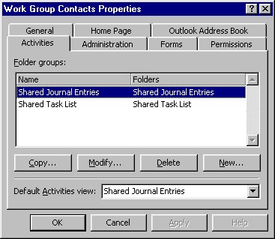
- Customize the Activities View. Create a contact in the public contact folder, go to the “Activities” tab. The “Show:” combobox now contains the two folder groups that were defined. Customize the view to show the columns and view settings that all users in the group should see by right-clicking on the column headers or using the “View” menu.

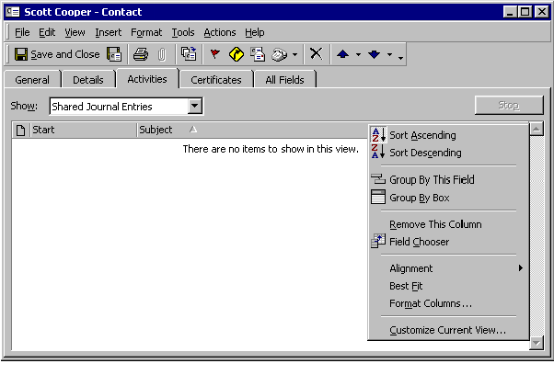

- Notify users of the new folder. Send a shortcut of the contact folder to the users who will work with this contact folder using “File➔Folder➔Send Link to Folder”.

Work Group member set up
- Adding the contact folder to favorites. Because the public folder favorite group has a “per user” setting, each user has to individually add the contact folder with its subfolders to their own favorite group. This is easily done by opening the folder and using the “File➔Folder➔ Add to Public Folder Favorites” command.

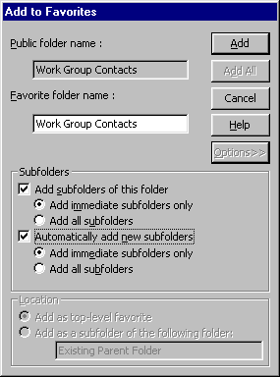

- Registering the contact folder as an address book. If the user wants to implement the contacts in the public contact folder as an e-mail address book they have to configure the contact folder on the “Folder Properties” dialog. This registration also enables the QuickFind toolbar to search this contact folder.

Working with the contacts in the folder
- Creating new associated items. All the “Actions” menu commands create items that will be saved in the user’s default folder. Therefore, new items should not be saved with the “Save” or “Save and Close” commands, rather with the “File➔Move to Folder” command.

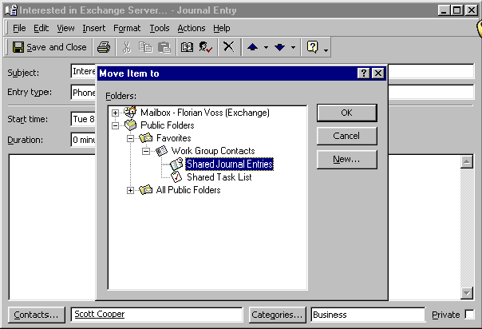

- Viewing Shared Activities. The “Activities” tab will now show the items that are stored in the folder groups that the administrator defined.

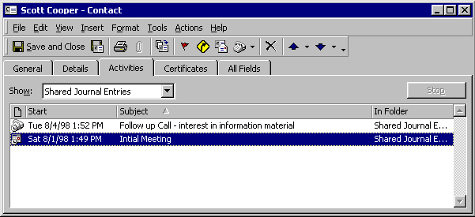

Sharing E-mail
It is a very common need to share incoming and outgoing e-mail from contacts within a workgroup. Exchange allows user to address e-mail directly to a public folder.

Add to Address book
Users add the folder to their address book through the “Folder Properties” dialog “Administration” tab. That allows them to address the folder in e-mail just like they would a regular contact

Forward or Blind Carbon Copy
Users can now forward incoming e-mail to that folder. They can enter the folder address in the “BCC:” field of outgoing e-mail to make copies of the e-mail available to their group members. “BCC” stands for “Blind Carbon Copy”-the customer who receives the e-mail is not able to see that it was copied to a work group folder.

Synchronizing Contact Information with Hand Held PC’s
Microsoft Outlook 97 and Outlook 98 can exchange information such as e-mail, schedules and contacts with a variety of handheld computing and communication devices, such as Windows™ CE Handheld PC computers, the Rex card from Franklin Publishing, the PalmPilot from Palm Computing, and certain cellular phones.

For more information, please visit the Outlook web site at http://www.microsoft.com/outlook/ for references of third-party products.

For more information: http://www.microsoft.com/office/


This is a preliminary document and may be changed substantially prior to final commercial release. This document is provided for informational purposes only and Microsoft makes no warranties, either express or implied, in this document. Information in this document is subject to change without notice. The entire risk of the use or the results of the use of this document remains with the user. The example companies, organizations, products, people and events depicted herein are fictitious. No association with any real company, organization, product, person or event is intended or should be inferred. Complying with all applicable copyright laws is the responsibility of the user. Without limiting the rights under copyright, no part of this document may be reproduced, stored in or introduced into a retrieval system, or transmitted in any form or by any means (electronic, mechanical, photocopying, recording, or otherwise), or for any purpose, without the express written permission of Microsoft Corporation.
Microsoft may have patents, patent applications, trademarks, copyrights, or other intellectual property rights covering subject matter in this document. Except as expressly provided in any written license agreement from Microsoft, the furnishing of this document does not give you any license to these patents, trademarks, copyrights, or other intellectual property.
Unpublished work. © 1998 Microsoft Corporation. All rights reserved.
Microsoft, the Office logo, Outlook, and NetMeeting are either registered trademarks or trademarks of Microsoft Corporation in the U.S.A. and/or other countries.
The names of actual companies and products mentioned herein may be the trademarks of their respective owners.

