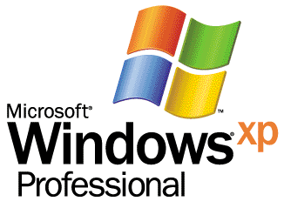 | 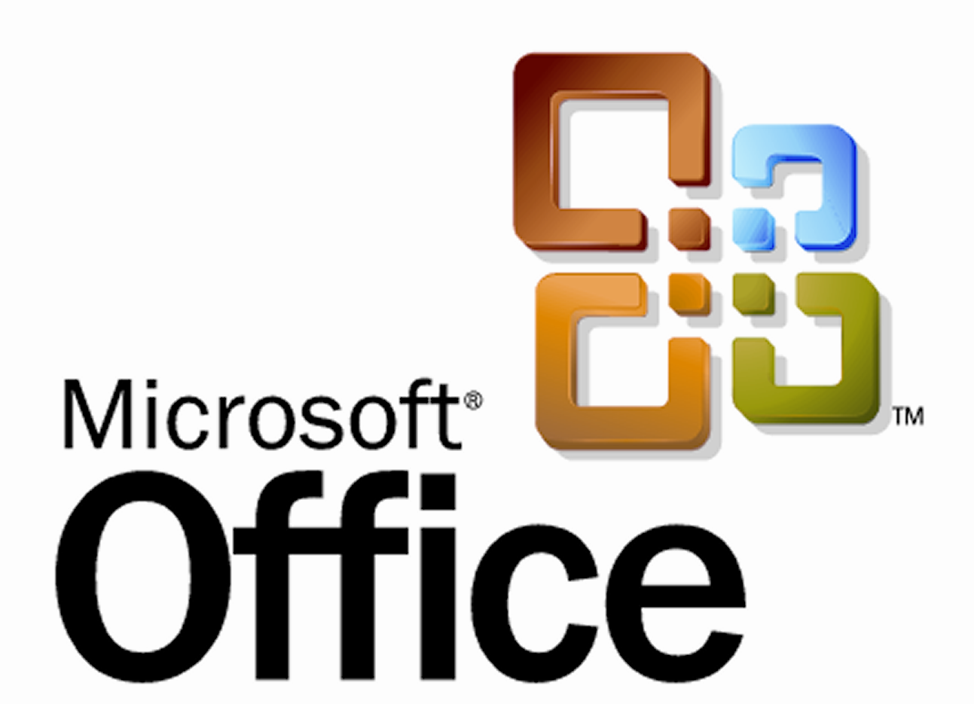
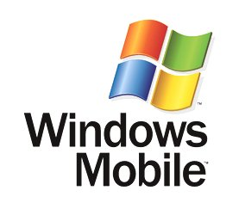
Windows XP Professional and Office Professional Edition 2003 for a Mobile Workforce
By Jerry Honeycutt
Published July 26
Abstract
Microsoft mobile solutions enable collaboration through communication. These solutions enable all of the mobility scenarios that this whitepaper describes by using systems with which you are already familiar, including Microsoft® Windows Server™ 2003, Microsoft Exchange Server 2003, Microsoft Windows® XP Professional, and Microsoft Office Professional Edition 2003. This white paper describes these solutions, including the key elements, investments, and decisions you must make in order to implement them in your organization.

The information contained in this document represents the current view of Microsoft Corporation on the issues discussed as of the date of publication. Because Microsoft must respond to changing market conditions, it should not be interpreted to be a commitment on the part of Microsoft, and Microsoft cannot guarantee the accuracy of any information presented after the date of publication.
This white paper is for informational purposes only. MICROSOFT MAKES NO WARRANTIES, EXPRESS OR IMPLIED, IN THIS DOCUMENT.
Complying with all applicable copyright laws is the responsibility of the user. Without limiting the rights under copyright, no part of this document may be reproduced, stored in or introduced into a retrieval system, or transmitted in any form or by any means (electronic, mechanical, photocopying, recording, or otherwise), or for any purpose, without the express written permission of Microsoft Corporation.
Microsoft may have patents, patent applications, trademarks, copyrights, or other intellectual property rights covering subject matter in this document. Except as expressly provided in any written license agreement from Microsoft, the furnishing of this document does not give you any license to these patents, trademarks, copyrights, or other intellectual property.
© 2003 Microsoft Corporation. All rights reserved. Microsoft, Active Directory, ActiveSync, MapPoint, MSN, the Office logo, OneNote, Outlook, PowerPoint, SharePoint, Windows, the Windows logo, Windows Mobile, and Windows Server are either registered trademarks or trademarks of Microsoft Corporation in the
The names of actual companies and products mentioned herein may be the trademarks of their respective owners. Microsoft Corporation • One Microsoft Way • Redmond, WA 98052-6399 • USA

Contents
Introduction 3
Mobility Scenarios 5
Road Warrior 7
Corridor Warrior 8
Telecommuter 9
Data Collector 9
Wireless Networking 11
Windows XP 12
Windows Mobile 2003 13
Wireless Infrastructure 13
Wireless Security 14
Mobile Devices 15
Notebook PC 15
Tablet PC 16
Pocket PC 2003 17
Smartphone 18
Mobile Infrastructure 19
Mobile Collaboration 20
Summary 23
For More Information 24

Introduction
Business communication is more than checking email and voice mail; for mobile users, it’s immediately accessing important information; acting on that information to the benefit of the business; and collaborating efficiently with customers, partners, and colleagues. In other words, successful business communications rely on an efficient exchange between people and data, which Microsoft’s mobile solutions enable.
In the not too distant past, mobility was merely taking laptop computers on the road. Deployment was simply selecting the best laptop computer and setting up phone lines for dial-up network access. And mobile users had simple access to files and connections to corporate email servers.
Expectations have increased, however, and the Internet has enabled a new vision for mobility that your competitors are leveraging. To compete, you must take advantage of this new vision in order to remain competitive in a world where data flows easily, people stay in ready touch, and mobile users are as effective away from the office as they are in the office. To achieve the goal, your mobile users need access to their line-of-business (LOB) applications. They need robust access to their email, and they require collaboration tools that help them share and access information. To complete the vision, your mobile users require the ability to connect to the corporate network from anywhere, anytime, and by using any device. Security from intrusion and viruses must pervade every part of this vision, from the mobile devices to the software they run to the infrastructure that supports them.
In this paper, you find the following sections:
This section: | Describes:
Mobility Scenarios | The four basic types of mobile users
Wireless Networking | The infrastructure for implementing wireless networking
Mobile Devices | The mobile devices that are available for your users
Mobile Infrastructure | The infrastructure for supporting the mobility vision
Mobile Collaboration | The tools available for enabling mobile collaboration
Figure 1 shows how to achieve the new vision for mobility. You don’t need separate systems to enable the mobility scenarios that this whitepaper describes. By using Windows Server 2003 and Exchange Server 2003 with Microsoft Windows® XP Professional, Office Professional Edition 2003, and a variety of mobile devices that work together throughout these solutions, you can significantly enhance mobile users’ productivity on the road, in the office hallways, or anywhere they need to connect to people and information. Microsoft .NET connects people to the information, systems, and devices that you see in this diagram. As a result, deploying and testing separate systems isn’t necessary, and in most cases, you can take advantage of much of your existing infrastructure and employee knowledge that already exists.
Figure 1. Microsoft Mobile Vision

Mobility Scenarios
Everyone in an organization can benefit from the Windows XP Professional and Office Professional Edition 2003 mobile features. Nader Djafari, Director of IT Operations and Services at Macromedia, said “Windows XP Professional gives our users the freedom to work where they want, reducing their stress and improving their productivity. Features like Remote Desktop and Offline Files and Folders mean that with Windows XP Professional, there are no barriers to productivity—just a lot of choices about how and where you want to work.” Office Professional Edition 2003 adds collaboration and productivity features to those that Nader Djafari mentions, making it easier for teams to work together productively—even when team members are away from their desks.
Even though these mobile features offer higher levels of productivity to everyone in an organization, different types of users gain these benefits in different ways. Microsoft identifies four types of mobile users who can benefit from these features. They are road warriors, corridor warriors, telecommuters, and data collectors. Each type of mobile user reaps the benefits of Windows XP Professional and Office Professional Edition 2003 from different combinations of form factors and remote access solutions. Table 1 summarizes these users, and the sections following this one provide more detail about each:
- Road Warrior. Professionals who travel frequently and require remote access
- Corridor Warrior. Knowledge workers who spend most of their time away from their desks
- Telecommuter. Knowledge workers who work occasionally at home
- Data Collector. Field service employees who travel fulltime, requiring remote access
Table 1. Mobility Scenarios
 | Road Warrior | Corridor Warrior | Telecommuter | Data Collector
Profile | - Connects to customers and colleagues | - Spends most time away from desk  - Collaborates with colleagues | - Accesses the corporate network irregularly | - Collects and processes data  - Delivers enhanced services to clients
Travel | - Mostly external | - Some external travel  - Meetings all day | - Accesses network from home or home office | - > 80% externally
Business Requirements | - Access to Email, Calendar and PIM  - Access to corporate network resources and line-of-business (LOB) applications  - Data and access security | - Access to Email, Calendar and PIM  - Access to information and applications while away from desk  - Data and access security | - Access to information and applications while at home office  - Data and access security | - Access to corporate network resources and LOB applications  - Data and access security
Form Factors | - Laptop PC  - Tablet PC  - Pockets PC  - Smartphone | - Laptop PC  - Tablet PC  - Pocket PC  - Smartphone | - Laptop PC  - Smartphone | - Pocket PC  - Tablet PC
Mobile Access | - Public wireless  - Dial-up  - Virtual private networking (VPN) | - Corporate wireless  - Remote Desktop | - Cable, DSL  - VPN  - Remote Desktop Dial-up | - Public wireless  - Dial-up  - VPN
Examples | - Executives  - Consultants  - Sales representatives | - Executives  - Healthcare workers  - Students | - Knowledge workers | - Field service employees in various industries

Road Warrior
Road warriors are typically professionals who travel frequently, such as sales professionals, spending up to 80% of their time out of the office. Whether they are corporate executives, members of a mobile sales force, or field representatives; they require technology that enables them to stay connected with customers and colleagues and allows them to work anytime from anywhere. Because road warriors aren’t within easy reach of the help desk, they need robust hardware and software on the road. And spending most of their time away from the office doesn’t reduce their need for the same applications that colleagues at the office use.
Ferghus is an example of a road warrior. Ferghus is a mobile sales professional who uses a laptop computer running Windows XP Professional. On his laptop computer, he runs a custom SQL Server™ application that contains a complete product catalog. Ferghus is able to update the product catalog by using dial-up connections and public hotspots for wireless access. The database updates orders and inventory information in real-time when an Internet connection is available; otherwise, the database synchronizes with the network when he returns to his hotel room each night.
The many, easy-to-use networking features in Windows XP Professional and Windows Server 2003 make it possible for Ferghus to stay current with his company’s inventory—even when he’s on the road. Ferghus also uses his connection to the company’s SharePoint™ portal to collaborate on proposals and documents with partners and colleagues. Using Office Professional Edition 2003, he can gather data from the portal that he uses to build targeted presentations for the next day’s client meetings.
He also easily synchronizes and updates his email and calendar information from Exchange Server 2003. He’s able to synchronize Office Outlook® 2003 with the server by using RPC over HTTP, which means that he doesn’t have to use VPN connection to connect to the corporate network. And Office Outlook 2003 is aware of the connection’s speed, so it downloads only mail headers if the connection is slow. For cases in which his computer isn’t handy, however, he can still access his email by using Office Outlook 2003 Web Access (OWA). When he’s disconnected from the server, he still has access to his information because Office Outlook 2003 maintains a local copy of his mailbox and address book (Cached Exchange mode).
Ferghus is one example of a road warrior. Road warriors have a broad choice of mobile devices from which to choose. They can use a traditional laptop computer, like Ferghus, or Tablet PC with wired and wireless networking. In any case, road warriors require access to corporate network resources and LOB applications through dial-up connections, VPN, or wireless public access. They tend to use their handheld devices for calendaring, email, and travel planning, so they can back up their primary computers with a Pocket PC or Windows Mobile-based Smartphones. Their information is with them regardless of whether they’re in a taxi, waiting for a flight, or on the go.

Corridor Warrior
Corridor warriors are professionals who work in the office but spend most of their day away from their desks. Examples of corridor warriors include healthcare professionals and managers. They travel less than 20% of the time and are usually dashing through the corridors from one patient or one meeting to the next. They require access to information and applications while away from their desks, add-hoc collaboration with their colleagues, and a paperless environment.
Julie is a healthcare worker and a typical example of a corridor warrior. During a typical day, she spends very little time sitting in front of her desktop computer. Instead, she bounces from patient to patient, visiting each in a different examination room. Lugging around a laptop PC isn’t an option; instead, she grabs her Windows XP-based Tablet PC from its docking station when she visits a patient. On her Tablet PC, she’s able to schedule appointments, look up patient history, take notes by using OneNote, collaborate with colleagues, look up diagnostic information, and more. Of course, she’s untethered from the network because her Windows XP-based Tablet PC supports wireless networking, so she’s free to move about the office with her computer.
The primary form factor for corridor warriors like Julie is the Tablet PC. They can also supplement traditional desktop computers with Windows Mobile-based Pocket PCs or Smartphones. Regardless, wireless networking is the key to keeping these professionals productive, and wireless Tablet PCs running Windows XP Professional or Windows-based Pocket PCs help them stay on top of their day. As Peter Tijerina, Consulting Systems Engineer with the Burlington Northern Santa Fe Railroad points out, “We’re seeing a growing demand for wireless network connectivity, and the level of support in Windows XP Professional will enable users to switch between docked and wireless configurations without having to adjust any settings or reboot their machines.” As well, OneNote running on a Tablet PC allows them to take handwritten notes which can be organized and reused efficiently; and InfoPath plugs them in to their company’s business processes. Adding the collaborative features of Exchange Server 2003 and SharePoint Portal Server further increases the productivity of these professionals. For example, Meeting Workspaces help make meetings more productive by getting information about them to attendees early.

Telecommuter
Telecommuters work at home at least 1 day a week. They are a special case for the IT department, often accessing corporate resources from a home computer by using a broadband or dial-up connection. With the Windows XP Professional feature Remote Desktop, telecommuters can access their office desktop PCs and corporate resources as though they were sitting in front of it. Telecommuters who leave the office only occasionally might take their Windows XP Professional-based laptop PCs back and forth to the office.
For example, Maggie takes her Windows XP Professional-based laptop PC to work at home. The next day, she starts the computer and then connects to the Internet by using broadband. Because of Network Location Awareness, she doesn’t need to reconfigure the computer’s network connection each time she changes location. After she connects to the Internet, she creates an IPSec-secured VPN connection to the office network. Then, she can work in a number of ways, depending on her requirements and how the IT department set her up. For example:
- She can connect to her desktop computer by using Remote Desktop. Afterward, she can work as though she were sitting in front of her desktop computer, including using her Office Professional Edition 2003 applications.
- She can connect to the corporate Terminal Server farm to access the applications available to her.
- She can use Office Professional Edition 2003 installed on her laptop PC. For example, she can use Outlook 2003 to check her email or use Word 2003 to edit a document located on the network.
In any case, telecommuters either have a desktop computer at home or a laptop computer that they take home with them. They require remote access to corporate network resources using VPN through dial-up or broadband Internet connections. They also connect to their primary desktop computer by using Remote Desktop.

Data Collector
Data collectors are field service employees in a variety of vertical industries. They tend to collect and process data, deliver enhanced services to better serve clients, and are out of the office or away from their desks more than 80% of the time. For example, delivery drivers, warehouse employees, and insurance claim adjusters are examples of data collectors. To help them perform their jobs, a plethora of vertical-market applications are available for wireless Windows Mobile-based Pocket PCs.
An example of a data collector is Bruce, an insurance claims adjuster. He uses a Windows Mobile-based Pocket PC with a customer .NET Compact Framework application that the IT department built to track information for a claim. As he works, he’s able to input data in to the master SQL Server database over a live GPRS connection. Also, he receives automated Systems Management Server (SMS) text messages from SQL Server indicating that he has another claim to process. To make his job easier, the custom application connects to the MapPoint® .NET Web service for directions to the new job site. But when he arrives at the new site, he’s unable to connect to GPRS due to the site’s remote geography. This isn’t a problem, however, because the custom application uses SQL Server 2003 Windows CE Edition to store data locally until he returns to a network coverage area.
In addition to using Windows Mobile-based Pocket PCs to collect data, data collectors can use Windows Mobile-based Smartphones. In any case, they require access to LOB applications through wireless networking and GPRS.

Wireless Networking
Wireless networking has revolutionized mobile computing for all types of mobile users. They are more productive, as they can access corporate network resources by using any public wireless network and can roam the building with their laptop computers and still have network access. When public wireless networks (short-ranged, high-speed 802.1x wireless networks in places like coffee shops, airports, and so on) aren’t available, they can still access their information by using their Smartphones to connect to the network using mobile operator data services (long range, low-speed data services such as GPRS, PCS, and so on). Wireless networking means that mobile users can squeeze more work time out of their day by gaining 8 to 12.5 hours per week in added productivity, and it significantly enhances their quality of life. The following list shows how wireless networking makes road warriors, corridor warriors, and data collectors more productive and improves their quality of life:
- Road warriors. Wireless networking can turn idle time into productive time by allowing road warriors to connect to corporate network resources that traditional wired network connections can’t access. For instance, sales professionals waiting for a delayed flight can use their laptop computer running Windows XP Professional to connect to the corporate network by using a public hotspot at the airport. Once connected, they can check email, access product catalogs, collaborate with colleagues via a SharePoint site, and so on. The result is that mobile sales professionals are able to make decisions quicker, since they don’t have to delay those decisions until they return to the office or find a wired network connection.
- Corridor warriors. By definition, corridor warriors spend more time away from their desks than they do sitting at them. Healthcare professionals are great examples of corridor warriors. Wireless networking keeps corridor warriors connected to the network whether they’re in meetings, consulting with patients, or working in the front office. They can use their Tablet PCs running Windows XP Tablet PC Edition to look up patient records, take notes, and send a quick message to a colleague. And they can use Remote Desktop to connect to their desktop computers, using them as though they were sitting at their desks typing on the keyboard. Wireless networking keeps corridor warriors connected even when wired network connections aren’t available or aren’t practical.
- Data collectors. Wireless networking is almost a necessity for data collectors. The locations where data collectors typically work aren’t practical locations for wired network connections. For example, installing wired network connections on a manufacturing floor or garage isn’t feasible. Wireless networking used in conjunction with devices like Pocket PCs and specialized applications not only make data collection in these places more feasible but also make it cost effective. Data collectors in the field, such as delivery drivers, can also rely on wireless networking at public hotspots to synchronize their data when their mobile operator data services connections aren’t available.
For all types of mobile users, wireless networking allows mobile users to connect to corporate network resources where traditional wired network connections aren’t available. It enables immediate collaboration regardless of whether a wired network connection is available. Decisions are made quicker because the usual delay of users returning to their desktop computers is eliminated by an instant, wireless connection to the corporate network. Last, wireless networking makes mobile computing more convenient. Rather than the frustration of finding phones and dialing in to the network, many mobile users choose to wait until later because of the inconvenience. Frustration levels decrease as mobile users learn that they can connect to their resources without hassles.

Windows XP
Wireless networking is better with Windows XP Professional. Windows XP Professional reduces wireless deployment costs via automatic configuration. The combined Rapid Economic Justification (REJ) and various total cost of ownership (TCO) studies show that when Windows XP Professional was installed, the increased reliability and stability directly influenced user productivity, efficiency, and support costs. Combined with wireless capability, the studies show a significant drop in the cost of ownership and a rise in productivity and efficiency. The Windows XP Professional wireless networking features themselves save organizations an astonishing $830 per laptop computer each year. For more information about REJ, see http://www.microsoft.com/value. Windows XP Professional also reduces Help desks’ call times for wireless networking questions due to simplified configuration, automatic roaming, and built-in Wi-Fi support. Windows XP Professional makes wireless networking practical for the average mobile user for whom it wasn’t previously feasible.
Windows XP Professional has new features and enhancements that make remote and wireless access simple for any wireless user, which in turn provides significant productivity gains for employers. Organizations considering Windows XP Professional find significant value in its ability to automatically enable wireless networking. Such cost reductions are directly related to features such as the Wireless Zero Configuration service, which allow users to leverage the technology without involving IT support staff. The following list describes scenarios in which Windows XP Professional and the Wireless Zero Configuration service make users more productive:
- With a wireless network adapter installed, Windows XP Professional searches for available networks to which it can connect. When an available network matches a preferred network, Windows XP Professional connects to it. If there are no configured preferred networks or no preferred networks are found, users can also select a specific network to which they want to connect. Users can prioritize the list of preferred networks—Windows XP Professional stores the list and connects to the networks in the chosen order. Connection management is possible without user intervention, but user interaction is sometimes necessary to choose specific networks or prioritize connection order.
- Automatic configuration makes wireless networking more practical for mobile users. Because configuring wireless network connections in Windows XP Professional is much easier than earlier versions of Windows using third-party device drivers, all types of mobile users can easily configure their wireless connections. Estimates are that simplified network configurations save organizations $68 per laptop each year. Wireless networking and simplified network configurations benefit IT professionals, too. Because users are more able to configure their own network connections, they become more self-sufficient. IT professionals no longer need to plan and configure every connection when they deploy the operating system to mobile users. And the Help desk gets fewer calls from mobile users as they change environments and thus need to configure new network connections.
- As users physically move their wireless computers from room to room, Windows XP Professional automatically remains connected by finding the best wireless AP with which to communicate. When it finds a new wireless access point, it automatically negotiates authentication and authorization with that wireless access point without user intervention, which provides a great experience for the mobile user. A user can move anywhere within a given wireless network and remain connected to the network. You can also configure an ad hoc wireless network, which is convenient during meetings when users want to share and collaborate.
Windows XP Professional makes wireless networking better in ways other than provided by the Wireless Zero Configuration service. For example, the operating system includes device drivers for most of the popular wireless adapters. And the device drivers that come with Windows XP Professional fully support Wireless Zero Configuration. In many cases, IT professionals don’t need to deploy third-party device drivers for their wireless adapters, and mobile users don’t have to download and install device drivers on their own (check the Hardware Compatibility List—HCL—before purchasing wireless adapters). Also, Windows XP Professional provides built-in support for IEEE 802.1X security. For more information about 802.1X wireless security, see the section “Wireless Security.”

Windows Mobile 2003
Windows Mobile 2003 software has support for wireless networking similar to Windows XP Professional. Like Windows XP Professional, Zero Configuration Wi-Fi makes finding and connecting to any 802.1x wireless network easy for Windows Mobile 2003 users. When a Wi-Fi-enabled Pocket PC encounters wireless hotspots, Windows Mobile 2003 automatically asks users if they want to connect to the network. Afterward, Windows Mobile 2003 saves the connection’s settings so that it connects automatically the next time the device is in range of the wireless network. Windows Mobile 2003 also detects automatically the presence of other data service devices, making it easier than ever for mobile users to stay in touch with people and information.

Wireless Infrastructure
Wireless networking is beneficial to an enterprise’s infrastructure in the following ways:
- Temporary network connectivity is more practical and less expensive. Wireless networking makes it feasible to set up, use, and take down temporary networks as required. Microsoft is a good example of leveraging this benefit. For example, the company configures temporary wireless networks at trade shows for the benefit of staff and attendees. A more general example is creating a temporary wireless network for the final crunch of a big project, which you can disassemble at the project’s completion.
- Wireless networks are quicker to deploy than wired networks. Wireless networks are more flexible than wired networks. They’re quicker to deploy because you don’t have to run cable throughout your building, and Windows XP Professional makes configuration easier.
- Wireless networking is more feasible in locations where wired networks aren’t practical. Locations such as conference rooms and cafeterias aren’t practically wired, and wireless networking makes it easy to add a network to those rooms. And traditional wired networking isn’t practical outdoors, but wireless networking is a perfect solution for an outdoor network. Additionally, older buildings and some types of construction prohibit pulling wires for a traditional network. Wireless networking significantly reduces the cost of networking in those scenarios and enables networking in environments that weren’t possible. For that matter, wireless networking is cheaper to deploy than cabling a building, and it scales more easily.

Wireless Security
While Wi-Fi has experienced a rapid growth, the industry has raised a number of security issues. The Wi-Fi standard defines authentication and encryption services based on the Wired Equivalent Privacy (WEP) algorithm. The problem is that WEP provides weak security and doesn’t scale to typical enterprise wireless deployments because key management is almost impossible. Windows XP Professional and the industry’s support for the following technologies combine to make wireless networks more secure, however:
- 802.1X. 802.1X provides authentication-based access control for wireless networks. For more detailed information about 802.1X and supporting protocols, see Wireless Network Security with IEEE 802.1X. Windows XP Professional ships with support for 802.1X. All major NIC vendors also support 802.1X and most have released Windows drivers that support it. Likewise, all major enterprise access-point vendors are supporting 802.1X. Contact your hardware vendors for more information about their support.
- WPA (Wi-Fi Protected Access). WPA is a replacement for WEP that provides more robust methods for encrypting data and authenticating network connections. The result is a new level of protection for mobile users who are taking advantage of the Windows XP Professional wireless features. For more information about WPA, see Overview of the WPA Wireless Security Update in Windows XP.
- RADIUS. RADIUS enables centralized authentication, authorization, and accounting for network access. Originally developed for dial-up remote access, RADIUS is now supported by wireless access points. Windows Server 2003 provides Internet Authentication Server (Microsoft’s implementation of RADIUS). The following are great resources to starting learning more about using RADIUS servers:
RADIUS Protocol Security and Best Practices, Internet Authentication Service for Windows 2000, Enterprise Deployment of IEEE 802.11 Using Windows XP and Windows 2000 Internet Authentication Service, and Microsoft Wireless LAN Deployment and Best Practices.
- Active Directory. For wireless networking, Active Directory® domains contain the user and computer accounts for authentication and the Group Policy settings to deploy computer certificates. To learn more about how Microsoft deployed Active Directory for use with wireless networking and the best practices that resulted, see the paper Microsoft Wireless LAN Deployment and Best Practices.
- Certificates. 802.1X and related protocols rely on digital certificates to verify the identity of users and computers. For more information about public-key cryptography and the Windows 2000 public key infrastructure (PKI), see the Windows 2000 Security Services Web page. To learn more about how Microsoft deployed certificates for use with wireless networking and the best practices that resulted, see the paper Microsoft Wireless LAN Deployment and Best Practices.

Mobile Devices
This section describes the four basic types of mobile devices:
- Notebook PC
- Tablet PC
- Pocket PC
- Smartphone

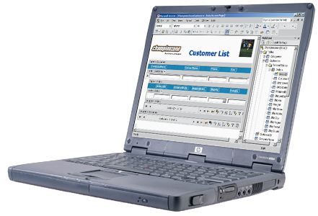
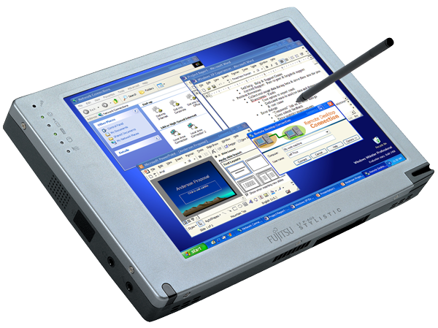
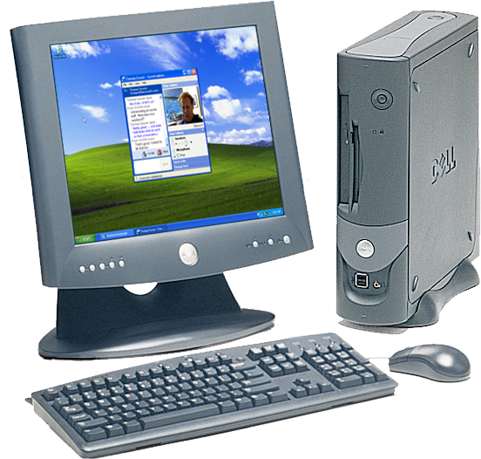
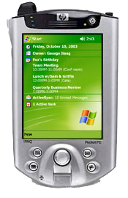
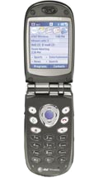
Figure 2 relates the type of mobile user to the mobile devices most suitable for their requirements. Each quadrant in this figure represents a level of productivity and mobility, with the top-right quadrant representing the highest level of both. The sections following this one describe these devices in more detail.
Potential Productivity Gains
Increased Mobility
Corridor Warrior
Tablet PC or Notebook + possibly Pocket PC
Road Warrior
Desktop or Notebook
and Home PC
Telecommuter
Work Extender
Data Collector
Tablet PC or Notebook +
Pocket PC and/or Smartphone
Tablet PC or Notebook +
Pocket PC and/or Smartphone
Figure 2. Mobility Usage Scenarios

Notebook PC
Notebook PCs (such as laptops, portables, etc.) are the staple computers for most business travelers. Current models contain in a slim form the processing power and conveniences that were limited to traditional desktop computers only a few years ago. For example, current high-end laptops, most of which are designed for Windows XP Professional, contain feature sets similar to the following:
- Pentium 4 mobile processor
- 256 MB of memory
- 40 GB of hard disk space
- Enhanced battery life and management
- High-resolution display adapters (1280 X 1024, for example)
- Universal Serial Bus (USB) ports
- FireWire (IEEE 1394) ports
- Wi-Fi networking support (802.11b wireless networking)
- Bluetooth wireless
These features make current-day laptop computers feasible replacements for desktop computers and essential companions for road warriors. No longer is maintaining both types of PCs necessary. And Windows XP Professional and Office Professional Edition 2003 make using laptop computers a better experience. Larry Rowland, CIO of Macromedia said, “Laptops increase productivity of users and Windows XP Professional increases the productivity of laptops—that’s a powerful equation.” The whitepaper “Windows XP Professional and Office Professional Edition 2003 for Mobile Business Users” describes the benefits of this combination.

Tablet PC
Tablet PCs with Windows XP Tablet PC Edition extend the features of laptop computers and Windows XP Professional, making it the best choice for the millions of road warriors, corridor warriors, and data collectors. Sales professionals working on the road, senior executives overseeing operations around the world, or supervisors working on the manufacturing floor all spend many hours each week working in places other than their offices.
Tablet PCs give mobile workers a powerful, versatile computing experience. The Tablet PC is a fully functional laptop that runs Windows XP Tablet PC Edition. Windows XP Tablet PC Edition is a superset of Windows XP Professional designed to add pen computing to an already rich feature set, not a stripped-down version of the operating system. Windows XP Tablet PC Edition provides new, advanced handwriting and speech recognition, which is surprisingly accurate, enabling the creation, storage, and transmission of handwritten notes and voice data.
Windows XP Tablet PC Edition adds the following to the features of typical laptop PCs:
- Tablet PCs run Windows XP Professional with specific enhancements for tablet computers. Users get all the features, reliability, and power of Microsoft’s latest operating system, as well as handwriting and speech recognition in a tablet form factor.
- Tablet PCs can run any application that’s compatible with Windows XP Professional. Users have access to the same tools that they have on their desktop computers in more versatile, tablet computers.
- Tablet PCs are available in two form factors, pure tablet and convertible, allowing users to choose a model that best suits their needs. Pure tablets don’t have a keyboard and rely on the pen as the primary input device. Convertible tablets have a keyboard and mouse but allow users to rotate the screen to use it like a tablet.
- Tablet PCs support docking stations and a variety of common accessories. Users can take advantage of a full complement of peripherals, including a full-size monitor, keyboard, mouse, printers, and external drives.
- Tablet PCs enable surprise hot-docking as well as fast standby and resume. Surprise hot-docking allows users to grab their Tablet PCs from their docking stations and get down the corridor in a hurry. Also, Tablet PCs resume from standby mode in about 5 seconds. This functionality allows users to save power when they aren’t using their computers without wasting time when they’re ready to use their computers again.
Last, pen and ink features extend to Office Professional Edition 2003, including ink capabilities in each Office Professional Edition 2003 program, so you can use your tablets’ pens to handwrite text in Outlook 2003, Word 2003, PowerPoint® 2003, and Excel 2003. And OneNote™ 2003 and Tablet PCs empower mobile users to collaborate more effectively by enabling them to take comprehensive notes, access crucial information, and share notes with team members.

Pocket PC 2003
Windows Mobile-based Pocket PCs give users the freedom to manage their work while on the go. They provide users the choice to communicate how they choose and stay connected to corporate information when they’re not in the office. Pocket PCs include familiar Microsoft software, including Pocket versions of Outlook, Word, Excel, and Internet Explorer. And, since Pocket PCs integrate with users’ desktop computers, users can take their files with them without having to learn new software.
Here are some examples of what users can do with Pocket PCs, using a form factor that fits in their pockets:
- Wirelessly exchange email and browse the Web
- Wirelessly exchange messages by using MSN® Messenger
- Open email attachments and edit them by using Pocket Word and Excel
- Access travel information, including local weather, flight status, and maps
- Make travel reservations, such as car, hotel, flight, and dinner
Microsoft recently released Windows Mobile™ 2003 that adds many features that mobile business users need. It includes Zero Configuration wireless, for example, just like Windows XP Professional. It supports Bluetooth, which makes connecting a Pocket PC to other Bluetooth-enabled devices easy. ActiveSync® technology synchronizes users’ devices with Windows XP Professional and Exchange Server 2003. Microsoft updated Connection Manager to make managing connections easier for users. And Windows Mobile™ 2003 includes better support for messaging, input, contact management, calendaring, and much more. The new features of Windows Mobile™ 2003 make it a truly indispensable tool for the mobile business user.

Smartphone
Windows Mobile-based Smartphones extend mobile phone technology. Smartphones deliver a rich set of applications, highly integrated telephony functionality, and an open development platform. Mobile phones built on the Smartphone platform provide both voice and text communication and rich wireless data applications in one easy-to-use device, as well as make it a truly personal and powerful mobile phone for work.
Windows Mobile-based Smartphones are available now. For example. the Motorola MPx200 is available in the US and Figure 3 shows the actual device.
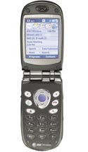
Figure 3. Motorola MPx200 Windows Mobile-based Smartphone
With Windows Mobile software, Microsoft is introducing a new phone experience. The company is integrating PDA-type functionality that mobile users rely on to do their jobs into a voice-centric handset that is comparable in size to today's popular cell phones. Smartphones are designed for one-handed operation with keypad access to both voice or data features. They’re optimized for voice and text communication, wireless access to Outlook information, and secure connections to corporate networks and the Internet. ActiveSync synchronizes Smartphones with Windows XP Professional and Exchange Server 2003. The Windows Mobile-based Smartphone gives users a choice to communicate via voice or text along with the ability to access information and services so you can stay in touch while on the road.

Mobile Infrastructure
Your mobile infrastructure supports users’ mobile hardware and software. Wireless networking, mobile devices, Windows XP Professional, Office Professional Edition 2003, and so on are only part of the vision. Microsoft also provides applications servers that support these client technologies. The following list describes these technologies and refers you to documents that contain more information:
- Windows Server 2003. Windows Server 2003 is the newest version of Microsoft’s server operating system. It offers organizations improvements over Windows 2000 Server by making the server operating system easier to deploy, manage, and use. For example, server roles make configuring Windows Server 2003 for remote access and VPN connections simpler. For more information about Windows Server 2003, see http://www.microsoft.com/windowsserver2003.
- Exchange Server 2003. Exchange Server 2003 is the core component of Microsoft messaging technologies. Microsoft designed it to unite employees and knowledge with a wide choice of access, including Outlook 2003 and Outlook Web Access. Exchange Server 2003 combined with Microsoft Mobile Information Server 2002 extends access to Pocket PC devices, Smartphone devices, and mobile browser-based devices. Exchange Server 2003 integrates seamlessly with Windows Server 2003, the Active Directory® directory service, Internet Information Services, and Microsoft Operations Manager. Exchange Server 2003 also meets the messaging and collaboration needs of any sized organization. For more information about Exchange Server 2003, see http://www.microsoft.com/exchange.
Outlook Web Access enables mobile users to access their email, calendars, contacts, tasks, and public folders from any computer with an Internet connection and a Web browser. With Exchange Server 2003, Outlook Web Access has even better performance, is more secure, and has user interface improvements that closely match those of Outlook 2003. For more information about Outlook Web Access, see http://www.microsoft.com/exchange/owa.
- Internet Security and Acceleration (ISA) Server. ISA Server provides mobile users with access to corporate network resources. It is a strong and reliable firewall between the public Internet and your private networks. ISA Server supports mobile users on the outside of the firewall via VPN technologies and IPSec security, which allows mobile users to connect to the corporate network securely. For network administrators, ISA Server provides a single point for management tools to control the access that mobile users have to network resources. Centralized management makes it simple for network administrators to control large distributed networking environments as simply as they can run a single-site network. For more information about ISA Server, see http://www.microsoft.com/isaserver.
- Live Communications Server 2003. Live Communications Server 2003 provides your business with enterprise-ready instant messaging (IM), presence awareness, and an extensible platform that connects people, information, and systems—enabling better decisions faster. With a familiar user experience integrated into Microsoft Office Professional Edition 2003 programs, Live Communications Server 2003 allows people to communicate without the constraints of geography, office location, or time zone.

Mobile Collaboration
Everything that this whitepaper has presented to this point has led to collaboration. Providing mobile users tools for connecting to the corporate network and building out the infrastructure to support those connections are the foundations for collaboration. The following list describes the Windows XP Professional and Office Professional Edition 2003 features that enable mobile users to collaborate more effectively:
- Office Professional Edition 2003. Office Professional Edition 2003 can help your organization and employees transform information into impact. It includes new and enhanced functionality to help people take advantage of this information, enabling them to communicate more effectively, collaborate with coworkers, and improve business processes. For more information about Office Professional Edition 2003, see http://www.microsoft.com/office.
- OneNote 2003. OneNote 2003 empowers mobile users to collaborate more effectively. It allows them to contribute in an increasingly demanding business environment by taking more accurate, comprehensive notes. It helps mobile users to access crucial information so they can make better decisions and take more effective action. Last, OneNote 2003, shown in Figure 4, gets teams and organizations on the same page so they can work together faster and more easily. For more information about OneNote 2003, see http://www.microsoft.com/office/onenote/prodinfo.
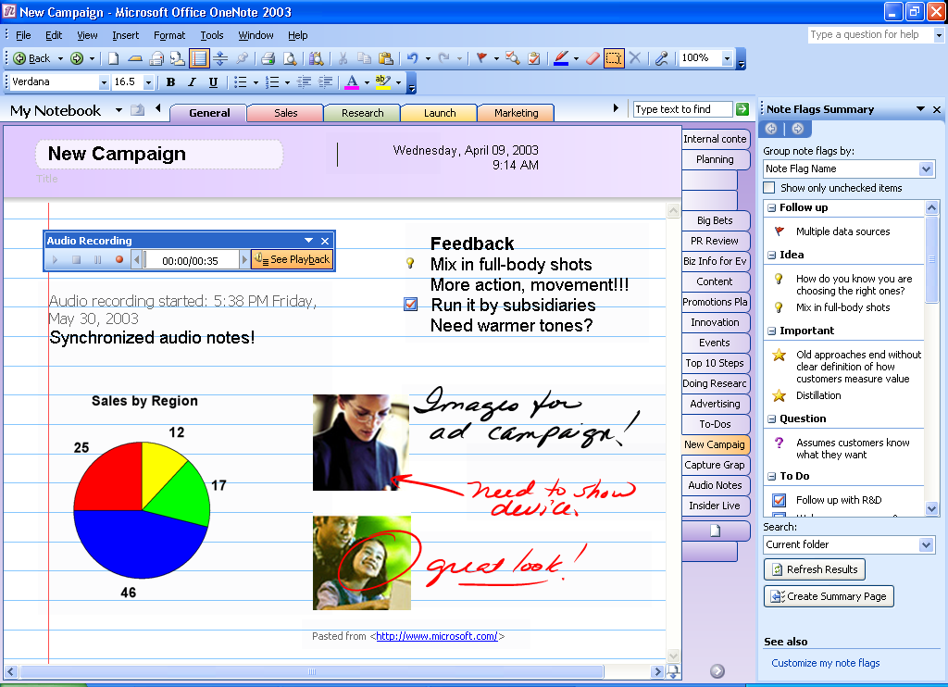
Figure 4. OneNote 2003
- Windows Messenger. Windows Messenger is the easy way for mobile users to communicate with their customers, partners, and colleagues. It keeps users updated with their contacts' online status. Users can collaborate with their online contacts, transfer files, and share applications and whiteboard drawings. Windows Messenger provides users with a great platform for online conferencing and collaboration and also improves relationships with customers and partners, as well as enhances communication among employees. The Windows Messenger technology in Windows XP Professional makes improvements in three significant areas, too. It’s an easy, complete real-time communications experience that lets users control their communications. It provides a better quality experience featuring phone-call quality voice and acceptable-quality video, so calling over the Internet is not only affordable but also engaging. It’s an extensible platform that extends the benefits of real-time communications to any application or service, enabling users to leverage innovations from developers and service providers. For more information, see http://www.microsoft.com/windowsxp/windowsmessenger.
- SharePoint technologies. Windows SharePoint Services 2.0 and Microsoft Office SharePoint Portal Server 2003 help mobile users share information whether they’re in the office or on the road. When they use it with Office Professional Edition 2003, SharePoint products and technologies provide benefits such as a central repository for documents, an interactive work environment for collaboration, and an architecture that allow you to separate the Web-hosting processes from the site data-retrieval processes. For more information about SharePoint technologies, see http://www.microsoft.com/office and http://www.microsoft.com/sharepoint.

Summary
Mobile business users need the ability to work when, where, how, and with whom they want—effortlessly. They need immediate access to information and people so they can act to benefit the business. Their success relies on an effective exchange with their customers, partners, and colleagues, as well as on their data, which the vision that this whitepaper describes enables. This vision has the following attributes:
- Connected. Microsoft’s mobile solutions enable your mobile business users to stay connected. They can communicate easily and collaborate with customers, partners, and colleagues more effectively.
- Productive. Microsoft’s mobile solutions help mobile business users work as productively away from the office as in the office. Windows XP Professional and Windows Mobile 2003 provide access to people and information when your workers need it.
- Dependable. Microsoft’s mobile solutions provide a secure and reliable infrastructure for supporting mobile business users. Dependability is critical on the road; they can rely on these solutions to help secure their information and their network connections ensuring performance at the highest levels.
You can enable Microsoft’s vision for mobility without requiring many separate systems, and in most cases, you can take advantage of much of your existing infrastructure and employee knowledge that already exists. By using products with which you’re already familiar—Windows Server 2003 and Exchange Server 2003 with Windows XP Professional, Office Professional Edition 2003, and mobile devices that work together throughout—you can significantly enhance mobile users’ success on the road, in the hallways, or anywhere they need to connect to people and information. To learn more about how this vision can help you build a better-connected business, see http://www.microsoft.com/business.

For More Information
Platforms:
- Windows XP Professional
- Office Professional Edition 2003
Devices:
- Windows XP Tablet PC Edition
- Windows Mobile-based Pocket PC
- Windows Mobile–based Smartphone
Infrastructure:
- Exchange Server 2003
- SharePoint Technologies
- Windows Sever 2003
Services:
- .NET

Empowering Mobile PC Users: The Financial Benefits of Windows XP Professional and Office XP, Bearing Point, December 2002

