
Landed Cost

Microsoft Dynamics™ SL

Capture actual shipping, handling, and import fees (landed costs) and easily roll them into the total cost of goods. With Microsoft Dynamics SL Landed Cost, distributors and manufacturers can calculate accurate inventory valuation by including additional charges beyond item purchase costs, such as miscellaneous origin and destination fees.

Benefits
- Improve accountability
Help ensure accurate cost and profit
analysis by accounting for all the costs
incurred for the delivery of inventory to the warehouse door, whether the costs are known at receipt or sometime thereafter.

- Reduce manual effort
Update inventory costs for items with
valuation methods, FIFO, LIFO, Average
Cost, and Specific Identification with
Multiple Valuation Method support.
Avoid adjusting entries after the fact by
automatically updating inventory values
and financial ledgers according to the
appropriate rules of each valuation method.

- Work with multiple currencies
Effectively record and account for the landed costs associated with goods acquired from international suppliers using multiple currencies. With bi-monetary support in Microsoft Dynamics SL Inventory, valuations
updated by landed costs can be represented in the inventory’s
alternate currency.

Accurately
account for all inventory costs as
soon as your inventory is delivered
to the warehouse door.

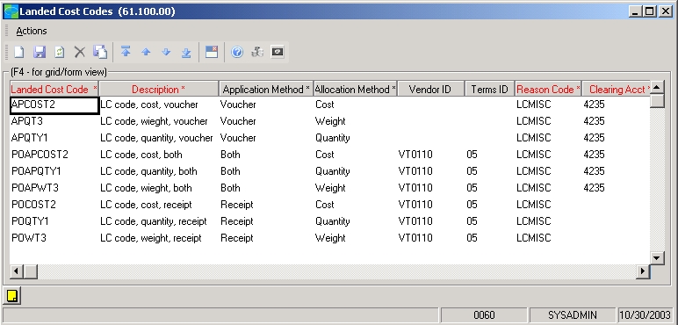

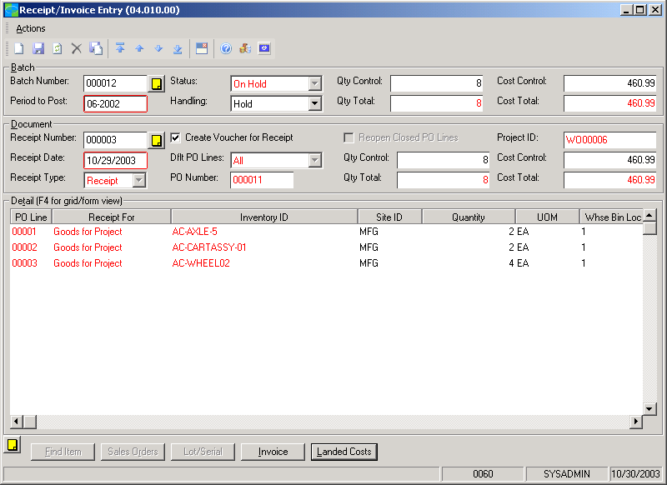

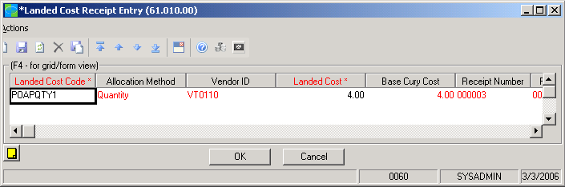

Adding
landed costs to your inventory
valuation enables you to calculate an accurate cost and profit analysis.



features

BENEFITS

Superior Accountability | Gain more accurate accounting of the total costs incurred in acquiring  goods to account for costs related to duty, freight, and insurance, which  are often added after the fact.
Inclusive Handling | Account for charges above and beyond the costs applied to merchandise  at the time of purchase order invoice/receipt entry.
Cost-Effective Administration | Manage profitability effectively by rolling the actual shipping, handling,  and import fees into the total cost of goods.
Precise Valuations | Streamline and improve procedures to correctly update inventory values  for costs incurred after goods are received according to their individual  valuation methods.
Streamlined Data Entry | Microsoft Dynamics SL Landed Cost automatically updates inventory  values and financial ledgers according to the appropriate rules of each  valuation method to ease manual tasks and help avoid adjusting entries  after-the-fact.
Multi-Currency Support | Convert and record landed costs incurred from international suppliers  easily. Enter values in their original currency for automatic conversion  to your base currency, ensuring a quick, easy, and accurate valuation.
Profitability Reporting | Accurately represent the true costs of used and tracked inventory goods  to reflect the correct profitability of your project. Landed costs are  automatically allocated to inventory goods received and posted to the  specified project.
Cost Grouping | Landed costs can be allocated to inventory items based on quantity,  cost, or weight.
After-the-Fact Updates | Record landed costs subsequent to the receipt of goods. Costs entered  after the fact will also update inventory value. Landed costs applied to  inventory goods received for a specific project will automatically record  and allocate the additional costs to the project.

For more information about Microsoft Dynamics™ SL, visit: http://www.microsoft.com/dynamics/sl

This document is for information purposes only.
MICROSOFT MAKES NO WARRANTIES, EXPRESS, IMPLIED, OR STATUTORY, AS TO THE INFORMATION IN THIS DOCUMENT.

© 2005 Microsoft Corporation. All rights reserved.
Microsoft, The Microsoft Dynamics Logo, are either registered trademarks or trademarks of Microsoft Corporation or Microsoft Business Solutions ApS in the United States and/or other countries. Microsoft Business Solutions ApS is a subsidiary of Microsoft Corporation.

