Microsoft® Office PerformancePoint™ 2007 Management Reporter  
Easily Consolidate and Share Key Business Data Across the Organization

**Microsoft® Office PerformancePoint™ Server 2007 is an integrated performance management application that provides robust monitoring, analytics, and planning capabilities. Microsoft Office PerformancePoint 2007 Management Reporter adds functionality to help corporations improve their business performance through an enhanced financial reporting process. Whether you are using PerformancePoint Management Reporter with PerformancePoint Server or directly with your general ledger system, your organization can create, generate and share financial reports easily, efficiently and accurately.**

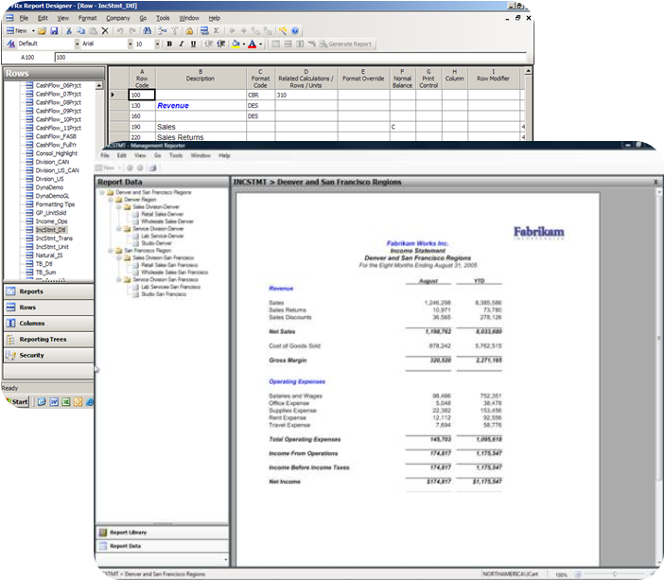

***Management Reporter is a powerful reporting application that makes it easy to visualize results.***

PerformancePoint Management Reporter and PerformancePoint Server 2007

Management reporting plays a key role in performance management. Displaying business results, performing variance analysis, comparing projections and consolidating data from disparate general ledgers provides business users with the business insight they need to make timely and relevant decisions. Accurate and auditable reporting is also essential to regulatory compliance.

Management Reporter is a part of PerformancePoint Server, which is built on the powerful Microsoft SQL Server™ platform. (Management Reporter is also available as a stand-alone solution, working directly with your general ledger.) It helps provides accurate reporting in real time, from a centrally managed source. Financial information is accurate and up-to-date, ensuring that reports are consistent. With Management Reporter, financial data can be combined from multiple financial models or general ledger companies and consolidated into a single report, giving your business users more visibility into the health of their business.

Benefits

Business users benefit from the easy-to-use and powerful reporting functionality included with Management Reporter, such as:

Cross-enterprise business view

Management Reporter provides organizations with a way to bring together financial information from different financial models or general ledger companies in order to create a consolidated view of the business.

Easy and secure report distribution

Widely distribute dynamic and standard reports including financial statements, management reports, and ad-hoc analysis to the decision-makers across the organization.

Strong support for regulatory compliance

Management Reporter helps organizations support generally accepted accounting practices (GAAP), international financial reporting standards (IFRS), and Sarbanes-Oxley regulations. Centralized data management, including security and business rules, and transactional reporting simplify regulatory compliance.

Enhanced partnership with IT

IT no longer has to spend time generating, formatting, and customizing financial reports for the business. Business users can create their own reports, while IT can help ensure they have the right infrastructure and data to access richer, more targeted information.

Key Features

These key features found in Management Reporter simplify the financial reporting process:

Easy creation and customization

Using the report wizard, key financial reports such as trial balance and income statements can be created in as few as seven steps. Additional templates are provided with Management Reporter that facilitate creating balance sheet and cash flow statements.

Advanced financial intelligence

Hierarchies can be defined to facilitate the creation of different views of your business. Business users can create management, legal, and soft consolidated reports. Combined with comparative data like month to month, year over year, and actual to forecast, business users are better able to understand business trends. Additional concepts include year to date amounts, debits vs. credits, and posted and unposted data.

Multiple ways to access reports

Business users can create and generate secured reports that are distributed to a report library for viewing via a native viewer, or exported to either Microsoft Excel or to RDL for access through SQL Server Reporting Services. Formatting is preserved, while business users can manage and access reports through the Microsoft Office SharePoint® Server 2007 Report Center.

Enterprise-grade statutory consolidation functionality

Business users can easily produce consolidated financial reports across multiple currencies while also supporting inter-company eliminations and reconciliations.

Integration with your general ledger

Management Reporter can be integrated with your general ledger system, allowing your organization to quickly create accurate and up-to-date reports easily. Partners and customers alike can use an SDK to build data providers that allow Management Reporter to connect directly to your general ledger system.

System Requirements

|  |
| --- |
| PerformancePoint 2007 Management Reporter is based on the following Microsoft programs and technologies:  ●   Windows Server® 2003, Standard Edition, or later  ●   Microsoft Windows® XP Professional SP2, or later  ●   Microsoft Office 2003 SP2, or later  ●   Microsoft SQL Server™ 2000 SP4, Standard Edition, or later  ●   Windows Installer 3.1, or later  ●   Microsoft .NET Framework 2.0  ●   Microsoft .NET Framework 3.0 |

For More Information

For more information about PerformancePoint Server 2007, visit <www.microsoft.com/performancepoint>.

For more information about Microsoft Business Intelligence, visit [www.microsoft.com/BI](http://www.microsoft.com/BI).