

Access-based Enumeration

Microsoft Corporation
Published: April 2005

Abstract
Access-based Enumeration (ABE) has been included in Microsoft® Windows Server™ 2003 Service Pack 1 to a) increase folder level security, b) improve administrator productivity by reliably streamlining large directory structures for less-technically savvy users, and c) provide a more seamless migration experience for end-users migrating to Windows servers. ABE filters shared folders visible to a user based on that individual user’s access rights, preventing the display of folders or other shared resources that the user does not have rights to access. ABE can be accessed via graphical user interface (GUI), command-line executable tool, and a robust advanced programming interface (API).



The information contained in this document represents the current view of Microsoft Corporation on the issues discussed as of the date of publication. Because Microsoft must respond to changing market conditions, it should not be interpreted to be a commitment on the part of Microsoft, and Microsoft cannot guarantee the accuracy of any information presented after the date of publication.
This White Paper is for informational purposes only. MICROSOFT MAKES NO WARRANTIES, EXPRESS, IMPLIED OR STATUTORY, AS TO THE INFORMATION IN THIS DOCUMENT.
Complying with all applicable copyright laws is the responsibility of the user. Without limiting the rights under copyright, no part of this document may be reproduced, stored in or introduced into a retrieval system, or transmitted in any form or by any means (electronic, mechanical, photocopying, recording, or otherwise), or for any purpose, without the express written permission of Microsoft Corporation.
Microsoft may have patents, patent applications, trademarks, copyrights, or other intellectual property rights covering subject matter in this document. Except as expressly provided in any written license agreement from Microsoft, the furnishing of this document does not give you any license to these patents, trademarks, copyrights, or other intellectual property.
The example companies, organizations, products, domain names, e-mail addresses, logos, people, places, and events depicted herein are fictitious. No association with any real company, organization, product, domain name, address, logo, person, places, or events is intended or should be inferred.
© 2005 Microsoft Corporation. All rights reserved.
Microsoft, MSDN, Windows, the Windows logo, Windows NT, Windows Server, and Windows Server System are either registered trademarks or trademarks of Microsoft Corporation in the United States and/or other countries.
All other trademarks are property of their respective owners.
Contents
Introduction 1
ABE Graphical User Interface 2
ABE command-line interface 5
Syntax 5
ABE API 7
Parameters 7
Returned values 7
SHARE_INFO_1005 flag 8
Remarks 8
Requirements 8
Limitations 9
Summary 12
Related Links 13

Introduction
File sharing in enterprise-scale environments can pose significant challenges. File servers are a critical part of every organization’s IT infrastructure and the crucial aspects of effective file sharing—data security and ease of access—must be balanced against each other. To help with this, Microsoft created Access-based Enumeration (ABE) and included it with Microsoft® Windows Server™ 2003 Service Pack 1 to increase security around file sharing, reliably streamline large directory structures for customers, and provide customers with a more seamless migration experience from foreign platforms. ABE filters shared folders visible to a user based on that individual user’s access rights, preventing the display of folders or other shared resources that the user does not have rights to access.
File sharing in networks poses unique security risks. One such risk arises from users without proper credentials seeing names of files and folders to which they do not have access. Even without accessing the contents of those folders, folder and file names can describe sensitive information such as customer names or research topics. ABE addresses this problem by making inaccessible files and folders invisible to users.
ABE can increase worker productivity. End users see only what files and folders they need for their responsibilities rather than spending time looking through lists of inaccessible folders and files. Administrators can be more productive because they do not have to help less-skilled users navigate through dense shared folders. Administrative inefficiencies can consume resources as surely as technical problems, and minimizing time-consuming problems help make any IT organization more productive.
In addition to making Windows Server 2003 easier to use, access-based filtering of shared folders also makes Windows Server 2003 easier to adopt. ABE provides a more fluid transition for customers migrating from various operating systems. With this new feature, file shares migrated to Windows can appear and behave the same as they did on another platform, which can reduce training time or communications necessary to guide users in a new environment.
Administrators can use the ABE graphical user interface (GUI) or command-line tool to activate this feature on shared resources. Alternatively, developers can use the ABE API to develop custom GUIs or command-line interfaces, or they can write scripts to selectively activate and deactivate ABE on many shared resources. A discussion of the ABE GUI follows below.

ABE Graphical User Interface
ABE can be implemented either by GUI or by command-line tool. The GUI provides customers with the most intuitive and self-explanatory means of enabling ABE, while the command-line interface allows administrators the most flexibility in managing ABE on shared resources across the network.
To access the ABE GUI, right-click on a shared folder and select Properties. The Access-based Enumeration tab of the Properties property sheet offers two options for enabling ABE.

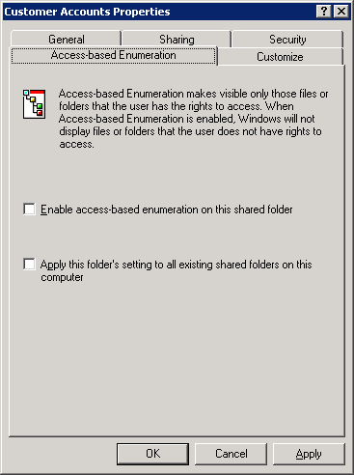
Figure 1 Customer Accounts shared folder without ABE
- To enable ABE on the selected shared folder only, select the Enable access-based enumeration on this shared folder check box.
- To apply ABE to all shared folders currently residing on a server, select Apply this folder’s setting to all existing shared folders on this computer check box.
Note that ABE can be enabled at the time of installation on all shared resources on the server on which ABE is being installed. After installation, ABE can be enabled via the GUI (specified above) or the command-line tool (specified later in this document). The option to enable ABE on individual shared folders is selected by default.

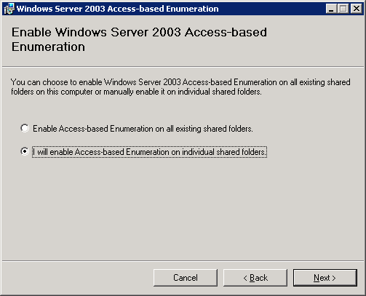
Figure 2 Access-based Enumeration installation wizard, enable on all shared resources option
To see ABE in action, consider the example of a user with limited access opening a shared folder containing folders for different customer accounts. Without ABE, this user will see all of the customer accounts in the folder. While the user can only access folders for which they have the appropriate permissions, just the names of the company’s customers may be sensitive information.

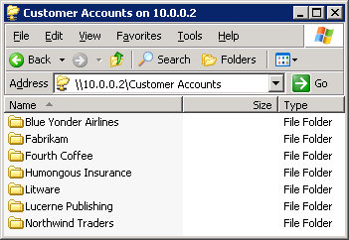
Figure 3 Customer Accounts shared folder without ABE
With the Enable access-based enumeration on this folder check box selected on the Customer Accounts Properties window (Figure 1), when accessing the Customer Accounts shared folder, the user would now see only the files he has permissions to view (Figure 4).

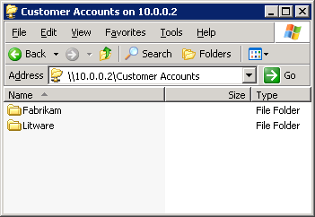
Figure 4 Customer Accounts shared folder with ABE enabled

ABE command-line interface
Administrators can execute ABE with great flexibility with the command-line tool, abecmd.exe. This command-line executable file allows system administrators to designate the shared resources to which the operation should apply. The command can be run either on the server on which the targeted shared resource resides or remotely from any member client or server with abecmd.exe. However, ABE can only be enabled on shared resources residing on servers running Windows Server 2003 SP1.

Syntax
abecmd [/enable | /disable] [/server <ServerName>] {/all | <ShareName>}
Parameter | Description
/enable | Enables ABE on the shared specified resource or on all shared resources.
/disable | Disables ABE on the shared specified resource or on all shared resources.
/server <ServerName> | Apply the action (making ABE enabled or not enabled) for shared resources on a server instead of the local computer.
/all | Apply the action (making ABE enabled or not enabled) for all shared resources.  Note: If /all and a ShareName is specified, the ShareName is ignored.
<ShareName> | Designates the shared resource to which ABE will be applied or removed.
Note: Either /all or ShareName must be specified.
With ABE enabled, the user in this scenario can only see those files which the user can access, in this case, Fabrikam and Litware. To enable ABE in this case, an administrator would have typed abecmd /enable “Customer Accounts” from the command-line on the file server (or abecmd /enable 10.0.0.2 “Customer Accounts” from another server).

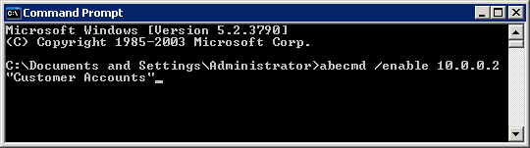
Figure 5 Command-line implementation of ABE on “Customer Accounts” share
Enterprise administrators can easily leverage this simple operation to obtain the powerful benefits of ABE. The command-line environment allows administrators and IT professionals to quickly enable or disable ABE. In addition to fundamental security and migration considerations, ABE benefits enterprise administrators by reducing time-consuming end-user support, freeing administrators to focus on higher-priority technical tasks. The convenience of a simple command-line interface allows administrators to capitalize on these advantages with minimal impact on dependent systems and services.

ABE API
Customers can also develop custom GUIs or command-line tools using the NetShareSetInfo API. NetShareSetInfo is a fully-integrated, robust API, ensuring compatibility of developed tools with Windows Server 2003 SP1. The API gives developers the tool to build scripts and interfaces to precisely implement ABE to meet the needs of the enterprise. In some circumstances custom interfaces can better meet the individual needs of administrators to easily select shared resources and toggle ABE on or off.
While this document will focus on the application of NetShareSetInfo to implementing ABE on shared resources, the API allows developers to read and set all parameters of a shared file or folder at an extremely low level. Thus custom scripts and interfaces utilizing ABE can interface elegantly and precisely with all aspects of shared network resources.
The NetShareSetInfo function sets the parameters of a shared resource:
NET_API_STATUS NetShareSetInfo(
LPWSTR servername,
LPWSTR netname,
DWORD level,
LPBYTE buf,
LPDWORD parm_err
);

Parameters
Parameter | Description
servername | Pointer to a string that specifies the DNS or NetBIOS name of the remote server on which the function is to execute. If this parameter is NULL, the local computer is used.  Note: In Windows NT® 4.0, this string must begin with \\
netname | Pointer to a string that specifies the name of the share on which to set information.
level | Specifies the information level of the data.  To enable ABE, this parameter must be set to 1005.
buf | Pointer to the buffer that specifies the data. The format of this data depends on the value of the level parameter.  With the level parameter set to 1005, the buf parameter points to a SHARE_INFO_1005 structure.
parm_err | Pointer to a value that receives the index of the first member of the share information structure that causes the ERROR_INVALID_PARAMETER error. If this parameter is NULL, the index is not returned on error.

Returned values
If the function succeeds, the return value is NERR_Success.
If the function fails, the return value can be one of the following error codes.

Return code | Description
ERROR_ACCESS_DENIED | The user does not have access to the requested information.
ERROR_INVALID_LEVEL | The value specified for the level parameter is invalid.
ERROR_INVALID_PARAMETER | The specified parameter is invalid.
NERR_NetNameNotFound | The share name does not exist.

SHARE_INFO_1005 flag
The flag within SHARE_INFO_1005 to enable ABE is SHI1005_FLAGS_ENFORCE_NAMESPACE_ACCESS 0x0800

Remarks
Only members of the Administrators or Power Users local group, or those with Print or Server Operator group membership, can successfully execute the NetShareSetInfo function. The Print Operator can set information only about Printer shares.

Requirements
Client | - Windows® XP  - Windows 2000 Professional  - Windows NT 4.0 Workstation  Note: While NetShareSetInfo can function on Windows® Me, Windows 98, or Windows 95, SHARE_INFO_1005 cannot.
Server | - Windows Server 2003  - Windows 2000 Server  - Windows NT 4.0 Server
Header | Declared in Lmshare.h; include Lm.h.
Library | Link to Netapi32.lib.
DLL | Requires Netapi32.dll.

Limitations
ABE changes the general behavior of file shares. These changes may require network considerations for which you may have not previously had to account. Despite the limitations, the command-line executable and API both allow administrators to precisely target resources on their networks for this functionality so that they may carefully balance the limitations with the benefits offered by ABE.
ABE may prevent backup applications from accessing all files and folders. This can interfere with the file backup process. Backup applications are built with the assumption that they will be able to access and copy all files in the directory structure. To prevent this problem, backup programs should run under the context of the service account that has the “back up files and directories” service right. Typically, Windows backup services run under this right. Additionally, the NetShareSetInfo API could be used to develop custom scripts to facilitate file backup properly in environments where ABE is deployed.
For more information about the NetShareSetInfo API, see the following:
- NetShareSetInfo on the MSDN® Web site at http://go.microsoft.com/fwlink/?linkid=45974
Also, in an ABE-enabled environment where multiple users work from the same client computer, cached server contents on the client computer can be seen by all users of the client computer.
ABE can also demand CPU resources from file servers. However, Microsoft benchmarking tests indicate that even for very large file structures, running ABE only consumes two to three percent of CPU cycles. Administrators must use their judgment in balancing security and performance on file servers, even when the overhead is small.
Below are two charts detailing a total of ten test runs reading shared directories containing from 500 to 128,000 files. The test runs were run sequentially, that is, all tests were run without restarting the server on which the test was run for each folder. Each set of six test runs consisted of accessing the shared resource three times with ABE not enabled, followed by accessing the share three times with ABE enabled.
Figure 6 Chart comparing folder access times with ABE not enabled and enabled, in turn
Figure 7 Detail of the first comparative chart focusing on smaller folders, filtered for disk reading
The data in Figure 7 shows the same information as the data in Figure 6, narrowed down to smaller directories: the chart only shows information for directories with 500 to 16,000 files.
Note that accessing the shared folder can sometimes be slower with ABE not enable. The server cache was primed before these test runs, enumerating the shared folders with ABE not enabled in order to read things like security profiles from the hard disk. This was done in order not to skew the test results: reading information from the hard disk is much more time-consuming than enumerating a shared folder with ABE enabled (as evidenced by Runs 1 and 2, both of which still had to read some information from the hard disk). Most importantly, with less than 15,000 files in the shared folder, access time for a server with ABE enabled and not enabled is indistinguishable—less than one second. While enabling ABE can certainly affect access time for particularly large folders, it represents a near trivial performance loss for smaller folders.

Summary
Sharing network resources in an enterprise is accompanied by unique challenges. ABE affords network administrators and IT professionals the means to meet the administrative side of these challenges by increasing system security, reliability, and productivity by limiting visibility of shared resources to those accessible by the user. ABE can help improve productivity by reducing the administrative burden associated with helping less-technically savvy users navigate shared folders in a large directory, of which many, they are not allowed to access. Finally, ABE increases the ease of use and adoption of Windows Server 2003, providing a more seamless user migration from competing operating systems. Provided with Windows Server 2003 Service Pack 1, ABE allows administrators to take advantage of this new feature via GUI, command-line executable tool, and API.

Related Links
For more information on ABE and related tools, see the following:
- NetShareSetInfo on MSDN at http://go.microsoft.com/fwlink/?linkid=45974
- SHARE_INFO_1005 on MSDN at http://go.microsoft.com/fwlink/?linkid=45504
- “Network Management Function Buffers” on MSDN at http://go.microsoft.com/fwlink/?linkid=45975

For the latest information about Windows Server 2003 SP1, see thee following:
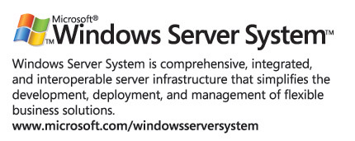
- Windows Server 2003 Web homepage on the Microsoft Web site at http://go.microsoft.com/fwlink/?linkid=5221

