
Bill of Materials

Microsoft Dynamics™ SL

Benefits
- Manage product structures
View product structures using a familiar
“explorer” type tool, navigating up and
down the tree that represents the parent/child relationships between parts. Identify items to be used in the manufacturing process and what quantities are required, adjusted by designated scrap factors.

- Define production routings
Define and document how the parts to
be used in the manufacturing process
are to be assembled and processed.
For each bill of material, you may define
a corresponding routing — from simple, using minimal labor information, to complex, focusing on move and queue time.

- Roll up standard costs
Build on product structures and routings to help you roll up standard costs, whether you are valuing your inventory at standard cost, or using one of the actual costing methods supported by Microsoft Dynamics SL Inventory. The robust update and rollup cost tools will make your job easier.

- Execute plans flawlessly
Use your pre-established multi-level bill
of material to relieve inventory for all
components and increment inventory for final assembly using the rolled-up cost. Flexible production entry helps you to easily execute your manufacturing plans.

- Monitor inventory
Using back flushing inventory
deductions, production entry can
explode subassemblies into component requirements, helping ensure that you keep accurate inventory levels for component, subassembly, and finished goods items.

Define, analyze, and manage your company’s products with Microsoft Dynamics SL Bill of Materials. Comprehensive features in three important manufacturing categories — bill of materials, production routings, and product costing — provide support for costing and production of manufactured and assembled goods.

View
costs, change orders, inventory information, and site information
for any bill of materials component.

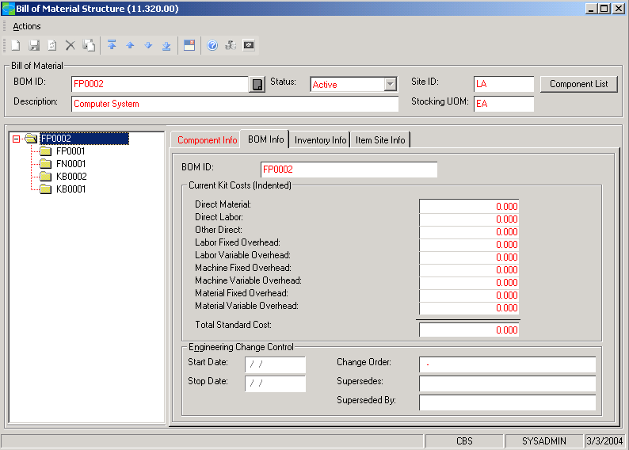

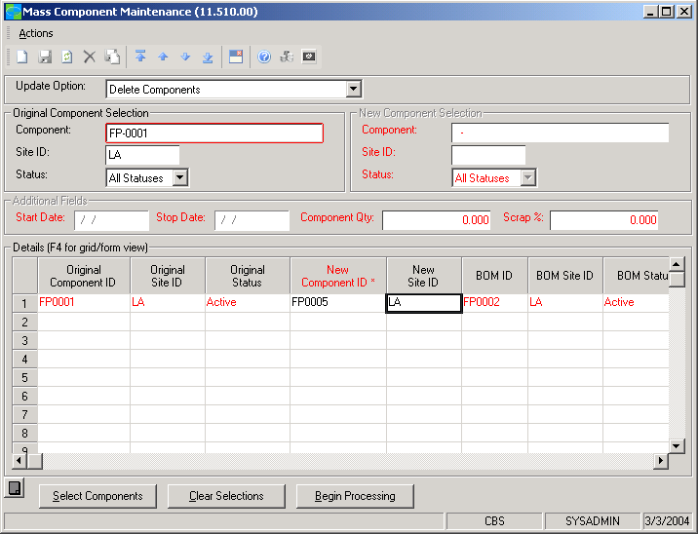

Manage
bulk deletion, replacement,
insertion, or modification of a
component across multiple bills
of material.

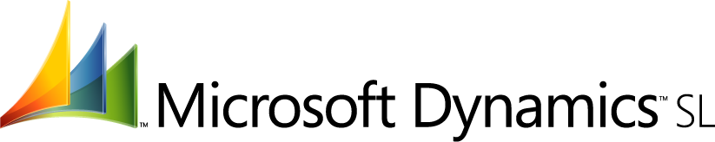

features

BENEFITS

Powerful Product Structuring | Define product structures on a multi-level basis, along with the instructions for how to build the manufactured item. Use these definitions to establish and manage standard costs.
Multi-Level Flexibility | “Nest” single-level bills in any order to define a multi-level bill, thereby  facilitating the multi-level manufacturing, documentation, and cost  rollup processes.
Robust Inventory Control | Maintain a unique bill of material for each site defined in your inventory  system. The same graphical representation is used to find where a  particular part is used throughout your Microsoft Dynamics SL Bill of  Materials definitions.
Integrated Work Order Support | Build the products you have engineered using work orders to track  work-in-process, including product structures and production routings.
Simplified Kitting and Assembly | Robust product definition — including parent/child relationships,  Product routing, and full cost roll-up — enable easy management  of production and assembly requirements.
Cost Control and Planning | Bill of Materials supports multiple costing methods while providing  roll-up for accurately costing production plans. Robust overhead  allocations and variance distributions provide cost visibility in the  planning and production of finished goods.
Adaptable Planning | Gain the flexibility to build as planned or change the plan on-the-fly at  a site level. Bill of Materials allows you to adapt business plans to meet  changing production, material, and labor requirements.
In-Depth Reporting | Sample Reports include a Bill of Material List, Component Where-Used  Lists, Standard Cost Change Preview, and many others — so you have  access to robust information at your fingertips.

This document is for information purposes only.
MICROSOFT MAKES NO WARRANTIES, EXPRESS, IMPLIED, OR STATUTORY, AS TO THE INFORMATION IN THIS DOCUMENT.

© 2005 Microsoft Corporation. All rights reserved.
Microsoft, The Microsoft Dynamics Logo, are either registered trademarks or trademarks of Microsoft Corporation or Microsoft Business Solutions ApS in the United States and/or other countries. Microsoft Business Solutions ApS is a subsidiary of Microsoft Corporation.

For more information about Microsoft Dynamics™ SL, visit: http://www.microsoft.com/dynamics/sl

