
Work Order

Microsoft Dynamics™ SL

Benefits
- Integrate with inventory
Microsoft Dynamics SL Work Order lets you know your on-hand and available inventory levels on a specific date so that you can view the plans and actions that are responsible for those levels.

- Maximize profits
Gain accurate, timely access to
work-in-process while production is under way and take corrective action on a work order with impending cost overruns. Production cost information is fully integrated with Microsoft Dynamics SL General Ledger for an accurate accounting.

- Gain inventory visibility
With a single click, access all plan and
action details for work orders, sales
orders, and purchase orders — including inventory position by site, cost layers, and transaction detail.

- Analyze costs
Collect production costs for all levels
on a single work order, or create a work
order to build each subassembly, and
then roll up the costs to the next level.
Where economies of scale dictate that a
work order produces more than a parent assembly requires, the excess may be placed into stock, or on another work order.

- Assess profitability
Easily evaluate the costs and profitability of your work orders and projects with high-level profitability and variance-to-budget analysis. Drill down to account category, transaction detail, and originating data entry screens.

Streamline the planning and handling of your work orders, so you that can control costs and maximize profits. Easy-to-implement and easy-to-use, Microsoft Dynamics SL Work Order helps plan and track product item costs and keep general ledger accounts and inventory quantities seamlessly integrated and in balance.

A quick glance
can provide important feedback on the progress of a work order.

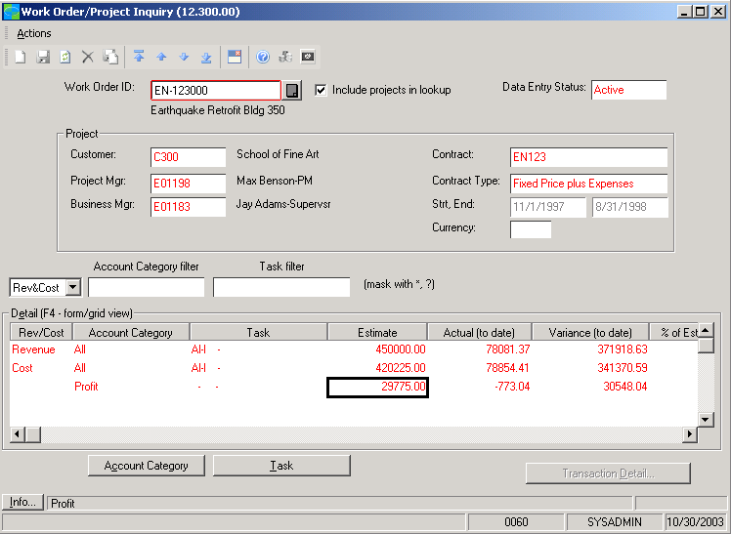

Compare
estimated and actual costs for
an accurate assessment of
profitability.



features

BENEFITS

Multiple Cost-Capture Methods | Capture any cost associated with inventory item production for each  work order, such as material, labor, and other costs. Outside costs  collected from other Microsoft Dynamics SL modules may be applied to  a work order.
Actual to Estimate or Actual to  Standard | Compare the estimated and standard costs established for the work order at the cost category level — as costs are applied to a work order (whether actual costs or based on standards).
Material Transfers and Returns | Return material or borrow from one order to satisfy another. Work Order  allows you to transfer material from one work order to another, back to  stock (any location), to a project/task, or to scrap.
Multiple Production Targets | Report production to multiple destinations. While keeping track of total  cost of production, distribute completed production to multiple locations  to maintain control throughout the production process.
Redirection of Production | Change intended production targets at the time the completed  production is reported — even if a work order was initiated with a  different intended production target.
Event History | Pinpoint the information needed to correct mistakes, and accelerate  training to minimize costs and increase revenue. Every event triggered  by Work Order is recorded in a detailed audit trail.
Powerful Reporting | Get the information you need when you need it. Sample reports include:  Shop Packet, Planned Inventory Position (projected on-hand inventory  balance for a given date), Work Order Profitability, Work Order Status,  and more.

For more information about Microsoft Dynamics™ SL, visit: http://www.microsoft.com/dynamics/sl

This document is for information purposes only.
MICROSOFT MAKES NO WARRANTIES, EXPRESS, IMPLIED, OR STATUTORY, AS TO THE INFORMATION IN THIS DOCUMENT.

© 2005 Microsoft Corporation. All rights reserved.
Microsoft, The Microsoft Dynamics Logo, are either registered trademarks or trademarks of Microsoft Corporation or Microsoft Business Solutions ApS in the United States and/or other countries. Microsoft Business Solutions ApS is a subsidiary of Microsoft Corporation.

