
Creating, Editing, and Managing Report Models for Reporting Services
SQL Server Technical Article

Writer: Jordi Rambla
Technical Reviewers: Douglas McDowell, Carolyn Chau, Bob Meyers, Paul Sanders

Published: January 2006
Applies To: Microsoft® SQL Server™ 2005 Reporting Services

Summary: This paper provides information about managing and editing report models with Microsoft SQL Server Reporting Services.
Copyright
The information contained in this document represents the current view of Microsoft Corporation on the issues discussed as of the date of publication. Because Microsoft must respond to changing market conditions, it should not be interpreted to be a commitment on the part of Microsoft, and Microsoft cannot guarantee the accuracy of any information presented after the date of publication.
This White Paper is for informational purposes only. MICROSOFT MAKES NO WARRANTIES, EXPRESS, IMPLIED OR STATUTORY, AS TO THE INFORMATION IN THIS DOCUMENT.
Complying with all applicable copyright laws is the responsibility of the user. Without limiting the rights under copyright, no part of this document may be reproduced, stored in or introduced into a retrieval system, or transmitted in any form or by any means (electronic, mechanical, photocopying, recording, or otherwise), or for any purpose, without the express written permission of Microsoft Corporation.
Microsoft may have patents, patent applications, trademarks, copyrights, or other intellectual property rights covering subject matter in this document. Except as expressly provided in any written license agreement from Microsoft, the furnishing of this document does not give you any license to these patents, trademarks, copyrights, or other intellectual property.
Unless otherwise noted, the example companies, organizations, products, domain names, e-mail addresses, logos, people, places and events depicted herein are fictitious, and no association with any real company, organization, product, domain name, email address, logo, person, place or event is intended or should be inferred.
© 2007 Microsoft Corporation. All rights reserved.
Microsoft, SQL Server, and Windows Server are either registered trademarks or trademarks of Microsoft Corporation in the United States and/or other countries.
The names of actual companies and products mentioned herein may be the trademarks of their respective owners.
Table of Contents
Introduction 1
Report Builder and Report Model Overview 2
Report Model 3
Report Model Components 4
Semantic Model Definition Language 4
Model Designer 5
Semantic Query Engine 6
Report Builder 6
Other Related Technologies 7
Report Designer 7
Report Viewers 8
Clickthrough Reports 8
Report Models from SQL Server Relational Databases 8
Creating a Data Source View 9
Generating a Report Model 11
Generating a Relational Report Model Automatically 12
Statistics in Report Model Generation 12
Editing the Generated Model 12
Reviewing the Generated Model 13
Model Presentation and Navigation Refinements 14
Model Structure Refinements 15
Advanced Model Refinements 15
Report Models from Analysis Services Data Sources 16
Model Generation 16
Analysis Services Design Considerations for Report Models 16
Cube Design Considerations for a Report Model 17
Query Behavior 18
Security 19
Report Model Deployment and Management 19
Security 19
Change Management 19
Schema Changes 20
Data Source Changes 20
Conclusion 20
Appendix A: Resources 21
For more information 21

Introduction
Microsoft® SQL Server™ Reporting Services (SSRS), a component of Microsoft SQL Server, is a comprehensive, server-based platform that enables the creation, management, and delivery of traditional paper-oriented reports, interactive Web-based reports, end-user ad hoc reports, and embedded reports. An integrated part of the Microsoft business intelligence framework, Reporting Services combines the data management capabilities of SQL Server and Microsoft Windows Server® 2003 with familiar and powerful Microsoft Office System applications to deliver real-time information to support daily operations and drive decisions.
In SQL Server 2005, Reporting Services includes a new ad hoc reporting tool called Report Builder that information workers can use to create their own reports and explore business data. Report Builder uses report models, which provide a user-friendly view of the business data and enables users to build reports without deep technical understanding of the underlying data sources.

About This Document
This document is designed to help customers and partners gain a better understanding of report models for Report Builder, how they work, and how to manage them. Topics included are:
- Overview of report models
- Report model design from SQL Server relational data sources
- Report model design from SQL Server Analysis Services data sources
- Model management and deployment
This paper applies to SQL Server 2005 Reporting Services only, as the Report Builder and report model functionality are new to this version of the product. This paper is intended as a complement to the report model documentation available in SQL Server Books Online. This paper assumes a basic understanding of Reporting Services and Report Builder. It is recommended that the reader already have completed the Report Builder and Report Model tutorials in SQL Server Books Online or an equivalent.

Report Builder and Report Model Overview
Enterprise reporting solutions are managed in much the same way as any typical IT project and usually focus on the functionality and report types that are predictable and add strategic value to the business.
Ad hoc report authoring is a complex task that does not fit a traditional business profile. Information workers know what information they need and how their report should look, but they usually don’t have the technical skills necessary to create a rich report design, to understand real-world database schemas, or to use formal query languages such as SQL and MDX. In contrast, IT staffers understand report design, the technical aspects of the data source schema, and formal query languages, but they are not available on demand to analyze, design, and deploy urgent or one-time reports.
Therefore, businesses need a reporting solution that enables information workers to create reports on demand and that speeds up simple report generation by IT staff.
The appropriate solution should cover two objectives:
- Make physical data source schemas easier to understand and utilize.
- Simplify the overall report-authoring experience for non-technical employees.
You can fulfill the first requirement by creating a metadata layer on top of the database schema and preparing it to present the most-frequently requested data in the most intuitive and accessible manner by using business taxonomy. The metadata layer will then translate report design, filtering, and parameters into the correct and optimized native queries against the underlying physical data source.
The second requirement is met by combining query design and layout design into simplified, high-level user actions. Report authoring using Report Builder starts with a predefined report template, which modifies the query and report layout together as the user adds or removes fields, groups, and subtotals. Templates drive the task of setting report layout, adding some uniformity to reports produced by different users.
SQL Server 2005 Reporting Services addresses these two requirements with two new technologies known as report models and Report Builder. The metadata layer is implemented in Semantic Model Definition Language (SMDL) models and the Semantic Query Engine. The technology to simplify report authoring is provided by the Report Builder application. In the following section you will learn more about these tools and technologies.
Ad Hoc Reporting Components
The following components comprise the ad hoc reporting functionality in Reporting Services.
- Report Builder client (end-user report creation tool).
- Report model (abstraction layer that provides business context to the end user).
- Model Designer (design tool used to create the report model).
- Semantic Query Engine (processor that generates data-source specific queries and accesses relational and multidimensional data sources when necessary).
- The report models and the user-created reports that are deployed on a report server and managed as standard report server objects.
The following diagram illustrates the relationship between the ad hoc reporting components.
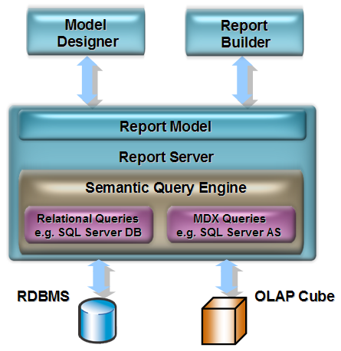

Figure 1. The Reporting Services ad hoc reporting components

Report Model
The report model is the metadata layer component that serves as the basis for building reports. Report designers, both end users and IT staff, will use the report model as the data source for the report instead of directly accessing a relational database or OLAP cube data source when designing reports.
The report model contains three key elements necessary for the ad hoc reporting process to function smoothly: bindings to the underlying data-source schema, a logical representation of the schema in the form of business entities that are familiar to end users, and the default information to be used according to the role that the entity plays in the report (primary entity, lookup entity, summary, and so on).
A report model definition is an XML file that follows the Semantic Model Definition Language (SMDL) specification. Therefore, report models are also referred to as semantic models, SMDL, or SMDL models.

Report Model Components
Report models primarily consist of the following three item types:
- Entities are the equivalent of objects or tables in a database. Entities are composed of attributes and roles.
- Attributes are the equivalent of object properties or columns in a database table.
- Roles are the equivalent of object references or relational foreign keys and join operations.
You can learn more about working with report model items in the Working with Entities in Model Designer topic and the Working with Roles, Source Fields, and Expressions topic in SQL Server Books Online.
Additionally, report models incorporate some organization functionality, allowing administrators to create folders (containers) and perspectives (sub-models). Consequently, report models for larger data sources can be more focused for their intended audience.
You can learn more about working with folders and perspectives in the Working with Folders in Model Designer topic and in the Working with Perspectives in Model Designer topic in SQL Server Books Online.

Semantic Model Definition Language
SMDL is an XML specification that defines the items allowed in a report model file. The report model file extension is ".smdl". SMDL defines items similar to objects, attributes, and references that are stored in collections whose root ancestor is the Semantic Model object itself.
You can learn more about Semantic Model concepts, objects, and relationships in the Model Designer Object Relationship Diagram topic in SQL Server Books Online. For detailed information about report model objects, see the Model Designer Object Properties and Model Designer Query Properties topics in SQL Server Books Online, respectively.

Model Designer
You can create report models manually or generate them automatically. SQL Server 2005 provides three tools for generating report models: Model Designer, Report Manager, and SQL Server Management Studio. Model Designer is an editing environment, embedded in SQL Server Business Intelligence Development Studio, that lets IT staff (development and/or operations) generate a draft report model from a relational data source and then refine it to match actual user reporting needs.
Report Manager and SQL Server Management Studio can automatically generate a report model from a SQL Server or Oracle relational data source or an Analysis Services multidimensional data source. However, you cannot use these tools to customize a report model after it has been generated. You can use Model Designer to customize models generated from relational data sources, but not from Analysis Services data sources.
The following figure shows the Model Designer environment.
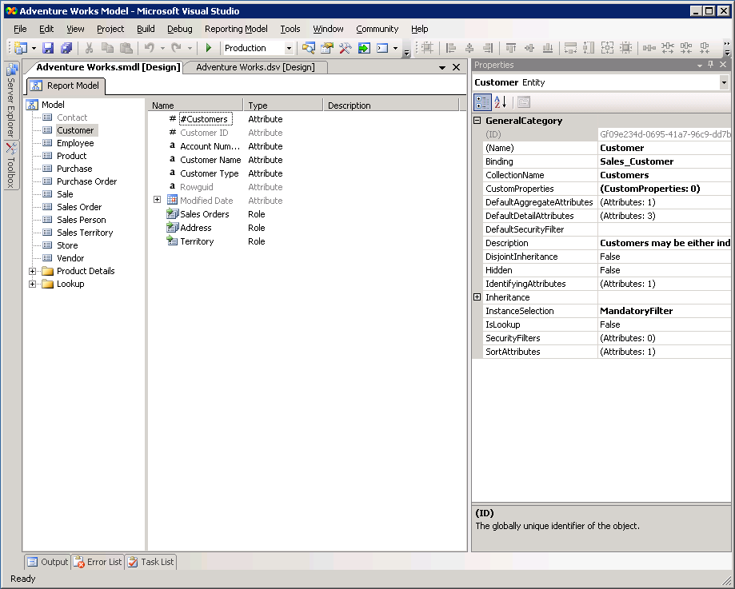
Figure 2. The Report Model Designer
For more information about how to use Model Designer, see Working with Model Designer in SQL Server Books Online. For information about creating a report model based on an Analysis Services cube, see Generating Models Using Report Management Tools in SQL Server Books Online.

Semantic Query Engine
The report model maps the data used in report definition to the schema in the data source. This mapping serves two purposes: first, it gathers the data to display in the report, and second, it filters the data request according to default filters, security filters, and report parameters.
The Semantic Query Engine’s job is to build and execute the appropriate queries against the SQL Server relational database or Analysis Services cube in Transact-SQL or MDX, respectively. The Semantic Query Engine generates additional queries when a Report Builder user requests a clickthrough report, which is a model-generated report, to find further details about an attribute or aggregated measure.

Report Builder
Report Builder is a client tool that lets users create, edit, view, and save report definitions from report models. Report definitions are stored as XML files that follow the Report Definition Language (RDL) specification, which is the same specification that all Reporting Services reports use. Thus, the only difference between reports designed with Report Builder and those designed with other tools is that the former ones always use a report model as the data source, while the later ones may or may not use a report model.
The following illustration shows the Report Builder user interface. Note the Explorer pane, the Design surface with a report template, and the Filter dialog box.
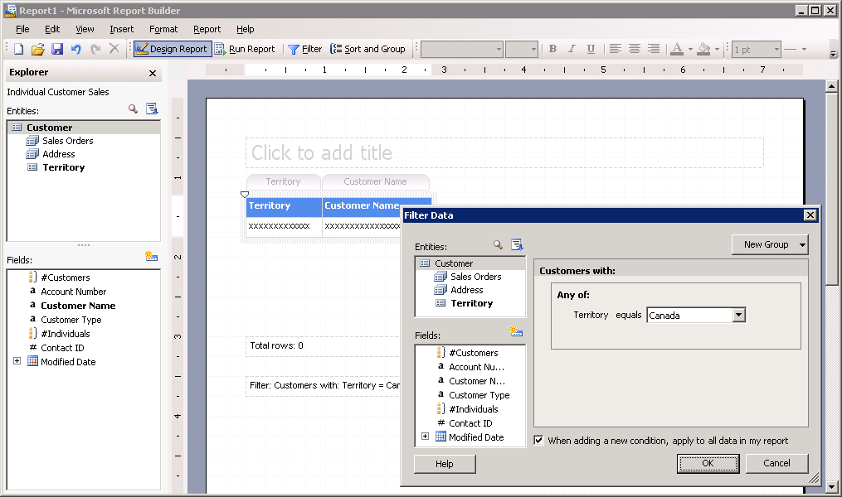
Figure 3. The Report Builder
Report Builder is a Microsoft .NET Framework application deployed dynamically via ClickOnce technology to the client. It requires the .NET Framework version 2.0 to be deployed on the client workstation. When a user starts Report Builder, it is installed automatically from the report server to a client workstation. The application is cached locally on the client workstation, updating automatically when a new version is deployed to the report server.
For more information about Report Builder, see the Report Builder Help (F1) and Working with Report Builder in SQL Server Books Online.

Other Related Technologies

Report Designer
Report Designer, a full-featured tool for designing reports, is embedded in SQL Server Business Intelligence Development Studio. Report models can be used as a data source for reports designed using Report Designer. Reports created with Report Builder can be modified in Report Designer, where additional functionality can be added to the report; however, reports created or modified in Report Designer cannot be opened in Report Builder.
For more information about Report Designer, see Designing and Creating Reports, Defining Datasets from Report Model Data Sources, and the tutorial Creating Model-Based Reports in Report Designer in SQL Server Books Online.

Report Viewers
Reports generated in Report Builder are exactly like any other report created in Report Designer. Therefore, you can access, request, and view reports that are generated by Report Builder in the same way you access other Reporting Services reports. For more information, see Viewing Reports in SQL Server Books Online.

Clickthrough Reports
In SQL Server 2005 Enterprise Edition, Report Builder includes a practical feature that enables users to drill through on the data in their reports without having to first design target reports and connect traditional drill-through links to them. This feature is called clickthrough reports. Clickthrough reports are generated automatically from the report model metadata. For example, while a user is looking at last month’s sales summary report, he might need to find out more about a certain order. Clickthrough reports allows him to click on the Order ID column, triggering an automatically generated report that shows the full order details for that order. Then, he might need to find out about a specific product or about the customer that placed that order. Again, he can click on the Product ID column or on the Customer Name field to see another clickthrough report about those fields.
In another scenario, a user might click on an aggregate field to show a report with the details contributing to this aggregate. What makes Report Builder’s clickthrough functionality special is that the report server will generate the drill-through report automatically, on the fly, using the information stored in the report model.
Using SQL Server Management Studio, model designers can attach a custom report as the drill-through target if the automatically generated report is not adequate.
Because automatic generation of clickthrough reports relies entirely on the report model metadata, a well-designed report model is critical for a successful user experience and for reducing the need to develop additional custom reports. A correctly adjusted model will greatly increase user productivity and satisfaction. A poor or incomplete model will sit unused at best. Automatically generated report models from relational sources should be considered only a starting point for your model, not an end; you will need to edit the model to customize it in a business-savvy way.
For more information, see Working with Clickthrough Reports in SQL Server Books Online.

Report Models from SQL Server Relational Databases
You can create and edit an SMDL model from scratch by creating entities and adding attributes and roles to them. Both entities and attributes bind to specific fields in the underlying schema. However, you can accelerate this task by using the model-generation options provided by Reporting Services. You can use either the Model Designer to manually create a report model, or you can use Reporting Services management tools to automatically generate and publish a model. The Report Model Wizard, invoked from the Model Designer, creates a draft model and provides a user interface for specifying rules for model generation, whereas the automated process uses predefined rules. In most cases, you will want to use the Model Designer and the Report Model Wizard so that you can customize your model.
The following table highlights the differences between using the Report Model Wizard to generate the model and using the management tools' Generate Model command.

Report Model Wizard | Automatic generation
Generated from a DSV, allowing for ample customization. | Generation from a data source. DSV is created internally.
DSV sets the tables, queries, columns and calculated columns to include in the model. | All tables and columns available in the data source will be included.
Set of rules to choose from. | Fixed set of rules applied internally.
Model should be saved and deployed by the designer. | Model is saved and published automatically.
Table 1. Comparison of report model generation methods

Creating a report model with the Report Model Wizard involves several steps:
- Create a connection to a data source.
- Create a Data Source View (DSV) to contain schema metadata.
- Review the resulting DSV to do a basic clean-up and revise the metadata to fit your business requirements.
- Using the revised DSV, invoke the Report Model Wizard to create the base model.
- Edit the report model to adjust it to expected usage.
- Deploy the report model to the Reporting Services report server. The model is deployed automatically when it is generated through Report Manager or SQL Server Management Studio.
You can find detailed step-by-step information in Tutorial: Creating a Report Model in SQL Server Books Online.

Creating a Data Source View
Report models are not created directly from a relational database schema. Instead, report model generation begins with a Data Source View (DSV) of the underlying relational data source. The Semantic Query Engine currently supports SQL Server and Oracle, and will be extended to support other databases as well.
Data Source Views are created in SQL Server Business Development Studio using the Data Source View Wizard available in report model projects.
Creating the DSV is an exercise in metadata modeling and serves to correct shortcomings or adapt an existing database design to a specific purpose. A DSV used in report model generation can be created specifically to generate the report model or it can be a previously created DSV, for example, one that was previously used to create an Analysis Services database.
Corrections can be made either in the DSV or in the report model, but the result of the report model generation process will be much more accurate if you spend some time resolving database issues in the DSV before generating the report model. Data-model considerations for DSV creation should include:
- Review the resulting DSV to do a basic clean-up. For example:
- Exclude entities unimportant to reporting (e.g., application configuration tables).
- Create useful calculated fields.
- Create intuitive aliases for entities and attributes.
- If the table or column names include prefixes that are meaningless to users, remove them by leveraging the editing features of Code view in the DSV XML editor. You can use the Replace command to make all changes at once.
- If you need to use the same model against multiple databases or schemas, make sure your connection string specifies a default database, and then use the editing features in the DSV XML editor to strip out the hard-coded schema prefixes produced by the DSV wizard. However, as you will see in a following section, the Model Wizard relies on the statistics saved in the DSV to determine many model features. If your targeted databases are significantly different, the same model might not apply correctly to all of them.
- Make sure each table has a primary key defined. The Model Wizard will not create entities for tables without a primary key. To set a multi-column primary key in the DSV, select all key columns, then right-click and select Set Logical Key.
- Make sure all foreign key relationships are defined. The DSV wizard will only pre-populate those that correspond to an existing FK constraint in the underlying physical database. The Model Wizard will create roles only for those relationships in the DSV.
- Identify the conceptual entities you want to expose in your model, and how you want to expose them. This is a possible procedure:
- Make a long list of sample questions you expect users to ask. Do not think about how the data is structured in the DSV when forming the questions; just use the phrases and terms your users will be familiar with.
- Identify major entities. If you expect users to frequently say, "I want a list of <x>…", or "I want to summarize <x>…", then <x> is probably a major entity. Most of these will correspond directly to the larger tables in your DSV, but others may be subsets of a given table or combinations (joins) of two or more tables.
- Identify lookup entities. Consider if they will be used as entities themselves or if they are always used as lookup entities only. In the later case make sure they are marked as such in the model. Use the model entity PromoteLookup property where appropriate to flatten a hierarchy of lookup entities.
- Create named queries to break up tables that (a) contain multiple record types that users will often want to consider independently, and (b) have many columns that are applicable to only one record type. For example, you may have a Person table that includes records for employees, vendor contacts, and customers, and contains columns that are common to all types of persons, as well as columns that are specific to only one or more of those types. You should create named queries for Person, Employee, Vendor Contact, and Customer, set PersonID as the primary key in each named query, and create relationships (based on the primary keys) that express the inheritance relationships between the different types. You will identify these relationships as inheritance in the report model.
You can learn more about creating Data Source Views in Working with Data Source Views in SQL Server Books Online.

Generating a Report Model
After the DSV is complete, you can use the Report Model Wizard to generate the report model. The wizard opens when you choose to create a new report model in SQL Server Business Intelligence Development Studio.
The following illustration shows the Report Model Wizard rule selection form.
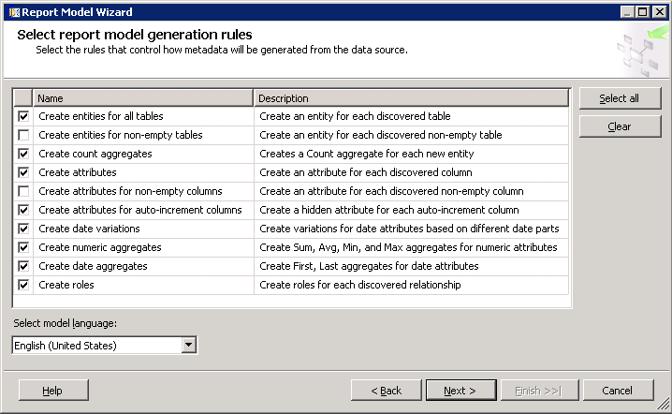
Figure 4. Report Model Wizard rule selection form
After the source DSV is selected, the Report Model Wizard will present a list of rules to be observed during report-model generation. Although you can change the default selection, keeping the default is recommended in most cases.
The consequences of changing the default settings are auto-explanatory except in the following case:
- Create attributes for auto-increment columns. Switching off this property will exclude the auto-increment columns from the entity—that is, they will not exist in the entity. Keeping the rule switched on will create the attributes with the Hidden property set to true.
Note The generation process will show progress with information entries, warnings, and alerts. You should review the messages list when the generation process is finished and before exiting the dialog box. The generation process information can not be copied, and no log is generated. Therefore, you should note any relevant information manually or by screen capture before exiting.

Generating a Relational Report Model Automatically
To generate the model automatically, you can use Report Manager or SQL Server Management Studio.
In Report Manager, you must navigate to the data source from which you want to generate the model. Open the data source properties page and click Generate Model. Remember to specify the model’s file destination first.
In SQL Server Management Studio, navigate to the data source. Right-click and select Generate Model. The report model will be generated from the data source, using a DSV created on the fly and a fixed set of rules, and automatically saved and published to the report server.

Statistics in Report Model Generation
The report model generation process uses statistics stored in the DSV file to decide how to set some entity and attribute properties, as shown in Table 2.

Statistics attribute | Item affected | Properties involved
stats_RowCount | Entity | Entity.InstanceSelection
stats_UniqueValuePercent | Attribute | Attribute.ValueSelection Attribute.DiscourageGrouping
stats_MaxWidth | Attribute | Attribute.Width
Table 2. Effects of DSV Statistics in report model generation

During the model generation process you will be prompted to update DSV statistics. You should update DSV statistics whenever you know or believe the underlying database content has changed significantly, especially if the total row count, uniqueness, or data frequencies might have changed.

Editing the Generated Model
The report model–generation process results in a full report model that contains all the entities, attributes, and roles in the DSV, plus some items, such as entity row count or date variations, that the process generates automatically.
As mentioned, the model obtained from the generation processes is a draft because some common rules apply for its generation. Although this automation lets you skip the tedious work of adding each entity, attribute, and role in the DSV to the model, it may not produce a customized or optimized business model. Therefore, generation is only the first step; next, you should adjust the model to the expected real-world usage.

Reviewing the Generated Model
After generating the initial report model, you should review it to see if you have to edit some of the items. In the following sections of this document you will find considerations for how to build a final report model. However, first you must understand how the Report Model Wizard interprets the DSV, and what you can expect as the generation output. Review the following points about resulting entities, roles, and attributes.
- Any entities lacking a primary key are excluded from the resulting model.
Report Builder could give unpredictable results when using entities without primary keys. Therefore, the generation process does not add non–primary keyed entities. You can use the DSV editor to add a logical primary key without changing the physical database.
- The report model includes attribute-reference collections such as IdentifyingAttributes and DefaultDetailAttributes.
Model generation includes an internal set of rules that leverage DSV statistics to determine which attributes will be referenced in each collection. You may find more information at http://blogs.msdn.com/bobmeyers/archive/2005/10/25/484895.aspx.
- Report model generation avoids using numbers as entity-identifying attributes.
This is the right choice for user friendliness, but this solution does not work in every case—for example, for invoice numbers or product IDs.
- Recursive roles in the underlying data source generate two role entries in the report model: one for the parent role and the other for the child role.
- If the DSV has a many-to-many relationship implemented with relationship-resolution or junction tables, the report model will construct an entity by selecting identifying columns from both related entities.
- Depending on the rules selected during report model generation, the Report Model Wizard generates some aggregates for each entity, including a count of the entity rows.
- Identity columns are hidden or omitted depending on rule settings.
- Numeric columns are extended with Total, Average, Minimum, and Maximum aggregates.
- Datetime type columns include a series of variations representing the application of common date functions to the corresponding day, month, and year. Additionally, aggregates for first and last (minimum and maximum) dates are created.
- Attribute data types are mapped from the SQL Server–supported data types to data types supported by SMDL.

Model Presentation and Navigation Refinements
Some of the edits you might like to introduce in the model relate to how the entities and attributes are presented to the user, and how to navigate between entities shown in Report Builder.
- In Report Builder, the action of double-clicking on entities or dropping them onto the design surface area implies adding the entity’s default set of attributes to the report. The value of the DefaultDetailAttributes collection entity property determines which attributes get added. You should review this collection property for each entity and select the most representative attributes, having this usage in mind.
- Review the entities built automatically to host many-to-many relationships. They will contain the identifying attributes of both entities. Check whether the selected attributes are appropriate or whether the entity should be hidden from end users using the techniques described below.
- Revise the InstanceSelection entity attribute to force a FilteredList or MandatoryFilter whenever appropriate. This property will dictate whether report designers are allowed to use an entity in a report without filtering the results. If the resulting set could be unmanageably large, it is recommended to force the use of a filter. Set InstanceSelection to Dropdown for attributes with a small number of distinct values.
- The Hidden property lets you hide entities, roles, and fields. Hiding an item implies that it does not appear in Report Builder. However, for roles, users can access hidden roles by following the appropriate role paths even if they are not shown in the initial entity list in Report Builder.
- Identity columns are hidden or omitted depending on model generation rule settings. You may want to display those columns that are meaningful to the end users, such as OrderID or InvoiceID. Note that IdentifyingAttributes should include the fewest columns/attributes possible.
- The attribute names in the report model are generated using capital letters as spacing indicators. Thus, "CustomerName" is converted to "Customer Name", which is usually preferable. However, some cases, the column name includes the table name, for example, "RegionDescription". Although this is fine for development and SQL editing tasks, it leads to duplicating the name of the table when you use report model attributes in a role. This situation is quite common; it happens with any report that involves attributes for more than one entity. Therefore, it is good practice to trim entity names from attribute names. You will need to decide whether to use the default ContextualName for other attributes or change them to Merge.
- Attribute width is expressed in characters. Report model generation uses DSV statistics to set the attribute width. However, when you drop fields onto Report Builder, the column title is taken into account as well. In Report Builder, the larger of the two determines the suggested column width. Therefore, keeping column names short for narrow columns should save report-editing time.
- The format of numeric and date type attributes can be tailored to user needs. Format syntax uses .NET Framework formatting codes. For more information about .NET Framework formatting syntax, see Formatting Types.
You can learn more about modifying the model presentation and navigation in the tutorial Refining a Report Model in Model Designer in SQL Server Books Online.

Model Structure Refinements
You can refine the way related entities appear in Report Builder or Report Designer. These modifications affect the behavior of entities involved in roles.
- Setting the ExpandInline role property to True shows all role target entity attributes as if they were role source-entity attributes. This is useful for reducing the number of navigation hops the user must make to reach an attribute from a role. Using this property makes sense only in the one-to-one cardinality sense of the relationship, for example, when adding Category Name to Product.
- You can complement the use of the ExpandInLine role property with the HiddenFields collection to allow only a selection of attributes to show up through these expanded relationships. However, this might entail a significant amount of work because you would need to check each role the entity is involved in. By combining ExpandInLine with the Hidden property, you might achieve seamless integration, but you lose some functionality, such as the ability to group by using the target entity.
- The IsLookup entity property can be used as an alternative to the Role.ExpandInline property. It can be less confusing to report model end users because the entity simply does not show up in the Entities pane. All entities referring to this entity through a role will display the lookup entity’s IdentifyingAttributes as their own attributes. This option is useful for all entities containing descriptions only, such as a table containing Status ID and Status Description. IsLookup can only be set for entities with a single IdentifyingAttribute. To turn a hierarchical chain of entities into lookup entities, you need to also set the PromoteLookup property to True.
You can learn more about refining the model structure in Refining a Report Model in Model Designer in SQL Server Books Online.

Advanced Model Refinements
You can further refine the model configuration properties to subdivide or organize the model or to adjust the click-through navigation to point to customized reports.
You can enhance the report model’s internal organization by the use of folders and perspectives. Folders are simple containers, but perspectives should be viewed as sub-models that have significant impact on how the user sees and accesses the report model data. Describing perspective implications is outside the scope of this document.
You can learn more about refining the model configuration in the tutorials Customizing Report Builder Clickthrough Reports and Refining a Report Model in Model Designer in SQL Server Books Online.
You can find more information about model perspectives in the Working with Perspectives in Model Designer topic in SQL Server Books Online.

Report Models from Analysis Services Data Sources
A report model can be automatically generated from an Analysis Services database. Both SQL Server Management Studio and Report Manager can be used to generate an SMDL model; however, the resulting model cannot be edited. Designers and analysts may design, or introduce design changes, to the referenced Analysis Services database to obtain better results when generating the model.

Model Generation
Models can be generated from Analysis Services data sources by using either Report Manager or SQL Server Management Studio. To do so, you need only a connection to the Analysis Services database and administrator rights on the database.
In Report Manager, locate the Analysis Services data source, open the Properties tab, and select Generate Model. In SQL Server Management Studio, connect to the Reporting Services report server, right-click the data source, and select Generate Model. This command applies a set of internal, non-editable, rules for report model generation.
If you change the definition of the Analysis Services database, you need to regenerate the report model to reflect those changes. In Report Manager, locate the Analysis Services data source, open the Properties tab, and select Regenerate Model. In SQL Server Management Studio, open the Properties dialog box for the data source, and on the Shared Data Sources tab select the check box Regenerate Model when this page is saved.
Item identifiers in models generated from Analysis Services data sources are textual, not GUIDs, based on the type and the name of the item. Therefore, each time a model is generated the item will receive the same identifier. The reports created on a previous model reference will run seamlessly against the new version of the model.

Analysis Services Design Considerations for Report Models
When a report model is generated from an Analysis Services database, the resulting model will generate according to the following generic principles:
- Measure groups are mapped to entities. The single report model will encompass all of the cubes within the Analysis Services database.
- Dimensions are mapped to entities. Fact dimensions will not result in a different entity. For example, given a cube with a "Sale" measure group and a "Sale Detail" fact dimension, the report model will contain a single entity with all the measures of "Sale" and all the dimension attributes of "Sale Detail."
- Relationships between measure groups and dimensions will be converted to model roles. Referenced relationships (used for indirect relationships) are exposed in the resulting model as regular roles.
- Measures are converted to entity attributes.
- Dimension attributes are converted to entity attributes. Report models do not have the concept of hierarchy. Hence, a dimension attribute will be included in the model if it is visible, or if there is a visible hierarchy that contains a level based on it. The key attribute of a dimension is always included, even if it is marked invisible.
- The entity attributes from measures and dimension attributes will be organized into folders in accordance with any display folders defined in the cube.
- Cube perspectives become report model perspectives. Each cube within an Analysis Services database becomes a perspective in the report model. The model itself is not available to Report Builder users; they must select a model perspective as the report design starting point.
- Calculated measures (calculated members) are converted to attributes for the entity corresponding to the measure group that the measures are associated with.
- Named sets defined on the key attribute of a dimension are converted to a subtype of the entity. For example, the named set "Large Customers" results in a subtype of "Customer."
- Key Performance Indicator (KPI) properties are converted to attributes on the entity corresponding to the measure group that the KPI is associated with. Each KPI will result in several attribute entities. That is, you will find an attribute for each of these properties: Goal, Value, Status, and Trend. Additionally, Status and Trend will have a variation that holds a picture of the StatusGraphic and the TrendGraphic, respectively.
When looking at the elements in the generated model, you may notice that the following Analysis Services constructs are not included:
- Calculated members that are not in the measures dimension.
- Parent-child hierarchies are not exposed, either as regular or recursive roles.
- Actions, including drillthrough actions. The EnableDrillthrough property is always enabled on aggregate attributes, irrespective of the Analysis Services drillthrough actions defined in the cube.
- Attribute relationships. A dimension results in a single entity and any relationship between the attributes of the dimension does not affect the report model.

Cube Design Considerations for a Report Model
Consider the following when designing a cube to be exposed via a report model:
- Calculated measures or KPIs that do not have an associated measure group will not appear in the report model. To configure the associated measure group for a calculated measure, you should use the Calculation Properties dialog box.
- The Dimension Attribute property GroupingBehavior is used for generating the DiscourageGrouping model attribute property.
- Any dimension attributes that are images must have the Image type set on the dimension attribute binding.
- Clickthrough functionality is always enabled on attributes resulting from measures, but only minimal details are included in the default Clickthrough reports. Custom clickthrough reports should be added as necessary.
- If translations are included in the cube and you want to expose these through the report model, you must create one data source per translation, setting the LocaleIdentifier property as appropriate in the connection string. One model is then generated for each such data source and will contain the metadata from the associated translation. Each model for each translation is generated and updated separately.
- Attribute folders are based on the AttributeHierarchyDisplayFolder dimension attribute property.

Query Behavior
The following items are important aspects of Report Builder queries against Analysis Services-based report models:
- Queries sent by Report Builder will always request the member value of dimension members and will use the member value for sorting and filtering. By default in Analysis Services, if an attribute has a name binding, then the member value will be the same as the member name, and if the attribute has no name binding, then the member value will be the same as the member key. However, each attribute can have an explicit binding to a column that provides the member value, which should return the value in the original data type. For example, a Date attribute in Analysis Services might have a key that is the DateTime (for example, "4/25/2006") and a name/caption that is a textual description ("Tuesday, 25th April, 2006"). In this case, the cube designer should set MemberValue to the key, to ensure reasonable sorting and filtering. Although you should consider this for any attribute, it is particularly relevant for DateTime attributes. For any DateTime attribute, the generated model will contain two report-model attributes: one that is the caption, and a variant of it that is the actual DateTime value.
- The notion of a "relationship" between two entities is based on the presence of a row in the fact table. For example, let’s say sales order "SO24" is due in the year 2005 based on the fact-table row. A calculated measure might still have a value for other years; for example, for sales order SO24, the calculated measure Growth might have a value both for year 2005 and 2006. This does not affect the fact that sales order SO24 is related only to the year 2005. Therefore, a report by year showing aggregate sales order data would not include values from SO24 in the aggregate for 2006, despite the fact that some calculated measures would be non-null in that year.
- There are limitations on the type of queries that can be executed. In particular, arbitrary navigation between entities is not possible. The Report Builder user interface is somewhat constrained to reflect this—it shows only entities to which it is possible to navigate. In other cases, the user might be able to form the query through the UI, but the query will produce an error message upon execution.

Security
The user generating the model must be a database administrator on the Analysis Services database. Note that no security is defined on the generated model, although this can be added as described below. Depending on the data-source settings, however, it is certainly possible to ensure that data is secured at the time of query, based on the user executing the report.

Report Model Deployment and Management

Security
Models and reports can be secured in several ways. Report models are securable items as are reports. Model security also exists at multiple levels.
- Secure the model itself as a whole. Administrators can decide which users and groups may access each report model. Users granted “View models” permission to the report model can create reports that use the report model as the report data source. For more information about report-model security, see Securing Models in SQL Server Books Online.
- Secure specific items in the model. Using item security, administrators manage which folders, entities, fields, and roles each user or group is allowed to view. Model item security is disabled by default. You can enable this feature and manage authorization for model items by using SQL Server Management Studio. For more information about securing model items, see Securing Models in SQL Server Books Online.
- Secure rows in the model. Row-level security is provided via security filters. Using security filters, administrators manage which rows each user or group is allowed to view. For more information, see the tutorial Applying Security Filters to Report Model Items in SQL Server Books Online.
- Secure access to the Report Builder application. For more information about Report Builder security, see Securing Report Builder in SQL Server Books Online.
- Secure reports. Reports built with Report Builder are standard Reporting Services reports, as mentioned earlier. Once published, these reports can be secured in the same ways as any other Reporting Services report. For more information about report security, see Securing Reports and Resources in SQL Server Books Online.

Change Management
Models and the reports based on them have many internal and external dependencies. Therefore, you need to consider the impact of changes introduced into the dependency chain. Report models based on relational data sources use GUID attributes to identify each entity, attribute, and role. As mentioned, the report model-generation process sets the GUIDs, which are re-created at each generation. For that reason and to preserve edits on the report model, generating a new report model each time a change occurs is not an option. You must work with the existing model and update it, either manually or by using the update options described below.
The Semantic Query Engine manages missing attributes when they are not critical to report processing. This functionality is in place to keep reports running when security attributes preclude users from seeing some attributes in the report that may be allowed to other users. Thus, if a user is not allowed to access a field such as the employee home telephone number, the Employee Listing report will run for that user but will not show the excluded information. This functionality works to your advantage when models are edited to delete a non-critical attribute. The report will still run after you have removed an attribute, although the report might show a blank field. However, query or report processing can be broken by other changes to the model.
Remember that you should not overwrite a model generated from a relational data source when any reports depend on it.

Schema Changes
If the underlying schema changes and report model entities or attributes are affected, you might have to update the report model accordingly. To do so in BIDS, use the Autogenerate command on the Reporting Model menu. You can also select Autogenerate from the model item's context menu. By using the context menu, you can select which item on the model you want to update without having to update the entire model.
The autogeneration process will show informational, warning, and alert messages. These messages will show all items in the model that are out-of-sync with the underlying DSV, even though those items are not specifically included in the item selected for autogeneration. This functionality helps detect potential errors than may lead to unpredictable errors when running reports based on the model.
Automatic update affects newly added items only. The autogeneration process will add any new entity, attribute, or role found in the DSV, but will not delete or change any entity, attribute, or role. Therefore, you need to manually manage updated or deleted items. The messages shown at the end of the generation process will highlight any entity, attribute, or role that needs to be updated in the resulting out-of-sync model. You will have to update the model manually or revert the DSV changes to maintain model-to-schema coherence.

Data Source Changes
You can develop and test your model in a development environment and then deploy the model in a production environment easily by changing the connection string in the data source file that the DSV uses. The two data source schemas must be identical.
Note that the DSV contains statistics based on the actual database data. As mentioned in the section "Statistics in Report Model Generation," the value of those statistics will drive some algorithm decisions during the model generation. Therefore, if the development database data is significantly different from the production database data, the model might not be optimized for the data that will eventually be used.

Conclusion
Microsoft SQL Server Reporting Services provides robust management and design tools that help you to easily generate report models and reports. However, to realize the advantages of ad hoc reporting, it is necessary to customize your implementation for your business needs. This document describes the process of designing report models, provides guidance on how to customize the model to your business needs, and highlights some important aspects to consider when planning report model generation and maintenance.

Appendix A: Resources
The following documentation sources provide additional details about the contents of the current document:
- Reporting Services Main Page
- MSDN Reporting Services Page
- TechNet Reporting Services Page
- Reporting Services Help in SQL Server Books Online
- Report Model tutorials in SQL Server Books Online:
  - Tutorial: Creating a Report Model
  - Tutorial: Creating a Report Model Based on an Analysis Services Cube
  - Tutorial: Refining a Report Model in Model Designer
  - Tutorial: Creating Model-Based Reports in Report Designer
  - Tutorial: Applying Security Filters to Report Model Items
  - Tutorial: Creating a Report Model-Based Query for Use in Report Designer
  - Tutorial: Customizing Report Builder Clickthrough Reports

About the author
Jordi Rambla is a mentor with Solid Quality Learning Business Intelligence division. His main area is enterprise reporting with SQL Server Reporting Services.

For more information
Microsoft SQL Server TechCenter
Did this paper help you? Please give us your feedback. On a scale of 1 (poor) to 5 (excellent), how would you rate this paper?!href(mailto: sqlfback@microsoft.com?subject=Feedback: Planning for Scalability and Performance)

