Automating IT Service Management with System Center
Microsoft System Center “Service Desk” Overview Whitepaper

April 2006
Table of Contents
Executive Summary 3
Introduction 3
IT Service Management Automation 3
System Center Service Desk 3
Extensibility Solution Packs 3
CMDB 3
Workflow 3
Knowledge 3
Console 3
Integration 3
System Center Service Desk Operational Scenarios 3
More Information 3

Executive Summary
To automate IT Service Management, it is necessary to implement a single point of contact in the service desk for all service requests, knowledge, and workflow, and for processes such as incident, problem, change, and asset management. This paper provides a high-level description of the Microsoft System Center solution for IT Service Management currently under development and code-named “Service Desk” (“SD”).

Introduction
To automate IT Service Management, one must manage the people, processes, and technologies that make up the IT Service Management discipline. Microsoft System Center management products enable best practice support to manage the various IT Service Management functions defined by the Microsoft Operating Framework (MOF) and Information Technology Infrastructure Library (ITIL). A key function of IT Service Management is the service desk. The service desk provides a contact point where people interact with IT services on issues such as problem or change Management. The service desk also provides an organization’s management visibility into the overall performance of the IT environment through reports and dashboards. Microsoft’s System Center product code-named “Service Desk” (“SD”) is designed to meet this need as part of the System Center family of solutions and help organizations reduce costs by automating their IT Service Management processes and making access to technology and organizational expert knowledge easier.
A lot of help desk products are available today, but many of these products have tackled only one area of IT Service Management automation and few have developed a solution that can be easily extended to grow and adapt to the changing needs of business. Microsoft has developed a solution that will address many common IT Service Management functions out of the box and is easily extended by customers, partners, and Microsoft to cover future needs of IT Service Management. Microsoft has done this by:
- Deeply integrating across Microsoft technologies and offering seamless workflows from inventory discovery and event detection to Service Management processes such as incident, problem, and change management that draw on this information.
- Leveraging the Microsoft technologies that most users already use or are familiar with to deliver a recognizable and common user experience and build on existing corporate IT knowledge.
- Investing in Self Service Portal technologies to help organizations reduce support costs.
- Pre-building and including process-automated workflows based on the Microsoft Operating Framework (MOF).
- Building an extensible Solution Pack framework, similar to the Microsoft Operations Manager Management Packs, for customers and partners to develop additional custom functionality for “SD”.
- Configuration Management Database (CMDB) based on System Definition Model lanuage
Across the company, Microsoft has made deep investments in the core technologies that make up the foundation of a great Service Management solution. The System Center “SD” product will use Office Server technologies such as SharePoint and InfoPath Server for its knowledge repository and Web-based forms. Windows Workflow Foundation provides the workflow engine driving process automation, and the configuration management database (CMDB) will be based on the System Definition Model (SDM). These technologies, along with embedded MOF processes and easy, open integration to other management tools, will produce a highly extensible, simple-to-use, Service Management solution that will provide an unprecedented view into an organization’s IT Service Management environment.
The initial product release will focus on the IT Service Management functions of incident, problem, change, and asset management. Integrations to other System Center products, such as System Center Operations Manager and System Center Configuration Manager, will be the focus for the initial release. The programming interfaces and connector infrastructure will also be available for Microsoft Partners to build integrations and add-ons for many third-party tools.
This paper provides a high-level overview of the IT Service Management service desk function as well as the architecture of the System Center “SD” product and some example scenarios to show the functionality that System Center “SD” will offer.

IT Service Management Automation
The service desk is the central point of contact between the IT organization and its customers and users on a day-to-day basis. The service desk is the customer touch point for the IT organization, allowing business processes to be integrated into the Service Management framework. One of the major responsibilities of the service desk is to coordinate the incident management function, but the service desk also provides an interface for customers and users to other Service Management activities, including change and asset management.
The service desk records all inbound user calls, whether it’s an incident, a request for new service, or simply a question. In the case of an incident, the function of the service desk is to minimize the business disruption by facilitating the prompt restoration of normal service. In the case of a service request, the function of the service desk is to deal with the request in the most appropriate manner, either by satisfying the request directly or by escalating/referring the request to an appropriate group.
The automation of IT Service Management through the service desk requires that the service desk product be able to automate the key tasks within the specific IT Service Management function. For example, if automating incident management, the service desk tool needs to make logging the call details easy and quick. It also needs to provide the user or analyst with access to expert knowledge so that the incident can be resolved. If the incident cannot be resolved at the service desk, the escalation process and path need to be well-defined and easy to follow. The workflows need to be easily defined and modifiable as Service Management processes evolve within an organization.
Self-service portals are an important interface for customers of IT Services; they provide an easy way to reduce cost and effort involved in routine service requests that can be easily automated. Users need to have easy access to the forms and tools required to execute typical Service Management activities, such as change approval or service request submissions.
Finally, the Service Management solution needs to be open and provide simple, easy access for anyone in the organization to understand the status of service requests and for managers to run desired reports.
Microsoft’s System Center management products provide IT staff members who are responsible for desktops, servers, and devices with a set of easy-to-use solutions for managing their infrastructure and the services delivered using that infrastructure. Delivering a product in the service desk area will provide powerful new functionality in the areas of incidents, problems, and asset and change management that, when tightly integrated with the existing System Center products, will result in a tremendously productive platform for end-to-end automation of IT processes.

System Center “Service Desk” (“SD”)
The basic architecture of a consolidated service desk includes a database for storing service requests, configuration items, and a console for users to enter, display, and interact with service requests. For the System Center “SD” product, Microsoft is extending this basic architecture to enhance the “SD” extensibility and functionality.

Extensibility Solution Packs
The System Center “SD” is designed to be an extensible platform, which allows for the automation of IT Service Management processes and helps organizations reduce cost by connecting customers and users with the workflow and knowledge in the IT environment. Customers and ISVs can easily enhance “SD” workflows by layering on Solution Packs. Solution Packs will allow development of reusable forms, workflows, and reports which plug into the “SD”. For example, an organization could develop a New Employee Solution Pack. This Solution Pack would include forms for entering new employee information, workflow to create user accounts and mailboxes, change requests to order computers or telephones, and reports to show progress. Any organizational process requiring forms, workflow, and a data repository can be created as a Solution Pack. Moreover, ISVs could develop Solution Packs to include knowledge, actions, and reports on how to identify and resolve issues with their software products.
The Solution Pack functionality allows the System Center “SD” to easily add new functionality without a version upgrade, making it more flexible to adapt with your organization.

CMDB
A CMDB is a database store that provides an authoritative view of your managed IT infrastructure and services, including all relevant information about current and desired state, history and future plans, associated incidents and problems, and related change requests. It also stores information about all of your assets and who is using them. Through federation with other System Center data stores to establish a unified view of the environment, the CMDB plays a critical role in ensuring consistency across your incident, problem, change, configuration, and asset management and planning IT processes.
The System Center “SD” will have a CMDB database based on the System Definition Model (SDM). The SDM is a language or a meta-model that is used to describe the structure and behavior (set of applicable operational tasks, rules, and policies) of a distributed system. Using this rich language as the foundation for a CMDB enables “SD” to capture a more detailed, comprehensive, and accurate description of the IT environment, greatly improving “SD”’s ability to consistently manage the environment. Further, the SDM is the core modeling technology at the heart of Microsoft’s Dynamic Systems Initiative (DSI), which is being adopted across the company. Using this same language that is also being adopted by the Visual Studio development tools to describe an application from its conception will additionally result in applications that are more rapidly developed and will easily populate the CMDB with rich information relevant to management when deployed to drive down ongoing operational costs.

Workflow
To automate the IT Service Management functions that the “SD” will manage requires a robust workflow engine. A workflow is a set of activities stored as a model that describes a real-world process. Work passes through the model from start to finish and activities can be executed by people or by system functions. Workflow provides a way of describing the order of execution and dependent relationships between pieces of short- or long-running work. The System Center “SD” will use the Microsoft WinFX Windows Workflow Foundation for its workflow engine. Windows Workflow Foundation will allow predefined workflows based on MOF processes to ship with the System Center “SD”. Customers can also customize or build their own workflows using Windows Workflow Foundation for execution within “SD”.

Knowledge
For a service desk to be effective, the user must have easy access to detailed expert knowledge. The System Center “SD” will include expert knowledge for troubleshooting and problem-solving, including the ability to leverage the Microsoft Product Groups and Microsoft Premier Support Services Knowledge Base. The included knowledge will also extend to procedures and processes defined by MOF, and users can customize or add their own organization-specific knowledge to the “SD”. Existing knowledge from other sources, such as Microsoft Operations Manager, or websites, such as Microsoft TechNet, will also be accessible through integrations to the “SD” consoles and portals.

Console

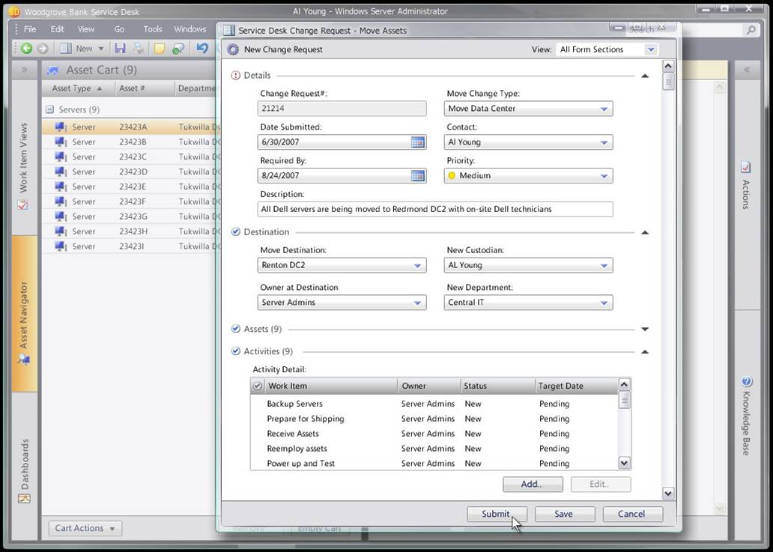
The System Center “SD” will have a Web-based interface (thin client) and a Windows Forms (thick client) console as well. The thick client console will provide a robust interface for high-volume users of the “SD” and administrators. The thick client console will have a similar look and feel to other Microsoft products, such as Microsoft Outlook or the Operations Manager consoles. This similarity will make “SD” easier to use for users already familiar with these other Microsoft products.
The System Center “SD” thin client will be based on SharePoint-based Web portals. The Self-Service Portal is a personalized end-user portal that will provide self-service functionality, such as notification, request submissions, knowledge search, and request tracking. The portal will also provide a Web-based version of the thick client console for operators and administrators. Users such as Change Approvers or Support Analysts will have access to work items, knowledge, and reports through the IT Portal. The Self-Service Portal functionality will be extensible through “SD” Solution Packs. If customers or partners want to add new processes or functionality to “SD”, it can easily be exposed through the Self-Service Portal.

Integration
One of the strengths of the System Center management products is the level of integration between the products. The System Center “SD” will include a linking framework with integrations out-of-the-box for Operations Manager, SMS, and Visual Studio Team System (VSTS). One possible scenario could unfold as follows: System Center Operations Manager detects the failure of a custom line-of-business application and opens an incident ticket in “SD”. An incident record is then created in “SD”. After the root cause of the incident is determined, the incident is escalated to development through “SD”’s connector to VSTS. This causes a bug to be created in VSTS that is linked to the incident record in “SD”. When development has a fix ready, they update the bug which causes the incident in “SD” to be updated, indicating that a fix is available. A change manager can then open a change request in “SD” to have the patch deployed. Through workflow, “SD” then automates the deployment of the patch through SMS. Once completed, “SD” automatically closes the incident record and any other related incidents and updates key stakeholders that the problem has been resolved.
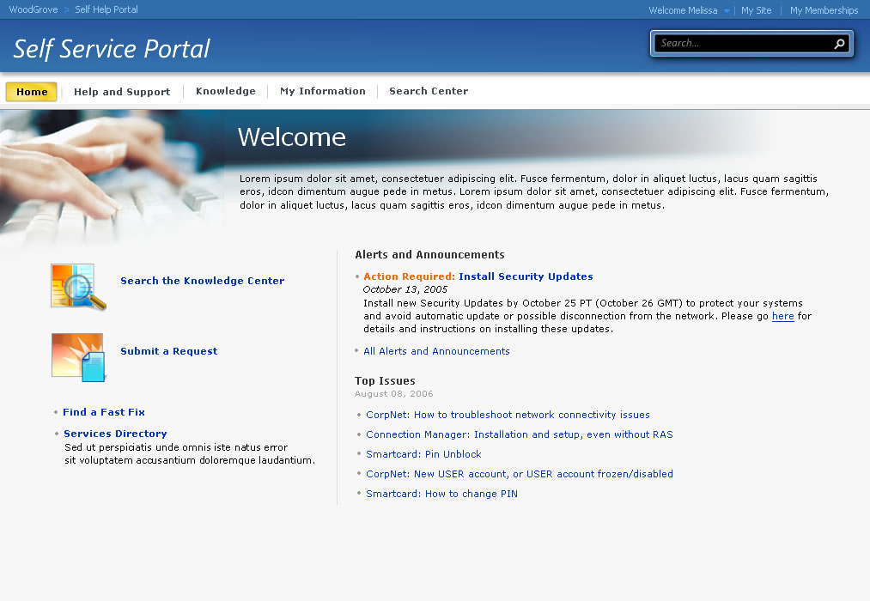
The integration within “SD” is provided by the linking framework, and it will be extensible through APIs and software development kits to allow development of connectors to other non-Microsoft management products. Microsoft is currently working with several partners to provide integrations to non-Microsoft management products.

System Center “Service Desk” Operational Scenarios
The following are some example scenarios illustrating the types of IT Service Management functions that the System Center “SD” will help organizations with.
Incident Management - Create Incident records based on information in management tools
“I want management tools to automatically create a Incident ticket when they detect a specific event or a sequence of events.”
A Business Application Administrator wants MOM to automatically create incident records whenever the performance of certain business applications falls below a specific threshold or when certain events appear in the Windows Event Log. They use the MOM Rules Wizard to define the criteria and the set of events, which should result in a new incident in “SD”. The wizard allows them to specify the priority of the incident ticket.
The Business Application Administrator is also able to obtain updated MOM Management Packs for “SD”, which have been set up to create incidents and problems when certain conditions (known to Microsoft) are detected in the production environment. They are able to customize the rules and event conditions provided within these Management Packs to suit their needs.
Problem Management - Identify problems by searching common incidents
“I want to be able to associate multiple incidents to a single problem for analysis.”
Often a series of similar incidents on one or more machines may be an indicator of a more serious problem. “SD” will allow administrators to search for like incidents and link them to a problem record for root cause analysis. Once the problem is resolved “SD” can automatically close all the related incidents and notify the stakeholders.
Asset Management - Track movement and ownership of hardware assets
“I need to be able to track the movement of assets and ensure that they are assigned to the correct cost center.”
Assuming that a Change Request has been used to transfer the ownership of an asset to another user or cost center, the asset record is automatically updated (in “SD”) when the request is successfully closed. However, assets are often transferred between users in the same department or cost center without going through any form of change management. A Manager who has received a new laptop, for example, allocates their existing machine to a direct report. “SD” needs to provide a mechanism that enables the current or previous owner to indicate change of ownership and the current location of the asset.
The Manager opens the Asset Management view in the “SD” UI and searches for the asset they are interested in. Having found it, they select the option to view “Asset History.” The UI displays the history of the asset, from its original purchase to its current state. The Manager notices that the asset was recently disposed of and selects this item to view more detailed information.
Change Management - Review and approve Change Request
“I need to be able to review and approve all changes to IT components and services to ensure that no new security vulnerabilities are introduced into the production environment.”
The Change Advisory Board (CAB) is responsible for reviewing all major changes to production systems; CAB members are notified that a new Change Request requires their approval. They open the “SD” UI and see all of the change requests they need to review and approve. They select one of these requests and open it to view more detailed information.
They view the business justification, implementation plan, configuration items, and supporting documentation associated with the request and decide to approve it; they select the “Approve Change” option in the UI. “SD” automatically notifies the person requesting the change to indicate that the CAB has approved it.
Self Service - Resolve an issue without calling the Service Desk
“I forgot my password to the Customer Management System (CMS) and I need to get it reset so that I can get in.”
When an employee has an IT problem, they can turn to the IT Portal first for assistance. Employees have to remember multiple username and password combinations for use on the different internal systems (i.e., no single sign-on).
When the employee arrives at the Portal page, they notice a text box that says “Find Answers.” When the employee begins typing “password,” they immediately get a drop-down list of suggested terms to complete their search. The employee selects “Password Forgotten” because that best represents the problem.
Without delay, a list of search results is displayed grouped in logical categories: FAQs, Articles, Forms, and Previous Requests. The employee focuses on a “QuickFix Solutions” box entitled “Did you forget your password?” In it, the employee gets an overview of what the QuickFix password reset tool does. The employee clicks the tool link and the tool walks the user through the process of resetting a password.

More Information
The following links provide more information on System Center and Microsoft Operations and Management solutions.
Microsoft System Center “Service Desk” http://www.microsoft.com/windowsserversystem/systemcenter/sd/default.mspx
Microsoft System Center Management Products http://www.microsoft.com/systemcenter
Microsoft Operating Framework http://www.microsoft.com/mof
Microsoft Dynamic Systems Initiative http://www.microsoft.com/dsi

