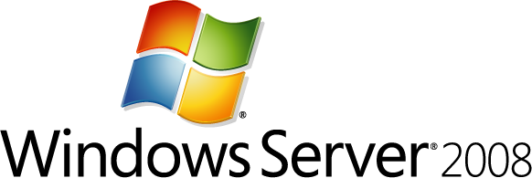

Running Domain Controllers in Hyper-V Guide
Microsoft Corporation
Published: January 2008
Abstract
This guide provides recommendations and cautions for running domain controllers as guests on Hyper-V™ servers.

Copyright information
Information in this document, including URL and other Internet Web site references, is subject to change without notice. Unless otherwise noted, the example companies, organizations, products, domain names, e-mail addresses, logos, people, places, and events depicted herein are fictitious, and no association with any real company, organization, product, domain name, e-mail address, logo, person, place, or event is intended or should be inferred. Complying with all applicable copyright laws is the responsibility of the user. Without limiting the rights under copyright, no part of this document may be reproduced, stored in, or introduced into a retrieval system, or transmitted in any form or by any means (electronic, mechanical, photocopying, recording, or otherwise), or for any purpose, without the express written permission of Microsoft Corporation.
Microsoft may have patents, patent applications, trademarks, copyrights, or other intellectual property rights covering subject matter in this document. Except as expressly provided in any written license agreement from Microsoft, the furnishing of this document does not give you any license to these patents, trademarks, copyrights, or other intellectual property.
© 2008 Microsoft Corporation. All rights reserved.
Active Directory, Microsoft, Windows, and Windows Server are either registered trademarks or trademarks of Microsoft Corporation in the United States and/or other countries.
The names of actual companies and products mentioned herein may be the trademarks of their respective owners.

Contents
Running Domain Controllers in Hyper-V 5
Audience 5
Scope 6
Sections of this guide 6
See Also 6
Planning Considerations for Virtualized Domain Controllers 6
Considering domain controller virtualization 7
Advantages of domain controller virtualization 7
Disadvantages of domain controller virtualization 7
Hyper-V requirements 8
Avoid creating single points of failure 8
Security considerations 9
Security boundaries 9
Security of VHD files 11
RODCs 11
Performance 12
Operations master roles 13
Global catalog servers and Exchange 14
See Also 14
Deployment Considerations for Virtualized Domain Controllers 14
Virtualization deployment practices to avoid 14
Physical-to-virtual migration 15
Using P2V Migration to Create Test Environments 15
Time service 16
Storage 16
See Also 17
Operational Considerations for Virtualized Domain Controllers 17
See Also 18
Backup and Restore Considerations for Virtualized Domain Controllers 18
Backup and restore practices to avoid 19
Restoring a virtual domain controller 19
Restoring the system state backup of a virtual domain controller 22
Restoring a virtual domain controller when an appropriate system state data backup is not available 23
See Also 25
Appendix A: Virtualized Domain Controllers and Replication Issues 25
USNs 25
Directory database identity 26
USN rollback 27
USN rollback detection 28
Undetected USN rollback 31
Read-only domain controllers 32
See Also 33

Running Domain Controllers in Hyper-V
Hyper-V™ is a key feature in Windows Server® 2008 and Windows Server 2008 R2 that you can use to consolidate different server roles onto a single physical computer.
Hyper-V is a hypervisor-based server technology that is optimized to provide virtualization of operating systems. Hyper-V supports a large variety of guest operating systems that can run concurrently on a single physical server. This guide specifically describes running domain controllers that use Windows Server 2003 or Windows Server 2008 on Hyper-V as guest operating systems. Hyper-V takes advantage of and requires a 64-bit architecture on the server’s operating system to provide improved performance and security. The guest operating systems can have either 32-bit architectures or 64-bit architectures.
With Hyper-V, you can install a Windows Server domain controller as a virtual machine alongside other application servers on a single physical Windows Server 2008 server. This can drastically reduce the number of physical computers in a datacenter, which in turn can reduce management and energy costs.
• Not all versions of Windows Server 2008 and Windows Server 2008 R2 include Hyper-V. For example, Windows Server 2008 HPC Edition, Windows® Web Server 2008, Windows Web Server 2008 R2—and all editions that specifically read “without Hyper-V”—exclude Hyper-V. To learn more about Windows Server 2008 versions, see Windows Server 2008 Overview of Editions (http://go.microsoft.com/fwlink/?LinkID=95948).
Notes
• The hypervisor is the lowest-level component that is responsible for interaction with core hardware in a hypervisor-based virtualization environment. The hypervisor is responsible for creating, managing, and deleting partitions. It directly controls access to processor resources. It also enforces policy on memory and device access.
With Hyper-V, it is possible to install multiple domain controllers on a single host server running Windows Server 2008. You can effectively host multiple domains, multiple domain controllers for the same domain, or even multiple forests on one physical server. This can be very helpful in the testing of a large-scale Active Directory® deployment.

Audience
This guide was written for information technology (IT) administrators, engineers, and architects who are evaluating the use of Windows Server 2008 with Hyper-V to host Windows Server 2003 or Windows Server 2008 domain controllers in virtual machines.

Scope
This guide discusses many of the important considerations that are specific to the deployment of a Windows Server 2003 and Windows Server 2008 virtual domain controller. It provides recommendations and tips to help you deploy and manage domain controllers in Hyper-V.
Some of the Hyper-V issues, such as storage and backup, that are not specific to domain controllers are not covered in this guide. This guide also does not address the potential cost savings of migration to virtual servers. Furthermore, because the process of making a virtual server a domain controller does not differ from the process of making a physical server a domain controller, this process (domain controller promotion) is not described in this guide.
For information about deploying and configuring Active Directory Domain Services (AD DS) on a non-Microsoft virtualization product, contact the appropriate vendor.
For additional information about vendor support of Microsoft server software in virtualized environments, see article 957006 (http://go.microsoft.com/fwlink/?LinkID=129503) and article 897615 in the Microsoft Knowledge Base (http://go.microsoft.com/fwlink/?LinkId=136786).

Sections of this guide
This guide includes the following topics:
• Planning Considerations for Virtualized Domain Controllers
• Deployment Considerations for Virtualized Domain Controllers
• Operational Considerations for Virtualized Domain Controllers
• Backup and Restore Considerations for Virtualized Domain Controllers
• Appendix A: Virtualized Domain Controllers and Replication Issues

See Also
Running Domain Controllers in Hyper-V (downloadable Word document)

Planning Considerations for Virtualized Domain Controllers
Before you begin the process of turning your domain controllers into virtual machines, there are several things you should consider. First, you should be aware of the advantages and disadvantages of turning your domain controllers into virtual machines. You should also be aware of the hardware requirements for setting up a Hyper-V server. Both of these subjects are discussed in the following sections of this topic.
If you do decide to create virtual domain controllers, see the later sections of this topic for information about selecting the appropriate type of configuration for your Hyper-V servers and virtual machines. Security and performance decisions are also discussed.

Considering domain controller virtualization
Before you turn domain controllers into virtual machines, carefully consider the advantages and disadvantages of doing this. With Hyper-V, the difference between physical machines and virtual machines is decreasing. However, there are still important factors that can help you determine whether a domain controller should be virtualized.

Advantages of domain controller virtualization
Virtualized domain controllers can have the following advantages:
• Consolidation. You can consolidate multiple domain controllers with other application servers onto comparatively fewer servers with Hyper-V. If you have multiple domain controllers in a hub site serving a small domain that has a presence in one or more other sites, you do not have to deploy multiple physical domain controllers to provide for bridgehead servers and redundancy support.
• Testing. Because testing environments rarely require high-performance domain controllers, you can set up a test configuration that represents your production environment using much less hardware than was required before virtualization technology was available. You can represent dozens of domain controllers on a few physical computers that have the same Active Directory configuration (including domains and sites) as your production domain controllers. You can test complex changes, such as schema changes or large-scale Active Directory site or replication changes, before you make these changes in your production environment.
• Deployment. The hardware environment that Hyper-V emulates remains unchanged throughout the life of a virtual machine, regardless of the underlying native hardware to which you might transfer the virtual machine. Therefore, you can vary server hardware in a preproduction environment to build and test the images even though the intended production server may be significantly different.
• Performance. If you follow all the performance recommendations in the topics in this guide, you can expect a decrease in performance of only 2 percent to 12 percent on a single domain controller that is running in a virtual machine under heavy load compared to one domain controller that is running on native hardware with the same specifications.

Disadvantages of domain controller virtualization
This guide contains important information about the risks of running domain controller virtual machines in a production environment. Virtual hard disk (VHD) files can be easily used and—potentially—easily misused, which is why it is important to manage them carefully when you deploy them in a production environment. When you consider whether to run domain controllers in virtual machines, remember that mishandling VHD image files can result in forest-wide corruption. Mishandling a VHD file could be as easy as starting an older copy of a VHD file or copying a VHD file to a different place on the network and running multiple copies at the same time.
Virtualized domain controllers can have the following disadvantages:
• Administration. In a production environment, data corruption that affects the entire forest can result from deliberate or inadvertent misuse of VHD files. In most cases, improper restore conditions are detected by the operating system and replication is stopped. However, this cannot guarantee the protection of data under all circumstances. To protect your forest against the effects of improperly restoring a domain controller that is running in a virtual machine, make sure that all the administrators in your organization review the information in Appendix A: Virtualized Domain Controllers and Replication Issues.
• Security and handling of image files. Anyone who handles VHD files or has other access to VHD files must be highly trusted in the organization and a member of trusted security groups in the forest. Any user who has the ability to copy a VHD file effectively owns the forest and its data. An attacker or unauthorized administrator could use a copied virtual machine file to compromise passwords or corrupt the forest. Also, unlike the theft of a physical computer, theft of a VHD file is more likely to go undetected. Therefore, you should secure the VHD files for the host operating system and the guest operating system with the same physical restrictions and software restrictions that you use to secure a physical domain controller. These restrictions include controlling access to the files and auditing file access as discussed in “Security considerations” later in this topic.

Hyper-V requirements
To install and use the Hyper-V role, you must have the following:
• An x64 processor. Hyper-V is available in x64-based versions of Windows Server 2008—specifically, the x64-based versions of Windows Server 2008 Standard, Windows Server 2008 Enterprise, and Windows Server 2008 Datacenter.
• Hardware-assisted virtualization. This feature is available in processors that include a virtualization option, specifically, Intel Virtualization Technology (Intel VT) or AMD Virtualization (AMD-V).
• Hardware Data Execution Protection (DEP). Hardware DEP must be available and enabled. Specifically, you must enable Intel XD bit (execute disable bit) or AMD NX bit (no execute bit).

Avoid creating single points of failure
You should attempt to avoid creating potential single points of failure when you plan your virtual domain controller deployment. You can avoid introducing potential single points of failure by implementing system redundancy. For example, consider the following recommendations while keeping in mind the potential for increases in the cost of administration:
1. Run at least two virtualized domain controllers per domain on different virtualization hosts, which reduces the risk of losing all domain controllers if a single virtualization host fails.
2. As recommended for other technologies, diversify the hardware (using different CPUs, motherboards, network adapters, or other hardware) on which the domain controllers are running. Hardware diversification limits the damage that might be caused by a malfunction that is specific to a vendor configuration, a driver, or a single piece or type of hardware.
3. If possible, domain controllers should be running on hardware that is located in different regions of the world. This helps to reduce the impact of a disaster or failure that affects a site at which the domain controllers are hosted.
4. Maintain physical domain controllers in each of your domains. This mitigates the risk of a virtualization platform malfunction that affects all host systems that use that platform.

Security considerations
The host computer on which virtual domain controllers are running must be managed as carefully as a writeable domain controller, even if that computer is only a domain-joined or workgroup computer. This is an important security consideration. A mismanaged host is vulnerable to an elevation-of-privilege attack, which occurs when a malicious user gains access and system privileges that were not authorized or legitimately assigned. A malicious user can use this type of attack to compromise all the virtual machines, domains, and forests that this computer hosts.
Be sure to keep the following security considerations in mind when you are planning to virtualize domain controllers:
• The local administrator of a computer that hosts virtual, writeable domain controllers should be considered equivalent in credentials to the default domain administrator of all the domains and forests that those domain controllers belong to.
• The recommended configuration to avoid security and performance issues is a host running a Server Core installation of Windows Server 2008, with no applications other than Hyper-V. This configuration limits the number of applications and services that are installed on the server, which should result in increased performance and fewer applications and services that could be maliciously exploited to attack the computer or network. The effect of this type of configuration is known as a reduced attack surface. In a branch office or other locations that cannot be satisfactorily secured, a read-only domain controller (RODC) is recommended. If a separate management network exists, we recommend that the host be connected only to the management network.
For information about RODCs, see Read-Only Domain Controller Planning and Deployment Guide (http://go.microsoft.com/fwlink/?LinkID=135993).
For more information about securing domain controllers, see Best Practice Guide for Securing Active Directory Installations (http://go.microsoft.com/fwlink/?LinkID=28521).

Security boundaries
Using virtual machines makes it possible to have many different configurations of domain controllers. Careful consideration must be given to the way that virtual machines affect boundaries and trusts in your Active Directory topology. Possible configurations for an Active Directory domain controller and host (Hyper-V server) and its guest computers (virtual machines running on the Hyper-V server) are described in the following table.

Machine | Configuration 1 | Configuration 2 | Configuration 3
Host | Workgroup or member computer | Domain controller | Domain controller
Guest | Domain controller | Workgroup or member computer | Domain controller

Recommended configuration for Hyper-V server hosting domain controllers
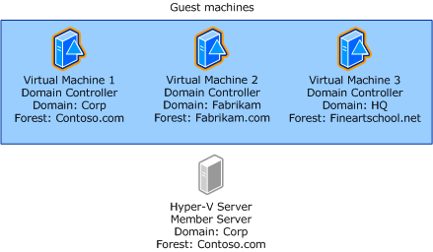

Configuration 1 is the recommended configuration of domain controllers when you use Hyper-V. In this configuration, the following items must be taken into consideration:
• The administrator on the host computer has the same access as a domain administrator on the writable domain controller guests and must be treated as such. In the case of an RODC guest, the administrator of the host computer has the same access as a local administrator on the guest RODC.
• A domain controller in a virtual machine has administrative rights on the host if the host is joined to the same domain. There is an opportunity for a malicious user to compromise all virtual machines if the malicious user first gains access to Virtual Machine 1. This is known as an attack vector. If there are domain controllers for multiple domains or forests, these domains should have centralized administration in which the administrator of one domain is trusted on all domains.
• The opportunity for attack from Virtual Machine 1 exists even if Virtual Machine 1 is installed as an RODC. Although an administrator of an RODC does not explicitly have domain administrator rights, the RODC can be used to send policies to the host computer. These policies might include startup scripts. If this operation is successful, the host computer can be compromised, and it can then be used to compromise the other virtual machines on the host computer.
In Configuration 2, the host computer is a domain controller with the Hyper-V role enabled. However, if Active Directory Domain Services (AD DS) is configured to use constrained delegation, Service Principle Names (SPNs) will not be automatically created for virtual machines (that is, for non-domain-controller virtual machines. Therefore, these SPNs must be created manually. To add SPNs for the constrained delegation, complete the following procedure.
On the domain controller that is running Hyper-V and for which you want to configure constrained delegation, perform the following procedure.
To create SPNs manually
1. Open an elevated Command Prompt window. To open an elevated Command Prompt window, click Start. In Start Search, type Command Prompt. In the Start menu, right-click Command Prompt, and then click Run as administrator.
2. At the command prompt, type the following commands, and then press ENTER:
SETSPN -A Microsoft Virtual Console Service/<NetBIOS name> <NetBIOS name>
SETSPN -A Microsoft Virtual Console Service/<FQDN> <NetBIOS name>
In these SETSPN commands, type the NetBIOS computer name of the domain controller (for example, SERVER1) for <NetBIOS name>. For <FQDN> type the fully qualified domain name (FQDN) of the domain controller (for example, server1.corp.contoso.com).
As a result of the way that Setspn.exe processes information, you must type the NetBIOS name twice, separated by a space, where indicated.
Note
For more information about constrained delegation, see Kerberos Protocol Transition and Constrained Delegation (http://go.microsoft.com/fwlink/?LinkId=137041).
In configuration 3, both host and guests are domain controllers. This configuration does not raise any security issues as long as all domain controllers are from the same forest. In this case, a user who is logged on to the Hyper-V server (host) should be considered to have default domain-administrator-level permissions in the domains of the virtual domain controllers (guests).

Security of VHD files
A VHD file of a virtual domain controller is equivalent to the physical hard drive of a physical domain controller. As such, it should be protected with the same amount of care that goes into securing the hard drive of a physical domain controller. Make sure that only reliable and trusted administrators are allowed access to the domain controller’s VHD files.

RODCs
One benefit of RODCs is the ability to place them at locations where physical security cannot be guaranteed, such as at branch offices. In this case, more effort must be made to mitigate the effects of an attack. You can use Windows® BitLocker™ Drive Encryption to protect VHD files from being compromised on the host through theft of the physical disk. For more information about BitLocker in Hyper-V, see Windows Server 2008 Hyper-V and BitLocker Drive Encryption (http://go.microsoft.com/fwlink/?LinkID=123534).

Performance
With the new microkernel 64-bit architecture, there are significant increases in Hyper-V performance from previous virtualization platforms. For best host performance, the host should be a Server Core installation of Windows Server 2008, and it should not have server roles other than Hyper-V installed.
Performance of virtual machines depends specifically on the workload. To guarantee satisfactory Active Directory performance, test specific topologies. Assess the current workload over a period of time with a tool such as the Reliability and Performance Monitor (Perfmon.msc) or the Microsoft Assessment and Planning (MAP) toolkit (http://go.microsoft.com/fwlink/?LinkId=137077). The MAP tool can also be valuable if you want to take an inventory of all of the servers and server roles that currently exist in your network.
To get a general idea of the performance of virtualized domain controllers, the following performance tests were carried out with the Active Directory Performance Testing Tool (ADTest.exe)(http://go.microsoft.com/fwlink/?LinkId=137088).
Lightweight Directory Access Protocol (LDAP) tests were run on a physical domain controller with ADTest.exe and then on a virtual machine that was hosted on a server that was identical to the physical domain controller. Only one logical processor was used for the physical computer, and only one virtual processor was used for the virtual machine to easily reach 100-percent CPU utilization. In the following table, the letter and number in parenthesis after each test indicate the specific test in ADTest.exe. As this data shows, virtualized domain controller performance was 88 to 98 percent of the physical domain controller performance.

Measurement | Test | Physical | Virtual | Delta
Searches/sec | Search for common name in base scope (L1) | 11508 | 10276 | -10.71%
Searches/sec | Search for a set of attributes in base scope (L2) | 10123 | 9005 | -11.04%
Searches/sec | Search for all attributes in base scope (L3) | 1284 | 1242 | -3.27%
Searches/sec | Search for common name in subtree scope (L6) | 8613 | 7904 | -8.23%
Successful binds/sec | Perform fast binds (B1) | 1438 | 1374 | -4.45%
Successful binds/sec | Perform simple binds (B2) | 611 | 550 | -9.98%
Successful binds/sec | Use NTLM to perform binds (B5) | 1068 | 1056 | -1.12%
Writes/sec | Write multiple attributes (W2) | 6467 | 5885 | -9.00%

To ensure satisfactory performance, integration components (IC) were installed to allow the guest operating system to use “enlightenments,” or hypervisor-aware synthetic drivers. During the installation process, it may be necessary to use emulated Integrated Drive Electronics (IDE) or network adapter drivers. In production environments, you should replace these emulated drivers with synthetic drivers to increase performance.
When you monitor performance of virtual machines with Reliability and Performance Manager (Perfmon.msc), within the virtual machine the CPU information will not be entirely accurate as a result of the way the virtual CPU is scheduled on the physical processor. When you want to obtain CPU information for a virtual machine that is running on a Hyper-V server, use the Hyper-V Hypervisor Logical Processor counters in the host partition.
For more information about performance tuning of both AD DS and Hyper-V, see Performance Tuning Guidelines for Windows Server 2008 (http://go.microsoft.com/fwlink/?LinkId=137276).
Also, do not plan to use a differencing disk VHD on a virtual machine that is configured as a domain controller because the differencing disk VHD can reduce performance. To learn more about Hyper-V disk types, including differencing disks, see New Virtual Hard Disk Wizard (http://go.microsoft.com/fwlink/?LinkId=137279).

Operations master roles
Domain controllers that hold most operations master (also known as flexible single master operations or FSMO) roles do not have significantly more load than other domain controllers. Therefore, they do not need special consideration for virtualization. Bridgehead servers do not need special consideration in terms of performance.
The one exception is the primary domain controller (PDC) emulator operations master role, which in general has higher processor load than other operations master roles. As a result, you may decide to use a physical computer to host the PDC emulator role to improve performance.

Global catalog servers and Exchange
Domain controllers that are configured as global catalog servers, which typically provide directory services for servers running Microsoft Exchange Server, may experience performance loads that are greater than the other domain controllers in your network. For example, when Exchange servers expand distribution lists, they can place a significant load on the domain controllers that provide global catalog services. For performance reasons, consider using physical servers instead of virtual machines for those global catalog servers that provide directory services to Exchange servers.
For additional information regarding AD DS in virtual hosting environments, see article 888794 in the Microsoft Knowledge Base (http://go.microsoft.com/fwlink/?LinkId=141292).
Note

See Also
Running Domain Controllers in Hyper-V (downloadable Word document)

Deployment Considerations for Virtualized Domain Controllers
This topic describes some things to consider when you deploy domain controllers on virtual machines. There are several common virtual machine practices that you should avoid when you deploy domain controllers. There are also special considerations for time synchronization and storage. The following sections describe these considerations.

Virtualization deployment practices to avoid
Virtualization platforms, such as Hyper-V, offer a number of convenience features that make managing, maintaining, backing up, and migrating computers easier. However, there are some common deployment practices and features that should not be used for virtual domain controllers. The following list describes the practices to avoid when you deploy domain controllers:
• Do not implement differencing disk virtual hard disks (VHDs) on a virtual machine that you are configuring as a domain controller. This makes it too easy to revert to a previous version, and it also decreases performance. For more information about VHD types, see New Virtual Hard Disk Wizard (http://go.microsoft.com/fwlink/?LinkID=137279).
• Do not clone the installation of an operating system without using Sysprep.exe because the security identifier (SID) of the computer will not be updated. For more information about running the System Preparation tool (Sysprep), see "Using virtual hard disks" in Ways to deploy an operating system to a virtual machine (http://go.microsoft.com/fwlink/?LinkId=137100).
• To help prevent a potential update sequence number (USN) rollback situation, do not use copies of a VHD file that represents an already deployed domain controller to deploy additional domain controllers. The next three items in this list are also recommended to help avoid potential USN rollback. For more information about USN rollback, see Appendix A: Virtualized Domain Controllers and Replication Issues.
• Do not use the Hyper-V Export feature to export a virtual machine that is running a domain controller.
Running Sysprep on a domain controller damages the AD DS installation. Use Sysprep before you install the AD DS role to produce a unique security identifier (SID) for that installation.
Warning

Physical-to-virtual migration
System Center Virtual Machine Manager (VMM) 2008 provides unified management of physical machines and virtual machines. It also provides the ability to migrate a physical machine to a virtual machine. This process is known as physical-to-virtual machine conversion (P2V conversion). During the P2V conversion process, the new virtual machine and the physical domain controller that is being migrated must not be on at the same time, to avoid a USN rollback situation as described in Appendix A: Virtualized Domain Controllers and Replication Issues.
You should perform P2V conversion using offline mode so that the directory data is consistent when the domain controller is turned back on. The offline mode option is offered and recommended in the Convert Physical Server Wizard. For a description of the difference between online mode and offline mode, see P2V: Converting Physical Computers to Virtual Machines in VMM (http://go.microsoft.com/fwlink/?LinkId=155072). During P2V conversion, the virtual machine should not be connected to the network. The network interface card (NIC) of the virtual machine should be enabled only after the P2V conversion process is complete and verified. At this point, the physical source machine will be off. Do not bring the physical source machine back onto the network again before you reformat the hard disk.
To prevent issues with Active Directory replication, ensure that only one instance (physical or virtual) of a given domain controller exists on a given network at any point in time.
Caution

Using P2V Migration to Create Test Environments
You can use P2V migration through the VMM to create test environments. You can migrate production domain controllers from physical machines to virtual machines to create a test environment without permanently bringing down the production domain controllers. However, the test environment must be on a different network from the production environment if two instances of the same domain controller are to exist. Great care must be taken in the creation of test environments with P2V migration to avoid USN rollbacks that can affect your test and production environments. The following is a method that you can use for creating test environments with P2V.
One in-production domain controller from each domain is migrated to a test virtual machine using P2V according to the guidelines stated in the Physical-to-virtual migration section. The physical production machines and the test virtual machines must be in different networks when they are brought back online. To avoid USN rollbacks in the test environment, all domain controllers that are to be migrated from physical machines to virtual machines must be taken offline. (You can do this by stopping the ntds service or by restarting the computer in Directory Services Restore Mode (DSRM).) After the domain controllers are offline, no new updates should be introduced to the environment. The computers must remain offline during the P2V migration; none of the computers should be brought back online until all the computers have been fully migrated. To learn more about USN rollback, see Appendix A: Virtualized Domain Controllers and Replication Issues.
Subsequent test domain controllers should be promoted as replicas in the test environment.

Time service
For virtual machines that are configured as domain controllers, disable time synchronization with the host through Integration Services. Instead, accept the default Windows Time service (W32time) domain hierarchy time synchronization.
Host time synchronization makes it possible for guest operating systems to synchronize their system clocks with the system clock of the host operating system. Because domain controllers have their own time synchronization mechanism, host time synchronization must be disabled on virtual machines that are configured as domain controllers. If domain controllers synchronize time from their own source and also synchronize time from the host, the domain controller time can change frequently. Because many domain controller tasks are tied to the system time, a jump in the system time could cause lingering objects to be left in the directory and replication to be stopped.
You can disable host time synchronization in the virtual machine settings in the Integration Services section of the Hyper-V Manager by clearing the Time Synchronization check box.
For information about installing and using Integration Services, see the Hyper-V Getting Started Guide (http://go.microsoft.com/fwlink/?LinkId=137146).

Storage
To optimize the performance of the domain controller virtual machine, use the following recommendations for storing operating system, Active Directory, and VHD files:
• Guest storage. Store the Active Directory database file (Ntds.dit), log files, and SYSVOL files on a separate virtual disk from the operating system files. Integration Components must be installed so that synthetic drivers can be used for Integrated Drive Electronics (IDE) instead of emulation. Virtual SCSI and IDE disks perform at the same speed when they use synthetic drivers.
• Host storage of VHD files. Recommendations: Host storage recommendations address storage of VHD files. For maximum performance, do not store VHD files on a disk that is used frequently by other services or applications, such as the system disk on which the host Windows operating system is installed. Store each VHD file on a separate partition from the host operating system and any other VHD files. The ideal configuration is to store each VHD file on a separate physical drive.
• Fixed VHD versus pass-through disks. There are many ways to configure storage for virtual machines. When VHD files are used, fixed-size VHDs are more efficient than dynamic VHDs because the memory for fixed-size VHDs is allocated when they are created. Pass-through disks, which virtual machines can use to access physical storage media, are even more optimized for performance. Pass-through disks are essentially physical disks or logical unit numbers (LUNs) that are attached to a virtual machine. Pass-through disks do not support the snapshot feature. Therefore, pass-through disks are the preferred hard disk configuration, because the use of snapshots with domain controllers is not recommended.
To reduce the chance of corruption of Active Directory data, use SCSI controllers or disable write caching on ATA/IDE drives:
• Use SCSI physical drives (as opposed to IDE/ATA drives) on Hyper-V servers that host virtual domain controllers. If you cannot use SCSI drives, ensure that write caching is disabled on the ATA/IDE drives that host virtual domain controllers. For more information, see Event ID 1539 – Database Integrity (http://go.microsoft.com/fwlink/?LinkId=162419).
• Use virtual SCSI controllers for any virtual machine that runs as a domain controller. If you cannot use virtual SCSI controllers, ensure that write caching is disabled on the virtual IDE drives of virtual machines that run as domain controllers. You can see the type of disk controllers that are installed in the Virtual Machine Manager Settings dialog box. For more information, see Configuring Virtual Machines (http://go.microsoft.com/fwlink/?LinkID=129912).

See Also
Running Domain Controllers in Hyper-V (downloadable Word document)

Operational Considerations for Virtualized Domain Controllers
Domain controllers that are running on virtual machines have operational restrictions that do not apply to domain controllers that are running on physical machines. When you use a virtualized domain controller, there are some virtualization software features and practices that you should not use:
• Do not pause, stop, or store the saved state of a domain controller in a virtual machine for time periods longer than the tombstone lifetime of the forest and then resume from the paused or saved state. Doing this can interfere with replication. To learn how to determine the tombstone lifetime for the forest, see Determine the Tombstone Lifetime for the Forest (http://go.microsoft.com/fwlink/?LinkId=137177).
• Do not copy or clone virtual hard disks (VHDs).
• Do not take or use a Snapshot of a virtual domain controller.
• Do not use a differencing disk VHD on a virtual machine that is configured as a domain controller. This makes reverting to a previous version too easy, and it also decreases performance.
• Do not use the Export feature on a virtual machine that is running a domain controller.
• Do not restore a domain controller or attempt to roll back the contents of an Active Directory database by any means other than using a supported backup. For more information, see Backup and Restore Considerations for Virtualized Domain Controllers.
All these recommendations are made to help avoid the possibility of an update sequence number (USN) rollback. For more information about USN rollback, see Appendix A: Virtualized Domain Controllers and Replication Issues.

See Also
Running Domain Controllers in Hyper-V (downloadable Word document)

Backup and Restore Considerations for Virtualized Domain Controllers
Backing up domain controllers is a critical requirement for any environment. Backups protect against data loss in the event of domain controller failure or administrative error. If such an event occurs, it is necessary to roll back the system state of the domain controller to a point in time before the failure or error. The supported method of restoring a domain controller to a healthy state is to use an Active Directory–compatible backup application, such as Windows Server Backup, to restore a system state backup that originated from the current installation of the domain controller. For more information about using Windows Server Backup with Active Directory Domain Services (AD DS), see the AD DS Backup and Recovery Step-by-Step Guide (http://go.microsoft.com/fwlink/?LinkId=138501).
With virtual machine technology, certain requirements of Active Directory restore operations take on added significance. For example, if you restore a domain controller by using a copy of the virtual hard disk (VHD) file, you bypass the critical step of updating the database version of a domain controller after it has been restored. Replication will proceed with inappropriate tracking numbers, resulting in an inconsistent database among domain controller replicas. In most cases, this problem goes undetected by the replication system and no errors are reported, despite inconsistencies between domain controllers.
There are two supported ways to perform backup and restore of a virtualized domain controller:
1. Run Windows Server Backup in the guest operating system.
2. Run Windows Server Backup on the host. This action calls the Volume Shadow Copy Service (VSS) writer of the guest to make sure that the backup is performed properly.

Backup and restore practices to avoid
As mentioned, domain controllers that are running in virtual machines have restrictions that do not apply to domain controllers that are running in physical machines. When you back up or restore a virtual domain controller, there are certain virtualization software features and practices that you should not use:
• Do not copy or clone VHD files of domain controllers instead of performing regular backups. If he VHD file is copied or cloned, it becomes stale. Then, if the VHD is started in normal mode, there might be a divergence of replication data in the forest. You should perform proper backup operations that are supported by Active Directory Domain Services (AD DS), such as using the Windows Server Backup feature.
• Do not use the Snapshot feature as a backup to restore a virtual machine that was configured as a domain controller. Problems will occur with replication when you revert the virtual machine to an earlier state. For more information, see Appendix A: Virtualized Domain Controllers and Replication Issues. Although using a snapshot to restore a read-only domain controller (RODC) will not cause replication issues, this method of restoration is still not recommended.

Restoring a virtual domain controller
To restore a domain controller when it fails, you must regularly backup system state. System state includes Active Directory data and log files, the registry, the system volume (SYSVOL folder), and various elements of the operating system. This requirement is no different for a domain controller that is running on a virtual machine than it is for a domain controller that is running on native hardware. System state restore procedures that Active Directory–compatible backup applications perform are designed to ensure the consistency of local and replicated Active Directory databases after a restore process, including the notification to replication partners of invocation ID resets. However, using virtual hosting environments and disk or operating system imaging applications makes it possible for administrators to bypass the checks and validations that ordinarily occur when domain controller system state is restore.
When a domain controller virtual machine fails and an update sequence number (USN) rollback has not occurred, there are two supported situations for restoring the virtual machine:
• If a valid system state data backup that predates the failure exists, you can restore system state by using the restore option of the backup utility that you used to create the backup. The system state data backup must have been created using an Active Directory–compatible backup utility within the span of the tombstone lifetime, which is by default, no more than 180 days. You should back up your domain controllers at least every half tombstone lifetime. For instructions about how to determine the specific tombstone lifetime for your forest, see Determine the Tombstone Lifetime for the Forest (http://go.microsoft.com/fwlink/?LinkID=137177).
• If a working copy of the VHD file is available, but no system state backup is available, you can remove the existing virtual machine. Restore the existing virtual machine by using a previous copy of the VHD, but be sure to start it in Directory Services Restore Mode (DSRM) and configure the registry properly, as described in the following section. Then, restart the domain controller in normal mode.
Use the process in the following illustration to determine the best way to restore your virtualized domain controller.
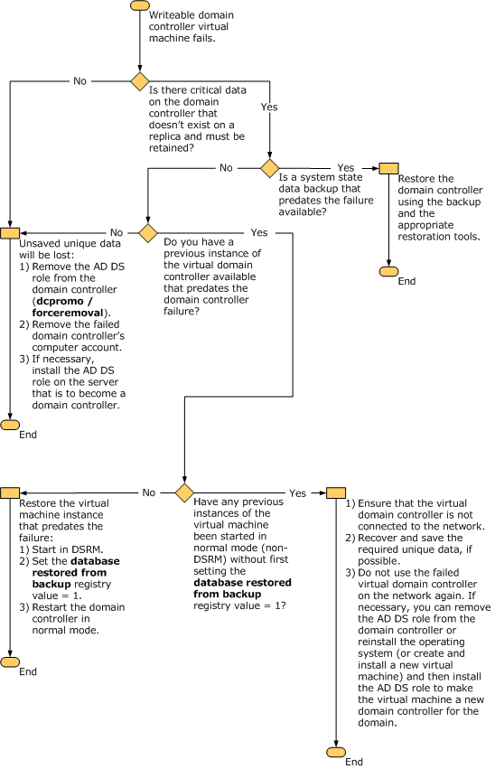

For RODCs, the restoration process and decisions are simpler.
Restoring the VHD of a virtual RODC
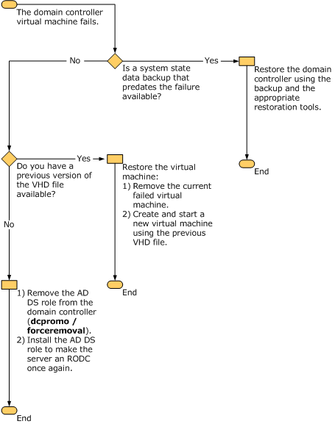

Restoring the system state backup of a virtual domain controller
If a valid system state backup exists for the domain controller virtual machine, you can safely restore the backup by following the restore procedure prescribed by the backup tool that you used to back up the VHD file.
To properly restore the domain controller, you must start it in DSRM. You must not allow the domain controller to start in normal mode. If you miss the opportunity to enter DSRM during system startup, turn off the domain controller’s virtual machine before it can fully start in normal mode. It is important to start the domain controller in DSRM because starting a domain controller in normal mode increments its USNs, even if the domain controller is disconnected from the network. For more information about USN rollback, see Appendix A: Virtualized Domain Controllers and Replication Issues.
Important
To restore the system state backup of a virtual domain controller
1. Start the domain controller’s virtual machine, and press F5 to access the Windows Boot Manager screen. If you are required to enter connection credentials, immediately click the Pause button on the virtual machine so that it does not continue starting. Then, enter your connection credentials, and click the Play button on the virtual machine. Click inside the virtual machine window, and then press F5.
If you do not see the Windows Boot Manager screen and the domain controller begins to start in normal mode, turn off the virtual machine to prevent it from completing startup. Repeat this step as many times as necessary until you are able to access the Windows Boot Manager screen. You cannot access DSRM from the Windows Error Recovery menu. Therefore, turn off the virtual machine and try again if the Windows Error Recovery menu appears.
2. In the Windows Boot Manager screen, press F8 to access advanced boot options.
3. In the Advanced Boot Options screen, select Directory Services Restore Mode, and then press ENTER. This starts the domain controller in DSRM.
4. Use the appropriate restore method for the tool that you used to create the system state backup. If you used Windows Server Backup, see Performing a Nonauthoritative Restore of AD DS (http://go.microsoft.com/fwlink/?LinkID=132637).

Restoring a virtual domain controller when an appropriate system state data backup is not available
If you do not have a system state data backup that predates the virtual machine failure, you can use a previous VHD file to restore a domain controller that is running on a virtual machine.
Do not use this procedure if the copy of the VHD that you are about to restore has been restarted in normal mode by any virtual machine.
Caution
To restore a previous version of a virtual domain controller VHD without system state data backup
1. Using the previous VHD, start the virtual domain controller in DSRM, as described in the previous section. Do not allow the domain controller to start in normal mode. If you miss the Windows Boot Manager screen and the domain controller begins to start in normal mode, turn off the virtual machine to prevent it from completing startup. See the previous section for detailed instructions for entering DSRM.
2. Open Registry Editor. To open Registry Editor, click Start, click Run, type regedit, and then click OK. If the User Account Control dialog box appears, confirm that the action it displays is what you want, and then click Yes. In Registry Editor, expand the following path: HKEY_LOCAL_MACHINE\SYSTEM\CurrentControlSet\Services\NTDS\Parameters. Look for a value named DSA Previous Restore Count. If the value is there, make a note of the setting. If the value is not there, the setting is equal to the default, which is zero. Do not add a value if you do not see one there.
3. Right-click the Parameters key, click New, and then click DWORD (32-bit) Value.
4. Type the new name Database restored from backup, and then press ENTER.
5. Double-click the value that you just created to open the Edit DWORD (32-bit) Value dialog box, and then type 1 in the Value data box. The Database restored from backup entry option is available on domain controllers that are running Windows 2000 Server with Service Pack 4 (SP4), Windows Server 2003 with the updates that are included in article 875495 in the Microsoft Knowledge Base (http://go.microsoft.com/fwlink/?LinkId=137182) installed, and Windows Server 2008.
6. Restart the domain controller in normal mode.
7. When the domain controller restarts, open Event Viewer. To open Event Viewer, click Start, click Control Panel, double-click Administrative Tools, and then double-click Event Viewer.
8. Expand Application and Services Logs, and then click the Directory Services log. Ensure that events appear in the details pane.
9. Right-click the Directory Services log, and then click Find. In Find what, type 1109, and then click Find Next.
10. You should see at least an Event ID 1109 entry. If you do not see this entry, proceed to the next step. Otherwise, double-click the entry, and then review the text confirming that the update was made to the InvocationID:
Active Directory has been restored from backup media, or has been configured to host an application partition.
The invocationID attribute for this directory server has been changed.
The highest update sequence number at the time the backup was created is <time>

InvocationID attribute (old value):<Previous InvocationID value>
InvocationID attribute (new value):<New InvocationID value>
Update sequence number:<USN>

The InvocationID is changed when a directory server is restored from backup media or is configured to host a writeable application directory partition.

11. Close Event Viewer.
12. Use Registry Editor to verify that the value in DSA Previous Restore Count is equal to the previous value plus one. If this is not the correct value and you cannot find an entry for Event ID 1109 in Event Viewer, verify that the domain controller’s service packs are current and then repeat the procedure by starting over at step 1.
13. Close Registry Editor.

See Also
Running Domain Controllers in Hyper-V (downloadable Word document)

Appendix A: Virtualized Domain Controllers and Replication Issues
This appendix describes replication issues that can occur as a result of an incorrect restoration of the Active Directory database with an older version of a virtual machine. For additional details about the Active Directory replication process, see How the Active Directory Replication Model Works (http://go.microsoft.com/fwlink/?LinkID=27636).

USNs
Active Directory Domain Services (AD DS) uses update sequence numbers (USNs) to keep track of replication of data between domain controllers. Each time that a change is made to data in the directory, the USN is incremented to indicate that a change has been made.
For each directory partition that a destination domain controller stores, USNs are used to track the latest originating update that a domain controller has received from each source replication partner, as well as the status of every other domain controller that stores a replica of the directory partition. When a domain controller is restored after a failure, it queries its replication partners for changes with USNs that are greater than the USN of the last change that the domain controller received from each partner before the time of the backup.
The following two replication process values contain USNs. Source and destination domain controllers use them to filter updates that the destination domain controller requires.
1. Up-to-dateness vector: A value that the destination domain controller maintains for tracking the originating updates that are received from all source domain controllers. When a destination domain controller requests changes for a directory partition, it provides its up-to-dateness vector to the source domain controller. The source domain controller then uses this value to reduce the set of attributes that it sends to the destination domain controller. The source domain controller sends its up-to-dateness vector to the destination at the completion of a successful replication cycle.
2. High water mark: Also known as the direct up-to-dateness vector. A value that the destination domain controller maintains to keep track of the most recent changes that it has received from a specific source domain controller for an object in a specific partition. The high water mark prevents the source domain controller from sending out changes that are already recorded by the destination domain controller.

Directory database identity
In addition to USNs, domain controllers keep track of the directory database of source replication partners. The identity of the directory database running on the server is maintained separately from the identity of the server object itself. The directory database identity on each domain controller is stored in the invocationID attribute of the NTDS Settings object, which is located under the following Lightweight Directory Access Protocol (LDAP) path: cn=NTDS Settings, cn=ServerName, cn=Servers, cn=SiteName, cn=Sites, cn=Configuration, dc=ForestRootDomain. The server object identity is stored in the objectGUID attribute of the NTDS Settings object. The identity of the server object never changes. However, the identity of the directory database changes when a system state restore procedure occurs on the server or when an application directory partition is added or removed from the server.
Consequently, invocationID effectively relates a set of originating updates on a domain controller with a specific version of the directory database. Both the up-to-dateness vector and the high water mark values refer to the invocationID so that domain controllers know from which copy of the Active Directory database the replication information is coming.
The invocationID is a globally unique identifier (GUID) value that is visible near the top of the output after you run the command repadmin /showrepl. The following text represents example output from the command:
Repadmin: running command /showrepl against full DC local host
Default-First-Site-Name\VDC1
DSA Options: IS_GC
DSA object GUID: 966651f3-a544-461f-9f2c-c30c91d17818
DSA invocationID: 966651f3-a544-461f-9f2c-c30c91d17818
When AD DS is properly restored on a domain controller, the invocationID is reset and the new value is replicated to all domain controllers in the forest. In response to this change, other domain controllers in the forest update their high water mark and up-to-dateness USNs to match the highest USNs that are contained in the system state of the restored domain controller. In this way, partner domain controllers recognize the restored domain controller’s highest USN as current rather than old.
For example, assume that VDC1 and DC2 are two domain controllers in the same domain. The following figure shows the perception of DC2 about VDC1 when the invocationID value is reset in a proper restore situation. In this case, the change to the invocationID on VDC1 replicates to DC2. DC2 thereby recognizes VDC1 as a restored domain controller, and it resets its up-to-dateness value for VDC2 to the value that reflects the current state of the restored directory database.
Replication synchronization involving a proper restore
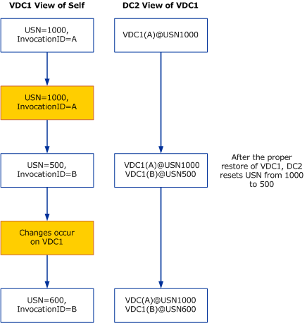

USN rollback
USN rollback occurs when the normal updates of the USNs are circumvented and a domain controller tries to use a USN that is lower than its latest update.
In Windows Server 2008 or Windows Server 2003 Service Pack 1 (SP1), USN rollback will be detected and replication will be stopped before divergence in the forest is created, in most cases. For Windows 2000 Server, the updates in article 885875 in the Microsoft Knowledge Base (http://go.microsoft.com/fwlink/?LinkId=137184) must be installed to enable this detection.
USN rollback can be caused in many ways, for example, when old virtual hard disk (VHD) files are used or physical-to-virtual conversion (P2V conversion) is performed without ensuring that the physical machine stays offline permanently after the conversion. Take the following precautions to ensure that USN rollback does not occur:
• Do not take or use a snapshot of a domain controller virtual machine.
• Do not copy the domain controller VHD file.
• Do not export the virtual machine that is running a domain controller.
• Do not restore a domain controller or attempt to roll back the contents of an Active Directory database by any other means than a supported backup solution, such as Windows Server Backup.
In some cases, USN rollback may go undetected. In other cases, it may cause other replication errors. In these cases, it is necessary to identify the extent of the problem and take care of it in a timely manner. For information about how to remove lingering objects that may occur as a result of USN rollback, see article 870695 in the Microsoft Knowledge Base (http://go.microsoft.com/fwlink/?LinkId=137185).

USN rollback detection
In most cases, USN rollbacks without a corresponding reset of the invocationID caused by improper restore procedures are detected. Windows Server 2008 provides protections against inappropriate replication after an improper domain controller restore operation. These protections are triggered by the fact that an improper restore operation results in lower USNs that represent originating changes that the replication partners have already received.
In Windows Server 2008 and Windows Server 2003 SP1, when a destination domain controller requests changes by using a previously used USN, the response by its source replication partner is interpreted by the destination domain controller to mean that its replication metadata is outdated. This indicates that the Active Directory database on the source domain controller has been rolled back to a previous state. For example, the VHD file of a virtual machine has been rolled back to a previous version. In this case, the destination domain controller initiates the following quarantine measures on the domain controller that has been identified as having undergone an improper restore:
• AD DS pauses the Net Logon service, which prevents user accounts and computer accounts from changing account passwords. This action prevents the loss of such changes if they occur after an improper restore.
• AD DS disables inbound and outbound Active Directory replication.
• AD DS generates Event ID 2095 in the Directory Service event log to indicate the condition.
The following illustration shows the sequence of events that occurs when USN rollback is detected on VDC2, the destination domain controller that is running on a virtual machine. In this illustration, the detection of USN rollback occurs on VDC2 when a replication partner detects that VDC2 has sent an up-to-dateness USN value that was seen previously by the destination domain controller, which indicates that VDC2’s database has rolled back in time improperly.
Example of how replication can become inconsistent 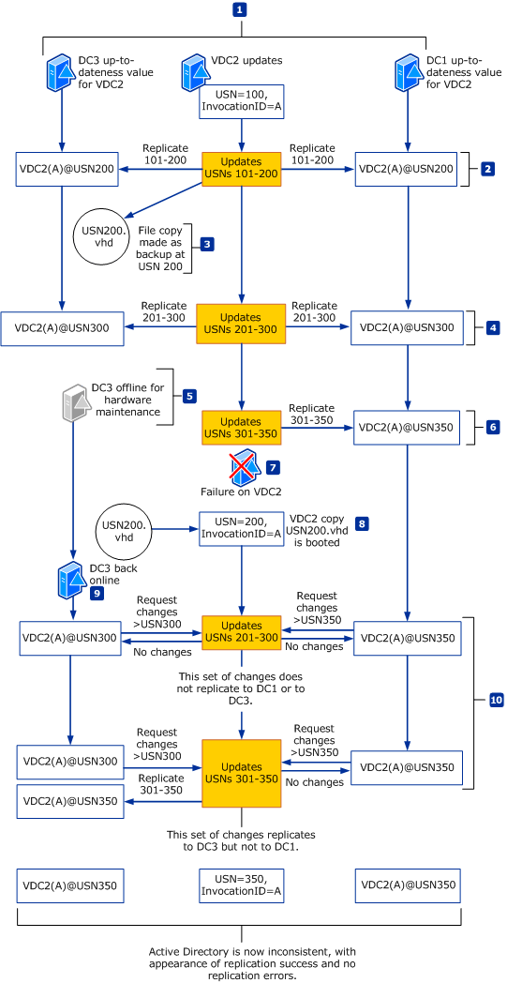

If the Directory Service event log reports Event ID 2095, complete the following procedure immediately.
To resolve Event ID 2095
1. Shut down the domain controller virtual machine that recorded the error, and ensure that it does not restart.
2. Determine whether a snapshot of the domain controller was recently used as a restore mechanism. If so, this is most probably the source of the error.
3. Attempt to determine whether any changes originated from this domain controller and propagated to other domain controllers. If the event was a result of a snapshot or copy of a virtual machine being started, try to determine the time the USN rollback occurred. You can then check the replication partners of that domain controller to determine whether replication occurred since then.
You can use the Repadmin tool to make this determination. For information about how to use Repadmin, see Monitoring and Troubleshooting Active Directory Replication Using Repadmin (http://go.microsoft.com/fwlink/?LinkId=122830). If you are not able to determine this yourself, contact Microsoft Customer Service and Support (http://go.microsoft.com/fwlink/?LinkID=102491) for assistance.
4. Forcefully demote the domain controller. This involves cleaning up the domain controller’s metadata and seizing the operations master (also known as flexible single master operations or FSMO) roles. For more information, see the “Recovering from USN rollback” section of article 875495 in the Microsoft Knowledge Base (http://go.microsoft.com/fwlink/?LinkID=137182).
5. Delete all former VHD files for the domain controller.

Undetected USN rollback
USN rollback might not be detected in one of two circumstances:
1. The VHD file is attached to different virtual machines that are running in multiple locations simultaneously.
2. The USN on the restored domain controller has increased past the last USN that the other domain controller has received.
In the first circumstance, other domain controllers might replicate with either one of the virtual machines, and changes might occur on either virtual machine without being replicated to the other. This divergence of the forest is difficult to detect, and it will cause unpredictable directory responses. This situation might occur after a P2V migration if both the physical and virtual machine are run on the same network. This could also happen if multiple virtual domain controllers are created from the same physical domain controller and then run on the same network.
In the second circumstance, a range of USNs applies to two different sets of changes. This can continue for extended periods without being detected. Whenever an object that is created during that time is modified, a lingering object is detected and reported as Event ID 1988 in Event Viewer. The following illustration shows how USN rollback might not be detected in such a circumstance.
Example illustrating how USN rollback might not be detected
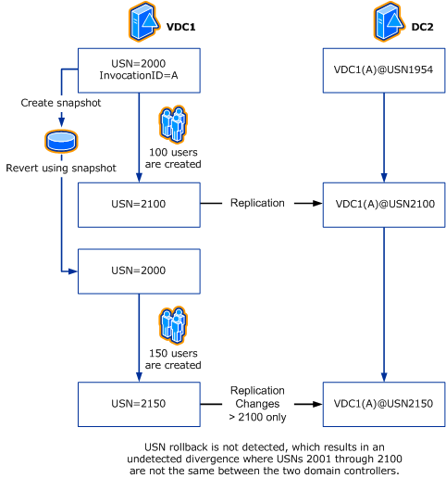

Read-only domain controllers
Read-only domain controllers (RODCs) are a new feature of Windows Server 2008. RODCs are domain controllers that host read-only copies of the partitions in an Active Directory database. RODCs avoid most USN rollback issues because they do not replicate any changes to the other domain controllers. However, if an RODC replicates from a writeable domain controller that has been affected by USN rollback, the RODC is affected as well.
Restoring an RODC using a snapshot is not recommended. Restore an RODC using an Active Directory–compatible backup application. Also, as with writeable domain controllers, care must be taken to not allow an RODC to be offline for more than tombstone lifetime. This condition can result in lingering objects on the RODC.
For more information about RODCs, see the Read-Only Domain Controller Planning and Deployment Guide (http://go.microsoft.com/fwlink/?LinkID=135993).

See Also
Running Domain Controllers in Hyper-V (downloadable Word document)

