The information contained in this document represents the current view of Microsoft Corporation on the issues discussed as of the date of publication. Because Microsoft must respond to changing market conditions, it should not be interpreted to be a commitment on the part of Microsoft, and Microsoft cannot guarantee the accuracy of any information presented after the date of publication.
This document is for informational purposes only. MICROSOFT MAKES NO WARRANTIES, EXPRESS, IMPLIED OR STATUTORY, AS TO THE INFORMATION IN THIS DOCUMENT.
Microsoft may have patents, patent applications, trademarks, copyrights, or other intellectual property rights covering this document or the subject matter included in this document. The furnishing of this document does not give you any license to these patents, trademarks, copyrights, or other intellectual property.
© 2006 Microsoft Corporation. All rights reserved.

Microsoft Project Portfolio Server 2006 Installation Guide
Table of Contents

Cover is for
position only

Microsoft Project Portfolio Server 2006 Installation Guide i
System Requirements for Project Portfolio Server 2006 2
System Requirements for Project Portfolio Web Access 4
Installation and Configuration Prerequisites 5
Introduction: 5
Configuration pre-requisites for your server running PPS 2006 5
Install .NET Framework 2.0: 5
Install Microsoft Visual C++ 2005 Redistributable Package: 5
Enable Microsoft Internet Information Services (IIS): 5
To enable IIS on Windows Server 2003 5
Microsoft SQL Server 2005: 6
Performing a single server installation of Microsoft Project Portfolio Server 2006 7
Restoring the Databases: 7
Installation of the PPS 2006 Application Files: 10
Configuring the Web.Config file: 17
Microsoft SQL 2005 Reporting Services Configuration 21
Configuration of Microsoft SQL Server 2005 Reporting Services 21
Configuring the Project Server 2003 PDS Extender 29
Configuring Portfolio Server 2006 in a distributed environment 31
Microsoft Office Project Portfolio Client Configuration 37
Configuring Visual Basic Access for Microsoft Excel 37
Configuring Internet Explorer’s Security settings: 38
Troubleshooting Common Installation Errors 40

System Requirements for Project Portfolio Server 2006
Project Portfolio Server 2006 processor, RAM, and hard disk requirements are highly dependent on the number of services installed on the computer and the load on the server.
Minimum requirements assume one server where all Project Portfolio Server components and supporting technologies (i.e., Microsoft SQL Server, Microsoft Windows® Server System) are installed.
To use Project Portfolio Server 2006 you need:
Component | Requirement
Operating system | Microsoft Windows Server 2003 SP1 or higher (32-bit)
Single box installation | - Server with a processor speed of at least 2.5 GHz; RAM capacity minimum of 1 GB, 2 GB recommended; disk space: 1 GB for installation;  - Microsoft SQL Server 2005 SP1 with a processor speed of at least 2.5 GHz, minimum 2 GB of RAM
Drive | CD-ROM or DVD drive
Display | Minimum 800x600; 1024x768 or higher- resolution monitor recommended
Browser | Microsoft Internet Explorer 6.0 with service packs (or higher) – 32 bit browser version is supported
Network Connection | 100 Megabits per second (Mbps) connection speed is required to utilize Project Portfolio Server functionality
Other requirements | Microsoft .NET Framework 2.0; IIS 6.0; ASP.NET 2.0
Additional Components | Office Project Portfolio Server 2006 processor, RAM, and hard-disk requirements are highly dependent on the number of services installed on the computer and the load on the server.  - Microsoft SQL 2005 Reporting Services (included with Microsoft SQL Server) is required for Reporting.  - Microsoft Office Project Server 2003 is required to use the Project Server Gateway (the bi-directional link between Office Project Portfolio Server 2006 and Microsoft Office Project Server 2003)  - Microsoft Windows SharePoint Services 2.0 (included in Microsoft Windows Server 2003) is required for Document Management

System Requirements for Project Portfolio Web Access
Microsoft Office Project Portfolio Web Access is a Web portal used to access the information stored in Microsoft Office Project Server 2003. Using Project Portfolio Web Access requires a Project Portfolio Server 2006 Client Access License (CAL).
To use Project Portfolio Web Access you need:
Component | Requirement
Computer and processor | 700 megahertz (MHz) processor or higher
Memory | 128 MB of RAM or more recommended (additional memory may be required depending on operating system requirements)
Hard disk | 40 MB of available hard disk space per workstation
Operating system | Windows XP SP2 or later, Windows XP Tablet Edition SP1 or later
Display | Minimum 800x600; 1024x768 or higher- resolution monitor recommended
Browser | Microsoft Internet Explorer 6.0 with service packs (or higher) – 32 bit browser version is supported
Network Connection | 256KB or higher connection
Other | - Microsoft Office Excel 2003 is required to load the matrix views in the Portfolio Optimizer module and generate reports.  - Adobe Acrobat 5.0 (or higher) is required to generate reports in pdf

Installation and Configuration Prerequisites

Introduction:
This installation guide will walk you through the required steps to successfully install Microsoft Project Portfolio Server 2006. This guide assumes you have already installed Windows Server 2003 on the local machine with the latest service packs and security fixes from the Windows update site.

Configuration pre-requisites for your server running PPS 2006

Install .NET Framework 2.0:
- Download and install the Microsoft .Net Framework 2.0 using the instructions provided at the following URL:
- http://www.microsoft.com/downloads/details.aspx?FamilyID=0856eacb-4362-4b0d-8edd-aab15c5e04f5&displaylang=en

Install Microsoft Visual C++ 2005 Redistributable Package:
- Download and install the Visual C++ 2005 Redistributable Package, using the instructions provided at the following URL: http://www.microsoft.com/downloads/details.aspx?familyid=32BC1BEE-A3F9-4C13-9C99-220B62A191EE&displaylang=en.

Enable Microsoft Internet Information Services (IIS):
Microsoft Project Portfolio Server 2006 requires Internet Information Services (IIS). This section here will take you through the process of enabling the required components in IIS.
Note: It is recommended that you configure IIS to use Secure Sockets Layer (SSL) for best security. For more information about configuring IIS to use SSL, see your IIS documentation.

To enable IIS on Windows Server 2003
- Click Start and then click Manage Your Server.
- On the Manage Your Server page, click Add or remove a role.
- On the Preliminary Steps pane, click Next.
- On the Server Role pane, click Application server (IIS, ASP.NET), and then click Next.
- On the Application Server Options pane, check the “Enable ASP.Net checkbox and then click Next.
- On the Summary of Selections page, click Next
- Click Finish.

Microsoft SQL Server 2005:
Microsoft Project Portfolio Server 2005 requires Microsoft SQL Server 2005 (Service Pack 1) configured with the components listed below.

Note: PPS 2006 supports SQL Server 2005 servers configured using Windows Authentication Mode. However if you are planning to host Microsoft Project Server 2003 databases on this same server, then you’ll need to configure SQL Server to use Mixed Mode authentication. Note: The SQL Server authentication mode can be changed anytime after SQL Server 2005 has been installed.

Required SQL Server 2005 Components for use with PPS 2006

- SQL Server Database Services
- Reporting Services
- Workstation components, Books online and development tools.

The instructions on the system requirements, installation and setup information for Microsoft SQL Server 2005 is documented in the Microsoft SQL Server 2005 Online Books.

Performing a single server installation of Microsoft Project Portfolio Server 2006
Installing Microsoft Project Portfolio Server 2006 can be a complex process, including many tasks that must be completed before, during, or after installing the product itself. This guide, while not intended to cover all the possible upgrade or installation paths, provides an overview of the steps necessary to install Portfolio Server 2006 on a single server running SQL Server 2005 and SQL Reporting Services 2005.

Note: The installation of Windows SharePoint Services on the same website and port number as Microsoft Project Portfolio Server 2006 or as Reporting Services is currently an unsupported configuration. If Windows SharePoint Services needs to be installed on the same server, it must be configured on a different site from where Portfolio Server is installed. Please refer to the Sharepoint installation instructions on installing and configuring Windows Sharepoint Services (v2) for more details. http://www.microsoft.com/resources/documentation/wss/2/all/adminguide/en-us/stsd01.mspx?mfr=true

Preparing and configuring the Project Portfolio Server 2006 databases on SQL Server 2005

The Microsoft Project Portfolio Server 2006 installation files include 2 blank databases that have been pre-configured for use with Project Portfolio Server 2006. In this section you’ll begin by restoring both the PPSAccountData as well as the PPSAccountIndex databases.

Restoring the Databases:
- In this section we’ll restore the 2 empty databases using the names specified below.
Name of Backup Database | Database Name to use during the Restore Process
PPSAccountData_EmptyDB.bak | PPSAccountData
PPSAccountIndex.bak | PPSAccountIndex

- Begin by copying the two database backup files from the Databases folder (located as part of the PPS 2006 installation files) to a folder of your choice on the local drive of your SQL server. E.g. to the following folder:

C:\Program Files\Microsoft SQL Server\MSSQL.Number\MSSQL\Backup

Note: MSSQl.Number represents the folder used by the SQL Server 2005 instance.

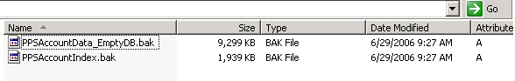

- Launch SQL Server Management Studio by clicking on Start, Programs, Microsoft SQL Server 2005, and SQL Server Management Studio

- On the Connect to Server window, for Server Type, select Database Engine, for Server Name enter the name of your SQL Server and for Authentication, select the appropriate authentication option (if using SQL Server authentication enter the corresponding username / password) and click Connect.

- Next right click on the Databases node in the hierarchy and select Restore Database…

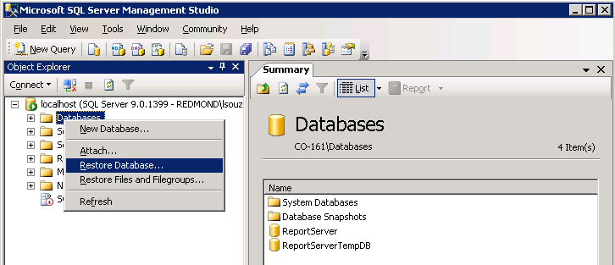

- In the Restore Database dialog, enter PPSAccountData in the To Database textbox.
- Next select the From device option and click on the “…” button.
- In the Specify Database dialog, click Add and browse to the location where the database backup files have been copied to and select the file named PPSAccountData_EmptyDB.bak and click OK

- In the Select the Backup Set to Restore section, ensure the Restore option is checked

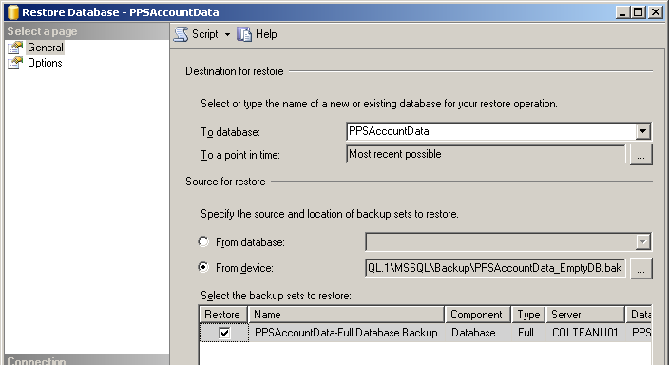

- Next in the Select a Page section (top left of the window), click Options
- In the Options page, ensure that the file path in the Restore as section is valid. E.g. C:\Program Files\Microsoft SQL Server\MSSQL.Number\MSSQL\Data
Note: Do not change the name of the file, just modify the path.

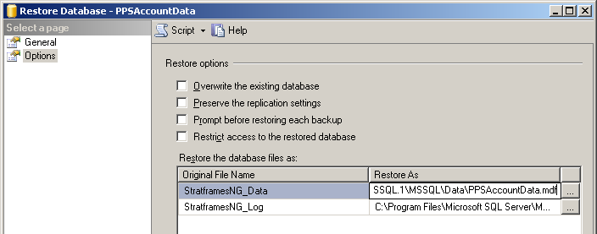
- Click OK to begin the database restore, and when the restore completes click OK to close the Restore Database window.

- Repeat the above steps 5 – 13 and restore the database backup file named PPSAccountIndex.bak as PPSAccountIndex

Installation of the PPS 2006 Application Files:

- On the server designated as the PPS 2006 server, browse to the C:\Program Files folder and create a folder named Microsoft Project Portfolio Server 2006
- Next in the newly created folder, create another folder named: ProjectPortfolio2006

- When the new folders have been created, your folder structure should look similar to the following: C:\Program Files\Microsoft Project Portfolio Server 2006\ProjectPortfolio2006

- Next copy the files located in the Application Files folder (located as part of the PPS 2006 installation files) to the newly created folder named ProjectPortfolio2006.

Note: You can use a different location for your installation folder, but you need to make sure that all references (which will appear as {InstallationPath} in this document) are updated with the new location. For example if you used the installation path as described in the above steps, your {InstallationPath} will be “C:\Program Files\Microsoft Project Portfolio Server 2006\ProjectPortfolio2006”

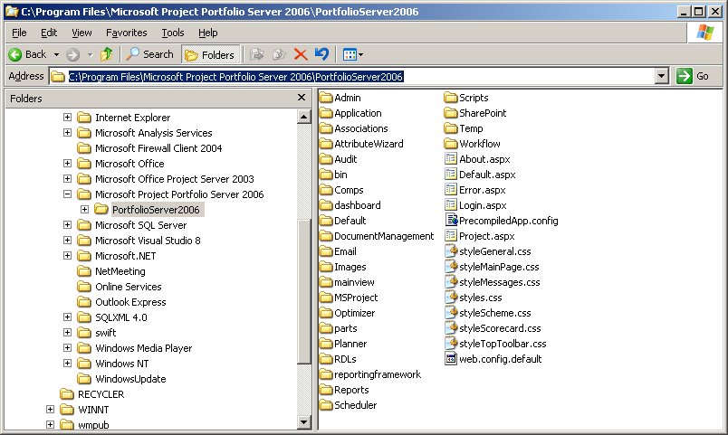

- Next launch the Internet Information Services Manager, by going to Start, Programs, Administrative Tools, Internet Information Services (IIS) Manager.

- In the Internet Information Services (IIS) Manager console, expand the Servername (local computer) as well as Web Sites node to display a list of sites currently on the server.

- Next right click on the Default Web Site and select New, Virtual Directory…

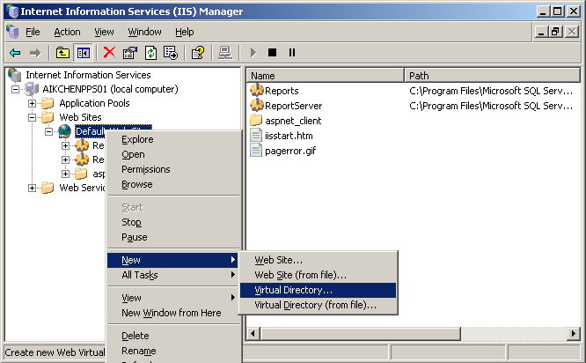

- On the Welcome to the Virtual Directory Creation Wizard window click Next

- On the Virtual Directory Alias window, specify the alias as PortfolioServer2006 and click Next
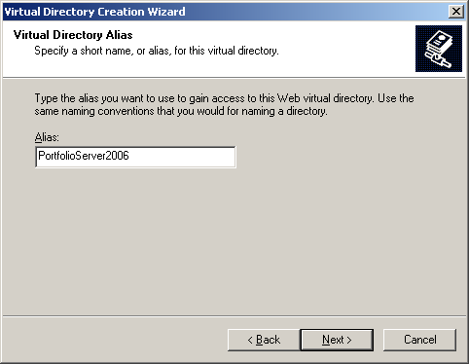

- In the WebSite Content Directory window, browse to the following folder C:\Program Files\Microsoft Project Portfolio Server 2006\PortfolioServer2006 and click Next

- On the Virtual Directory Access Permissions window, ensure the Read and Run Scripts (such as ASP) permissions are checked and click Next

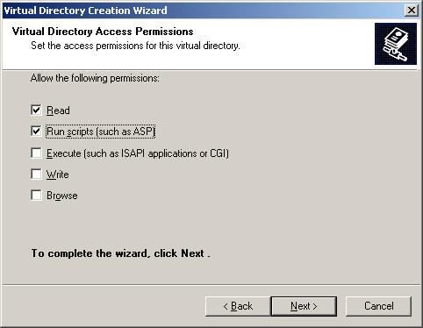

- Click Finish to close the Virtual Directory creation wizard.

Configuring authentication methods on the Virtual Directory

- In the Internet Information Services (IIS) Manager console, under the default web site, right click on the PortfolioServer2006 virtual directory and select Properties.
- Click on the Directory Security tab and under the Authentication and access control, click Edit
- In the Authentication Methods window, enable Integrated Windows authentication and click OK. (Do not enable anonymous access)
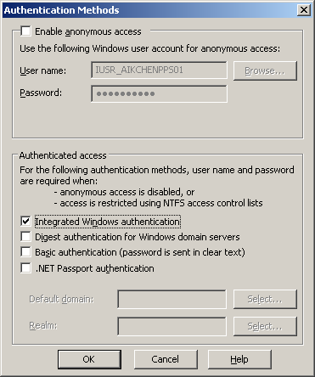

- Next click on the ASP.NET tab and set the ASP.NET version to 2.0.50727

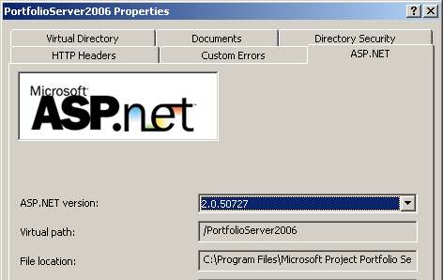
- Click on the Documents tab and ensure that default.aspx is listed as a default content page.
- If it is not listed, click Add… and in the Add Content Page dialog box enter default.aspx and click OK.

- Next remove all the other options in the list leaving only default.aspx and click OK.
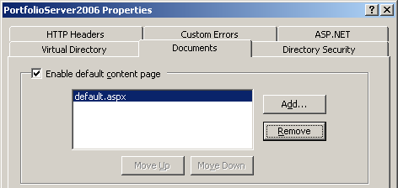

- Finally click on the Virtual Directory tab and ensure that Execute permissions is set to Scripts only and Application Pool set to DefaultAppPool

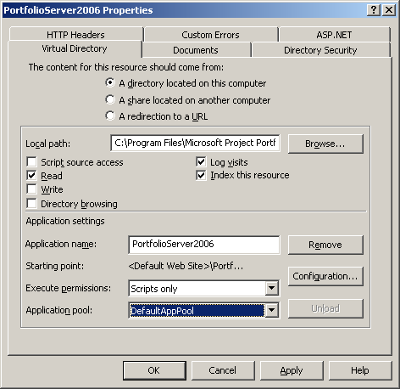
- This completes the configuration of your newly created virtual directory, click OK to save and close the virtual directory properties window.

Enabling the required Web Service Extensions

- In the Internet Information Services (IIS) Manager console, click on the Web Service Extensions node and ensure that ASP.NET v2.0.50727 is set to Allowed.

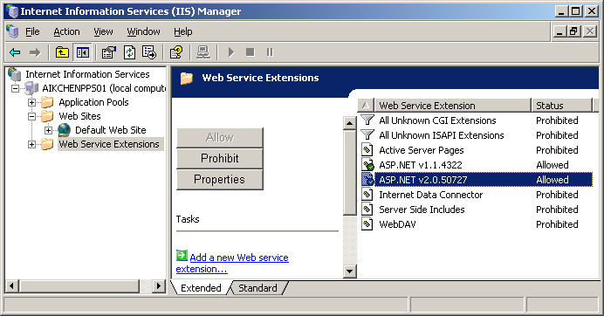

Register scripts for the new site and install the Project Portfolio Server Scheduler service:

- Open the Command Prompt, by going to Start, Run and type cmd in the Run dialog box and click OK.

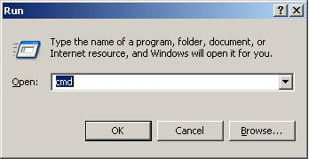

- Perform a change directory to the Microsoft.NET Installation folder by typing:

cd %windir%\Microsoft.NET\Framework\v2.0.50727

- Next in the command prompt type:
aspnet_regiis -c

- Below is a sample of what the above steps look like when it completes successfully.

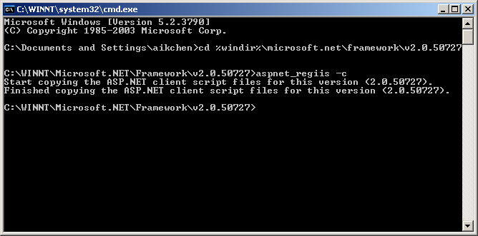

- Next in the command prompt run the following commands, replacing the {InstallationPath} with the appropriate location (If you followed the installation instructions as per how it has been outlined in this document, the path you should use would be: C:\Program Files\Microsoft Project Portfolio Server 2006\PortfolioServer2006)

InstallUtil “{InstallationPath}\bin\Microsoft.Office.Project.PortfolioServer.DataLayer.dll”
InstallUtil “{InstallationLocation}\Scheduler\Microsoft.Office.Project.PortfolioServer.Scheduler.exe”

If you are using the default paths as specified in this document, the 2 command lines would look similar to the following (you can copy, paste and run each section in the command prompt):

installutil "C:\Program files\Microsoft Project Portfolio Server 2006\Portfolioserver2006\bin\Microsoft.Office.Project.PortfolioServer.datalayer.dll"

installutil "C:\Program files\Microsoft Project Portfolio Server 2006\Portfolioserver2006\Scheduler\Microsoft.Office.Project.PortfolioServer.Scheduler.exe"

Configuring the Web.Config file:
In this step we’ll make a copy of the Web.Config.Default file, rename it as web.config and modify the web.config with the appropriate pointers to the SQL Server databases, SMTP and Reporting server.

Tip: Walk through this section carefully as the configuration of the web.config file is often the cause of installation related errors.

- Launch Windows Explorer and browse to C:\Program Files\Microsoft Project Portfolio Server 2006\PortfolioServer2006
- Locate and right click on the file named web.config.default and select Copy
- Next paste a copy of the file into the same folder and rename it as web.config
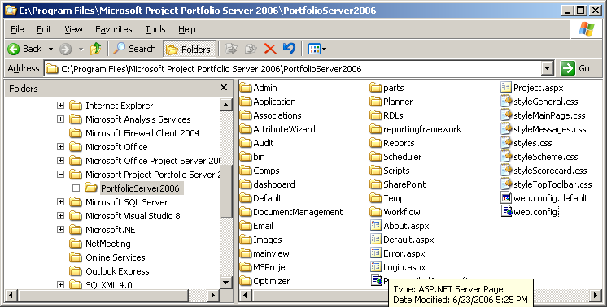

- Open the Web.Config file using an XML or text editor of your choice.

Configuring your database connection

- Scroll to the <appSettings> section. (In notepad you can also use CTRL-F and type the keyword “appsettings” to locate the correct section.)

- In the DB Connection section, you can specify the connection to your SQL Server using either Windows authentication (default) or SQL server authentication. By default, the windows authentication section has been uncommented and is the recommended authentication method.

[DBNAME] – Do not modify this.

[DATABASE_SERVER] – Specify the name of your SQL server. If SQL server is installed on your local machine it should be set to (local).
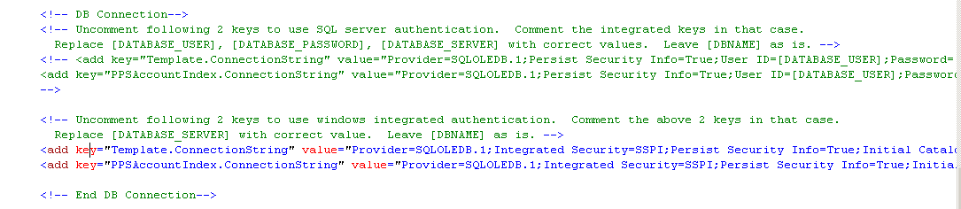

Editing the Reporting Server connection:

- In the Reporting Server section, replace the following keys with the correct values.

[REPORTING_SERVER] – Specify the URL to your Reporting Services server. E.g. http://ServerName/ReportServer. Note: If you do not have a Report Server setup, specify the following URL: http://localhost/Reportserver

[REPORTING_USER]
[REPORTING_PASSWORD]

By default the instructions will walk you through the use of the Network Service account to access your report server and that is the recommended approach, which means you do not need to specify anything in this section. If you intend to use an alternate account, you can specify the username and password in this section, if not it should be left blank. See sample screen capture below.
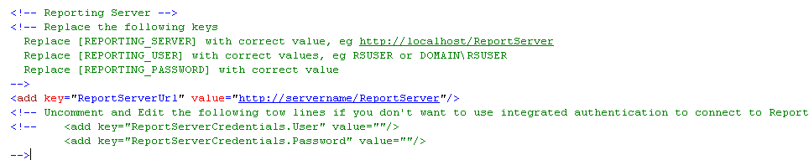

Connecting to the SMTP server:

    - In the SMTP Section, replace the following keys with the correct values:

[SMTP_SERVER] – Replace with the name of the SMTP server.

[MAIN_APPLICATION_URL] – Specify the URL to be used when connecting to PPS2006. If you used the naming conventions in this document, your URL should look similar to: http://Servername/ProjectPortfolio2006 or http://FullyQualifiedDomainName/ ProjectPortfolio2006

[EMAIL_FROM_ADDRESS] – Add the email address that the application will send emails from (i.e. email@SpecifyYourCompanysDomainName.com).

Note: Even if you do not want to use the SMTP Server ensure you add a value in each section.
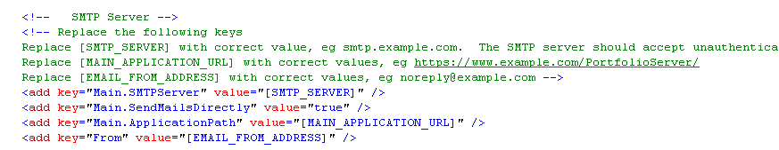

Error logging settings:

- In the Error Logging section – leave the section as is.
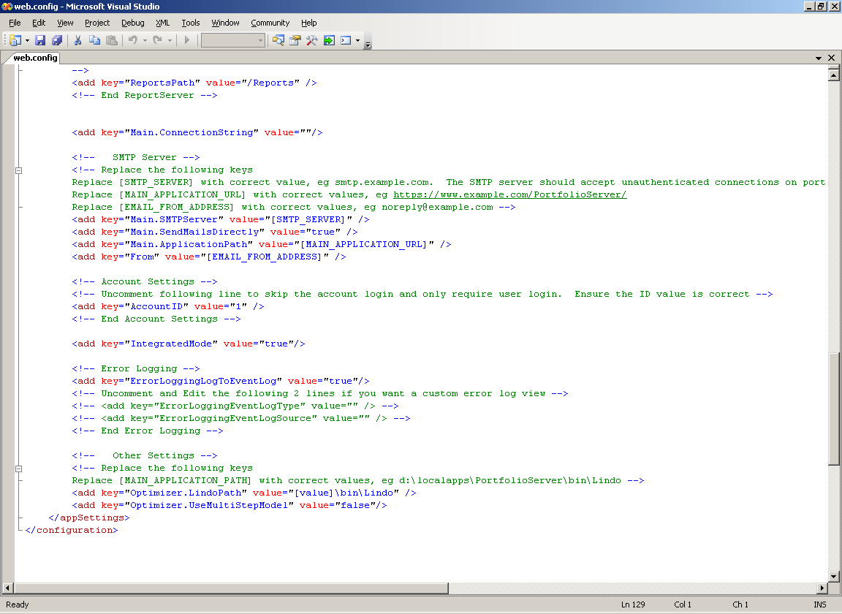

Other configuration settings:

- Other Settings section - Replace the following keys with the correct values:
[MAIN_APPLICATION_PATH] – Add the {InstallationPath} of the application (if you used the naming conventions in this document, it should be C:\Program Files\Microsoft Project Portfolio Server 2006\PortfolioServer2006)

- Verify all the modification you’ve made and then Save and close the file.

Verify that the required services are available and can be started

- Click on Start, Programs, Administrative Tools, Services to launch the Services console.

- Scroll through the list of services and look for the Project Portfolio Server Scheduler service

- Right click on the service and select Start to start the service.

- Next scroll to the bottom of the list and look for the World Wide Web Publishing Service, ensure that the service is started.

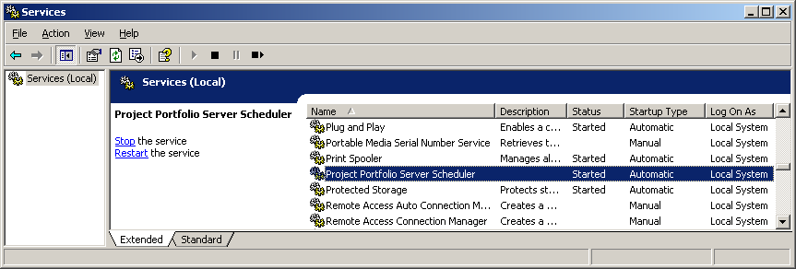

Verify that you can successfully login to Microsoft Office Project Portfolio Server 2006

- On the server where you’ve installed PPS2006, launch Internet Explorer and connect to the following URL: http://localhost/ProjectPortfolio2006
Note: If you’ve installed PPS2006 on a different port or used a different name for the Virtual Directory make sure you specify according to how your server is configured.)

- On the login page, use the following User Name and Password:
User Name = super
Password = 1
Note: Before opening the Optimizer module ensure you complete the Microsoft Excel configuration settings (see section titled: Microsoft Office Project Portfolio Client Installation).

Microsoft SQL 2005 Reporting Services Configuration

Configuration of Microsoft SQL Server 2005 Reporting Services
The following steps provide an overview of the configuration steps you’ll need to complete in order to use Microsoft Project Portfolio Sever 2006 with Microsoft SQL 2005 Reporting Services.

Note: This document assumes that SQL Server 2005 Reporting Services has been successfully installed and setup, and that it’s installed on the same machine as Microsoft Office Project Portfolio Server 2006.

Copying the required Portfolio Server DLLs.

- Copy the following 2 DLLs from:

C:\Program Files\Microsoft Project Portfolio Server 2006\PortfolioServer2006\bin

to the folder:

C:\Program Files\Microsoft SQL Server\MSSQL.NUMBER\Reporting Services\ReportServer\bin
Microsoft.Office.Project.PortfolioServer.Reporting.dll
Microsoft.Office.Project.PortfolioServer.Constants.dll

- Once the files have been copied, browse to C:\Program Files\Microsoft SQL Server\MSSQL.NUMBER\Reporting Services\ReportServer\bin select the 2 newly copied DLLs, right click and select Properties.
Note: MSSSQL.Number represents the instance where Reporting Services is installed

- Select the Security tab and click Add…

- In the Select Users, Computers , or Groups window, type Network service in the dialog box and click OK

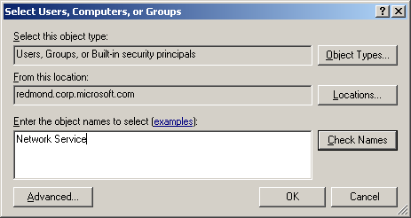

- Next ensure that the Network Service account is selected and check the Read and Read & Execute permissions and click OK

Configuring the rsreportserver.config file

- Browse to the C:\Program Files\Microsoft SQL Server\MSSQL.NUMBER\Reporting Services\ReportServer folder and

- Open the file named rsreportserver.config with an XML or text editor of your choice.

- Search for the following line in the <Data> section (on standard installations this should be around line 124).

“<Extension Name="XML" Type="Microsoft.ReportingServices.DataExtensions.XmlDPConnection,Microsoft.ReportingServices.DataExtensions"/>”

- Add a new entry (it is easiest to copy and paste the following sample to avoid typing
errors) :

<Extension Name="PPSConnection" Type="Microsoft.Office.Project.PortfolioServer.Reporting.PPSConnection,Microsoft.Office.Project.PortfolioServer.Reporting">
<Configuration>
<Key Name="Binaries" Value="C:\Program Files\Microsoft Project Portfolio Server 2006\PortfolioServer2006\bin" />
<Key Name="Config" Value="C:\Program Files\Microsoft Project Portfolio Server 2006\PortfolioServer2006\Web.config"/>
</Configuration>
</Extension>

The edited section should look like this:

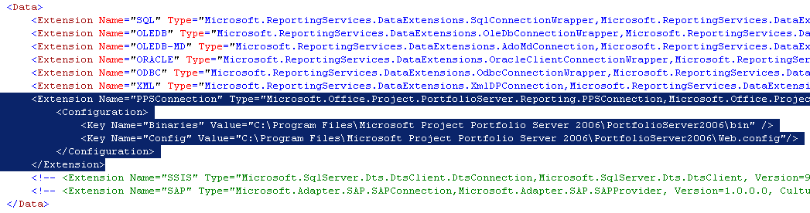

Note: Make sure that the path used for key Binaries and Config reflects the path where you unpacked the Application files. If you used the default location, it should be at: C:\Program Files\Microsoft Project Portfolio Server 2006\PortfolioServer2006\

Also this section is case sensitive and errors might result in Reporting Services failing to start if incorrect cases are used.

- Once you’ve verified that your edits are correct, save and close the file.

Configuring the rssrvpolicy.config file

- In the same folder open the rssrvpolicy.config file with an XML or text editor of your choice.

- Scroll to the end of the file (on standard installations it is around line 138) and add a new <CodeGroup> entry just after the existing CodeGroups and ensure that the Url path points to a valid path.

E.g Change the section MSSQL.Number to point the correct instance. E.g. MSSQL.2

Note: The line containing the URL was wrapped for display convenience, in the configuration, the entire URL line should be on a single line.

<CodeGroup
class="UnionCodeGroup"
version="1"
PermissionSetName="FullTrust">
<IMembershipCondition
class="UrlMembershipCondition"
version="1"
Url="C:\Program Files\Microsoft SQL Server\MSSQL.Number\Reporting Services\ReportServer\bin\Microsoft.Office.Project.PortfolioServer.Reporting.dll"/>
</CodeGroup>

- Below is a sample screen capture of what it should look like:

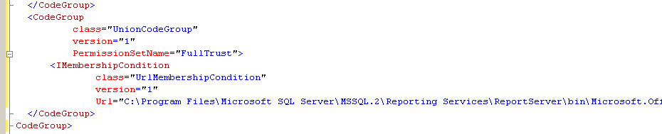

- Once you’ve verified that your edits are correct, save and close the file.
- Using the same steps above (steps 1 – 4) make the same edits to the file named rsmgrpolicy.config. In this file, the edit is around line 126. This file is located at:

C:\Program Files\Microsoft SQL Server\MSSQL.Number\Reporting Services\ReportManager

Note: MSSSQL.Number represents the instance where Reporting Services is installed

Adding the Reporting Server User

- Launch Internet Explorer and connect to: http://localhost/Reports (replace localhost with the Reporting Services machine, if you are working remotely).

- Click on the Properties tab and click on New Role Assignment to add a new role assignment.

Note: If you followed the exact steps in this document, your copy of Microsoft Project Portfolio Server 2006 should run under the credentials of the Network Service.

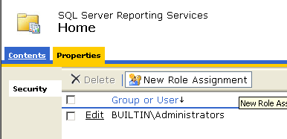

- In the New Role assignment page, for Group or User name, type: Network Service and select the check boxes for the Browser and Publisher role and click OK.

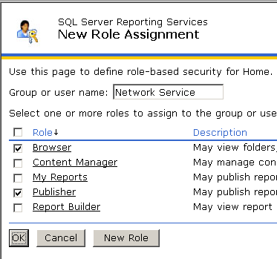
- When the new role assignment has been added, you should see that the Network Service has been added with a new role assignment on the Properties page.

Configuring the Report Services Data Sources

- Click on the Contents tab, and click New Folder
- For the name of the new folder, type: Reports and click OK to create the folder.
- Next click on the Reports folder and click New Data Source
- In the New Data Source page, provide the details f0r the new data source
  - Name: PPSAccountIndex
  - For Connection Type select: PPS Datasource
  - For Connect using, select the option: Windows NT Integrated Security

NOTE: If in the connection type combo box does not appear “Project Portfolio Server Datasource”, it means that something was not done properly in the above steps.

Upload the RDL Files

In this section we’ll upload all the rdl files located in C:\Program Files\Microsoft Project Portfolio Server 2006\PortfolioServer2006\RDLs\Legacy to the Reports folder in SQL Server Reporting Services. . There are a total of 25 reports that you’ll need to upload. The steps to importing the files are as follows:

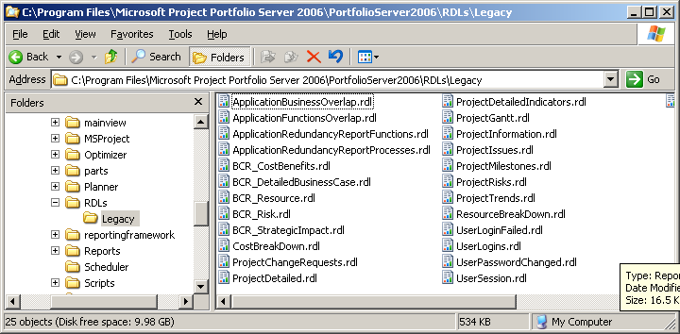

- On the SQL Server Reporting Services page, check to make sure you are in the Reports folder. Below is a screen capture of what your screen should look like.
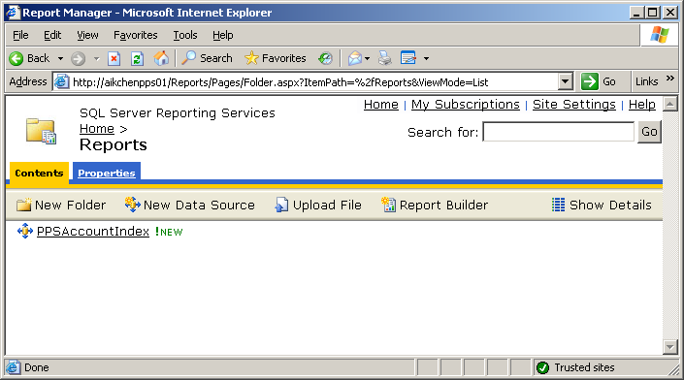
- Next click on Upload File, and click Browse and browse to the {Installation Location}\RDLs\Legacy folder.

Note: If you used the default paths specified in this document, the location is at: C:\Program Files\Microsoft Project Portfolio Server 2006\PortfolioServer2006
- Select the first file in the list, click Open and back on the Upload File page, click OK
- Repeat the above steps 1 -3 for the rest of the RDL files.
- Once you’ve completed uploading all of the RDL files, verify to make sure you’ve successful imported all the RDL files.

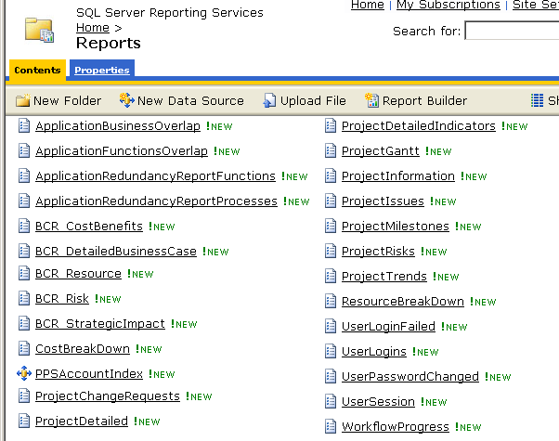

Configuring the list view options

- Click on the Show Details button in the top right.
- For all reports EXCEPT the reports listed below, click on the Edit button and check the Hide in list view checkbox and click Apply.

Note: This will hide RDL files that are used for sub-reports or are not generated through the Reports feature.

- Main reports that should remain visible are:
BCR Detailed Business Case
Project Detailed

Configuring the Project Server 2003 PDS Extender
The steps below are only necessary if you intend to use Microsoft Project Portfolio Server 2006 with Microsoft Project Server 2003. This will extend the default Microsoft Project Server 2003 installation through a PDS extension to allow Project Portfolio Server 2006 to integrate with Project Server 2003.

Configuring the PDS Extension

- On your Project Portfolio Server 2006 server, locate the file named: Microsoft.Office.Project.PortfolioServer.PDSExtender.dll.
Note: If you used the installation paths specified in this doc it should be under: C:\Program Files\Microsoft Project Portfolio Server 2006\PortfolioServer2006\bin\
- Next copy this file to the {ProjectServerInstallationPath}\BIN directory on your Project Server 2003 server. Typically this would be at the following path on your Project Server 2003 server: C:\Program Files\Microsoft Office Project Server 2003\BIN
- Perform a change directory to the Microsoft.NET Installation folder by typing:

cd %windir%\Microsoft.NET\Framework\v2.0.50727

- Next in the command prompt type the following command line to register the PDS extension:

Regasm.exe "{ProjectServerInstallationPath}\BIN\Microsoft.Office.Project.PortfolioServer.PDSExtender.dll" /codebase
Note: If you are using the default paths for your Project Server 2003 installation, the command lines would look similar to the following (you can copy and paste this into the command prompt to save time):

Regasm.exe "C:\Program Files\Microsoft Office Project Server 2003\BIN\Microsoft.Office.Project.PortfolioServer.PDSExtender.dll" /codebase
- Click on Start, Run and type regedit in the dialog and click OK.
- Browse to: HKEY_LOCAL_MACHINE/SOFTWARE/Microsoft/Office/11.0/MS Project/WebClient Server/Project Server
- Right click on the ProjectServer node and click New, String Value

- For the name of the new string value type: PDSExtensionEx1 and press Enter
- Next double click on the string named PDSExtensionEx1
- In the Edit String window, under the Value Data textbox type: Microsoft.Office.Project.PortfolioServer.PDSExtender.ExtenderMain and click OK

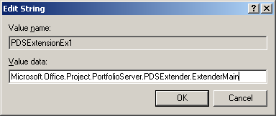

- Below is a screen capture of what the registry entry should look like if it has been configured correctly. Note: Make sure that this PDS extension is registered exactly as per the steps in this doc. E.g. it must be named as PDSExtensionEx1. If you have existing PDS extensions, those extensions will have to be added under a different string name. e.g. PDSExtensionEx2, PDSExtensionEx3 etc.

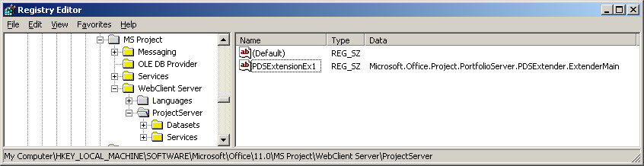

- This completes the setup of the Project Portfolio Server 2006 PDS Extension for project Server 2003. For configuration steps, please refer to the configuration manuals for further instructions.

Configuring Portfolio Server 2006 in a distributed
environment
The steps for setting up Microsoft Project Portfolio Server 2006 in a distributed environment is similar to a single server installation of PPS 2006. However if you plan to use windows integrated authentication between Project Portfolio Server 2006 and Microsoft SQL Reporting Services 2005, the additional steps in this section will serve as a guide for how it should be configured.

The basic premise of the steps below is to configure new application pools using a common domain account as the application pool identity. This will help ensure that the identities used between both applications match. At the same time, the appropriate permissions will also need to be granted on this service account.

Pre-requisites

- The machines are in the same domain
- Net Framework 2.0 and all the pre-requirements are installed across all machines (requirements are the same as outlined in the Installation and Configuration section of this guide.)
- Create a service account in the domain e.g Domain\PPSAppAccount

Configuration steps on the PPS 2006 server:

Add the Service account to the IIS_WPG group
- On the PPS 2006 server, launch the Computer Management console by going to Start, All Programs, Administrative Tools, Computer Management.

- Expand the Local Users and Groups node and click on the Groups folder.

- Next double click on the IIS_WPG group and click Add

- In the Select Users Computers, or Groups window, type the name of the domain account to be used as the application pool identity and click Check Names to make sure that it is a valid account and click OK

Create a new application pool with the appropriate identity

- Next launch the Internet Information Services Manager, by going to Start, Programs, Administrative Tools, Internet Information Services (IIS) Manager.

- In the Internet Information Services (IIS) Manager console, expand the Servername (local computer) as well as Application Pools node to display the list of application pools.

- Next right click on the Application Pools node and select New, Application Pool…

- For the Application Pool ID, type: PPSAppPool and click OK
- Next right click on the new application pool that you had just created (PPSAppPool) and select Properties
- Click on the Identity tab, select the Configurable option.
- For the User name field, type the username in the form of domain\accountname
- For the password field, enter the password for the account and click OK. You’ll be prompted to confirm the password, re-type the password and click OK

Assign the new application pool to the PortfolioServer virtual directory

- In Internet Information Services Manager, expand the Web Sites as well as Default Web Site node, right click on the PortfolioServer2006 virtual directory and select Properties

- Ensure that you are on the Virtual Directory tab and under Application Pool, select PPSAppPool, then click Apply and OK

Configure permissions on the C:\winnt\temp folder

- Next launch Windows explorer and browse to C:\Winnt\temp

- Right click on the temp folder, select Sharing and Security

- In the Temp Properties window, select the Security tab and click Advanced

- In the Advanced Security Settings for Temp window click Add and enter the same domain user account used in the above steps and click OK

- Next select the 2 options: List Folder / Read Data and Delete permissions and click OK to close the remaining dialog boxes.

Configure permissions on the .Net framework temp folder

- In Windows explorer browse to: C:\WINNT\Microsoft.NET\Framework\v2.0.50727

- Right click and select Properties on the folder named: Temporary ASP.Net Files

- In the properties window, select the Security tab and verify that the IIS_WPG local , Network Service account as well as the service account (in the form of domain\accountname) has the following permissions on the folder:

  - Modify: Allow
  - Read & Execute: Allow
  - List Folder Contents: Allow
  - Read: Allow
  - Write: Allow

- Once the permissions have been verified and set, click OK to close the Properties window.

Configure the scheduler service with a different log on identity

- Launch the Services management console, by going to Start, Control Panel, Administrative Tools, Services

- Scroll through the list of services and look for the Project Portfolio Server Scheduler service.

- Double click on the service name and click on the Log On tab

- Select the This account option and specify the username and password of your service account in the form of domain\accountname and click OK. If prompted with additional information dialog boxes, click OK.

Copying adodb.dll from the SQL 2005 Server to the PPS 2006 Server

Note: This section is only necessary if SQL Server 2005 is installed on a separate server from where PPS 2006 is installed. If both SQL 2005 and PPS 2006 is installed on the same server, you can skip this section.

- Log on to your SQL Server 2005 server and browse to: C:\Program Files\Microsoft.NET\Primary Interop Assemblies and copy the file named adobd.dll and paste it either into a share or onto a removable media of your choice e.g. USB drive, floppy etc and log out of your SQL Server.
- Next log on to your PPS 2006 machine, copy the file adodb.dll from the location where you had placed it and paste it into the following folder:
{Installation Location}\bin.
If you used the default location specified in this document the location should be: C:\Program Files\Microsoft Project Portfolio Server 2006\ProjectPortfolio2006\bin

Configuration steps on the SQL Server 2005 server:

Granting db_datareader and db_datawriter access
- Log on as an administrator on your SQL Server machine and launch the SQL Server Management Studio by clicking on Start, Programs, Microsoft SQL Server 2005, and SQL Server Management Studio

- On the Connect to Server window, for Server Type, select Database Engine, for Server Name enter the name of your SQL Server and for Authentication, select the appropriate authentication option (if using SQL Server authentication enter the corresponding username / password) and click Connect.

- Next expand the Security node and right click on the Logins node in the hierarchy and select New Login…

- In the Login – New window, for login name, specify the domain account that will be used as the service account.

- On the Select a page section (top left section of the window) select the User Mapping page, then select the map checkbox for both the PPSAccountData and PPSAccountIndex databases and ensure that it has both db_datareader and db_datawriter database role memberships.

- When the above settings have been successfully configured, click OK to close the Login – New window.

Configuration steps on the Reporting Services 2005 server:

Granting the domain service account access to Report server

- Launch Internet Explorer and connect to your report server: e.g. http://NameofReportServer/Reports

- Click on the Properties tab and click on New Role Assignment to add a new role assignment.

- In the New Role assignment page, for Group or User name, type the name of your domain account e.g.: Domain\AccountName and select the check boxes for the Browser and Publisher role and click OK.

- When the new role assignment has been added, you should see that the domain account that you specified has been added with a new role assignment on the Properties page.

Adding the domain service account to the IIS_WPG group

- On the Report Server, launch the Computer Management console by going to Start, All Programs, Administrative Tools, Computer Management.

- Expand the Local Users and Groups node and click on the Groups folder.

- Next double click on the IIS_WPG group and click Add

- In the Select Users Computers, or Groups window, type the name of the domain service account to be used as the application pool identity and click Check Names to make sure that it is a valid account and click OK

Create a new application pool with the appropriate identity

- Next launch the Internet Information Services Manager, by going to Start, Programs, Administrative Tools, Internet Information Services (IIS) Manager.

- In the Internet Information Services (IIS) Manager console, expand the Servername (local computer) as well as Application Pools node to display the list of application pools.

- Next right click on the Application Pools node and select New, Application Pool…

- For the Application Pool ID, type: PPSAppPool and click OK

- Next right click on the new application pool that you had just created (PPSAppPool) and select Properties

- Select the Identity tab, choose the Configurable option.

- For the User name field, type the username in the form of domain\accountname

- For the password field, enter the password for the account and click OK. You’ll be prompted to confirm the password, re-type the password and click OK

Assign the new application pool to the ReportServer virtual directory

- In the Internet Information Services Manager, expand the Web Sites as well as Default Web Site node, right click on the ReportServer virtual directory and select Properties

- Ensure that you are on the Virtual Directory tab and under Application Pool, select PPSAppPool, then click Apply and OK

Microsoft Office Project Portfolio Client Configuration

For all client computers that will be accessing Microsoft Project Portfolio Server 2006 and intend to use the Optimizer module, please log in as an administrator on each client machine and complete the following steps. As PPS 2006 uses Activex controls, the controls will have to be downloaded and installed on each client machine before users who do not have administrative privileges can use it.

Configuring Visual Basic Access for Microsoft Excel
The Portfolio Optimizer uses certain components of Microsoft Excel. In order for the Microsoft Project Portfolio Server 2006 to programmatically access Microsoft Excel, you’ll need to configure the following settings in Microsoft Excel for each user.

Configuring Microsoft Office Excel 2003

- On the client computer that will be used to access PPS 2006, launch Microsoft Excel by going to Start, Programs, Microsoft Office, Microsoft Office Excel 2003
- In Microsoft Excel, click on Tools, Macro, Security to open the Security window
- Select the Trusted Publishers tab, and ensure that the Trust access to Visual Basic Project option is checked.
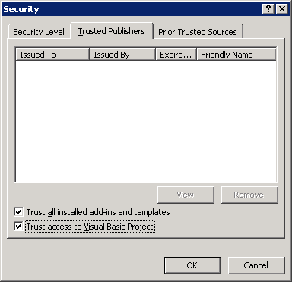

Configuring Internet Explorer’s Security settings:
Microsoft Office Project Portfolio requires that browser settings are set at their default values. These steps are not mandatory and can be used as a troubleshooting step in situations where certain client computers can successfully connect to PPS 2006 while others fail for unknown reasons.

- In Internet Explorer, click on Tools, Internet Options to open the Internet Options window.

- In the next section configure your Internet Explorer settings according to where Project Portfolio Server 2006 will be hosted.

  - If PPS 2006 will be hosted on the local intranet, select the Local intranet zone
  - Next click on the Custom Level button and ensure the following settings are configured according to the following settings below. Note, the settings below are the default IE settings for this zone. Please veiry that the following settings match.

Settings Description: | Settings Configured as:
Download signed ActiveX controls | Prompt
Run ActiveX controls and plug-ins | Enable
Script ActiveX controls marked safe for scripting | Enable
Submit non encrypted form data | Enable
Active scripting | Enable

  - If PPS 2006 will be hosted over the Internet, select the Trusted sites zone, and click on Sites
  - Specify the URL used to connect to PPS 2006 and click Add. (You may need to uncheck the following option if you are not using SSL: Require server verification (https) for all sites in this zone
  - Click Close to close the Trusted sites window once your site has been added
  - Next click on the Custom Level button and ensure the following settings are configured according to the settings below. Note, the settings below are the default IE settings for the Trusted sites zone. Once you’ve veirifed the settings click OK to close the Security Settings window.

Settings Description: | Settings Configured as:
Download signed ActiveX controls | Enable
Run ActiveX controls and plug-ins | Enable
Script ActiveX controls marked safe for scripting | Enable
Submit non encrypted form data | Enable
Active scripting | Enable

- Click on the Privacy tab and verify that the pr9ivacy settings are configured at Medium and Block pop-ups is checked.

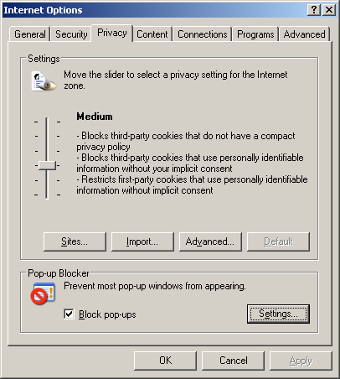

Troubleshooting Common Installation Errors
This is a listing of the common errors and steps to resolve the issue. This will extend the default Microsoft Project Server 2003 installation through a PDS extension to allow Project Portfolio Server 2006 to interact with Project Server 2003.

Symptom:
When logging into Portfolio Server 2006, you receive the following error in Internet Explorer

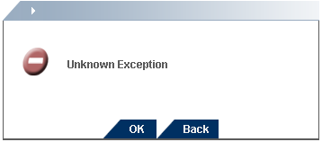

You also notice the follow error in the event log:

Session['Security.NAME'] = super
Session['SessionID'] = dbthil455wldeu45f3c1h245632949099339022250
Session['Security.AccountID'] = 1
Session['Security.UserID'] = 1
SessionID:dbthil455wldeu45f3c1h245
Form Data: No Form Data Found

Steps to take:
Ensure that the following key is configured with a valid Report Server URL. If you do not use Reporting Services, enter: http://localhost/ReportServer. Also make sure that the value for both the ReportServerCredentials.User and ReportServerCredentials.Password is set to “”.

<add key="ReportServerUrl" value="http://localhost /ReportServer"/>
<add key="ReportServerCredentials.User" value=""/>
<add key="ReportServerCredentials.Password" value=""/>

Symptom:
When accessing certain functions in the Portfolio Optimizer, you receive the following error message:

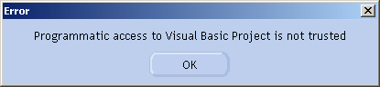

Steps to take:
Review the steps in the section “Configuring Visual Basic Access for Microsoft Excel” and ensure that the option: “Programmatic access to Visual Basic Project is not trusted” is checked.

Symptom:
When logging into Project Portfolio Server 2006, you receive the following error in Internet Explorer:

Server Error in '/PortfolioServer2006' Application.
--------------------------------------------------------------------------------

Compilation Error
Description: An error occurred during the compilation of a resource required to service this request. Please review the following specific error details and modify your source code appropriately.

Compiler Error Message: BC30691: 'StratFramesIdentity' is a type in 'ApplicationSecurity' and cannot be used as an expression.

Source Error:

Line 1: <% Response.Redirect("~/"+((Microsoft.Office.Project.PortfolioServer.BusinessLayer.ApplicationSecurity.StratFramesIdentity)Context.User.Identity).AccountID+"/Project.aspx"); %>

Source File: C:\Program Files\Microsoft Project Portfolio Server 2006\PortfolioServer2006\Default.aspx Line: 1

Steps to take:
Check and verify that there is a file named web.config and that it is configured correctly. The location of the web.config file should be at the following location if your installation was based on this document. C:\Program Files\Microsoft Project Portfolio Server 2006\ProjectPortfolio2006

