Commerce Portal
Microsoft® Business Solutions–Navision® Commerce Portal leverages the Internet to streamline interactions with vendors and customers.

Key Benefits:
- Improves your responsiveness to vendor and customer demands.
- Makes it convenient for supply chain partners to do business with you.
- Reduces costs by automating commerce interactions.

Make the Internet Work for You and Your Partners
In order to choose the right e-commerce solution, you have to ask the right questions:
- Does your e-commerce solution do more than just catalog your product offerings on the Internet?
- How can you use the Internet to strengthen supply chain relationships and make your business more efficient?
- Do the solution’s features match the way you do business?
- Do the features benefit your partners?
Commerce Portal for Microsoft Business Solutions–Navision answers all of your interactive business needs. It streamlines interactions through Web-based trading, self-service, and other forms of collaboration.
Your supply chain partners interact with you through a personalized Web portal that matches the needs of their particular roles. Every partner has their own personalized base through which they can do business with you.
With Commerce Portal, you connect your customers and vendors to your business management system by way of the Internet.
You respond to your partners’ needs with Web access to real-time information and self-service features from within your Microsoft Navision solution. Information is always up-to-date and accurate, and self-service features are relevant to the user’s particular business needs.
Owing to real-time integration and the use of business logic, Commerce Portal for Microsoft Navision offers a straightforward way to do business with your supply chain partners.
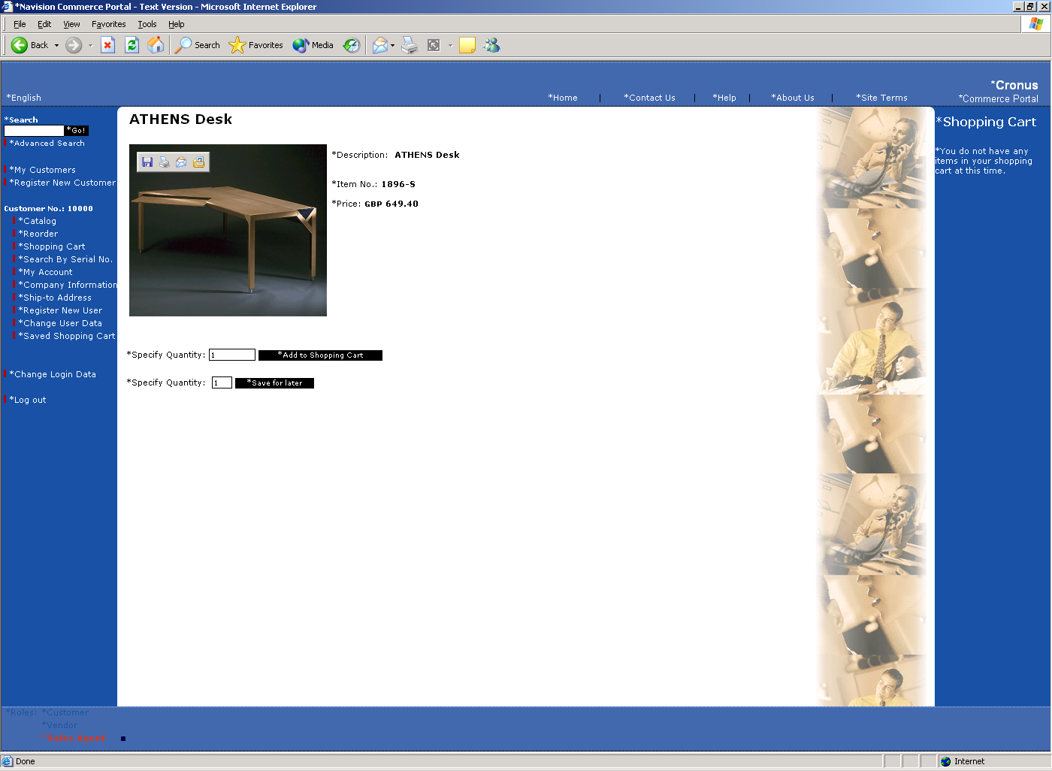

A Smart Solution
Commerce Portal makes it easy for customers, vendors, and partners to serve themselves directly from their Web portal – anytime, anywhere. They can maintain and query data and documents across the range of functions found in Microsoft Navision (depending on their particular role and the access rights that have been defined).
Commerce Portal opens a window to information and services that allows your supply chain partners to serve themselves. It makes business faster and more convenient for them, and for you. Your supply chain partners have access to a wealth of features that make it easy for them to do business with you. For example, users can:
- Execute advanced searches.
- Check the shipping progress of orders.
- Check item availability.
- Create orders and view order status.
- Convert quotes to orders and assign existing
orders to blanket orders.
For a complete list of Commerce Portal features, see the Commerce Portal data summary sheet.

Ask Your Partner
To learn more about Microsoft Business Solutions–Navision Commerce Portal, contact your Microsoft Certified Business Solutions Partner. They have the expertise necessary to design a solution that fits your specific business needs. Or, visit our website at:
http://www.microsoft.com/BusinessSolutions

About Microsoft Business Solutions
Microsoft Business Solutions, a division of Microsoft, offers a wide range of integrated, end-to-end business applications and services designed to help small, midmarket, and corporate businesses become more connected with customers, employees, partners, and suppliers. Microsoft Business Solutions' applications optimize strategic business processes across financial management, analytics, human resources management, project management, customer relationship management, field service management, supply chain management, e-commerce, manufacturing, and retail management. The applications are designed to provide insight to help customers achieve business success. More information about Microsoft Business Solutions can be found at: www.microsoft.com/BusinessSolutions.

Address:
Microsoft Business Solutions ApS
Frydenlunds Allé 6
2950 Vedbaek
Denmark
Tel +45 45 67 80 00
Fax +45 45 67 80 01
http://www.microsoft.com/BusinessSolutions
Key Features | Description
Role & Permission Management  - Personalization  - Role set up | Role & Permission Management is the application area in Microsoft Navision from where roles are easily set up and managed. You create roles and add permissions in a graphical user interface and it is as simple as using Microsoft Navision.  Roles are flexible and can be customized to the exact requirements of any organization. All activities leverage the existing business logic in Microsoft Navision.
Sales Management  - Set up customers  - Maintain contact information  - Order cycle tracking  - Blanket order  - Extended reordering | Sales Management Web enables the entire sales process. Your customers can set up themselves via the Web portal and can maintain their contact information such as shipping addresses and contact persons.  With the advanced order-tracking feature, your customers will always know exactly where their order is in the order/sales cycle. Moreover, your customers can allocate an order to a blanket order set up in advance.  Extended reordering means that the customer has convenient access to a previously made order to facilitate easy reordering.
Purchase Management  - Maintain contact information  - Maintain catalog  - Maintain delivery date  - Reverse auctions  - Drop shipment | Purchase Management Web enables the entire purchasing process. Vendors can maintain all information about themselves that is stored in Microsoft Navision. This includes product information such as catalogs, item numbers, and prices. Furthermore, delivery dates can be maintained so that they are always up-to-date, ensuring optimal supply chain performance.  Reverse Auctions, which are set up and managed from within Microsoft Navision, allow vendors to bid on an order via the Web portal. This ensures that companies will always get the best possible price the market can offer.  Moreover, vendors can drop ship orders to customers and thus eliminate supply chain inefficiencies.
Notification Management  - Event based e-mail  - Place holder | Commerce Portal has advanced notification features throughout the application.  The system can be set up to send e-mail notifications when any given event occurs, for example when a certain item becomes available, when an order is shipped, or when a reverse auction is opened.  The place holder makes it possible to send personalized e-mails to partners automatically. The e-mails can contain business data from Microsoft Navision, for instance, order numbers and balances.
Content Management  - Multilanguage | Commerce Portal comes with advanced Content Management functionality.  All Web pages are managed from within Microsoft Navision. This means that a Microsoft Navision user can complete all Web page maintenance without the assistance of Internet consultants.
Microsoft Commerce Server feature  - Catalog  - Profiling  - Cross selling  - Targeting  - Site analytics  - Bizdesk | Commerce Portal uses the advanced catalog features of Microsoft Commerce Server and Microsoft Commerce Server 2002 for customizing and maintaining catalog structures and hierarchies.  With Profiling you can monitor user behavior on your site. This data can be used, for example, in cross selling. Cross selling lets you offer customers additional goods based on what they have already selected for their order.  Targeting enables you to target customers with special offers based on user preferences and previous shopping behavior.  Site analytics lets you analyze user behavior in great detail and generate reports, for example to assess the effect of a campaign.  Bizdesk is the graphical user interface from which all Commerce Server features are administered.

System Requirements
To obtain all of the features mentioned in this fact sheet,  the following modules and technologies are required: | Server Environment:  - Microsoft Business Solutions–Navision 3.70  - Microsoft Business Solutions–Navision Application Server 3.70  - Microsoft® Windows® Server 2000 or Microsoft® Windows® Server 2003  - Microsoft® SQL Server® 2000, SP3 (used by Commerce Server)  - Microsoft® Commerce Server 2000/2002  - Microsoft® XML Parser 3.0, SP2  - .NET Framework (only with Commerce Server 2002)  Client:  - Microsoft Business Solutions–Navision 3.70  - Operating systems: Microsoft® Windows® 98 SE, Microsoft® Windows® NT 4.0 (SP6a) Workstation or Server, Microsoft® Windows® 2000, Microsoft® Windows® XP, Microsoft® Windows® Server 2003, or Microsoft® Windows® Server 2000.  - Microsoft Internet Explorer 5.5, SP2  Important: In order to use Commerce Portal with Navision 4.0, you must use the Commerce Portal Synchronization services and demo sites released with Navision 3.70. Contact your Microsoft Business Solutions Partner for additional information.

© 2004 Microsoft Business Solutions ApS, Denmark. All rights reserved. Microsoft, Great Plains, Navision, Visual Studio, and Windows are either registered trademarks or trademarks of Microsoft Corporation, Great Plains Software, Inc., FRx Software Corporation, or Microsoft Business Solutions ApS or their affiliates in the United States and/or other countries. Great Plains Software, Inc., FRx Software Corporation, and Microsoft Business Solutions ApS are subsidiaries of Microsoft Corporation. The names of actual companies and products mentioned herein may be the trademarks of their respective owners. The example companies, organizations, products, domain names, e-mail addresses, logos, people, and events depicted herein are fictitious. No association with any real company, organization, product, domain name, e-mail address, logo, person, or event is intended or should be inferred.

