
Microsoft®
Office Resource Kit

Technical Article (whitepaper)

Outlook Deployment Options: Customizing a PRF File

Writer: Stacia Snapp
Technical Reviewer: Dan Costenaro
Project Editor: Stan McKenzie

Published: March 2004
Applies To: Microsoft® Outlook® 2002 and Microsoft Office Outlook 2003

Summary: Most Microsoft Outlook profile settings can be configured and deployed to users by using the Microsoft Custom Installation Wizard or the Custom Maintenance Wizard. However, on occasion administrators might want to deploy Outlook settings that are not included in the wizards. When this is the case, the Outlook profile file (PRF file) can be used. This paper describes the PRF file, how to modify it with new settings, and how to deploy it to users.

Copyright

The information contained in this document represents the current view of Microsoft Corporation on the issues discussed as of the date of publication. Because Microsoft must respond to changing market conditions, it should not be interpreted to be a commitment on the part of Microsoft, and Microsoft cannot guarantee the accuracy of any information presented after the date of publication.

This whitepaper is for informational purposes only. MICROSOFT MAKES NO WARRANTIES, EXPRESS, IMPLIED, OR STATUTORY, AS TO THE INFORMATION IN THIS DOCUMENT.

Complying with all applicable copyright laws is the responsibility of the user. Without limiting the rights under copyright, no part of this document may be reproduced, stored in or introduced into a retrieval system, or transmitted in any form or by any means (electronic, mechanical, photocopying, recording, or otherwise), or for any purpose, without the express written permission of Microsoft Corporation.

Microsoft may have patents, patent applications, trademarks, copyrights, or other intellectual property rights covering subject matter in this document. Except as expressly provided in any written license agreement from Microsoft, the furnishing of this document does not give you any license to these patents, trademarks, copyrights, or other intellectual property.

© 2003 Microsoft Corporation. All rights reserved.

Microsoft and Microsoft Office Outlook 2003 are either registered trademarks or trademarks of Microsoft Corporation in the United States and/or other countries.

The names of actual companies and products mentioned herein may be the trademarks of their respective owners.

Table of Contents
Introduction 1
Overview of configuring and distributing a PRF file 1
Information necessary to edit a PRF file 1
The structure of the PRF file 2
Descriptions of sections in the PRF file 2
Overwriting an existing Outlook profile 5
By example: Examining where service information is located in a PRF file 6
Understanding Outlook MAPI profiles in the registry 7
Determining the Outlook MAPI data type and Outlook MAPI property for an Outlook MAPI profile setting 7
Determining the registry data that corresponds to the Outlook MAPI profile setting 12
Setting up new PRF file entries to work together 12
Deploying a PRF file 13
Appendix A: Additional Exchange Server settings 14
Appendix B: Sample PRF file with notations 19

Introduction
Most settings for Microsoft® Outlook® 2002 and Microsoft Office Outlook 2003 can be efficiently configured, updated, and deployed to users by using standard deployment tools — typically by using the Custom Installation Wizard before installation and the Custom Maintenance Wizard after installation. Settings can also be captured by using the Office Profile Wizard, which results in an OPS file that can be deployed to users.
However, to modify existing settings or to configure settings that are "outside the norm" — such as those not included in the wizards — you can create and edit an Outlook profile file (PRF file), and then deploy that to your users by using the installation or maintenance wizards, or by deploying the PRF file by itself. This whitepaper focuses on how to configure new settings by using a PRF file, and how to distribute these new settings to users.

Overview of configuring and distributing a PRF file
You can update users' Outlook profiles by editing an existing Outlook profile file (PRF file) in a text editor (such as Notepad), and then distributing the file to users. Once the PRF is distributed, the new settings are applied when Outlook starts the next time.
All of the Outlook customizations available in the Custom Installation Wizard or Custom Maintenance Wizard can be manually edited in the PRF file. In addition, you can add or configure custom settings — such as adding a new messaging service for your users that is not provided in the Custom Maintenance Wizard. By using the PRF file, you can configure multiple services and settings simultaneously across multiple desktops without user intervention.
This document includes a step-by-step example on how to make these kinds of changes, as well as a sample PRF file that contains detailed comments to guide you in configuring settings (see Appendix B).
After you save the new PRF file, you can distribute it in several ways. For example, you can place it on a network share; when users double-click the file, the PRF file is executed and the settings are applied. Or, you can distribute it by using the Custom Installation Wizard or Custom Maintenance Wizard.
Tip A fast way to create a PRF file for use with an initial deployment is to specify Outlook options in the Custom Installation Wizard, export the settings to a PRF file from the wizard, and then edit the PRF file in a text editor.

Information necessary to edit a PRF file
To modify a PRF file, you must know the following information:
- The location of the Outlook MAPI profile setting in the registry. For Windows 2000 and Windows XP, it is found along this path: HKEY_CURRENT_USER\Software\Microsoft\Windows NT\CurrentVersion\Windows Messaging Subsystem\Profiles\Profile Name\Section GUID. For example, most Outlook client settings are located under the 0a0d020000000000c000000000000046 Section GUID, while some settings related to the Exchange Server are under the 13dbb0c8aa05101a9bb000aa002fc45a Section GUID.
- The value name of the registry entry for the Outlook setting, which consists of two parts — the Outlook MAPI profile property type and the Outlook MAPI profile property value.
- The value of the Outlook MAPI profile property you plan to configure. You can determine this value for some settings by referencing Appendix A of this paper. Or you can figure out the value by trial and error — by setting options in the Outlook user interface, and then checking the registry to see how the values have changed.
Once you have gathered the above information, you can create entries and set values for each variable in the proper sections of the PRF file. When Outlook imports the PRF file, the registry settings are updated.
Note Settings stored in an existing profile may no longer be stored in the same location when you upgrade to a new version of Outlook. For example, with Outlook 2002, many items were moved from being profile-specific to being general client settings. This was done to make it easier to change a value on an enterprise level for Outlook 2002 and later versions without having to create new profiles for all users. These general client settings can be captured by using the Profile Wizard in the Office Resource Kit.

The structure of the PRF file
As with previous versions of Outlook, the PRF file for Outlook 2003 is the configuration file that lists Outlook MAPI services that will be available to a user. These services are:
- Microsoft Exchange Server
- Personal Folders
- Outlook Address Book
- Personal Address Book
- LDAP Directory
- Internet E-mail Accounts
- Third Party MAPI services
Each service is listed in the file along with the information needed to configure that service. The configuration information includes details such as the name of the Exchange Server, the location and name of the Personal Folders file, the directory to store the Offline Address Book in, and the server names to be used when downloading e-mail from the Internet.

Descriptions of sections in the PRF file
The PRF file is divided into sections which are listed and described below.

Section 1 – Profile Defaults
String identifiers found to the left of the equal sign (=) in this section (ProfileName, DefaultProfile, and so forth) are defined in the PRF processor in Outlook and cannot be modified externally. These are default settings used to set up a user profile.
For example:
[General]
Custom=1
ProfileName=EveryAccount

Section 2 – Services in Profile
This section includes the [Service List] — the list of services to be configured in the client. The services are listed in the order in which they are added to the profile. Each service listed here is defined and referenced in Section 4.
For example:
[Service List]
Service1=Microsoft Exchange Server
ServiceEGS=Exchange Global Section

Section 3 – Internet accounts in Profile
Internet accounts can be POP, IMAP, or HTTP e-mail accounts. This section lists the Internet accounts that will be defined and referenced in Section 5.
For example:
[Internet Account List]
Account1=I_Mail
Account2=IMAP_I_Mail
Account3=INET_HTTP

Section 4 – Values for each service
This is the section to which you can add properties or change existing property values for the services in the profile. MAPI profile properties are defined for services under each respective [ServiceN] heading. Valid Profile Property names are determined by the MAPI profile property Mapping in Section 6.
For example:
[Service1]
OverwriteExistingService=No
UniqueService=Yes
MailboxName=%UserName%

Section 5 – Values for each Internet account
This section defines values for the POP, IMAP, and HTTP e-mail accounts referenced in Section 3. Internet account properties are listed in a similar way as service properties, using [AccountN] heading notations. Valid Profile Property names are determined by the MAPI profile property Mapping in Section 7.
For example:
[Account1]
UniqueService=No
AccountName=POP Account
POP3Server=pop.mail.ms.com

Section 6 – Mapping for profile properties
This section lists each service name that Outlook supports and the numerical MAPI profile property values that correspond to the registry keys that the Outlook PRF processor implements when storing the profile properties.
All values listed in Section 6 map directly to HKEY_CURRENT_USER\Software\Microsoft\Windows NT\CurrentVersion\Windows Messaging Subsystem\Profiles\Profile Name registry entries, where ProfileName is replaced by the name of the corresponding profile. When a service is added, a new GUID is created for it.
The Exchange Sections have predefined GUIDs assigned because they are unique services. A service can have more than one section GUID, so the number of GUIDs in the registry does not always correspond to the number of services Outlook has “registered.”
Section 6 includes a number of mapping strings for profile properties. This makes the PRF file very flexible. If you know the specific property you want to change, you can write a PRF file with the appropriate properties in Section 6 and the appropriate corresponding property values in Section 4, which allows the property to be deployed.
Caution Use great caution in specifying these properties and values, because conflicting settings can result. When feasible, a safer option is to use the Custom Installation Wizard and Custom Maintenance Wizard tools to create and modify profiles with the correct values. These tools include most properties administrators need to deploy, with a friendly user interface for specifying the options.
For example:
[Microsoft Exchange Server]
ServiceName=MSEMS
MDBGUID=5494A1C0297F101BA58708002B2A2517
MailboxName=PT_STRING8,0x6607
HomeServer=PT_STRING8,0x6608
OfflineAddressBookPath=PT_STRING8,0x660E
OfflineFolderPath=PT_STRING8,0x6610

Section 7 – Mapping for internet account properties. DO NOT MODIFY
This section corresponds to the mapping for the specified [AccountN] accounts in Section 5. There is a GUID in the Profile section (GUID 9375CFF0413111d3B88A00104B2A6676) that expands and lists DWORD data types. Each of these DWORD types corresponds to an Account in the PRF file. There may be more than one DWORD registry key per account; so, as with Services, there is not a one-to-one mapping for Accounts.
The same registered property types are present here as are listed in Section 6, and the same notation is provided for MAPI profile property mapping. The separate sections (2, 4, 6 and 3, 5, 7) are an artifact of Internet Only (OMI) and Corporate Workgroup modes. Because OMI was stored in a different place in the registry for earlier versions of Outlook, and migration code depends on values being in a consistent format, you should not modify this section even if you are deploying updates for a version of Outlook later than Outlook 2000.
For example:
[I_Mail]
AccountType=POP3
;--- POP3 Account Settings ---
AccountName=PT_UNICODE,0x0002
DisplayName=PT_UNICODE,0x000B
EmailAddress=PT_UNICODE,0x000C

Overwriting an existing Outlook profile
An existing profile can either be overwritten or updated when a new PRF file is executed. Several settings control how the new settings get applied:
- In Section 1, the setting OverwriteProfile can be set to Yes, Append, or No. To update existing profiles, set the value to Append. This preserves the existing profile and updates the sections that have been changed. To overwrite existing profiles with a new profile, set the value to Yes. To prevent overwriting an existing profile, set the value to No.
- In Section 1, the setting ModifyDefaultProfileIfPresent can be set to True or False. When set to True, Outlook will modify the default profile even if the new and existing profile names are different.
- For each service to be updated, the setting OverwriteExistingService can be set to Yes or No. Set the value to Yes so properties are recreated for that service. The default for OverwriteExistingService is No. If No is specified, the service will not be updated, even if new settings have been listed.
For example, to update the name of the Exchange Server in user profiles by using a PRF file, you could use entries such as the following (for example):
; **************************************************************
; Section 1 - Profile Defaults
; **************************************************************

[General]
Custom=1
DefaultProfile=Yes
OverwriteProfile=Append
ModifyDefaultProfileIfPresent=TRUE

; **************************************************************
; Section 2 - Services in Profile
; **************************************************************

[Service List]
ServiceEGS=Exchange Global Section

;***************************************************************
; Section 4 - Default values for each service.
;***************************************************************

[ServiceEGS]
HomeServer=NewServerName ; Name of the new Exchange Server

;***************************************************************
; Section 6 - Mapping for profile properties
;***************************************************************

[Exchange Global Section]
SectionGUID=13dbb0c8aa05101a9bb000aa002fc45a
HomeServer=PT_STRING8,0x6608

By example: Examining where service information is located in a PRF file
Outlook PRF file definitions and mappings work together to specify changes to Outlook settings. It can be helpful to follow an example when you first configure a PRF file. This section provides an example of how to set Outlook to prompt users whether to work offline when Outlook starts. The example will illustrate how the definitions and mappings work together to define new settings for a service.
For this example, two settings are required: Manually control connection state and Choose the connection type when starting. These settings are Microsoft Exchange Server properties and are specific to profiles, so they can be modified by using a PRF file.
Services are listed in Section 4 of the PRF file. For each [ServiceN] section and property defined in Section 4, there must be valid MAPI profile properties for that service defined under Section 6. The entry for each property in Section 6 includes the Outlook MAPI data type and Outlook MAPI property stored in the registry for the profile. The entry for each property in Section 4 includes the value of the Outlook MAPI property that will be written into the registry value’s data field.
Before we can specify the correct settings in the PRF file, we need to know where those settings are stored in the registry for the profile. Then we can determine the entries we need to add or modify to configure the settings in the PRF file.

Understanding Outlook MAPI profiles in the registry
Each Outlook profile is stored in the registry under the name of the profile:
HKEY_CURRENT_USER\Software\Microsoft\Windows NT\CurrentVersion\Windows Messaging Subsystem\Profiles\Profile Name
For example, a profile called UserProfile on Windows XP would be stored in this location:
HKEY_CURRENT_USER\Software\Microsoft\Windows NT\CurrentVersion\Windows Messaging Subsystem\Profiles\UserProfile
Each profile name has a set of GUIDs that correspond to the MAPI profile’s sections. Some of these GUIDs are fixed for all Outlook profiles. Other GUID names are randomly generated and will be different in each profile.
For example, under Profile Name will be the following key:
0a0d020000000000c000000000000046
This is a fixed GUID under which Outlook client settings are located. You can see this entry in the PRF file, under Section 6:
[Microsoft Outlook Client]
SectionGUID=0a0d020000000000c000000000000046
Many profile-specific settings for Outlook are found under this key in the registry and are configured under this section in the PRF file.
In our example, we want to make changes to the Exchange Server service (changing two settings related to this service: Manually control connection state and Choose the connection type when starting). These settings are stored in the Exchange Global Section of the profile in the registry. The Exchange Global Section also has a fixed GUID:
13dbb0c8aa05101a9bb000aa002fc45a
In the PRF file, under Section 6, this entry is described as the SectionGUID for Exchange settings:
[Exchange Global Section]
SectionGUID=13dbb0c8aa05101a9bb000aa002fc45a

Determining the Outlook MAPI data type and Outlook MAPI property for an Outlook MAPI profile setting
To change the settings for our example, we need to know the Outlook MAPI data type and Outlook MAPI property that correspond to the Outlook setting we want to change. The following submenu includes the settings we are changing for this example: Manually control connection state and Choose the connection type when starting.
You can find this submenu by doing the following:
- In Outlook, on the Tools menu, and then click E-mail Accounts.
- Select View or change existing e-mail accounts, then click Next.
- Select the Exchange Server account, then click Change.
- On the next page, click More Settings.

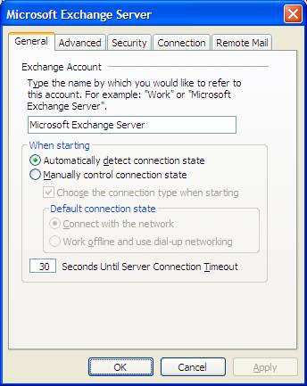

If these settings are changed in the user interface, you can see how this affects the Outlook MAPI profile in the registry.
In this example, the settings are listed (in the registry and in the PRF file) under the Exchange Global Section GUID:
13dbb0c8aa05101a9bb000aa002fc45a
To find the registry location of other settings in the profile that are not included in this example, see Appendix A of this paper. Or, if the setting you want to change is not listed in Appendix A, you may be able to determine the registry location of the setting by trial and error. That is, you can change the value in the user interface, and then check the registry to see what changed.
Since we know from Appendix A that the settings on the Microsoft Exchange Server submenu are under the Exchange Global Section GUID, we can find these in the registry entry of our example Outlook profile (“Outlook Test Profile”):

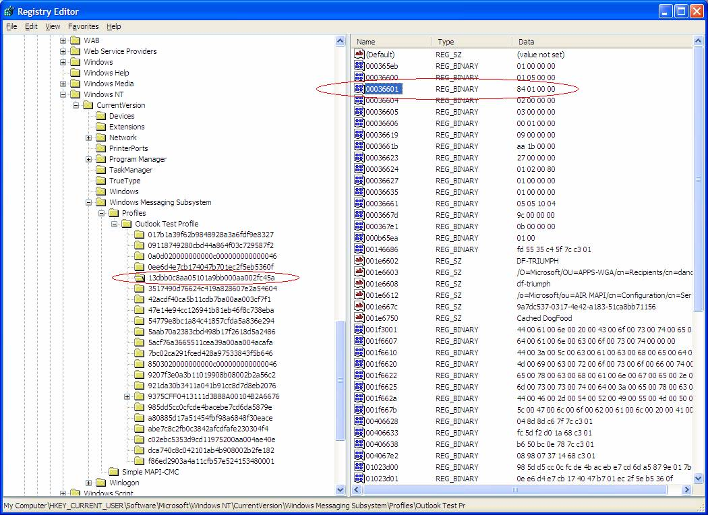

If we change one or more options on this submenu, the data, which correspond to bit flags in this registry entry, will change. For example, change Automatically detect connection state to Manually control connection state. The Data entry is updated from 84 01 00 00 to 94 01 00 00 as shown:

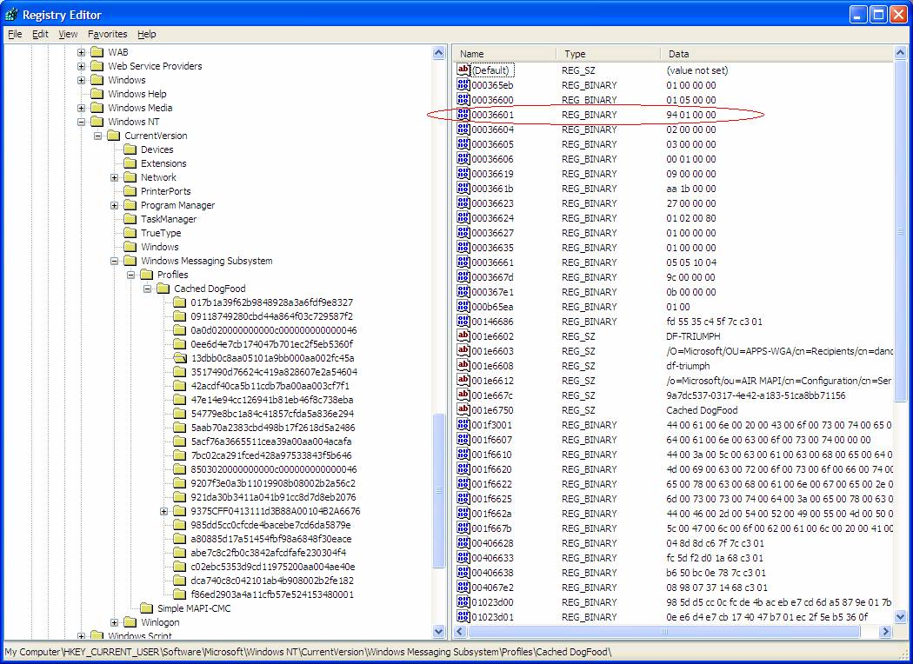

If we make another change, such as Choose the connection type when starting, the flags change again — in this case, to 96 01 00 00:

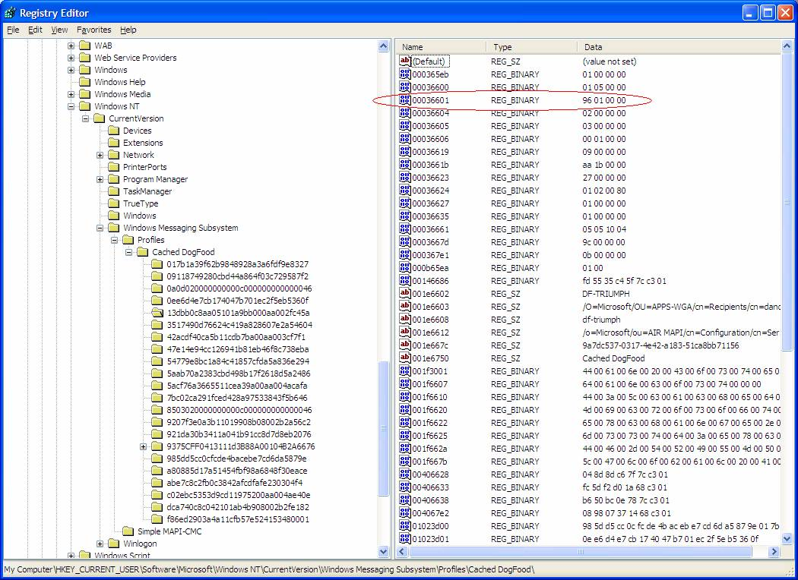

Now that you have the value name for the data that changed, you need to understand how this information works to modify Outlook behavior, and how it is included in the PRF file. The value name can be divided into two groups of four digits each: the Outlook MAPI data type (the first four digits) and the Outlook MAPI property (the last four digits). The following table explains how to determine the Outlook MAPI data type.

Data type | Corresponding digits
PT_BOOLEAN | 0x000b
PT_LONG | 0x0003
PT_I4 | 0x0003
PT_STRING8 | 0x001e
PT_SHORT | 0x0002
PT_I2 | 0x0002
PT_UNICODE | 0x001f

The table shows that the 0003 (the left four digits in our example) is a PT_LONG Outlook MAPI property. This means that, if we want to update settings in the registry value in our example (such as the Choose the connection type when starting setting), the Outlook MAPI data type we would use in the PRF is PT_LONG.
The second part of the registry value in this example — 6601 — is the Outlook MAPI property name we modified. We would specify this part of the registry value in the PRF file to define the Outlook MAPI property we are making a change to. To define the Outlook MAPI property in the PRF file, we use this format:
<variablename>=<Outlook MAPI data type>,0x<Outlook MAPI property>
Note that you choose a <variablename> that makes sense to you. So, for example, you could use the following property definition:
ConnectTypeOnStart=PT_LONG,0x6601

Determining the registry data that corresponds to the Outlook MAPI profile setting
Now that you've identified the property you will change to update the settings, you will define how the user interface setting changes are reflected in the registry. As illustrated in the screen shots in the previous section, when both settings were updated in the user interface, the data changed from 84 01 00 00 to 96 01 00 00. This is the result of changing the appropriate bits (flags) for each setting within the data. (Some settings change more than a single bit, so this should not be generalized to all settings changes.)
The two bits that change in the registry data for our two example settings are shown below.
Before 84 01 00 00 = 10000100 00000001 00000000 00000000
After 96 01 00 00 = 10010110 00000001 00000000 00000000
------------------------------------------------------------
Difference 12 00 00 00 = 00010010 00000000 00000000 00000000
There are other bits in the registry data on this property that you don’t want to lose. It is important to change only the flags that map to the setting you are updating, while saving the current values of existing settings (as shown).
The value you see for the combination of settings you chose is 96 01 00 00. This is how Outlook stores the property data in the registry. To specify the new value in the PRF file, you include it in Section 4 as the value of the variable name we defined for that setting in Section 6 (in this example, ConnectTypeOnStart).
However, to specify this value in the PRF file, the value must be written in reverse order. For example:
Data in the registry: 12 34 56 78
Value in the PRF File: 0x78563412
In our example, the value 96 01 00 00 is in the registry. Therefore, in the PRF file you would specify 0x00000196.

Setting up new PRF file entries to work together
Using the information we determined in the previous section, we can now update the PRF file to set the two example options (Manually control connection state and Choose the connection type when starting) in users’ Outlook profiles. To summarize:
- In Section 2, define the service area where the settings are located.
- In Section 4, under the service area name (ServiceEGS), create a variable and set it to the value that will create the correct MAPI profile property value in the registry. This sets the Outlook options to configure users’ profiles with the chosen settings.
- In Section 6, under the section that we specified for the service area in Section 2, provide the GUID location and define the mapping for the variable set in Section 4.
The new PRF file entries for our example are shown below:
;***************************************************************
; Section 2 – Services in the profile
;***************************************************************
ServiceEGS=Exchange Global Section
;***************************************************************
; Section 4 - Default values for each service.
;***************************************************************
[ServiceEGS]
ConnectTypeOnStart=0x00000196 ; Setting the Outlook MAPI profile property to the way we like it.
;***************************************************************
; Section 6 - Mapping for profile properties
;***************************************************************
[Exchange Global Section]
SectionGUID=13dbb0c8aa05101a9bb000aa002fc45a ; The location in the registry where this value is stored.
ConnectTypeOnStart=PT_LONG,0x6601 ; The mapping for the Outlook MAPI profile property that we’re configuring.

Deploying a PRF file
Beginning with Outlook 2002, Outlook no longer uses the separate Newprof.exe or Modprof.exe code to make changes to a profile. The process is now simplified. Instead of requiring a series of files to be chained together, Outlook can be configured to automatically import the PRF file when it starts.
A summary of options for updating settings with a custom PRF file follows. For detailed deployment information, see <a href="/office/ork/2003/three/ch7/OutB03.htm">Customizing Outlook Profiles by Using PRF Files</a>.
You can update settings in Outlook with your custom PRF in several ways. For example:
- Use the /importprf switch. For example:
Outlook.exe /importprf \\server1\share\outlook.prf
Outlook starts and the PRF file is imported, changing the specified settings in the user’s profile in the registry.
- Set registry keys to trigger Outlook to import the PRF file when Outlook starts. First, set the value ImportPRF to the location of the PRF file. For example:
HKCU\Software\Microsoft\Office\11.0\Outlook\Setup\ImportPRF=\\server1\share\Outlook.prf
Then, reset the Outlook FirstRun key to alert Outlook to process the PRF file. To do this, delete the FirstRun registry value HKCU\Software\Microsoft\Office\11.0\Outlook\Setup\FirstRun, or set its data to 0.

Appendix A: Additional Exchange Server settings
Listed below are additional settings which can be used with Exchange Server, corresponding to options included in the Microsoft Exchange Server dialog box shown below.
For each option listed, the setting is provided with the value used. The binary representations show which bit(s) are affected by a given setting in the corresponding data entry.

The Exchange Account name corresponds to:
0x001f6620: “” – a string value for the PRF file as a PT_UNICODE property type.

“Automatically detect connection state” corresponds to:
0x00036601: xxxx xxxx xxxx xxxx xxxx xxxx xxx0 xxxx
“Manually control connection state” corresponds to:
0x00036601: xxxx xxxx xxxx xxxx xxxx xxxx xxx1 xxxx

“Choose the connection type when starting” corresponds to:
0x00036601: xxxx xxxx xxxx xxxx xxxx xxxx xxxx xx1x – when checked
0x00036601: xxxx xxxx xxxx xxxx xxxx xxxx xxxx xx0x – when unchecked

“Connect with the network” corresponds to:
0x00036606: xxxx xxxx xxxx xxxx xxxx xx01 xxxx xxxx
“Work offline and use dial-up networking” corresponds to:
0x00036606: xxxx xxxx xxxx xxxx xxxx xx10 xxxx xxxx

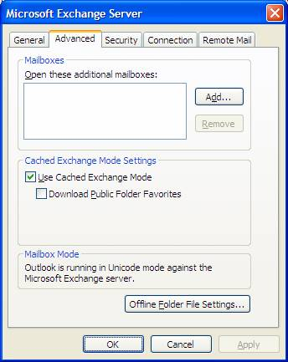

“Use Cached Exchange Mode” corresponds to:
0x00036601: xxxx xxxx xxxx xxxx xxxx xxx1 1xxx xxxx – when checked
0x00036601: xxxx xxxx xxxx xxxx xxxx xxx0 0xxx xxxx – when unchecked

“Download Public Folder Favorites” corresponds to:
0x00036601: xxxx xxxx xxxx xxxx xxxx x1xx xxxx xxxx – when checked
0x00036601: xxxx xxxx xxxx xxxx xxxx x0xx xxxx xxxx – when unchecked

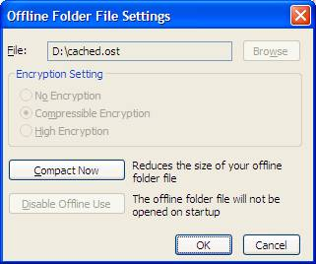

File path (text box for File: above) corresponds to:
0x001f6610: “” – a string value for the PRF file as a PT_UNICODE property type.

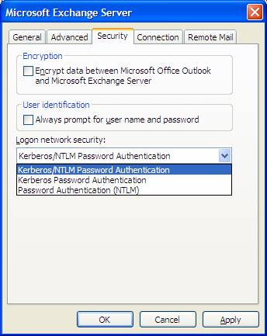

“Encrypt data between Microsoft Office Outlook and Microsoft Exchange Server” corresponds to:
0x00036606: xxxx xxxx xxxx xxxx x1xx xxxx xxxx xxxx – when checked
0x00036606: xxxx xxxx xxxx xxxx x0xx xxxx xxxx xxxx – when unchecked

“Always prompt for user name and password” corresponds to:
0x00036601: xxxx xxxx xxxx xxxx xxxx xxxx 1xxx xxxx – when checked
0x00036601: xxxx xxxx xxxx xxxx xxxx xxxx 0xxx xxxx – when unchecked

“Logon network security” drop down corresponds to:
0x00036619: xxxx xxxx xxxx xxxx xxxx xxxx 0000 1001 – Kerberos/NTLM Password Authentication
0x00036619: xxxx xxxx xxxx xxxx xxxx xxxx 0001 0000 – Kerberos Password Authentication
0x00036619: xxxx xxxx xxxx xxxx xxxx xxxx 0000 1010 – Password Authentication (NTLM)

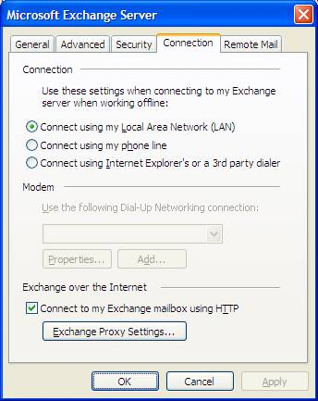

“Connect to my Exchange mailbox using HTTP” corresponds to:
0x00036623: xxxx xxxx xxxx xxxx xxxx xxxx xxxx xxx1 – when checked
0x00036623: xxxx xxxx xxxx xxxx xxxx xxxx xxxx xxx0 – when unchecked

If you click Exchange Proxy Settings, you see this dialog:

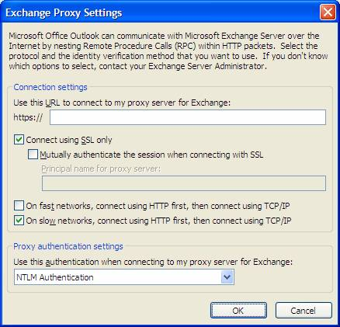

“Use this URL to connect to my proxy server for Exchange” corresponds to:
0x001f6622: “” -- string value for PRF file as PT_UNICODE property type.

“Connect using SSL only” corresponds to:
0x00036623: xxxx xxxx xxxx xxxx xxxx xxxx xxxx xx1x – when checked
0x00036623: xxxx xxxx xxxx xxxx xxxx xxxx xxxx xx0x – when unchecked

“Mutually authenticate the session when connecting with SSL” corresponds to:
0x00036623: xxxx xxxx xxxx xxxx xxxx xxxx xxxx x1xx – when checked
0x00036623: xxxx xxxx xxxx xxxx xxxx xxxx xxxx x0xx – when unchecked

“Principal name for proxy server” corresponds to:
0x001f6625: “” – a string value for the PRF file as the PT_UNICODE property type.

“On fast networks, connect using HTTP first, then connect using TCP/IP” corresponds to:
0x00036623: xxxx xxxx xxxx xxxx xxxx xxxx xxxx 1xxx – when checked
0x00036623: xxxx xxxx xxxx xxxx xxxx xxxx xxxx 0xxx – when unchecked

“On slow networks, connect using HTTP first, then connect using TCP/IP” corresponds to:
0x00036623: xxxx xxxx xxxx xxxx xxxx xxxx xx1x xxxx – when checked
0x00036623: xxxx xxxx xxxx xxxx xxxx xxxx xx0x xxxx – when unchecked

“Use this authentication when connecting to my proxy server for Exchange” dropdown corresponds to:
0x00036627: xxxx xxxx xxxx xxxx xxxx xxxx xxxx xx10 – NTLM Authentication
0x00036627: xxxx xxxx xxxx xxxx xxxx xxxx xxxx xx01 – Basic Authentication

Appendix B: Sample PRF file with notations
A sample PRF file — generated by selecting all options for Outlook in the Custom Installation Wizard — is shown below. Additional in-line comments have been added to provide details for many of the options. The PRF file generated by the Custom Installation Wizard does not contain these additional comments.

; **************************************************************
; Section 1 - Profile Defaults
; **************************************************************
[General]
Custom=1
ProfileName=EveryAccount ; Name of the profile. Any string
; value is valid.
DefaultProfile=Yes ; Will this be set as the default
; profile once created?
OverwriteProfile=Yes ; Overwrite an existing profile if
; it has the same name? A value of
; Append means to modify the profile
; settings. No means don’t overwrite.
ModifyDefaultProfileIfPresent=FALSE ; When modifying a profile, if no
; match is found, modify the default
; profile?
DefaultStore=Service2 ; Which store will contain mail?
; Exchange Server or Personal
; Folders? Section 2 below defines
; this.
; **************************************************************
; Section 2 - Services in Profile
; **************************************************************
[Service List]
Service1=Microsoft Exchange Server ; The list of services to configure
; within a profile. Each service
ServiceEGS=Exchange Global Section ; listed here will be configured
; under its appropriate header
Service2=Personal Folders ; listed in Section 4.
Service3=Outlook Address Book
Service4=LDAP Directory
Service5=Personal Address Book
;ServiceX=Microsoft Outlook Client
;***************************************************************
; Section 3 - List of internet accounts
;***************************************************************
[Internet Account List]
Account1=I_Mail ; List of Internet accounts to be
; configured with the profile.
Account2=IMAP_I_Mail ; Multiple accounts can be
; configured.
Account3=INET_HTTP ; Each account will be listed in
; Section 5.
;***************************************************************
; Section 4 - Default values for each service.
;***************************************************************
[Service1] ; Microsoft Exchange Server.
OverwriteExistingService=No ; Used when modifying a profile.
; NOTE: You must set the
; OverwriteProfile=Append setting
; in Section 1 in order for this
; value to take effect.
; Possible values:
; Yes – Overwrite the existing service with the new information.
; No – No changes will be made to the service.
; If the command is missing, the default value is No.
UniqueService=Yes
; Can this service be listed in the profile more than once?
; For Exchange Server service – No
; For Personal Folders service – Yes
MailboxName=%UserName% ; The alias name Exchange should use
; when making the profile.%UserName%
; means to use the account name of
; the currently logged in user.
HomeServer=df-wag ; The name of the Exchange Server
; the user will connect to.
OfflineAddressBookPath=%USERPROFILE%\local settings\application data\microsoft\outlook\ ; Path where the Offline Address
; Book should be stored.
OfflineFolderPath=%USERPROFILE%\local settings\application data\microsoft\outlook\outlook.ost ; Path and name of the Offline
; Folders file.
AccountName=Microsoft Exchange Server

[ServiceEGS]
MailboxName=%UserName%
HomeServer=df-wag

[Service2] ; Personal Folders
UniqueService=No
Name=Personal Folders
PathToPersonalFolders=%USERPROFILE%\local settings\application data\microsoft\outlook\outlook.pst ; Path and name of the Personal
; Folders file.
EncryptionType=0x40000000

[Service3] ; Outlook Address Book
; No configuration needed with the Address Book
[Service4] ; LDAP Directory
UniqueService=No
ServerName=ldap.bigfoot.com ; Name of the LDAP server
DisplayName=Company LDAP Directory ; The display name of the service
ConnectionPort=389 ; Connect to LDAP over this port
UseSSL=FALSE ; Use LDAP over SSL?
UserName=LDAP: User Name
SearchBase=LDAP: Search Base
SearchTimeout=60
MaxEntriesReturned=100

[Service5] ; Personal Address Book
NameOfPAB="Personal Address Book" ; Display name for the PAB
Path="%USERPROFILE%\local settings\application data\microsoft\outlook\mailbox.pab" ; Path and name of the Personal
; Address Book
ShowNamesBy=0
;[ServiceX]
;FormDirectoryPage=
;-- The URL of Exchange Web Services Form Directory page used to
; create Web forms.
;WebServicesLocation=
;-- The URL of Exchange Web Services page used to display unknown forms.
;ComposeWithWebServices=
;-- Set to TRUE to use Exchange Web Services to compose forms.
;PromptWhenUsingWebServices=
;-- Set to TRUE to use Exchange Web Services to display unknown forms.
;OpenWithWebServices=
;-- Set to TRUE to prompt user before opening unknown forms when using Exchange Web Services.
;***************************************************************
; Section 5 - Values for each internet account.
;***************************************************************
[Account1] ; Internet E-mail account properties
UniqueService=No
AccountName=POP Account ; The display name for the service
POP3Server=pop.mail.ms.com ; POP3 server to retrieve mail from
SMTPServer=smtp.mail.ms.com ; SMTP server to send mail to
POP3UserName=popuser ; Username for the service.
; Can use the environment variable
; %UserName% in place of popuser.
EmailAddress=popaddress@ms.com ; The email address associated with
; this Internet connection
POP3UseSPA=0 ; Does the POP account use Secure
; Password Authentication (SPA)?
DisplayName=POP: Full Name ; User’s display name
ReplyEMailAddress=POP: Reply Address ; User’s ReplyTo address
SMTPUseAuth=1 ; Does the SMTP require
; authentication?
SMTPAuthMethod=0 ; The SMTP authentication method
ConnectionType=0 ; The connection type to the server
LeaveOnServer=0x0 ; Leave a copy of message on the
; server
ConnectionOID=MyConnection ; The name of the connection ID
POP3Port=110 ; Port number to use with POP3
POP3UseSSL=0 ; Use SSL with the POP3 connection?
ServerTimeOut=60 ; Number of seconds before timeout
SMTPPort=25 ; Port number to use with SMTP
SMTPUseSSL=0 ; Use SSL with the SMTP connection?

[Account2] ; Internet E-mail account properties
UniqueService=No
AccountName=IMAP Account
IMAPServer=incoming.imap.mail.com
SMTPServer=smtp.imap.mail.com
IMAPUserName=imapuser
EmailAddress=imapuser@mail.com
IMAPUseSPA=0
DisplayName=IMAP: Full Name
ReplyEMailAddress=IMAP: Reply Address
SMTPUseAuth=1
SMTPAuthMethod=0
ConnectionType=0
RootFolder=
ConnectionOID=MyConnection
IMAPPort=143
IMAPUseSSL=0
ServerTimeOut=60
SMTPPort=25
SMTPUseSSL=0

[Account3] ; Internet E-mail account properties
UniqueService=No
HttpServer=http://services.msn.com/svcs/hotmail/httpmail.asp
UserName=httpusername
Organization=HTTP: Organization
Reply=HTTP: Reply Address
Account=HTTP Account
EmailAddress=HTTP@mail.com
FullName=HTTP: Full Name
Connection Type=0
ConnectOID=

;***************************************************************
; Section 6 - Mapping for profile properties
;***************************************************************
; These are the registry entry definitions for where values will
; be stored, along with their data types.
[Microsoft Exchange Server]
ServiceName=MSEMS
MDBGUID=5494A1C0297F101BA58708002B2A2517
MailboxName=PT_STRING8,0x6607
HomeServer=PT_STRING8,0x6608
OfflineAddressBookPath=PT_STRING8,0x660E
OfflineFolderPath=PT_STRING8,0x6610

[Exchange Global Section]
SectionGUID=13dbb0c8aa05101a9bb000aa002fc45a
MailboxName=PT_STRING8,0x6607
HomeServer=PT_STRING8,0x6608
RPCoverHTTPflags=PT_LONG,0x6623
RPCProxyServer=PT_UNICODE,0x6622
RPCProxyPrincipalName=PT_UNICODE,0x6625
RPCProxyAuthScheme=PT_LONG,0x6627
CachedExchangeConfigFlags=PT_LONG,0x6629

[Personal Folders]
ServiceName=MSPST MS
Name=PT_STRING8,0x3001
PathToPersonalFolders=PT_STRING8,0x6700
RememberPassword=PT_BOOLEAN,0x6701
EncryptionType=PT_LONG,0x6702
Password=PT_STRING8,0x6703

[Outlook Address Book]
ServiceName=CONTAB

[LDAP Directory]
ServiceName=EMABLT
ServerName=PT_STRING8,0x6600
UserName=PT_STRING8,0x6602
UseSSL=PT_BOOLEAN,0x6613
DisplayName=PT_STRING8,0x3001
ConnectionPort=PT_STRING8,0x6601
SearchTimeout=PT_STRING8,0x6607
MaxEntriesReturned=PT_STRING8,0x6608
SearchBase=PT_STRING8,0x6603

[Microsoft Outlook Client]
SectionGUID=0a0d020000000000c000000000000046
FormDirectoryPage=PT_STRING8,0x0270
WebServicesLocation=PT_STRING8,0x0271
ComposeWithWebServices=PT_BOOLEAN,0x0272
PromptWhenUsingWebServices=PT_BOOLEAN,0x0273
OpenWithWebServices=PT_BOOLEAN,0x0274

[Personal Address Book]
ServiceName=MSPST AB
NameOfPAB=PT_STRING8,0x001e3001
Path=PT_STRING8,0x001e6600
ShowNamesBy=PT_LONG,0x00036601

; ************************************************************************
; Section 7 - Mapping for internet account properties. DO NOT MODIFY.
; ************************************************************************
[I_Mail]
AccountType=POP3
;--- POP3 Account Settings ---
AccountName=PT_UNICODE,0x0002
DisplayName=PT_UNICODE,0x000B
EmailAddress=PT_UNICODE,0x000C
;--- POP3 Account Settings ---
POP3Server=PT_UNICODE,0x0100
POP3UserName=PT_UNICODE,0x0101
POP3UseSPA=PT_LONG,0x0108
Organization=PT_UNICODE,0x0107
ReplyEmailAddress=PT_UNICODE,0x0103
POP3Port=PT_LONG,0x0104
POP3UseSSL=PT_LONG,0x0105
; --- SMTP Account Settings ---
SMTPServer=PT_UNICODE,0x0200
SMTPUseAuth=PT_LONG,0x0203
SMTPAuthMethod=PT_LONG,0x0208
SMTPUserName=PT_UNICODE,0x0204
SMTPUseSPA=PT_LONG,0x0207
ConnectionType=PT_LONG,0x000F
ConnectionOID=PT_UNICODE,0x0010
SMTPPort=PT_LONG,0x0201
SMTPUseSSL=PT_LONG,0x0202
ServerTimeOut=PT_LONG,0x0209
LeaveOnServer=PT_LONG,0x1000

[IMAP_I_Mail]
AccountType=IMAP
;--- IMAP Account Settings ---
AccountName=PT_UNICODE,0x0002
DisplayName=PT_UNICODE,0x000B
EmailAddress=PT_UNICODE,0x000C
;--- IMAP Account Settings ---
IMAPServer=PT_UNICODE,0x0100
IMAPUserName=PT_UNICODE,0x0101
IMAPUseSPA=PT_LONG,0x0108
Organization=PT_UNICODE,0x0107
ReplyEmailAddress=PT_UNICODE,0x0103
IMAPPort=PT_LONG,0x0104
IMAPUseSSL=PT_LONG,0x0105
; --- SMTP Account Settings ---
SMTPServer=PT_UNICODE,0x0200
SMTPUseAuth=PT_LONG,0x0203
SMTPAuthMethod=PT_LONG,0x0208
SMTPUserName=PT_UNICODE,0x0204
SMTPUseSPA=PT_LONG,0x0207
ConnectionType=PT_LONG,0x000F
ConnectionOID=PT_UNICODE,0x0010
SMTPPort=PT_LONG,0x0201
SMTPUseSSL=PT_LONG,0x0202
ServerTimeOut=PT_LONG,0x0209
CheckNewImap=PT_LONG,0x1100
RootFolder=PT_UNICODE,0x1101

[INET_HTTP]
AccountType=HOTMAIL
Account=PT_UNICODE,0x0002
HttpServer=PT_UNICODE,0x0100
UserName=PT_UNICODE,0x0101
Organization=PT_UNICODE,0x0107
UseSPA=PT_LONG,0x0108
TimeOut=PT_LONG,0x0209
Reply=PT_UNICODE,0x0103
EmailAddress=PT_UNICODE,0x000C
FullName=PT_UNICODE,0x000B
Connection Type=PT_LONG,0x000F
ConnectOID=PT_UNICODE,0x0010

