

Windows Server 2008 Power Savings

Microsoft Corporation

Published: June 2008

Abstract

In Windows Server® 2008, Microsoft is introducing new features and technologies, some of which were not available in Windows Server® 2003, that will help to reduce the power consumption of server and client operating systems, minimize environmental byproducts, and increase server efficiency. This document describes some of these features and technologies.



Copyright Information

This document supports the release of Windows Server® 2008. This document is provided for informational purposes only and Microsoft makes no warranties, either express or implied, in this document. Information in this document, including URL and other Internet Web site references, is subject to change without notice. The entire risk of the use or the results from the use of this document remains with the user. Unless otherwise noted, the example companies, organizations, products, domain names, e-mail addresses, logos, people, places, and events depicted herein are fictitious, and no association with any real company, organization, product, domain name, e-mail address, logo, person, place, or event is intended or should be inferred. Complying with all applicable copyright laws is the responsibility of the user. Without limiting the rights under copyright, no part of this document may be reproduced, stored in or introduced into a retrieval system, or transmitted in any form or by any means (electronic, mechanical, photocopying, recording, or otherwise), or for any purpose, without the express written permission of Microsoft Corporation.

Microsoft may have patents, patent applications, trademarks, copyrights, or other intellectual property rights covering subject matter in this document. Except as expressly provided in any written license agreement from Microsoft, the furnishing of this document does not give you any license to these patents, trademarks, copyrights, or other intellectual property.

© 2008 Microsoft Corporation. All rights reserved.

Microsoft, MS-DOS, Active Directory, ActiveX, Aero, Authenticode, BitLocker, BizTalk, ClearType, Internet Explorer, SharePoint, SQL Server, Windows, Windows Media, Windows NT, Windows PowerShell, Windows Server, and Windows Vista are either registered trademarks or trademarks of Microsoft Corporation in the United States and/or other countries.

All other trademarks are property of their respective owners.

Contents

Executive Summary 4

The Case for Reducing Power Consumption 4

Out-of-the-Box Power Savings 5

Saving Power through Virtualization 7

Managing Server and Client Power Usage with Group Policy 11

Managing Power Usage on Windows Vista Clients 12

Appendix Data 14

#### Executive Summary

Energy-efficient computing is becoming a priority for businesses and organizations seeking to control costs and reduce their impact on the environment. One way for an organization to reduce power usage is to implement an energy-efficient server infrastructure that facilitates management and allocation of power to computing resources as needed.

Microsoft® Windows Server™ 2008 has been designed with energy efficiency in mind, to provide customers with ready and convenient access to a number of new power-saving features. It includes updated support for Advanced Configuration and Power Interface (ACPI) processor power management (PPM) features, including support for processor performance states (P-states) and processor idle sleep states on multiprocessor systems. These features simplify power management in Windows Server 2008 (WS08) and can be managed easily across servers and clients using Group Policies. Even more significant power savings are made possible by Hyper-V™, the hypervisor-based virtualization technology included as a server role in Windows Server 2008. Hyper-V makes it possible to consolidate servers onto a much smaller number of physical machines, significantly reducing power consumption without unduly sacrificing performance.

#### The Case for Reducing Power Consumption

As businesses use more servers, and as the servers themselves become more powerful, the amount of electricity it takes to operate them rises proportionately. Faster processors generally draw more power than slower ones, and generate more heat, requiring more powerful cooling systems. A recent study found that the amount of electricity used by servers and auxiliary equipment worldwide more than doubled between 2000 and 2005, to more than 1.2 billion kilowatt-hours (kWh) yearly—a figure that represents 0.8 percent of the estimated world electricity sales[1].

This increase has come over a period when the cost of electricity itself has risen significantly. The U.S. Department of Energy reports that the average cost of electricity to the industrial sector has increased by more than 41 percent over the past seven years (2000‑2007)—double the rate of inflation—and 33 percent for the commercial sector.[2] Electricity costs in many other parts of the world have increased by as much or more. By taking all of these factors into account leads to the conclusion that the electricity cost of running servers is an increasingly significant expenditure for many businesses and other organizations, and will continue to grow in the future.

Aside from the direct cost of electricity, the environmental impact of excessive power usage is a growing concern for governments, businesses, and organizations seeking to reduce the production of greenhouse gases that contribute to global warming. Under international agreements such as the Kyoto Protocol and the Bali Roadmap, as well as local regulations in jurisdictions around the world, businesses and other organizations (collectively referred to as “operators”) are subject to limits on greenhouse gas emissions, which are typically managed through carbon credit programs. Operators that cut their emissions production can trade unused carbon credits on exchanges such as the European Climate Exchange, providing additional revenue. Implementing “green” policies can also provide businesses with valuable public-relations benefits among an increasingly environmentally conscious populace.

#### Out-of-the-Box Power Savings

Microsoft conducted a series of tests to compare the power consumption of Windows Server 2008 against that of Windows Server 2003 (WS03). For the first test, both operating systems were 64-bit editions, and were installed with out-of-the-box (OOB) configurations on a single server with 2 dual-core processors and 4 gigabytes (GB) of RAM. (Windows Server 2003 was installed and tested, and then the hard disk was reformatted and Windows Server 2008 was installed on the same hardware.) Identical file operations tests were conducted with escalating load levels up to the maximum load level the system could accommodate, and power consumption was monitored.

The tests revealed that Windows Server 2008 OOB achieved power savings of up to 10 percent over Windows Server 2003 OOB at comparable levels of throughput[3]. Figure 1 illustrates the observed power consumption under each operating system[4], with wattage and workload expressed as a percentage of the maximum observed under Windows Server 2008. WS03 (the blue line), required more power than WS08 (the red line) at each data point to achieve comparable throughput, and was only able to attain approximately 80% of the maximum throughput observed for WS08. (For test results, see Appendix A, Test Results Spreadsheet, Tab 1 Power and Throughput.)



Figure 1: Power usage comparison between OOB installations of Windows Server 2003 and Windows Server 2008.

These power savings can be attributed in part to the improved support for PPM in Windows Server 2008. PPM is now enabled by default, making the power savings illustrated in Figure 1 immediately available, without additional configuration, when Windows Server 2008 is installed on capable hardware. Using Group Policy, you can easily customize the PPM settings on individual servers and groups of servers across your organization as appropriate for each server’s functions and needs. (See “Managing Server and Client Power Usage with Group Policy” below for more information.)

In a separate set of tests, an enterprise-class server with 4 quad-core processors, 16 gigabytes of RAM, and a 288GB RAID5 hard disk array was configured with Windows Server 2003 running Internet Information Services 6 (IIS6). Power consumption was monitored while the server was in an idle state, and while it was being subjected to a processing load generated by 20 active clients. Windows Server 2003 was then replaced with Windows Server 2008 running Internet Information Services 7 (IIS7) on the same physical hardware, and the tests were repeated. Figure 2 shows the results of the 4 tests performed on this hardware.



Figure 2: Power usage of idle vs. active servers for Windows Server 2003 and Windows Server 2008.

These tests showed Windows Server 2008 using less power than Windows Server 2003 when running on the same hardware at comparable levels of throughput. Savings ranged between 2.3 percent at idle and 6.8 percent when the servers were actively servicing requests. Again, the power management configuration in both operating systems was the default OOB setting. In its default configuration, Windows Server 2008 adjusts the processor performance state of capable CPUs based on workload requirements, whereas in Windows Server 2003 the CPU always runs at P0 (the highest-performance processor state) by default.

Figure 3 projects the number of kilowatt-hours (kWh) that would be consumed by each server for an entire year, as well as the estimated cost in US dollars and the estimated amount of carbon dioxide (CO2) produced (which can be useful for calculating carbon credits) for the same time period.[5] (For test results, see Appendix A, Test Results Spreadsheet, Tabs 2-5.)

|  |  |  |  |  |  |
| --- | --- | --- | --- | --- | --- |
| **Server Configuration** | | **Measured** | **Projected Equivalents** | | |
| **Standalone Server Setup** | **Processing Load** | **Average Watts** | **kWh per Year** | **Cost** | **Kilograms of CO2** |
| WS03 IIS6 | Idle | 467.62 | 4,099.16 | $374.66 | 3,187 |
| WS08 IIS7 | Idle | 456.73 | 4,003.70 | $356.94 | 3,113 |
| WS03 IIS6 | 20 active clients | 536.66 | 4,704.36 | $429.98 | 3,657 |
| WS08 IIS7 | 20 active clients | 500.10 | 4,383.88 | $400.69 | 3,408 |

Figure 3: Measured results converted to estimated per-year costs and equivalences for Windows Server 2003 and Windows Server 2008.

#### Saving Power through Virtualization

Each traditional physical server in an organization’s infrastructure creates a guaranteed minimum power usage overhead, dictated by the power supply, physical devices like hard disks connected to the server, cooling requirements, and other factors. This can consume 60 percent or more of the server’s maximum power-draw, even when the server is idle. However, servers typically run at far below their capacity and on average only utilize 5 to 15 percent of the actual CPU capabilities.[6] This low asset utilization is a problem created by a number of factors, such as lack of flexibility in utilizing computing resources and the difficulty of estimating how much capacity will be needed. Traditionally, most organizations allocate processing power, storage, and memory resources in order to handle anticipated peak loads and unanticipated usage spikes, rather than for normal operating requirements resulting in an excess of capacity during periods of normal operation. In addition, when buying servers, a company may buy more processing power than needed because its choices are limited; for example, less powerful processors may no longer be available, or local policy dictates minimum requirements for the organization. The result is an excess of capacity that is effectively wasted during periods of normal operation.

Such scenarios are ideal candidates for consolidation using Hyper-V, the hypervisor-based virtualization technology included as a role of Windows Server 2008. Hyper-V extends virtualization capability in a number of ways, including:

* Allowing management of 64-bit virtual machines alongside 32-bit virtual machines.
* Enabling virtual machines to access larger amounts of memory.
* Permitting virtual machines to leverage multiple processors.

Virtualization is a key feature of the operating system and helps customers benefit from server consolidation by achieving isolation between virtual machines.

Hyper-V is available in the Standard, Enterprise, and Datacenter editions of Windows Server 2008. Each edition includes the right to run a different number of simultaneous virtual machines out-of-the-box: one on Windows Server 2008 Standard, four on Windows Server 2008 Enterprise, and an unlimited number on Windows Server 2008 Datacenter. Additional licenses can also be purchased and added to a Standard or Enterprise installation at any time.

To quantify the power savings made possible by virtualization, Microsoft conducted a series of power usage tests on standalone servers and Hyper-V servers hosting multiple virtual machines, and compared the results. The configurations and test scenarios used for this paper are for illustrative purposes only, and are not meant to be recommendations for your specific environment. Different server roles may require different resources. For example, memory would be the key resource needed for a web workload, while disk capacity might be more important for file services or SQL. It pays to profile your own systems and the services you hope to provide before you adopt any particular configuration.

For these tests, Windows Server 2008 with the Hyper-V role was installed on the enterprise-class server used in the previously referenced tests, and configured with 4 virtual machines, each running Windows Server 2008 and IIS7. Each individual virtual machine was simultaneously subjected to a load generated by 20 active clients, and the power consumption of the physical server was monitored. The test was then repeated with 10 virtual machines running simultaneously. Figure 4 shows the results, along with the results of the standalone tests discussed earlier for comparison purposes. (For test results, see Appendix A, Test Results Spreadsheet, Tabs 4-7.)

|  |  |  |  |  |  |
| --- | --- | --- | --- | --- | --- |
| **IIS Server** | | **Measured** | **Projected** | | |
| **Server Setup** | **Processing Load** | **Average Watts** | **kWh per Year** | **Cost** | **Kilograms of CO2** |
| IIS6 x 1 standalone | 20 active clients | 536.66 | 4,704.36 | $429.98 | 3,657 |
| IIS7 x 1  standalone | 20 active clients | 500.10 | 4,383.88 | $400.69 | 3,408 |
| Hyper-V IIS7 x 4 virtual machines | 20 active clients per IIS server | 517.66 | 4,537.81 | $414.76 | 3,528 |
| Hyper-V IIS7 x 10 virtual machines | 20 active clients per IIS server | 512.17 | 4,489.68 | $410.36 | 3,491 |

Figure 4: Comparison of standalone and Hyper-V servers

Comparing the standalone IIS configuration to the Hyper-V configurations reveals much more significant power savings that can be realized through virtualization. The physical server consumed 517.6 watts on average while running 4 virtual IIS machines, just 3.5 percent more power than it used when configured as a standalone IIS machine.

The implications of these results are significant: if multiple virtual machines can run on a single physical machine without consuming significantly more power than a standalone server while keeping comparable throughput, that means you can add virtual machines at essentially no power cost, as dictated by your hardware and performance needs. The savings continue to scale with the number of servers you are able to virtualize. Running 4 virtual machines means saving the equivalent power output of three physical servers; running 10 virtual machines means saving the equivalent power output of 9 physical servers.



Figure 5: Power consumption of 1 physical server in standalone and Hyper-V tests

Figure 6 and Figure 7 show the practical effect of expanding your data center by adding virtual capacity, compared to physical capacity. Adding 4 physical IIS servers with the same hardware profile used in the tests would consume more than 17,000 kilowatt-hours of electricity per year; adding 10 physical servers would consume almost 44,000 kilowatt-hours of electricity per year. The difference adds up to thousands of dollars a year at current electricity rates.

|  |  |  |  |  |
| --- | --- | --- | --- | --- |
| **WS08 IIS7 Server** | **Projected** | | | |
| **Server setup** | **Average watts** | **kWh/year** | **Cost** | **Kilograms of CO2** |
| Standalone IIS7 server × 4 | 2,000.40 | 17,535.51 | $1,602.75 | 13,633 |
| One Hyper-V server with 4 IIS7 virtual machines | 517.66 (measured) | 4,537.81 | $414.76 | 3,528 |
| Potential Savings | 1,482.74 | 12,997.70 | $1,187.99 | 10,105 |
| Standalone IIS7 server × 10 | 5,001.00 | 43,838.77 | $4,006.86 | 34,083 |
| One Hyper-V server with 10 IIS7 virtual machines | 512.17 (measured) | 4,489.68 | $410.36 | 3,491 |
| Potential Savings | 4,488.83 | 39,349.09 | $3,596.51 | 30,592 |

Figure 6: Power usage of a Hyper-V server compared to multiple physical servers performing the same work

Saving power also means reducing the amount of CO2 your data center contributes to the atmosphere. A single Hyper-V server with 10 virtual IIS servers can reduce your CO2 output by more than 30 metric tons compared to the output of 10 physical servers with the same hardware profile. In carbon terms, this is the equivalent of burning 1,500 liters of gasoline, rather than 14,000 liters (or 396 gallons rather than 3,698 gallons).

In addition to its beneficial effects on the environment, this reduction can translate directly into revenue in jurisdictions that engage in carbon trading. At the current market rate of about €25 per metric ton for European carbon allowances, even this modest Hyper-V deployment could free up carbon credits worth €750, or more than $1,100 USD, every year.



Figure 7: The yearly power consumption of a Hyper-V server running 1, 4, and 10 virtual machines, compared to multiple physical servers performing the same work

The potential power savings provided by Hyper-V virtualization are clear and significant. This is vividly illustrated by the results of the tests described above, which found that the power usage of a single Hyper-V server hosting 4 or 10 virtual machines did not differ significantly from the power usage of the same server when hosting a single instance of IIS7, all while maintaining comparable performance. With 4 virtual machines on a single host, the power usage per server is effectively one fourth, and with 10 it is effectively one tenth. Organizations could see even more dramatic savings by increasing the number of virtual machines running on each physical host, as performance considerations allow.

#### Managing Server and Client Power Usage with Group Policy

On capable systems, the standard OOB configuration of power management policy in Windows Server 2008 automatically reduces the P-state during periods of reduced demand for processor resources, and increases the performance level automatically during periods of higher demand. In general, this standard configuration should be appropriate for most usage scenarios. In some cases, however, circumstances might require a server to run continuously at a certain performance level, or to not exceed a specified minimum or maximum performance level. For example, a server that handles non-critical batch jobs as its primary workload might be configured to remain at a lower performance level regardless of transient spikes in processor activity.

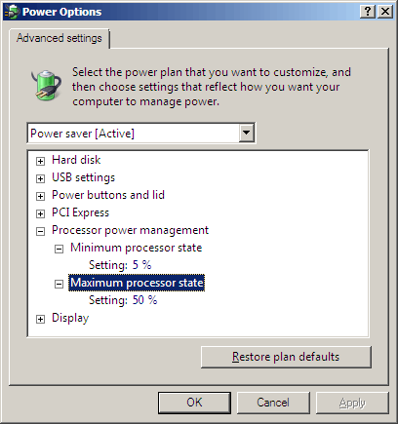

Figure 8: Setting minimum and maximum processor states under Advanced Settings in Windows Server 2008

In scenarios where continuous full power is not a requirement, Windows Server 2008 processor power management settings can be implemented on Windows servers and desktops using Group Policy Objects (GPOs). This would allow an administrator to easily implement an enterprise-wide and centrally-controlled power saving scheme. Figure 8 provides an example of this configuration with Active Directory in a Windows Server 2008 environment.

To take advantage of the advanced CPU throttling features of Windows Server 2008, your CPU and BIOS must comply with the ACPI specification for processor performance states. Consult your hardware manufacturer’s documentation to determine if your CPU and BIOS are capable of supporting multiple P-states, and, if so, how to enable the feature. If your current hardware cannot support multiple P-states, you may still be able to take advantage of other power management features in Windows Server 2008 (see “Managing Power Usage on Windows Vista Clients”).

#### Managing Power Usage on Windows Vista Clients

Enterprise users often leave their computers on overnight, either by choice or to comply with IT policy. This can allow administrative tasks like disk defragmenting, virus scanning, and software update downloading and installation to execute without disruption. However, leaving desktop computers on at night and on weekends can waste thousands of kilowatt-hours of electricity every year even in small and medium-size organizations. Using Windows Server 2008 and Group Policy, you can centrally manage the power policy of compatible client workstations running Microsoft Windows Vista®, which includes the same power-management features that have been introduced in Windows Server 2008. For example, you can configure computers to automatically enter a sleep state after a specified period of inactivity, and you can use PPM power policy to specify the range of P-states at which the client can operate.

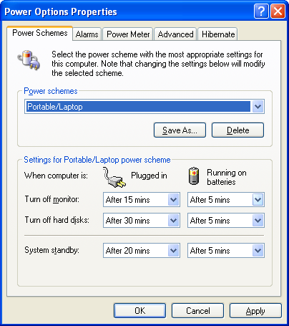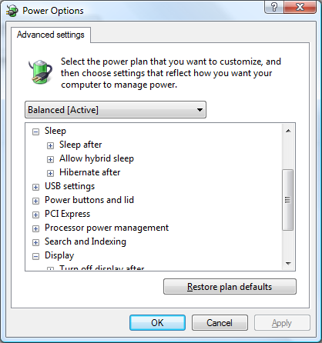

Figure 9: Power management options in Windows XP, left, and Windows Vista, right

In contrast to the limited selection of power management options available in the Microsoft Windows® XP Power Options Properties dialog, the Power Options dialog in Windows Vista offers direct control over a much greater number of options, including:[7]

* Wireless adapter power settings
* Allow hybrid sleep (a state in which the computer writes the contents of RAM to disk before going to sleep)
* USB selective suspend
* PCI Express bus power management
* Minimum and maximum processor state
* Power savings mode for search and indexing
* Adaptive display control

Windows Server 2008 makes it easy to create, distribute, and manage policy for both Windows XP and Windows Vista clients across the entire spectrum of devices that each can manage. The combination of Windows Server 2008 and Vista Clients offers administrators the greatest potential and greatest flexibility in implementing power-saving policies.

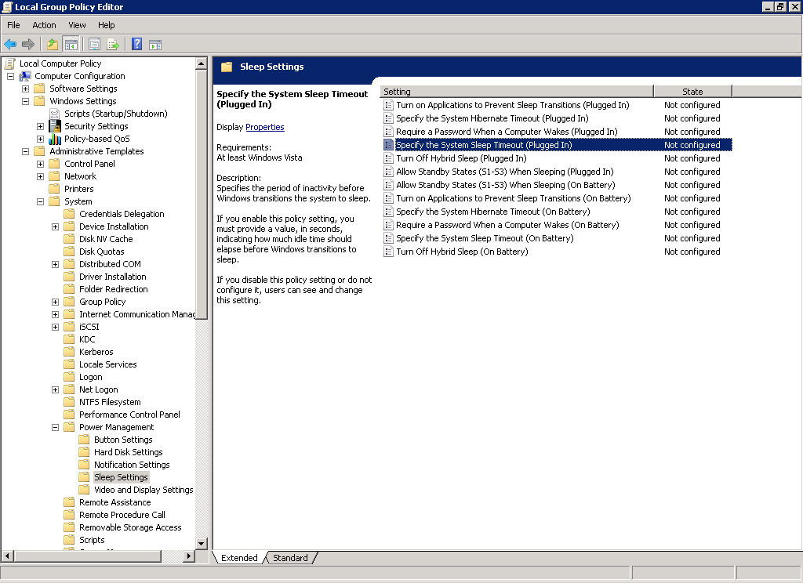

Figure 10: Group Policy Editor in Windows Server 2008 can be used to manage power saving features in Windows Vista

#### Appendix Data

For specific information on test results data, the following appendix data is available for download:

* Appendix A - Test Results Spreadsheet

#### Appendix B – System Information and Test Tools

#### Appendix C – Throughput

1. *Estimating Total Power Consumption by Servers in the U.S. and the World*, Jonathan G. Koomey, Ph.D., Staff Scientist, Lawrence Berkeley National Laboratory and Consulting Professor, Stanford University, February 15, 2007
2. Bureau of Labor Statistics: <http://data.bls.gov/cgi-bin/cpicalc.pl>
3. Power comparison of server unit only. Does not include external drive arrays.
4. NOTE: Power usage will vary with different system units from different vendors, as power consumption is dependent on hardware configuration in addition to software.
5. See *Average Retail Price of Electricity to Ultimate Customers by End-Use Sector, by State* (<http://www.eia.doe.gov/cneaf/electricity/epm/table5_6_b.html>) and *Greenhouse Gas Equivalencies Calculator* (<http://www.epa.gov/cleanenergy/energy-resources/calculator.html>) from the U.S. Environmental Protection Agency.
6. IDC, “Virtualization and Multi-core Innovations Disrupt the Worldwide Server Market,” March 2007.
7. For more information, see <http://www.energystar.gov/index.cfm?c=power_mgt.pr_power_mgt_winVista_default>.