

Project REAL:
Enterprise Class Hardware Tuning for Microsoft Analysis Services
SQL Server Technical Article

Authors: Harsh Bhaiya, Unisys Corporation
Sanjay Aggarwal, Unisys Corporation
Technical Reviewers: Len Wyatt, Ian Hepburn, David Hua, Kevin Lange
Published: September 2006
Applies To: Microsoft® SQL Server™ 2005 Analysis Services

Summary:
This paper describes best practices for hardware optimization for a multi-terabyte SQL Server 2005 data warehouse and cube. It describes hardware testing and tuning exercises conducted with large-scale Analysis Services (MS OLAP) cubes based on a multi-terabyte SQL Server data warehouse. Topics include lab setup, cube processing, MDX query load testing, processor comparison, and storage optimization as they pertain to an enterprise implementation of Analysis Services. The test exercise walks through a hardware tuning plan which reduced cube processing by half. It shows the significance of disk I/O, number of processors, and processor architecture on cube processing and concurrent user load testing performance.
Cube processing time was reduced by 50% via hardware tuning. The number of processors and processor architecture on cube processing and concurrent user load are significant variables, as is disk I/O.
Audience:
This white paper is intended for Business Intelligence managers and architects seeking to characterize and optimize the capabilities of enterprise-class hardware in relation to MS OLAP.

Microsoft® Copyright

The information contained in this document represents the current view of Microsoft Corporation on the issues discussed as of the date of publication. Because Microsoft must respond to changing market conditions, it should not be interpreted to be a commitment on the part of Microsoft, and Microsoft cannot guarantee the accuracy of any information presented after the date of publication.

This White Paper is for informational purposes only. MICROSOFT MAKES NO WARRANTIES, EXPRESS, IMPLIED OR STATUTORY, AS TO THE INFORMATION IN THIS DOCUMENT.

Complying with all applicable copyright laws is the responsibility of the user. Without limiting the rights under copyright, no part of this document may be reproduced, stored in or introduced into a retrieval system, or transmitted in any form or by any means (electronic, mechanical, photocopying, recording, or otherwise), or for any purpose, without the express written permission of Microsoft Corporation.

Microsoft may have patents, patent applications, trademarks, copyrights, or other intellectual property rights covering subject matter in this document. Except as expressly provided in any written license agreement from Microsoft, the furnishing of this document does not give you any license to these patents, trademarks, copyrights, or other intellectual property.

Unless otherwise noted, the companies, organizations, products, domain names, e-mail addresses, logos, people, places, and events depicted in examples herein are fictitious. No association with any real company, organization, product, domain name, e-mail address, logo, person, place, or event is intended or should be inferred.

Microsoft, Visual Studio, and Windows are either registered trademarks or trademarks of Microsoft Corporation in the United States and/or other countries.

The names of actual companies and products mentioned herein may be the trademarks of their respective owners.

Unisys® Copyright

NO WARRANTIES OF ANY NATURE ARE EXTENDED BY THIS DOCUMENT. Any product or related information described herein is only furnished pursuant and subject to the terms and conditions of a duly executed agreement to purchase or lease equipment or to license software. The only warranties made by Unisys, if any, with respect to the products described in this document are set forth in such agreement. Unisys cannot accept any financial or other responsibility that may be the result of your use of the information in this document or software material, including direct, special, or consequential damages. You should be very careful to ensure that the use of this information and/or software material complies with the laws, rules, and regulations of the jurisdictions with respect to which it is used.

The information contained herein is subject to change without notice. Revisions may be issued to advise of such changes and/or additions. Notice to Government End Users: The software and accompanying documentation are delivered and licensed as "commercial computer software" and "commercial computer software documentation" as those terms are used in 48 C.F.R.'s 12.212 and 48 C.F.R.'s 227.7202-1 through 227.7202-4, as applicable. The Government shall receive only those rights provided in the standard commercial software license, or where applicable, the restricted and limited rights provisions of the contract FAR or DFARS (or equivalent agency) clause.

© 2006 Unisys Corporation. All rights reserved.

Unisys is a registered trademark of Unisys Corporation. Microsoft, Analysis Services, SQL Server, and Visual Studio are either trademarks or registered trademarks of Microsoft Corporation. All other brands or products referenced herein are acknowledged to be trademarks or registered trademarks of their respective holders.

Table of Contents
Project REAL Overview 5
Business case scenario 5
Introduction 5
Project REAL Data and Design Overview 6
Project REAL data warehouse 6
Project REAL OLAP cube 7
Performance Test Methodology 9
Full cube processing test 10
User query load test 12
Shared OLAP environment test 13
Test Lab Setup 14
Testing and Tuning 18
Full cube processing test 18
First round—Itanium2 18
Optimizing disk I/O for Analysis Services data volume 19
Dual-core Xeon (EM64T) for OLAP cube processing 21
Initial cube processing time 23
Optimizing disk I/O for the data warehouse volume 24
Increasing memory from 64 GB to 128 GB 25
Analysis Services Temp folder 26
SQL Server tempdb tuning 26
Final cube processing time on dual-core Xeon (EM64T) 26
User load testing 28
Cache hits 28
% Processor utilization 30
Memory utilization 31
Disk reads 31
Network traffic 32
Shared OLAP environment test 33
Conclusion 34
Appendix A—Perfmon Counters 35
Appendix B—Software Stack 37
References 38

Project REAL Overview
Project REAL is an effort to discover best practices for creating business Intelligence applications that are based on Microsoft® SQL Server™ 2005 by creating reference implementations that are rooted in actual customer scenarios. This means that customer data is brought in-house and is used to work through the same issues that the customers face during deployment. These issues include:
- The design of schemas—both relational and for Analysis Services.
- The implementation of a data extraction, transformation, and loading (ETL) process.
- The design and deployment of client front-end systems, both for reporting and for interactive analysis.
- The sizing of systems for production.
- The management and maintenance of the systems on an ongoing basis, including incremental updates to the data.
By working with real deployment scenarios, we gain a complete understanding of how to work with the tools. Our goal is to address the full gamut of concerns that a large company would face during their own real-world deployment.

Business case scenario
Project REAL is based on sales and inventory analysis requirements for the retail giant Barnes and Noble®. The solution is intended to collectively serve different types of users such as buyers, planners, analysts, managers, and executives stationed in company headquarters, and in locations such as the stores and the distribution centers all across the U.S.
One requirement is to provide a series of summarized as well as fully detailed analytic views that help evaluate the inventory levels and sales trends required to support ordering decisions. The solution represents all aspects of a large data warehouse, such as large data volumes, complex operations, and business rules.
Like all mission-critical systems, Project REAL requires an aggressive data processing batch window for both daily incremental processing as well as monthly and quarterly restatements. It must expose the data in a form useful to designated business users with quick responses to a high volume of requests coming from a large concurrent user base.
For more information, see the “Project REAL: Technical Overview” white paper. A number of papers, tools, and samples from Project REAL are available as a reference on the Project REAL Web site. See References for additional information.

Introduction
This white paper covers a detailed technical discussion of the extended hardware performance testing and tuning conducted using Microsoft SQL Server 2005 Analysis Services (MS OLAP) cubes, and the large Microsoft SQL Server 2005 relational data warehouse developed for Project REAL running on enterprise-class hardware—the Unisys® ES7000™ (with both Intel® Itanium2® and Intel Xeon EM64T processors) as the consolidated database servers, and the EMC® CX700™ as the attached data storage subsystem.
This paper describes the workloads, testing iterations, testing scope and objectives, test results, and multiple levels of (mostly) hardware-related tuning suggestions, and offers a range of hardware best practices and insights to use while implementing an enterprise OLAP solution.
The tests are based on separate but associated efforts in the Unisys BICOE (Business Intelligence Center of Excellence) lab in parallel with the performance testing conducted by Microsoft in the Project REAL lab as documented in the “Project REAL: Performance” white paper. (Note This paper has not been published yet. It is expected to be published and linked from the Project REAL Web site by January 2007.) The similarities and differences between the two efforts are also emphasized, affirming that these tests were complementary in nature.
This paper is intended for:
- Business Intelligence Managers implementing enterprise scale OLAP solutions.
- Data Warehouse and OLAP Architects seeking to characterize the capabilities of enterprise-class hardware in relation to MS OLAP.
- Business Intelligence Infrastructure Architects wanting to optimize the hardware setup for MS OLAP.

Project REAL Data and Design Overview
This section provides a summary of the data source, the data warehouse, and the OLAP cube design. For details, see the “Project REAL: Analysis Services Technical Drilldown” white paper.
Project REAL data source
The source data of this test is the Project REAL relational data warehouse. This data is used for processing the Cube and Measure groups. The cubes are described in detail in a later section.
The Project REAL data warehouse consists of two major subject areas: Sales and Inventory. The data is sourced as a full copy of the production data warehouse at Barnes and Noble as of late December 2004 and approximately 2 terabytes as delivered. The data was masked to protect the proprietary business data of Barnes and Noble, but all characteristics of the data that are important to performance testing were retained.

Project REAL data warehouse
The Project REAL data warehouse contains 15 dimension areas and 4 fact table areas, as listed in Table 1 and Table 2.
The majority of the fact data is divided into multiple fact tables adjoining on weeks (referred as the multi-table format). Project REAL has also implemented the partition-table format for the data warehouse where a few large tables contain the entire fact data internally partitioned by weeks. However, only the multi-table format is used in this test since the focus is primarily on OLAP performance testing.
The dimension tables are fully denormalized, with all the related attributes in a single dimension table leading to an absolute star schema. There are no relational database indices because the Project REAL OLAP processing does not require them.
Highlights on the fact tables
The total number of rows for the fact tables was approximately 10 billion (see Table 1). Store sales fact data (for all items Barnes and Noble sold) was retained for the last 36 months; Store inventory fact data (for all items in each store) was retained for the last 12 months; and Distribution Center inventory fact data was retained for the last 3 months.

Table 1 Data warehouse fact tables
Fact Tables | Tables | Rows | Size (MB) | Bytes/Row | Rows/Table
DC Inventory facts | 18 | 54,405,164 | 4,363 | 84 | 3,022,509
Store Inventory facts | 53 | 8,630,298,635 | 435,983 | 53 | 162,835,823
Store Sales facts | 157 | 1,366,052,628 | 192,354 | 148 | 8,700,972
Division Strategy facts | 1 | 33,417,014 | 2,013 | 63 | 33,417,014

Highlights on the dimensions
The data warehouse consists of large slowly changing dimension tables to track history based on complex business rules. Row count and size of dimension tables is noted in Table 2.

Table 2 Data warehouse dimension tables
Dimension | Tables | Rows | Size (MB)
Item | 1 | 6,975,084 | 5,043 MB
Customer | 1 | 5,636,425 | 1,028 MB
Store | 1 | 4,127 | ~2 MB
12 other Dims | 12 | 50,620 | ~3 MB

Project REAL OLAP cube
Project REAL OLAP cubes possess the same level of granularity as the data warehouse, and therefore are not summary cubes. All the data described in the previous section is processed and stored in OLAP cubes. The only storage option tested for Project REAL is the MOLAP format because MOLAP provides the maximum performance benefit. Table 3 provides a summary of the cube design.
The total size of the Analysis Services database is 189,155 MB. Interestingly, data compression is observed to be higher for the Store Sales measure group than for the Store Inventory measure group. The Store Sales measure group contains additive measures and mostly currency data types. In contrast, the Store Inventory measure group contains semi-additive measures and mostly integer data types (see Table 3).

Table 3 Analysis Services measure groups
Measure group | Measures | Aggregation | Data types | Partitions | Size (MB)
DC Inventory | 4 | 4 LastNonEmpty | 3 Integer  1 UnsignedInt | 18 | 1,137 MB
Store Inventory | 6 | 6 LastNonEmpty | 4 Integer  1 Currency  1 UnsignedInt | 1,301 | 140,979 MB
Store Sales | 9 | 9 Sum | 1 Integer  7 Currency | 156 | 40,551 MB
Item Vendor | 1 | 1 Sum | 1 Integer | 5 | 633 MB

The Store Sales measure group is partitioned by weeks. Due to the larger data volume, the Store Inventory measure group is partitioned by two attributes (weeks and then subjects).
Project REAL implemented custom aggregations designed specifically for the queries that were tested. Details of the Analysis Services cube partitioning strategies and aggregation designs are discussed in the “Project REAL: Performance” white paper. (Note This paper has not been published yet. It is expected to be published and linked from the Project REAL Web site by January 2007.)
Table 4 provides a summary of the dimensions as stored in the cube. Note the high number of attributes and the user hierarchies that provide for tremendous flexibility in slicing and dicing the multidimensional data cubes.

Table 4 Analysis Services dimensions
Dimension | Leaf members | Hierarchies | Attributes | Size (MB)
Item | 6,975,085 | 9 | 44 | 3,965 MB
Customer | 5,066,951 | 2 | 17 | 1,878 MB
Store | 4,128 | 1 | 18 | ~2 MB
8 other Dims… | 30,750 | 5 | 25 | ~5 MB

Project REAL Data Flow Diagram

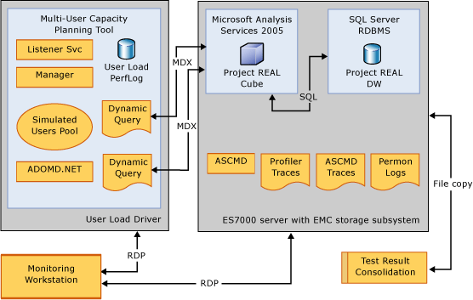
Figure 1 Component Architecture: Project REAL data flow setup at the test lab

The component architecture diagram in Figure 1 presents the data flow and connections between the components of the Project REAL lab setup. The components are related to both the user query load tests and the cube processing tests described in the next section. This diagram can be associated with the hardware layout in Figure 2 to better grasp the test environment.

Performance Test Methodology
OLAP Performance tests were conducted on Unisys ES7000™ systems with Itanium2 and EM64T Intel® processors in order to explore the capabilities of the scale-up servers for the OLAP workloads. The storage layout design for the EMC CX700, used as a direct attached storage, was appropriately reconfigured at several stages based on the observed bottlenecks during the test.
The hardware, data size, and user workloads were selected to be a representative of the realistic challenges commonly faced at most enterprise customers. The storage subsystems were tuned within the span of a realistic production system.
This test exercise focused on:
- Optimizing OLAP Cube Processing and concurrent user load testing by measuring and tuning hardware bottlenecks.
- Observing the effects of server-side tuning for Analysis Services.
- Observing the effects of using different Intel® processors.

Full cube processing test
One of the challenges for an enterprise BI implementation is the recurring full processing of the OLAP cubes. Full processing is a standard requirement for most OLAP implementations in the retail industry, depending on the aggregation design (rigid versus flexible).
Typically, transaction restatements, reclassification of dimension members, systemic latencies in data file uploads or periodic adjustments on a weekly, monthly, quarterly, or even yearly basis can change the aggregation calculations in an OLAP cube, necessitating a full reprocess.
For this testing exercise, the full cube processing is done through a command-line utility called ASCMD. XMLA scripts are called through the ASCMD that initiate the full processing for the specified partitions. The XMLA script also enumerates the number of partitions to be processed in parallel.
The partitions in Project REAL are divided into nine phases corresponding to the measure groups. The Sales and Inventory partitions in particular are further divided into yearly and quarterly phases respectively, due to the high number of partitions.
Dimension processing is not explicitly specified in the phases since it is automatically called by the OLAP engine each time the dimensions are not already preprocessed.
Cube processing phases for Project REAL
The nine processing phases that group all the partitions in the cube are as follows:
- Phase 1: Item Vendor
- Phase 2: Distribution Center
- Phase 3: Sales 2002
- Phase 4: Sales 2003
- Phase 5: Sales 2004
- Phase 6: Inventory Q1
- Phase 7: Inventory Q2
- Phase 8: Inventory Q3
- Phase 9: Inventory Q4
Although cube processing was divided into several phases, their processing workloads were not balanced. For example, the Sales and Inventory phases differ in the number of partitions, the data volume, the aggregation design and the aggregation calculations (semi-additive vs. additive measures). These differences will become even more pronounced in subsequent sections of the paper that describe performance testing.
The following example SQL queries are typical of the queries that are executed for each partition being fully processed.
Example—SQL Query for processing the Sales partition
SELECT
[SalesFactTable].[Measure01]
,[SalesFactTable].[Measure02]
…
,[SalesFactTable].[SK_Dim01_ID]
,[SalesFactTable].[SK_Dim02_ID]
…
FROM
[SalesFactTable]
Approximate Time Elapsed: 4:00 minutes per query
Average Number of Rows Returned: 8 million+

Example—SQL Query for processing the Inventory partition
SELECT
[InventoryFactTable].[Measure01]
,[InventoryFactTable].[Measure02]
…
,[InventoryFactTable].[SK_Dim01_ID]
,[InventoryFactTable].[SK_Dim02_ID]

FROM
[InventoryFactTable]
WHERE
SK_Member_Name IN
(SELECT
Member_Name
FROM [PartitionList]
LEFT OUTER JOIN [PartitionMemberList]
ON Partition_Name = Partition_Name
WHERE
Partition_Name = ‘123456789’
)
Approximate Time Elapsed: 2:30 minutes per query
Average Number of Rows Returned: 5 million+

Processing events for each partition
The following set of events takes place while fully processing each partition.
- Execute SQL
- Read data
- Write data
- Aggregate
- Merge aggregations
- Build aggregations and indexes
For more details on the cube processing architecture, see the “Analysis Services 2005 Processing Architecture” white paper. (Note This paper has not been published yet. It is expected to be published and linked from the Project REAL Web site by January 2007.)
Note on incremental data load testing: Incremental processing test is beyond the scope of this exercise. Incremental processing is covered as part of the recurring ETL in the “Project REAL: Performance” white paper. (Note This paper has not been published yet. It is expected to be published and linked from the Project REAL Web site by January 2007.)

User query load test
Another challenge for an enterprise BI implementation is ensuring fast and efficient responses to a high volume of analytical queries from a large number of enterprise users. The users in this exercise were simulated to run simultaneous MDX queries at varied levels as well as different combinations of attributes and calculations.
The user load configured to scale from 0 to 500 in increments of 100 users every 15 minutes. Users were set with random think times ranging from 0 to 60 seconds. The MDX queries coming from the users were constructed dynamically by using a set of parameterized queries and assigning them the parameter values as shown in the following example MDX query construction.
Example—MDX Query construction for user load testing
WITH
SET [Rolling 24 Weeks] AS 'LastPeriods(24, |fiscalWeek|)'
SELECT
NON EMPTY [Rolling 24 Weeks] ON COLUMNS ,
{ [Measures].[Days In Stock], [Measures].[Model Qty], [Measures].[On Hand Qty]
, [Measures].[Sales Qty], [Measures].[Return Qty] } ON ROWS
FROM [REAL Warehouse]
WHERE ( |district| )
The parameter values for the tokens in the example MDX query above are taken from the MDX sets listed in Table 5.

Table 5 Example—Parameters tokens for user queries
Parameter tokens | MDX set returning the values for the tokens | No. of values
|fiscalWeek| | {descendants([Time].[Fiscal].[Fiscal Year].[FY 2004], [Time].[Fiscal].[Fiscal Week])} | 52
|district| | {[Store].[Geography].[District].Members} | 51

This example alone can create up to 2,652 different queries. A combination of 24 such query structures and up to 14 tokens were used to create distinct MDX queries that were randomly distributed across all the simulated users. These queries were based on actual business questions from Barnes and Noble users.
The aggregations in the cube were custom designed specifically to cater to these load-testing queries. Also, as the number of users increases, queries get answered from both the disks reads as well as the data cache. This simulates a realistic user load that a production environment will experience.
User-load testing software
The user-load testing tool used for this exercise was an unreleased Microsoft internal tool. Microsoft Visual Studio® 2005 Team Edition for Software Testers™ (VSTS) may also be used for testing a similar user load. Microsoft will release tools and samples that will assist load testing with VSTS for Analysis Services.

Shared OLAP environment test
The third series of tests were the shared environment tests. A shared OLAP environment is defined as multiple OLAP cubes sharing the same hardware environment, but catering to separate business objectives. Often, related subject area cubes are hosted in a shared environment. For example, logistics cubes can be hosted on the same servers as inventory cubes even when accomplished through separate projects. Cube processing or user activities for one cube can disrupt the users of another cube because they share the same physical server. A short test was conducted to compare the Intel® processors in a simulated shared environment.
Since Project REAL developed a single cube, a copy of that cube was hosted on the same server under a different name, pretending to be for a different project to form a shared OLAP environment. One Analysis Services cube was subjected to full processing while the other cube was tested for user query load. These tests were the same as described in Full Cube Processing Test and User Load Query Test later in this paper except that they were run concurrently. The results were then compared to the previous tests to see the impact of the shared OLAP environment.

Test Lab Setup
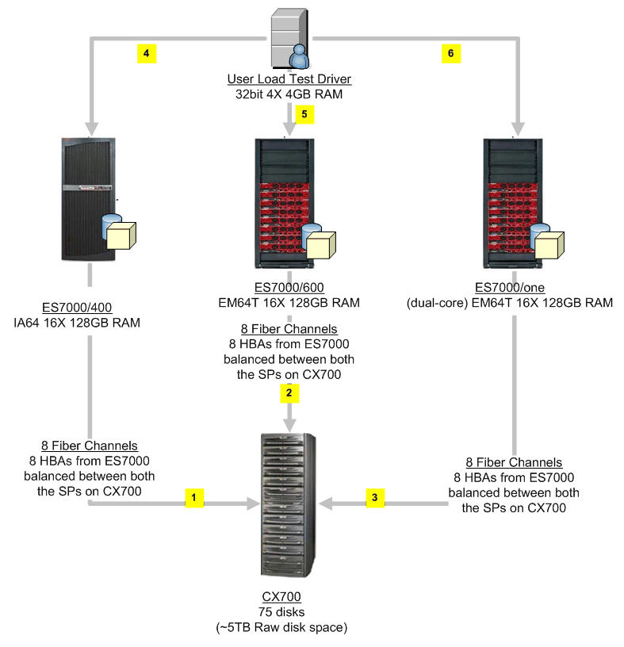

Figure 2 Hardware layout (see Figure 1 for software layout)
The Unisys BICOE (Business Intelligence Center of Excellence) lab test environment (see Figure 2) for this test consists of three Unisys® ES7000™ systems with the following processor types:
- Intel Itanium2 (IA64) – 1.6GHz, 9-MB cache
- Intel Xeon (EM64T) – 3.33GHz, 8-MB cache
- Intel Xeon dual-core (EM64T) – 3GHz, 4-MB cache
(See References for links to architecture documentation.)
The Unisys ES7000 consists of “cells,” self-sufficient 3U servers interconnected by Intel Scalability Port cables. Each cell has 4 processor sockets, 8-64 GB memory and 5 PCI-X slots, and can host multiple electronically isolated operating systems or scale to form a 32-socket SMP platform for a single operating system. It is possible to selectively assign the processor, memory, and I/O from different cells to a specific Host Operating System.
All three ES7000 were configured with 16 sockets (4 cells). This means that the dual-core machines show up with 32 cores. Memory modules on the server were interleaved between cell pairs. For details, see the “Project REAL: Hardware Architecture” paper. (Note This paper has not been published yet. It is expected to be published and linked from the Project REAL Web site by January 2007.)
EMC CX700 was used as the storage subsystem. 75 hard drives with 73 GB per drive provide ~5 terabytes of raw disk space. The same storage subsystem was used for testing with the different ES7000 models and was attached to the respective servers for different test cycles.
The storage subsystem was used in a direct attached mode using the optical Emulex Host Bus Adapters (HBAs) installed in the server. A total of eight HBAs were used for all the tests to ensure high-speed connectivity between the storage and the servers. The HBAs were positioned to use the extensive I/O capabilities of the ES7000™ by spreading them across different cells (that is, two per cell) and hence using dedicated I/O channels. The connecting fiber channels were balanced across two service processors on the EMC CX700 storage subsystem to better utilize its cache.
As mentioned previously, the EMC CX700 storage subsystem used in the test consists of multiple physical hard drives, commonly referred to as spindles. A set of spindles is then tied together in RAID groups. Logical volumes called LUNs are carved out of these RAID groups and are assigned a RAID Level (for example 0, 1, 5, 1/0). Finally, LUNs are presented to the host operating system as logical disks.
Volume usage summary
The storage layout shown in Table 6, Figure 3, and Figure 4 is the final layout that evolved from a series of testing and tuning. The test iterations that led to this final storage layout are discussed in the later part of this paper.

Table 6 Storage layout summary
Volume | Usage | RAID  groups | LUNS | RAID  level | Total spindles
(C:) | Internal drive for OS |  | n/a | 1/0 | 1
AS | Analysis Services data | 3 | 3 | 1/0 | 24
ASB | Analysis Services backup
AST | Analysis Services Temp
ASU | ASCMD, processing logs
DW | SQL data for data warehouse | 5 | 5 | 1/0 | 40
DWL | SQL log for data warehouse | 1 | 1 | 1/0 | 1
TD | tempdb for SQL Server | 1 | 1 | 1/0 | 8
TDL | tempdb log for SQL Server | 1 | 1 | 1/0 | 1
Windows Disk Management
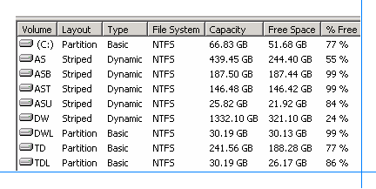
Figure 3 Volume capacity

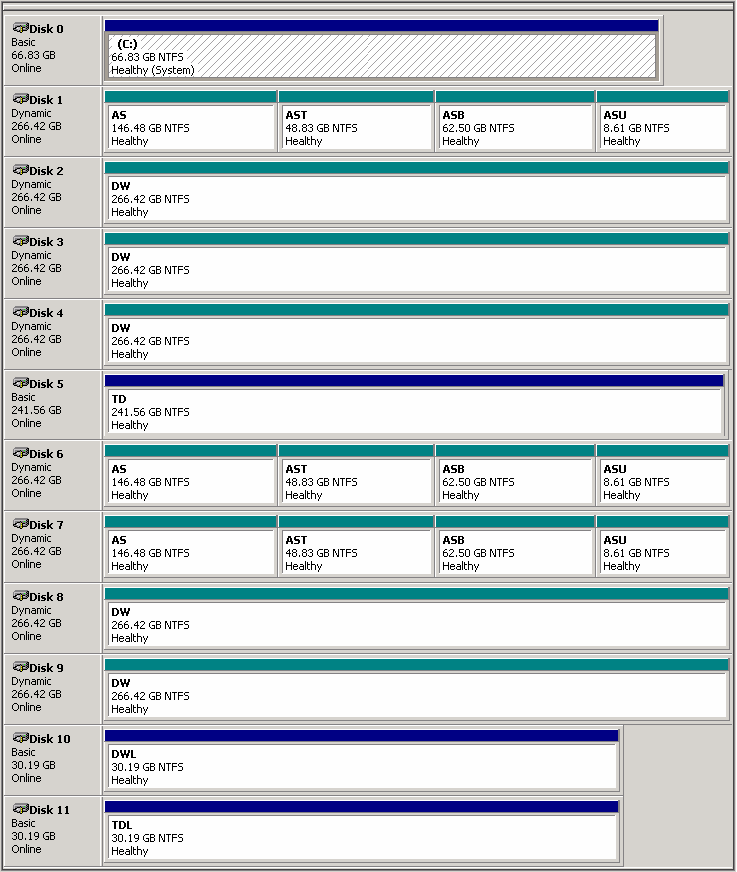
Figure 4 Volume layout
The blue bars in Figure 4 indicate the primary partition and the green indicate the dynamic striped volume. LUNs created in the EMC CX700 are presented to the operating system as separate disks. To store more data on a volume beyond an individual LUN’s capacity, create a dynamic striped volume by striping multiple disks. As seen in Figure 4, the data warehouse stripe volume was created by tying five disks together to host the multi-terabyte data warehouse. Similarly, an Analysis Services data striped volume is created to host the cubes. Windows Disk Management also provides the ability to map the logical volumes to the physical hard drives as shown in a later section (Figure 16) for monitoring purposes.
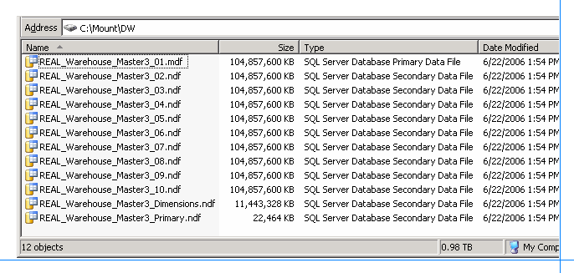
Figure 5 SQL data files
The SQL data for the data warehouse was spread across 10 files (see Figure 5).
The tempdb database was split across 16 files (using the rule of thumb of one file per processor, as shown in Figure 6). On the dual-core system, tempdb was split across 32 files. Since the Inventory phase was observed to use tempdb, splitting tempdb into multiple files resulted in performance gains.
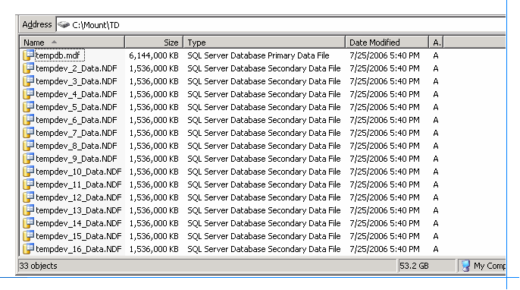
Figure 6 tempdb files
Note: To reduce performance overheads, the Windows paging file was disabled. However, disabling paging files prevents memory dumps in the event of an OS crash.

Testing and Tuning
Testing was done in multiple iterations and small tuning changes were made incrementally in order to closely observe the effects. Some of the iterations were repeated after major gains were observed.

Full cube processing test
This section documents some of the key hardware tuning practices that have proven beneficial and provides the cube processing results with examples from the Sales 2004 and Inventory Q1 phases.

First round—Itanium2
The testing started with an initial setup of the ES7000 with 16 Itanium2 processors with 64-GB RAM. The storage for the relational data warehouse was spread over 10 files stored on 10 LUNs carved out of 5 RAID groups with 8 spindles each. The Analysis Services data volume was created with 16 spindles, and the SQL Server tempdb volume was created with 4 spindles. The final setup is discussed in the Test Lab Setup section. This section traces the evolution of the final configuration, intending to provide insight into hardware tuning efforts.
Observing bottlenecks: Analysis Services data volume
During the first round of cube processing, current disk queue lengths were observed as shown in Figure 7. The green lines indicate the current disk queue length for the data warehouse volume. The red lines indicate the current disk queue lengths for the Analysis Services data volume.
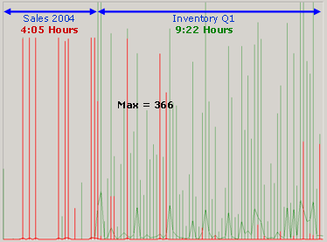
Figure 7 Current disk queue length (1)
Red: Analysis Services data volume
Green: Data warehouse volume
Note The figure is scaled to represent the processing time and the maximum current disk queue length.

Optimizing disk I/O for Analysis Services data volume
Theoretically, adding spindles can provide disk read and write performance gains by increasing IOPS (I/O per second). Therefore, an additional RAID group was created with 8 spindles and added to the previous set of 2 RAID groups with 8 spindles each for the Analysis Services data volume. A dynamic striped volume was then created in Windows Disk Management (see Figure 4) to increase the total spindles for the Analysis Services data volume from 16 to 24.
This resulted in faster cube processing and fewer red spikes (see Figure 8) but higher green bars for the data warehouse volume due to increased SQL workloads.
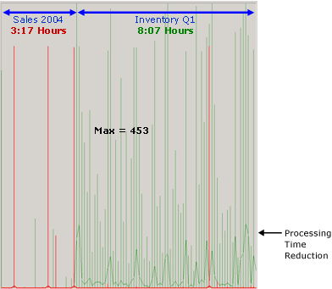
Figure 8 Current disk queue length (2)
Red: Analysis Services data volume
Green: Data warehouse volume
Note: The figure has been scaled to represent the processing time and the maximum current disk queue length.
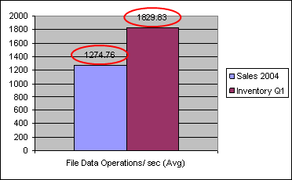
Figure 9 File data operations/sec for the Analysis Services data volume configured with 16 spindles

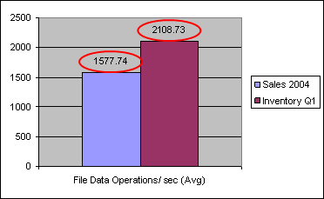
Figure 10 File data operations/sec for the Analysis Services data volume configured with 24 spindles
The graphs show that the File data operations/ sec improved (compare the data labels in Figure 9 to those in Figure 10) by increasing the spindle count. However, these gains are not indefinite. Adding additional spindles might not result in additional gains as the I/O performance may have reached its threshold.

Table 7 % Improvement by adding spindles to the Analysis Services data volume
Processing  phase | Disk read  (Avg) | Disk write  (Avg) | Rows converted /sec (Avg) | File data operations /sec (Avg)
Sales 2004 | 124.29% | 125.86% | 124.36% | 123.77%
Inventory Q1 | 115.02% | 115.43% | 115.40% | 115.24%

Table 7 shows the % improvement for performance counters measuring read and write activities for the Analysis Services data volume compared to the previous test runs. It is also interesting to note that the file data operations/ sec showed approximately 10% more improvement for the Sales phase than for the Inventory phase.
Since the Inventory phase is more voluminous than the Sales phase, its workload on the relational data warehouse for executing SQL statements was higher. This is possibly why the improvements for file data operations /sec for the Inventory phase was lower than for the Sales phase. This high workload on the relational data warehouse for the Inventory processing phase might possibly be facilitated by additional processors.

Dual-core Xeon (EM64T) for OLAP cube processing
Dual-core processors contain twice as many processing cores as single-core processors. These additional processors could help with the high workloads for the Inventory processing phase. Hence, we ran the test with the dual-core Xeon (EM64T) processors available in the lab and the results were quite exciting. Cube processing was much faster on the dual-core system.
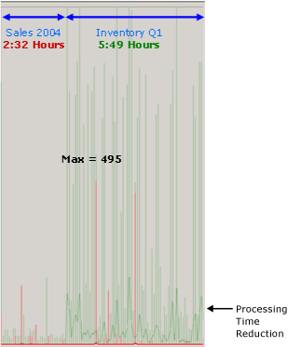
Figure 11 Current disk queue length (3)
Red: Analysis Services data volume
Green: Data warehouse volume
Note: The figure has been scaled to represent the processing time and the maximum current disk queue length.
The Inventory phase processing time improved remarkably with the dual cores by not only improving SQL query execution on the relational data warehouse, but by also enhancing the speed of OLAP cube aggregation.
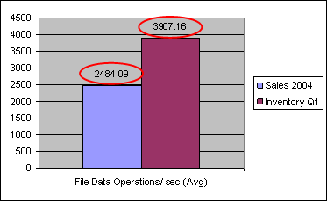
Figure 12 File data operations/ sec on a dual-core Xeon (EM64T)
Sales processing phases made comparatively smaller gains on a dual-core system than did the Inventory phases, as seen in the file data operations/sec graphs in Figure 12 (compare data labels in Figure 12 with Figure 10). Since the additional processors facilitated the relational data warehouse workloads for the Inventory phase more than for the Sales phase, the difference in gains was not a surprise.
Windows Task Manager
The processor utilization peaked at several stages of the cube processing (see Figure 13). Memory was divided between SQL Server, set at a maximum limit of 96 GB, and Analysis Services, which was permitted to use the remainder of 128 GB. Analysis Services was never under memory pressure.
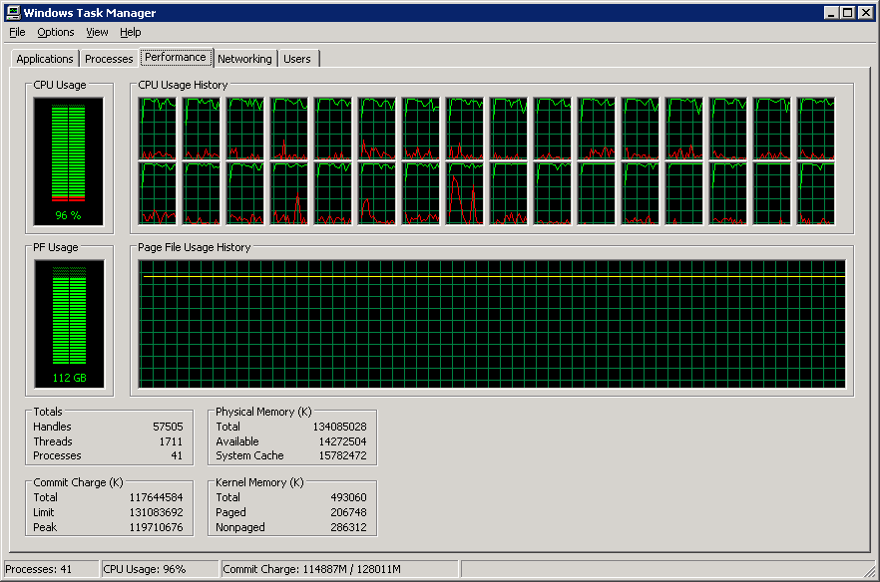
Figure 13 Task Manager on a dual-core Xeon (EM64T) system with 16 sockets and 128-GB RAM
See Figure 14 for % processor utilization on a 16-socket dual-core Xeon (EM64T) server. Even though the average processor utilization was under 20%, the standard deviation illustrates that processor utilization was much higher (almost consistently peaking) for several intervals during the cube processing test. The impact of using more processors is illustrated in Table 8 where single-core Xeon (EM64T) servers are compared with dual-core Xeon (EM64T) servers for cube processing times.
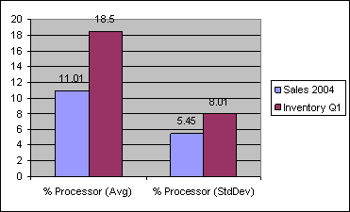
Figure 14 % Processor utilization for a dual-core Xeon (EM64T)

Initial cube processing time
Table 8 provides a concise phase summary of the initial cube processing times as observed on each processor type.

Table 8 Phase wise Cube Processing Time
Platform | Xeon (EM64T) | Itanium2 | Dual-core Xeon (EM64T)
Phase | Hours | Hours | Hours
Phase 1: Item Vendor | 0:42 | 0:40 | 0:39
Phase 2: Distribution Center | 0:11 | 0:09 | 0:08
Phase 3: Sales 2002 | 3:08 | 2:31 | 2:09
Phase 4: Sales 2003 | 3:25 | 2:53 | 2:24
Phase 5: Sales 2004 | 3:39 | 3:17 | 2:32
Phase 6: Inventory Q1 | 9:24 | 8:07 | 5:49
Phase 7: Inventory Q2 | 7:58 | 6:44 | 5:05
Phase 8: Inventory Q3 | 9:13 | 7:54 | 5:39
Phase 9: Inventory Q4 | 9:14 | 8:10 | 5:46
 | 46:54:00 | 40:26:19 | 30:11:00
Avg. Rows converted/ sec | 58468 | 63454 | 90824

Observing bottlenecks: data warehouse volume
Improved SQL query execution with the dual-core Xeon (EM64T) processors resulted in an increase in read activities from the disks. Evidently, the current disk queue length on the data warehouse volume for both Inventory and Sales phases went higher than witnessed earlier (see green bars on Figure 11 versus Figure 8). The current disk queue length for the Inventory phase was enormously high and cube processing became disk-bound.
This problem also presents an opportunity. Improving the storage performance for the data warehouse could become a source of improvement for the Inventory phase processing in particular.

Optimizing disk I/O for the data warehouse volume
As mentioned in the first round of testing, the 10 SQL data files were initially spread across 5 different RAID groups (catering to 10 LUNs). Had the querying of the data warehouse during cube processing gone to different SQL data files in parallel, this setting might have been useful.
However, the cube building process is a sequential read from all of the SQL data files. Disk activity was seen to shift from one RAID group to another as cube processing proceeded. The RAID groups were almost never busy concurrently.
The SQL query for cube processing consisted of sequential reads from the SQL data files for the data warehouse despite parallel processing of the partitions. We surmised that cube processing performance would increase if all the files were stored in one large data warehouse volume supported by all the 40 spindles at once. This will increase the IOPS.
Thus, the storage layout for the data warehouse was reconfigured. The 5 RAID groups were re-carved into only 5 LUNs, and these LUNs were then tied together in a single dynamic striped volume, as shown in Figure 4.
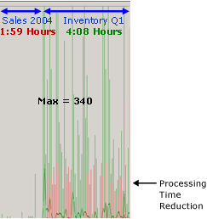
Figure 15 Current disk queue length (4)
Red: Analysis Services data volume
Green: Data warehouse volume
Note: The figure has been scaled to represent the processing time and the maximum current disk queue length.
The results were impressive. File data operations/ sec for final cube processing improved, leading to a shortened full cube processing batch window. As seen in Figure 15, the current disk queue length for the data warehouse was also reduced.
The storage was not optimized further in order to reasonably reflect real world production environments.
Monitoring disk IOPS on EMC CX700
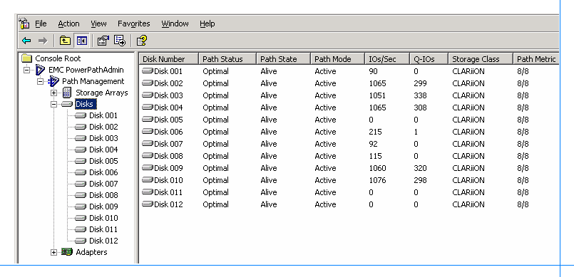
Figure 16 Disk IOPS as seen on EMC PowerPath
Disk IOPS improved because the dynamic volume for the data warehouse was spread across 40 spindles was observed on EMC PowerPath. All five data warehouse LUNs were concurrently active (see Figure 16).

Increasing memory from 64 GB to 128 GB
The tests started with 64-GB RAM on all systems. Memory was not observed to be under pressure at any time. 64 GB was adequate for both cube processing and data cache. Increasing memory to 128 GB did not result in any processing or query load performance gains.
Initially, SQL Server was set at a maximum limit of 48 GB and the rest was made available for Analysis Services. When the physical memory was increased to 128 GB, the maximum limit on SQL Server was raised to 96 GB. During cube processing, SQL Server used all the available memory and did not release it unless specifically requested by another process. All 96 GB was occupied by SQL Server very quickly.
However, the process working set memory for SQL Server remained under 32 GB and the process working set memory for Analysis Services also remained under 12 GB.

Analysis Services Temp folder
It was observed that if enough RAM is available on the server, the entire cube processing operates in memory and no activity is registered on the Analysis Services Temp folder. On 64-bit systems, the Analysis Services Temp folder is not specified by default. It was purposely set during this testing exercise; however, no activities or performance differences were noted.

SQL Server tempdb tuning
Another interesting observation was that the SQL Server tempdb volume was queued up for requests. Initially, only 4 spindles were provided with the assumption that it will not be highly used.
But we noticed that tempdb gets used for the distinct count SQL queries during dimension processing and quite extensively for the Inventory phase processing (as observed in Figure 17). It is not used during the Sales phase processing.
To alleviate the request queues, the spindles were increased from 4 to 8. The current disk queue length for the tempdb volume immediately declined and IOPS improved.
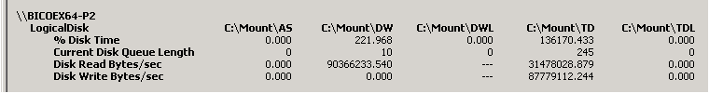
Figure 17 tempdb (C:\Mount\TD) activities observed during Inventory Processing phases
Note: Analysis Services server-side properties
As part of the testing, we also changed the settings for the following Analysis Services properties:
- CoordinatorExecutionMode
- MaxParallel
- BuildMaxThread
No significant gains were observed and hence the settings were reverted to default values.

Final cube processing time on dual-core Xeon (EM64T)
Table 9 shows the best cube processing times achieved during this test. Cube processing times achieved in this test are not the best possible. The hardware tuning covered in this paper is not exhaustive and additional improvements can be made through hardware and software tuning.

Table 9 Final cube processing time
Platform | Dual-core Xeon (EM64T)
Phase | Hours
Phase 1: Item Vendor | 0:38
Phase 2: Distribution Center | 0:07
Phase 3: Sales 2002 | 1:34
Phase 4: Sales 2003 | 1:44
Phase 5: Sales 2004 | 1:59
Phase 6: Inventory Q1 | 4:08
Phase 7: Inventory Q2 | 3:44
Phase 8: Inventory Q3 | 4:11
Phase 9: Inventory Q4 | 4:06
 | 22:11:00
Avg. Rows converted/ sec | 123,530

120,000+ rows converted /sec is one of the highest cube processing rates we have observed in our labs.
User Load Testing

Note: The user query load test and the results described in this paper are unlike the user load tests described in the “Project REAL: Performance” white paper. (Note This paper has not been published yet. It is expected to be published and linked from the Project REAL Web site by January 2007.)
The query load tests in this paper are based on a mix of 70% warm-cache and 30% cold-cache queries. This scenario was created to reasonably simulate a realistic production environment where query processing is a mix of cache-reads and disk-reads, whereas the query tests described in the Performance white paper are entirely cold-cache. These were conducted to measure the working of the processor when directly subjected to a specified load.
Both these tests highlight very dissimilar aspects of query load behavior from a processor point of view. Therefore, the results presented in these papers are not contradictory but complementary.
Also, the processors used for both the tests differ on clock speeds and cache sizes.

User load testing
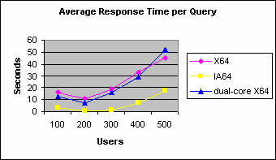
Figure 18 Average response time for user query load test by processor types
Figure 18 plots average response time per query for the user load testing by each processor type. Figure 19 shows the standard deviation for the average response time for the user loads by each processor type.
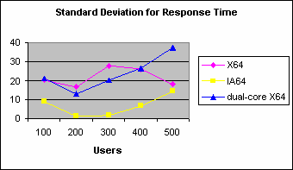
Figure 19 Standard deviation for user query load test by processor type
Table 10, Table 11, and Table 12 document the query response times in a tabular format.
The response times for the Itanium2 processors are noticeably lower than for the Xeon (EM64T) and dual-core Xeon (EM64T) processors. Standard deviation also shows that the response times varied less for the Itanium2 than for others.
The next section discusses a few other performance monitoring counters to gain an insight into the performance differences between Itanium2, Xeon (EM64T), and dual-core Xeon (EM64T) processors, as recorded during user query load tests.

Cache hits
Since the test started with cold cache directly at a 100-user load, the average MSAS 2005 cache direct hit ratio was approximately 50% for the 100-user test iteration (see Table 10, Table 11, and Table 12). The average MSAS 2005 cache direct hit ratio for subsequent user loads was maintained at approximately 70% since those iterations took advantage of some data already in cache from the prior iterations. This explains why the user response for 200 users is lower than for 100 users, as seen in Figure 18.
Tables 10–12 also provide more details on the user load tests such as total queries completed, average non-empty cells per query and the average think time set for each user.

Table 10 User load testing for Itanium2
Users | Cache  hit  ratio | Avg  resp.  time | Stdev  resp.  time | Avg  think  time | Average  thrput. | Queries  completed | Queries  failed | Avg  not empty cells /qry
100 | 52.2 | 3.5 | 9.1 | 30.4 | 2.66 | 2607 | 0 | 335
200 | 68.5 | 0.8 | 1.5 | 29.9 | 5.96 | 5827 | 0 | 333
300 | 70.0 | 1.4 | 1.9 | 30.1 | 8.75 | 8527 | 0 | 326
400 | 72.3 | 7.4 | 6.7 | 30 | 9.30 | 9028 | 0 | 327
500 | 76.0 | 17.7 | 14.4 | 30 | 8.07 | 7993 | 0 | 330

Table 11 User load testing for Xeon (EM64T)
Users | Cache  hit  ratio | Avg  resp.  time | Stdev  resp.  time | Avg  think  time | Average  thrput. | Queries  completed | Queries  failed | Avg  not empty cells /qry
100 | 54.0 | 15.9 | 20.3 | 30.9 | 1.92 | 1891 | 0 | 337
200 | 71.3 | 10.5 | 16.5 | 30.6 | 4.42 | 4354 | 0 | 317
300 | 73.1 | 18.7 | 27.9 | 30.6 | 5.56 | 5463 | 0 | 330
400 | 73.5 | 33.3 | 26.2 | 30.5 | 5.72 | 5720 | 0 | 328
500 | 73.7 | 44.9 | 18.2 | 30.3 | 5.91 | 6122 | 0 | 333

Table 12 User load testing for dual-core Xeon (EM64T)
Users | Cache  hit  ratio | Avg  resp.  time | Stdev  resp.  time | Avg  think  time | Average  thrput. | Queries  completed | Queries  failed | Avg  not empty cells /qry
100 | 53.2 | 13 | 21.2 | 29.9 | 2.11 | 2048 | 0 | 343
200 | 65.9 | 7.6 | 13.1 | 29.9 | 4.85 | 4749 | 0 | 333
300 | 70.1 | 16 | 20.4 | 30 | 5.94 | 5817 | 0 | 330
400 | 71.9 | 29.3 | 26.4 | 30 | 6.06 | 6197 | 0 | 335
500 | 70.2 | 52 | 37.1 | 29.9 | 5.31 | 5518 | 0 | 331
An interesting observation about Analysis Services cache hits related to the processor type is seen in the graph in Figure 20. MSAS 2005 cache direct hits /sec for the Itanium2 server is higher than for the Xeon (EM64T) and the dual-core Xeon (EM64T) servers.
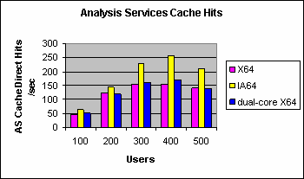
Figure 20 Analysis Services direct cache hits /sec by user load
The Itanium2 provided the best performance for user query load test of the three processor types tested. The dual-core Xeon (EM64T) yielded response times analogous to the Xeon (EM64T) even though it contained twice as many cores.

% Processor utilization
Processor utilization on Itanium2 during user query load tests was lower than on the Xeon (EM64T) and dual-core Xeon (EM64T) even though the query performance was much better, as seen on Figure 21.
The lower processor utilization for the Itanium2 can be explained based on the information in the previous section, Cache Hits, that shows how MSAS 2005 cache direct hits /sec were higher for the Itanium2 than for the other processors. Also, the Itanium2 architecture with Explicitly Parallel Instructions Computing (EPIC) allows for a higher number of instructions executed per clock cycle. Therefore, CPU utilization on the Itanium2 remains lower in comparison to the Xeon (EM64T) for answering the same queries.
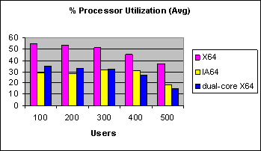
Figure 21 Processor utilization (Avg.) by user load
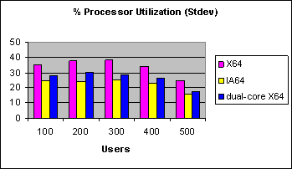
Figure 22 Processor utilization (Stdev.) by user load

Memory utilization
Figure 23 shows that memory utilization was similar for all three processor types. Memory usage incremented for each user load to hold additional data cache fetched to answer newer queries that could not be answered from the existing data cache. Similar memory utilization across all the three processor types also indicates that the data load for queries was balanced across all the tests iterations.
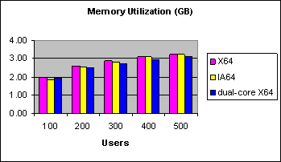
Figure 23 Memory utilization by user load

Disk reads
File data operations /sec for the Itanium2 were marginally higher than for other processors, signifying slightly faster disk read performance (see Figure 24).
Disk read operations diminished as the test progressed, with user loads going from 100 to 500. At higher user loads, data cache collected in memory was also higher, resulting in a higher number of queries getting answered from the cache as opposed to the disk reads.
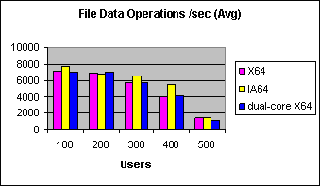
Figure 24 File data operations /sec by user load
The Itanium2 processor generated consistently low query response times by managing the data cache on the server better than the other processor types as seen in this test. We infer that data-cache management was markedly superior for the Itanium2 than for the other processor types.
Although direct correlation between processor architecture and OLAP performance requires further investigation, we theorize that the superior performance on the Itanium2 for user query load may be attributed to some of the following Itanium2 features:
- Itanium2 architecture, implementing Extremely Parallel Instruction Computing (EPIC)
- Large register sets (128)
- Higher number of instructions executed per clock cycle
- 9 MB level three (L3) cache size

Network traffic
Among other observations, network traffic remained low even with 500 users, with 500 KB highest bytes sent/ sec, which was almost always under 1% utilization on a gigabit connection. Throughput was never high enough for the network to be a bottleneck.

Shared OLAP environment test
Shared OLAP environment tests, as described in Shared OLAP Environment Test, were quite interesting as well. Performance on the Xeon (EM64T) and dual-core Xeon (EM64T) were most impacted due to the stress from concurrently querying a cube while processing another cube on the same server. The Itanium2, in comparison, was highly resilient to this shared OLAP environment.
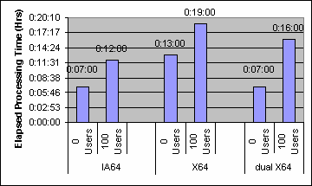
Figure 25 Cube processing in a shared OLAP environment
Figure 25 shows cube processing times for a small cube while no users were querying the systems and compares it with cube processing times for the same cube while 100 users were querying the systems. Itanium2 suffered the least impact on cube processing time from concurrently putting 100 users on the same system.
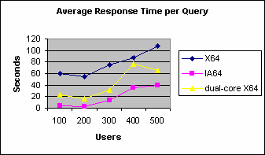
Figure 26 User query load test in a shared OLAP environment
Query response times on the Xeon (EM64T) were highly impacted by the shared OLAP environment. Query response times on the Itanium2 were the least disrupted by simultaneously processing a cube. Compare Figure 18 to Figure 26 to observe the change in user query response times due to the shared OLAP environment.
Standard deviation for the query response times in the shared OLAP environment tests (Figure 27) was within similar thresholds as in the dedicated query load tests discussed in User Load Testing, implying consistency in the user-load test results.
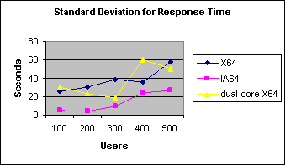
Figure 27 Standard deviation for user query load test by processor type

Conclusion
The hardware tuning in this test reduced cube processing time in half. Storage layout was observed to be one of the first ways of improving cube processing time by reducing bottlenecks for both disk reads and writes. Increasing the number of processors was another effective way to decrease cube processing time.
Processor architecture played a significant role in user query load performance, whereas the number of cores was important in cube processing performance. The Itanium2 was much better for query performance than the Xeon (EM64T) and dual-core Xeon (EM64T) processors. Even though the Itanium2 showed decent performance for cube processing, it was only slightly better than the Xeon (EM64T). The dual-core Xeon (EM64T) with double the number of processors proved to be excellent for cube processing.
The version of the dual-core Xeon (EM64T) processor used in this test does not have a third-level cache. Future versions of dual-core Xeon (EM64T) will contain a third-level cache, which can improve user query load performance. Similar tests will be carried out when the highly anticipated dual-core Itanium2 processors become available in the lab.

Appendix A—Perfmon Counters
The key perfmon counters we found useful for monitoring a cube processing test are listed in Table 13.

Table 13 Key perfmon counters for cube processing monitoring
Key perfmon counters | Monitored value
% Processor time | Min, Max, Avg, Std Dev
LogicalDisk: Current disk queue length – Analysis Services data volume | Max, Avg, Std Dev
LogicalDisk: Current disk queue length – data warehouse volume | Max, Avg, Std Dev
LogicalDisk: Current disk queue length – SQL tempdb volume | Max, Avg, Std Dev
MSAS 2005: Processing - Rows converted/ sec | Max, Avg
File data operations/ sec | Max, Avg

The perfmon counters that we found particularly useful for user load testing are listed in Table 14.

Table 14 Key perfmon counters for user load test monitoring
Key perfmon counters | Monitored value
% Processor time | Min, Max, Avg, Std Dev
LogicalDisk: Current disk queue length – Analysis Services data volume | Max, Avg, Std Dev
LogicalDisk: Disk Read Bytes/sec - Analysis Services data volume | Min, Max, Avg
MSAS 2005: Cache – Direct hit ratio | Max, Avg
MSAS 2005: Cache – Direct hits/sec | Max, Avg
MSAS 2005: Connection – Current connections | Max, Avg
MSAS 2005: Storage Engine Query – Network roundtrips/sec | Max, Avg
MSAS 2005: Threads – Processing pool busy threads | Max, Avg
MSAS 2005: Threads – Query pool busy threads | Max, Avg
File data operations/ sec | Max, Avg
Perfmon counters watchlist
The watchlist in Figure 28 shows all the perfmon counters logged during the cube processing and user load tests.
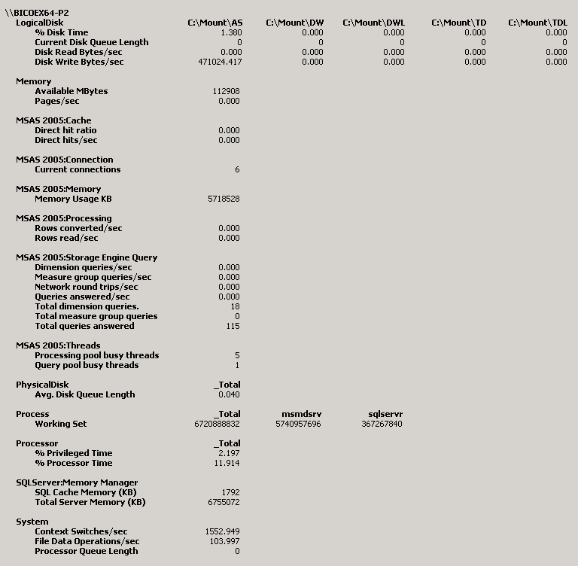
Figure 28 Standard deviation for user query load test by processor type
For more precise monitoring of CPU utilization during cube processing, the following counters can also be logged.

Table 15 Detailed CPU utilization monitoring
Key perfmon counters | Monitored value
% Processor time - msmdsrv | Min, Max, Avg, Std Dev
% Processor time - sqlservr | Min, Max, Avg, Std Dev

Appendix B—Software Stack
The tests described in this paper were conducted on the following versions of the software stack (Table 15).

Table 16 Software stack
Software stack | Service Pack and QFE | Build
Microsoft Windows 2003™ Datacenter | SP1 | 3790
Microsoft SQL Server® 2005 Database Engine | SP1, QFE 2153 | 9.0.2153
Microsoft SQL Server 2005 Analysis Services | SP1, QFE 2153 | 9.0.2153.00
ASCMD | n/a | 9.0.0.1

References
Links

Project REAL Web site | http://www.microsoft.com/sql/bi/ProjectReal
ASCMD | http://msdn2.microsoft.com/en-us/library/ms365187.aspx
Analysis Services 2005 Processing Architecture | http://msdn2.microsoft.com/en-us/library/ms345142.aspx
Intel Processor | Itanium2:  http://www.intel.com/products/processor/itanium2  Xeon EM64T:  http://www.intel.com/products/processor/xeon  Itanium versus x86 processors:  https://www.itaniumsolutionsalliance.org/news/whitepapers_brochures/Itanium_and_x86_white_paper.pdf
Unisys Server | ES7000:  http://www.unisys.com/products/enterprise__servers/high_d_end__servers/index.htm
EMC Storage Subsystem | CX700:  http://www.emc.com/products/systems/clariion_cx700.jsp
Books

Ralph Kimball, Margy Ross. “The Data Warehouse Toolkit , 2nd Edition: The Complete Guide to Dimensional Modeling”

Teo Lachev. “Applied Microsoft Analysis Services 2005 and Microsoft Business Intelligence Platform”

Details for ASCMD are available on http://msdn2.microsoft.com/en-us/library/ms365187.aspx

