Project REAL: Business Intelligence ETL Design Practices
SQL Server Technical Article

Author: Erik Veerman, Solid Quality Learning
Technical Reviewers: Grant Dickinson
Partners: Intellinet, Solid Quality Learning
Published: May 2005
Updated: November 2006
Applies To: SQL Server 2005

Summary: Read about SQL Server 2005 Integration Services in action. Used in the business intelligence reference implementation called Project REAL, Integration Services demonstrates a high-volume and real-world based extraction, transformation, and loading (ETL) process. This ETL solution supports a multi-terabyte data warehouse, and contains representative data processing, configuration, and administration mechanisms of a large warehouse initiative.

Copyright
This is a preliminary document and may be changed substantially prior to final commercial release of the software described herein.

The information contained in this document represents the current view of Microsoft Corporation on the issues discussed as of the date of publication. Because Microsoft must respond to changing market conditions, it should not be interpreted to be a commitment on the part of Microsoft, and Microsoft cannot guarantee the accuracy of any information presented after the date of publication.

This White Paper is for informational purposes only. MICROSOFT MAKES NO WARRANTIES, EXPRESS, IMPLIED OR STATUTORY, AS TO THE INFORMATION IN THIS DOCUMENT.

Complying with all applicable copyright laws is the responsibility of the user. Without limiting the rights under copyright, no part of this document may be reproduced, stored in or introduced into a retrieval system, or transmitted in any form or by any means (electronic, mechanical, photocopying, recording, or otherwise), or for any purpose, without the express written permission of Microsoft Corporation.

Microsoft may have patents, patent applications, trademarks, copyrights, or other intellectual property rights covering subject matter in this document. Except as expressly provided in any written license agreement from Microsoft, the furnishing of this document does not give you any license to these patents, trademarks, copyrights, or other intellectual property.

Unless otherwise noted, the example companies, organizations, products, domain names, e-mail addresses, logos, people, places, and events depicted herein are fictitious, and no association with any real company, organization, product, domain name, e-mail address, logo, person, place, or event is intended or should be inferred.

© 2005 Microsoft Corporation. All rights reserved.

Microsoft, Visual Basic, and Visual Studio are either registered trademarks or trademarks of Microsoft Corporation in the United States and/or other countries.

The names of actual companies and products mentioned herein may be the trademarks of their respective owners.

Table of Contents

Introduction 1
Project REAL ETL objectives 2
Summary 2
Data profile 3
Fact tables 3
Dimension tables 4
Database structures 4
Data partitioning approaches 7
Multi-table fact tables 8
ETL and table partition strategy 9
Integration Services development environment 10
Naming and layout practices 11
Project REAL ETL Solution Highlights 12
ETL auditing and logging 12
Execution tracking and Integration Services logging 13
Package execution start and completion 15
Package OnError event handlers 17
Lineage additions to the warehouse 18
Tracking ETL commands 20
Pipeline performance statistics capture 21
ETL audit reporting 24
Dynamic package configuration design 24
SQL configurations 24
XML file configurations 25
Parent variable configurations 26
Data processing architecture 27
Control flow and data flow 27
Integration Services architectural advantages 28
Dimension table ETL processing 29
Fact table ETL processing 36
Dimension lookups 37
Multi-table and partitioned table fact data loading 39
Multi-table Store Sales fact table processing 40
Partitioned table Store Sales fact table processing 42
Analysis Services processing 45
Analysis Services dimension processing 46
Analysis Services partition processing 48
Advanced data processing concepts 49
Handling inferred member additions 49
Data processing optimization techniques 53
Performance Testing and Analysis 57
Partitioned table versus multi-table performance 58
Partitioned table lessons learned 59
Database snapshot overhead 60
Database snapshot lessons learned 61
Distributed SQL Server architecture versus consolidated architecture 62
Distributed versus consolidated server lessons learned 63
Conclusion 63

Introduction
Successful business intelligence (BI) applications need solid tools to run on. The process of creating these applications is also facilitated when developers and administrators possess an associated base of knowledge about how to carry out a successful implementation—in short, best practices information. Through Project REAL, Microsoft and several of its partners are discovering best practices for BI applications that are based on Microsoft® SQL Server™ 2005. In Project REAL we are doing this by creating reference implementations based on actual customer scenarios. This means that customer data is brought in-house and is used to work through the same issues that these customers face during deployment. These issues include:
- Design of schemas—both relational schemas and those used in Analysis Services.
- Implementation of data extraction, transformation, and loading (ETL) processes.
- Design and deployment of client front-end systems, both for reporting and for interactive analysis.
- Sizing of systems for production.
- Performance tuning and optimization.
- Management and maintenance of the systems on an ongoing basis, including incremental updates to the data.
By working with real deployment scenarios, we gain a complete understanding of how to work with the tools. Our goal is to address the full gamut of concerns that a large company would face during their own real-world deployment.
This paper focuses on the SQL Server Integration Services (SSIS) extraction, transformation, and loading (ETL) design for Project REAL. This design is based on Barnes & Noble’s ETL architecture—built from the ground up to use Integration Services and the first production ETL implementation of Integration Services. Since the solution is not an upgraded design based on Data Transformation Services (DTS) or another ETL tool, many of the approaches taken are unlike the typical ETL architecture seen in DTS. The goal for this solution was to think outside the box and design an ETL process that could model a best practice for general ETL design, leveraging the new application architecture of Integration Services. Throughout this white paper, we explain the design decisions that were made for each scenario and implementation detail of the Project REAL Integration Services effort.
For an overview of Project REAL, see “Project REAL: Technical Overview” at http://www.microsoft.com/technet/prodtechnol/sql/2005/projreal.mspx. A number of Project REAL papers, tools and samples will be produced over the lifetime of the project. To find the latest information, see the Project REAL—Business Intelligence in Practice Web site at http://www.microsoft.com/sql/bi/ProjectREAL.
Project REAL is a cooperative endeavor between Microsoft and a number of its partners in the BI area. These partners include: Apollo Data Technologies, EMC, Intellinet, Panorama, Proclarity (recently acquired by Microsoft), Scalability Experts, and Unisys. The business scenario for Project REAL, and the source data set, was graciously provided by Barnes & Noble.

Project REAL ETL objectives
In any business intelligence (BI) system, ETL processing exists to support the reporting and analytical requirements. ETL needs to be implemented with this supporting role in mind. This is not to diminish the important role that it plays, since the data to be reported is directly handled through ETL processing. Some aspects of ETL include timing, performance, and the accuracy of the processing; also important are the support, management, scalability, and extensibility of the ETL design. Real-world systems always have unknowns and anomalies that affect the ETL. These require that the ETL processing be able to handle changes easily and support the end goal of a stable system.
For Project REAL, these key areas led to several primary objectives for the ETL design as follows:
- ETL administration. In order to provide administrative support, a design was implemented that allows the tracking and reporting of ETL metadata. This element enables a clear picture of the state of the processing for informational and troubleshooting purposes, helping isolate issues and resolve them.
- Dynamic configuration. This goal was developed to support an enterprise system in the publication and distribution of the core components. It also involved design adaptability for business and technical requirement changes and an environment suitable for a large support and development team.
- Platform integration. This involved designing a solution that would interact with the multiple tiers of a BI solution. These include security, the infrastructure, relational and OLAP structures, and the reporting and analysis tools that harvest the data.
- Performance. Attention to performance issues was critical for the Project REAL solution given the volume of data processed and managed in the warehouse. In total, the data amounted to multiple terabytes.
- Demonstrability. Typical ETL systems are designed and optimized for production environments only. In the case of this project, an additional design criteria was that features of the system should be discoverable and simple to demonstrate. This means that, for instance, Script components were favored over custom compiled components. While the latter approach is a more real-world implementation, it does not meet this criteria.

Summary
This paper highlights several specific design principles, some of the lessons learned through the design process, and an overall picture of the architecture of the solution. It provides a big-picture reference and includes some design highlights of the solution. As new solutions mature and are developed on the SQL Server 2005 platform, more detailed and comprehensive material will be published. Future papers will expand upon concepts, fine-tune performance design, and probably demonstrate examples of better designs. This paper provides a solid reference for BI ETL based on Integration Services. It can be a tool used by BI architects during the planning and development of ETL redesigns, upgrades, and new implementations.
Integration Services functionality goes beyond just handling ETL—it provides many more capabilities for systems integration, information management, and data transformation. This paper touches upon only a few aspects of the product, covering core parts of Integration Services as they relate to ETL processing.
The examples in this paper relate directly to the Project REAL implementation. Each example was selected because it highlights particular aspects of Integration Services as it applies to ETL processing. These examples demonstrate some of the goals previously described and common ETL scenarios including:
- Integration Services development environment
- ETL auditing and logging
- Dynamic configuration design for property and data source administration
- Dimension processing for standard and unique scenarios
- Fact table processing of dimension associations and fact table updates
- Data processing architecture design
- Data processing optimization techniques
All of these are implemented in the Project REAL Integration Services solution, which has been successfully run with 90 days of daily and weekly production volume data. The data processed includes a portion of the holiday retail rush and spans two years to demonstrate the stability and reliability of this as a real-world example. As has been mentioned, the “real” Integration Services solution that the Project REAL ETL design is based on, has been in production since November 2004 at Barnes & Noble. These examples and packages are available for detailed review of the implementation specifics with a smaller set of sample data for testing and execution. To download the implementation, visit the Project REAL Web site at http://www.microsoft.com/sql/solutions/bi/projectreal.mspx. This information will be published on the Project REAL Web site at a future date. In addition, the packages will be presented at industry conferences to demonstrate the Project REAL Integration Services design.

Data profile
The ETL for Project REAL typifies the extraction requirements for many business scenarios, even though this reference project focuses on a retail system. As is common for ETL processing, there are a set of daily processing requirements, where changes and additions to source data are extracted and processed through to the system in nightly batches. Furthermore, a set of weekly processes are run to manage the weekly inventory snapshot grain for the dimensional model. The data profile includes daily extractions of transactions, dimension updates, and weekly management of the inventory fact tables.

Fact tables
The relational model is a standard star schema design with two primary types of fact tables; sales and inventory. Sales transactions are collected daily and represent detailed product purchases across the retail stores, including orders made on the Web. Multiple millions of transactions are handled that must be added to the sales fact structure, with a majority of the sales records coming from the previous day’s sales. In addition, there are a small handful of sales that are new to the system but are late-arriving historical sales (meaning that the sales rows arrive in the source system several days later than the actual transactions took place). The primary metrics tracked revolve around the quantity and sale amount of each item-level transaction.
The inventory structure is designed as a standard snapshot fact table at the weekly grain, where inventory positions are updated on a daily basis but historically managed in weekly increments. Inventory is tracked at both the store and distribution center grains down to the item level, which produces tens of millions of rows weekly, and requires millions of changes on a daily basis. A primary reporting objective is to see inventory and sales trends and prevent out-of-stock scenarios. Therefore, besides the standard ‘on-hand’ quantities, a ‘days in stock’ fact is tracked, which identifies the number of days that an item was in stock for the weekly grain at the store or distribution center locations. When a week comes to a close, the inventory levels are duplicated and initialized for the start of a new week, an intensive process required of the ETL.

Dimension tables
The dimensions that support the fact tables have some unique aspects, which made the design interesting and highlight various aspects of Integration Services. The product dimension has several million members and contains standard changing and historical attributes, but it also requires that historically tracked attribute and hierarchy changes start only after a sale has occurred. How this impacts the ETL is discussed in this paper. In addition to the product dimension, several other typical retail dimensions are involved. Because of the way the source data is managed, all of the dimensions require that if a dimension member is missing during fact processing, a placeholder record with the relevant business key be added to the dimension until the full dimension source is available for a complete update. This is called an inferred member and it has processing impact on the ETL. A few of the dimensions are also sourced directly from the primary transaction or inventory source tables and require special handling for their additions to the fact tables.
Given the complex dimensionality, the overall Integration Services process demonstrates the flexibility and scalability of the tool, and provides a strong reference point for many ETL designs built on the SQL 2005 platform.

Database structures
A typical data warehouse contains many database-related structures that assist in handling the processing logic, structure management, and of course, the dimension and fact tables. For the Project REAL sample warehouse (called REAL_Warehouse_Sample) all of these objects have been consolidated into a single SQL Server database. This simplifies the management of and relationships between these objects. Any SQL Server database can contain several different types of database objects within a database itself. These common objects perform different functions valuable to a data warehouse system and the following ETL processes:
- Tables. Provide the primary storage for the dimension and fact tables, but also provide a metadata storage mechanism for information related to the execution, transformation logic, auditing, and OLAP processing within Project REAL.
- Views. Used within the Project REAL database for Analysis Services support, providing an abstraction layer between the physical tables and the Unified Dimensional Model (UDM) defined with the cubes, which allow some OLAP-related business logic to be handled in the relational engine.
- Stored procedures. Provide the mechanism needed to perform operations and the data within both the metadata table and the primary warehouse tables. The Project REAL procedures are used for primary ETL logic, to perform set based updates, and to assist in the tracking auditing information.
- User-defined functions. Assist in making common code modular for consolidation and functions and also provide a way in the Project REAL database to perform complex queries with recursion for audit reporting.
To help group these objects—both to physically separate them and identify their use—a new SQL Server 2005 functionality, called database schemas, is employed. In prior versions of SQL Server, every object had an owner and the most common owner was DBO. With SQL Server 2005, schemas can be used to replace owners (or database users) so that multiple owners can be given rights to a schema. The four-part naming convention is [server].[database].[schema].[object]. Several schemas were created in the Project REAL warehouse database to separate the objects. The following table highlights the different schemas, their organizational purpose, the types of objects that the schema owns, and some example objects within that schema

Schema (description) | Object Types (use) | Object Examples (purpose)
admin  (Schema defined for objects related to the administration of Project REAL data and configuration) | Tables  (Configuration metadata)  Stored procedures  (Metadata updates) | admin.Configuration  (Table used for Integration Services configuration implementation)  admin.up_SetLogicalDate  (Stored procedure used to update the source data snapshot to pull)
audit  (Schema defined for the tracking and reporting of ETL audit information) | Tables  (Persist audit and lineage information about the ETL execution  Stored procedures  (Add and update the audit information)  User-defined functions  (Reporting audit data) | audit.CommandLog  (Table that tracks the execution commands used by the ETL process)  audit.up_Event_Package_OnError  (Procedure called when a package error occurs to capture error information)  audit.uf_Progress  (Table-valued function returning recordset of execution status and progress)
dbo  (Default schema used by SQL Server when objects are created by a database owner and a schema is not identified) | Tables  (Core fact and dimension tables) | dbo.tbl_Dim_Item  (Table containing all attributes related to the product dimension)  dbo.tbl_Fact_DC_Inventory  (Fact table containing the inventory snapshot of the District Center inventory levels captured weekly)
etl  (Schema used by the ETL process to assist in data transformations and staging) | Tables  (Staging tables used for various ETL purposes)  Stored procedures  (Data updates and inserts affecting primary dimension and fact tables) | etl.DimItem_KeyLog  (Staging table containing used to optimize SCD processing)  etl.up_FactStoreInventory_Update  (Procedure that performs a set based SQL update against the Store Inventory fact table)
mt  (Schema that contains ETL logic used for the multi-table fact data partitioning approach) | Stored procedures  (ETL and maintenance tasks required for the multi-table table approach)  User-defined functions  (Maintenance table checks) | mt.up_FactStoreSales_Create  (Procedure that executes DDL to create the Sales Fact tables)  mt.up_FactDCInventory_Index  (Procedure that adds/removes the defined indexing strategy to the DC Inventory tables)  mt.uf_GetPartitionsExisting  (Table-valued function that returns the existing partition tables for a specific fact schema)
olap  (Schema that identifies objects used to support Analysis Services ETL and definitions) | Tables  (Provide metadata of the OLAP structures for ETL processing requirements)  Views  (Return partition metadata for ETL and used for Analysis Services Data Source View (DSV) object support) | olap.part_MeasureGroupList  (Table containing the Measure Groups used in Analysis Services for ETL processing)  olap.PT_Get_Partition_List  (View that returns the Analysis Services to partition table mapping with metadata for ETL processing)  olap.vTbl_Fact_Store_Sales  (View used by the Analysis Services DSV to define the structure and relationships for the Sales Fact table)
part  (Schema used for functions and procedures that assist in the administration of partitions) | Stored procedures  (Identify affected partitions in ETL and provide logic for changing the partition approach)  User-defined functions  (Provide system metadata needed for partition management) | part. up_GetPartitionsToProcess  (Procedure returning recordset of affected partitions by ETL for processing)  part.uf_GetFilegroupForBoundary  (Function returning the File Group for a specific partition boundary)  part.uf_GetSchemeForPartitionedTable  (Function that returns the partition scheme for a specific table)
pt  (Schema that contains ETL logic used for the partitioned table fact data partitioning approach) | Stored procedures  (ETL and maintenance tasks required for the partitioned table approach)  User-defined functions  (Maintenance table checks) | pt.up_FactDCInventory_Switch  (Procedure that switches a partition out of the DC Inventory partition table into a loading table for ETL optimization)  pt.uf_GetPartitionsExisting  (Table-valued function that returns the existing partitions for a specific fact schema)
util  (Schema that contains objects used for generic and common database tasks) | Stored procedures  (Execution code for common ETL database tasks)  User-defined functions  (Common scalar conversion code used for data cleansing and administration) | util.up_ExecuteSQL  (Utility procedure that executes Transact-SQL statements and captures the statement to the audit table)  util.uf_GetEndOfWeekDate  (Function that returns the end-of-the-week date for an identified day)

Data partitioning approaches
SQL Server 2005 Enterprise Edition includes the ability to separate data within a single table by creating multiple underlying physical partitions. The advantage of using partitioned tables is scalability in volume and management of tables containing multiple millions to billions of rows. Therefore Project REAL, as a reference implementation, aimed to highlight uses of partitioned tables in the database and the management of partition tables in the ETL. However, because only Enterprise Edition and Developer Edition support partitioned tables, the solution also must demonstrate a nonpartitioned table approach to the warehouse database with ETL packages that load the alternate design.
In comparison, dimension tables in data warehouses are only a fraction of the size of fact tables. Therefore, managing data volumes through multiple tables or partitioned tables is almost exclusively handled for fact tables. An exception to this might be dimensions that are used for clickstream URLs, which could number in the hundreds of millions of members, rather than a few million members on the normal upper range of dimension sizes.

Multi-table fact tables
To model solutions that do not involve SQL Server 2005 Enterprise Edition or that do not use partitioned tables, a multi-table approach was taken for the handling of data volumes in the fact tables. Every identified fact table schema has several tables that are used in conjunction; these, in total, contain all the fact-related data. The DDL schema for these tables is identical—the only difference is the range of values (across time) used in each table. Figure 1 shows SQL Server Management Studio, drilled down to table structures in Project REAL configured for the multi-table approach.
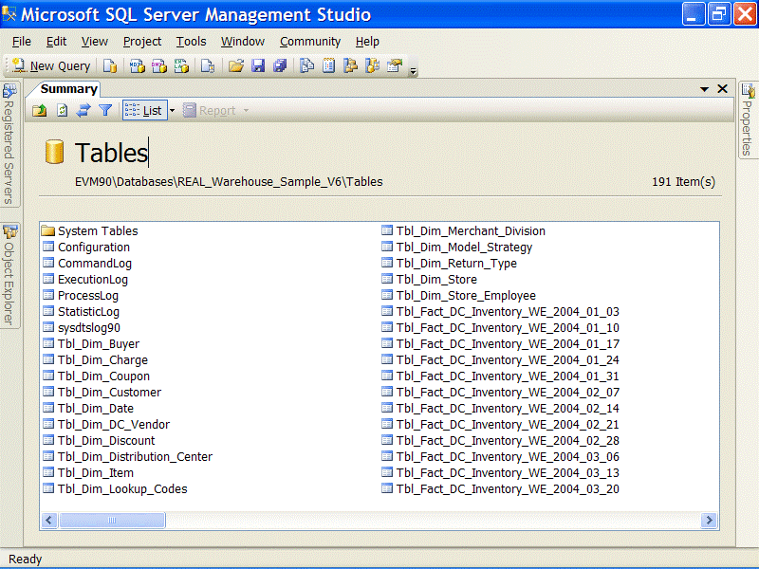
Figure 1
Note that each fact table entity has multiple physical tables with suffixes appended that indicate the data that they contain. The suffix is in the form “_YYYYMMDD” and represents the ending day of data for that table, grouped on a weekly basis. You may wonder how to determine the threshold on the data range for these tables or for the partitioned tables. The factors in determining this are the width of each row and how much data will be contained in the fact entity each day, week, or month. Since the full Project REAL data set for the inventory fact table was at about 180 MB per week, we separated the data on a weekly basis. The sales fact data ranges only in the 30-50 MB records per week range, but these tables were designed with the same date ranges for consistency.
Partitioned table fact tables (partitioned table approach)
There is only one Project REAL warehouse database for both the multi-table and partitioned table schemas. The installation guide describes the mechanism for switching back and forth between the multi-table tables and the partitioned table tables. This mechanism consists of executing the stored procedures part.up_SwitchToPT or part.up_SwitchToMT. These procedures consolidate the physical tables into a single partitioned table or take the partitions from the partition-table design into a multi-table design. This approach allowed the team to maintain a single database instead of trying to keep two separate (multi-table and partitioned table) databases in sync. This technique is not intended to represent a useful real-world technique; it is simply a valuable deployment mechanism for demonstration purposes.
SQL Server 2005 partitioned tables provide great value for enterprise data warehouses with large volumes. The relational schema is simplified; this means that when looking at the database tables through Management Studio, there is only one instance of every fact table entity, which contains all the data for that table. Even more important, partitioned tables provide simpler querying and management of data. A query can be executed against a partitioned-table fact table and the query engine can target the correct underlying partitioned based on the filter conditions for the query. This makes query writing and performance better with partitioned tables. Figure 2 shows SQL Server Management Studio displaying the tables of Project REAL configured using the partitioned table approach.
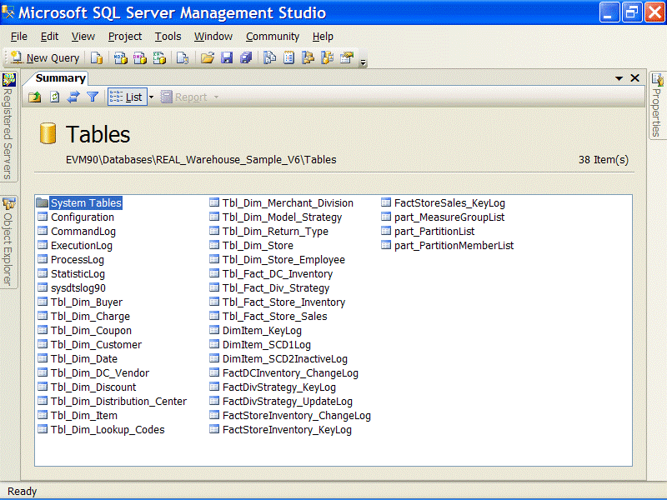
Figure 2

ETL and table partition strategy
You can find the full details of the partitioned table design and data management in the “Project REAL: Data Lifecycle - Partioning” white paper (http://www.microsoft.com/technet/prodtechnol/sql/2005/realpart.mspx). In this white paper, we consider how to handle the different partitioning approaches as they relate to the ETL design and Integration Services. As you would imagine, ETL requirements are slightly different between the multi-table and the partitioned table database design approaches. These differences are highlighted in the Fact table ETL processing section.

Integration Services development environment
Business Intelligence (BI) Development Studio is built on the Microsoft Visual Studio® 2005 (VS) platform. Although this is a wholesale change from the Enterprise Manager-based UI in SQL Server 2000, BI Development Studio features are implemented in a way that allows an easy transition for database administrators (DBAs), data architects, and developers alike. VS has a simplified UI profile that focuses on the needs of the BI developer, requiring less development expertise than did previous versions.
For Project REAL, a single BI solution houses the Recurring ETL project. This project runs all the Integration Services packages on an incremental basis. Figure 3 shows Solution Explorer with the Integration Services packages. The package names indicate their function. Several types of packages exist; the first and simplest are the dimension packages. Each dimension that is sourced from its own source entity has its own package. The fact table packages are similar in design, except they are named in accordance to the table partitioning design that is in place (PT for partitioned table, MT for multi-table).
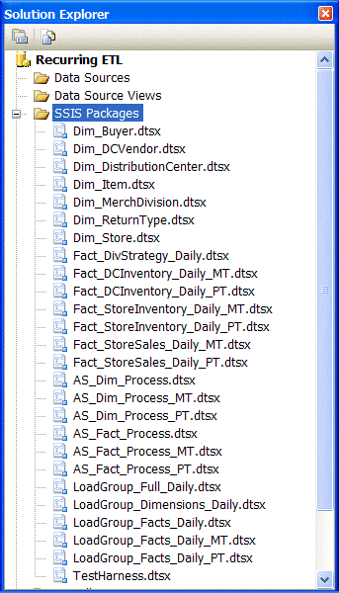
Figure 3
For processing coordination, a third set of packages, called load group packages, is displayed. These packages contain no processing business logic. They handle the orchestration of the dimension and fact package previously described as well as some application auditing. Figure 4 shows an example of a load group package. The Execute Package task is leveraged to execute child dimension and fact packages. The control flow handles the workflow and parallelization of some processing tasks. Other tasks are included that assist in the process auditing—these are described in more detail later in this paper.
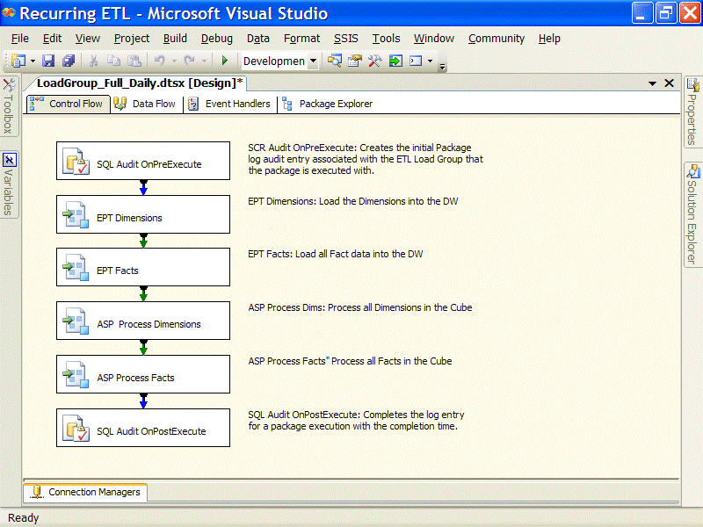
Figure 4

Naming and layout practices
The convention that is used for package layout, task naming, and annotations is worthy of note. For consistency, all tasks and transformations are generally named starting with a three- or four-letter abbreviation of the type of task or transformation followed by a three- or four-word description of the object function. This greatly helps in auditing and logging, since logging details are tracked by object name. Package layout generally flows first from top to bottom and then from left to right as tasks or transformations break out from the primary control flows and data flows. Annotations help to document packages by describing each task in more detail, as shown in Figure 5.
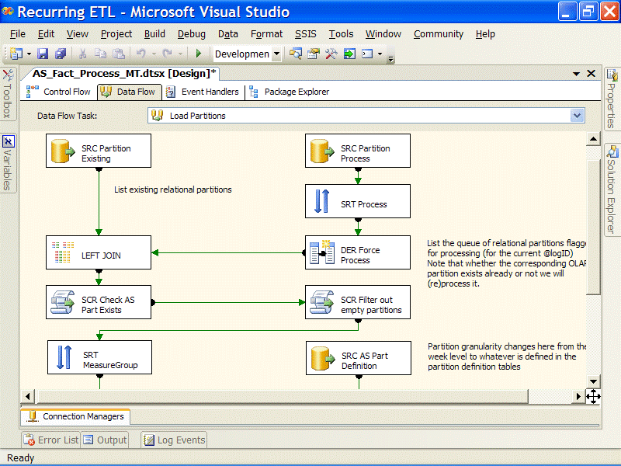
Figure 5

Project REAL ETL Solution Highlights
After considering the background and the organization of the ETL solution, the following examples highlight the package design and implementation. Although overall the solution demonstrates many aspects of data warehouse ETL, the highlight in this white paper includes:
- Auditing and logging
- Package configurations
- Dimension and fact ETL
- Analysis Services processing

ETL auditing and logging
Project REAL ETL auditing is comprised of several different layers, designed to track common ETL auditing tasks as well as metrics related to ETL performance. Furthermore, a series of stored procedures and user-defined functions help to report the auditing information, modeled for administrators and developers. The Integration Services packages and ETL logic contained in them capture the following five levels of auditing and logging, which map directly to five auditing tables in the warehouse database:
- Execution tracking. High-level ETL execution details are captured with the execution tracking mechanism, persisting statistics about when a set of packages was executed, on which machine, which packages were executed in coordination, and high-level error details. This data is tracked into the audit.ExecutionLog table in the warehouse database.
- Command auditing. Throughout an ETL process, various SQL and MDX data commands are used to perform data transformation, database operations, and Analysis Services (AS) object management. These commands are captured along with their execution times into the audit.CommandLog table in the warehouse database.
- Performance statistics. An integral part of the ETL involves leveraging the Integration Services pipeline engine, which processes the data from sources, performing transformation and bulk inserts into the warehouse. Performance statistics are tracked about data flow volumes and processing times in the audit.StatisticLog table in the warehouse database.
- Integration Services logging. Native functionality in SQL Server Integration Services is the capability to track various package and task events. Integration Services logging is used to track error details to the default logging table, dbo.sysdtslog90, which is tied to the other auditing structures for more detailed information and error messages.
- Partition process log. The audit.ProcessLog table in the warehouse database is updated when fact tables are affected during processing. This captures which tables and/or partitions are affected and is used for Analysis Services partition processing. The details of this structure are described in Analysis Services Processing, later in this paper.

Execution tracking and Integration Services logging
Execution tracking in the Project REAL ETL is integrated into the package structure design through parent workflow packages and subsequent child packages with custom auditing steps that track high-level execution information. This includes package starting, ending, and failures. Furthermore, these execution details are tied together with the built in logging functionality of Integration Services.
Integration Services natively provides detailed package execution logging to a variety of log provider types. These detail log entries are event-driven and denormalized into the selected provider’s destination. For Project REAL logging, SQL Server is the log provider; therefore, log entries are inserted into a single table, dbo.sysdtslog90. To limit the transactional activity into the logging table, only the OnError event has been selected. However, other events also prove valuable to capture with the built-in logging: OnWarning, OnValidation, OnExecute, OnPreExecute, OnPostExecute, etc. Figure 6 highlights the logging event details selector within Integration Services.
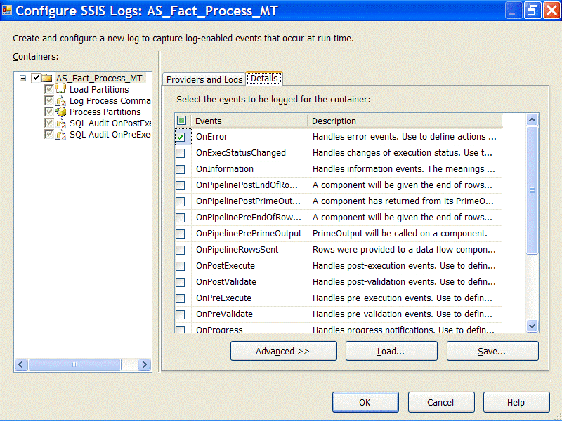
Figure 6
Note that each record in a logging event is associated with the Execution ID of the associated package that the task or transformation ran under. This Execution ID is a GUID that is uniquely generated every time a package is run. When Integration Services logging is turned on at the lowest grain, it can produce hundreds if not thousands of entries for each package execution. Integration Services logging provides great detail for troubleshooting purposes. However, by itself this information is difficult to harvest and follow without intimate knowledge of Integration Services events and a clean way to map the package Execution ID to a specific package executed by the engine.
This is why for Project REAL, the goal was to enhance the built-in logging provider with some specific BI-related execution auditing, but also to leverage the logging features for detailed drill-down error reporting. The execution auditing added to the packages is tracked in a table called audit.ExecutionLog, which contains logging IDs and a reference to the built-in Integration Services logging table. Figure 7 shows the table relationships.
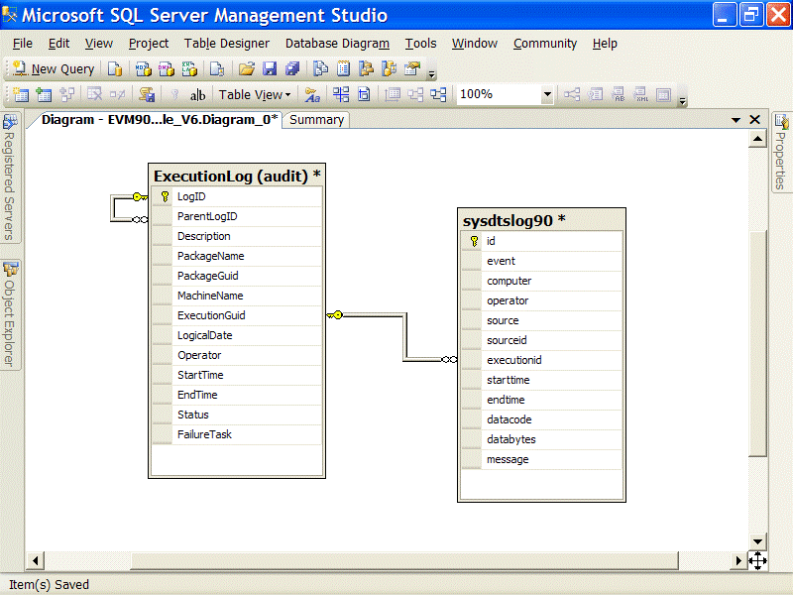
Figure 7
The audit.ExecutionLog table is a self-referencing table that nests the execution of parent and child packages that are executed in tandem. As Figure 7 shows, this table tracks the Execution ID which relates directly to the Execution ID in the Integration Services table and provides that critical link between custom execution tracking and built-in logging. Next, we look at how these execution attributes are captured during a package execution.

Package execution start and completion
Project REAL ETL execution auditing is mainly implemented by using the Execute SQL task. In all packages (load group packages, dimension packages, and fact packages), the first and last steps in the control flow track the execution start and completion. The example package in Figure 8 illustrates this pattern.
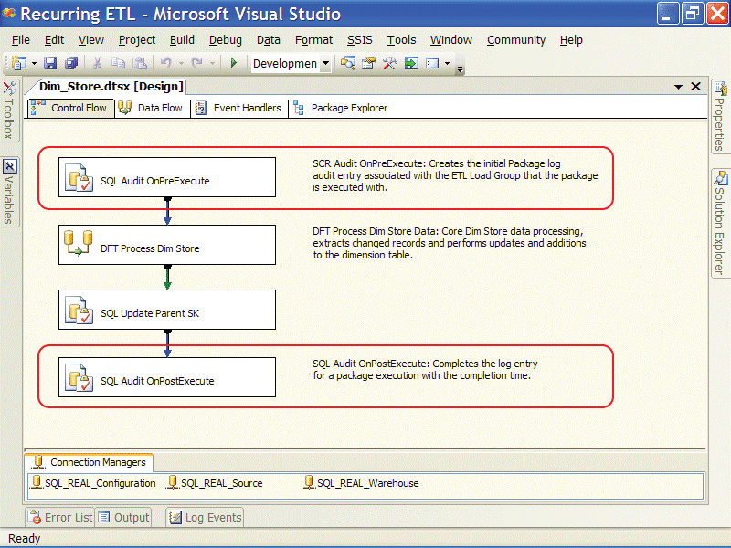
Figure 8
The Execute SQL task that is used for the package start tracks not only the time that the package begins, but also several auditing details about the package execution. The package audit start runs the audit.up_Event_Package_OnBegin stored procedure as a parameterized query in the following code:

exec audit.up_Event_Package_OnBegin
?, null, ?, ?, ?, ?, ?, ?, ? output

Each“?” in the Transact-SQL statement is a parameter in a parameterized query and is mapped to Integration Services variables. Figure 9 highlights the Execute SQL task parameter mapping functionality and the variables that are mapped in the order of the “?” in the Transact-SQL statement.
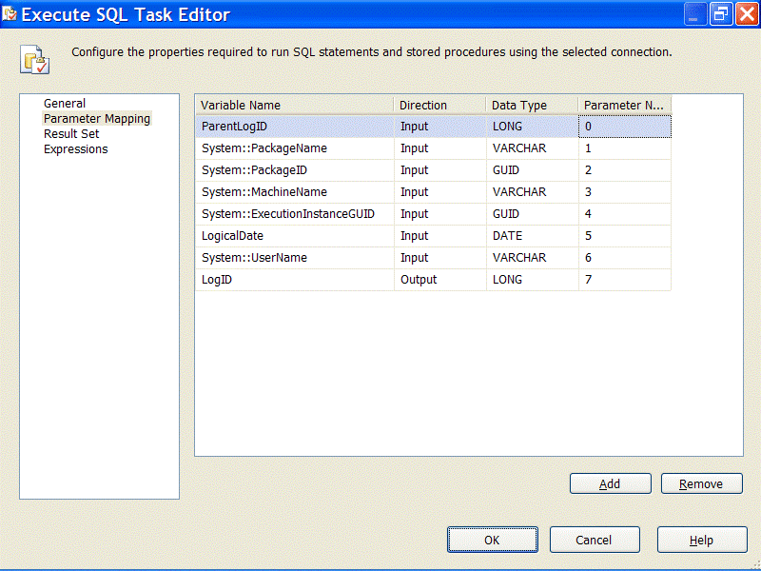
Figure 9
Note that many of the variables used in the mapping are system variables that the package contains by default, some of which are updated at run time. The System:ExecutionID parameter is the execution GUID value that maps to the built-in logging table.
In order to associate a parent package with a child package, two Execution IDs are used: a ParentLogID and a LogID. The ParentLogID is inherited from the parent package (if there is one) through a parent package variable configuration (the configuration design is discussed in the next section). When a package is run, this ParentLogID is passed into the stored procedure shown above, which creates a LogID for the package. This is returned as an output parameter, as shown in Figure 10. The ParentLogID and LogID stored in the audit.ExecutionLog table provide the self-referencing relationship useful for reporting.

Package OnError event handlers
Another function of execution auditing is to identify packages that contain errors. One nice feature of Integration Services is Event Handler control flows. These are available on the third tab of the package UI. The OnError event handler is defined at the package level to identify in the audit.ExecutionLog table which packages executed with errors.
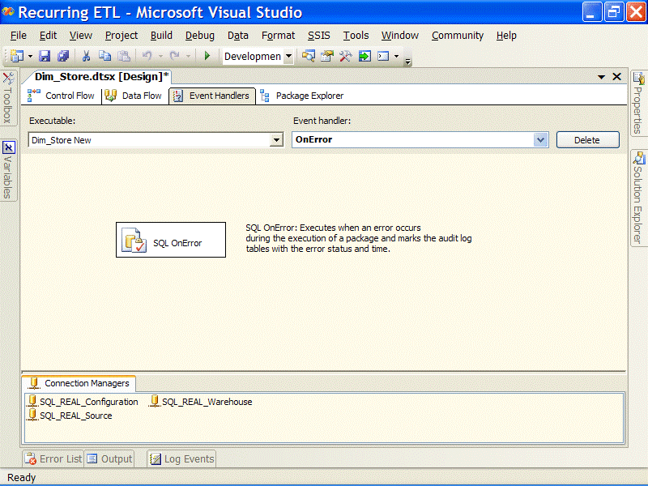
Figure 10
As has already been mentioned, error details are tracked through the built-in logging table, so this Execute SQL task when fired by an OnError event, simply calls the audit.up_Event_Package_OnError procedure, identifying that an error occurred. The procedure takes the error details from the built-in dbo.sysdtslog90 table and updates the status and error columns of the audit.ExecutionLog table.

Lineage additions to the warehouse
In execution tracking for Project REAL ETL, the auditing is associated to the data that is loaded into the dimension and fact tables in the warehouse. The LogID generated for each package ties not only the auditing metadata together for reporting and isolating, but is also used in the warehouse to identify the record source. Every dimension and fact record originated from a specific data load, and the LogID value is added to each table mapped to the ETL_Load_ID column. This is useful for data lineage and validation purposes, as well as for manual corrections that might be needed in case of data corruption.
The LogID batch identifier is added to the data flow immediately after the source data is extracted, by using the Derived Column transformation. Therefore, any downstream transformations can utilize this column for updates, inserts, and tracking, with little overhead required to include this metadata with the records. Figure 11 highlights the Derived Column transformation and how the LogID is added to the pipeline.
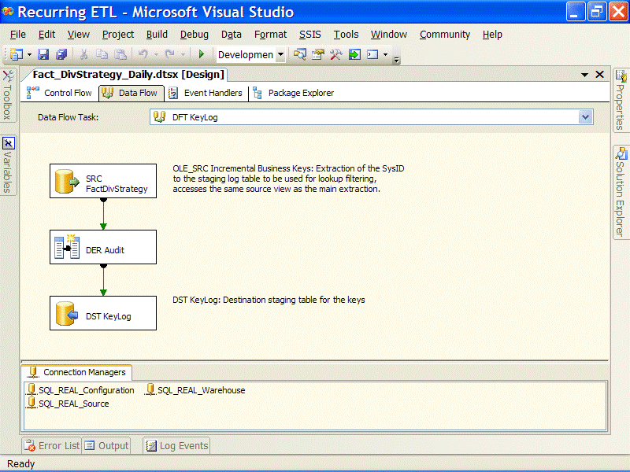
Figure 11

The Derived Column transformation, DER Audit, simply adds the LogID variable to the pipeline columns so that it is available for use in the dimension and fact tables (Figure 12).
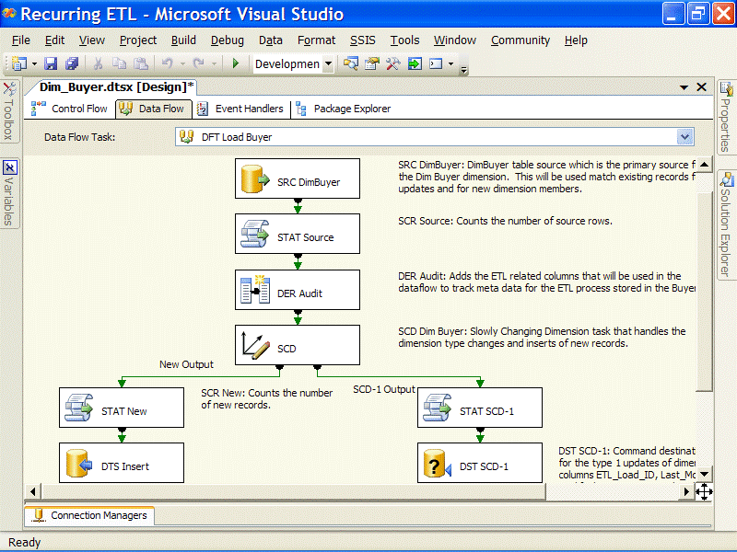
Figure 12

Tracking ETL commands
Most moderate to complex ETL solutions execute several dozen SQL statements and other commands during processing. For Project REAL, this involves several types of statements that update data, manage partitions, insert records, etc. Each of these commands is tracked into the audit.CommandLog auditing table.

Column | Description | Example Data
LogID | LogID of the executing package | 1
CommandID | IDENTITY value of the record | 1
Key | Description of the command | “Create Index” or  “Switch Partition In” etc…
Type | Category of command | “SQL” or  “XMLA” etc…
Value | The command statement | “CREATE VIEW vFactStoreSales AS  SELECT …  FROM …  …”
LogTime | Datetime when the command was run | “6/14/2006 12:23 PM”

Most of the log entries reflect SQL commands that were executed by the util.up_ExecuteSQL stored procedure. Every Transact-SQL statement to be executed is delegated to this procedure, which first captures the statement into the audit.CommandLog table (via the audit.up_Event_Package_OnCommand procedure) and then executes dynamically. The following code is the util.up_ExecuteSQL procedure code.

CREATE PROCEDURE [util].[up_ExecuteSQL]
@key varchar(50)
,@sql varchar(max)
,@logID int
,@debug bit = 0 --Debug mode?
with execute as caller
as
-- exec util.up_ExecuteSQL 'Test', 'select', 0, 1
begin
set nocount on

if @debug = 1 begin
print '--' + @key
print (@sql)
end else begin
--Write the statement to the log first so we can monitor it (with nolock)
exec audit.up_Event_Package_OnCommand
@Key = @key
,@Type = 'SQL'
,@Value = @sql
,@logID = @logID
--Execute the statement
exec (@sql)
end --if

set nocount off
end –proc

Pipeline performance statistics capture
The Data Processing Architecture section explains the value of leveraging the Integration Services data flow engine (the pipeline) to achieve scalability and manageability of ETL data processing. This approach generates a compelling need to capture statistics about data flow performance. This brings us to another level of auditing: pipeline performance statistics.
Pipeline performance statistics track the volume and speed of data as it flows through the data flow. Identifying bottlenecks in the pipeline that cause backpressure on the sources can inhibit the ability of Integration Services to deliver optimal extractions from the source, which is a common ETL requirement. The statistics focus on four primary areas:
- Duration. The total duration it took for all the relevant data to pass through a point in the pipeline (not all data in a data flow pass through all the transformations as data can be split, combined, handled as errors, etc.).
- Row count. The number of rows that passed through the pipeline at the same point, which provides a measure of data count accuracy from source to destination.
- Performance. The minimum, maximum, and mean rows per second, giving a picture of how the data was processing and if data reached a saturation point of performance before slowing.
- Log time. The point in time when the last row completed through the point in the pipeline.
The statistics are captured into a table called audit.StatisticLog in the warehouse database. The Project REAL Integration Services solution captures these performance metrics by using a generically designed Script component that is placed in strategic areas of the data flow. Figure 13 shows an example of the Buyer Dimension package with three statistic-capture (Script component) transformations highlighted.
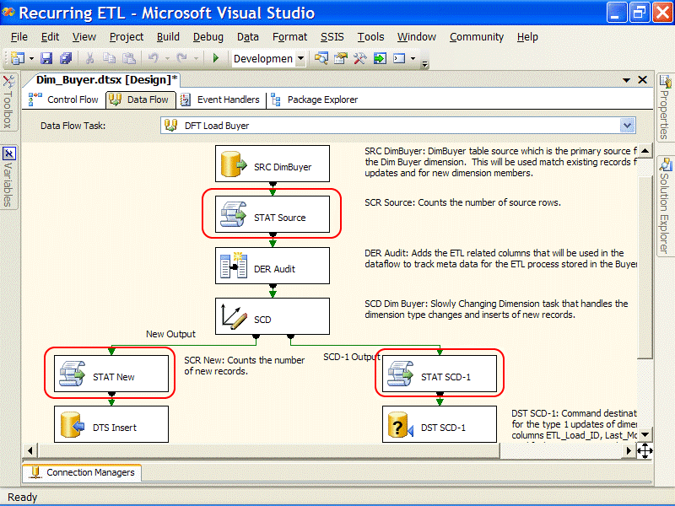
Figure 13
Each Script component that captures these statistics is named with a STAT prefix followed by a short word description of where the component resides in the data flow. Each STAT script has the same code, for reusability.

Imports System
Imports System.Data
Imports System.Data.OleDb
Imports System.Collections

Public Class ScriptMain
Inherits UserComponent

Private startTicks, totalTicks As Long
Private rowCount, totalRows As Integer
Private rps As New ArrayList() 'rps = rows per second

Public Overrides Sub Input0_ProcessInput(ByVal Buffer As Input0Buffer)
'Save the rate statistic for this buffer
If startTicks <> 0 Then
totalRows += rowCount
Dim ticks As Long = CLng(DateTime.Now.Ticks - startTicks)
If ticks > 0 Then
totalTicks += ticks
Dim rate As Integer = CInt(rowCount * (TimeSpan.TicksPerSecond / ticks))
rps.Add(rate)
End If
End If
'Reinitialize the counters
rowCount = 0
startTicks = DateTime.Now.Ticks
'Call the base method
MyBase.Input0_ProcessInput(Buffer)
End Sub

Public Overrides Sub Input0_ProcessInputRow(ByVal Row As Input0Buffer)
rowCount += 1 'No exposed Buffer.RowCount property so have to count manually
End Sub

Public Overrides Sub PostExecute()
MyBase.PostExecute()

'Define the Stored Procedure object
With New OleDbCommand("audit.up_Event_Package_OnCount")
.CommandType = CommandType.StoredProcedure
'Define the common parameters
.Parameters.Add("@logID", OleDbType.Integer).Value = Variables.LogID
.Parameters.Add("@componentName", OleDbType.VarChar, 50).Value = _
Me.ComponentMetaData.Name
.Parameters.Add("@rows", OleDbType.Integer).Value = totalRows
.Parameters.Add("@timeMS", OleDbType.Integer).Value = _
CInt(totalTicks \ TimeSpan.TicksPerMillisecond)

'Only write the extended stats if RowCount > 0
If rps.Count > 0 Then
'Calculations depend on sorted array
rps.Sort()
'Remove boundary-case statistics
If rps.Count >= 3 Then rps.RemoveAt(0)
'Calculate min & max
Dim min As Integer = CInt(rps.Item(0))
Dim max As Integer = CInt(rps.Item(rps.Count - 1))
'Define the statistical parameters
.Parameters.Add("@minRowsPerSec", OleDbType.Integer).Value = min
.Parameters.Add("@maxRowsPerSec", OleDbType.Integer).Value = max
End If
'Define and open the database connection
.Connection = New OleDbConnection(Connections.SQLRealWarehouse.ConnectionString)
.Connection.Open()
Try
.ExecuteNonQuery() 'Execute the procedure
Finally 'Always finalize expensive objects
.Connection.Close()
.Connection.Dispose()
End Try
End With
End Sub
End Class

The previous script uses three primary functions in the object model:
- ProcessInputBuffer, which runs once per pipeline buffer that passes through the component.
- ProcessInputRow, which runs for each row.
- PostExecute, which is called after the last row flows through the Script component.
Both the ProcessInputBuffer and ProcessInputRow functions capture the statistics, collecting the number of rows and execution time for each buffer. The PostExecute function calculates the metrics, observes the final time, then passes this information into a stored procedure by using an OLE DB Command transformation.
This code, given its reusability, is a prime example of code that should be compiled as a custom component. However, it was left as a Script component in Project REAL to alleviate the need to install the component as part of the installation script. This also makes the system easier to demonstrate.

ETL audit reporting
ETL auditing, as exemplified by these several layers, provides useful information, not just to administrators who manage the ETL process, but also to the developers who troubleshoot and optimize, and to end users who verify the sources and row counts.
Project REAL includes two table-valued functions that consolidate the results into usable information to be viewed: audit.uf_GetExecutionLogTree and audit.uf_Progress. Both leverage the SQL Server 2005 feature called the common table expression (CTE) to traverse the self-referencing relationship in the audit.ExecutionLog table. This allows the data to be reported through the hierarchy down to any level of package nesting.

Dynamic package configuration design
The key to the manageability, distribution, and deployment of Integration Services packages lies in the configuration. Integration Services contains several ways to configure package properties at execution time, which allow the update of connection information, variables, and any other tasks or transformation properties requiring a dynamic configuration at execution. Several built-in methods of configuration are available, covering a broad spectrum of environment requirements that differing solutions can take advantage of, including:
- Configuration files
- Environment variables
- SQL configuration tables
- Parent package variables
This functionality is really useful when migrating an ETL package from development to staging to production. In most cases, this can be accomplished by simply changing a few entries in the configuration system.

SQL configurations
The goal for Project REAL was to centralize configurations and allow the ETL design to be deployable to two unique environments: the scale-up model and the distributed model. There are several versions of the REAL solution (a full volume version, a sample version, and a demo version) for reference and demonstration purposes. Therefore, configurations were centralized to the different database versions of the solution by using the built-in SQL configurations, which allow configuration properties and mappings to be placed into a relational table and shared across packages. To open the centralized management tool, select Integration Services, then Configurations. Figure 14 shows the SQL configuration options.
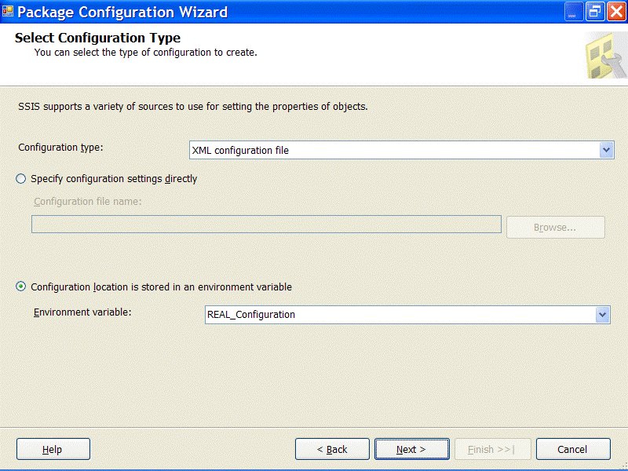
Figure 14
The configuration table has a number of entries for different properties. The first set of entries is for connections. It is important to point out how the configuration entries for connections apply and how Solution Data Sources work for a package. When a connection is created from a DataSource object, the connection is a run-time copy of the data source and is not updated from the parent data source when a package is executed. Because data sources are design-time constructs, when a package is opened in the UI, the connections are updated if they were built from a data source within the Integration Services solution. Connections are a great candidate for configurations—they typically need to be dynamic, based on the environment (development, test, or production). Other entries in the Project REAL configuration table are variable mappings, which allow the update of variable values used in the ETL for processing logic and management.

XML file configurations
In Figure 15, the location of the appropriate SQL configurations table is based on a package connection. However, if all the connection information is located in the configuration table, this presents a circular reference that results in the use of the hard-coded package connection value, which is not desired. To prevent this, a second configuration type is used—XML File Configurations. Again, with the goal of centralizing the configurations to a database table, only one configuration entry is needed in the XML file—the connection string that points to the database containing the SQL Configurations table. As you can see in Figure 15, there is really only one property for an XML file configuration—the location and file name of the XML file.
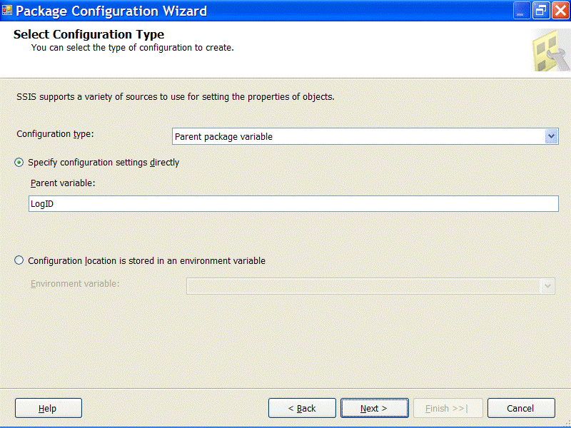
Figure 15
The file configuration provides the ability to use a server environment variable that defines the location of the configuration file. Since all packages reference this file, using an environment variable allows a single location for a file change. This is also valuable for deployment, where other servers executing these packages can use different file locations and file names. This use of environment variables is different from the Integration Services environment variable configuration, where a server can contain multiple environment variables that override any package property.

Parent variable configurations
All Project REAL configuration usage described so far has been for properties that are global in scope—that is, connections and variables that are used for every execution of a package or group of packages in a designated environment. Some configurations need to be limited to the specific execution of the package and workflow group in which the package participates. For example, the batch identifier of the workflow group, LogID, is created at the initial step of the load group package and used in all the child packages. Every execution of the packages runs under the context of a different batch and therefore, the configuration for this variable must be dynamic according to the executing package.
The parent package variable configuration feature of Integration Services allows a child package to inherit variables from a parent package. This is different than the Integration Services predecessor, DTS, where variables were pushed down from the parent package to the child package. In Integration Services, the child package requests the variable by name from the parent package, allowing the variable to be inherited from any calling parent package that uses the Execute Package task to call the child package.
The Project REAL requirement to have a configuration that is local to the execution instance of the package or set of packages is nicely met by the parent package variable configuration feature. The LogID is inherited by all the dimension and fact packages as well as the Execution ID of the parent package to further allow data correlation between the packages. Figure 16 shows the variable configuration for the LogID identifier.
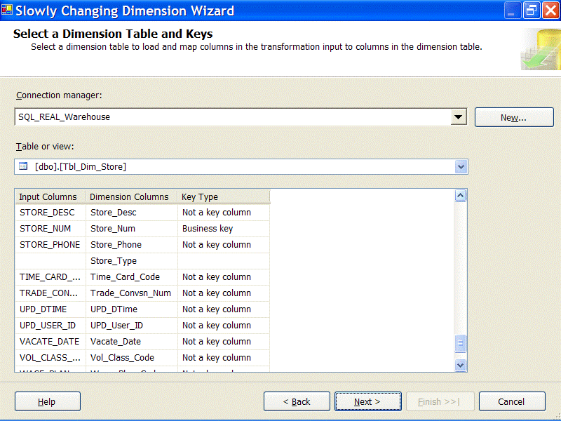
Figure 16

Data processing architecture
So far we have discussed the supporting structure of the Integration Services design without discussing the core ETL processing logic. This has helped set the stage for a more thoughtful consideration of the processing logic once the concepts addressed in prior sections are understood. However, before describing the specifics of the Project REAL data processing implementation, it is important to consider some of the new features of Integration Services in the context of important ETL principles.

Control flow and data flow
The primary features of Integration Services used to implement core business logic are contained in the control flow and data flow components. These components have already been mentioned a few times in this article in reference to the environment and auditing structures of Project REAL.
At a cursory level, the control flow is the task workflow engine that coordinates the business process flow logic for a package. Every package has exactly one primary control flow (event handlers are a type of control flow), whether the package contains a single step or dozens of interconnected tasks. Tasks within the control flow are linked by constraints—success, failure, completion, and custom constraint expressions and Boolean logic.
The data flow is the data processing engine that handles data movement, transformation logic, data organization, and the extraction and commitment of the data to and from sources and destinations. Unlike the control flow, there can be multiple data flows defined in packages that are orchestrated by the control flow. Although the data flow has green and red connectors that look very similar to the control flow workflow connectors, their function is completely different. The data flow connector is like a pipeline of data that flows from one transformation to another in small batches of data, called buffers. While this is the easiest way to visualize how a data flow works, in reality the defined transformations are actually doing most of the moving—over the data buffers for the best optimal performance.

Integration Services architectural advantages
Beyond the product advantages that Integration Services has over DTS in the areas of interoperability, configuration, restartability, and logging, it has a transformation engine that allows economies of scale and opens ETL architecture to more stable, flexible, and performance-based designs. For Project REAL, these advantages were considered in the core ETL development and therefore, certain design decisions departed from the status quo DTS-based architecture.
Limited staging
To begin, Integration Services allows the reduction of a staging environment by enabling complex data transformations, cleansing, and lookups to be performed directly in the data flow, with little dependence on the RDBMS engine and storage. Data comparisons between the source and warehouse tables can be handled through lookups and merge transformations with conditional splits to direct the results to the appropriate loading logic. With this consideration, the only requirement for the database engine is to output the data to the Integration Services data flow rather than to the database that is performing the lookups or joins or row comparisons.
Pipeline advantages
Most data flow components enable true pipelined parallelism (with some notable exceptions such as the Sort and Aggregate transformations), which means that the spectrum of processing for warehouse object(s) happens concurrently in small data buffers without the need to wait for the entire upstream process to finish before moving to the next. This helps relieve the extraction impact on the source system, and in most cases seen during Project REAL development, when an Integration Services package is optimized, the time it takes to extract raw data from the source and land it immediately to a database is roughly equivalent to the time it takes to extract the data and pass it on to a series of in-memory transformations designed in the data flow component.
Data cleansing and transformation
The out-of-the box Integration Services Data Flow transformations include a series of data cleansing tools such as fuzzy lookups and joins, character maps, data type conversions, derived columns, and a set of Boolean-based functions for data comparisons and replacement.
Many-to-many sources and destinations
Since a single data flow can contain multiple heterogeneous sources and destinations, data that originates from a single source can be split to multiple destinations. The same applies to the reverse scenario; multiple source objects can combine to a single destination. Often in a BI system, a dimension may be sourced from different tables within the same system or from different systems. Similarly, facts can originate from one or many tables or a transactional source may be broken out into multiple fact table destinations.
Dimension and fact grain and type changes
Warehouse objects are typically loaded at the same grain as their source OLTP object. However, there can be situations where a dimension is aggregated to a higher grain or a parent child self-joined source is denormalized to a standard hierarchy. Source records may require pivoting, for example, when source rows are consolidated from a fourth normal design down to a consolidated recordset of related attributes. Fact tables may also go through similar transformations when they are either aggregated or grouped to meet reporting requirements. These less common scenarios can often be handled within the data flow using other out-of-the-box transformations—Aggregate, Pivot, Un-pivot, Sort, Merge Join, etc.

Dimension table ETL processing
Handling the history of a dimension is one of the more complex aspects of an ETL solution. For Project REAL, the dimensional loading scenarios involve not only processing historical and changing attributes, but also dimension change types and out-of-synch fact-to-dimension associations. Besides considering the built-in functionality of the SCD (Slowly Changing Dimension) wizard, several more distinct requirements included in the project are covered:
- Inferred dimension members, where a fact is received without a matching dimension member because the full dimension record is not yet available to load. These are sometimes referred to as orphan facts.
- Changing SCD types, where the members within a single dimension have different historical change requirements that individually may undergo changes through time.
Integration Services provides the capabilities to deal with both the standard and unique cases of the Project REAL solution, as will be shown.
Slowly Changing Dimension wizard
Every ETL designer wants a tool that can easily handle slowly changing dimensions. Within Integration Services is a wizard that walks the developer through a series of steps based on the source and destination dimension schemas, to determine the changing characteristics. The wizard then builds the transformations needed to process that dimension. Even when the requirements change, reinvoking the wizard is stateful; original selections can be modified to handle the new process.
For Project REAL, the Slowly Changing Dimension (SCD) tool was very advantageous. All but one of the star schema dimension tables use the SCD transformation. It drastically reduced development time for dimension processing. To show how the SCD wizard works, the Store dimension provides the most comprehensive use of the wizard. The requirements of the Store dimension involve:
- New dimension members. The addition of a new dimension member that is added to the source.
- Changing dimension attributes. The traditional type-1 column changes where history is overwritten every time the source column value changes.
- Historical dimension attribute. The traditional type-2 column where history is preserved by the addition of a new dimension record that is associated with all new fact records until the next change.
- Inferred members. When a dimension member has not been loaded into the dimension table before the fact process runs, a placeholder record is added, which is then subsequently updated (both type-1 and type-2 columns) when the complete source dimension becomes available.
The first screen of the wizard, using the Store dimension as an example, shows a list of the columns with a selection that are available for their business key(s) as shown in Figure 17.
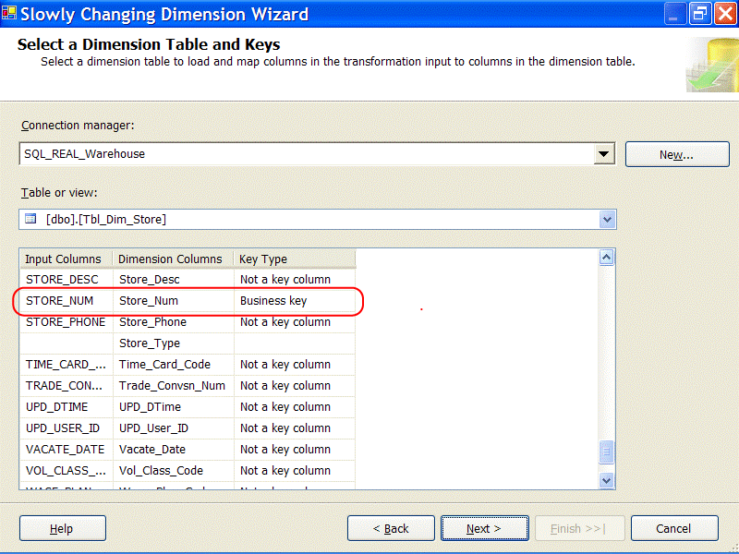
Figure 17
Next, the wizard requires a distinction of the columns that participate in the change types. The choices are Changing attribute, Historical attribute, and Fixed attribute. The Fixed attribute identifies columns that should not change. Figure 18 shows these attributes.
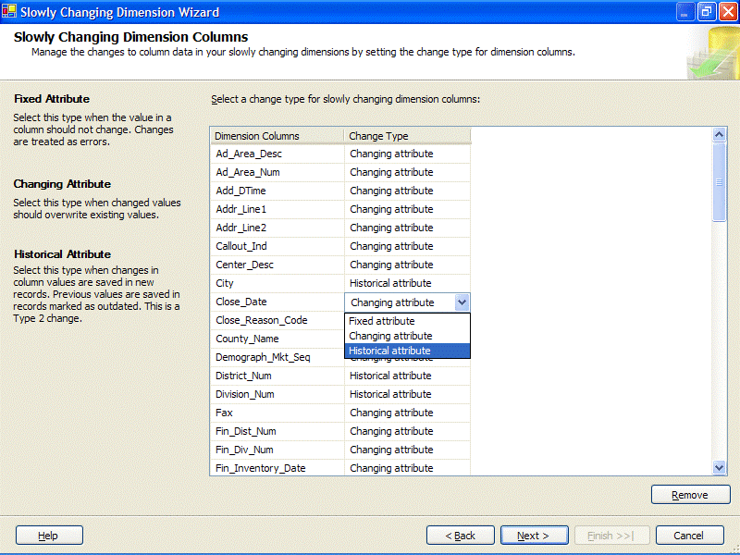
Figure 18
Dimensions that contain historical or type-2 columns require some metadata to manage the current and historical nature of each change. The next screen (Figure 19) defines how the Store dimension tracks history. In this situation, a Current_Row column tracks which dimension record is the current record for the dimension row that changes.
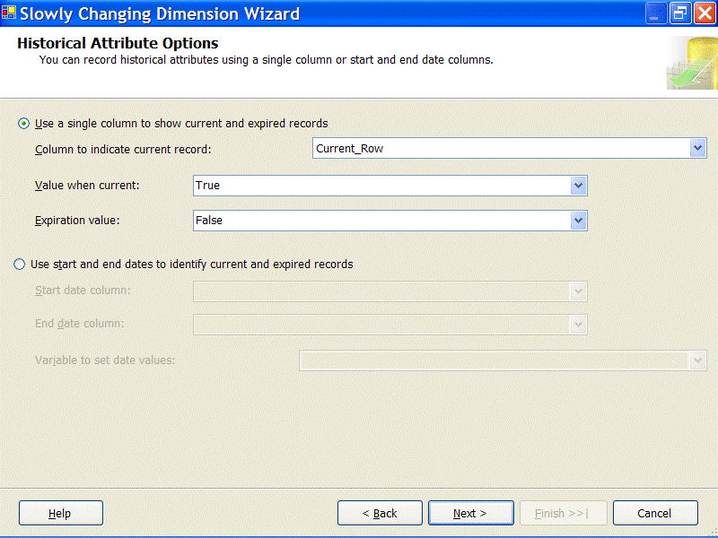
Figure 19
Next, if inferred members are used, the screen shown in Figure 20 identifies how the SCD wizard knows when a dimension record is an inferred member, so that all the columns, besides the business key are updated during processing. Two options exist. The first option indicates that all nonkey columns are NULL values to identify an inferred member. The second option is driven by a flag column that indicates if the member is inferred. Since NULL columns do not display well in Analysis Services, we use a column called Inferred_Member. Then we could replace the attributes used in Analysis Services hierarchies with named Unknown values.
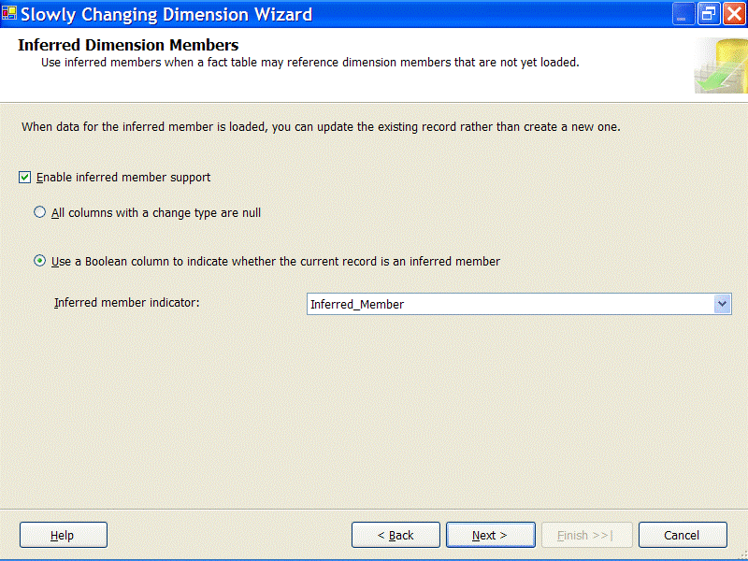
Figure 20
After the last screen, the wizard generates a series of transformations customized to the details that were entered during the wizard process. The main transformation is called the Slowly Changing Dimension transformation. It takes as an input the source records for the dimension, whether they are a full copy of the dimension source or only a subset of the source records—those added or changed on the source. The SCD task can be thought of as a combination of a noncached Lookup transformation and a Conditional Split transformation, where the source dimension records are evaluated against the warehouse dimension and then distributed out to the different SCD outputs. Figure 21 shows the final UI image of the Store SCD transformation with its associated outputs.
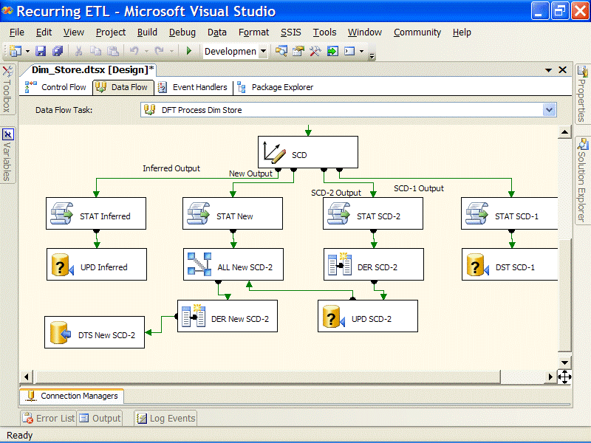
Figure 21
Large dimension scenario (DimItem)
The only Project REAL dimension processing package that does not use the SCD transformation is the Item dimension. Its requirements are unique and its size (approximately 6 million members) requires special handling for scalability.
One characteristic that differentiates the Item dimension from the rest of the dimensions is the kind of SCD change types that occur. Besides requiring an inferred member, Changing attributes, and Historical attributes, the requirements specify that for a given member, its attribute change types can modulate from Changing to Historical; type 1 to type 2. This occurs when the first sale happens for an item. Before the first sale, all the attributes act as changing type-1 attributes, but once a sale occurs, a subset of the attributes become historical type-2 changes. This scenario has been coined a type 1.5 change and is driven by the business desire to limit the number of type-2 additions to the dimension. This is because when an item is entered into the transactional system for the first time, the process for establishing its characteristics causes multiple changes to happen in the first several days. While these initial attribute details are worked out, the dimension member is in a state where a change to any attribute causes an update of that attribute in the dimension rather than a new type-2 historical record. This limits dimension table growth to valuable historical changes, when an item is stable and selling. Although driven by a different business requirements, this scenario is similar to how an inferred member works. However, in this case the source dimension record is available and the requirement to update all attributes remains until the sale requirement is met.
A deciding factor of whether to use the SCD wizard was the volume of records processed for the dimension. The 6-million member Item dimension can undergo tens of thousands of changes a day across its 100 attributes. The built-in SCD component lookup process was generating an equivalent number of calls to the database, querying a large wide table, and returning dozens of columns in the result row. This process was not sufficient for the time window desired; therefore an alternative approach was taken.
Figure 22 shows the primary data flow of the Dim_Item package, with the two built-in transformations (Merge Join and Conditional Split) that form the part of the solution that takes the place of the SCD transformations used in all the other dimension packages.
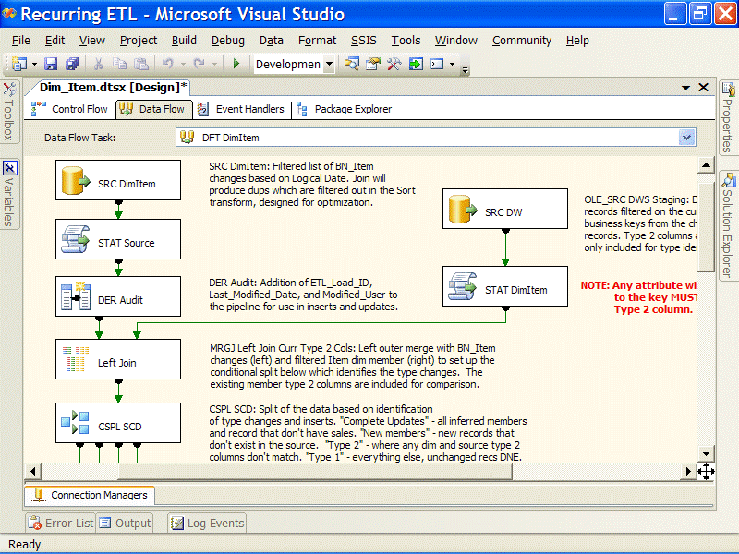
Figure 22
A primary objective of any SCD process is to compare the source data to the dimension data. The first step in doing this with Integration Services (outside of the SCD transformation) is to bring the data from these two sources together. The two primary options for this are the Lookup and the Merge Join transformations. To achieve the best performance using the Lookup transformation, the entire dimension would need to be in cache so that all the columns would be immediately available for the change type comparisons. However, caching all the columns of a large table may require several GB of memory and take a significant amount of time to load into memory. Instead, a left Merge Join transformation is used, where the source records on the left are matched with the current dimension members on the right across the business key, as Figure 23 shows. The effect of this join is to stream in only those Item records that are used in the relevant facts. Columns needed from the dimension for change type analysis are included in the data flow for matching records. A left merge is used so that new records from the source (left) will continue down the pipe where they can be added to the dimension as new members.
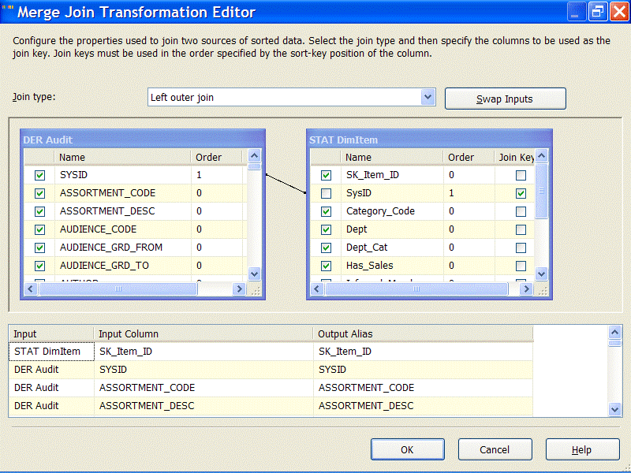
Figure 23
The merge in this scenario performs very well because the input columns are already sorted—as matches occur, the records are released to the downstream transforms for processing.
The Conditional Split transformation (located immediately below the Merge Join transformation in Figure 22) evaluates certain conditions and then directs the rows to multiple transformation outputs. Conditions are evaluated in order. The first condition met for a row designates its output, so that a row is not sent to multiple outputs.
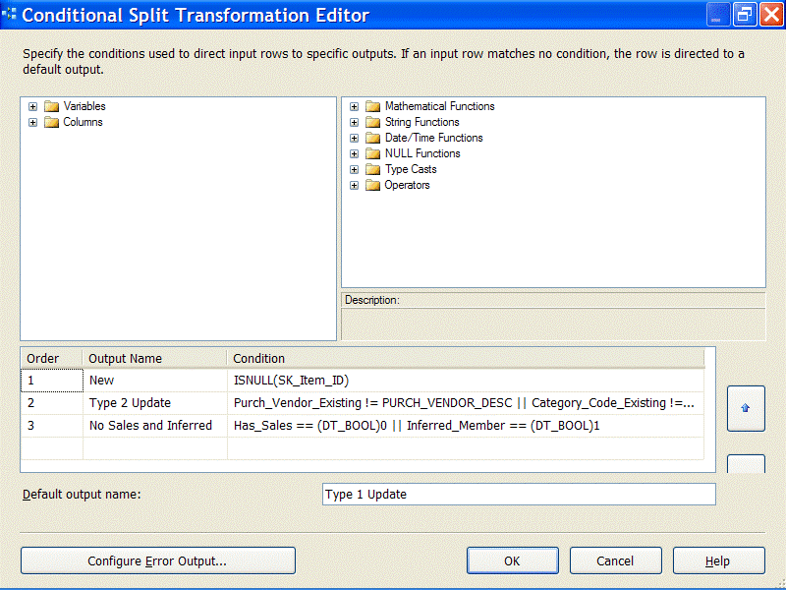
Figure 24
The Conditional Split transformation in Figure 24 first evaluates whether the right side of the join had a match using an ISNULL function. Source rows that matched the null check are output to a transformation that adds the row as a new dimension member. Since the remaining members all had matches to the warehouse dimension table, the changing type criteria are evaluated.
Next, historical change attributes are evaluated. If there is a change in one or more of the historically tracked attributes, a type-2 change record is generated.
The next criteria evaluated are the Inferred Member and Sales Flag conditions. Since both of these require a complete update to the dimension attributes, they are combined and handled at the same time.
Finally, any changes to the remaining changing type columns cause a dimension update statement to overwrite the previous value for that attribute (in a type-1 fashion).
Note that the final condition is not specified, but the default output for the Condition Split describes this scenario—this is semantically equivalent to the ELSE section of an IF statement in imperative programming languages. Since the source records are only new and changed rows, we know that if all the other requirements are met, the last criteria must apply to the remaining records. This emphasizes the fact that the order of the criteria is crucial for the correct processing of the Item dimension.
The transformations downstream from the conditional split, as shown in Figure 25, look very similar to the output of the SCD transformation in the Store example. This is because the output is modeled after the SCD processing of new additions, changes, and inferred members (called complete updates because of the ”Has Sales” requirement described earlier).
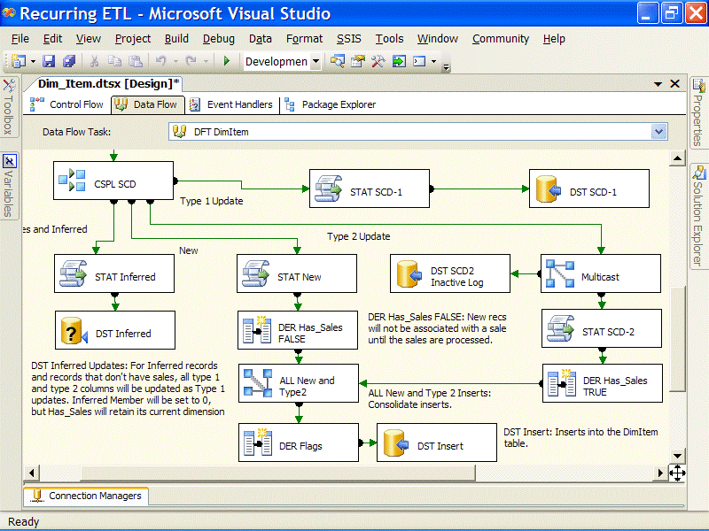
Figure 25

Fact table ETL processing
The Project REAL solution highlights several common scenarios involving fact table ETL processing. For one, the Store Sales table is a transactional fact table and captures the sale activity every day for every store. Second, both the Store Inventory and the DC Inventory tables are snapshot fact tables and require capturing the entire inventory positions on a weekly basis.
Moreover, as discussed in Data Profile earlier this paper, the fact table design models both a multi-table approach and a partitioned table approach. Every fact table has two packages in the Integration Services project to show the differences in processing.
For the purposes of this paper, four different areas of fact table ETL are featured:
- Dimension surrogate key lookups
- Multi-table fact data loading
- Partitioned table fact data loading

Dimension lookups
Every fact table process requires a way to associate the facts with the dimension table. This has been handled across the board by using the Lookup transformation, which can cache the dimension. As the source rows flow through, it quickly returns the surrogate keys needed for the fact table based on the business key association. This process is straightforward and particularly effective for dimensions with smaller row counts. Whenever a dimension has historical type-2 changes, and therefore a current row identifier, the cache is filtered to use only the current rows, so that the most recent version of the dimension member is associated with the fact. Figure 26 shows the Reference Table tab of the Lookup transformation. In this example for the store dimension, a query is used to filter on the Current_Row.
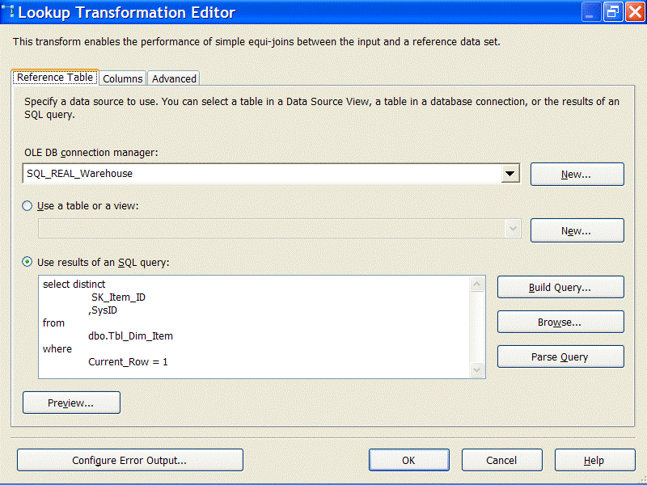
Figure 26
In the Columns tab of the Lookup transformation, the data flow columns are mapped to the reference table columns. Since the goal of the dimension lookup is to get the surrogate key of the dimension, the business key is used as a map (Store_Num), and the surrogate key is returned (SK_Store_ID) along with a secondary column that is used downstream in the data flow.
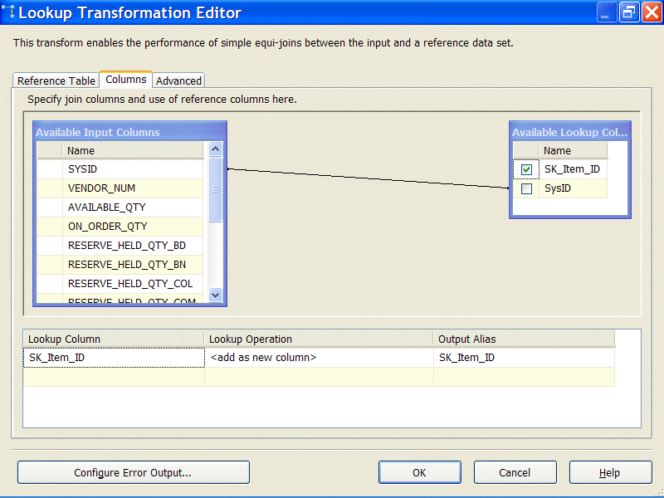
Figure 27
From a data flow standpoint, the source rows simply go from lookup to lookup, associating the rows with the most recent dimension surrogate keys. The data flow in Figure 28 shows the Lookup transformations described previously. Several other transformations are displayed, including a Script transformation and Union All transformations used for the inferred members, which are described in detail in the next section.
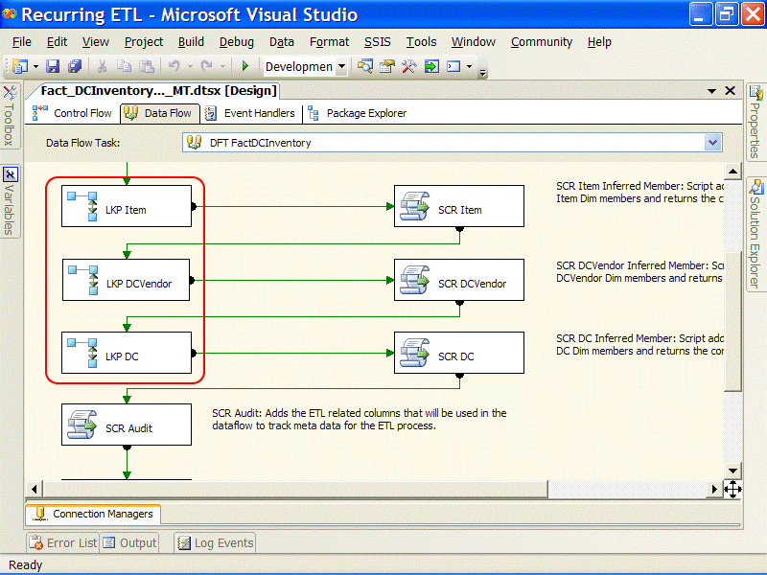
Figure 28
For the Item dimension, which contains millions of rows, an optimization technique is employed to limit the lookup to only those rows needed for whichever fact table process is executing. For more information, see Data processing optimization techniques later in this paper.

Multi-table and partitioned table fact data loading
The next consideration for fact table ETL processing is how to load fact table data with Integration Services. This involves considering both a multi-table approach and a partitioned table approach, given the Project REAL examples and the inherent differences in the loading logic. For both of these examples, the Store Sales packages is used; Fact_StoreSales_Daily_MT.dtsx and Fact_StoreSales_Daily_PT.dtsx. A look at the control flow logic, as Figure 29 reveals, shows that these two packages have a very similar workflow logic.
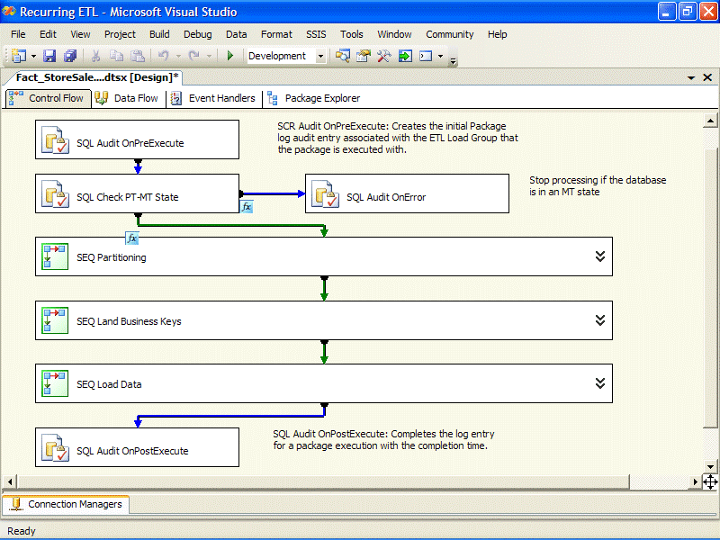
Figure 29
Both packages follow an identical workflow pattern. The Execute SQL tasks at the beginning and end handle the auditing and the checks for the right partitioning state—these procedures ensure that a multi-table package is not run against a database that is in a partitioned table state (and vice-versa). In addition, the three Sequence containers are ordered to first handle partitioning management, stage business keys for optimization (see Data processing optimization techniques), and handle the core data processing for the Store Sales data. The processing differences between the fact tables are more obvious when the Sequence containers are expanded, specifically in the SEQ Partitioning and the SEQ Load Data containers. This section highlights the differences and explains the purposes of each.

Multi-table Store Sales fact table processing
The multi-table process to load the sales transactions involves table and index management and identifying the current tables for the data to be loaded. Figure 30 expands the SEQ Partitioning container for the multi-table approach.
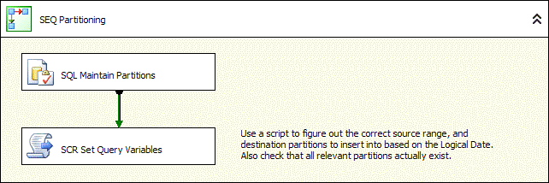
Figure 30
The two steps involved are an Execute SQL task that manages the tables and a Script task to identify the current and prior week sales tables.
- The Execute SQL task runs the mt.up_FactStoreSales_Maintain procedure, which adds and maintains the tables as needed based on the processing date (defined by the Integration Services variable LogicalDate).
- The Script task updates two package variables (Partition_LastWeek and Partition_ThisWeek) with the names of the current and prior week fact tables. The data flow discussed later shows how these variables are used in conjunction with the inserts.
The workflow for the SEQ Load Data container handles the primary data processing logic. Figure 31 shows the tasks involved for this data loads.
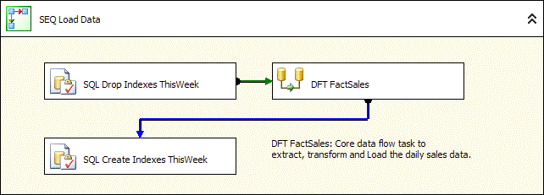
Figure 31
The flow is straightforward. The data flow that does the loading is bookended by two Execute SQL tasks. The first drops the indexes for the current week sales fact table and the later re-adds the indexes. This is for optimization, as the indexes can be re-created faster than the RDBMS engine can manage a bulk load while the indexes remain, thereby speeding up the ETL process. Note that this technique may not apply in all cases; the mitigating factor is the ratio of new data to existing data, as well as the number and type of indexes. More information on this topic can be found on the Web.
As we look at the data flow logic, be aware that new sales transactions in a single days’ process may not all include all sales that occurred on that day. A small percentage of sales can lag up to four weeks before they are available for the warehouse. This package handles what is known in data warehousing as late-arriving facts. Dimension lookups have already been shown and discussed; Figure 32 shows the Data Flow transformations and adapters that handle the loading portion of this package.
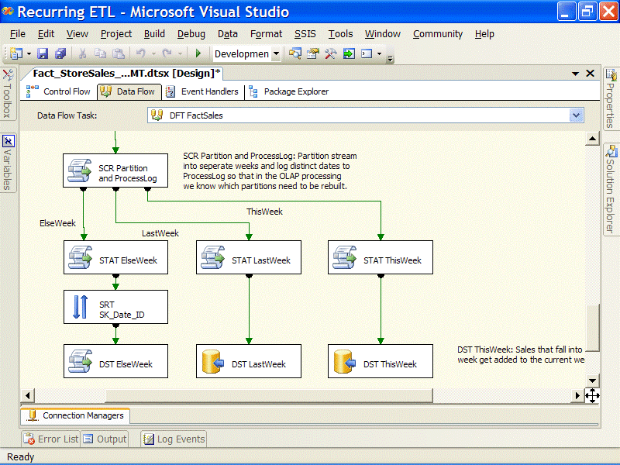
Figure 32
At the point in the pipeline where the SCR Partition and ProcessLog Script component is located, all of the dimension surrogate keys are available, metadata columns have been added, and the measures are formatted. The only remaining tasks are to identify into which table each fact row should be inserted and to insert the rows into the fact tables.
The purpose of the SCR Partition and ProcessLog is two-fold. First, it acts like a conditional split in that each row is routed out one of three defined outputs:
- ThisWeek for sales records where the sales date is between the LogicalDate and the prior Saturday.
- LastWeek for Sales dates that are from the week before the prior Saturday.
- ElseWeek is a catch-all for any transactions that are late arriving earlier than the LastWeek range.
The second purpose of the SCR Partition and ProcessLog component is to capture every table that is affected, by inserting the table name into the audit.ProcessLog table. This will be used for the Analysis Services processing logic, so that only the measure group partitions that are based on fact tables that were updated during the ETL are processed.
The inserts into the fact tables for the current week and prior week are handled with two OLE DB destination adapters. Figure 33 shows the OLE DB Destination Editor for the DTS This Week adapter.
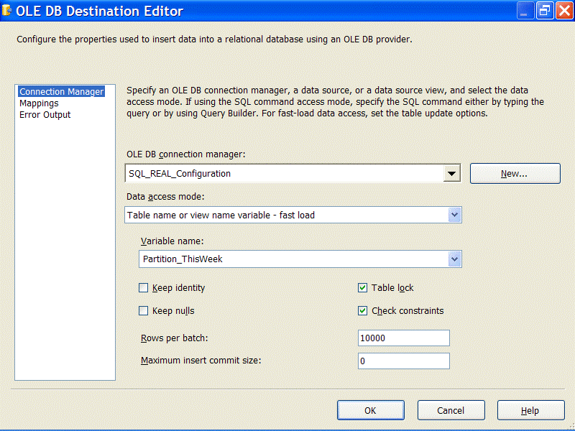
Figure 33
Since the current fact tables name changes weekly (in the multi-table design), the table name can not be hard-coded into the destination. To handle this, the Data access mode property is set to Table name or view name variable fast load. This allows the table into which the records are inserted to be based on the value of a variable. The Variable name property is set for this destination to the Partition_ThisWeek variable, which was updated in the control flow in a prior task as shown in Figure 30. As expected, the properties of the LastWeek output are identical except for the chosen variable Partition_LastWeek.
Any sales transaction that is older than two weeks (which only amounts to a few records) are sorted and then passed to another Script component, DST ElseWeek. For each record, the column values are passed into a procedure where the row is added dynamically to the relevant Sales fact table.

Partitioned table Store Sales fact table processing
Partitioned tables can either simplify or add a measure of complexity to an ETL process. For small volume ETL, the partition table can merely be the destination of the fact ETL, and the SQL Server 2005 Relational Engine will interpret the Inserts and add them to the correct underlying partition. This comes with a performance impact, sometimes doubling the bulk loading process times. For performance sake, an alternate approach can be taken, which yields much better performance results. This approach involves detaching the most current partition from the partitioned table into a separate table, handling the data processing directly into the detached table, then having the table re-integrated back into the partitioned table. Figure 34 exhibits the SEQ Load Data container from the Sales fact table package.
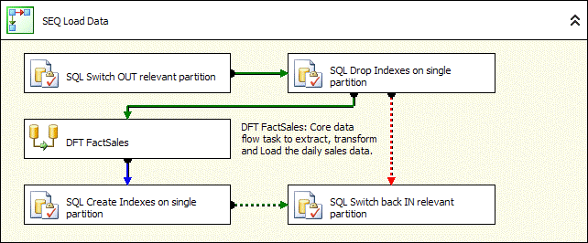
Figure 34
The workflow is similar to the multi-table container shown in Figure 34; however, it contains two additional tasks and a modified precedence constraint. The first Execute SQL task in the container takes the most current partition from the table and creates a staging table, using the exec pt.up_FactStoreSales_Switch procedure. The procedure changes the partition scheme and functions (how partition tables are managed) and the current partition is pulled out of the table by performing structural changes only (and not requiring data to be physically copied). This partition is put into a table called FactStoreSales_Staging.
The drop and re-create index Execute SQL tasks surrounding the data flow are identical to the multi-table processes. The final task, SQL Switch back IN relevant partition, integrates the staging table back into the Sales partitioned table. You will notice that the precedence constraints will execute the final task if the Index Creation step is successful or if the Drop Index fails (the dashed lined indicate a logical OR). This ensures that the partition table remains intact with all its original partitions even in the event of a failure.
Turning our attention to the data flow differences, Figure 35, similar to Figure 34, shows the DFT FactSales Data Flow task from the point where SCR Partition and ProcessLog Script component evaluates the sales date for processing.
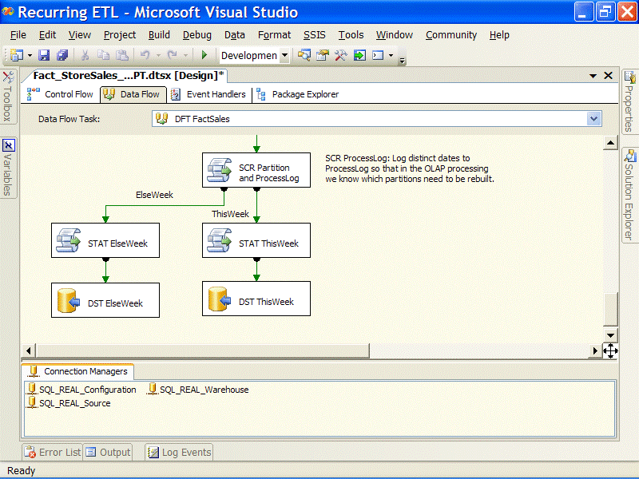
Figure 35
The code in the SCR Partition and ProcessLog Script component for the partitioned table is almost identical to the script for the multi-table. Both track which partitions are affected and record this information in the audit.ProcessLog table. Both evaluate the sales date to identify to which output each row is routed. But in the partitioned table approach, there are only two outputs, ThisWeek and ElseWeek. With the partitioned table approach, all the data from prior weeks, which is very few rows, are inserted directly into the Sales fact table, and the engine can determine into which partition to insert the rows. Compare this to the dynamic table inserts that the multi-table approach requires, given that every prior week has a different table name. Figure 36 shows the editor window for the DST ElseWeek destination adapter.
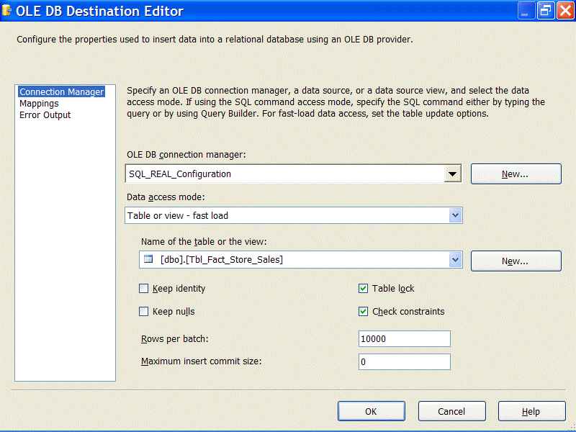
Figure 36
Rather than storing the table name inside of a variable (as the multi-table approach uses), this adapter uses the direct Table or view – fast load data access mode, making this destination configuration straightforward. The DST ThisWeek adapter is identically configured by using the destination table as the staging table, etl.FactStoreSales_Staging.

Analysis Services processing
For most traditional data warehouse solutions that use Analysis Services, dimension and partition OLAP processing is the responsibility of the ETL process. This is not necessary with SQL Server 2005 Analysis Services because of proactive caching and the scheduling mechanism that the product provides. It’s easiest to think about OLAP processing from a push-pull perspective—either Analysis Services pulls the data or an ETL process pushes the data. Analysis Services decides when to process its objects by a triggering condition such as a data change (this is called proactive caching) or a predetermined schedule defined within Analysis Services. The reason that most data warehouses use the full MOLAP design with the schedule not defined in Analysis Services but rather in the ETL, is that usually the data in the warehouse is updated on a strict recurring basis (often nightly or weekly). The ETL knows best when the data in the fact and dimension tables have been updated.
There are several options for processing Analysis Services objects within the ETL, each with situational advantages. With Integration Services built-in Analysis Services processing support, the following list briefly highlights the options available for processing OLAP objects:
- Analysis Services Processing task. When the OLAP processing needs to run exactly the same every time (objects and types of processing), the Analysis Services Processing task is the answer. Easy to use in any package, the objects are selected and the processing method chosen.
- Data flow processing destinations. Data coming from the Integration Services pipeline can be directly added to Analysis Services objects before or at the same time that the data is added to the dimension and tact tables. Two data flow destinations provide this support; the Partition Processing and Dimension Processing. This support is useful for near real-time processing requirements as data can be directly added to the object, reducing data latency.
- Analysis Services Execute DDL task. With XMLA, Analysis Services objects can be added, deleted, and modified just as the SQL DDL language can modify relational engine objects. However, XMLA goes beyond just DDL as it can also be defined to process objects. When the Analysis Services Execute DDL task is used for processing, the XMLA script can be modified in a prior task in the control flow, allowing for more granular and custom control over the processing than the Processing task does. This is a great choice for more complicated Analysis Services solutions that involve partitions and variable processing methods.
- Analysis Management Objects (AMO). Programming through scripts or compiled applications is another way to handle Analysis Services processing. The API for Analysis Services programming is Analysis Management Objects, or AMO. A Script task within Integration Services can use AMO to connect to, modify, and process Analysis Services objects. Alternately, the code can be embedded into an application.
- ASCMD.EXE. SQL Server 2005 Service Pack 1 includes a new command-line tool for running Analysis Services commands (XMLA, MDX, and DMX). For processing, an XMLA script can be created that the ascmd.exe utility can run in many contexts.

Analysis Services dimension processing
The dimension processing design for Project REAL is straightforward, which is typical given that dimensions structures are static in most Analysis Services solutions. For the dimension processing, the Project REAL ETL leverages the ascmd.exe utility to run a predefined XMLA script. Since the Project REAL code can be executed on either a 32-bit or 64-bit machine, this allows the flexibility to choose the correct script to execute. Figure 37 shows the control flow steps within the AS_Dim_Processing_PT package (which visually is identical to the multi-table version of the package).
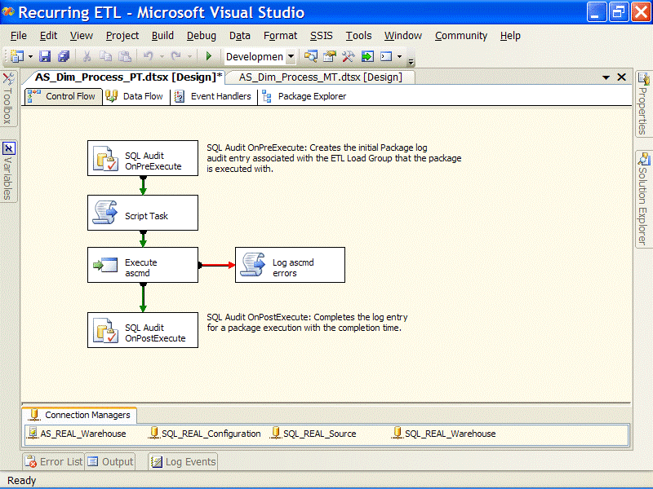
Figure 37
The Script task modifies three package variables: RootDir, maxParallel, and ProcessType. These are required to correctly run the ascmd.exe utility with arguments. The ensuing Execute Process task is defined to call the executable and pass in the correct arguments. Setting the arguments from the updated variable is done through property expressions. Figure 38 shows the expressions property page of the Execute Process task.
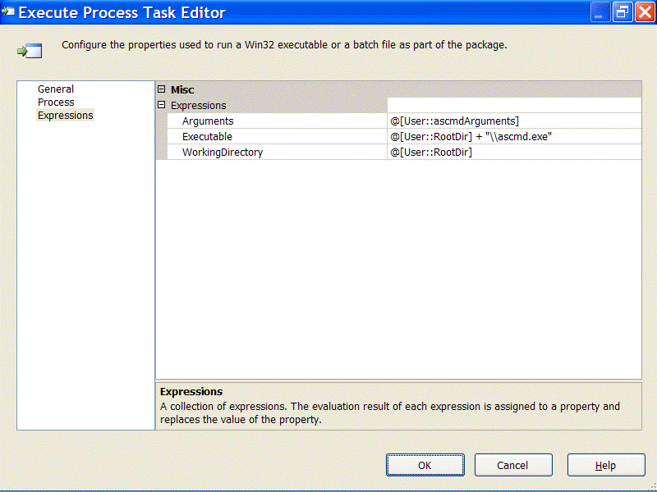
Figure 38
When the task runs, the Arguments, Executable, and Working Directory properties are updated through the property expressions by using the values of the variables. And finally, if an error occurs when the ascmd.exe runs, the Control Flow precedence handles directs the next step to a Script task which writes the error to the same file that the ascmd.exe logs its output.

Analysis Services partition processing
Measure group partition processing is naturally more complicated than dimension processing. Analysis Services solutions that involve more than one partition per measure group often require the ETL to add new partitions and then correctly identify which partitions to process depending on whether data was added to the underlying sources. Figure 39 represents the control flow for the AS_Fact_Process_PT package, which involves both adding partitions and processing affected partitions.
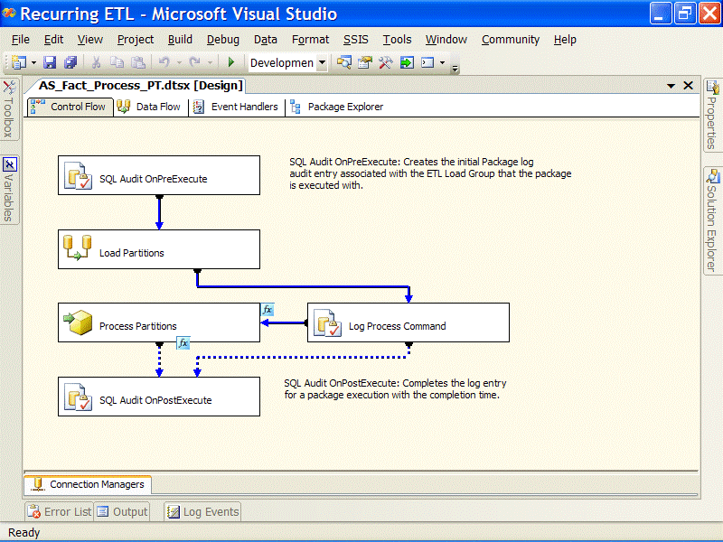
Figure 39
The two primary tasks used for handling the logic are:
- The Load Partitions data flow, which generates the XMLA code needed for processing and adds Analysis Services partitions where applicable.
- The Process Partitions Execute Analysis Services DDL task, which runs the XMLA code generated in the prior step.
The more complicated data flow requires identifying affected table partitions, checking the existence of related Analysis Services partitions (and adding them when appropriate), then building the XMLA Script for processing. Figure 40 shows the data flow pipeline that handles this logic.
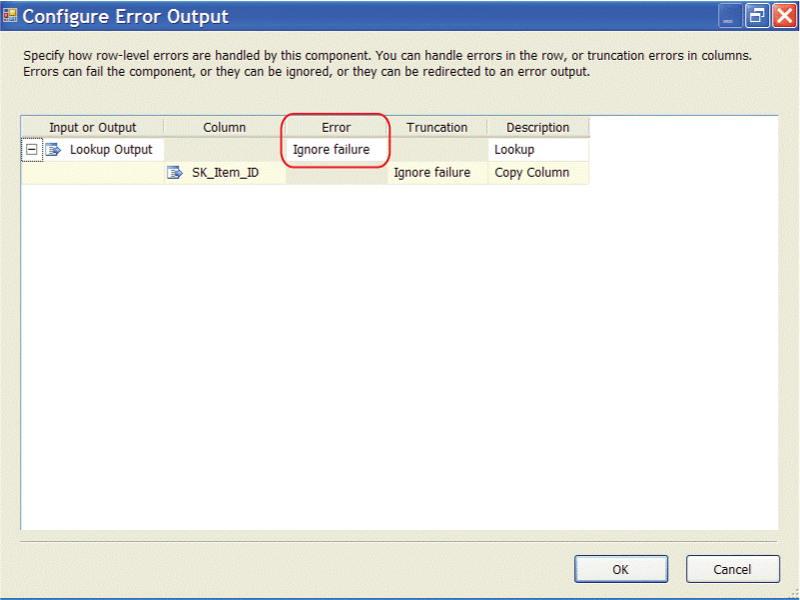
Figure 40
Essentially the two sources and transformations through the Merge Join identify the partitions that were affected by the fact loading (entries in the audit.ProcessLog table that captured this data) and match them up with the existing partitions and properties from the relational database. The rest of the transformations, excluding the last Script component, prepare the Analysis Services cubes for processing. This involves using AMO embedded within the Script components to check their existence and create new partitions as needed. The final transformation, SCR Build XMLA Process Cmd, builds the XMLA code and puts it into a package variable called xmlaProcess.
Back in the control flow, the Log Process Command Execute SQL task logs the XMLA code that will run. The precedence evaluates whether the xmlaProcess variable contains any text. If no partitions are scheduled to be processed, the value is empty and the XMLA execution is bypassed; otherwise the Execute Analysis Services DDL task runs, which uses the xmlaProcess variable for the source of the XMLA code to execute.

Advanced data processing concepts
Several aspects of the ETL required advanced considerations and design to handle both complexity and volume. These relate to handling missing dimension members and optimizations.

Handling inferred member additions
Since the Project REAL dimensions require that inferred members be created when a dimension record does not exist, we have more work to do. As a reminder, an inferred member is a dimension record that acts as a placeholder with only the business key value, so that when the full dimension record becomes available, all the dimension columns are updated with the new values. The update process happens during the processing of the dimension, but the addition of the inferred member happens during the fact process when the Lookup transformation does not yield a match. When the Lookup transformation that handles the cached dim lookup for the key cannot find a match, the row is still passed downstream, but the lookup surrogate key is NULL. To configure the output so that the row is still handed downstream, instead of failing the component or rerouting the row, click the Configure Error Output button in the Lookup UI and configure the row to Ignore failure. See Figure 41.
Figure 41
By configuring the primary Lookup transformation this way, we can still identify which dimension members are missing by checking for a NULL value in the surrogate key. All the surrogate dimension keys in Project REAL are database identity columns, which makes this process more difficult than if the keys were unique identifiers that could be generated by Integration Services. Several approaches were considered to handle the inferred member additions. Given the data volume, the requirements necessitated a way to keep the process running optimally by keeping the inferred member additions in the primary data flow. To keep the process streamlined and to avoid multiple data flows, the newly generated inferred member keys needed to be brought back into the data flow before the next dimension lookup. Also, since the primary Lookup transformation cache is loaded before the data flow execution, when an inferred member is added to the database the first time, it is not added to the cache with the rest of the dimension records. So, if there are thousands of fact records coming across for the same unmatched business key, all the records will not be found in the cache and are therefore sent to the error output for the inferred member addition process—this causes duplicate inferred records to be created.
Given the above requirements, a Script transformation was selected to handle inferred members additions. A Script transformation, different from a Script task, is used in the data flow. It can perform compiled Visual Basic®. NET script-based manipulations on the rows and columns coming through the pipeline. In situations where a unique scenario requires special handling, the Script transformation is flexibile and customizable. The specific goal was to take the unmatched lookup output, add the inferred member to the dimension table in the database, and get back the newly generated surrogate key, all without making multiple calls to the database for the same unmatched business key. Before developing the Visual Basic .NET script, an algorithm was constructed to solve the requirements of this process:
- Initial steps, executed before the first record is processed are:
  - Declare variables.
  - Create a hash table to be used for the business key(s) and output surrogate key lookup for optimization.
- For each row coming through the Script transformation pipeline, check the hash table for the existence of the current business key. Then:
  - If the business key exists, return the surrogate key to the pipeline output.
  - If the business key does not exist:
    - Connect to the database.
    - Execute the stored procedure that creates the inferred member and returns the surrogate key.
    - Add the business key and new surrogate key to the hash table.
    - Return the surrogate key to the pipeline output.
- Cleanup and deallocation following the last row of the pipeline input.
The following Script transformation is an example inferred member process for the Store lookup, used when the Store_Num business key does not have a matching record in the lookup.

Imports System
Imports System.Data
Imports System.Data.OleDb
Imports System.Collections

Public Class ScriptMain
Inherits UserComponent

Private objCommand As New OleDbCommand("etl.up_DimItem_CreateInferredMember")
Private parmBusinessID, parmSurrogateID As OleDbParameter
Private htCache As New Generic.SortedDictionary(Of Integer, Integer)

Public Overrides Sub InputMain_ProcessInputRow(ByVal Row As InputMainBuffer)
'This Sub is called once for every row entering the Script component. The
'Business Key (BK) is saved to a variable and then used to lookup the
'Surrogate Key (SK) in the local cache. If the SK is not found then the BK
'is inserted into the database and the resulting SK inserted into the cache.
If Row.SKItemID_IsNull Then
Dim intBusinessKey As Integer = Row.SYSID
Dim intSurrogateKey As Integer
If Not htCache.TryGetValue(intBusinessKey, intSurrogateKey) Then
intSurrogateKey = Me.ExecuteSP(intBusinessKey)
htCache.Add(intBusinessKey, intSurrogateKey)
End If
Row.SKItemID = intSurrogateKey
End If
End Sub

Private Function ExecuteSP(ByVal BusinessId As Integer) As Integer
'This Function executes the SQL Stored Procedure (SP) that does the insert. The
'values for the Business Keys are set, and the Return Value is reset before
'executing the SP. Note that for performance reasons, references to each parameter
'are used as opposed to looking them up by name each time.
parmBusinessID.Value = BusinessId
parmSurrogateID.Value = 0
objCommand.ExecuteNonQuery()
Return CInt(parmSurrogateID.Value)
End Function

Public Overrides Sub PreExecute()
'This Sub initializes the SQL Connection and Stored Procedure
MyBase.PreExecute()

'Define the Stored Procedure object
With objCommand
.CommandType = CommandType.StoredProcedure
.Connection = New OleDbConnection(Connections.SQLREALWarehouse.ConnectionString)
.Connection.Open()
With .Parameters
'Add the Surrogate Key Output Parameter and maintain a reference to it
parmSurrogateID = .Add("@SK_Item_ID", OleDbType.Integer)
parmSurrogateID.Direction = ParameterDirection.InputOutput

'Add Business Parameter 1 and maintain a reference to it
parmBusinessID = .Add("@SysID", OleDbType.Integer)

'Add other parameters
.Add("@hasSales", OleDbType.Boolean).Value = CBool(1)

'Add the standard Parameters and set their values from the package variables
.Add("@logID", OleDbType.Integer).Value = Variables.LogID
.Add("@logicalDate", OleDbType.Date).Value = Variables.LogicalDate
.Add("@operator", OleDbType.VarChar, 30).Value = Variables.UserName
.Add("@unknownCode", OleDbType.VarChar, 2).Value = Variables.UnknownCode
.Add("@unknownString", OleDbType.VarChar, 50).Value = Variables.UnknownString
.Add("@unknownNumber", OleDbType.Integer).Value = Variables.UnknownNumber
End With
.Prepare()
End With
End Sub

Public Overrides Sub PostExecute()
MyBase.PostExecute()

'Finalize expensive objects
htCache = Nothing
objCommand.Connection.Close()
End Sub
End Class

The procedure that is executed by the Script transformation checks the dimension for the existence of the business key. If the record does not exist, it inserts a new record (the inferred member). It then returns the newly added Identity column to the script so it can be used downstream in the data flow.
After the Inferred Member script transformation, the records are available for the next dimension lookup. Figure 42 shows a series of lookups, their associated inferred member lookups, and the unions needed to bring the results back together.
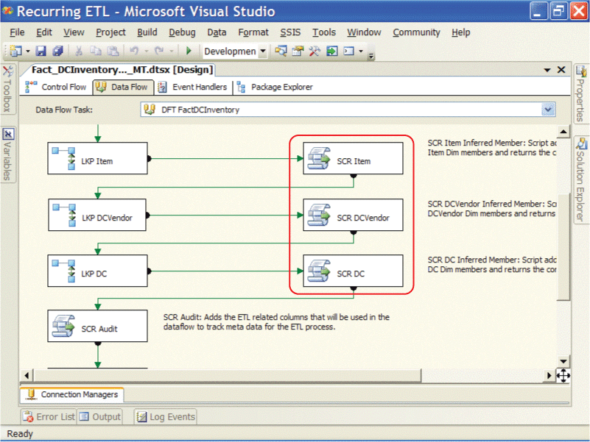
Figure 42

Data processing optimization techniques
Throughout the Project REAL development process, a few optimization techniques have been identified that help streamline the ETL. These involve principles based on the architectural advantages of the product, settings within Integration Services, and data flow tuning to handle large volumes. Some of the optimizations include:
- Using high-value targeted data staging to filter lookups and data merge sources.
- Limiting asynchronous (blocking) Data Flow transformation usage like aggregations and sorting.
- Handling common data processing scenarios before the exception.
- Considering batch updates for large volume dimension or fact table updating.
High-value targeted staging
The fully cached Lookup transformation correlates data between sources, such as associating dimension keys with fact table records. For large dimensions, however, loading the entire dimension into the lookup memory cache takes a long time and uses RAM that could be available for other processes. For Project REAL, we created a targeted staging table for the business keys of the large item dimension, which contains 6-7 million members. This narrow staging table is populated in the fact table packages by using a data flow that contains a single source and destination and extracts only the product business key from the transactional source and lands it to a staging table. Figure 43 shows the successful completion of staging 4.4 million business keys in 55 seconds. Since the extraction is so targeted and narrow, this data flow finishes in a matter of seconds for several million rows.
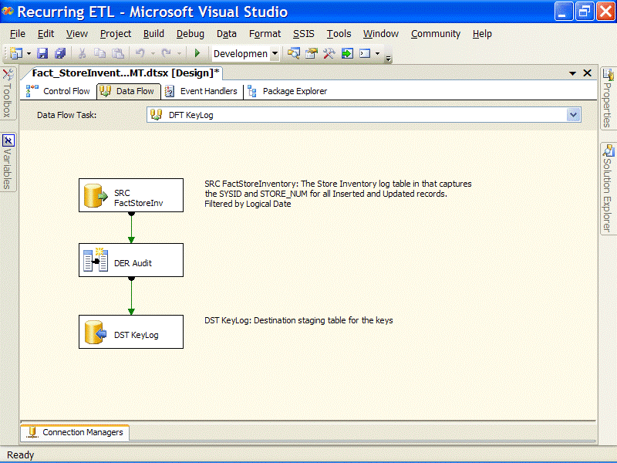
Figure 43
The staged keys are then used to filter the query that the lookup uses to load its cache. Since the business keys in a dimension are already indexed, the join to limit the dimension records performs very well. For this example, this technique filters the dimension lookup cache down to almost 1/10 of the complete dimension size, yet still contains all the dimension members needed for the lookup during the fact processing since the same set of business keys are used for the lookup. The following SQL code is used to populate the lookup cache, and involves filtering the dimension (Tbl_Dim_Item) with the business keys contained in the staging table (etl.FactStoreInventory_KeyLog).

select distinct
item.SK_Item_ID
,keylog.SysID
,item.SK_Parent_Item_ID
,convert(money, item.Retail_Amt) as Retail_Amt
,keylog.ETL_Load_ID
from
dbo.Tbl_Dim_Item as item
inner join
etl.FactStoreInventory_KeyLog as keylog
on
item.SysID = keylog.SysID
where
item.Current_Row = 1
This approach can also be employed to limit the source records used in a Merge Join transformation. Merge joins are used in several scenarios in a similar fashion as the lookup, to associate source and destination data together. When the requirements call for comparing several dozen columns between the source and the warehouse, a Lookup transformation may not be able to handle the size of the lookup cache as every column of each row would need to be stored into memory. An alternate approach is to use a Merge Join transformation to bring the source and warehouse data together. The Merge Join does not have the memory overhead, but can also take advantage of a filtered warehouse source when the business keys are staged, as described earlier.
Limit the Sort and Aggregate Data Flow transformations
While limiting the Sort and Aggregation transformations will benefit performance (since they hold up all the rows in the pipeline and consume time and resources), there are times when they are needed or required. For example, the Merge Join, which is used in several Project REAL packages, requires that the sources be sorted by the column(s) that define the join. Using a Sort transformation for both sources would require that all the rows on both sides of the merge be held up in the Sort transformation before being released to the Merge Join. Small data sets may not be affected by this, but more sizeable volumes cause a couple effects. First, the records loaded into the sorts (or aggregation in other examples) are stored in memory. As thresholds are reached, portions of the cache can be temporarily loaded off onto disk by either the Sort transformation or through the virtual memory manager, thereby creating inefficiencies in I/O and using memory resources that other downstream transformations may need for processing. When transformations used in the data flow causes data to be held up, pressure is put on the data upstream in the pipeline. If this filters back up to the source connections, the extraction and therefore the overall processing time will be slower.
This does not imply that we completely avoided using the Sort or Aggregation transformations. Overall, they operate remarkably fast and are useful for many situations. Rather, this is a caution for high-volume scenarios or limited memory resource availability.
For this Merge Join example, the Sort transformation can be eliminated if the source data can be presorted. In all the Project REAL scenarios, this worked quite well. Since an ETL process typically uses a Merge Join for data association across business keys for dimensions or surrogate keys for facts, the sort may be pushed back to the Source Connection query. Sorting on a relational engine can require a lot of overhead unless the right index or combination of indexes exists. Since business and surrogate keys are strong candidates for indexes, adding an ORDER BY clause to the SQL query may be valuable and efficient. To do this, the data flow needs to be made aware that the source is sorted and the columns and direction to which the sort applies. This is done in the Advanced Editor of the Source connection. On the Input and Output Properties tab, look at the top level properties of the OLE DB Source Output and set the IsSorted property to True. Secondly, the columns that are sorted need to be specified through the SortKeyPosition property in the Output Columns container as shown in Figure 44. Then the data flow will recognize the sort.
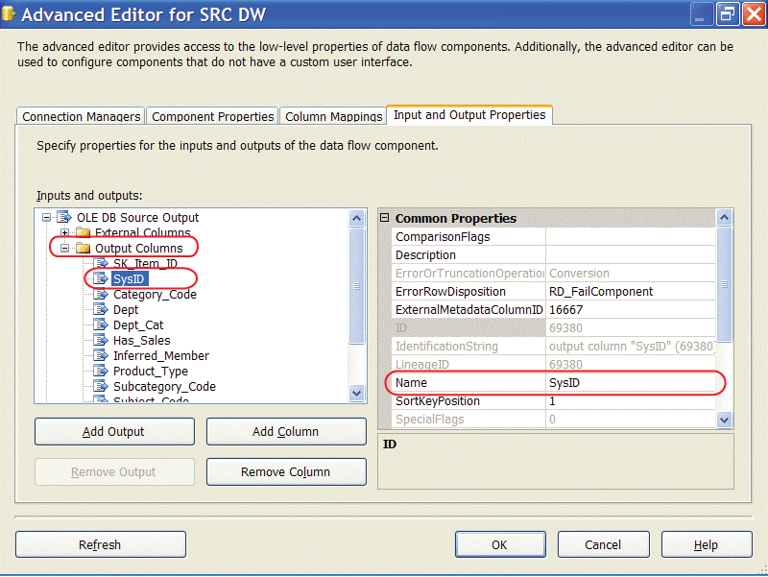
Figure 44
In other situations where the sorting or aggregation requirements involve only a subset of the data flow data, another optimization suggestion is to branch off the data (using a Multicast transformation), filter the rows if required (using a Conditional Split transformation), then specify the subset of output columns needed for the data processing (within the sort or aggregate).
Handling the common scenarios before the exception
With the branching, merging, filtering, and union capabilities in the pipeline, there are ways to optimize the processing by dealing with unique scenarios separately. This may be realized when an operation can be accomplished ninety plus percent of the time using a streamlined process like the cached lookup or bulk destination, but the remaining ten percent exception requires limiting the process by a less efficient method.
The OLE DB Command transformation vs. batch updates
Large volume updates can be a problem in an ETL process. Some systems avoid fact table updates altogether to avoid the overhead cost of the process. Creating fact table change records to offset measure differences brings its own set of challenges in reporting and processing. The daily inventory processing for Project REAL models this situation. The inventory snapshot fact table has a weekly grain with almost 200 million records stored per week. Furthermore, there can be as many as 10 million changes to the current inventory data on a daily basis. Add this together and it spells bottleneck.
The two primary methods to handle an update process of this size are:
- Use the OLE DB Command transformation with a parameterized query.
- Land the change records to a staging table and perform a set-based RDBMS update.
For the first method, Integration Services contains a transformation that can interact with the database directly to handle various operations, the most common being an update statement. The OLE DB Command transformation uses an SQL statement that is parameterized with mappings to data flow columns. As rows are passed to the transformation, the operation is performed with the data provided in the rows. Since the operation is performed one row at a time, it has a number of limitations when used to process a large series of updates. When millions of rows are pushed through this transformation to perform updates this results in serious drawbacks, such as the impact on the relational database, the back pressure it puts on the data flow, and the time required to complete the processing.
The second approach involves staging the data and using the relational engine to handle the update by joining the staged table with the destination table in an update statement. This involves the heavily leveraging of a staging environment, but given the cost, there may be overall gains in pursuing this approach as an alternative to the first method. Drawbacks to this approach are the resource costs of using a staging environment and the impact on the warehouse database during the update process, which may involve both resource stressing of the system and table, page, or row locking.
The advantages of the latter approach are only evident when compared with the alternative. By staging the data needed for the update, the pipeline performs much better, since the destination transformation can be optimized. Also, the overall impact duration to the destination table should be reduced, because a set-based operation can be handled more efficiently by SQL than the alternative row-by-row updates. The update also benefits from optimized indexing and potentially handling the updates into a series of smaller batch processes.

Performance Testing and Analysis
In conclusion, this section focuses on performance testing analysis with some generalizations observed from this testing. This section is not an exhaustive analysis of the ETL runs. It highlights a few key areas of performance to provide help in making architectural decisions for hardware choices and processing placement.
For testing, the full masked data set was used, with different configurations of the database and Integration Services ETL process (for a full description of the environment, hardware, and information capture, see “Project REAL Monitoring and Instrumentation” at https://www.microsoft.com/technet/prodtechnol/sql/2005/technologies/realmoninst.mspx. Each analysis focuses on a single-day ETL execution of the larger data set within a longer multi-day run, and the two are compared. General row counts are provided in some analyses to give perspective on the processing times. Part of the performance analysis comes from results captured by using the logging and auditing structured built into the Integration Services packages and described in the ETL auditing and logging section.
Each data warehouse system and ETL process have unique requirements, data profiles, designs, hardware, and environments (and therefore different bottlenecks). These principles will help direct architects and developers where to direct testing for SSIS and provide a head start in the architectural process. Tests similar to these can be run to determine like metrics for architectural tuning.
Three primary areas of analysis are represented. Each provides a different perspective on the Project REAL ETL architecture and highlighting different testing scenarios:
- Partitioned table versus multi-table performance. The Project REAL database structure and packages are designed both for a partitioned table and multi-table approach. Understanding the architecture impact of these designs during the ETL runs, will enable you to be aware of the how the tables should be implemented and the ETL packages designed.
- Database snapshot overhead Database snapshots are a good transaction mechanism for ETL, as they allow a full process to be rolled back quickly as opposed to the default isolation level of REAL COMMITTED, which often requires a long rollback time in large ETL scenarios. This analysis compares the ETL execution of a single day with a snapshot defined and without a snapshot used.
- Distributed SQL Server architecture versus consolidated architecture. This analysis considers the network and disk implications of executing Integration Services ETL packages on a separate server as opposed to running the packages on the data warehouse database server. In both scenarios, the source data lives on a separate server

Partitioned table versus multi-table performance
The first performance comparison highlights the ETL overhead of partitioned tables versus a multi-table approach. For comparison purposes, the Store Sales fact table package is used to highlight both the execution times of each task and the pipeline statistics as they relate to fact table processing. The Store Sales partitioned table and multi-table packages are shown in Figures 26 to 36 earlier in this paper.
For consistency, each ETL run was performed on the distributed architecture, with Integration Services packages executing on the 64-bit Itanium2 16-processor server with a database snapshot turned on. The following table shows task execution times within the packages, comparing the multi-table approach with the partitioned table approach. This data was gathered by capturing the Integration Services OnPreExecute and OnPostExecute built-in log events.

Task Name (Fact_StoreSales_Daily_MT and Fact_StoreSales_Daily_PT) | Time with MT (mm:ss) | Time with PT (mm:ss) | PCT (%) impact
SQL Audit OnPreExecute | 00:01 | 00:01 | 0%
SQL Check PT-MT State | 00:01 | 00:01 | 0%
SQL Maintain Partitions | 00:01 | 00:01 | 0%
SCR Set Query Variables | 00:00 | NA | NA
SQL Truncate Keys Table | 00:01 | 00:01 | 0%
DFT KeyLog | 02:40 | 02:48 | 5%
SQL Switch OUT relevant partition | NA | 00:01 | NA
SQL Drop indexes on partition/table | 00:01 | 00:01 | 0%
DFT FactSales | 22:05 | 39:37 | 79%
SQL Create indexes on partition/table | 00:50 | 00:59 | 18%
SQL Switch back IN relevant partition | NA | 00:00 | NA
SQL Audit OnPostExecute | 00:00 | 00:00 | 0%
TOTAL: Fact_StoreSales_Daily_MT | 25:40 | 43:29 | 69%

This data indicates that the performance overhead of the partitioned table is almost exclusively found in the primary data flow for the fact table processing. Other management tasks, such as index and table or partition management tasks take up only a small percentage of the overall processing times.
To better understand the performance overhead within the data flow, the pipeline STAT tracking provides the source and destination statistics. These have been captured into the audit.StatisticsLog table using a Script component described earlier in this paper.
The following table shows the row count, time, and rows per second average of the DFT FactSales data flow with the two different runs of the Fact_StoreSales_Daily packages.

STAT Component | Rows | Time (mm:ss) | Rows per Second
Multi Table - Fact_StoreSales_Daily_MT (DFT FactSales)
STAT Source | 2,828,130 | 15:41 | 3005
STAT ThisWeek | 2,773,558 | 13:39 | 3383
STAT LastWeek | 54,572 | 13:39 | 66
Partitioned Table - Fact_StoreSales_Daily_PT (DFT FactSales)
STAT Source | 2828130 | 14:41 | 3209
STAT ThisWeek | 2773558 | 12:45 | 3623
STAT ElseWeek | 54572 | 29:09 | 31

When comparing the source extractions (STAT Source) and the current week inserts (STAT ThisWeek), the data process times are very similar. However, when looking at the late-arriving fact data (STAT LastWeek and STAT ElseWeek), it is clear that the partitioned table process is significantly longer, approximately 29 minutes versus 13 minutes. As described earlier in this paper, the multi-table package performs an OLE DB fast load insert into the Last Week table. The partitioned table package inserts data that is older than one week directly into the partitioned table. The time increase is due to the overhead of the engine determining the correct partition to insert the data into while handling the index updates at the same time. To achieve identical performance, the partitioned table package could be designed to extract out two partitions (instead of just the current week) and to handle both the current week and last week inserts as OLE DB fast loads directly into nonpartitioned tables.

Partitioned table lessons learned
Lesson 1. The metadata management for partitioned tables comes with very little overhead. The tasks to extract a partition out to a table and then re-consume it back into the partition table took one second each, underscoring that data does not always have to physically move (unless moving a partition to a different filegroup) when restructuring partitioned tables for ETL optimization.
Lesson 2. High-volume ETL with partitioned tables will benefit by first decoupling the current data partition from the partition table, then running the ETL inserts (with updates or deletes as applicable), and finally re-consuming the partition back into the partition table. The current week partition inserts even performed slightly better in the Partition Table package. The prior week partition load took longer because the inserts incurred the overhead of the partition table managing the inserts.

Database snapshot overhead
The second performance comparison focuses on using database snapshots to manage transactions for ETL. A database snapshot is a read-only, static view of a database, which, when created can provide the ability to query the state-in-time picture of the database. Beneficial to ETL, the database can be rolled back to the state of the snapshot, therefore allowing a complicated process to run but providing a means to quickly roll back to the snapshot point in time. In practice, we found snapshots to be a useful means of performing iterative tests during development, since the original state of the data could be recovered quickly and simply. We also considered using snapshots as an end-of-day production mechanism to easily ‘roll back’ a problematic ETL run, but did not reach any conclusive decision as to advocating this as a best practice.
Related to ETL, a database snapshot must be created at the start (or at the rollback points in the ETL), dropped if successful, and rolled back if necessary. The following code highlights these processes:
Snapshot Creation

USE master
GO
-- Set the file path below appropriately for your system
CREATE DATABASE [REAL_Warehouse_Sample_V6_SNAPSHOT] ON
( NAME = N'REAL_Warehouse_Sample_V6', FILENAME =
'C:\Microsoft Project REAL\DB\REAL_Warehouse_Sample_V6.ss')
AS SNAPSHOT OF [REAL_Warehouse_Sample_V6]

Snapshot Rollback

USE master
GO

ALTER DATABASE REAL_Warehouse_Sample_V6
SET SINGLE_USER WITH ROLLBACK IMMEDIATE
go

restore database REAL_Warehouse_Sample_V6
from DATABASE_SNAPSHOT ='REAL_Warehouse_Sample_V6_Snapshot'

ALTER DATABASE REAL_Warehouse_Sample_V6 SET MULTI_USER WITH ROLLBACK IMMEDIATE

Snapshot Deletion

USE master
GO

DROP DATABASE [REAL_Warehouse_Sample_V6_SNAPSHOT]

Comparing the ETL process with snapshot turned on and snapshot turned off is a straightforward test. The following table shows package execution times for a complete daily run comparing the use of a database snapshot versus not using a snapshot. Both execution runs were configured with partitioned tables. The Integration Services packages were executed on a separate 32-bit server.

Nested Package Name  (rows processed) | Time, Snapshot Off (mm:ss) | Time, Snapshot On (mm:ss) | PCT (%) Impact
LoadGroup_Full_Daily | 59:08 | 77:11 | Total: 23%
LoadGroup_Dimensions_Daily | 12:23 | 16:17 | 24%
Dim_DCVendor (12,683) | 00:03 | 00:13 | 77%
Dim_DistributionCenter (4) | 00:01 | 00:01 | 0%
Dim_Buyer (580) | 00:03 | 00:03 | 0%
Dim_ReturnType (7) | 00:01 | 00:01 | 0%
Dim_MerchDivision (5) | 00:01 | 00:01 | 0%
Dim_Store (3979) | 00:19 | 00:23 | 17%
Dim_Item (96,796) | 12:19 | 16:14 | 24%
LoadGroup_Facts_Daily | 46:45 | 60:52 | 23%
Fact_DCInventory_Daily  (2,942,801) | 07:07 | 07:08 | 0%
Fact_DivStrategy_Daily  (5261) | 01:58 | 04:32 | 57%
Fact_StoreSales_Daily  (2,967,517) | 09:17 | 13:31 | 31%
Fact_StoreInventory_Daily  (4,257,860) | 46:44 | 60:50 | 23%

Database snapshot lessons learned
Lesson 3. Creating a database snapshot is a great choice for ETL development but generates a run-time overhead in the neighborhood of 20-25%. Evaluate the advantages achieved by using a snapshot for transactional consistency, ETL manageability, and rollback times. The overhead may be outweighed by its advantages, especially in a high-volume environment.

Distributed SQL Server architecture versus consolidated architecture
The final comparison involves evaluating the execution of packages on the same server as the destination database in a scale-up architectural model versus a distributed model where the Integration Services packages are running on a separate machine. In both models, the data is sourced from a separate machine across the network. In the consolidated model, the packages persist and are executed on the same machine as the data warehouse. In the distributed model, the packages reside and execute on a separate box connected to both the source and data warehouse machines.
Since each Project REAL architecture choice involves different hardware, it is inadequate to compare package and task execution times. Instead, this performance comparison will target two IO metrics: network I/O and disk I/O.
These tests compare a full day ETL execution process for the multi-table partition configuration with database snapshots off. In the graphs in Figures 45 and 46, the two executions are overlaid with a full day processing time across the X-axis. The metrics for the BI-REAL-IS server show the distributed execution and the BI-REAL-DW server results show the consolidated execution.
For the first comparison, Figure 45 shows the logical disk I/O reads and writes compared between the package execution on the Integration Services server versus the execution of the packages on the database server. The dark blue and light blue lines for the BI-REAL-DW statistics show the I/O reads and I/O writes during the process of the packages on the same server. The orange and brown lines show the I/O reads and writes of the BI-REAL-IS machine when the packages were executed on a separate machine from the database server.
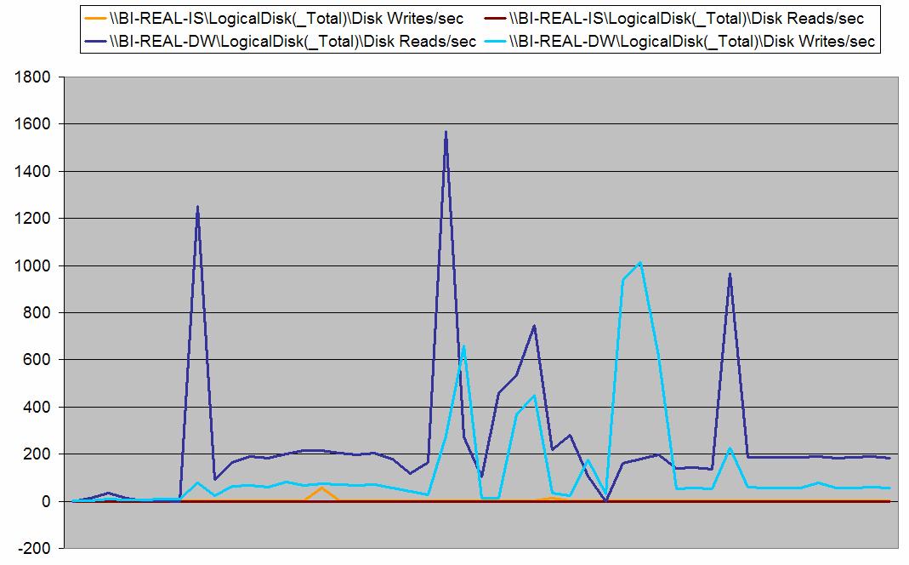
Figure 45
Since we can see that the execution of the ETL on a separate server incurs very little disk I/O (orange and brown lines), we know that the disk I/O overhead on the scale-up server (light and dark blue lines) is the database engine managing data commits to disk.
The chart in Figure 46 highlights network I/O, comparing the execution of the ETL on a separate server versus executed on the database server. The pink line shows network traffic when the ETL is run on the database server, BI-REAL-DW. The dark blue line shows network traffic for the execution of the ETL on a separate machine, BI-REAL-IS.
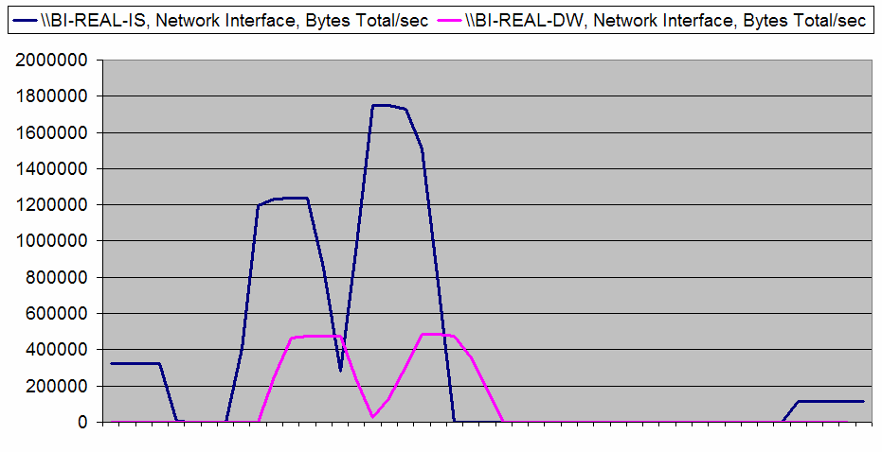
Figure 46
As observed, network traffic doubles when the ETL runs on a separate server. When the ETL is run on the same server as the data warehouse, the destination database is local for the packages. Therefore, inserts and updates do not incur network overhead.

Distributed versus consolidated server lessons learned
Lesson 4. Integration Services resource overhead is not focused on disk I/O; the pipeline architecture is more processor and memory intensive. The ETL process, when run on a separate machine had virtually no disk overhead. The scalability path for Integration Services is to increase memory so that Integration Services does not need disk to handle temporary storage when constrained by memory.
Lesson 5. Network I/O patterns show that local data loads reduce the network overhead, but high throughput server backbones provide a more than sufficient network tier. The distributed package run peaked out at under 10 Mbps (megabits per second), less than 1% of the bandwidth of a GigE network. Architecture decisions on scale up versus distributed are based on source system activity times, licensing, and shared application environments.

Conclusion
The business logic encapsulated in the core Integration Services control flow and data flow components represents the fundamental ETL operations that support the big picture objectives of Project REAL—available, organized, and accurate information for analysis. Besides the business data processes, an ETL solution requires mechanisms that support the administration and development methods, which have also been incorporated into the Project REAL solution. Overall, Integration Services provides the capabilities to meet these prerequisites—data and operational—with the performance, ease of development, and flexibility that are essential for today’s complex needs.
Recognition and thanks are due to the Barnes & Noble, Intellinet, and Microsoft Consulting teams for driving the “real” solution to success, and also to the Microsoft Integration Services development team for their invaluable help in providing design consultation and support through the beta lifecycle of SQL Server 2005. The lessons contained in this white paper were gained not only because of the time and effort put in during Project REAL, but also because of the hours spent in performance testing, design reviews, trials and error, and gathering and planning project requirements that went on at Barnes & Noble. This base has allowed the Project REAL effort to focus on taking the core ETL and optimizing, adapting, and enhancing it to be a strong ETL model for the SQL Server 2005 platform.

For more information:
http://www.microsoft.com/sql/solutions/bi/projectreal.mspx

Did this paper help you? Please give us your feedback. On a scale of 1 (poor) to 5 (excellent), how would you rate this paper?!href(mailto: sqlfback@microsoft.com?subject=Feedback: [Paper Title])

