MSN Spaces Photo Booth
Richard Davis
Software Design Engineer at SharpLogic Software
In this article we will take a look at the MSN Spaces Photo Booth project, and help you get started with the process of creating your very own.
The photo booth application is a Windows Forms application that shows you a live preview from a webcam in the left-hand panel, and the last captured photo in the right-hand panel. You can use the mouse to perform all operations, but if an Xbox controller is connected to the PC that will override the mouse movement control.
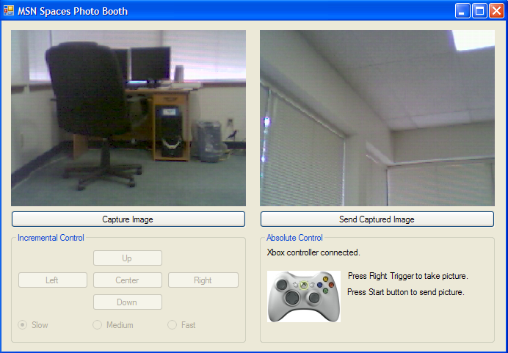
Figure 1 - MSN Spaces Photo Booth application in action

This project does require some hardware and software components, so please take note of these requirements before you get started.

Hardware Requirements
- If you would like to be able to control the camera from your computer, you will need a Phidgets Pan & Tilt Camera Kit. This will allow you to mount a webcam onto an assembly that has two servo motors, which control the pan and tilt movements.
- At a minimum, you will need a Logitech QuickCam Messenger webcam that plugs in via a USB port to your computer. You can get this from Amazon or Phidgets. You will not have control of the movements in this case, however, which is a lot of fun.
- Another fun add-on to this project is an Xbox 360 controller which you can get at a variety of electronics retail outlets as well as online retailer such as Amazon. As an alternative, a regular Xbox controller with USB adapter will work as well. With this, we can control the pan & tilt webcam, take pictures, and send them off to our MSN Spaces blog.
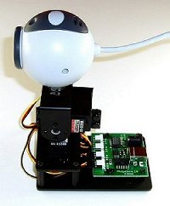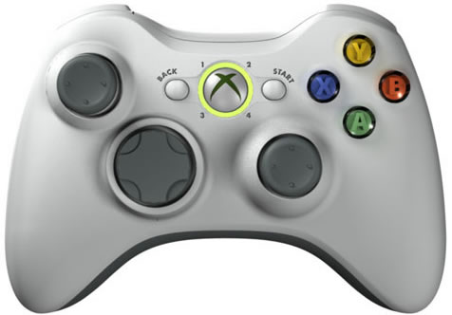
Figure 2 - Phidgets Pan & Tilt Camera Assembled | Figure 3 - Microsoft Xbox 360 Controller

Software Requirements
You should download and install the following software components in order to get the Photo Booth application up and running on your machine:
- Microsoft .NET Framework 2.0 if you don’t already have it on your machine.
  - To check if you already have it installed, go to your Windows Control Panel, select Add or Remove Programs, and check if the “Microsoft .NET Framework 2.0” is listed
- DirectX End-User Runtimes (April 2006) Full Download
- Microsoft Visual C# or Visual Basic 2005 Express Edition or higher.
- Phidgets device libraries. These are required to connect the Pan & Tilt camera kit.
- MSN Spaces Photo Booth application
- Sign up for an MSN Spaces account if you don’t already have one

Hardware Setup
Once you have the software requirements taken care of, you will need to assemble your pan & tilt camera. Detailed assembly instructions are provided on the Phidgets USA website. The camera itself may require you to install some driver software, and that should be included with the pan & tilt or your webcam package. Once the pan & tilt camera device is built and plugged in, you can attach an Xbox 360 controller to your computer via USB. Windows will automatically recognize the new hardware and you can play with it in the Game Controllers section of Control Panel:
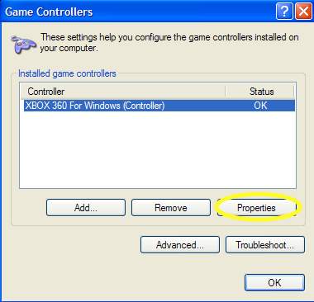 | 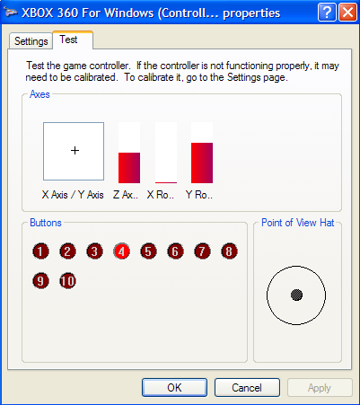
Figure 4 – Game Controller dialog box | Figure 5 – Properties window

Configuring your MSN Spaces Account
Some changes may need to be made to the configuration of your MSN Spaces account in order to allow the Photo Booth application to send blog updates to it.
- The first change is simply a checkbox to allow updates to be sent via email.
- The second change is to create a secret word that will be appended to your MSN Spaces account name when creating the email address that you will send your blog updates to. For example, if your MSN Space is at spaces.msn.com/myspace and your secret word is “secret”, then the email address to send blog updates to will be myspace.secret@spaces.msn.com.
- The third change is to add your email address to the list of emails addresses allowed. If you do not put the address you will be sending pictures from here, MSN Spaces will not accept them even if the secret email address is known. See MSN Spaces for more help if needed.
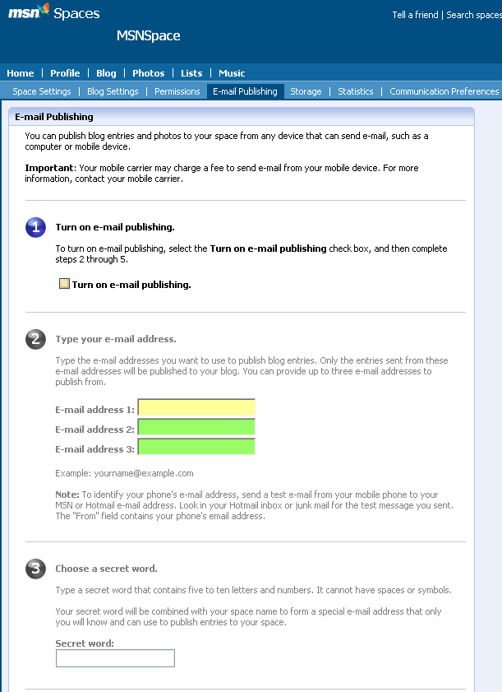
Figure 6 – Configuring your MSN Spaces account

Configuring the Photo Booth Application
Before you fire up the Photo Booth application, you will need to make some changes to the application configuration file. Open the MSNSpacesPhotoBooth.sln solution file in Visual Studio and load the App.config file from the Solution Explorer. You will see a number of application setting keys that look something like the following:

<add key="msnSpacesEmail" value="account.secret@spaces.msn.com"/>
<add key="mailServer" value="mail.myserver.com"/>
<add key="mailServerAccount" value="myemail@myserver.com"/>
<add key="motorMoveIncrement" value="0.03"/>
<add key="pictureTitleDialog" value="false"/>

- The “msnSpacesEmail” key is for the value of the email address used to send updates to the blog.
- In order to send email out, you will need to provide values for the “mailServer” and “mailServerAccount” keys.
- The “motorMoveIncrement” is a setting that affects the movement of the servo motors that control the camera when using the mouse controls. Increasing the value will speed up the movement, decreasing the value will slow it down.
- Finally, the “pictureTitleDialog” key determines whether or not the user will be prompted to enter a photo title when sending a picture to MSN Spaces. If it is set to “false”, the Photo Booth application will add the current timestamp to the image by default.

Running the Photo Booth Application
At this point you should have following setup steps completed:
- Constructed pan & tilt camera – powered and attached to PC
- Installed camera drivers and software
- Installed Phidgets library
- Attached Xbox controller to PC via USB (optional)
Now you should be ready to play with the Photo Booth application. With the MSNSpacesPhotoBooth.sln solution file open in Visual Studio, press F5 to start the application. At this point, you should see the main Photo Booth form load and a live video preview shown in the left-hand panel. Use the left thumb stick on the Xbox controller to move the camera around. The right trigger of the Xbox controller will take a picture and the Start button will send the last captured picture.

When you send a picture with the Photo Booth application, it will take the last photo snapshot that was taken and add it as an attachment to a new email message. Next, everything is packaged up and sent off asynchronously using a SmtpClient object. While this packaging occurs, the photo booth application will not allow more pictures to be sent - this will result in an error.

Note: The first picture may take a few moments to be sent, but subsequent pictures should be faster.

As long as you do not receive any errors, wait a few minutes for the message to get posted on your MSN Spaces blog. If you then navigate or refresh your MSN spaces blog page, you should see the new photo posted!

MSN Spaces Photo Booth Architecture
This project does not actually involve too much original coding to get things up and running. It definitely is a lesson in integration, however, because we leverage quite a few other libraries and code snippets that are freely available. Most of the classes listed in Figure 7 below were developed by other people who were kind enough to release their code for the hobbyist community.
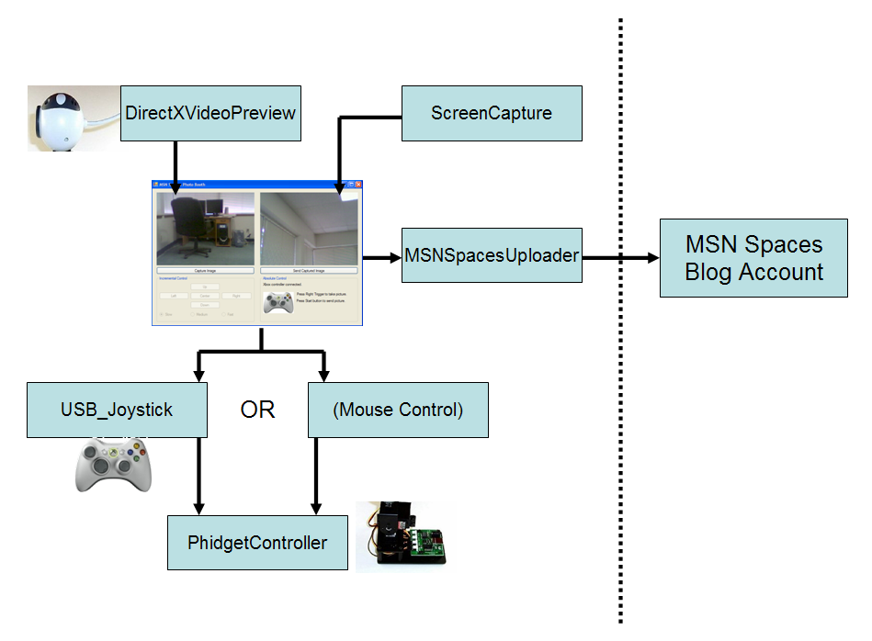
Figure 7 - Overall Picture Booth Application Components

Figure 7 gives you an idea of how the hardware components of this project tie into some of the classes you will find in the project solution. To begin exploring the code base for this application, start with the PictureTakerForm code file. As you read through the code and comments, you will notice how the use of the existing libraries that we have been referring to have made life much easier for us. We do not need to have much of an understanding of the hardware components; we just need to know how to integrate with the libraries.

Open the MSNSpacesUploader code file and read through the code. This class was developed to take care of the uploading of pictures to a MSN Spaces blog. It provides a public method named UploadPicture that takes a filename and title as strings. UploadPicture will create a new MailMessage object using the email account settings that were set when the MSNSpacesUploader object was created. Next, a new Attachment object is created that contains the picture to be sent. After adding the new Attachment to the Attachments collection, the mail is sent asynchronously using a SmtpClient object. The MSNSpacesUploader class also provides a SendComplete event so that the main Form can be updated when the mail message is sent.

MSN Spaces Screensaver
Once the picture taker application is up and running, you can view the pictures by visiting your MSN Space using Internet Explorer or by using one of the many different blog readers available. Another possibility is to do it yourself!

In this section we will take a look at a screensaver that uses the RSS feed from your MSN Blog in order to extract the remote picture files for display. This sounds like it could be quite a bit of work, but luckily for us the Express editions of Visual Studio come with a Screen Saver Starter Kit that already has much of the functionality that we desire for this project.

The Screen Saver Starter Kit has already implemented functionality for working with RSS feeds and displaying text and graphics, and is already setup to be recognized as a screen saver application by Windows. It also has a dialog box that allows the user to provide configuration information like the URL to the RSS feed.

Before we can setup the screen saver, we will need to build it. To do this, load the MSN Spaces screen saver solution file (either MSNSpacesScreenSaver.sln or MSNSpacesScreenSaverVB.sln) and select Build | Build Solution from the main menu. This will create the screen saver executable file for you in the “bin\Debug” directory of the project you choose to build.

If you run the executable you just built, you will only see the title of the screen saver because it has not been installed and configured on your machine yet. To install the screensaver on your computer:
- Change the extension of the file from .EXE to .SCR (accept any warnings).
- Right-click on the file and select Install (brings up Display Properties window).
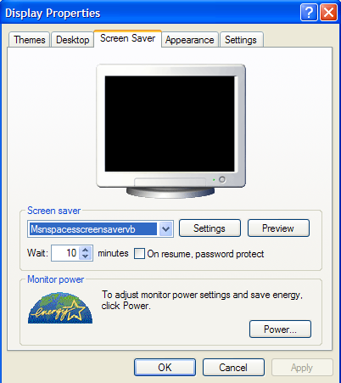
Figure 8 – Display Properties dialog box

- Click on Settings in Display Properties window (brings up Screen Saver Settings).
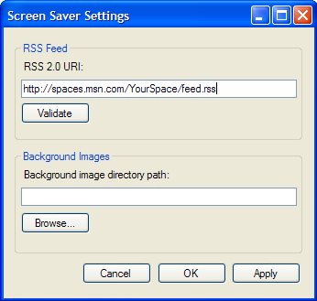
Figure 9 – Screen Saver Settings dialog box

- Enter the URL to your MSN Spaces Blog RSS feed and click Validate to make sure that the RSS feed is set up correctly.
- To save your changes, click the Apply button followed by the OK button.

To preview the screen saver, press the Preview button in the Display Properties window. The first image that is displayed is the title screen which simply describes what the screen saver is all about. The screen saver then loads the RSS feed that is configured and looks for images to download from the MSN Spaces server. As images are downloaded, they are cached locally so that there is not need to keep downloading them after the screen saver slideshow starts over. In addition, the screen saver will reload the RSS feed to check for changes at the start of every cycle so that if new pictures are added they will be shown.

Conclusion
This project can help get you get started with building your own virtual photo booth, however there are many areas where it can be improved upon. One great feature to add would be to allow users to take multiple photos while offline. Right now you can take a single snapshot and upload only that image. Taking subsequent snapshots will result in the loss of the previous shot. It would be great if you could add a mode where each shot was saved, like a digital camera does, and then provide a way to pick which pictures to upload later. In addition, it would be great to be able to do some quick cropping, image manipulation, filters, and so on.

Credits
Thanks go out to the following groups and individuals:

DirectX.Capture library and DirectXVideoPreview class thanks to Brian Low.
Visit http://www.codeproject.com/cs/media/directxcapture.asp for more information or visit www.codeproject.com and search for DirectX.Capture.

PhidgetController class for working with a set of pan and tilt servos thanks to PhidgetsUSA and Matt Trossen, Alex Ward, and Brian Keller.

USB_Joystick class for working with Xbox controller thanks to PhidgetsUSA and Alex Ward.

ScreenCapture class for taking capturing frames from the video preview panel thanks to James Crowly. Visit http://www.developerfusion.co.uk/show/4630/ for more information.

