A Platform for Institutional Effectiveness

*A Microsoft Corporation White Paper for Higher Education*

*March 2010*



# Abstract

The *Microsoft Platform for Institutional Effectiveness (MPIE)* is an integrated technology architecture connecting all people across an educational institution with the information they need to direct their actions in a manner consistent with the institution’s goals and priorities. The model is differentiated from more common approaches that focus primarily on business intelligence (BI) tools. The Microsoft® approach incorporates BI as a component of a more comprehensive architecture that unifies quantitative analytics with qualitative assessment within a familiar collaborative environment. The integrated architecture is targeted at aligning daily activities with strategic priorities and capturing front-line observations that inform strategic planning.

The MPIE is not something that institutions need to “go buy.” In fact, the overwhelming majority of U.S. institutions already license and use many of the Microsoft products that comprise the key components of the architecture. It is the underlying Microsoft technologies that enable broad and impactful adoption across the institution because they are both affordable and familiar. This is, however, a comprehensive approach that institutional executives must lead. Successful utilization of this model is primarily dependent upon executive leadership guiding an institutional commitment to foster a culture of evidence and accountability corresponding directly to mission, vision, and goals.

This paper describes the Microsoft Platform for Institutional Effectiveness and explains how technology that is already owned (affordable) and already used (familiar) can be broadly adopted across the institution. This platform supports a culture (everyone) where goal-focused and evidence-based behavior optimizes institutional resources toward balanced goal attainment across administrative efficiencies (business), academic outcomes (learning), and constituent relationships (lifestyle) in alignment with fulfilling the institutional mission and advancing on the published vision.

Table of Contents

Abstract 2

Executive Summary 5

Collaborative Analysis 8

Accountability Is More than Business Intelligence and Assessment Is More than Numbers 8

Differentiating Analysis and Business Intelligence Analytics 8

Institutional Effectiveness Is a Cultural Change 9

It Begins with Executive Leadership 9

Driving an Adoptive Culture 9

Information Is Everywhere 10

The Need to Stay Connected 10

Transforming Business Intelligence into Institutional Effectiveness 12

Breadth of Deployment 12

Effectiveness: Guiding Principles 13

It’s Not as Easy as It Sounds 13

Focus on the Project, Not the Product 13

Pay for Value-Based Solutions, Not Products and Tools 14

Culture Means Everybody 14

Analytics Require Active Contribution to Achieve Real Value 14

Meeting the Challenge 15

Microsoft Platform for Institutional Effectiveness 19

Effective Institutions Are the Result of Effective People 20

Four Core Elements of the MPIE 20

Focused on People 20

Based on Familiar Tools 20

Integrated Platform for Identity, Content, and Data 20

Broad Based Application Partner Ecosystem 20

Recommended Steps 21

Appendix 23

Technical Architecture 23

Technology and Architecture 23

Portal Infrastructure (Presentation Layer) 24

Unified Communications and Collaboration 24

Seamless and Intuitive 25

Process- and System-Integrated 25

Flexible and Trusted 25

Streamlined Communications Through Microsoft Unified Communications 25

Content Management and Collaboration Infrastructure (Middleware Layer) 26

Web Services 26

Integration 27

Comprehensive Search 27

Security, Data Management, and Systems Integration (Core Services Layer) 27

Identity Management 27

Data Management and Systems Integration 28

Interoperability 29

Application Integration and Business Process Management 30

Cloud-Based Services: The Next Generation of Service Offerings 30

Windows Azure Platform 30

# Executive Summary

*Institutional effectiveness* is a most interesting term. What is it that determines precisely how effective a higher-education institution really is? As colleges and universities across the country are facing increasing challenges from operational pressures, competition for students, faculty, and research funding, coupled with the need to educate a new generational workforce, there are constantly increasing demands to achieve more with fewer resources. These demands are forcing institutions to be able to better assess themselves relative to progress against goals, and in greater detail than ever before. As a result, institutional effectiveness is increasingly focused on a deeper and broader understanding of critical administrative, academic, and relationship programs and outcomes, and how they align to an institution’s mission and goals.

When faced with these challenges and continually varying education market conditions, it is often easier for a higher-education institution to focus more on efficiency (the achievement of maximum result with minimal effort by measuring output over costs or time) than it is to drive greater effectiveness (producing a decided, decisive, or desired effect). This frequently leads to a healthy debate on college and university campuses as to whether efficiency is a byproduct of effectiveness or vice versa. Efficiency is certainly a component of effectiveness, but it must be balanced with attainment in key areas of institutional accountability, such as academic achievement and constituent relationships. Efficiencies that threaten institutional reputation, for example, are no bargain.

Reducing costs, streamlining operations, and eliminating programs are often the first approaches that are used to try to stem the tide of issues that arise during challenging times. Experience demonstrates, however, that this cannot be the only approach to reach the desired outcomes that define an institution’s overall effectiveness against its goals. On the contrary, in an article published in *The Chronicle of Higher Education* (May, 2009), Molly Corbett Broad, President of the American Council on Education, was quoted as saying, “This is a time when the game is changing. Hunkering down is not a smart option.” The impetus behind her statement was that challenging market conditions call for bold and self-assured action if institutions want to increase their effectiveness and their potential to meet and exceed their defined goals and objectives. In reality, it is becoming increasingly obvious that effectiveness and efficiency are not mutually exclusive goals. There are countless examples of efficient actions that result in greater effectiveness by both reducing costs and improving key outcomes—for example, online bill payment reduces costs, streamlines cash flow, and improves student services by providing more convenient options.

In order to take this more comprehensive approach, higher-education institutions are recognizing the importance of being able to assess effectiveness at the institutional, department, program, course, and individual levels. This is not an easy task and there are numerous challenges to optimizing effectiveness. Successful initiatives require better planning, setting specific goals, accessing the right information at the right time, and defining objective and measurable assessment criteria. Fortunately, today’s technology-based approaches enable the advanced collection and alignment of data and information to measurable goals and objectives. This empowers institutions to gain a broader understanding of their status and progress across all functional areas, including academics, organizational resource alignment, and the overall student and faculty experience.

It is not really possible to achieve a thorough understanding of just how effective an institution is without its leadership team fostering and sustaining a culture of accountability. That is, an environment that enables wide-ranging review of progress against objectives, coupled with an ability to determine the most effectual approaches to replicating success and improving upon initiatives that are not meeting their defined goals.

At Microsoft, our aim is simple—to help our higher-education customers take full advantage of the information that they can garner from their administrative and academic environments by aligning it directly to the goals and aspirations of their respective institutions. This enables more effective planning and decision making, and allows for improved tracking and evaluation of categorical progress, areas requiring improvement, and successful programs and initiatives. We believe that we can best do this by helping institutions realize a stronger balance of attainment that results from the wide-ranging involvement of people across the institution into the process of aligning day-to-day actions with the broader goals of the institution.

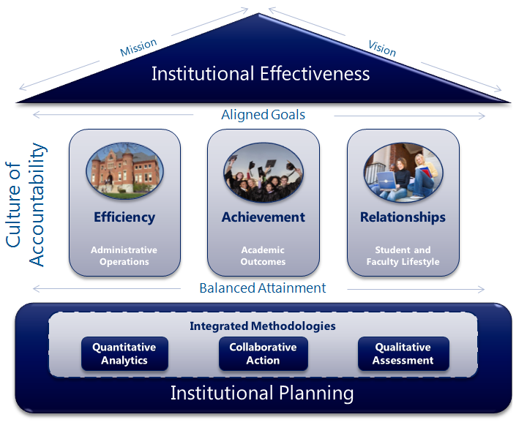

Figure 1. Microsoft Platform for Institutional Effectiveness

As defined in this white paper, and illustrated in Figure 1, our platform is an architectural approach that integrates institutional planning, collaboration, analytics, and assessment into the everyday actions of higher-education constituents in order to foster an institutional culture of accountability. The model recognizes that quantitative analytics, qualitative assessment, and collaborative action are actually integrated methodologies, that when properly aligned with institutional targets, can lead to more balanced goal attainment. This approach has been developed from an increasing understanding that both greater effectiveness and efficiency are derived from a focus on bringing together people, processes, and information, and not from the isolated use of individual technology products. It is through this model that Microsoft is committed to working more closely with our higher-education customers to better ensure that information, productivity tools, and applications are more effectively aligned to the mission, vision, and strategic objectives of their institutions and constituents.

*“Colleges may find themselves forced to shut certain programs and cut certain people the way the auto manufacturers and other industries are shedding workers and divisions. But unlike those businesses, they have more than the bottom line to guide them. Colleges have values and missions.”*

*- Goldie Blumenstyk, “In a Time of Crisis, Colleges Ought to Be Making History,” The Chronicle, May 1, 2009*

# Collaborative Analysis

## Accountability Is More than Business Intelligence and Assessment Is More than Numbers

Institutional effectiveness is a continuous cycle where administrators, staff, faculty, and students make decisions informed by facts, act decisively, assess the results, and continually cycle back as part of a comprehensive process that begins with strategic planning and ends with specific follow-up. Business intelligence (BI) tools maneuver the quantitative data elements that enable stakeholders to measure actual progress on a recurrent basis. But it is the integration of qualitative assessment and the collaborative action of functional groups that delivers the rich analysis and identifies the specific actions needed to overcome complex institutional challenges.

There are many case studies and customer examples of institutions that have solely implemented specific BI products. Many such studies tout efficiency gains in time savings related to access to information, but few go on to mention gains in effectiveness and improvements in institutional outcomes. The limitation is that these implementations are often technology-centric approaches that are focused on the functionality of a product or group of products. An institutional-effectiveness initiative, conversely, is a comprehensive, process-centric approach focused on successful adoption by people, and is led by a leadership team committed to fostering a culture of accountability based on attainment of clearly understood goals.

## Differentiating Analysis and Business Intelligence Analytics

Many business-intelligence solutions available today include tools for “analytics,” meaning that within the suite of technology tools that can display structured data in reports or dashboards, there are also capabilities for advanced data visualization and possibly even data-mining. These tools can be very effective at presenting *quantitative* data in impressive and easy-to-understand formats capable of delivering insight and identifying trends that ad-hoc tools might never surface. Without question analytics can be very useful, but it is not analysis.

***BI = Quantitative***

***Analysis =   
Quantitative + Qualitative + Collaborative***

Analysis includes the *qualitative* process of situational assessment, the intelligent series of questions that inevitably follows, and seeks to better understand the impact of discrepancies between a college or university’s plan and actual results. Institutional analysis includes the collaborative recognition of root causes and builds towards agreement upon a course of action that assures continuation of those things that are working or defines corrective measures for those that are not. Analysis is a key element of institutional effectiveness that drives comprehensive, continuous planning and an action-oriented process that can lead to the resolution of issues and the removal of obstacles that can impede the achievement of institutional goals.

# Institutional Effectiveness Is a Cultural Change

## It Begins with Executive Leadership

While implementing a specific BI product may have more easily identifiable project milestones and clear lines of responsibility (that include the IT organization), an institutional-effectiveness initiative is an ongoing and continuous process that begins with executive leadership and extends throughout the institution. This is by no means an easy task. As stated by Sal Rinella, President of the Society for College and University Planning, as he addressed the elements of a successful planning process, “Leaders who successfully guide these forces and take their institutions to a higher plane do so through a unique, almost magical, combination of art, science, politics, psychology, and, most would admit, good fortune … and the development of organizational capacity and the culture to make it work.”

Fortunately, with today’s tools, integrating the combination of factors referenced in this paper makes the entire process less “magical.” It can now be more firmly based on quantitative, qualitative, and collaborative analytics integrated with methodologies that very accurately reflect the current status and developing trends across an institution. Analytical-based evaluations that provide the foundation for institutional planning allow for continual monitoring of progress while fostering an environment of assessment and accountability. This allows an institution to better model results, and to drive specifically targeted action that is directly aligned with its objectives.

## Driving an Adoptive Culture

Technology’s actual impact on an organization is directly related to how it is used and how many people use it. Technology has the potential to connect people with the information they need to drive individual actions in a manner aligned with institutional goals. In order for technology to be most effective, however, it must be used. For many institutions, the tools for connecting people (collaboration), storing and managing documents and information (content management), and accessing data (BI) are independent of one another. They are generally not tied to a distributed and strategic planning framework that aligns goals and objectives at each level of the organization. Data must be available, but also must be tied to a context that is meaningful to the person looking at it. To which of my goals and objectives does this data relate? How will my thinking and the subsequent actions derived from the data change? Unfortunately, it is often the lack of integration, limited familiarity with new technology products and their respective user interfaces, and the inadequate relevance of “just looking at data” that results in less than desirable levels of user adoption and overall impact on the institution.

***Adoption Depends on   
Familiarity + Relevance + Integration***

A typical scenario for someone seeking information is to first ask a colleague, then search existing documents and Web pages, and then ultimately he or she may finally defer to a still unfamiliar BI tool, or more likely, have someone else do it for them. Assuming that they are successfully able to access information, they are then likely to invoke what is the most commonly used function across all BI tools—export to *Microsoft Office Excel®*. This is such a common step because it moves information into a familiar everyday tool from which users can add narrative to provide additional context, and it is often integrated with collaboration tools that allow them to share the information, to solicit feedback, and to try to keep others updated.

## Information Is Everywhere

One of the primary challenges is that essential information comes in many forms. Some of it resides in structured databases, even more exists in unstructured content (for example, files, e-mails, and instant messages), and often times the most impactful information is in the possession of individuals. An effective information access strategy must not only enable access to information in databases, but must facilitate connections, communications, and collaboration across people, documents, and data. This in turn leads to an environment that is easier to use, more impactful, and drives a broader based rate of adoption across the institution.

***Preferred Information Sources:   
People, Documents, Databases*** *documents, and heads*

## The Need to Stay Connected

In the earlier referenced “export to Office Excel” scenario the user moves the data into a familiar tool so that they can better share the information and connect with others. There is, however, a disconnect that occurs. The data is now actually disconnected from its original source. In this example, any edits or changes are now made by the individual user and are no longer contained within the institutional asset that holds the “single version of the truth.” The impact of the disconnected data may cause numerous discussions where the primary debate centers on the difference between “your data and my data.” A common approach to address this situation is to cast blame and identify Excel as the problem. The actual problem is disconnected data. An asset with nearly ubiquitous adoption and utilization across the institution (like Excel) is one to be effectively leveraged, not abandoned. Today’s BI solutions can be easily integrated with tools like Excel, and make it possible for users to browse and access data from a “single version of the truth” through a familiar interface. By leveraging familiar tools and integrating enterprise data into an everyday collaborative environment, an institution can provide all users with access to shared and trusted information that is used to make or support strategic decisions and everyday actions. This can provide institutional leaders with greater assurance that analysis and decisions are more often based on consistent data points being utilized across the institution. Additionally, as integrated and collaborative analytical and analysis tools are adopted across the institution, it becomes easier for an institution’s leadership team to drive and sustain a culture of greater accountability.

# Transforming Business Intelligence into Institutional Effectiveness

As outlined in Figure 2, specific steps can be taken to assure that data and information derived from business intelligence initiatives has a greater impact on institutional efficiency and effectiveness.

|  |  |  |
| --- | --- | --- |
| Expand the range of: | So that the Institution can more effectively… | Microsoft Platform Tenet |
| Information Sources | **Connect people with the most appropriate information and resources available, spanning databases, content, individuals, and teams.** | **Critical information resides across the institution, in many formats, both within and outside of the institution’s Enterprise Resource Planning (ERP) system.** |
| Functionality | **Combine quantitative evidence with qualitative narrative to capture contextually relevant insight from the individual and the team.** | **Wider-ranging capabilities turn viewers of information into institutional planning participants and contributors.** |
| User Deployment | **Expand a culture of accountability through pervasive access to relevant information.** | **Drives greater responsibility for institutional effectiveness across the institution.** |

Figure 2. Factors that transform the impact of BI

## Breadth of Deployment

As many institutions strive to create a true culture of accountability, the focus tends to continue to be more on access to data and less on culture. For accountability to effectively become part of the culture it must be pervasive and prioritized. That makes it essential for BI, as a component of institutional effectiveness, to fully support and drive the ability of an institution to track progress against goals and objectives. Its use and role must be clearly delineated and pervasive so that the principles of measurable and definable accountability become a part of the fabric of the institution as a whole.

Breadth of Capability

Whereas BI is focused on presenting information, institutional effectiveness is about decision makers and stakeholders learning from information in order to validate and then guide subsequent actions. Effective BI must go beyond the presentation of quantitative data. It must include the capture of an individual or group’s qualitative thinking about what they know or have learned, and the collaborative actions that will occur as a result of their analysis. Of course the prerequisite to this process is alignment. The identified goals and subsequent tracking of progress against goals of any individual, group, or department scorecard must be appropriately aligned with the priorities and expectations of the institution as a whole.

In summary, BI technologies alone primarily present quantitative data, while well-conceived institutional-effectiveness strategies integrate quantitative presentation with qualitative review that is directly linked and aligned with the goals of an institution’s mission and vision. In recognition of the increasing pressure for greater accountability, institutions of higher education have begun to respond. Many are creating new organizational positions to drive effectiveness, others have instituted more stringent program review procedures, and all are looking at technology solutions as a vehicle to help them collect, manage, publish, reflect, and act on information and content.

# Effectiveness: Guiding Principles

## It’s Not as Easy as It Sounds

Connecting people with information may be an easy concept, but it is complex in its application. At a minimum it requires sufficient knowledge of the user, the context, and the information. Properly identifying “who you are,” “what you need,” “where you can find it,” and “how you can deliver it” in a timely manner requires the coordination of multiple technologies, the user’s role and identity management, adherence to institutional policies, and a clear definition of process.

## Focus on the Project, Not the Product

Although the evaluation process for the selection of a BI product can stimulate the necessary procedural and process initiatives required as part of an institutional effectiveness strategy, many organizations place too much value on the BI product itself rather than the desired outcomes. As a result, it is critical for institutional leaders to keep staff and constituents focused on the objectives of the effectiveness process as they relate directly to the mission and strategic goals of the institution.

## Pay for Value-Based Solutions, Not Products and Tools

It is essential for an institution to assess the infrastructure and tools that it already uses to determine if they can provide some of the capabilities that address the needs of its effectiveness objectives. An institution should resist the urge to buy technologies offering analytical capabilities that it may already own and recognize the value of proven applications, or services, that can speed implementation, eliminate risk and/or cost, and that offer relevance. Funding can then be redirected from individual technology tools to architecturally integrated solutions that are based on a sound technology foundation.

## Culture Means Everybody

Many institutions seek a “culture of accountability” but often tend to focus more on data than culture (people). Successful approaches to institution-wide effectiveness drive adoption across the institution (see Figure 3), from decision makers in the Provost’s office to trend analysis work in the Enrollment Management office. This can only occur when the importance is clearly defined as a priority from the leadership of the institution.

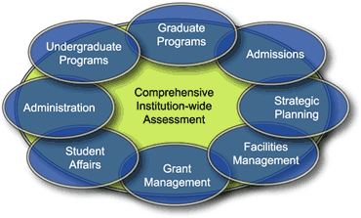

Figure 3. Institution-wide effectiveness

## Analytics Require Active Contribution to Achieve Real Value

Analytics begins with the presentation of information. As positive and negative conditions are identified, an institutional-effectiveness platform engages contributors to augment data with contextually relevant thought, debate, and narrative. This leads to a stronger participative, data-driven, decision-making environment across all levels of the institution. By integrating BI into a familiar collaborative environment that recognizes and rewards contribution, you not only capture both quantitative and qualitative assessment, you also stimulate action among individuals and teams to mitigate risk and seize opportunities for improvement and goal attainment.

# Meeting the Challenge

The remainder of this white paper describes how Microsoft technologies, integrated with third-party business-partner solutions, can address the challenges defined earlier. Through our continuing work with our higher-education customers, we have been able to successfully demonstrate to them how they can apply many of the technologies that they already own to drive a comprehensive and integrated institutional-effectiveness strategy across their institutions.

A leading example of an application that helps facilitate collaborative accountability is the *TracDat* application from Microsoft business partner, Nuventive (Pittsburgh, PA). *TracDat* supports institutional assessment, strategic planning, administrative planning, and accreditation through a unified framework. Nuventive’s approach, which is often integrated as a key component of the Microsoft platform, recognizes that effective outcomes assessment requires commitment to a goal-aligned, continual closed-loop process that occurs throughout the institution. This process (see Figure 4) unites data with the thinking and action(s) that result from an institution’s commitment to a role-based planning strategy. The application enables all areas of the institution to use data to effect change, and to define, document, manage, assess, and present achievements to key constituents.

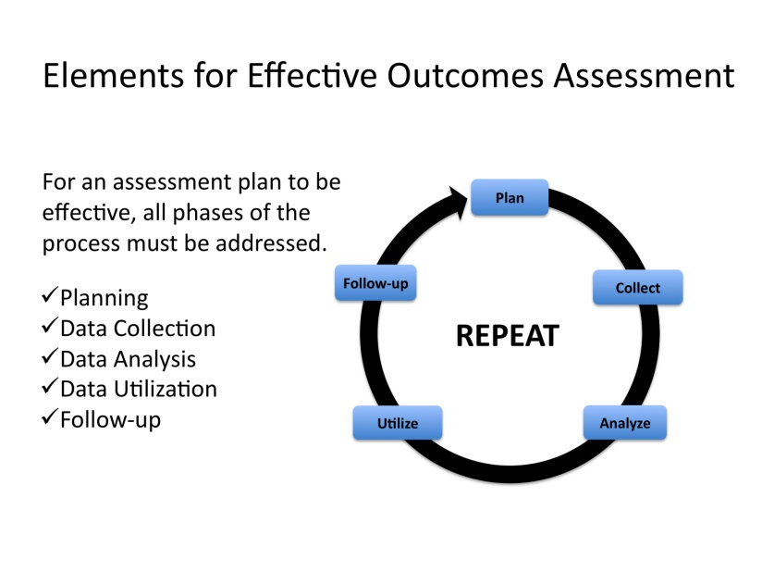

Figure 4. Elements for effective outcomes assessment

Our work with Nuventive validates the fact that planning processes can often stall at the level of plan creation, with less change having taken place than what was desired or expected. Technology, however, can dramatically impact and support goal-aligned, data-supported change by enabling the process and making it easier to discern progress, or the lack thereof, on an ongoing basis. As illustrated in Figure 5, this changes the focus from having little or no formalized process in place to adopting a cycle of continual assessment of information that supports measurable attainment of the goals and objectives of the institutional plan.

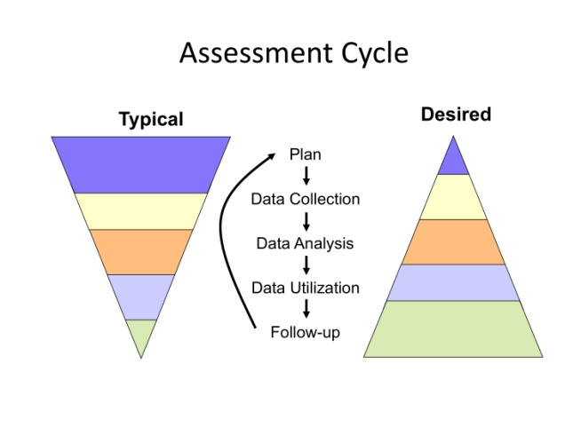

Figure 5. Assessment cycle

*TracDat’s* integration with *Microsoft Office SharePoint®* *Server* extends Nuventive’s solution by leveraging the robust collaboration, document management, and data management capabilities found within SharePoint. Accessing institutional effectiveness through a familiar and user-friendly, role-based interface supports the expansion of a culture of data-driven change by more effectively driving the involvement and participation of a wider representation of the institutional community. As illustrated in Figure 6 and Figure 7, the combination of powerful technology and application products can create an easy-to-understand and easy-to-use environment that directly addresses the challenge of defining and monitoring progress against institutionally aligned goals.

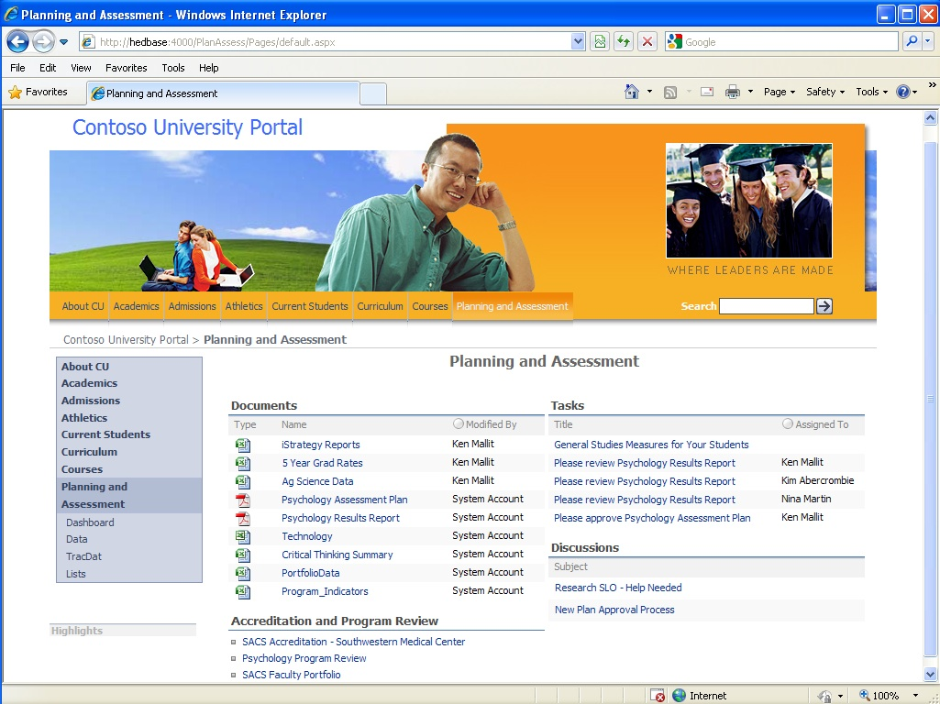

Figure 6. Example of an integrated planning and assessment portal

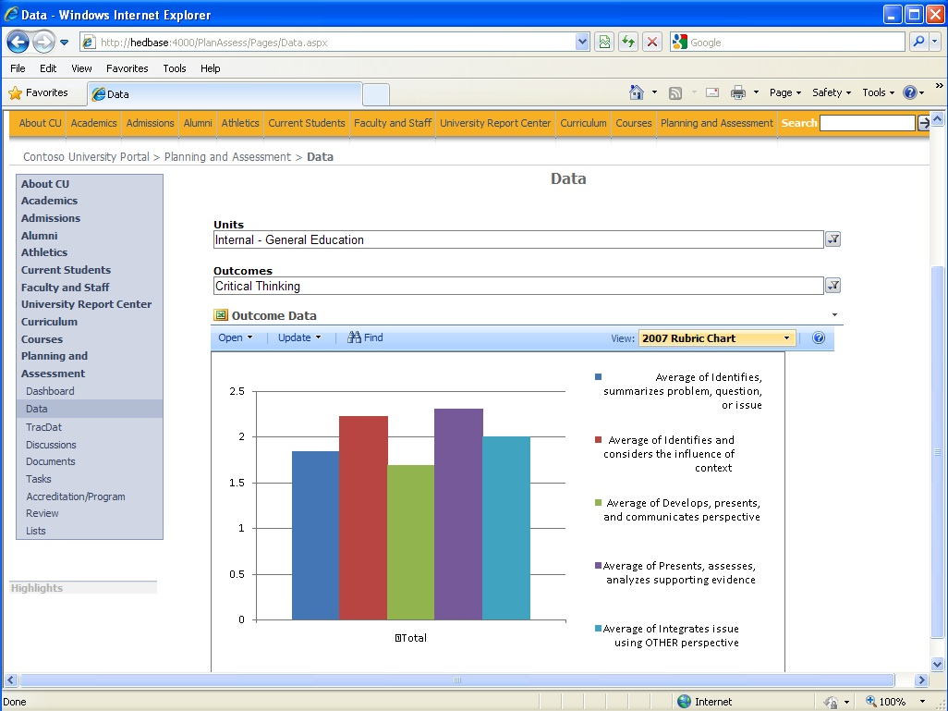

Figure 7. Example of a graphical representation of student assessment data

# Microsoft Platform for Institutional Effectiveness

The *Microsoft Platform for Institutional Effectiveness* (MPIE) provides higher education leaders with an opportunity to combine *qualitative assessment* with *quantitative analytics* within a familiar *collaborative environment* and engage individuals across their respective institutions in the ongoing process of enhancing institutional progress against defined goals and objectives.

By leveraging the model an institution can:

* Align leveled priorities and actions with the mission, vision, goals, and initiatives of the institution.
* Affect daily action with better information to drive decisions.
* Capture relevant data and observations to guide continuous improvement towards goal attainment.
* Create and monitor measurable progress at all levels against an institution-wide strategic plan.

Based on an *integrated information infrastructure* as shown in Figure 8, the platform connects people and information across the institution. Using familiar technologies, many of which most institutions already own, it provides for a significantly lower cost of deployment, an increased rate of adoption, and provides constituents (based on their individual roles) the timely information that they need to make better decisions.

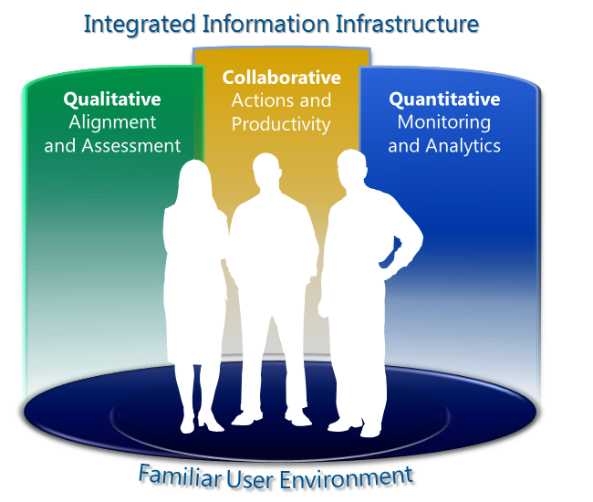

Figure 8. Familiar user environment

# Effective Institutions Are the Result of Effective People

By focusing on enhancing individual performance through more pervasive utilization of everyday tools, an institution can more quickly impact a broader population of its constituents. This approach allows an institution to shift resources away from the evaluation, acquisition, and deployment of new products and focus instead on the evaluation and design of new processes to improve academic outcomes, administrative efficiency, and the student/faculty experience.

Although this document does discuss technology as a key enabler, it is written from the perspective that investments in technology must be balanced with improvements in process and investments in people. One way to achieve that balance is to assess the capabilities of the tools that the institution already owns. This leads to a better understanding of how desired process improvements can best be achieved. The MPIE combines assessment, analytics, and action in a single familiar user environment, enabling broad and rapid adoption across the organization and encouraging continuous process improvement. Deploying new tools across an institution can be very costly, thus it is important to note that this is an architecturally based approach that capitalizes on technologies that the vast majority of colleges and universities already own and use every day. It is designed to be both affordable (so that it can be deployed across the organization) and to work with familiar end-user tools (so that it can and will be more easily adoptable across the institution).

## Four Core Elements of the MPIE

### Focused on People

Technology does not resolve business and academic challenges—people do. The platform provides the integrated infrastructure and familiar end-user tools necessary to enable the process of innovation by seamlessly integrating assessment, analytics, and planning into the everyday culture of the institution.

Based on Familiar Tools

Adoption is the key determinant of success for any project. The approach is fully integrated with the familiar Microsoft Windows® and Microsoft Office environment that your institution most likely already owns, and that people in your organization most likely use every day.

Integrated Platform for Identity, Content, and Data

The architecture seamlessly integrates identity management, enterprise content management, and data management into a single platform.

Broad Based Application Partner Ecosystem

The partner ecosystem ensures a wide range of choice and long-term flexibility for the specific applications that provide functionality for planning, accountability, business intelligence, academics, the business of institutions, and the student/faculty experience.

The Microsoft Platform for Institutional Effectiveness is unique in that it helps an institution address the challenges associated with traditional BI initiatives by:

* Uniting quantitative and qualitative analysis within collaboration and productivity tools.
* Integrating periodic assessment activities into daily productivity and decision making.
* Broadening access across the institution by using familiar and affordable tools.

# Recommended Steps

Microsoft Corporation recognizes that it holds a position of privilege within the higher-education community. It is a place that allows us to work closely with the vast majority of higher-education institutions across the country. As a result, we understand our responsibility to continually strive to add as much value to our business relationship with our higher-education customers as we can. This is why we have invested considerable time and effort into evaluating our role in helping institutions of higher learning address key challenges, such as overall effectiveness, progress against goals and objectives, and the optimization of their increasingly important technology environments.

What we have long understood is that technology products alone do not provide solutions to challenges and problems. It is the people that use technology products and the way in which they are integrated into our customer’s businesses that make them most effective. Nowhere does this apply more aptly than to the process of defining and accounting for progress against institutional-effectiveness targets. We recognize that supporting, developing, and realizing a culture of measurable accountability is not easy to accomplish. It requires a philosophical commitment, leadership, support, and effective tools to manage and understand progress.

The development of our *Platform for* *Institutional Effectiveness* is a result of our understanding of the organizational and operational dynamics of higher-education institutions, the complexity and importance of the need, and the realization that we have products and partner solutions that, when combined, can provide a powerful solution to an important challenge.

If your institution is interested in having a serious dialogue about institutional effectiveness, inclusive of the importance of accountability and assessment, strategic planning, academics, the business of your institution, the student and faculty experience, and the optimization of technology investments—so are we. Each of these topics is a key to an institution’s overall mission, vision, goals, and objectives. Each is a key component to perceived and realized effectiveness. The discussion is easy to initiate. Contact your local Microsoft representative and the process has begun.

**Authors**

*Richard M. Seidner, Executive Director, Microsoft U.S. Public Sector Education*

*Rob Curtin, Solutions Specialist, Microsoft U.S. Public Sector Education*

*Richard Young, Senior Technical Architect, Microsoft U.S. Public Sector Education*

# Appendix

# Technical Architecture

## Technology and Architecture

The Microsoft Platform for Institutional Effectiveness consists of three distinct functional layers (see Figure 9 on the next page):

* User Experience (Presentation Layer)
* Portal, Document Management, and Collaboration Infrastructure (Middleware Layer)
* Security, Data Management, and Systems Integration (Core Services Layer)

These three layers are comprised of the following Microsoft server product suites and/or technologies:

* *Microsoft Office SharePoint Server with PerformancePoint® Services*
* *Microsoft Exchange Server 2007*
* *Microsoft Office Communication Server 2007*
* *Microsoft Windows Server® 2008*
* *Microsoft SQL Server® 2008*
* *Microsoft Silverlight®*
* *Microsoft BizTalk® Server*

The Microsoft approach to solution architectures is to provide our customers with the ability to incorporate, over time, those features critical to the institution’s specific needs while leveraging existing technology assets to reduce overall costs. Core to this approach is the ability to integrate with existing and emerging solutions and technologies from Microsoft, business partners, and third-party providers. For example, both *BizTalk Server* and *SQL Server* provide tools and services that support connectivity to Oracle, DB2, and other data sources.

In the sections that follow, we provide high-level descriptions of the technical design of the Microsoft Platform for Institutional Effectiveness and include examples of how some of our partners are leveraging the platform to support operational capabilities and help higher-education customers gauge the effectiveness of their respective institutions.

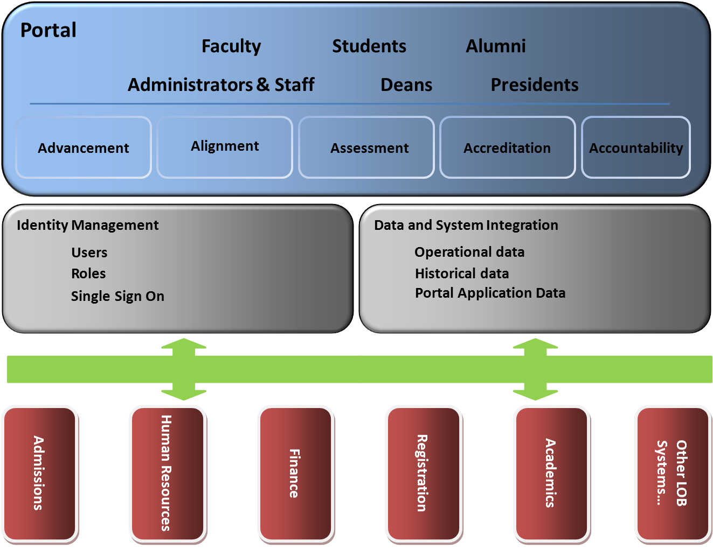

Figure 9. Microsoft Platform for Institutional Effectiveness in higher education

# Portal Infrastructure (Presentation Layer)

The *presentation layer* is an important part of any solution architecture—a poorly designed or implemented presentation layer can lead to increased complexity, a lack of flexibility, and an inefficient and frustrating user experience. Browser-based applications provide benefits over traditional rich client applications in terms of deployment and manageability, which has led to their increased popularity in recent years. Institutions of higher learning are demanding cutting-edge, feature-rich, immersive, and personalized user experiences with security and reliability that inspires confidence and ensures continued operational success.

## Unified Communications and Collaboration

Colleges and universities are increasingly making use of the latest in communications and collaboration technologies to improve their overall efficiency, provide a better environment for faculty and students to work together more effectively, improve learning outcomes, enhance alumni communities, and support the institutional planning and assessment process. Institutions are exploring ways to integrate commonly used tools such as telephony, e-mail, instant messaging, podcasting, and Web conferencing into a more seamless environment that improves information sharing at a cost-effective price point. The portal infrastructure incorporates a unified communication and collaboration capability that provides an effective means for institutional constituents to work in partnership, pool resources, build teams, analyze and report on progress and programs, and more efficiently and effectively conduct the business of the institution.

This approach assures that there is a dynamic way for administrators, faculty, students, and other constituents to get information and resources to each other as quickly and effectively as possible, and provides the benefits discussed in this section.

### Seamless and Intuitive

Higher education stakeholders have a unified experience that allows them to use the most effective ways to communicate across multiple types of devices (for example, personal computers or laptops, smart phones, and voice-over-IP devices), providing them the capability of anytime, anywhere access to learning, education resources, and operational information through an easy-to–use, Internet-accessible portal.

### Process- and System-Integrated

By supporting industry standards and interfaces that are broadly available, IT staff can use or build convenient and contextual communications capabilities into both instructional and administrative applications and systems.

### Flexible and Trusted

This approach takes full advantage of the *Windows* operating system, enabling our higher-education customers and partners to deploy solutions that provide them with the greatest flexibility in establishing an efficient and secure communications infrastructure. This assures that we are providing institutions with a flexible security model that supports role-based access to information, ensuring that the right to use sensitive data and/or resources is limited only to those authorized to do so.

### Streamlined Communications Through Microsoft Unified Communications

Microsoft and its partners understand the importance of enabling educational institutions to be more productive by improving the ability to connect people and information across multiple modes of communications. Rather than struggling with separate tools and interfaces, educators and administrators that leverage the platform’s unified communications capabilities realize increased access to each other, students, alumni, and information at the right times and in the best way for their specific situation. “Presence” information, through *Microsoft Office Communications Server*, provides colleagues with details about a person’s availability, whether online for instant messaging, open for a phone call or meeting, or out of the building. Users can point and click to communicate with each other from within any of their *Office* system applications, such as *Microsoft Office Outlook®*, *Microsoft Office Word*, and *Office Excel*). Whether making phone calls from an Office *Outlook* e-mail message or identifying the availability of the author of a resource, faculty, students, and administrators can find and get to the people or resource they need as expeditiously as possible.

* With *Exchange Server*, higher-education institutions can easily control the methods by which their users send and receive messages. All message types, including voicemail, e-mail, and fax messages, appear alongside one another in the *Office Outlook* Inbox.
* In addition, the Microsoft platform incorporates technologies to provide colleges and universities substantially greater visibility into the institutions performance; one of these offerings is *Office SharePoint Server with PerformancePoint Services*. Designed to deliver dashboards, scorecards, and reports that visualize analytics and give institutions the data they need to track progress against established measurements and goals.

# Content Management and Collaboration Infrastructure (Middleware Layer)

*Office SharePoint Server*is at the core of the middleware layer, providing the collaboration backbone (see Figure 10). A tool that is specifically designed to make it easier for people to work together, share resources, create best practices, and to help colleges and universities achieve greater efficiency, responsiveness, and lower operational costs.

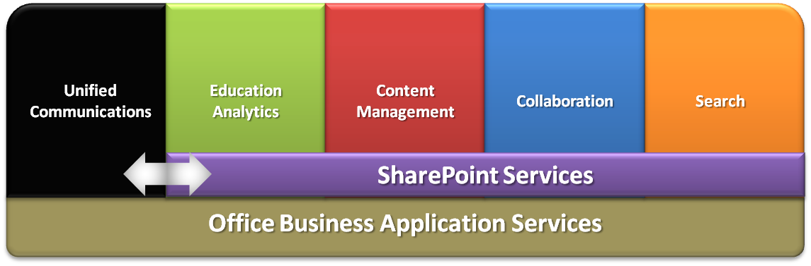

Figure 10. Office SharePoint Server

As a result, the platform’s collaboration capabilities include the features outlined in this section.

## Web Services

Web services provide a means to connect and extend existing (and future) applications via standard Web protocols and data formats. By providing this type of functionality, you can more easily integrate existing applications, such as enrollment management and/or recruitment systems, into the shared portal environment.

## Integration

The architecture supports integration with a broad range of products and technologies, along with those of our partners and many of our competitors. Our priority is to offer our education customers collaborative tools and services that can work within existing technology environments, reducing the need for wholesale upgrades and/or complete replacement of existing systems, leading to a reduced cost of ownership.

## Comprehensive Search

Comprehensive Search provides colleges and universities with the tools needed to search large repositories of data that may exist in disparate data stores managed by the institution. This search functionality is an integral part of the *Microsoft Platform for Institutional Effectiveness*. It can be extended to support existing third-party applications and solutions, assisting users to easily find, use, and share information with other colleagues as required.

# Security, Data Management, and Systems Integration (Core Services Layer)

The *core services layer* consists of security, data management, and system integration services allowing applications and services that are using different data formats and protocols to communicate in a secure environment.

## Identity Management

Digital identities have taken on an increasingly important role in campus data centers as IT departments define which applications and data sources faculty, staff, students, and alumni can access. In many situations, IT departments have not consolidated the security infrastructure supporting the various systems that mange financial aid, facilities operations, course registration, HR, and other applications that provide core operational support for the institution. Since each application and resource typically has its own mechanism for handling authentication and authorization, managing this critical information can be a challenge. The Microsoft platform employs *Windows Server* and provides built in security and role-based access through its *Active Directory® Service, Authorization Manager*, and *Identity Lifecycle Manager (ILM)* as a means of consolidating disparate identity management systems.

*Active Directory* and ILM provide role-based security management, giving IT departments the ability to manage digital identities from a central location. Specifically, it allows the implementation of uniform policies for system administrators and users depending on their respective roles. This enables comprehensive management of the mapping between individual access control and the tasks performed by different stakeholders (for example, faculty, staff, students, and alumni). The *Authorization Manager* provides a comprehensive framework for integrating role-based access management into an application or computer. It enables technology administrators to provide access through assigned user and computer roles that relate specifically to the job or user functions. As a result, the technologies incorporated into the platform enable IT departments to provide access to faculty, staff, students, and alumni using a role-based methodology. When users log on, based on their specific role, they only have access to the components of the overall architecturethat are relevant to their specific situation or their authorized needs.

## Data Management and Systems Integration

*SQL Server 2008* provides the data management and system integration services for the MPIE (see Figure 11). *SQL Server 2008* offers colleges and universities enterprise-level security, reliability, and scalability while providing a lower total cost of ownership than competing products. It delivers this solution with high availability for instructional, analytical, and administration management applications. Out-of-the-box, *SQL Server 2008* provides the following services:

* **Database Services** provide the core services for storing, processing, and securing data. This service enables controlled access and rapid transaction processing to meet the requirements of the most demanding education data applications.
* **Reporting Services** deliver rich, Web-enabled reporting functionality, allowing administrators and instructors the ability to create reports that draw content from a variety of data sources, and publish reports in various easy to understand formats.
* **Integration Services** offer a platform for building high-performance data integration and workflow solutions, including extraction, transformation, and loading (ETL) operations for linking disparate data sources together.
* **Analysis Services** provide institutions with a unified and integrated view of all student and institutional performance data and the foundation for reporting online analytical processing (OLAP) and analysis, key performance indicators (KPIs), scorecards, and data mining.

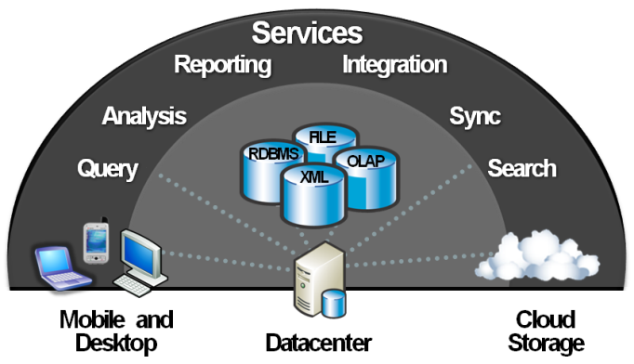

Figure 11. SQL Server 2008 services architecture

## Interoperability

This design, applied to institutional effectiveness, embraces interoperability through current solutions that use the new generation of XML-based software, through technology and intellectual property (IP) licensing, and in partnerships with companies that are dedicated to helping software products work together. There are two major elements to the interoperability strategy that are incorporated into the architecture. First, we continue to support higher education’s need for technology that works well with what is already in place. Our products and solutions focus on interoperability and have significant functionality dedicated to connection with non-Microsoft products. Second, we are working with the technology industry to define a new generation of software and Web services that enables software to efficiently share information and opens the door to a greater degree of "interoperability by design" across different solutions and technologies.

An example of an integrated third-party application component (optional) to the Microsoft Platform for Institutional Effectiveness is the *HigherEd Analytics Suite* (see Figure 12) from Microsoft business partner *iStrategy* (Owings Mills, MD)—a data warehouse and analytics reporting solution designed specifically for colleges and universities. This solution enables institutions to build and deploy multidimensional data warehouse solutions in days instead of years. Figure 12 demonstrates the use of data management and systems integration as a core component to extract, transform, and load data from disparate enterprise systems typically found across institutional campuses. Leading universities such as the University of Maryland, Baltimore County (UMBC), and Xavier University are using *HigherEd Analytics Suite* to aggregate key performance measures and perform drill-down analysis of student and institutional data tied directly to overall effectiveness goals and objectives.

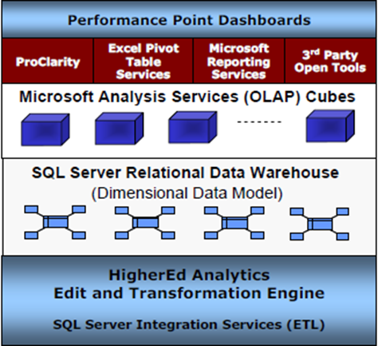

Figure 12. iStrategy Higher Education Analytics Suite

## Application Integration and Business Process Management

MPIE addresses the broad application integration and business process management needs that challenge colleges and universities when IT domains are often decentralized and autonomously supporting disparate systems and platforms. *BizTalk Server* is a platform-agnostic, hub-and-spoke services-oriented infrastructure solution. It facilitates real-time, message-based integration and process management services through industry standard interfaces and out-of-box technology adapters.

For example, institutions that want to streamline repeatable and manual processes can utilize *BizTalk Server* to orchestrate system integration with business processes and workflow, while providing analytical reports and business-rule editing tools that allow for “real-time” visibility and control.

# Cloud-Based Services: The Next Generation of Service Offerings

The concept of *cloud computing* is not a new one—hosting applications or delivering computational services in a multi-tenet configuration originated during technology’s mainframe era. What makes this recent incarnation of hosted services exciting is the richness of services and deployment options available to customers that can best suit their unique circumstances. A new generation of hosted services called *Microsoft Azure™ Services* affords institutions the option of deploying and supporting their IT solutions in one of three models—on-premise, hosted (*cloud-based*), or a hybrid approach that provides the option of supporting both on-premise and hosted applications simultaneously.

## Windows Azure Platform

*Azure* is the Microsoft platform for building and deploying cloud-based applications, providing developers on-demand compute and storage resources to create, host, and manage scalable Web applications through Microsoft data centers. Based on familiar Microsoft products and technologies, *Azure* is a group of cloud technologies, each providing a specific set of services that colleges and universities can incorporate into their existing IT architecture to extend and/or create new services offerings to support the institution’s operational needs. The *Azure Services Platform* consists of five core components (see Figure 13):

* *Windows Azure* for service hosting, scalable storage, and automated service management.
* *Microsoft SQL Azure* for infrastructure data storage and reporting.
* *Windows Azure Platform AppFabric* for access control and cloud-based service bus messaging infrastructure.
* *Live Services* for handling user data and application resources that can connect a developer’s application to any number of users and devices.
* *Microsoft Dynamics CRM* and *SharePoint Services* that extend the capabilities of these platforms for business content, collaboration, and rapid deployment.

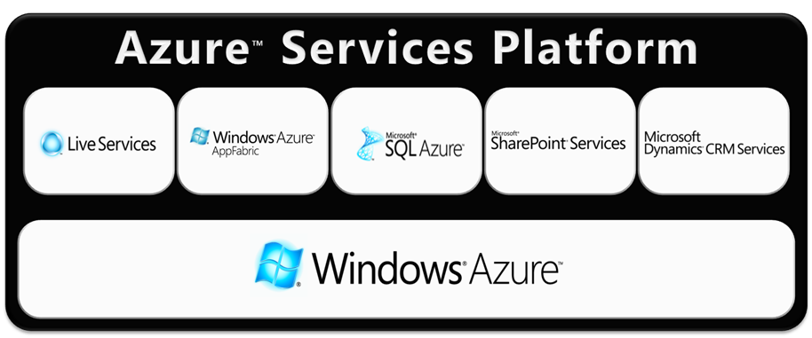

Figure 13. Microsoft Windows Azure Platform

*Live Services* was the first of the *Azure Services* made available to the public. This cloud-based service offering consists of a set of building blocks within the *Azure Services Platform* for handling user data and application resources. It provides developers with an easy on-ramp to build rich social applications and experiences that can connect *Windows Live™* users and includes *Mesh* technologies for synchronizing user’s data and extending Web applications across multiple devices. As with many large organizations, colleges and universities face the challenge of managing multiple identity management systems (for example, e-mail, student registration systems, library, and HR systems). *Live Services* provides federated identity management services that allow institutions to manage multiple identity management systems from a central service, as shown in Figure 14.

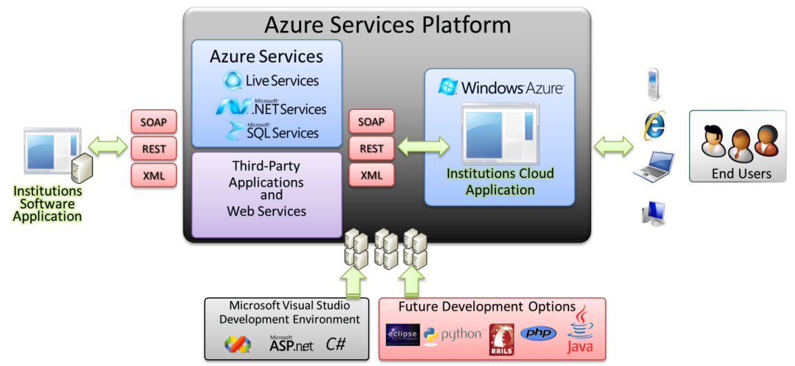

Figure 14. Azure's commitment to interoperability

Higher-education institutions, like many businesses today, look to the cloud as a cost-saving alternative, reducing in-house servers and management staff. While some applications are well-suited for the cloud, it is important to evaluate which workloads need to connect to other workloads and applications, and how IT departments can best manage security, compliance, and regulation. Institutions need to determine which workloads run best locally and which skills, tools, and assets transfer best to the cloud. Instead of pushing everything to the cloud, organizations recognize the need to complement existing on-premise software with online services, making it easier to consistently access data from any location, anytime, whether connected or not. The *Azure Services* Platform delivers the flexibility, scalability, and security to meet the demands of the 21st century college or university system and provides another technology option for implementing a comprehensive, institutionally effective architecture.

The information contained in this document represents the current view of Microsoft Corporation on the issues discussed as of the date of publication. Because Microsoft must respond to changing market conditions, it should not be interpreted to be a commitment on the part of Microsoft, and Microsoft cannot guarantee the accuracy of any information presented after the date of publication.

This white paper is for informational purposes only. MICROSOFT MAKES NO WARRANTIES, EXPRESS OR IMPLIED, IN THIS DOCUMENT.

Complying with all applicable copyright laws is the responsibility of the user. Without limiting the rights under copyright, no part of this document may be reproduced, stored in, or introduced into a retrieval system, or transmitted in any form or by any means (electronic, mechanical, photocopying, recording, or otherwise), or for any purpose, without the express written permission of Microsoft Corporation.

The example companies, organizations, products, domain names, e-mail addresses, logos, people, places, and events depicted herein are fictitious. No association with any real company, organization, product, domain name, e-mail address, logo, person, place, or event is intended or should be inferred.

Microsoft may have patents, patent applications, trademarks, copyrights, or other intellectual property rights covering subject matter in this document. Except as expressly provided in any written license agreement from Microsoft, the furnishing of this document does not give you any license to these patents, trademarks, copyrights, or other intellectual property.

© 2010 Microsoft Corporation. All rights reserved.

Microsoft, Active Directory, Azure, BizTalk, Excel, Outlook, PerformancePoint, SharePoint, Silverlight, SQL Server, Windows, Windows Live, and Windows Server are trademarks of the Microsoft group of companies.

The names of actual companies and products mentioned herein may be the trademarks of their respective owners.