Compare MSDN and Expression Subscriptions
MSDN Subscriptions give you access to an incredible range of software, tools and support, making it easy for you to build outstanding applications. Your MSDN Subscription provides past and present developer tools, operating systems, servers, and application software to use in developing and testing your applications. With MSDN Professional or MSDN Premium subscriptions you also get Software Assurance for Visual Studio so you can always upgrade to the latest technology. Additionally, as an MSDN subscriber you get access to technical support, Managed Newsgroups, MSDN Library reference materials, and a wide array of online forums to help you get the support you need.
MSDN and Expression Subscriptions include software licensed for the design, development, testing, and demonstration of your programs. MSDN Subscriptions support developers, testers, architects, and database professionals, whereas Expression Subscriptions support professional designers and web developers. For more information on how you can use software included in an MSDN Subscription, see MSDN Subscription Software Use Rights.
You can also purchase subscriptions to TechNet Plus, which include software you can use only for evaluation purposes. For more information about TechNet Plus subscriptions, see Compare MSDN and TechNet Plus.
The table below summarizes the benefits of the MSDN and Expression Subscriptions. For detailed information, you can download the complete list of products available through MSDN and Expression Subscriptions.

Subscription and Pricing * | Software Benefits | Other Benefits | Who should subscribe?
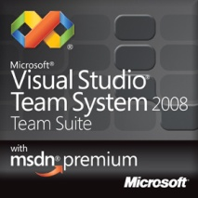  Visual Studio Team System Team Suite with MSDN Premium  New: $10,939  Renewal: $3,499 | - Visual Studio Team System 2008 Team Suite  - VSTS Team Foundation Server Workgroup Edition (5 users)  - Expression Studio  - Servers  - Operating Systems  - Office  - Microsoft Dynamics  - Toolkits, SDKs and DDKs | - 4 Technical support incidents  - MSDN Library  - Managed Newsgroup support  - Online Concierge  - MSDN Magazine  - MSDN Flash | Software developers, testers, and architects who perform different roles on the same project or different roles from one project to the next. This gives the full Visual Studio toolset.  VSTS is appropriate for members of moderate to advanced software teams needing automated builds, bug tracking, performance optimization, and other features in VSTS and TFS.
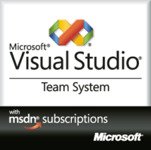  Visual Studio Team System Editions with MSDN Premium  - Development  - Architecture  - Test  - Database  New: $5,469  Renewal: $2,299 | - The Visual Studio Team System 2008 role selected  - VSTS Team Foundation Server Workgroup Edition (5 users)  - Expression Studio  - Servers  - Operating Systems  - Office  - Microsoft Dynamics  - Toolkits, SDKs and DDKs | - 4 Technical support incidents  - MSDN Library  - Managed Newsgroup support  - Online Concierge  - MSDN Magazine  - MSDN Flash | Software developers, testers, and architects who consistently perform the same duties, requiring only one type of VSTS tool.  VSTS is appropriate for members of moderate to advanced software teams needing automated builds, bug tracking, performance optimization, and other features in VSTS and TFS.
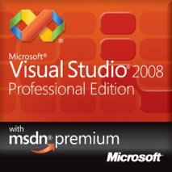  Visual Studio Professional with MSDN Premium  New: $2,499  Renewal: $1,999 | - Visual Studio 2008 Professional Edition  - Visual SourceSafe  - Expression Studio  - Servers  - Operating Systems  - Office  - Microsoft Dynamics  - Toolkits, SDKs and DDKs | - 4 Technical support incidents  - MSDN Library  - Managed Newsgroup support  - Online Concierge  - MSDN Magazine  - MSDN Flash | Professional developers, software testers, or IT professionals needing access to the largest pool of Microsoft software for use in software development projects, including installation of test or development environments.
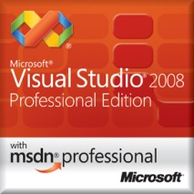  Visual Studio Professional with MSDN Professional  New: $1,199  Renewal: $799 | - Visual Studio 2008 Professional Edition  - Visual SourceSafe  - SQL Server, all versions  - Operating Systems  - Toolkits, SDKs and DDKs | - 2 Technical support incidents  - MSDN Library  - Managed Newsgroup support  - Online Concierge  - MSDN Magazine  - MSDN Flash | Professional developers, software testers, or IT professionals needing access to Microsoft operating systems and SQL Server for use in software development projects, including installation of test or development environments.
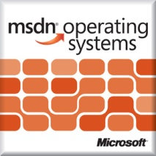  MSDN Operating Systems  New: $699  Renewal: $499 | - Operating Systems  - Toolkits, SDKs and DDKs | - 2 Technical support incidents  - MSDN Library  - Managed Newsgroup support  - Online Concierge  - MSDN Magazine  - MSDN Flash | Software testers or IT professionals who need to set up test labs with Microsoft operating systems, but do not need additional products.  Example: Test or IT staff at a video card manufacturer needs to set up a lab for testing drivers on multiple versions of Windows.
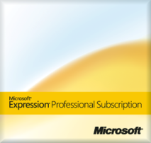  Expression Professional Subscription  New: $999  Renewal: $649 | - Expression Studio  - Visual Studio Standard Edition  - Windows Vista Business & Ultimate  - Windows XP Professional  - Office Standard  - Visio Professional  - Project Professional  - Groove  - Virtual PC | - 2 Technical support incidents | Professional Designers and Web Developers

To order a subscription, please visit: http://msdn.microsoft.com/subscriptions/buynow/

* Prices listed are Estimated Retail Prices (ERP) in US dollars and do not include applicable taxes. Retail subscriptions last 12 months. Organizations should contact their Microsoft representative or preferred reseller for Volume Licensing prices. Click here for pricing and purchasing options in your region.
The information is representative and not comprehensive. Products, versions, and availability are subject to change.
© 2009 Microsoft Corporation. All rights reserved.

