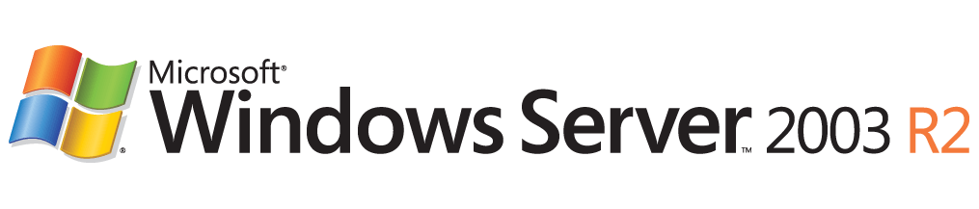

DFS Operations Guide: Using the DFSRAdmin Command-line Tool
Microsoft Corporation
Published: December 2005
Author: Tim Elhajj

Abstract
The Dfsradmin.exe command line tool is new for the Distributed File System (DFS) in the Microsoft® Windows Server™ 2003 R2 operating system. Use this tool to administer DFS replication from the command line. This guide offers step-by-step instructions for performing common tasks using DFSRAdmin.

Information in this document, including URL and other Internet Web site references, is subject to change without notice. Unless otherwise noted, the example companies, organizations, products, domain names, e-mail addresses, logos, people, places, and events depicted herein are fictitious, and no association with any real company, organization, product, domain name, e-mail address, logo, person, place, or event is intended or should be inferred. Complying with all applicable copyright laws is the responsibility of the user. Without limiting the rights under copyright, no part of this document may be reproduced, stored in or introduced into a retrieval system, or transmitted in any form or by any means (electronic, mechanical, photocopying, recording, or otherwise), or for any purpose, without the express written permission of Microsoft Corporation.
Microsoft may have patents, patent applications, trademarks, copyrights, or other intellectual property rights covering subject matter in this document. Except as expressly provided in any written license agreement from Microsoft, the furnishing of this document does not give you any license to these patents, trademarks, copyrights, or other intellectual property.
© 2005 Microsoft Corporation. All rights reserved.
Microsoft, Active Directory, Windows, and Windows Server are either registered trademarks or trademarks of Microsoft Corporation in the United States and/or other countries.
The names of actual companies and products mentioned herein may be the trademarks of their respective owners.

Contents
DFS Operations Guide: Using the DFSRAdmin Command-line Tool 5
Minimum Requirements for this End-to-End Scenario 5
Step 1: Create a Replication Group 6
Step 2: Add a Default Replication Group Schedule 8
Step 3: Add Members to the Replication Group 9
Step 4: Creating Replication Connection Objects 10
Step 5: Creating the Replicated Folders 13
Step 6: Setting Key Membership Properties 15
Summary 17

DFS Operations Guide: Using the DFSRAdmin Command-line Tool
The Dfsradmin.exe command line tool (DFSRAdmin) is new for the Distributed File System (DFS) in the Microsoft® Windows Server™ 2003 R2 operating system. This document offers step by step instructions for replicating folders between members using the new DFS Replication feature of DFS.
After you perform a task with the command line tool, this guide shows you how to check the result of your effort by using the DFS Management console, if a result is apparent in the console. There are some commands you can issue with DFSRAdmin that offer no result in the console. When this is the case, we call it out.
Although this guide does offer an end-to-end scenario for DFS Replication, this is not meant as a comprehensive guide to every task that you can perform with DFSRAdmin. The command line tool contains Help that covers all the available commands and switches, including syntax examples. Access this help by typing the following command from a command prompt:
DFSRAdmin.exe /?

Minimum Requirements for this End-to-End Scenario
The goal of this scenario is to set up a replication group with two members and two replicated folders which both use a replication group schedule.
We assume that you deployed Windows Server 2003 R2 on at least two servers, both of which must be used for DFS Replication. We also assume that there is an Active Directory environment and that the Active Directory schema was extended to accommodate the new objects and attributes required by DFS Replication.
This guide also offers an order of operations for each of these steps; to use this guide successfully, you must start at step one and proceed to the last step.
Note
Any parameter that is not required by DFSRAdmin has a pre-defined default value. For example, by default staging quotas are set to four gigabytes (4 GB) per replicated folder. You can use optional parameters to override default values or you can modify the values later by use the set action.

Step 1: Create a Replication Group
The replication group defines which servers participate in replication. The following command creates a new replication group called “My Replication group”. This replication group has the description, “Distribution RG”.
To create a replication group
1. Open a command prompt.
2. Type the following command:
dfsradmin RG New /rgname:"My Replication Group" /rgdesc:"Distribution RG"
Note
You can type dfsradmin RG /? for a list of all possible actions on the replication group. You can also get help for any of the listed actions by typing dfsradmin RG<action>/? for specific syntax and examples of each action. Where <action> in the second command is any of the actions listed by the first command.
Now open the DFS Management console and adjust the display so that the newly created replication group appears.
To view the replication group in DFS Management console
1. In DFS Management console, right click Replication and select Add Replication Groups to Display.
2. In Add Replication Groups to Display dialog box, select My Replication Group and click OK.
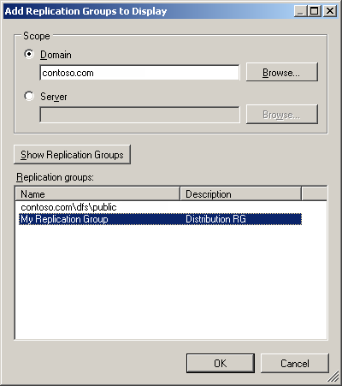

When you add the replication group in the DFS Management console, a new node appears under the replication node.
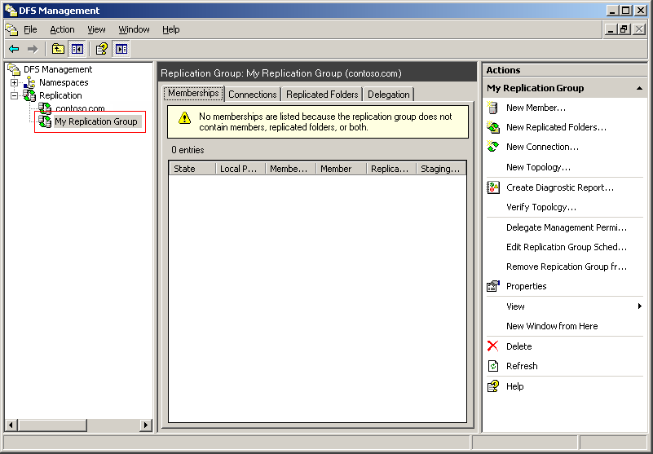

Step 2: Add a Default Replication Group Schedule
The schedule specifies when replication occurs and how much bandwidth can be used for replication. The following command sets the default replication schedule to enable replication twenty four hours a day, seven days a week, using full bandwidth. This schedule applies to all connections that do not have a custom schedule.
To set the schedule and bandwidth limits for replication group
1. Open a command prompt.
2. Type the following command:
dfsrAdmin RG Set Schedule full /RGName:"My Replication Group"
Note
You can type dfsradmin RG Set Schedule /? for help about schedule options, syntax, and examples.
Now use the DFS Management console to view the schedule for the replication group.
To view the schedule for the replication group in DFS Management console
1. In DFS Management console, right click My Replication Group and select Edit Replication Group Schedule.
2. When you are finished with the schedule, click OK.
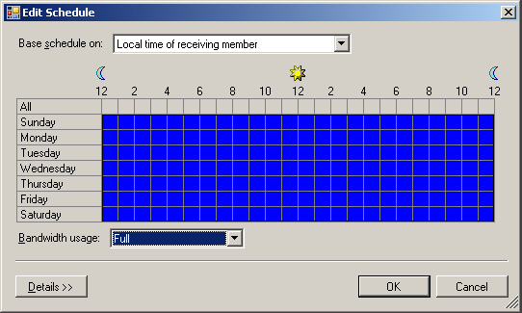

Step 3: Add Members to the Replication Group
Members are individual servers in a replication group. The following commands add two members to the replication group. These two Windows Server 2003 R2 member servers are named server1 and server2; however, you should substitute the names of your own member servers.
To add members to the replication group
1. Open a command prompt.
2. Type the following command:
dfsradmin member new /rgname:"My Replication Group" /memname:server1
3. When you see the message "Command completed successfully", type the following command:
dfsradmin member new /rgname:"My Replication Group" /memname:server2
Note
You can type dfsradmin Mem /? for parameters and syntax examples.
While the new members are actually in the replication group, they are not visible in the DFS Management console until they have been associated with a particular replicated folder.
Note
The member name can be a name a full qualified DNS name, a NETBIOS name, an IP address or a name in Domain\Server format. This offers you the ability to add members on a domain other than the default domain from which DFSRAdmin is being run. If you use the Domain\Server format, the server does not have to be on-line.

Step 4: Creating Replication Connection Objects
Connection objects establish the replication topology. The following commands create two one-way connection objects. With both connection objects in place, replication can occur to and from both servers.
To create replication connection object between server1 and server2
1. Open a command prompt.
2. Type the following command:
dfsradmin conn new /rgname:"My Replication Group" /SendMem:server1 /RecvMem:server2 /ConnEnabled:true /ConnKeywords:"From server1 to server2"
To create replication connection object between server2 and server1
1. Open a command prompt.
2. Type the following command:
dfsradmin conn new /rgname:"My Replication Group" /SendMem:server2 /RecvMem:server1 /ConnEnabled:true /ConnKeywords:"From server2 to server1"
Now use the DFS Management console to view the properties for each of the connections.
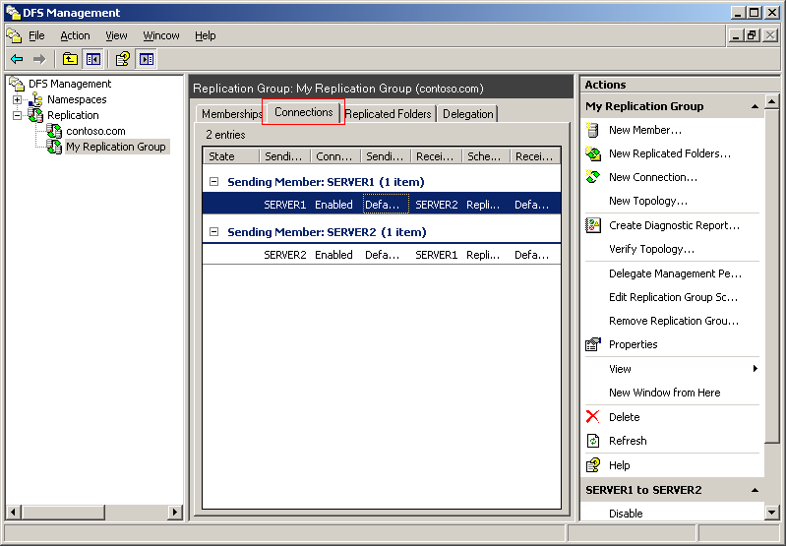

To view the properties of each connection object in DFS Management console
1. In DFS Management console, select My Replication Group.
2. In the action pane, click Refresh.
3. In the details pane, click the Connections tab.
4. Right click the connection, and then select Properties.
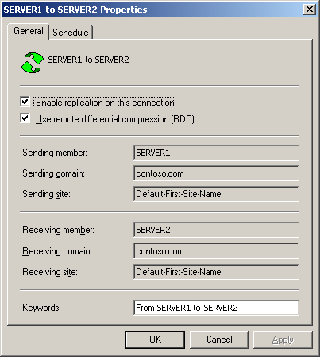

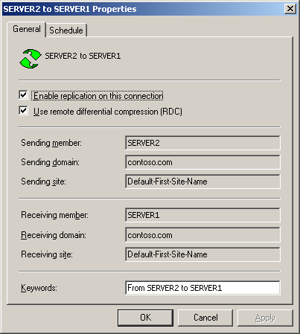

Step 5: Creating the Replicated Folders
Replicated folders enable you to replicate documents contained within the folders. The following commands create two replicated folders called Office and Docs. These commands also take advantage of filters, which prevents the replication of specified file types.
To create a replicated folder called Office
1. Open a command prompt.
2. Type the following command:
dfsradmin RF New /rgName:"My Replication Group" /RfName:Office /RfFileFilter:"*.doc,*.csv,*.xls,*.txt" /RfDirFilter:"dirA,dirB"
To create a replicated folder called Docs
1. Open a command prompt.
2. Type the following command:
dfsradmin RF New /rgName:"My Replication Group" /RfName:Docs /RfFileFilter:"*.doc,*.csv,*.xls,*.txt" /RfDirFilter:"dirA,dirB"
Now use the DFS Management console to view the properties for each of the replicated folders.
To view the replicated folders in DFS Management console
1. In DFS Management console, select My Replication Group.
2. In the action pane, click Refresh.
3. In the details pane, click the Memberships tab.
Notice that by default the membership object was created along with the replicated folders. Among other things, a membership allows you to associate servers with replicated folders. Some default settings for the membership object were also utilized in the creation of the replicated folder. For example, the size of the staging quota is the default value of 4 GB.
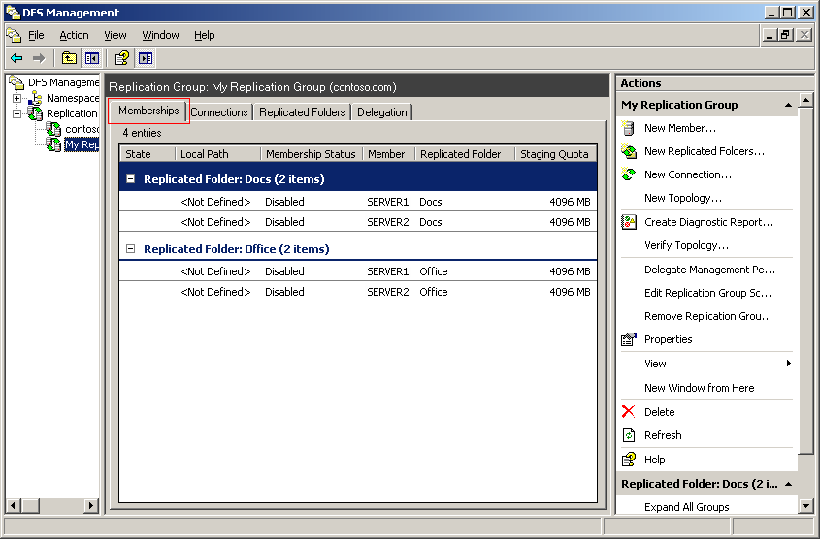

We modify some of these default values in the next step, "Step 6: Setting Key Membership Properties."

Step 6: Setting Key Membership Properties
There are some membership properties that have no default values but must be set for replication to occur. You must designate one server as the primary member for a replicated folder. These examples designate server1 as the primary member for both replicated folders. We also define the local path for the replicated folder and the staging area.
Quotas come with default values, but we can easily change these values. In the following commands we define quotas for both staging areas and the Conflict and Deleted folders. When a replicated file is modified on two or more members, DFS Replication uses a "last-writer wins" method for determining which version of a file to keep. The losing file is stored in the Conflict and Deleted folder on the member that resolves the conflict. This member might not be the member where the changes originated.
To associate server1 as the primary member for the Office replicated folder with a root path, staging area, and reassigned default values
1. Open a command prompt.
2. Type the following command:
dfsradmin Membership Set /RgName:"My Replication Group" /RfName:Office /MemName:server1 /LocalPath:C:\dc\Office /MembershipEnabled:true /StagingPath:C:\dc\staging /StagingSize:1000 /CDSize:350 /IsPrimary:true
To associate server1 as the primary member for the Docs replicated folder with a root path, staging area, and reassigned default values
1. Open a command prompt.
2. Type the following command:
dfsradmin Membership Set /RgName:"My Replication Group" /RfName:Docs /MemName:server1 /LocalPath:C:\dc\Docs /MembershipEnabled:true /StagingPath:C:\dc\staging /StagingSize:1000 /CDSize:350 /IsPrimary:true
These examples designate server2 as a member for both replicated folders, but not the primary member.
To associate server2 as a member for the Office replicated folder with a root path, staging area, and reassigned default values
1. Open a command prompt.
2. Type the following command:
dfsradmin Membership Set /RgName:"My Replication Group" /RfName:Office /MemName:server2 /LocalPath:C:\dc\Office /MembershipEnabled:true /StagingPath:C:\dc\staging /StagingSize:1000 /CDSize:350 /IsPrimary:false
To associate server2 as a member for the Docs replicated folder with a root path, staging area, and reassigned default values
1. Open a command prompt.
2. Type the following command:
dfsradmin Membership Set /RgName:"My Replication Group" /RfName:Docs /MemName:server2 /LocalPath:C:\dc\Docs /MembershipEnabled:true /StagingPath:C:\dc\staging /StagingSize:1000 /CDSize:350 /IsPrimary:false
Now use the DFS Management console to view the properties for each of the memberships.
To view the memberships in DFS Management console
1. In DFS Management console, select My Replication Group.
2. In the action pane, click Refresh.
3. In the details pane, click the Memberships tab.
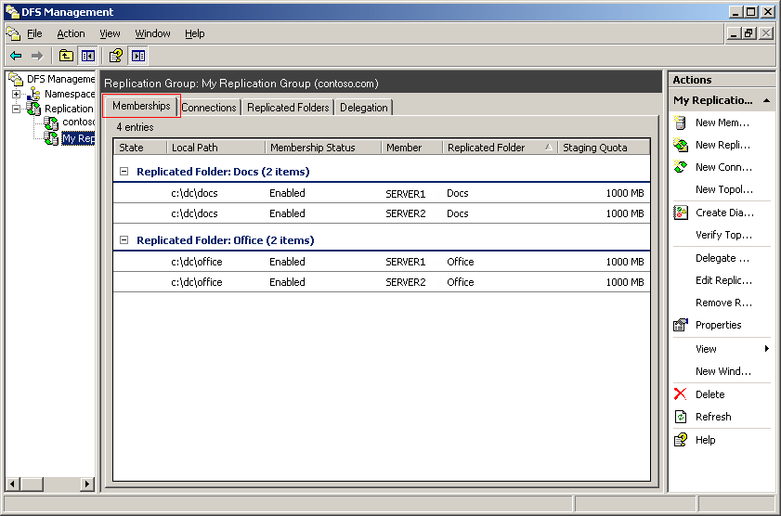

Summary
You have now published the basic configuration to Active Directory and the replicated folders are created on both servers. You can explore more advanced features in DFSRAdmin to publish the replicated folder to DFS Namespaces, delegate administration rights, or modify each of the different settings from the staging quota to file and folder filters.
On all the commands shown in this scenario, you can also use the optional /domain: parameter. This parameter allows you to switch from the default domain from which DFSRAdmin is being run. This enables you to add, delete, or modify Active Directory objects related to DFS replication in other domains. The following example illustrates using the /domain parameter:
DfsrAdmin RG new /RgName:"My Replication Group" /Desc:”Data Collection” /Domain:Contoso2

