

ISA Server 2004 Standard Edition
Quick Start Guide

Install and Configure ISA Server 2004 for Secure Internet Access

For the latest information, please see http://www.microsoft.com/isaserver


Contents
Introduction 2
Windows 2000/Windows Server 2003 Configuration Baseline 3
STEP 1: Configuring the Network Interfaces 6
IP Address and DNS Server Assignment 6
Configuring the Internal Network Interface 6
External Network Interface 7
External Interface with a Permanent IP Address 7
External Interface with a Dynamic IP Address 9
Network Interface Order 10
Setting up a Dial-up Connection 11
Creating the Dial-up Connectoid on a Windows 2000 Server Computer 12
Creating the Dial-up Connectoid on a Windows Server 2003 Computer 13
STEP 2: Installing and Configuring a DNS Server on the ISA Server Firewall 14
Installing the DNS Service 14
Installing the DNS Server Service on Windows 2000 Server 14
Installing the DNS Server Service on Windows Server 2003 15
Configuring the DNS Service 16
Configuring the DNS Service in Windows 2000 Server 17
Configuring the DNS Service in Windows Server 2003 19
Configuring the DNS Service on the Internal Network DNS Server 22
STEP 3: Installing and Configuring a DHCP Server on the ISA Server Firewall 24
Installing the DHCP Service 24
Installing the DHCP Server Service on a Windows 2000 Server Computer 24
Installing the DHCP Server Service on a Windows Server 2003 Computer 25
Configuring the DHCP Service 26
Configuring the Windows 2000 Server DHCP Server Service 27
Configuring the Windows Server 2003 DHCP Server Service 27
STEP 4: Installing and Configuring the ISA Server 2004 Software 29
Configuring ISA Server 2004 39
Configuring System Policy to Support Dynamic Addresses on the External Interface 55
Configuring Dial-up Preferences (dial-up connections only) 58
STEP 5: Configuring the Internal Network Computers 62
Configuring Internal Clients as DHCP Clients 62
Configuring DHCP Clients on Remote Internal Networks 63
Troubleshooting 64
Troubleshooting Cable Connections 64
Troubleshooting DSL Connections 64
Troubleshooting Name Resolution 64
Unable to use Specific Applications 65
ISA Server 2004 Resources 66
The ISA Server 2004 Help File 66
The Microsoft ISA Server 2004 Web Site 66
The Microsoft ISA Server 2004 Newsgroups 66
The ISAserver.org Web Site 66

Introduction
Welcome to your ISA Server 2004 firewall software. ISA Server 2004 is designed from the ground up to provide a high level of security and protection against Internet intruders and attackers. In addition to the robust security ISA Server 2004 provides for your network, the firewall software also allows you to connect all your computers to the Internet.
Your ISA Server 2004 firewall software has a wide range of capabilities and its feature set makes it the firewall of choice for Microsoft networks. Your first task is to get the software installed and configured. After you correctly install the ISA Server 2004 software, it will do the following:
- Help protect your network against Internet attackers
- Enable your computers to connect to the Internet
This Guide walks you through the following procedures:
- Configuring your Windows 2000 or Windows Server 2003 computer
- Installing the ISA Server 2004 software
- Configuring the ISA Server 2004 software to help protect your network and allow your computers to connect to the Internet
- Configuring computers on your LAN to connect to the Internet through the ISA Server 2004 firewall computer
The next section discusses assumptions we make about the Windows 2000 or Windows Server 2003 computer that will host the ISA Server 2004 software.

Windows 2000/Windows Server 2003 Configuration Baseline
You can install ISA Server 2004 on either Windows 2000 server or Windows Server 2003. There should be no extra services or applications running on the ISA Server 2004 machine, other than those discussed in this ISA Server 2004 Quick Start Guide. This is important because additional services or applications can complicate the ISA Server 2004 software installation and reduce the level of security the firewall can provide for your network.
The firewall machine should not be acting in any of the following roles:
- Domain controller
- Web Server
- FTP Server
- Certificate Server
- NNTP (NEWS) Server
- Exchange Server
- Sharepoint Server
If the machine on which you were planning to install the ISA Server 2004 software is acting in any of these roles, you should find another computer to use for your ISA Server 2004 firewall.
The firewall is the first computer Internet intruders try to attack because it is directly connected to the Internet. ISA Server 2004 is a firewall that helps protect your network from attackers and the ISA Server machine itself should be configured as securely as possible.
- WARNING:
The Guidelines in this Quick Start Guide do not apply to Small Business Server (SBS). SBS enforces a unique set of requirements on the ISA Server 2004 software which fall outside the scope of this Quick Start Guide. Please refer to your SBS documentation for details on how to install and configure ISA Server 2004 on an SBS machine.

This Quick Start Guide makes the following assumptions about the Windows 2000 Server or Windows Server 2003 computer on which you will install the ISA Server 2004 firewall software:
- We do not assume that you have any other Windows servers on your network. You can have other Windows servers on your network, but they are not required.
- We assume that you are installing ISA Server 2004 on either a Windows 2000 Server or Windows Server 2003 computer.
- We assume that you have installed Windows 2000 Server or Windows Server 2003 on a computer using the default installation settings and have not added any software to the Windows 2000 Server or Windows Server 2003 computer
- We assume that your Windows 2000 Server or Windows Server 2003 computer already has two Ethernet cards or an Ethernet card and a cable or DSL modem installed. We further assume that one of the Ethernet network interfaces is connected to the LAN and the other is connected to the Internet, or a single Ethernet card is connected to your LAN and a modem connects to the Internet.
- We assume that all machines on your internal network use the TCP/IP networking protocol to connect to one another.
- We assume that machines on the Internal network are configured as DHCP clients and will use the ISA Server 2004 firewall machine as their DHCP server.
- We assume that the Windows 2000 Server or Windows Server 2003 machine onto which you’re installing the ISA Server 2004 firewall software is not a member of a Windows domain. You can have a Windows 2000 Server or Windows Server 2003 domain on the internal network, but the computer running ISA Server 2004 does not need to be a member of your domain. However, if you do have an internal network domain and the Windows 2000 Server or Windows Server 2003 computer onto which you plan to install the ISA Server 2004 software is already a member of the internal network domain, you can leave that machine as a domain member. This will not change any of the procedures discussed in this document.
The goal of this Quick Start Guide is to get you started quickly. It does not go into detailed explanations or descriptions of ISA Server 2004’s many features and capabilities. You can learn about your ISA Server 2004 firewall in more detail after your firewall is configured and the computers on your network can access the Internet.
Throughout this Quick Start Guide, we will refer to internal and external interfaces. The internal interface is the Ethernet card or modem connecting the ISA Server 2004 firewall computer to your private network or LAN. The external interface is a network interface connecting you to the Internet. This external interface can be an Ethernet card, an analog modem, a T1 CPE/router or even a broadband DSL or cable bridge (“modem”) or router.
Figure 1 shows the ISA Server 2004 firewall and its relationship to the internal and external networks. The internal interface is an Ethernet card connected to a hub or switch on the internal network and the external interface is an Ethernet card or a modem connecting the ISA Server 2004 firewall to the Internet.
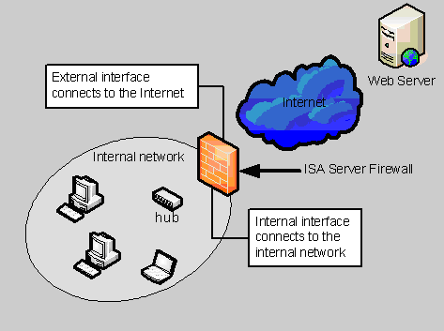
Figure 1: The physical relationships between the ISA Server 2004 firewall
and the internal and external networks.

There are 5 steps required to get the ISA Server 2004 firewall installed and configured to help protect your network and enable internal network clients to access the Internet:
- STEP 1:
Configure the network interfaces
- STEP 2:
Install and configure a DNS server on the ISA Server 2004 firewall computer
- STEP 3:
Install and configure a DHCP server on the ISA Server 2004 firewall computer
- STEP 4:
Install and configure the ISA Server 2004 software
- STEP 5:
Configure the internal network computers as DHCP clients

The rest of this Quick Start Guide walks you through each of these steps.

STEP 1: Configuring the Network Interfaces
The ISA Server 2004 firewall computer must have at least one internal network interface and one external network interface. The internal network interface is the network interface directly connected to the internal network. The external network interface can be an Ethernet card, a cable modem, a DSL modem, or a dial-up analog modem. The external network interface allows the ISA Server 2004 firewall to connect to the Internet.
You must carry out the following procedures to correctly configure the network interfaces on the ISA Server 2004 firewall computer:
- Assign IP addresses to the internal and external network interfaces
- Assign a DNS server address to the internal interface of the ISA Server 2004 computer
- Arrange the network interface order
- Set up the Dial-up Networking connectoid if you use a dial-up connection to the Internet

IP Address and DNS Server Assignment
You must assign IP addresses to the internal and external interfaces of the ISA Server 2004 firewall computer. The ISA Server 2004 firewall computer also requires a DNS server address so that it can translate names used to connect to Internet servers to IP addresses.
In this section, we discuss the following:
- Configuring the internal network interface
- Configuring the external network interface

Configuring the Internal Network Interface
The internal network interface must have an IP address that is on the same network ID as other computers on the directly attached network. This address must be in the private network address range and the address must not already be in use on the network.
You should configure the ISA Server 2004 firewall to use the internal interface address as its DNS server address. This Quick Start Guide assumes that your internal network computers use DHCP to obtain IP addressing information and that the ISA Server 2004 computer will be their DHCP Server.
The ISA Server 2004 firewall must have a static IP address bound to its internal interface. Perform the following steps on the Windows 2000 Server or Windows Server 2003 computer that will become the ISA Server 2004 firewall computer:
- Right click the My Network Places icon on the desktop and click the Properties option.
- In the Network Connections window, right click the internal network interface and click the Properties option.
- In the network interface’s Properties dialog box, click the Internet Protocol (TCP/IP) entry and then click the Properties button.
- In the Internet Protocol (TCP/IP) Properties dialog box, select the Use the following IP address option. Enter the IP address for the internal interface in the IP address text box. Enter the subnet mask for the internal interface in the Subnet mask text box. Do not enter a default gateway for the internal interface.
- Select the Use the following DNS server addresses option. Enter the IP address of the internal interface of the ISA Server 2004 computer in the Preferred DNS server text box. This is the same number you entered in step 4. Click OK in the Internet Protocol (TCP/IP) Properties dialog box.
- Click OK on the internal interface’s Properties dialog box.

- WARNING:
Never enter a default gateway address on the internal interface

External Network Interface
The external interface configuration varies depending on the type of interface you use to connect to the Internet. There are two primary types of external interfaces:
- An external interface using a statically assigned or permanent IP address
- An external interface using a dynamic or non-permanent IP address
Many Internet Service Providers (ISPs) offer “business accounts” that provide permanent, statically assigned IP addresses. Hobbyist or home-user accounts are usually assigned a non-permanent address. Dial-up modem connections, (with the exception of ISDN dial-up connections), usually are assigned non-permanent IP addresses. In this section, you’ll find out how to configure each connection type.
- NOTE:
Cable, DSL and T1 connections, among others, can have either a permanent or non-permanent IP address assigned to the external interface.

External Interface with a Permanent IP Address
There are four common situations in which you would use an Ethernet card on the external interface of the ISA Server 2004 firewall computer:
- You have a DSL connection using a DSL modem (note: some DSL modems install as network interface cards which are installed into the ISA Server 2004 firewall computer; in those circumstances, the internal DSL modem plugs into the DSL filtered wall jack)
- You have a cable Internet connection using a cable modem. The Ethernet card plugs into the cable modem’s Ethernet connection
- You have a T1, fractional T1 or similar dedicated connection to the Internet and there is a router in front of the ISA Server 2004 firewall computer
- You have a broadband DSL or cable Internet connection and you are using a broadband router in front of the ISA Server 2004 firewall.
Figure 2 shows the relationship between the ISA Server 2004 firewall computer and the broadband router.
- NOTE:
Throughout this ISA Server 2004 Quick Start Guide, we use the terms “in front of” and “behind” the ISA Server 2004 firewall computer. Devices “in front of” the ISA Server 2004 firewall computer are between the ISA Server 2004 firewall and the Internet. From the internal network, you must go through the ISA Server 2004 firewall computer to connect to machines in front of the ISA Server 2004 firewall. Devices “behind” the ISA Server 2004 computer are on the internal network; these devices are protected by the ISA Server 2004 firewall computer.

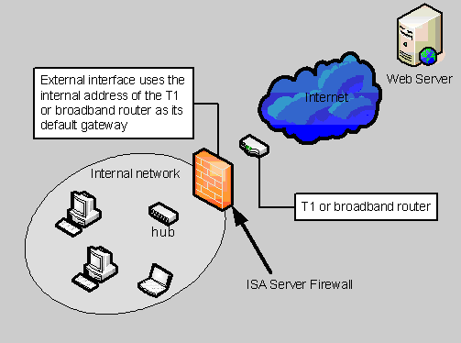
Figure 2: Diagram shows the relationship between the ISA Server 2004 firewall,
the internal network and the router in front of the ISA Server 2004 computer

Perform the following procedures if your external interface uses an Ethernet card and has a permanent IP address assigned to it:
- Right click the My Network Places icon on the desktop and click the Properties option.
- In the Network Connections window, right click the external network interface and click the Properties option.
- In the network interface’s Properties dialog box, click the Internet Protocol (TCP/IP) entry and then click the Properties button.
- In the Internet Properties (TCP/IP) Properties dialog box, select the Use the following IP address option. Enter the IP address for the external interface in the IP address text box. Enter the subnet mask for the external interface in the Subnet mask text box. Enter a default gateway for the external interface. Check with your ISP to obtain the proper IP address, subnet mask and default gateway addresses.

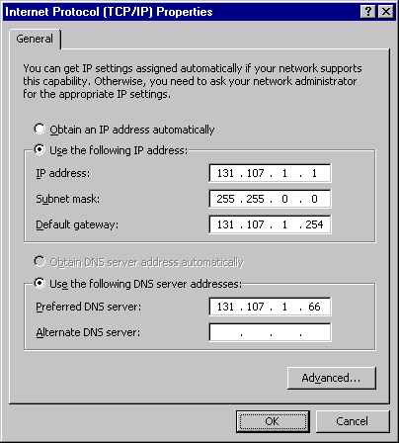
- WARNING:
Do not guess at what your external IP address should be. If your ISP assigns you a permanent IP address, ask your ISP to confirm the numbers used for your IP address, Subnet mask, Default gateway and Preferred DNS server. If you use a broadband router in front of the ISA Server 2004 firewall computer, use the IP address, subnet mask and default gateway recommended by the ISP that provided the router
- Select the Use the following DNS server addresses option. Enter the IP address of the internal interface in the Preferred DNS server text box. Click OK in the Internet Protocol (TCP/IP) Properties dialog box.
- Click OK in the internal interface’s Properties dialog box.

- NOTE:
Dial up connections represent a special case and are discussed in the Setting up a Dial-up Connection section. Do not perform the following steps for configuring the external interface with a dynamic IP address if you use a dial-up connection to connect to the Internet.

External Interface with a Dynamic IP Address
The most common situation in which an Ethernet card is used on the external interface with a non-permanent IP address is when the Ethernet card is a cable or DSL modem, or it connects to a DSL or cable modem. Your DSL or cable provider can tell you whether you have a permanent or non-permanent address.
Perform the following steps if your external interface uses a non-permanent (dynamic or DHCP assigned) IP address:
- Right click the My Network Places icon on the desktop and click the Properties option.
- In the Network Connections window, right click the external network interface and click the Properties option.
- In the network interface’s Properties dialog box, click the Internet Protocol (TCP/IP) entry and then click the Properties button.
- In the Internet Protocol (TCP/IP) Properties dialog box, select the Obtain an IP address automatically option.
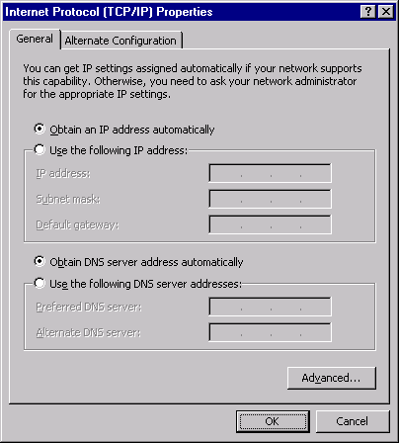

- Select the Use the following DNS server addresses option. Enter the IP address of the internal interface of the ISA Server 2004 computer in the Preferred DNS server text box. Click OK in the Internet Protocol (TCP/IP) Properties dialog box.
- Click OK in the internal interface’s Properties dialog box.

Network Interface Order
The internal interface of the ISA Server 2004 computer should be placed on top of the network interface list to ensure the best performance for name resolution. Perform the following steps to configure the network interface order on both Windows 2000 Server and Windows Server 2003 computers:
- WARNING:
Do not change the interface order if you are using a Dial-up connection to connect to the Internet. This procedure applies only to situations in which you use non-dialup connections to connect to the Internet.
Perform the following steps to change the network interface order:
- Right click the My Network Places icon on the desktop and click the Properties option.
- In the Network and Dial-up Connections window, click the Advanced menu, then click the Advanced Settings option.
- In the Advanced Settings dialog box, click the internal interface in the list of Connections on the Adapters and Bindings tab. After the internal interface is highlighted, click the up-arrow to move the internal interface to the top of the list of interfaces.
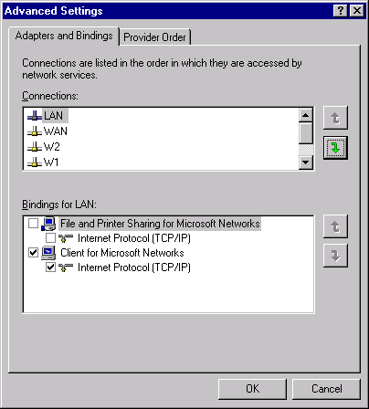
- Click OK in the Advanced Settings dialog box.

Setting up a Dial-up Connection
ISA Server 2004 firewall computers can use Dial-up Networking connections, which are configured in the Network and Dial-up Connections window in Windows 2000 Server and the Network Connections window in Windows Server 2003, to connect to the Internet. These dial-up connection entries are named connectoids. You’ll create Dial-up Networking connectoids and then use these to configure Dial-up Preferences in the ISA Server 2004 management console later in this Quick Start Guide.
We will assume your dial-up hardware is already installed and is working properly. The next step is to create the Dial-up Networking connectoid you’ll use to connect the ISA Server 2004 firewall computer to your ISP. We will cover procedures for creating the connectoid in Windows 2000 Server and Windows Server 2003 computers separately.
- NOTE:
These steps are performed differently in Windows 2000 Server and Windows Server 2003. Go to the section applying to the operating system onto which you’re installing ISA Server 2004 and follow those steps.

Creating the Dial-up Connectoid on a Windows 2000 Server Computer
Perform the following steps on the Windows 2000 Server computer to create the dial-up connectoid:
- Right click the My Network Places icon on the desktop and click the Properties option.
- In the Network and Dial-up Connections window, double click the Make New Connection icon.
- In the Location Information dialog box, enter your area code and access number if required. Click OK.
- Click OK in the Phone and Modem Options dialog box.
- Click Next on the Welcome to the Network Connection Wizard page.
- Select the Dial-up to the Internet option on the Network Connection Type page and click Next.
- On the Welcome to the Internet Connection Wizard page, select the I want to set up my Internet connection manually, or I want to connect through a local area network (LAN) option and click Next.
- Select the I connect through a phone line and a modem option on the Setting up your Internet connection page and click Next.
- On the Step 1 of 3: Internet account connection information page, enter the correct Area code and Telephone number for your ISP Internet connection. Click Next.
- On the Step 2 of 3: Internet account logon information page, enter the User name and Password provided to you by your ISP and click Next.
- On the Step 3 of 3: Configuring your computer page, enter a Connection name. For example, name the connection ISP Internet Link. Click Next.
- Select No on the Set Up Your Internet Mail Account page and click Next.
- Click Finish on the Completing the Internet Connection Wizard page.
- The ISP Internet Link entry now appears in the Network and Dial-up Connections window and it has a telephone icon associated with it.
- Right click the ISP Internet Link and click the Properties option. In the ISP Internet Link Properties dialog box, click the Options tab. If you want the link to automatically redial if the connection is dropped, put a checkmark in the Redial if line is dropped checkbox. You can then configure the Redial attempts and Time between redial attempts to meet your preferences. The default Idle time before hanging up value is set to never. If you want the modem to drop a connection after an idle period, change this value.
- NOTE:
Modern networks and applications require frequent connections to the Internet. You should anticipate that the dial-up connection will remain connected most of the time, as internal network hosts connect to the Internet at any time of day for a variety of reasons. You can prevent connections from internal network clients by limiting connections based on schedules. Please refer to the ISA Server 2004 Help for more information on creating schedules.

Creating the Dial-up Connectoid on a Windows Server 2003 Computer
Perform the following steps on the Windows Server 2003 computer to create the dial-up connectoid that connects the machine to the Internet:
- Right click the My Network Places icon on the desktop and click the Properties option.
- In the Network Connections window, double click the New Connection Wizard icon.
- Click Next on the Welcome to the New Connection Wizard page.
- On the Network Connection Type page, select the Connect to the Internet option and click Next.
- On the Internet Connection page, select the Connect using a dial-up modem option and click Next.
- On the Connection Name page, enter ISP Internet Link in the ISP Name text box and click Next.
- On the Phone Number to Dial page, enter the area code and phone number you use to connect to the ISP in the Phone number text box and click Next.
- On the Connection Availability page, select the Anyone’s use option and click Next.
- On the Internet Account Information page, enter the User name and Password provided to you by your ISP. Confirm the password in the Confirm password text box. Place checkmarks in the Use this account name and password when anyone connects to the Internet from this computer and Make this the default Internet connection checkboxes. Remove the checkmark from the Turn on Internet Connection Firewall for this connection checkbox. Click Next.
- Click Finish on the Completing the New Connection Wizard page.
- The Connect ISP Internet Link dialog box appears. Click the Properties button.
- On the ISP Internet Link Properties dialog box, click the Options tab. If you want the connection to automatically redial if the link is dropped, put a checkmark in the Redial if line is dropped checkbox. You can configure custom Redial attempts and Time between redial attempts values if you select this option. If you want the connection to drop after a period of idleness, change the value in the Idle time before hanging up list box. If you do not want the link to drop, select the never option in the idle time drop down list. Click OK after making the changes.
- Close the Connect ISP Internet Link dialog box.
- NOTE:
Modern networks and applications require frequent connections to the Internet. You should anticipate that the dial-up connection will remain connected most of the time as internal network hosts connect to the Internet at any time of day for a variety of reasons. You can prevent connections from internal network clients by creating schedules. Please refer to the ISA Server 2004 Help for more information on creating schedules.

STEP 2: Installing and Configuring a DNS Server on the ISA Server Firewall
You should install a DNS server on the ISA Server 2004 firewall computer. This enables machines on your network to perform Internet host name resolution. Computers must be able to resolve names of Internet servers in order to contact computers not located on the internal network. Even if you already have a DNS server located on the internal network, you should configure the ISA Server 2004 firewall computer as a caching-only DNS server and configure computers on the internal network to use the ISA Server 2004 machine as their DNS server.

Installing the DNS Service
The DNS Server service is not installed by default on Windows server operating systems. Procedures for installing the DNS Server service on Windows 2000 Server and Windows Server 2003 machines are very similar. We will discuss the installation procedures for Windows 2000 Server and Windows Server 2003 separately in this section.
- NOTE:
These steps are performed differently in Windows 2000 Server and Windows Server 2003. Go to the section applying to the operating system onto which you’re installing ISA Server 2004 and follow those steps.

Installing the DNS Server Service on Windows 2000 Server
Perform the following steps to install the DNS Server service on a Windows 2000 Server computer:
- Click Start, point to Settings and click Control Panel.
- In the Control Panel window, double click the Add/Remove Programs entry.
- In the Add/Remove Programs window, click the Add/Remove Windows Components button.
- In the Windows Components Wizard dialog box, select the Networking Services entry in the list of Components. Do not put a checkmark in the checkbox. After highlighting the Networking Services entry, click the Details button.
- In the Networking Services dialog box, put a checkmark in the Domain Name System (DNS) checkbox and click OK.

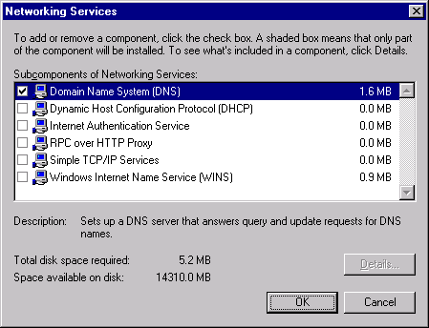
- Click Next in the Windows Components dialog box.
- You will see a terminal services page if terminal services is enabled on the machine; click Next in the Terminal Service Setup dialog box.
- Click OK in the Insert Disk dialog box. In the Files Needed dialog box, provide a path to the i386 folder from the installation CD in the Copy files from text box, then click OK.
- Click Finish in the Completing the Windows Components Wizard page.
- Click Close in the Add/Remove Programs window.

Installing the DNS Server Service on Windows Server 2003
Perform the following steps to install the DNS Server service on a Windows Server 2003 computer:
- Click Start, point to Control Panel and click Add or Remove Programs.
- In the Add or Remove Programs window, click the Add/Remove Windows Components button.
- In the Windows Components Wizard dialog box, select the Networking Services entry in the list of Components. Do not put a checkmark in the checkbox! After highlighting the Networking Services entry, click the Details button.
- In the Networking Services dialog box, put a checkmark in the Domain Name System (DNS) checkbox and click OK.

- Click Next in the Windows Components dialog box.
- Click OK in the Insert Disk dialog box. In the Files Needed dialog box, provide a path to the i386 folder from the installation CD in the Copy files from text box, then click OK.
- Click Finish on the Completing the Windows Components Wizard page.
- Close the Add or Remove Programs window.

Configuring the DNS Service
The DNS Server on the ISA Server 2004 firewall machine performs DNS queries for Internet host names on the behalf of computers on the internal network. The DNS Server on the ISA Server 2004 firewall should be configured as a caching-only DNS server. A caching-only DNS Server does not contain information about your public or private DNS names. The caching-only DNS Server can resolve Internet host names and cache the results, but it does not answer DNS queries for names on your private internal network DNS zone or your public DNS zone.
- NOTE:
DNS is an inherently complex topic. Do not be concerned if you do not completely understand the details of DNS operations. The DNS service will be correctly configured when you perform the steps in this section.
If you have an internal network DNS server supporting an Active Directory domain, you can configure the caching-only DNS server located on the ISA Server 2004 firewall to refer requests to your internal network domain to the DNS server on your internal network. The end result is that the caching-only DNS server on the ISA Server 2004 firewall computer will not interfere with your current DNS server setup.
In this section, we provide instructions on how to configure the DNS Server service on Windows 2000 Server and Windows Server 2003 computers.
- NOTE:
These steps are performed differently in Windows 2000 Server and Windows Server 2003. Go to the section applying to the operating system onto which you’re installing ISA Server 2004 and follow those steps.

Configuring the DNS Service in Windows 2000 Server
Perform the following steps to configure the DNS service on the Windows 2000 Server computer:
- Click Start, point to Programs and point to Administrative Tools. Click the DNS entry in the Administrative Tools menu.
- Expand all nodes in the left pane of the DNS console. Right click your server name, point to View and click Advanced.
- Right click the server name in the left pane of the console and click the Properties option.
- In the server’s Properties dialog box, click the Interfaces tab. Select the Only the following IP addresses option. Click any IP address in the list of IP addresses that is not the IP address on the internal interface. Select this non-internal interface IP address and click the Remove button. Click Apply.
- Click the Forwarders tab. Put a checkmark in the Enable forwarders checkbox. Enter the IP address of your ISP’s DNS server in the IP address text box and click Add. Put a checkmark in the Do not use recursion checkbox. Click Apply and then click OK.
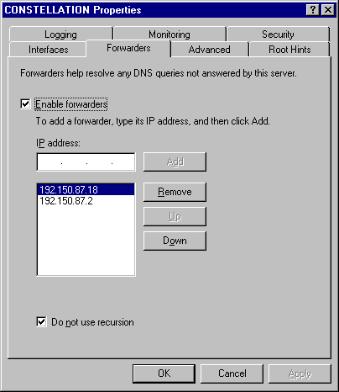

- Right click the server name in the left pane of the console, point to All Tasks and click Restart.

Perform the following steps only if you have an internal network Active Directory domain and an existing DNS server on the internal network:
- WARNING:
DO NOT perform the following steps if you do not already have a DNS server on your internal network. These steps are only for those networks already using Windows 2000 Server or Windows Server 2003 Active Directory domains.
- Right click the Reverse Lookup Zone node in the left pane of the console and click the New Zone command.
- Click Next on the Welcome to the New Zone Wizard page.
- Select the Standard primary option on the Zone Type page and click Next.
- Select the Network ID option on the Reverse Lookup Zone page and enter the network ID where your domain controller is located in the text box. Click Next.
- Accept the default file name on the Zone File page and click Next.
- Click Finish on the Completing the New Zone Wizard page.
- Right click the Forward Lookup Zones node in the left pane of the console and click the New Zone command.
- Click Next on the Welcome to the New Zone Wizard page.
- Select Standard primary on the Zone Type page and click Next.
- Enter the name of your internal network domain in the Type the name of the zone text box on the Zone Name page. Click Next.
- Accept the default file name on the Zone File page and click Next.
- Click Finish on the Completing the New Zone Wizard page.
- Expand the Forward Lookup Zones node in the left pane of the console and right click the domain name. Click the New Host command.
- In the New Host dialog box, type the computer name of the DNS server on the internal network that is authoritative for your Active Directory domain in the Name (uses parent domain name if blank) text box. Enter the IP address of the DNS server on the internal network in the IP address text box. Put a checkmark in the Create an associated pointer (PTR) record checkbox. Click Add Host.
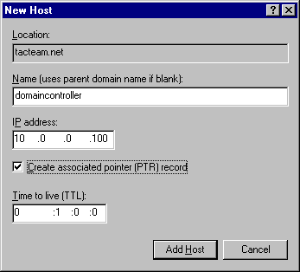
- Click OK in the DNS dialog box. Click Done in the New Host dialog box.
- In the right pane of the DNS console, right click the NS record for the domain and click the Properties option. In the domain’s Properties dialog box, click the current entry in the server list and then click the Remove button.
- Click the Add button on the Name Servers tab. In the New Resource Record dialog box, click the Browse button. In the Browse dialog box, double click your server name, then double click the Forward Lookup Zones folder. Double click your internal network domain name. Double click the name of the DNS server on the internal network. Click OK in the New Resource Record dialog box.
- Click Apply and then click OK in the domain’s Properties dialog box.
- Right click the SOA record in the left pane of the DNS console and click the Properties option.
- On the Start of Authority (SOA) tab, click the Browse button that lies to the right of the Primary server text box. In the Browse dialog box, double click your server name, then double click the Forward Lookup Zones folder. Double click your domain name and then double click the DNS server name on the internal network.
- Click Apply and then click OK in the domain’s Properties dialog box.
- Right click the server name in the left pane of the console, point to All Tasks and then click Restart.

Configuring the DNS Service in Windows Server 2003
Perform the following steps to configure the DNS service on the Windows Server 2003 computer:
- Click Start and point to Administrative Tools. Click the DNS entry.
- Right click the server name in the left pane of the console, point to View and click Advanced.
- Expand all nodes in the left pane of the DNS console.
- Right click the server name in the left pane of the DNS console and click the Properties option.
- In the server’s Properties dialog box, click the Interfaces tab. Select the Only the following IP addresses option. Click any IP address that is not an IP address bound to the internal interface of the computer. After highlighting the non-internal IP address, click the Remove button. Click Apply.
- Click the Forwarders tab. Enter the IP address of your ISP’s DNS server in the Selected domain’s forwarder IP address list text box and then click Add. Put a checkmark in the Do not use recursion for this domain checkbox. Click Apply.

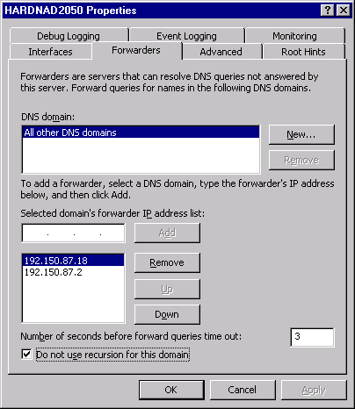
- Click OK in the server’s Properties dialog box.
- Right click the server name, point to All Tasks and click the Restart command.
Perform the following steps only if you have an internal network DNS server that you are using to support an Active Directory domain:
- WARNING:
DO NOT perform the following steps if you do not already have a DNS server on your internal network. These steps are only for those networks already using Windows 2000 Server or Windows Server 2003 Active Directory domains.
- Right click the Reverse Lookup Zones node in the left pane of the console and click New Zone.
- Click Next on the Welcome to the New Zone Wizard page.
- On the Zone Type page, select the Stub zone option and click Next.
- Select the Network ID option and then enter the network ID of the network on which the internal network DNS server is located on the Reverse Lookup Zone Name page in the Network ID text box. Click Next.
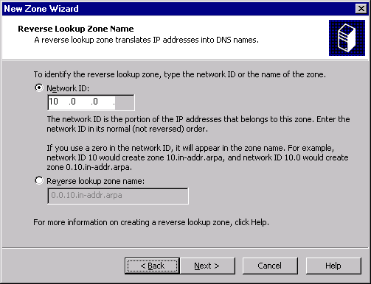
- Accept the default file name on the Zone File page and click Next.
- On the Master DNS Servers page, enter the IP address of your internal network DNS server in the IP address text box and click Add. Click Next.
- Click Finish on the Completing the New Zone Wizard page.
- Right click the Forward Lookup Zones node in the left pane of the console and click the New Zone command.
- Click Next on the Welcome to the New Zone Wizard page.
- On the Zone Type page, select the Stub zone option. Click Next.
- On the Zone name page, type the name of your internal network domain in the Zone name text box. Click Next.
- On the Zone File page, accept the default name for the zone file and click Next.

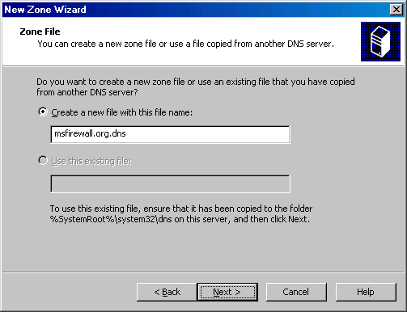

- On the Master DNS Servers page, enter the IP address of your internal network’s DNS server in the IP address text box and click Add. Click Next.
- Click Finish on the Completing the New Zone Wizard page.
- Right click the server name in the left pane of the console, point to All Tasks and click Restart.

Configuring the DNS Service on the Internal Network DNS Server
If your organization has an existing DNS infrastructure, you should configure your Internal network’s DNS server to use the DNS server on the ISA Server 2004 firewall as its DNS forwarder. This provides a more secure DNS configuration because your Internal network DNS server never communicates directly with an untrusted DNS server on the Internet.
The Internal network DNS server forwards DNS queries to the DNS server on the ISA Server 2004 firewall and the DNS server on the ISA Server 2004 resolves the name, places the result in its own DNS cache, and then returns the IP address to the DNS server on the Internal network.
Perform the following steps on the Internal network DNS server to configure it to use the DNS server on the ISA Server 2004 firewall as its forwarder:
- Note:
Perform the following steps only if you have a DNS server on the Internal network.
- Click Start and point to Administrative tools, then click DNS.
- In the DNS Management console, right click the server name in the left pane of the console and click Properties.
- In the server’s Properties dialog box, click the Forwarders tab.
- On the Forwarders tab, enter the IP address on the Internal interface of the ISA Server 2004 firewall in the Selected domain’s forwarder IP address list text box. Click Add.
- The IP address of the internal interface of the ISA Server 2004 firewall appears in the list of forwarder addresses.
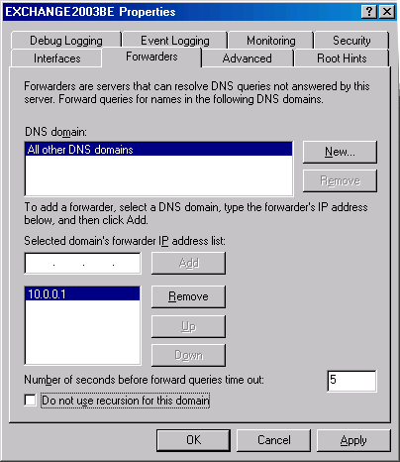
- Put a checkmark in the Do not use recursion for this domain checkbox. This option prevents the Internal network DNS server from trying to resolve the name itself in the event that the forwarder on the ISA Server 2004 firewall is unable to resolve the name.
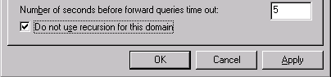
- Click Apply and then click OK.

STEP 3: Installing and Configuring a DHCP Server on the ISA Server Firewall
Each of your computers needs an IP address and other information that allows them to communicate with each other and with computers on the Internet. The DHCP Server service can be installed on the ISA Server 2004 firewall computer and can provide IP addressing information to internal network computers. This Quick Start Guide assumes you will use the ISA Server 2004 firewall computer to assign IP addresses and other networking information to computers on your network.
- WARNING:
You must not have any other DHCP servers on the network. If you have another machine on the network acting as a DHCP server, disable the DHCP service on that machine so that the ISA Server 2004 firewall acts as your only DHCP server on the network.

Installing the DHCP Service
The DHCP Server service can be installed on Windows 2000 Server and Windows Server 2003 computers. The procedure varies slightly between the two operating systems. In this section, we discuss procedures for installing the DHCP Server service on Windows 2000 Server and Windows Server 2003 computers.
NOTE:
These steps are performed differently in Windows 2000 Server and Windows Server 2003. Go to the section applying to the operating system onto which you’re installing ISA Server 2004 and follow those steps.

Installing the DHCP Server Service on a Windows 2000 Server Computer
Perform the following steps to install the DHCP Server service on a Windows 2000 Server computer:
- Click Start, point to Settings and click Control Panel.
- In the Control Panel window, double click the Add/Remove Programs entry.
- In the Add/Remove Programs window, click the Add/Remove Windows Components button.
- In the Windows Components Wizard dialog box, select the Networking Services entry in the list of Components. Do not put a checkmark in the checkbox! After highlighting the Networking Services entry, click the Details button.
- In the Networking Services dialog box, put a checkmark in the Dynamic Host Configuration Protocol (DHCP) checkbox and click OK.
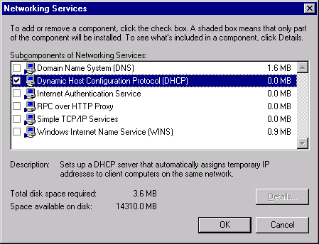
- Click Next in the Windows Components dialog box.
- If terminal services are enabled on the machine, click Next in the Terminal Service Setup dialog box.
- Click Finish on the Completing the Windows Components Wizard page.
- Click Close in the Add/Remove Programs window.

Installing the DHCP Server Service on a Windows Server 2003 Computer
Perform the following steps to install the DNS Server service on a Windows Server 2003 computer:
- Click Start, point to Control Panel and click Add or Remove Programs.
- In the Add or Remove Programs window, click the Add/Remove Windows Components button.
- In the Windows Components Wizard dialog box, select the Networking Services entry in the list of Components. Do not put a checkmark in the checkbox! After highlighting the Networking Services entry, click the Details button.
- In the Networking Services dialog box, put a checkmark in the Dynamic Host Configuration Protocol (DHCP) checkbox and click OK.

- Click Next in the Windows Components dialog box.
- Click Finish on the Completing the Windows Components Wizard page.
- Close the Add or Remove Programs window.

Configuring the DHCP Service
The DHCP Server must be configured with a range of IP addresses it can assign to computers on your network. The DHCP Server also provides other networking information to your computers, such as the addresses of a DNS Server and default gateway. The DNS server and default gateway addresses for your computers will be the IP address on the internal interface of the ISA Server 2004 firewall. The DHCP server uses a DHCP scope to provide this information to the internal network clients. You must create a DHCP scope that provides the correct information.
- NOTE:
The DHCP server must not assign addresses that are already in use on your network. You must create exclusions for these IP addresses. Examples of excluded IP addresses might be static or reserved addresses assigned to print servers, file servers, mail servers or Web servers; these are just a few examples of devices or server that always have the same IP address assigned to them. These addresses are permanently assigned to these servers and network devices.
The procedure varies slightly for Windows 2000 Server and Windows Server 2003 computers. We will discuss each configuration in this section.
- NOTE:
These steps are performed differently in Windows 2000 Server and Windows Server 2003. Go to the section applying to the operating system onto which you’re installing ISA Server 2004 and follow those steps.

Configuring the Windows 2000 Server DHCP Server Service
Perform the following steps to configure the Windows 2000 DHCP Server with a scope that assigns the proper IP addressing information to the internal network computers:
- Click Start, point to Programs and then point to Administrative Tools. Click the DHCP entry.
- Expand all nodes in the left pane of the DHCP console. Right click the server name in the left pane of the console and click New Scope.
- Click Next on the Welcome to the New Scope Wizard page.
- Type SecureNAT Client Scope in the Name text box on the Scope Name page. Click Next.
- On the IP Address Range page, type the first IP address and the last IP address for the range in the Start IP address and End IP address text boxes. For example, if you are using the network ID 192.168.1.0 with a subnet mask of 255.255.255.0, enter the start IP address as 192.168.1.1 and the end IP address as 192.168.1.254. Click Next.
- On the Add Exclusions page, type the IP address of the internal interface of the ISA Server 2004 firewall in the Start IP address text box and click Add. If you have any other servers on the network that already have statically assigned IP addresses that you do not want to change, add those addresses to the list. Click Next after adding all the addresses you want to exclude from the DHCP scope.
- Accept the default value on the Lease Duration page and click Next.
- On the Configuring DHCP Options page, select Yes, I want to configure these options now and click Next.
- On the Router page, type the IP address of the internal interface of the ISA Server 2004 firewall computer and then click Add. Click Next.
- On the Domain Name and DNS Servers page, enter the IP address of the internal interface of the ISA Server 2004 firewall computer in the IP address text box and click Add. If you have an Active Directory domain on the internal network, enter the name of your internal network domain in the Parent domain text box. Do not enter a domain name in the Parent domain text box unless you have an existing Active Directory domain on the internal network. Click Next.
- Do not enter any information on the WINS Servers page. Click Next.
- Select the Yes, I want to activate this scope now option on the Activate Scope page and click Yes.
- Click Finish on the Completing the New Scope Wizard page.

Configuring the Windows Server 2003 DHCP Server Service
Perform the following steps to configure the Windows Server 2003 DHCP Server with a scope that will assign the proper IP addressing information to the internal network clients:
- Click Start and point to Administrative Tools. Click the DHCP entry.
- Expand all nodes in the left pane of the DHCP console. Right click the server name in the left pane of the console and click New Scope.
- Click Next on the Welcome to the New Scope Wizard page.
- Type SecureNAT Client Scope in the Name text box on the Scope Name page. Click Next.
- On the IP Address Range page, type the first IP address and the last IP address for the range in the Start IP address and End IP address text boxes. For example, if you are using the network ID 192.168.1.0 with a subnet mask of 255.255.255.0, then enter the start IP address as 192.168.1.1 and the end IP address as 192.168.1.254. Click Next.
- On the Add Exclusions page, type the IP address of the internal interface of the ISA Server firewall in the Start IP address text box and click Add. If you have any other servers on the network that already have statically assigned IP addresses that you do not want to change, add those addresses to the list. Click Next after adding all the addresses you want to exclude from the DHCP scope.
- Accept the default value on the Lease Duration page and click Next.
- On the Configuring DHCP Options page, select Yes, I want to configure these options now and click Next.
- On the Router page, type the IP address of the internal interface of the ISA Server 2004 firewall computer and then click Add. Click Next.
- On the Domain Name and DNS Servers page, enter the IP address of the internal interface of the ISA Server 2004 firewall computer in the IP address text box and click Add. If you have an Active Directory domain on the internal network, enter the name of your internal network domain in the Parent domain text box. Do not enter a domain name in the Parent domain text box unless you have an existing Active Directory domain on the internal network. Click Next.
- Do not enter any information on the WINS Servers page. Click Next.
- Select the Yes, I want to activate this scope now option on the Activate Scope page and click Yes.
- Click Finish on the Completing the New Scope Wizard page.

STEP 4: Installing and Configuring the ISA Server 2004 Software
The Windows 2000 Server or Windows Server 2003 computer is now ready for the ISA Server 2004 software. The installation procedure is the same for both Windows 2000 Server and Windows Server 2003. However, if you install ISA Server 2004 on Windows 2000 Server, Service Pack 4 or higher must first be installed.
In the following installation example, the machine has two Ethernet cards with permanent addresses assigned to the Internal and External network interfaces. This is the situation you might have if you have a T1, cable or DSL connection. In the case of DSL and cable connections, there would be a DSL or cable router in front of the ISA Server 2004 firewall and the default gateway on the External interface is the IP address of the Internal interface of the router.
The following steps demonstrate how to install the ISA Server 2004 software on a dual-homed (two Ethernet cards) Windows Server 2003 machine:
- Insert the ISA Server 2004 installation media into the CD-ROM drive or connect to a network share point hosting the ISA Server 2004 installation files. If the installation routine does not start automatically, double click the isaautorun.exe file in the root of the installation files tree.
- On the Microsoft Internet Security and Acceleration Server 2004 page, click the link for Review Release Notes and read the release notes. The release notes contain useful information about important issues and configuration options. After reading the release notes, click the Read Setup and Feature Guide link. You don’t need to read the entire guide right now, but you may want to print it to read later. Click the Install ISA Server 2004 link.
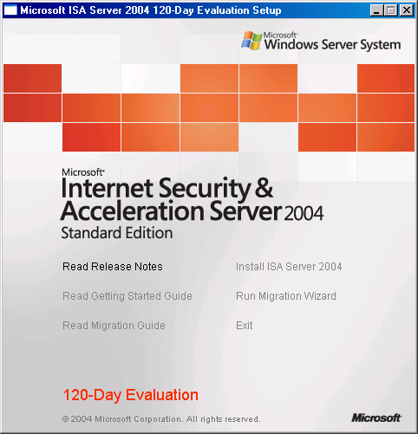
- Click Next on the Welcome to the Installation Wizard for Microsoft ISA Server 2004 page.
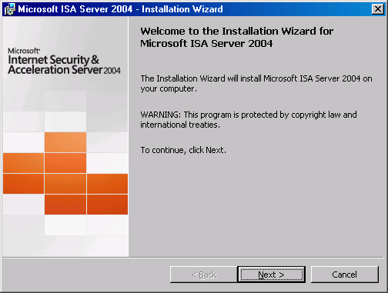
- Select the I accept the terms in the license agreement option on the License Agreement page. Click Next.
- On the Customer Information page, enter your name and the name of your organization in the User Name and Organization text boxes. Enter your serial number in the Product Serial Number text box. Click Next.
- On the Setup Type page, select the Custom option. If you do not want to install the ISA Server 2004 software on the C: drive, click the Change button to change the location of the program files on the hard disk. Click Next.
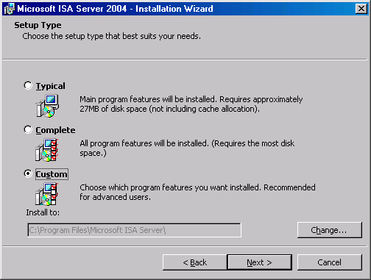
- On the Custom Setup page, you can choose which components to install. By default, the Firewall Services, ISA Server Management and Firewall Client Installation Share are installed. The Message Screener, which is used to control spam and file attachments from entering and leaving the network, is not installed by default. You must install the IIS 6.0 SMTP service on the ISA Server 2004 firewall computer before you install the Message Screener. Use the default settings and click Next.

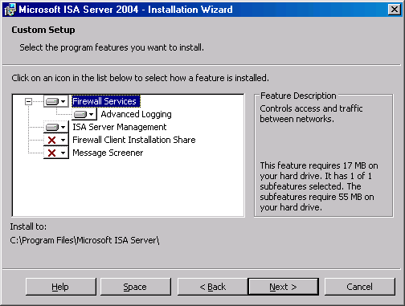
- On the Internal Network page, click the Add button. The Internal network is different from the Local Address Table (LAT) that was used by ISA Server 2000. In the case of ISA Server 2004, the Internal network contains trusted network services with which the ISA Server 2004 firewall must communicate. Examples of such services include Active Directory domain controllers, DNS, DHCP, terminal services client management workstations, and others. The firewall System Policy automatically uses the Internal network. We will look at the System Policy later in this document.

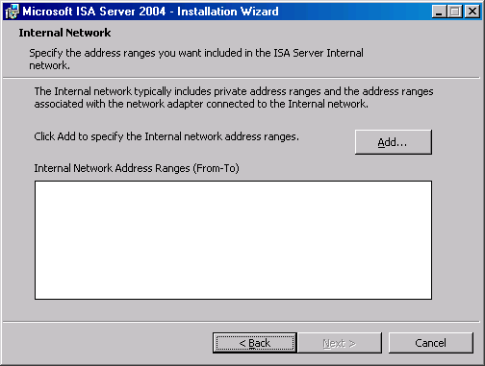
- On the Internal Network setup page, click the Select Network Adapter button.
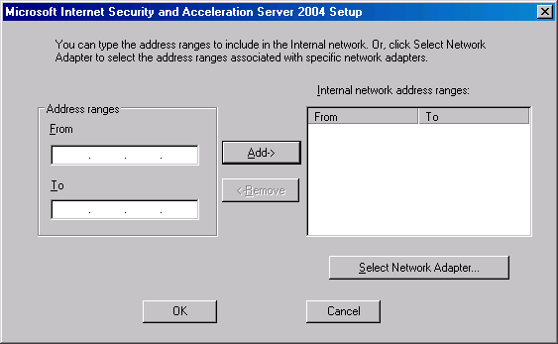
- In the Configure Internal Network dialog box, remove the checkmark from the Add the following private ranges… checkbox. Leave the checkmark in the Add address ranges based on the Windows Routing Table checkbox. Put a checkmark in the checkbox next to the adapter connected to the Internal network. In this example we have renamed the network interfaces so that the interface name reflects its location. Click OK.
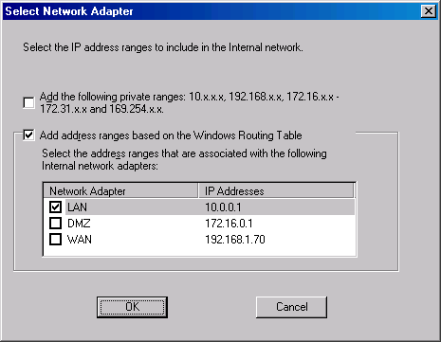
- Click OK in the dialog box informing you that the Internal network was defined, based on the Windows routing table.
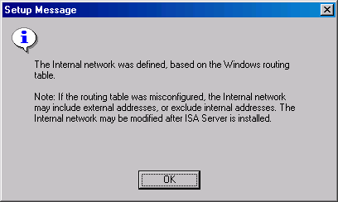
- Click OK on the Internal network address ranges dialog box.
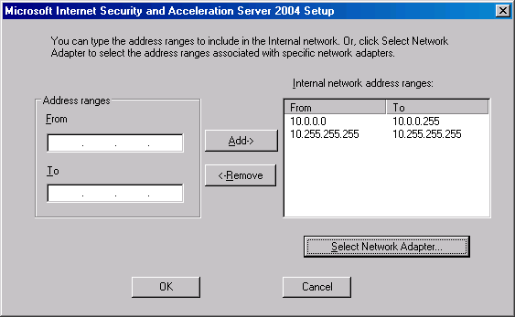
- Click Next on the Internal Network page.
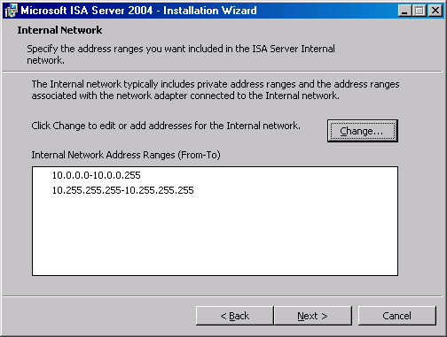
- Put a checkmark in the Allow computers running earlier versions of Firewall Client software to connect checkbox. This will allow you to continue using the ISA Server 2000 Firewall client software as you migrate to ISA Server 2004. Click Next.
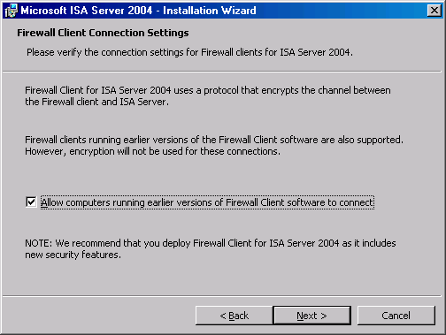
- On the Services page, note that the SNMP and IIS Admin Service will be stopped during installation. If the Internet Connection Firewall (ICF) / Internet Connection Sharing (ICF) and/or IP Network Address Translation services are installed on the ISA Server 2004 machine, they will be disabled, as they conflict with the ISA Server 2004 firewall software.
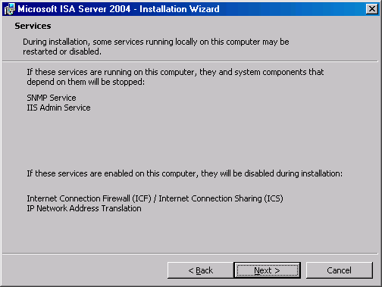
- Click Install on the Ready to Install the Program page.
- On the Installation Wizard Completed page, click Finish.
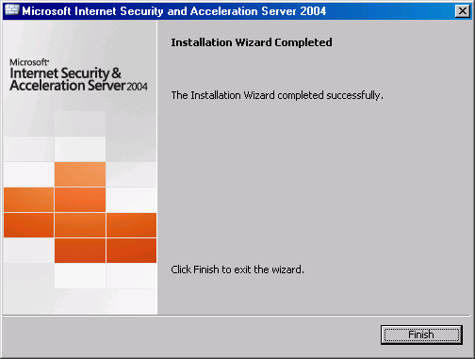
- Click Yes on the Microsoft ISA Server dialog box informing that you must restart the server.
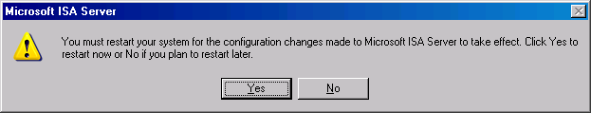
- Log on as an Administrator after the machine restarts.
- Click Start and point to All Programs. Point to Microsoft ISA Server and click ISA Server Management. The Microsoft Internet Security and Acceleration Server 2004 management console opens and displays the Welcome to Microsoft Internet Security and Acceleration Server 2004 page.
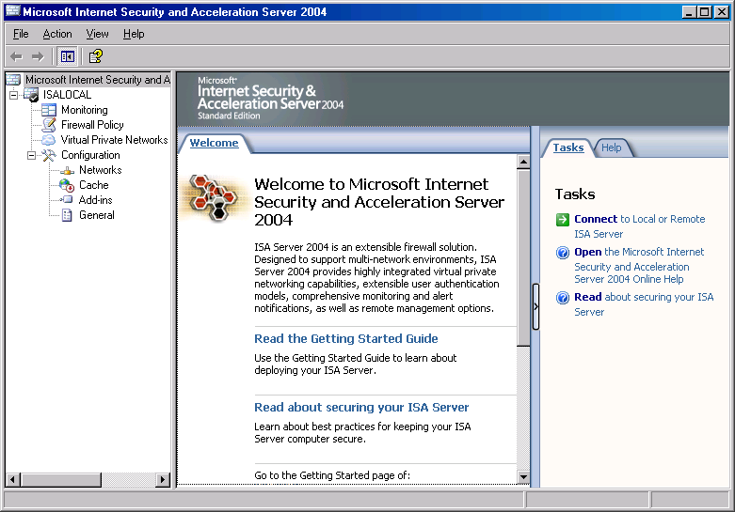

Configuring ISA Server 2004
ISA Server 2004 configuration is the same for both Windows 2000 Server and Windows Server 2003. You need to create four Access Rules and make a change to the firewall’s System Policy if the external interface does not have a permanent IP address.
Tables 1 through 4 show the details of each of these rules.
Table 1 DHCP Request (Server)
Name | DHCP Request (Server)
Action | Allow
Protocols | DHCP (request)
From | Anywhere
To | Local Host
Users | All Users
Schedule | Always
Content Types | All content types
Purpose | Allow DHCP clients to send DHCP requests to the DHCP server on the ISA Server 2004 firewall

Table 2 DHCP Reply (Server)
Name | DHCP Reply (Server)
Action | Allow
Protocols | DHCP (reply)
From | Local Host
To | Internal
Users | All Users
Schedule | Always
Content Types | All content types
Purpose | Allow the DHCP server on the ISA Server 2004 firewall machine to reply to DHCP requests made by Internal network DHCP clients

Table 3 Internal DNS Server to Forwarder
Name | Internal DNS Server to forwarder
Action | Allow
Protocols | DNS
From | DNS Server*
To | Local Host
Users | All Users
Schedule | Always
Content Types | All content types
Purpose | Allow Internal network DNS server to forward queries to the DNS forwarder on the ISA Server 2004 firewall machine
* User defined

Table 4 All Open
Name | All Open
Action | Allow
Protocols | All Outbound Traffic
From | Internal
To | External
Users | All Users
Schedule | Always
Content Types | All content types
Purpose | Allow Internal network clients access to all protocols and sites on the Internet

In addition to these Access Rules, you should configure the firewall System Policy to allow DHCP replies from External network DHCP servers.
Perform the following steps to create the DHCP Request (Server) rule:
- In the Microsoft Internet Security and Acceleration Server 2004 management console, expand the server name and then click the Firewall Policy node.
- In the Firewall Policy node, click the Tasks tab in the Task Pane. On the Task Pane, click the Create a New Access Rule link.
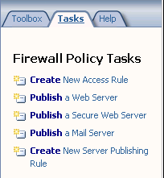
- On the Welcome to the New Access Rule Wizard page, enter DHCP Request (Server) in the Access Rule name text box. Click Next.
- On the Rule Action page, select the Allow option and click Next.
- On the Protocols page, select the Selected protocols option from the This rule applies to list and then click the Add button.
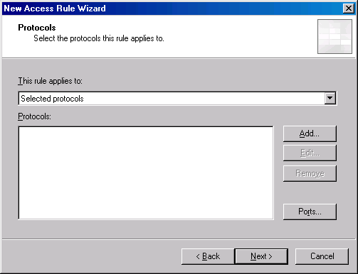
- In the Add Protocols dialog box, click the Infrastructure folder. Double click the DHCP (request) entry and then click Close.
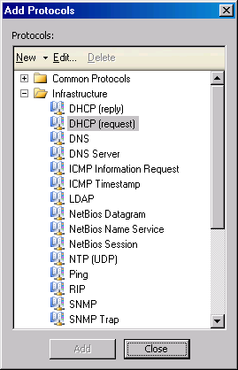
- Click Next on the Protocols page.
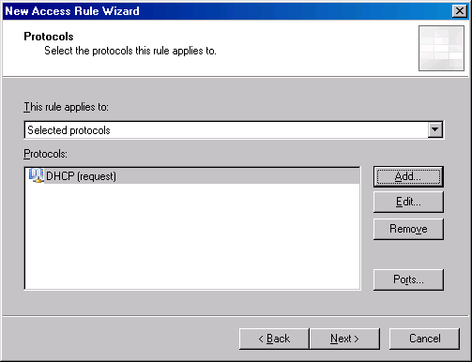
- On the Access Rule Sources page, click the Add button.
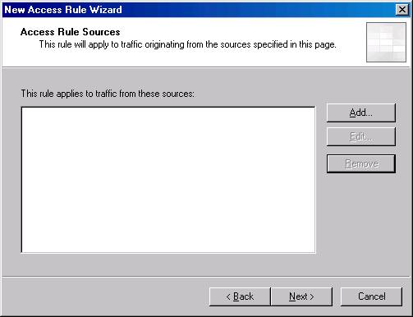
- In the Add Network Entities dialog box, click the Computer Sets folder. Double click the Anywhere entry and click Close.
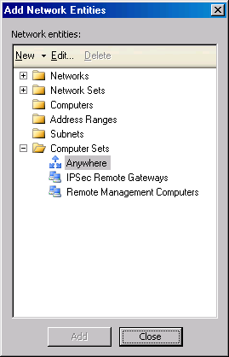
- Click Next on the Access Rule Sources page.
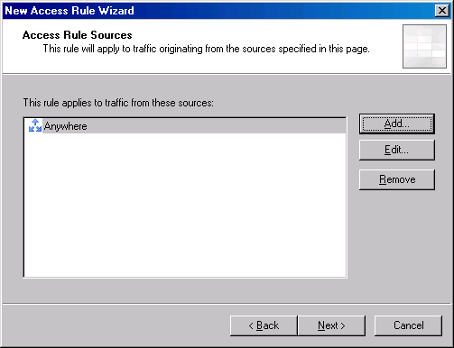
- On the Access Rule Destinations page, click the Add button.
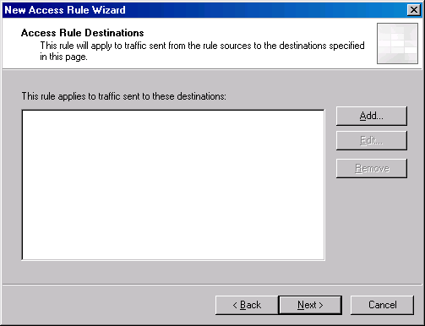
- In the Add Network Entities dialog box, click the Networks folder and then double click the Local Host entry. Click Close.
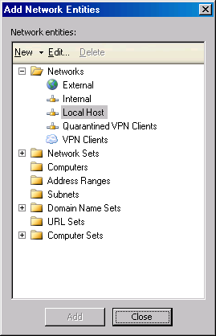
- Click Next on the Access Rule Destinations page.
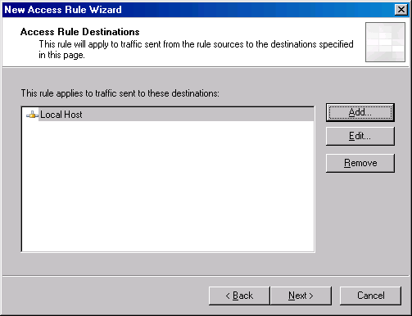
- On the User Sets page, accept the default entry, All Users, and click Next.
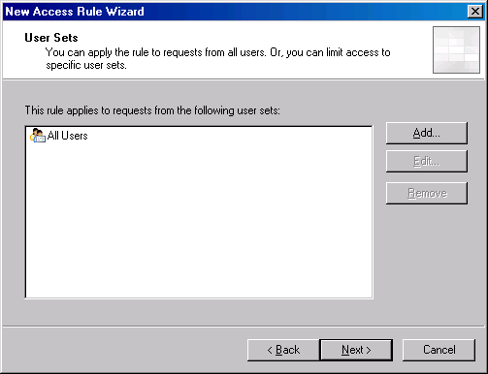
- On the Completing the New Access Rule Wizard page, review the settings and click Finish.

Perform the following steps to create the DHCP Reply (Server) rule:
- In the Microsoft Internet Security and Acceleration Server 2004 management console, expand the server name and then click the Firewall Policy node.
- In the Firewall Policy node, click the Tasks tab in the Task Pane. On the Task Pane, click the Create a New Access Rule link.
- On the Welcome to the New Access Rule Wizard page, enter DHCP Reply (Server) in the Access Rule name text box. Click Next.
- On the Rule Action page, select the Allow option and click Next.
- On the Protocols page, select the Selected protocols option from the This rule applies to list and then click the Add button.
- In the Add Protocols dialog box, click the Infrastructure folder. Double click the DHCP (request) entry and then click Close.
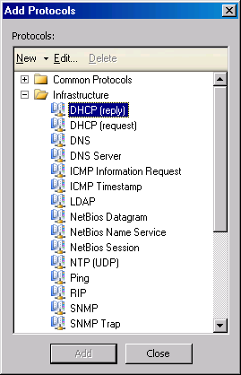
- Click Next on the Protocols page.
- On the Access Rule Sources page, click the Add button.
- In the Add Network Entities dialog box, click the Networks folder. Double click the Local Host entry and click Close.
- Click Next on the Access Rule Sources page.
- On the Access Rule Destinations page, click the Add button.
- In the Add Network Entities dialog box, click the Networks folder and then double click the Internal entry. Click Close.
- Click Next on the Access Rule Destinations page.
- On the User Sets page, accept the default entry, All Users, and click Next.
- On the Completing the New Access Rule Wizard page, review the settings and click Finish.

Perform the following steps to create the Internal DNS Server to Forwarder rule:
- In the Microsoft Internet Security and Acceleration Server 2004 management console, expand the server name and then click the Firewall Policy node.
- In the Firewall Policy node, click the Tasks tab in the Task Pane. On the Task Pane, click the Create a New Access Rule link.
- On the Welcome to the New Access Rule Wizard page, enter Internal DNS Server to Forwarder in the Access Rule name text box. Click Next.
- On the Rule Action page, select the Allow option and click Next.
- On the Protocols page, select the Selected protocols option from the This rule applies to list and then click the Add button.
- In the Add Protocols dialog box, click the Infrastructure folder. Double click the DNS entry and then click Close.
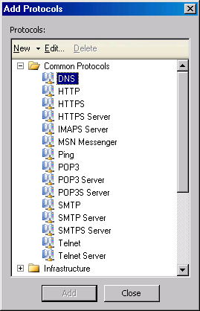
- Click Next on the Protocols page.
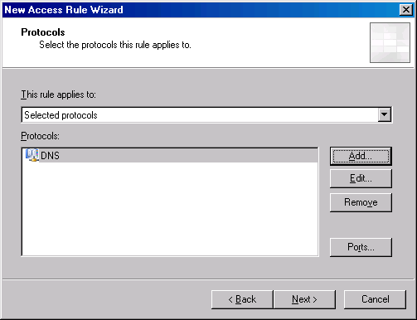
- On the Access Rule Sources page, click the Add button.
- In the Add Network Entities dialog box, click the New menu, then click Computer.
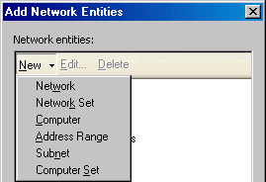
- In the New Computer Rule Element dialog box, enter Internal DNS Server in the Name text box. Enter 10.0.0.2 in the Computer IP Address text box. Click OK.
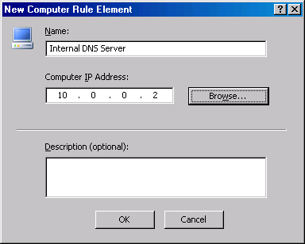
- In the Add Network Entities dialog box, click the Computers folder and then double click the Internal DNS Server entry. Click Close.
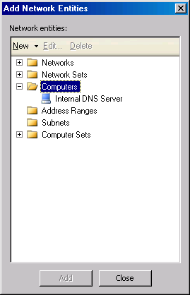
- Click Next on the Access Rule Sources page.
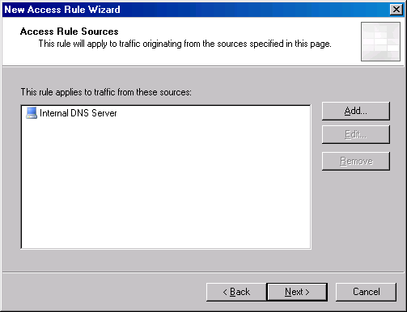
- On the Access Rule Destinations page, click the Add button.
- In the Add Network Entities dialog box, click the Networks folder and then double click the Local Host entry. Click Close.
- Click Next on the Access Rule Destinations page.
- On the User Sets page, accept the default entry, All Users, and click Next.
- On the Completing the New Access Rule Wizard page, review the settings and click Finish.

Perform the following steps to create the All Open rule:
- In the Microsoft Internet Security and Acceleration Server 2004 management console, expand the server name and then click the Firewall Policy node.
- In the Firewall Policy node, click the Tasks tab in the Task Pane. On the Task Pane, click the Create a New Access Rule link.
- On the Welcome to the New Access Rule Wizard page, enter DHCP Reply (Server) in the Access Rule name text box. Click Next.
- On the Rule Action page, select the Allow option and click Next.
- On the Protocols page, select the All outbound traffic option from the This rule applies to list and then click Next.
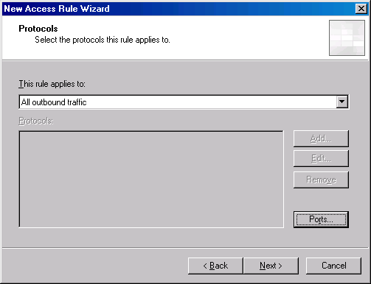
- Click Next on the Protocols page.
- On the Access Rule Sources page, click the Add button.
- In the Add Network Entities dialog box, click the Networks folder. Double click the Internal entry and click Close.
- Click Next on the Access Rule Sources page.
- On the Access Rule Destinations page, click the Add button.
- In the Add Network Entities dialog box, click the Networks folder and then double click the External entry. Click Close.
- Click Next on the Access Rule Destinations page.
- On the User Sets page, accept the default entry, All Users, and click Next.
- On the Completing the New Access Rule Wizard page, review the settings and click Finish.
Your Access Rule should look like those in the figure below. Note that in this example, you do not need to reorder the rules. When you start creating advanced Access Rules to control inbound and outbound access, you may need to reorder rules to obtain the desired results.
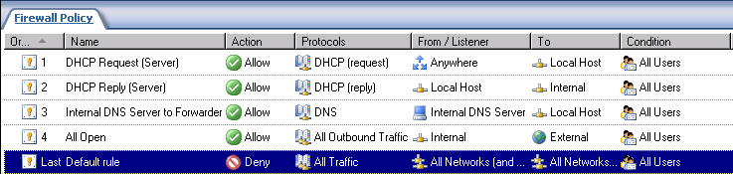

Configuring System Policy to Support Dynamic Addresses on the External Interface
ISA Server introduces a System Policy, which is a set of firewall policy rules that control how the ISA Server computer enables communications with network infrastructure elements that are necessary to manage network security and connectivity. ISA Server 2004 is installed with a default system policy, designed to address the balance between security and connectivity.
Some system policy rules are enabled upon installation. These are considered the most basic and necessary rules for effectively managing the ISA Server environment. You can subsequently identify those services and tasks that you require to manage your network, and enable the appropriate system policy rules. You should work on locking down the ISA Server 2004 System Policy after you have become more familiar with the ISA Server 2004 operations. We will not cover locking down System Policy in this ISA Server 2004 Quick Start Guide.
System Policy rules are evaluated before Access Rules that are created by the firewall administrator. Because of this, we must modify System Policy Rule to allow the ISA Server 2004 firewall to communicate with DHCP servers on the External network when the External interface uses DHCP to obtain IP addressing information.
Perform the following steps to configure this System Policy:
- In the Microsoft Internet Security and Acceleration Server 2004 management console, expand the server name in the left pane of the console and then click the Firewall Policy node. Click the Tasks tab in the Task Pane and then click the Edit System Policy link.
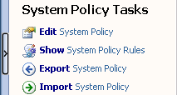
- In the System Policy Editor, locate the Network Services node in the Configuration Groups section and then click the DHCP entry.
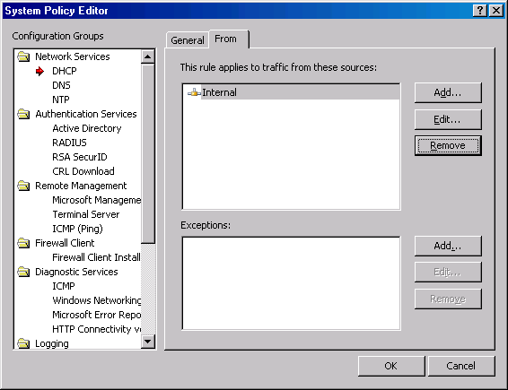
- Click the From tab in the System Policy Editor and then click Add. In the Add Network Entities dialog box, double click External and click Close.
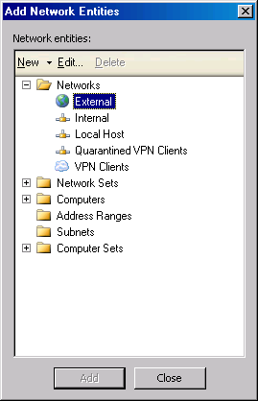
- In the System Policy Editor, the External network appears in the This rule applies to traffic from these sources section. Click OK.
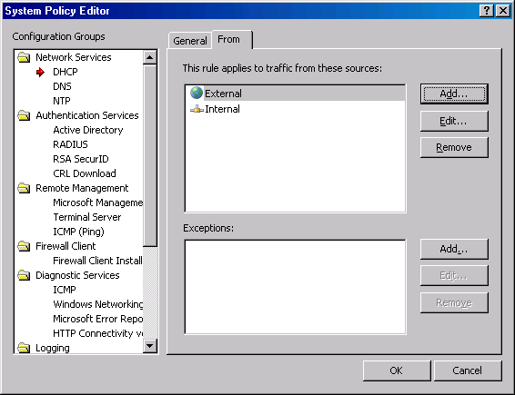

Configuring Dial-up Preferences (dial-up connections only)
You must configure Dial-up preferences for ISA Server 2004 firewalls that use dial-up connections to the Internet. The dial-up connectoid must be created before you configure the Dial-up Preferences.
Perform the following steps to configure the Dial-up Preferences:
- In the Microsoft Internet Security and Acceleration Server 2004 management console, expand the server name in the left pane of the console and then expand the Configuration node. Click the General node.
- In the General node, click the Specify Dial-up Preferences link.
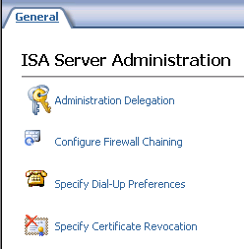
- In the Dialing Configuration dialog box, select the Allow automatic dialing to this network option so that the ISA Server 2004 firewall automatically dials the connection when a request comes from a host on the internal network. Select the External network from the list of networks under this option. Put a checkmark in the Configure this dial-up connection as the default gateway checkbox. This enables the ISA Server 2004 firewall to use the dialup connection to connect to the Internet.
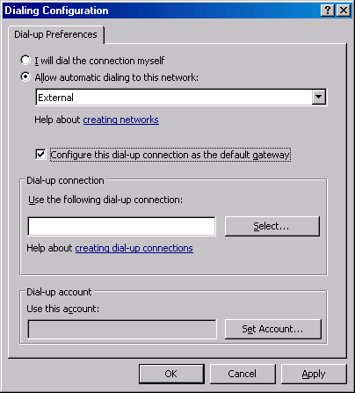
- Click the Select button. In the Select Network Dial-up Connection dialog box, select the dial-up connection you created to connect to the Internet. Click OK.
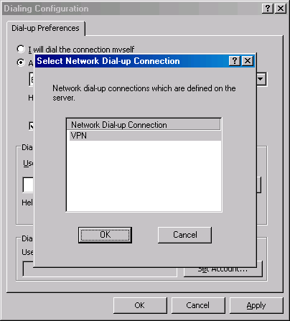
- On the Dialing Configuration dialog box, click the Set Account button. In the Set Account dialog box, enter the User account that is used by the dial-up connection to connect to the Internet. This is the user account assigned to you by your ISP. Do not use the Browse button to find this account. Enter the ISP account’s password and confirm the password in the Password and Confirm password text boxes. Click OK.
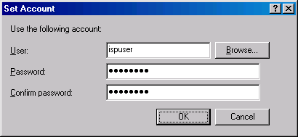
- Click Apply and then click OK in the Dialing Configuration dialog box.
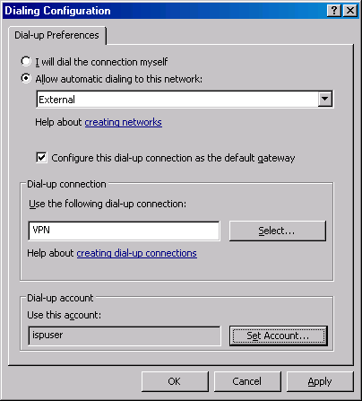
- Click Apply to save the changes and update the firewall policy.
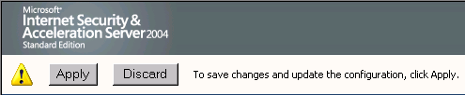
- Click OK in the Apply New Configuration dialog box.
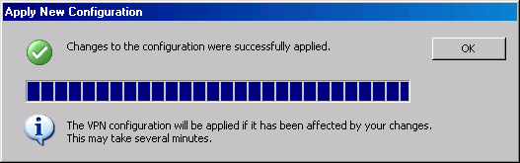

STEP 5: Configuring the Internal Network Computers
In this ISA Server 2004 Quick Start Guide, Internal network computers are set up as ISA Server SecureNAT clients. A SecureNAT client is a machine with a default gateway address set to an IP address of a network device that routes Internet-bound requests to the internal IP address of the ISA Server 2004 firewall.
When internal network computers are on the same network ID as the internal interface of the ISA Server 2004 firewall, the default gateway of the internal network computers is set as the internal IP address on the ISA Server 2004 firewall machine. This is how the DHCP scope on the DHCP server located on the ISA Server 2004 firewall is configured.
In this section, we configure internal network computers that are on the same network ID as the internal interface of the ISA Server 2004 firewall and clients that may be located on network IDs that are not on the same network ID. This latter configuration is more common on larger networks that have more than one network ID on the internal network.
- NOTE:
The “network ID” is part of the IP address. Network IDs are part of advanced TCP/IP networking concepts. Most small networks have only one Network ID and you do not need to be concerned about knowing your network ID. If you have a router anywhere behind the ISA Server 2004 computer, you need to understand network IDs. Please refer to the resources listed in the ISA Server 2004 Resources section for help with network IDs if you need more information on this issue.

Configuring Internal Clients as DHCP Clients
Internal network clients should be configured as DHCP clients. The DHCP client can request IP addressing information from a DHCP server. In this section, you will find out how to configure the Windows 2000 (Server or Professional) client as a DHCP client. The procedure is similar for all Windows-based clients. Perform the following steps to configure the internal network client and a DHCP client:
- Right click the My Network Places icon on the desktop and click the Properties option.
- In the Network Connections window, right click the external network interface and click the Properties option.
- In the network interface’s Properties dialog box, click the Internet Protocol (TCP/IP) entry and then click the Properties button.
- In the Internet Protocol (TCP/IP) Properties dialog box, select the Obtain an IP address automatically option.
- Select the Use the following DNS server addresses option. Enter the IP address of the internal interface in the Preferred DNS server text box. Click OK in the Internet Protocol (TCP/IP) Properties dialog box.
- Click OK in the internal interface’s Properties dialog box.

Configuring DHCP Clients on Remote Internal Networks
DHCP clients on remote networks are computers that have a router (or layer 3 switch) separating them from the internal interface of the ISA Server 2004 firewall. DHCP clients on these remote networks are not able to contact the DHCP server located on the ISA Server 2004 firewall because DHCP messages can’t pass through routers by default. Most routers allow you to configure them to pass these DHCP requests using methods variously described as “IP Helper”, “BOOTP relay” or “DHCP relay”. Check your router’s documentation for detailed procedures on how to allow the DHCP requests from clients on remote networks to contact the internal interface of the ISA Server 2004 firewall computer. This is not an issue if you don’t have any routers on the Internal network.

Troubleshooting
The procedures described in this Quick Start Guide are designed to provide a quick and reliable method for creating a secure firewall configuration while allowing a rich Internet experience for internal network clients. However, there are some common problems you might encounter that are related to the type of Internet connection you use on the external interface of the ISA Server 2004 firewall.

Troubleshooting Cable Connections
Cable modem connections with non-permanent IP addresses on the external interface of the ISA Server 2004 firewall computer usually work fine when the System Policy is configured to allow DHCP responses from External DHCP servers. However, some cable providers use variants of the DHCP protocol that might not work correctly with the ISA Server 2004 firewall’s DHCP client settings.
If you find the connection to the Internet stops after it has been functional for a period of time, perform the following steps to confirm the problem:
- Open a command prompt and enter ipconfig /all, then press ENTER
- If you see that the IP address for your Internet connection is 0.0.0.0, this indicates that the ISA Server 2004 firewall was not able to renew its IP address because the cable company is using an incompatible DHCP method.
- Close the command prompt window.
If you encounter this problem, put a cable router in front of the ISA Server firewall and use an Ethernet connection on the external interface of the ISA Server 2004 firewall computer. Configure the external interface of the ISA Server 2004 firewall to use the internal IP address of the cable router as its default gateway.

Troubleshooting DSL Connections
DSL connections using ATM routers almost never introduce problems for ISA Server 2004 firewalls. However, there are often issues with using a Point-to-Point Protocol over Ethernet (PPPoE) dial-up connectoid. The most common issue is related to the MTU (Mean Transfer Unit) setting on the clients and server. You can learn more about the problem and how to fix it at http://www.isaserver.org/tutorials/ISA_Server_2000_and_DSL_by_David_Fosbenner.html

If you prefer not to change the MTU settings on all your computers, you can put a DSL router in front of the ISA Server firewall and use an Ethernet connection on the external interface of the ISA Server 2004 firewall computer. Configure the external interface of the ISA Server 2004 firewall to use the internal IP address of the DSL router as its default gateway. This configuration allows the ISA Server 2004 firewall to have a permanent IP address on its external interface.

Troubleshooting Name Resolution
Your caching-only DNS server on the ISA Server 2004 firewall handles all Internet name resolution. This caching-only DNS server is configured to use your ISP’s DNS server as a forwarder. If you find that you can reach Web sites using an IP address, but not using the name of the Web site, there might be problems with your ISP’s DNS server. If you suspect that there is a problem with your ISP’s DNS sever, you can reverse the forwarder configuration you set when you configured the caching-only DNS server and allow your DNS server to perform recursion. If disabling the forwarder fixes the problem, contact your ISP to find out if there is a problem with their DNS server or if they have changed their DNS server’s IP address.

Unable to use Specific Applications
The SecureNAT client can access a wide range of protocols that allow it work with the most popular Internet applications. However, there are some Internet applications that do not work with the SecureNAT client configuration. The most common types of applications that do not work with the SecureNAT client configuration are Internet games, voice/video, and some “custom” applications. These applications do not work because they are complex protocols that require secondary connections. While the SecureNAT client can work with complex protocols, an application filter must be installed on the ISA Server 2004 firewall to enable the SecureNAT client to work with these applications.
The Firewall client software is required to enable ISA Server 2004 client machines to access complex protocols and applications. The Firewall client can manage the connections and does not require a special application filter to be installed on the ISA Server 2000 firewall machine.
In addition to providing access to complex protocols, the Firewall client software provides powerful per user based outbound access controls. These per user access controls allow you to provide access to some sites to one group of users, and other sites to another group of users. The ISA Server 2004 Firewall client greatly increases the level of security and flexibility of your ISA Server 2004 firewall.
For more information about how to install and configure the Firewall client software, please refer to the ISA Server 2004 Help file.

ISA Server 2004 Resources
Congratulations! If you have completed all the procedures in this ISA Server 2004 Quick Start Guide, your network is protected from Internet intruders and your computers can connect to the Internet. When you’re comfortable with your new ISA Server 2004 firewall, you might want to learn more about advanced firewall configuration options. Advanced configuration allows you to:
- Make the ISA Server 2004 firewall a VPN server, allowing you to connect to your network from any location in the world
- Publish your Exchange Server so that you can use the full Outlook 2000, Outlook 2002 or Outlook 2003 e-mail client from any location in the world
- Publish your Exchange Outlook Web Access site so you can connect to Outlook Web Access from any location in the world
- Control the content that users on your network can access on Internet sites
- And much more…
The following is a list of useful resources that will help you configure the ISA Server 2004 firewall’s advanced options:

The ISA Server 2004 Help File
The first place to look for help is the ISA Server 2004 Help File. The Help file contains a wealth of information about almost every component and feature included with ISA Server 2004 firewalls. Check the Help File first to see if it has the information you need.

The Microsoft ISA Server 2004 Web Site
The Microsoft official ISA Server 2004 Web site is located at www.microsoft.com/isaserver Visit this site regularly for information about ISA Server 2004 and new documents that help make it even easier to set up and maintain your ISA Server 2004 firewall.

The Microsoft ISA Server 2004 Newsgroups
You can go to the Microsoft discussion groups to read about the experiences of other ISA Server 2004 firewall owners. You can also ask questions of other ISA Server 2004 firewall owners. There are a number of people on these groups who help ISA Server 2004 firewall owners, and some of them are Microsoft Most Valuable Professionals (MVPs). This is a designation awarded to IT professionals who are ISA Server 2004 firewall experts. Visit the Official Microsoft discussion groups at http://www.microsoft.com/isaserver/community/newsgroups/default.asp

The ISAserver.org Web Site
ISAServer.org is an independent Web site dedicated to the ISA Server firewall community. The ISAServer.org site has hundreds of articles on ISA Server firewall configuration, maintenance and management. The discussion boards on the site are very active and some of the foremost ISA Server firewall experts in the world are regular attendees of this highly interactive site. Visit the site at www.isaserver.org

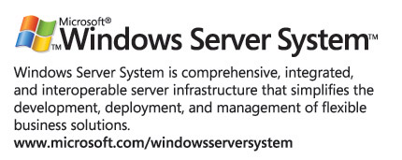

The information contained in this document represents the current view of Microsoft Corporation on the issues discussed as of the date of publication. Because Microsoft must respond to changing market conditions, it should not be interpreted to be a commitment on the part of Microsoft, and Microsoft cannot guarantee the accuracy of any information presented after the date of publication.
This white paper is for informational purposes only. MICROSOFT MAKES NO WARRANTIES, EXPRESS OR IMPLIED, IN THIS
DOCUMENT.
Complying with all applicable copyright laws is the responsibility of the user. Without limiting the rights under copyright, no part of this document may be reproduced, stored in, or introduced into a retrieval system, or transmitted in any form or by any means (electronic, mechanical, photocopying, recording, or otherwise), or for any purpose, without the express written permission of Microsoft Corporation.
Microsoft may have patents, patent applications, trademarks, copyrights, or other intellectual property rights covering subject matter in this document. Except as expressly provided in any written license agreement from Microsoft, the furnishing of this document does not give you any license to these patents, trademarks, copyrights, or other intellectual property.
© 2004 Microsoft Corporation. All rights reserved.
The example companies, organizations, products, domain names, e-mail addresses, logos, people, places, and events depicted herein are fictitious. No association with any real company, organization, product, domain name, e-mail address, logo, person, place, or event is intended or should be inferred.
Microsoft trademarks are either registered trademarks or trademarks of Microsoft Corporation in the United States and/or other countries.
The names of actual companies and products mentioned herein may be the trademarks of their respective owners.

