

ISA Server 2004 Enterprise Edition
Quick Start Guide
Published: January 2005
For the latest information, please see http://www.microsoft.com/isaserver/

Table of Contents
Introduction 3
Installation Options 5
Network Topology 6
Installing the Configuration Storage Server on a Domain Controller 9
Creating and Configuring a New Enterprise Policy 15
Assign Enterprise Administrator and Enterprise Auditor Roles 16
Define the Default Enterprise Policy 19
Create a New Enterprise Network 19
Create an Enterprise Network Rule 20
Create a New Enterprise Policy 25
Create an Enterprise Access Rule 26
Move Enterprise Access Rule Relative Positions 28
Creating and Configuring a New Array and Array Policy 31
Create a New Array 33
Configure Array Properties 36
Create the Intra-Array Network 41
Configure the Enterprise Remote Management Computers Computer Set 44
Create an Array Access Rule 46
Move the Enterprise Access Rule Below the Array Access Rule 51
Back Up the Enterprise Configuration 54
Back Up the Array Configuration 55
Installing the Firewall on the First Array Member 57
Install the ISA Server 2004 Software on the First Array Member 57
Configure the Intra-Array Communications IP Address 65
Installing the Firewall on the Second Array Member 66
Enabling the Cache Array Routing Protocol on the Array 66
Create Cache Drives on the Array 68
Enable the Web Proxy Listener on the Intra-Array Network Interfaces 71
Enable CARP on the Array 72
Enable Automatic Discovery on the Internal Network Web Listener 73
Configure Web Browsers to Use the Autoconfiguration Script Through Automatic Discovery 75
Enabling Network Load Balancing with Bidirectional Affinity on the Array 76
Enable Network Load Balancing for the Enterprise Array 76
Change the Default Gateway on the Protected Network Client Computers 79
Testing ISA Server 2004 Enterprise Edition Firewall Policies 80
Summary 81

Introduction
Microsoft® Internet Security and Acceleration (ISA) Server 2004 Enterprise Edition is a stateful packet and application-layer inspection firewall. Like ISA Server 2004 Standard Edition, ISA Server 2004 Enterprise Edition provides stateful packet inspection and stateful application-layer filtering for all connections made to, and through, the computer running ISA Server 2004 Enterprise Edition. In addition to being a highly secure stateful firewall, ISA Server 2004 Enterprise Edition can be configured as a Web caching proxy server, remote access virtual private network (VPN) server, and a site-to-site VPN gateway.
ISA Server 2004 Enterprise Edition includes all the features and functionality found in ISA Server 2004 Standard Edition. In addition, ISA Server 2004 Enterprise Edition includes:
- Support for Web caching arrays using the Cache Array Routing Protocol (CARP). Web caching arrays significantly improve ISA Server Web proxy and caching performance through the intelligent CARP algorithm. Web performance enhancements provided by CARP lead to increased end-user satisfaction and productivity.
- Integrated support for the Windows Network Load Balancing (NLB) service. NLB allows you to deploy an array of ISA Server 2004 Enterprise Edition computers in a high availability network environment. NLB provides both failover and load balancing for all connections made through an ISA Server 2004 Enterprise Edition array. If one member of the array should go offline, remaining array members can take over for the downed server. The load balancing aspect of NLB increases array performance, because it minimizes the chance of any single server in the array being overburdened by connection requests.
- Array configuration is stored in an Active Directory® Application Mode (ADAM) database. Firewall policy for the array is stored in an ADAM database that can be placed on an array member, on a Configuration Storage server on the corporate network, or on a domain controller. Multiple Configuration Storage servers can be configured to provide fault tolerance for array configuration, and Configuration Storage servers can be placed at multiple locations, such as main and branch offices, to ensure that firewall configuration is always available to array members.
- An enhanced management console, ISA Server Management, enables management of all arrays in the organization. From a single ISA Server 2004 Enterprise Edition management console, you can manage hundreds of array member servers contained in dozens of arrays located at disparate locations situated around the globe. ISA Server Management allows you to configure firewall policy at a single location and automatically update globally distributed array member servers automatically.
- Support for both enterprise and array policies. You can create enterprise policies that are applied to multiple arrays. Enterprise policies allow you to create standardized firewall access policy and have it applied to globally distributed arrays. Array administrators can be allowed to customize array policy by creating firewall policies that apply only to a specific array and integrate array policy with enterprise policy. Combining enterprise and array firewall policies provides both the required level of centralized firewall control for an entire organization and enables array administrators to customize firewall policy to meet specific requirements of their particular enterprise array.
ISA Server 2004 Enterprise Edition provides centralized control over network security policy and high availability required by globally distributed enterprise environments. Centralized control reduces the chances of firewall configuration errors leading to a catastrophic security event that puts an organization’s key data assets at risk. High availability ensures that employees are able to access critical corporate data assets and Internet information required to perform their work.
Installation and basic configuration of ISA Server 2004 Enterprise Edition can be potentially complex. This ISA Server 2004 Enterprise Edition Quick Start Guide is designed to help you install and configure a simple enterprise array as quickly and simply as possible. This ISA Server 2004 Quick Start Guide is not intended to replace comprehensive documentation on ISA Server 2004 Enterprise Edition, nor is it meant to provide a collection of ISA Server 2004 Enterprise Edition best practices. The goal of this Quick Start Guide is to quickly provide an operational test enterprise array deployment so that you can evaluate it on your own network.
The following issues are discussed in this ISA Server 2004 Enterprise Edition Quick Start Guide:
- Installation options
- Network topology
- Installing the Configuration Storage server on a domain controller
- Creating and configuring a new enterprise policy
- Creating and configuring a new array and array policy
- Installing the firewall on the first array member
- Installing the firewall on the second array member
- Enabling the Cache Array Routing Protocol on the array
- Enabling Network Load Balancing with bidirectional affinity on the array
- Testing the ISA Server 2004 Enterprise Edition firewall policies

Installation Options
One of the first decisions you need to make before deploying an ISA Server 2004 Enterprise Edition array is where to place the Configuration Storage server. The Configuration Storage server is a computer hosting the ADAM database, which stores the array’s firewall policies. A single Configuration Storage server can store firewall policy for multiple ISA Server 2004 Enterprise Edition arrays, and these arrays can be located anywhere in the organization.
ISA Server 2004 Enterprise Edition supports the following Configuration Storage server placement scenarios:
- The Configuration Storage server and array members are located in the same or in trusted domains. The Configuration Storage server is on a non-array member computer.
- The Configuration Storage server and array members are located in the same or in trusted domains. The Configuration Storage server is installed on an array member.
- The Configuration Storage server and array members are installed in a workgroup. The Configuration Storage server is installed on a non-array member computer.
- The Configuration Storage server and array members are installed in a workgroup. The Configuration Storage server is installed on an array member.
- The Configuration Storage server is installed on a domain member. The array members are installed in a workgroup.
The most straightforward installation scenario is when the Configuration Storage server and array members are all part of the same Active Directory directory service domain, and the Configuration Storage server is installed on a computer that is not an array member. This ISA Server 2004 Enterprise Edition Quick Start Guide discusses this scenario only. For information about how to configure the ISA Server 2004 Enterprise Edition using one of the other scenarios in the preceding list, see ISA Server 2004 Enterprise Edition Help and supplemental documentation at www.microsoft.com/isaserver.

Network Topology
Figure 1 depicts the network topology and server placement used in this ISA Server 2004 Enterprise Edition Quick Start Guide.
Figure 1 ISA Server 2004 Enterprise Edition example network topology

Table 1 includes details about the configuration of each computer participating in the ISA Server 2004 Enterprise Edition Quick Start Guide example network. Note that not all services or servers are used in this ISA Server 2004 Enterprise Edition Quick Start Guide.
Table 1 IP addressing and server configuration information for ISA Server 2004 Enterprise Edition sample network

Setting | Array-1 | Array-2 | Domain Controller | EXCHANGE
Dedicated IP address | Int: 10.0.0.1  Ext: 192.168.1.70  NLB: 222.222.222.1 | Int:10.0.0.3  Ext: 192.168.1.71  NLB: 222.222.222.2 | 10.0.0.4 | 10.0.0.2
Virtual IP address | Int: 10.0.0.10  Ext: 192.168.1.72 | Int: 10.0.0.10  Ext: 192.168.1.72 | Not applicable | Not applicable
Subnet mask | Int: 255.255.255.0  Ext: 255.255.255.0 | Int: 255.255.255.0  Ext: 255.255.255.0 | 255.255.255.0 | 255.255.255.0
Default gateway | Int: N/A  Ext:192.168.1.60 | Int: N/A  Ext: 192.168.1.60 | 10.0.0.1 until NLB is configured for the array.  10.0.0.10 after NLB is configured on the array. | 10.0.0.1 until NLB is configured for the array.  10.0.0.10 after NLB is configured on the array.
DNS server address | Int: 10.0.0.4  Ext: N/A | Int: 10.0.0.4  Ext: N/A | 10.0.0.4 | 10.0.0.4
WINS server address | Int: 10.0.0.4  Ext: N/A | Int: 10.0.0.4  Ext: N/A | 10.0.0.4 | 10.0.0.4
Operating system | Windows Server™ 2003 | Windows Server 2003 | Windows Server 2003 | Windows Server 2003
Installed services | ISA Server 2004 Enterprise Edition | ISA Server 2004 Enterprise Edition | Active Directory  Configuration Storage server  DNS  WINS  DHCP  IAS  CA | Exchange Server 2003
Role on network | First member of ISA Server 2004 Enterprise Edition enterprise array | Second member of ISA Server 2004 Enterprise Edition enterprise array | Active Directory domain controller, Configuration Storage server, and host for network services supporting the ISA Server enterprise array. | Exchange Server 2003 to demonstrate Exchange Server remote access scenarios
Domain member | Yes | Yes | Yes | Yes
FQDN in domain DNS | array-1.msfirewall.org | array-2.msfirewall.org | dc.msfirewall.org | exchange.msfirewall.org

This ISA Server 2004 Quick Start Guide assumes you have installed these four servers and configured them based on the specifications in Table 1. Array members can be directly connected to the Internet, or placed behind a firewall or router that connects the network to the Internet. In this ISA Server 2004 Enterprise Edition Quick Start Guide example network, the array members are located behind an ISA Server 2004 Standard Edition computer and their default gateways are set as the internal interface of the upstream ISA Server 2004 Standard Edition computer.
If you choose not to install the computers in the configuration provided in Table 1, you can still use this ISA Server 2004 Enterprise Edition Quick Start Guide. Replace the names and IP addresses with the names and addresses in your environment. However, you must make the Configuration Storage server and array members part of the same or trusted Active Directory domains.

Installing the Configuration Storage Server on a Domain Controller
The first step is to install the Configuration Storage server. In the ISA Server 2004 Enterprise Edition Quick Start Guide scenario, you can make any domain member server a Configuration Storage server. This includes a domain controller in the same domain or trusting domain. To reduce the number of computers required on the example network used in this guide, and to demonstrate support for a combined Configuration Storage server and domain controller, this scenario installs the Configuration Storage server on the domain controller.
All array members communicate with the Configuration Storage server to update their configuration. In addition, you will install the ISA Server 2004 Enterprise Edition management console, ISA Server Management, on the Configuration Storage server. All management of the ISA Server 2004 Enterprise Edition array is performed in ISA Server Management on this computer. Note that you can install the ISA Server 2004 Enterprise Edition management console on any computer running Microsoft Windows Server 2003 or Windows® XP. It does not need to be installed on the Configuration Storage server.
After all computers in the example network are installed and configured, place the ISA Server 2004 Enterprise Edition CD-ROM into the domain controller (dc.msfirewall.org) and perform the following steps:
- The Autorun menu should appear automatically. If it does not, open Windows Explorer and double-click ISAAutorun.exe.
- In the Microsoft ISA Server 2004 Setup dialog box, click Install ISA Server 2004.
- On the Welcome to the Installation Wizard for Microsoft ISA Server 2004 page, click Next.
- On the License Agreement page, read the license agreement, select the I accept the terms in the license agreement option, and then click Next.
- On the Customer Information page, enter your User Name, Organization, and Product Serial Number. Click Next.
- On the Setup Scenarios page, select the Install Configuration Storage server option and click Next.
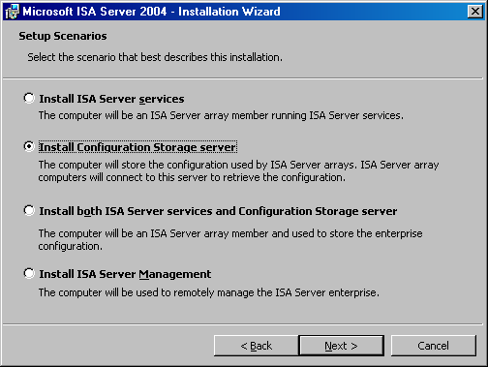
- On the Component Selection page, accept the default settings. The default settings install ISA Server Management and the Configuration Storage server. Click Next.
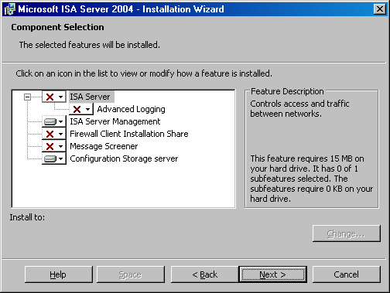
- On the Enterprise Installation Options page, select the Create a new ISA Server enterprise option and click Next.
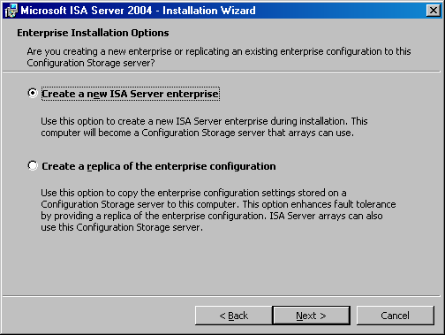
- Read the information on the New Enterprise Warning page. This information explains that you should have only a single ISA Server 2004 Enterprise Edition enterprise defined in your organization. Click Next.
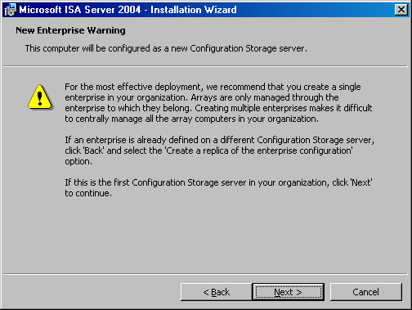
- On the Create New Enterprise page, enter a name and description for your ISA Server 2004 Enterprise Edition enterprise in the Enterprise name and Description text boxes. Click Next.
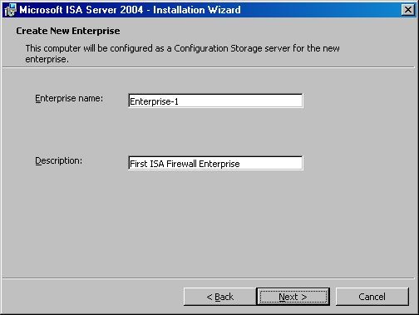
- On the Enterprise Deployment Environment page, select the I am deploying in a single domain or in domains with trust relationships option. Click Next.
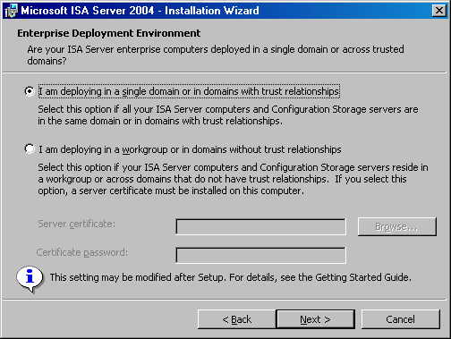
- On the Configuration Storage Server Service Account page, select the account under which the Configuration Storage server service will run. When you install a Configuration Storage server on a domain controller, you need to specify an account under which the Configuration Storage server service will run. This account will be given permissions to log on as a service. Note that if this account does not belong to the Domain Admins group, you must perform additional steps after you complete the installation of the Configuration Storage server. For more information, see the Configuration Storage server on Active Directory domain controller section in the Getting Started Guide. In this example, type Administrator in the User name text box and the domain Administrator’s password in the Password text box. Click Next.
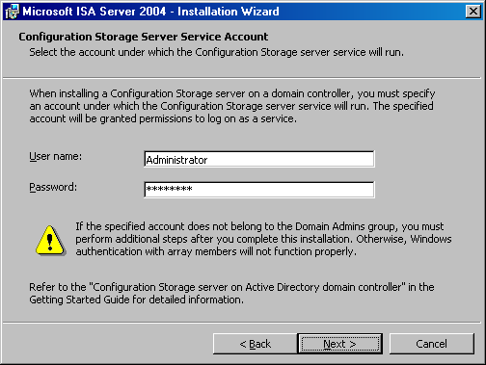
- Click Install on the Ready to Install the Program page.
- When the installation completes, select the Invoke ISA Server Management when the wizard closes option, and then click Finish.

Creating and Configuring a New Enterprise Policy
ISA Server 2004 Enterprise Edition supports enterprise firewall policies that can be applied to one or more arrays. Enterprise policies can be created once, and then applied to one or more arrays with the goal of standardizing security policy throughout the organization. Enterprise policies can also be integrated with local array policies. This provides array administrators with an additional level of control over traffic moving through ISA Server 2004 Enterprise Edition arrays.
In this section, you will examine the following procedures involved with creating and configuring an enterprise policy:
- Assign Enterprise Administrator and Enterprise Auditor roles. You can assign firewall enterprise administrator and firewall enterprise auditor permissions to users or groups. Enterprise administrators have complete configuration control over computers in the enterprise, and enterprise auditors can audit any computer in the organization.
- Define the default enterprise policy. ISA Server 2004 Enterprise Edition includes a default enterprise policy. The implications of this policy are discussed.
- Create a new enterprise network. The ISA Server 2004 Enterprise Edition computer performs stateful packet and application-layer inspection on communications moving from one ISA Server 2004 Enterprise Edition network to another ISA Server network. You will create an ISA Server network at the enterprise level and use this for access control.
- Create an enterprise network rule. This rule sets the route relationship between the enterprise Internal network and the Internet. Network rules control the route relationship between the source and destination networks in a communication. You can choose either route or network address translation (NAT). You will create a NAT relationship between our enterprise network and the Internet.
- Create a new enterprise policy. Enterprise policies include access rules that can be overlaid on local array access rules to create an integrated firewall policy. This provides centralized security management required for standardization, and flexibility for the local array administrators to create array-level access rules and publishing rules.
- Create an enterprise access rule. A new access rule is created and named Enterprise All Open. The Enterprise All Open access rule allows access from all hosts to all sites using any protocol.
- Move enterprise access rule relative positions. The Enterprise All Open access rule is moved so that it is applied before array policy. This demonstrates how you can move enterprise policy rules so that they can be applied before or after local array policy rules.

Assign Enterprise Administrator and Enterprise Auditor Roles
In this procedure, you will assign the ISA Server Enterprise Administrator and ISA Server Enterprise Auditor roles.
Perform the following steps to assign the enterprise roles:
- In the left pane of the ISA Server 2004 Enterprise Edition console, expand the Enterprise node, and then expand the Enterprise Policies node. Your console should now appear similar to that in the following figure.
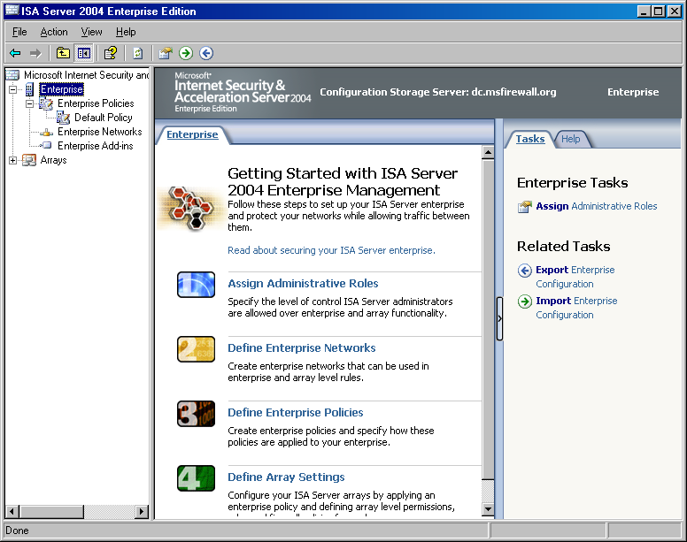
- Right-click the Enterprise node in the left pane of the ISA Server 2004 Enterprise Edition console and click Properties.
- In the Enterprise Properties dialog box, click the Assign Roles tab. On the Assign Roles tab, you can configure which users and groups are allowed access to the Configuration Storage server, and which users and groups can monitor arrays.
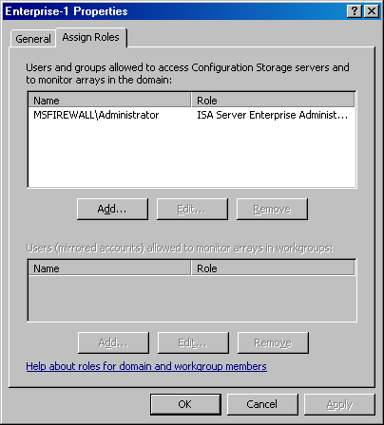
- Click the Add button to display the Administration Delegation dialog box. You can add local or domain users or groups to either the ISA Server Enterprise Administrator or ISA Server Enterprise Auditor roles for the entire enterprise. Use the Browse button to locate the user or group, and then click the drop-down arrow in the Role list to assign the appropriate role to the user or group selected. Click OK to save the changes.
- In the example used in the ISA Server 2004 Enterprise Edition Quick Start Guide, you do not make any changes to the Administration Delegation configuration.
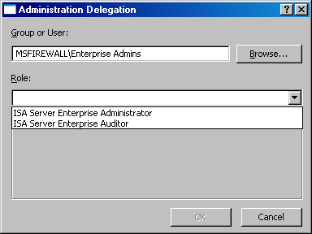

Define the Default Enterprise Policy
In the left pane of the ISA Server 2004 Enterprise Edition console, a Default Policy is located under the Enterprise Policies node. You cannot change or delete this Default Policy. The purpose of this policy is to ensure that the ISA Server 2004 Enterprise Edition array is completely locked down by default. Only traffic you explicitly allow through the firewall array is allowed to traverse the array.
If you create no other enterprise policies, this default enterprise policy is applied to all arrays you create. This policy is configured to place the default rule included in the Default Policy at the end of the access rule list, after the array’s firewall policy.
The enterprise Default Policy ensures that the ISA Server 2004 Enterprise Edition array secures your organization by default.

Create a New Enterprise Network
Enterprise networks can be used in both enterprise and array-level access rules. In this ISA Server 2004 Enterprise Edition Quick Start Guide, you will create an enterprise network to demonstrate how enterprise networks are created in contrast to array-level networks.
Perform the following steps to create a new enterprise network:
- In the ISA Server 2004 Enterprise Edition console, confirm that the Enterprise Policies node is expanded and click the Enterprise Networks node.
- In the details pane, click the Networks tab.
- Click the Tasks tab in the task pane, and then click Create a New Network.
- On the Welcome to the New Network Wizard page, in Network name, type a name for the new enterprise network. In this example, the name of the new enterprise network is Enterprise Internal. Click Next.
- On the Network Addresses page, you specify all the addresses that are defined as internal for your organization, or a subset of addresses, depending on your enterprise-level requirements. Click the Add Range button to add addresses to your enterprise network.
- In the IP Address Range Properties dialog box, enter the range of addresses you want to use for this enterprise network. In this example, enter a Start address of 10.0.0.0 and an End address of 10.0.0.255. Click OK.
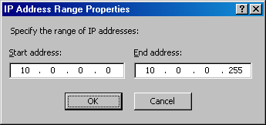
- The new address range now appears in the list of Address ranges on the Network Addresses page. Click Next.
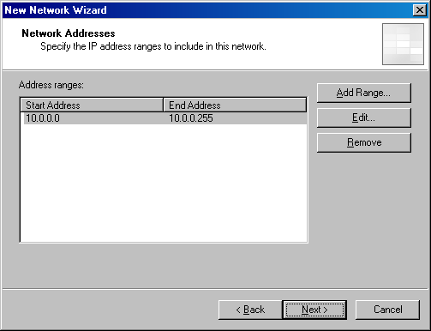
- Click Finish on the Completing the New Network Wizard page.

Create an Enterprise Network Rule
For traffic to move from one ISA Server firewall network to another ISA Server firewall network (a firewall network is a network configured at the ISA Server enterprise or array level), a network rule must be created defining the route relationship between the source and destination networks.
In this example, you will create a network address translation (NAT) relationship between the Enterprise Internal network and the Internet. This allows the array to use NAT for all connections between the hosts on the Enterprise Internal network and the Internet.
Perform the following steps to create the network rule:
- In the left pane of the ISA Server 2004 Enterprise Edition console, click the Enterprise Networks node. In the details pane, click the Network Rules tab.
- Click the Tasks tab in the task pane. Click Create a Network Rule.
- On the Welcome to the New Network Rule Wizard page, enter a name for the network rule in the Network rule name text box. In this example, you name the network rule Enterprise Internal to External. Click Next.
- On the Network Traffic Sources page, click the Add button.
- In the Add Network Entities dialog box, expand the Enterprise Networks folder and double-click Enterprise Internal. Click Close.
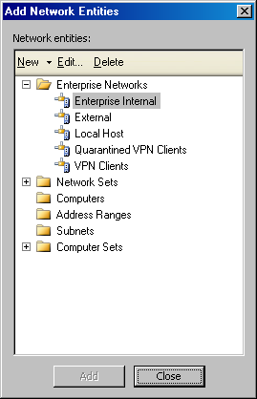
- Click Next on the Network Traffic Sources page.
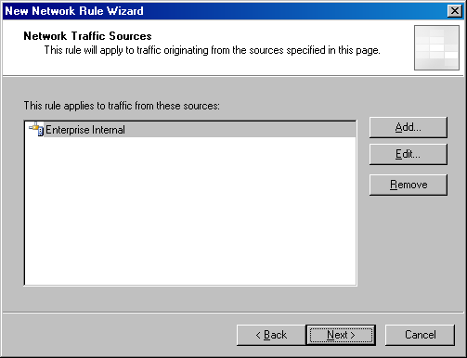
- On the Network Traffic Destinations page, click the Add button.
- In the Add Network Entities dialog box, expand the Enterprise Networks folder and double-click External. Click Close.
- Click Next on the Network Traffic Destinations page.
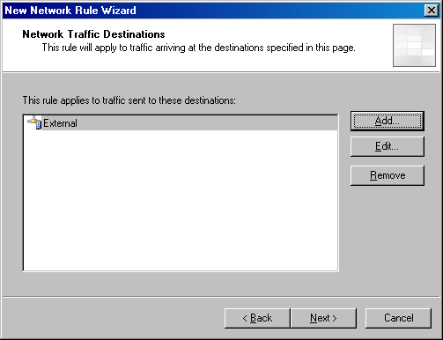
- On the Network Relationship page, select the Network Address Translation (NAT) option and click Next.
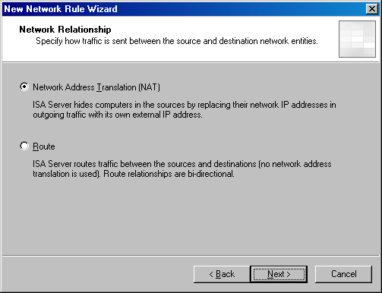
- Click Finish on the Completing the New Network Rule Wizard page.
- The new network rule appears in the list of enterprise network rules.
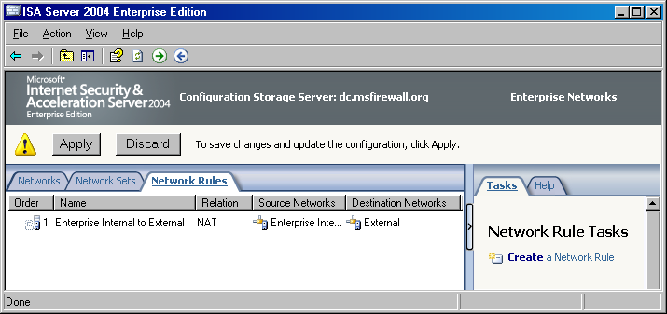

Create a New Enterprise Policy
You can create enterprise policies and populate these enterprise polices with access rules, which can then be overlaid on array policies. Enterprise policies enable the enterprise administrator to centralize firewall access control throughout all firewall arrays in the organization. You need to create a new enterprise policy before creating custom enterprise access rules, which are used to control access through enterprise policy throughout your organization.
Perform the following steps to create a new enterprise policy:
- In the ISA Server 2004 Enterprise Edition console, click the Enterprise Policies node in the left pane of the console, and then click the Tasks tab in the task pane. On the Tasks tab, click Create New Enterprise Policy.
- On the Welcome to the New Enterprise Policy Wizard page, enter a name for the new enterprise policy in the Enterprise policy name text box. In this example, you name the new enterprise policy Enterprise Policy 1. Click Next.
- Click Finish on the Completing the New Enterprise Policy Wizard page.
The new enterprise policy now appears in the left pane of the console. Click Enterprise Policy 1. You see that there is a single rule included in the new enterprise policy, which is the default rule. This default rule prevents all communications moving through the ISA Server 2004 Enterprise Edition computers to which this enterprise policy applies. You will need to create an enterprise-level access rule to allow traffic through the ISA Server firewall arrays based on enterprise policy.

Create an Enterprise Access Rule
You can now populate the enterprise policy with access rules. In this ISA Server 2004 Enterprise Edition Quick Start Guide, you will create a simple Enterprise All Open access rule allowing outbound traffic from hosts on the Enterprise Internal network to the Internet. You will use this Enterprise All Open access rule as an example only. In a well-managed enterprise, enterprise firewall administrators create access rules that are consistent with the Principle of Least Privilege, where users are allowed access only to the resources they require to accomplish their work.
However, as a proof of concept, you will create an Enterprise All Open access rule to simplify the initial configuration of your enterprise policy. We recommend that you disable this rule and create more restrictive access rules after confirming that your test enterprise-level access rule performs as expected.
Perform the following steps to create the Enterprise All Open access rule in your Enterprise Policy 1 enterprise policy:
- In the ISA Server 2004 Enterprise Edition console, click the Enterprise Policy 1 enterprise policy in the left pane of the console. Click the Tasks tab in the task pane, and then click Create Enterprise Access Rule.
- On the Welcome to the New Access Rule Wizard page, enter a name for the access rule in the Access rule name text box. In this example, enter the name Enterprise All Open in the Access rule name text box. Click Next.
- On the Rule Action page, select the Allow option and click Next.
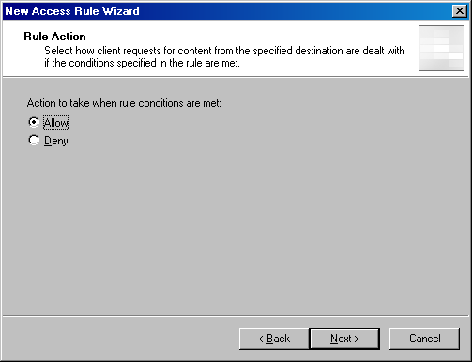
- On the Protocols page, click the drop-down arrow on the This rule applies to list and click All outbound traffic. Click Next.
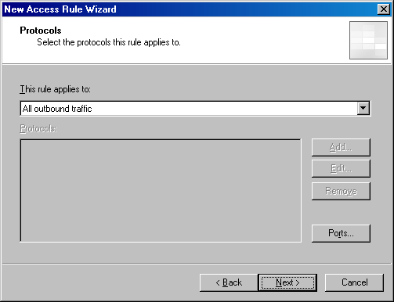
- On the Access Rule Sources page, click the Add button.
- In the Add Network Entities dialog box, expand the Enterprise Networks folder, and then double-click Enterprise Internal. Click Close.
- Click Next on the Access Rule Sources page.
- On the Access Rule Destinations page, click the Add button.
- In the Add Network Entities dialog box, expand the Enterprise Networks folder, and then double-click External. Click Close.
- Click Next on the Access Rule Destinations page.
- On the User Sets page, accept the default entry All Users and click Next.
- Review your settings on the Completing the New Access Rule Wizard page and click Finish.

Move Enterprise Access Rule Relative Positions
Enterprise access rules can be applied before or after array-level rules. This provides the enterprise firewall administrator with the flexibility to configure centralized firewall policy for all array members to which a particular enterprise policy is applied. You can create one or more access rules in an enterprise policy and then configure these rules, on a per-rule basis, to be applied either before or after local array policy.
Array administrators can be allowed to create their own custom array-level policies that are applied before or after one or more enterprise access rules. This provides flexibility for both enterprise and array administrators when configuring access control for network protection.
In the following figure, you can see that the enterprise access rule is placed after the Array Firewall Policy.
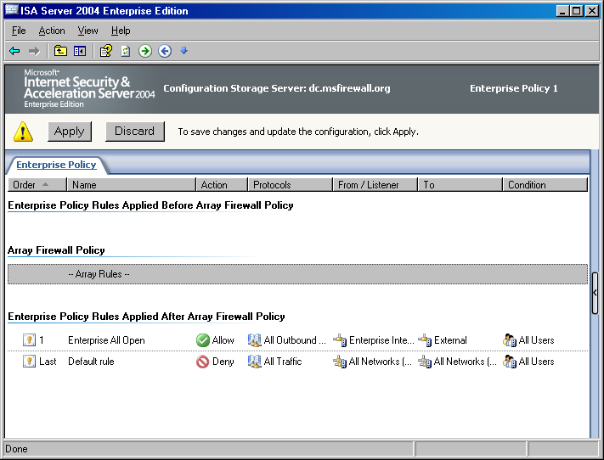
In this example, you will want the Enterprise All Open access rule to be applied before the array policy. You can do this by selecting the Enterprise All Open access rule, and then clicking the Move Up button, as shown in the following figure.
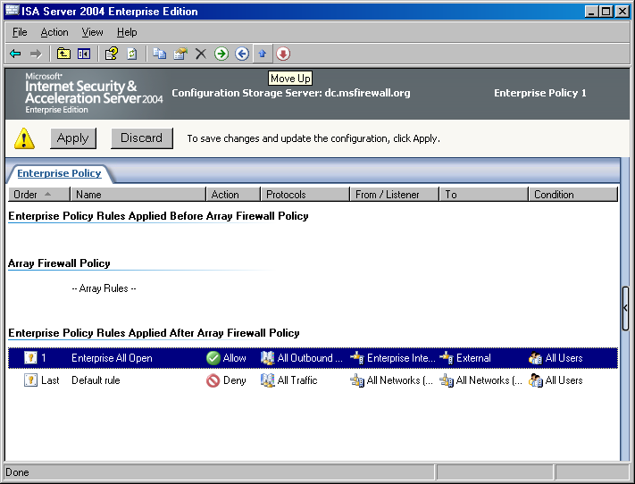
Move the Enterprise All Open access rule to the top of the list. Your enterprise policy should appear like the following figure.
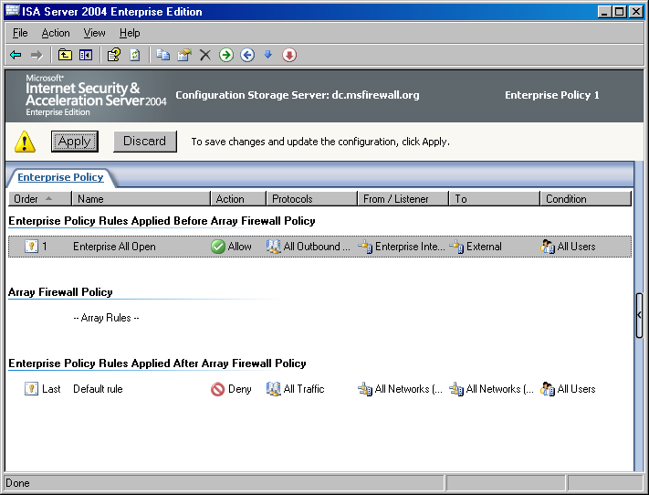

Creating and Configuring a New Array and Array Policy
Collections of ISA Server 2004 Enterprise Edition computers can be grouped into firewall arrays. A firewall array shares a common configuration and all computers within the array share a common firewall policy. ISA Server 2004 Enterprise Edition arrays can consist of two or more firewall devices. Arrays make it easy to configure multiple firewalls because a single firewall policy is applied to all array members.
The array concept may be confusing to ISA Server 2004 Standard Edition administrators who are not accustomed to configuring firewall policy for multiple computers through a unified management interface. Configuring array policy for an enterprise array is similar to configuring firewall policy for a single ISA Server 2004 Standard Edition computer. The primary difference is that when configuring enterprise array policy, the same policy is applied to all computers in the array. In contrast, when you configure firewall policy on an ISA Server 2004 Standard Edition computer, policy is applied only to a single computer.
Note that while firewall policy is automatically applied to all computers in an array, there are some configuration options that do not lend themselves to array-level configuration. The ISA Server 2004 Enterprise Edition management interface informs you when you encounter one of these per-server configuration options and allows you to make the appropriate per-server settings when required.
You must create ISA Server 2004 Enterprise Edition arrays because there are no default arrays. In this section, you will perform the following ISA Server 2004 Enterprise Edition array-related tasks:
- Create a new array. There are no default arrays, so you must create a new array to which you will apply firewall policy.
- Configure array properties. There are many characteristics that define an array. The first step after creating a new array is to define these array-specific characteristics, such as addresses used for intra-array communications.
- Create the intra-array network. Each array member in the sample network used in this ISA Server 2004 Enterprise Edition Quick Start Guide has three network interfaces. One network interface is connected to the default External network, another interface is connected to the default Internal network, and the third interface is connected to a network dedicated to intra-array communications. This intra-array communications network is required because you will later enable Network Load Balancing (NLB) for the array. A dedicated network adapter is required because ISA Server 2004 Enterprise Edition integrated NLB uses only unicast mode NLB.
- Configure the Enterprise Remote Management Computers computer set. After creating the array, several network objects are included by default. One of these network objects is the Remote Management Computers computer set. You will need to add the Configuration Storage server, on which you will run the ISA Server 2004 Enterprise Edition management console, to this computer set so that it can manage computers in the ISA Server 2004 Enterprise Edition array.
- Create an array access rule. In this section, you will create an HTTP-only access rule to demonstrate how to create an array-level rule, and then demonstrate how enterprise and array policies interact.
- Move the enterprise access rule below the array access rule. You can move enterprise rules above and below array-level access rules. This section demonstrates how to do this.
- Back up the enterprise configuration. ISA Server 2004 Enterprise Edition allows you to easily back up and restore your enterprise configuration. This section demonstrates procedures for backing up the enterprise configuration.
- Back up the array configuration. In addition to making it easy to back up the enterprise firewall policy, ISA Server 2004 Enterprise Edition makes it easy to back up the array-level policy. This section demonstrates how to back up the array policy.

Create a New Array
The first step is to create a new array. You can create one or more arrays in the ISA Server 2004 Enterprise Edition console from a single management workstation. There is never a need to use RDP to manage the firewall configuration on any array member computer. Perform the following steps to create the new enterprise array:
- In the ISA Server 2004 Enterprise Edition console, click the Arrays node in the left pane of the console. Click the Tasks tab in the task pane and click Create New Array.
- On the Welcome to the New Array Wizard page, enter a name for the new array in the Array name text box. In this example, you name the array NEWARRAY. Click Next.
- On the Array DNS Name page, enter the fully qualified domain name that Firewall clients and Web Proxy clients should use when connecting to the array. In this example, you enter newarray.msfirewall.org. You should create Host (A) records in the Internal network DNS that map the internal IP address of each array member to this name. Enter newarray.msfirewall.org in the Array’s DNS name text box and click Next.
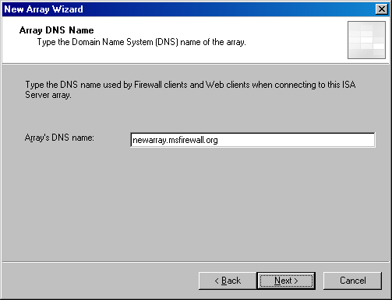
- On the Assign Enterprise Policy page, in Apply this enterprise policy to the new array, select Enterprise Policy 1. Click Next.
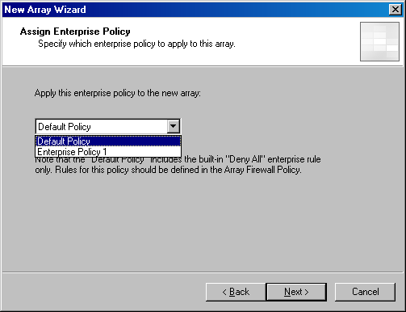
- On the Array Policy Rule Types page, select the type of array firewall policy rules that an array administrator can create for the array. This option enables the enterprise administrator to limit the scope of rule types that an array administrator can create and helps centralize control over network firewall security policy. In this example, select the "Deny" access rules, "Allow access" rules, and Publishing rules (Deny and Allow) check boxes. Click Next.
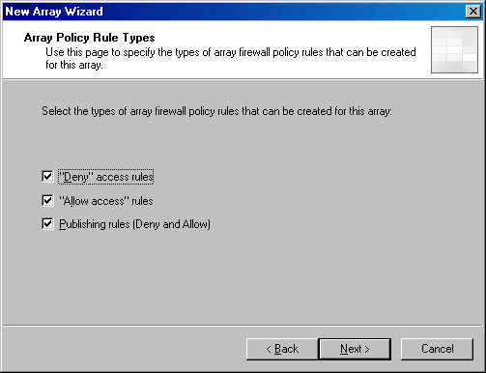
- On the Completing the New Array Wizard page, click Finish.
- In the Create New Array dialog box, click OK when the array is successfully created.
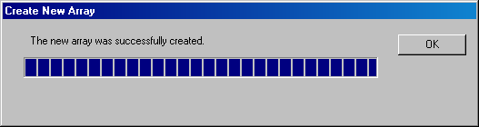

Configure Array Properties
In the left pane of the ISA Server 2004 Enterprise Edition console, expand the Arrays node, expand the NEWARRAY node, and then expand the Configuration node. With each of these nodes expanded, you can see all nodes and subnodes used to configure the array. The first step is to configure the general properties of the array. Perform the following steps to configure the array properties:
- Click the NEWARRAY node in the left pane of the console, and then click the Tasks tab in the task pane. On the Tasks tab, click Configure Array Properties.
- The first tab you see in the NEWARRAY Properties dialog box is the General tab. There is nothing you need to configure on this tab.
- Click the Policy Settings tab. On the Policy Settings tab, you can change the enterprise policy assigned to the array. You can also change the array firewall policy rule types that can be configured on this array. In this example, you do not make any changes on this tab.
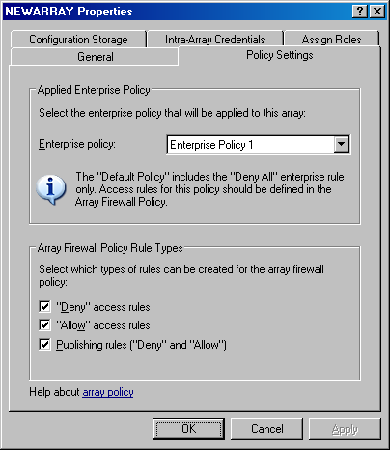
- Click the Configuration Storage tab. On the Configuration Storage tab, you can enter the name of the Configuration Storage server in Configuration Storage server (enter the FQDN). This value is entered by default during installation of the Configuration Storage server. You can also enter an alternate Configuration Storage server in Alternate Configuration Storage server (optional). Configuring an alternate Configuration Storage server provides fault tolerance in the event that the default Configuration Storage server is not available. Array members check the Configuration Storage server for updated policy based on the setting in the Check the Configuration Storage server for updates every box. The default is every 15 seconds, but you can configure the update interval to be any value. In this example, you do not make any changes on the Configuration Storage tab.
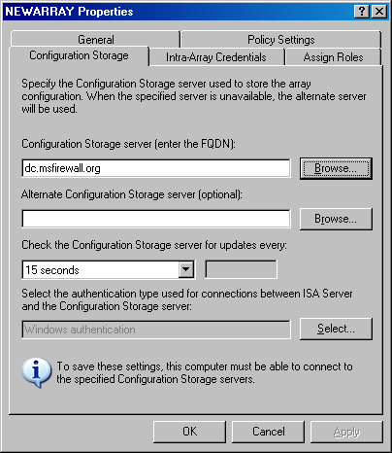
- On the Intra-Array Credentials tab, you configure the method for which credentials an array member should use when performing intra-array communications. Because all array members and the Configuration Storage server are members of the same domain, the default setting is Authenticate using the computer account of the array member. If all computers were not members of the same or trusted Active Directory domain, you would select the Authenticate using this account (for workgroup configuration only) option. In this example, you do not make any changes on the Intra-Array Credentials page.
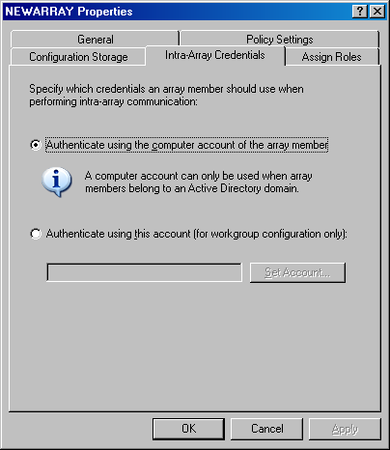
- Click the Assign Roles tab. On the Assign Roles tab, you configure the users and groups that are allowed management roles for this array. Click the Add button on the Assign Roles tab. Use the Browse button to select a user or group to which you want to assign an array management role. Click the drop-down arrow for the Role list. You can assign users or groups to one of the following array roles: ISA Server Array Administrator, ISA Server Array Auditor, or ISA Server Array Monitoring Auditor. In this example, you assign the MSFIREWALL\Domain Admins group the ISA Server Array Administrator role. Click OK.
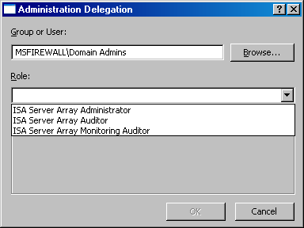
- Click Apply, and then click OK in the NEWARRAY Properties dialog box.
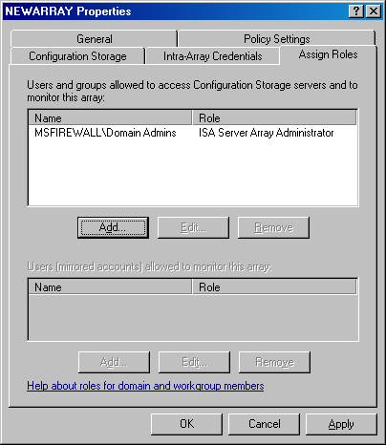

Create the Intra-Array Network
Each member in the array on our example network has a third network adapter installed that is dedicated to intra-array communications. This is required because later you will enable ISA Server 2004 Enterprise Edition integrated Network Load Balancing (NLB) within the array. ISA Server 2004 Enterprise Edition NLB uses only unicast mode NLB. To prevent issues related to unicast mode NLB, you need a network interface dedicated to intra-array communications.
The ISA Server firewall array members consider all addresses that are not part of a defined ISA Server firewall network to be part of the default External network. To prevent routing errors, you must create an ISA Server firewall network definition for the intra-array network. Perform the following steps to create the intra-array network:
- In the ISA Server 2004 Enterprise Edition console, click the Networks node located under the Configuration node. Click the Tasks tab in the task pane and click Create a New Network.
- On the Welcome to the New Network Wizard page, enter a name for the new network in the Network name text box. In this example, you name the new network Intra-array Network. Click Next.
- On the Network Type page, select the Perimeter Network option and click Next.
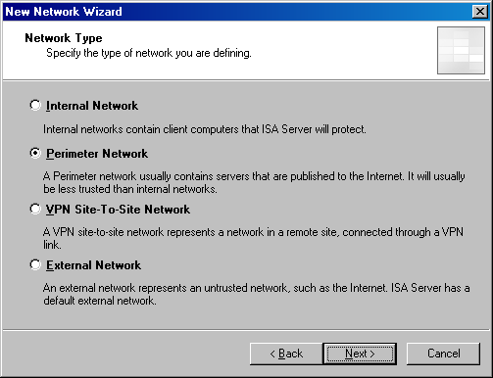
- On the Network Addresses page, you configure the addresses used on the intra-array network. You can use the Add Range, Add Adapter, or Add Private buttons to add the address range defining the network. However, you are not able to use the Add Adapter button in this example, because there are no computers assigned to the array yet. Because there are no computers assigned to the array, the Configuration Storage server does not have information about the array member adapters. In this example, click the Add Range button.
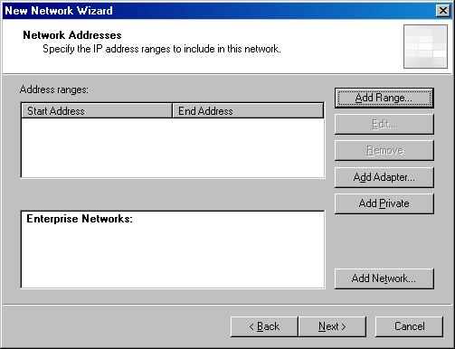
- In the IP Address Range Properties dialog box, enter the first and last addresses in the range in the Start address and End address text boxes. In this example, enter a Start address of 222.222.222.0 and an End address of 222.222.222.255. Click OK.
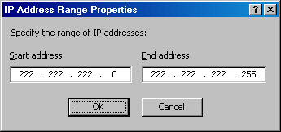
- Click Next on the Network Addresses page.
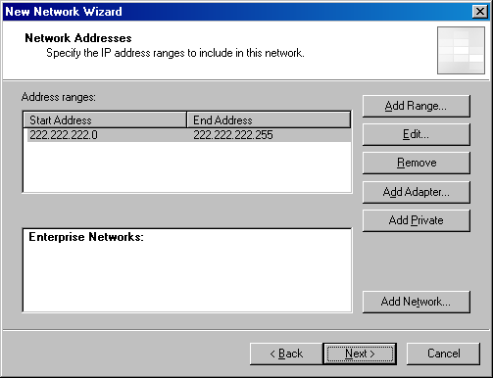
- Click Finish on the Completing the New Network Wizard page.

Configure the Enterprise Remote Management Computers Computer Set
To manage the enterprise array computers from a management station running the ISA Server 2004 Enterprise Edition console, the management station must be added to the Enterprise Remote Management Computers computer set. This computer set network object is created for you automatically. You only need to add the address of your management station to the computer set. In this example, you will add the IP address of the Configuration Storage server to this computer set. Perform the following steps to add the Configuration Storage server to the Enterprise Remote Management Computers computer set:
- In the ISA Server 2004 Enterprise Edition console, click the Enterprise Policy 1 node in the left pane of the console. In the task pane, click the Toolbox tab.
- On the Toolbox tab, click Network Objects. On the Network Objects tab, expand the Computer Sets folder.
- Double-click the Enterprise Remote Management Computers computer set.
- In the Enterprise Remote Management Computers Properties dialog box, click the Add button, and then click the Computer menu item.
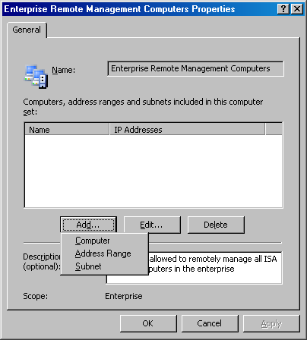
- In the New Computer Rule Element dialog box, enter a name for the management station in the Name text box. In this example, you name the entry Enterprise Management Station. In the Computer IP Address text box, enter the IP address of the management station. In this example, the IP address of the management station is 10.0.0.4, so enter 10.0.0.4 in the text box. Click OK.
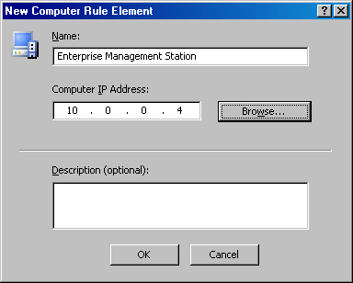
- Click Apply, and then click OK in the Enterprise Remote Management Computers Properties dialog box.

Create an Array Access Rule
To demonstrate the interactions between enterprise policy and array policy access rules, you will create an access rule in the array policy allowing outbound access only to HTTP. Perform the following steps to create the HTTP-only access rule:
- In the ISA Server 2004 Enterprise Edition console, expand the Arrays node, and then expand the NEWARRAY node. Click the Firewall Policy (NEWARRAY) node in the left pane of the console.
- Click the Tasks tab in the task pane, and then click Create Array Access Rule.
- On the Welcome to the New Access Rule Wizard page, enter a name for the access rule in the Access rule name text box. In this example, you name the rule Array – HTTP only. Click Next.
- On the Rule Action page, select the Allow option and click Next.
- On the Protocols page, confirm that the Selected protocols option is selected in the This rule applies to list, and then click the Add button.
- In the Add Protocols dialog box, expand the Common Protocols folder. Double-click HTTP and click Close.
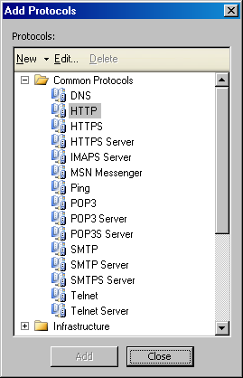
- Click Next on the Protocols page.
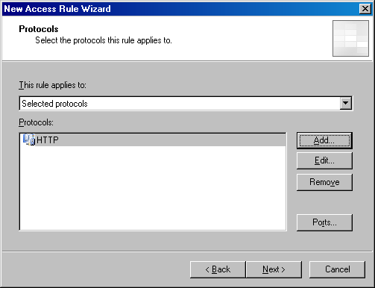
- On the Access Rule Sources page, click the Add button.
- In the Add Network Entities dialog box, expand the Enterprise Networks folder, and then double-click Enterprise Internal. Click Close.
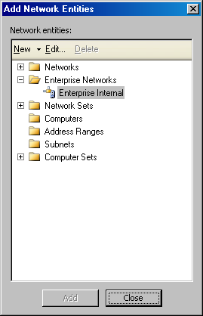
- Click Next on the Access Rule Sources page.
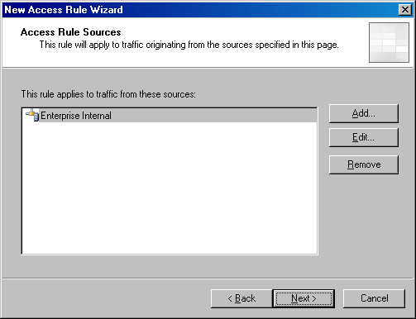
- On the Access Rule Destinations page, click the Add button.
- In the Add Network Entities dialog box, expand the Networks folder, and then double-click the External network. Click Close.
- Click Next on the Access Rule Destinations page.
- On the User Sets page, accept the default entry All Users and click Next.
- Click Finish on the Completing the New Access Rule Wizard page.
- The array firewall policy should now look like the display in the following figure.
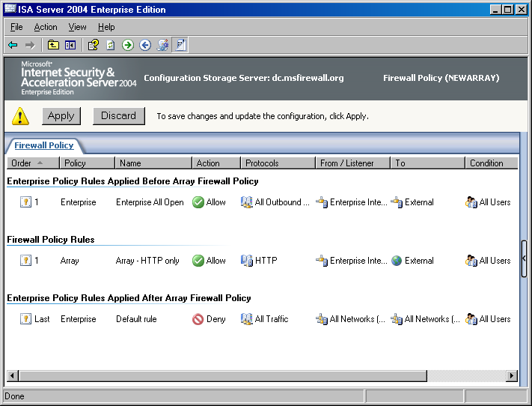

Move the Enterprise Access Rule Below the Array Access Rule
You can move enterprise access rules contained in the enterprise policy assigned to the array to be evaluated either before or after array-level rules on a per-rule basis. To do this, you must change the enterprise rule’s position in the enterprise policy configuration.
Perform the following steps to move the enterprise access rule:
- Click the Enterprise Policy 1 node in the left pane of the ISA Server 2004 Enterprise Edition console. The following figure shows the configuration of the current enterprise policy.
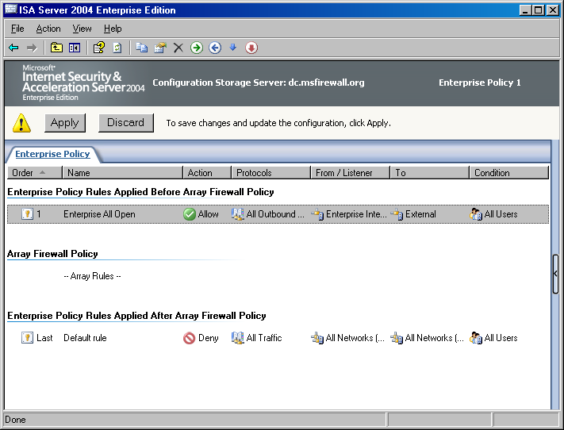
- Click the Enterprise All Open access rule and click the Move Down button (represented by a down-pointing blue arrow in the MMC button bar). The enterprise policy now looks like what appears in the following figure.
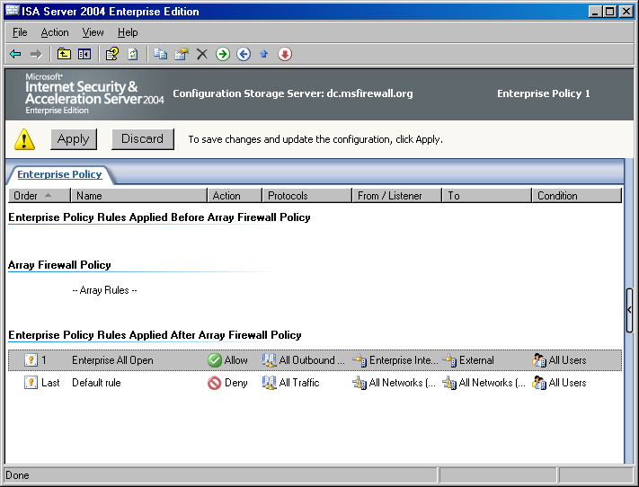
- Click the Firewall Policy (NEWARRAY) node in the left pane of the console. You can see that the Enterprise All Open access rule now appears below the array policy rule.
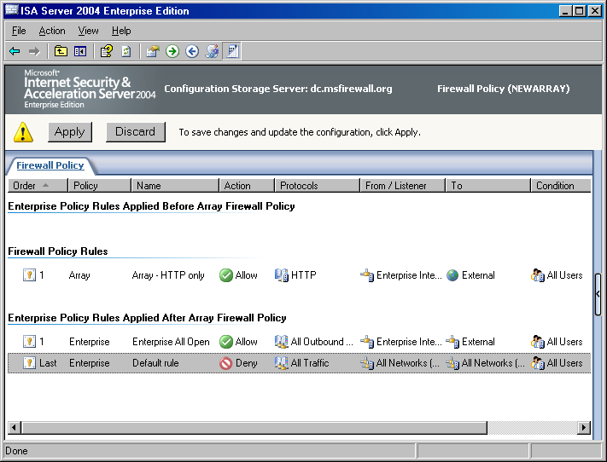
- Return to the Enterprise Policy 1 node and move the Enterprise All Open access rule to the top of the list. Later in this ISA Server 2004 Enterprise Edition Quick Start Guide, you will test the effects of moving enterprise policy access rules.
- The basic enterprise and array configuration is now complete. Click the Apply button to save the changes to the firewall policy.
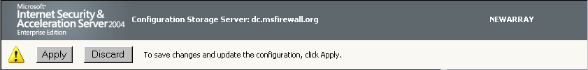
- Click OK in the Apply New Configuration dialog box when the configuration is successfully applied.

Back Up the Enterprise Configuration
At this point, you are ready to back up the Enterprise Policy configuration. The enterprise policy can be backed up to an .xml file and that file can be used to restore enterprise policy in the event of a disaster causing loss of the Configuration Storage server. Perform the following steps to back up the enterprise configuration:
- In the ISA Server 2004 Enterprise Edition console, click the Enterprise node in the left pane of the console. Click the Tasks tab in the task pane, and then click Export Enterprise Configuration.
- Click Next on the Welcome to the Export Wizard page.
- On the Export Preferences page, select the Export user permission settings check box and click Next.
- On the Export File Location page, enter a path and name for the enterprise configuration backup file. In this example, enter C:\enterprise_config in the Save the data to this file (enter the full path) text box. Click Next.
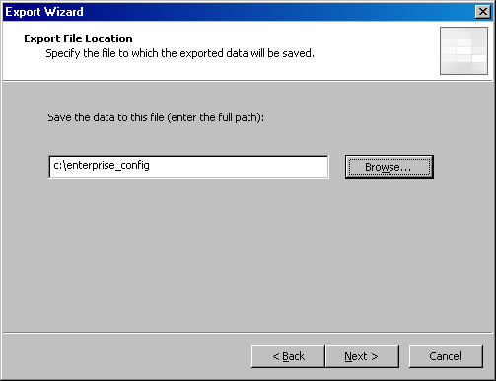
- Click Finish on the Completing the Export Wizard page.
- Click OK after the dialog box appears informing you that the export was successful.

Back Up the Array Configuration
You should also back up the array configuration at this point. Perform the following steps to back up the array configuration to an .xml file that you can use to later restore the array in the event that the Configuration Storage server is lost:
- In the ISA Server 2004 Enterprise Edition console, click the NEWARRAY node in the left pane of the console. Click the Tasks tab in the task pane, and then click Export (Back Up) Array Configuration.
- Click Next on the Welcome to the Export Wizard page.
- On the Export Preferences page, select the Export confidential information and Export user permission settings check boxes. Enter a password and confirm the password in the Password and Confirm password text boxes. Click Next.
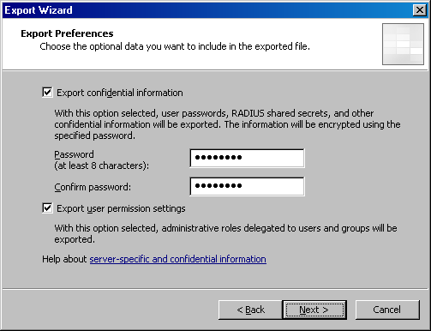
- On the Export File Location page, enter a path and file name for the array backup file. In this example, enter C:\array_backup. Click Next.
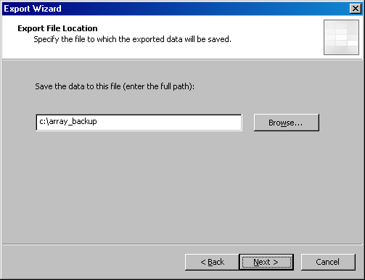
- Click Finish on the Completing the Export Wizard page.
- Click OK after the dialog box appears informing you that the export was successful.

Installing the Firewall on the First Array Member
The enterprise and array configuration are now in place on the Configuration Storage server. You can now install the ISA Server 2004 Enterprise Edition software on the first array member and enable the first array member to join the array that you have preconfigured.
In this section, you will perform the following procedures:
- Install the ISA Server 2004 software on the first array member. The ISA Server 2004 Enterprise Edition Setup Wizard makes it easy to install the first member of the ISA Server 2004 Enterprise Edition array.
- Configure the intra-array communications IP address. You later enable Network Load Balancing (NLB) on the internal and external interfaces of the ISA Server 2004 Enterprise Edition array. To provide full NLB support, you will configure the array members to use a network interface and IP address dedicated to intra-array communications.

Install the ISA Server 2004 Software on the First Array Member
Perform the following steps to install the ISA Server 2004 Enterprise Edition software on the first member (array-1) of the enterprise array:
- Insert the ISA Server 2004 Enterprise Edition CD-ROM into the first array member (array-1 in this example) and click Install ISA Server 2004 on the Autorun page. If the Autorun page does not appear, double-click ISAAutorun.exe on the root of the CD.
- Click Next on the Welcome to the Installation Wizard for Microsoft ISA Server 2004 page.
- On the License Agreement page, read the license agreement, and then select the I accept the terms in the license agreement option. Click Next.
- On the Customer Information page, enter your User Name, Organization, and Product Serial Number. Click Next.
- On the Setup Scenarios page, select the Install ISA Server services option. Click Next.
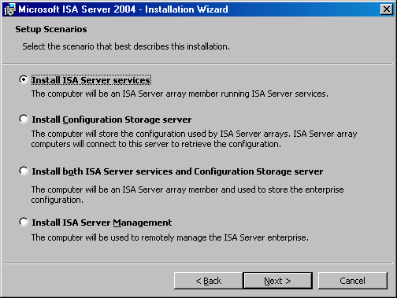
- On the Component Selection page, you can see that ISA Server, Advanced Logging, and ISA Server Management are installed by default. Accept these default settings and click Next.
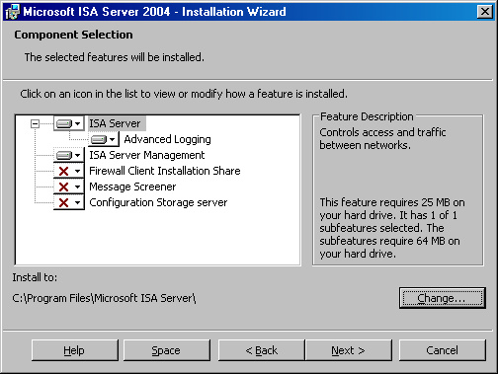
- On the Locate Configuration Storage Server page, enter the fully qualified domain name of the Configuration Storage server in the Configuration Storage server (type the FQDN) text box. In this example, the FQDN of the Configuration Storage server is dc.msfirewall.org. Enter this value in the text box and click Next.
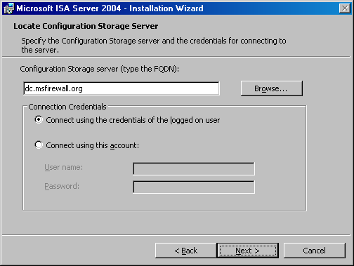
- On the Array Membership page, select the Join an existing array option and click Next.
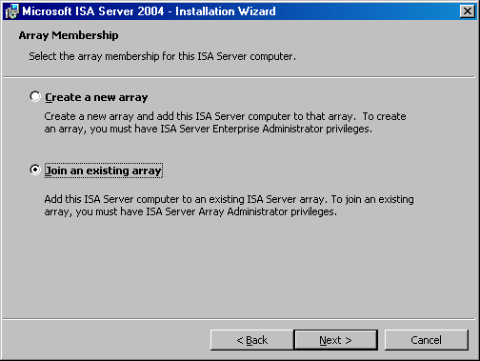
- On the Join Existing Array page, click the Browse button.
- On the Arrays to join page, select the array and click OK.
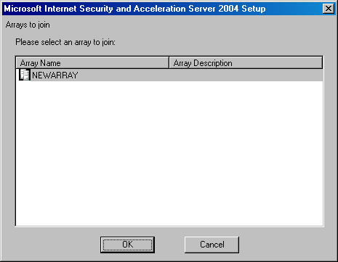
- Click Next on the Join Existing Array page.
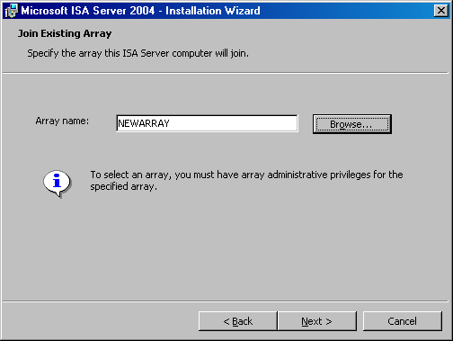
- On the Configuration Storage Server Authentication Options page, select the Windows authentication option and click Next.
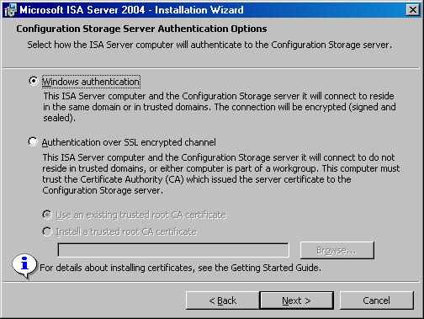
- On the Internal Network page, click the Add button.
- In the Address dialog box, click the Add Adapter button.
- In the Select Network Adapters dialog box, select the check box for the internal interface of the first array member. Click OK.
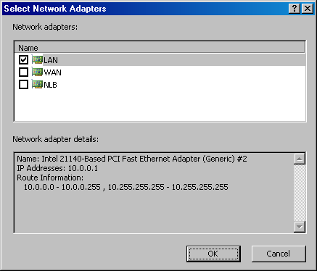
- Click OK in the Addresses dialog box.
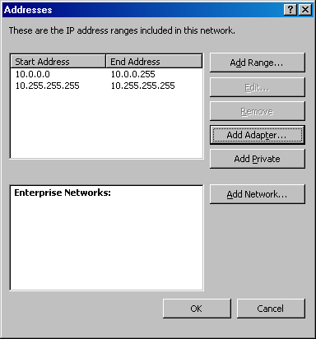
- Click Next on the Internal Network page.
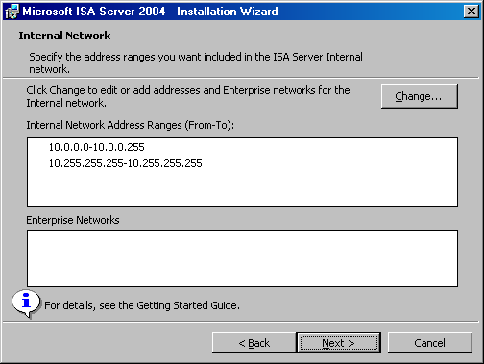
- Click Next on the Services Warning dialog box.
- Click Install on the Ready to Install the Program page.
- On the Installation Completed page, click the Finish button.
- Click Yes on the Microsoft ISA Server dialog box asking if you want to restart the firewall.

Configure the Intra-Array Communications IP Address
Array members need to communicate with one another through network interfaces connected to the dedicated NLB network that you created earlier. By default, intra-array communications take place on the primary IP address bound on each member of the array. However, because you later enable NLB on both the internal and external interfaces of each firewall in the enterprise array, you need to force the array members to communicate using the IP addresses bound to the adapters connected to the intra-array network.
Perform the following steps to force the first array member to use the intra-array adapter for intra-array communications (the second array member automatically detects that it should use the adapter on the same network ID as the intra-array adapter on the first member of the array):
- In the left pane of the ISA Server 2004 Enterprise Edition console, expand the array name, and then expand the Configuration node. Click the Servers node.
- In the details pane of the console, right-click the name for the first server in the array (array-1 in this example) and click Properties.
- In the array-1 Properties dialog box, click the Communication tab. On the Communication tab, enter the IP address of the intra-array network interface in the Use this IP address for communication between array members. In this example, type 222.222.222.1, in the text box.
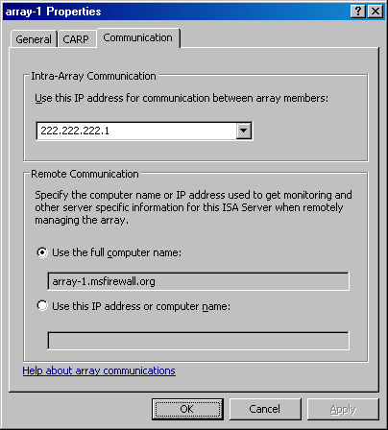
- Click Apply, and then click OK in the array-1 Properties dialog box.
- Click Apply to save the changes and update the firewall policy.
- Click OK in the Apply New Configuration dialog box.

Installing the Firewall on the Second Array Member
You can now install the ISA Server 2004 Enterprise Edition software on the second array member. Perform the same procedure that you did when you installed the first array member. During installation, you will notice that you are not asked for the definition of the array’s Internal network. The reason for this is that you already defined the array’s Internal network when installing the first array member, so there is no reason to perform the procedure a second time.
After installing ISA Server 2004 Enterprise Edition on the second array member, configure the second array member to use the IP address on its intra-array communications interface for intra-array communications. Use the same procedure that you did for configuring the intra-array address for the first array member, except this time configure array-2 to use the IP address 222.222.222.2.

Enabling the Cache Array Routing Protocol on the Array
The Cache Array Routing Protocol (CARP) significantly enhances the basic Web caching capabilities found in ISA Server 2004 Standard Edition. CARP allows you to distribute the Web proxy cache across multiple array servers. In addition, Web content is never duplicated. A Web object is placed on a single member of the CARP array and is never stored on any other array member computer. This reduces the amount of disk space you need to dedicate to the Web cache and significantly increases the amount of content you can cache per unit disk space configured for the array.
ISA Server 2004 Enterprise Edition Web caching arrays also provide for load balancing and fault tolerance. When the Web Proxy clients are configured with the autoconfiguration script (which can be done so that the ISA Server firewall administrator never needs to interact with client computers), they are able to correctly identify which ISA Server firewall array member is responsible for Web content that they want to retrieve. The Web Proxy client sends a request to the array member responsible for the content. This client-side routing feature enhances the array’s load balancing capabilities because it ensures that no array member is ever overburdened with a disproportionate number of Web requests.
In this section, you will enable CARP to create an ISA Server 2004 Enterprise Edition Web caching array. You will complete the following procedures:
- Create cache drives on the array. The array Web cache is stored on a disk file located on the hard disk of each member of the ISA Server 2004 Enterprise Edition Web caching array. You will use the ISA Server 2004 Enterprise Edition console on the management station to create the Web cache disk files on each array member.
- Enable the Web Proxy listener on the intra-array network interfaces. The Web Proxy listener must be enabled on the interfaces used by each array member on the dedicated intra-array communications network. You will enable the Web Proxy listener using ISA Server Management.
- Enable CARP on the array. CARP can be enabled on a per-network basis. You want internal network hosts to be able to use CARP, so you will enable CARP on the internal network interfaces of the array.
- Enable automatic discovery on the Internal network Web listener. Automatic discovery allows Web Proxy clients to use Web Proxy Automatic Discovery (WPAD) entries in DNS or Dynamic Host Configuration Protocol (DHCP) to automatically discover the array’s autoconfiguration information.
- Configure Web browsers to use the autoconfiguration script through automatic discovery. The autoconfiguration script enables Web Proxy clients to determine which member of the Web caching array is responsible for the requested Web content. This enables the Web Proxy clients configured with the autoconfiguration script to determine in advance the correct array member to send the Web request to. This is client-side Web routing, and it can significantly improve overall Web performance.

Create Cache Drives on the Array
Web caching is disabled by default on ISA Server 2004 Enterprise Edition arrays. The first step to create a distributed CARP-enabled Web caching array is to create cache drives on each array member. Perform the following steps to create cache drives on each member of the firewall array:
- At the enterprise management station on the Internal network, open the ISA Server 2004 Enterprise Edition console, expand the array name, and then expand the Configuration node in the left pane of the console. Click the Cache node.
- Right-click the array-1 entry in the details pane and click Properties.
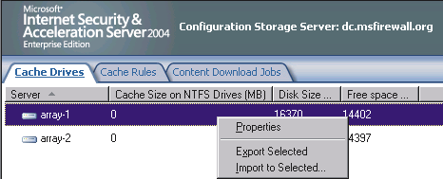
- In the array-1 Properties dialog box, enter a value for the size of the cache file on the array-1 computer. In this example, you create a 100 megabyte (MB) cache file. Enter 100 in the Maximum cache size (MB) text box and click Set. Click Apply, and then click OK.
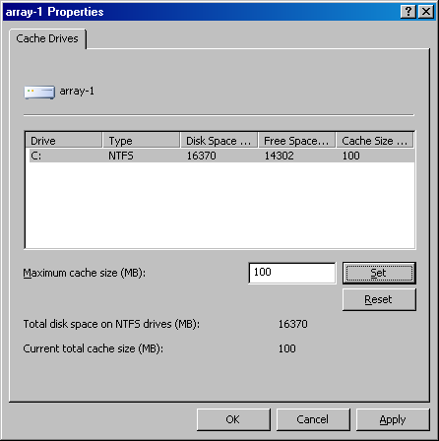
- In the details pane, right-click array-2 and click Properties.
- In the array-2 Properties dialog box, enter the value for the size of the cache file on the array-2 computer. In this example, you create a 100 MB cache file. Enter 100 in the Maximum cache size (MB) text box and click Set. Click Apply, and then click OK.
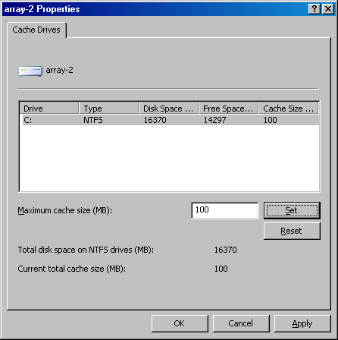
- The size of the cache files appears in the Cache Size on NTFS Drives (MB) column in the details pane.
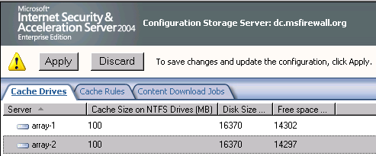

Enable the Web Proxy Listener on the Intra-Array Network Interfaces
The Web Proxy listener must be enabled on the interface used for intra-array communications. Perform the following steps to enable the Web Proxy listener on the intra-array communication network interface:
- In the ISA Server 2004 Enterprise Edition console, click the Networks node located under the Configuration node.
- In the details pane, right-click the Intra-array Network entry and click Properties.
- Click the Web Proxy tab. On the Web Proxy tab, select the Enable Web Proxy clients check box.
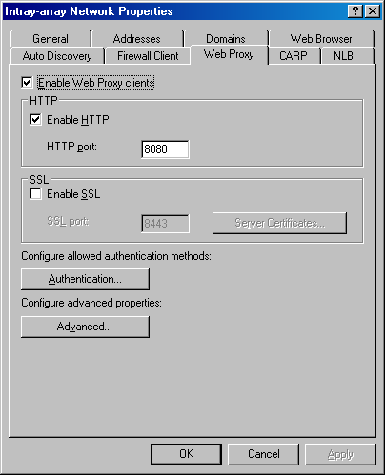
- Click Apply. Do not close the Intra-array Network Properties dialog box.

Enable CARP on the Array
The next step is to enable CARP on the ISA Server 2004 Enterprise Edition Web caching array. Perform the following steps to enable CARP on the array:
- In the Intra-array Network Properties dialog box, click the CARP tab.
- On the CARP tab, select the Enable CARP on this network check box.
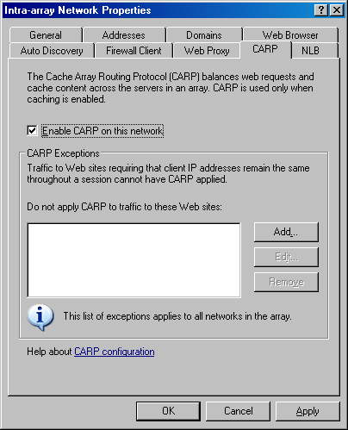
- Click Apply, and then click OK.
- Click Apply to save the changes and update the firewall policy.
- In the ISA Server Warning dialog box, select the Save the changes and restart the services option and click OK.
- Click OK in the Apply New Configuration dialog box.

Enable Automatic Discovery on the Internal Network Web Listener
For the Web Proxy clients to fully take advantage of CARP, you should enable the Web Proxy clients to perform client-side Web routing. Client-side Web routing enables the Web Proxy clients to know which ISA Server 2004 Enterprise Edition array member is responsible for the Web object requested. The Web Proxy clients must be configured to obtain Web routing information from the array to perform client-side routing.
There are two methods you can use to configure the Web Proxy clients to perform client-side routing: Configure a Web Proxy Automatic Discovery (WPAD) entry in DNS or Dynamic Host Configuration Protocol (DHCP), or configure the browsers to use the autoconfiguration script. To take advantage of automatic discovery, the array must be able to publish automatic discovery information to WPAD clients.
Perform the following steps to enable the array to publish automatic discovery information:
- In the ISA Server 2004 Enterprise Edition console, click the Networks node in the left pane of the console. Click the Networks tab in the details pane and right-click the Internal network. Click Properties.
- In the Internal Properties dialog box, click the Auto Discovery tab.
- On the Auto Discovery tab, select the Publish automatic discovery information check box. Leave the default Use this port for automatic discovery requests port at 80.
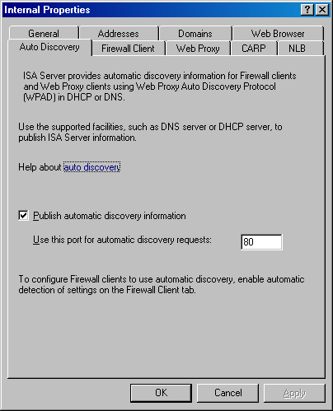
- Click Apply, and then click OK.
- Click Apply to save the changes and update the firewall policy.
- Click OK in the Apply New Configuration dialog box.

Configure Web Browsers to Use the Autoconfiguration Script Through Automatic Discovery
The default setting for Internet Explorer is to use automatic discovery to obtain information from the Web caching array. However, for the Web browser to automatically obtain this information, a WPAD entry must be configured in DNS or DHCP. For more information about configuring WPAD entries, see the instructions in Automatic Discovery for Firewall and Web Proxy Clients at http://www.microsoft.com/technet/prodtechnol/isa/2004/plan/automaticdiscovery.mspx.
In this ISA Server 2004 Enterprise Edition Quick Start Guide, you will manually configure the browser to obtain the autoconfiguration script. If the Web Proxy client computers are part of an Active Directory domain, you can configure Group Policy to automatically configure the Web browsers to use the autoconfiguration script without requiring WPAD entries.
Perform the following steps to configure the browser on the dc.msfirewall.org computer:
- Open Internet Explorer, click the Tools menu and then click Internet Options.
- In the Internet Properties dialog box, click the Connections tab.
- On the Connections tab, click the LAN Settings button.
- In the Local Area Network (LAN) Settings dialog box, clear the Automatically detect settings check box and select the Use automatic configuration script check box. In the Address text box, enter http://10.0.0.1:8080/array.dll?Get.Routing.Script. Click OK.
- Click OK in the Internet Properties dialog box.

Enabling Network Load Balancing with Bidirectional Affinity on the Array
ISA Server 2004 Enterprise Edition includes integrated support for the Windows Network Load Balancing (NLB) service. This integrated support enables the ISA Server 2004 Enterprise Edition array to leverage the Windows Server 2003 enhanced NLB bidirectional affinity feature. Bidirectional affinity enables NLB-enabled firewall arrays to support complex protocols requiring secondary connections and ensures that secondary connections are routed through the same firewall through which the initial client request was made. This prevents connections from being routed to an array member that has no knowledge of the initial connection.
Management of NLB is done within ISA Server Management. You can enable NLB for one or more networks defined within the array. In this ISA Server 2004 Enterprise Edition Quick Start Guide, you will enable NLB for both the internal and external interfaces on the array members. This enables high availability for both inbound and outbound connections made through the ISA Server firewall array.
In this section, you will perform the following procedures:
- Enable Network Load Balancing for the enterprise array
- Change the default gateway on the protected network client computers

Enable Network Load Balancing for the Enterprise Array
Perform the following steps to enable NLB for the ISA Server 2004 enterprise array:
- In the ISA Server 2004 Enterprise Edition console, click the Networks node located under the Configuration node.
- Click the Tasks tab in the task pane, and then click Enable Network Load Balancing Integration.
- On the Welcome to the Network Load Balancing Integration Wizard page, click Next.
- On the Select Load Balanced Networks page, select the External and Internal check boxes.
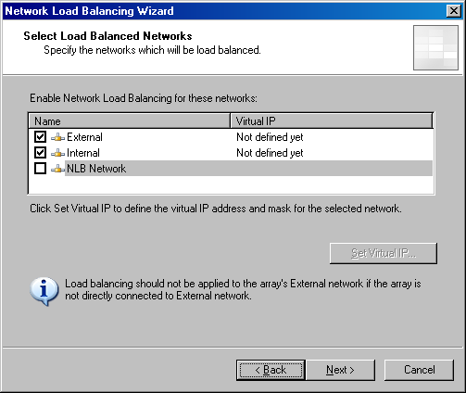
- Click the External network and click Set Virtual IP.
- In the Set Virtual IP Address dialog box, enter the virtual IP address that will be used for the external NLB array interfaces. In this example, you enter 192.168.1.72 for the Virtual IP address and 255.255.255.0 for the Mask. Click OK.
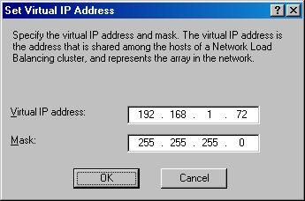
- Select the Internal network, and then click Set Virtual IP.
- In the Set Virtual IP Address dialog box, enter the virtual IP address that will be used for the internal interfaces of the array. In this example, you enter 10.0.0.10 for the Virtual IP address and 255.255.255.0 for the Mask. Click OK.
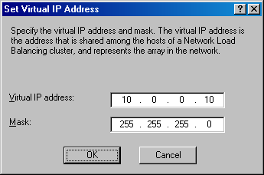
- Click Next on the Select Load Balanced Networks page.
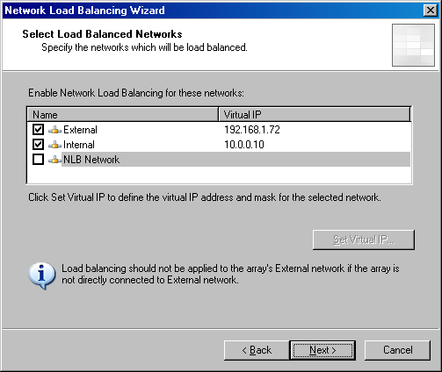
- Click Finish on the Completing the Network Load Balancing Integration Wizard page.
- Click Apply to save the changes and update the firewall policy.
- In the ISA Server Warning dialog box, select the Save the changes and restart the services option. Click OK.
- Click OK in the Apply New Configuration dialog box.
- Restart both members of the ISA Server 2004 Enterprise Edition array.

Change the Default Gateway on the Protected Network Client Computers
Now that NLB is configured, you can configure the hosts on the ISA Server 2004 Enterprise Edition protected networks to use the internal virtual IP address as their default gateway. Change the default gateway on dc.msfirewall.org and exchange.msfirewall.org to the virtual IP address on the internal interfaces of the array, which is 10.0.0.10.

Testing ISA Server 2004 Enterprise Edition Firewall Policies
You can now test array firewall policy. At this time, the enterprise access rule allowing all traffic outbound is the default rule. You can test this rule by opening the Web browser and going to a Web site, such as www.isaserver.org. When you look at the log file entries after making the request, you will see that our enterprise-level allow rule passed the request through the firewall to the Web site.
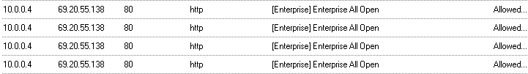
You can now go into the Enterprise Policies node and click the Enterprise Policy 1 node and move the Enterprise All Open access rule to the bottom of the Enterprise Policy. Click Apply to save the changes and update the firewall policy, and then Click OK in the Apply New Configuration dialog box.
Close the Web browser and open it again. Visit the Web site, such as www.msn.com. You see the following entries in the log file.
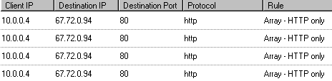
Now use the Web browser to visit the Microsoft FTP site at ftp://ftp.microsoft.com. The log file entries show that the array-level policy did not allow the connection. The connection was passed by the ISA Server firewall array by the enterprise-level policy.
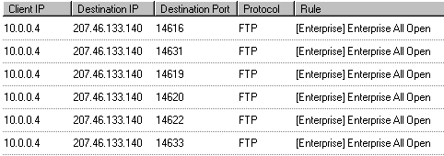

Summary
This ISA Server 2004 Enterprise Edition Quick Start Guide discusses concepts and procedures that enable you to create an enterprise firewall array when all array members and the Configuration Storage server belong to the domain. After creating the enterprise array, you create an enterprise policy, a new array, and then array-level policies. This document then describes how to enable a CARP Web caching configuration and NLB on the internal and external interfaces of the ISA Server 2004 Enterprise Edition firewall array.

The information contained in this document represents the current view of Microsoft Corporation on the issues discussed as of the date of publication. Because Microsoft must respond to changing market conditions, it should not be interpreted to be a commitment on the part of Microsoft, and Microsoft cannot guarantee the accuracy of any information presented after the date of publication.

This White Paper is for informational purposes only. MICROSOFT MAKES NO WARRANTIES, EXPRESS, IMPLIED OR STATUTORY, AS TO THE INFORMATION IN THIS DOCUMENT.

Complying with all applicable copyright laws is the responsibility of the user. Without limiting the rights under copyright, no part of this document may be reproduced, stored in or introduced into a retrieval system, or transmitted in any form or by any means (electronic, mechanical, photocopying, recording, or otherwise), or for any purpose, without the express written permission of Microsoft Corporation.

Microsoft may have patents, patent applications, trademarks, copyrights, or other intellectual property rights covering subject matter in this document. Except as expressly provided in any written license agreement from Microsoft, the furnishing of this document does not give you any license to these patents, trademarks, copyrights, or other intellectual property.
Unless otherwise noted, the example companies, organizations, products, domain names, e-mail addresses, logos, people, places, and events depicted herein are fictitious, and no association with any real company, organization, product, domain name, e-mail address, logo, person, place, or event is intended or should be inferred.

© 2005 Microsoft Corporation. All rights reserved.

Microsoft, Active Directory, and Windows are either registered trademarks or trademarks of Microsoft Corporation in the United States and/or other countries.

The names of actual companies and products mentioned herein may be the trademarks of their respective owners.

