
Crystal Reports Professional 8.5

Microsoft Dynamics™ SL

Benefits
- Work the way you want
Modify the form and content of any of
the existing standard reports included
with Microsoft Dynamics SL by using Crystal
Reports — or create an unlimited number of new reports.

- Customize reports
Create reports from existing or custom
database tables, or modify standard reports to meet your specific needs. Add or delete fields, add or refine data filtering and sorting, calculate totals and averages, combine multiple databases, and much more.

- Increase reporting impact
Use a variety of fonts, graphics files, boxes, lines, and even embedded objects from other applications, along with integrated graphing and customizable styles. The Reports Expert Wizard guides you to the report style you need and assists you in customizing reports to look the way you want.

- Study data easily
Analyze data with multi-pass reporting for example, a first pass to compute the total and a second pass to compute a percentage of total — and unlimited sorting. You can easily access any Microsoft SQL Server™ database, as well as integrate queries from multiple databases into a single report.

- Maintain data integrity
Define database access rights for users
who can create reports as well as for which fields can be included on reports. For example, you can limit which users can report on customer credit limits or other sensitive information. Crystal Reports is a read-only report writing and query
tool, so database integrity is always maintained.

Modify any existing report or create an unlimited number of custom reports to suit your needs with Crystal Reports Professional 8.5, the industry-leading report writer included with Microsoft Dynamics SL
System Manager. Crystal Reports provides powerful reporting and query capabilities for both novice and experienced users. Use it to select,
analyze, summarize, and present data in almost any way imaginable.

Modify
existing reports or create limitless
custom reports to suit your needs.

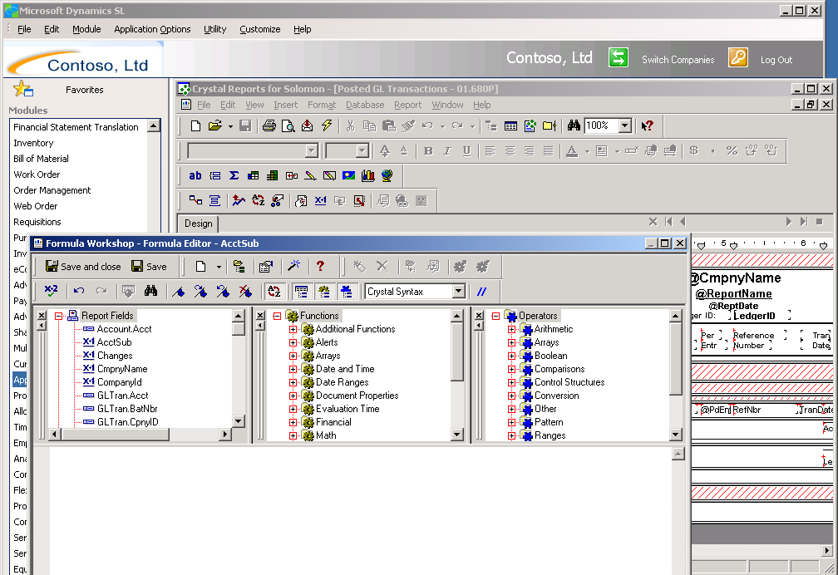



Benefits

Features

Extensive Web Reporting Capabilities | Create new reports and give your customers, suppliers, and employees  immediate access to presentation-quality, information-rich reports via the Web, using the most advanced viewer type supported by your browser.
Designed for Efficiency | Find the information you need easily using a visual “group tree” with drill-down and search capability. Reports are delivered by the report server one page at a time to facilitate faster viewing.
Industry-Standard Reporting | Help ensure your return on investment with a market-leading reporting tool and more than 800 standard, customizable reports.
Rapid Report Design | Create professional-looking reports in minutes with the Reports Expert Wizard.
Flexible Reporting | Choose from a broad variety of report types, place data in your report wherever you want, and customize it to look any way you choose. Reports can be as simple or as complex as you require.
Presentation-Quality Reporting | Add greater impact to your reports using charts and graphs. Integrated graphing includes more than 80 customizable styles and can reflect detail, group, or formula data as required.
Increased Reporting Impact | Select from a variety of fonts, graphics files, boxes, lines, and even embedded objects from other applications. Exercise precise control over the placement of report objects.
Powerful Data Analysis | Analyze your data with capabilities such as multi-pass reporting and unlimited sorting, including sorting on groups, custom sorting, and Top N/Bottom N sorting. Sub-reports allow viewing of the same data in different ways.
Extensive Calculations | Perform simple-to-complex calculations using Crystal Reports’ powerful formula language. The language can also be extended using advanced programming techniques to create even more powerful analysis.
Variable Report Delivery | Distribute completed reports electronically through e-mail, your intranet, and the Web. Export report data to many popular file formats, including Microsoft Office Excel, Microsoft Office Word, IBM Lotus 1-2-3, Corel WordPerfect, and ASCII text.
Integrated Reporting Solutions | Develop advanced, integrated report solutions. Application developers can use the Automation Server Interface to the Crystal Reports Engine to further increase reporting customization and impact.

For more information about Microsoft Dynamics™ SL, visit: http://www.microsoft.com/dynamics/sl

This document is for information purposes only.
MICROSOFT MAKES NO WARRANTIES, EXPRESS, IMPLIED, OR STATUTORY, AS TO THE INFORMATION IN THIS DOCUMENT.

© 2005 Microsoft Corporation. All rights reserved.
Microsoft, The Microsoft Dynamics Logo are either registered trademarks or trademarks of Microsoft Corporation or Microsoft Business Solutions ApS in the United States and/or other countries. Microsoft Business Solutions ApS is a subsidiary of Microsoft Corporation.

