Patch and update management is a pain point for IT organizations worldwide. Windows Update Services, the update management component of Windows Server, addresses this issue by helping to automate the update management process which reduces the amount of time, effort, cost, and risk associated with the process.

Windows Update Services helps you to:
- Increase administrator productivity and control over the update management process.
- Minimize network bandwidth usage and impact of network issues on the update process.
- Easily determine key system health and update deployment metrics.
- Optimize the end user experience by minimizing disruption to productivity.

Infrastructure to Update All Microsoft Products
Windows Update Services has the ability to deliver updates for all Microsoft products. When initially released, Windows Update Services will support updates to various versions of Windows, Office, Exchange and SQL Server™ products, as well as MSDE. Support for updating other Microsoft products will be enabled on an ongoing basis without requiring an upgrade or redeployment of the existing Windows Update Services infrastructure.

Flexible Update Management Capabilities
Windows Updates Services significantly expands the scope of functionality and granularity of control for update management. The scanning of systems for missing updates is integrated into the solution, simplifying the detection of missing patches and helping administrators easily determine which systems need to be updated, which updates need to be deployed to specific systems, and which target systems should be updated automatically.

Windows Update Services adds the ability to uninstall updates for applicable patches. It also allows groups of systems to be targeted for uninstalls and deployment. Administrators can now control the frequency with which clients check for and download approved updates, and specify deadlines for when an update installation should be enforced.

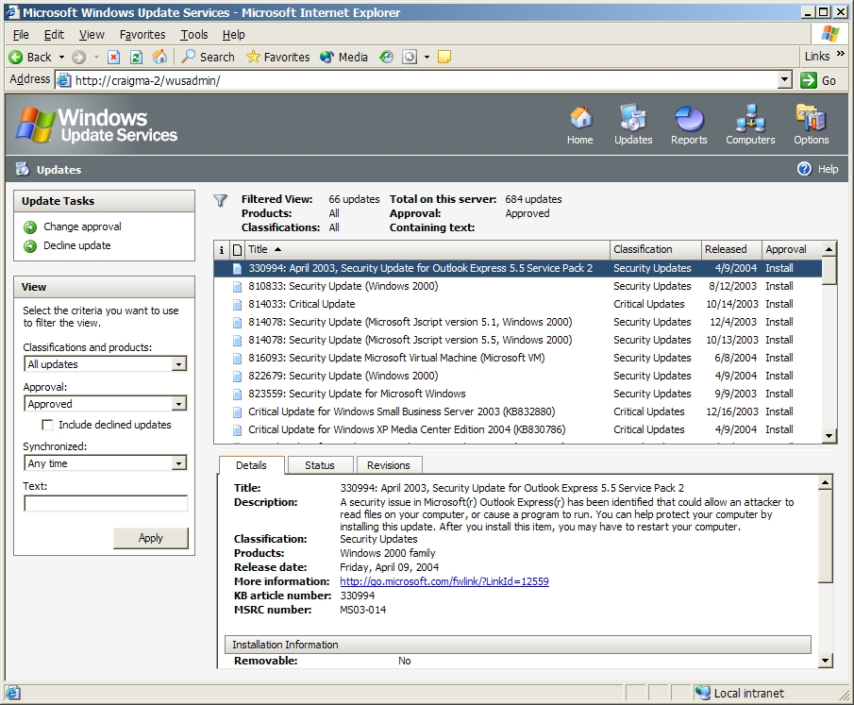

Figure 1: Update Approvals and Details Screen

Advanced Network Optimization
Windows Update Services leverages core Windows technologies including Background Intelligent Transfer Service (BITS) and Microsoft Windows Installer (.msi), to seamlessly handle network interruptions and minimize the download size and network bandwidth consumption typically associated with update deployments.
Downloads are automatically restarted from the point at which network service is interrupted. By default, only unused network bandwidth is used, resulting in no impact to network responsiveness. Binary delta compression technologies dramatically reduce the size of updates.
In addition to specifying which updates should be downloaded (by product version and update type), administrators can also determine whether to download the entire update or only the update metadata.

Consolidated Status Reports
Windows Update Services delivers a set of essential reports allowing administrators to easily determine key system health and update deployment metrics.
By viewing these reports, administrators can quickly determine successes, failures or errors, and other detailed information associated with new updates deployed.

Enhanced End User Experience
Windows Update Services includes features to minimize impact on end user productivity. For updates that do not require a restart, the system can be configured to silently install the updates without user notification or interaction. For updates that require restarts, patch installations can be grouped to consolidate multiple restarts into a single restart.

When user interaction is required, Windows Update Services automatically enables the user interaction in the language defined for the Windows client or server operating system.

Easy, Flexible System Implementation
When Windows Update Services servers are deployed in a hierarchical topology to support distributed computing environments, child servers can be configured and administered independently of their parent servers.

For systems not managed centrally, for example an unmanaged corporate PC, one-touch configuration enables easy setup of the Windows Update Services client. Windows Update Services is also designed to automatically upgrade its agents, to simplify the task of rolling out future versions across a distributed computing environment.

Increased Administrator Productivity
Windows Update Services significantly increases administrative efficiency during the update management process. The enhanced user interface is designed to boost administrator productivity by making it easy to configure, manage, troubleshoot, and report on various aspects of the update management infrastructure and process. To further increase efficiency, update approvals to specific target groups can be automated through configuration of the Windows Update Services server. For larger distributed environments, Windows Update Services clients can be centrally configured using Group Policy in Active Directory® directory service environments.

Core Update Management Infrastructure
Windows Update Services is the first step toward delivering core software distribution and update management infrastructure for Microsoft software. Over time, it is expected that management products from Microsoft and other vendors will build on this infrastructure to deliver enhanced management solutions for updating Microsoft software on your Windows platforms.

