
INTEGRATED

Microsoft Dynamics: Built to Work
with the 2007 Microsoft Office System

- Extend Access to business-critical information by delivering Microsoft Dynamics data through Microsoft Office Outlook®, Microsoft SharePoint® products and technologies and in refreshable Microsoft Office Excel® worksheets.

- Search Simultaneously for business information stored in Microsoft Dynamics as well as in Microsoft Office programs such as Excel, Word, InfoPath®, and Outlook.

- Deliver Contextually Relevant, role-based business information and processes to employees, customers and suppliers through Microsoft Dynamics integration with Microsoft Office SharePoint Server 2007.

- Work in a Familiar Environment with shared user interface components in Microsoft Dynamics and the 2007 Microsoft Office suites.

- Maximize your Microsoft Technology Investment by deploying applications designed to work together seamlessly and automatically.

- Use the Tools You Already Know, easily sharing Microsoft Dynamics data with Microsoft Office programs, such as Excel, Word, Outlook, and Project.

The two most powerful information systems in your business
are coming together more intuitively, and more powerfully, than ever before.

Microsoft Dynamics™ and the 2007 Microsoft® Office system have been designed to work together in new ways, helping you increase the penetration of business data throughout your organization,
and deliver important benefits to employee productivity, customer loyalty and overall business efficiency.

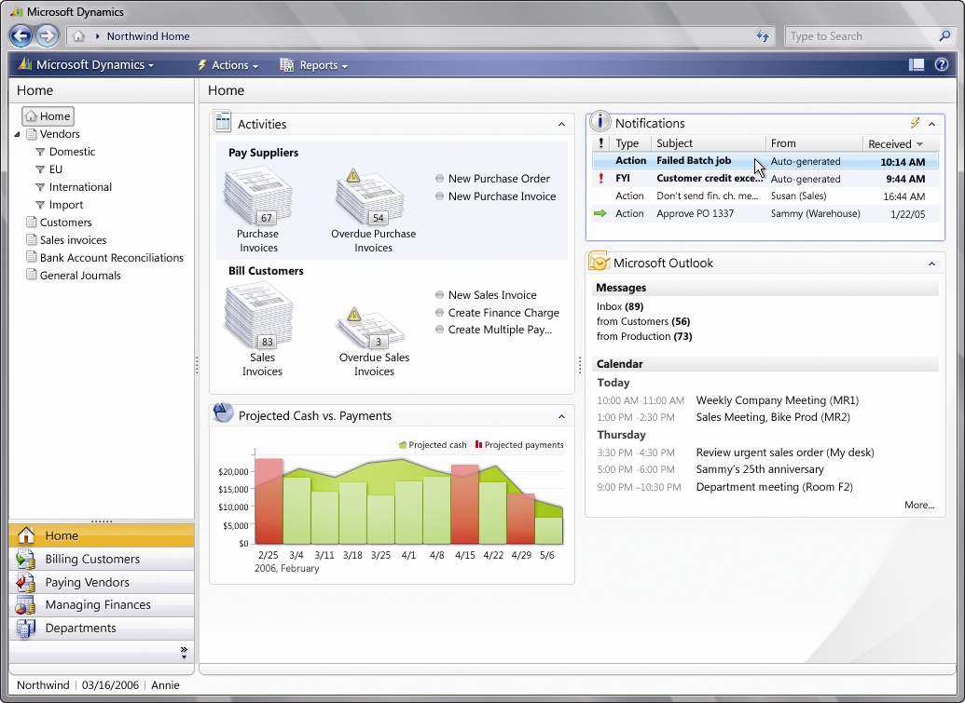

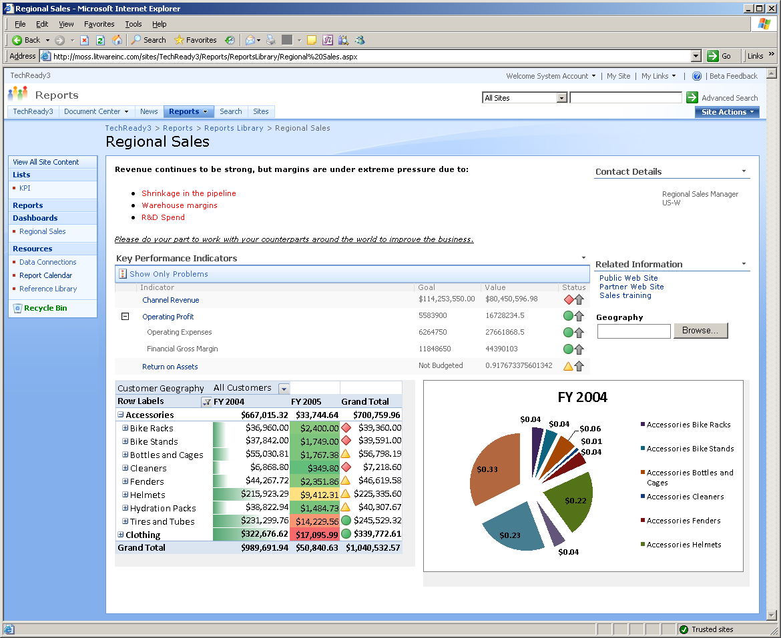

Microsoft Dynamics’ role-based design ensures the most important information and processes are delivered to your users in an easy-to-understand way.

Microsoft Dynamics working with Microsoft Office Sharepoint Server 2007 and Microsoft Excel to provide critical and refreshable business intelligence (BI) dashboards.


Share data between Microsoft Dynamics and Microsoft Office programs, making it easy to analyze, communicate and collaborate using up-to-date data. | Enable information workers to access business-critical data using the applications and forms they are used to. Microsoft Dynamics uses XML as the standard protocol for sharing data with Microsoft Office programs including Excel, Word, and Outlook.
Search across Microsoft Dynamics and Microsoft Office programs bringing together your ability to locate the right information through a single search operation. | Save time by searching for business-critical information only once! Search information contained in your business applications at the same time you search information contained in Microsoft Office Excel, Word, Outlook and other Microsoft Office programs. Find all related documentation regarding a particular customer, sale, project or other business transaction.
Attach Microsoft Office documents to Microsoft Dynamics records for fully traceable communications. | Attach contracts, project plans, engineering specs and other transaction-related Microsoft Office documents to your Microsoft Dynamics customer, supplier, manufacturing order, project or other records, making it easy to create a central access point for all related information. Attaching customer-related documents to Microsoft Dynamics™ CRM records gives you a 360-degree view of all customer activity.
Create role-based views pushing relevant data to users, and making it easy to access the processes each person needs. | Deliver the specific business data and processes each group in your organization needs, giving them the performance measurements and reports they need to stay on top of their portion of the business, as well as the processes they need to easily and effectively work with your organization, such as purchasing, sales and HR management.
Extend access to business data and processes to everyone who needs it, including employees throughout your organization as well as customers, suppliers and other business partners. | Utilize portals to share role-appropriate data and processes with each group in your organization, as well as with customers and suppliers, using Office SharePoint Server 2007 to manage access rights and deliver real-time, accurate business data for faster, better-informed decisions.
Streamline approvals and notifications enabling processes to move more quickly and efficiently using standardized Windows Workflow Foundation technologies. | Easily create workflow routines to streamline invoice approvals, purchase approvals, timecard reviews and other processes, and deliver proactive alerts in Outlook to assist managers and decision-makers in keeping an eye on the important metrics of your business such as cost overruns, sales quotas, receivables outstanding or other measures you define.
Utilize a common Microsoft Office look and feel aiding ease of learning and increasing adoption rates. | Based on the look and feel of familiar Microsoft Office programs, Microsoft Dynamics gives users an immediate, prioritized view of their work, helping them access information and processes quickly.
Include business data in Microsoft Office programs making it easier to communicate with customers, suppliers and other business partners. | Create customer loyalty e-mails, past-due notice letters and other business forms in Microsoft Office programs, such as Excel, Word, InfoPath and Outlook, and populate them with data from Microsoft Dynamics.
Improve business insight with live, refreshable Excel spreadsheets and KPI lists so business-critical data is always up-to-date. | Automatically export data from Microsoft Dynamics to Excel, and create and distribute refreshable Excel spreadsheets. Spreadsheets and PivotTable® documents can be centrally stored, managed and shared via the web, using Office SharePoint Server 2007 solutions.
Go mobile taking Microsoft CRM data offline while you travel and synchronizing changes upon reconnecting. | As with emails and appointments, users can take CRM data offline with Outlook so they can keep working while they’re on the road without connectivity. Changes made to CRM data while offline are automatically synched when back online. This improves productivity by providing users uninterrupted access to critical customer information regardless of connectivity.

For more information about Microsoft Dynamics, visit: www.microsoft.com/Dynamics

This document is for information purposes only. MICROSOFT MAKES NO WARRANTIES, EXPRESS, IMPLIED, OR STATUTORY, AS TO THE INFORMATION IN THIS DOCUMENT.
© 2006 Microsoft Corporation. All rights reserved. Microsoft, the Microsoft Dynamics logo, Microsoft Dynamics, InfoPath, Microsoft Office Outlook, Microsoft SharePoint, Microsoft Office Excel, Microsoft Office Excel PivotTable, are either registered trademarks or trademarks of Microsoft Corporation or Microsoft Business Solutions ApS in the United States and/or other countries. Microsoft Business Solutions ApS is a subsidiary of Microsoft Corporation.

