Computer hardware management has never been an easy task, a comprehensive knowledge of internal board Configuration and design was necessary.
Well, as we all know the Windows 2000 and Windows XP operating systems has lead us to a new era, where we can say configuring hardware is no longer a problem, in most cases.

This article will address the hidden secrets of hardware installation and configuration emphasizing on improving system performance and stability.

Windows XP plug and play (PnP) manger offers great flexibility with respect to hardware setup and configuration, it will do most of the work on its own, or advice you on what course of action to take in order to resolve a conflict or problem.

The first and most important thing about computer hardware is the Hardware Compatibility List (HCL). The HCL is a huge database containing all hardware that is compatible with the different Windows operating systems. Choosing hardware that has been checked to comply with the Microsoft Windows environment is your first step towards a stable system.

Further information about the HCL can be obtained from http://www.microsoft.com/hcl

Next, it is advisable to use the latest device drivers for you hardware, device drivers can be obtained from the Windows Update site, or from the hardware vendor. Using the latest device driver will insure greater performance and stability.

We are now ready to take a closer look at the device manager and its hidden secrets.

As we all know the device manager is the central point of administration for your computer hardware, where a complete hardware layout and settings is displayed.
Nevertheless, a deep look into it will reveal a world of hidden hardware secrets and features.

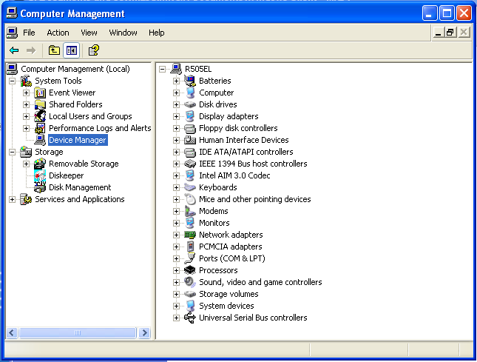

The Device Manager

Here are some tips:

Disabling unused IDE ports:

You can gain a substantial decrease of system boot time by disabling unused hardware.
Most computers have two IDE ports, Windows XP tries to detect new IDE devices upon every boot, disabling an unused IDE port will save valuable boot time.
By clicking the IDE ATA/ATAPI Controllers icon, selecting the primary IDE controller (the same applies for the secondary controller), clicking properties and advanced settings, we can easily disable an unused port.
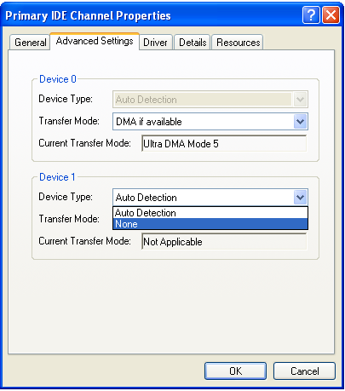

Notice the “Not Applicable” transfer mode for device 1, which indicates that it is not in use, and therefore can be disabled (by changing the device type to: None).

Using a PS/2 or USB mouse instead of a serial mouse:

Another tip that will save boot time is use a PS/2 or USB mouse instead of a serial mouse. Serial hardware takes time to detect, Windows assumes that there is no serial mouse connected to your computer, and skips this detection process from the /fastdetect switch in the boot.ini file.

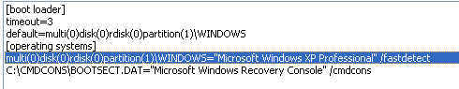

Nevertheless, a mouse detection process will be initiated at every system boot, if a serial mouse was present and configured.

Increasing disk performance by enabling disk write cache:

A cache mechanism greatly improves disk drive’s performance, the amount of cache changes from one model / vendor to another. Windows 2000 and Windows XP can offer an additional caching mechanism that will furtherer improve disk performance.
All that is required is simply to enable it, from the disk drive’s properties.

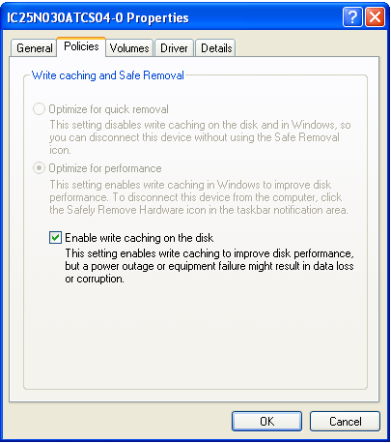

Freeing system interrupts:

I am sure we all remember that the modern PC has 16 hardware interrupts to offer (starting from 0 to 15), where most interrupts are already in use, thus leaving us with interrupt conflicts and interrupt sharing, which leads to a decrease of performance.

For those of you who don’t quite remember an Interrupt Request Line (IRQ) is an electronic signal, usually with an amplitude of 5 volts that is generated by an I/O device upon its completion of an I/O process. The IRQ signal is sent to the Central Processing Unit (CPU) thus requesting it to stop / pause its current running process and execute a corresponding interrupt handling routine.

PC IRQ-Table
0 | System Timer
1 | Keyboard
2 | Switch to IRQ controller 2
3 | COM2, COM4
4 | COM1, COM3
5 | LPT2 / free
6 | Floppy
7 | LPT1, LPT3
8 | Real Time Clock
9 | Redirected IRQ 2
10 | free
11 | free
12 | PS/2 Mouse
13 | Math Co-Processor
14 | Primary IDE Controller
15 | Secondary IDE Controller

Notice the low amount of free interrupts, conflicts and sharing are inevitable and will occur if you try to use a sound card, SCSI host, Video decoding card, an Ethernet card and others at the same time.

There are two methods for interrupt handling: Polling for interrupts and Vectored interrupts.

The term “polling” refers to the CPU having to initiate an I/O status check to determine whether an I/O operation was completed, this method was used in past, when vectored interrupt technology wasn’t available.

The term "vectored interrupt" refers to the fact that the interrupting device
tells the CPU where to look for the interrupt handler entry point, this is method is faster, and is the most common method used.

The basic actions for freeing interrupts would be to disable unused hardware from the integrated peripherals menu in the system Basic Input Output System (BIOS).

Windows XP offers a new approach to interrupt management, as we can configure some peripheral devices such as parallel ports to use polling for interrupts, thus freeing more interrupts for other hardware.

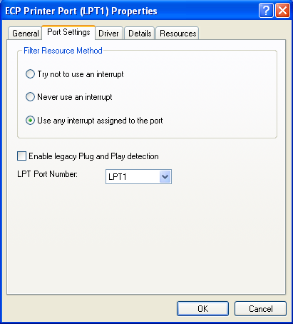

Notice the “Never use an interrupt option”

Polling will result in some performance decrease for the parallel port, we can accept that when it comes to parallel printers, scanners etc.

Freeing more interrupts will result in less sharing, this is what that really makes a difference when it comes to system performance.

Amit Marlov, B.Eng EE, MCP
Microsoft Windows Client Regional Director
Email: v-amitma@microsoft.com

