Gathering Data for Simple Calculations with Excel 97

What you will learn from this lesson
With Excel 97 you will:
- Start a new workbook.
- Enter and format a title.
- Modify the text style and font size.
- Enter column headings and adjust column width.
- Move data.
- Edit data.
- Customize the enter key.

What you should do before you start this lesson
Creating a worksheet with Excel 97 is easy. To help you experience the power of Excel 97, you will use excerpted material from Getting America’s Students Ready for the 21st Century: Meeting the Technology Literacy Challenge, atechnology report from the U.S. Department of Education.
Getting ready to create a worksheet
- Start Excel 97.
- Open a new workbook.

Exploring the lesson
Excel 97 makes it easy to enhance lessons and reports with data that you and your students can enter and edit quickly. You can create informational charts, grade books with calculating features, data-based statistical programs, graphics, and simple task charts using Excel 97.
Starting new workbooks
Excel 97 makes it easy to design a new workbook to suit your purpose.
Creating a new worksheet
- Open a new worksheet.
- On the File menu, click Save As.
- Type Technology as the file name.
- Click the Save button.

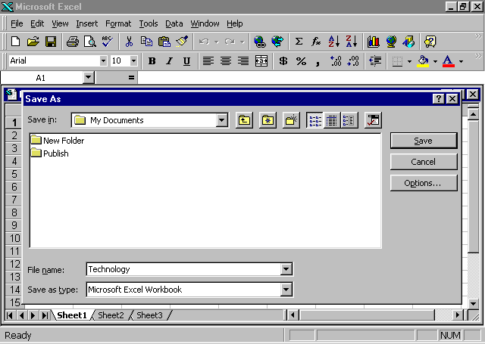

Entering and formatting titles
Using titles on the worksheets makes it easier to read and understand the information shown. You can retain the existing styles, create your own styles, or customize your own workbook template. The next exercise illustrates how easy it is to enter and modify font styles and sizes in your worksheet.
Note
You can add other formatting characteristics to your title. To make the text bold, click the text cell, and click the Bold button on the Formatting toolbar.

Entering and formatting a title on the worksheet
- With the Technology worksheet open, move the pointer to cell E3, type Technology Challenge, and then press enter.
- Click cell E3.
- On the Formatting toolbar, click the Font box, and click Arial. (You may have to use the down arrow next to the Font box to find Arial.)
- On the Formatting toolbar, click the arrow next to the Font Size box, click 14, and then click the Bold button.

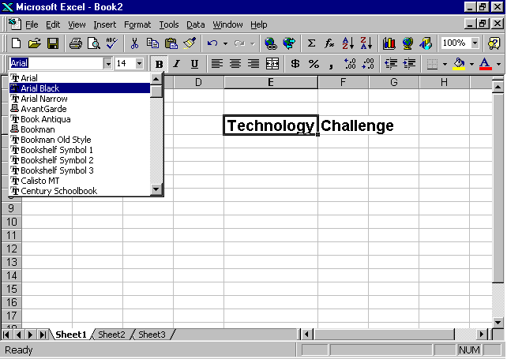

Entering column headings and adjusting widths
Column headings help you and others understand the data or information you have entered on your worksheet. Sometimes the column heading is too large to fit into a column. Even though it does not show the entire title or formula, the cell still contains everything you entered into it. This exercise shows you how to increase or decrease the column width to fit the information you are entering.
Note
Press the enter key to move down one cell at a time. See “Extensions” at the end of the chapter for instructions on customizing the enter key.
Entering column headings and adjusting their widths
- Using the Technology worksheet, click cell B5, and type Dates in cell B5.
- Press tab to go to cell C5, and then type Elementary Schools.
- Press tab to go to cell D5, and then type Secondary Schools.
- Schools. One cell will overlap the other.
- Press enter.
Note
The pointer becomes a

or double-arrow when it is placed between columns at the top of a chart.
- At the top of the worksheet, position the pointer at the top of the grid between columns C and D until the pointer changes into a double-arrow line and then double-click.
- Repeat steps 4 and 5 between cells D and E.
- Select the words Technology Challenge, and move the + pointer to a cell line until it changes to an arrow.
- Click and drag the text to begin in cell C3.
- Save the worksheet.
With these easy steps you can customize a template or design your own workbook to present your information.

Arranging text with the Copy, Paste, and Cut commands
With Excel 97, it is easy to modify data. When you and your students use the features in Excel 97 to create a table, you may decide on a different order of column heads or you may want to revise them. It is important to make changes before you build a formula for the chart in order to maintain correct calculations.
Using the Cut, Paste, and Copy commands to arrange text
- Using the Technology worksheet, right-click cell C3, and click Cut.
- Right-click cell C1, and click Paste.
Note
Usually Cut is used to move the contents of a cell or cells to a different location. Copy is used to duplicate the contents of a cell or cells in another location.
- Right-click cell D5, and click Cut.
- Right-click cell D10, and click Paste.
- Right-click cell C5, and click Cut.
- Right-click cell D5, and click Paste.
- Right-click cell D10, and click Cut.
- Right-click Cell C5, and click Paste.
- Try dragging cell C5 and cell D5 to new locations as you did in the previous exercise.
- Close the file without saving.

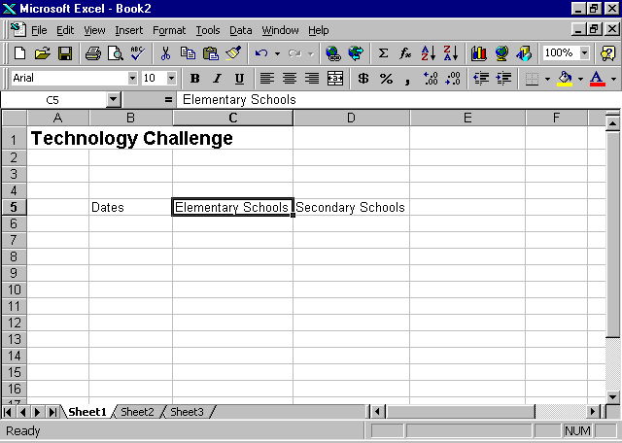

Note
When you enter data in a column format, you may find it easier and faster to use arrow keys to move between cells.
Entering data
Using Excel 97 is a powerful way to enter and display data or text. For example, you can have Excel 97 display a date showing the month, day, and year with the time, or showing only the first letter of the month, followed by a two-digit year. Numbers can be displayed as whole numbers, numbers with decimals, or numbers written in scientific notation.
Entering data for growth of World Wide Web sites in U.S. schools
- Open the Technology workbook.
- Starting in cell B6, type the following information into the worksheet, under the corresponding headings.
- Save your file.

Dates  Note  Office Assistant has information on different ways to enter a formula so that you can perform a variety of mathematical calculations. | Elementary | Secondary
1/1/95 | 85 | 110
4/1/95 | 160 | 360
7/1/95 | 225 | 380
10/1/95 | 250 | 660
1/1/96 | 425 | 900
4/1/96 | 800 | 1400
6/1/96 | 1100 | 1720

Doing simple calculations
Using Excel 97, you can perform a wide range of mathematical calculations and functions according to what you need from your data. To calculate sums (totals) and percentages, use the mathematical operation of adding numbers to get a total, and then divide each number that was just added by that total.
Calculating the sum of schools with Web sites
- In the Technology workbook, click cell E5, type Total Sites, and press enter.
- Click cell E5 again, and on the Formatting toolbar, click the Bold button.
- Click cell E6, and on the Formula toolbar click the Edit Formula button (the = sign).
- Click the Functions arrow, and choose Sum. (C6:D6 appears in the window.)
- Click OK.
- To sum each pair of numbers, click E6 and drag the fill handle from E6 to E12.

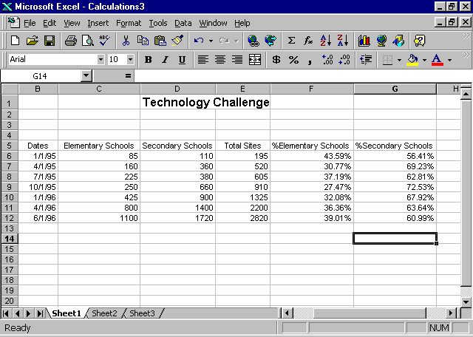

Calculating the percentage of schools with Web sites by category
- Click cell F5, type % of Elem schools, and then press enter.
- Click cell F5 again, and then click the Bold button on the Formatting toolbar.
- Click cell G5, type % of Sec schools, and press enter.
- Click cell G5 again, and on the Formatting toolbar click the Bold button.
- Click F6, and click the Edit Formula button (the = sign).
- Type C6/E6, and click OK.
- On the Formatting menu, click Cells. On the Number tab, choose Percentage, and then type 2 in the decimal places.
Note
You may have to zoom out to see the total chart. On the View menu, click Zoom, and choose 50% or whichever level is best for you.
- Click F6, and drag the fill handle to F12 to calculate the percentage for each pair of numbers. Click OK.
- Repeat steps 3 through 8 for Secondary Schools using the formula D6/E6 to calculate the percentage.
- Save the worksheet, and close it.

How you can use what you learned
Microsoft Excel 97 can be used to record and calculate grades. You can create a master record to track student names and assignments. With the student names in a column, and the assignments in a row, you can see at a glance the status of the homework.
You can create your budget and track expenses for school projects. Excel 97 creates many types of graphs to visually explain numerical data. Charts show complex relationships clearly and simply, making it easier for teachers and students to identify patterns in data. Creating graphs will be explained in detail in a later chapter.

Extensions
You can change the direction in which the pointer moves when you press enter. If the default direction is to the right, and you are entering data in a column, you can change the default to down. You can change the direction of the pointer to support your movements.

Customizing the enter key
Changing the direction of the enter key
- Open a new workbook.
- On the Tools menu, click Options.
- Click the Edit tab.
- Click Move selection after Enter, and in the Direction box, click Right, and click OK.
- Repeat steps 1 through 4 to change the direction back to Down.
- Close the workbook without saving it.

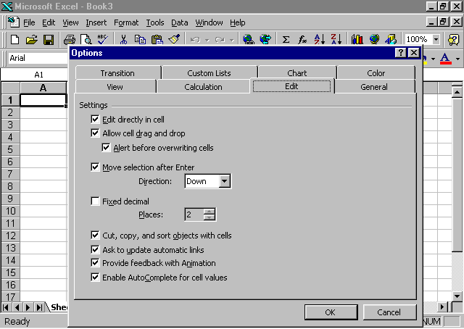

Summarizing what you learned
In this chapter you have explored and practiced:
- Starting and formatting a new workbook.
- Entering titles.
- Modifying text style and font size.
- Entering column headings and adjusting their widths.
- Arranging text with the Copy, Paste, and Cut commands.
- Calculating simple formulas, sums, and percentages.
- Customizing the enter key.

