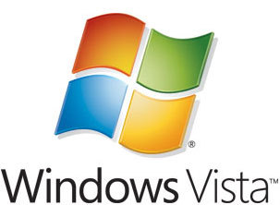

Windows Vista Beta 2 Print Management Step by Step Guide
Microsoft Corporation
Published: November 2005
Author: Alaina Dyrness
Editor: Gina Lozier

Abstract
Print Management provides up-to-the-minute details about the status of printers and print servers on the network. You can use Print Management to install printer connections to a group of client computers simultaneously. Print Management can help you find printers that have an error condition by using filters. It can also send e-mail notifications or run scripts when a printer or print server needs attention. On printer models that provide a Web page, Print Management can help you manage data such as toner and paper levels from remote locations, if needed.

This document supports a preliminary release of a software product that may be changed substantially prior to final commercial release, and is the confidential and proprietary information of Microsoft Corporation. It is disclosed pursuant to a non-disclosure agreement between the recipient and Microsoft. This document is provided for informational purposes only and Microsoft makes no warranties, either express or implied, in this document. Information in this document, including URL and other Internet Web site references, is subject to change without notice. The entire risk of the use or the results from the use of this document remains with the user. Unless otherwise noted, the example companies, organizations, products, domain names, e-mail addresses, logos, people, places, and events depicted herein are fictitious, and no association with any real company, organization, product, domain name, e-mail address, logo, person, place, or event is intended or should be inferred. Complying with all applicable copyright laws is the responsibility of the user. Without limiting the rights under copyright, no part of this document may be reproduced, stored in or introduced into a retrieval system, or transmitted in any form or by any means (electronic, mechanical, photocopying, recording, or otherwise), or for any purpose, without the express written permission of Microsoft Corporation.

Microsoft may have patents, patent applications, trademarks, copyrights, or other intellectual property rights covering subject matter in this document. Except as expressly provided in any written license agreement from Microsoft, the furnishing of this document does not give you any license to these patents, trademarks, copyrights, or other intellectual property.

© 2005 Microsoft Corporation. All rights reserved.

Microsoft, Windows, Windows Vista, and Windows Server are either registered trademarks or trademarks of Microsoft Corporation in the United States and/or other countries.
References to any third-party products or their hardware identifiers are for illustrative purposes only. These product is not endorsed by Microsoft Corporation.
All other trademarks are property of their respective owners.

Contents
Windows Vista Print Management Step by Step Guide 5
What Is Print Management? 5
Who Should Use Print Management? 5
Benefits of Print Management 6
In This Guide 6
Requirements for Print Management 6
Security Requirements 6
Steps for Deploying and Operating Print Management 7
Step 1: Install Print Management 7
Stopping Trustworthy Site Pop-up Messages 7
Step 2: Open Print Management 7
Step 3: Add Print Servers 8
Adding a Local Print Server 8
Adding Network Print Servers 9
Step 4: View Printers 9
Adding and Removing Columns 11
Showing Extended View 11
Filtering Views 12
Step 5: Saving a custom view 13
Step 6: Manage Printers 14
Automatically Installing Printers to the Local Print Server 14
Using Print Management for Bulk Printer Management Tasks 15
Pausing, Canceling, or Resuming Print Jobs on One or More Printers 15
Deleting Printers 16
Updating Device Drivers 16
Listing and Removing Printers in Active Directory 17
Exporting a List of Printers and Displayed Columns 17
Deploying Printers to Users or Computers by Using Group Policy 17
Step 7: Troubleshoot Printers 20
Using the Printer Web Page 20
Setting E-mail Notifications 21
Setting Server Notifications 22
Printing a Test Page 23
Using Scripts 23
Step 8: Troubleshoot Print Management 23
Logging Bugs and Feedback 24
Additional Resources 24
Technology Adoption Program support 25

Windows Vista Print Management Step by Step Guide
Welcome to the Beta 2 release of the Windows Vista™ operating system. We appreciate your taking the time to evaluate, deploy, and provide feedback for Print Management.

What Is Print Management?
Print Management is a snap-in in Microsoft Management Console (MMC) that enables you to install, view, and manage all of the printers in your organization from any computer running Windows Server 2003 R2 and the Windows Vista Beta 2 operating system. Print Management is also available for Windows XP clients (x86 and x64). Windows XP Print Management functionality is similar to other versions of Print Management with the following exceptions: property pages are not supported (e.g. Printer/Ports/Driver/Form properties and Server properties), and the feature “Automatically Add Network Printers” on local server is not supported. Print Management provides up-to-the-minute details about the status of printers and print servers on the network. You can use Print Management to install printer connections to a group of client computers simultaneously. Print Management can help you find printers that have an error condition by using filters. It can also send e-mail notifications or run scripts when a printer or print server needs attention. On printer models that provide a Web page, Print Management has access to more data, such as toner and paper levels, which you can manage from remote locations, if needed.

Who Should Use Print Management?
This guide is targeted at the following audiences:
• Print Administrators and Help Desk professionals.
• IT planners and analysts who are evaluating the product.
• Enterprise IT planners and designers.
• Early adopters.

Benefits of Print Management
Print Management saves the print administrator a significant amount of time installing printers on client computers, and managing and monitoring printers. Tasks that can require up to 10 steps on individual computers now can be accomplished in 2 or 3 steps on multiple computers simultaneously and remotely.
By using Print Management with Group Policy, you can automatically make printer connections available to users and computers in your organization. In addition, Print Management can automatically search for and install network printers on the local subnet of your local print servers.

In This Guide
• Requirements for Print Management
• Security Requirements
• Steps for Deploying and Operating Print Management
• Logging Bugs and Feedback
• Additional Resources

Requirements for Print Management
To use Print Management on Windows Vista Beta 2, the Print Management snap-in is automatically installed and available through Microsoft Management Console (MMC).
Print Management allows you to view printers that are running on print servers running Windows 2000 Server, Windows Server 2003, Windows Server 2003 R2, Windows Server® Code Name "Longhorn", and Windows Vista Beta 2.
It is recommended that you first use the steps provided in this guide in a test lab environment. Step-by-Step guides are not necessarily meant to be used to deploy Windows Server features without accompanying documentation (as listed in the Additional Resources section) and should be used with discretion when using as a stand-alone document.

Security Requirements
To take full advantage of Print Management, you must be logged on as an administrator or a member of the Administrators group on the print servers you are managing.
It is good practice for administrators to use an account with restrictive permissions to perform routine, non-administrative tasks and to use an account with broader permissions only when performing specific administrative tasks.
You can use Print Management to monitor any print server and printer without administrative privileges. However, you will be unable to perform certain functions, such as adding and deleting printers and printer drivers.

Steps for Deploying and Operating Print Management
To deploy and operate Print Management, complete the following tasks:

Step 1: Install Print Management
The Print Management snap-in is automatically installed and available through Microsoft Management Console (MMC).

Stopping Trustworthy Site Pop-up Messages
Some printers are equipped with Web pages that provide access to additional features and functionality. Intermittent warning messages may appear from Internet Explorer as a result of communication with these Web pages. There are two ways to eliminate these messages. One method is to add each printer's Web site to the list of trusted Web sites in Internet Explorer. The second method is to turn off the Enhanced Security Configuration option in Internet Explorer by using Add or Remove Windows Components. For more information about how turning off this option affects your server's security, see Managing Internet Explorer Enhanced Security Configuration on the Microsoft Web site (http://go.microsoft.com/fwlink?LinkId=28735).

Step 2: Open Print Management
If you want to use Print Management on a computer in another location by using Remote Desktop, the remote computer must have Windows Server Longhorn and Print Management installed.
To open Print Management
• Open Control Panel, point to Administrative Tools, and then click Print Management.

Step 3: Add Print Servers
You can add both a local print server and network print servers to Print Management. Note that the computer on which Print Management is installed does not need to be a print server.

Adding a Local Print Server
If the server on which you are using Print Management is also a print server and you want to manage the printers that it hosts by using Print Management, use the following procedure to add the local print server to Print Management.
To add a local print server
1. In the Print Management tree, right-click Print Management, and then click Add/Remove Servers…
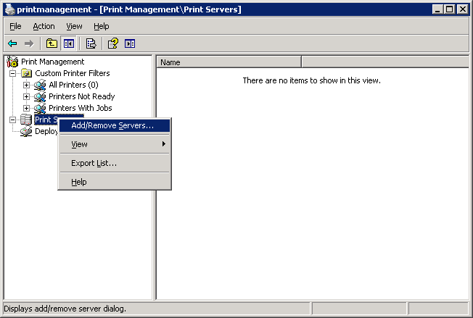

2. In the Add/Remove Servers box, under Configure Print Management, click Add the Local Server to designate the local machine as the print server.
3. Click OK.

Adding Network Print Servers
The following procedure describes how to add network print servers to the console.
To add a print server
1. In the Print Management tree, right-click Print Management or PrintServers, and then click Add/Remove Servers.
2. In the Add/Remove Servers dialog box, under Specify print server, in Add server field, do one of the following:
• Type the name of the print server you want managed.
• Click Browse to locate and select the print server.
3. Click Add to List.
4. Add as many print servers as you want, and then click OK.

Step 4: View Printers
The Print Management tree contains three places where printer information is stored: Custom Printer Filters, Print Servers, and Deployed Printers. The Custom Printer Filters folder contains the All Printers, Printers Not Ready, and Printers With Jobs objects. All Printers displays a dynamic view of all of the printers on all of the servers available for managing with Print Management. All of the custom views, or filters, of printers that you create are stored in Custom Printer Filters.
The network printer servers that you add are stored in Print Servers. Every printer server automatically is given four objects that serve as filters for information about a server:
• Drivers
• Forms
• Ports
• Printers
To quickly access the Print Server Properties dialog box, right-click the Drivers, Forms, or Ports objects, and then click Manage Drivers, Manage Forms, or Manage Ports.
Deployed Printers contains a list of all of the printers located in Print Management that are managed by Group Policy objects. For more information about managing printers by using Group Policy, see Deploying Printers to Users or Computers by Using Group Policy later in this guide.

Offline Print Servers
If a server goes offline, the printer server icon will change and (Offline) will be appended to the server name. All of the printers on that server will be hidden from all views. The Drivers, Forms, Ports, and Printers objects will also be hidden from view until the server comes back online.

Printer Details
The details for each printer display in the results pane of the console. The results pane contains columns with values such as the printer name, queue status, jobs in queue, and server name. You can add and remove columns to show only certain characteristics of the printers, and you can filter among all the print servers in your organization to display only printers with specific criteria in the columns. Figure 1 shows both a filtered view and the resulting columns.
In any view, you can sort on one criterion by clicking on the heading of one of the columns.
Figure 1 A view of printers where "Queue Status" equals "Paused"
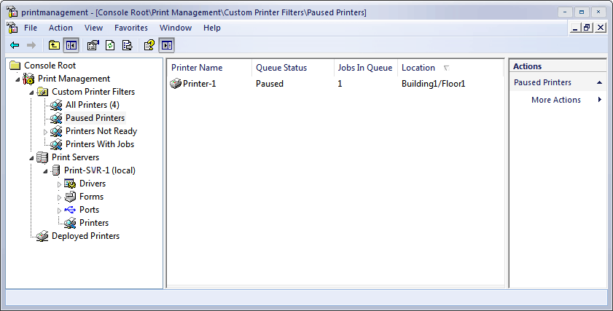

You can also show an extended view, which shows more detail about the queue and provides access to the printer's Web page, if one is available. You can add, remove, and sort columns in extended view.

Adding and Removing Columns
When you click the Printers object in each print server or an object in the Printers folder, you can view the columns in the results pane that contain printer details. You can change the columns in the view, but the columns you choose will be the same in all of the Printers objects and all of the custom views.
To add and remove columns
1. In the Print Management tree, under a print server, right-click Printers, point to View, and then click Add/Remove Columns.
2. In the Add/Remove Columns dialog box, select the name of the column, and then click Add or Remove.
The columns you set will be in effect the next time you open Print Management only if you save the MMC file.

Showing Extended View
Extended view displays beneath the columns in the right pane, separated by a splitter bar. Extended view is useful when you want more information about the status of a print job, its owner, the number of pages, the size of the job, when it was submitted, its port, its priority, and so on.
In addition, when the printer has a Web page, extended view gives you access to it by exposing an additional tab. The Web page displays details about the physical properties of the printer and specifications, and sometimes allows remote administration. For more information, see Using the printer Web page later in this guide.
When extended view is enabled, it is enabled for all Printer objects under all print servers and custom views.
To show extended view
• In the Print Management tree, under any print server, right-click Printers, and then click Show Extended View.
Note
To display or hide columns in extended view, select a printer. On the Jobs tab, right-click the column heading row, and then click the name of the column that you want to display or hide.

Filtering Views
You can use the filtering feature to create custom views of printers, for example, it might be helpful to filter for printers with certain error conditions or those printers in a group of buildings regardless of the print server they use. Each view is dynamic, so the data is always up to date. All filtered views are stored in the Printers folder in the Print Management tree.
An example of a filter that may be useful is shown in Figure 2. This custom view displays all printers on the specified printer server that have a queue status other than Ready and where there are one or more jobs in the print queue.
Figure 2 Using filter criteria to create a custom view of printers
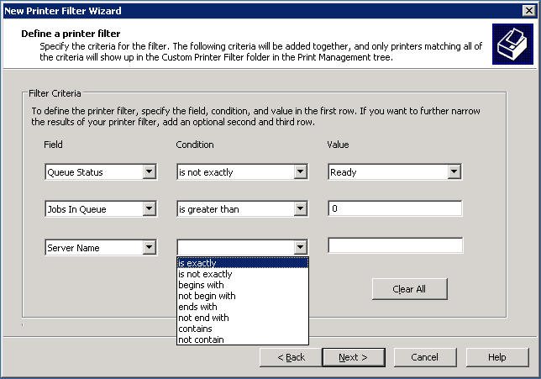

For every filtered view that you set up, you have the option of setting notifications by e-mail or choosing to run a script. To learn how to use these options see Troubleshoot Printers later in this guide.
To set up and save a filtered view
1. In the Print Management tree, right-click the Custom Printer Filters folder, and then click Add New Printer Filter. This will launch the New Printer Filter Wizard.
2. Under Printer Filter Name and Description, do the following:
a. Type a name for the printer filter. The name will appear in the Custom Printer Filter folder in the Print Management tree.
3. Type a description that helps you recall the difference between this and other printers filters. The description is displayed when you choose Properties for a filter
4. Click Next.
5. Under Define a printer filter, do the following:
a. In the Field list, click the print queue or printer status characteristic.
b. In the Condition list, click the condition.
c. In the Value box, type a value.
d. Continue adding criteria until your filter is complete, and then click Next.
6. Under Set Notifications (Optional), do the following:
a. Select the Send e-mail notification checkbox and type one or more recipient and sender e-mail addresses. An SMTP server must be specified to route the message.
b. To create a New Printer Filter with no e-mail notification, clear the checkbox.
c. Click Next.
7. Under Run Script, do the following:
a. Select the checkbox and then type the path where the script file is located. To add more arguments, type them in the Additional Arguments box.
b. To create a New Printer Filter without specifying a script, clear the checkbox.
8. Click Finish.

Step 5: Saving a custom view
If you use customized views of Print Management, it might be useful to save one or more views. Print Management files are *.msc files.
The following are Print Management settings that you can customize for viewing:
• Print servers added
• Custom views (filters) and notifications
• Column preferences

Step 6: Manage Printers
You can use Print Management to manage all of the printers in your enterprise, including printers in branch offices. You can use the same interface to control how printers are shared, update drivers, and control print queues. It is unnecessary to navigate to the individual folders for each printer on each printer server.
By using Print Management in conjunction with the Configure Your Server Wizard and Terminal Services, you can automatically search for and install network printers on a local print server in branch offices. This is helpful when branch office personnel are not trained in administrative duties. You can deploy a printer to an entire group of people or make a printer available to every computer in a particular room. For more information, see Deploying Printers to Users or Computers by Using Group Policy later in this guide.

Automatically Installing Printers to the Local Print Server
As the administrator on the local print server, you can add and remove printers. Print Management can automatically detect all printers located on the same subnet as the print server, install the appropriate printer drivers, set up the queues, and share the printers. Unless a printer driver cannot be found, no intervention is needed.
The automatic detect feature cannot function over firewalls, so if you want to use the feature for a branch office or another location beyond the subnet of your server, use Remote Desktop to log on to the local print server and start the process from that computer. You need to have administrator permissions on the computer where the printers will be added.
To automatically add network printers
1. In the Printer Management tree, right-click the local print server, click Add Printer.
2. This will launch the Network Printer Installation Wizard.
3. Select Have the wizard search the network for printers and automatically configure the port.
4. Click Next.
Note
You may be prompted to specify which driver you want to install for a printer, but otherwise, the process is automatic.

Using Print Management for Bulk Printer Management Tasks
You can perform some management tasks on multiple printers simultaneously. To do this, you can set up a filter so that all of the desired printers are in the same view and easy to select.
The following is a list of the tasks that are possible to perform on multiple printers simultaneously:
• Pause print jobs
• Cancel print jobs
• Resume print jobs
• List a printer
• Remove a printer
• Delete a printer
For more information about each task, see the following sections in this guide.

Pausing, Canceling, or Resuming Print Jobs on One or More Printers
When a printer is not responding due a problem such as lack of paper, you can use Print Management to cancel or suspend all of the pending print jobs. You can execute these actions on more than one printer at a time. You may want to set up a filter to show all of the printers for which you want to cancel jobs, so that you can easily select all of the printers at the same time.
To pause, cancel, or resume all print jobs on a printer
1. In the Print Management tree, under the appropriate print server, click Printers.
2. In the results pane, right-click the printer for which you want to pause, cancel, or resume all print jobs, and then click the appropriate command.

Deleting Printers
You can delete one or more printers at a time from a print server. Note that you can set up a custom view to filter all the printers you want to delete.
Alert users that the printer will be deleted and provide an alternative printer to use. Before you delete the printer, make sure the queue is empty.
To delete a printer from a print server
1. In the Print Management tree, under the appropriate print server, click Printers.
2. In the results pane, right-click the printer you want to delete, and then click Delete.

Updating Device Drivers
Printer driver details are shown separately for each server that you have added to the Print Management snap-in console. By default, the driver name, driver version, environment, and provider columns are visible. You can add columns to show more details such as the config file path, data file path, default datatype, driver file path, manufacturer, and so on.
You can export the list of details to a text file for use outside of Print Management.
To manage device drivers
1. In the Print Management tree, under the appropriate print server, right-click Drivers, and then click Manage Drivers.
2. Do one or more of the following:
• To add a printer driver, click Add, and then complete the Add Printer Driver Wizard.
• To remove a printer driver, select a driver from the list, and then click Remove.
• To reinstall a printer driver, select a driver, and then click Reinstall.
• To view the details for a printer driver, select the driver, and then click Properties.

Listing and Removing Printers in Active Directory
Listing in Active Directory makes it easier for users to locate and install printers. After you install printers on a printer server, you can use Print Management to list them in Active Directory.
In fact, you can list more than one printer simultaneously. You may want to set up a filter to show all of the printers to list or remove, so that you can easily select all of the printers at the same time.
To list or remove printers in Active Directory
1. In the Print Management tree, under the appropriate print server, click Printers.
2. In the results pane, right-click the printer you want to list or remove, and then click List in Directory or Remove from Directory.

Exporting a List of Printers and Displayed Columns
You can export a text file containing the data available on any Printers object, which includes the currently displayed columns.
To export a list of printers
1. In the Print Management tree, under the appropriate print server, right-click Printers, then click Export List.
2. In the Export List dialog box, in File name, type the name of the file, and then click Save.

Deploying Printers to Users or Computers by Using Group Policy
Print Management can be used with Group Policy to automatically add printer connections to a client computer's Printers and Faxes folder.
To do this, you use the Deploy with Group Policy dialog box to automatically add a printer connection setting to an existing Group Policy object (GPO) in Active Directory. When Group Policy processing runs on client computers, the printer connection settings are applied to the users or computers associated with the GPO. Printers you deploy by using this method appear in the Deployed Printers object of Print Management tree when the print server they are connected to is being monitored.
This method of installing a printer is useful in a laboratory, classroom, or branch office setting where every computer in the room or office needs access to the same printer. It is also useful in large organizations, where computers and printers are often separated by function, workgroup, or department, such as marketing or human resources.
A printer connection that has been installed by using a per-user connection is available to the user no matter what computer the user logs on to in the network. A printer connection that has been installed by using a per-machine connection appears in the Printers and Faxes folder, ready for use by any user of that computer.
To enable this feature on computers running versions of Windows earlier than Windows Vista Beta 2, you must use a utility called PushPrinterConnections.exe.
To do this, you add the PushPrinterConnections.exe utility to a machine startup script (for per-machine connections) or to a user logon script (for per-user connections) to all computers or users that will get the GPO with printer connection settings after you deploying printer connection settings by using Print Management. The utility reads the settings made by the GPO containing the printer setting and adds the printer connection.
It is a good idea to use the same GPO for both the printer connection settings and running the PushPrinterConnections.exe to ensure that the appropriate users and computers are updated every time the GPO is updated.
Note
Only per-user printer connections are supported on computers running Windows 2000. Windows XP or later is required for per-machine printer connections.
Important
You must have write access to the Group Policy object to use it to manage printers. Before you install printers by using Group Policy, you must have a GPO for your printer connections settings that is assigned to the appropriate users and computers. You can use the Group Policy Object Editor or Active Directory Users and Computers to create a GPO.
For more information about using Group Policy, see Enterprise Management with the Group Policy Management Console on the Microsoft Web site (http://go.microsoft.com/fwlink?linkid=22814)
To install printers to groups of users or computers by using Group Policy
1. In the Print Management tree, under the appropriate print server, click Printers.
2. In the results pane, right-click the printer you want to deploy, and then click Deploy with Group Policy.
3. In the Deploy with Group Policy dialog box, click Browse, and then choose a Group Policy object.
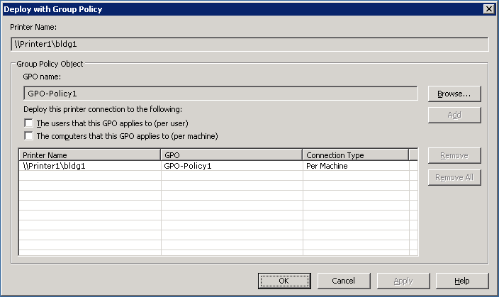

4. Click OK.
5. To assign the printer connection setting to the GPO, do one or both of the following:
• As a per-user setting, select the Deploy this connection to the users that this GPO applies to (per user) check box.
• As a per-machine setting, select the Deploy this connection to the computers that this GPO applies to (per machine) check box.
6. Click Add.
7. Repeat steps 3 to 6 to add the printer connection setting to another GPO.
8. Click OK.
To use the PushPrinterConnections.exe file
1. Using Group Policy Management console (gpmc.msc), right-click the GPO with your printer connections settings and click Edit.
2. In the Group Policy Object Editor tree, navigate to one following locations:
• If the printer connections are deployed per-machine, go to Computer Configuration, Windows Settings, Scripts (Startup/Shutdown).
• If the printer connections are deployed per-user, go to User Configuration, Windows Settings, Scripts (Logon/Logoff).
3. Right-click Startup or Logon, and then click Properties.
4. In the Logon Properties or Startup Properties dialog box, click Show Files.
5. Copy the PushPrinterConnections.exe file to this location and then close the window.
6. In the Logon Properties or Startup Properties dialog box, click Add.
7. Type PushPrinterConnections.exe in the Script Name box.
8. If you want to enable logging, type –log in the Script Parameters box. Log files are written to %windir%\temp\ppcMachine.log (for per-computer connections) and %temp%\ppcUser.log (for per-user connections) on the computer on which the policy is applied.
9. Click OK.

Step 7: Troubleshoot Printers
Print Management has several features that may help you identify and resolve printer problems -- even in remote locations. Setting pre-defined filters lets you easily find all printers that are not in Ready status or that have a backed up queue. Many devices, regardless of manufacturer, provide rich status information, which is readily available to Print Management. By closely monitoring the printers in your organization, you may even be able to resolve problems before they happen, such as identifying when paper or toner is low.
You can set up e-mail notifications to alert you when a printer needs attention. This is especially useful when you have printers at multiple locations with different people responsible for managing them. By using an automated system to notify you when a printer or printer server is down, the problem may be resolved sooner and less attention may need to be focused on the monitoring program.

Using the Printer Web Page
Multifunction printers sometimes have a Web page that is accessible though extended view in Print Management. The functionality on the printer Web page will vary depending upon both the model and the manufacturer of the printer. Some multifunction printers provide remote functions, the amount of paper in each tray, and the toner level. You may be able to delete print jobs or upgrade device drivers from the printer Web pages.
Note
If the printer is down due to a networking error, the printer Web page cannot be displayed.

Setting E-mail Notifications
When you create a view, or filter for specific printer criteria, you have the option of sending an automatic e-mail notification to someone when the conditions of the filter are met. This is useful for resolving printer problems, particularly in an organization with multiple buildings and administrators.
For example, you can set up a view of all printers managed by a particular print server where the status does not equal Ready. Then, if a printer changes from the Ready status to another status, the administrator could receive a notification e-mail from Print Management.
To send these notifications, you must specify that the SMTP server forward the messages.
To set e-mail notifications
1. In the Print Management tree, do one of the following:
• To set a notification on an existing filtered view, in the Printers folder, right-click the filtered view, and then click Properties. Click the Notification tab.
• To set a notification on a new filtered view, right-click the Printers folder, and then click New Filtered Printers Folder. Follow the instructions until you reach the Specify Notification page.
2. Select the Send e-mail notification check box.
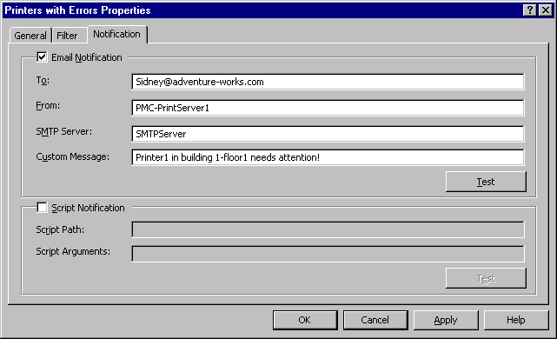

3. Enter the following information:
• In To, type the e-mail address of the recipient. Use the format account@domain. Use semicolons to separate multiple accounts.
• In From, type the e-mail address of the sender. Use the format account@domain.
• In SMTP Server, type the host name of the SMTP server that will forward the e-mail notifications.
• In Custom Message, type a text message describing the conditions of the printer problem.

Setting Server Notifications
In addition to setting notifications on a custom set of printers, you can set notifications on printer server objects. For example, if the server is offline, or the spooler goes down, an e-mail notification can be sent. To do this, right-click a print server object, click Notification, and then follow steps 2 and 3 in "To set e-mail notifications."

Printing a Test Page
You can quickly print a test page from any printer in your organization. This is helpful for testing a printer, particularly when you are not in the same building.
To print a test page
1. In the Print Management tree, click the appropriate print server.
2. In the results pane, right-click the printer for which you want a test page, and then click Print Test Page.

Using Scripts
When you create a filter for specific printer criteria, you have the option of running a script when the conditions of the filter are met. Script notifications are defined in the Notifications dialog box. Setting script notifications are useful for resolving printer problems and troubleshooting.
For example, you could automatically run a script to restart a spooler when printers go offline. You could also automatically run a script that prints a test page.
The arguments passed to the script for filter notifications are: UserSpecifiedArguments Printername \\ServerName Filtername. When your script does not take any Print Management defined parameters, you can use the Test button to verify the script performs as expected. UserSpecifiedArguments must be separated by a space. Print Management and user defined parameters cannot exceed 2048 characters.
For server notifications the arguments are: UserSpecifiedArguments ServerState ServerName. For example, you could automatically run a script to restart a remote spooler when the service goes offline.
Scripts can be written in Visual Basic Script (.vbs) or any scripting language available on the computer. The script has to be on the computer with Print Management. The script should be running with your credentials and you need to have the permissions to do whatever it is that you want the script to do.
An example of a command that you might use in a script is to restart a remote print spooler: sc \\%2 start spooler

Step 8: Troubleshoot Print Management
If you are using a firewall with Print Management some or all of the printers on a network print server may not be displayed. To solve the problem, add Print Management to the list of exceptions in the firewall software configuration. For example, in Windows Firewall the setting is File and Printer Sharing on the Exceptions tab.
To display printers using a firewall
1. Click Start, Control Panel, Windows Firewall.
2. Under the Exceptions tab, select File and Printer Sharing, and then click Edit.
3. In the Edit a Service dialog box, click Change Scope, select Any computer (including those on the Internet).
4. Click OK.

Logging Bugs and Feedback
Your feedback is very important to help us improve this feature in future releases of Windows Vista Beta 2. Please provide feedback regarding your experience using Print Management, problems that you encounter, and whether this document was helpful. We also appreciate any suggestions about ways we can make this feature more useful.
When logging bugs, use the instructions on the Microsoft Connect Web site (http://go.microsoft.com/fwlink/?LinkId=49779). We are also interested in feature requests and general feedback about Print Management.

Additional Resources
The following resources provide additional information about Print Management.
• If you need product support, see the Microsoft Connect Web site (http://go.microsoft.com/fwlink/?LinkId=49779).
• To access newsgroups for Print Management, follow the instructions that are provided on the Microsoft Connect Web site (http://go.microsoft.com/fwlink/?LinkId=50067).
• You can e-mail your questions about Print Management to prninfo@microsoft.com.
• For information about using scripts, see Script Repository: Printing on the Microsoft Web site (http://go.microsoft.com/fwlink/?LinkId=50001).
• For more information about Print Services, see Print Services on the Microsoft Web site (http://go.microsoft.com/fwlink/?LinkId=50121).

Technology Adoption Program support
If you are a beta tester and part of the special Technology Adoption Program (TAP) beta program, you can also contact your appointed Microsoft development team member for assistance.

