

Operating System

Deploying Internet Connection Firewall Settings for Microsoft® Windows® XP with Service Pack 2

Microsoft Corporation
Published: December 2003

Abstract
Windows XP Service Pack 2 (SP2), currently in Beta testing, includes significant enhancements to the Internet Connection Firewall (ICF) component, also known as the Windows Firewall. ICF is a stateful firewall that discards unsolicited incoming traffic, providing a level of protection for computers against malicious users or programs. To provide better protection for computers connected to any kind of network (such as the Internet, a home network, or an organization network), Windows XP SP2 enables ICF on all network connections by default. This new behavior can impair some types of communications. This article describes how to deploy the appropriate configuration settings for ICF on an organization network so that it is enabled and providing protection and so that communications are not impaired.

This is a preliminary document and may be changed substantially prior to final commercial release of the software described herein.
The information contained in this document represents the current view of Microsoft Corporation on the issues discussed as of the date of publication. Because Microsoft must respond to changing market conditions, it should not be interpreted to be a commitment on the part of Microsoft, and Microsoft cannot guarantee the accuracy of any information presented after the date of publication.
This document is for informational purposes only. MICROSOFT MAKES NO WARRANTIES, EXPRESS OR IMPLIED, AS TO THE INFORMATION IN THIS DOCUMENT.
Complying with all applicable copyright laws is the responsibility of the user. Without limiting the rights under copyright, no part of this document may be reproduced, stored in or introduced into a retrieval system, or transmitted in any form or by any means (electronic, mechanical, photocopying, recording, or otherwise), or for any purpose, without the express written permission of Microsoft Corporation.
Microsoft may have patents, patent applications, trademarks, copyrights, or other intellectual property rights covering subject matter in this document. Except as expressly provided in any written license agreement from Microsoft, the furnishing of this document does not give you any license to these patents, trademarks, copyrights, or other intellectual property.
© 2003 Microsoft Corporation. All rights reserved.
Microsoft, Windows, and Active Directory are either registered trademarks or trademarks of Microsoft Corporation in the United States and/or other countries.
The names of actual companies and products mentioned herein may be the trademarks of their respective owners.

Contents
Overview 1
Enabled by Default for All the Connections of the Computer 1
New Global Configuration Options that Apply to All Connections 1
New Set of Dialog Boxes for Local Configuration 2
New Shielded Mode 2
Startup Security 3
Local Subnet Restriction 3
Excepted Traffic Can Be Specified by Application Filename 3
Built-in Support for IPv6 ICF 3
New Configuration Options for Netsh and Group Policy 4
Windows XP SP2 and the Impact to Enterprise Networks 5
Allowing Users to Install Windows XP SP2 from Windows Update 6
Using Windows XP SP2 ICF and IPSec 6
Deploying TCP/IP ICF Settings With Group Policy 7
Step 1: Updating Your Group Policy Objects With the New ICF Settings 7
Step 2: Specifying ICF Settings for Your Group Policy Objects 9
Recommended Settings for ICF Group Policy Settings 10
Group Policy Settings in Mixed Windows XP Environments 10
Deploying ICF Settings Without Group Policy 12
Deploying IPv6 ICF Settings 13
Appendix A: ICF Group Policy Settings 14
Operational Mode 14
Allow User Preference/Group Policy Settings Merge 15
Define Allowed Programs 16
Allow Dynamically Assigned Ports for RPC and DCOM 18
Allow File and Print Sharing 19
Allow ICMP Settings 20
Allow Remote Assistance Support 20
Allow Universal Plug and Play 22
Define Custom Open Ports 22
Appendix B: Netsh Command Syntax for the Netsh Firewall Ipv4 Context 25
add allowedprogram 25
set allowedprogram 26
delete allowedprogram 26
set icmpsetting 26
set logging 27
set opmode 27
add portopening 28
set portopening 28
delete portopening 29
set service 29
set notifications 30
show 30
Appendix C: Netsh Command Syntax for the Netsh Firewall Ipv6 Context 31
set adapter 31
set globalport 31
set logging 31
show 31
Appendix D: Troubleshooting Tools for ICF in Windows XP SP2 33
Summary 35
Related Links 36

Overview
Windows XP Service Pack 2 (SP2), currently in Beta testing, includes significant enhancements to the Internet Connection Firewall (ICF), also known as the Windows Firewall. ICF is a stateful firewall that drops all unsolicited incoming traffic that does not correspond to either traffic sent in response to a request of the computer (solicited traffic) or unsolicited traffic that has been specified as allowed (excepted traffic). This behavior of ICF provides a level of protection from malicious users and programs that use unsolicited incoming traffic to attack computers.
In Windows XP (prior to SP2), ICF is disabled by default for all connections, unless enabled for an Internet connection by the Network Setup Wizard or Internet Connection Wizard. Manually enabling of ICF is done through a single checkbox on the Advanced tab of the properties of a connection, from which you can also configure the set of excepted traffic by specifying Transmission Control Protocol (TCP) or User Datagram Protocol (UDP) ports.
In Windows XP SP2, there are many changes to ICF, including the following:
- Enabled by default for all the connections of the computer
- New global configuration options that apply to all connections
- New set of dialog boxes for local configuration
- New Shielded mode
- Startup security
- Local subnet restriction
- Excepted traffic can be specified by application filename
- Built-in support for IPv6 ICF
- New configuration options for Netsh and Group Policy

Enabled by Default for All the Connections of the Computer
ICF in Windows XP SP2 is globally enabled by default. This means that, by default, all the connections of a computer running Windows XP SP2 have ICF enabled, including LAN (wired and wireless), dial-up, and virtual private network (VPN) connections. New connections also have ICF enabled by default.
Although this behavior provides more protection for Windows XP-based computers, this default behavior can have profound consequences for the information technology (IT) department of an organization network with regards to application compatibility and the ability to manage the computers on the network. For more information, see "Windows XP SP2 and the Impact to Enterprise Networks" in this article.

New Global Configuration Options that Apply to All Connections
ICF in Windows XP SP2 allows you to configure settings that apply to all the connections of the computer (global configuration). In Windows XP (prior to SP2), ICF settings are configured per connection, which means that if you want to enable ICF on multiple connections and configure excepted traffic, you must configure each connection separately. When you change a global ICF setting, the change is applied to all the connections on which ICF is enabled.
ICF in Windows XP SP2 also allows per-connection configuration. Connection-specific configuration overrides global configuration.

New Set of Dialog Boxes for Local Configuration
The settings for ICF in Windows XP (prior to SP2) consist of a single checkbox (the Protect my computer and network by limiting or preventing access to this computer from the Internet check box on the Advanced tab of the properties of a connection) and a Settings button from which you can configure excepted traffic, logging settings, and allowed ICMP traffic.
In Windows XP SP2, the check box has been replaced with a Settings button which displays a Internet Connection Firewall dialog box, from which you can configure general settings, permissions for programs and services, connection-specific settings, log settings, and allowed ICMP traffic. You can also configure ICF settings from the Internet Connection Firewall icon in Control Panel. The following figure shows the new Internet Connection Firewall dialog box.
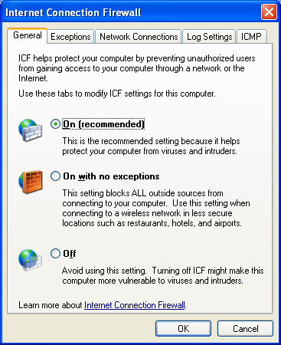
When ICF is configured in an organization network using Group Policy, by default all of the local ICF configuration options are grayed out and unavailable.

New Shielded Mode
With Windows XP (prior to SP2), ICF is either enabled (allows solicited and excepted traffic) or disabled (allows all traffic).
With Windows XP SP2, a new operating mode known as Shielded mode can be selected (corresponding to the On with no exceptions option on the General tab of the new Internet Connection Firewall dialog box). When ICF for Windows XP SP2 is running in Shielded mode, all unsolicited incoming traffic is dropped, including excepted traffic. Shielded mode can be used to temporarily lock down computers during a known network attack or when a malicious program is spreading. Once the network attack is over and appropriate updates are installed to prevent future attacks, then ICF can be placed in the protected mode, which allows excepted traffic.

Startup Security
In Windows XP (prior to SP2), ICF is active on the connections on which it is enabled when the Internet Connection Firewall (ICF)/Internet Connection Sharing (ICS) service is started successfully. Therefore, when a computer running Windows XP (prior to SP2) is started, there is a delay between when the computer is active on the network and when the connections are protected with ICF. This delay makes it possible for the computer to be attacked during startup.
In Windows XP SP2, there is a startup ICF policy to perform stateful packet filtering, which allows the computer to perform basic networking startup tasks using Dynamic Host Configuration Protocol (DHCP) and Domain Name System (DNS) to configure the computer and communicate with a domain controller to obtain Group Policy updates. Once the Internet Connection Firewall (ICF)/Internet Connection Sharing (ICS) service is started, it uses its configuration and removes the startup policy. The startup policy settings cannot be configured.
There is no ICF startup security if ICF is disabled.

Local Subnet Restriction
In Windows XP (prior to SP2), the excepted traffic can originate from any IP address. In Windows XP SP2, ICF allows you to specify that excepted traffic can originate from any IP address or an IP address that matches the local subnet to which the connection that received the traffic is attached. This can be useful for home networking, in which you want to allow file and printer sharing for the computers on the local home network, but do not want to allow access to your file or printer shares to malicious Internet users. In this case, you would allow file and printer sharing as excepted traffic for the local subnet only.

Excepted Traffic Can Be Specified by Application Filename
In Windows XP (prior to SP2), you manually configure excepted traffic by specifying the set of TCP and UDP ports that correspond to the traffic of a specific application or service. This can make configuration difficult for users that do not know the set of TCP and UDP ports for the application or service or how to find them. Also, this configuration does not work for applications that do not listen on a specific set of UDP or TCP ports.
To make the specification of excepted traffic easier, it is possible in Windows XP SP2 to configure excepted traffic by either specifying the set of TCP or UDP ports or the filename of the application. When the application runs, ICF monitors the ports on which the application listens and automatically adds them to the list of allowed incoming unsolicited traffic.
To allow you to quickly enable exceptions for commonly allowed incoming unsolicited traffic, ICF has preconfigured permissions, such as file and printer sharing and Universal Plug and Play (UPnP).

Built-in Support for IPv6 ICF
Windows XP SP2 includes the Internet Protocol version 6 (IPv6) ICF that is included in the Advanced Networking Pack for Windows XP. IPv6 ICF is installed as the IPv6 Internet Connection Firewall component in the Networking Services category of Add/Remove Windows Programs in Control Panel-Add or Remove Programs. Once installed, IPv6 ICF is automatically enabled on all IPv6 connections. IPv6 ICF can be configured using commands in the netsh firewall ipv6 context. For more information, see Appendix C.

New Configuration Options for Netsh and Group Policy
With Windows XP (prior to SP2), the only way to enable or disable ICF is through the Network Connections folder, the Network Setup Wizard, and the Internet Connection Wizard. To configure excepted traffic, you must either use the Network Connections folder or your application must be ICF-aware, in which case it automatically enables excepted traffic when it runs.
With Windows XP SP2, you have the following additional configuration options:
- Netsh commands
Netsh is a command-line tool through which you can configure settings for network components. To configure a component, it must support a set of commands through a Netsh context. Windows XP (prior to SP2) has no Netsh context for ICF. With Windows XP SP2, you can now configure ICF settings through a series of commands in the netsh firewall context. Using Netsh, you can create Netsh scripts to automatically configure a set of ICF settings for both TCP/IP and IPv6. For more information, see Appendix B and Appendix C.
- New configuration application programming interfaces (APIs)
With Windows XP (prior to SP2), there are APIs by which applications can automatically configure excepted traffic and configure ICF settings. With Windows XP SP2, there are new APIs through which you can configure ICF for both global and connection-specific settings all the items that are available through the Internet Connection Firewall Control Panel applet. You can use these APIs to create customized configuration programs that can be run by users on an organization network.
- Extensive support to configure settings using Group Policy
To centralize the configuration of large numbers of computers in an organization network that use the Active Directory® directory service, ICF settings for computers running Windows XP SP2 can be deployed through Computer Configuration Group Policy. A new set of Computer Configuration Group Policy ICF settings allow a network administrator to configure ICF operational modes, excepted traffic, and other settings using a Group Policy object.
When ICF is configured in an organization network using Group Policy, by default all of the local ICF configuration options are grayed out and unavailable.
When using the new ICF Group Policy settings, you can configure two different profiles:
- Domain profile
The domain profile is the set of ICF settings that are needed when the computer is connected to the network that contains the domain controllers of the organization. For example, the domain profile might contain excepted traffic for the applications needed by a managed computer in an enterprise network.
- Mobile profile
The mobile profile is the set of ICF settings that are needed when the computer is not connected to the network that contains the domain controllers of the organization. A good example is when an organization laptop is taken on the road and connects to the Internet using a public broadband or wireless Internet service provider. Because the organization laptop is directly connected to the Internet, the mobile profile should contain more restrictive settings than the domain profile.
For more information, see "Deploying TCP/IP ICF Settings With Group Policy" in this article

Windows XP SP2 and the Impact to Enterprise Networks
For enterprise networks, the default behavior of having ICF enabled by default on all network connections can have a significant impact on the types of communication that can occur once Windows XP SP2 is installed. For many enterprise networks using Windows XP (prior to SP2), ICF is disabled on all connections connected to the enterprise network because enterprise networks typically are not directly connected to the Internet. The enterprise network firewall, proxy, and other systems provide some level of protection from the Internet to intranet network computers. However, the absence of using host firewalls such as ICF on intranet connections leaves computers vulnerable to malicious programs brought onto the intranet by computers that attach directly to the intranet.
For example, an employee connects an organization laptop to a home network that does not have adequate protections. Because the organization laptop does not have a host firewall enabled on its network connection, it gets infected with a malicious program (such as a virus) that uses unsolicited incoming traffic to spread to other computers. The employee then brings his or her laptop back to the office and connects it to the organization intranet, effectively bypassing the security systems that are at the edge of the intranet. Once connected to the intranet, the malicious program begins to infect other computers. If ICF was enabled by default, the laptop computer might not get infected with the malicious program when connected to their home network. Even if it did get infected, when it connected to the intranet, the local intranet computers might not become infected because they also have ICF enabled.
The consequences to blocking all unsolicited incoming traffic by default can affect network communications if the computers running Windows XP SP2 are managed, are servers, are listeners, or are peers. The following lists provide examples of components and capabilities of a computer running Windows XP SP2 for which communication can be impaired by the default behavior of ICF:
- The Windows XP SP2 computer is managed
- Simple Network Management Protocol (SNMP) Agent
- Windows Management Interface (WMI)
- Remote management using Netsh or an Microsoft Management Console (MMC) snap-in
- Remote Assistance
- Microsoft Systems Management Server (SMS)
- Other management system
- The Windows XP SP2 computer is acting as a server
- Internet Information Services (IIS)
- File and Printer Sharing
- Message Queuing
- Simple TCP/IP Services
- Print Services for UNIX
- The Windows XP SP2 computer is acting as a listener
- UPnP
- Routing Information Protocol (RIP) Listener
- The Windows XP SP2 computer is acting as a peer
- Third-party peer-to-peer networking applications
Notes if the Windows XP SP2 computer is acting as a client, then enabling ICF does not impair communications. Examples are Web access, email, Group Policy, and management agents that request updates from a management server.
If your network is using any of these components included with Windows XP SP2, provided by Microsoft as separate products, or provided by third parties, then by default, communication will be impaired when Windows XP SP2 is installed. To prevent this from happening, Windows XP SP2 must be deployed with the appropriate ICF settings to allow the computer to act as a managed computer, a server, a listener, or a peer for those applications and services being used on your network.
Because the deployment of Windows XP SP2 can impact communications on your network, it is highly recommended that you test Windows XP SP2 with critical administrative and business applications before deploying it on your production network.
The details of deploying ICF settings for Windows XP SP2 are described in "Deploying TCP/IP ICF Settings With Group Policy" and "Deploying ICF Settings Without Group Policy" in this article.

Allowing Users to Install Windows XP SP2 from Windows Update
When planning your deployment of Windows XP SP2, one of the issues that you must confront is whether you will allow your network users to download and install Windows XP SP2 from Windows Update. In order to install Windows XP SP2, your users must be logged on as an administrator or as a member of the Administrators group. If this is the case and you allow them to install Windows XP SP2, then after it is installed on a computer, that computer might not be manageable using your management software because ICF by default is globally enabled. The computer might not be manageable until ICF is configured with the appropriate excepted traffic. This can be done using Group Policy settings, a script, or a configuration program.
If you do not allow your users to install Windows XP SP2, then you can use your management software to deploy Windows XP SP2 along with the appropriate ICF settings so that at all times during the deployment, the computers on your network are manageable.

Using Windows XP SP2 ICF and IPSec
ICF is used to block unsolicited incoming traffic. However, you cannot specify the source address of the solicited or excepted traffic. Internet Protocol security (IPSec), built into Windows XP, can provide this extra level of protection. Using IPSec policies, you can specify the traffic that is blocked (dropped), permitted (allowed), or protected using cryptography for both outbound and incoming traffic. In any of these three cases (blocked, permitted, protected), IPSec can be configured for a specific range of source and destination addresses.
If you are already using IPSec to block, permit, or protect traffic, then ICF on computers running Windows XP SP2 provides additional protection against attacks based on unsolicited traffic.

Deploying TCP/IP ICF Settings With Group Policy
The best way to manage ICF settings in an organization network is to use Active Directory and the new ICF settings in Computer Configuration Group Policy. This method requires the use of Active Directory with either Windows 2000 or Windows Server 2003 domain controllers. Group Policy updates are requested by the domain member computer, and are therefore solicited traffic that is not dropped when ICF is enabled.
When you use Group Policy to configure ICF, by default users will be unable to change its configuration using the Internet Connection Firewall Control Panel applet. All of the tabs on the Internet Connection Firewall dialog box will be grayed out and unavailable.
The basic steps for deploying ICF settings for Windows XP SP2 with Active Directory are the following:
- Update your Group Policy objects with the new ICF settings.
- Specify ICF settings for your Group Policy objects.
The following sections describe these steps in detail.
Note The procedure to update your Group Policy object with the new ICF settings will replace the System.adm file that is stored for the Group Policy object being modified with the version that is provided with Windows XP SP2, which includes the new ICF settings. If a Group Policy administrator on your production network performs this procedure, your production environment will be updated.

Step 1: Updating Your Group Policy Objects With the New ICF Settings
To update your Group Policy objects for network environments using Windows Server 2003 and Windows XP SP1, it is recommended that you use the Group Policy Management Console, a free download available from Microsoft. For more information, see Group Policy Management Console with Service Pack 1 at http://www.microsoft.com/downloads/details.aspx?FamilyId=C355B04F-50CE-42C7-A401-30BE1EF647EA&displaylang=en.
To update your Active Directory Group Policy objects with the new ICF settings using the Group Policy snap-in (provided with Windows XP SP2), do the following:
- Install Windows XP SP2 on a computer that is a member of the domain that contains the computer accounts of the other computers running Windows XP on which you plan to install Windows XP SP2.
- Restart the computer and log on to the Windows XP SP2 computer as a member of the Domain Administrators security group, the Enterprise Administrators security group, or the Group Policy Creator Owners security group.
- From the Windows XP desktop, click Start, click Run, type mmc, and then click OK.
- On the File menu, click Add/Remove Snap-in.
- On the Standalone tab, click Add.
- In the Available Standalone Snap-ins list, click Group Policy Object Editor, and then click Add.
- In the Select Group Policy Object dialog box, click Browse.
- In the Browse for a Group Policy Object, click the Group Policy object that you want to update with the new ICF settings. An example is shown in the following figure.
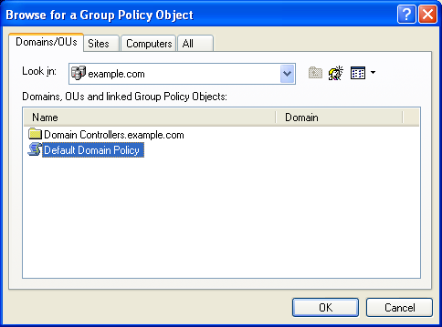
- Click OK.
- Click Finish to complete the Group Policy Wizard.
- In the Add Standalone Snap-in dialog box, click Close.
- In the Add/Remove Snap-in dialog box, click OK.
- In the console tree, open Computer Configuration, Administrative Templates, Network, Network Connections, and then Internet Connection Firewall. An example is shown in the following figure.
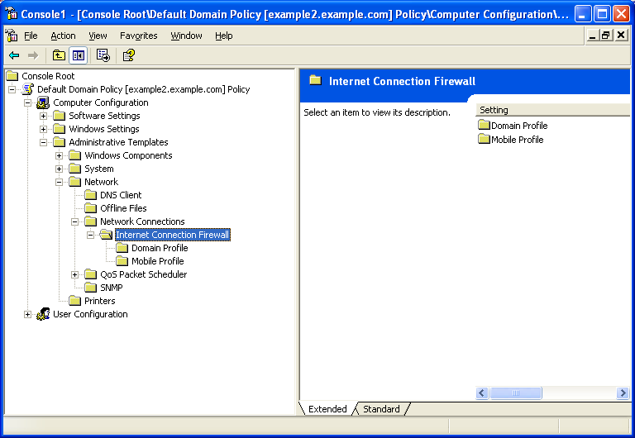
Repeat this procedure for every Group Policy object that is being used to apply Group Policy to computers that will have Windows XP SP2 installed.

Step 2: Specifying ICF Settings for Your Group Policy Objects
After a Group Policy object has been updated, it can be configured for ICF settings that are appropriate for ICF and the use of management, server, listener, or peer applications and services that are being run on your Windows XP SP2 computers.
There are two sets of ICF settings to configure:
- The domain profile settings that are used by the computers when they are connected to a network that contains domain controllers.
- The mobile profile settings that are used by the computers when they are connected to a network that does not contain domain controllers.
If you do not configure mobile profile settings, their default values are still applied. Therefore, it is highly recommended that you configure both domain and mobile profile settings.
As previously described, the mobile profile settings are typically more restrictive that the domain profile because the mobile profile settings do not need to include applications and services that are only used in a managed domain environment.
Both the domain profile and mobile profile contain the same set of ICF settings, as shown in the following figure.
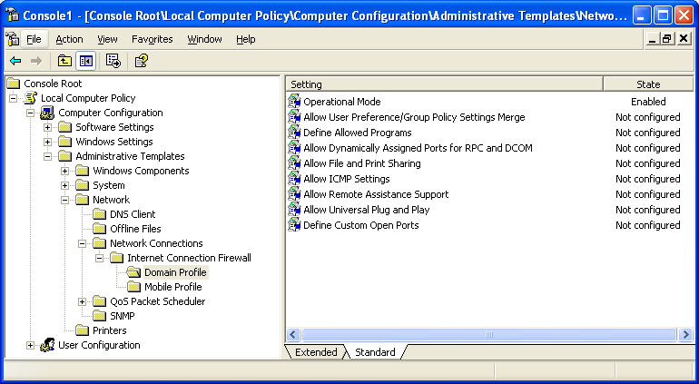
The ICF Group Policy settings consist of the following:
- Operational Mode Used to configure the operating mode of ICF (Enabled, Disabled, or Shielded.)
- Allow User Preference/Group Policy Settings Merge Used to enable local configuration of ICF.
- Define Allowed Programs Used to define excepted traffic in terms of application file names.
- Allow Dynamically Assigned Ports for RPC and DCOM Use to specify whether or not listening ports can be opened for applications using Remote Procedure Call (RPC) and Distributed Component Object Model (DCOM).
- Allow File and Print Sharing Used to specify whether file and printer sharing traffic is allowed.
- Allow ICMP Settings Used to specify the types of unsolicited Internet Control Message Protocol (ICMP) traffic that are allowed.
- Allow Remote Assistance Support Used to specify whether the Windows XP Remote Assistance component can accept an Offer Remote Assistance-based connection request (in which an invitation is not required from the novice computer).
- Allow Universal Plug and Play Used to specify whether the computer can participate in UPnP.
- Define Custom Open Ports Used to specify excepted traffic in terms of TCP and UDP ports.
For information about these settings, including example dialog boxes, see Appendix A.
Use the Group Policy snap-in to modify the ICF settings in the appropriate Group Policy objects. Note that you only need to modify ICF settings for Group Policy objects that are applied to Active Directory system containers (domains, organizational units, and sites) that contain computer accounts corresponding to computers that are or will be running Windows XP SP2.
Once the ICF settings are configured, the next refresh of Computer Configuration Group Policy will download the new ICF settings and apply them for computers running Windows XP SP2. Computers that are running Windows 2000, Windows Server 2003, or Windows XP (prior to SP2) ignore the new ICF settings.

Recommended Settings for ICF Group Policy Settings
The following are the recommendations for the ICF Group Policy settings for Windows XP SP2:
- Operational Mode Enabled
- Allow User Preference/Group Policy Settings Merge Disabled
- Define Allowed Programs Set to the names of applications and services used by the computers running Windows XP SP2 on your network for managed, server, listener, or peer applications.
- Allow Dynamically Assigned Ports for RPC and DCOM Disabled
- Allow File and Print Sharing Enabled only if the computers running Windows XP SP2 are sharing local folders and printers.
- Allow ICMP Settings Enabled only to allow diagnostic or management capabilities that are based on ICMP traffic.
- Allow Remote Assistance Support Enabled only if you use Offer Remote Assistance to diagnose and fix remote Windows XP SP2 computers.
- Allow Universal Plug and Play Enabled only if you use UPnP devices on your network.
- Define Custom Open Ports Set to the TCP and UDP ports used by the Windows XP SP2 computers on your network for managed, server, listener, or peer applications that cannot be specified by filename.

Group Policy Settings in Mixed Windows XP Environments
A mixed Windows XP environment is one in which there both Windows XP (prior to SP2) and Windows XP SP2 computers present.
For computers running Windows XP (prior to SP2), the only way to control ICF behavior through Group Policy is use the Prohibit use of Internet Connection Firewall on your DNS domain network Computer Configuration Group Policy setting in Computer Configuration/Administrative Templates/Network/Network Connections. This Group Policy setting is still present when Group Policy objects are updated for the new ICF settings.
Computers running Windows XP (prior to SP2) only implement the Prohibit use of Internet Connection Firewall on your DNS domain network Computer Configuration Group Policy setting.
Computers running Windows XP SP2 implement both the Prohibit use of Internet Connection Firewall on your DNS domain network setting and the new ICF settings in the following way:
- If the Prohibit use of Internet Connection Firewall on your DNS domain network setting is enabled and there are no changes to the default values of the new ICF settings, then ICF is disabled when connected to the network from which the Group Policy object was obtained.
- If the Prohibit use of Internet Connection Firewall on your DNS domain network setting is enabled and there are any changes to the default values of the new ICF settings, then ICF is enabled when connected to the network from which the Group Policy object was obtained with new ICF settings.

Disabling the Use of ICF Across Your Network
If you decide to disable the use of ICF across your entire network, which contains a mixture of computers running Windows XP SP2 and Windows XP (prior to SP2), then you should configure the following Group Policy settings:
- Prohibit use of Internet Connection Firewall on your DNS domain network is set to Enabled
- Domain Profile - Operational Mode is set to Disabled
- Mobile Profile - Operational Mode is set to Enabled

Deploying ICF Settings Without Group Policy
Although Group Policy is the recommended and easiest method to deploy ICF settings for Windows XP SP2 computers, there are situations in which this method is not possible or not used. For example, an environment that uses Windows NT 4.0 domains or that uses workgroups cannot use Active Directory and Group Policy to propagate ICF settings to multiple computers on an organization network. Another example is an organization that uses Active Directory, but does not use Group Policy to centrally configure user or computer configuration settings.
When Group Policy cannot be used or is not used, you have the following options to configure ICF settings for computers running Windows XP SP2:
- Use the Unattend.txt file to configure ICF settings while Windows XP SP2 is being installed
The Unattend.txt file for Windows XP SP2 has additional options to configure the new ICF settings. For more information, see the Windows XP SP2 installation files. Use this method to configure ICF during the installation of Windows XP SP2.
Note The ability to configure ICF settings using the Unattend.txt file is not enabled for the Windows XP SP2 Beta.
- Run a script file that contains Netsh commands to configure ICF settings
To configure Windows XP SP2 computers after SP2 has been installed, you can have your users run a script file, such as a batch file (*.BAT) or a command file (*.CMD), that contains the series of Netsh commands to configure the ICF operational mode, allowed programs, allowed ports, etc. For more information about using Netsh to configure ICF and IPv6 ICF, see Appendix B and Appendix C in this article. For more information about the Netsh tool, see Managing Windows 2000 Networking Components with Netsh.
- Run a custom configuration program that uses the new ICF APIs to configure ICF settings
To configure Windows XP SP2 computers after SP2 has been installed, you can have your users run a custom configuration program that uses the new ICF configuration APIs to configure the ICF operational mode, allowed programs, allowed ports, etc.
Note New ICF APIs are not yet documented.
For both the script file or the custom configuration program, you can deploy them to be run by your users in the following ways:
- If you are running management software, configure it to have each computer running Windows XP SP2 to download the script or configuration program and run it or to run it from a network location.
- Send either the script or program file or a link to the script or program file in an email message with instructions that users of computer running Windows XP SP2 must run it.
- Place the script or program on a Web page and instruct the users of computers running Windows XP SP2 to access the Web page and run it.
Users running scripts from an email message or from a file share or Web page must be logged on with an account that is a member of the local Administrators group.

Deploying IPv6 ICF Settings
Because there are no Group Policy settings or configuration APIs for configuring IPv6 ICF, deploying configuration settings for IPv6 ICF consist of creating a Netsh script and distributing it for execution by your users using management software, email, or a Web page.
For more information about using Netsh to configure IPv6 ICF, see Appendix C in this article.

Appendix A: ICF Group Policy Settings
This appendix describes the details of the ICF Group Policy settings found in the Group Policy snap-in in the following locations:
- Computer Configuration/Administrative Templates/Network/Network Connections/Internet Connection Firewall/Domain Profile
- Computer Configuration/Administrative Templates/Network/Network Connections/Internet Connection Firewall/Mobile Profile
From these locations, you can configure the following Group Policy settings:
- Operational Mode
- Allow User Preference/Group Policy Settings Merge
- Define Allowed Programs
- Allow Dynamically Assigned Ports for RPC and DCOM
- Allow File and Print Sharing
- Allow ICMP Settings
- Allow Remote Assistance Support
- Allow Universal Plug and Play
- Define Custom Open Ports

Operational Mode
The Operational Mode setting allows you to specify the operating mode of ICF. An example of configuring Operational Mode is shown in the following figure.
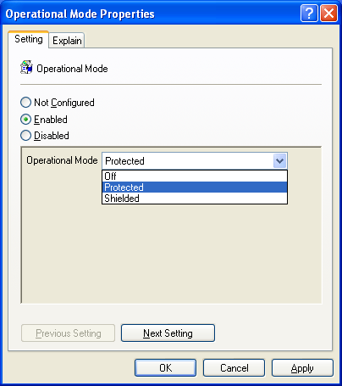
You can select the following:
- Not Configured (default)
No change to the status of ICF is made. Users may enable or disable ICF from the Internet Connection Firewall Control Panel applet.
- Enabled
ICF is enabled in the specified operational mode. The operational modes are:
- Off ICF is disabled and cannot be enabled by users.
- Protected ICF is enabled to allow only solicited and excepted incoming traffic.
- Shielded ICF is enabled to allow only solicited incoming traffic. Settings for excepted traffic are ignored.
- Disabled
Disables ICF.

Allow User Preference/Group Policy Settings Merge
The Allow User Preference/Group Policy Settings Merge setting is used to allow local ICF settings, and is shown in the following figure.
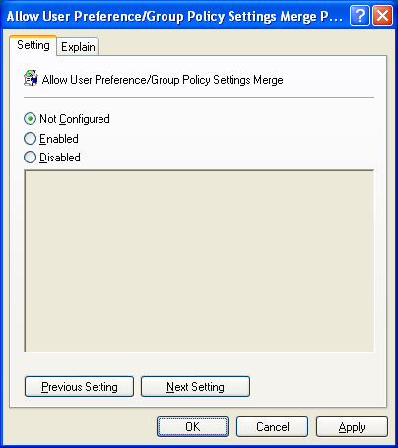
For example, by allowing the merging of Group Policy and local ICF settings, an administrator could specify that some ports be opened and users could still open additional ones. This makes it possible for administrators to define a domain policy (with allowed programs and open ports), but still allow users to add their own excepted traffic.
You can select the following:
- Not Configured (default)
Local ICF configuration is not allowed.
- Enabled
Merging of Group Policy and local settings is allowed.
- Disabled
Local ICF configuration is not allowed.

Define Allowed Programs
The Define Allowed Programs setting allows you to configure excepted traffic by specifying the program's file name, and is shown in the following figure.
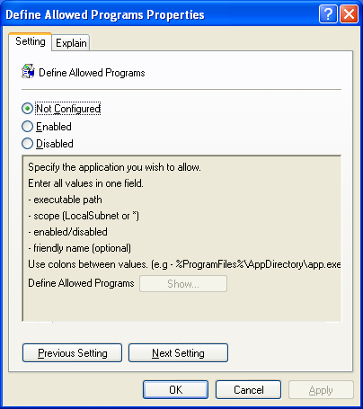
You can select the following:
- Not Configured (default)
No excepted traffic is configured. Users cannot specify allowed programs locally, unless the Allow User Preference/Group Policy Settings Merge setting is set to Enabled.
- Enabled
The configured programs are excepted traffic.
- Disabled
No excepted traffic is configured. Users cannot specify allowed programs locally, unless the Allow User Preference/Group Policy Settings Merge setting is set to Enabled.
To define the list of allowed programs, click Enabled, and then click Show. The Show Contents dialog box is displayed. An example is shown in the following figure.
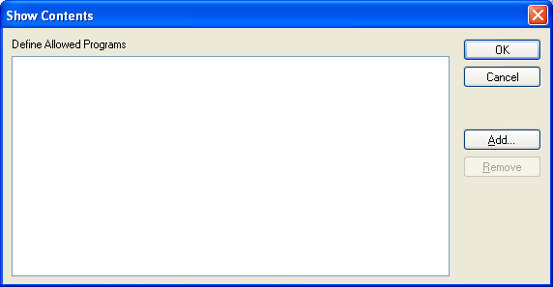
From Show Contents, you can add or remove an allowed program. You cannot edit an existing allowed program. To change an existing allowed program, remove it, and then add with the correct parameters.
To add a new allowed program, click Add. An example is shown in the following figure.
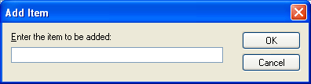
In Add Item, type the parameters for an allowed program using the following syntax:
ProgramPath:*|LocalSubnet:Enabled|Disabled:ApplicationName
- ProgramPath
Type the path and file name of the application as it is installed on the Windows XP SP2 computers. You can use variables such as %ProgramFiles% when specifying the program path.
- *|LocalSubnet
Type * to specify traffic originating from any source IP address. Type LocalSubnet to specify traffic originating from only the locally attached subnet.
- Enabled|Disabled
Type Enabled to allow incoming unsolicited traffic to this application. Type Disabled to allow the item to appear in the allowed programs list, but it will not be active (incoming unsolicited traffic is not allowed). Typing Disabled does not prevent additional entries for the same application that would enable it. Additionally a user could still add the program even if the administrator had added it using the disabled option, provided the Allow User Preference/Group Policy Settings Merge setting is set to Enabled.
- ApplicationName
Type a friendly name for the program. This becomes the name of the program in the list of allowed programs in the ICF settings of the Windows XP SP2 computers.
The following is an example of an allowed program entry:
%ProgramFiles%\ExampleAppFolder\Example.exe:*:Enabled:Example Program
Note You can add the same application multiple times to the Allowed Programs list. An entry to enable a program takes precedence over an entry to disable it.

Allow Dynamically Assigned Ports for RPC and DCOM
The Allow Dynamically Assigned Ports for RPC and DCOM setting allows you to specify whether listening ports are opened for RPC and DCOM traffic, and is shown in the following figure.
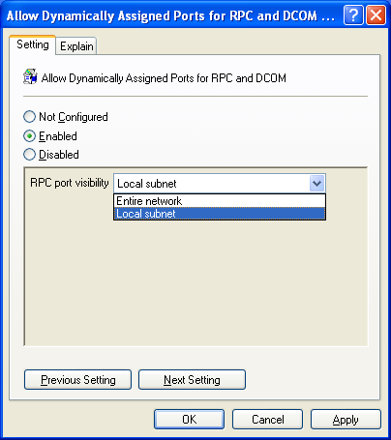
Examples of the services that rely on RPC and DCOM listening ports include the following:
- WMI
- Group Policy Resultant Set of Policy
You can select the following:
- Not Configured (default)
Listening ports for RPC and DCOM are not allowed. Users cannot enable RPC and DCOM port listening unless the Allow User Preference/Group Policy Settings Merge setting is set to Enabled and the service uses static ports.
- Enabled
Listening ports for RPC and DCOM are allowed. When you select Enabled, you must also specify whether the ports are opened for all source IP addresses (Entire network) or only those that match the local subnet.
- Disabled
Listening ports for RPC and DCOM are not allowed. Users cannot enable RPC and DCOM port listening unless the Allow User Preference/Group Policy Settings Merge setting is set to Enabled.
Note Since RPC and DCOM ports have become one of the most popular targets for network attacks, it is recommended you select this option only if it is absolutely necessary to run critical applications. Read the application documentation and latest Microsoft Knowledge Base articles for the service you wish to run for the best security recommendations. In some cases, it might be possible to manually open a smaller subset of ports to meet your needs, and decrease the vulnerability enabled by this option.

Allow File and Print Sharing
The Allow File and Print Sharing setting specifies whether the ports for file and printer sharing are open, and is shown in the following figure.
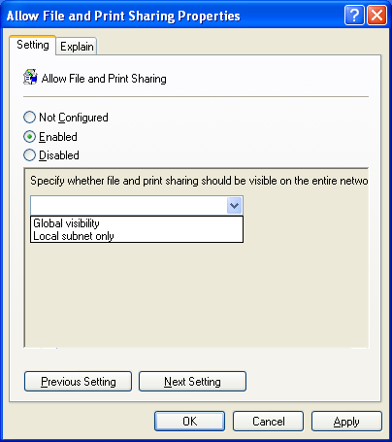
You can select the following:
- Not Configured (default)
The ports for file and printer sharing are not opened. Users cannot open the ports for file and printer sharing locally, unless the Allow User Preference/Group Policy Settings Merge setting is set to Enabled.
- Enabled
The ports for file and printer sharing are opened. The following ports are opened:
- UDP 137
- UDP 138
- TCP 139
- TCP 445
When you select Enabled, you must also specify whether the ports are opened for all source IP addresses (Global visibility) or only those that match the local subnet.
- Disabled
The ports for file and printer sharing are not opened. Users cannot open the ports for file and printer sharing locally, unless the Allow User Preference/Group Policy Settings Merge setting is set to Enabled.

Allow ICMP Settings
The Allow ICMP Settings Setting allows you to configure specific types of ICMP messages as excepted traffic, and is shown in the following figure.
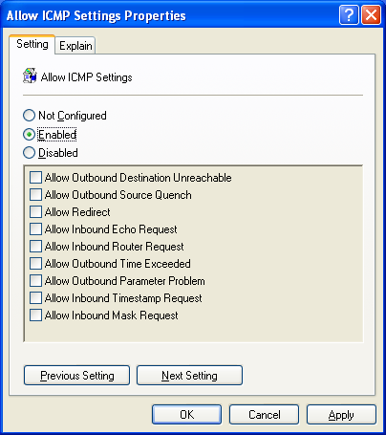
You can select the following:
- Not Configured (default)
No unsolicited incoming ICMP traffic is allowed. Users cannot allow ICMP traffic locally, unless the Allow User Preference/Group Policy Settings Merge setting is set to Enabled.
- Enabled
The specified unsolicited incoming ICMP traffic is allowed. When you select Enabled, you must also specify the specific types of ICMP messages that are allowed.
- Disabled
No unsolicited incoming ICMP traffic is allowed. Users cannot allow ICMP traffic locally, unless the Allow User Preference/Group Policy Settings Merge setting is set to Enabled.

Allow Remote Assistance Support
The Allow Remote Assistance Support setting allows you to specify whether Offer Remote Assistance-based connections are allowed, and is shown in the following figure.
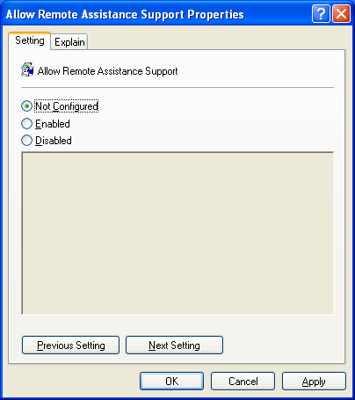
You can select the following:
- Not Configured (default)
Offer Remote Assistance-based connections are not allowed.
- Enabled
Offer Remote Assistance-based connections are allowed. TCP 135 port is opened and the Helpsvc.exe program is added to the list of allowed programs.
For the Windows XP SP2 Beta, if any ICF Group Policy settings are used, then you must do one of the following to fully enable both Solicited (an invitation is sent from the novice computer) and Offer-based Remote Assistance connections:
- Set the Allow User Preference/Group Policy Settings Merge setting to Enabled. This setting allows Remote Assistance to dynamically open all the ports it needs.
- If the Allow User Preference/Group Policy Settings Merge setting is set to Not Configured (the default) or Disabled, then you must set Allow Remote Assistance Support to Enabled and configure the following:
Add the following entry to the Define Custom Open Ports setting:
3389:TCP:*:Enabled:Remote Assistance
Add the following entry to the Define Allowed Programs setting:
%WINDIR%\PCHealth\HelpCtr\Binaries\HelpCtr.exe:*:Enabled:HELPCTR
- Disabled
Offer Remote Assistance-based connections are not allowed.

Allow Universal Plug and Play
The Allow Universal Plug and Play setting specifies whether the ports for UPnP are open, and is shown in the following figure.
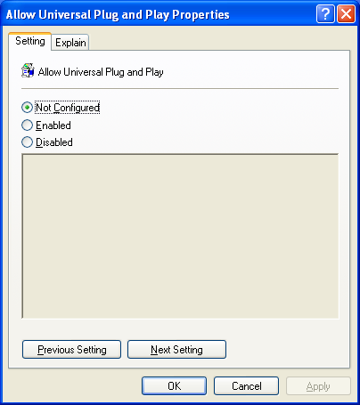
You can select the following:
- Not Configured (default)
The ports for UPnP are not opened. Users cannot open the ports for UPnP locally, unless the Allow User Preference/Group Policy Settings Merge setting is set to Enabled.
- Enabled
The ports for UPnP are opened. The following ports are opened:
- UDP 1900
- TCP 2869
- Disabled
The ports for UPnP are not opened. Users cannot open the ports for UPnP locally, unless the Allow User Preference/Group Policy Settings Merge setting is set to Enabled.

Define Custom Open Ports
The Define Custom Open Ports setting allows you to specify excepted traffic in terms of open TCP and UDP ports, and is shown in the following figure.
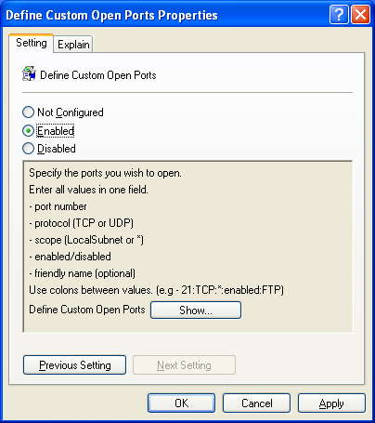
You can select the following:
- Not Configured (default)
No excepted traffic is configured. Users cannot specify open ports locally, unless the Allow User Preference/Group Policy Settings Merge setting is set to Enabled.
- Enabled
The configured ports are excepted traffic.
- Disabled
No excepted traffic is configured. Users cannot specify open ports locally, unless the Allow User Preference/Group Policy Settings Merge setting is set to Enabled.
To define the list of open ports, click Enabled, and then click Show. The Show Contents dialog box is displayed. An example is shown in the following figure.
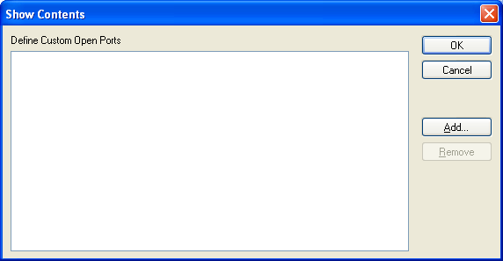
From Show Contents, you can add or remove an open port. You cannot edit an existing open port. To change an open port, remove it, then add with the correct parameters.
To add a new open port, click Add. An example is shown in the following figure.
In Add Item, type the parameters for an open port using the following syntax:
Port#:TCP|UDP:*|LocalSubnet:Enabled|Disabled:PortName
- Port#
Type the port number for the TCP or UDP Port.
- TCP|UDP
Type TCP to specify a TCP port. Type UDP to specify a UDP port.
- *|LocalSubnet
Type * to specify traffic originating from any source IP address. Type LocalSubnet to specify traffic originating from only the locally attached subnet.
- Enabled|Disabled
Type Enabled to allow incoming unsolicited traffic to this port. Type Disabled to allow the item to appear in the ports list, but it will not be active (incoming unsolicited traffic is not allowed). Typing Disabled does not prevent additional entries for the same port that would enable it. Additionally a user could still add the port even if the administrator had added it using the disabled option, provided the Allow User Preference/Group Policy Settings Merge setting is set to Enabled.
- PortName
Type a friendly name for the traffic or program that uses the port. This becomes the name of the port in the list of open ports in the ICF settings of the computers running Windows XP SP2.
The following is an example of an open port entry:
23:TCP:*:Enabled:Telnet
Note You can add the same application multiple times to the Open Ports list. An entry to enable an open port takes precedence over an entry to disable it.

Appendix B: Netsh Command Syntax for the Netsh Firewall Ipv4 Context
The following Netsh commands can be used in scripts or at the command line to configure ICF for TCP/IP traffic when executed from the netsh firewall ipv4 context:
- add allowedprogram
- set allowedprogram
- delete allowedprogram
- set icmpsetting
- set logging
- set opmode
- add portopening
- set portopening
- delete portopening
- set service
- set notifications
- show
The following sections describe each command and its syntax.

add allowedprogram
Used to add excepted traffic by specifying the program's filename.
Syntax:
add allowedprogram

[ program = ] path
[ name = ] name
[ [ mode = ] ENABLE|DISABLE
[ scope = ] ALL|SUBNET
[ profile = ] CURRENT|CORPORATE|OTHER|ALL ]

program - The path and file name.

name - The friendly name.

mode - The operating mode of the excepted traffic for the program.
If no mode is specified, ENABLE is assumed.
ENABLE - Enforced by the firewall.
DISABLE - Not enforced by the firewall.

scope - The scope. If no scope is specified, SUBNET is assumed.
ALL - All traffic will be allowed.
SUBNET - Only local subnet traffic will be allowed.

profile - The profile. If no profile is specified, CURRENT is assumed.
CURRENT - The current profile.
CORPORATE - The corporate profile (also known as the domain profile).
OTHER - The other profile (also known as the mobile profile).
ALL - All profiles.

set allowedprogram
Used to modify the settings of an existing allowed program.
Syntax:
set allowedprogram

[ program = ] path
[ [ name = ] name
[ mode = ] ENABLE|DISABLE
[ scope = ] ALL|SUBNET
[ profile = ] CURRENT|CORPORATE|OTHER|ALL ]

program - The path and file name.

name - The friendly name.

mode - The mode. If no mode is specified, ENABLE is assumed.
ENABLE - Traffic is allowed.
DISABLE – Traffic is dropped.

scope - The scope. If no scope is specified, SUBNET is assumed.
ALL - All traffic will be allowed.
SUBNET - Only local subnet traffic will be allowed.

profile - The profile. If no profile is specified, CURRENT is assumed.
CURRENT - The current profile.
CORPORATE - The corporate profile (also known as the domain profile).
OTHER - The other profile (also known as the mobile profile).
ALL - All profiles.

delete allowedprogram
Used to delete an existing allowed program.
Syntax:
delete allowedprogram

[ program = ] path
[ [ profile = ] CURRENT|CORPORATE|OTHER|ALL ]

program - The path and file name.

profile - The profile. If no profile is specified, CURRENT is assumed.
CURRENT - The current profile.
CORPORATE - The corporate profile (also known as the domain profile).
OTHER - The other profile (also known as the mobile profile).
ALL - All profiles.

set icmpsetting
Used to specify allowed ICMP traffic.
Syntax:
set icmpsetting

[ type = ] 3-5|8|10-13|17|ALL
[ [ mode = ] ENABLE|DISABLE
[ profile = ] CURRENT|CORPORATE|OTHER|ALL
[ interface = ] name ]

type - The type.
3 - Allow outbound destination unreachable.
4 - Allow outbound source quench.
5 - Allow redirect.
8 - Allow incoming echo request.
10 - Allow incoming router request.
11 - Allow outbound time exceeded.
12 - Allow outbound parameter problem.
13 - Allow incoming timestamp request.
17 - Allow incoming mask request.
ALL - All types.

mode - The mode. If no mode is specified, ENABLE is assumed.
ENABLE - Specified ICMP traffic is allowed.
DISABLE - Specified ICMP traffic is dropped.

profile - The profile. If no profile is specified, CURRENT is assumed.
CURRENT - The current profile.
CORPORATE - The corporate profile (also known as the domain profile).
OTHER - The other profile (also known as the mobile profile).
ALL - All profiles.

interface - The friendly name of the interface from Network Connections.

NOTE: The profile and interface parameters may not be used together.

set logging
Used to specify logging options for ICF either globally or for a specific connection (interface).
Syntax:
set logging

[ [ filelocation = ] path
[ maxfilesize = ] 1024-32767
[ droppedpackets = ] ENABLE|DISABLE
[ connections = ] ENABLE|DISABLE ]

filelocation - The path and file name.

maxfilesize - The maximum size in bytes.

droppedpackets – Log dropped packets.
ENABLE – Enable logging of dropped packets.
DISABLE – Disable logging of dropped packets.

connections – Log successful connections.
ENABLE – Enable logging of successful connections.
DISABLE – Disable logging of successful connections.

set opmode
Used to specify the operating mode of ICF either globally or for a specific connection (interface).
Syntax:
set opmode
[ mode = ] DISABLE|ENABLE|SHIELD
[ [ profile = ] CURRENT|CORPORATE|OTHER|ALL
[ interface = ] name ]

mode - The mode.
DISABLE – ICF disabled, all solicited incoming traffic allowed.
ENABLE – ICF enabled, only solicited and excepted incoming traffic allowed.
SHIELD - ICF enabled, only solicited incoming traffic allowed.

profile - The profile. If no profile is specified, CURRENT is assumed.
CURRENT - The current profile.
CORPORATE - The corporate profile (also known as the domain profile).
OTHER - The other profile (also known as the mobile profile).
ALL - All profiles.

interface - The friendly name of the interface from Network Connections.

NOTE: The profile and interface parameters may not be used together. If the
interface parameter is used, SHIELD cannot be used.

add portopening
Used to add excepted traffic by specifying a TCP or UDP port.
Syntax:
add portopening

[ protocol = ] TCP|UDP|ALL
[ port = ] 1-65535
[ name = ] name
[ [ mode = ] ENABLE|DISABLE
[ scope = ] ALL|SUBNET
[ profile = ] CURRENT|CORPORATE|OTHER|ALL
[ interface = ] name ]

protocol - The protocol.
TCP
UDP
ALL - All protocols.

port - The port.

name - The friendly name.

mode - The mode. If no mode is specified, ENABLE is assumed.
ENABLE - The specified traffic is allowed.
DISABLE – The specified traffic is dropped.

scope - The scope. If no scope is specified, SUBNET is assumed.
ALL - All traffic will be allowed.
SUBNET - Only local subnet traffic will be allowed.

profile - The profile. If no profile is specified, CURRENT is assumed.
CURRENT - The current profile.
CORPORATE - The corporate profile (also known as the domain profile).
OTHER - The other profile (also known as the mobile profile).
ALL - All profiles.

interface - The friendly name of the interface from Network Connections.

NOTE: The profile and scope parameters may not be used if specifying the interface
parameter.

set portopening
Used to modify the settings of an existing open TCP or UDP port.
Syntax:
set portopening

[ protocol = ] TCP|UDP|ALL
[ port = ] 1-65535
[ [ name = ] name
[ mode = ] ENABLE|DISABLE
[ scope = ] ALL|SUBNET
[ profile = ] CURRENT|CORPORATE|OTHER|ALL
[ interface = ] name ]

protocol - The protocol.
TCP
UDP
ALL - All protocols.

port - The port.

name - The friendly name.

mode - The mode. If no mode is specified, ENABLE is assumed.
ENABLE - Enforced by the firewall.
DISABLE - Not enforced by the firewall.

scope - The scope. If no scope is specified, SUBNET is assumed.
ALL - All traffic will be allowed.
SUBNET - Only local subnet traffic will be allowed.

profile - The profile. If no profile is specified, CURRENT is assumed.
CURRENT - The current profile.
CORPORATE - The corporate profile (also known as the domain profile).
OTHER - The other profile (also known as the mobile profile).
ALL - All profiles.

interface - The friendly name of the interface from Network Connections.

NOTE: The profile and scope parameters may not be used if specifying the interface
parameter.

delete portopening
Used to delete an existing open TCP or UDP port.
Syntax:
delete portopening

[ protocol = ] TCP|UDP|ALL
[ port = ] 1-65535
[ [ profile = ] CURRENT|CORPORATE|OTHER|ALL
[ interface = ] name ]

protocol - The protocol.
TCP
UDP
ALL - All protocols.

port - The port number.

profile - The profile. If no profile is specified, CURRENT is assumed.
CURRENT - The current profile.
CORPORATE - The corporate profile (also known as the domain profile).
OTHER - The other profile (also known as the mobile profile).
ALL - All profiles.

interface - The friendly name of the interface.

NOTE: The profile parameter may not be used if specifying the interface parameter.

set service
Used to allow or drop RPC and DCOM traffic, file and printer sharing, and UPnP traffic.
Syntax:
set service

[ type = ] FILEANDPRINT|RPCANDDCOM|UPNP|ALL
[ [ mode = ] ENABLE|DISABLE
[ scope = ] ALL|SUBNET
[ profile = ] CURRENT|CORPORATE|OTHER|ALL ]

type - The type.
FILEANDPRINT - File and printer sharing traffic.
RPCANDDCOM - RPC and DCOM traffic.
UPNP - UPnP traffic.
ALL - All types.

mode - The mode. If no mode is specified, ENABLE is assumed.
ENABLE - Specified traffic is allowed.
DISABLE - Specified traffic is dropped.

scope - The scope. If no scope is specified, SUBNET is assumed.
ALL - All traffic will be allowed.
SUBNET - Only local subnet traffic will be allowed.

profile - The profile. If no profile is specified, CURRENT is assumed.
CURRENT - The current profile.
CORPORATE - The corporate profile (also known as the domain profile).
OTHER - The other profile (also known as the mobile profile).
ALL - All profiles.

set notifications
Used to specify whether notifications to the user when applications attempt to open ports are enabled.
Syntax:
set notifications

[ [ mode = ] ENABLE|DISABLE
[ profile = ] CURRENT|CORPORATE|OTHER|ALL ]

Sets the notification mode.

mode - The mode. If no mode is specified, ENABLE is assumed.
ENABLE - Enforced by the firewall.
DISABLE - Not enforced by the firewall.

profile - The profile. If no profile is specified, CURRENT is assumed.
CURRENT - The current profile.
CORPORATE - The corporate profile.
OTHER - The other profile.
ALL - All profiles.

show
The following show commands are used to display the current configuration:
- show allowedprogram Displays the allowed programs.
- show config Displays the local configuration information.
- show currentprofile Displays the current profile.
- show icmpsetting Displays the ICMP settings.
- show logging Displays the logging settings.
- show opmode Displays the operational mode.
- show portopening Displays the excepted ports.
- show service Displays the services.
- show state Displays the current state information.
- show notifications Displays the current settings for notifications.

Appendix C: Netsh Command Syntax for the Netsh Firewall Ipv6 Context
The following Netsh commands can be used in scripts or at the command line to configure IPv6 ICF traffic when executed from the netsh firewall ipv6 context:
- set adapter
- set globalport
- set logging
- show
The following sections describe each command and its syntax.

set adapter
Used to create or modify ICF for allowed ICMP traffic, TCP ports, or UDP ports on specific IPv6 connections.
Syntax:
set adapter

name [icmp type#|all=enable|disable]
[port port#=enable|disable [name=name] [protocol=tcp|udp]]
[ignoreglobalport port#=enable|disable [name=name] [protocol=tcp|udp]]
[filtering=enable|disable]

set globalport
Used to create or modify an allowed port for all IPv6 connections.
Syntax:
set globalport

port#=enable|disable [name=name] [protocol=tcp|udp]

set logging
Used to configure ICF logging options for IPv6 traffic.
Syntax:
set logging

[filelocation=location] [filesize=size]
[droppedpackets=enable|disable]
[successfulconnections=enable|disable]

show
The following show commands are used to display the current configuration:
- show adapter Displays the network connections and whether ICF filtering is enabled.
- show globalport Displays the global port settings.
- show logging Displays the logging settings.

Appendix D: Troubleshooting Tools for ICF in Windows XP SP2
To obtain information when troubleshooting ICF in Windows XP, use the netsh firewall ipv4 show config and netsh firewall ipv4 show state commands.
Example netsh firewall ipv4 show config command:
netsh firewall ipv4>show config

Local profile:
-------------
Profile = CORPORATE
Local policy = DISABLE
Operational mode = ENABLE
Notification mode = ENABLE

Local allowed programs:
Mode Subnet Program / Name
-------------------------------
ENABLE NO %windir%\system32\usmt\migwiz.exe / Files and Settings Transfer
Wizard
ENABLE NO %ProgramFiles%\NetMeeting\conf.exe / NetMeeting
ENABLE NO %ProgramFiles%\Messenger\msmsgs.exe / Windows Messenger

Local profile:
-------------
Profile = OTHER (current)
Local policy = DISABLE
Operational mode = ENABLE
Notification mode = ENABLE

Local allowed programs:
Mode Subnet Program / Name
-------------------------------
ENABLE NO %windir%\system32\usmt\migwiz.exe / Files and Settings Transfer
Wizard
ENABLE NO %ProgramFiles%\NetMeeting\conf.exe / NetMeeting
ENABLE NO %ProgramFiles%\Messenger\msmsgs.exe / Windows Messenger

Local interface:
---------------
Interface = Local Area Connection
Operational mode = ENABLE

Local interface:
---------------
Interface = Local Area Connection 2
Operational mode = ENABLE

Local logging:
-------------
File location = (null)
Max file size = 0 KB
Dropped packets = DISABLE
Connections = DISABLE

Example netsh firewall ipv4 show state command:
netsh firewall ipv4>show state

Effective profile:
-----------------
Profile = OTHER
Operational mode = ENABLE
RPC and DCOM = DISABLE
Notifications = ENABLE

Effective allowed programs:
Local policy Subnet Program / Full path / Name
------------------------------------------------
YES NO %ProgramFiles%\Messenger\msmsgs.exe / G:\Program Files\Mes
senger\msmsgs.exe / Windows Messenger
YES NO %ProgramFiles%\NetMeeting\conf.exe / G:\Program Files\NetM
eeting\conf.exe / NetMeeting
YES NO %windir%\system32\usmt\migwiz.exe / G:\XP_PRO\system32\usm
t\migwiz.exe / Files and Settings Transfer Wizard

Effective ICMP settings:
Mode Number Description
----------------------------
DISABLE 3 Allow outbound destination unreachable
DISABLE 4 Allow outbound source quench
DISABLE 5 Allow redirect
DISABLE 8 Allow inbound echo request
DISABLE 10 Allow inbound router request
DISABLE 11 Allow outbound time exceeded
DISABLE 12 Allow outbound parameter problem
DISABLE 13 Allow inbound timestamp request
DISABLE 17 Allow inbound mask request

Effective dynamic port openings:
Port Protocol Net protocol Subnet Process Type Program
--------------------------------------------------------------
1900 UDP IPV4 NO 1076 APP G:\XP_PRO\system32\svchos
t.exe ((null))

Summary
This article describes the changes being made to ICF in Windows XP SP2. Because ICF is being enabled by default on all connections, communications can be impaired if the Windows XP SP2 computer is managed, acting as a server, acting as a listener, or acting as a peer. This article described how to deploy ICF settings in an organization intranet for computers running Windows XP SP2 using the new Computer Configuration Group Policy settings, using the Unattend.txt file, a Netsh script, or a custom configuration program.

Related Links
See the following resources for further information:
- Windows XP Service Pack 2: A Developer's View at http://msdn.microsoft.com/security/default.aspx?pull=/library/en-us/dnwxp/html/securityinxpsp2.asp
- The Inside Scoop on Windows XP at http://www.microsoft.com/technet/treeview/default.asp?url=/technet/prodtechnol/winxppro/default.asp

For the latest information about Windows XP, see the Windows XP Web site at http://www.microsoft.com/windowsxp.

