
Microsoft® Exchange Server Compatibility with Microsoft Windows Server Operating Systems
White Paper
Published: April 2003
Contents
Introduction 1
Changes in Windows Server 2003 that Affect Exchange 1
Supported Combinations of Exchange and Windows Servers 2
Exchange Server 5.5 2
Exchange 2000 2
Exchange 2003 3
Upgrading to Exchange 2003 and Windows Server 2003 3
Additional Resources 4

Microsoft Exchange Server Compatibility with Microsoft Windows Server
Operating Systems
White Paper

Published: April 2003
For the latest information, please see http://www.microsoft.com/exchange/

Introduction
Microsoft® Exchange Server 2003, the next version of the Exchange messaging and e-mail-based collaboration server, is specifically designed to help address business requirements for heightened security in today’s computing environments. In accordance with the Microsoft company-wide Trustworthy Computing initiative, Exchange 2003 running on Microsoft Windows Server™ 2003 provides many new features and enhancements to improve reliability, manageability, and security.
When designing new product releases, Microsoft balances new features and functionality with providing our customers the highest possible level of interoperability and/or coexistence with previous product versions. Microsoft does its best to ensure that customers can extend current infrastructure investments, yet have the opportunity to incorporate new technologies into their existing computing environments. This document provides an overview of Windows Server 2003 compatibility with Exchange 2003, Exchange 2000 Server, and Exchange Server 5.5 in addition to supported configurations in a mixed-mode Exchange and Windows environment.

Changes in Windows Server 2003 that Affect Exchange
Both Exchange 2000 and Exchange 2003 rely heavily on Internet Information Services (IIS) in the Windows Server operating system for all Internet-based protocol services. For Windows Server 2003, IIS was extensively reengineered in accordance with industry best practices for increased system security. IIS in Windows Server 2003 now has two different modes: IIS 6.0 mode and IIS 5.0 compatibility mode. Improvements in IIS 6.0 include new fault tolerance that isolates applications in their own memory space and better protection against spam by disabling Internet Server Applications Programming Interfaces (ISAPI) by default. Additionally, IIS is not installed by default when running setup for Windows Server 2003; it is “locked down” to maximum security when selected for first installation on a server. These architectural design changes to IIS fundamentally change how Exchange and other applications utilize IIS in Windows Server 2003.
With approximately 350 code changes in Windows Server 2003 that affected Exchange, Microsoft determined that it would better benefit our customers to focus development efforts on Exchange 2003 to take full advantage of the new improvements in IIS 6.0, rather then on updating either version of Exchange to run on Windows Server 2003 in IIS 5.0 compatibility mode or Exchange 2000 to work with the new architecture in IIS 6.0. As a result, Exchange 2000 needs to be physically installed on a server running Windows 2000 with Service Pack (SP) 3 to coexist in a Windows Server 2003 environment. Exchange 2003 is fully supported on both Windows 2000 Server and Windows Server 2003 running IIS 6.0.

Supported Combinations of Exchange and Windows Servers
Just as Microsoft Windows NT® Server and Windows 2000 Server were designed to coexist in the same environment, Exchange 2003 is also designed to coexist with Exchange 2000 or Exchange 5.5. Table 1 shows various supported configurations of Exchange 5.5, Exchange 2000, and Exchange 2003 with Windows 2000 and Windows Server 2003.
Note The physical server running Exchange must be installed on a supported version of the Windows Server operating system. For example, Exchange 2000 with SP2 should not be installed or run on a physical server running Windows Server 2003.
Table 1 Supported combinations of Exchange and Windows Servers
Supported configurations | Windows Server operating system |  | Active Directory environment
Exchange Version | Windows 2000 + SP3 | Windows Server 2003 | Windows 2000 + SP3 | Windows Server 2003
Exchange 5.5 + SP3 | Yes | No | Not applicable | Not applicable
Exchange 2000 + SP2 | Yes | No | Yes | Yes
Exchange 2000 + SP3 | Yes | No | Yes | Yes
Exchange 2003 | Yes | Yes | Yes | Yes

Exchange Server 5.5
Microsoft Exchange Server 5.5 can be installed on either Windows NT Server 4.0 or Windows 2000 Server operating systems; however, Exchange 5.5 does not use Microsoft Active Directory® directory service. Exchange 5.5 uses its own directory and, when running on Windows 2000, it can coexist in a mixed Windows 2000 Server and Windows Server 2003 environment.

Exchange 2000
Exchange 2000 should be installed on a server that is running Windows 2000 Server. Exchange 2000 should not be installed on Windows Server 2003 because the HTTP services will not function correctly when running on either IIS 6.0 or IIS 5.0 compatibility mode. However, Exchange 2000 with SP3 or later can operate in a Windows Server 2003 Active Directory environment. In this mixed-mode configuration, Exchange 2000 benefits from the new enhancements in Windows Server 2003, such as using the global catalogs in Windows Server 2003.

Exchange 2003
Exchange 2003 runs on either Windows 2000 with SP3 or Windows Server 2003 operating systems as well as within either Active Directory environment. Additionally, when upgrading an Exchange 2003 server from Windows 2000 to Windows Server 2003, Exchange 2003 automatically sets Windows Server 2003 to IIS 6.0 mode. If Windows Server 2003 is manually set to IIS 5.0 compatibility mode, Exchange 2003 automatically updates the setting to IIS 6.0 mode one time and shows an error message if Windows Server 2003 is again manually returned to IIS 5.0 compatibility mode. Exchange 2003 requires that Windows Server 2003 be set to IIS 6.0 mode for all HTTP services to function properly.

Upgrading to Exchange 2003 and Windows Server 2003
Customers who intend to upgrade from either Exchange 5.5 or Exchange 2000 to Exchange 2003 can rest assured that their messaging infrastructure will not be disrupted during the upgrade. Based on the approved configurations shown in Table 1, Microsoft fully supports coexistence in a mixed-mode Exchange and Windows environment. Additionally, Figure 1 illustrates potential options of supported combinations with Exchange and Windows servers within a mixed-mode environment.
Although Exchange 5.5 and Exchange 2000 should not be installed on servers running Windows Server 2003, Windows 2000 file and print servers, domain controllers, and global catalog servers can all be upgraded to Windows Server 2003 with no impact on Exchange.
Note If upgrading from Exchange 2000 to Exchange 2003, a physical server running Exchange 2000 should be upgraded to Exchange 2003 before upgrading the operating system to Windows Server 2003. This is the approved upgrade path supported by Microsoft.
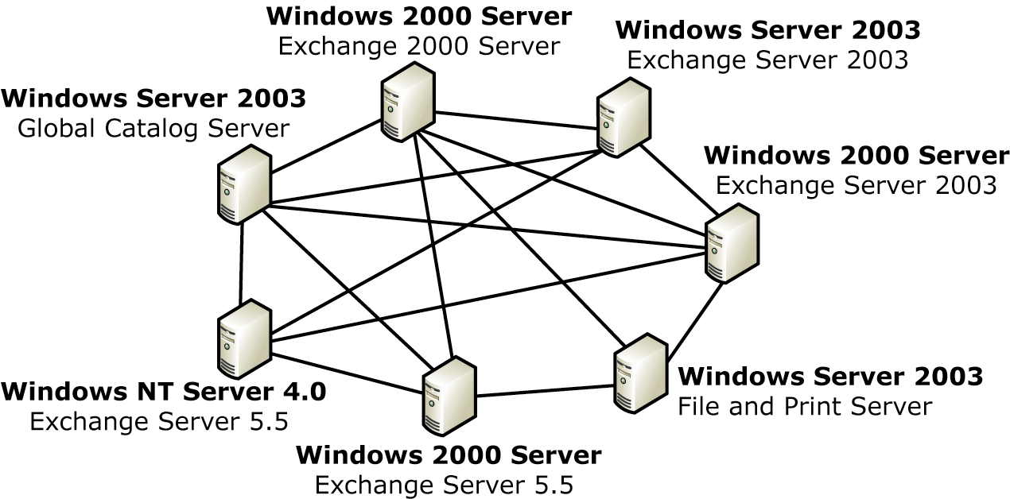
Figure 1 Example of a mixed-mode Exchange and Windows Server environment

Additional Resources
For more information about Windows Server 2003 Internet Information Services, visit http://www.microsoft.com/windowsserver2003/default.mspx or read the What’s New in Internet Information Services 6.0 white paper, http://www.microsoft.com/windowsserver2003/evalution/overview/technologies/iis.mspx
For more information about security and privacy, read the Building a Platform for Trustworthy Computing white paper at http://www.microsoft.com/security
For more information on the Microsoft Trustworthy Computing initiative, read http://www.microsoft.com/security/whitepapers/secure_platform.asp
For more information about Exchange 2000 configuration and security recommendations, visit
http://www.microsoft.com/exchange/techinfo/deployment/2000/BestConfig.asp
For more information about Exchange 5.5 configuration and security recommendations, visit http://www.microsoft.com/exchange/techinfo/deployment/55/bestconfig.asp

Did this paper help you? Please give us your feedback. On a scale of 1 (poor) to 5 (excellent), how would you rate this paper?
mailto:mailto:exchdocs@microsoft.com?subject=Feedback: Exchange Server Compatibility with Windows Server Operating Systems


This is a preliminary document and may be changed substantially prior to final commercial release of the software described herein.
The information contained in this document represents the current view of Microsoft Corporation on the issues discussed as of the date of publication. Because Microsoft must respond to changing market conditions, it should not be interpreted to be a commitment on the part of Microsoft, and Microsoft cannot guarantee the accuracy of any information presented after the date of publication.
This White Paper is for informational purposes only. MICROSOFT MAKES NO WARRANTIES, EXPRESS, IMPLIED OR STATUTORY, AS TO THE INFORMATION IN THIS DOCUMENT.
Complying with all applicable copyright laws is the responsibility of the user. Without limiting the rights under copyright, no part of this document may be reproduced, stored in or introduced into a retrieval system, or transmitted in any form or by any means (electronic, mechanical, photocopying, recording, or otherwise), or for any purpose, without the express written permission of Microsoft Corporation.
Microsoft may have patents, patent applications, trademarks, copyrights, or other intellectual property rights covering subject matter in this document. Except as expressly provided in any written license agreement from Microsoft, the furnishing of this document does not give you any license to these patents, trademarks, copyrights, or other intellectual property.
© 2003 Microsoft Corporation. All rights reserved.
Microsoft, Active Directory, Windows, Windows NT, and Windows Server are either registered trademarks or trademarks of Microsoft Corporation in the United States and/or other countries.
The names of actual companies and products mentioned herein may be the trademarks of their respective owners.

