Enabling a Superior Client Experience with Outlook 2003

Published: September 2003

Abstract: Outlook 2003 introduces a number of new features that enable improved information worker productivity over a variety of networks. When using Outlook 2003 as an email client on Exchange Server-based systems, the negative impact of transient issues like high latency, loss of connectivity, and limited bandwidth are significantly reduced. This paper describes the new features and capabilities that make this possible.
Table of Contents
Key Concepts and Definitions 1
Executive Overview 1
Introduction 1
Messaging Technology Overview 2
Connection Speed, Latency and Reliability 3
Client Connection Types 4
Outlook 2003 Technology Overview 4
Cached Exchange Mode 7
Cached Exchange Mode Technical Overview 8
Using Cached Exchange Mode 9
Key Cached Exchange Mode Performance Considerations 13
What to Avoid When Using Cached Exchange Mode 16
Cached Exchange Mode Deployment 19
Automatic Conflict Resolution 20
Conflict Resolution in Action 20
RPC over HTTP 22
MAPI Compression 22
Buffer Packing 23
Recommended Settings Based on User Type 24
Exceptions 26
Conclusion 26
Frequently Asked Questions 27
Find Additional Information 27

The information contained in this document represents the current view of Microsoft Corporation on the issues discussed as of the date of publication. Because Microsoft must respond to changing market conditions, it should not be interpreted to be a commitment on the part of Microsoft, and Microsoft cannot guarantee the accuracy of any information presented after the date of publication.

This White Paper is for informational purposes only. MICROSOFT MAKES NO WARRANTIES, EXPRESS, IMPLIED OR STATUTORY, AS TO THE INFORMATION IN THIS DOCUMENT.

Complying with all applicable copyright laws is the responsibility of the user. Without limiting the rights under copyright, no part of this document may be reproduced, stored in or introduced into a retrieval system, or transmitted in any form or by any means (electronic, mechanical, photocopying, recording, or otherwise), or for any purpose, without the express written permission of Microsoft Corporation.

Microsoft may have patents, patent applications, trademarks, copyrights, or other intellectual property rights covering subject matter in this document. Except as expressly provided in any written license agreement from Microsoft, the furnishing of this document does not give you any license to these patents, trademarks, copyrights, or other intellectual property.

© 2003 Microsoft Corporation. All rights reserved.

Microsoft, the Office logo, Outlook, and Windows are either registered trademarks or trademarks of Microsoft Corporation in the United States and/or other countries.

The names of actual companies and products mentioned herein may be the trademarks of their respective owners.

Microsoft Corporation One Microsoft Way, Redmond, WA 98052-6399 USA

Enabling a Superior Client Experience with Outlook 2003
Technical White Paper

Published:
For the latest information, please see http://www.microsoft.com/Office/

Key Concepts and Definitions
Cached Exchange mode – Cached Exchange mode combines Offline mode’s ability to shield information workers from transient network issues with Online mode’s rich feature set to deliver a consistently superior experience. In Cached Exchange mode, Microsoft® Office Outlook 2003 works from a local copy of an information worker’s Microsoft Exchange Server mailbox stored locally in an Offline Folder file (OST file), along with the Offline Address Book (OAB). The cached mailbox and OAB are updated frequently from the Exchange server and are available even when disconnected.
RPC over HTTP – With Outlook 2003, information workers can now connect to Exchange over the internet without using a virtual private network. Outlook clients use remote procedure calls (RPC) to communicate with the Exchange server. Previously, this communication needed to take place over TCP/IP, but it is now supported over HTTP.

Executive Overview
Outlook 2003 introduces a number of new features that enable improved information worker productivity over a variety of networks. When using Outlook 2003 as an email client on Exchange Server-based systems, the negative impact of transient issues like high latency, loss of connectivity, and limited bandwidth is significantly reduced. This paper describes the new features and capabilities that make this possible. Most of the improvements are relevant to Microsoft Exchange 5.5, Microsoft Exchange 2000, and Microsoft Exchange 2003, though some are exclusive to Exchange 2003.
In the context of these new capabilities, the latter section of this paper provides usage and optimization information for each of the key features of Outlook 2003. Finally, the paper concludes by offering specific recommendations for achieving the best client experience in a given usage situation.

Introduction
Whether at the office, at home, a hotel, or in a taxi, information workers have a number of access methods at their disposal: broadband, dialup, and cellular, to name a few. As a result, they expect to be able to access their email anytime, anywhere.
Users of previous versions of Outlook had an array of options for achieving the best email access experience based upon such factors as the connection to the server and usage habits. The core decision for these users was whether to use Online mode or Offline mode. They used Online mode when possible in order to get full access to all email, calendar and free/busy information, to create rules, and so on. When they were offline or had a slow connection to the server, they would use sophisticated combinations of various capabilities in Offline mode to try to achieve a seamless experience.
While Microsoft Outlook 2000 and, especially, Microsoft Outlook 2002 went a long way to make it possible for information workers to access the rich set of Outlook functionality no matter where they were, Outlook 2003 goes much farther. Outlook 2003 brings substantial improvements to many existing features, and it also brings some key new features.
The driving vision behind the improvements to Outlook 2003 was to provide a messaging client that would “just work”, regardless of the quality, speed, and reliability of its connection to the Exchange server. For example, Outlook 2003 makes deciding between Online mode and Offline mode a thing of the past. Instead, information workers will be able to use a new connection feature called Cached Exchange mode, which provides a superior experience whether they are connected all the time or not. Cached Exchange mode shields information workers from transient issues such as latency and temporary losses of connectivity. It also serves as the foundation for enabling information workers to “walk around with Outlook:” that is, they will be able to seamlessly transition between connected and non-connected states, having full access to functionality while not connected. They will also be able to seamlessly change power states (between on and hibernate or standby) without shutting down Outlook 2003.
The key technologies that combine to provide a superior client experience in Outlook 2003 are:
- Cached Exchange Mode
- Network Speed Awareness
- Improved Synchronization Efficiency and Robustness
- Automatic Conflict Resolution
- RPC over HTTP for Direct Outlook to Exchange Server Connection over the Internet
- PST/OST Enhancements
The remainder of this paper discusses these technologies, describes their use, and offers specific tuning recommendations for how to best apply these technologies in different connection scenarios.

Messaging Technology Overview
Before discussing specific improvements to the information worker’s experience of Outlook, it is important to understand what kinds of things are always in need of improvement in any messaging system. The best way to understand that is to understand how Outlook 2003 communicates with Exchange Server.
Outlook 2003 communicates with Microsoft Exchange Server via remote procedure calls (RPC). Outlook retrieves data differently depending on whether the Outlook client is able to connect to the Exchange server. The basic types of communication are as follows:
- Data Requests: Outlook requests data from the mailbox in order to display it for the information worker or to complete an action:
- Sending email messages
- Switching folders
- Displaying individual items such as messages, contacts, or appointments
- Displaying reminders
- Using the address book for name resolution
- Scheduling meetings with others
- Synchronization: synchronizing the information on the local computer with the Server:
- Sending email messages
- Receiving email messages
- Downloading the address book
- Processing rules
All of the issues of performance and, indeed, all the technologies described below that have been designed to improve performance, have to do in some way with managing or facilitating data requests and synchronization. In this context, the next sections describe the key environmental variables for using Outlook 2003.

Connection Speed, Latency and Reliability
Before introducing the different server connection scenarios, it is important to make the distinction among connection speed, latency, and reliability. When people think about their connection to the server and performance, they usually think only in terms of connection speed. But connection speed is only part of the performance equation. Latency and reliability are the other major factors.
Latency is the amount of time it takes for a request to a server to return to the client (including the processing time). An information worker could have a reasonably good connection, such as DSL or a cable modem, but be so far away geographically that latency becomes a performance issue. Factors that affect latency include the distance to the server, the number of routers in between, the time it takes to process a request on the server (which includes factors such as the capacity and load on the server), and the network load. The influence that latency has can be reduced by reducing the number of requests made to the server.
The reliability of a client’s connection to the Exchange server can have just as much impact on performance as the speed or latency. If a connection is interrupted while sending an email, this impacts performance. Taken together, connection speed, latency, and reliability are the Network Characteristics of any given connection scenario.

Client Connection Types
Cached Exchange mode, Network Speed Awareness, and other features combine to reduce the impact that the client connection type has on the Outlook 2003 client experience. Whether an information worker connects over the LAN, over dialup, or over DSL, the basic experience of smooth, seamless access will be the same.
However, we still pay attention to connection types because they impact the amount and reliability of data traveling over the wire in a given period of time. That is, an information worker using Cached Exchange mode over a dialup connection will be able to create messages, look up free/busy information, etc., even if the connection is dropped, but, of course, the connection speed and reliability still determine such things as how long it will take to perform the initial synchronization, how long it will take to send email, and so on. Once these factors are known, an information worker can improve performance in a number of ways. For example, to speed the initial synchronization, the information worker can specify that Outlook only copy message headers to the local OST.
Another reason it is important to understand how the client connects is that there are also some instances where Online mode still makes sense (these are described in the “Exceptions” section below), and this will be affected by connection type.
The following are the key client connection types:
- Network (LAN/WAN) – LAN connections are generally high speed, high quality, and low latency. WAN connections vary in speed and latency but are usually high quality.
- DSL, ISDN, or Cable Modem – These are all much better connections than traditional dial-up. Latency can still be a factor, particularly if the information workers are geographically far from the email servers.
- Modem – This is generally the slowest connection method, and frequently, the telephone line is dual use—not dedicated to a network connection.

Outlook 2003 Technology Overview
Outlook 2003 introduces a number of new technologies and improvements to existing technologies, including:
- Cached Exchange mode – Introduced above, Cached Exchange mode combines Offline mode’s ability to shield information workers from transient network issues with Online mode’s rich feature set to deliver a consistently superior experience. In Cached Exchange mode, Outlook works from a local copy of an information worker’s Exchange mailbox stored in an Offline Folder file (OST file) on the information worker’s computer, along with the Offline Address Book (OAB). The cached mailbox and OAB are updated periodically from the Exchange server.
By caching the information worker’s mailbox and the OAB locally, Outlook no longer depends on on-going network connectivity for access to user information. Whenever possible, Outlook 2003 will synchronize the offline copy of the mailbox with the server, so, even when they disconnect from the network (or temporarily lose connectivity), information workers do not have to do anything to ensure they have the most recent data. Furthermore, they do not lose any functionality – they can create mail, access free/busy information, look up names in the address book, and so on. Whey they reconnect, Outlook seamlessly (and without intervention) synchronizes.
In addition to improving the information worker’s experience by using local copies of mailboxes, Cached Exchange mode determines network speed to optimize the type and amount of data sent. For example, if On Slow Connections Download Only Headers is configured, Outlook will automatically change the type and amount of data sent over the connection when it determines that the connection speed is lower than 128KB.
- Remote Procedure Call (RPC) over HTTP – When used with Exchange Server 2003, Outlook 2003 can now connect to the Exchange Server from any internet-capable connection without the inconvenience and overhead associated with using a virtual private network (VPN). Such inconveniences include the necessity of initiating the connection and the problem of dropped connections while working within Outlook.
When using RPC over HTTP, Outlook 2003 wraps an HTTP/HTTPS header around each MAPI RPC request. This gives Outlook the capability of communicating to the server using direct HTTP or HTTPS. Utilizing the correct configuration, this allows a rich client experience to a corporate mailbox server over an insecure network such as the Internet.
- Synchronization Improvements – Synchronization between Outlook and Exchange is more efficient and robust with Outlook 2003. This is especially true when working with Exchange Server 2003. For example, Microsoft has reduced the number of change notifications when the client is working in Cached Exchange mode. This efficiency results in cost savings on pay-by-the-byte networks and generally reduces the amount of time required to complete any synchronization. Key improvements include the following:
  - Smart Change Synchronization – Outlook performs synchronization at the item level (for example, an individual email message). Therefore, if changes occur to a message object or any part of the headers, the entire item has to be re-synchronized. In versions prior to Outlook 2003, this meant that any change would trigger a synchronization of the whole item. For example, if a mobile user synchronizes a large message to a local OST file and then replies to it, the large message would have to be re-synchronized with the server even though only a portion of the header was changed.
Outlook 2003 treats reply/forward header information and message flags as special attributes. When these change, a synchronization of the entire object does not re-occur.
  - Incremental Change Synchronization (ICS) Check-pointing – When Outlook 2003 is used to synchronize data against an Exchange 2003 server, an advanced Incremental Change Synchronization (ICS) check-pointing algorithm is used. This ensures that data does not need to be re-sent if network connectivity is lost during synchronization. Rather, Outlook 2003 will pick up where it left off and continue the synchronization.
  - Skip Bad Items – During fast transfer synchronization, Outlook 2003 will skip and log any bad or malformed items that it finds on the server. In previous releases of Outlook, such items would cause the synchronization process to fail.
  - Pre-Synchronization Reporting – Outlook 2003 determines the number and size of items to be synchronized and presents a visual notification to information workers on the exact progress of synchronization.
- MAPI Compression – Outlook 2003 and Exchange Server 2003 communications are much faster than previous versions due to MAPI compression. The compression affects the entire message body, including attachments. For example, Microsoft Word documents compress very well through this new MAPI compression mechanism.
- Buffer Packing – When Outlook 2003 and Exchange Server 2003 are used together, buffer packing provides additional efficiency to client and server communications. There is a close relationship between buffer sizes and compression as the Outlook client can request a data buffer of 32Kb. However, once the server has compressed the data, it may be significantly smaller on the wire. Therefore, to accommodate varying compression rates but keep buffer sizes large, Exchange 2003 includes support for ‘buffer packing’. This allows the server to keep adding compressed data to the buffer until the buffer is full.
- Automatic Conflict Resolution – Outlook 2003 detects and prevents conflicts that occur when multiple clients independently modify the same data. Sometimes such a conflict is spurious, such as when an information worker dismisses a meeting reminder from OWA, but Snoozes the reminder in Outlook while not connected to the network (once Outlook connects and synchronizes, the item will be in conflict). Outlook 2003 automatically resolves these conflicts.
Outlook also auto-resolves real conflicts without user intervention and without any data loss. An example of a real conflict is when an information worker modifies the content of a Task both from OWA and from Outlook when not connected; when Outlook connects to the server and synchronizes, it will recognize the conflict and resolve it.
- PST and OST Enhancements – Outlook 2003 provides support for Unicode PSTs and OSTs. Also, the size limitation of a PST or OST file has been increased to 20 GB.
- Improved Send/Receive Groups – Introduced in Outlook 2002, Send/Receive groups allow information workers to selectively send and receive email for greater flexibility and better performance. For example, with Outlook 2002, an information worker using a slow GPRS connection might use Offline mode and Send/Receive groups to synchronize only messages smaller than 20KB and only in the Inbox.
Send/Receive groups are not needed when using Cached Exchange mode. For certain usage scenarios where Cached Exchange mode is not the best performance solution, information workers can take advantage of improved Send/Receive groups. For example, the configuration dialog is more usable and now provides some additional options when used against Exchange Server 2003: information workers can specify that only message headers get synchronized, or they can specify Full Item caching with conditions on exchange folders.
Table 1 provides a quick list of these features and shows which Exchange Server version is required.
Table 1: Key Outlook 2003 features for improved client experience
Outlook 2003 Feature | Exchange 5.5 | Exchange 2000 | Exchange 2003
Cached Exchange mode | X | X | X
RPC/HTTP |  |  | X
Smart Change Synchronization | X | X | X
ICS Check-pointing |  |  | X
Skip Bad Items |  |  | X
Pre-Synchronization Reporting |  |  | X
MAPI Compression |  |  | X
Buffer Packing |  |  | X
Automatic Conflict Resolution | ? | ? | X
PST/OST Enhancements | ? | X | X
Send/Receive Groups Improvements | ? | ? | X

Cached Exchange Mode
For nearly all connection scenarios (exceptions are described later in this document), Cached Exchange mode is the recommended connection mode, as opposed to Online mode. Cached Exchange mode offers information workers the following direct benefits:
- Once messages have been cached locally, no further server interactions are required. This results in much faster access of messages and attachments
- No loss of traditional functionality such as new mail notifications, full GAL details, free/busy lookup, public folder access and delegate support
- Intelligent use of bandwidth by synchronizing only headers on slow connections (< 128KB)
- Smoothly handles power state transitions (hibernate and standby)
Cached Exchange mode offers administrators the following direct benefits:
- Reduced server load – Once messages have been cached locally, re-opening of the same message does not involve any server transactions.
- Reduced network load – Once messages have been pulled over the network once, the subsequent access of those messages will not incur further network traffic
Cached Exchange mode works on Exchange Server 5.5, 2000, and Exchange Server 2003. When used with Exchange Server 2003, Cached Exchange mode provides the advanced option to cache full items or to cache message headers only. This allows those in limited bandwidth or high latency situations to quickly synchronize their mailboxes, review their mail, then selectively retrieve full content for the messages they want.

Cached Exchange Mode Technical Overview
The default mode of working in Outlook 2003 is Cached Exchange mode. When an information worker starts up the client, Outlook 2003 will register its presence with the Exchange server in the normal way. Then, as shown in figure 1, Outlook automatically maintains a local copy of the information worker’s data, using an OST file.
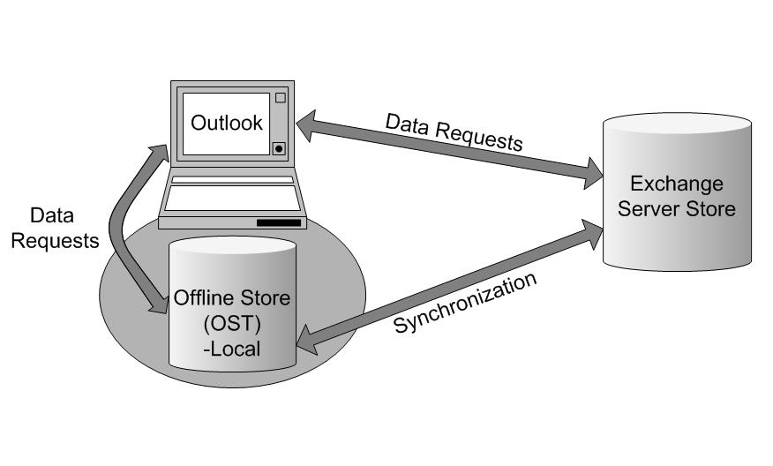
Figure 1: Cached Exchange mode
The information worker actually interacts with this local data for most common operations. In this way, loss of connectivity does not have as much negative impact on the client experience. When data that is not generally replicated locally is needed, Outlook 2003 will work directly against the Exchange server to complete that operation.

Network Speed Awareness
Outlook 2003 detects the state and speed of its connection to the server and responds accordingly, giving it the ability to be more responsive over low-speed or unreliable network connections, or when an information worker is moving from one wireless network connection to another. This enables Outlook 2003 to remain usable, and when combined with the Cached Exchange mode, actually hides network reliability issues (periodic loss of connection, for example) from information workers almost entirely.
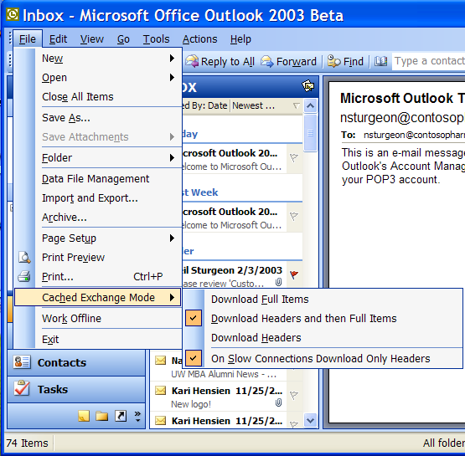
In the default configuration shown in figure 2, Outlook 2003 will optimize all of this based on the connection speed. As shown, there are three possible connection modes within Cached Exchange mode, with one extra option:
Figure 2: Download options
The default option to Download Headers and then Full Items, combined with the option to On Slow Connections Download Only Headers, provides the best client experience when the client connection is not perfect.

Using Cached Exchange Mode
The following sections describe the usage of Outlook 2003 in Cached Exchange mode, explaining events and actions and configuration options along the way.

Configuring Outlook for Cached Exchange Mode
On a new installation of Outlook, Cached Exchange will be enabled by default. On an upgrade, one can enable Cached Exchange by doing the following:

- While using Outlook 2003, choose Tools, Email Accounts…
- Chose View or change existing email accounts, and click Next.
- Make sure Microsoft Exchange Server is the account selected and click the Change button.
- On the dialog shown in figure 3 select Use Cached Exchange. Click Next.

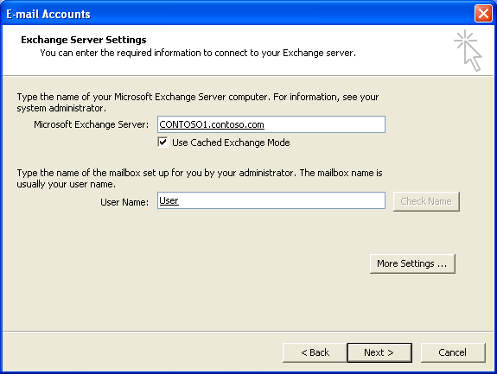
Figure 3: Choosing Cached Exchange mode
- Click Ok and restart Outlook.

Starting in Cached Exchange mode
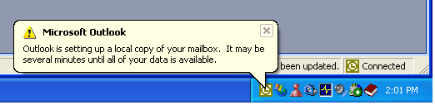
When Outlook starts in Cached Exchange mode for the first time, a balloon will appear from the notifications tray indicating that Outlook is preparing a local copy of the mailbox (see figure 4).
Figure 4: User notification

Synchronizing Data
The time required for the initial synchronization to complete will depend primarily on the size of the mailbox and the speed of the connection to the Exchange server. Since access to all data will not be available until this process is completed, it is recommended that the information worker be on a fast connection when they start Cached Exchange mode for the first time.
Once the initial synchronization is complete, Outlook 2003 will automatically keep the local copy up to date. If a change is made to the data on the server, the server sends a notification to Outlook which causes Outlook 2003 to synchronize the changes. Changes on the server could occur if a new message was received or another client made some change to existing data. If changes are made to the local data, Outlook 2003 will automatically synchronize those changes up to the server. This all happens in real-time and without any user intervention.

Synchronization Timing
To provide the best balance between usability and network efficiency, Microsoft has optimized the timing of synchronization communications between Outlook 2003 and Exchange Server. By default, the following process is in effect whenever the client is in Cached Exchange mode:
- When a change is created by the information worker, a 15-second timer is started.
- If another change occurs within a 15-second window, then the timer is restarted.
- If no other changes occur before the timer expires, then the data is synchronized to the server.
- If changes continue to occur before the timer expires and at least one minute has elapsed, then the changes are synchronized to the server anyway.
When a new mail notification is received, Outlook 2003 will synchronize the folder/s in which the new item or change resides. Unread counts will update, and any rules will be processed.
These timer values may be changed by creating and deploying the following registry keys:
HKEY_CURRENT_USER\Software\Microsoft\Office\11.0\Outlook\EXSyncTimer
"Upload"=dword:0000000f (default is 15 seconds)
"Download"=dword:0000001e (default is 30 seconds)
The Policy setting is under the following location:
HKEY_CURRENT_USER\Software\Policies\Microsoft\Office\11.0\Outlook\EXSyncTimer

Folder Synchronization Order
When Outlook 2003 synchronizes with Exchange Server, it follows a specific order. Microsoft worked hard to determine the order that would provide the best experience. For example, folders that generally contain small amounts of information but that are important are synchronized first. The order is as follows:
- Utility folders (common views, views, security settings)
- Calendar
- Contacts
- Drafts
- Inbox
- All other folders (user defined)
- Sent Items
- Deleted Items
- Public Folder Favorites (user added)

Synchronization Reporting
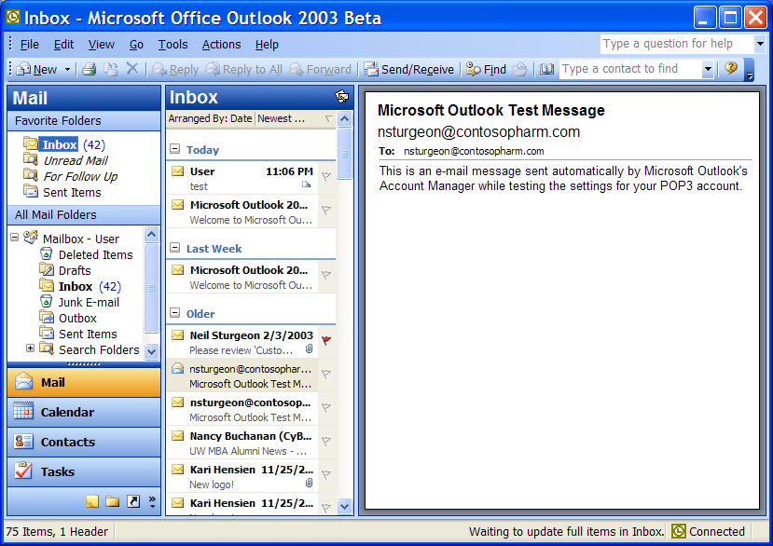
Cached Exchange mode provides a lot of information about the status of the client connection to the Exchange server. Outlook 2003 uses the bottom right side of the status bar to display two types of information. At far right, Outlook 2003 displays the connection status (Connected, Trying to Connect, and so on). To the left of this section, Outlook 2003 displays very specific information on the status of synchronization. Figures 5, 6, and 7 show examples of the Sync Progress notification area.

Figure 5: Synchronization progress
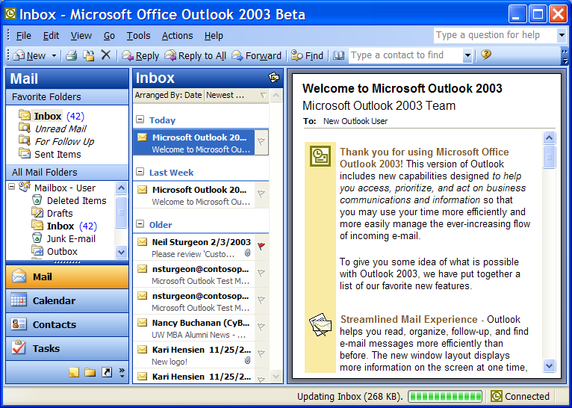
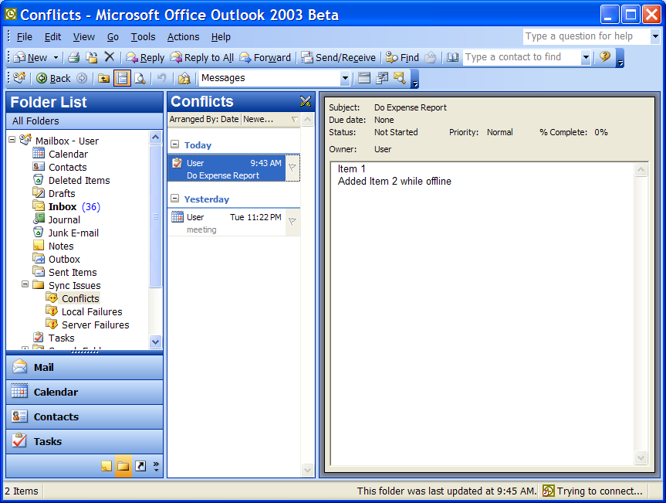
Figure 6: Synchronization progress
Figure 7: Synchronization progress

Sync Issues Folder
Synchronization in Outlook 2003 is very robust. As described previously, Outlook 2003 will skip and log any bad or malformed items that it finds on the server, and continue to synchronize properly. Bad items will be placed in the Sync Issues folder. The Sync Issues also contains items in conflict, which is described in the “Automatic Conflict Resolution” section.

Key Cached Exchange Mode Performance Considerations
There are a number of issues to be aware of when you are configuring and deploying Cached Exchange mode. The way the feature works in Outlook 2003 to maintain an up-to-date local copy of an Exchange mailbox and other information can affect or interact with other Outlook features and behavior. In some scenarios, you might choose to take steps to improve how Cached Exchange mode works together with — or in parallel with — other Outlook features, for your whole organization or for a certain group of users (for example, information workers who travel frequently).

Send/Receive Synchronization Considerations
Cached Exchange mode works independently from existing Outlook Send/Receive actions to synchronize information workers’ OST and OAB files with Exchange Server data. Send/Receive settings still — by default — update information workers’ Outlook data in the same manner that Send/Receive works in older versions of Outlook. Those who are accustomed to synchronizing Outlook data by pressing F9 or clicking Send/Receive may not realize that manual synchronization is not necessary to keep Outlook data current with Cached Exchange mode. In fact, if a number of information workers repeatedly execute unnecessary Send/Receive requests to Exchange Server, Exchange Server and network performance may be affected.
To minimize additional network traffic and server usage, you might want to inform information workers that manual Send/Receive actions are unnecessary in Cached Exchange mode. This might be especially helpful for certain groups of Outlook users — for example, those who typically used Outlook in offline mode with earlier Outlook versions and used Send/Receive to synchronize their data regularly or just before disconnecting from the network. This type of data synchronization now occurs automatically with Cached Exchange mode.
Another option to manage the issue of unnecessary Send/Receive activity is to disable the Send/Receive option. However, this might be unadvisable in some scenarios when disabling the feature creates problems for information workers — such as when you upgrade current Outlook users with POP accounts and existing customized Send/Receive groups to Outlook 2003. In this situation, disabling Send/Receive removes the capability to download POP email messages.

Offline Address Book (OAB) Considerations
Cached Exchange mode allows Outlook 2003 to access the local Offline Address Book for needed user information instead of requesting the data from Exchange Server. Local access to data greatly reduces the need for Outlook to make remote procedure calls (RPCs) to Exchange Server, shielding the information worker from much of the network access required in Exchange online mode or in previous versions of Outlook.
To be shielded from as many unnecessary server calls as possible, information workers should have the Full Details OAB available on their computers. Information workers access the Download page, shown in figure 8, by clicking Tools, Send/Receive, Download Address Book.
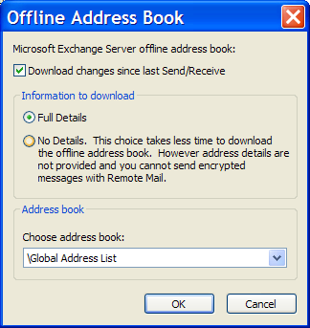
Figure 8: Offline Address Book options
Once information workers have a reasonably current OAB downloaded to (or installed on) their computers, only incremental updates to the OAB are needed to continue to protect information workers from otherwise unnecessary server calls to retrieve user data. In Cached Exchange mode, Outlook 2003 synchronizes the information worker’s OAB with updates from the Exchange Server copy of the OAB every 24 hours. You can control how often information workers download OAB updates by limiting how often you update the Exchange Server copy of the OAB. If there is no new data to synchronize when Outlook checks, the OAB is not updated.
Note Although those with a No Details OAB can use Outlook with Cached Exchange mode, it is recommended to ensure that information workers have a Full Details OAB installed on their computers. Outlook 2003 must make server calls to retrieve any required user properties that are not available in the local OAB, which can result in significant network access when information workers do not have a Full Details OAB.

Offline File Folders (OSTs) Considerations
When deploying Cached Exchange mode for Outlook, be aware that information workers’ OST files can increase in size by 50 percent to 80 percent over the size of the mailbox reported in Exchange Server. The format Outlook 2003 uses to store data locally for Cached Exchange mode is less efficient than the server data file format, resulting in more disk space used when mailboxes are downloaded to provide a local copy for Cached Exchange mode.
When Cached Exchange mode first creates a local copy of an information workers’ mailbox, the information worker’s current OST file — if one exists — is simply updated. When mailboxes are relatively small (for example, less than 500 megabytes (MB) of Exchange Server data), this works fine. However, for those with larger mailboxes, you should ensure that the use of Unicode-formatted OST files — the new file format in Outlook 2003 — before deploying Cached Exchange mode. Unicode OST files can store up to 20 gigabytes (GB) of data, instead of the limit of 2 GB on non-Unicode (ANSI) Outlook files.
By creating Unicode OST files, you can help avoid error messages that result when Outlook runs out of OST file space when attempting to create a local copy of the information worker’s mailbox for Cached Exchange mode. Outlook with Cached Exchange mode also works better when there is plenty of free space in the OST file — for example, when only 5 percent to 10 percent of a 20 GB OST file is used.
Also be sure that information workers’ OST files are located in a folder with sufficient disk space to accommodate information workers’ mailboxes. For example, if information workers’ hard drives are partitioned to use a smaller drive for system programs (the system drive is the default location for the folder that contains the OST file), you should specify a folder on another drive with more disk space as the location of OST files.

Managing Performance Issues
There are many factors that influence a information worker’s perception of Cached Exchange mode performance, including free disk space and CPU speed, and what level of performance the information worker is accustomed to when using Outlook. For example, those who used Offline mode in previous versions of Outlook might experience Cached Exchange mode as providing a much better user experience, while those who formerly accessed Exchange in online mode might perceive Outlook performance as having decreased (depending on other factors as well).
One factor that can contribute to reduced performance is a large OST file. If an OST file grows too large (for example, larger than 1 GB), Outlook with Cached Exchange mode performance degrades. To improve response time in Outlook, information workers should either reduce the size of their mailbox (for example, by archiving older files) or turn off Cached Exchange mode. To help prevent the problem of overly large OST files, you can set a limit on the mailbox size in Exchange Server. You might also choose to turn off synchronizing Public Folder Favorites if you previously enabled the option in your deployment of Cached Exchange mode.

Public Folder Favorites Considerations
Cached Exchange mode can be configured to download and synchronize the public folders included in information workers’ Favorites folders for Outlook Public Folders. An information worker could access the property page shown in figure 9 by clicking Tools, Email Accounts, View or change existing email accounts, selecting the Exchange account and clicking Change, More Settings, and the Advanced tab.
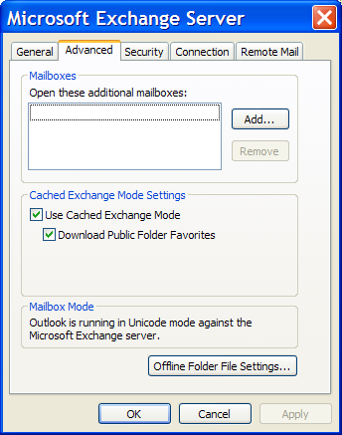
Figure 9: Configuring Outlook 2003 to download Public Folder Favorites
By default, Public Folder Favorites are not synchronized. However, if your organization uses public folders extensively, you may want to turn on this option. You can configure an option to download Public Folder Favorites in the Custom Installation Wizard when you customize your Cached Exchange mode deployment.
However, if information workers’ Public Folders Favorites folders include large public folders, their OST files can become large also, which can adversely affect Outlook performance in Cached Exchange mode. Before you configure Cached Exchange mode to turn on this option, ensure that information workers are selective about the public folders that are included in their Public Folder Favorites, and also ensure that their OST files are large enough — and are in folders with enough disk space — to accommodate the additional storage requirements for the public folder downloads.

What to Avoid When Using Cached Exchange Mode
Since Outlook 2003 offers multiple modes of connecting to Exchange, there are some functions and features that do not necessarily fit with Cached Exchange mode. The following sections describe practices to avoid in order to achieve the best performance in Cached Exchange mode.

Outlook 2003 Features
Some Outlook features reduce the effectiveness of Cached Exchange mode because they require network access or because the bypass Cached Exchange mode functionality. The primary benefit of using Cached Exchange mode is that it shields the client from network and server connection issues. Features that rely on network access can cause delays in Outlook 2003 responsiveness that information workers would not otherwise experience when using Cached Exchange mode.
The following features rely on network access and can therefore cause delays in Outlook 2003 when the connection to Exchange is not fast:
- Delegate access
- Opening another information worker’s calendar or folder
- Using a public folder that has not been cached
In addition, some aspects of certain Outlook 2003 features also require network access to retrieve necessary information — such as looking up free/busy information — which can cause a delayed response even when information workers have fast connections to Exchange data. The delays can occur unpredictably, rather than only when the feature is accessed.
It is recommended that you disable or do not implement the following features — or combination of features — if you deploy Cached Exchange mode:
- Instant Messaging integration
If information workers right-click on the pawn icon in an email message header, Outlook checks for free/busy status for that person. You can disable Instant Messaging integration by using Group Policy.
- The “toast” alert feature together with digital signatures on email messages
To verify a digital signature, Outlook must check a network server. By default, Outlook displays a “toast” message that contains a portion of an email message when new messages arrive in an information worker’s Inbox. If the information worker clicks on the toast message to open a signed email message, Outlook checks (using network access) for a valid signature on the message.
- Multiple Address Book containers
Typically, the Address Book contains the Global Address List (GAL) and Contacts folders. Some organizations configure subsets of the GAL, which are displayed in the Address Book. These subset address books can also be included in the list that defines the search order for address books. If subset address books are included in the search order list, Outlook might need to access the network to check these address books each time a name is resolved in an email message.

Outlook 2003 Add-Ins
Another way in which the benefits of using Cached Exchange mode can be reduced is by installing certain Outlook 2003 add-ins. Some add-ins can bypass the expected functionality of Headers Mode (Download Headers Only) in Cached Exchange mode by accessing Outlook 2003 data by using the object model. For example, if you use Microsoft ActiveSync to synchronize a handheld computer, full Outlook items will be downloaded, not just headers, even over a slow connection. In addition, the update process will be slower than if you downloaded the items in Outlook because one-off applications use a less efficient type of synchronization.

Client Side Rules
When using Outlook 2003 with Microsoft Exchange Server, it is possible to have server-based rules and client side rules. Server-based rules can be processed entirely on the server—for instance, an information worker that uses the mailbox for the delivery location might have a rule that deletes all email from a specific alias. Since both the Inbox and the Deleted Items are on the server, the rule can be processed there without interaction from the client.
Client side rules require some processing by the client. If the same information worker has a PST where emails of certain types are stored, and has a rule moving all emails from a specific alias to that folder, the server cannot do all of the processing since the PST is on the local computer and can only be accessed when Outlook 2003 is connected to the server. In this case, Exchange creates a deferred action item on the server that runs the next time there is a synchronization action. Because information workers cannot choose to not run deferred actions, client side rules can have a very big impact on performance, particularly when working over slower links.
For better performance, information workers should:
- Remove any unnecessary client side rules
- Use the “stop processing more rules” action
- Consider the necessity of the junk mail rule – this is a client side rule that slows down synchronization
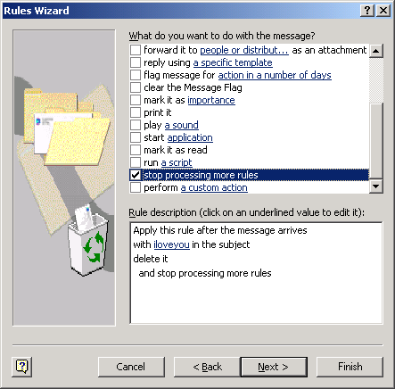
When creating rules, information workers should always add the “stop processing more rules” action at the end of the list of actions for that rule (see Figure 10). If not, every rule the information worker has runs on that message, even if the action that the information worker needs has already been completed. If an information worker has five rules and does not use that option, all five rules must be processed on every single message that enters the Inbox, which can really hurt performance regardless of the connection.

Figure 10: Stop processing more rules

Cached Exchange Mode Deployment
To deploy Outlook 2003 with Cached Exchange mode, you enable the option in the Custom Installation Wizard, and then choose from several options for Cached Exchange mode download settings (for example, Download only headers). After you configure the desired options, you save the settings with other configurations in the transform that you use to deploy Office or Outlook 2003 to your users.
If information workers in your organization do not already have OST files, you might choose to configure a default OST file location for Cached Exchange mode (and offline use). If you do not specify a different OST location, Outlook 2003 will automatically create an OST in the default location when information workers start Outlook 2003 in Cached Exchange mode.
To configure Cached Exchange mode settings in the Custom Installation Wizard:
- In the Custom Installation Wizard, on the Outlook: Specify Exchange Settings page, click Configure an Exchange Server connection.
- Note that you must choose Modify Profile or New Profile on the Outlook: Customize Default Profile page in order to configure Exchange Server settings in the wizard.
- To specify a new location for OST files, click More Settings, and then click Enable offline use. Enter a folder path in the Directory path to store the Offline Address Book files box, and then click OK.
- To specify default download behavior for Cached Exchange mode, on the Outlook: Specify Exchange Settings page, click Configure Cached Exchange Mode.
- Select the Use Cached Exchange Mode check box to turn on Cached Exchange mode for information workers. If you do not select the check box, Cached Exchange mode will be disabled by default.
- If you selected to turn on Cached Exchange mode in step 3, choose a default download option:
- Download only headers
Information workers see header information and the beginning of the message or item body (a 256 KB plain-text buffer of information). Full items are downloaded only when they click the InfoBar to request a full-item download.
- Download headers followed by the full item
All headers are downloaded first, and then full items are downloaded. The download order might not be chronological. Outlook downloads headers and then full items in the folder the information worker is currently accessing, and then downloads headers (followed by full items) in folders recently viewed.
- Download full items
Full items are downloaded. The download order may not be chronological. Outlook downloads full items in the folder the information worker is currently accessing, and then downloads full items in folders recently viewed.
- To turn off Headers Only mode, clear the On slow connections, download only headers check box.
- Downloading only headers is the default behavior when information workers are on slow connections. However, there are scenarios in which Outlook perceives a fast connection as slow, or vice versa. In these situations, you may want to set or clear this option.
- Choose to have Public Folder Favorites downloaded as part of Cached Exchange mode synchronizations to information workers’ OST files.
By default, Public Folder Favorites are not downloaded. Downloading Public Folder Favorites might cause information workers’ OST files — if they use non-Unicode OSTs — to grow past the 2 GB size limit, resulting in errors when Outlook synchronizes. Also, synchronizing Public Folder Favorites causes extra network traffic that might be unwelcome on slow connections.

Automatic Conflict Resolution
As mentioned above, Outlook 2003 automatically resolves spurious conflicts, and it auto-resolves real conflicts without user intervention and without any data loss. Conflict resolution is made possible by property-level change tracking in Outlook 2003 PSTs and OSTs. The data generated by the new change tracking is stored locally. As a result, Outlook is able to resolve most conflicts automatically.

Conflict Resolution in Action
Consider the following scenario:
- An information worker modifies the content of a task from Outlook 2003 while not connected.
- Subsequently, the information worker connects through Outlook Web Access while her Outlook client is still disconnected and modifies the same task.
- When Outlook connects to the server and synchronizes, it will recognize the conflict and resolve it.
The information worker will see that the conflict has been resolved, in this case, by keeping the changes made most recently through Outlook Web Access and discarding the older changes made through Outlook 2003. Outlook 2003 uses a number of factors to determine the winning item and the losing item. The basic sequence of actions is as follows:
- Leverage the new change tracking in the store to determine which properties changed on the local copy of the item. In this case, there was a change to the text within the task item.
- Retrieve the same set of properties from the version on the server (this includes ignorable properties). In this case, there was a different change to the text within the task item.
- For each property that is not ignorable, compare the value between the server’s version and the local version
- For each difference that is detected:
  - Determine if the property is client-decidable
    - If it is, examine the two values and store the appropriate value. In this case, it is resolvable, and the most recent version wins.
    - If it is not resolvable, generate a conflict when Outlook 2003 tries to sync the item.
- Since we have a winner, set the client-decidable properties on the servers version
- Do not synchronize the losing item
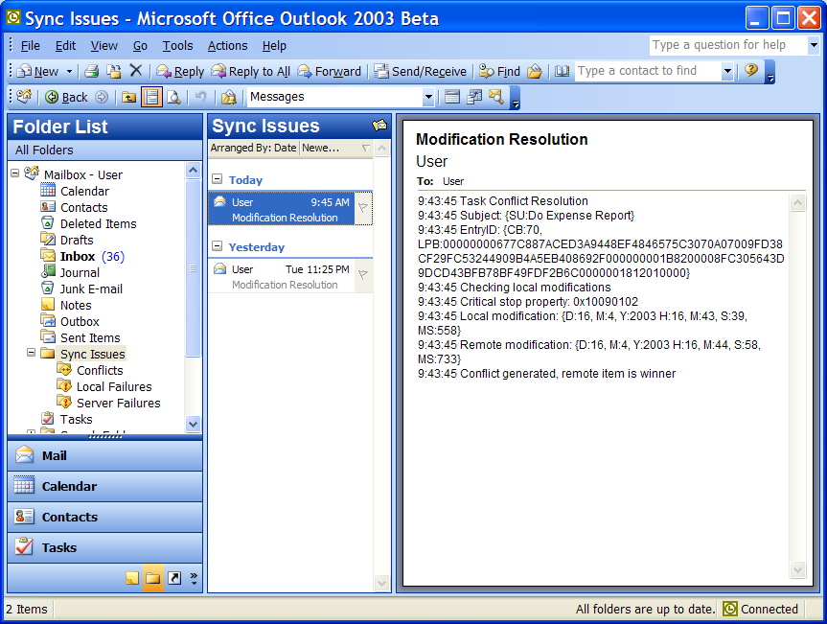
By opening the Synch Issues folder, shown in figure 11, the information worker can see how the resolution for this conflict was accomplished.
Figure 11: The Resolution notification in the Sync Issues folder
Outlook also keeps the losing item in case the information worker needs it. This is located in the Conflicts subfolder of the Sync Issues folder. The losing item in this case was the older modification made offline, as shown in figure 12.
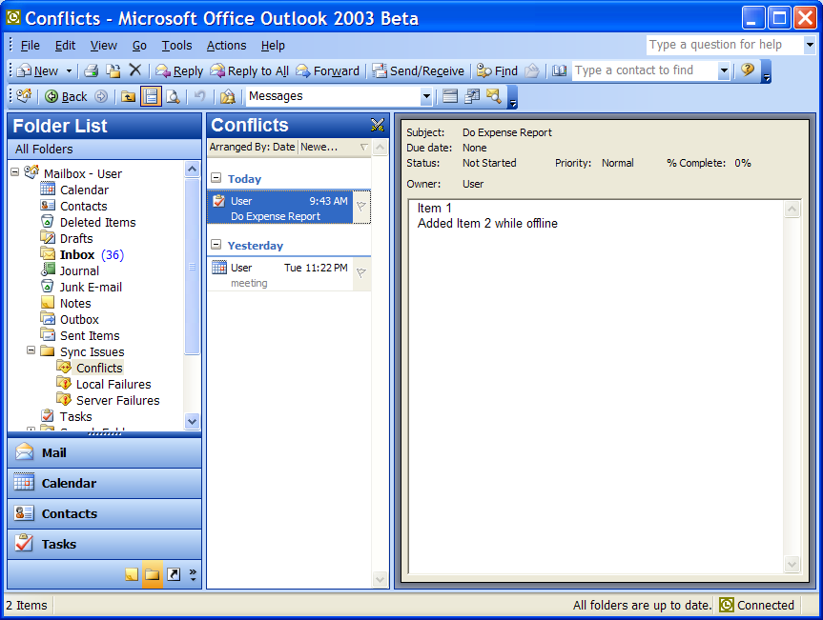
Figure 12: The losing item is kept in the Conflicts folder

RPC over HTTP
Explain technology
Can’t figure out how to set it up – greyed out

MAPI Compression
As described previously, Outlook 2003 and Exchange Server 2003 communications are much faster than previous versions due to MAPI compression.
One further major improvement is that all data is compressed between the client and server. The compression ratio will vary due to the data to be transmitted; much the same way as zipping different file types produces mixed results. HTML and plain text bodies can usually compress to between 60 and 80% of their original size, with an additional bytes on wire saving of 20% for RTF data (which is already compressed). The compression affects the entire message body, including attachments. For example, Microsoft Word documents compress very well through this new MAPI compression mechanism and during the initial testing costs were 60% less than the CPU utilization with 50% fewer bytes on the wire.
The compression technology used between Outlook 2003 and Exchange 2003 is called XPRESS and is based on the Lempel-Ziv algorithm. This is the same technology that Active Directory uses to perform compression of its RPC data when replicating between servers. All data over the size of 1 KB is compressed, and the technology is built into both client and server; therefore the compression is full duplex. Older versions of Outlook perform MAPI transfers by calling EcDoRpc; whereas Outlook 2003 calls EcDoRpcExt. Therefore, the compression is only enabled for Outlook 2003 clients.

Buffer Packing
Buffer packing provides additional efficiency to client and server communications. There is a close relationship between buffer sizes and compression as the Outlook client can request a data buffer of 32Kb. However, once the server has compressed the data, it may be significantly smaller on the wire. Therefore, to accommodate varying compression rates but keep buffer sizes large, Exchange 2003 includes support for ‘buffer packing’. This allows the server to keep adding compressed data to the buffer until the buffer is full.
Tables 2 and 3 provide a quick comparison between Outlook XP and Outlook 2003 with respect to buffer sizes, packing and compression:

Table 2: Outlook XP against Exchange 2000 / 2003
Mode | Data Flow | Network | Client Buffer Size | Data Buffer Size | Size on Wire | Compress
Online | Download/Upload | LAN | 32Kb | 32Kb | 32Kb | No
Online | Download/Upload | WAN | 4Kb/8Kb | 4Kb/8Kb | 4Kb/8Kb | No
Offline | Download/Upload | All | 32Kb | 32Kb | 32Kb | No

Table 3: Outlook 2003 against Exchange 2003
Mode | Data Flow | Network | Client Buffer Size | Data Buffer Size | Size on Wire | Compressed
Online | Download | All | 32Kb | 32Kb | <32Kb | Yes
Online | Upload | All | 32Kb | 32Kb | <32Kb | Yes
Cached | Download | All | 96Kb | >96Kb | 96Kb | Yes
Cached | Upload | All | 32Kb | 32Kb | <32Kb | Yes
Offline | Download | All | 32Kb | >32Kb | 32Kb | Yes
Offline | Upload | All | 32Kb | 32Kb | <32Kb | Yes

The net result of the change in buffer sizes, the packing and compression, is fewer round-trips between the client and server and less data transmitted. This increased performance will be very noticeable on slow or latent networks such as GPRS and GSM.

Recommended Settings Based on User Type
As described above, the single most important way to achieve optimal performance is to use the proper connection mode (Online, Offline, or Cached). In general, Cached Exchange mode with Full Item caching is what information workers ought to aim for, if the connection can support it. The following paragraphs describe the various client/server connection scenarios and provide recommendations for which mode to use.
Whether we are talking about corporate desktop users, mobile laptop users, or home users, there are some common elements to any Outlook client connection to a server. Elements such as connection speed and connection latency have an impact on which configuration provides the best trade-off of performance and functionality.
Table 4 shows a summary of user types, how they are connected, and how they should use Outlook 2003. We have already discussed the network characteristics of how information workers connect (Speed, Latency, and Reliability). The user types are:
- Desktop or Laptop User on the Corporate Network - When the only options were Online and Offline, most Outlook users who were connected to the server locally over a LAN used Online mode. Depending on latency, many who were connected to the server remotely, even over a high-speed WAN connection, used Offline mode.
Now, most will want to use Cached Exchange mode, even if they have a very fast, very low-latency connection to the server
- Laptop User on DSL, Cable or ISDN – If information workers need to be connected to the network for reasons other than email access, VPN is still the preferred remote access method. But if access to other network resources is not an issue, using RPC over HTTP will improve usability (as described above). If the Network Characteristics support it, Cached Exchange mode with Full Item caching is recommended.
- Laptop User on Dial-UP – Because dial-up is slow, Cached Exchange mode with Headers is recommended.
- Laptop User on GPRS – GPRS users fall into two classes: those who are cost-conscious and those who want the best functionality regardless of cost. The cost-conscious user should run Outlook 2003 in Cached Exchange mode and use Send/Receive groups. Those who want full functionality should use Cached Exchange mode with Headers.
- Home Computer User – Home computer users may connect over Cable, DSL, ISDN, or dial-up. See Table 4 for recommendations for home users.

Table 4: Recommended Settings Based on Client Connection
User Type | Server Connection/Proximity | Network Characteristics |  |  | Recommended Configuration
User Type | Server Connection/Proximity | Bandwidth/Speed | Latency | Reliability | Recommended Configuration
Desktop User Corporate Network | LAN  Local | Fast | Low | High | Cached Exchange mode with Full Item caching
Desktop User Corporate Network | WAN  Remote | Medium to Fast | Variable | High | Cached Exchange mode with Full Item caching – ideal case for this recommendation
Laptop User on Corporate Network | LAN (over Ethernet) | Fast | Low | High | Cached Exchange mode with Full Item caching
Laptop User on 802.2003 | LAN (over wireless) | Fast | Low | Medium | Cached Exchange mode with Full Item caching
Laptop User on DSL, Cable or ISDN | VPN or RPC over HTTP | Variable | Low to Medium | Medium to High | Cached Exchange mode with Full Item caching – or – Outlook Web Access
Laptop User on Dial-Up | Dial-Up | Slow | Variable | High | Cached Exchange mode with Headers
Laptop User on GPRS (Don’t care about cost) | GPRS | Slow | Variable | Low | Cached Exchange mode with Headers
Laptop User on GPRS (Cost conscious) | GPRS | Slow | Variable | Low | Offline Mode with Send/Receive groups
Laptop User not connected to network | NONE | NA | NA | NA | Cached Exchange mode or Offline Mode
Shared Computer | Variable | Variable | Variable | Variable | Outlook in Traditional Online Mode – or –Outlook Web Access
Home Computer User who checks work mail | Cable or DSL | Medium to Fast | Low to Medium | Medium to High | Cached Exchange mode with Full Item caching – or –Outlook Web Access
Home Computer User who checks work mail | Dial-Up or other slow connection | Slow | Variable | High | Cached Exchange mode with Headers

Exceptions
There are a few exceptions to the general recommendation to use Cached Exchange mode. These are described below.

Using a Shared Workstation
Note in the table above that the recommendation for connecting on a shared computer is to use Online mode. This is because Cached Exchange mode requires an initial synchronization, which takes some time. Hence, if an information worker is connecting from a computer that she will likely not use again, the ability to immediately use the client in Online mode (or OWA) outweighs the performance increase associated with Cached Exchange mode.

Large Mailboxes
There is another exception to the general preference for Cached Exchange mode. When in Cached Exchange mode Outlook 2003 must perform analysis of the mailbox to ensure proper synchronization. On very large mailboxes, the overhead of Cached Exchange mode begins to outweigh its benefits. Therefore, those with very large mailboxes ought to use Online mode or Offline mode, or they should move older items to a PST to reduce the size of the server-based mailbox.

Forcing Full Message Download
Another situation involves using a slow connection, which would normally cause Outlook 2003 to download headers only. If the information worker wishes to download everything, disconnect and then continue to read and reply to the new email, she would temporarily switch her Cached Exchange Mode setting to Download Full Items, as shown in figure 13.
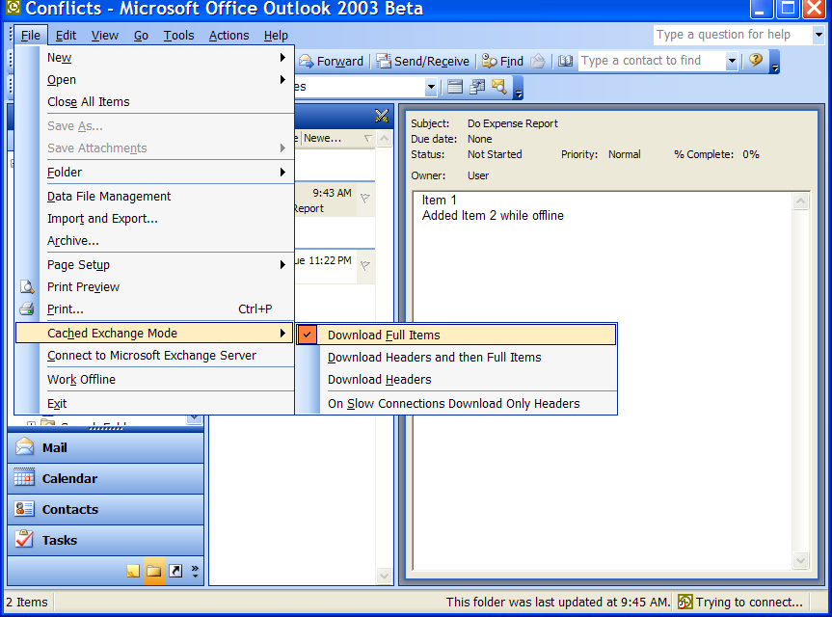
Figure 13: Changing the Cached Exchange mode settings
This will result in all of your emails being downloaded in their entirety. The download will take longer but she can disconnect after synchronizing, knowing that she can work productively offline.

Conclusion
The features described in this paper make Outlook 2003 a superior messaging client, especially when it is used with Exchange Server. Cached Exchange mode, improved synchronization, better compression, and other features combine to provide a client that “just works.” Regardless of how information workers connect, Outlook 2003 is designed to provide a superior experience that removes that need for constant configuration changes to meet changing network and usage scenarios. As a result, Outlook 2003 helps information workers focus less on their messaging client technology and more on their jobs.

Frequently Asked Questions

Does Cached Exchange mode require Exchange Server 2003 as the server?
The core functionality of Cached Exchange mode will work with Exchange 5.5, 2000, and Exchange Server 2003. The advanced ability to cache full message items or only message headers does require the server to be Exchange Server 2003.

Find Additional Information
For more information, see the following web sites:
Office…
http://www.microsoft.com/office

