Table of Contents
Table of Contents 1
Summary of New Features 1
Introduction 1
Outlook Web Access Premium 1
Performance 1
Logon Page 1
Choose Your Outlook Web Access Version 1
Choose Your Security Level 1
Activity vs. Inactivity 1
Clearing the Credentials Cache 1
UI Revamp 1
New Mail View and Reading Pane 1
Mark as Read/Unread 1
Context Menu 1
Quick Flagging 1
Junk Mail Filtering 1
Other New View Features 1
Deferred Refresh After Delete 1
Color Schemes 1
Standard Fonts 1
New Navigation 1
Easier Moving or Copying to Folders 1
Update Folders 1
Search Folders 1
Notifications 1
Public Folders 1
Log Off 1
Improved E-mail Experience 1
Spell Check 1
New Addressing Wells 1
GAL Properties Sheets 1
Add to Contacts 1
Find Names Enhancements 1
Auto Signature 1
Default Mail Font 1
Navigate After Delete 1
Read Receipt Settings 1
“Web Beacon” Blocking 1
Privacy Protection When Following A Link In E-Mail 1
Attachment Blocking 1
Infobar Improvements 1
Reply Header And Body Not Indented 1
Item Window Size 1
Window Status Bar 1
Mail in Public Folders 1
Signed And Encrypted Mail 1
Requirements 1
Why You Should Download The S/MIME Control 1
How To Download The S/MIME Control 1
Getting Your Digital ID 1
Removing The S/MIME Control 1
Rules 1
Actions and Criteria 1
Handling Disabled Rules 1
Broken Rules 1
Personal Tasks 1
No Task Requests 1
Delete vs. Skip Occurrence 1
Setting Completion Percentage 1
Task Reminder Differences 1
Meeting Request Enhancements 1
Other Notable Improvements 1
BiDi Support 1
Options Page Toolbar 1
Outlook Web Access Basic 1
Logon Page 1
UI Revamp 1
Junk Mail Filtering 1
Navigation 1
Improved E-mail Experience 1
GAL Properties Sheets 1
Find Names Enhancements 1
Auto Signature 1
Default Mail Font 1
Navigate After Delete 1
Read Receipt Settings 1
“Web Beacon” Blocking 1
Privacy Protection When Following A Link In E-Mail 1
Attachment Blocking 1
Sensitivity And Reply/Forward Infobar 1
Reply Header and Body Not Indented 1
Item Window Size And Status Bar 1
Mail in Public Folders 1
Signed And Encrypted Mail 1
Rules 1
Personal Tasks 1
Meeting Request Enhancements 1
Other Differences From Outlook Web Access Premium 1

Summary of New Features
Feature | Description | Outlook Web Access Premium | Outlook Web Access Basic
Logon/Logoff Improvements
Logon page | New customized form for logging on to Outlook Web Access; includes cookie-based validation where the Outlook Web Access cookie is invalid after user logs out or is inactive for predefined amount time. | Yes, with choice of using Outlook Web Access Basic | Yes, but only allows use of Outlook Web Access Basic
Clear credentials cache on logoff | After logoff all credentials in Internet Explorer 6 Service Pack 1 (SP1) credentials cache are cleared automatically. | Yes, in Internet Explorer 6 SP1 | No
Public or shared computer and Private computer logon options | To provide organizations with more protection, two logon page security options can be used. The private option can be set to provide a longer period before user is logged off because of inactivity. | Yes | Yes
General User Interface Improvements
User interface updates | New color schemes, reorganized toolbars. | Yes, plus new view menu, default user interface font, and bidirectional support | Yes, but only one color scheme available
Item window sizing | During an Outlook Web Access session, item windows open at the last window size set by the user instead of always opening at 500x700 pixels. | Yes | No
Item window status bar | A status bar is now available on item windows where a user can see the destination URL of a hyperlink in an e-mail message when the mouse pointer is positioned over the link. | Yes | No. Items do not open in separate windows, but the status bar is still available.
View Improvements
Two-line mail view | New view orients message list vertically instead of horizontally; works well with Reading Pane. | Yes | No
Reading Pane (called the Preview Pane in previous versions of Outlook Web Access) | Resizable Reading Pane now appears to right of message list by default; attachments can be opened directly from Pane. Additionally, user has option to determine if items are marked items as read when viewed in Reading Pane. | Yes | No
Mark as read/unread | Command enables users to mark unread messages as read or vice versa. | Yes | No
Quick Flagging | Command enables users to assign follow-up flag to messages. | Yes | No
Context Menu | Context Menu available in mail view; special context menu also available on quick flag. | Yes | No
Keyboard shortcuts | Common actions such as new message, mark as read/unread, and reply and forward are available when focus is in message list. | Yes | No
Items per page | Users can determine how many items appear per page in e-mail, contact, and task views | Yes | Yes
Mail icons | Icons display state and type of messages. | Yes | Yes
Deferred view update | The view is auto-refreshed only after 20 percent of messages are moved or deleted from a page, not after each deletion. This results in increased performance. | Yes | No
Navigation Improvements
New Navigation Pane | Unified user interface contains module shortcuts, full folder tree, refresh item count button, customizable width. | Yes | Shortcuts only
Search folders | Outlook-created search folders are displayed in folder tree. These must be created in the Outlook Online mode. | Yes | No
Notifications | New e-mail and reminder notifications are displayed in Navigation Pane. | Yes | No
Public folders | Public folders are displayed in new window. | Yes | No
Log Off option on toolbar | Log Off option is now on the view toolbar, not in the Navigation pane. | Yes | No
Mail Workflow Improvements
Spelling checker | Spelling checker is provided for e-mail messages. | Yes | No
New addressing wells | New integrated look; easier deletion of recipients. | Yes | No
Global Address List Properties sheets | Property sheets now display name, address, and phone information for resolved Global Address List (GAL) users. | Yes; available in received items, draft items, Check Names dialog box, and Find Names dialog box | Yes; only available in received items and draft items
Add to Contacts | Users can add resolved recipients in received mail or drafts to main contacts folder. | Yes, feature in Properties sheets or context menu on resolved names | No
Send mail from Find Names | Users can send new messages to addresses found in the Find Names dialog box when it is opened from an e-mail view. | Yes | No
Open Find Names from message | Users can open Find Names from a message and use it to add new recipients to a draft message; also used to add recipients to a contact distribution list. | Already available in previous versions of Outlook | Yes
Contacts in Find Names | Users can search main contacts folder in Find Names. | Yes | No
Sorted results in Find Names and Check Names | The results in Find Names and Check Names now are sorted in alphabetical order | Yes | Yes
Auto signature | Users can create a signature that is automatically included in e-mail messages. | Yes, HTML-based formatting; also on-demand insertion | Yes, plain-text formatting; no on-demand insertion
Default mail editor font | User-customizable default font is provided for e-mail editor. | Yes | No
Navigate after delete | Users can open the next or previous item after deleting an item | Yes | No
Read receipts | Users can use or ignore read-receipt requests | Yes; users also can send receipts even when the option is set to ignore requests | Yes; users are not able to l send receipts when option is set to ignore requests
“Web Beacon” blocking | Users can control options for blocking external content in e-mail. | Yes | Yes
Privacy protection when navigating links in e-mail | Destination site only receives server name where e-mail message with link was located — not server name, account name, and subject of e-mail message. | Yes | Yes
Attachment blocking | Administrator options restrict access to some or all attachments in messages. | Yes | Yes
Junk mail filtering | Options to set up safe- and blocked-sender lists | Yes | Yes
Sensitivity infobar | Sensitivity information is displayed in infobar | Yes | Yes
Reply/Forward infobar | Reply/Forward information is displayed in infobar | Yes | Yes
No indenting replies | The reply header and reply body are no longer indented. | Yes | Yes; Outlook Web Access Basic never indented
Reply to messages/posts in Public Folders | Users now can reply by e-mail to messages or posts in public folders when accessing public folders through a front-end server | Yes | Yes
Encrypted/signed mail | Sending and receiving encrypted and/or signed e-mail is supported. | Yes, Internet Explorer 6 on Microsoft for Windows 2000 or higher | No
Rules Improvements
Rules | Users can create and manage server-based e-mail-handling rules. | Yes | No
Task Improvements
Personal tasks | Users can create and manage personal tasks and receive reminders for these items. | Yes | Yes, but no reminders
Calendar Improvements
Reply/Forward Meeting Requests | Users can now reply to senders of Meeting Requests and/or forward Meeting Requests to other users. | Yes | Yes
Attendee reminder | Attendees can set own reminder times from received meeting requests. | Yes | No
Custom meeting cancellation notice | Users can type in the body of a meeting cancellation notice before sending it. | Yes | Yes
View Calendar from a meeting request | Attendees can open the calendar from a meeting request, | Yes | No
Performance Improvements
Bytes over the wire | Fewer bytes sent over the wire from server to browser. Additionally, when data is sent from the server to browser during initial logon has been reorganized to speed up rendering the Inbox. | Yes | Yes
Compression support | Administrators can configure compression support for Outlook Web Access and provide a performance improvement of nearly 50 percent for most actions on slow network connections. | Yes, when accessed with Internet Explorer 6 SP1 + Q328970 or higher | Depends on the browser.

Introduction

Welcome to Microsoft Office Outlook Web Access provided by Exchange Server 2003. Outlook Web Access’ user interface has gone true blue, but this Web client's makeover is more than skin deep. There are a host of major new features in the product and nearly as many improvements in existing features:

- Faster performance
- Better logon/logoff experience
- Spell check
- Rules for managing mail
- E-mail signatures
- Encrypted and signed mail
- Personal tasks
- Enhanced meeting requests
- And a whole lot more…

What follows is a guided tour of the additions and changes in this release of Outlook Web Access. It’s divided into two sections.

The first section covers the enhancements in the Outlook Web Access Premium client, which runs only in Microsoft Internet Explorer 5.01 - 6.x for Windows. The second section focuses on improvements in the Basic client, which is designed to run in most common browsers (compliance with the HTML 3.2 and European Computer Manufacturers Association (ECMA) Script standards is required).

Outlook Web Access Premium

Performance
The Outlook Web Access team has made great efforts to improve the product’s speed by reducing the bytes of code that must travel from the server to the browser in response to common user actions. By sending fewer bytes, you have to wait less time to see the results of your actions. Plus, if your Exchange administrator enables Outlook Web Access compression and you’re using Internet Explorer 6 SP1 for Windows with patch Q328970 or higher, the byte reduction — and resulting speed gains — are even greater.

Outlook Web Access also downloads necessary client-side files to your browser while you’re entering your credentials on the logon page. By the time you’re logged in, essential scripts and controls already should be on your PC and ready for Outlook Web Access to use, thus making your Inbox appear more quickly.

Overall, even with the enhanced interface and multitude of new features about which you’ll read in the following pages, Outlook Web Access should seem faster — especially over slow connections — and respond more quickly to your commands.

Logon Page

When you access your e-mail account through Outlook Web Access, if you’re logging on via a front-end server (this is probably how you connect to Outlook Web Access, for example, when you use an Internet address like https://mail.northwindtraders.com/exchange), the first difference you’ll notice is a new logon page.

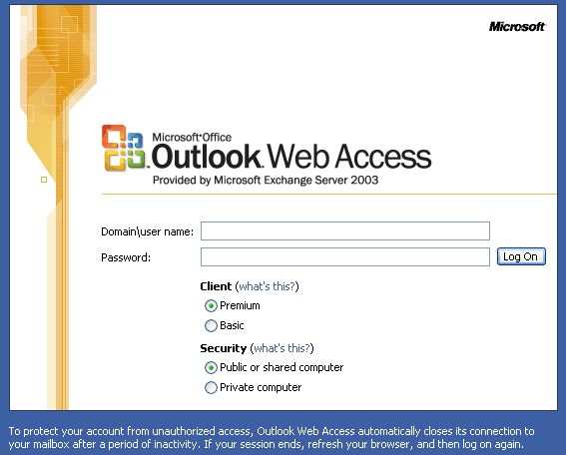

You’re still required to type your DOMAIN\username and network password to enter your account.

This logon page is more than a cosmetic change — it offers several elements of new functionality.

Choose Your Outlook Web Access Version
You can choose which version of the Outlook Web Access client to load — the Premium client, which is designed specifically for Internet Explorer 5.01 - 6.x for Windows, or the Basic client, which runs in most browsers.

You might wonder why you’d ever want to load up the Basic client if you’re running Internet Explorer 5.01 or higher. There are two reasons: speed and accessibility.

Because Outlook Web Access Basic must work in any browser (or at least those browsers that support HTML3.2 and ECMA Script), it is designed to be a simple user experience that loads quickly. On a slow link, the Basic client may be the best option if you just need to quickly check your Inbox or look up the time of an appointment on your Calendar.

But Outlook Web Access Basic lacks some useful features available in the Premium client, and it also has a less familiar UI that bears little in common with Outlook. (Improvements in the Basic client are covered later in this document.) For longer Outlook Web Access sessions, the workflow enhancements in the Premium client may prove more beneficial than the raw download speed of Outlook Web Access Basic.

If you are a user with accessibility needs, however, you are likely to prefer the Basic client. The simple HTML 3.2 in which the Basic client is written interacts well with common screen readers and other accessibility aids.

Choose Your Security Level
Besides choosing which version of Outlook Web Access to use, you also must choose a security level that’s appropriate for the computer from which you are logging in. The security level determines how long your Outlook Web Access session will remain open if you leave the computer unattended.

If you are connecting from a public Internet kiosk, you should choose the “Public or Shared Computer” option. You will remain logged in to Outlook Web Access as long as your session is not inactive for more than 15 minutes.

If you are logging in from your computer at home or work, you should choose the “Private” option. You will remain logged in to Outlook Web Access as long as your session is not inactive for more that 24 hours. (The period of inactivity required before automatic logoff on public and private computers can be shortened or lengthened for all users by an Outlook Web Access administrator.)

This new feature is designed to safeguard access to your account. Outlook Web Access’ power resides in the fact that you can use it to view your corporate mail, appointments, contacts, and tasks from any computer that’s connected to the Internet. But this convenience opens up a security risk.

In the past, it’s been possible for you to open an Outlook Web Access session on a public Internet terminal and then leave the terminal with your Outlook Web Access session available to future terminal users. That’s because Outlook Web Access relied on the browser to store your Outlook Web Access username and password. To clear the browser’s credentials cache, you had to close the browser.

If you were using Outlook Web Access at an Internet terminal where it was impossible to close the browser when you were done with the terminal, your Outlook Web Access credentials would remain stored in the terminal’s browser. Thus the next terminal user may have been able go through the browser’s history log to gain unfettered access to your Outlook Web Access account.

Now when you log on to Outlook Web Access using the new logon page, your credentials are stored in a session cookie. Instead of needing to close the browser to log off, you merely need to click the “Log Off” button in Outlook Web Access (closing the browser also still should log you off). The session cookie is expired, and access to your account is closed. Thus at a public Internet terminal, now you can log off from Outlook Web Access with confidence that your account won’t be open to future users.

And if you accidentally leave the terminal without logging off from Outlook Web Access, automatic logoff reduces the risk of unauthorized access to your account by causing the session cookie to expire after a period of inactivity. By choosing the “Public” option when you log on to Outlook Web Access from an Internet terminal or shared computer, you do your part in keeping your data secure by shortening the period of inactivity that’s required for automatic logoff to occur.

Activity vs. Inactivity
Because you’re going to be logged off from Outlook Web Access after a certain amount of inactivity, it’s important to understand what constitutes activity.

In general, any interaction between the client and the server is considered activity: opening, sending, or saving an item; switching folders or modules; refreshing the view or the browser. Outlook Web Access Premium also has special code so that typing in a message body is counted as activity. However, typing in any other type of item (appointment, meeting request, post, contact, task, etc.) is not considered activity.

There is no warning before automatic logoff occurs. If you have any concern that you are going to be logged off automatically, the best thing to do is every so often perform one of the actions that causes interaction with the server.

If you do get automatically logged off while working in Outlook Web Access Premium, the effects are not catastrophic. When you try to perform some action — for example, sending a meeting request after logoff has occurred — you’ll be prompted to log in again. Once you’re reconnected, you can perform the action that previously resulted in the prompt to log in.

If your mailbox is on an Exchange 2000 SP3 server instead of an Exchange 2003 server, you may find the experience of reconnecting after automatic logoff a bit more cumbersome. That’s because you may not be prompted to login in again in some circumstances. You’ll perform an action, and Outlook Web Access will appear unresponsive.

Don’t fret! Leave your item windows open. All you need to do in this circumstance is go to the browser window that contains the main Outlook Web Access view (such as your inbox or calendar), refresh the browser, and you’ll see the log on screen again. Once you’re reconnected, you can perform the action that previously was unresponsive.

Later in this document, we’ll cover how the automatic logoff experience applies to Outlook Web Access Basic.

Clearing the Credentials Cache
If you do not access Outlook Web Access through the new logon page, we’ve still made Outlook Web Access’ logoff more secure for users of Internet Explorer 6 SP1 for Windows. With Internet Explorer 6 SP1, the browser’s credentials cache is cleared upon logoff from Outlook Web Access. Closing the browser window is no longer necessary to clear the credentials cache.

UI Revamp

Once you log in to Outlook Web Access, you always start in your Inbox, so that’s the next stop on our tour.

New Mail View and Reading Pane
Besides the new blue color scheme and cleaned-up toolbar, you’ll immediately notice the new “Two-Line View” of messages in your inbox with the Reading Pane (previously known as the Preview Pane) to the right.

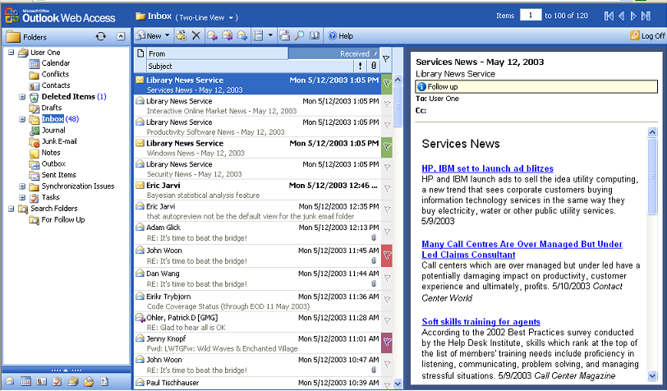

The new layout provides more content in the Reading Pane without diminishing the number of visible items in the message list.

We know one size doesn't fit all when it comes to the amount of screen space to allocate between the message list and the Reading Pane. So now you can divvy up the space as you prefer for every mail folder in your mailbox. And Outlook Web Access will remember your preferences for each folder even after you log off.

Just put your mouse pointer in the boundary between the list and the Reading Pane. When you see the pointer change to , hold the primary mouse button and drag to resize. (This feature only works in Internet Explorer 5.5 and up.)

If you prefer the classic layout with the Reading Pane at the bottom, you can move it back there — or turn it off all together with the Reading Pane toggler on the toolbar.

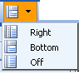

You also can return to the traditional layout of your message list or switch into any of the other Outlook Web Access views you’ve come to rely on. The view menu now is located just above the message list.

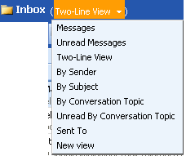

There also are new options for determining whether to automatically mark a message as read when you view it in the Reading Pane. These options are available in the “Reading Pane Options” section of the Outlook Web Access Options Page.

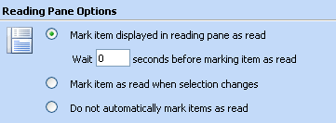

Mark as Read/Unread
The mail view hasn’t just been reoriented — it has new commands, too.

The features “Mark as Read” for unread messages and “Mark as Unread” for previously read messages are available in two ways: a) as keyboard shortcuts, b) as part of a new context menu in the mail view.

The keyboard shortcuts for the feature are as follows:

Mark selected message as read - Ctrl+Q
Mark selected message as unread - Ctrl+U

Context Menu
The context menu, available by right-clicking on items in the message list, contains mark as read/unread as well as several other common commands:

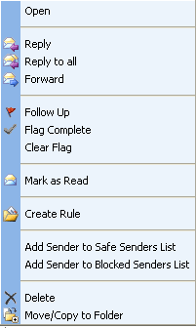

Quick Flagging
You’ll notice there are flagging commands on the context menu. With them, you can quickly flag a message for follow-up or mark complete an item that was previously flagged for follow-up. You also can completely clear the flag status.

These follow-up flags are different from the flags you could set in past versions of Outlook, because they don’t have an associated reminder that you can set to pop up at a desired time. And you can’t use them as a means to flag items you send to other users. Quick Flags simply provide a visual indicator for letting you see which items in your mail you marked as needing further action.

It’s not necessary to use the context menu to flag an item. You simply can click the blank flag icon next to the message that you want to flag. If the flag already has been turned on, you can mark the flag as complete by clicking it again. To clear the flag completely, though, you must use the context menu.

And, finally, if you get tired of farmhouse red for your flag color, you can right-click the flag icon to bring up a context menu of six choices ranging from harvest yellow to aquamarine blue.

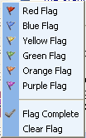

Junk Mail Filtering
Outlook Web Access now has tools to help you keep unwanted junk mail out of your inbox.

Once you enable the option to filter junk e-mail under the “Privacy and Junk E-mail Prevention” section of the Outlook Web Access options page, you’ll be able to quickly add specific senders to your block list.

When you get mail that is from a junk-mail sender, right-click on the message in the message list and choose “Add Sender to Blocked Senders List.” All future mail from that sender will go straight to your Junk E-mail folder. Note: You’ll still have to delete the original message to get it out of your inbox.

If your Exchange administrator has enabled the server-side junk-mail filter (not shipping on the Exchange Server 2003 CD but planned for an SP1 release), then all incoming messages will be scanned, and those that are judged as likely to be spam will be moved automatically to the Junk Mail folder. If mail from some senders is falsely judged as spam, you’ll have the ability to ensure that nothing else from that sender gets moved automatically to the junk mail folder. Just right-click the message and choose “Add Sender to Safe Senders List.”

If you receive mail from distribution lists, you also can add these distribution lists to the “Safe Recipients” list so that these messages will not be filtered to your junk mail. To manage your safe recipients, you need to open the e-mail, right-click on the name of the distribution list, and then choose the “Add to Safe Recipients” option.

If you want to see who is in your safe or block lists or make changes to those lists, you can do so by choosing the “Manage Junk E-mail Lists…” button on the Outlook Web Access options page. From this dialog, you can see the contents of your safe and block lists. You also can add, delete, or modify members of the lists from here.

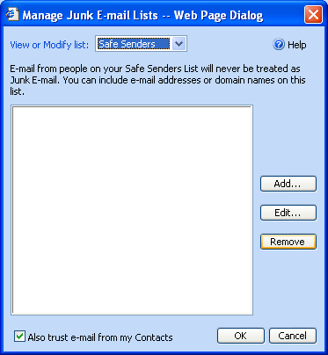

Outlook 2003 also will have its own junk-mail filter. Any additions or changes you make to your block or safe lists in Outlook Web Access will be made in Outlook 2003. The reverse also is true: Outlook Web Access will pick up any additions or changes you make to your block or safe lists in Outlook.

Other New View Features
There are several other new features in the mail view:
- You can set the number of items that display per page in the message list — now you’re not just stuck at 25 (see the “Messaging Options” section of Outlook Web Access’ options page). This option also will affect the number of contacts and tasks that display per page in those modules.
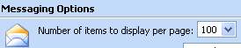
Take note: It can be great to view 100 items per page on a LAN or broadband connection but painfully slow on a dial-up connection. The scenario in which you most commonly will use Outlook Web Access should determine how you set this option.
- You can open or save attachments directly from the Reading Pane.
- You can view sender or recipient properties directly from the Reading Pane.
- When your focus is in the mail view, you have several new keyboard shortcuts for common commands:
Refresh view - F9 (also works for refreshing items in other views)
New message - Ctrl+N (also works for creating new items in other views)
Reply to selected message - Ctrl+R
Reply all to selected message - Ctrl+Shift+R
Forward selected message- Ctrl+Shift+F
The reply and forward shortcuts also work in the item window for a received mail message.
- Icons in your mail folders show the types of messages you’ve received, if they are read or unread, and whether you’ve replied to or forwarded them. These icons can make scanning your mail folders a much quicker task.
- The “By Conversation Topic” view has been improved so that the conversation topic containing the most recent e-mail is at the top of the view.

Deferred Refresh After Delete
In past versions of Outlook Web Access, after you deleted an item in a message list, Outlook Web Access would re-retrieve the entire contents of the list, thus showing you any new messages that had been delivered to the folder. This made deleting messages a slow process, because you had to wait for the entire list to refresh after every delete.

Now Outlook Web Access will not refresh the message list after a delete until more than 20 percent of the messages on a page in the list have been deleted. The percentage is based on the total number of items set to display per page (as set by the user in the Outlook Web Access options page) — not the actual count of messages on a page.

For example, if you request 100 messages to display per page, your message list will not automatically refresh until you’ve deleted 21 messages from a page.

Don’t be alarmed if you’re worried that now you’ll never automatically see your new mail. You still can set an option to be notified when new mail has arrived.

Color Schemes
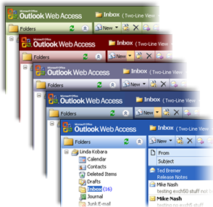
Outlook Web Access’ UI has been changed from gray to a bright blue to match the appearance of Microsoft Office 2003 applications. You also can set the client's hue to one that better suits your mood.

Just go to the “Appearance” section of the Outlook Web Access options page and pick a different color scheme from the dropdown. The standard options are blue, dark blue, burgundy, olive and silver. Additionally, your company may have added its own customized color schemes to the mix.

Standard Fonts
Along with the snazzy new color schemes, the Outlook Web Access user interface looks more stylish because the font used on all the UI text is the same one that’s found in most Microsoft applications. Say goodbye to seeing the Outlook Web Access interface in Times New Roman just because that’s the browser’s default font.

And when you read e-mail messages, if the sender was using a “plain text” mail editor that did not set a font preference on the message body, Outlook Web Access selects a proper font in which to display the message content instead of relying on the browser’s default font.

New Navigation

One of the biggest changes in Outlook Web Access is the merger of the shortcuts bar and folder bar into one unit — no more switching between folders and shortcuts. They’re all in one place now on the new Navigation Pane. You can make the shortcuts large or small, as shown in the following pictures.

Large Shortcuts
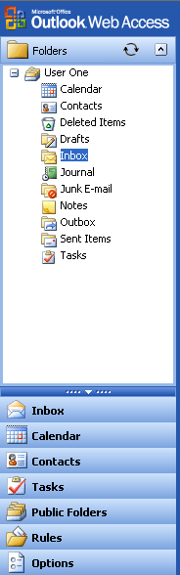
Small Shortcuts
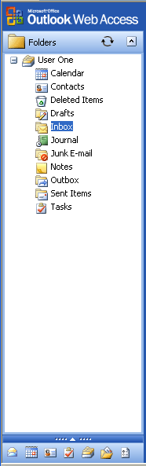

You also can set the width of the Navigation Pane by dragging its border to the left or the right, and Outlook Web Access will remember the custom size from session to session.

Easier Moving or Copying to Folders
If you drag and drop an e-mail message from the message list into a folder in the Navigation Pane, the destination folder where you position your mouse pointer is highlighted — no more guessing which folder is the target of your move or copy.

Even better, if you want to move an e-mail message into a subfolder that isn’t visible, just drag the message to the parent folder but don’t release the mouse button. Keep your mouse pointer positioned over the parent folder until the subfolders automatically expand. Then continue your drag to the now-visible subfolders and release the mouse button when the desired folder is highlighted.

Update Folders
One of the most common complaints from Outlook Web Access users is that the number of unread messages in their folders doesn’t stay updated in real time. The problem with providing such functionality is that it would use significant server and network resources to continually poll your Exchange server to keep the folder information accurate. But now you have an easier option than refreshing the entire browser to get updated counts of unread messages in your folders.

Just click the icon at the top of the folder list. When you do that, you’ll get a refreshed count of unread items in your inbox and other folders without affecting any other part of the client.

Words of warning: Refreshing the folder tree will collapse any open folder branches, so if you’re working in a folder that’s nested several levels deep, you may not want to update all your folders right now. You can update the counts for an individual folder by right-clicking it and choosing “Update Folder” from the context menu.

You also may notice that some folders show an item count in blue parentheses like this (1), but others show a count in green brackets like this [1]. The former is the number of unread items in a folder, while the latter is the total number of items in a folder. By default, the Drafts folder now shows a total item count. In Outlook you can set your count-type preferences for every folder, and Outlook Web Access will respect those preferences.

Search Folders
Along with a couple new navigation options such as Tasks and Rules, there may be a new section in your folder tree called Search Folders.

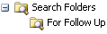

We’ll cover Tasks and Rules later in this document. Search Folders are a new addition to Outlook 2003. They’ll only show up in Outlook Web Access if you’ve created or activated them while running Outlook in “online mode,” where Outlook has a constant connection to the Exchange server. Search Folders can’t be created or modified in Outlook Web Access. And if you only use Outlook in “cached Exchange” mode, you’ll never see any Search Folders in Outlook Web Access.

Search Folders are very powerful because they let you find all the mail in your account that’s been sent from a particular person or that’s been flagged for follow up or that meets some other set of criteria important to you. If you use Search Folders in Outlook 2003, now you can use them in Outlook Web Access, too!

Notifications
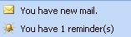
If you’ve enabled the setting to be notified of new mail and/or reminders, the Navigation Pane now tells you when you have new items in your inbox and/or active reminders that you’ve neither dismissed nor snoozed.

Public Folders
Public Folders now display in their own window. If you click the Public Folders button on the Navigation Pane, it launches a new browser window containing only Public Folders.

Log Off
This feature has been moved from the Navigation Pane to the far end of the toolbar.

Improved E-mail Experience

E-mail is the heart of Outlook Web Access, and we’ve added features to make it easier than ever to compose messages or get the information you need from received messages.

Spell Check
It’s time to find a better excuse for typos in your messages other than “Outlook Web Access doesn’t have a spell checker.” In Outlook Web Access for Exchange 2003, you can spell check in English, French, German, Italian, Korean, or Spanish. Just click the familiar spell check icon in a draft e-mail message’s toolbar: .

If you've ever sent a message and then immediately wished you'd spell checked it first, Outlook Web Access also lets you set an option to always spell check on send.

One warning: Remember that spell checking in Outlook Web Access is a server-side process, which means the contents of your message must be sent back to the server for examination. On a slower link, you may find the process of automatically spell checking every outgoing message to be time-consuming. Keep this in mind when deciding whether to enable the feature to always spell check on send.

The “Spelling Options” section in the Outlook Web Access options page is the place to configure your spell check settings. But guess what? There’s nothing to download to enable spell check. It just works!
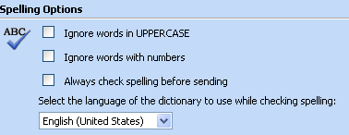

New Addressing Wells
Here’s a familiar scenario: You type an alias in an Outlook Web Access e-mail message and then learn when you try to send the message that the address was unrecognized. When this happens, how easy is it to get rid of that bad e-mail address from your message?

If you were smart enough to realize from the get-go that you had to click the unrecognized name to bring up its properties and then delete the address from that properties dialog — good for you! But for anyone who found the process tedious at best and confusing at worst, help is here.
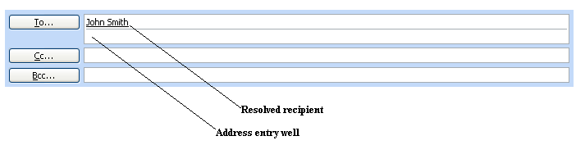

Outlook Web Access for Exchange 2003 makes it easy to delete ambiguous or recognized addresses from an e-mail message you’re composing. All you have to do is click the address to highlight it, and press the delete key to remove it. You also can right-click the address and choose “Remove” from the context menu.

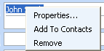

GAL Properties Sheets
When you right-click a recognized or ambiguous address, you’ll also notice “Properties” as a menu choice. But the properties dialog in Outlook Web Access for now shows a lot more useful information.

If a name in an e-mail message has been resolved against the Global Address List (GAL), in the properties dialog you now will see some of the key GAL properties for that address — not just the display name and SMTP address of the recipient.

Properties sheet from a received message
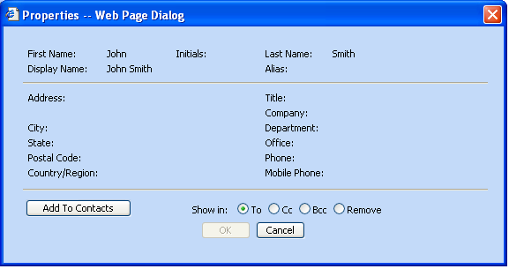

Properties sheet from a draft — has additional controls for determining location of recipient
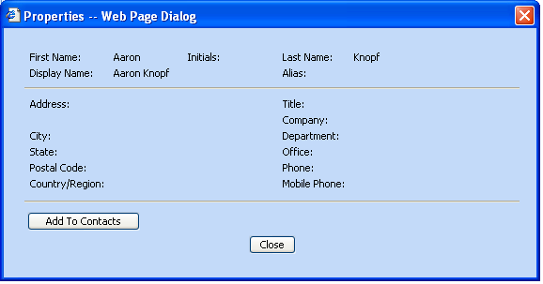

Outlook Web Access doesn’t show the full range of GAL properties that Outlook shows, just the main address and phone information that’s listed in the GAL for the address.

Simple SMTP addresses or addresses that come from your Contacts folder still show the same information as was available in old versions of Outlook Web Access: display name and SMTP address.

Properties sheets are now available from more locations than e-mail messages or meeting requests. They also can be invoked by double-clicking (or right-clicking and choosing “Properties”) on the sender or recipients in received e-mail messages. Or as noted earlier, in the Reading Pane you can double-click senders or recipients to see their properties.

There also are buttons for invoking properties from Find Names and from the Check Names.

Add to Contacts
The “Add to Contacts” command makes it easy to quickly add any address — whether it’s on a message you’re composing or on a message you’ve received — into your main Contacts folder.

You’ll find the command conveniently located on the context menu that appears when you right-click a resolved name in an e-mail message or meeting request. (This context menu is not available in the Reading Pane.) There’s also an “Add to Contacts” button in the properties dialog for resolved e-mail addresses.

Find Names Enhancements
Adding the ability to invoke properties sheets from Find Names is just one of several enhancements we’ve made there.

Now you can choose whether to search the GAL or your Contacts folder when you’re looking up an address.

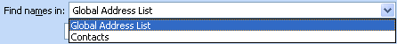

And if you call up Find Names from a view instead of an e-mail message, there’s a new feature for creating a message to any one of the addresses in your search results.

You’ll also notice that the search results in Find Names or Check Names now are sorted alphabetically

Auto Signature
How many times have you typed your name, title, extension, and other bits of info at the end of every message you send in Outlook Web Access? If your answer is, "Too many," well your days of needless typing are over.

Create an Outlook Web Access signature by clicking the "Edit Signature" button under “Messaging Options” on the options page, and then give your fingers a rest.

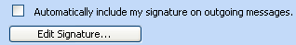

You can set the signature to be automatically included in every message you create. Or you can just create the signature and insert it on demand via the "Insert Signature" toolbar button in the message compose form: .

Default Mail Font
Another new setting under “Messaging Options” is the default font for the e-mail editor. Now your Outlook Web Access e-mail editor font no longer has to be the same as the browser’s default font. Choose any font face, size, and color available on your PC or stick with the choice that Outlook Web Access makes for you.

Navigate After Delete
Outlook Web Access now has a long-requested feature to allow you to choose where you navigate after deleting an open message. You can choose to automatically open the next message in the folder, open the previous message, or go back to the message list in the view.

The default behavior is to automatically open the next message. You can change your preference in the “Messaging Options” on the Outlook Web Access options page.

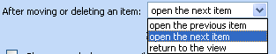

It’s important to note that regardless of your setting, if you open a message from Folder A, switch to Folder B, and then delete the open message, you’ll navigate to the message list for Folder B. Outlook Web Access will not open a new message from Folder A.

Finally, if you delete a message directly from the message list — not one that you had opened into its own window — the highlight will move down in the message list after the delete if you’ve chosen either the “open the next message” setting or the “return to the view” setting. The highlight will move up if you’ve chosen “open the previous message.”

Read Receipt Settings
In previous versions of Outlook Web Access, if you read a message where the sender had requested a read receipt, Outlook Web Access sent the receipt automatically. You didn’t have a choice to block the sending of read receipts. Well, now you do with Outlook Web Access for Exchange 2003.

In the “Privacy and Junk E-mail Prevention” section of the Outlook Web Access options page, there’s a setting to determine whether Outlook Web Access sends read receipts.

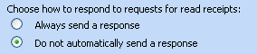

By default, Outlook Web Access will no longer send read receipts automatically. In the Premium client, you’ll see an infobar in a received e-mail message any time a user requests a read receipt. There will be a link in the infobar that you can activate if you wish to honor the request for a receipt.

If you change the setting to always send read receipts, then Outlook Web Access will fall back to the old behavior of automatically filling all read-receipt requests without notifying you of those requests.

“Web Beacon” Blocking
When a junk-mail sender distributes junk e-mail, he often doesn’t know whether he’s sending messages to valid e-mail recipients. But with old versions of Outlook Web Access, if you were to open a junk e-mail — or even just read it in the preview pane — the sender had the potential to know your address was real and active because of something called a “Web beacon.” Now Outlook Web Access blocks potential “Web beacons” by default.

Here’s how a “Web beacon” works. When you receive an HTML-based e-mail message, it can contain pictures, video, or other types of content other than just text. Sometimes those pictures, videos, etc. come as attachments, which actually reside in the message body. But other times this content is located on an external Web server on the Internet rather than actually being part of the e-mail message. And it’s in messages that contain references to external content where trouble with “Web beacons” can begin

Let’s say that instead of referencing a picture or video, the sender references a program on his Web server that is designed to catalog your e-mail address as valid once you open the message. That’s a “Web beacon.” And if the sender was a junk e-mailer, once he knows your address is legit, it’s open season on your account.

But Outlook Web Access for Exchange 2003 has made it tougher for junk senders to use “Web beacons” to retrieve your e-mail address. Now if you receive a message with references to external content, Outlook Web Access will block the download of that content and display the following warning message.

Outlook Web Access can’t tell you whether the message actually contains “Web beacons.” The references to external content may be harmless. If you believe the message is legitimate, you can just choose to see the message with all its pictures and other external content. But if you suspect the message contains beacons for nefarious purposes, you now can just delete the message without triggering anything that tells the sender, “Hey, I’m here. Send me more junk mail.”

You also have the option of disabling this feature in the Outlook Web Access options page.

Privacy Protection When Following A Link In E-Mail
When a user clicks a hyperlink in the body of an e-mail message, Outlook Web Access helps protect private information from being revealed to the visited Web site. Past versions of Outlook Web Access would reveal the user’s account name, server name, and the subject of the message that contained the link. Now only the user’s server name is revealed to the visited site.

Attachment Blocking
There are a host of new attachment-blocking features in Outlook Web Access.

By default, attachments with the following extensions are blocked in Outlook Web Access for Exchange 2003: ade, adp, app, asx, bas, at, chm, cmd, com, cpl, crt, csh, exe, fxp, hlp, hta, inf, ins, isp, js, jse, ksh, lnk, mda, mdb, mde, mdt, mdw, mdz, msc, msi, msp, mst, ops, pcd, pif, prf, prg, reg, scf, scr, sct, shb, shs, url, vb, vbe, vbs, wsc, wsf, wsh.

Users who receive messages with these attachments will see the following message in the infobar.

Administrators also can block access to attachments in specific scenarios. At the most restrictive, an administrator can block access to all attachments. Or it’s possible for an administrator to block access to attachments when users connect to Outlook Web Access through the Internet but to allow access when users connect through the corporate intranet. This is particularly useful for keeping users from potentially compromising corporate security by opening attachments when using Outlook Web Access at public Internet terminals while still providing full access to employees in the office.

Similar to attached files are documents and other types of files stored in Public Folders. By default, Outlook Web Access now blocks users from opening these documents. But an administrator has the same flexibility of permitting or denying access to these files that the admin has to permitting or denying access to attachments.

Infobar Improvements
The infobar now will indicate the date and time you replied to or forwarded a received message.

The infobar in a received e-mail now shows the message’s sensitivity setting, if one was sent, such as Confidential.

Reply Header And Body Not Indented
Here’s a common scenario: You get added to a message that other people already have sent back and forth many times over. You want to understand the history of the issue that’s being discussed, so you scroll through the old contents of the message, working your way through all the replies back to the original message. But before you reach the beginning, you get to a point where it’s impossible to read any more. The old contents have been indented into illegibility because of the Outlook Web Access feature of indenting the old message body on reply.

Well, Outlook Web Access is not going to indent the message on reply any more. We can’t guarantee what other e-mail clients will do. But from now on, with Outlook Web Access for Exchange 2003 (or Outlook 2003), the reply header and body will stay at the same alignment as the original content. Instead of an indent, a horizontal rule offsets the reply header and body from the new content.

Item Window Size
Outlook Web Access used to always launch any window, either to read an item or create an item, at the set size of 500 pixels wide by 700 pixels high. If you resized an item window, it didn’t matter. The next time you opened an item, it still would be 500x700.

Now, during an Outlook Web Access session, Outlook Web Access will remember if you resize the item window and will open all future item windows at that size. The new window size is not persisted to future Outlook Web Access sessions.

This works for all item windows — mail, calendar, contacts, and tasks. It is one size for all item windows, not one size for messages and another for tasks.

Window Status Bar
All Outlook Web Access item windows now show a status bar at the bottom. If you receive a message that contains a hyperlink, you can position your mouse pointer over the link and look in the status bar to see the target Web address (aka the URL) for the link.

Mail in Public Folders
You’ve always been able to post to Public Folders from Outlook Web Access, but in Outlook Web Access for Exchange 2000 you couldn’t send e-mail from Public Folders.

For example, if you wanted either to reply privately by e-mail to a post or e-mail in a public folder or to forward the item to another person, you couldn’t do it. Now you can so long as you connect to your Outlook Web Access account through a front-end server. (If you’re reaching your account through an address like https://mail.northwindtraders.com/exchange, you’re probably going through a front-end server.)

If you are able to reply or forward to an item in a public folder, you’ll see additional buttons on the item toolbar and additional choices on the context menu if you right click the item in the public folder’s message list:

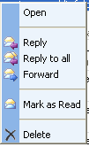

Signed And Encrypted Mail

A major addition to the Outlook Web Access e-mail experience is the ability to send and receive signed and/or encrypted mail, also known as S/MIME mail.

Signed mail is verified to be sent by the possessor of a specific digital ID. When you receive an e-mail with a valid digital signature, you can have more assurance that the message came from the listed sender than you would with either an unsigned e-mail or an e-mail with an invalid digital signature.

Encrypted mail is mail that can be opened only by a user with a specific digital ID. The holder of that digital ID has a special key for decrypting the message you sent.

Requirements
There are four requirements that you must meet to use S/MIME mail in Outlook Web Access:
- You must be using Internet Explorer 6.x for Windows. This feature will not work on any other browser — including other versions of Internet Explorer.
- You must be working on a PC where you can download the S/MIME control.
- You must have a valid digital ID for sending signed mail and/or receiving encrypted mail.
- You must be using Windows 2000 or above.

Why You Should Download The S/MIME Control
Even if you don’t intend to send signed or encrypted mail, there are several reasons to download the control.

First, with the S/MIME control, you can just drag and drop files and even other e-mails into the body of a message you’re composing. If the files you drag and drop are graphics, they’ll show up inline in the message body. All other types of attachments, including other e-mail messages, will show up in the attachment well.

Second, if you don’t find it easy to drag and drop items into a message, the S/MIME control’s Add Attachment dialog is far easier to use than it is in the normal e-mail editor. You don’t need to use one dialog to find the items and another to attach them. And you can attach multiple files at one time so long as the files all are stored in the same location.

Third, no matter how files or items are added to the attachment well, if you realize you want to remove them from your message, all you need to do is right-click the items and choose “Remove” from the context menu.

Fourth, even if you don’t intend to send signed or encrypted mail, the S/MIME control will better handle the signed mail you receive. If you don’t have the S/MIME control, at best, you’ll be able to read the signed messages, but any attachments will get stripped out if you try to forward the messages. At worst you may not be able to read the signed messages at all. Past Outlook Web Access users may view this as an improvement. Previously, the attachments and the entire body of a signed message were dropped on reply or forward, and you also couldn’t open e-mail attachments in signed messages you received.

But if you download the S/MIME control, you’ll be able to read all these signed messages and forward them in their full fidelity!

How To Download The S/MIME Control
The button for downloading the S/MIME control is available in the “E-mail Security” section of the Outlook Web Access options page.

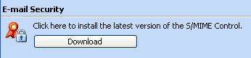

After you click download, you’ll see the following file download dialog:

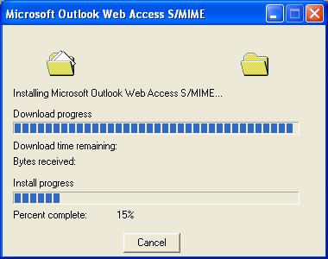

Once the control is installed on your computer, you’ll notice that there are two new buttons on the toolbar of the e-mail message editor: . These are the buttons that you’ll use to encrypt and/or sign messages on demand. The first button is for encrypting messages. The second is for digitally signing messages.

The “E-mail Security” section of your options page also will have new features for setting all your messages to be encrypted and/or signed by default.

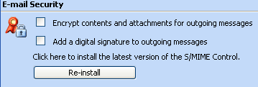

Finally, any signed e-mail you receive now will display additional information about the signature of the sender when you click the button in the message.

If you ever need to reinstall the S/MIME Control for any reason, you can go back to the “E-mail Security” section of the OWA options page and choose the “Re-install” button. And if your administrator upgrades your Exchange server, you may see an infobar in your inbox to download an updated version of the S/MIME Control, at which point you would just repeat the original steps you followed here to download it.

It’s also important to note that this control needs to be installed on any computer where you want to use S/MIME mail in Outlook Web Access. There may be some PCs, such as Internet kiosks, where you are unable to download the control. In these locations, you will not be able to send signed mail or read encrypted mail from Outlook Web Access. And remember, it only works in Internet Explorer 6.x on Windows 2000 or higher.

Even after you’ve downloaded the control, you’re still only halfway toward using S/MIME mail. You still need a digital ID for signing your mail and receiving encrypted mail

Getting Your Digital ID
Every organization has a different process for assigning digital IDs to users. You should check with your Exchange administrator about how to obtain a digital ID.

If you want to send encrypted mail to another user, that recipient also will need to have a digital ID that Outlook Web Access understands. If you try to send an encrypted message to a user who isn’t enabled to receive encrypted mail, the send will not proceed and you will receive the following warning:

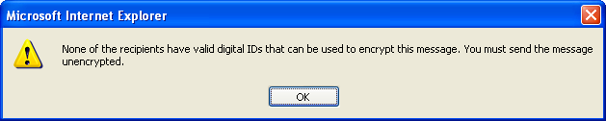

If you are sending an encrypted message to multiple recipients and some of these recipients are not enabled to receive encrypted mail, you will be told which recipients do not have the necessary digital IDs to receive encrypted mail:

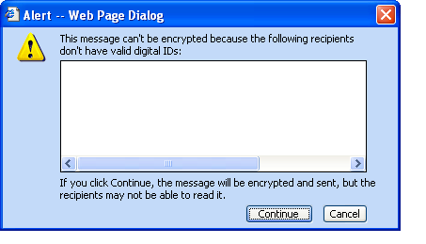

If you continue with the send, any recipients without digital IDs will not be able to read the message.

It’s easy to preemptively check whether a user can receive encrypted mail. Just look up his or her e-mail properties (by any of the methods described earlier in this primer).
If the user has the  icon on her properties sheet, she can receive encrypted mail. But if she has the icon, she is not enabled to receive encrypted mail. Of course, this information is only displayed in e-mail properties sheets if you have first installed the S/MIME control.

Removing The S/MIME Control
If you decide not to use the S/MIME control, you can remove it from the Add or Remove Programs feature in the Windows Control Panel. Just choose to remove the program called “Microsoft Outlook Web Access S/MIME.” Please make sure to close any open messages in Outlook Web Access before removing the S/MIME control.

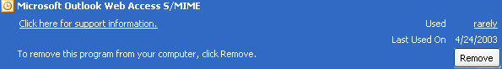

Rules

You now can create server-based mail-handling rules in Outlook Web Access or use it to manage the server-based rules you created in Outlook. The link for entering the rules interface is near the bottom of the Navigation Pane. Here’s what you’ll see if you activate it (of course, you’ll have a different set of rules):

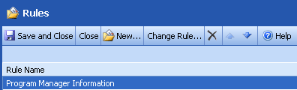

Actions and Criteria
Any rule created in Outlook that can’t be modified in Outlook Web Access is grayed out in the Outlook Web Access rules interface. Outlook Web Access has a simple rule editor that isn’t designed to handle the full gamut of conditions and criteria available in creating rules in Outlook. Rather, as shown below, Outlook Web Access focuses on using rules for the most common mail-management scenarios like moving mail from a particular sender or with a particular subject to a specific folder.

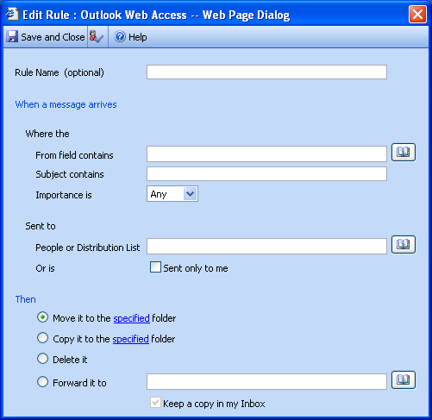

The most common mail-handling actions are supported:
- Automatically move/copy message to a folder.
- Automatically delete message.
- Automatically forward a message (with the option to keep a copy).

There are several criteria that Outlook Web Access rules can evaluate before acting on messages:
- From field contains ______.
- Subject contains ______.
- Sent to (user names and/or distribution list).
- Sent only to me.
- Level of importance.
The rule editor also can be invoked directly via a toolbar button in a received message 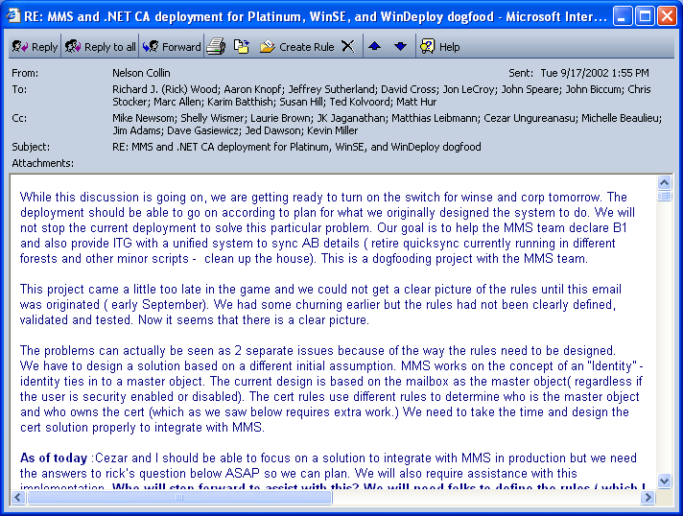 or from the context menu in the mail view.

Handling Disabled Rules
Because of interoperability limitations with Outlook, Outlook Web Access will need to delete all rules disabled from Outlook before letting you modify any active rules.

Some people create many rules in Outlook that they enable and disable based on their schedules. For example, a traveling salesperson may enable a rule while she is out of the office to forward all mail with a particular subject to a specific coworker. When the salesperson returns to the office, she disables the rule.

But if this salesperson were to go to Outlook Web Access to create or modify another rule while this forwarding rule was disabled, Outlook Web Access would need to delete the disabled rule before saving the Outlook Web Access-created/modified rule.

This deletion of disabled rules will not happen automatically. When you go to modify a rule, you will receive a warning indicating that your disabled rules will be deleted if you proceed. The choice is yours.

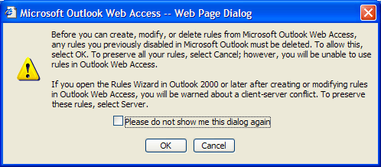

If you do modify rules from Outlook Web Access, the next time you launch Outlook or attempt to modify rules there, you may be asked via a dialog whether you want to keep client or server-side rules. If you want to retain the rules you created in Outlook Web Access, you will need to choose server-side rules. Your client-side rules will no longer function and will be gone completely when using Outlook 2000 or earlier. In some cases, remnants of these defunct rules still may appear in OWA, where they will need to be deleted.

Broken Rules
Sometimes other actions you take in Outlook or Outlook Web Access have an affect whether a rule can function correctly. For example, say you have a rule to move all items from John Smith into the “Messages from John Smith” folder. If you delete this folder, your rule to move items there becomes invalid.

When a condition like this occurs, the Outlook Web Access rules interface will display the broken rule in red, and there will be an infobar explaining that the rule needs to be repaired.

Personal Tasks

You might be asking yourself, “Haven’t I always been able to see Tasks in Outlook Web Access.” Sure, the old version of Outlook Web Access let you see the tasks you created in Outlook, but you couldn't edit these tasks or create new ones.

Outlook Web Access for Exchange 2003 lets you create and manage personal tasks or manage those personal tasks you already created in Outlook.

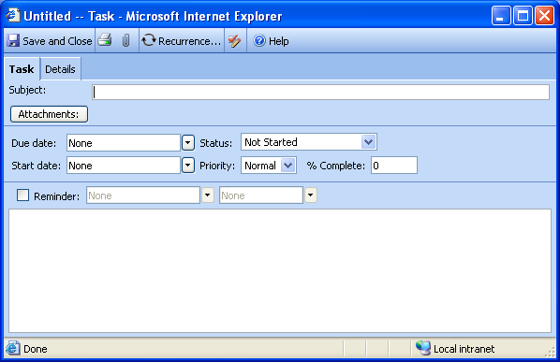

No Task Requests
Outlook has a feature for delegating tasks to other users via Task Requests. Outlook Web Access does not have this functionality. Furthermore, in Outlook Web Access you cannot process Task Requests sent from Outlook or update any delegated tasks you’ve already accepted in Outlook.

Outlook Web Access does allow users to delete Task Requests or previously accepted delegated tasks, but the assignor will receive no feedback that the delete took place.

Delete vs. Skip Occurrence
In Outlook, when a user attempts to delete a recurring task, the user receives a choice: delete a single occurrence or the entire recurring series.

In Outlook Web Access, the delete command ALWAYS deletes the entire task series. If a user wants to skip an individual occurrence, there is a command on the task edit form for skipping a single occurrence:

Setting Completion Percentage
Outlook allows users to input decimal values in the “% Complete” field, but Outlook Web Access always will round this values to the nearest whole number. If an Outlook user inputs a decimal value in this field and then later looks at the task in Outlook Web Access, the value will appear to have changed to the nearest whole number. However, the change will not be permanent unless the user actively saves the task in Outlook Web Access.

Task Reminder Differences
In Outlook, when a task reminder appears, it is listed as being due at that moment. But this is not necessarily accurate. For example, if the task’s due date was set to be a day later than the reminder date, the task isn’t due when the reminder appears.

In Outlook Web Access, when a task reminder appears, Outlook Web Access calculates how much time remains between the reminder date/time and the task due date. Because tasks have no due time, the “Day start time” as set in “Calendar Options” on the Outlook Web Access options page is used as the task due time.

For example, say a task reminder was set to appear on January 1, 2004 at 12 p.m. for a task that’s due on January 2, 2004. And the “Day start time” is set for 8 a.m. When the reminder for the task appears, it would be listed as being due in 20 hours.

If a task has no due date, Outlook Web Access will display a due-in value of “None” in a reminder for that task.

Meeting Request Enhancements

Several popular Outlook features now have been added to Outlook Web Access meeting requests.

- You now can forward meeting requests to people not originally on the organizer’s invite list (even if you’re the organizer). You also can create an e-mail reply to a meeting organizer (and optionally all the attendees) directly from a meeting request.
- When canceling meetings, you now can edit the meeting cancellation notice before it is sent to explain the reason for the cancellation.
- Attendees now can set reminders on the meeting requests they accept in Outlook Web Access.
- Invitees can open the Calendar from a meeting request so that they can view their schedules while evaluating the meeting request.

Other Notable Improvements

BiDi Support
Outlook Web Access now supports right-to-left layouts in the Arabic and Hebrew versions of the client.

You’ll also notice two new buttons on the formatting toolbar in the e-mail editor: . These buttons are for setting the individual direction of each paragraph in your e-mail message. If you are composing a message in a left-to-right language like English but need to add a paragraph containing right-to-left content — say some Arabic or Hebrew — you can start a new paragraph and switch into right-to-left mode by clicking .

The reverse is true, too: If you are composing in a right-to-left language like Arabic or Hebrew but need to add a left-to-right paragraph in English, for example, you can switch into left-to-right mode by clicking .

Internet Explorer 6.x for Windows is required for bidirectional support.

Options Page Toolbar
The toolbar now stays put when you scroll through the Outlook Web Access options page, which means as soon as you’ve made your changes in options, you can save them without having to scroll back to the toolbar.

——————————————————————————————

Outlook Web Access Basic
The Outlook Web Access Basic client is designed to run in most common browsers (compliance with the HTML 3.2 and European Computer Manufacturers Association (ECMA) Script standards is required). Outlook Web Access Basic has a different user interface than the Premium client and only a subset of the Premium client’s functionality. Outlook Web Access Basic, however, is the preferred client for users with accessibility needs.

This document provides a quick overview of what was added to Outlook Web Access Basic in Exchange 2003. It is necessary to first read about the enhancements to Outlook Web Access Premium to understand the changes in the Basic client.

Logon Page

When you access your e-mail account through Outlook Web Access, if you’re logging on via a front-end server like https://mail.northwindtraders.com/exchange, you’ll be directed to a logon page.

If you are using Internet Explorer 5.01 - 6.x for Windows as your browser, you’ll get the Outlook Web Access Premium version of the logon page, where you can choose the Premium or Basic client. If you are using any other browser, you will not have this choice.

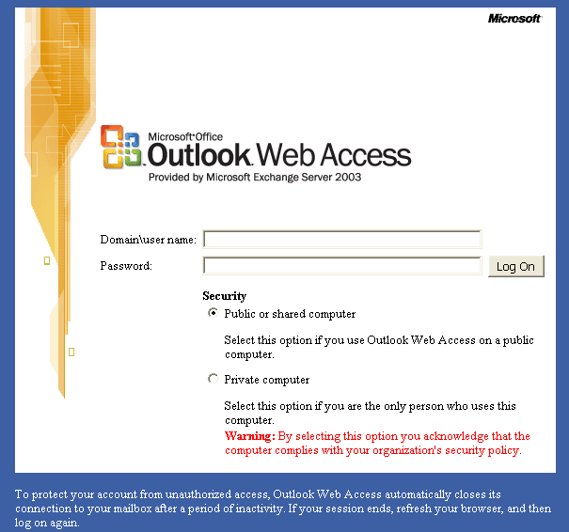

The security-level feature functions exactly the same way as described for Outlook Web Access Premium and has the same effect on how long your session can be inactive before expiring.

UI Revamp

Once you log in to Outlook Web Access Basic, you’ll notice that the UI has been refreshed from battleship gray to the same true-blue color scheme as in the Premium version. However, this is the only color scheme available for the Basic client. Also, the Basic client still uses the browser’s default font for displaying UI text.

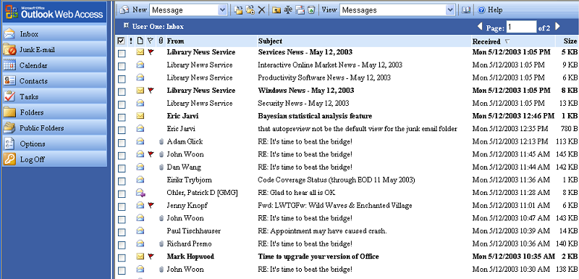

The enhancements to the e-mail view include:

- An option to set the number of lines that display per page in the message list — now you’re not just stuck at 25 (see the “Messaging Options” section of the Outlook Web Access options page). Note: Whatever value you set in the Premium client is used by the Basic client and vice versa.
- Icons in your mail folders show the types of messages you’ve received and whether the messages are read or unread.
- The “By Conversation Topic” view has been improved to put the newest conversation at the top of the messages list.

Outlook Web Access Basic does not have a Reading Pane, context menus, the ability mark as read/unread, Quick Flagging, keyboard shortcuts, or deferred refresh after delete.

Junk Mail Filtering
Outlook Web Access Basic does allow you to manage your junk e-mail settings, but you cannot add new senders to the block or safe lists directly from the view. Instead, you must manage these settings completely from the “Privacy and Junk E-mail Prevention” section of the Outlook Web Access options page. Just choose the “Manage Junk E-mail Lists” button, and you’ll be taken to an interface where you can add, modify, or remove members in your block and safe lists.

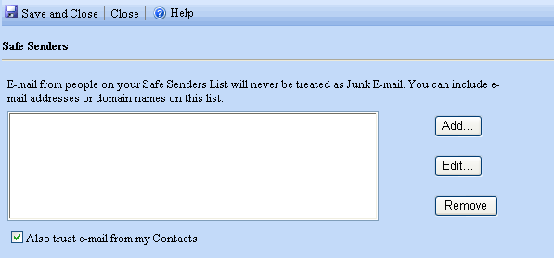

The contents of the block and safe lists will be the same whether you manage them from Outlook, Outlook Web Access Basic, or Outlook Web Access Premium.

Navigation

There have been cosmetic changes to the Outlook Web Access Basic Navigation Pane. There is now a link there for quick access to your Junk Mail folder, and the Public Folders link is now in the Navigation Pane, too. But otherwise the Navigation Pane functions as it always has.

Outlook Web Access Basic provides no access to Search Folders or rules. There are no commands for updating folders or for making it easier to drag items into folders, because Outlook Web Access Basic does not show folders in the Navigation Pane. And there are no notifications in the Outlook Web Access Basic Navigation Pane for new mail or pending reminders. In fact, Outlook Web Access Basic does not display reminders at all.

Improved E-mail Experience

Outlook Web Access Basic does not have a spell checker, and the functionality of adding/removing the addresses in the recipient wells has not been changed.

GAL Properties Sheets
If a name in an e-mail message or meeting form has been resolved against the Global Address List (GAL), in the properties dialog you now will see some of the key GAL properties for that address — not just the display name and SMTP address of the recipient. Just click any resolved name in an e-mail you’re writing or reading to see its properties sheet.

Properties sheet from a draft — has additional controls for determining location of recipient
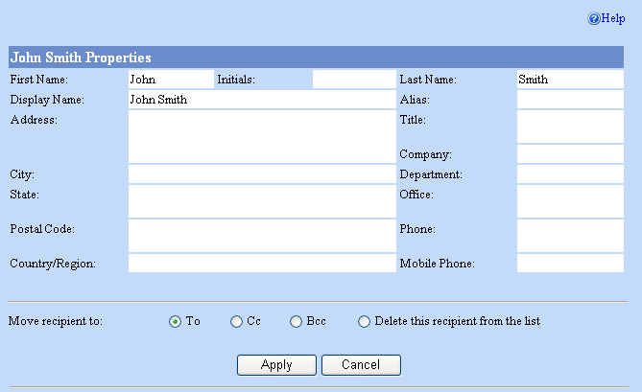

Properties sheet from a received message
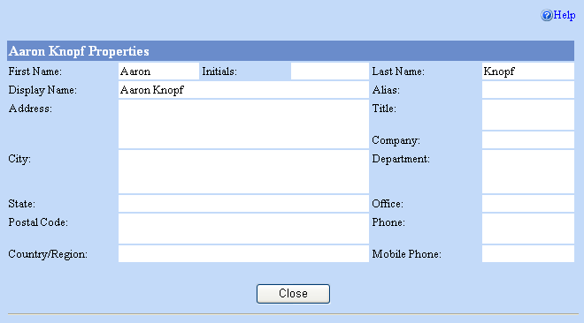

Outlook Web Access doesn’t show the full range of GAL properties that Outlook shows, just the main address and phone information that’s listed in the GAL for the address.

Simple SMTP addresses or addresses that come from your Contacts folder still show the same information as was available before: display name and SMTP address.

Unlike in Outlook Web Access Premium, Outlook Web Access Basic does not have buttons for invoking e-mail properties from Find Names or Check Names.

Outlook Web Access Basic does not have the “Add to Contacts” feature on properties sheets or anywhere else in the client.

Find Names Enhancements
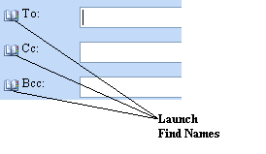
You now can add names found in a GAL search directly to a message or a meeting request you’re composing. Just click on any of the address book icons in the mail or meeting compose forms to launch Find Names.

Find Names now appears in its own window, and the results of your query are sorted alphabetically.

You can’t search Contacts in Outlook Web Access Basic’s Address Book — only the GAL.

Auto Signature
You can create a plain-text auto signature in basic Outlook Web Access in the editor under “Messaging Options” on the Outlook Web Access options page.

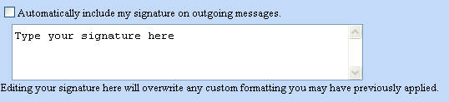

If you already have created a signature in Outlook Web Access Premium, then a plain-text representation of that signature will exist in Outlook Web Access Basic. If you make any edits to the signature in Outlook Web Access Basic, however, you will overwrite all custom formatting in your Outlook Web Access Premium signature.

You cannot insert a signature on demand in Outlook Web Access Basic — you either enable it to be inserted automatically or not at all.

Default Mail Font
Because Outlook Web Access Basic only allows plain-text mail editing, there is no need for a default font.

Navigate After Delete
Outlook Web Access Basic does not have special options for where to go after deleting an open message. You always return to the message list.

Read Receipt Settings
By default, Outlook Web Access for Exchange 2003 will not send read receipts automatically. But unlike in the Premium client, you won’t se a message in the infobar any time a user requests a read receipt. If you set the option not to send read receipts, Outlook Web Access Basic never will let you send a read receipt.

If you change the setting to always send read receipts, then Outlook Web Access will fall back to the old behavior of automatically filling all read-receipt requests without notifying you about those requests.

Please note that however you set this option in the Premium client will affect the behavior in the Basic client and vice versa.

“Web Beacon” Blocking
This is the same in Outlook Web Access Basic as it is in Outlook Web Access Premium. If you enable or disable the feature in the Premium client, it will affect behavior in the Basic client and vice versa.

Privacy Protection When Following A Link In E-Mail
This feature is the same in Outlook Web Access Basic as Outlook Web Access Premium.

Attachment Blocking
This administrative setting affects Outlook Web Access Basic just as it affects Outlook Web Access Premium.

Sensitivity And Reply/Forward Infobar
This feature is the same in Outlook Web Access Basic as Outlook Web Access Premium.

Reply Header and Body Not Indented
Because Outlook Web Access Basic uses a plain-text mail editor, Outlook Web Access Basic has never indented old message content on reply or forward.

Item Window Size And Status Bar
Because items in Outlook Web Access Basic do not display in their own windows, the window-size feature does not apply to Outlook Web Access Basic. Furthermore, because Outlook Web Access Basic runs in the full browser window and does not open individual item windows, the status bar always has been available when items are open.

Mail in Public Folders
This feature is the same in Outlook Web Access Basic as Outlook Web Access Premium.

Signed And Encrypted Mail

There is no S/MIME mail in Outlook Web Access Basic. However, Outlook Web Access Basic now lets you open attached e-mail within a clear-signed message. Furthermore, Outlook Web Access Basic preserves the message body contents (but not attachments) when you reply to or forward a clear-signed message.

Rules

There is no rules interface in Outlook Web Access Basic. However, your e-mail still is processed according to the server-side rules you set from Outlook or Outlook Web Access Premium.

Personal Tasks

All of the task-related features available in Outlook Web Access Premium also are available in Outlook Web Access Basic except for reminders. (You can set a reminder date and time, but no reminder will ever appear in Outlook Web Access Basic.) Of course, because of UI differences, the way to complete certain actions may be different.

For example, in the task view, to mark an item as complete, you cannot just click a “Mark Complete” checkbox as in Outlook Web Access Premium. Instead, you must select the task to mark complete and then choose the “Mark Complete” button on the toolbar.

Or when composing a task, the user interface for choosing a task start date, due date, or reminder date is very different in the Basic client from the Premium client.

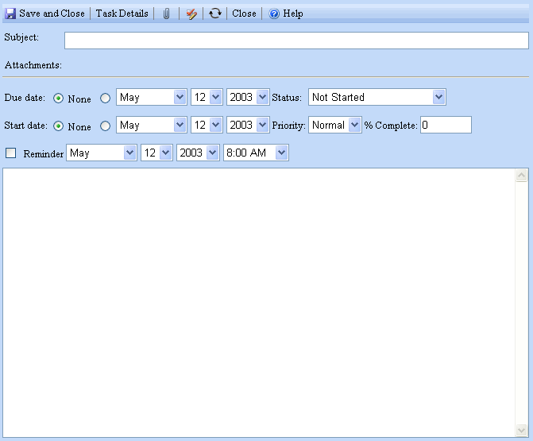

Meeting Request Enhancements

Several popular Outlook features now have been added to Outlook Web Access Basic meeting requests.

- You now can forward meeting requests to people not originally on the organizer’s invite list (even if you’re the organizer). You also can create an e-mail reply to a meeting organizer (and optionally all the attendees) directly from a meeting request.
- When canceling meetings, you now can edit the meeting cancellation notice before it is sent to explain the reason for the cancellation.
- Invitees can open the Calendar from a meeting request so that they can view their schedules while evaluating the meeting requests.

However, attendees cannot set reminders on accepted meeting requests in Outlook Web Access Basic.

Other Differences From Outlook Web Access Premium

Outlook Web Access Basic does not support right-to-left layouts for languages such as Arabic and Hebrew.

Toolbars and view headers are not fixed to the top of the window, so when the user scrolls down in the view, the toolbars and view headers scroll off screen.

