

Planning an Exchange Server 2003 Messaging System



 | Valid Until: January 1, 2004  Product Version: Exchange Server 2003  Reviewed by: Exchange Product Development  Latest Content: www.microsoft.com/exchange/library  Author: Exchange Documentation Team



Planning an Exchange Server 2003 Messaging System

Michele Martin

Published: August 2003
Applies To: Exchange Server 2003
Copyright
Information in this document, including URL and other Internet Web site references, is subject to change without notice. Unless otherwise noted, the example companies, organizations, products, domain names, e-mail addresses, logos, people, places, and events depicted herein are fictitious, and no association with any real company, organization, product, domain name, e-mail address, logo, person, place, or event is intended or should be inferred. Complying with all applicable copyright laws is the responsibility of the user.
Microsoft may have patents, patent applications, trademarks, copyrights, or other intellectual property rights covering subject matter in this document. Except as expressly provided in any written license agreement from Microsoft, the furnishing of this document does not give you any license to these patents, trademarks, copyrights, or other intellectual property.
© 2003 Microsoft Corporation. All rights reserved.
Microsoft, Active Directory, ActiveSync, Microsoft Press, MSDN, MS-DOS, Outlook, Windows, Windows Mobile, Windows NT, and Windows Server are either registered trademarks or trademarks of Microsoft Corporation in the United States and/or other countries.
The names of actual companies and products mentioned herein may be the trademarks of their respective owners.

Acknowledgments

Project Editor: Brendon Bennett, Cathy Anderson
Contributing Writers: Jon Hoerlein, Joey Masterson, Teresa Appelgate, Patricia Anderson, Christopher Budd
Contributing Editors: Janet Lowen, Linda Werner & Assoc.
Technical Reviewers: Nino Bilic, Evan Dodds, Brad Owen, Scott Roberts, Exchange Product Team
Graphic Design: Kristie Smith
Production: Sean Pohtilla, Joe Orzech, Aksel Fagernaes

Table of Contents
Introduction 1
What Will You Learn from This Book? 1
Who Should Read This Book? 2
What Technologies Does This Book Cover? 2
How Is This Book Structured? 3

Chapter 1
Exchange 2003 Design Considerations 5
Assessing Your Requirements 5
Business Requirements 6
Administrative Requirements 7
User Requirements 8
Security 8
Understanding Your Current Environment 8
Network Infrastructure 9
Active Directory 12
Understanding Versions of Exchange, Windows, and Outlook 14
Comparing Windows Server Versions 15
Improvements in Exchange 2003 16
Improvements in Outlook 2003 19
Putting It All Together 21

Chapter 2
Planning Your Active Directory and Administrative Model 23
Options for Integrating Exchange with Active Directory 23
Single Forest 24
Dedicated Exchange Forest (Resource Forest) 25
Multiple Forests Running Exchange 27
Deciding on a Centralized or Distributed Administrative Model 28
Roles and Permissions 29
Recipient Management and Server Management 29
Administration and Routing 29
Data Management 30
Interoperability with Exchange 5.5 30
Public Folder Management 30
Public Folder Replication 31
Planning Considerations 31

Chapter 3
Planning Your Deployment Path 35
The Goal: Running Exchange 2003 in Native Mode 35
Why You Want to Run in Native Mode 36
Planning for the Switch to Native Mode 38
Installing a New Exchange 2003 Organization 39
Upgrading from Exchange 2000 39
Moving from Exchange 5.5 to Exchange 2003 40
Moving from a Pure Exchange 5.5 Organization 40
Moving from a Mixed Mode Exchange 2000 and Exchange 5.5 43

Chapter 4
Planning Your Exchange Infrastructure 45
Topological Boundaries and Limitations 45
Centralized vs. Distributed Messaging Systems 46
Characteristics of a Centralized Messaging System 46
Characteristics of a Distributed Messaging System 48
Routing Design 49
When to Create a Routing Group 49
Important Considerations 50
Server Placement 50
Active Directory Server Placement 51
Exchange Servers 52
Server Sizing and Tuning 54
Capacity Planning and Topology Calculator 54
Microsoft Exchange Server Load Simulation Tool 54
Exchange Stress and Performance Tool 54
Jetstress 55
Optimizing Memory Usage 55
Protocol Support in Exchange 2003 55
Using Front-End Servers 55
Front-End and Back-End Exchange Server Scenarios 57
Front-End and Back-End Functionality 57
Securing Exchange with ISA Server 2000 58
Using RPC over HTTP 59

Chapter 5
Planning for Reliability 63
System-Wide Reliability Measures 64
Hardware Redundancy 64
Power Control 65
Security Patches and Antivirus Measures 65
Monitoring 65
Disaster Recovery Planning 66
Active Directory and DNS Server Availability 66
Front-End Server Availability 66
Using Network Load Balancing 66
Creating Redundant Virtual Servers 67
Back-End Servers and Exchange Data Availability 67
Server Partitioning Best Practices 67
Storing Transaction Log Files and Database Files 69
Using Server Clustering 71
Exchange Data Storage Solutions 93
How a Storage Area Network Benefits Exchange 94
Planning a Storage Solution 95
General Storage Principles 96
Exchange 2003 Considerations 100
Storage Area Networks and Volume Shadow Copy Service 100
Placing Exchange Data on the Storage Device 101
Testing Disk Performance with Jetstress 103

Appendix A
Checklist for Evaluating Your Current Environment 107

Appendix B
Optimizing Memory Usage 111

Appendix C
Additional Resources 115
Web Sites 115
Exchange Server 2003 Books 115
Technical Papers 115
Tools 116
Resource Kits 116
Microsoft Knowledge Base Articles 117

Introduction
A growing number of businesses today regard messaging systems as mission-critical systems. For this reason, companies place strict reliability and availability requirements on their e-mail systems. Equally important is the heightened demand for new messaging system features. An increasingly mobile work force and more geographically dispersed businesses mean that user requirements are continually evolving. All of these factors place demands on Information Technology managers and system architects, who are charged with designing highly reliable and consistently available messaging systems that meet users' needs.
To design a successful Microsoft® Exchange Server 2003 messaging system, you need to understand the capabilities and limitations of the software and hardware upon which you build your messaging system. Whether you are developing a new Exchange Server 2003 messaging system or upgrading from a previous Exchange implementation, you need to balance the limitations of your network infrastructure with the capabilities of your messaging system, operating system, and user software.
This book helps you with these challenges by guiding you through the process of evaluating your existing environment and pointing out the technical considerations that influence your design choices. It presents recommendations for designing an Exchange 2003 messaging system. It also describes improvements in Exchange 2003, Microsoft Windows Server™ 2003 and Microsoft Office Outlook® 2003, and it identifies network infrastructure, hardware, Microsoft Active Directory® directory service, and administrative concerns. In addition, this book discusses the considerations that help you design a highly reliable and consistently available messaging system, including storage technologies, clustering, server tuning, and client configuration.

What Will You Learn from This Book?
This book provides detailed answers to the following questions:
- What factors do I need to consider when designing or upgrading an Exchange 2003 messaging system? (Chapter 1)
- How do new features in Exchange 2003, Windows Server 2003, and Outlook 2003 affect the way I design the system? (Chapter 1)
- How do I integrate Exchange with my Active Directory infrastructure? (Chapter 2)
- What are the recommendations for public folder and free/busy folder placement? (Chapter 2)
- What are the recommendations for routing design and server placement? How can I optimize memory usage in my servers? (Chapter 4)
- Based on my network infrastructure and requirements, to what extent can I centralize my servers? What are the scaling capabilities and limits of Exchange 2003? (Chapter 4)
- How can I maximize the reliability and availability of the messaging system? (Chapter 5)

Who Should Read This Book?
This book is designed for Information Technology professionals who are responsible for planning and designing Exchange messaging systems for their companies. Such professionals may be in the following roles:
- System architects—those people who are responsible for designing the overall server infrastructure, developing server deployment strategies and policies, and contributing to networking connectivity design.
- Information Technology managers—those people who are the technical decision makers and who manage the Information Technology staff responsible for the infrastructure, the desktop and server deployment, and server administration and operations across sites.
- Systems administrators—those people who are responsible for planning and deploying technology across Windows® servers and evaluating and recommending new technology solutions.
- Messaging administrators—those people who are responsible for implementing and managing organizational messaging.

What Technologies Does This Book Cover?
This book discusses messaging system and related technologies at a high level to point out features and limitations. For detailed information about specific technologies, you should refer to Windows, Outlook, and Exchange product documentation. The technologies that this book covers include the following:
- Microsoft Exchange Mobile Synchronization and Browse
- Microsoft Office Outlook Web Access 2003
- Microsoft Outlook 2003 Cached Exchange Mode
- Microsoft Windows Server Active Directory directory service forest and domain partitioning
- Microsoft Windows Clustering
- Redundant array of independent disks (RAID)
- Remote procedure call (RPC) over HTTP (remote procedure call over HTTP)
- Storage area networks
- Volume Shadow Copy service

How Is This Book Structured?
This book is structured according to the process you would typically follow when planning a messaging system. It begins by providing guidelines for assessing your requirements and examining your existing network infrastructure. It then helps you plan and design the system by providing considerations and recommendations for integrating Exchange with Active Directory, placing hardware, and incorporating technologies that maximize reliability and availability.
Chapter 1, "Exchange 2003 Design Considerations"
This chapter helps you evaluate your business, administrative, and user requirements and conduct a technical assessment of the environment in which you will deploy Exchange 2003. It also provides an overview of specific features in Windows Server, Exchange, and Outlook that influence your planning and design decisions.
Chapter 2, "Planning Your Active Directory and Administrative Model"
This chapter helps you plan how to integrate Exchange into your Active Directory structure. It also helps you design your administrative model by evaluating the roles in your company.
Chapter 3, "Planning Your Deployment Path"
This chapter discusses various paths to deploying Exchange 2003 based on whether you are currently running a previous version of Exchange. It also provides recommended deployment paths specific to your situation.
Chapter 4, "Planning Your Exchange Infrastructure"
This chapter helps you identify the technical requirements for your Exchange messaging system and discusses the concepts you need to consider when planning your Exchange infrastructure, including routing design, server placement, and server sizing and tuning.
Chapter 5, "Planning for Reliability"
This chapter discusses the concepts and technologies that help you design a highly reliable and available messaging system, including storage technologies, clustering, server tuning, and configuration of client computers.
Appendix A, "Checklist for Evaluating Your Current Environment"
Appendix A provides a checklist that outlines the physical and logical factors you should consider when you assess your current environment.
Appendix B, "Additional Resources"
Appendix B contains links to additional resources that help you maximize your understanding of planning and deploying Exchange 2003.
Chapter 1

Exchange 2003 Design Considerations
Before you begin planning a Microsoft® Exchange Server 2003 messaging system, you need to gather a large amount of business and technical information. Many companies have their own system development methodologies to guide them through the process of designing or upgrading systems. Such methodologies generally begin with gathering requirements and assessing the current environment. Even if your company does not follow a formal methodology, the proper approach to the planning phase begins with these first steps.
Planning your Exchange Server 2003 messaging system typically progresses as follows:
- First, evaluate your business, administrative, user, and security requirements, and conduct a technical assessment of the environment in which you plan to deploy the messaging system.
- Next, assess your technical solutions, and determine the target Exchange messaging system design.
- Finally, perform a gap analysis to determine what you need to accomplish to move from your existing environment to your target design.
This chapter begins with the assumption that you have gathered all of the business, administrative, user, and security requirements for your messaging system. It then helps you evaluate the requirements you gathered by pointing out some of the issues in these categories and describing what these requirements can mean for the design of your messaging system. This chapter also provides guidance for conducting a technical assessment of your current environment. This chapter ends by giving an overview of specific features in Microsoft Windows Server™ 2003, Exchange 2003, and Microsoft Office Outlook® 2003 that influence your planning and design decisions.

Assessing Your Requirements
Business, administrative, user, and security requirements directly affect the design of your Exchange messaging system. Because companies use various methodologies to gather and document requirements unique to their situations, this section does not provide an exhaustive list of all possible requirements. Instead, it focuses on some general types of requirements and the issues associated with each that can influence your planning.

Business Requirements
Some of the business requirements that you need to identify before you begin planning an Exchange messaging system include the following:
- Service Level Agreements (SLAs)
- Network and hardware cost constraints
- Software cost constraints
Business requirements, particularly cost constraints, determine the extent to which you must work within the existing infrastructure or whether it is feasible to upgrade the network infrastructure, hardware, and software.

Service Level Agreements
SLA requirements determine how things such as storage, clustering, and backup and recovery factor into your system. When assessing SLAs, determine your company's expectations regarding reliability and availability, including message delivery time, percentage of uptime, and amount of storage per user. Identify the hours of regular operation and the expectations around planned downtime. In addition, identify the company's estimated cost of unplanned downtime so that you can design the proper amount of fault tolerance into your messaging system.
New features in Exchange 2003 and Windows Server 2003 may affect the way you design your system to meet SLAs. In particular, the new Volume Shadow Copy service may challenge the limits that your SLAs previously imposed. Because backups can take a long time to complete, you previously may have had to limit the number of users you hosted on each mailbox store to meet SLA limitations for uptime. With Volume Shadow Copy service, however, the backup is performed from the shadow copy, so there is no affect on the database that the applications are using. Volume Shadow Copy service can back up Exchange (or any application data) almost instantaneously and without downtime. This allows helps you support greater numbers of users per server and, in turn, reduces the total number of servers. When used in conjunction with hardware that supports Windows Server 2003 Volume Shadow Copy service, you can create nearly-instant backups of databases of any size from 100 GB to several terabytes. You can also set up clusters split across physical locations. All of these features provide much higher service levels than may have been possible in the past.

Network and Hardware Cost Constraints
Financial constraints surrounding upgrades to the existing network and hardware directly affect the design of your Exchange messaging system. Depending on the integrity of your existing network, certain upgrades may be necessary to meet business and user requirements. In cases where upgrade possibilities are limited, you may or may not be able to take advantage of certain messaging features, such as RPC over HTTP in Exchange 2003. This feature can help you provide a better messaging experience over existing low-speed, unreliable network connections.
If it is part of your business strategy to reduce total cost of ownership by consolidating or centralizing server hardware, certain features in Exchange 2003, Windows Server 2003, and Outlook 2003 can help facilitate this strategy. For example, Exchange 2003 is less subject to memory fragmentation, which means that Exchange 2003 servers with fast processors can handle more users per server before reaching a memory fragmentation limit. This is also the case with Windows Server 2003, which manages memory better so you can host more users on a server before you encounter memory fragmentation issues. Better memory management does not necessarily mean that you will see significant gains in CPU performance or scalability, but usually you can host more users on a server.
For more information about new features, see "Understanding Versions of Exchange, Windows Server, and Outlook" later in this chapter.

Software Cost Constraints
As with network and hardware upgrades, financial constraints surrounding upgrades to operating systems, server applications, and applications for client computers directly affect the design of your Exchange messaging system. For example, if you can upgrade your client computers to Outlook 2003, the Cached Exchange Mode feature provides a better experience over slow or low bandwidth network connections.

Administrative Requirements
Your company's administrative requirements have a significant impact on system design, especially if you want to reduce administrative costs by moving toward a more centralized model.
Businesses usually implement administrative models that generally fall into two categories:
- Centralized management A single group maintains complete control of the Exchange system. With this model, you implement a small number of administrative groups, whether you have a single data center or a large number of branch offices. A single information technology group performs all administrative tasks. This model is typical in small- or medium-sized companies, but can also be used in larger companies that have high bandwidth connectivity between all regional offices.
- Distributed management Complete control over management of the Exchange system is distributed to company regions or divisions. The company might create at least one administrative group for each region or division, with each administrative group containing routing groups, policies, servers, public folder directory hierarchies, and other objects specific to each division. A central information technology group may be responsible for managing standards and guidelines, but not for daily system administration. Usually, each region or division controls its own assets and performs its own system administration.
Note In Exchange 5.5, a site defines both administrative and routing boundaries. In Exchange 2000, the site concept is split into routing groups and administrative groups for greater flexibility. In Exchange 2000 and Exchange 2003, a routing group refers to a collection of full-time, reliable servers in which messages are routed directly from server to server. An administrative group refers to a collection of users with administrative authority and is not confined by routing group boundaries.

Understanding your company's administrative requirements helps you determine whether to implement a centralized model, a distributed model, or a combination of the two. For more information about the interdependencies between Exchange administration and Active Directory® directory service administration, see "Understanding Your Current Environment" later in this chapter. For more information about planning your administrative model, see Chapter 2, "Planning Your Active Directory and Administrative Model."

User Requirements
Some of the user requirements that determine how you plan your Exchange messaging system include the following:
- Remote access In companies whose offices are geographically dispersed and connected by slow- and low-bandwidth network connections, users may require a better offline experience. By assessing this requirement along with your business requirements and constraints, you can determine whether you can take advantage of features such as Cached Exchange Mode in Outlook 2003 to provide a better offline experience.
- Web access Users may require the ability to access their Exchange information from the Internet. Several changes to Microsoft Office Outlook Web Access 2003 in the areas of user interface and performance improve the experience for users in remote offices. However, investments in operating system upgrades may be required; for example, the performance gains that result from new compression technology rely on using Windows Server 2003 as the operating system.
- Mobile access Users may require the ability to access their Exchange information from mobile devices, for example, a Microsoft Pocket PC 2002 Phone Edition device.
For more information about improvements in user experience available in the latest releases of Windows® and Exchange, see the section "Understanding Versions of Exchange, Windows, and Outlook" later in this chapter.

Security
Your security requirements may affect your Active Directory design. For example, your company may require strict security boundaries between directories for separate business units, which means that you may need to establish multiple forests. For more information, see "Active Directory" later in this chapter.

Understanding Your Current Environment
Before you design your Exchange messaging system, you need to understand the physical and logical aspects of your current environment. From a physical standpoint, your design depends on the type and integrity of your network infrastructure. These factors influence how you deploy Exchange, where you place servers, and the expected user experience. From a logical standpoint, Exchange 2003 depends on Active Directory directory service for its services, so your existing Active Directory framework must be sound. In fact, it is highly recommended that you design your Active Directory framework with Exchange in mind.
Important An Active Directory infrastructure must be in place before you deploy Exchange 2003. When designing Active Directory, you should understand how Exchange considerations affect your design. Use the information in the Windows Active Directory deployment documentation in conjunction with the information in Chapter 2 of this book to determine how to best design Active Directory for your company.

This section describes various aspects of the network infrastructure and Active Directory framework that you should assess when planning an Exchange messaging system. For a checklist that outlines the physical and logical factors you should consider when assessing your current environment, see Appendix A, "Checklist for Evaluating Your Current Environment."

Network Infrastructure
One of the first things you should do is build a complete picture of the existing physical network so that you can determine how well your existing infrastructure supports Exchange. Going through this process can help you identify any needs for upgrades to the existing LAN or WAN. Start with a simple representation of the entire network to identify locations of offices and the connections between them, and then build in more detail (see Figure 1.1).
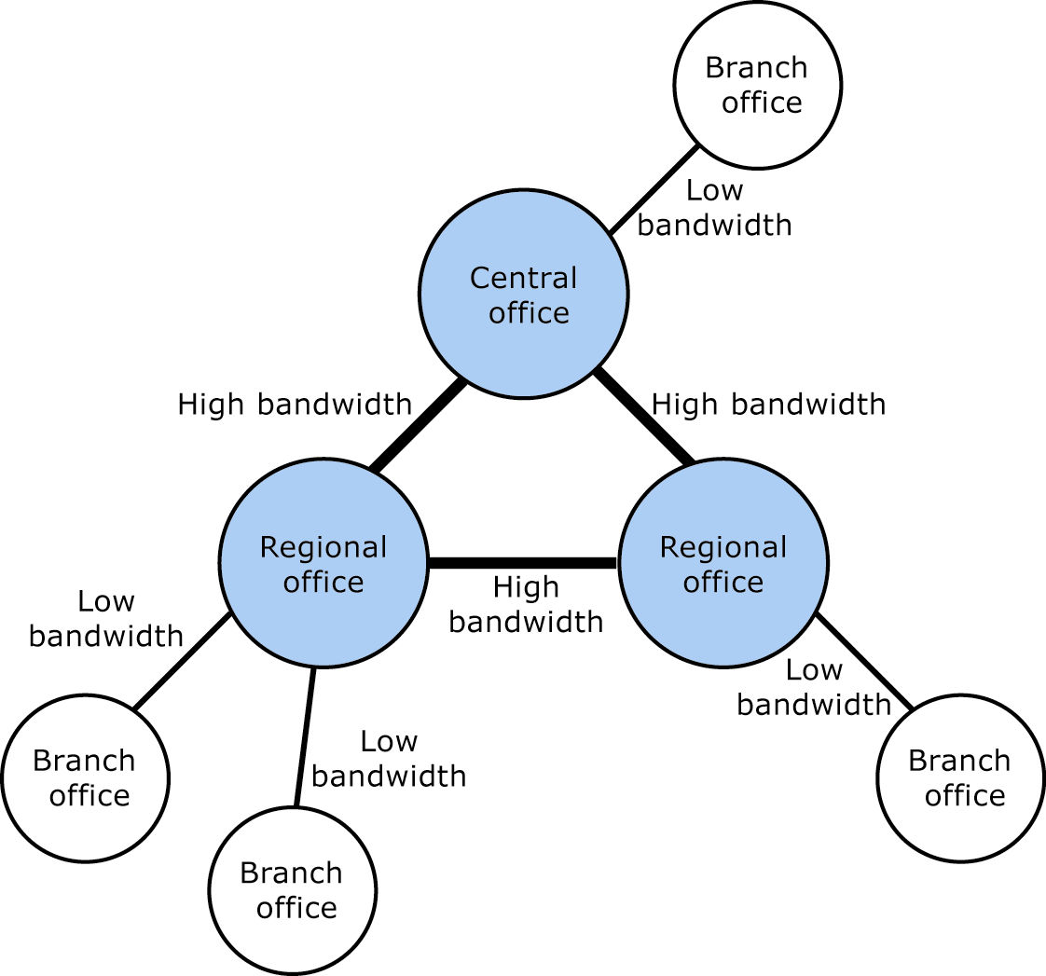
Figure 1.1 Start with a simple representation of your network infrastructure

To obtain a detailed picture of the LAN and WAN configuration, diagram all site locations, connection types, and network topologies (such as bus, token ring, or star). Include the locations of firewalls and perimeter networks. Your assessment should also include a thorough inventory of the hardware that currently makes up your network infrastructure, including stand-alone and clustered servers, routers, and switches. Also note all data center logistics, including rack space, cabling, and power supplies. The checklist in Appendix A lists specific items you examine during this assessment.
In general, you should assess your network infrastructure from the following perspectives:
- Geographical considerations
- Bandwidth and latency
- Current usage
- Current messaging system
These areas are discussed in the following sections.

Geographical Considerations
After you map out the locations of buildings, campuses, and branch offices, determine the types of network connections to each site, as well as the placement of routers and switches. A thorough understanding of this infrastructure can help you determine the number of Exchange routing groups you need, as well as the servers that will constitute each routing group. You also need to know the incoming and outgoing messaging points, including messages to servers within an Exchange organization and servers outside the Exchange messaging system.
In Exchange, servers within a routing group must have full-time, reliable connections because mail transfers directly from server to server. Even if sites or locations are geographically dispersed, you may be able to use a single routing group if all of your network connections are full-time, reliable connections. For more information about routing group design, see Chapter 2, "Planning Your Active Directory and Administrative Model."

Bandwidth and Latency
A key consideration for planning your messaging system is the total amount of data that can be transmitted over the network in a given amount of time. This quantity is determined by a combination of bandwidth and latency. Bandwidth is the speed of transmission over a network connection in kilobits per second. Latency refers to the amount of time it takes in milliseconds to transfer data from one point to another. Both of these factors combine to determine the amount of data that can be transmitted in a certain amount of time over the network. The product of these two factors directly affects user perception of how long it takes to process a transaction.
When evaluating your network connections, you need to evaluate bandwidth and latency, recognizing that although some types of network connections can maximize bandwidth, they may increase latency. For example, a satellite connection may offer high bandwidth, but latency may suffer when compared to ground connections such as frame relay or dial-up Integrated Services Digital Network (ISDN).
For Exchange, the minimum recommended bandwidth for connections to remote offices is 56 Kbps. When mapping site locations and connections, determine the type and speed of network connectivity, and factor in the amount of latency introduced due to distances between sites. You may need to recommend network upgrades as part of the project.

Current Usage
The current usage of the network is another key consideration. Examine network usage from all angles, including use by applications and users. Along with identifying the current applications that use the network, consider the impact of future projects or initiatives. You need to plan for the additional impact that future applications will have on the network.
An extremely important consideration when assessing current usage is the network load at peak times. To determine user load on the network, look at the number of users in the various sites as well as their patterns of use.
In general, if a site has more than ten users and is connected by low-bandwidth, high-latency network connections, the site should work in offline mode. Sites connected by low-bandwidth, high-latency network connections benefit from upgrading to Windows Server 2003, Exchange 2003, and Outlook 2003, because they can use the full features of Cached Exchange Mode in Outlook 2003.

Current Messaging System
During planning, you should ask the following questions about your current messaging system:
- What impact does your current messaging system have on your network?
- Are you currently running an earlier version of Exchange? If so, are you running Exchange 5.5, Exchange 2000, or both versions in mixed mode?
During planning you should determine the impact of your current messaging system on your network. To simulate the usage of your current messaging system, use load-simulation tools such as Microsoft Exchange Server Load Simulation Tool (LoadSim.exe) and the Exchange Stress and Performance (ESP) tool. LoadSim simulates the effect of high usage by Outlook MAPI clients and helps you customize the Outlook profiles you want to use during testing. ESP simulates the effect of high usage by non-MAPI clients, such as Post Office Protocol (POP), Internet Message Access Protocol (IMAP), Simple Mail Transfer Protocol (SMTP), and Outlook Web Access 2003. You can also use ESP to simulate load in an architecture that incorporates front-end servers.
The method you follow for upgrading from an existing Exchange messaging system to Exchange 2003 depends on whether you are running Exchange 5.5 or Exchange 2000. If you are currently running Exchange 5.5 on Windows NT® Server version 4.0, you need to plan for moving user accounts to Active Directory and synchronizing directory information. Exchange 5.5 has its own directory service, whereas Exchange 2003 relies on Active Directory for its directory services. In your project plan, you need to build in a method for synchronizing the two directories. You may also need to plan for a period of coexistence until you can move entirely to Exchange 2003 and Active Directory. If you are running Exchange 2000 or a mixed Exchange 5.5 and Exchange 2000 environment, upgrading to Exchange 2003 is straightforward if Active Directory is already updated with current directory information. For this reason, you need to carefully examine the state of your directory information. For more information about how to plan your deployment path from Exchange 5.5 to Exchange 2003, see Chapter 3, "Planning Your Development Path."
If you are currently running Exchange 5.5, another factor to consider is using Exchange 2003 with Outlook 2003 Cached Exchange Mode feature to host more users per server, thereby reducing the number of Exchange servers you need. For more information about Cached Exchange Mode, see "Understanding Versions of Exchange, Windows, and Outlook" later in this chapter.

Active Directory
Along with assessing your current environment from a physical standpoint, you should understand how Windows Server and Active Directory are deployed in your organization. Exchange 2003 uses Active Directory to store and share directory information with Windows Server. Because the two are tightly integrated, your planning efforts need to include a thorough investigation of the impact that Exchange has on your Active Directory design, and vice versa.
If Active Directory is already deployed, it is important for you to understand the existing Active Directory structure and how Exchange fits into this structure. This section describes the key considerations.
If you have not yet deployed Active Directory, you are in a better position to design your Active Directory infrastructure with Exchange in mind. It is recommended that you read through this book to understand the interdependencies between Exchange and Active Directory. However, for comprehensive Active Directory deployment information, use the following resources:
- Windows Server 2003 Resource Kit
- Best Practice Active Directory Design for Exchange 2000 technical paper (http://go.microsoft.com/fwlink/?LinkId=17837). (This paper refers to Exchange 2000, but the information also applies to Exchange 2003.)
For more information about recommended ways to integrate Exchange 2003 with Active Directory, see Chapter 2, "Planning Your Active Directory and Administrative Model."
The remainder of this section discusses how to assess your existing Active Directory design as it relates to Exchange in the following areas:
- Physical site structure
- Domain and forest partitioning
- Administration
- Domain controller and global catalog server placement

Physical Site Structure
Start with an assessment of the locations of Windows Server sites and the connections between them as discussed in "Network Infrastructure" earlier in this chapter. Exchange uses your Windows network infrastructure so you do not have to create and maintain a separate infrastructure for Exchange. An important factor to consider is how point-to-point routing is structured. For example, determine whether site A can communicate to site C through site B or whether there are routing restrictions.

Domain and Forest Partitioning
Because of the tight integration between Exchange and Active Directory, the Active Directory forest structure directly affects your Exchange planning. There is a one-to-one relationship between an Active Directory forest and an Exchange organization. An Exchange organization can span only a single Active Directory forest. Likewise, an Active Directory forest can host only a single Exchange organization. Understanding your current forest structure and the reasoning behind those design decisions can help you to decide whether to use an existing forest to host Exchange or whether to create a new forest to host Exchange.
Although the recommended design for Active Directory consists of a single Active Directory forest for the entire organization. Your organization may contain multiple forests that represent separate business units. One reason this design may be necessary is if your organization needs strict security boundaries between the directories for each business unit.
In a multiple forest scenario, you need to determine which forest is to host Exchange. To reduce the administrative burden, you also need to implement a provisioning method so that changes made in one forest are propagated to the other forests, for example, by using Microsoft Identity Integration Manager (MIIS). Another option is to create a separate forest dedicated to running Exchange. For more information about reducing the administrative burden, see Chapter 2, "Planning Your Active Directory and Administrative Model."
Important It is recommended that you establish a single Active Directory forest for your entire organization. However, if your company requires strict security boundaries between business units, multiple forests may be necessary. In Active Directory, a forest forms a strict security boundary, which means that administrators in the forest are isolated from other forests. Domains, however, are primarily administrative boundaries. For more information about Active Directory design and administration, see the technical papers Best Practice Active Directory Design for Managing Windows Networks (http://go.microsoft.com/fwlink/?LinkId=18348) and Design Considerations for Delegation of Administration in Active Directory (http://go.microsoft.com/fwlink/?LinkId=18349).

Start by documenting the forests, domains, and Windows sites that make up your organization. Note the servers that make up each domain and the operating system software each server is running. Also, note the groups or individuals who own each forest, domain, and Windows site.

Administration
Another key consideration is the administrative model that is in place in the organization. Because Exchange 2003 uses Active Directory, you administer Exchange in conjunction with the operating system. Active Directory provides a way for you to delegate administrative authority to directory objects through organizational units in Active Directory Users and Computers. You can delegate Windows administrative permissions at the organizational unit level in Active Directory. For Exchange server administration, you can group servers into an administrative group and delegate permissions to the administrative group.
When documenting the servers that make up each domain in a forest, also document the groups or individuals to whom Active Directory administrative permissions have been granted. Then, based on your business requirements, you can use this information to determine how the Exchange servers should be administered. For more information about planning your administrative model, see Chapter 2, "Planning Your Active Directory and Administrative Model."

Domain Controller and Global Catalog Server Placement
When documenting the servers in each domain, identify the domain controllers and global catalog servers. This information is critical for planning an Exchange organization because you need to know how users in various locations log on and how global address list information and Exchange objects will replicate throughout the forest. A domain controller is limited to the domain in which it is installed. The function of a global catalog server in Active Directory is to maintain a partial attribute set for user objects across all domains in the forest. You may need to make changes in the placement of these servers for Exchange. For more information about Active Directory server placement, see Chapter 2, "Planning Your Active Directory and Administrative Model."

Understanding Versions of Exchange, Windows, and Outlook
After you assess your business requirements and document your existing environment, you can apply what you know about the capabilities of the messaging software and operating system software toward a design choice that meets your company's needs.
One of the biggest challenges in designing an Exchange messaging system is balancing business and user requirements against the capabilities of your existing system. To meet certain user requirements, you may have to recommend upgrades to the network backbone, server hardware, or operating system software. The following sections briefly describe the features in the latest versions of Exchange, Windows Server, and Outlook that impact your design choices. They can help you determine whether technical upgrades may be necessary.

Comparing Windows Server Versions
In many cases, the combination of Exchange Server 2003, Windows Server 2003, and Outlook 2003 can help companies consolidate their sites and reduce the number of servers in remote locations.

Windows Server 2003
The following features and changes in Windows Server 2003 may affect the way you design Active Directory and Exchange:
- Increased number of sites per forest Because of Windows Server 2003 improvements to the Knowledge Consistency Checker (KCC) and Intersite Topology Generator (ISTG), forests can contain a greater number of sites than in Microsoft Windows 2000 Server. In Windows 2000 Server the limit was 300 sites per domain; a Windows Server 2003 domain can contain 3,000 sites. These scalability improvements may affect your forest structure.
- Volume Shadow Copy service Windows Server 2003 contains Volume Shadow Copy service capabilities that enable online backup of application data volumes almost instantaneously and without downtime. Volume Shadow Copy service works with applications, operating systems, backup programs, and storage hardware to create a consistent shadow copy of data. This feature allows creates high-fidelity backup recovery and data mining without significant impact to performance.
- Storage Area Network support Windows Server 2003 contains several improvements to support for Storage Area Networks, including improvements in connecting to volumes, handling fiber channel Storage Area Networks, and the ability to start from a Storage Area Network.
- Log on without a local global catalog server In Windows Server 2003 users can log on without a local global catalog server. This feature caches user credentials and significantly reduces requests to the global catalog server. However, the ability to log on without a local global catalog server is intended for use in Windows sites that do not contain Exchange users.
Important In Windows sites that contain Exchange users, it is always recommended that you install a local global catalog server.

Windows 2000 Server
If you continue to use Windows 2000 Server as the operating system or if you upgrade some servers to Windows Server 2003, some of the Windows Server 2003 features are not available until you upgrade to a pure Windows Server 2003 forest.
In particular, the RPC over HTTP feature in Outlook requires that the Exchange server and a global catalog server run Windows Server 2003 and that your Active Directory schema be upgraded to Windows Server 2003.
Other features of Exchange 2003, such as Volume Shadow Copy service, are available when you run Exchange 2003 on Windows Server 2003, but it is not required that you upgrade the Active Directory schema to Windows Server 2003.

Improvements in Exchange 2003
Exchange 2003 provides improved functionality in the following areas:
- Routing
- Support for Volume Shadow Copy service
- Support for Outlook 2003 Cached Exchange Mode
- Outlook Web Access for Exchange 2003
- Mobile Device Support for Exchange 2003
- Outlook 2003
Some of the improvements in these areas depend on whether you are running Windows Server 2003 or Outlook 2003. The following sections discuss these improvements and their dependencies.

Routing Improvements
In Exchange 2000, routing improvements over Exchange 5.5 helped you to move away from hub-and-spoke routing architectures. For example, you may have had to establish a hub-and-spoke routing architecture for Exchange 5.5 to support hard-wired routing paths. To accomplish this, you probably deployed a number of servers dedicated to message routing in the hub site.
Link state routing introduced in Exchange 2000 made it possible for sending servers to determine the best routing path by the state of the link. This change enabled a move toward peer-to-peer networks between routing groups because messages from any routing group can find a direct route to the receiving group over your network backbone.
Exchange 2003 further improves upon the link state routing features of Exchange 2000 by reducing the amount of link state traffic in two ways.
- Performance is improved over what are commonly known as oscillating links, or links that are intermittently available and unavailable. Exchange 2003 reduces link state traffic by attempting to determine if the connector is oscillating. If there are multiple conflicting state changes in the link state queue for a connector in a given interval, the connector is considered an oscillating link and its link state remains up (in service or available for that period). Leaving an oscillating connector up rather than continually changing the link state reduces the amount of link state traffic that is replicated between servers.
- Performance is improved in the case of a site to which there is only one route. In this case, Exchange 2003 reduces link state traffic by determining that no alternate path exists and suppressing the link state information. If no alternate path exists for a link, the link state is always marked as up (in service). Exchange lets mail queue for delivery and sends it when the route becomes available.
Both of these changes enhance performance because they reduce the propagation of link state information.

Volume Shadow Copy Service
One of the practical limits to the number of users supported on a single server is the time it takes to back up the mail storage. To significantly reduce this limit, you need the ability to almost instantaneously backup and restore your mailbox stores with highly consistent data. Exchange 2003 works with the Volume Shadow Copy service in Windows Server 2003 to help you create nearly instantaneous backups of Exchange data at a specific point in time.
The Volume Shadow Copy service backup method solves several problems with previous backup methods. When an Exchange database is connected, e-mail transactions can continue to occur at any time. If you try to make a quick backup of the data at a particular point in time (a shadow copy), e-mail transactions may still occur while the backup is progressing. As a result, when the backup finishes, it may contain an inconsistent copy of the data. In addition, because it is recommended that you store Exchange database files (.edb files), transaction log files, and Multipurpose Internet Mail Extensions (MIME) content (.stm files) on separate volumes, data may be inconsistent. For example, if you make a shadow copy of the data undergoing a change, and it has not yet been written to the log file, the files do not match.
Without Volume Shadow Copy service, the way to work around this problem is to conduct backups while the database is offline, which means that backups must be performed during downtime. In other words, Exchange has to be shut down so you can perform a consistent backup. But this approach poses scheduling problems and negates any benefit of shadow copy backups. This approach also makes it difficult to complete backups because of the increasing demand for systems to be available 24 hours a day, 7 days a week.
Volume Shadow Copy service, however, creates a consistent point-in-time shadow copy of data while the system is online. After receiving a backup request, Volume Shadow Copy service notifies Exchange services that a backup is about to occur. Exchange then prepares for the backup by cleaning up on-disk structures and flushing caches and log files.
Important Exchange supports the Volume Shadow Copy service for normal backups and copy backups, but not for incremental or differential backups.

Support for Outlook 2003 Cached Exchange Mode
Exchange 2003 supports Outlook 2003 Cached Exchange Mode, which gives users access to Exchange information from a local cache in the form of an .ost file. Exchange ensures that the mailbox on the server and the .ost file on the client remain synchronized as long as the network connection is available. If the network connection is intermittent or is lost entirely, the user can continue to work by accessing e-mail data from the information stored in the local .ost file. Requests for updates from the client to the Exchange server are eliminated, so Outlook 2003 users will no longer see the message indicating that data is being requested from the Exchange server during periods of intermittent or no connectivity. The elimination of update requests from the client also results in less data traffic from the client to the server.
For more information about Cached Exchange Mode, see "Improvements in Outlook 2003" later in this chapter.

Outlook Web Access 2003 Improvements
The new version of Outlook Web Access in Exchange Server 2003 contains improvements such as forms based authentication, rules, spell checking, and the ability to send and receive digitally signed and encrypted e-mail messages. The user interface has also been significantly redesigned to provide a user experience similar to that provided with Outlook 2003, including a right-hand preview pane and improved navigation pane.
Outlook Web Access for Exchange 2003 has the ability to perform faster, especially over slow connections, and therefore will be far more responsive to user interactions.
The following list briefly describes the significant new features for Outlook Web Access for Exchange 2003:
- Bytes over the wire The speed of Outlook Web Access has been improved by reducing the amount of information that must travel from the server to the browser. Fewer bytes are sent over the wire from server to browser. However, be aware that the logon process involves more bytes than the logon process in Outlook 2003.
- Compression support Administrators can configure compression support for Outlook Web Access and provide a performance improvement of nearly 50 percent for most actions on slow network connections. User performance for Outlook Web Access has been optimized for slow network connections with support for data compression. Outlook Web Access compression works by compressing either static or dynamic or both types of web pages, depending on the compression setting you are using. With data compression, your users can see performance increases of up to 50 percent on slower network connections such as traditional dial-up access. You can enable compression from Exchange System Manager.
- Forms Based Authentication You can enable a new logon page for Outlook Web Access that will store the user's name and password in a cookie instead of in the browser. When a user closes his or her browser, the cookie is cleared. Additionally, after a period of inactivity, the cookie is cleared automatically. The new logon page requires users to enter their domain, user name, and password, or their full user principal name (UPN) e-mail address and password. To enable the Outlook Web Access logon page, you must enable forms-based authentication on the server.
The improvements in features, functionality, and performance may affect decisions about which client your users should primarily use to access their Exchange information. In remote sites, Outlook Web Access may be the primary choice, which is a consideration when planning WAN connections and server placement.

Mobile Device Support for Exchange Server 2003
Exchange 2003 provides mobile device support by providing two applications that can support both Microsoft Windows Mobile™ 2003 powered devices and other mobile devices.. You can deploy mobile device support to Exchange to provide your users the ability to access their Exchange information from a variety of mobile devices. You deploy your Exchange server to use Exchange ActiveSync® and Outlook Mobile Access in the same way that you deploy your Exchange server to use Outlook Web Access 2003. By default, when you install Exchange, all of your users are enabled for synchronization and for browse access with Outlook Mobile Access.
- Synchronization Synchronizing a device to an Exchange server gives your users access to their Exchange information without their being constantly connected to a mobile network. Users can use their mobile carrier connection to synchronize their Exchange information to their Pocket PC 2002 Phone Edition or Smartphone device and then access this information while offline.
- Up to Date Notification Up-to-date notifications are automatically generated SMS messages that are sent to a user's Windows Mobile device when a new e-mail message, calendar appointment, or contact arrives in the user's mailbox. Users must configure their devices to receive up-to-date notifications.
- Mobile browse access Exchange Server 2003 includes the Outlook Mobile Access application, which makes it possible for users to access their Exchange server to view e-mail messages, contacts, calendar, and tasks with mobile devices.

Improvements in Outlook 2003
Outlook 2003 provides improved functionality in the following areas:
- Cached Exchange Mode
- RPC over HTTP
- Kerberos authentication
Some of the improvements in these areas depend on whether you are running Windows Server 2003 or Outlook 2003. These improvements and their dependencies are discussed below.

Cached Exchange Mode
Cached Exchange Mode in Outlook 2003 significantly improves the experience for users who are located in offices that have low-bandwidth, high-latency connections because it gives users access to mail from either a local cache (.ost file) or from the Exchange 2003 server. Exchange 2003 provides better support for Cached Exchange Mode than previous versions of Exchange because it efficiently synchronizes the mailbox on the server and the .ost file on the client. Requests for updates from the client to the Exchange server are eliminated.
Cached Exchange Mode is especially useful in branch office scenarios, where remote offices have slow or unreliable connections. Users can work from their local cache with or without a network connection, and Exchange synchronizes the local cache and the server mailbox when a connection is available. In addition, Cached Exchange Mode requires fewer requests to the server, which reduces server load per user and helps you support more users per server.

Deployment Considerations for Cached Exchange Mode
When you deploy Outlook 2003 in your messaging environment, you can allow your users to use the Cached Exchange Mode feature for Outlook. However, when you deploy this feature, you should make sure to stage your rollouts. A user's .ost file is created on his or her computer when the user attempts to synchronize with an Exchange server. This means that all of the information in the user's mailbox will be transferred from the server to his or her computer. For this reason, you should stage rollouts of this feature so that no more than 75 users are attempting to perform an initial synchronization between their Exchange server and their computer running Outlook 2003. Staging your rollout for Cached Exchange Mode is necessary because users will effectively download a complete copy of their mailbox from the Exchange server to use on their local computer. This initial download could adversely affect performance on your Exchange server if many of your users download their mailboxes at one time.
The amount of data is of special concern if the connection is slow and several users connect at the same time. If users' mailboxes are very large (for example, greater than 2 GB each), synchronization with the .ost file could have a significant impact on the network connection. This situation can occur especially in organizations that place no limits on mailbox size.
You should also note that the .ost file is placed in the profile directory by default so, if a user has roaming profiles (for example, across different branch offices), the cache is available in only one of the profiles.

RPC over HTTP
The RPC over HTTP feature in Windows Server 2003 eliminates the need for remote office users to connect to their Exchange servers by using a virtual private network (VPN). Users running Outlook 2003 can connect directly to an Exchange 2003 server within a corporate environment over the Internet. For Exchange to support RPC over HTTP, all Exchange servers that users with Outlook 2003 will access must be running Exchange Server 2003. Additionally, RPC over HTTP is supported only by Outlook 2003. Finally, all computers in your messaging environment that your users will need to use with RPC over HTTP communication must be running Windows Server 2003. This includes the following computers:
- All global catalog servers
- All Exchange servers that your Outlook 2003 users will access
After you configure the recommended Exchange front-end and back-end server architecture with Internet Security and Acceleration (ISA) Server, users can use RPC over HTTP to connect to your Exchange 2003 servers.
Important To use RPC over HTTP, your Active Directory schema must be upgraded to Windows Server 2003.

The recommended method for deploying RPC over HTTP is to install ISA Server with Feature Pack 1 in the perimeter network and position your RPC proxy server within the corporate network. Your RPC proxy server can be either your Exchange front-end server or another Web server that you allow users to connect to from the Internet. For more information about deployment options, see "Using RPC over HTTP" in Chapter 4.
To enable RPC over HTTP for your organization, you need to do the following:
- Configure a server as an RPC proxy server If you have a server that your users can access from the Internet, such as an Exchange front-end server, you can configure the server to be your RPC proxy server. This RPC proxy server is responsible for specifying which ports communicate with the global catalog servers and all Exchange 2003 servers with which the Outlook 2003 client computer needs to communicate.
- Configure your internal network to use RPC over HTTP Computers that Outlook 2003 users will access, including any Exchange Server 2003 computers and the global catalog servers, must be configured for RPC over HTTP communication. Additionally, the perimeter network must be configured to allow for RPC over HTTP communication.

Kerberos Authentication
Exchange 2003 and Outlook 2003 can now use Kerberos to authenticate users to the Exchange servers. If your network uses Windows Server 2003 domain controllers, your users can authenticate across forests to the domain controllers in trusted forests, thereby allowing user accounts and Exchange servers to exist in different forests.
Exchange 2003 uses Kerberos when sending user credentials between an Exchange front-end server and the Exchange back-end servers. Previous versions of Exchange used Basic authentication for applications such as Outlook Web Access to send their credentials between an Exchange front-end server and an Exchange back-end server. As a result, companies had to use a security mechanism such as Internet Protocol security (IPSec) to encrypt information from the Exchange front-end server to the Exchange back-end servers.

Putting It All Together
When planning the placement of Exchange servers and the administration of directories and servers, it is usually recommended that you start with a centralized model and add servers, routing groups, and administrative groups only when necessary. With the features available in Exchange 2003, Windows Server 2003, and Outlook 2003, businesses may be encouraged to adopt more centralized messaging systems than have been possible in the past. In addition, with the proliferation of higher speed and higher bandwidth connections, companies made up of geographically dispersed offices can consider centralizing their hardware and administration so that they can reduce the number of servers required in remote locations. The factors that drive centralization break down into three main categories:
- Centralizing the hardware that serves remote offices Communication between the client and server is compressed, and traffic is significantly reduced due to improvements in Outlook RPC communication and Outlook Web Access 2003 compression. Exchange 2003 has a number of features that help you consolidate your sites and administrative groups. In addition, Cached Exchange Mode in Outlook 2003 helps you reduce the number of servers located in remote locations that are connected with restricted bandwidth and high latency.
- Reducing the number of servers To reduce total cost of ownership, it is common for companies to try to reduce the number of servers needed to sustain the messaging needs of their users. Your company may decide to reduce the number of servers needed by investing in high-end servers, including high performance processors and servers with multiple processors. Windows Server 2003 and Exchange 2003 also support hyperthreading technology, in which a single processor is able to run multiple threads (and appears as two processors instead of one). The processor must be hyperthreading-enabled and you must use Windows Server 2003 and Exchange 2003.
- Centralizing server and directory administration Companies may want to combine and centralize their administrative workforce to reduce administrative costs. One feature that simplifies administration is the improved method for moving mailboxes in Exchange System Manager. Administrators can move mailboxes more efficiently and can recover from failures more easily when corrupt items are encountered. In addition, administrators can schedule mailbox moves to begin and end at a certain time.
Chapter 2

Planning Your Active Directory and Administrative Model
In Chapter 1, you examined your current Microsoft® Active Directory® directory service model (if Active Directory is already implemented) and assessed your administrative requirements. Now you can plan how to integrate Microsoft Exchange Server 2003 into your Active Directory model. You can also plan Exchange administration by evaluating the roles in your organization as they relate to the administrative model you choose for your Exchange organization.
This chapter begins by discussing the various ways you can integrate Exchange with Active Directory. It then discusses the options available for designing your administrative model.

Options for Integrating Exchange with Active Directory
Because Microsoft Windows Server™ 2003 and Exchange 2003 both rely on Active Directory for directory services, you need to determine how to integrate Exchange into your Active Directory structure.
To deploy Exchange, you need to begin with an established Active Directory infrastructure that is in a stable, working state. If you are upgrading from a Microsoft Windows NT® environment, the ideal condition for deploying Exchange is for all Windows NT accounts and resources to have been migrated to Active Directory. However, you can deploy Exchange even if you are still in the process of migrating Windows NT objects to Active Directory or if you need to retain a Windows NT forest to hold certain resource objects. The examples discussed in this section cover these various scenarios.
Within each forest, you can combine resources for administering Windows Server 2003 and Exchange or you can manage these resources separately. The ability to combine resources is made possible by the integration between Exchange and Windows Server 2003.
There are four main options for integrating Exchange with Active Directory:
- Single forest
- Dedicated Exchange forest
- Multiple forests with one forest hosting Exchange
- Multiple forests running Exchange
Each of these options is described in further detail in the following sections. For a complete discussion about integrating Exchange into your Active Directory infrastructure, see the technical paper Best Practice Active Directory Design for Exchange 2000 (http://go.microsoft.com/fwlink/?LinkId=17837). (This paper refers to Exchange 2000, but the information also applies to Exchange 2003.)

Single Forest
If your organization has a single Active Directory forest, you can implement Exchange in that forest. The single forest Exchange design is recommended because it offers the richest set of mail system features and has the most streamlined administrative model. Because all resources are contained in a single forest, a single global address list (GAL) contains all users across the entire forest. Figure 2.1 illustrates this scenario.
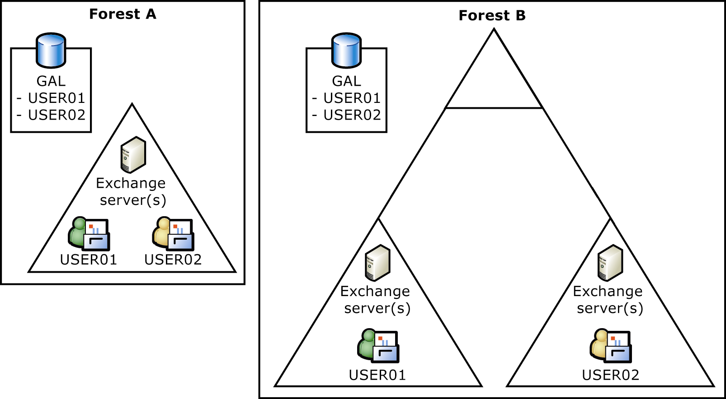
Figure 2.1 Two examples of implementing Exchange in a single Active Directory forest

The single forest option offers the following advantages:
- Provides the richest set of mail system features
- Allows for a streamlined administrative model
- Leverages an existing Active Directory structure
- Uses existing domain controllers and global catalog servers
- Does not require provisioning or synchronization
The main disadvantage associated with this option is that administrators need to determine how to share or divide responsibilities for managing Active Directory and Exchange objects.

Dedicated Exchange Forest (Resource Forest)
There are some cases in which you may need to set up a separate Active Directory forest that is dedicated to running Exchange. For instance, you may have a Windows NT forest that you want to retain. Or, you may need to separate administration of Active Directory objects and Exchange objects; therefore, you may want to set up a separate Active Directory forest dedicated to running Exchange. Companies that require security (forest) boundaries between Active Directory administration and Exchange administration may choose this option.
If you want to create a separate Active Directory forest dedicated to Exchange, you need to create a trust between the network operating system forest and the dedicated Exchange forest. You may also need to set up a provisioning or synchronization process so that your mailbox accounts mirror your user accounts. As shown in Figure 2.2, the provisioning process ensures that there is a placeholder object in Forest B for each corresponding account in Forest A. Because all Exchange resources are contained in a single forest, a single GAL contains all users across the entire forest.
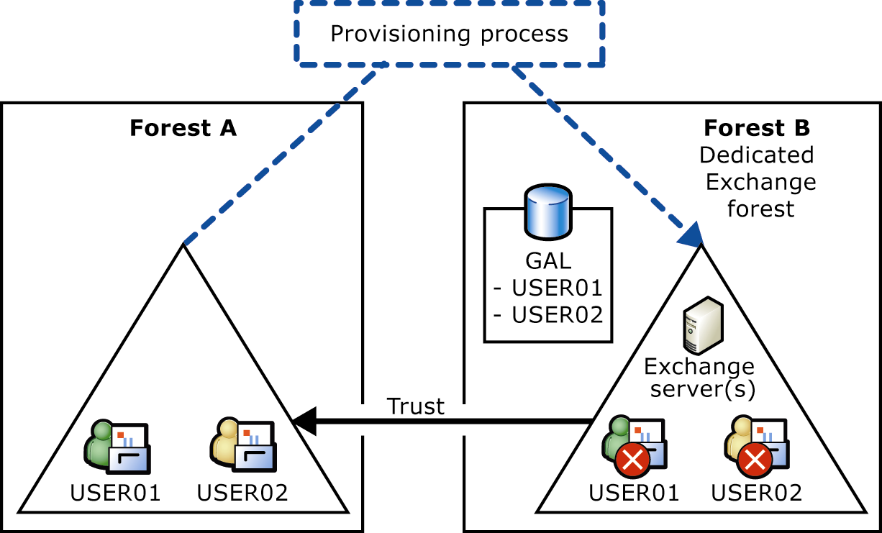
Figure 2.2 Separate, dedicated Exchange forest

The main advantage of the dedicated Exchange forest option is a security boundary between Active Directory and Exchange administration.
The disadvantages associated with this option include the following:
- Does not leverage the benefits of integrating Exchange and Active Directory administration, giving you more administrative overhead.
- Requires installing duplicate domain controllers and global catalog servers in Windows® sites where Exchange will run, which increases the cost.
- Requires a provisioning process so that Active Directory updates are reflected in Exchange. (For example, creating a new Active Directory user in Forest A generates a mailbox-enabled placeholder object with permissions.)
A variation of the resource forest is multiple forests with one forest hosting Exchange. If you have multiple Active Directory forests, the way you deploy Exchange depends on the degree of autonomy you need to maintain between the forests. Companies with business units that require security (forest) boundaries for directory objects, but can share Exchange objects, may choose to deploy Exchange in one of the forests and use it to host mailboxes for the other forests in the company. In this scenario, you can set up a trust between the Exchange forest and other forests. You may also need to set up a provisioning process so that each time an administrator creates a user in Active Directory, a disabled user with a mailbox is created in Exchange. Because all Exchange resources are contained in a single forest, a single GAL contains all users across all forests. Figure 2.3 illustrates this scenario.
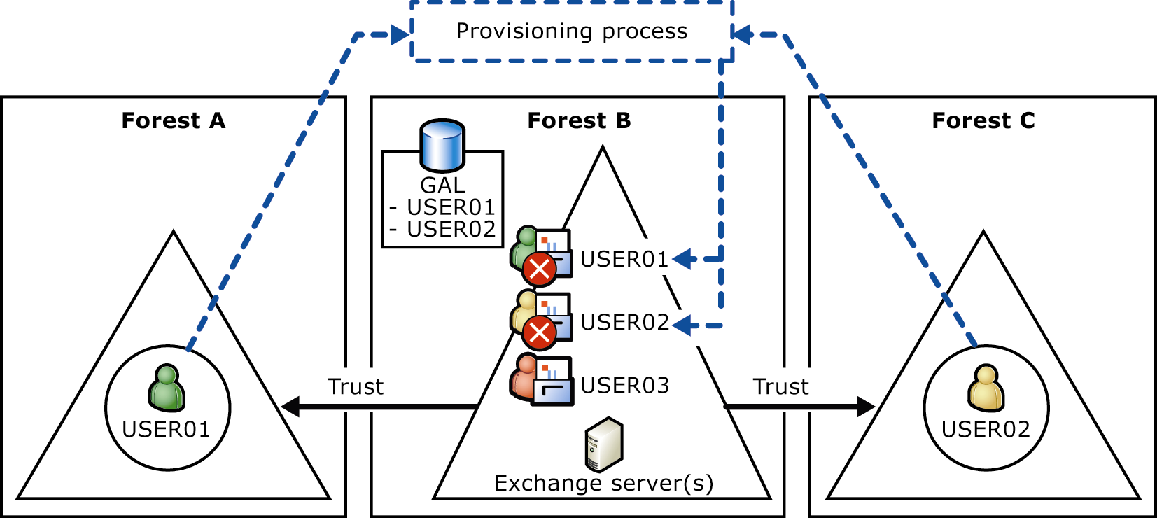
Figure 2.3 Multiple Active Directory forests with one forest hosting Exchange

The main advantages associated with this option include the following:
- Leverages an existing Active Directory structure
- Uses existing domain controllers and global catalog servers
- Provides strict security boundaries between forests
The disadvantages associated with this option include the following:
- Requires a provisioning process so that Active Directory updates are reflected in Exchange. (For example, creating a new Active Directory user in Forest A generates a mailbox-enabled object with permissions that is disabled in Forest B.)
- Requires that forest administrators determine how to share or divide responsibilities for managing Active Directory and Exchange objects.

Multiple Forests Running Exchange
Although deploying Exchange in separate forests is not the ideal scenario, companies may be forced into this scenario as a result of special circumstances such as mergers and acquisitions. To keep the global address lists synchronized across forests, you must set up a synchronization process, for example, Microsoft Identity Integration Manager (MIIS) so that users contained in one forest appear as contacts in other forests. Figure 2.4 illustrates this scenario.
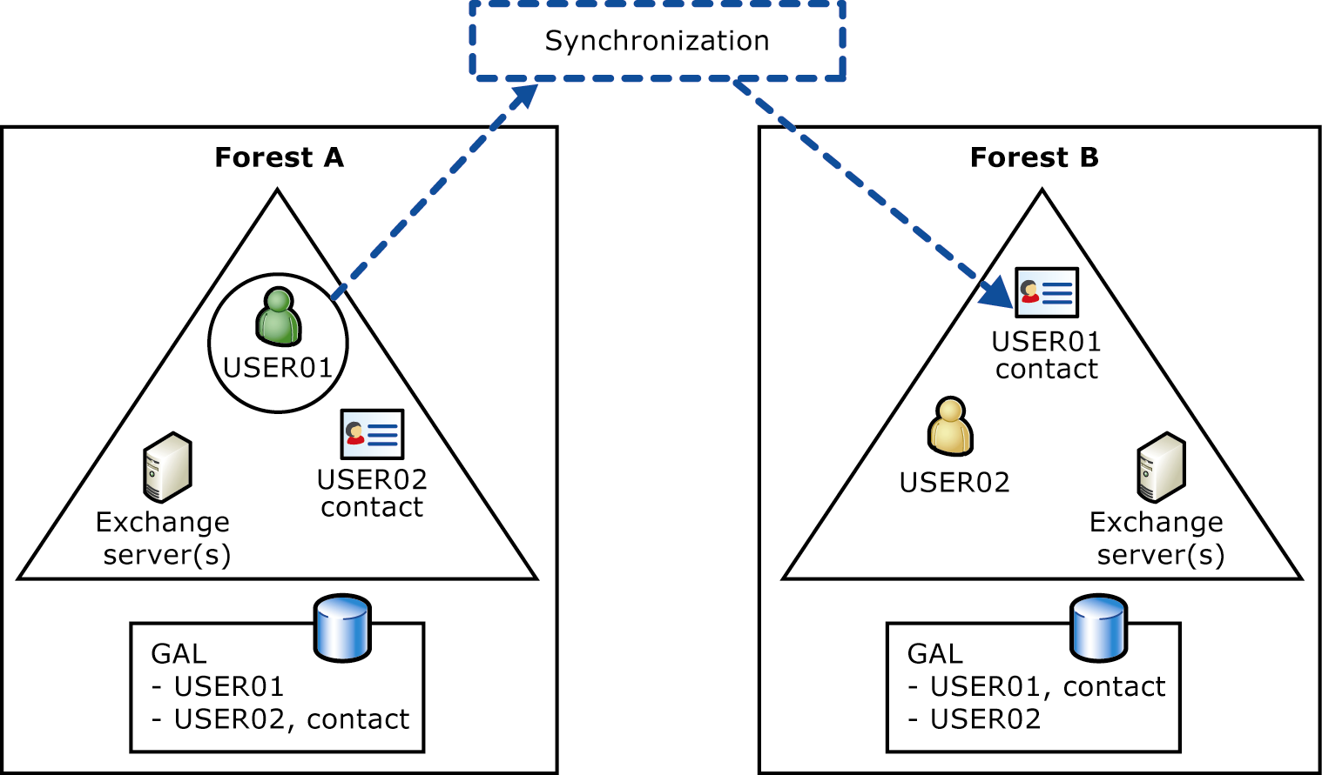
Figure 2.4 Exchange deployed in multiple forests with synchronization between forests

The concerns associated with this option include the following:
- Mailboxes are in separate forests so features are limited; for example, you cannot delegate mailbox permissions and you cannot browse distribution list memberships in other forests.
- A synchronization process is required if your company requires a GAL that contains all users from all forests.
- Inter-organizational replication is required because of multiple public folder hierarchies.
- Administrators need to determine how to share or divide responsibilities for managing Active Directory and Exchange objects.
- SMTP configuration is more complex.
- Replication of free/busy information is more complex.

Deciding on a Centralized or Distributed Administrative Model
Based on your administrative requirements, security requirements, and technical capabilities, you can design a centralized administrative model, a distributed administrative model, or a combination of the two. By deciding on whether your model will be centralized or distributed, you are essentially determining whether you will create one or more administrative groups.
Administrative groups provide a way to group objects together (such as servers, policies, routing groups, and public folder hierarchies) and define the scope of permissions for the group. For example, if your organization has two sets of administrators that manage two sets of Exchange servers, you can create two administrative groups that contain these two sets of servers. To establish permissions, you can add the appropriate Windows users and groups to the security settings on the two administrative groups. Then, Active Directory propagates these settings to all the configuration objects within the administrative group. To assign Exchange permissions to the administrative groups, you can use the Exchange Administration Delegation Wizard. This wizard simplifies assigning permissions and creating and maintaining access control lists (ACLs).
A centralized Exchange administrative model is characterized by a single Exchange administrative group (the default administrative group), centralized server management, and centralized policy management. Recall that in Exchange 2003 the administrative model is completely independent of the physical infrastructure, so your Exchange administrative model can be centralized even if your company consists of several branch offices. Only one administrative group can exist, but there can be many routing groups. As discussed in "Options for Integrating Exchange with Active Directory" earlier in this chapter, if your administrative model is highly centralized and does not require any strict security boundaries between business units, you can follow the single forest model.
If logical business divisions require autonomy in terms of Exchange server administration, you may need a distributed model. In this model, individual business units or regions have complete control over management of the Exchange organization, although a central group can manage standards and guidelines. In a distributed model, you create at least one administrative group for each region or division. This model is similar to the site model in earlier versions of Exchange and is often used by organizations that have branch offices operating independently. You must also consider whether separating business units by using administrative groups is sufficient, or whether you need to create strict security boundaries between them. If the latter is the case, the only way to create strict security boundaries is to place business units in separate forests, as discussed in "Options for Integrating Exchange with Active Directory" earlier in this chapter.
Note Support costs can be very high for branch offices. For this reason, you should weigh these support costs against the cost of upgrading network connections and centralizing servers.

A combined model can separate the administrative responsibilities for different geographical locations into specialized administrative groups, but can assign a centralized administrative group that defines organization responsibilities. In this example, administrators of a centralized organization policies group control system and recipient policies used across the organization. Regional groups define daily administrative tasks that administrators perform at different geographical locations. Each of these groups contains other objects, such as public folders and servers, which the local groups manage.
Important If your Exchange organization is mixed, which means it contains Exchange 2000 or Exchange 2003 and Exchange 5.5 servers, Exchange displays one administrative group and one routing group for each Exchange 5.5 site by default.

Roles and Permissions
The flexibility of assigning roles and permissions to administrators in Windows Server 2003 and Exchange means a full range of possibilities for managing recipients, servers, and policies. In addition to the requirements discussed in Chapter 1, consider how the following capabilities of Active Directory and Exchange 2003 affect the way you organize your administrative roles:
- A single administrator can perform tasks for both Windows Server 2003 and Exchange.
- You can organize and administer users based on security considerations, permissions, location, domains, forest, or other requirements.
- You can specify user and group access by object class; for example, you can grant administrators permission to view the status of the mailbox store but not the size of a user's mailbox.

Recipient Management and Server Management
With the introduction of Active Directory, you can separate the administration of servers from the administration of recipients. Recipients are defined as objects in Active Directory and include users, groups, and contacts. You create mailboxes, new users, distribution groups, and perform other related tasks in Active Directory Users and Computers because these objects are contained in and managed by Active Directory. However, you configure servers, connectors, public folders, address lists, protocols, and policies in Exchange System Manager.
Identify who performs administrative tasks, such as user account management and daily operation of Exchange. Because Exchange and Windows use Active Directory, some of these tasks are an extension of Windows Server administration. If one person manages all Windows users, consider having this person also manage Exchange recipients, because these tasks are closely related. If different people perform administrative tasks for different groups of users or servers, you might consider using multiple administrative groups to make it easier to assign permissions to a set of Exchange objects for special circumstances.

Administration and Routing
Identify who manages administration and routing in your Exchange system. When you first install Exchange, it runs in mixed mode so that servers running earlier versions of Exchange can coexist within the Exchange organization. Exchange organizations that no longer coexist with earlier versions of Exchange can switch to native mode. The administrative model for organizations in native mode separates routing and administration: you can organize servers in administrative groups to manage permissions and apply system policies, and you can assign servers to routing groups that span administrative groups to most efficiently manage message traffic. For more information about administrative groups and routing groups, see "Routing Design" in Chapter 4.

Data Management
Identify who manages mailbox stores and public folder stores. Depending on how you organize your system, your public folder hierarchy may be split by regions or divisions within your organization. You can use permissions to define who administers the public folder hierarchy in your organization. Backup and restore accountability can rest with Exchange administrators or with another group. For more information about managing information and backing up resources, see Chapter 5, "Planning for Reliability."

Interoperability with Exchange 5.5
Mailbox management includes creating, modifying, and deleting mailboxes, e-mail addresses, and related properties. In Exchange 2000 and Exchange 2003, mailbox management is integrated with Active Directory recipient management.

Public Folder Management
Your network infrastructure, security requirements, and administrative model determine the decisions you make regarding public folder administration. Public folder management encompasses not only public folders, but also system folders. One of these system folders is the free/busy folder, which controls whether you can see other users' free/busy information when setting up a meeting. After you work through the concepts in Chapter 1 and the preceding topics in this chapter, you should have a good understanding of your existing infrastructure and the issues that affect your administrative model.
The following features of public folders help you control how public folders are managed and administered:
- Replication A public folder can be configured to have copies (replicas) on multiple servers. Replicas are useful for distributing the user load on servers, distributing public folders across geographical areas, and backing up public folder data. You can set up a replication schedule based on how often data in the public folder changes. You can set this schedule for all public folders or for a specific public folder.
- Public folder referrals When a client must use an alternate server to access public folder content, Exchange uses the routing group configuration to refer the client to another server. This alternate server may reside in a different routing group. The public folder referral process allows the client to access content wherever it exists, even when the specific server that contains the data is not known. This process also eliminates the need for a cost-based referral list because the cost information is determined based on the routing group connector costs.

Public Folder Replication
A public folder can be configured to have replicas on multiple public folder servers. Replicas are useful for distributing the user load on servers, distributing public folders geographically, and providing redundancy for public folder data. All replicas of a public folder are equal, so there is no master replica.
During public folder replication, the public folder hierarchy is replicated to every server that has public folders in the Exchange organization, but the contents are replicated only to servers on which an administrator has set up replicas. Changes made to items in a replica are sent to all other replicas of the public folder throughout the organization. Changes made to the folder, the folder's properties, or the public folder hierarchy are replicated to all servers.
When more than one replica of a public folder exists, connections that users make are distributed across all replicas in an organization. If a replica of the folder is on the user's public folder server, the first connection attempted is to that replica. If a connection to the replica cannot be made because a server is unavailable or because a network connection cannot be made, a connection to a different server in the routing group is attempted. If routing connectors enable public folder referrals, connections to servers in other routing groups are attempted.

Planning Considerations
This section provides specific planning considerations and recommendations for public folders.

Dedicated Public Folder Servers
The public folder store relies on mail transport for delivery of replication messages. The public folder store does not replicate messages based on topology details. If the content of a public folder is modified and it has five replicas, then a single replication message is generated and addressed to all five other public folder stores. For this reason, your routing topology has a great impact on how efficiently public folders are replicated.
In general, to separate public folder replication traffic from mail traffic, it is recommended that you deploy a dedicated public folder server for administrative groups that contain more than three servers. Deploying a dedicated public folder server reduces replication traffic and simplifies the administration of public folders. After you set up a dedicated public folder server, remove the public folder stores from the mailbox servers. The public folder server, in turn, does not have to host any mailboxes, but it does require a mailbox store to allow for mail-enabled public folders. Then configure users' mailbox stores to use the dedicated public folders server as the default public folder store.

Public Folder Placement
If your organization is made up of multiple remote locations, you have two options for public folder placement. You can place public folder replicas on local Exchange servers so that each location has a replica of public folders from other locations. Or, you can store all public folder information in a central server in the data center or hub so that you maintain a single, accurate source of data. The choice of options is based on the balance between accuracy and convenience, it and depends on user requirements and usage patterns.
If you plan to centralize your Exchange servers, you may decide not to install an Exchange public folder server in remote sites. However, you should be aware that, if the sites are connected by low-bandwidth, high-latency network connections, public folder access does not benefit from Microsoft Office Outlook® 2003 Cached Exchange Mode the way that mailbox access does. Unlike mailbox data, public folder data is not cached locally on the client computer (unless you add a public folder to your offline "Favorites," which are kept synchronized with the server's data). Therefore, requests for public folder data are directed over the remote connection to an Exchange server in the data center. Therefore, access to public folders is subject to the latency inherent in your network connections.
In cases where no local Exchange public folder server exists and access to a server is available over a low-bandwidth, high-latency connection, it is recommended that users access public folders by using Outlook Web Access 2003. Compared to Outlook, Outlook Web Access usually provides faster access to public folders when there is no local Exchange public folder server.
Note If you use Cached Exchange Mode, public folder data is not cached locally for Outlook 2003 users. Requests for public folder data are directed over the remote connection to an Exchange server, so these requests are also subject to the latency inherent in the connection. In most cases, the need for instantaneous access to public folder information is not a requirement. However, this need is a factor you should consider when testing your Exchange infrastructure and then use it to determine whether the degree of latency is acceptable for your organization.

System Folder Placement
Each public folder store contains system folders invisible in Exchange System Manager by default. (To view system folders, right-click the Public Folders container under Folders, and then click View System Folders.) Among the system folders are the following folders:
- Schedule+ free/busy folder
- Offline address book folder

Schedule+ Free/Busy Folders
The Schedule+ free/busy folder contains information that Outlook users use to view the availability of others when scheduling meetings. Each administrative group has one free/busy folder. If your administrative model calls for multiple administrative groups, you can configure the Schedule+ free/busy folder to maintain replicas of free/busy folders from any or all of the other administrative groups. Replication occurs just as it does for public folders. Because each administrative group has one free/busy folder and an administrative group can span multiple routing groups, you may need to add a folder replica in each routing group. Adding this folder ensures that free/busy information is always local. Be sure to verify that the routing group connectors allow public folder referrals.
Access to free/busy information is one of your most important considerations. First, consider network connectivity and bandwidth issues. Then, balance these issues with how users schedule meetings and determine the level of delay acceptable to your business. In the case of free/busy information, if users do not have access to a local copy of free/busy folder data, they may experience a delay in receiving other users' free/busy information when scheduling meetings. If it is critical that users in a specific location always have access to up-to-date scheduling information, you should host free/busy folders in a centralized location, even if it results in delays for users who access the information over low bandwidth connections. If the need for up-to-date information is not as critical as fast access to free/busy information, you can host free/busy folders on local Exchange servers.
If you decide to host free/busy information on local Exchange servers, you need to consider whether to place copies of free/busy folders from other locations on the local server. If users in different locations rarely schedule meetings with each other, you do not necessarily have to keep local replicas of free/busy folders from other locations.
Note As with public folder data, if you use Cached Exchange Mode, free/busy data is not cached locally for Outlook 2003 users, so free/busy requests are subject to any latency inherent in the remote connection.

Offline Address Book Folders
The offline address book folder contains subfolders that store offline address lists. You should choose an appropriate server to generate and update offline address lists. For increased server performance, select a server that is not busy performing other tasks.
If you use Cached Exchange Mode, you should consider the impact on the server when users download offline address lists. This impact could be significant, not only the first time users download offline address lists, but on a daily basis. You may want to consider setting up one or two servers to handle offline address books.

Configuring Referrals
Like Exchange 2000, public folder referrals in Exchange 2003 are transitive. This means that if public folder referrals are allowed between routing groups A and B, and between routing groups B and C, public folder referrals are automatically allowed between routing groups A and C. In Exchange 2000, if you wanted to control traffic to public folders, you had to create separate routing groups to contain the public folder servers. This is because the ability to allow or not allow public folder referrals was available only at the routing group connector level. In Exchange 2003, however, you can configure referrals at the server level instead of the connector level. For each Exchange 2003 server, you can select a list of other servers to which referrals are allowed. Therefore, you no longer need to create separate routing groups for the sole purpose of controlling public folder referrals.
In a topology characterized by fast network connections, referral traffic may not be an issue. By default, a server can make referrals to any other server and, as long as the connections are fast and reliable, no traffic issues result. However, if you have Exchange servers with public folder replicas in remote sites with high-latency connections, you may want to refine the public folder referral model by identifying specific servers that can accept referrals.
Chapter 3

Planning Your Deployment Path
The most appropriate path for deploying Microsoft® Exchange Server 2003 depends on whether the organization is currently running a previous version of Exchange. Upgrading from an existing Exchange 2000 organization is a relatively simple process. However, migrating from an Exchange 5.5 organization to Exchange 2003 entails some additional planning because you need to migrate directory information to Active Directory® directory service and messaging system data to Exchange 2003. In general, smaller companies may be less concerned about the time it takes to deploy Exchange 2003 and migrate directory and messaging system data to new servers. However, in larger companies where it is not feasible to upgrade all locations at one time, deployment may take from a few weeks to years. In either case, you must use Active Directory Connector (ADC) to maintain coexistence between organizations until all locations are upgraded from Exchange 5.5.
In any case, you need to choose the most appropriate deployment path by answering the following questions:
- Is Exchange 5.5, Exchange 2000, or a combination of the two currently running in the organization?
- Should you migrate messaging data from any messaging systems other than Exchange?
- If you are migrating from an Exchange 5.5 organization, can you switch to Exchange 2003 soon after migration and coexistence, or do you need to factor in an extended period of coexistence?
- How long before you can switch to Exchange 2003 native mode? Can the business live without certain features until then?
This chapter discusses various paths to deploying Exchange 2003 based on these important questions. It also provides the recommended deployment paths in each situation.

The Goal: Running Exchange 2003 in Native Mode
An Exchange 2003 organization can operate in two modes: native mode and mixed mode. Native mode offers full Exchange 2003 functionality, but mixed mode offers interoperability with Exchange 5.5. When you install Exchange 2003, your Exchange organization is in mixed mode by default. This default setting ensures future interoperability with Exchange 5.5.
Native mode in Exchange 2003 is essentially the same as native mode in Exchange 2000 (with some exceptions as outlined in Table 3.1). The presence of Exchange 5.5 servers is what determines whether you can run in native mode. Thus, if your organization contains a mixture of both Exchange 2000 and Exchange 2003 servers but no Exchange 5.5 servers, you can switch the Exchange organization to native mode.
Note There is no direct relationship between the mode of the Windows® domain and the mode of an Exchange organization. The similarity exists only in terms of naming and restrictions on earlier versions.

Why You Want to Run in Native Mode
Running an Exchange organization in native mode gives you the full flexibility of Exchange 2003 when you manage your messaging system.
Exchange 5.5 servers running in native mode allow you to do the following:
- Remove ADC and Site Replication Service.
- Rename your organization.
- Consolidate administrative groups and define routing groups and administrative groups with greater flexibility.
- Move mailboxes between servers in different administrative groups.
Some features specific to Exchange 2003 are available only when the Exchange organization is running in native mode:
- Query-based distribution groups A query-based distribution group provides the same functionality as a standard distribution group, but instead of specifying static user memberships, a query-based distribution group allows you to use an Lightweight Directory Access Protocol (LDAP) query to dynamically build membership. Query-based distribution works reliably in a pure Exchange 2003 deployment or in a native Microsoft Exchange 2000 and Exchange 2003 deployment in which all Exchange 2000 servers are running Service Pack 3 (SP3), with Microsoft Windows Server™ 2003 global catalog servers. Although query-based distribution groups work with Microsoft Windows 2000 Server, they perform significantly better with Windows Server 2003.
- InetOrgPerson The InetOrgPerson object class is used in several non-Microsoft LDAP and X.500 directory services to represent people within an organization. Exchange 2003 supports InetOrgPerson to make migrations from other LDAP directories to Active Directory more efficient. You can create an InetOrgPerson only if you are running a Windows Server 2003 domain controller. InetOrgPerson can be mail-enabled or mailbox-enabled only when the organization is a pure Exchange 2003 organization running in native mode.
Table 3.1 summarizes the features available in native mode and mixed mode.

Table 3.1 Features available in native mode vs. mixed mode
Feature | Available in mixed Exchange 5.5, Exchange 2000, and Exchange 2003 organization? | Available in Exchange 2003 or Exchange 2000 native mode? | Available in pure Exchange 2003 organization that is in native mode?
Move mailboxes between servers in the same administrative group | Yes | Yes | Yes
Move mailboxes between servers in different administrative groups | No | Yes | Yes
Create an administrative group that spans multiple routing groups | No | Yes | Yes
Use query-based distribution groups | No | Yes | Yes
InetOrgPerson object can be mail-enabled or mailbox-enabled | No | No | Yes

Running in Mixed Mode
For Exchange 5.5, Exchange 2000, and Exchange 2003 to coexist and replicate directory information, the Exchange 2000 and Exchange 2003 configuration must remain in a state that Exchange 5.5 can recognize. Running your Exchange organization in mixed mode allows for interoperability among these versions of Exchange. ADC is also critical to ensure coexistence between the Exchange 5.5 directory and Active Directory.
Note Because of the limitations of mixed-mode operation, you should not operate in mixed mode if your organization uses strictly Exchange 2000 and Exchange 2003 servers and if you are sure you will not install an Exchange 5.5 server into your organization.

Mixed mode is designed only for interoperability between Exchange 2003 servers and Exchange 5.5 servers, and you should plan to switch to native mode as soon as it is feasible. Operating your Exchange organization in mixed mode has the following limitations and issues:
- Exchange 5.5 sites map directly to administrative groups and vice versa.
- You can only move mailboxes between servers that are in the same administrative group.
- Routing group membership must consist only of servers installed in the administrative group that is defined with the routing group.
Note When an Exchange 2003 organization is in mixed mode and Exchange 5.5 sites are mapped one-to-one with administrative groups, you can subdivide the routing structure for the Exchange 2003 servers in the collection by using routing groups. Because in mixed mode a particular routing group can belong to only one administrative group, a server cannot belong to a routing group that is held under a different administrative group. Exchange 5.5 servers do not make these routing group distinctions and continue to use the site boundary for routing purposes.

Planning for the Switch to Native Mode
Your goal should be to minimize the period of coexistence between Exchange 5.5 servers and Exchange 2003 servers so that you can take full advantage of Exchange 2003 features. Remember that after you switch an Exchange 2003 organization from mixed mode to native mode, the organization is no longer interoperable with Exchange 5.5 systems. Exchange organizations operating in native mode can contain Exchange 2003 and Microsoft Exchange 2000 servers. You can switch an Exchange organization to native mode only when all of the Exchange servers in it are running Exchange 2003 or Exchange 2000.
Determine when in the project plan all of the following conditions will be true, and plan to switch your Exchange organization to native mode at that time:
- You no longer have Exchange 5.5 servers in your organization.
- You have no plans to add Exchange 5.5 servers to your organization in the future, for example, as a result of a merger or the acquisition of a company with Exchange 5.5 servers.
- Your company will never require interoperability between your Exchange 2003 or Exchange 2000 servers and Exchange 5.5. (You can use connectors to provide connectivity to older versions of Exchange; however, these servers exist outside the Exchange organization.)
- Your organization does not use any connectors or gateway applications that run only on Exchange 5.5.
Important After you switch from mixed mode to native mode, the change cannot be reversed, and the organization is no longer interoperable with Exchange 5.5 systems. For detailed information about how to switch to native mode, see the book Exchange Server 2003 Deployment Guide" (http://www.microsoft.com/exchange/library).

Installing a New Exchange 2003 Organization
Deploying Exchange 2003 in an organization where no previous versions of Exchange are running is fairly straightforward. The main considerations are whether the organization is running Windows 2000 Server or Windows Server 2003 and whether Active Directory is implemented in a way that accommodates Exchange. Another major consideration is whether you need messaging systems other than Exchange to connect to or migrate from, such as Lotus Notes or Novell GroupWise. If so, you need to plan for installing and running connectors.
For more information about how to install a new Exchange 2003 organization, see the following resources:
- Exchange Server 2003 Deployment Guide
(http://www.microsoft.com/exchange/library)
- Exchange Server Deployment Tools
(http://www.microsoft.com/exchange/tools)

Upgrading from Exchange 2000
If your current Exchange environment consists of a pure Exchange 2000 organization in native mode, Active Directory is already implemented and supporting Exchange.
An important thing to note is that if you are upgrading an Exchange 2000 server to Exchange 2003, you need to remove the following components first because they are not supported in Exchange 2003:
- Microsoft Mobile Information Server Exchange Event Source. This component is replaced by the Exchange Mobile Browse component in Exchange 2003.
- Instant Messaging Server, Microsoft Exchange 2000 Chat Service, Microsoft Exchange 2000 Conferencing Server, Key Management Service, Microsoft Exchange Connector for Lotus cc:Mail, and Microsoft Exchange MS Mail Connector. If you want to retain these services in your organization, you should not install Exchange 2003 on the servers running these components; you can retain an Exchange 2000 server to run such components.
You should also check third party services that depend on or interoperate with Exchange 2000 to ensure that they are supported with Exchange 2003. Examples include back up systems, antivirus applications, and other connectors (such as fax connectors).
For more information about how to upgrade from Exchange 2000, see the following resources:
- Exchange Server 2003 Deployment Guide
(http://www.microsoft.com/exchange/library)
- Exchange Server Deployment Tools
(http://www.microsoft.com/exchange/tools)

Moving from Exchange 5.5 to Exchange 2003
If your current organization is running Exchange 5.5, Exchange 2000, or a combination of the two in mixed mode, you have several options for moving to Exchange 2003. As noted earlier, you must have a stable Active Directory environment before you deploy Exchange 2003.
However, you do not necessarily have to be completely finished with your Active Directory deployment to deploy Exchange 2003. For example, you may not be ready to move all Microsoft Windows NT® accounts to Active Directory, but you may want to define an Active Directory domain that can host Exchange 2003 mailboxes. In this case, you can allow ADC to create placeholders in Active Directory for the Windows NT accounts. Exchange 2003 uses these placeholders to ensure e-mail functionality with Exchange 5.5 sites that are not deployed in an Active Directory domain. Then you can move the mailboxes for these accounts to Exchange 2003 servers that are deployed in an Active Directory domain. When you are ready to join the Windows NT accounts to Active Directory (either by upgrading the Windows NT domain or using Active Directory migration tools), you can merge the mailbox placeholder with the Windows account.
Regardless of your current environment, the recommended deployment path is the standard path, which involves installing Exchange 2003 into an existing Exchange 5.5 organization. By following this path, you can use the new Exchange Server Deployment Tools in Exchange 2003, which contain all of the recommended steps, diagnostic tools, and setup links that help you install Exchange 2003.
If your source Exchange 5.5 organization and your target Exchange 2003 organization must be in separate forests, your other choice is to migrate Exchange 5.5 data to the separate Exchange 2003 organization.
This section describes your options based on whether you are starting with a pure Exchange 5.5 organization or a mixed mode Exchange 2000 and Exchange 5.5 organization.

Moving from a Pure Exchange 5.5 Organization
Moving from a pure Exchange 5.5 organization means that you have not yet moved your Exchange 5.5 directory information to Active Directory, although Active Directory is implemented in your organization. There are two main ways to deploy Exchange 2003 when you are running a pure Exchange 5.5 messaging system:
- Standard path Deploy Exchange 2003 in the Exchange 5.5 organization (recommended).
- External migration path Migrate Exchange 5.5 data to a separate Exchange 2003 organization.
The following sections discuss these options.

Standard Path: Deploy Exchange 2003 in the Exchange 5.5 Organization (Recommended)
This method is recommended because you can take advantage of the Exchange Server Deployment Tools that lead you through the entire process. The Exchange Server Deployment Tools provide the recommended steps, diagnostic tools, and setup links to help you successfully install Exchange 2003.
With this method, you install ADC and use ADC Tools to set up connection agreements that synchronize Exchange 5.5 directory information with Active Directory. Then you connect new server hardware that runs Exchange 2003 to your existing Exchange 5.5 organization. Finally, you move mailboxes and replicate public folders to the new server.
This strategy is optimal for your organization if you do not plan to make major architectural or topological changes. You should already have Active Directory deployed within your organization, but it is not necessary to upgrade all of your Microsoft Windows NT Server version 4.0 domains or user accounts to Windows 2000 Server or Windows Server 2003. Each Exchange 5.5 site must contain at least one server running Exchange 5.5 with SP3. It is also recommended that your existing organization contain at least one Active Directory domain that is in native mode.
The following resources contain complete information about using this method to deploy Exchange 2003:
- Exchange 2003 Deployment Guide available in the Exchange Server 2003 Technical Library (http://www.microsoft.com/exchange/library).
- Exchange Server Deployment Tools, located on the Exchange Server 2003 compact disc and available for download at Exchange Server 2003 Tools and Updates (http://www.microsoft.com/exchange/updates).

External Migration Path: Migrate Exchange 5.5 Data to a Separate Exchange 2003 Organization
An alternative to adding a new Exchange 2003 server to the Exchange 5.5 organization involves creating a new Exchange 2003 organization and migrating directory information and mailboxes to the new organization. With this method, you install a new Exchange 2003 messaging system in a separate Active Directory forest and migrate directory data and messaging data to the new organization. This method requires that Active Directory be in place in the target organization.
This option requires a combination of migration tools, the use of which depends on the size of your migration and your need for system coexistence. The two recommended ways to deploy Exchange 2003 by using this method are as follows:
- Active Directory Migration Tool → Migration Wizard
- ADC → Active Directory Migration Tool → Active Directory Cleanup Wizard → Migration Wizard
For both of these options, a trust relationship must exist between Active Directory forests and Windows NT domains.
You still use the Exchange Server Deployment Tools to go through the standard deployment steps, but during Exchange Setup, you choose not to join an existing Exchange 5.5 organization.
For more information about using these methods, see the technical paper Migrating Mailboxes from Microsoft Exchange Server Version 5.5 to Microsoft Exchange 2000 Server (http://go.microsoft.com/fwlink/?LinkId=18351). Although this article is geared toward Exchange 2000, the concepts also apply to Exchange 2003.

Active Directory Migration Tool → Migration Wizard
This method is best for small companies with a small number of mailboxes to migrate. First, run Active Directory Migration Tool, which migrates user security identifiers (SIDs) and creates active user accounts in Active Directory. Then, run Migration Wizard, which matches mailboxes to the new accounts and configures the new accounts so they are mailbox-enabled.
If the Exchange 2003 domain is in native mode, running Active Directory Migration Tool offers the advantage of carrying over permissions from the old account to the new account. To do this, you need to run Active Directory Migration Tool with the option to migrate SIDs. When Active Directory Migration Tool creates a new account, it populates the new account's SIDHistory attribute with the old account SID. Migration Wizard then searches for matching SIDs and, if it finds a match, converts the account to a mailbox-enabled user account.
Important To retain permissions, the target domain in Windows Server 2003 (the domain where you install Active Directory Migration Tool and into which security principals or resources are migrated) must be in native mode. The SIDHistory attribute exists in the domain schema only if the Active Directory domain is in native mode.
Note As an alternative to using Active Directory Migration Tool, you can follow the standard process for upgrading from Windows NT Server version 4.0 to Windows Server 2003. Following this process preserves the SID.

ADC → Active Directory Migration Tool → ADClean → Migration Wizard
This method is best for large companies. If the process of creating accounts with Active Directory Migration Tool and Active Directory Cleanup Wizard (adclean.exe) is expected to take a long time, you may want to set up ADC first to create contacts in Active Directory. Setting up ADC first allows Active Directory users to exchange e-mail messages with Exchange 5.5 users during lengthy periods of coexistence. As with the previous method, you then use Active Directory Migration Tool to retain the account permissions (for example, permissions to printers, file shares, and other mailboxes).
Important To retain permissions, the target domain in Windows 2000 Server (the domain where you install Active Directory Migration Tool and into which security principals or resources are migrated) must be in native mode. The SIDHistory attribute exists in the domain schema only if the domain in Windows 2000 Server is in native mode.

In this migration method, the following steps occur:
- ADC creates contacts in Active Directory with e-mail addresses.
- Active Directory Migration Tool creates new user accounts in Active Directory but does not match the new accounts to the existing contacts.
- The Active Directory Cleanup Wizard merges the new user accounts (from Active Directory Migration Tool) with the existing contacts (from ADC).
- The Migration Wizard finds the mail-enabled users, creates Exchange 2003 mailboxes, and migrates Exchange 5.5 mailbox data to the new mailboxes.

Moving from a Mixed Mode Exchange 2000 and Exchange 5.5
If both Exchange 5.5 and Exchange 2000 already coexist, Active Directory is already implemented and supporting Exchange. Active Directory Connector is running to keep the Exchange 5.5 Directory and Active Directory synchronized.
In this case, you have the following options for deploying Exchange 2003:
- Upgrade one of the Exchange 2000 servers
- Deploy a new Exchange 2003 server
In either case, you must first upgrade ADC on all servers that are running ADC to the version of ADC provided with Exchange Server 2003. In addition, you should verify that your connection agreements are set up properly. To do this, use the ADC tools supplied in the Exchange 2003 version of ADC.
Important The ADC tools provide recommendations for connection agreements based on your directory configuration. To prevent directory replication problems, it is strongly recommended that you accept the recommendations.

After you upgrade all instances of ADC and run ADC Tools, you can install the first Exchange 2003 server or upgrade a Microsoft Exchange 2000 server to Exchange 2003.
It is important to note that if you are upgrading an Exchange 2000 server to Exchange 2003, the following components need to be removed first because they are not supported in Exchange 2003:
- Microsoft Mobile Information Server Exchange event sink. This component is replaced by the Exchange Mobile Browse component in Exchange 2003.
- Instant Messaging Server, Microsoft Exchange 2000 Chat Service, Microsoft Exchange 2000 Conferencing Server, and Key Management Service, Microsoft Exchange Connector for Lotus cc:Mail, and Microsoft Exchange MS Mail Connector. If you want to retain these services in your organization, you should not install Exchange 2003 on the servers that are running these components.

Chapter 4

Planning Your Exchange Infrastructure
In Chapter 1, you assessed your requirements from both a business and user perspective, and you determined the state of your current environment. This chapter helps you identify the technical requirements for your Exchange messaging system. After you understand your technical requirements, you can perform a gap analysis and determine what changes need to be made to your existing environment, including network infrastructure, hardware, and software upgrades. This chapter discusses the concepts you need to consider when planning your Exchange infrastructure. The following areas are discussed:
- Topological boundaries and limitations
- Centralized vs. distributed messaging systems
- Routing design
- Server placement
- Server sizing and tuning

Topological Boundaries and Limitations
Before you begin planning your Exchange organization, it is important that you are aware of the topological boundaries and limitations, as well as the known limits for a single Exchange organization. The simpler the design the easier the topology is to maintain. As a general guideline, create as few administrative groups, routing groups, and domains as possible.
Some limits are built into Exchange. A single Exchange organization cannot exceed any of the following limits:
- 1000 Exchange servers
- 1000 Administrative groups
- 100 domains
In addition, it is recommended that you have no more than 150 routing groups.

Centralized vs. Distributed Messaging Systems
If your company is composed of offices all connected by high-bandwidth, reliable network connections, regardless of the distance between offices, you can implement a centralized messaging system. A centralized messaging system means that all of your Exchange servers are located and managed in a central data center and that you have a single routing group. When planning your messaging system, it is best to start with this model in mind because it is the most cost-effective and easily managed.
If your company contains remote offices with low-bandwidth, high-latency, unreliable network connections, you can introduce routing groups to control how messaging traffic is routed from one location to another. However, as you have seen in the previous two chapters, remote locations and multiple routing groups do not prevent you from centralizing your administrative model. In addition, with the features in Microsoft® Windows Server™ 2003, Exchange 2003, and Microsoft Office Outlook® 2003, you also have the opportunity to consolidate your server hardware by removing Exchange servers from remote sites. With these changes, users can log on remotely to Windows® services and Exchange 2003 and experience fewer problems related to performance degradation or connectivity.
This section discusses the characteristics of centralized and distributed messaging systems and gives you some guidelines for planning each model.

Characteristics of a Centralized Messaging System
A centralized messaging system consists of a large data center that hosts all server resources, including Active Directory® directory service global catalog servers, domain controllers, and Exchange servers. The data center supports all messaging system users, whether they connect locally or remotely. The following are characteristics of a centralized messaging system:
- Data is hosted and managed in a centralized location regardless of whether the clients are connected remotely. This contrasts with the distributed model, where users have local access to mailboxes but server administration is more complex.
- Software upgrades can be rolled out from a centralized location.
- The data center incorporates power insulating devices such as an uninterruptible power supply (UPS) and "hot site" or "cold site" contingencies. A hot site is a full-service commercial site that provides all of the equipment needed for a company to continue operations in the event of a disaster. A cold site is a service that provides space but that the company must furnish and set up. A hot site gets the company up and running faster, but a cold site is a less expensive option.
- The network is fully meshed, and the LAN or WAN connections are high-speed, reliable connections so that only a single routing group is required. Even if the sites that make up the core data center are geographically dispersed (whether they are located across a campus or on different continents), you do not need to create additional routing groups. (Exceptions, including latency issues, are discussed in "Routing Design" later in this chapter.)
Business requirements associated with reducing cost and security requirements are usually the driving forces behind centralizing systems. The requirements revolve around location centralization (reducing the number of sites that provide server resources), physical consolidation (replacing smaller servers with high-end servers), administrative consolidation, and data consolidation (centralizing storage solutions that provide backup and disaster recovery capabilities).

Important Considerations
Consider a centralized design only if prerequisites in the following areas are already met or are included in the project plan:
- Client upgrades If you plan to deploy Exchange 2003 but not Outlook 2003, offline Cached Exchange Mode is not available to users, and the experience is not improved. In fact, if network connections between client computers and the proposed data center site are slow and unreliable, you need to consider a distributed design.
- Data center hardware costs Weigh the cost of installing high-end servers and clusters in the data center against the administrative cost savings of centralizing the servers. It is recommended that you cluster the back-end servers to build high availability and redundancy into the system, but this involves greater costs up front. However, these costs may be more than offset by reductions in operational costs, infrastructure costs, reduced downtime, and greater scalability.
- Contingency planning When you centralize your server and data resources across the organization, you increase the possible single points of failure. You must formulate contingency plans in the event your data center is subjected to a catastrophic event.
- Network outages Consider the impact that a network outage will have on users in remote locations. If the users have Outlook Cached Exchange Mode enabled, this consideration is less of an issue.
- Operational and administrative cost reductions Centralizing server resources reduces operational costs because service capacity and growth are achieved with better use of resources. It also reduces infrastructure costs associated with storage and backup requirements.
- Data storage With larger centralized data volumes, you must use more reliable storage systems to improve the integrity of your data. In addition, by reducing the complexity of your server infrastructure, you can more readily restore services and data when a failure occurs.
- LAN and WAN connectivity If your current network does not provide the type of bandwidth and speed required for centralizing servers, you need to build a network upgrade into the project plan.
- Security A centralized model gives you easier security management, thus, a greater degree of control. This control makes it easier for security staff to maintain up-to-date virus signatures and take timely action in response to security incidents. Another advantage of a centralized design is that it locates your servers in a data center that you can physically secure.

Characteristics of a Distributed Messaging System
A branch office or distributed messaging deployment is one where numerous branch offices or smaller distributed sites have slow connections to a corporate hub or data center. The branches contain their own Exchange servers, domain controllers, and global catalog servers. A distributed messaging system is usually adopted when the network cannot handle traffic to a central hub for services, so the operating system and messaging servers are placed locally. User requirements may be another factor. If the requirements for user experience and availability cannot be met by connecting to a data center, you may have no choice but to place servers in the remote sites.
An Exchange branch office deployment has the following characteristics:
- The messaging system consists of a large number of locations (branches), each containing an Exchange server, domain controllers, and at least one global catalog server.
- The branch office locations usually contain a small or varying number of users.
- The network is usually structured as a hub-and-spoke topology.
- The network connections between the branch office locations and the central hub or data center are typically low-bandwidth, high-latency, or unreliable.
The main reasons behind deploying a distributed messaging system include the following:
- The company's users are dispersed across sites.
- The company's network infrastructure cannot handle traffic to a central hub for services.
- The user requirements dictate that a server be placed locally to provide optimal user experience and availability.

Important Considerations
Consider the following issues when making your decision about a distributed design:
- Software upgrades Rolling out important updates and patches can be much more challenging in a distributed messaging system.
- If you want to use RPC over HTTP, all computers in your messaging environment that your users will need to use with RPC over HTTP communication must be running Windows Server 2003. This includes all global catalog servers and all Exchange servers that your Outlook 2003 users will access.
- Operational and administrative costs Distributed messaging systems require more servers and result in higher operational and administrative costs.
- Data storage With distributed servers, the service infrastructure is more complex, which makes it more difficult to restore services and data when a failure occurs.
- Network connections For remote offices, it is recommended that the network connection to the hub site or data center be no less than 56 Kbps between servers. Between a hub and an office, however, a higher connection speed is recommended.
- Security The physical security of servers in branch offices is a major consideration. In a branch office design, you must take precautions to ensure that servers are not located in open areas and that they are physically secured.

Routing Design
Your routing topology is the basis of your messaging system. You must plan your routing topology with network, bandwidth, and geographical considerations in mind. This section explains how routing works in Exchange Server 2003 to create a routing topology that works with your existing systems and network and shows you how to design connectors for communicating with recipients outside your organization.
Routing describes how Exchange transfers messages from one server to another. When planning your routing topology, you need to understand how messages are transferred within Exchange and plan a topology for the most efficient transfer of messages. You also need to plan the locations of connectors to messaging systems outside your Exchange organization. Careful planning can reduce the volume of network traffic and optimize Exchange and Windows services.

When to Create a Routing Group
A routing group is a collection of Exchange servers with full-time, high-bandwidth, reliable connections. Within a routing group, all mail is transferred directly between servers. All servers in the routing group must be able to communicate with the server designated as routing group master (the server in charge of tracking and propagating link state information within the group).
If all of your computers running Exchange have high-bandwidth, reliable connections, it may not be necessary to create multiple routing groups. You may want to create routing groups only when you connect two or more locations that have low-bandwidth, unreliable, or intermittent connections. For example, if your company has two physical locations, one in Portland, Oregon, and another in New York City, each location can maintain a separate routing group. To connect the two routing groups, you can install a routing group connector and set up a schedule or limits for transmitting mail.
If you have an existing organization, it may not be possible to reconfigure your routing topology. However, If you are designing your routing topology from scratch, the best practice is to start with a single routing group and add routing groups only when necessary. If your organization contains only a single group of servers and those servers have reliable, high-bandwidth, permanent connections, one routing group is all that is required. If, however, any of the following factors apply, multiple routing groups may be necessary:
- Network connections don't provide the connectivity required.
- Problems often afflict the underlying network.
- There are multiple Exchange 5.5 sites.
- Message transmission must be scheduled or controlled between different locations.
- You need to set up administrative restrictions around message flow.
In Chapter 1, you conducted a thorough assessment of your existing network infrastructure. Before you begin planning your routing design, use the information you gathered to answer the following questions:
- What is the current network topology?
- What are the connections between locations, including available bandwidth and latency?
- What other applications use bandwidth, and what applications are planned for the future?
- How many users are at each location?
- Where are the users located, and what are their usage patterns? With which groups do they communicate?
- What type of business does your company conduct? Consider tools that are already using bandwidth (for example, point-of-sale systems).
- Where are the data centers?
- Where are your Internet access points?
- Do you need access to public folders across locations? Do you have applications or public folder usage across different locations?
- Do you need to share free/busy information across locations? (Remember that free/busy information is handled in the same way as public folder referrals.)
- What is the current Active Directory design, and where are global catalog servers and domain controllers placed? How are the Windows sites designed (in other words, do they correlate to routing groups)?

Important Considerations
Connectors between routing groups are ways to funnel mail; in fact, too many connectors can have a negative impact on message flow. For this reason, try to avoid creating too many routing groups; it is recommended that you not exceed 150 routing groups. However, in situations where you have multiple connections to a possible destination, you can define connectors between routing groups to control message flow. Within a routing group, communication between servers is point-to-point, so you cannot determine paths and costs to ensure the least expensive route between two servers is chosen. However, by creating routing groups, you can assign costs to various paths to ensure the most efficient route is used.
In addition to planning routing groups internal to your organization, you also need to plan the locations of connectors to messaging systems outside your Exchange organization.

Server Placement
Because Exchange uses Active Directory, it is crucial that you consider your Windows Server network topology as you plan your Exchange deployment. In general, for best performance, you should make sure you have at least one global catalog server in each Windows site where Exchange is installed. Although Windows Server 2003 allows users to log on even without a local global catalog server, Exchange still requires a local global catalog server. In addition, using multiple domain controllers within domains distributes the lookup traffic and provides redundancy if a domain controller fails. For more information about planning Windows sites, domains, and domain controllers, see the Windows Server documentation.

Active Directory Server Placement
In Chapter 1, you examined the current Active Directory structure. The following list summarizes the recommendations for placement of Active Directory domain controllers and global catalog servers to support your Exchange organization:
- Ensure that DNS is correctly configured at the hub site and all branches. Ensure that name resolution and DNS functionality are both operating correctly.
- Ensure that the server assigned the infrastructure master role is not a global catalog server.
- In branch offices that service more than 10 users, one global catalog server must be installed in each location that contains Exchange servers. Deploying two global catalog servers for redundancy is ideal. If a physical site does not have two global catalog servers, you can configure existing domain controllers as global catalog servers.
- Exchange requires WINS (even though Windows does not).
The sections that follow give more information about where to place global catalog servers and domain controllers.

Domain Controllers
In most deployment scenarios, you should not run Exchange 2003 on computers that also function as Windows domain controllers. Instead, you should configure servers running Exchange and Windows domain controllers as separate computers because, if one computer experiences problems, the other is less likely to be affected. Furthermore, if your servers running Exchange do not have to perform domain controller tasks in addition to serving Exchange client computers, the performance of those servers under heavy user loads improves.
To help ensure the safety of your Active Directory information, store the information on more than one domain controller. In the event that one of the servers experiences a problem, you should have at least two domain controllers to help secure your Active Directory information.
In addition, ensure that you have a solid backup plan for your domain controllers. In Exchange 5.5, by backing up the Dir.edb file, you were backing up a server's directory information. With Exchange 2000 and Exchange 2003, however, Exchange information is held in Active Directory, and domain controller backups are critical. Ensure your Windows infrastructure supports backup and reliability of this information.

Global Catalog Servers
Global catalog servers are required for logon because they contain information about universal group membership. This membership grants or denies user access to resources. If a global catalog server cannot be contacted, a user's universal membership cannot be determined and log on access is denied.
Note Although Windows Server 2003 provides features that do not require a local global catalog server, you still need a local global catalog server for Exchange and Outlook to use. The global catalog server is critical for Exchange services (including log on, group membership, store services) and access to the global address list (GAL). Deploying global catalog servers locally to both servers and users makes address lookups more efficient. Contacting a global catalog server across a slow connection increases network traffic and impairs the user experience.

Consider the following when placing global catalog servers:
- All Exchange servers and users should have fast access to a global catalog server.
- At least one global catalog server must be installed in each domain that contains Exchange servers.
- There should generally be a 4:1 ratio of Exchange processors to global catalog server processors, assuming the processors are similar models and speeds. However, depending on your situation, higher global catalog server usage, a large Active Directory, or large distribution lists can necessitate more global catalog servers.

Exchange Servers
Determining where to place Exchange servers depends on whether your messaging system is centralized or distributed. Use the information you have gathered about service level agreements, user requirements, and the versions of software that you will deploy in the organization to determine whether users need access to a local Exchange server.

Mailbox Servers
For remote locations connected by slow or unreliable network connections, you need to determine how any interruptions in service affect the business and to what extent interruptions are acceptable. If access to updated Exchange data at all times is critical, you need to place Exchange servers in the remote locations. If, after weighing the costs of deploying additional servers against cost savings of a more centralized model, you decide that a certain level of service interruption is acceptable, you may be able to deploy all Exchange servers in a data center. Recall that in this case, if you want to take advantage of features such as Cached Exchange Mode and RPC over HTTP to improve the experience for remote users, you may need to also consider upgrading to Windows Server 2003 and Outlook 2003.

Public Folder Servers
As discussed previously, if your organization is made up of multiple remote locations, you can place public folder replicas on local Exchange servers so that each location has a replica of public folders from other locations. Or, you may want to consider storing all public folder information in a central server in the data center or hub so that you maintain a single, accurate source of data. This decision is based on the balance between accuracy and convenience and depends on user requirements and usage patterns.

Free/Busy Servers
One of your main considerations is access to free/busy information. Without a local copy of free/busy folder data, users may experience a delay in receiving other users' free/busy information when scheduling meetings. Consider how users in your organization schedule meetings. The requirements surrounding access to updated scheduling information can vary among companies. If it is critical that users always have access to up-to-date scheduling information, you need to host free/busy folders in a centralized location. If the need for up-to-date information is not as critical as the need for fast access, you can deploy local Exchange servers to host free/busy information, recognizing that delays in receiving updated free/busy information over the network may occur. You should determine what level of delay is acceptable to your business.
If you decide to host free/busy information on local Exchange servers, the other consideration is whether to place copies of other free/busy information from other locations on the local server. If users in different locations rarely schedule meetings with each other, you do not necessarily have to keep local replicas of free/busy information from other locations. However, if you decide to keep local copies of public folders from other locations, note that the replication schedule defined for a public folder determines when its changes are propagated. If replicas of free/busy information are maintained across multiple locations, it may take time for changes in one location to propagate to the other locations. Thus, a user might consult the local free/busy data while scheduling a meeting, but the free/busy data is out of date because schedule changes made in another location have not yet replicated.

Offline Address List Servers
Exchange 2003 uses Active Directory to provide offline address list services. The address list files that Exchange generates are stored in a public folder. Users working offsite can connect to Exchange and download these offline address lists remotely to retrieve information about other users in the organization.
When you generate an offline address list, address lists specified for the offline address list are converted to a single data file and stored in a system public folder. When users download the offline address list, this data file is used as the source of information.
You must choose an appropriate server to generate and update offline address lists. The more address lists contained in an offline address list, the harder the server chosen for the offline address list must work.
If you use Cached Exchange Mode, you should consider the impact on the server when users download offline address lists. This impact could be significant, not only the first time users download offline address lists, but on a daily basis. You may want to consider setting up one or two servers to handle offline address books.

Server Sizing and Tuning
To determine the number of Exchange servers you need to handle user load, use the following capacity planning tools:
- Capacity Planning and Topology Calculator
- Microsoft Exchange Server Load Simulation Tool (LoadSim.exe)
- Exchange Stress and Performance (ESP) tool
- Jetstress
Important Because some of these tools create accounts that have insecure passwords, these tools are intended for use in test environments, not in production environments.

Capacity Planning and Topology Calculator
Capacity Planning and Topology Calculator helps you determine the size of the servers you need for your Exchange 2000 or Exchange 2003 server clusters. Capacity Planning and Topology Calculator can be found at http://go.microsoft.com/fwlink/?LinkId=1716.

Microsoft Exchange Server Load Simulation Tool
With Microsoft Exchange LoadSim, you can simulate the load of MAPI clients against Exchange. You simulate the load by running LoadSim tests on client computers. These tests send messaging requests to the Exchange server, causing a load on the server.
Use the output from these tests in the following ways:
- To calculate the client response time for the server configuration under client load
- To estimate the number of users per server
- To identify bottlenecks on the server
For more information about the LoadSim tool or to download LoadSim, see the "Load Simulator" section of Microsoft Exchange 2000 Server Resource Kit at the Exchange 2003 Tools & Updates Web site at http://go.microsoft.com/fwlink/?LinkId=1710.

Exchange Stress and Performance Tool
The Exchange Stress and Performance tool (ESP) is a highly scalable stress and performance tool for Exchange. It simulates large numbers of client sessions by concurrently accessing one or more protocol services. Scripts control the actions each simulated client takes. The scripts contain the logic for communicating with the server. Test modules (DLLs) then run these scripts. Test modules connect to a server through Internet protocols, calls to application programming interfaces (APIs), or through interfaces like OLE DB.
ESP is modular and extensible and currently provides modules for most Internet protocols, including the following:
- Web Distributed Authoring and Versioning (WebDAV)
- Internet Message Access Protocol version 4rev1 (IMAP4)
- Lightweight Directory Access Protocol (LDAP)
- OLE DB
- Post Office Protocol version 3 (POP3)
- Simple Mail Transfer Protocol (SMTP)
For more information about the ESP tool or to download ESP, see the Microsoft Exchange 2003 Tools & Updates Web site at http://www.microsoft.com/exchange/tools.

Jetstress
Exchange 2003 is a disk-intensive application that requires a fast, reliable disk subsystem to function correctly. Jetstress (Jetstress.exe) is a tool in Exchange to help administrators verify the performance and stability of the disk subsystem prior to putting their Exchange server into production. For more information about Jetstress, see "Testing Disk Performance with Jetstress" in Chapter 5.

Optimizing Memory Usage
A server's virtual address space usage determines a mailbox server's overall performance and scalability. When virtual memory runs low, performance decreases dramatically. Although Exchange 2003 automatically optimizes usage for small- to medium-sized servers, additional tuning is necessary for servers with more than 1 GB of physical memory.
For more information about monitoring and optimizing memory usage on your servers, see Appendix B.

Protocol Support in Exchange 2003
If you plan to support MAPI, HTTP, POP, or IMAP users, you need specific recommendations for designing your topology and configuring your network. This section discusses the recommendations associated with using front-end servers and configuring RPC over HTTP.

Using Front-End Servers
From the perspective of supporting individual protocols for your messaging environment, deploying Exchange begins with defining your server architecture. If your organization has more than one Exchange server, the recommended server architecture for client access is the Exchange front-end and back-end server architecture. This design addresses several client access considerations for your Exchange deployment. If you plan to support MAPI, HTTP, POP3, or IMAP4, you can use the Exchange front-end and back-end server architecture to realize the following benefits:
- Single namespace The primary advantage of a front-end and back-end server architecture is the ability to expose a single, consistent namespace that users can use to access their mailboxes. Without a front-end server, each user must know the name of the server that stores his or her mailbox. This need to know the server name complicates administration and compromises flexibility because every time your organization grows or changes and you move some or all mailboxes to another server, you must inform the users. With a single namespace, users can use the same URL or POP and IMAP client configuration, even if you add or remove servers or move mailboxes from server to server. In addition, creating a single namespace ensures that Outlook Web Access, POP, or IMAP access remains scalable as your organization grows.
- Ability of the front-end server to balance processing tasks among servers You can configure servers running Exchange 2003 to support Secure Sockets Layer (SSL) traffic between the client computer and the server to help protect the traffic from third-party interception. However, encrypting and decrypting message traffic uses processor time. When SSL encryption is in use, front-end and back-end server architecture provides an advantage because the front-end servers can handle all encryption and decryption processing. In addition, you can use an SSL accelerator to further mitigate the impact encryption and decryption has on the server. An SSL accelerator improves performance by removing processing tasks from back-end servers, while still allowing data to be encrypted between the client computer and the server running Exchange.
- Security You can position the front-end server as the single point of access on or behind an Internet firewall that is configured to allow only traffic to the front-end from the Internet. Because the front-end server has no user information stored on it, this server provides an additional layer of security for the organization. In addition, you can configure the front-end server to authenticate requests before proxying them, which helps protect the back-end servers from denial-of-service attacks.
- Increased IMAP access to public folders The IMAP protocol allows a server to refer a client to another server. Exchange 2000 supports this referral functionality in cases where a public folder store on a particular server does not contain the content requested and the client needs to be referred to another server. However, this functionality requires a client that supports IMAP referrals, and most clients do not support referrals. (The University of Washington Pine client and toolkit is one example of a client that supports referrals.) When a nonreferral-enabled IMAP client connects through a front-end server, the client has access to the entire public folder hierarchy. When a front-end server proxies a command to a back-end server, it automatically handles any referral response that is passed back when attempting to access a folder that is not available on the back-end server. This process makes the referral transparent to the client. For more information about the nonreferral-enabled IMAP clients, see Request for Comments (RFC) 2221 and RFC 2193.
For more information about using front-end servers, see the technical paper Using Microsoft Exchange 2000 Front-End Servers (http://go.microsoft.com/fwlink/?LinkId=14575). Although it is geared toward Exchange 2000, the concepts also apply to Exchange 2003.

Front-End and Back-End Exchange Server Scenarios
Although the Exchange front-end and back-end server architecture can be deployed in several ways, this server architecture is deployed in generally the same way. First, one of the Exchange servers in your deployment is designated as a front-end server and becomes responsible for routing all requests from clients to the appropriate back-end exchange server. Second, you need to decide on the location for your Exchange server. Depending on where you locate your Exchange server, you configure your internal network to handle communication between your front-end Exchange server and the other computers that it needs to communicate with. Finally, when you combine your Exchange front-end and back-end server architecture with Microsoft Internet Security and Acceleration (ISA) Server, you get a more secure and reliable client access model.

Front-End and Back-End Functionality
The functionality of the front-end server is to proxy requests on behalf of the client to the appropriate back-end server or resource. However, the front-end Exchange server takes on additional tasks depending on the client and protocol used. The following section describes how the front-end server works with the particular client and protocol used.

Outlook
Microsoft Office Outlook® 2003, as well as previous versions of Outlook, use Messaging Application Programming Interface (MAPI) to communicate with Exchange. Because MAPI clients use RPC calls to communicate with Exchange, it is difficult to provide remote access to Exchange. However, Exchange Server 2003 and Outlook 2003 uses the Windows RPC over HTTP networking component for Internet Information Services (IIS) to provide remote access to Exchange. When you use RPC over HTTP, Outlook 2003 clients send all communication to the Exchange server over port 80 (HTTP) or port 443 (HTTPS).

RPC over HTTP
To use remote access to Exchange, you configure your Exchange deployment to allow RPC over HTTP. Configuring Exchange to use RPC over HTTP involves designating your Exchange front-end server to act as the RPC proxy server. The RPC proxy server then handles all RPC over HTTP requests on behalf of the client and proxies the request to the appropriate back-end resource. Additionally, back-end resources including the global catalog server and the back-end Exchange servers will be specially configured to communicate with the front-end Exchange server. If you use ISA Server as an advanced firewall, ISA Server is configured to publish the RPC virtual directory on the RPC proxy server and to allow clients to connect to their Exchange servers. ISA Server can be configured to monitor and inspect traffic coming through port 80 or port 443, thereby enhancing your ability to control network traffic heading to your Exchange front-end server.

Securing Exchange with ISA Server 2000
As a best practice alternative to locating your front-end Exchange 2003 servers in the perimeter network, deploy ISA Server. ISA Server acts as an advanced firewall that helps control Internet traffic entering your network. When you use this configuration, you locate all your Exchange 2003 servers within your corporate network, and use ISA Server as the advanced firewall server exposed to Internet traffic in your perimeter network.
All inbound Internet traffic bound to your Exchange servers, such as Outlook Web Access, RPC over HTTP communication from Outlook 2003 clients, Outlook Mobile Access, POP3, IMAP4, and so on are processed by your ISA Server. When ISA Server receives a request to an Exchange server, ISA Server proxies the requests to the appropriate Exchange servers on your internal network. The internal Exchange servers return the requested data to the ISA Server, and then ISA Server sends the information to the client through the Internet. Figure 4.1 shows an example of a recommended ISA deployment.
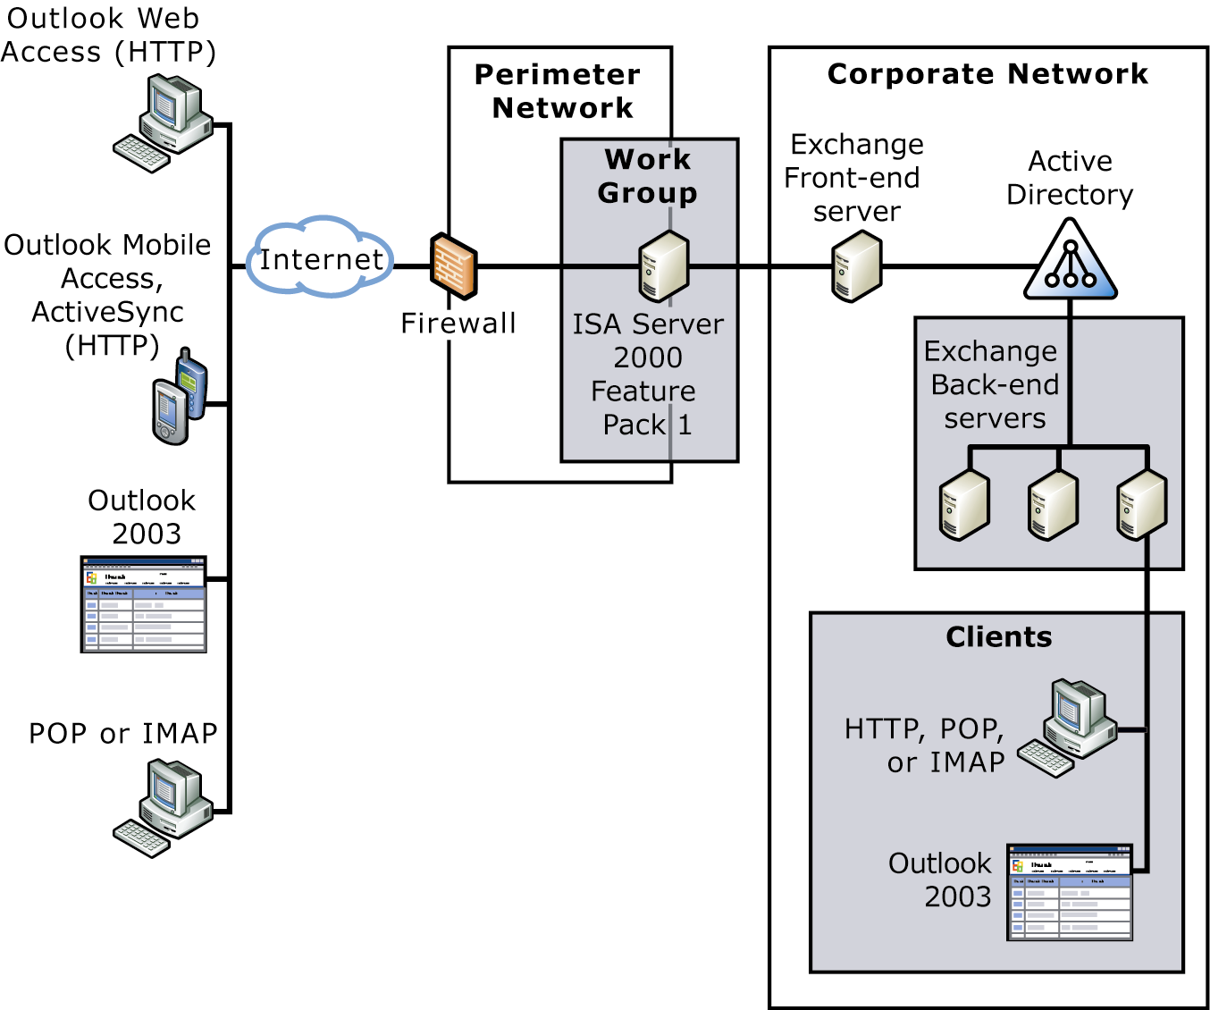
Figure 4.1 Deploying Exchange 2003 Behind ISA Server

Using ISA Server as an advanced firewall server in the perimeter network to help protect your messaging network provides the following advantages:
- ISA Server is not a member of the domain; if the ISA Server is compromised, your domain is not penetrated.
- Because ISA Server is not a domain member, it does not need to communicate with a domain controller or global catalog server, which reduces the number of ports open between the perimeter network and your internal corporate network.
- ISA Server can pre-authenticate traffic bound for your Exchange servers that originates on the Internet, helping to ensure that only authenticated traffic reaches your corporate network.
- ISA Server can detect and help prevent certain malicious network traffic, such as denial of service attacks and port scans.

Using RPC over HTTP
The Windows Server 2003 RPC over HTTP feature enables Outlook users to connect to their Exchange server over the Internet even if firewalls intervene. The recommended deployment strategy is to use ISA Server 2000 with Feature Pack 1 as your security infrastructure, or to locate ISA Server within the perimeter network and then locate your Exchange front-end server (acting as your RPC proxy server) inside of the corporate network. Alternatively, you can locate the Exchange 2003 front-end server acting as an RPC proxy server in the perimeter network.
When you use ISA Server as your reverse proxy server, you have several deployment options. For more information about installing ISA Server as a reverse proxy server to use with Exchange, see the book Exchange Server 2003 Deployment Guide (http://www.microsoft.com/exchange/library).
When you deploy RPC over HTTP in your corporate environment, you have two main deployment options based on where you locate your RPC proxy server:
- Option 1 (recommended) Deploy ISA Server in the perimeter network, and position your RPC proxy server (Exchange front-end server) within the corporate network.
Note When you use ISA Server as your advanced firewall server, you have several deployment options. For information about how to install ISA Server as an advanced firewall server, see the book Using Microsoft Exchange 2000 Front-End Servers (http://go.microsoft.com/fwlink/?LinkId=14575).

- Option 2 Position the Exchange 2003 front-end server acting as an RPC proxy server in the perimeter network.
Each of these options is detailed in the following sections.

Option 1: ISA Server in the Perimeter Network
The first option is to use ISA Server in the perimeter network and position the RPC proxy (front-end) server in the corporate network. This option is recommended. By using ISA Server in the perimeter network to route RPC over HTTP requests and positioning the Exchange front-end server in the corporate network, you need to open only port 80 or port 443 on the internal firewall for Outlook 2003 clients to communicate with Exchange. Additionally, you can completely remove the internal firewall between ISA Server and your corporate network because ISA Server with Feature Pack 1 provides additional security features that standard firewalls cannot provide. Figure 4.2 illustrates this deployment scenario.
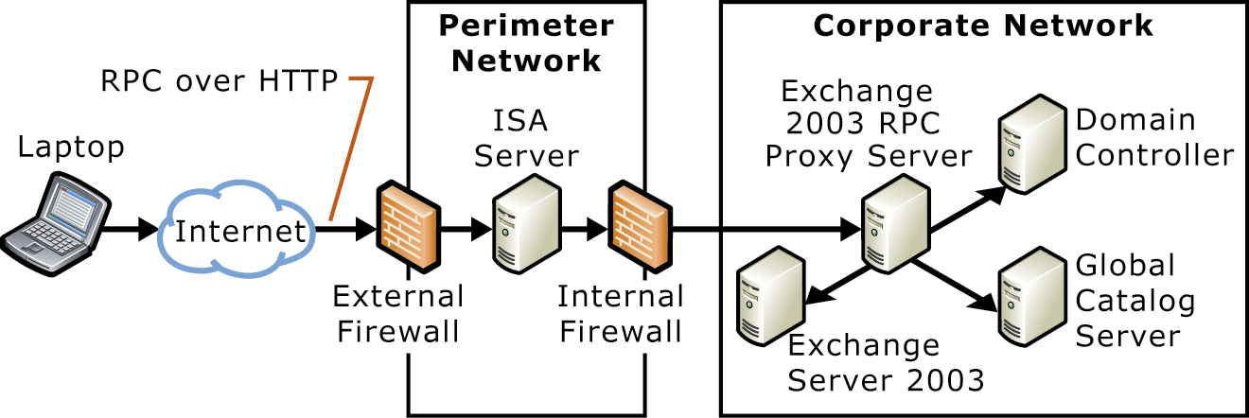
Figure 4.2 Deploying RPC over HTTP using ISA Server as a reverse proxy server in the perimeter network

When located in the perimeter network, the server running ISA Server is responsible for routing RPC over HTTP requests to the Exchange front-end server acting as an RPC proxy server. In this scenario, the RPC proxy server uses specified ports to communicate with other servers that use RPC over HTTP.

Option 2: RPC Proxy Server in the Perimeter Network
Although not recommended, you can position the Exchange 2003 front-end server acting as the RPC proxy server inside the perimeter network. In this scenario, you specify a limited number of ports that the RPC proxy server needs. Figure 4.3 illustrates this deployment scenario. Note that, in the following example, your Exchange front-end server still needs all of the standard ports to communicate with the internal corporate network in addition to the ports for RPC over HTTP.
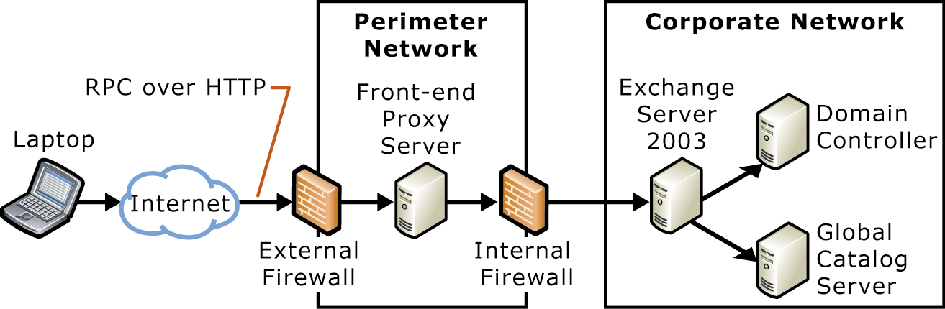
Figure 4.3 Deploying RPC over HTTP on the Exchange front-end server in the perimeter network

For more information about how to configure RPC over HTTP deployment options 1 and 2, see "Deploying RPC over HTTP" later in this chapter. Again, in this scenario, the RPC proxy server uses specified ports to communicate with other servers that use RPC over HTTP.

Deploying RPC over HTTP
To deploy RPC over HTTP, do the following:
- Configure your Exchange front-end server as an RPC proxy server.
- Configure the RPC virtual directory in Internet Information Services (IIS) on the Exchange front-end server.
- Configure the registry on the Exchange 2003 computer that communicates with the RPC proxy server to use ports specified by Exchange 2003 for RPC over HTTP communication.
- Open the specified ports on the internal firewall for RPC over HTTP, as well as the standard ports for Exchange front-end communication.
- Create a profile for your users to use with RPC over HTTP.
After you complete these steps, your users can begin using RPC over HTTP to access the Exchange front-end server.
To use RPC over HTTP, you must run Windows Server 2003 on the following computers:
- All Exchange 2003 servers accessed with RPC over HTTP.
- The Exchange 2003 front-end server acting as the RPC proxy server.
- All domain controllers that communicate with the Outlook 2003 clients and the Exchange 2003 servers configured to use RPC over HTTP.
- The global catalog server used by Outlook 2003 clients and the Exchange 2003 servers configured to use RPC over HTTP.
Exchange 2003 must be installed on all Exchange servers that the RPC proxy server uses. Additionally, all client computers running Outlook 2003 must be running Microsoft Windows XP Service Pack 1 (SP1) or later with the update "Windows XP Patch: RPC Updates Needed for Exchange Server 2003 Beta" (http://go.microsoft.com/fwlink/?LinkId=16687).
Chapter 5

Planning for Reliability
This chapter discusses the concepts and technologies that help you design a highly available and reliable messaging system, including storage technologies, clustering, server tuning, and client configuration.
To design a reliable, highly available messaging system, you need to maximize the system's fault tolerance. Fault tolerance refers to a system's ability to continue functioning when part of the system fails. In a fault tolerant server organization, preventive measures minimize the possibility of a disaster occurring and the impact of a disaster should one occur.
To ensure that your Microsoft® Exchange Server 2003 organization is fault tolerant, you should take steps at various levels within your infrastructure. Figure 5.1 outlines the various levels and summarizes the measures you can take at each level to maximize fault tolerance.
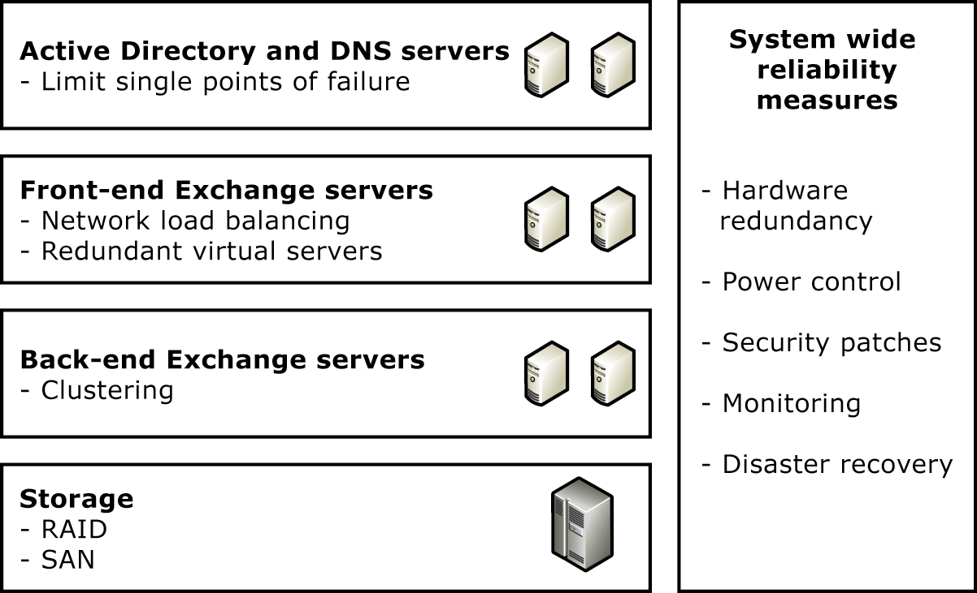
Figure 5.1 Designing reliability into your messaging system

The remainder of this chapter discusses various ways you can design fault tolerance into your messaging system at each level within your messaging system infrastructure:
- System-wide reliability measures Incorporate such things as hardware redundancy, power control, and monitoring throughout your system.
- Microsoft Active Directory directory service and DNS availability Ensure that your domain controllers, global catalog servers, and DNS servers are protected from failure.
- Front-end server availability Use Network Load Balancing and redundant virtual servers to increase availability.
- Back-end servers and Exchange data availability Partition your Exchange files and use server clustering.
- Exchange data storage solutions Use redundant array of independent disks (RAID) and Storage Area Network technologies to increase fault tolerance.

System-Wide Reliability Measures
You can design fault tolerance into your system in several ways that not only benefit your messaging system but your entire network. The following sections discuss the following ways that you can maximize fault tolerance:
- Hardware redundancy
- Power control
- Security patches and antivirus measures
- Monitoring
- Disaster recovery planning

Hardware Redundancy
It is crucial that you incorporate special server and storage hardware configurations that duplicate the hardware within your Exchange organization so that you minimize single points of failure. By incorporating these duplicate hardware configurations, one path of data input/output (I/O) or the physical hardware components of a server (such as computer, network, and Storage Area Network components) can fail without affecting the operations of a server.
The hardware you use to minimize the single points of failure depends on what components you want to make redundant. Some of the latest products from hardware vendors build redundancy into their server or storage solution hardware. Some hardware vendors even provide unique hardware implementations, such as backup and restore hardware for Exchange.
Besides ensuring that your organization contains adequate replacement hardware or specialized hardware, you can also minimize the affect that a hardware failure or other problem (for example, a software failure or security issue), by considering the additional topics in this section.
Note Beyond the technologies presented, a detailed discussion about additional technologies associated with this type of hardware is outside the scope of this book. For more information about implementing hardware designed to minimize single points of failure, search the Microsoft Exchange Web site (http://www.microsoft.com/exchange).

Power Control
Using an uninterruptible power supply (UPS) and battery backup to increase fault tolerance in your Exchange organization is a necessity for servers that contain mission-critical data, especially in large server deployments. A UPS and battery backup provides protection against power surges and short power losses that can cause damage to your servers and the data they contain. If the location of your servers requires cooling to keep the hardware working properly, consider making the climate control system fault tolerant. (For example, keep a battery backup power supply available for each cooling unit.)

Security Patches and Antivirus Measures
To help protect the servers in your Exchange organization from accidental or purposeful harm that may result in downtime, take the following precautions:
- Keep your servers up-to-date with security patches. Subscribing to the Microsoft Security Notification Service ensures that you receive immediate notification of security bulletin releases for any Microsoft product. To subscribe, go to the Product Security Notification Web site (http://go.microsoft.com/fwlink/?LinkId=12217).
- Ensure access permissions are set up correctly.
- Keep your servers in a physical environment that prevents unauthorized people from accessing them.
- Ensure that adequate antivirus software is installed on all your servers. Keep the software up-to-date with the latest virus signature files. Use the automatic update feature of your antivirus application to keep the virus signatures current.
Important File-level scanners cause problems when used with Exchange. If you want to use a file-level scanner, you should exclude Exchange directories from the scan. For more information, see Microsoft Knowledge Base article 328841, "XADM: Exchange and Antivirus Software" (http://support.microsoft.com/?kbid=328841).

Monitoring
To maximize system reliability, you need to be able to manage, monitor, and troubleshoot your servers and applications on an ongoing basis. If a problem occurs, you need to be able to react quickly so that you can recover data and make it available as soon as possible. Microsoft Operations Manager Exchange Management Pack is a system-wide monitoring solution that you could use with Exchange 2000. For more information about Microsoft Operations Manager, see the online book Monitoring Exchange 2000 with Microsoft Operations Manager 2000 (http://go.microsoft.com/fwlink/?LinkId=18177). Microsoft Operations Manager Exchange Management Pack is included with Exchange 2003.

Disaster Recovery Planning
In addition to doing everything you can from a physical infrastructure perspective to make sure your Exchange system is fault tolerant, you need to develop and implement a well-planned backup and recovery strategy. For more information about developing a disaster recovery plan, see the online book, Disaster Recovery for Microsoft Exchange 2000 Server (http://go.microsoft.com/fwlink/?linkid=18350). Although the book pertains to Exchange 2000, the concepts are essentially the same for Exchange 2003.

Active Directory and DNS Server Availability
Exchange relies heavily on Active Directory® directory service and Domain Name System (DNS). For this reason, ensure that domain controllers, global catalog servers, and DNS servers in your organization are well protected from possible failures.
In most deployment scenarios, you should not run Exchange on computers that also function as Microsoft Windows Server™ 2003 domain controllers. Instead, you should configure servers running Exchange and Windows® as separate computers because, if one computer experiences problems, the other is less likely to be affected. Furthermore, if your servers running Exchange do not have to perform domain controller tasks in addition to serving Exchange client computers, the performance of those servers under heavy user loads improves.
In addition, to help maximize the safety of your Active Directory information, store the information on more than one domain controller. In the event that one of the servers experiences a problem, you should have at least one backup server to preserve your Active Directory information.

Front-End Server Availability
On Exchange front-end servers, you should do the following to build fault tolerance into your messaging system:
- Use Network Load Balancing
- Create redundant virtual servers

Using Network Load Balancing
In a corporate or hosting environment, you may want to load balance the front-end servers. Windows provides load balancing through Network Load Balancing.
Windows Network Load Balancing works by clustering two or more servers that represent the Network Load Balancing cluster with a single IP address. Each computer receives traffic to its own unique IP address and the shared IP address. Each member of the Network Load Balancing cluster performs a hashing algorithm to map incoming clients to one of the members of the Network Load Balancing cluster based on the client IP address, port, and other information. When a packet arrives, all servers or hosts perform the same hashing algorithm, and the output is one of the hosts. That host then responds to the packet. The mapping does not change unless the number of hosts in the Network Load Balancing cluster changes.

Creating Redundant Virtual Servers
When configuring Network Load Balancing, you create identical virtual servers on all front-end servers that are part of the Network Load Balancing cluster. Configuring redundant virtual servers facilitates load balancing. In addition, the configuration of every server in the Network Load Balancing cluster must be same; otherwise, clients may experience different behavior depending on the server to which they are routed.

Back-End Servers and Exchange Data Availability
There are several recommendations for maximizing the availability of Exchange data on back-end servers. The primary goal is to partition the Exchange application data and messaging data in a way that allows for better fault tolerance and easier troubleshooting. Partition the Exchange application data and messaging data in this way:
- Use server partitioning best practices Separate your Exchange application files from your Exchange data.
- Store transaction log files and database files Store these files separately to increase fault tolerance and optimize recovery.
- Use server clustering Cluster the back-end servers to optimize messaging system availability.

Server Partitioning Best Practices
To increase fault tolerance and provide for easier troubleshooting, you should do the following:
- Partition your disks so that you can start with a command prompt in an emergency. Partitioning your disks in this way increases your recovery options. For example, you can start with a command prompt and modify or replace any damaged startup files that prevent you from starting Windows.
- Partition your disks so that your Exchange application files, Exchange database files, and Exchange transaction log files are all on separate volumes to increase performance and reduce the amount of data you need to recover. (For more information about storing transaction log files and database files, see "Storing Transaction Log Files and Database Files" later in this chapter.)
If you partition your disks by using these recommendations, each set of files is assigned a separate drive letter. Having each set of files represented by its own drive letter helps you keep track of which partitions you must back up in accordance with the disaster recovery method you choose.
Table 5.1 illustrates a possible partitioning scheme for an Exchange server that has six hard disks, including two storage groups, each containing four databases. Because the number of hard disks and storage groups on your Exchange server may be different than the number of hard disks and storage groups used in this example, apply the logic of this example as it relates to your own server configuration. In Table 5.1, note that drives F, G, H, and I may point to external storage devices.
Table 5.1 Exchange hard disk partitioning scheme
Disk | Drive configuration
Fixed Disk 1 | Drive C (file allocation table (FAT)16)—Windows startup files and MS-DOS® operating system startup files, with a startup option in Boot.ini to start up an MS-DOS command prompt.  Drive D (NTFS)— Windows operating system files and swap file.
Fixed Disk 2 | Drive E (NTFS)—Exchange files and additional server applications (such as antivirus software and resource kits).
Fixed Disk 3 | Drive F (NTFS)—Transaction log files for storage group 1.
Fixed Disk 4 | Drive G (NTFS)—Database files for storage group 1.
Fixed Disk 5 | Drive H (NTFS)—Transaction log files for storage group 2.
Fixed Disk 6 | Drive I (NTFS)—Database files for storage group 2.

You can apply the partitioning recommendations presented in this section whether you are storing Exchange database files on a server or on an advanced storage solution such as a Storage Area Network. In addition to partitioning, you should incorporate technologies such as disk mirroring (RAID-1) and disk striping with parity (RAID-5 or RAID-6). For more information about these technologies, see "Exchange Data Storage Solutions" later in this chapter.

Storing Transaction Log Files and Database Files
As discussed in the previous section, to provide fault tolerance in the event of a hard disk failure, you should keep your Exchange transaction log files and database files on separate physical hard disks. Furthermore, if you keep these log files and database files on separate disks, you significantly increase hard disk I/O performance.
Note You can track the operations made on every database within a storage group because each storage group has its own set of transaction log files. Transaction log files maintain a sequential record of every operation performed on a database. Transaction log files are not deleted until a normal or incremental backup is performed for all the databases in a storage group.

If you lose the hard disk containing the Exchange databases, you can replace the damaged disk and then restore the most recent database backups. After you restore the databases, an automatic log file replay of all transactions that occurred after the backup transfers the recorded transactions from the log files to the databases on disk. This process may involve both a "hard recovery" and a "soft recovery" process. Hard recovery refers to the process of replaying transaction log files from tape after you restore a database from an online backup. After the hard recovery, if Exchange determines that additional log files are available on the server for replay, a soft recovery process restores these additional log files into the restored database.
If you lose the hard disk containing the transaction log files, but not the disk containing your databases, you do not have to restore any Exchange data from backup. However, losing the hard disk containing the transaction log files is more dangerous than losing the hard disk containing the databases because you cannot replay transactions that are recorded to log files but not recorded to the physical database files on disk. This increases the chance of losing data that is not preserved in either the log files or in the last backup. When the databases are disconnected, the transactions in memory are written to the databases on disk to make them current (also known as a "dirty shutdown"). To restore these databases to consistency without the missing log files, you must use ESEUTIL to repair them. To recover from a loss of transaction log files, first copy the inconsistent database files (*.EDB and *.STM file pairs) to a safe place. Then restore the database from the backup and replay as much of the transaction logs as are available. Next, repair the inconsistent database so that it is mountable, and then mount it either in a recovery storage group or on an alternate forest recovery server. Finally, use ExMerge.exe to recover the changes from the inconsistent database and to move the changes to the restored database.
Important If you keep your Exchange databases and transaction log files on the same physical hard disk and that disk fails, you can recover only the data that existed up to your last backup.

You can minimize the time it takes to recover from a hard disk failure if you keep each of your Exchange storage groups on a separate hard disk. If only one disk fails and you have each storage group located on a separate physical hard disk, you need only to restore the storage group that is kept on the failed disk.

Disk Defragmentation
The process of disk defragmentation involves rearranging data on a server's hard disks to make the files more contiguous for more efficient reads. Defragmenting your hard disks helps increase disk performance and ensures that the servers in your Exchange organization run smoothly and efficiently.
Because severe disk fragmentation can cause performance problems, run a disk defragmentation program (such as Disk Defragmenter) on a regular basis or when server performance levels fall below normal. Because more disk reads are necessary when backing up a heavily fragmented file system, ensure that your disks are recently defragmented.
Exchange databases also require defragmentation. Online defragmentation occurs daily by default on Exchange databases. You can perform offline defragmentation by using ESEUTIL, which requires that databases be taken offline. Offline defragmentation for Exchange databases is usually recommended only if a large number of users are moved off the server running Exchange 2003. Because offline defragmentation alters the database pages completely, you should create new backups of the Exchange 2000 databases immediately after offline defragmentation. For more information about online and offline defragmentation, see "Online and Offline Defragmentation" in Chapter 2, "Understanding Disaster Recovery Concepts," in the technical paper Disaster Recovery for Microsoft Exchange 2000 Server (http://go.microsoft.com/fwlink/?linkid=18350).

Hard Disk Space Considerations
Ensure that you have adequate hard disk capacity for your servers running Exchange. You should have enough space on your hard disk to restore both the database and the log files.
You could have a backup that is too large to restore to its original location. For example, a normal backup performed once a week, plus six days of differential backups, might require more disk space during a restore than your server has available. Whether the restore requires more disk space than you have available depends on how many log files are generated during a week. For example, a server generating 2,000 log files in a week amounts to 10 GB of log file space, in addition to the space required for the database.
Performing normal backups on a daily basis reduces the amount of space required to restore your Exchange databases. The reason for this reduced space is that normal backups delete the transaction log files up to the time that you perform the backup. Therefore, if you need to restore your Exchange databases, perform normal backups on a daily basis to ensure that you do not have to restore more than one day's worth of log files.
Also, you should never let your database drive (the hard disk containing the .edb and .stm files) become more than half full. Although a database drive that is half full results in unused disk space, it can still reduce extended server downtime for the following reasons:
- You can restore databases faster than with a full drive (especially if the file system is fragmented).
- You can perform offline defragmentation on the same physical disk instead of copying databases over to a maintenance server, (a task that takes much longer than copying database files to a temporary directory on the same physical hard disk).
- You can back up a copy of the databases to the same physical disk before you restore them, which enables you to attempt to repair the databases if a problem occurs during the restore process (for example, the existing backup contains errors). For this reason, it is recommended that you move or copy the current database and log files before restoring a database.
Note Given the large size of the average database, copying your most current database to a different physical disk drive or to another server may add several hours to your downtime. However, if you have sufficient local disk space on the same physical drive, you can move the current database files to another folder by using a command prompt or Windows Explorer before you perform the restore.

Using Server Clustering
Microsoft Cluster Server Cluster service is a Windows Server feature that administrators can use to achieve continuous availability of server resources.
You must be familiar with Cluster Service concepts before you plan and deploy Exchange 2000 clusters. Many resources, including Windows Server 2003 Help, Microsoft Windows Server 2003 Resource Kit, and Web sites such as Microsoft Developer Network (MSDN®), offer information about Windows Server 2003 clustering concepts. Additional resources are listed at the end of this document.

Benefits of Clustering
Creating Exchange clusters provides high levels of availability so that you can keep your mission-critical applications running in the event of a failure.
A common Information Technology industry term for maximum reliability is "five nines," meaning that a server runs 99.999 percent of the time, which translates into just 5 minutes of downtime per year. Most businesses, however, do not need such stringent uptime requirements.
For the majority of usage scenarios, 99.99 percent uptime is adequate because this percentage equals less than one hour of downtime per year. Aberdeen Group, Inc. found that Windows Server delivers 99.95 percent uptime right out of the box, before the servers are fully optimized for the environment, and before the Information Technology staff is experienced in using the new operating system.
Building Exchange server clusters harnesses the reliability of Windows so that you can build highly available Exchange clusters. To read the report from Aberdeen Group, Inc. and to find out more about Windows reliability, see the Windows Web site at http://go.microsoft.com/fwlink/?LinkId=9066.
The following sections discuss reliability in Exchange clusters.

Exchange 2003 Clustering Features
Exchange 2003 offers a number of clustering improvements. For example, Exchange 2003 supports up to eight nodes and contains added features that enhance security. The performance of Exchange clustering has also been improved for Exchange 2003. Specifically, the time it takes for a server to fail over to a new node has been reduced.
The following are some of the significant updates that relate to Exchange clustering for Exchange 2003:
- Support for up to eight-node clusters Exchange has added support for up to eight-node active/passive clusters when using Windows Server 2003 Enterprise Edition or Windows Server 2003 Datacenter Edition.
- Support for volume mount points Exchange has added support for the use of volume mount points when using Windows Server 2003 Enterprise Edition or Windows Server 2003 Datacenter Edition.
- Improved failover performance Exchange has improved the performance of clustering by reducing the amount of time it takes a server to fail over to a new node.
- Improved security Exchange cluster servers are now more secure. For example, the Exchange 2003 permissions model has changed, and Kerberos authentication protocol is enabled by default.
- Improved prerequisite checking Exchange performs more prerequisite checks to help ensure your cluster servers are deployed and configured properly.
The following sections discuss some of these features in detail. For more information about Exchange clustering, see the technical paper Deploying Microsoft Exchange 2000 Server Clusters (http://go.microsoft.com/fwlink/?linkid=10193). Although this paper was most recently updated for Exchange 2000 SP3, most of the content is applicable to Exchange 2003 clusters.
Note Some of the improvements to clustering discussed in this section become available when using the Windows Server 2003 operating system in conjunction with Exchange 2003. For additional benefits of using Windows Server 2003 for the servers in your Exchange 2003 clusters, see the technical paper Technical Overview of Clustering in Windows Server 2003 (http://go.microsoft.com/fwlink/?LinkId=16303).

Support For Up to Eight-Node Clusters
Exchange 2003 enhances clustering capabilities by introducing support for eight-node Exchange clusters. Eight-node clusters are supported only when running Windows Server 2003 Enterprise Edition or Windows Server 2003 Datacenter Edition. Another requirement for clusters with three nodes or more is that at least one node must be passive.
Note All Exchange 2003 clustering recommendations are for active/passive cluster configurations. Active/active clustering is supported on two nodes.

Support for Volume Mount Points
Volume mount points are now supported on shared disks when the nodes of your cluster are running Window Server 2003 Enterprise Edition or Datacenter Edition with four or more nodes. Volume mount points are directories that point to specified disk volumes in a persistent manner. (For example, you can configure C:\Data to point to a disk volume.) Mount points bypass the need to associate each disk volume with a drive letter, thereby surpassing the 26-drive letter limitation.
For more information about mounted drives and how to create mounted drives, consult your Windows Server 2003 documentation.

Improved Failover Performance
For clustering in Exchange 2003, the amount of time it takes for a node to fail over to another node is reduced, thereby improving overall performance. The following sections provide information about the improvements to failover times.

Improved Dependency Hierarchy for Exchange Services
To decrease the amount of time it takes to fail over a server, Exchange 2003 provides an improved dependency hierarchy for Exchange services. Specifically, the Exchange protocol services, which were previously dependent on the Microsoft Exchange Information Store service, are now dependent on the Microsoft Exchange System Attendant service (Figures 5.2 and 5.3).
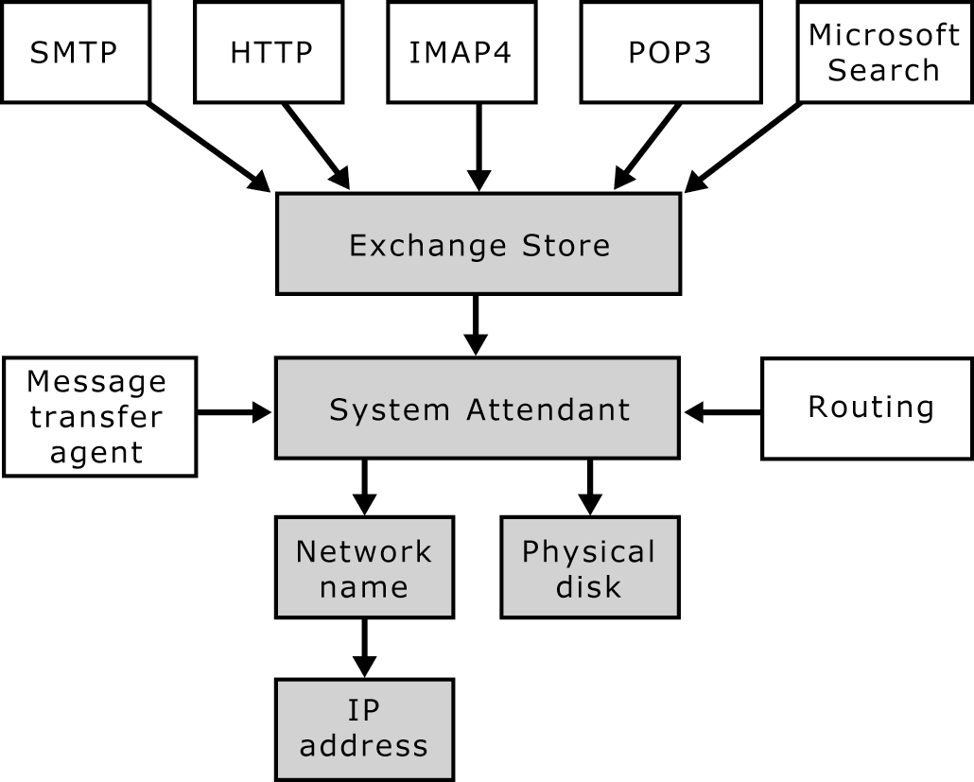
Figure 5.2 Hierarchy of Exchange dependencies in Exchange 2000

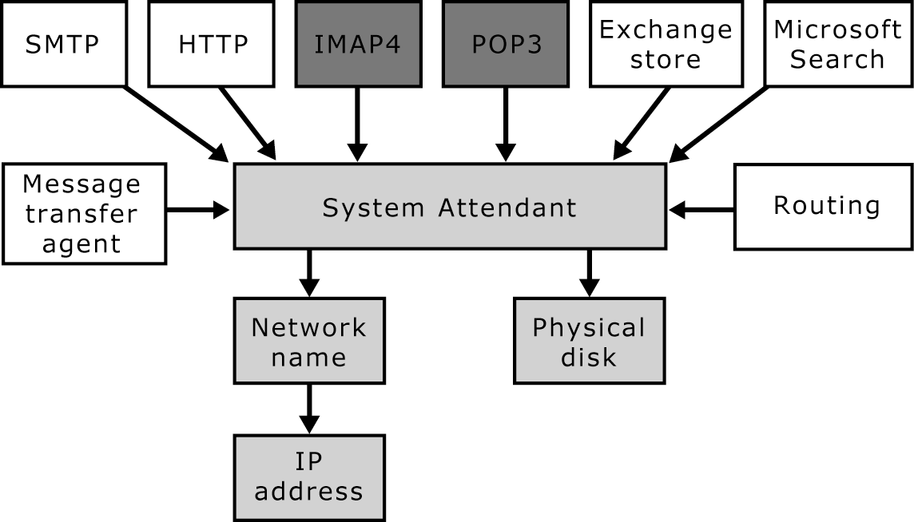
Figure 5.3 Hierarchy of Exchange dependencies in Exchange 2003

Note In Exchange 2003, the Internet Message Access Protocol version 4rev1 (IMAP4) and Post Office Protocol version 3 (POP3) resources are not created automatically when you create a new Exchange virtual server.

If a failover occurs, this improved hierarchy allows the Exchange mailbox stores, public folder stores, and Exchange protocol services to start simultaneously. As a result, all Exchange resources (except the System Attendant service) can now start and stop simultaneously, thereby improving failover time. Additionally, if the Exchange store stops, it is no longer dependent on other services to restart.
Another benefit is the reduction of downtime resulting from an Exchange virtual server failover. This reduction can save several minutes.

Improved Detection of Available Nodes
When running Exchange 2003 on Windows Server 2003, the cluster service automatically detects the free node. The overall time it takes for Exchange to fail over to the free node is reduced. Therefore, for both planned and unplanned failovers, downtime is reduced.

Improved Security
Exchange 2003 clustering, when run on Windows Server 2003, includes the following security features:
- Clustering permission model changes
- Kerberos enabled by default on Exchange virtual servers
- Internet Protocol security (IPSec) support from front-end servers to clustered back-end servers
- IMAP4 and POP3 resources are not added by default when you create a virtual server
The following section discusses each of these features in detail.

Clustering Permission Model Changes
The permissions needed to create, delete, or modify an Exchange virtual server are modified in Exchange 2003. The best way to understand these modifications is to compare the Exchange 2000 permissions model with the new Exchange 2003 permissions model.

Exchange 2000 Permissions Model
For an Exchange 2000 cluster administrator to create, delete, or modify an Exchange virtual server, the logged on user and the Cluster service account require the following permissions:
- If the Exchange virtual server is the first Exchange virtual server in the organization, you must have Exchange Full Administrator permissions at the organizational level.
- If the Exchange virtual server is not the first Exchange virtual server in the organization, you must have Exchange Full Administrator permissions at the administrative group level.

Exchange 2003 Permissions Model
In Exchange 2003, the permissions model has changed. The Windows Cluster service account no longer requires Exchange Full Administrator permissions in the Exchange organization or administrative group. The logon permissions of the user administering the cluster are the ones that are required to create, modify, and delete Exchange virtual servers.
However, the logon permissions of the user administering the cluster will need different permission levels depending on the mode in which your Exchange organization is running (native mode or mixed mode) and on the configuration of your topology.
Note Routing groups in Exchange organizations running in native mode can span multiple administrative groups. Routing groups in Exchange organizations running in mixed mode cannot span multiple administrative groups.
When your Exchange organization is in native mode, if the Exchange virtual server is in a routing group that spans multiple administrative groups, the user needs Exchange Full Administrator permissions on that administrative group as well.
In topologies, such as parent/child domains where the cluster server is the first Exchange server in the child domain, you must have Exchange Administrator Only permissions at the organizational level to specify the server responsible for Recipient Update Service in the child domain.

Kerberos Enabled by Default on Exchange Virtual Servers
Kerberos is the authentication protocol in Windows 2000 Server and later that provides mutual authentication. However, Windows Cluster service did not support Kerberos enabled cluster groups until Windows 2000 Server Service Pack 3 (SP3). Because of this, the older authentication protocol, NTLM, was the default authentication protocol for Exchange servers running in clusters.
Because Kerberos is supported in Windows Cluster service on Windows 2000 SP3 or later or Windows Server 2003 and Exchange 2003, Kerberos is enabled by default when you create an Exchange virtual server on a server running Windows Server 2003 or Windows 2000 SP3.

IPSec Support from Front-End Servers to Clustered Back-End Servers
You can use Internet Protocol security (IPSec) if a secure channel is required between front-end and back-end cluster servers. This configuration is fully supported when both the front-end servers and back-end servers are running Exchange 2003 on Windows Server 2003.

IMAP4 and POP3 Resources Not Added by Default
For improved security, the IMAP4 and POP3 protocol resources are no longer created when you create an Exchange virtual server. For more information about enabling IMAP4 or POP3, see Chapter 8, "Managing Exchange Clusters," in the book Exchange Server 2003 Administration Guide (http://www.microsoft.com/exchange/library).

Checking Clustering Prerequisites
Exchange 2003 performs more prerequisite checks on clusters than previous versions of Exchange. For example, Exchange 2003 performs more installation checks to ensure that Exchange is installed on your cluster nodes correctly. Similarly, Exchange 2003 performs more virtual server checks to ensure that Exchange virtual servers are configured correctly.

Understanding Exchange 2003 Clustering
The clustering feature in Windows helps you achieve scalability and high availability for server applications such as Exchange. A cluster consists of individual computers (also called nodes) that function cohesively in a cluster service. These computers act as network service providers or as reserve computers that take over server operations for another node if it experiences problems. Clustering provides fault tolerance and reliability. Furthermore, depending on how you configure your cluster, clustering can simplify the process of recovering a single server from disasters.
In a clustering environment, Exchange runs as a virtual server (not as a stand-alone server) because any node in a cluster can assume control of a virtual server. If the node running the Exchange virtual server experiences problems, the Exchange virtual server goes offline for a brief period until another node takes control of the damaged node.
You can use either an active/passive or active/active configuration for your Exchange clusters, although active/passive configuration is recommended.
This section discusses the following aspects of Exchange 2003 clustering:
- Windows Clustering
- Exchange virtual servers
- Quorum disk resource
- Cluster configurations
- Windows and Exchange version requirements
- Example of a two-node cluster topology
- Understanding failovers
- IP addresses and network names

Windows Clustering
To create Exchange 2003 clusters, you must use Windows Clustering. Windows Clustering is a feature of Windows Server 2003 Enterprise Edition and Windows Server 2003 Datacenter Edition. Windows Cluster service is the essential software component that controls all aspects of Windows Clustering. When Exchange 2003 Setup is run on a node of a Windows Server 2003 cluster, the cluster-aware version of Exchange is automatically installed. Exchange 2003 uses the following Windows Clustering features:
- Shared nothing architecture Windows Clustering features a shared nothing architecture, which means that, although all nodes in the cluster can access shared data, they cannot access it at the same time. For example, if a physical disk resource is assigned to node 1 of a two-node cluster, node 2 cannot access the disk resource until node 1 is taken offline, fails, or the disk resource is moved to node 2 manually.
- Resource DLL Windows communicates with resources in a cluster by using a resource DLL. Exchange 2000 provides its own custom resource DLL (named Exres.dll) to communicate with Cluster service. Communication between Cluster service, and Exchange 2003 is customized to provide all Windows Clustering functionality.
- Groups Exchange 2003 uses Windows cluster groups to contain Exchange virtual servers in a cluster. An Exchange virtual server in a cluster is a Windows cluster group containing cluster resources, such as an IP address and Exchange 2003 System Attendant.
- Resources Exchange virtual servers include Windows Cluster service resources, such as IP address resources, network name resources, and physical disk resources. Exchange virtual servers also include their own Exchange-specific resources. After you add the Systems Attendant Instance resource (an Exchange-specific resource) to a Windows cluster group, Exchange automatically creates the other essential Exchange-related resources, such as the HTTP Virtual Server Instance, the Information Store Instance, and MS Search Instance.

Exchange Virtual Servers
To create an Exchange 2003 cluster, you create a Windows 2000 cluster group and then add specific resources to it. Exchange 2003 clusters create logical servers referred to as Exchange virtual servers. Unlike a stand-alone (non-clustered) computer running Exchange 2003, an Exchange virtual server is a cluster group that can be failed over if the server currently running the Exchange virtual server fails. When one computer in the cluster fails, one of the remaining nodes in the cluster takes over for the failed Exchange virtual server, and clients can access this server by using the same Exchange server name.
An Exchange virtual server is a cluster group that requires, at a minimum, the following resources:
- Static IP address.
- Network name.
- One or more physical disks for shared storage.
- An Exchange 2003 Server System Attendant resource. (The System Attendant resource installs other required Exchange resources.)
Figure 5.4 illustrates the resources of an Exchange 2003 cluster and the resource dependencies.
Figure 5.4 Exchange 2003 resources and dependencies

Note In Exchange 2003, the IMAP4 and POP3 resources are not automatically created when you create a new Exchange virtual server. For more information about IMAP4 and POP3 resources, see Chapter 8, "Managing Exchange Clusters," in the book Exchange Server 2003 Administration Guide (http://www.microsoft.com/exchange/library).

Client computers connect to an Exchange virtual server the same way they connect to a stand-alone computer running Exchange 2003. Microsoft Windows 2000 Server provides the IP address resource, the Network Name resource, and disk resources associated with the Exchange virtual server; Exchange 2003 provides the System Attendant resource and other required resources. When you create the System Attendant resource, all other required and dependant resources are installed.
Table 5.2 describes the Exchange 2003 components and their dependencies.
Table 5.2 Exchange Server 2003 cluster resource description and dependencies
Component | Description | Dependency
System Attendant | System Attendant is the fundamental resource that controls the creation and deletion of all the resources in the Exchange virtual server. | Network name resource and shared disk resources.
Exchange store | Provides mailbox and public folder storage for Exchange Server. | System Attendant
SMTP | Handles relay and delivery of e-mail. | System Attendant
MAP4* | Optional component that provides access to e-mail messages for IMAP4 clients. | System Attendant
POP3* | Optional component that provides access to e-mail messages for POP3 clients. | System Attendant
HTTP | Provides access to Exchange mailboxes and public folders via HTTP (for example, Microsoft Office Outlook® 2003 Web Access 2003). | System Attendant
Exchange MS Search Instance | Provides content indexing for the Exchange virtual server. | System Attendant
Message transfer agent (MTA) | There can be only one MTA per cluster. The MTA is created on the first Exchange virtual server. All additional Exchange virtual servers are dependent on this MTA. The MTA is responsible for communication with X.400 system and for interoperation with Exchange 5.5. | System Attendant
Routing service | Builds the link state tables. | System Attendant

Note Only one Exchange virtual server in a cluster has an MTA resource. All other Exchange resources exist in each Exchange virtual server.
* In Exchange 2003, the IMAP4 and POP3 resources are not automatically created when you create a new Exchange virtual server. For more information about the IMAP4 and POP3 resources, see Chapter 8, "Managing Exchange Clusters," in the book Exchange 2003 Administration Guide (http://www.microsoft.com/exchange/library).

Microsoft Exchange 2000 Server clusters do not support the following Exchange 2000 components:
- Microsoft Active Directory Connector (ADC)
- Microsoft Exchange 2000 Calendar Connector
- Exchange Connector for Lotus Notes
- Exchange Connector for Novell GroupWise
- Microsoft Exchange Event service
- Site Replication Service (SRS)
- Network News Transfer Protocol (NNTP)
Note Exchange 2000 clusters do not support NNTP. The NNTP service, (a subcomponent of the Windows 2000 Internet Information Services, (IIS) component, is still a required prerequisite for installing Exchange 2000 in a cluster. After you install Exchange 2000 in a cluster, the NNTP service is not functional.

Quorum Disk Resource
The most important disk in the cluster is the disk designated as the quorum disk resource. The quorum disk resource maintains configuration data in the quorum log, cluster database checkpoint, and resource checkpoints. The quorum disk resource also provides persistent physical storage across system failures. Because the cluster configuration is kept on quorum disk resource, all nodes in the cluster must be able to communicate with the node that owns it.
Figure 5.5 illustrates a quorum disk resource in a two-node cluster.
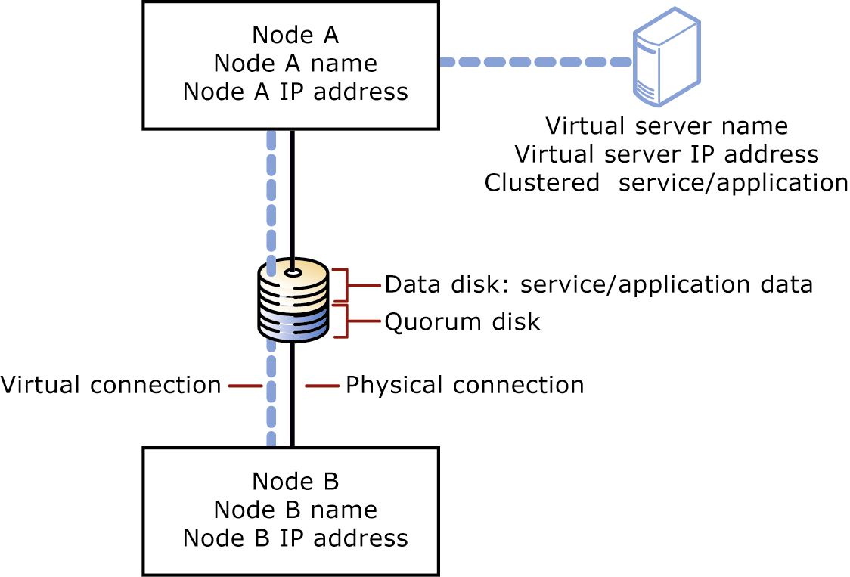
Figure 5.5 The quorum disk resource in a two-node cluster

When a cluster is created or when network communication between nodes in a cluster fails, the quorum disk resource prevents the nodes from forming multiple clusters. To form a cluster, a node must arbitrate for and gain ownership of the quorum disk resource. For example, if a node cannot detect a cluster during the discovery process, the node attempts to form its own cluster by taking control of the quorum disk resource. However, if the node does not succeed in taking control of the quorum disk resource, it cannot form a cluster.
The quorum disk resource stores the most current version of the cluster configuration database in the form of recovery logs and registry checkpoint files. These files contain cluster configuration and state data for each individual node. When a node joins or forms a cluster, Cluster service updates the node's individual copy of the configuration database. When a node joins an existing cluster, Cluster service retrieves the configuration data from the other active nodes.
Cluster service uses the quorum disk resource recovery logs to:
- Guarantee that only one set of active, communicating nodes can operate as a cluster.
- Enable a node to form a cluster only if it can gain control of the quorum disk resource.
- Allow a node to join or remain in an existing cluster only if it can communicate with the node that controls the quorum resource.
Note You should create new cluster groups for Exchange virtual servers, and no Exchange virtual server should be created in the cluster group with the quorum disk resource.

Cluster Configurations
With the clustering process, you can manage a group of independent servers as a single system. Each server in the cluster has individual memory, processors and network adapters, but shares a common storage medium. Each server also has an identical processor and the same amount of RAM. A separate private network, used only for cluster communication between the nodes, can connect these servers.
Note Although you can configure Exchange to support multiple virtual servers on a single node, it is recommended that only one virtual server run on each node in the cluster.

The following sections discuss Exchange 2003 cluster configurations. Before you create your Exchange 2003 clusters, determine the level of availability expected for your users. After you make this determination, configure your hardware to the Exchange 2000 cluster that best meets your needs.
You can install either active/passive or active/active Exchange 2000 clusters, although active/passive clustering is recommended.

Active/Passive Clustering
In active/passive clustering, the cluster includes a primary node and one or more secondary nodes. The secondary nodes are idle until a failover occurs on a primary node. When the primary node in an active/passive cluster fails or is taken offline, the clustering feature in Windows takes over. The failed node is taken offline, and a secondary node takes over the operations of the failed node. It usually takes only a few minutes for the cluster to fail over to another node. As a result, the Exchange resources on your cluster are unavailable to users for only a brief period of time.
Exchange considers the following configuration to be an active/passive cluster:
Number of Exchange virtual servers < Number of nodes in the cluster

Active/Active Clustering
In active/active clustering, both nodes in your cluster group are active. (They each share the processing operations of the cluster.) When one node in an active/active cluster fails or is taken offline, the remaining node in the cluster takes over for the failed node.
Exchange considers the following configuration to be an active/active cluster:
Number of Exchange virtual servers ≥ Number of nodes in the cluster

Cluster Groups
When you configure an Exchange cluster, you must create groups to manage the cluster and the Exchange virtual servers in the cluster. Furthermore, you can independently configure each Exchange virtual server. When creating cluster groups, consider the following recommendations:
- When creating groups within Cluster service, create a separate group for the quorum disk resource to provide fault tolerance for the cluster.
- Assign each group its own set of physical hard disks to the cluster resources in that group. This way, if an individual hard disk fails, cluster resources in other groups are not affected.
- Use separate physical hard disks to store an Exchange virtual server's transaction log files and database files. Separate hard disks prevent a single hard disk failure from eliminating the log files and database files for that Exchange virtual server. This recommendation is also relevant for Exchange stand-alone servers.

Windows and Exchange Version Requirements
Specific versions of Windows and Exchange are required to create Exchange clusters. Table 5.3 outlines these requirements.
Table 5.3 Windows and Exchange version requirements
Windows version | Exchange version | Cluster nodes available
Any Windows Server product | Microsoft Exchange Server 2003 | None
Windows 2000 Server or Microsoft Windows Server 2003 Standard Edition | Exchange Server 2003 or Exchange Server 2003 Enterprise Edition | None
Windows 2000 Advanced Server | Exchange Server 2003 Enterprise Edition | Up to two
Windows 2000 Datacenter Server | Exchange Server 2003 Enterprise Edition | Up to four
Windows Server 2003 Enterprise Edition | Exchange Server 2003 Enterprise Edition | Up to eight
Windows Server 2003 Datacenter Edition | Exchange Server 2003 Enterprise Edition | Up to eight

Example of a Two-Node Cluster Topology
Figure 5.6 shows an example of a two-node cluster topology. Both cluster nodes are members of the same domain. The cluster nodes are connected to the public network and a private cluster network. The physical disk resource is the shared disk in the cluster.
If only one cluster node owns one Exchange virtual server, this situation is an active/passive configuration. If both nodes own one or more Exchange virtual servers, or if either node owns two Exchange virtual servers, this situation is an active/active configuration (see Figure 5.6).
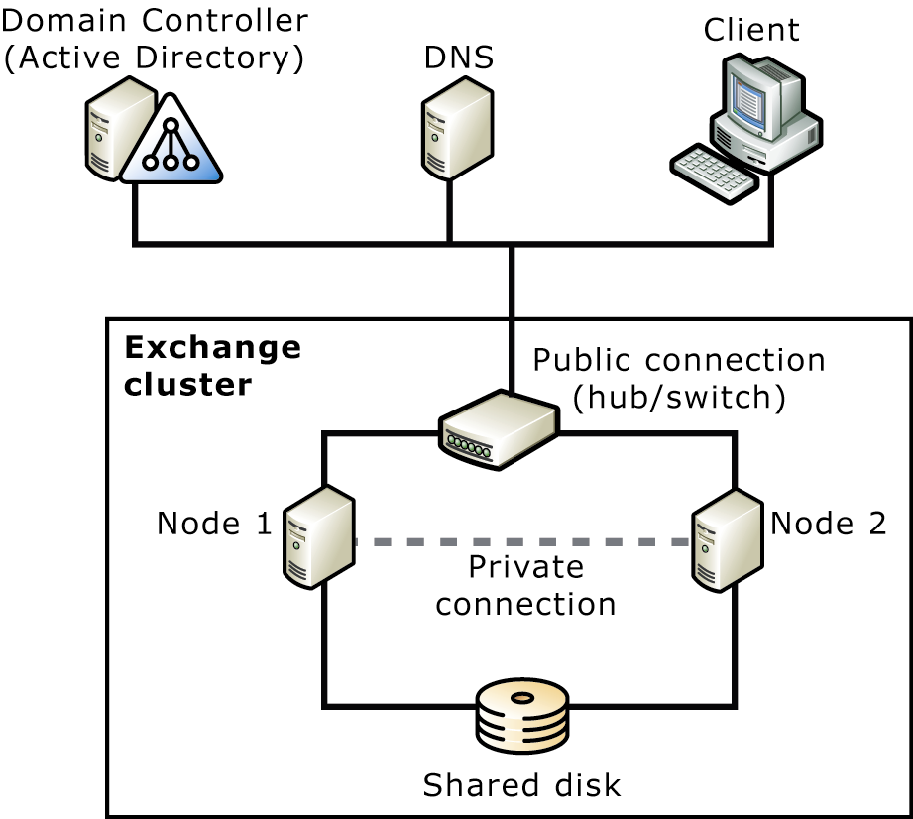
Figure 5.6 Example of a two-node Exchange cluster

Understanding Failovers
The failover time for Exchange virtual servers is important. To maintain high availability, the failover time must be short. There are two scenarios for failover: planned and unplanned.
In a planned failover:
- The Exchange administrator uses Cluster service to move the Exchange virtual server to another node.
- All resources of the Exchange virtual server go offline.
- The resources move to the node specified by the Exchange administrator.
- All resources of the Exchange virtual server go online.
In an unplanned failover:
- One resource (or several) of the Exchange virtual server fails. The failure is discovered with the next IsAlive check or if one of the resources fails.
- Cluster service automatically takes all dependent resources offline.
- If the failed resource is configured to restart (default setting), Cluster service attempts to restart the failed resource and all its dependent resources.
- If the resource fails again:
- Cluster service tries to restart it again.
-or-
- If the resource is configured to affect the group (default) and the resource has failed a certain number of times (default 3) within a configured time period (default 300 seconds), Cluster service takes all resources in the Exchange virtual server offline.
- All resources are failed over (moved) to another node in the cluster. If specified, this is the next node in the Preferred Owners list.
- Cluster service attempts to bring all resources of the Exchange virtual server online on the new node.
- If the same or another resource fails again on the new node, Cluster service repeats the previous steps and may need to fail over to yet another node (or back to the original node).
- If the Exchange virtual server keeps failing over, Cluster service fails over the Exchange virtual server a maximum number of times (default 10) within a specified time period (default 6 hours). After this time, the Exchange virtual server stays in a failed state.
- If failback is configured (default is turned off), Cluster service either moves the Exchange virtual server back to the original node immediately when the original node becomes available or at a specified time of day if the original node is available again, depending on the group configuration.

IP Addresses and Network Names
A typical installation of a cluster includes a public network that client computers use to connect to Exchange virtual servers and a private network for cluster node communication. If n represents the number of cluster nodes and e represents the number of Exchange virtual servers, a cluster has, at a minimum, 2*n + e + 1 IP addresses and n + e + 1 NetBIOS names:
- Each node of the cluster has two static IP addresses (the public and private network connection IP addresses of each node) and one NetBIOS name.
- The cluster itself has a static IP address and a NetBIOS name.
- Each Exchange virtual server has a static IP address and a NetBIOS name.
Important It is strongly recommended that you use a private network for cluster communication and static IP addresses in any cluster deployment. Using Dynamic Host Configuration Protocol (DHCP) prevents client computers from connecting to the cluster, and the entire cluster may fail if the DHCP server fails to renew the IP lease. Using a private network for cluster communication is strongly recommended. Otherwise, a failure of the public network connection of one node prevents the cluster nodes from communicating with each other, and the failure blocks affected resources from failing over and may even cause the entire cluster to collapse.

A common and reliable configuration for an Exchange Server four-node cluster is a design in which three nodes are active and one node is passive. This design attempts to balance the CPU, disk, memory, and network load of the computer so that no component of the system is bottlenecked prematurely.
Figure 5.7 illustrates the four-node Exchange cluster described in this section.
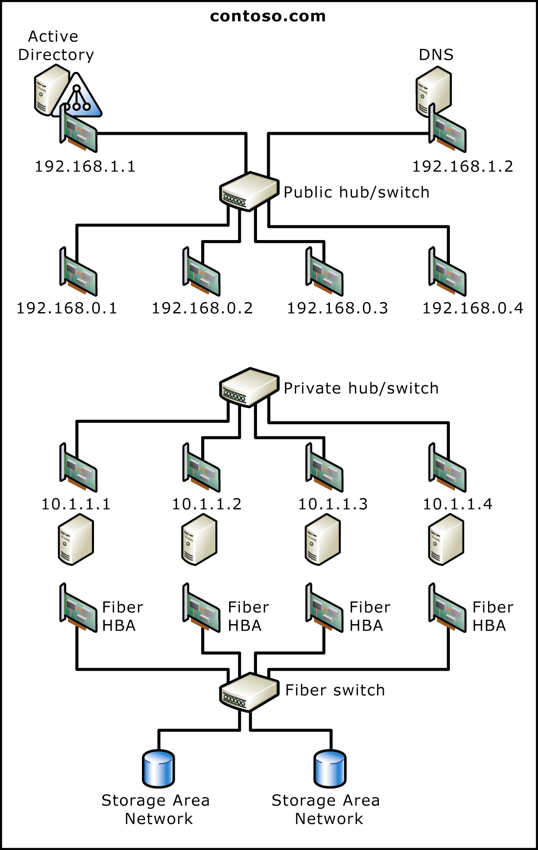
Figure 5.7 Example of a four-node Exchange cluster

Planning Considerations for Clustering
The following considerations are important when planning for Exchange 2003 clusters. These considerations apply to Exchange 2003 clusters on Windows 2000 Advanced Server, Windows 2000 Datacenter Server, Windows Server 2003 Enterprise Edition, and Windows Server 2003 Datacenter Edition.
You should consider the following when planning your Exchange clusters:
- Dedicating computers to Exchange
- Separate hard drives for log files
- Storage group limitations
- Drive letter limitations
The following sections discuss these considerations in more detail.

Dedicating Computers to Exchange
In addition to Exchange 2003, your server clusters can run other applications. However, the performance of your Exchange virtual servers is affected by running multiple applications on the same node. Consider the following when deciding whether to dedicate computers to Exchange:
- If you use a cluster for more than one application, you should consider dedicating a node for each application and ensure that enough passive nodes are available.
- If you use clusters to provide Exchange services to your users, it is recommended that you run only Exchange 2003 on your clusters and run other applications on separate hardware.
- For best results, an Exchange virtual server should not fail over to an active node that runs another application.
- The cluster nodes of an Exchange 2003 cluster must be member servers of a domain. Exchange 2003 clusters do not support cluster nodes as domain controllers or global catalog servers.
For more information about the performance of Exchange 2003 clusters, see Chapter 8, "Managing Exchange Clusters," in the book Exchange Server 2003 Administration Guide (http://www.microsoft.com/exchange/library).

Separate Hard Disks for Log Files
If the storage groups for an Exchange virtual server are configured so that the log files are on one set of physical drives and the databases on another, all of the drives must be configured as disk resources within the same Exchange virtual server. That is, all of the data must be on a shared disk, and all of the physical disk resources must be part of the Exchange cluster group. This allows the log files and the storage group databases to fail over to another node if the Exchange virtual server goes offline.
Note All disk resources that contain Exchange data should also be made dependent on the System Attendant resource.

Storage Group Limitations
Exchange 2003 is limited to four storage groups per server. This limitation is a physical one and applies to each node of a cluster as well. This limitation may create problems with active/active configurations but does not affect active/passive configurations. Table 5.4 illustrates this limitation.

Table 5.4 A two-node active/active Exchange 2003 cluster configuration with too many storage groups
Exchange virtual server | State | Storage group names
Node 1  Exchange virtual server (EVS)1 | Active | storage group 1, storage group 2, storage group 3
Node 2  EVS2 | Active | storage group 1, storage group 2

In Table 5.4, the Exchange cluster includes five storage groups. If EVS2 on node 2 fails over to node 1, node 1 cannot connect to one of the storage groups from node 2 because node 1 will have exceeded the four-storage-group limitation for a single cluster node. As a result, EVS2 does not come online on node 1. If node 2 is still available, EVS2 fails over back to node 2.
Note Exchange 2003 does support a fifth storage group for backup and recovery purposes. However, you cannot use the fifth storage group to create new user mailboxes.

Drive Letter Limitations
Exchange 2003 clusters with four or more nodes have an additional limitation that you must plan for before building the cluster. Windows has a 24-drive letter limitation per server. If you plan to have the majority of disks on the server as shared cluster resources, the 24-drive letter limitation applies to the entire cluster, not just to each individual node. Regardless of the number of nodes in the cluster, the maximum number of shared disks is 23. (The reason the maximum number of shared disks is 23 and not 24 is that a disk must be reserved for the system disk on each node.)
It is recommended that you use one drive letter for the databases and one for the log files of each storage group. In a four-node cluster with three Exchange virtual servers, you can have up to 12 storage groups. Thus, more than 24 drive letters may be needed for a four-node cluster.
The following sections can help you learn more about planning your cluster storage solution, depending on whether your operating system is Windows 2000 or Windows Server 2003.

Windows 2000 Drive Limitations
For certain configurations of four-node clusters running Windows 2000 Datacenter Server, you may need to disable one or more drives to make room for more shared disks in a cluster. For example, you may want to disable the CD-ROM or DVD-ROM drives on your servers. Remember that maximizing the number of shared disks can reduce your ability to map drives for network share access.
Note Because Windows Clustering does not support the use of volume mount points (a form of logical disk), you cannot use volume mount points for your Exchange shared disks with Windows 2000. However, volume mount points can be used for local drives, for example, CD-ROM or DVD drives.
This drive letter limitation is a limiting factor in how you design storage group and database architecture for an Exchange cluster running Windows 2000 Datacenter Server.

Disk Configuration with Three Storage Groups
Table 5.5 shows some sample configurations that illustrate drive limitations.
The design shown in Table 5.5 is very reliable; each storage group (storage group 1, storage group 2, and storage group 3) has a dedicated drive for its databases and a dedicated drive for its log files. An additional disk is used for the Exchange virtual server SMTP queue directory. However, with this design, you are limited to three storage groups per Exchange virtual server.
Table 5.5 A 3-active/1-passive architecture with three Exchange virtual servers, each with three storage groups
Node 1 (EVS1 active) | Node 2 (EVS2 active) | Node 3 (EVS3 active) | Node 4 (passive)
Disk 1: SMTP/MTA | Disk 8: SMTP | Disk 15: SMTP | Disk 22: Quorum
Disk 2: storage group 1 databases | Disk 9: storage group 1 databases | Disk 16: storage group 1 databases
Disk 3: storage group 1 logs | Disk 10: storage group 1 logs | Disk 17: storage group 1 logs
Disk 4: storage group 2 databases | Disk 11: storage group 2 databases | Disk 18: storage group 2 databases
Disk 5: storage group 2 logs | Disk 12: storage group 2 logs | Disk 19: storage group 2 logs
Disk 6: storage group 3 databases | Disk 13: storage group 3 databases | Disk 20: storage group 3 databases
Disk 7: storage group 3 logs | Disk 14: storage group 3 logs | Disk 21: storage group 3 logs

Disk Configuration with Four Storage Groups
The design shown in Table 5.6 adds an additional storage group, but to stay within the 23-disk limit, the databases of each of the four storage groups (storage group 1, storage group 2, storage group 3, and storage group 4) per Exchange virtual server are combined across two disks. The database files (.edb and .stm) of storage group 1 and storage group 2 share a common disk volume, and the database files of storage group 3 and storage group 4 share a common disk volume. The benefit of this design is that you can use all four storage groups in a four-node cluster. The disadvantage of this design is that the volumes that house the shared storage group databases may need to be very large, and if a database disk fails, two storage groups are affected instead of one.

Table 5.6 A 3-active/1-passive architecture with three Exchange virtual servers, each with four storage groups
Node 1 (EVS1 active) | Node 2 (EVS2 active) | Node 3 (EVS3 active) | Node 4 (passive)
Disk 1: SMTP/MTA | Disk 8: SMTP | Disk 15: SMTP | Disk 22: Quorum
Disk 2: storage group 1 and storage group 2 databases | Disk 9: storage group 1 and storage group 2 databases | Disk 16: storage group 1 and storage group 2 databases
Disk 3: storage group 1 logs | Disk 10: storage group 1 logs | Disk 17: storage group 1 logs
Disk 4: storage group 1 logs | Disk 11: storage group 2 logs | Disk 18: storage group 2 logs
Disk 5: storage group 3 and storage group 4 databases | Disk 12: storage group 3 and storage group 4 databases | Disk 19: storage group 3 and storage group 4 databases
Disk 6: storage group 3 logs | Disk 13: storage group 3 logs | Disk 20: storage group 3 logs
Disk 7: storage group 4 logs | Disk 14: storage group 4 logs | Disk 21: storage group 4 logs

Windows Server 2003 Volume Mount Points
Volume mount points are now supported on shared disks when the nodes of your cluster are running Windows Server 2003 Enterprise Edition or Datacenter Edition with four or more nodes. Volume mount points (also known as NTFS junction points or mounted drives) are directories that point to specified disk volumes in a persistent manner. (For example, you can configure C:\Data to point to a disk volume.) Volume mount points bypass the need to associate each disk volume with a drive letter, thereby surpassing the 26-drive letter limitation.
For more information about volume mount points and how to create them, see your Windows Server 2003 documentation.
When installing volume mount points in clusters, consider the following:
- Make sure that you create unique volume mount points so that they do not conflict with existing local drives on any node in the cluster.
- Do not create volume mount points between disks on the cluster storage device (cluster disks) and local disks.
- Do not create volume mount points from the cluster disk that contains the quorum disk resource. You can, however, create a volume mount point from the quorum disk resource to a clustered disk.
- Volume mount points from one cluster disk to another must be in the same cluster resource group and must be dependent on the root disk.
It is recommended that you use volume mount points with Exchange 2003 clusters with four or more nodes. You should use one root disk per storage group. You can place the logs on the root disk and place the database on the mounted drive. If not enough drive letters are available (such as in an 8 node cluster), you can use a single root disk but, to minimize the risk of data loss if case of disk failure, do not store data on the root disk. You need one root disk for each Exchange virtual server.
For more information about adding a volume mount point to an Exchange virtual server, see Chapter 6, "Deploying Exchange 2003 in a Cluster," in the book Exchange Server 2003 Deployment Guide (http://www.microsoft.com/exchange/library).

Cluster Hardware Compatibility List
For Windows Server 2003 Enterprise Edition and Windows Server 2003 Datacenter Edition, Microsoft supports only complete server cluster systems chosen from the Windows Server Catalog (http://go.microsoft.com/fwlink/?LinkId=17219). To see if your system or hardware components, including your cluster disks, are compatible, browse the hardware in this catalog. For a geographically dispersed cluster, both the hardware and software configuration must be certified and listed in the Windows Server Catalog.
The network interface cards (NICs) used in certified cluster configurations must be chosen from the Windows Catalog.
It is recommended that your cluster configuration consist of identical storage hardware on all cluster nodes to simplify configuration and eliminate potential compatibility problems.

Scalability-Related Considerations
Determining the sizing and scalability of your clusters depends on how you plan to implement server clustering. This section discusses the following aspects of cluster sizing:
- Sizing active/passive clusters
- Sizing active/active clusters
- Server components to test
- Capacity planning tools

Sizing Active/Passive Clusters
Active/passive clusters are the recommended configuration for Exchange server clusters. Windows 2000 Advanced Server supports two-node active/passive clusters, and Windows 2000 Datacenter Server supports two-node, three-node, or four-node active/passive clusters.
Exchange 2003 supports clusters with up to eight nodes. Exchange clusters with eight nodes are supported only when using Windows Server 2003 Enterprise Edition and Windows Server 2003 Datacenter Edition. Another qualification when establishing an eight-node cluster is that at least one node must be passive.
You can figure out sizing for active/passive clusters by using Capacity Planning and Topology Calculator, just as you would for stand-alone server deployments.
Note It is highly recommended that you test the sizing metrics you determine in a lab by using Microsoft Exchange Server Load Simulation Tool (LoadSim.exe) before deployment. For more information about LoadSim, see "Microsoft Exchange Server Load Simulation Tool" later in this chapter.

Sizing Active/Active Clusters
Active/active clusters are not a recommended configuration for Exchange clusters. Exchange supports only two-node active/active clusters.
When using Capacity Planning and Topology Calculator to plan your active/active clusters, there are two very important constraints:
- Ensure that the number of concurrent user connections per node does not exceed 1,900. If you have more than one Exchange virtual server per node, ensure that the sum of all concurrent user connections is less than 1,900.
- Ensure the average CPU load per server does not exceed 40 percent.
Note Before you deploy, you must test the sizing metrics you determine in a lab using LoadSim. For more information about LoadSim, see "Microsoft Exchange Server Load Simulation Tool" later in this chapter.

After you deploy your cluster, you must do the following:
- Monitor the number of concurrent connections (users) per node. If the number of concurrent users per node exceeds 1,900 for more than 10 minutes, move users off the node.
- Monitor the CPU load for each server in the cluster. If the CPU load exceeds 40 percent (load generated from users) for more than 10 minutes, move users off the server. This load does not include administrative increases in loading, for example, moving users.

Server Components to Test
It is extremely important to test the capacity of your clusters before you make them available in your organization.
The following list identifies some of the hardware components you need to test:
- Individual computer components such as hard disks and controllers, processors, and RAM
- External components such as routers, bridges, switches, cabling, and connectors
The following are some of the stress tests you need to set up:
- Test cluster performance under heavy network loads.
- Test cluster performance under heavy disk input/output (I/O) to the same disk.
- Test cluster performance under heavy Exchange services load.
- Test cluster performance under a large number of simultaneous logon attempts.
- Fail over each Exchange virtual server at least once to each of the nodes.

Capacity Planning Tools
Use the following tools to determine server sizing and scalability.

Capacity Planning and Topology Calculator
Capacity Planning and Topology Calculator helps you determine the size of the servers you need for your Exchange 2000 or Exchange 2003 server clusters. Capacity Planning and Topology Calculator can be found on the Microsoft Exchange Web site at http://go.microsoft.com/fwlink/?LinkId=1716.

Microsoft Exchange Server Load Simulation Tool
With the Microsoft Exchange LoadSim, you can simulate the load of MAPI clients against Exchange. You simulate the load by running LoadSim tests on client computers. These tests send messaging requests to the Exchange server, causing a load.
Use the output from these tests in the following ways:
- To calculate the client response time for the server configuration under client load
- To estimate the number of users per server
- To identify bottlenecks on the server
For more information about LoadSim or to download LoadSim, see "Load Simulator" in Microsoft Exchange 2000 Server Resource Kit at http://go.microsoft.com/fwlink/?LinkId=1710.

Exchange Stress and Performance Tool
The Exchange Stress and Performance tool (ESP) is a highly scalable stress and performance tool for Exchange. It simulates large numbers of client sessions by concurrently accessing one or more protocol services. Scripts control the actions each simulated client takes. The scripts contain the logic for communicating with the server. Test modules (DLLs) then run these scripts. Test modules connect to a server through IPs, calls to application programming interfaces (APIs), or through interfaces like OLE DB.
ESP is modular and extensible and currently provides modules for most IPs, including the following:
- Web Distributed Authoring and Versioning (WebDAV)
- IMAP4
- LDAP
- OLE DB
- POP3
- SMTP
For more information about the ESP tool or to download ESP, see the Microsoft Exchange Web site at http://go.microsoft.com/fwlink/?LinkId=1709.

Volume Shadow Copy Service and Clusters
Mounting a shadow copy on a standalone server is different from mounting a shadow copy on a cluster. On a standalone server, you can create a shadow copy and then import the shadow copy to the same computer. However, on a cluster, if you create a shadow copy and then try to import the shadow copy to a computer in the same cluster, a disk signature conflict occurs.
The following example illustrates this situation:
A standalone computer has a disk signature of 1234. You create a shadow copy, which creates a logical unit number (LUN) 9 with disk signature of 1234, the same as the original disk signature. You can import LUN 9 to a different server because there is no disk signature conflict. You can also import LUN 9 to the same server because the disk signature automatically changes to a different number, such as 9999.
However, consider a server with a disk signature of 1234 that is deployed in a cluster. You create a shadow copy, which creates LUN 9 with disk signature of 1234. You can import LUN 9 to a server in a different cluster because there is no disk signature conflict. But, you cannot import LUN 9 to a different server in the same cluster because the disk signature remains 1234, which causes a disk signature conflict within the cluster. One way to avoid this conflict is to keep the shadow copy on a Storage Area Network or a server in a separate cluster, and access it from there.

Exchange Data Storage Solutions
Microsoft recommends that you use a Storage Area Network for the storage of your Exchange files; this configuration optimizes server performance and reliability.
Important Microsoft generally recommends that you use direct access storage (DAS) or Storage Area Network storage array solutions, because this configuration optimizes performance and reliability for Exchange. Microsoft does not support network-attached storage solutions.

A Storage Area Network provides storage and storage management capabilities for company data. Storage Area Networks use Fibre Channel switching technology to provide fast and reliable connectivity between storage and applications.
A Storage Area Network has three major component areas:
- Fibre Channel switching technology
- Storage arrays on which data is stored and protected
- Storage and Storage Area Network management software
Hardware vendors sell complete Storage Area Network packages that include the necessary hardware, software, and support. Storage Area Network software manages network and data flow redundancy by providing multiple paths to stored data (see Figure 5.8). Because Storage Area Network technology is relatively new and continues to evolve rapidly, you can plan and deploy a complete Storage Area Network solution to accommodate future growth and emerging Storage Area Network technologies. Ultimately, Storage Area Network technology facilitates connectivity between multi-vendor systems with different operating systems to storage products from multiple vendors.
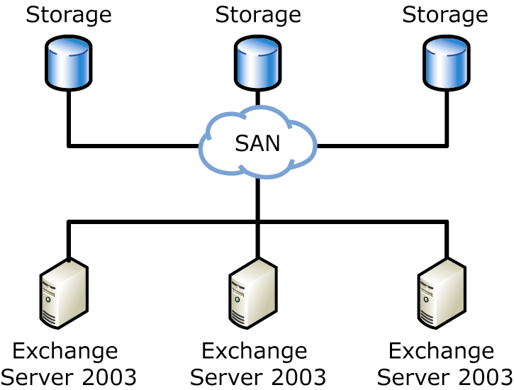
Figure 5.8 SAN storage solution

Currently, Storage Area Network solutions are best for companies and for Information Technology departments that need to store large amounts of data.
Although deployment cost can be a barrier, a Storage Area Network solution may be preferable because the long-term total cost of ownership (TCO) can be lower than the cost of maintaining many direct-attached storage arrays. Consider the following advantages of a Storage Area Network solution:
- If you currently have multiple arrays managed by multiple administrators, centralized administration of all storage frees up administrators for other tasks.
- In terms of availability, no other single solution has the potential to offer the comprehensive and flexible reliability that a vendor-supported Storage Area Network provides. Some companies can expect enormous revenue loss when messaging and collaboration services are down. If your company has the potential to lose significant revenue as a result of an unavailable messaging service, it could be cost-effective to deploy a Storage Area Network solution.
Before you invest in a Storage Area Network, calculate the cost of your current storage solution in terms of hardware and administrative resources, and evaluate the company's need for dependable storage.

How a Storage Area Network Benefits Exchange
The following are advantages to implementing a Storage Area Network solution in your Exchange 2003 organization:
- Exchange 2003 requires high I/O bandwidth that is supported only by a Storage Area Network-attached storage array. In contrast, network storage solutions that rely on access to Exchange 2003 database files through the network stack can increase the risk of data corruption and performance loss.
- Exchange 2003 also requires mailbox and public folders stores to exist on a drive that is local to the Exchange server. This requirement is met by Storage Area Network solutions that connect to Exchange servers through a local Fibre Channel connection. Other storage solutions that rely on a network redirector to process disk resources do not meet this requirement.
- Storage Area Networks are highly scalable, which is an important consideration for Exchange. As mail data grows and mailbox limits are continually challenged, you must increase storage capacity and I/O rates. As your organization expands, a Storage Area Network helps you to easily add disks. Choose a Storage Area Network that incorporates storage virtualization, which helps you to easily add storage and quickly reallocate it to your Exchange servers. With storage virtualization, you can purchase storage disks in accordance with your budget.
- The scalable nature of Storage Area Networks also makes it possible to expand your Exchange organization by adding servers. With Storage Area Networks you can connect multiple Exchange servers to multiple storage arrays and then divide the storage among them.
- Through the use of mirroring and shadow copy backups that use Volume Shadow Copy service, backup, recovery, and availability are all enhanced with a Storage Area Network.

Planning a Storage Solution
As you plan your storage strategy for Exchange 2003, you need to balance three criteria: capacity, availability, and performance. The choices you make as you plan and implement your storage solution affect the cost associated with administration and maintenance of your Exchange 2003 environment.
- Capacity In Exchange 2003, your total capacity is roughly equal to the number of mailboxes multiplied by the amount of storage allocated to each mailbox. If your organization is supporting public folders, you must add the appropriate amount of disk space to accommodate public folder storage.
- Availability The level of e-mail availability your messaging system requires depends on your company needs. For some companies, e-mail usage is light and considered non-essential, but for many companies today, e-mail is a mission-critical service. The priority that your company places on e-mail determines the level of investment and resources allocated to a consistently available e-mail solution. Overall availability is increased by redundancy. Thus, redundancy can mean that you should cluster applications to provide CPU redundancy or implement a redundant array of independent disks (RAID) solution to provide data redundancy.
- Performance Performance requirements are also unique to each organization. This chapter refers to performance as it relates to throughput. With regard to storage technology, throughput is measured by how many reads and writes per second a storage device can perform.
Before you design your storage solution for Exchange 2003, determine how your company prioritizes these three criteria, especially when considering a balance between availability and performance. This section focuses mainly on mailbox storage, but the principles and concepts apply to public folder storage as well.
When you install Exchange 2003, all data is stored locally, by default, on the drive on which you install Exchange. To determine the capacity, level of availability, and performance associated with this default configuration, you must consider the following factors:
- Number and speed of CPUs
- Amount of RAM
- Server type (mailbox server, public folder server, connector server, and so forth)
- Number of physical disks
Because of the many variables in determining server sizing and capacity, use the tools described in "Capacity Planning Tools" earlier in this chapter. In general, if the default configuration does not meet your requirements, you should plan a new storage solution that maximizes capacity, performance, and availability for Exchange. The following sections discuss the factors you should consider regarding storage.

General Storage Principles
Regardless of the application you are running, consider the following storage principles to help you maximize capacity, performance, and availability:
- You can decrease the processing required from the CPU by implementing a specialized hardware solution, such as a RAID or a Storage Area Network that incorporates RAID technology. In this scenario, it is assumed that you use a hardware solution rather than a software (host-based) RAID solution.
- You can also decrease the overall time it takes to complete a transaction by separating files that are accessed sequentially from files that are accessed randomly. Storing sequentially accessed files separately keeps the disk heads in position for sequential I/O, which reduces the amount of time required to locate data.
- Multiple small disks perform better than a single large disk. For example, if you need to store 72 GB of data, consider using four 18-GB disks instead of one 72-GB disk. In general, more disks result in faster performance.
Use the information in the following sections to compare and contrast these storage technologies.

RAID Solutions
By using a RAID solution, you can increase the fault tolerance of your Exchange organization. In a RAID configuration, part of the physical storage capacity contains redundant information about data stored on the hard disks. The redundant information is either parity information (in the case of a RAID-5 volume) or a complete, separate copy of the data (in the case of a mirrored volume). The redundant information enables data regeneration.
To ensure that your servers running Exchange continue to function properly in the event of a single disk failure, you can use disk mirroring or disk striping with parity on the hard disks within your Exchange organization. With disk mirroring and disk striping with parity, you can create redundant data for the data on your hard disks.
Although disk mirroring creates duplicate volumes that can continue functioning if a disk in one of the mirrors fails, disk mirroring does not prevent damaged files (or other file errors) from being written to both mirrors. For this reason, do not use disk mirroring as a substitute for keeping current backups of important data on your servers.
Note When using redundancy techniques such as parity, you sacrifice some hard disk I/O performance for fault tolerance.

Because transaction log files and database files are critical to the operation of a server running Exchange, you should keep the transaction log files and database files of your Exchange storage group on separate physical drives. You can also use disk mirroring or disk striping with parity to prevent the loss of a single physical hard disk from causing a portion of your messaging system to fail. For more information about disk mirroring and disk striping with parity, see your Windows Server 2003 documentation.
To implement a RAID configuration, it is recommended that you only use a hardware RAID product rather than software fault-tolerant dynamic disk features.
The following sections discuss four primary implementations of RAID: RAID-0, RAID-1, RAID-0+1, and RAID-5. Although there are many other RAID implementations, these four types serve as an adequate representation of the overall scope of RAID solutions.

RAID-0
RAID-0 is a striped disk array; each disk is logically partitioned in such a way that a "stripe" runs across all the disks in the array to create a single logical partition. For example, if a file is saved to a RAID-0 array and the application that is saving the file saves it to drive D, the RAID-0 array distributes the file across logical drive D (see Figure 5.9). In this example the file spans all six disks.
Figure 5.9 RAID-0 disk array

From a performance perspective, RAID-0 is the most efficient RAID technology because it can write to all six disks at once. When all disks store the application data, the most efficient use of the disks occurs.
The drawback to RAID-0 is its lack of fault tolerance. If the Exchange mailbox databases are stored across a RAID-0 array and a single disk fails, you must restore the mailbox databases to a functional disk array and restore the transaction log files. In addition, if you store the transaction log files on this array and you lose a disk, you can perform only a point-in-time restoration of the mailbox databases from the last backup.
RAID-0 is not a recommended solution for Exchange.

RAID-1
RAID-1 is a mirrored disk array in which two disks are mirrored (see Figure 5.10).
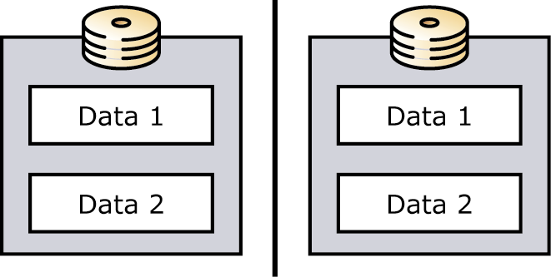
Figure 5.10 RAID-1 disk array

RAID-1 is the most reliable of the three RAID arrays because all data is mirrored as it is written. You can use only half of the storage space on the disks. Although this may seem inefficient, RAID-1 is the preferred choice for data that requires the highest possible reliability.

RAID-0+1
A RAID-0+1 disk array gives the highest performance while ensuring redundancy by combining elements of RAID-0 and RAID-1 (see Figure 5.11).
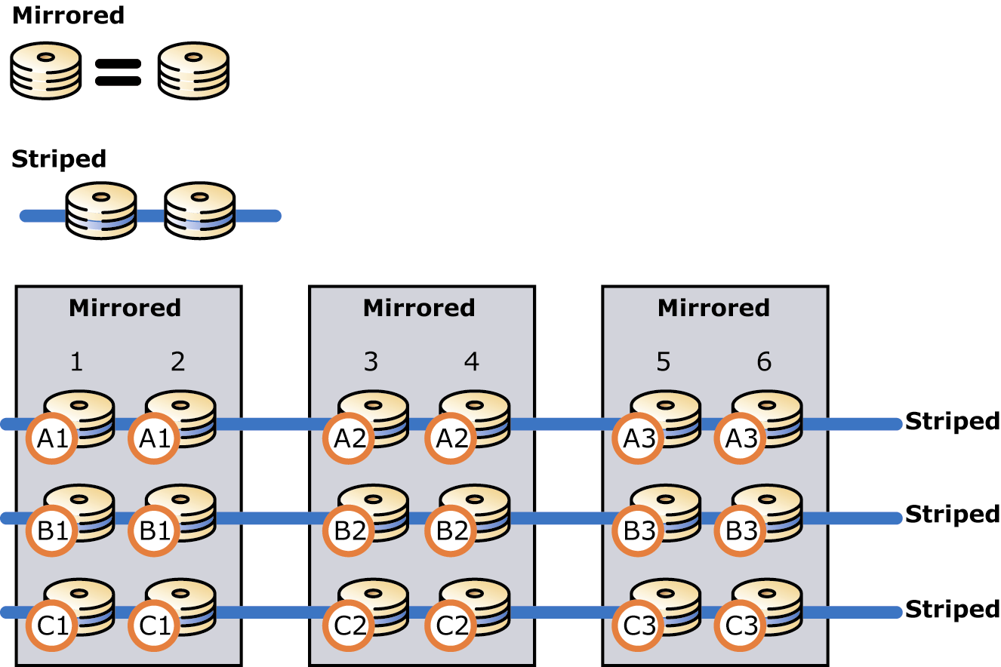
Figure 5.11 RAID-0+1 disk array

In a RAID-0+1 disk array, data is mirrored to both sets of disks (RAID-1) and then striped across the drives (RAID-0). Each physical disk is duplicated in the array. If you have a six-disk RAID-0+1 disk array, three disks are available for data storage.

RAID-5
RAID-5 is a striped disk array, similar to RAID-0 in that data is distributed across the array; however, RAID-5 also includes parity. This means that there is a mechanism that maintains the integrity of the data stored on the array so that if one disk in the array fails, the data can be reconstructed from the remaining disks (see Figure 5.12). Thus, RAID 5 is a reliable storage solution.
Figure 5.12 RAID-5 disk array

However, to maintain parity among the disks, 1/n disk space is sacrificed (where n equals the number of drives in the array). For example, if you have six 9-GB disks, you have 45 GB of usable storage space. To maintain parity, one write of data is translated into two writes and two reads in the RAID-5 array; thus, overall performance is degraded.
The advantage of a RAID-5 solution is that it is reliable and uses disk space more efficiently than RAID-1 and RAID-0+1.

Comparing RAID Solutions
Because capacity is relatively stable, it is helpful to evaluate these RAID solutions by comparing cost, performance, and reliability against a constant capacity. Table 5.7 is based on the following assumptions:
- You are storing 90 GB of data.
- You are using 9-GB drives.
- Your arrays can write data to disks at the rate of 100 I/O processes per second.

Table 5.7 Comparing RAID solutions
RAID solution | Number of drives (cost) | Maximum writes/second | Maximum reads/second | Reliability
RAID-0 | 10 | 1000 | 1000 | Low
RAID-0+1 | 20 | 1000 | 2000 | Very high
RAID-5 | 11 | 275 | 1100 | High

Note RAID-1 is not evaluated in the table because only two disks can be implemented in a RAID-1 solution. You need two 45-GB drives to store 90 GB of data, which would result in much lower throughput.

You assess reliability by evaluating the impact that a disk failure would have on the integrity of the data. RAID-0 does not implement any kind of redundancy, so a single disk failure on a RAID-0 array requires a full restoration of data. RAID-0+1 is the most reliable solution of the three because two or more disks must fail before data is potentially lost; in other words, very specific sets of disks must fail before data is lost.
You evaluate cost by calculating the number of disks needed to support your array. The RAID-0+1 implementation is the most expensive because you must have twice as much disk space as you actually need. However, this configuration also yields much higher performance than the same-capacity RAID-5 configuration, as judged by the maximum read and write rates.

Exchange 2003 Considerations
When planning your storage solution, consider the following features of Exchange 2003:
- You can use Volume Shadow Copy service capabilities, which are described in the next section.
- All data stored on Exchange is not managed in the same way; thus, a single storage solution for all data types is not the most efficient.
- Servers that do not host mailboxes or public folders, such as connector servers, may not benefit from advanced storage solutions because they typically store data for a short time and then forward the data to another server. In some cases, you might prefer RAID-0 configuration for these types of servers.
- An Exchange 2003 server supports up to four storage groups. Each storage group has its own set of transaction log files and supports up to five databases. Your disaster recovery strategy plays an important role in determining how many storage groups and databases your storage solution should support. Your recovery plan should state your company's restore time requirements. It is this requirement that dictates your storage configuration.
- In Exchange, transaction log files are accessed sequentially, and databases are accessed randomly. In accordance with general storage principles, you should separate the transaction log files (sequential I/O) from databases (random I/O) to maximize I/O performance and increase fault tolerance. Specifically, you should move each set of transaction log files to its own array, separate from storage groups and databases.

Storage Area Networks and Volume Shadow Copy Service
The Exchange 2003 online backup API automatically synchronizes and gathers the Exchange 2003 database and transaction log file data required for successful restoration. An online backup of Exchange 2003 databases occurs through the same channel as normal database access. If this access is across the network, backup and restore operations might greatly increase peak bandwidth requirements.
To provide rapid backup and restore functionality, several Storage Area Network solutions bypass the Exchange 2003 online backup API in favor of the newer, faster Volume Shadow Copy service backups. To achieve the full benefit of Volume Shadow Copy backup, use a backup application that is Volume Shadow Copy-enabled and a storage array with a Volume Shadow Copy hardware provider. You will need to check with your vendors to determine whether these features are available in their products.
Important If you implement a Volume Shadow Copy backup solution for Exchange 2003, the vendor of your Volume Shadow Copy solution is your primary support provider for backup and recovery issues and your storage array vendor is your primary support for storage array issues.

For more information about Volume Shadow Copy backups and the limited support Microsoft Product Support Services (PSS) can provide, see Microsoft Knowledge Base article 311898, "XADM: Hot Split Snapshot Backups of Exchange" (http://support.microsoft.com?kbid=311898).
Note A Storage Area Network provides a solution to the exception discussed in "Drive Letter Limitations" earlier in this chapter. If you use Volume Shadow Copy service together with server clustering, the cluster does not allow you to assign two different drive letters to volumes that share the same disk signature. A Storage Area Network solves this problem by enabling you to keep the shadow copy in a separate location on the Storage Area Network where you can access it from that location.

Placing Exchange Data on the Storage Device
Exchange stores data in three main locations:
- SMTP Queue directory
- Database files (.edb and .stm files)
- Transaction log files

SMTP Queue Directory
The SMTP Queue director stores SMTP messages until they are written to a database (public or private, depending on the type of message) or sent to another server or connector.
Typically, messages stored in the SMTP queue are there for a short time. Therefore, your storage solution for the SMTP queue should optimize performance before capacity and reliability. However, in some situations, when downstream processes fail, the SMTP queue could be required to store a large amount of data. For that reason, do not assume that a RAID-0 array is the best storage solution for SMTP queues. Generally, RAID-0 is acceptable only if mail loss is acceptable. RAID-1 is a good solution because it gives some measure of reliability while providing adequate throughput.
In Exchange 2003, you can now use System Manager to change the location of the Queue directory. In System Manager, this option is available from the Message tab of the SMTP virtual server object.

.EDB and .STM Files
An Exchange database consists of a rich-text .edb file and a Multipurpose Internet Mail Extensions (MIME) content .stm file.
The .edb file stores the following items:
- All of the MAPI messages
- Tables used by the Store.exe process to locate all messages
- Checksums of both the .edb and .stm files
- Pointers to the data in the .stm file
The .stm file contains messages that are transmitted with their native Internet content. Because access to these files is generally random, they can be placed on the same disk volume.
As you plan your storage solution for these files, implement a solution that ensures reliability; in other words, RAID-0 is not a recommended option. After reliability, your storage solution is based on a choice between optimizing performance (RAID-1) and optimizing capacity (RAID-5). If possible, use RAID-1 (or RAID-0+1) for these files.
You can store public folders on a RAID-5 array because data in public folders is usually written once and read many times. RAID-5 provides improved read performance.

Transaction Log Files
Each storage group generates its own set of transaction log files. Transaction log files maintain the state and integrity of .edb and .stm files. As new transactions occur, the transactions are simultaneously written in the log file and in memory. Log file transactions are not recognizable as Exchange messages, but they contain transaction data and specify where in the .edb file the data should be written. Before the transactions are committed to the .edb file, users access the transactions from memory. Then, when the load on the server has decreased, transactions are committed to the .edb file for permanent storage. The process of caching transactions in memory and deferring the update of the database files on the physical disk is referred to as a "lazy write."
If a disaster occurs, and you must rebuild a server, you use the latest transaction log files to recover your databases. If you have access to the latest backup and the transaction log files since the backup, you can recover all of your data. However, if you lose any of the transaction log files, the data is permanently lost.
You can significantly improve the performance and fault tolerance of Exchange servers by placing each set of transaction log files on a separate drive. Because each storage group has its own set of transaction log files, the number of dedicated transaction log drives for your server should equal the number of planned storage groups. With a Storage Area Network solution, you can select a product to easily partition the virtualized space into separate virtual drives for storage groups and transaction log files. In addition, because transaction log files are critical to the operation of a server, you should protect the drives against failure, ideally by hardware mirroring using RAID. A RAID-0+1 configuration (in which data is mirrored and then striped) is recommended.
Note Distribute the database drives across many Small Computer System Interface (SCSI) channels or controllers, but configure them as a single logical drive to minimize SCSI bus saturation.

An example disk configuration is as follows:
- C:\ System and boot (mirror set)
- D:\ Page file
- E:\ Transaction log files for storage group 1 (mirror set)
- F:\ Transaction log files for storage group 2 (mirror set)
- G:\ Database files for both storage groups (multiple drives configured as hardware stripe set with parity
Note The following drives should always be formatted for NTFS:
• System partition
• Partition containing Exchange binaries
• Partitions containing transaction log files
• Partitions containing database files
• Partitions containing other Exchange files

Testing Disk Performance with Jetstress
Exchange 2003 is a disk-intensive application that requires a fast, reliable disk subsystem to function correctly. Jetstress (Jetstress.exe) is a tool in Exchange to help administrators verify the performance and stability of the disk subsystem prior to putting their Exchange server into production.
Jetstress helps verify disk performance by simulating Exchange disk I/O load. Specifically, Jetstress simulates the Exchange database and log file loads produced by a specific number of users. You use System Monitor, Event Viewer, and Extensible Storage Engine Utility (ESEUTIL) in conjunction with Jetstress to verify that your disk subsystem meets or exceeds the performance criteria you establish.
With Jetstress you can perform two types of tests: the Jetstress Disk Performance Test and the Jetstress Disk Subsystem Stress Test. The Disk Performance Test runs for two hours and enables you to verify the performance and sizing of your storage solution. The Disk Subsystem Stress Test runs for 24 hours and enables you to test the storage reliability over a significant amount of time. Running both tests is the best way to verify the integrity and performance of your disk subsystem.
After successful completion of the Jetstress Disk Performance Test and Jetstress Disk Subsystem Stress Test in a non-production environment, you are ready to move on to the next stage in your Exchange 2003 deployment process. You have ensured that your Exchange 2003 disk subsystem is adequately sized (in terms of performance criteria you establish) for the user count and user profiles you have established.
Note Jetstress is supported only when running with Exchange 2000 or Exchange 2003 or newer versions of ESE.DLL. Also, due to this support limitation, Jetstress is supported only on Windows 2000 Server, Windows Server 2003, Windows 2000 Advanced Server, and Windows Server 2003 Datacenter Edition (Microsoft Windows NT® Server version 4.0 and earlier are not supported).

Appendixes


Appendix A

Checklist for Evaluating Your Current Environment
The following checklist outlines the physical and logical factors you should take into consideration when assessing your current environment, as discussed in Chapter 1.

Physical plant
Data center floor space
Rack space
Network sizing
WAN (may need to provision higher bandwidth connections)
Degree of separation between physical sites (latency introduced)
LAN upgrades
Backbone
Modem pools or alternate dial-up
Hardware needs
Servers
Memory
Processor
Storage
High bandwidth network interface cards (NICs)
Routers
Memory
Processor
Switches
Firewalls
Power
Power grid Service Level Agreement (SLA)
Projected power draw
Uninterruptible power supply (UPS) or other power-insulating device (generators, etc.)
Designated "hot" site

Staffing
Training on newly introduced technologies and procedures
Augmentation
Administrators
Support staff

Geography
Time zone issues
Languages

WAN
Encapsulation upgrade (asynchronous transfer mode [ATM], etc.)
Optimization (permanent virtual circuit [PVC] for frame relay)
Overall quality of connections

LAN
Encapsulation change (token ring to Ethernet)
Layer 2 device removal or upgrade

Network
TCP/IP end-to-end
IP Hop count between endpoints
Subnetting considerations (Active Directory® directory service site considerations)
Device configuration
Routers and open ports
Switches
Firewalls and open ports
Ports and layer 4 protocols enabled on filtering or blocking devices
All encryption and decryption operations
All format-change operations (for example, other mail gateways and X.400 connectors)
remote procedure call (RPC) connectivity
network basic input/output system (NetBIOS)
Public key infrastructure (PKI)
Virtual private network (VPN)
Shared dependencies between Internet Information Services (IIS), Simple Mail Transfer Protocol (SMTP), and Network News Transfer Protocol (NNTP)
DNS
Windows® Internet Name Service (WINS)

Network operating system
Shared dependencies between DHCP, NTLM, NTLMv2, and LM
Windows NT® Server version 4.0 domain structure: Trusts, primary domain controllers, backup domain controllers
Windows 2000 Server or Windows Server™ 2003 Active Directory
Forest structure
Domain structure
Migration
Site structure

Security
Kerberos
Migration
Security principles
Security identifier (SID) history

Directories
Migration
Active Directory Connector
Meta directories

Administration
Migration
Permissions delegation
Management

Appendix B

Optimizing Memory Usage
This appendix contains information about monitoring and optimizing memory usage on your servers.

Monitoring Memory Usage
You can monitor the Event Viewer application log and Performance Logs and Alerts (Performance on the Administrative Tools submenu) for virtual memory problems. In the application log, a 9582 warning appears when the largest free block of virtual memory decreases to 32 MB. If you see this, you should restart the Exchange store process at the next opportunity. If the largest block decreases to 16 MB, a 9582 error appears again; this error means the server could fail, and you should restart the server at the earliest opportunity. Failure to act on these events could result in sporadic mail delivery and IMAIL conversion failures (12800 events).
In Performance Logs and Alerts, monitor the following counters:
- VM Largest Block Size counter in the MSExchangeIS object: A healthy server has more than 200,000,000 bytes (200 MB) as the largest free block. If the value is lower, you should carefully monitor the server.
- Pool Pages Bytes in the Memory object: Amounts greater than 200 MB indicate a problem except when backups are running. During backups, each page in the cache manager is backed by a pool page.
- Pool Nonpaged Bytes in the Memory object: Amounts greater than 100 MB indicate a problem.
- Free System Page Table Entries in the Memory object: Amounts less than 3000 indicate a problem.
- Working Set in the Process object: An upward trend indicates a potential memory leak.
If a server shows signs of low virtual address space, you should adjust the following settings. If these settings are not optimized for Exchange, event 9665 appears in Event Viewer.
- If the server is running Windows® 2000 Advanced Server or Windows Server™ 2003 and has 1 GB or more of physical memory, set the /3GB switch in the Boot.ini file as described below.
- If the server is running Windows Server 2003 (any edition), configure the /USERVA switch and SystemPages registry key as described below. If the server is running Windows 2000, ensure that Windows 2000 SP3 or later is installed.
- If the server has 1 GB or more of physical memory, set the HeapDeCommitFreeBlockThreshold registry parameter as described below.
- Tune the store database cache size if necessary as described below.

Event 9665
Exchange performs an optimal memory configuration check when the store process starts. If the memory settings are not optimal, you see event 9665 in Event Viewer. This message appears in the following instances:
- The server is running Windows 2000 and the SystemPages value in the registry is set outside the range of 24000 to 31000.
- The server has 1 GB of memory or more and does not have the /3GB switch.
- The server is running Windows Server 2003, has 1 GB of memory or more and the /3GB switch is set, but the /USERVA setting is not present or is outside the range of 3030 to 2970.
If you see this event, check the SystemPages and HeapDeCommitFreeBlockThreshold settings in the registry, as well as the /3GB switch and the /USERVA setting in the Boot.ini file. The following sections contain recommendations for each of these settings.
Note If you want to turn off the memory configuration check, you can create the registry key shown in Table B.1.

Table B.1 Registry key to turn off memory configuration check
Path | HKEY_LOCAL_MACHINE\SYSTEM\CurrentControlSet\Services\MSExchangeIS\ParametersSystem\
Parameter | Suppress Memory Configuration Notification
Type | REG_DWORD
Setting | 1

Note The memory configuration check does not occur on servers running Microsoft® Small Business Server.

Setting the /3GB Switch
By default, Windows 2000 Advanced Server and Windows Server 2003 allocate 2 GB of virtual address space to user mode processes such as Store.exe. If a server has 1 GB or more of physical memory, set the /3GB switch in the Boot.ini file to increase virtual address space. For more information about the /3GB switch, see Microsoft Knowledge Base article 266096, "XGEN: Exchange 2000 Requires /3GB Switch with More Than 1 Gigabyte of Physical RAM" (http://support.microsoft.com/?kbid=266096).
Important The /3GB switch is designed for Windows 2000 Advanced Server and all editions of Windows Server 2003. Do not set the /3GB switch in Windows 2000 Standard Edition.

Configuring /USERVA and SystemPages
If the server is running Windows 2000, you should set the SystemPages registry key to a value between 24000 and 31000. The SystemPages registry key is located in the following path:
HKEY_LOCAL_MACHINE\SYSTEM\CurrentControlSet\Control\Session Manager\Memory Management\SystemPages
If the server is running Windows Server 2003, set the SystemPages value to zero, and set the /USERVA=3030 parameter in the Boot.ini file. These settings let you enter more system page table entries on the server, which is critical for scale-up systems.
For additional information, see Microsoft Knowledge Base article 810371, "XADM: Using the /Userva Switch on Windows 2003 Server-Based Exchange Servers" (http://support.microsoft.com/?kbid=810371).

Setting the HeapDeCommitFreeBlockThreshold Registry Key
The HeapDeCommitFreeBlockThreshold registry key controls the amount of free space required before the heap manager decommits (or frees up) memory. The default is zero, which means that the heap manager decommits each 4-KB page that becomes available. Over time, virtual address space can become fragmented. On servers that have 1 GB or more of physical memory, you can set the registry key to a higher value to reduce or eliminate fragmentation. Set the registry key as shown in Table B.2, and then restart the server. For more information about the HeapDeCommitFreeBlockThreshold registry key, see Microsoft Knowledge Base article 315407, "XADM: The 'HeapDeCommitFreeBlockThreshold' Registry Key" (http://support.microsoft.com/?kbid=315407).

Table B.2 Settings for the HeapDeCommitFreeBlockThreshold registry key
Path | HKEY_LOCAL_MACHINE\SYSTEM\CurrentControlSet\Control\Session Manager
Parameter | HeapDeCommitFreeBlockThreshold
Type | REG_DWORD
Default | Zero
Recommended setting* | 262144

* This value is the number of blocks in decimal. The recommended value is 262144, which corresponds with a hexadecimal value of 0x00040000.

Adjusting the Store Database Cache Size
The store database cache (also referred to as the Extensible Storage Engine buffer) caches database transactions before they are committed to the database. By default, Exchange 2003 allocates 896 MB if the /3GB switch is set on the server and 576 MB if the /3GB option is not set. In the following instances, adjusting the maximum buffer size can increase performance:
- If the server is running Exchange 2003 and other server-side applications, reduce the buffer to limit the use of memory by Exchange.
- On servers with more than 2 GB of memory, increase the size of the buffer (up to a maximum of 1200 MB).
Before you increase the maximum buffer size, use Performance Logs and Alerts to monitor the store instance of the Virtual Bytes counter (in the Process object) under normal load. The Virtual Bytes counter shows the current size (in bytes) of the virtual address space that the Store.exe process uses. The value should be below 2.8 GB if the /3GB switch is set and below 1.8 GB if the /3GB switch is not set. If the values are higher, do not increase the maximum buffer size. If the values are lower, you can increase the maximum buffer size up to 1,200 MB. For example, if the /3GB switch is set, and the virtual bytes count is 2.5 GB under heavy load, you can increase your maximum buffer size by approximately 300 MB.
Be aware that on servers experiencing address space fragmentation issues, increasing the buffer size may negatively affect server performance. A larger buffer means more virtual address space consumption; increasing the buffer may result in system instability.
To adjust the maximum buffer size, use Active Directory® Service Interface (ADSI) Edit to modify the msExchESEParamCacheSizeMax value. For more information about how to modify the msExchESEParamCacheSizeMax value, see Microsoft Knowledge Base article 266768, "XSTR: How to Modify the Store Database Maximum Cache Size" (http://support.microsoft.com/?kbid=266768). After you set the value, wait for Active Directory to replicate the value throughout the forest. Then restart the Microsoft Exchange Information Store service.
Important Be careful not to choose the msExchESEParamCacheSizeMin value.

Table B.3 summarizes maximum buffer size default values and recommendations. The value is expressed as a page count and should be set to an exact multiple of 8192 for maximum efficiency.
Table B.3 Buffer size default values and recommendations
Default size on /3GB servers | 229376 (896 MB)
Default size on non /3GB servers | 147456 (576 MB)
Recommended maximum | 307200 (1.2 GB)
Very large address-space-constrained servers | 196608 (768 MB)

Appendix C

Additional Resources
For information about Microsoft® Exchange Server, see http://www.microsoft.com/exchange. Additionally, the following technical papers, resource kits, and Microsoft Knowledge Base articles provide valuable information regarding disaster recovery concepts and processes.
Note To download a self-extracting executable file of all Exchange Product Team technical articles and online books, see http://go.microsoft.com/fwlink/?LinkId=10687

Web Sites
Microsoft Exchange Server 2003 Technical Library
(http://www.microsoft.com/exchange/library)
Exchange Server 2003 Tools and Updates
(http://www.microsoft.com/exchange/updates)
MSDN® Web site
(http://msdn.microsoft.com/)

Exchange Server 2003 Books
Exchange Server 2003 Administration Guide
(http://www.microsoft.com/exchange/library)
Exchange Server 2003 Deployment Guide
(http://www.microsoft.com/exchange/library)

Technical Papers
Deploying Microsoft Exchange 2000 Server Clusters
(http://go.microsoft.com/fwlink/?LinkId=6271)
Storage Solutions for Microsoft Exchange 2000 Server
(http://go.microsoft.com/fwlink/?LinkId=1715)
Best Practice Active Directory Design for Exchange 2000
(http://go.microsoft.com/fwlink/?LinkId=17837)
Best Practice Active Directory Design for Managing Windows Networks
(http://go.microsoft.com/fwlink/?LinkId=18348)
Design Considerations for Delegation of Administration in Active Directory
(http://go.microsoft.com/fwlink/?LinkId=18349)
Deploying Microsoft Exchange 2000 Server Clusters
(http://go.microsoft.com/fwlink/?LinkId=14578)
Disaster Recovery for Microsoft Exchange 2000 Server
(http://go.microsoft.com/fwlink/?LinkId=18350)
Migrating Mailboxes from Microsoft Exchange Server Version 5.5 to Exchange 2000 Server
(http://go.microsoft.com/fwlink/?linkid=18351)
Monitoring Exchange 2000 with Microsoft Operations Manager 2000
(http://go.microsoft.com/fwlink/?linkid=18177)

Tools
Exchange Server 2003 Tools and Updates
(http://www.microsoft.com/exchange/updates)
Exchange Stress and Performance Tool (ESP)—Build 5531.0
(http://go.microsoft.com/fwlink/?LinkId=1709)
Exchange 2000 Capacity Planning and Topology Calculator
(http://go.microsoft.com/fwlink/?LinkId=1716)
Load Simulator in the Exchange 2000 Server Resource Kit
(http://go.microsoft.com/fwlink/?LinkId=1710)

Resource Kits
Microsoft Exchange 2000 Server Resource Kit (http://go.microsoft.com/fwlink/?LinkId=6543)
You can order a copy of Microsoft Exchange 2000 Server Resource Kit from Microsoft Press® at http://go.microsoft.com/fwlink/?LinkId=6544.
Windows 2000 Resource Kit (http://go.microsoft.com/fwlink/?LinkId=6545)
You can order a copy of Microsoft Windows 2000 Server Resource Kit from Microsoft Press at http://go.microsoft.com/fwlink/?LinkId=6546.

Microsoft Knowledge Base Articles
The following Microsoft Knowledge Base articles are available on the Web at http://support.microsoft.com/.
266096, "XGEN: Exchange 2000 Requires /3GB Switch with More Than 1 Gigabyte of Physical RAM"
(http://support.microsoft.com/?kbid=266096)
266768, "XSTR: How to Modify the Store Database Maximum Cache Size"
http://support.microsoft.com/?kbid=266768)
272314, "XADM: Preparing a Mixed Mode Organization for Conversion to Native Mode"
(http://support.microsoft.com/?kbid=272314)
305145, "How to: Remove the IFS Mapping for Drive M in Exchange 2000 Server"
(http://support.microsoft.com/?kbid=305145)
311898, "XADM: Hot Split Snapshot Backups of Exchange"
(http://support.microsoft.com/?kbid=311898)
315407, "XADM The 'HeapDeCommitFreeBlockThreshold' Registry Key"
(http://support.microsoft.com/?kbid=315407)
810371, "XADM: Using the /Userva Switch on Windows 2003 Server-Based Exchange Servers"
(http://support.microsoft.com/?kbid=810371)
Does this book help you? Give us your feedback. On a scale of 1 (poor) to 5 (excellent), how do you rate this book?
Mail feedback to exchdocs@microsoft.com?subject=Feedback: Planning an Exchange 2003 Messaging System
For the latest information about Exchange, see the following Web pages:
- Exchange Server 2003 Technical Library
http://www.microsoft.com/exchange/library
- Exchange Server 2003 Tools and Updates
http://www.microsoft.com/exchange/updates
- Exchange Technical White Papers (self-extracting executable)
http://go.microsoft.com/fwlink/?LinkId=10687

   

