Microsoft Office PerformancePoint Server 2007 Management Reporting
Easily Consolidate and Share Key Business Data Across the Organization

Microsoft® Office PerformancePoint™ Server 2007 is an integrated performance management application that provides robust monitoring, analytics, and planning capabilities. PerformancePoint Server 2007 enables businesses to articulate goals, monitor business activity, identify and analyze issues, and collaborate and take action.

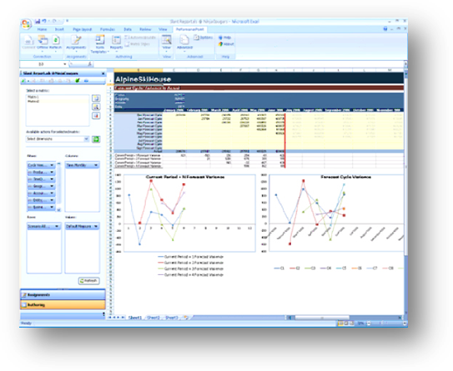
Powerful reporting tools make it easy to visualize results.
Management Reporting and Consolidation with Office PerformancePoint Server 2007
Management reporting plays a key role in performance management. Displaying the results, performing variance analysis, comparing projections, and consolidating data from disparate sources provides business users with the business intelligence they need to make timely and relevant decisions. Accurate and auditable reporting is also essential to regulatory compliance.
Office PerformancePoint Server 2007, built on the powerful Microsoft SQL Server™ platform and integrated with the familiar and easy-to-use Microsoft Office environment, provides data in real time from a single, centrally managed source. Information is up to date and consistent, and consolidated reports can combine operational and financial data into a single report.
Benefits
Users benefit from the easy-to-use and powerful reporting functionality in Office PerformancePoint Server 2007, including:
- Cross-enterprise business view
The SQL Server Business Intelligence platform integrates information from many different sources and systems to provide a complete perspective of business performance across the enterprise and from multiple departments such as finance, operations, human resources, sales, and marketing.
- Easy mass distribution
Widely distribute dynamic and standard reports including financial statements, management reports, and ad-hoc analysis to the decision-makers who need this information.
- Strong support for regulatory compliance
Office PerformancePoint Server 2007 supports generally accepted accounting practices (GAAP), international financial reporting standards (IFRS), and Sarbanes-Oxley regulations. Centralized management, including security and auditing of

business rules, spreadsheets, and scorecards, simplifies regulatory compliance.
- Enhanced partnership with IT
IT no longer has to spend time generating, formatting, and customizing reports for the business. Users can create their own reports, and IT can help ensure they have the right infrastructure and data to access richer, more targeted information.
Key Features
These key features of Office PerformancePoint Server 2007 simplify reporting:
- Integration with Microsoft Office Excel®
Build, customize, and share production-quality reports from Excel while being connected to the security-enhanced, centrally managed server.
- Easy customization
Templates and forms enable users to create and distribute customized reports accurately, quickly, and easily.
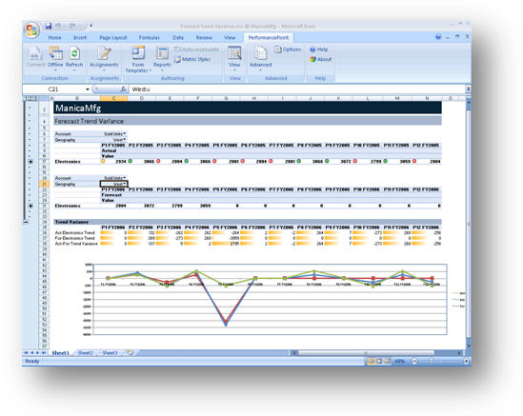
Build and manage reports in Excel.
- Enterprise-grade statutory consolidation functionality
Produce statutory consolidation including multicurrency conversions, intercompany eliminations, reconciliations, and multi-tier allocations.
- Advanced financial intelligence
Turn advanced financial analysis such as sensitivity and variance analysis (for example, price/quantity/customer/product mix/timing) into easy-to-understand reports.
- Multiple ways to access reports
Reports created in Excel can be exported to SQL Server Reporting Services so the user reporting experience is more consistent. Filtering and formatting is preserved, and users can manage and access reports through SQL Server Report Manager and the Microsoft Office SharePoint® Server 2007 Report Center.
System Requirements
Office PerformancePoint Server 2007 is based on the following Microsoft programs and technologies:
● Windows Server® 2003 SP1, Standard Edition, or later
● Microsoft Windows® XP Professional SP2, or later
● Microsoft Office 2003 SP2, or later
● Microsoft SQL Server™ 2005 SP2, Standard Edition, or later
● Windows Installer 3.1, or later
● Microsoft .NET Framework 2.0
● Microsoft Internet Information Services 6.0
● ASP.NET 2.0

For More Information
For more information about Office PerformancePoint Server 2007, visit www.microsoft.com/performancepoint.

For more information about Microsoft Business Intelligence, visit www.microsoft.com/office/BI.

This document is for informational purposes only. MICROSOFT MAKES NO WARRANTIES, EXPRESS OR IMPLIED, IN THIS SUMMARY.
The example companies, organizations, products, domain names, e-mail addresses, logos, people, places, and events depicted herein are fictitious. No association with any real company, organization, product, domain name, e-mail address, logo, person, place, or event is intended or should be inferred.
© 2006 Microsoft Corporation. All rights reserved. Microsoft, Excel, PerformancePoint, SharePoint, SQL Server, Windows, and Windows Server are either registered trademarks or trademarks of Microsoft Corporation in the United States and/or other countries. All other trademarks are property of their respective owners.

