Hands-On Lab
Lab Manual
Linq to Sql: Database Language Integrated Queries

Information in this document is subject to change without notice. The example companies, organizations, products, people, and events depicted herein are fictitious. No association with any real company, organization, product, person or event is intended or should be inferred. Complying with all applicable copyright laws is the responsibility of the user. Without limiting the rights under copyright, no part of this document may be reproduced, stored in or introduced into a retrieval system, or transmitted in any form or by any means (electronic, mechanical, photocopying, recording, or otherwise), or for any purpose, without the express written permission of Microsoft Corporation.

Microsoft may have patents, patent applications, trademarked, copyrights, or other intellectual property rights covering subject matter in this document. Except as expressly provided in any written license agreement from Microsoft, the furnishing of this document does not give you any license to these patents, trademarks, copyrights, or other intellectual property.

© 2005 Microsoft Corporation. All rights reserved.

Microsoft, MS-DOS, MS, Windows, Windows NT, MSDN, Active Directory, BizTalk, Sql Server, SharePoint, Outlook, PowerPoint, FrontPage, Visual Basic, Visual C++, Visual J++, Visual InterDev, Visual SourceSafe, Visual C#, Visual J#, and Visual Studio are either registered trademarks or trademarks of Microsoft Corporation in the U.S.A. and/or other countries.

Other product and company names herein may be the trademarks of their respective owners.

Contents
Lab 1: L To Sql: Database Language Integrated Queries 1
Lab Objective 1
Exercise 1 – Using Code Generation to Create the Object Model 1
Task 1 – Creating a Linq Project 1
Task 2 - Adding a reference to the System.Data.Linq assembly 2
Task 3 - Adding a Linq to Sql file 2
Task 4 – Adding a new Data Connection 3
Task 5 – Creating your object model 4
Task 6 – Querying your object model 5
Task 7 – Mapping a stored procedure 5
Task 8 – Retrieving new results 6
Exercise 2 Internals: Creating your first Linq To Sql Application 7
Task 1 – Creating a Linq Project 7
Task 2 - Adding a reference to the System.Data.Linq assembly 8
Task 3 – Mapping Northwind Customers 8
Task 4 – Querying Database Data 9
Task 5 – Exploring the IDE 11
Exercise 3 Internals: Creating an Object Model 12
Task 1 – Create the order entity 12
Task 2 – Mapping Relationships Across Tables 13
Task 3 – StronglyTyping the DataContext Object 15
Exercise 4 – Modifying Database Data 16
Task 1 – Modifying your object model 16
Task 2 – Creating a new Entity 16
Task 5 – Updating an Entity 17
Task 6 – Deleting an Entity 17
Task 7 – Submitting changes 18
Task 7 – Using Transactions 19
Exercise 5 – Working with Advanced features 20
Task 1 - Adding a Linq to Sql file 20
Task 2 – Adding a new Data Connection 20
Task 3 – Creating your object model 21
Task 4 – Integrating Custom Queries 21
Task 4 – Exploring Object Identity 22

Lab 1: Linq To Sql: Database Language Integrated Queries
This lab is intended to provide a clear picture of the relational data access support provided by the Linq Project, referred to as Linq to Sql. You will start by creating an object model based on the Northwind database, followed by querying that database using the new VB.NET query expressions.
You will next create an object model from an existing database using the Linq to Sql Designer. You will look at mapping relationships across tables and using Create, Update, and Delete operations. You will then explore the use of transactions, object retrieval techniques, stored procedure integration and object identity with Linq to Sql.
Linq to Sql is a language-agnostic component of the Linq Project. Although the samples in the document are shown only in Visual C# for consistency, Linq to Sql can be used just as well with Visual Basic .NET.

The Linq Project relies on new keywords and syntax introduced with the language, and it’s completely integrated with Microsoft Visual Studio 2008. This gives us the opportunity to use all the features of the new IDE like the integrated debugger, IntelliSense™, and instant syntax check.

Lab Objective
Estimated time to complete this lab: 60 minutes
The objective of this lab is to gain an understanding of the role Linq to Sql plays in database integration with Visual C# applications. You will explore the CRUD operations -- Create, Retrieve, Update, and Delete, and how they are invoked without explicit usage of Sql query or update commands. You will learn how classes are mapped to database tables and how to fine-tune the mapping process.

Exercise 1 – your first Linq to Sql database application
Exercise 2 – Creating an object model from a database
Exercise 3 – Using code generation to create the object model
Exercise 4 – Modifying data in the database
Exercise 5 – Working with advanced features

Exercise 1 – Using Code Generation to Create the Object Model
In this exercise we will see how simple it is to create an object model using the visual Linq designer. Subsequent exercises (2 and 3) delve into HOW this happens behind the scenes: but the designer does it for you!

Task 1 – Creating a Linq Project
- Click the Start | Programs | Microsoft Visual Studio 2008 | Microsoft Visual Studio 2008 menu command.
- In Microsoft Visual Studio, click the File | New | Project… menu command
- In the New Project dialog, in Project types, click Visual C#
- In the New Project dialog, in Templates, click Console Application
- Provide a name for the new solution by entering “Linq To Sql CS” in the Name field
- Click OK
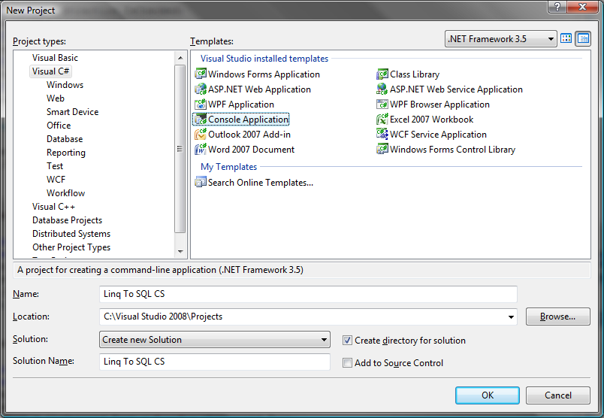

Task 2 - Adding a reference to the System.Data.Linq assembly
- In Microsoft Visual Studio, click the Project | Add Reference… menu command
- In the Add Reference dialog make sure the .NET tab is selected
- click System.Data.Linq assembly
- Click OK
In Program.cs import the namespace System.Data.Linq adding the following line just after the existing using statements:
using System.Data.Linq;

Task 3 - Adding a Linq to Sql file
- In Microsoft Visual Studio, click the Project | Add New Item… menu command
- In Categories click Data
- In Templates click Linq To SQL Classes
- Provide a name for the new item by entering “Northwind” in the Name field
- Click Add
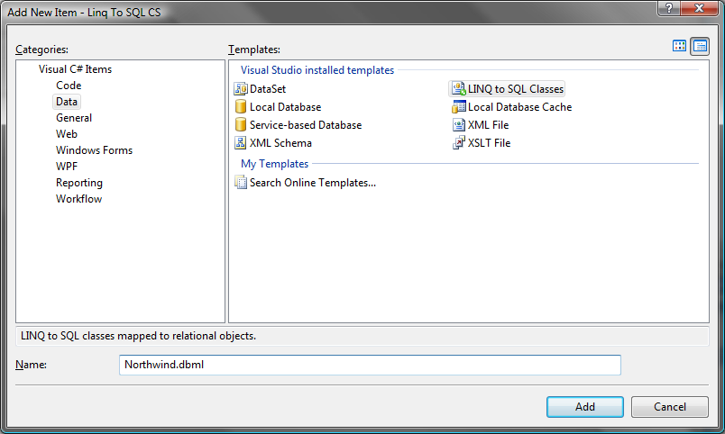

Task 4 – Adding a new Data Connection
- In Microsoft Visual Studio, click the View | Server Explorer menu command (or press Ctrl+W,L)
- In the Server Explorer click the Connect to database button
- In the Add Connection dialog provide the local database server by entering “.\sqlexpress” in the Server name field
- Choose our database by choosing “Northwind” in the Select or enter a database name combo box
- Click Test Connection to verify a successful connection to the database
- Click OK

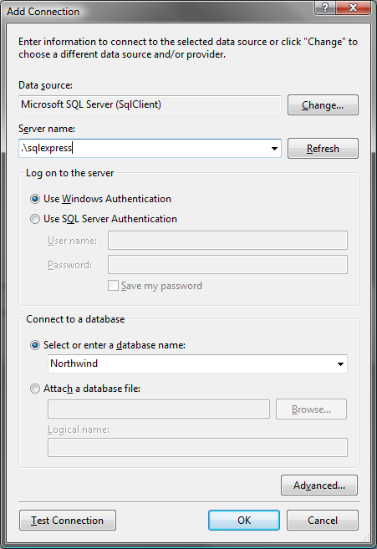

Task 5 – Creating your object model
- Open the Data Connections treeview
- Open the Northwind folder
- Open the Tables folder
- Open the Northwind.dbml file double clicking it from the solution explorer
- From the tables folder drag the Customers table into the designer pane
- From the tables folder drag the Orders table into the designer pane
- From the tables folder drag the Employees table into the designer pane

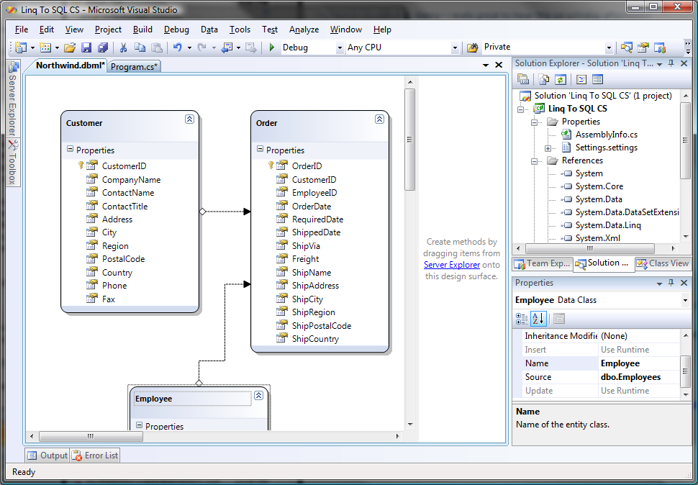

Task 6 – Querying your object model
- Press F5 to debug the project
As you can see, the designer has written all the “plumbing” code for you. Your Main code still works just fine!

Task 7 – Mapping a stored procedure
We’ve seen how to map tables to objects and how to represent relationships between tables. Now we are going to see how we can map a stored procedure to our object model.

- Open the Data Connections treeview
- Open the Northwind folder
- Open the Stored Procedures folder
- Open the Northwind.dbml file double clicking it from the solution explorer
- From the Stored Procedures folder drag the Ten Most Expensive Products into the method pane
- Make the following changes to the Main method to use the model created by the designer.
static void Main(string[] args)
{
// If we query the db just designed, we don't need a connection string
NorthwindDataContext db = new NorthwindDataContext();

// Query for customers who live in London
var custs = from customer in db.Customers
where customer.City == "London"
select customer;

foreach (Customer cust in custs)
{
Console.WriteLine("ID={0}, Qty={1}", cust.CustomerID, cust.Orders.Count);
}

foreach(var prod in db.Ten_Most_Expensive_Products())
{
Console.WriteLine("Product Name={0}, UnitPrice={1}", prod.TenMostExpensiveProducts, prod.UnitPrice);
}

Console.ReadLine();
}
- Press F5 to debug the project
As you type in the code, notice how, in the IDE, IntelliSense is able to show the mapped stored procedure Ten_Most_Expensive_Products as a method of the strongly typed DataContext the designer has generated. Notice also that the designer has created a Ten_Most_Expensive_Product type containing two typed properties that map to the fields returned by the stored procedure. Note, if you copy/pasted the above code: simply type “p.” to see what we’re talking about.

Task 8 – Retrieving new results
So far we have run queries that retrieve entire objects. But you can also select the properties of interest. It is also possible to create composite results, as in traditional Sql, where an arbitrary collection of columns can be returned as a result set. In Linq to Sql, this is accomplished through the use of anonymous types.
- Modify the code in the Main method as shown to create a query that only retrieves the ContactName property:
static void Main(string[] args)
{
// If we query the db just designed we don’t need a connection string
NorthwindDataContext db = new NorthwindDataContext();

var q = from customer In db.Customers
where customer.Region == null
select customer.ContactName;

foreach(var cust in q)
{
Console.WriteLine(cust);
}

Console.ReadLine();
}

- Modify the code as shown to create a new object type to return the desired information:
static void Main(string[] args)
{
// If we query the db just designed we don’t need a connection string
NorthwindDataContext db = new NorthwindDataContext();

var q = from customer in db.Customers
where customer.Region == null
select new {customer.CompanyName, customer.ContactName};

foreach(var cust in q)
Console.WriteLine("{0}/{1}", cust.CompanyName, cust.ContactName)
Next

Console.ReadLine()
}

- Press F5 to debug the application
Notice that the new operator is invoked with no corresponding type name. This causes the compiler to create a new anonymous type based on the names and types of the selected columns. Notice how in the foreach statement, an instance of the new type is referenced using var and its properties are still accessible due to the strong typing support built into Linq.

- Change the code as follows to do a join:

static void Main(string[] args)
{
// If we query the db just designed we don’t need a connection string
NorthwindDataContext db = new NorthwindDataContext();

var ids = (from customer in db.Customers
from emp in db.employees
where customer.City == emp.City
select emp.EmployeeID).Distinct();

foreach(var id in ids)
Console.WriteLine(id)
Next

Console.ReadLine()
}
- Press F5 to debug the solution
The above example illustrates how a Sql style Join can be used when there is no explicit relationship to navigate. It also shows how a specific property can be selected (projection) instead of the entire object.

Exercise 2 Internals: Creating your first Linq To Sql Application
In this exercise, you will learn how to map a class to a database table, and how to retrieve objects from the underlying table. This is the ‘nuts and bolts’ of what’s going on behind the covers of exercise 1.

Close your existing application, and repeat tasks 1 and 2 from exercise 1 (the tasks, without diagrams, are repeated here for reference).

Task 1 – Creating a Linq Project
- Click the Start | Programs | Microsoft Visual Studio 2008 | Microsoft Visual Studio 2008 menu command.
- In Microsoft Visual Studio, click the File | New | Project… menu command
- In the New Project dialog, in Project types, click Visual C#
- In the New Project dialog, in Templates, click Console Application
- Provide a name for the new solution by entering “Linq To Sql CS 2” in the Name field
- Click OK

Task 2 - Adding a reference to the System.Data.Linq assembly
- In Microsoft Visual Studio, click the Project | Add Reference… menu command
- In the Add Reference dialog make sure the .NET tab is selected
- click System.Data.Linq assembly
- Click OK
In Program.cs import the namespace System.Data.Linq adding the following lines along with the other using statements:
using System.Data.Linq
using System.Data.Linq.Mapping

Task 3 – Mapping Northwind Customers
- Create an entity class to map to the Customer table by entering the following code in Program.cs (put the Customer class declaration immediately above the class Program declaration):
public class Customer
{
[Column(IsPrimaryKey=true)]
Public CustomerID As String
}

The Table attribute maps a class to a database table. The Column attribute then maps each field to a table column. In the Customers table, CustomerID is the primary key and will be used to establish the identity of the mapped object. This is accomplished by setting the IsPrimaryKey parameter to true. An object mapped to the database through a unique key is referred to as an entity. In this example, instances of Customer class are entities.
- Add the following code to declare a City property:
[Table(Name="Customers")]
public class Customer
{
private string _City;

[Column(IsPrimaryKey=true)]
public string CustomerID;

[Column(Storage="_City")]
public string City
{
get
{
return _City;
}

set
{
_City = value;
}
}
}

Fields can be mapped to columns as shown in the previous step, but in most cases properties would be used instead. When declaring public properties, you must specify the corresponding storage field using the Storage parameter of the Column attribute.
- Enter the following code within the Main method to specify the link to the Northwind database and establish a connection between the underlying database and the code-based data structures:
static void Main(string[] args)
{
// Use a standard connection string
DataContext db = new DataContext("Data Source=gerry_vista;Initial Catalog=Northwind;integrated security=true");

// Get a typed table to run queries
Table<Customer> Customers;
Customers = db.GetTable<Customer>();
}

The Customers table acts as the logical, typed table for queries. It does not physically contain all the rows from the underlying table but acts as a proxy to allow strongly typed queries.

The next step retrieves data from the database using the DataContext object, the main conduit through which objects are retrieved from the database and changes are submitted.

Task 4 – Querying Database Data
- Although the database connection has been established, no data is actually retrieved until a query is executed. This is known as lazy or deferred evaluation. Add the following query for London-based customers:
static void Main(string[] args)
{
// Use a standard connection string
DataContext db = new DataContext("Data Source=.\sqlexpress;Initial Catalog=Northwind");

// Get a typed table to run queries
Table<Customer> Customers;
Customers = db.GetTable<Customer>();
}

// Attach the log showing generated Sql to console
// This is only for debugging / understanding the working of Linq to Sql
db.Log = Console.Out;

// Query for customers in London
var custs = from customer in Customers
where customer.City == "London"
select customer
End Sub
This query, which returns all of the customers from London defined in the Customers table, is expressed in query expression syntax, which the compiler will translate into explicit method-based syntax. Notice that the type for custs is not declared. This is a convenient feature of Visual C# that allows you to rely on the compiler to infer the correct data type. This is especially useful since queries can return complex multi-property types that the compiler will infer for you, with no need for explicit declaration.
- Add the following code to execute the query and print the results:
static void Main(string[] args)
// Use a standard connection string
DataContext db = new DataContext("Data Source=.\sqlexpress;Initial Catalog=Northwind");

// Get a typed table to run queries
Table<Customer> Customers;
Customers = db.GetTable<Customer>();

// Attach the log showing generated Sql to console
// This is only for debugging / understanding the working of Linq to Sql
db.Log = Console.Out;

// Query for customers in London
var custs = from customer in Customers
where customer.City == "London"
select customer;

foreach(var cust in custs)
{
Console.WriteLine("ID={0}, City={1}", cust.CustomerID, cust.City)
}
Next

Console.ReadLine()
End Sub

The example in step 1 of task 3 shows a query. The query is only executed when the code above consumes the results. At that point, a corresponding Sql command is executed and objects are materialized. This concept, called ‘lazy evaluation’, allows queries to be composed without incurring the cost of an immediate round-trip to the database for query execution and object materialization. Query expressions are not evaluated until the results are needed. The code above results in the execution of the query defined in step 1 of task 3.

- Press F5 to debug the solution
- Press ENTER to exit the application
The call to the Console.ReadLine method prevents the console window from disappearing immediately. In subsequent tasks, this step will not be stated explicitly.
You should see a console window that looks like this:
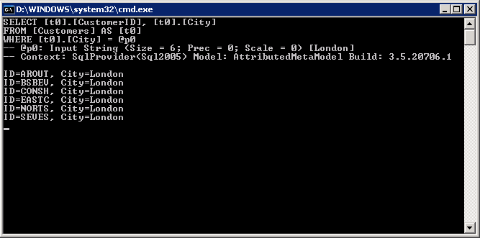

The first part of the screen shows the log of the Sql command generated by Linq and sent to the database. You can then see the results of our query. Notice that that the rows retrieved from the db are transformed into “real” CLR objects. This can be confirmed using the debugger.

Task 5 – Exploring the IDE
- In the Visual C# editor select the Console.WriteLine line inside the foreach loop
- In Microsoft Visual Studio, click the Debug | Toggle breakpoint menu command (or click F9)
- Press F5 to debug the application
- When the debugger stops the execution look at the locals window (or press Ctrl+D,L if the window doesn’t appear)
- Inspect the variable cust to see its properties
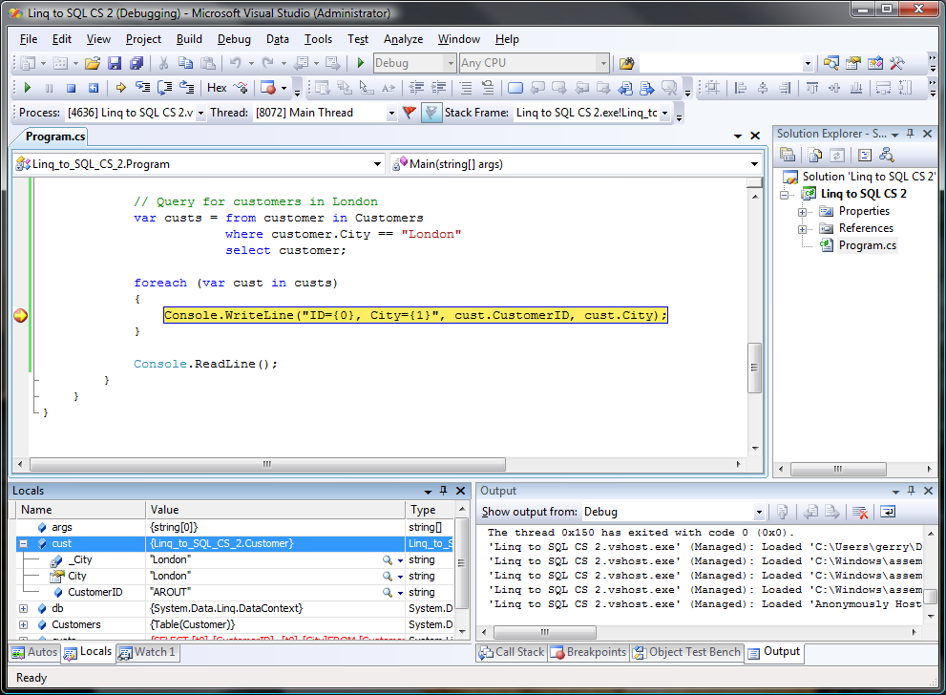

You can also move the mouse over the variables and see how the IDE is fully aware of the type of the objects we have created.

Exercise 3 Internals: Creating an Object Model
In this exercise, you will learn how to create a simple object model. Our first object model will be really simple and composed by two objects mapping two database tables. Then we will see how to map relationships between tables.

Task 1 – Create the order entity
- After the Customer class definition, create the Order entity class definition with the following code:

[Table(Name="Orders")]
public class Order
{
private string _CustomerID;
private int _OrderID;

[Column(Storage="_CustomerID", DbType="NChar(5)")]
public string CustomerID
{
get
{
return _CustomerID;
}
set
{
_CustomerID = value;
}
}
[Column(Storage="_OrderID", DbType="Int NOT NULL IDENTITY", IsPrimaryKey=true, IsDBGenerated:=true)]
public readonly int OrderID
{
get
{
return _OrderID;
}
}
}

Task 2 – Mapping Relationships Across Tables
- Add a relationship between Orders and Customers with the following code, indicating that Orders.Customer relates as a foreign key to Customers.CustomerID:
[Table(Name="Orders")]
public class Order
{
private string _CustomerID;
private int _OrderID;

[Column(Storage="_CustomerID", DbType="NChar(5)")]
public string CustomerID
{
get
{
return _CustomerID;
}
set
{
_CustomerID = value;
}
}
[Column(Storage="_OrderID", DbType="Int NOT NULL IDENTITY", IsPrimaryKey=true, IsDBGenerated:=true)]
public readonly int OrderID
{
get
{
return _OrderID;
}
}

private EntityRef<Customer> _Customer = new EntityRef<Customer>();

[Association(Storage="_Customer", ThisKey="CustomerID")]
public Customer Customer

get
{
return _Customer.Entity;
{

set
{
_Customer.Entity = value;
}
}

Linq to Sql allows to you express one-to-one and one-to-many relationships using the EntityRef and EntitySet types. The Association attribute is used for mapping a relationship. By creating the association above, you will be able to use the Order.Customer property to relate directly to the appropriate Customer object. By setting this declaratively, you avoid working with foreign key values to associate the corresponding objects manually. The EntityRef type is used in class Order because there is only one customer corresponding to a given Order.
- Annotate the Customer class to indicate its relationship to the Order class. This is not strictly necessary, as defining it in either direction is sufficient to create the link; however, it allows you to easily navigate objects in either direction. Add the following code to the Customer class to navigate the association from the other direction:
[Table(Name="Customers")
public class Customer
private string _City
[Column(IsPrimaryKey=true)]
public string CustomerID
private EntitySet<Order> _Orders;

_Orders = new EntitySet<Order>;

[Association(Storage="_Orders", OtherKey="CustomerID")]
public EntitySet<Order> Orders()
{
get
{
return _Orders;
}
set
{
_Orders.Assign(value);
}
}
…}

Notice that you do not set the value of the _Orders object, but rather call its Assign method to create the proper assignment. The EntitySet type is used because from Customers to Orders, rows are related one-to-many: one Customers row to many Orders rows.
- You can now access Order objects directly from Customer objects, or vice versa. Modify the Main method with the following code to demonstrate an implicit join:

static void Main(string[] args)
{
// Use a standard connection string
DataContext db = new DataContext
("Data Source=.\sqlexpress;Initial Catalog=Northwind");

// Get a typed table to run queries
Table<Customer> Customers;
Customers = db.GetTable<Customer>();

// Query for customers who have placed orders
var custs = from customer in Customers
where customer.Orders.Count > 0
select customer;

foreach (var cust in custs)
{
Console.WriteLine("ID={0}, Qty={1}", cust.CustomerID, _
cust.Orders.Count);
}

Console.ReadLine()
}

- Press F5 to debug the solution

Task 3 – StronglyTyping the DataContext Object
- Add the following code above the Customer class declaration:
public class NorthwindDataContext : DataContext
{
// Table(Of T) abstracts database details per table/date type
public Table<Customer> Customers;
public Table<Order> Orders;

public NorthwindDataContext(string connection): base(connection)
{
}
}

- Make the following changes to the Main method to use the strongly-typed DataContext.
static void Main(string[] args)
{
// Use a standard connection string
NorthwindDataContext db = new NorthwindDataContext
("Data Source=.\sqlexpress;Initial Catalog=Northwind")

// Query for customers who have placed orders
var custs = from customer in Customers
where customer.Orders.Count > 0
select customer;

foreach (var cust in custs)
{
Console.WriteLine("ID={0}, Qty={1}", cust.CustomerID, cust.Orders.Count);
}

Console.ReadLine()
}

- Press F5 to debug the solution
This optional feature is convenient since calls to GetTable<T> are not needed. Strongly typed tables can be used in all queries once such a DataContext-derived class is used.
Generating the database table relationships and object model can be tedious and prone to error: we do NOT advise you take that approach, but it’s included in this lab for education. Those who prefer command lines tool can choose to use SqlMetal, a code generation tool that you can use to create your object model manually. The end result is the same.
The easiest and best option is to use the new designer (just seen) with its seamless Visual Studio integration. Also, remember that automatic code generation is strictly an option – you can always write your own classes or even use a different code generator if you prefer.

Exercise 4 – Modifying Database Data
In this exercise, you will move beyond data retrieval and see how to manipulate the data. The four basic data operations are Create, Retrieve, Update, and Delete, collectively referred to as CRUD. You will see how Linq to Sql makes performing CRUD operations simple and intuitive. Open the Linq to SQL CS project from the first lesson.

Task 1 – Modifying your object model
We are going to modify our object model by adding two more tables:
- Open the Data Connections treeview in Server Explorer
- Open the Northwind folder
- Open the Tables folder
- Open the Northwind.dbml file double clicking it from the solution explorer
- From the tables folder drag the Order Details table into the designer pane
- From the tables folder drag the Products table into the designer pane

Task 2 – Creating a new Entity
- Creating a new entity is straightforward. Objects such as Customer and Order can be created with the new operator as with regular Visual Basic Objects. Of course you will need to make sure that foreign key validations succeed. Change the Main method entering the following code to create a new customer:
- Modify the Main method so that it appears as the following (note: it is expected that having added this code, the new row will not show in the results):
static void Main(string[] args)
{

// Use a standard connection string
NorthwindDataContext db = new NorthwindDataContext();

// Create the new Customer object
Customer newCust = new Customer();
newCust.CompanyName = "AdventureWorks Cafe";
newCust.CustomerID = "ADVCA";

// Add the customer to the Customers table
db.Customers.InsertOnSubmit(newCust);
Console.WriteLine("Customers matching CA before update");

var CACustomers = from customer in db.Customers
where customer.CustomerID.Contains("CA")
select customer;

foreach (var cust in CACustomers)
{
Console.WriteLine("{0}, {1}, {2}, {3}",
cust.CustomerID, cust.CompanyName,
cust.ContactName, cust.Orders.Count);
}

Console.ReadLine();
- Press F5 to debug the solution
Notice that the new row does not show up in the results. The data has not been added to the database yet.

Task 5 – Updating an Entity
- Once you have a reference to an entity object, you can modify its properties like you would with any other object. Add the following code to modify the contact name for the first customer retrieved:
static void Main(string[] args)
{
// Use a standard connection string
NorthwindDataContext db = new NorthwindDataContext();
// Create the new Customer object
Customer newCust = new Customer();
newCust.CompanyName = "AdventureWorks Cafe";
newCust.CustomerID = "ADVCA";

// Add the customer to the Customers table
db.Customers.InsertOnSubmit(newCust);
Console.WriteLine("Customers matching CA before update");

var CACustomers = from customer in db.Customers
where customer.CustomerID.Contains("CA")
select customer;

foreach (var cust in CACustomers)
{
Console.WriteLine("{0}, {1}, {2}, {3}",
cust.CustomerID, cust.CompanyName,
cust.ContactName, cust.Orders.Count);
}

Customer existingCust = CACustomers.First();
// Change the contact name of the customer
existingCust.ContactName = "New Contact";

Console.ReadLine();
}

As in the last task, no changes have actually been sent to the database yet.

Task 6 – Deleting an Entity
- Using the same customer object, you can delete the first order detail. The following code demonstrates how to sever relationships between rows, and how to remove a row from the database.

Customer existingCust = customers.First();

// Change the contact name of the customer
existingCust.ContactName = "New Contact";
// Access the first element in the Orders collection
Order ord0 = existingCust.Orders[0];

// Access the first element in the OrderDetails collection
Order_Detail detail0 = ord0.Order_Details[0];

// Mark the Order Detail row for deletion from the database
db.Order_Details.DeleteOnSubmit(detail0);

Task 7 – Submitting changes
- The final step required for creating, updating, and deleting objects is to actually submit the changes to the database. Without this step, the changes will only be local, will not be persisted and will not show up in query results. Insert the following code to finalize the changes:
db.SubmitChanges();

Console.ReadLine();

- Modify the main method so you can see how the code behaves before and after submitting changes to the database (Note: to differentiate the customer queries, we’ve named then CACustomers1 and CACustomers2):
static void Main(string[] args)
{
// Use the standard connection string
NorthwindDataContext db = new NorthwindDataContext();

// Create the new Customer Object
Customer newCust = new Customer();
newCust.CompanyName = "AdventureWorks Cafe";
newCust.CustomerID = "ADVCA";

// Add the customer to the Customers table
db.Customers.InsertOnSubmit(newCust);

Console.WriteLine("Customers matching CA before update");

var CACustomers = from customer in db.Customers
where customer.CustomerID.Contains("CA")
select customer;

foreach(var cust in CACustomers)
{
Console.WriteLine("{0}, {1}. {2}. {3}", cust.CustomerID, cust.CompanyName, cust.ContactName, cust.Orders.Count);
}

Customer existingCust = CACustomers.First();

// Change the contact name of the customer
existingCust.ContactName = "New Contact";

// Access the first element in the Orders collection
Order ord0 = existingCust.Orders[0];

// Access the first element in the OrderDetails collection
Order_Detail detail0 = ord0.Order_Details[0];

// Mark the Order Detail row for deletion from the database
db.Order_Details.DeleteOnSubmit(detail0);

db.SubmitChanges();

Console.ReadLine();

Console.WriteLine("Customers matching CA after update");

var CACustomers2 = from customer in db.Customers
where customer.CustomerID.Contains("CA")
select customer;

foreach (var cust in CACustomers2)
{
Console.WriteLine("{0}, {1}, {2}, {3}",
cust.CustomerID, cust.CompanyName,
cust.ContactName, cust.Orders.Count);
}

Console.ReadLine();
}

- Press F5 to debug the solution
Naturally, once the new customer has been inserted, it cannot be inserted again due to the primary key uniqueness constraint. Therefore this program can only be run once. As an extended exercise, consider writing the code to delete the row!

Task 7 – Using Transactions
- In Microsoft Visual Studio, click the Project | Add Reference… menu command
- In the Add Reference dialog make sure the .NET tab is selected
- click System.Transactions assembly
- Click OK

Linq to Sql by default uses implicit transactions for insert/update/delete operations. When SubmitChanges() is called, it generates Sql commands for insert/update/delete and wraps them in a transaction. But it is also possible to define explicit transaction boundaries using the TransactionScope the .NET Framework 2.0 provides. The TransactionScope type is found in the System.Transactions namespace.
- At the top of Program.cs, add the following using directive:
using System.Transactions
- In Main, replace all the existing code with the following code to have the query and the update performed in a single transaction:
// Use a standard connection string
NorthwindDataContext db = new NorthwindDataContext();
TransactionScope ts = new TransactionScope();
var products = from prod in db.Product
where prod.ProductID == 15
select prod;
Product product = products.First();
// Show UnitsInStock before update
Console.WriteLine("In stock before update: {0}", product.UnitsInStock);
if (product.UnitsInStock.Value > 0)
{
product.UnitsInStock = product.UnitsInStock--;
}
db.SubmitChanges();
ts.Complete();
Console.WriteLine("Transaction successful");
Console.ReadLine();
- Press F5 to debug the application

Exercise 5 – Working with Advanced features
When SubmitChanges() is called, Linq to Sql generates and executes Sql commands to insert, update and delete database rows. Application developers can override these actions with custom code. In this way, alternative facilities like database stored procedures can be automatically invoked by the change processor. In this exercise, you will learn more about:
- Using custom Sql commands for updating the database
- Exploring object identity and using multiple DataContext objects

Task 1 - Adding a Linq to Sql file
- In Microsoft Visual Studio, click the Project | Add New Item… menu command
- In the Templates click Linq To Sql Classes
- Provide a name for the new item by entering “DVDCollection” in the Name field
- Click OK

Task 2 – Adding a new Data Connection
- In Microsoft Visual Studio, click the View | Server Explorer menu command (or press Ctrl+W,L)
- In the Server Explorer click the Connect to database button
- In the Add Connection dialog provide the local database server by entering “.\sqlexpress” in the Server name field
- Choose our database by choosing “DVDCollection” in the Select or enter a database name combo box
- Click OK

Task 3 – Creating your object model
- Open the Data Connections treeview
- Open the DVDCollection folder
- Open the tables folder
- Open the DVD

- Collection.dbml file double clicking it from the solution explorer
- From the tables folder drag the DVDs table into the method pane
- Open the Stored Procedures folder
- From the Stored Procedures folder drag the DeleteDVD into the method pane
- From the Stored Procedures folder drag the InsertDVD into the method pane
- From the Stored Procedures folder drag the UpdateDVD into the method pane

Task 4 – Integrating Custom Queries
By defining a method on your strongly-typed DataContext, the change processor can be instructed to use a stored procedure instead of the normal auto-generated update command. Even if the DataContext class is auto-generated by the Linq to Sql code generation tool, you can still specify these methods in a partial class of your own.

- Custom query capabilities are especially important when a database is already in place and optimized with stored procedures. Add the following code to Program.cs just before the class program definition to add a custom implementation of the insert operation:
public partial Class DVDCollectionDataContext
{
public static void InsertDVD(DVD dvd)
{
Console.WriteLine("Before Insert");

// Generate a new ID for this entity/row
string guid = System.Guid.NewGuid().ToString();
DVD.ID = guid;

ExecuteCommand("exec InsertDVD {0}, {1}, {2}",
DVD.ID, DVD.Title, DVD.MyRating);
}
}

The Console.WriteLine call will show when the method is invoked.
- Just as for the insert operation, you can add custom functionality to the delete and update operations. Instead of invoking the stored procedure using ExecuteCommand, you can also directly call an already mapped stored procedure. Add the following code to the DVDCollectionDataContext class to support this:
public static void DeleteDVD(DBD dvd)
{
Console.WriteLine("Before Deleting");
DeleteDVD(dvd.ID);
}
public static void UpdateDVD(DVD original, DVD current)
{
Console.WriteLine("Before Updating");
UpdateDVD(original.ID, current.Title, current.MyRating);
}

- Modify Main so that it looks like this:
private static void Main(string[] args)
{
// Use a standard connection string
DVDCollectionDataContext db = new DVDCollectionDataContext();

// Create a new DVD entry
DVD newDVD = new DVD();
newDVD.Title = "New DVD";
newDVD.MyRating = 5;

// Add the new DVD to the in-memory collection
db.DVDs.InsertOnSubmit(newDVD);

// Persist the DVD to the database
db.SubmitChanges();

// Display the newly generated ID
Console.WriteLine("New ID: {0}", newDVD.ID);

// Grab the first DVD (just created)
DVD disc = db.DVDs.First();

Console.WriteLine("ID={0}:{1}/{2}", disc.ID, disc.Title, disc.MyRating);
// Update the DVD Title, then back to db
disc.Title = "The Updated Title";
db.SubmitChanges();

// Grab the first DVD (just modified)
disc = db.DVDs.First();

Console.WriteLine("ID={0}:{1}/{2}", disc.ID, disc.Title, disc.MyRating);

// Remove the DVD, then submit to the database
db.DVDs.DeleteOnSubmit(disc);

db.SubmitChanges();

Console.ReadLine();
}

- Press F5 to debug the solution

Task 4 – Exploring Object Identity
- Linq to Sql preserves object identity across multiple queries. If two queries contain overlapping results, the same entity is returned in each result set. This simplifies application logic as objects can be assumed to unique and hence consistent, whereas, with typical relational data access APIs, the developer is forced to catch overlaps to prevent multiple copies from being created. Note that consistency is handled through the DataContext object (or a derived class). If more than one DataContext is used, each will maintain its own copy of individual objects. Modify the Main method to match the following:
private static void Main(string[] args)
{
// Use a standard connection string
NorthwindDataContext db = new NorthwindDataContext();

Customer c1 = db.Customers.First();
Customer c2 = db.Customers.First();

Console.WriteLine("Name1={0}, Name2={1}" + " c1 = c2 is {2}",
c1.CompanyName, c2.CompanyName, Object.ReferenceEquals(c1, c2));

Console.ReadLine();
}
- Press F5 to debug the solution
As you can see, the two variables hold a reference to the same object.
- In order to demonstrate the ability to access the objects as distinct entities, modify the code as follows:
private static void Main(string[] args)
{
// Use a standard connection string
NorthwindDataContext dbNW = new NorthwindDataContext();
Customer c1 = dbNW.Customers.First();

// Create a second connection
NorthwindDataContext dbNW2 = new NorthwindDataContext();
Customer c2 = dbNW2.Customers.First();

Console.WriteLine("Name1={0}, Name2={1}" + " c1 = c2 is {2}",
c1.CompanyName, c2.CompanyName, Object.ReferenceEquals(c1, c2));

Console.ReadLine();
}

- Press F5 to debug the solution
Now, although the two objects still refer to the same row, the two variables no longer reference the same object.
- Notice that the query used to retrieve the object is irrelevant – as long as the row in the database is the same, and the same DataContext is used, only one object will be created. This of course assuming that the same DataContext is being used.
Object equality is a vital feature in an object-relational framework. It ensures that if you update the state of an entity (e.g. calling a property) the change will happen consistently throughout your application. Linq to Sql provides powerful built-in features to make this happen with no additional work on your side.
Lab Summary
Instructor's Note: Linq to Sql is still an early technology, but sufficient progress has been made to demonstrate powerful data capabilities.

In this lab you performed the following exercises:
Exercise 1 – Creating the first DB Application
Exercise 2 – Creating a Database Object model
Exercise 3 – Using Code Generation to Create Object Model
Exercise 4 – Modifying the Database Data
Exercise 5 – Working with Advanced Features

In this lab, you learned about how the Linq Project is advancing query capabilities to the .NET Framework. You mapped database tables to language types and populated them with live data. You also saw how seamlessly data can be retrieved and updated with little extra work than required for traditional objects. Finally, you saw how advanced capabilities such as transactions, custom queries, and object identity can make it easier for developers to simply concentrate on the application logic. Linq to Sql provides a powerful bridge from objects to relational data making data-driven applications easier to build than ever.
Thank you for trying Linq to Sql. We look forward to your feedback.

