
Collaboratively Implementing Product Lifecycle Engineering Changes
Using the Microsoft Office System
Technical Discussion Guide

The information contained in this document represents the current view of Microsoft Corporation on the issues discussed as of the date of publication. Because Microsoft must respond to changing market conditions, it should not be interpreted to be a commitment on the part of Microsoft, and Microsoft cannot guarantee the accuracy of any information presented after the date of publication.
This document is for informational purposes only. MICROSOFT MAKES NO WARRANTIES, EXPRESS OR IMPLIED, AS TO THE INFORMATION IN THIS DOCUMENT.
Complying with all applicable copyright laws is the responsibility of the user. Without limiting the rights under copyright, no part of this document may be reproduced, stored in or introduced into a retrieval system, or transmitted in any form or by any means (electronic, mechanical, photocopying, recording, or otherwise), or for any purpose, without the express written permission of Microsoft Corporation.
Microsoft may have patents, patent applications, trademarks, copyrights, or other intellectual property rights covering subject matter in this document. Except as expressly provided in any written license agreement from Microsoft, the furnishing of this document does not give you any license to these patents, trademarks, copyrights, or other intellectual property.
Unless otherwise noted, the example companies, organizations, products, domain names, e-mail addresses, logos, people, places and events depicted herein are fictitious, and no association with any real company, organization, product, domain name, e-mail address, logo, person, place or event is intended or should be inferred.
© 2005 Microsoft Corporation. All rights reserved.
Microsoft, Active Directory, InfoPath, MSDN, SharePoint, Visual Studio, BizTalk, Outlook, Excel, Windows, and Windows Server are either registered trademarks or trademarks of Microsoft Corporation in the United States and/or other countries.
All other trademarks are property of their respective owners.

1 Executive Summary 4
Purpose of This Guide 4
2 Business Challenges and Solutions 6
Business Challenges 6
Addressing the Challenges 7
Building an Engineering Change Process Solution Using the Microsoft Office System 8
Benefits 9
3 Architectural Overview 11
Sample Solution Architecture 11
Client Tier 12
Business Logic (Server) Tier 13
Data Services Tier 13
Customization and Extensibility 14
Using an Engineering Change Process Solution 15
4 Infrastructure Considerations 19
Software Considerations 19
Integration and Scalability Considerations 20
Integration 20
Scalability 20
Configuration Planning Considerations for Project Server 21
Windows SharePoint Services Capacity Guidelines 22
Throughput Limits 22
Scale Limits 22
Integration with SharePoint Portal Server 22
Security Considerations 23
5 Next Steps 24
Resource and Skill Considerations 24
Engineering Staff 24
Developer 24
Network Administrator 25
Potential Partner Solutions 25
Solution Showcase for the Microsoft Office System 25
6 Appendix 26
General References 26
Developer Resources 26
Product Training 27
Security Information 27

1 Executive Summary
Engineering change processes are an important stage in the product lifecycle management (PLM) practices of manufacturers. The systems used to track and manage engineering changes, however, are often fragmented and disconnected from essential business processes such as procurement, sales operations, and finance. The need to manage engineering changes effectively is magnified because the changes can affect each participant in manufacturing processes, from engineers to suppliers.
Processes related to product development, including engineering change processes, can be made more efficient if designers, engineers, and suppliers that make product parts work from the same data and use common tools. Setting up an engineering change process solution that enables collaborative team work, automates workflow, provides a product information repository, and helps integrate diverse business systems can help a manufacturing organization accelerate product introductions, maintain product quality, reduce costs, and contribute to customer satisfaction.
This guide describes an example of a PLM–engineering change process solution based on the Microsoft® Office System. Microsoft SharePoint® Products and Technologies provides a central team portal, issue tracking, a product information repository, and document management capabilities. The capabilities of the Microsoft Office Information Bridge Framework and Microsoft BizTalk® Server 2004 help integrate data from varied business systems and data stores. The data made available through the Information Bridge Framework can be viewed and updated in commonly used applications such as Microsoft Office Word 2003 and Microsoft Office Excel® 2003. In addition, as part of an engineering change process solution, manufacturers can deploy an enterprise project management solution based on Microsoft Office Project Professional 2003 and Microsoft Office Project Server 2003.
An Office-based solution can help manufacturers manage engineering change workflow by providing internal teams with tools for tracking and analyzing recurring problems, a centralized product-data repository that is accessible to internal and external team members, and features that enable group communication and collaboration.

Purpose of This Guide
This guide provides information intended to help business and technical decision makers in manufacturing organizations assess and recommend information technology solutions designed to manage engineering change processes. It summarizes challenges that businesses face managing these processes and describes how a solution based on the Microsoft Office System can address those challenges. This guide does not describe the steps required to set up a complete solution. In addition, the example described in this guide is not a complete PLM application that features multiple modules or a full product data management (PDM) system.
This guide also covers the following topics:
● The architecture and operations of a sample solution
● Issues to consider with respect to scalability, security, and other operational needs
● Resources and skills related to implementing and maintaining a solution
● Additional resources for information about Microsoft software products and technologies and Microsoft partners who develop engineering change process solutions

2 Business Challenges and Solutions
This chapter describes challenges related to managing engineering change processes in a manufacturing company. It explains how these challenges can be addressed by a software solution designed to manage steps in these processes and describes the benefits of basing a solution on the Microsoft Office System.

Business Challenges
A product lifecycle management (PLM) system is used to manage a number of activities required to develop, model, track, and manage manufactured products, including sales, maintenance, and product retirement. A PLM system generally includes four key modules, listed and described in the following table:

Module | Functions
Collaborative Product Design | Collaboration workspaces  Process engineering visualization  CAD translation and interoperability  Web-based design environment
Product Portfolio Management | Product planning  Product concept development  Product mix strategy  Project management  Program management  Reporting
Product Data Management | Product structure (BOM)  Document management  Engineering change management  Data vaulting, version control, re-use and publishing  Configuration management
Product Engineering & Simulation | MCAD/EDA design applications  MCAE/ECAE performance simulation applications

The Collaborative Product Design (CPD) module is at the center of the PLM system. The Product Data Management module feeds and accepts data updates from the CPD module and is used to track engineering changes. A CPD module can also be integrated with information systems used by a manufacturer's suppliers to facilitate shared business processes.
Processes related to implementing engineering changes raise challenges for manufacturing businesses in several areas, including product quality, scheduling, response to changes in market conditions, and customer satisfaction. For example, engineering change processes that delay the introduction of a new product can cause a manufacturer to face increases in operating costs and decreases in profit or market position.
The lack of a system framework that facilitates collaborative workflow can compromise the quality of manufactured products because design changes might not be approved or implemented within the required timeframe. Changes might be made without the benefit of reviewing feedback from customers, and groups or individuals with a stake in a change might not be consulted or informed of decisions.
A lack of integration between systems and processes can delay product introductions because a company's principal business processes are not incorporated with departmental functions. For example, the status of an engineering change might be tracked in a departmental system that is not integrated with a scheduling system used to manage other manufacturing stages. The lower revenue and profitability that result from product delays can adversely affect a company's competitive position and lower customer satisfaction.
Companies that lack integrated information systems also could lack access to data that can clarify market dynamics. A slow response to market changes can have a direct effect on costs, profit, and customer satisfaction.
Poor product quality leads to an increase in customer issues. Customers might feel as though their feedback is not considered when a company is slow to resolve issues. A company might lack knowledge about the status or resolution of an issue without a system that collects and stores product data in a single location.
Finally, manufacturers must account for regulatory compliance in their work processes. Regulations such as the Transportation Recall Enhancement Accountability and Documentation (TREAD) Act for automotive manufacturers or the European Union directive Waste from Electrical and Electronic Equipment (WEEE) require businesses to maintain more product data. This information becomes part of the product record, which is usually managed by the PDM module of a PLM system.

Addressing the Challenges
The key elements of a software solution that is designed to manage engineering change processes are workflow automation, group collaboration, and data synchronization. In addition, a solution should be designed to handle all the tasks related to the execution of engineering changes, not only portions of the process. For example, a solution must have the capability to support routine, task-oriented jobs such as data analysis, as well as those, such as collaborative design, that integrate key business processes.
Engineering changes can be managed by using a central repository of documents and product information that is accessible to internal and external team members. Engineering changes can be tracked and updated and the results then fed to other components of a PLM system. Once the data is part of a company's PLM system, it can be integrated with the rest of the manufacturing enterprise.
When manufacturing companies are engaged in changing their designs or work with their suppliers and partners on new designs, they need tools that help facilitate collaboration among team members. A solution should provide capabilities to manage collaborative processes by supporting workflow with project management tools, a central data repository, and the automatic assignment of tasks.
Issues that lead to compromised product quality, high operating costs, and product delays can be addressed by cross-team design sessions and by analytical tools that organizations can use to identify trends and recurring issues. Business processes that are fragmented—for example, departmental processes that are not tied to central work processes—can be connected by integrating internal systems and legacy systems. A solution that provides a framework and supplies the data to regularly analyze market changes can help increase customer satisfaction through better responsiveness.

Building an Engineering Change Process Solution Using the Microsoft Office System
A solution for managing engineering change processes involves a number of different Microsoft Office System applications. SharePoint Portal Server 2003 can be used to create a central portal that team members use to view product issues, the status of engineering changes, overall project plans, schedules, and reports. A SharePoint site can also serve as a centralized product-data repository through document libraries and list management. In addition, Microsoft Windows® Server™ and ASP.NET support the use of Web services so that SharePoint Products and Technologies application programming interfaces (APIs) can interact with various data sources and line-of-business applications.
Microsoft Word 2003 and Microsoft Excel 2003 are familiar to many users. Both applications support Extensible Markup Language (XML) and custom XML schemas, which provide users with access to data and enterprise systems from Office documents through a technology such as the Information Bridge Framework. The Information Bridge Framework can be used to display relevant workflow actions in the task pane of an Office document. The Information Bridge Framework can also display data from underlying systems that expose compatible Web service interfaces. For example, the Information Bridge Framework could be used to insert bill of materials (BOM) data from a BOM management tool into an Excel spreadsheet or a Word document for use in requesting information from or conveying information to suppliers.
As a component of an engineering change process solution developed with Microsoft Office, a Microsoft Office InfoPath® form can be used to collect information related to a specific engineering change. An InfoPath form can be linked to organizational information sources and be integrated with business processes through its support of customer-defined XML schemas and its integration with Web services.
Microsoft Office Project Professional 2003 can be integrated with Microsoft Office Project Server 2003 to manage business process templates, project schedule sites, resource assignments, and the creation of project plans. When used with Project Server 2003 and Microsoft Office Project Web Access, Project Professional provides enterprise project management (EPM) capabilities such as current information about resource availability and project status. Project Server 2003 enables organizations to store project and resource information centrally and consistently. It supports portfolio management, resource management, and collaboration capabilities in an EPM solution. Project Web Access can organize information stored in Project Server into different pages and views. These views include a variety of fields and filters and are formatted to focus on specific areas of a project. Project Server also integrates with Microsoft Windows SharePoint® Services for file management and collaboration capabilities.
Microsoft BizTalk Server 2004 provides features such as human workflow services and enterprise application integration. Human workflow services enable the integration of workflow orchestrations into a process flow, such as approval loops, routing, and tracking of multiple documents that are required in product lifecycle processes. Integrating enterprise applications such as a customer relationship management (CRM) or enterprise resource planning (ERP) system through BizTalk Server enables an organization to combine the data from various systems into a collaborative product development initiative that includes engineering change processes.
By using a solution such as the example described in this guide, manufacturers can implement an engineering change process that enables collaboration across an organization. Internal and external parties can work together to identify recurring problems, investigate and validate solutions, and post final product designs to the release vault.

Benefits
A PLM–engineering change process solution based on Microsoft Office System technology helps engineering teams by providing a centralized product information repository and a portal site that enables collaboration and facilitates communication. Additional benefits include the following:
● Accelerates time-to-market by automating process workflow, distributing tasks through e-mail, and facilitating collaborative work sessions
● Improves product quality by providing tools that help identify and analyze recurring issues
● Improves group productivity by integrating data sources
● Reduces costs through workflow automation, data integration, and collaboration
Overall, a PLM–engineering change process solution developed with the Microsoft Office System helps manufacturing organizations manage engineering changes more effectively. A solution helps automate common project management functions, provides a central location for gaining access to product data, and facilitates collaboration required of teams and suppliers.
A number of partners are available to help build solutions. For more information about Microsoft partners and proposal solutions, see Chapter 5, "Next Steps," later in this guide.

3 Architectural Overview
This chapter describes a basic architecture of an engineering change process solution that can be based on the Microsoft Office System. The chapter also highlights operations that can be performed by a solution, including issue tracking, automatic notification, and recording changes to product data.

Sample Solution Architecture
The Microsoft Office System and Microsoft Windows Server 2003 form the framework for the example of an engineering change process solution that is described in this guide. Support for XML and custom-defined schemas in Office 2003 applications enable users to gain access to data and connect to enterprise business systems from Office documents. Microsoft Windows Server 2003 and Web services provide a platform for collaboration, planning, and integration that software developers can extend.
The example described in this guide is based on Office applications such as Microsoft SharePoint Portal Server 2003 and Microsoft Office InfoPath 2003. The example makes use of the Microsoft Office Information Bridge Framework to make data from line-of-business applications available to users in the Office task pane. The example also includes Microsoft BizTalk Server 2004 as a platform for integrating business processes between diverse systems and organizations. A solution similar to the example could be deployed across a three-tier architecture, using a client tier, a business logic tier, and a data services tier, as shown in Figure 3.1. In addition, a solution could be based on the principles of service oriented architecture (SOA) so that companies could implement only those components required to manage their processes related to engineering change, such as collaboration features, project management tools, and document assembly.
For more information about SOA, see:
http://msdn.microsoft.com/architecture/soa
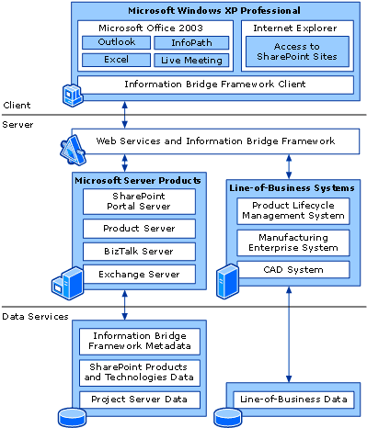
Figure 3.1
A basic solution architecture

Client Tier
The client tier consists of Windows XP Professional, with Internet Explorer 6 and Microsoft Office applications, including Microsoft Office InfoPath 2003 and Microsoft Office Outlook® 2003. Live Meeting, a hosted Web conferencing service, also plays a role in collaboration with the added benefit of having the server deployed and managed by Microsoft.
The client layer provides users with access to product data through SharePoint sites and Office applications. SharePoint Portal Server provides a centralized location for document storage and issue lists and provides tools that facilitate collaboration, such as automatic notification. Office applications can be configured or programmed to work with data from underlying systems. For example, team members involved in engineering changes can use an InfoPath form to collect and distribute data about a specific product change. The data in the form can be drawn from and sent to line-of-business applications.
The Information Bridge Framework enables the integration of data systems and Office documents through metadata. The data is displayed in the task pane, which can be programmed to also provide actions that a user can perform on the data. For example, a user can search a data repository from the task pane, assign sections of a document to team members for writing or review, or add content to a data repository managed through a SharePoint site.

Business Logic (Server) Tier
The business logic tier consists of Microsoft server products and line-of-business applications such as a bill of material (BOM) management system that might need to be integrated into a product lifecycle management system.
Within the business logic layer, data from underlying data sources and business systems can be exposed to applications in the client layer as XML. The data can be exposed through Web services that are built with the Microsoft .NET Framework or through other Web services or data access mechanisms that can provide data as XML. The Information Bridge Framework metadata service facilitates the integration of Web service data with Microsoft Office documents such as Excel spreadsheets and Word documents.
The business logic layer also consists of the Web Part server provided by Microsoft Windows SharePoint Services and Microsoft BizTalk Server, which provide workflow orchestration and business process integration. The solution might include an ERP server, a line-of-business server, or a legacy BOM/PDM server. SharePoint Portal Server and Project Server can use native access rights controls available through Windows Server 2003. However, Microsoft Active Directory® or a similar directory service based on the Lightweight Directory Access Protocol (LDAP) can provide the ability to integrate authentication for collaboration resources with authentication for other data sources. Client notifications can be enabled in Windows SharePoint Services through the implementation of Microsoft Exchange Server or another e-mail server that supports the Simple Mail Transfer Protocol (SMTP).

Data Services Tier
The data layer consists of databases that support Microsoft Windows SharePoint Services, the Information Bridge Framework, and Project Server, in addition to databases for other line-of-business systems. SharePoint Portal Server and Project Server databases are the two primary repositories for product development information. SharePoint Portal Server provides the collaboration and workflow platform, and Project Server stores project and resource schedules and costs for an entire organization.
The SharePoint Products and Technologies configuration and content databases support the business logic of the SharePoint team sites and the documents stored in document libraries. The Microsoft Project Server databases include the transactional database that stores information about project management tasks, resource allocations, schedules, and task status, for example, and any data warehouses that might be necessary for additional reporting.
BizTalk Server 2004 provides native support for Web services and the ability to import and export business processes described in Business Process Execution Language (BPEL), which is a specification that enables collaboration and sequencing logic to be implemented in a process definition based on XML, Web Services Description Language (WSDL), and XML Schema. BizTalk Server can also be used to connect applications within a single organization (commonly referred to as Enterprise Application Integration, or EAI) or to connect applications in different organizations (commonly referred to as business-to-business, or B2B, integration).

Customization and Extensibility
The capabilities built into products such as Microsoft InfoPath 2003 and SharePoint Portal Server 2003 can provide an organization with an effective engineering change process solution. These products can also be adapted and extended to provide specific needs that might be required. For example, an organization might have its own data visualization tools that it wants to include on a SharePoint site, or it might want to develop Web Parts that contain data related to engineering resources.
Services for information workers available in BizTalk Server 2004 provide areas for potential customization, including the following:
● Reporting: Business Activity Services (BAS) such as Business Activity Monitoring (BAM) can analyze running business processes, support business process provisioning and configuration, and enable manufacturers to set up and manage interactions with suppliers and other partners.
● Application Integration: BizTalk Server 2004 also adds technology called Human Workflow Services that provides a workflow infrastructure, enabling people to interact with business processes using tools such as Microsoft Outlook. Connecting applications within a single organization, these capabilities allow for extensibility in enterprise application integration (EAI) and business-to-business (B2B) integration.
Figure 3.2 shows typical components of an Office-based engineering change process solution. It identifies some of the capabilities that are provided by the applications and also areas that can be developed in an implementation of a solution such as the example described in this guide. The appendix to this guide also lists online resources that provide information about developing solutions with the Microsoft products that are included in the example of an engineering change process solution.
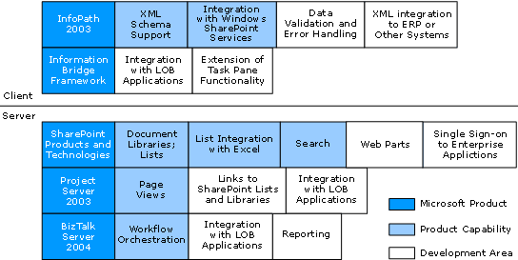
Figure 3.2
Functional areas in which a solution can be customized or extended

Using an Engineering Change Process Solution
Workflow related to engineering changes in a manufacturing organization often follows processes such as the following:
● Customer feedback prompts change
● Engineering department evaluates alternatives and determines appropriate process or design change
● Internal and external suppliers are consulted as needed
● Engineering department reviews updated designs
● Engineering change is approved, and the new specification released
An Office-based engineering change process solution designed to manage processes such as these should have capabilities to facilitate group collaboration and discussions, integrate data systems, automate workflow, and make and track task assignments. It should also provide tools for identifying and analyzing recurring issues.
Figure 3.3 shows a SharePoint Portal site that is used to list and track issues that require the attention of the engineering department. Each issue is assigned an ID for tracking purposes. The name of the team member who is assigned to handle the issue is displayed in the list, together with details such as status, priority, and a description of the issue.
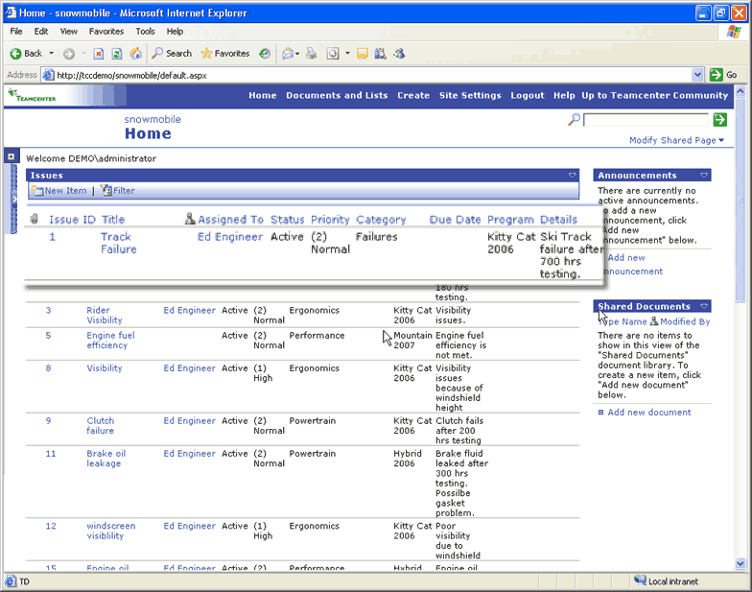
Figure 3.3
A SharePoint Portal site that is configured to list and track engineering change issues
To help analyze items that are listed on the SharePoint site and to help identify items related to recurring problems, teams can filter the list or export it to Excel. When the status of an issue changes or an item is assigned for further analysis and assessment, a notification is sent in e-mail indicating that action is required, as shown in Figure 3.4. The e-mail message includes a link to the issue item on the SharePoint site, so summarizing the issue or listing pertinent details in the message itself is unnecessary.
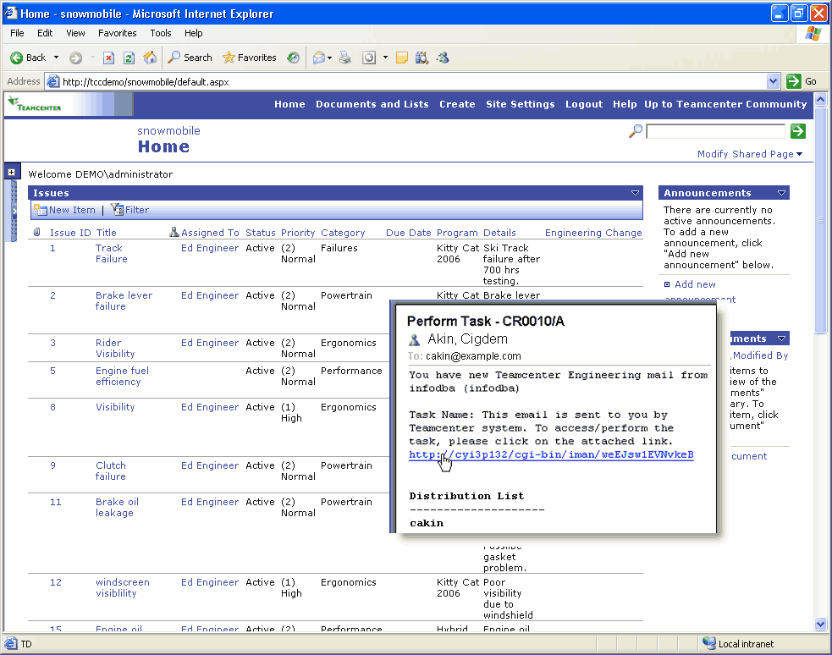
Figure 3.4
Team members receive notifications automatically when an action is required for a specific item
After receiving notification that an issue needs attention, an engineering supervisor might assign an engineer to the issue and initiate engineering change workflow by filling out an InfoPath form with details about the issue. Submitting the form could invoke a Web service that feeds relevant information to appropriate systems and notifies the engineer the supervisor assigned that further action is required.
The engineer assigned to the issue can refer to Web Parts on the SharePoint site to gather more information about the issue. For example, a Web Part might provide information from the product testing department about a product defect. In cases in which a supplier or other external vendor is involved with the product's design or production, the engineer could set up a work session in Live Meeting to discuss the issue and assess alternatives for addressing it. If a supplier needs to perform additional analysis, they could report their findings by posting them to an externally available SharePoint site.
As an engineering change proceeds through testing and other workflow phases, the status of the change can be tracked on the SharePoint site. Notification of changes in status are sent to team members and supervisors. Documentation related to the change and to testing can be posted to a document library managed through the SharePoint site to maintain a repository of product information.
An engineering change process solution could also include the capability to capture and distribute feedback from customers about the change before it is formally approved as part of a product's design. Upon approval of the engineering change, updated specifications can be published to a company's release vault to be used in the manufacturing processes that follow.
The example described in this chapter is one approach to using the Microsoft Office System as a platform for an engineering change process solution. The solution merges the capabilities of applications and tools that are designed to facilitate collaboration, integrate business systems, gather information from diverse data sources, and manage projects.

4 Infrastructure Considerations
This chapter describes topics related to information technology infrastructure that an organization should consider when evaluating the deployment of an engineering change process solution. These topics include which Microsoft software products can be used to build a solution, issues related to the configuration and scalability of a solution, capacity guidelines, and security.

Software Considerations
This section lists the Microsoft products and technologies that can be used to create an engineering change process solution using the Microsoft Office System.
For client computers, the following products can be used:
● Microsoft Windows XP Professional, with Service Pack 2
www.microsoft.com/windowsxp/pro/evaluation/sysreqs.asp
● Microsoft Internet Explorer
www.microsoft.com/windows/ie
● Microsoft Office Professional Enterprise Edition 2003
www.microsoft.com/office/prodinfo.mspx
● Microsoft Office InfoPath 2003
www.microsoft.com/office/prodinfo.mspx
● Microsoft Office Project Professional 2003 (as a component of the EPM solution)
www.microsoft.com/office/project/prodinfo
● Microsoft .NET Framework 1.1
http://msdn.microsoft.com/netframework
● Microsoft Office Information Bridge Framework client component
http://msdn.microsoft.com/library/default.asp?url=/library/en-us/odc_ibf2003_ta/html/odc_ibfintro.asp
For server computers, the following products can be used:
● Microsoft Windows Server 2003
www.microsoft.com/windowsserver2003/evaluation/sysreqs
● Internet Information Services (IIS) 6.0 with Microsoft ASP.NET
www.microsoft.com/windowsserver2003/iis
● Microsoft SharePoint Products and Technologies
www.microsoft.com/sharepoint
● Microsoft SQL Server™ 2000 SP3a or later (SQL Server 2005 recommended)
www.microsoft.com/sql
● Microsoft Office Project Server 2003 (as component of the EPM solution)
http://support.microsoft.com/?scid=ph;en-us;2526
● Microsoft .NET Framework 1.1
http://msdn.microsoft.com/netframework
● Microsoft Office Information Bridge Framework server component
http://msdn.microsoft.com/library/default.asp?url=/library/en-us/odc_ibf2003_ta/html/odc_ibfintro.asp
● Microsoft BizTalk Server 2004
www.microsoft.com/biztalk

Integration and Scalability Considerations
The following sections cover possible integration and scaling issues related to an Office-based engineering change process solution.

Integration
Service oriented architectures are ideal for integrating product lifecycle management capabilities with current systems and data sources. By creating Web service interfaces to existing data sources, existing systems can be integrated without modifying them. For example, many BizTalk Server adapters can be integrated with enterprise resource planning (ERP) or other systems and expose the data those systems store through Web services.
The Information Bridge Framework also enables integration between line-of-business applications and the Microsoft Office System. The Information Bridge Framework uses a client component, metadata, SOAP, and Web services that enable users of Office applications to take action on data from line-of-business applications when working in a document. The Information Bridge Framework metadata defines how a user interacts with line-of-business data from various enterprise applications, and Web services enable the interaction.

Scalability
Several of the components and services in Project Server 2003 that provide project management features and functionality are installed by default on the computer running Project Server 2003. For larger deployments, components such as the View Processing service can be installed on a separate computer to distribute the load on an organization's servers.
Both Project Server 2003 and Microsoft Windows SharePoint Services can be deployed in a load-balanced cluster. Client requests can be distributed across a load-balanced cluster by using software such as Windows Network Load Balancing (NLB) or by using hardware such as a router or switch.
For more information about scalability and configuration options for the Enterprise Project Management Solution, see the Microsoft Office Project Server 2003 Configuration Planning Guide, part of the Project Server 2003 Technical Library at: www.microsoft.com/technet/prodtechnol/office/proj2003/reskit
When deploying a solution, also consider scalability issues such as the following:
● One server: Using a single server reduces the cost of ownership, but this configuration limits the amount of storage and is a factor in future scalability. This approach could be used by a business that wants to build a pilot solution for testing.
● Two servers: Using SQL Server on one server to store data and using a second server to host project sites provides more options for storage and is a configuration that can be scaled up to include other servers if they are needed in the future.
● Server farm: A server farm is suitable for companies that have a server farm already, those in which clustering is in use, and those that are planning to incorporate them at the same time they are implementing a solution. A company that needs the capacity of a server farm would most likely require several content databases in which to store site data for each virtual server.

Configuration Planning Considerations for Project Server
Factors such as the types of projects that an organization undertakes or the user roles that are defined within an organization should be considered in decisions about the hardware and software configurations used when deploying the applications and components that make up the Microsoft Office Enterprise Project Management Solution.
Configuration decisions related to deploying Project Server 2003, for example, should be based on factors such as the size of an organization and the number of users that need to be supported. Other factors that can affect configuration decisions, hardware choices, and system performance include the following:
● The types and characteristics of projects that need to be supported; for example the number, size, and duration of projects in an organization.
● The number and types of users the system is designed for. Organizations should categorize users to determine the number of project managers, resource managers, team members, and viewers. Project managers who use Project Professional add the most load on the system; viewers create the least amount of load.
● The types of work that an organization performs and how the organization will use Project Server. Will an organization use Project Server for time tracking only, or also for collaboration and portfolio management?
● Environmental factors such as network packet latency and network bandwidth, the geographic distribution of users, the use of wide-area networks, the use of an extranet and domain. For example, organizations should determine whether external users need access to Project Server data. Also, in a single domain or a multiple domain configuration in which two-way trust relationships exist between domains, users gain access to Project Server components and resources by means of Windows authentication. If two-way trust relationships do not exist between domains, local accounts must be created for each server in the domain in which the server requires access to enable authentication.

Windows SharePoint Services Capacity Guidelines
Important issues to consider when evaluating an Office-based solution are the two kinds of capacity guidelines for Windows SharePoint Services: throughput limits and scale limits. This information should be taken into account in planning for hardware purchases and server configuration.

Throughput Limits
Throughput limits are the approximate number of transactions per second that a given server configuration can handle. Throughput limits help determine how many simultaneous users can use a given server resource without negatively affecting performance.

Scale Limits
Scale limits provide a guideline for the approximate number of objects that can be created in a given scope, for example, the number of documents per folder. This guideline helps you determine the server configuration required to host a given number of objects.
For more information about Windows SharePoint Services capacity, see the article “Capacity Planning for Windows SharePoint Services” at:
www.microsoft.com/technet/treeview/default.asp?url=/technet/prodtechnol/windowsserver2003/technologies/sharepoint/wssadmin/stsb07.asp

Integration with SharePoint Portal Server
An engineering change process solution that includes a site built on Windows SharePoint Services can be integrated with an enterprise portal application such as Microsoft SharePoint Portal Server. SharePoint Portal Server makes available additional features, such as cross-site indexing, enhanced search capabilities, document classification, and others.
SharePoint Portal Server 2003 provides centralized access to multiple systems, including Office applications, business intelligence and project management systems, and line-of-business applications. The portal also features search technology developed by Microsoft Research that enables users to search file shares, Web servers, Microsoft Exchange Server public folders, Lotus Notes, and Windows SharePoint Services sites without customization.

Security Considerations
In-depth discussions of security, secure deployment, and secure coding practices can be found on the Microsoft Web site by searching on the keyword security. For more information about critical security updates, see the Microsoft Security home page at:
www.microsoft.com/security
When considering security-related issues for a solution you create, use the following resources:
● Follow Windows Server 2003 Security Guidelines. For practical information and in-depth security guides and resources for issues specific to Windows Server 2003, see the TechNet Windows Server 2003 Security Center at:
www.microsoft.com/technet/security/prodtech/windowsserver2003.mspx
● Follow Information Bridge Framework Security Guidelines. For more information, see "Security Overview" in the Microsoft Office Information Bridge Framework Planning and Architecture Guide, available at:
www.microsoft.com/downloads/details.aspx?FamilyId=D7FA9F2F-3512-4163-A4AB-A36EEA3B6163&displaylang=en
● Understand how Microsoft Windows SharePoint Services uses the elements that interact with and affect your security for Web site content. For information about user authentication, the SharePoint administrators group, site groups, administrative port security, SQL Server connection security, and firewall protection, see the Administrator's Guide for Windows SharePoint Services security topic "Windows SharePoint Services Security Model" at:
www.microsoft.com/resources/documentation/wss/2/all/adminguide/en-us/stsb03.mspx
● Current technical guidance, tools, training, and updates for planning and managing a security strategy are available at the Security Guidance Center at:
www.microsoft.com/security/guidance
● Many of the custom application components created as part of a collaborative product development initiative are implemented using .NET user controls, ASP.NET, and other .NET Framework classes. A discussion of secure coding practices has been documented at:
http://msdn.microsoft.com/security/securecode
● In addition to direct access rights management, access to documents can be further managed using Microsoft Office 2003 Information Rights Management (IRM) to help prevent information from being read by people who do not have permission to access the content. More information about IRM can be found at:
www.microsoft.com/resources/documentation/office/2003/all/reskit/en-us/outb05.mspx

5 Next Steps
This chapter provides information that an organization should consider if it pursues the implementation of an engineering change process solution built on the Microsoft Office System. The chapter describes resources and skills required to develop, implement, and maintain a solution and provides information about Microsoft partners.

Resource and Skill Considerations
An organization that implements an engineering change process solution needs personnel with expertise in engineering processes, software development, and network administration. A solution provider or partner might perform the work of some or all of these roles. The following sections highlight functions that are performed by an engineer and other roles.

Engineering Staff
The engineering personnel involved in planning an engineering change process solution should have experience with the organization's manufacturing processes and be familiar with Microsoft Office Project, Microsoft InfoPath, and other Microsoft Office applications. The engineering personnel must also be familiar with the data systems used in an organization and understand what data is required to feed a product lifecycle system. The engineering expert also needs to know how to work with the basic features of a SharePoint site.
● Functions: Analyzes engineering processes and defines the rules and behaviors required within the processes. Helps determine how processes will be tracked and managed. Creates prototypes of templates. Helps define user access requirements and site configuration.
● Skills: General knowledge of process analysis procedures, project management and engineering processes, and the logical structures of data sources.

Developer
A developer who works on an Office-based engineering change process solution should have experience programming with the object models for Office applications and with the Microsoft .NET Framework.
● Functions: Implements the engineering processes defined by the engineering staff. Defines required XML schemas. Might design SQL Server databases for storage.
● Skills: Programming experience with Windows Server 2003, SQL Server 2000, the .NET Framework, and XML. Familiarity in developing BizTalk Server orchestrations.

Network Administrator
A network administrator is responsible for setting up a SharePoint site, adding site templates and Web Parts, managing permissions, and handling deployments of the solution. A network administrator might need to troubleshoot issues related to connectivity to corporate networks and access to SharePoint sites.
● Functions: Sets up communication among the components specified by the developer. Deploys Internet Information Services and Windows SharePoint Services as required. Might create and maintain SQL Server databases.
● Skills: Familiarity administering Windows Server 2003, BizTalk Server, SQL Server 2000, Windows SharePoint Services, and applications developed with the .NET Framework.

Potential Partner Solutions
Microsoft industry partners can play a role in developing a solution that helps a manufacturer manage its engineering change processes. A partner can provide deployment support, customize a solution by adding Web Parts and other tools, and improve the workflow features and security of a solution.
You can also find more information about partner solutions at:
http://directory.partners.extranet.microsoft.com/

Solution Showcase for the Microsoft Office System
The Solution Showcase for the Microsoft Office System highlights how leading organizations solve business problems using the Microsoft Office System. The Solution Showcase provides information about how Microsoft customers can obtain more value from their investments in the Microsoft Office System.
For more information about the Solution Showcase, see:
www.microsoft.com/office/showcase

6 Appendix
The sections that follow list a variety of resources about product lifecycle management (PLM) solutions and Microsoft software products. The resources include information about the Microsoft products that can be used to build an engineering change process solution and links to sites that provide product documentation, technical articles, and training resources.

General References
● Microsoft-based Product Lifecycle Management (PLM) Solutions
www.microsoft.com/industry/manufacturing/PLMsolutions.mspx
● Microsoft Solutions for Product Design Collaboration
www.microsoft.com/industry/manufacturing/PDCsolution.mspx

Developer Resources
For information related to developing solutions with the products featured in the sample engineering change process solution described in this guide, see the following Web sites:
● Enterprise Project Management (EPM) Solution Overview
www.microsoft.com/office/project/prodinfo/epm/overview.mspx
● Microsoft Office Developer Center
www.msdn.microsoft.com/office
● SharePoint Products and Technologies Software Development Kit (SDK)
www.microsoft.com/downloads/details.aspx?familyid=AA3E7FE5-DAEE-4D10-980F-789B827967B0&displaylang=en
● Project Server Deployment Resources
http://office.microsoft.com/en-us/FX011442351033.aspx
● Project Server 2003 Technical Library
www.microsoft.com/technet/prodtechnol/office/proj2003/reskit/default.mspx
● Office Developer Center: Information Bridge Framework
http://msdn.microsoft.com/office/understanding/ibframework
● Microsoft Office Developer Center: Project
http://msdn.microsoft.com/office/understanding/project
● Microsoft Office Developer Center: InfoPath
http://msdn.microsoft.com/office/understanding/infopath
● BizTalk Server Developer Center
http://msdn.microsoft.com/biztalk

Product Training
For information about product training, see the following Web sites:
● SQL Server Training
www.microsoft.com/sql/techinfo/training
● Windows Server 2003 Training
www.microsoft.com/windowsserver2003/techinfo/training
● Windows SharePoint Services Administrator's Guide
www.microsoft.com/downloads/details.aspx?FamilyID=a637eff6-8224-4b19-a6a4-3e33fa13d230&displaylang=en
● Enterprise Project Management Solution
www.microsoft.com/learning/syllabi/en-us/2732Afinal.mspx

Security Information
For security information, see the following Web sites:
● Windows SharePoint Services Security Model, in the Windows SharePoint Services Administrators Guide. Product and technology guidance that will help you protect your platforms, networks, desktops, and data.
www.microsoft.com/resources/documentation/wss/2/all/adminguide/en-us/stsb03.mspx
● MSDN Security Developer Center: In-depth technical content, community resources, downloads, product information, and more for developers interested in writing secure code and using security APIs.
http://msdn.microsoft.com/library/default.asp?url=/library/en-us/dnanchor/html/securityanchor.asp
● Microsoft Security: Comprehensive and up-to-date information on virus alerts, security bulletins, technical information, and events.
www.microsoft.com/security
● Security Tools on TechNet: Tools to assess vulnerabilities and strengthen security.
www.microsoft.com/technet/treeview/default.asp?url=/technet/security/tools
● Microsoft Baseline Security Analyzer (MBSA): Scans for common incorrect configurations and missed updates.
www.microsoft.com/technet/security/tools/mbsahome.mspx
● Microsoft SQL Server 2000 SP3 Security Features and Best Practices: Guide to best practices.
www.microsoft.com/technet/prodtechnol/sql/2000/maintain/sp3sec00.mspx
● Windows Server 2003 Security Center: Provides guidance, tools, and templates that help secure Windows Server 2003 in many environments.
www.microsoft.com/technet/security/prodtech/windowsserver2003.mspx

