

Operating System

Computer Browsing for SOHO Networks with Microsoft Windows

Microsoft Corporation
Published: December 2003
Updated: July 2004

Abstract
Computer browsing is the act of viewing and then connecting to computers and their shared resources using My Network Places or Network Neighborhood. To facilitate the display of computers and workgroups in My Network Places or Network Neighborhood, the Computer Browser service collects and distributes the browse list, and then services client computer requests to view the browse list. This article describes the operation of the Computer Browser service on a small office/home office (SOHO) network consisting of a single network segment and how to perform typical computer browsing operations on computers running Microsoft® Windows® XP, Windows 2000, Windows Millennium Edition (Me), Windows 98, and Windows NT® 4.0.

The information contained in this document represents the current view of Microsoft Corporation on the issues discussed as of the date of publication. Because Microsoft must respond to changing market conditions, it should not be interpreted to be a commitment on the part of Microsoft, and Microsoft cannot guarantee the accuracy of any information presented after the date of publication.
This document is for informational purposes only. MICROSOFT MAKES NO WARRANTIES, EXPRESS OR IMPLIED, AS TO THE INFORMATION IN THIS DOCUMENT.
Complying with all applicable copyright laws is the responsibility of the user. Without limiting the rights under copyright, no part of this document may be reproduced, stored in or introduced into a retrieval system, or transmitted in any form or by any means (electronic, mechanical, photocopying, recording, or otherwise), or for any purpose, without the express written permission of Microsoft Corporation.
Microsoft may have patents, patent applications, trademarks, copyrights, or other intellectual property rights covering subject matter in this document. Except as expressly provided in any written license agreement from Microsoft, the furnishing of this document does not give you any license to these patents, trademarks, copyrights, or other intellectual property.
© 2003 Microsoft Corporation. All rights reserved.
Microsoft, Windows, Windows NT are either registered trademarks or trademarks of Microsoft Corporation in the United States and/or other countries.
The names of actual companies and products mentioned herein may be the trademarks of their respective owners.

Contents
Computer Browsing Overview 1
Browsing Operations 1
How Computer Browsing Works on a SOHO Network 3
Collection of Browsing Information 4
Distribution of Browsing Information 4
Backup Browse Server Selection 5
Servicing of Browse Client Requests 6
Obtaining the List of Servers Within its Workgroup 6
Obtaining the List of Servers Within Another Workgroup 8
Obtaining the Shared Resources of a Server Computer 8
Limitations of Computer Browsing 8
Changes to the Computer Browser Service for Windows XP Service Pack 2 9
Computer Browsing for Different Versions of Windows 11
Windows XP 11
Viewing the Local Workgroup 11
Viewing All Workgroups 12
Viewing the Shared Resources on a Computer 13
Connecting to a Shared Resource on a Computer 14
Configuring the Workgroup Name 15
Windows 2000 16
Viewing the Local Workgroup 16
Viewing All Workgroups 17
Viewing the Shared Resources on a Computer 18
Connecting to a Shared Resource on a Computer 18
Configuring the Workgroup Name 19
Windows Me 20
Viewing the Local Workgroup 20
Viewing All Workgroups 22
Viewing the Shared Resources on a Computer 22
Connecting to a Shared Resource on a Computer 23
Configuring the Workgroup Name 23
Properties of the File and Printer Sharing for Microsoft Networks Component 24
Windows 98 26
Viewing the Local Workgroup 26
Viewing All Workgroups 26
Viewing the Shared Resources on a Computer 27
Connecting to a Shared Resource on a Computer 28
Configuring the Workgroup Name 29
Properties of the File and Printer Sharing for Microsoft Networks Component 30
Windows NT 4.0 31
Viewing the Local Workgroup 31
Viewing All Workgroups 32
Viewing the Shared Resources on a Computer 32
Connecting to a Shared Resource on a Computer 33
Configuring the Workgroup Name 33
Summary 35
Related Links 36

Computer Browsing Overview
Computer browsing is the use of My Network Places, Network Neighborhood, Windows Explorer, or a Browse window within applications to view the workgroups on the network and the server computers within them. The computer on which My Network Places, Network Neighborhood, or Windows Explorer is being used is known as the browse client. The computer that is providing the list of workgroups or the list of servers within a workgroup is known as a browse server. The list of workgroups and the servers within a specific workgroup is known as the browse list. Computer browsing is enabled by the Computer Browser service, which by default runs on Windows computers that have the File and Printer Sharing for Microsoft Windows component installed.
The computers designated as browse servers eliminate the need for all computers on the network to maintain a list of all the workgroups and their servers on the network. By assigning the browse server role to specific computers, the Computer Browser service lowers the amount of network traffic required to build and maintain a list of all the computers on the network.

Browsing Operations
The typical browsing operations done by a user on a computer running Windows are the following:
- Viewing the local workgroup
All of the server computers in the workgroup to which the browse client belongs are displayed in either the My Network Places or Network Neighborhood windows.
- Viewing all workgroups
All of the workgroups on the network to which the browse client is attached is displayed in either the My Network Places or Network Neighborhood windows.
- Viewing the shared resources on a server computer
All of the shared folders, printers, and other resources are displayed in a window for the server computer.
- Connecting to a shared resource on a computer
The browse client attempts to connect to a specific shared folder, printer, or other resource of a server computer.
Only the first two operations involve the Computer Browser service, browse clients, browse servers, and the browse list. The last two operations involve the Client for Microsoft Networks component on the browse client and the File and Printer Sharing for Microsoft Networks component on the server computer and, unlike the first two operations, involve file and printer sharing security. Depending on the security configuration of the server computer and how the resource is shared, the user attempting to view the shared resources or connect to a shared resource may receive:
- An access denied error.
- A dialog box that allows them to type a user name and password.
Which message the user receives depends on whether the server computer is a member of a domain, the type of file sharing used on the server computer, the permissions associated with the shared folder or printer, and the user name and password being used by the browse client.
For example, if a user has a notebook computer that belongs to their employer and is a member of the employer's domain and they bring it home and connect it to their home network, attempts to view the set of shared resources on the notebook computer might result in a dialog box to type a user name and password.
For more information about file and printer sharing security and the shared folder connection process for various versions of Windows, see File and Printer Sharing with Microsoft Windows.

How Computer Browsing Works on a SOHO Network
The operation of the Computer Browser service in Windows can be understood in terms of three processes:
- Collection of browsing information
- Distribution of browsing information
- Servicing of browse client requests
The browsing collection and distribution processes occur between browse servers. For workgroups, the following types of browse servers are defined:
- Master Browse Server
The computer that collects and maintains the master list of available servers within its workgroup and a list of other workgroups and their Master Browse Servers. It also distributes this list, referred to as the browse list, to the Backup Browse Servers upon request.
- Backup Browse Server
A computer that retrieves a copy of the browse list from the Master Browse Server. It then distributes information in the browse list to browse clients upon request.
The computer that acts as the Master Browse Server is determined through an election process. For a given workgroup, there is only one Master Browse Server and zero or more Backup Browse Servers. Typical SOHO networks consisting of less than 32 computers will either have only a Master Browse Server or a Master Browse Server and a single Backup Browse Server.
Computers running Windows XP, Windows 2000, Windows Millennium Edition (Me), Windows 98, and Windows NT 4.0 can perform the Master Browse Server and Backup Browse Server roles.
Note There is another type of browse server defined that is used in environments containing a Windows domain. The primary domain controller of the domain becomes the Domain Master Browse Server. Besides being a Master Browse Server for its network segment, the Domain Master Browse Server synchronizes the browse list for the Master Browse Servers in the domain that are located on different network segments. Because the typical SOHO network consists of a single network segment, this article does not describe these processes. If your SOHO network contains a domain controller, then its role on the network segment for a domain is the same as the Master Browse Server for a workgroup. For information on browsing for multiple segment networks containing domains, see Computer Browser Service Technical Reference.
The Master Browse Server is elected automatically. On a network that contains different versions of Windows, it is sometimes necessary to configure the computers so that one computer always becomes the Master Browse Server and other computers do not become browse servers. However, the computer that is designated as the Master Browse Server must be on the network whenever any of the other computers are on the network. Otherwise, attempts to browse the network from the other computers will result in a "The list of servers for this workgroup is not available." error message. For example, if you have a broadband Internet connection and the computer connected directly to the Internet is always on, then it is a good candidate for being the designated Master Browse Server.
To configure the computers on your network to have a designated Master Browse Server, do the following:
- For the designated Master Browse Server computer, configure it to be a preferred Master Browse Server.
For a computer running Windows Me or Windows 98, change the Browse Master setting to Enabled in the advanced properties of the File and Printer Sharing for Microsoft Networks component. For more information, see "Windows Me" and "Windows 98" in this article.
For a computer running Windows XP, Windows 2000, or Windows NT 4.0, set the HKEY_LOCAL_MACHINE\SYSTEM\CurrentControlSet\Services\Browser\Parameters \MaintainServerList registry setting to Yes using the Regedit.exe tool.
- For all the other computers on the network, configure them to be ineligible to become a browse server.
For a computer running Windows Me or Windows 98, change the Browse Master setting to Disabled in the advanced properties of the File and Printer Sharing for Microsoft Networks component. For more information, see "Windows Me" and "Windows 98" in this article.
For a computer running Windows XP, Windows 2000, or Windows NT 4.0, set the HKEY_LOCAL_MACHINE\SYSTEM\CurrentControlSet\Services\Browser\Parameters \MaintainServerList registry setting to No using the Regedit.exe tool.

Collection of Browsing Information
The Master Browse Server performs the collection process by accumulating the following information in its browse list:
- A list of servers within its workgroup
Every 12 minutes, every computer running the File and Print Sharing for Microsoft Networks component within the workgroup broadcasts a Host Announcement message. The Master Browse Server does not send a Host Announcement message.
The Master Browse Server receives the Host Announcement message and the sender’s computer name is either added or refreshed in the list of servers of the workgroup.
- A list of other workgroups
Every 15 minutes, every Master Browse Server of a workgroup broadcasts a Workgroup Announcement message. Contained in the Workgroup Announcement message is the workgroup name and the computer name of the Master Browse Server of the workgroup. Each Master Browse Server stores the announced workgroup name and its associated Master Browse Server in its browse list.

Distribution of Browsing Information
The distribution process is the process by which the browse list maintained during the collection process is distributed to the computers that will service the requests from browse clients. This occurs through the following:
- Periodic Local Master Announcement message
Every 12 minutes, the Master Browse Server broadcasts a Local Master Announcement message. This message informs the Backup Browse Servers that the Master Browse Server for the workgroup still exists. If the Master Browse Server is not heard from within 12 minutes, a Backup Browse Server starts an election by broadcasting an Election message. The election process selects a new Master Browse Server.
- Backup Browse Servers request an updated list from the Master Browse Server
Every 12 minutes, each Backup Browse Server contacts the Master Browse Server in its workgroup to download its browse list. The downloaded browse list includes the list of servers within the workgroup and the list of other workgroups and their associated Master Browse Servers.
The collection and distribution process is shown in the following figure.
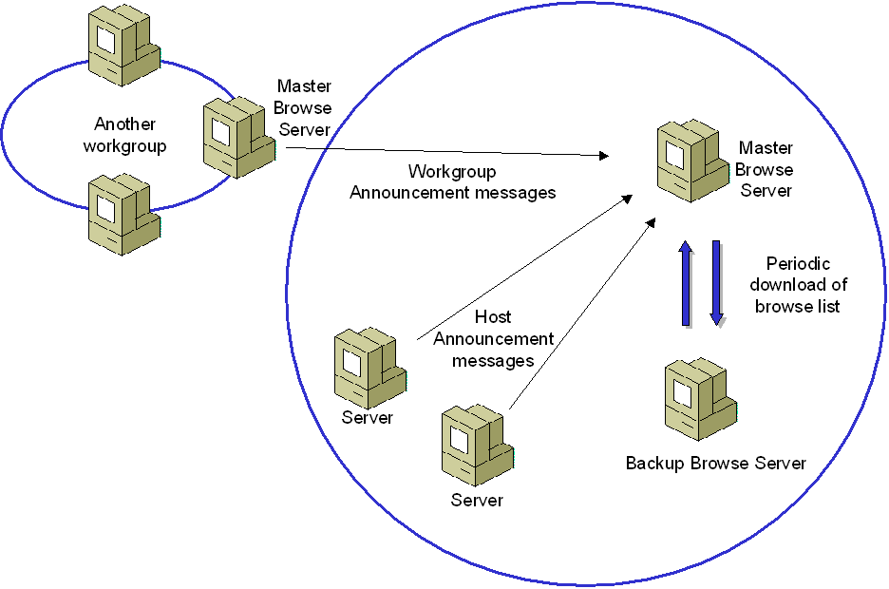

Backup Browse Server Selection
Backup Browse Servers are chosen by the Master Browse Server from the set of potential browse servers in the workgroup list. The Master Browse Server broadcasts a Become Backup message containing the name of the chosen potential browse server. Upon receipt of the Become Backup message, the chosen server becomes a Backup Browse Server and requests the current copy of the browse list from the Master Browse Server.
When a Backup Browse Server is shut down gracefully (through Start-Shut Down or Start-Turn Off Computer), it sends a special Host Announcement message, informing the Master Browse Server that it is no longer a server in the workgroup. The Master Browse Server updates its list of Backup Browse Servers, and, if needed, chooses an additional Backup Browse Server from the list of potential browse servers in the workgroup.

Servicing of Browse Client Requests
Once the browse list has been built by the Master Browse Server and distributed to the Backup Browse Servers, it can be used to service browse client requests. Browse client requests take the following forms:
- List of servers within its workgroup
- List of servers within another workgroup
- List of shares on a server

Obtaining the List of Servers Within its Workgroup
On a computer running Windows that is a member of a workgroup, you can view the list of servers in your workgroup through the My Network Places or Network Neighborhood windows. For the details of how to view the list of servers in your workgroup for each version of Windows, see the "Computer Browsing for Different Versions of Windows" section of this article.
To get the list of servers within its workgroup, the browse client does the following:
- The browse client broadcasts a Get Backup List Request message containing the name of the browse client's workgroup.
- The Master Browse Server responds directly to the browse client request with a list of computer names for the browse servers in the workgroup.
- The client randomly selects one of the browse servers, connects to it and sends it a request for the servers in its workgroup. The selected browse server can be the Master Browse Server or a Backup Browse Server.
- The browse server responds with the list of servers in the workgroup.
This process is shown in the following figure.
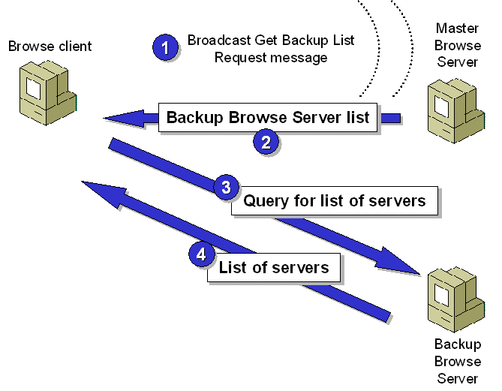
In some cases, if the browse client has already received a Local Master Announcement message from the Master Browse Server in its workgroup, then it does not send a Get Backup List Request message and uses the Master Browse Server to obtain the list of servers in the workgroup.
For subsequent requests for a list of servers within its workgroup, the client continues to use the selected browse server. If the selected browse server does not respond, the browse client selects a new browse server in the list of browse servers. If none of the browse servers respond, the browse client broadcasts a new Get Backup List Request message to obtain an updated list of browse servers for the workgroup.
The contents of the workgroup window depend on the configuration of the workgroup name on all the computers on your network. To simplify browsing on a SOHO network, all of the computers on your network should be configured with the same workgroup name.
The computers displayed in the workgroup window correspond to the list of servers in the browse list for the workgroup that are stored on the browse server that is currently being used by the client computer. If all of the servers on your SOHO network are not present in the workgroup window, it might be due to the following:
- The Master Browse Server has not successfully received the Host Announcement message sent from the missing servers. If this is the case, then neither the Master Browse Server nor any Backup Browse Servers have the missing servers in their browse lists.
- The Master Browse Server has successfully received the Host Announcement message sent from the missing servers, however the Backup Browse Server that is being used by the browse client has not yet obtained the updated browse list from the Master Browse Server,
If a server computer that is started on the network with the same workgroup name does not appear in the workgroup window, it does not mean that you cannot connect to it. To verify, do the following:
- Click Start, and then click Run.
- In Open, type \\ComputerName and then press ENTER.
The window that is displayed contains the file and printer shares of the specified server computer. An example is shown in the following figure.
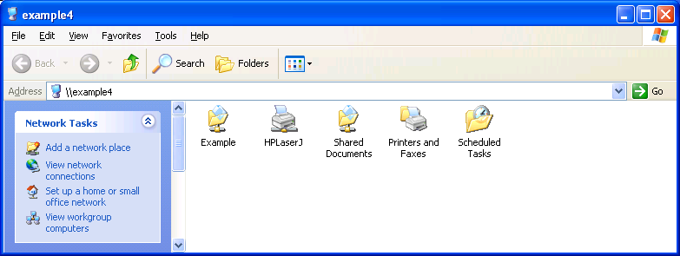
From this window, you can connect to the shared resources of the server computer.

Obtaining the List of Servers Within Another Workgroup
On a computer running Windows that is a member of a workgroup, you can view the list of servers in another workgroup through the My Network Places or Network Neighborhood windows. For the details of how to view the list of servers in other workgroups for each version of Windows, see the "Computer Browsing for Different Versions of Windows" section of this article.
To obtain the list of servers within another workgroup, the browse client does the following:
- The browse client broadcasts a Get Backup List Request message containing the name of the desired workgroup.
- The Master Browse Server for that workgroup responds directly to the browse client request with a list of computer names for the browse servers in the workgroup.
- The client randomly selects one of the browse servers, connects to it and sends it a request for the servers in its workgroup. The selected browse server can be the Master Browse Server or a Backup Browse Server for the workgroup.
- The browse server for the workgroup responds with the list of servers in the workgroup.

Obtaining the Shared Resources of a Server Computer
On a computer running Windows, you can view the shared resources of a server computer from Start-Run or through the My Network Places or Network Neighborhood windows. For the details of how to view the list of shares on a server for each version of Windows, see the "Computer Browsing for Different Versions of Windows" section of this article.
At the command line, you can view the list of shares of a specific computer from the display of the net view \\ServerName command.
To obtain the list of share resources on a server computer, the client computer resolves the name of the server computer, creates a connection to the server computer, and then requests the shared resources of the server computer. Subject to the security settings of the server computer, the server computer responds with a list of shared resources.
Although the request for the list of servers does not involve the Computer Browser service or browse servers, it is part of the browsing operation done through My Network Places or Network Neighborhood.

Limitations of Computer Browsing
The Computer Browsing service is designed to provide an updated list of workgroups and the computers within them by using a minimum of network and computer resources. The communication that the Computer Browser service uses has the following characteristics:
- Periodic
Messages sent to maintain the browse list are sent periodically, typically every 12 or 15 minutes. This is done to keep the network resources required for computer browsing low.
- Unreliable
Messages typically exchanged are sent as single messages, without first establishing a connection or session for communication. This is done to keep the local computer resources required for computer browsing low.
- Unsynchronized
The browse list that is stored on multiple browse servers in a workgroup can become unsynchronized. Therefore, a browse client that uses one browse server can display a different set of computers and workgroups than a browse client that uses another browse server.
Because the communication between servers, Master Browse Servers, Backup Browse Servers is periodic, unreliable, and synchronized, the Computer Browsing service does not provide real-time updating of the browse list. Therefore, the display of computers and workgroups on your SOHO network using My Network Places or Network Neighborhood does not necessarily reflect the actual set of workgroups and computers on your network.
Additionally, the Computer Browsing service (used for collecting, distributing, and servicing browse list requests) operates independently from the Client for Microsoft Networks and File and Printer Sharing for Microsoft Networks components (used for viewing shared resources and making file and printer sharing connections). Because of this, it is possible to have the following conditions:
- The server appears in the workgroup window but you are unable to open it (connect to it) because the server computer is not on the network.
This can occur when the server computer is shut down or disconnected from the network, but the computer name is still in the browse lists of the browse servers of the workgroup.
- The server does not appear in the workgroup window, but you are able to open it (connect to it) from Start-Run.
This can occur when the browse server browse lists do not yet contain the name of the server.
Therefore, the browse list maintained by the Master Browse Server, distributed to the Backup Browse Servers, and viewable through My Network Places or Network Neighborhood is not the definitive source of information of the active workgroups and computers on the network. This is especially true when the set of computers on the network change abruptly.
For information about troubleshooting computer browsing on a SOHO network, see Troubleshooting Computer Browsing on SOHO Networks with Microsoft Windows.

Changes to the Computer Browser Service for Windows XP Service Pack 2
To reduce the problems with computer browsing on small networks with less than 32 computers running Windows, Windows XP Service Pack 2 (SP2) includes the following changes to the Computer Browser service:
- To reduce the amount of time it takes to add an entry to the browse list of the Master Browse Server, computers running Windows XP with SP2 send Host Announcement messages at the following intervals: 1, 2, 4, 8, and then every 12 minutes.
- A computer running Windows XP with SP2 broadcasts a Host Announcement Request message after being elected as the Master Browse Server to obtain a current list of computers in its workgroup.
- On a SOHO network containing only computers running Windows XP with SP2, a Backup Browse Server is not elected.
Windows XP SP2 includes the Windows Firewall, a replacement for the Internet Connection Firewall in Windows XP and Windows XP with Service Pack 1 (SP1). To prevent confusing browsing behavior when Windows Firewall is enabled, the Computer Browser service is not started unless the File and Printer Sharing exception for Windows Firewall has been enabled. You can enable the File and Printer Sharing exception from the Exceptions tab of the Windows Firewall Control Panel applet. When enabled, Windows Firewall allows incoming computer browsing messages so that a computer running Windows XP with SP2 can act as a Master Browse Server for a workgroup.

Computer Browsing for Different Versions of Windows
The following sections describe how to perform browsing operations for the following versions of Windows:
- Windows XP
- Windows 2000
- Windows Me
- Windows 98
- Windows NT 4.0

Windows XP
This section describes how to perform browsing functions on a computer running Windows XP, Home Edition or Windows XP Professional.

Viewing the Local Workgroup
To view the computers in the local workgroup, do the following:
- Click Start, and then click My Network Places.
The My Network Places window is displayed. An example is shown in the following figure.
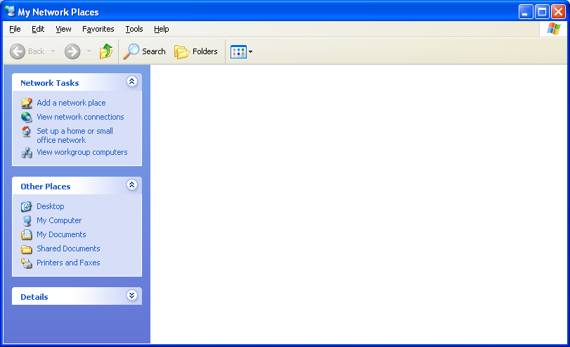
- In the Network Tasks list, click View workgroup computers.
A window is displayed containing the set of computers in your home or small office workgroup. The title of this window is the name of your workgroup. An example is shown in the following figure.
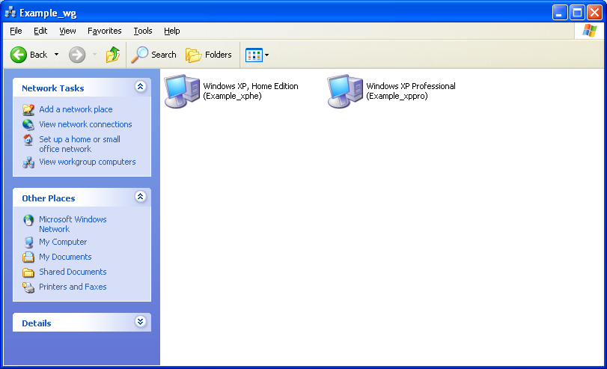

Viewing All Workgroups
To view all the workgroups on your network from the workgroup window for Windows XP Home Edition, click the Up folder icon in the workgroup window toolbar (next to the Back and Forward icons). The resulting Microsoft Windows Network window displays all of the workgroups on your network. An example is shown in the following figure.
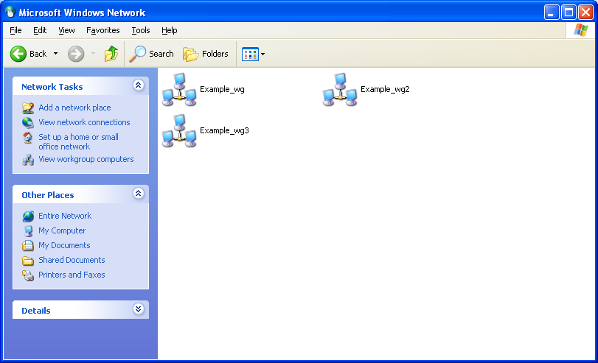
To view all the workgroups on your network from the workgroup window for Windows XP Professional, click on the Address bar, and then click Microsoft Windows Network. The resulting Microsoft Windows Network window displays all of the workgroups on your network. An example is shown in the following figure.
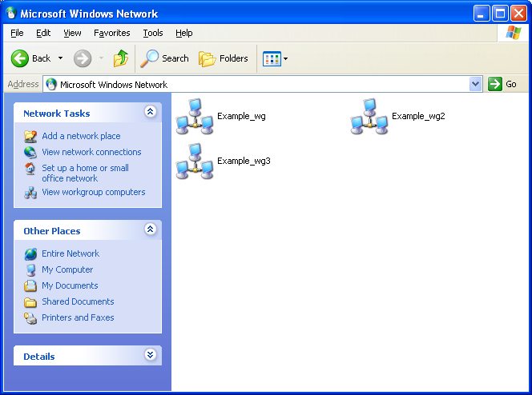

Viewing the Shared Resources on a Computer
To view the shared resources on a computer, double-click the computer in a workgroup window. An example is shown in the following figure.
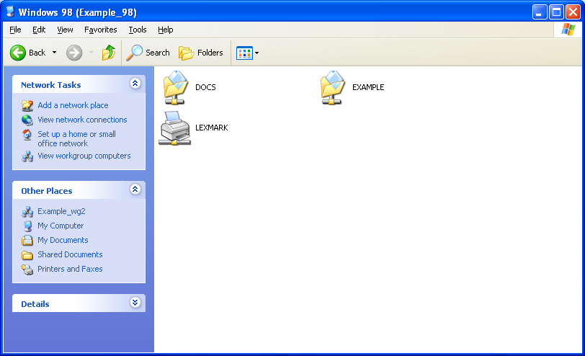

Connecting to a Shared Resource on a Computer
To connect to a shared resource on the computer, double-click the shared resource. An example is shown in the following figure.
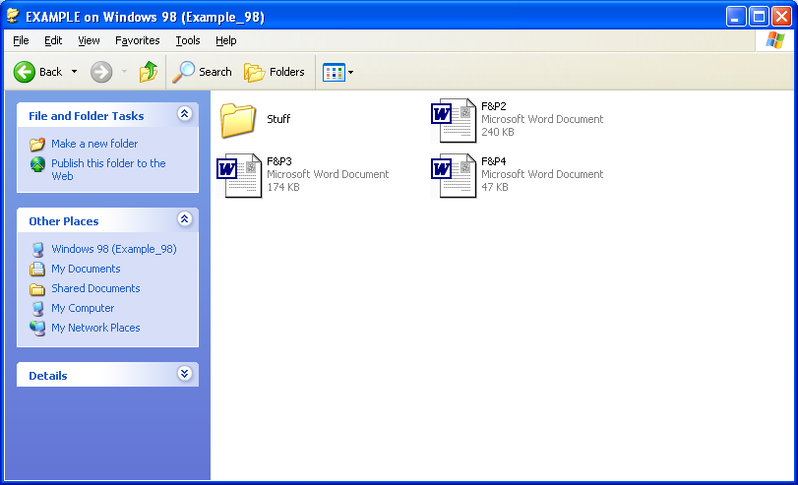

Configuring the Workgroup Name
For Windows XP Home Edition, the workgroup name is set to MSHOME by default and is normally configured when you run the Network Setup Wizard. For Windows XP Professional, you are required to type a workgroup name during installation.
A workgroup name must not be the same as the name of any of the computers on your network. A workgroup name can have as many as 15 characters, but it cannot contain any of the following characters:
; : " < > * + = \ | ? ,
To simplify browsing, all the computers on your network should use the same workgroup name.
To configure the workgroup name on a computer running Windows XP, do the following:
- Click Start, and then click Control Panel.
- In Control Panel, click Performance and Maintenance.
- In Performance and Maintenance, click System.
- In System Properties, click the Computer Name tab, and then click Change. An example is shown in the following figure.
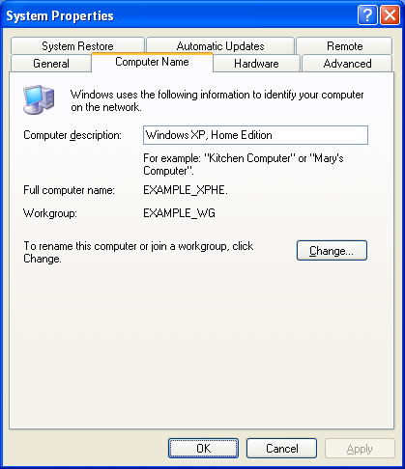
- In Computer Name Changes, type the name of the workgroup in Workgroup, and then click OK. An example is shown in the following figure.
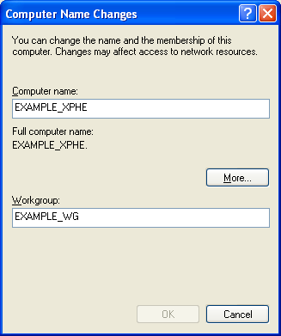
- You are prompted with a Computer Name Changes message box, welcoming you to the new workgroup. Click OK.
- You are prompted with another Computer Name Changes message box, telling you that you must restart the computer before the change to the workgroup can take effect. Click OK.
- In System Properties, click OK.
- You are prompted with a System Settings Change message box, asking you if you want to restart your computer. Save any work you had open in other programs, shut those programs down, and then click Yes in the System Settings Change message box.

Windows 2000
This section describes how to perform browsing functions on a computer running Windows 2000.

Viewing the Local Workgroup
To view the computers in the local workgroup, do the following:
- From the Windows 2000 desktop, double-click My Network Places.
The My Network Places window is displayed. An example is shown in the following figure.
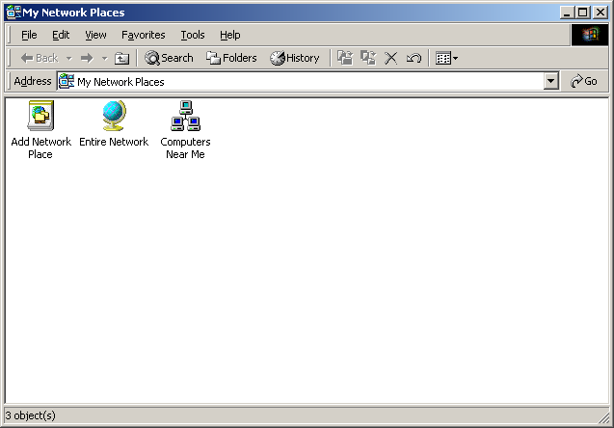
- Double-click Computers Near Me.
A Computers Near Me window is displayed containing the set of computers in your home or small office workgroup. An example is shown in the following figure.
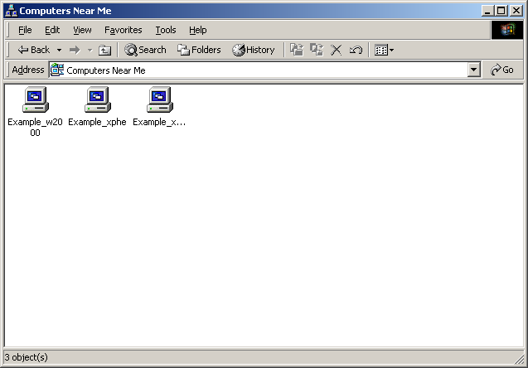

Viewing All Workgroups
To view all the workgroups on your network from the My Network Places window, double-click Entire Network. In the Entire Network window, double-click Microsoft Windows Network. The resulting Microsoft Windows Network window displays all of the workgroups on your network. An example is shown in the following figure.
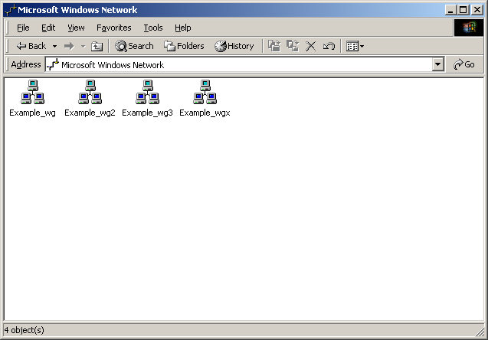

Viewing the Shared Resources on a Computer
To view the shared resources on a computer, double-click the computer in the workgroup window. An example is shown in the following figure.
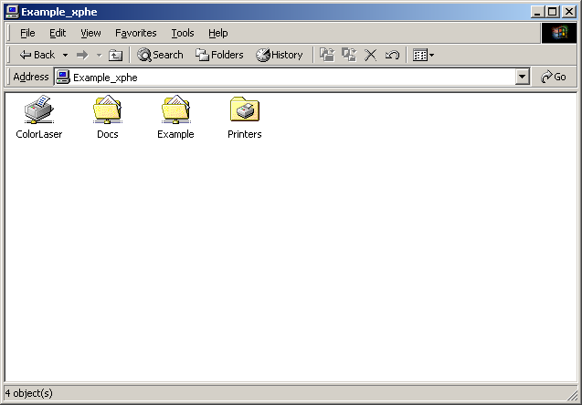

Connecting to a Shared Resource on a Computer
To connect to a shared resource on the computer, double-click the shared resource. An example is shown in the following figure.
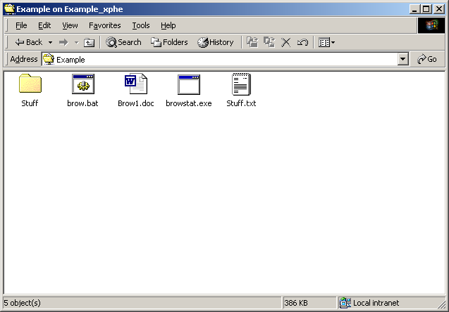

Configuring the Workgroup Name
To configure the workgroup name on a computer running Windows 2000, do the following:
- From the Windows 2000 desktop, right-click My Computer, and then click Properties.
- In System Properties, click the Network Identification tab, and then click Properties. An example is shown in the following figure.
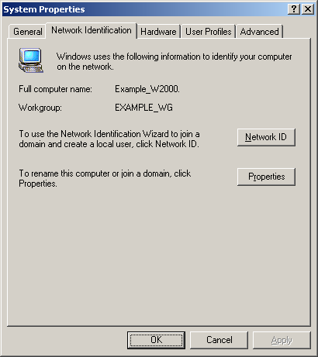
- In Computer Name Changes, type the name of the workgroup in Workgroup, and then click OK. An example is shown in the following figure.
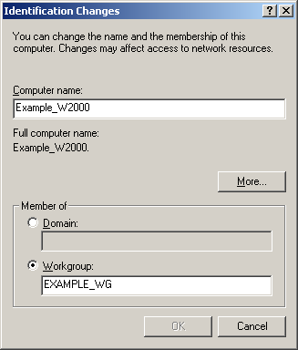
- You are prompted with a Computer Name Changes message box, welcoming you to the new workgroup. Click OK.
- You are prompted with another Computer Name Changes message box, telling you that you must restart the computer before the change to the workgroup can take effect. Click OK.
- In System Properties, click OK.
- You are prompted with a System Settings Change message box, asking you if you want to restart your computer. Save any work you had open in other programs, shut those programs down, and then click Yes in the System Settings Change message box.

Windows Me
This section describes how to perform browsing functions on a computer running Windows Me.

Viewing the Local Workgroup
To view the computers in the local workgroup, do the following:
- From the Windows Me desktop, double-click My Network Places.
An example My Network Places window is shown in the following figure.
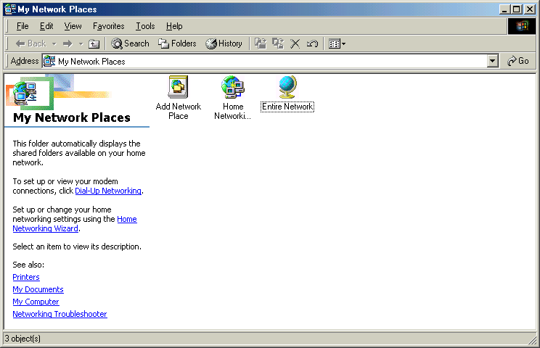
- In My Network Places, double-click Entire Network.
- In the Entire Network window, double-click the workgroup to which the computer belongs. An example is shown in the following figure.
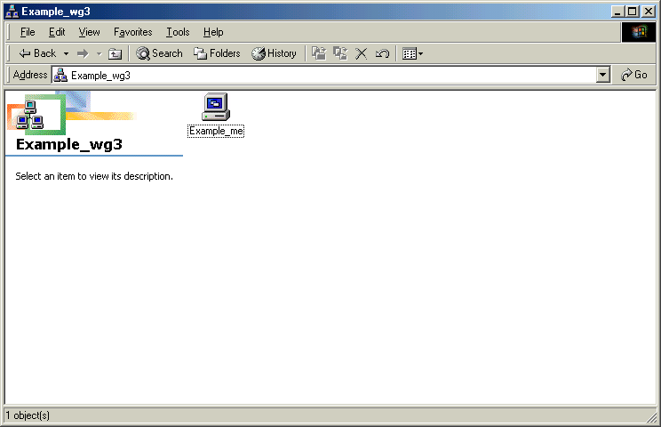

Viewing All Workgroups
To view all the workgroups on your network from the My Network Places window, double-click Entire Network. The resulting Entire Network window displays all of the workgroups on your network. An example is shown in the following figure.
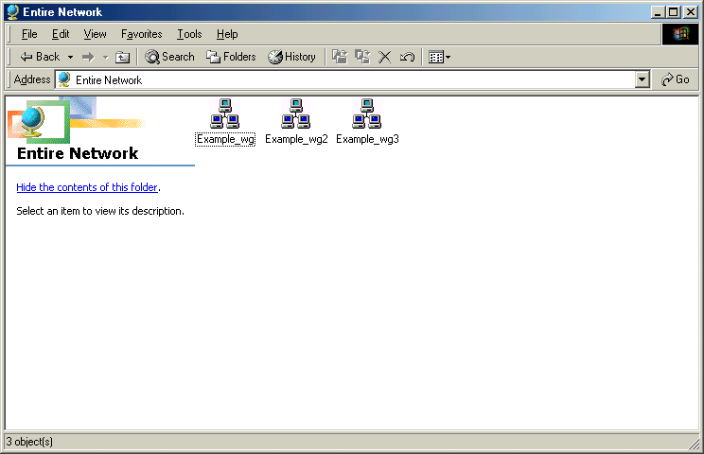

Viewing the Shared Resources on a Computer
To view the shared resources on a computer, double-click the computer in the workgroup window. An example is shown in the following figure.
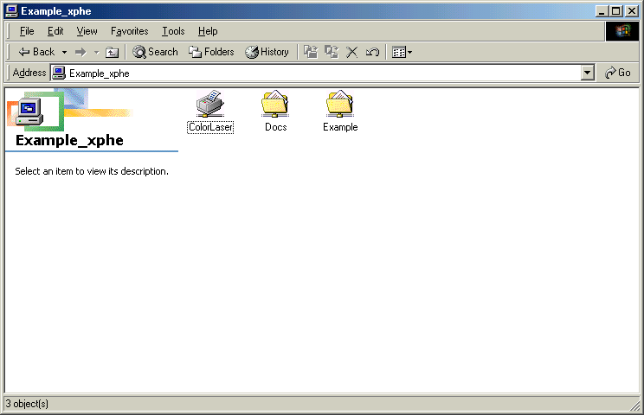

Connecting to a Shared Resource on a Computer
To connect to a shared resource on the computer, double-click the shared resource. An example is shown in the following figure.
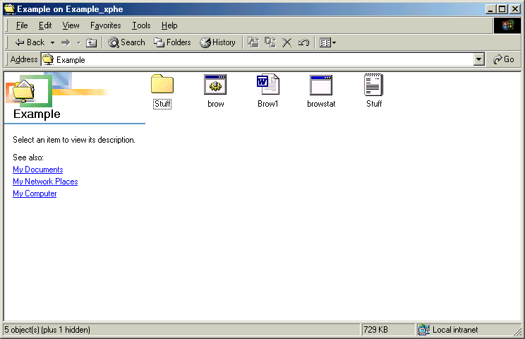

Configuring the Workgroup Name
To configure the workgroup name on a computer running Windows Me, do the following:
- From the Windows Me desktop, right-click My Network Places, and then click Properties.
- In Network, click the Identification tab. An example is shown in the following figure.
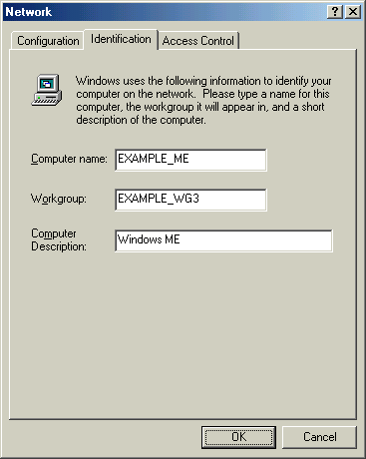
- Type the name of the workgroup in Workgroup, and then click OK.
- You are prompted with a System Settings Change message box, asking you if you want to restart your computer. Save any work you had open in other programs, shut those programs down, and then click Yes in the System Settings Change message box.

Properties of the File and Printer Sharing for Microsoft Networks Component
You can modify the operation of the Computer Browsing service on a computer running Windows Me through the properties of the File and Printer Sharing for Microsoft Networks component by doing the following:
- From the Windows Me desktop, right-click My Network Places, and then click Properties.
- In Network, on the Configuration tab, click File and printer sharing for Microsoft Networks in the list of installed components. An example is shown in the following figure.
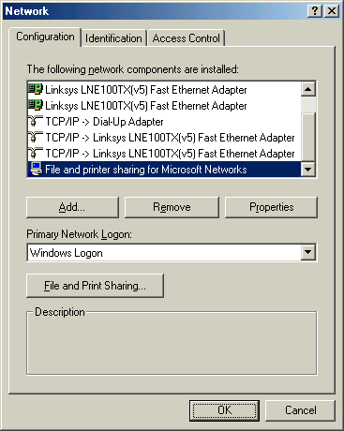
- Click Properties. On the Advanced tab, there are two settings, as shown in the following figure.
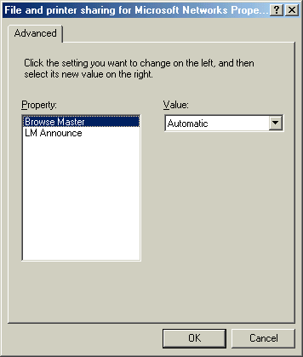
With the Browse Master setting, you can control whether the computer can be a browse server and its preference for being a browse server. By setting Browse Master to Automatic (the default setting), the computer can be a browse server if it wins an election or is selected by a Master Browse Server. By setting Browse Master to Enabled, the computer has a better chance of winning a browse server election and becoming the Master Browse Server. By setting Browse Master to Disabled, the computer cannot become a browse server.
With the LM Announce setting, you can control whether or not the announcements sent by computers running Microsoft LAN Manager are received and added to the browse list. By default, LM Announce is set to No.
- Make the appropriate changes, and then click OK.
- In Network, click OK.
- You are prompted with a System Settings Change message box, asking you if you want to restart your computer. Save any work you had open in other programs, shut those programs down, and then click Yes in the System Settings Change message box.

Windows 98
This section describes how to perform browsing functions on a computer running Windows 98.

Viewing the Local Workgroup
To view the computers in the local workgroup, from the Windows 98 desktop, double-click Network Neighborhood. The Network Neighborhood window displays the set of computers in your home or small office workgroup. An example is shown in the following figure.
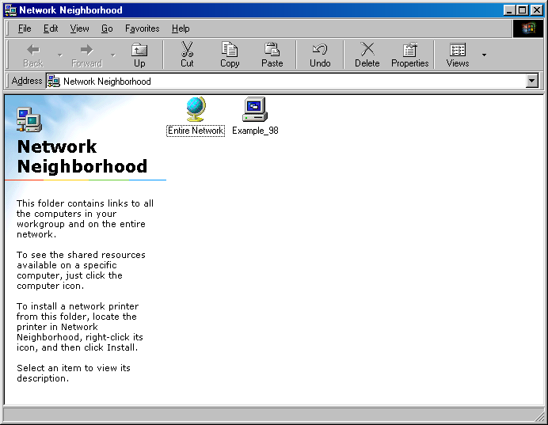

Viewing All Workgroups
To view all the workgroups on your network from the Network Neighborhood window, double-click Entire Network. The resulting Entire Network window displays all of the workgroups on your network. An example is shown in the following figure.
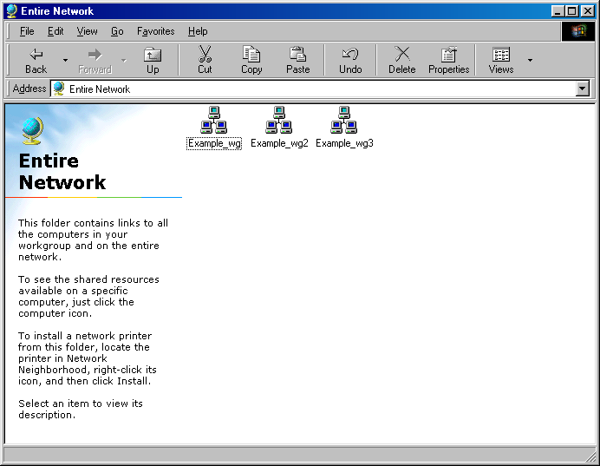

Viewing the Shared Resources on a Computer
To view the shared resources on a computer, double-click the computer in the Network Neighborhood or workgroup window. An example is shown in the following figure.
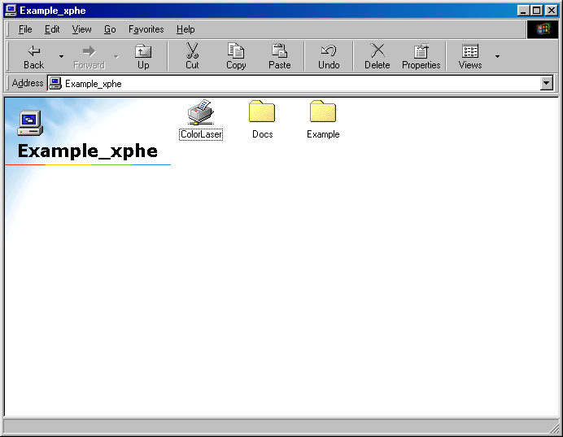

Connecting to a Shared Resource on a Computer
To connect to a shared resource on the computer, double-click the shared resource. An example is shown in the following figure.
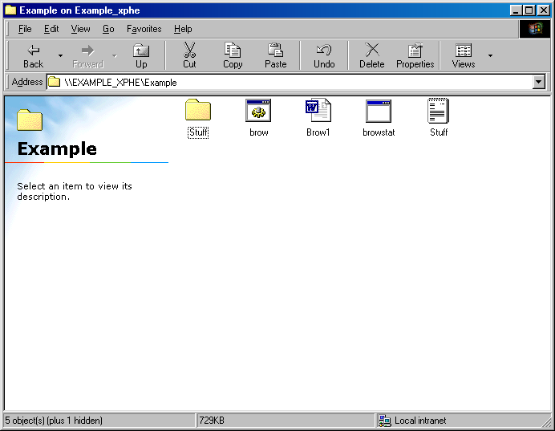

Configuring the Workgroup Name
To configure the workgroup name on a computer running Windows 98, do the following:
- From the Windows 98 desktop, right-click Network Neighborhood, and then click Properties.
- In Network, click the Identification tab. An example is shown in the following figure.
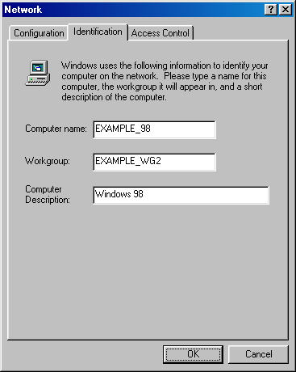
- Type the name of the workgroup in Workgroup, and then click OK.
- You are prompted with a System Settings Change message box, asking you if you want to restart your computer. Save any work you had open in other programs, shut those programs down, and then click Yes in the System Settings Change message box.

Properties of the File and Printer Sharing for Microsoft Networks Component
You can modify the operation of the Computer Browsing service on a computer running Windows 98 through the properties of the File and Printer Sharing for Microsoft Networks component by doing the following:
- From the Windows 98 desktop, right-click Network Neighborhood, and then click Properties.
- In Network, on the Configuration tab, click File and printer sharing for Microsoft Networks in the list of installed components. An example is shown in the following figure.
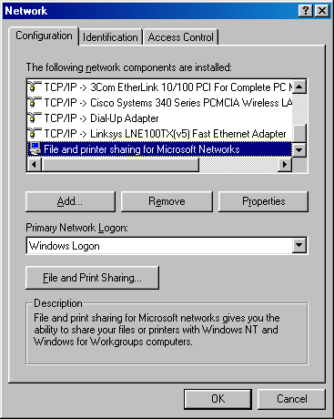
- Click Properties. On the Advanced tab, there are two settings, as shown in the following figure.
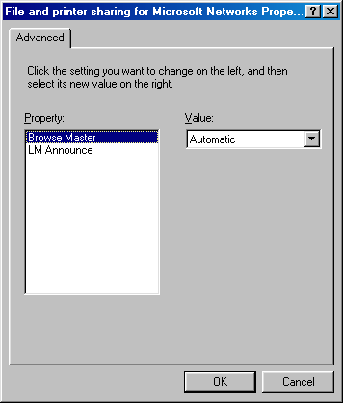
With the Browse Master setting, you can control whether the computer can be a browse server and its preference for being a browse server. By setting Browse Master to Automatic (the default setting), the computer can be a browse server if it wins an election or is selected by a Master Browse Server. By setting Browse Master to Enabled, the computer has a better chance of winning a browse server election and becoming the Master Browse Server. By setting Browse Master to Disabled, the computer cannot become a browse server.
With the LM Announce setting, you can control whether or not the announcements sent by computers running Microsoft LAN Manager will be received and added to the browse list. By default, LM Announce is set to No.
- Make the appropriate changes, and then click OK.
- In Network, click OK.
- You are prompted with a System Settings Change message box, asking you if you want to restart your computer. Save any work you had open in other programs, shut those programs down, and then click Yes in the System Settings Change message box.
Note Windows 98 might prompt you to insert the Windows 98 product CD-ROM when making a change to network settings.

Windows NT 4.0
This section describes how to perform browsing functions on a computer running Windows NT 4.0.

Viewing the Local Workgroup
To view the computers in the local workgroup, double-click Network Neighborhood, from the Windows NT 4.0 desktop. The Network Neighborhood window displays the set of computers in your home or small office workgroup. An example is shown in the following figure.
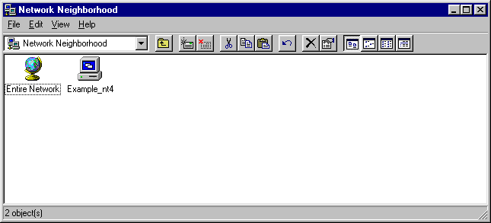

Viewing All Workgroups
To view all the workgroups on your network from the Network Neighborhood window, double-click Entire Network. In the Entire Network window, double-click Microsoft Windows Network. The resulting Microsoft Windows Network window displays all of the workgroups on your network. An example is shown in the following figure.
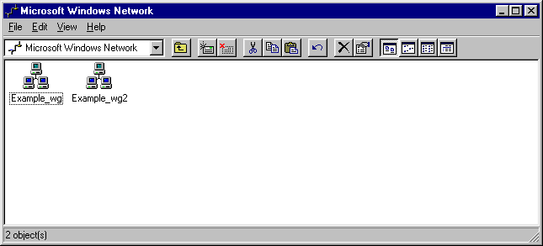

Viewing the Shared Resources on a Computer
To view the shared resources on a computer, double-click the computer in the Network Neighborhood or workgroup window. An example is shown in the following figure.
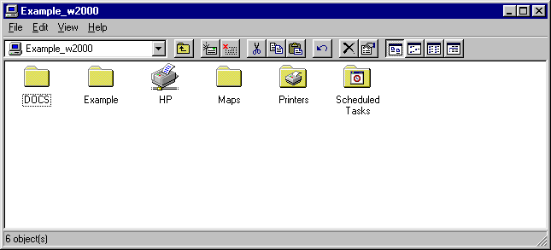

Connecting to a Shared Resource on a Computer
To connect to a shared resource on the computer, double-click the shared resource. An example is shown in the following figure.
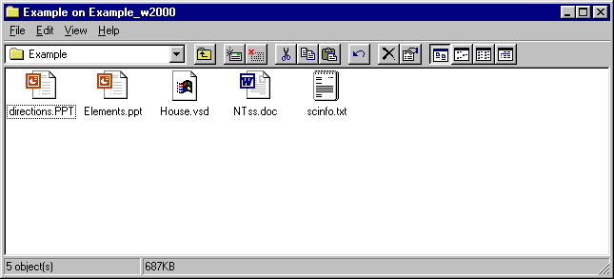

Configuring the Workgroup Name
To configure the workgroup name on a computer running Windows NT 4.0, do the following:
- From the Windows NT 4.0 desktop, right-click Network Neighborhood, and then click Properties.
- On the Identification tab, click Change. An example is shown in the following figure.
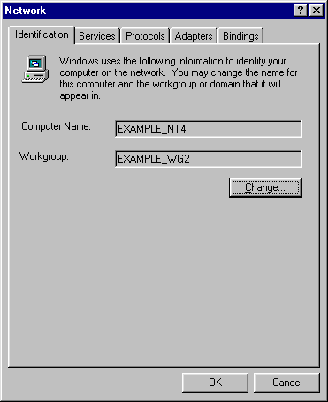
- In Identification Changes, type the name of the workgroup in Workgroup, and then click OK. An example is shown in the following figure.
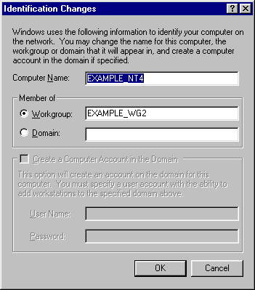
- You are prompted with a System Settings Change message box, asking you if you want to restart your computer. Save any work you had open in other programs, shut those programs down, and then click Yes in the System Settings Change message box.

Summary
Windows computer browsing allows you to view the computers in the workgroup of your network, view their shared resources, and connect to a shared resource through My Network Places or Network Neighborhood. The Computer Browsing service automatically designates computers on your network to be the Master Browse Server or a Backup Browse Server, which collect and distribute the browse list that is accessed by browse client computers. For each version of Windows (Windows XP, Windows 2000, Windows 98, Windows Me, and Windows NT 4.0), there are different ways to view workgroups and the computers within them and to connect to shared resources.

Related Links
See the following resources for further information:
- Home and Small Office Networking with Windows XP at http://www.microsoft.com/homenet
- Troubleshooting Computer Browsing on SOHO Networks with Microsoft Windows at http://www.microsoft.com/downloads/details.aspx?FamilyID=b5a2baba-cc80-4bcf-b1e4-d629028554e4&DisplayLang=en
- File and Printer Sharing with Microsoft Windows at http://www.microsoft.com/downloads/details.aspx?FamilyID=87c0a6db-aef8-4bef-925e-7ac9be791028&DisplayLang=en
- Troubleshooting File and Printer Sharing in Microsoft Windows XP at http://www.microsoft.com/downloads/details.aspx?FamilyID=fd7fd48d-6b4a-448e-a632-076f98a351a2&DisplayLang=en
- Troubleshooting Home Networking in Windows XP at http://support.microsoft.com/default.aspx?scid=kb;en-us;308007
- Description of File Sharing and Permissions in Windows XP at http://support.microsoft.com/default.aspx?scid=kb;en-us;304040
- Sharing Files and Folders from the Windows XP Professional Resource Kit at http://www.microsoft.com/technet/treeview/default.asp?url=/technet/prodtechnol/winxppro/reskit/prde_ffs_flez.asp

For the latest information about Windows XP, see the Windows XP Web site at http://www.microsoft.com/windowsxp.

