Java to .NET Framework Migration Workshop
Performing Automatic Code Migration
INCLUDEPICTURE "../PowerPnt/JAVAMIG_04/Slide_284.jpg" \* MERGEFORMAT INCLUDEPICTURE "../PowerPnt/JAVAMIG_04/Slide_284.jpg" \* MERGEFORMAT 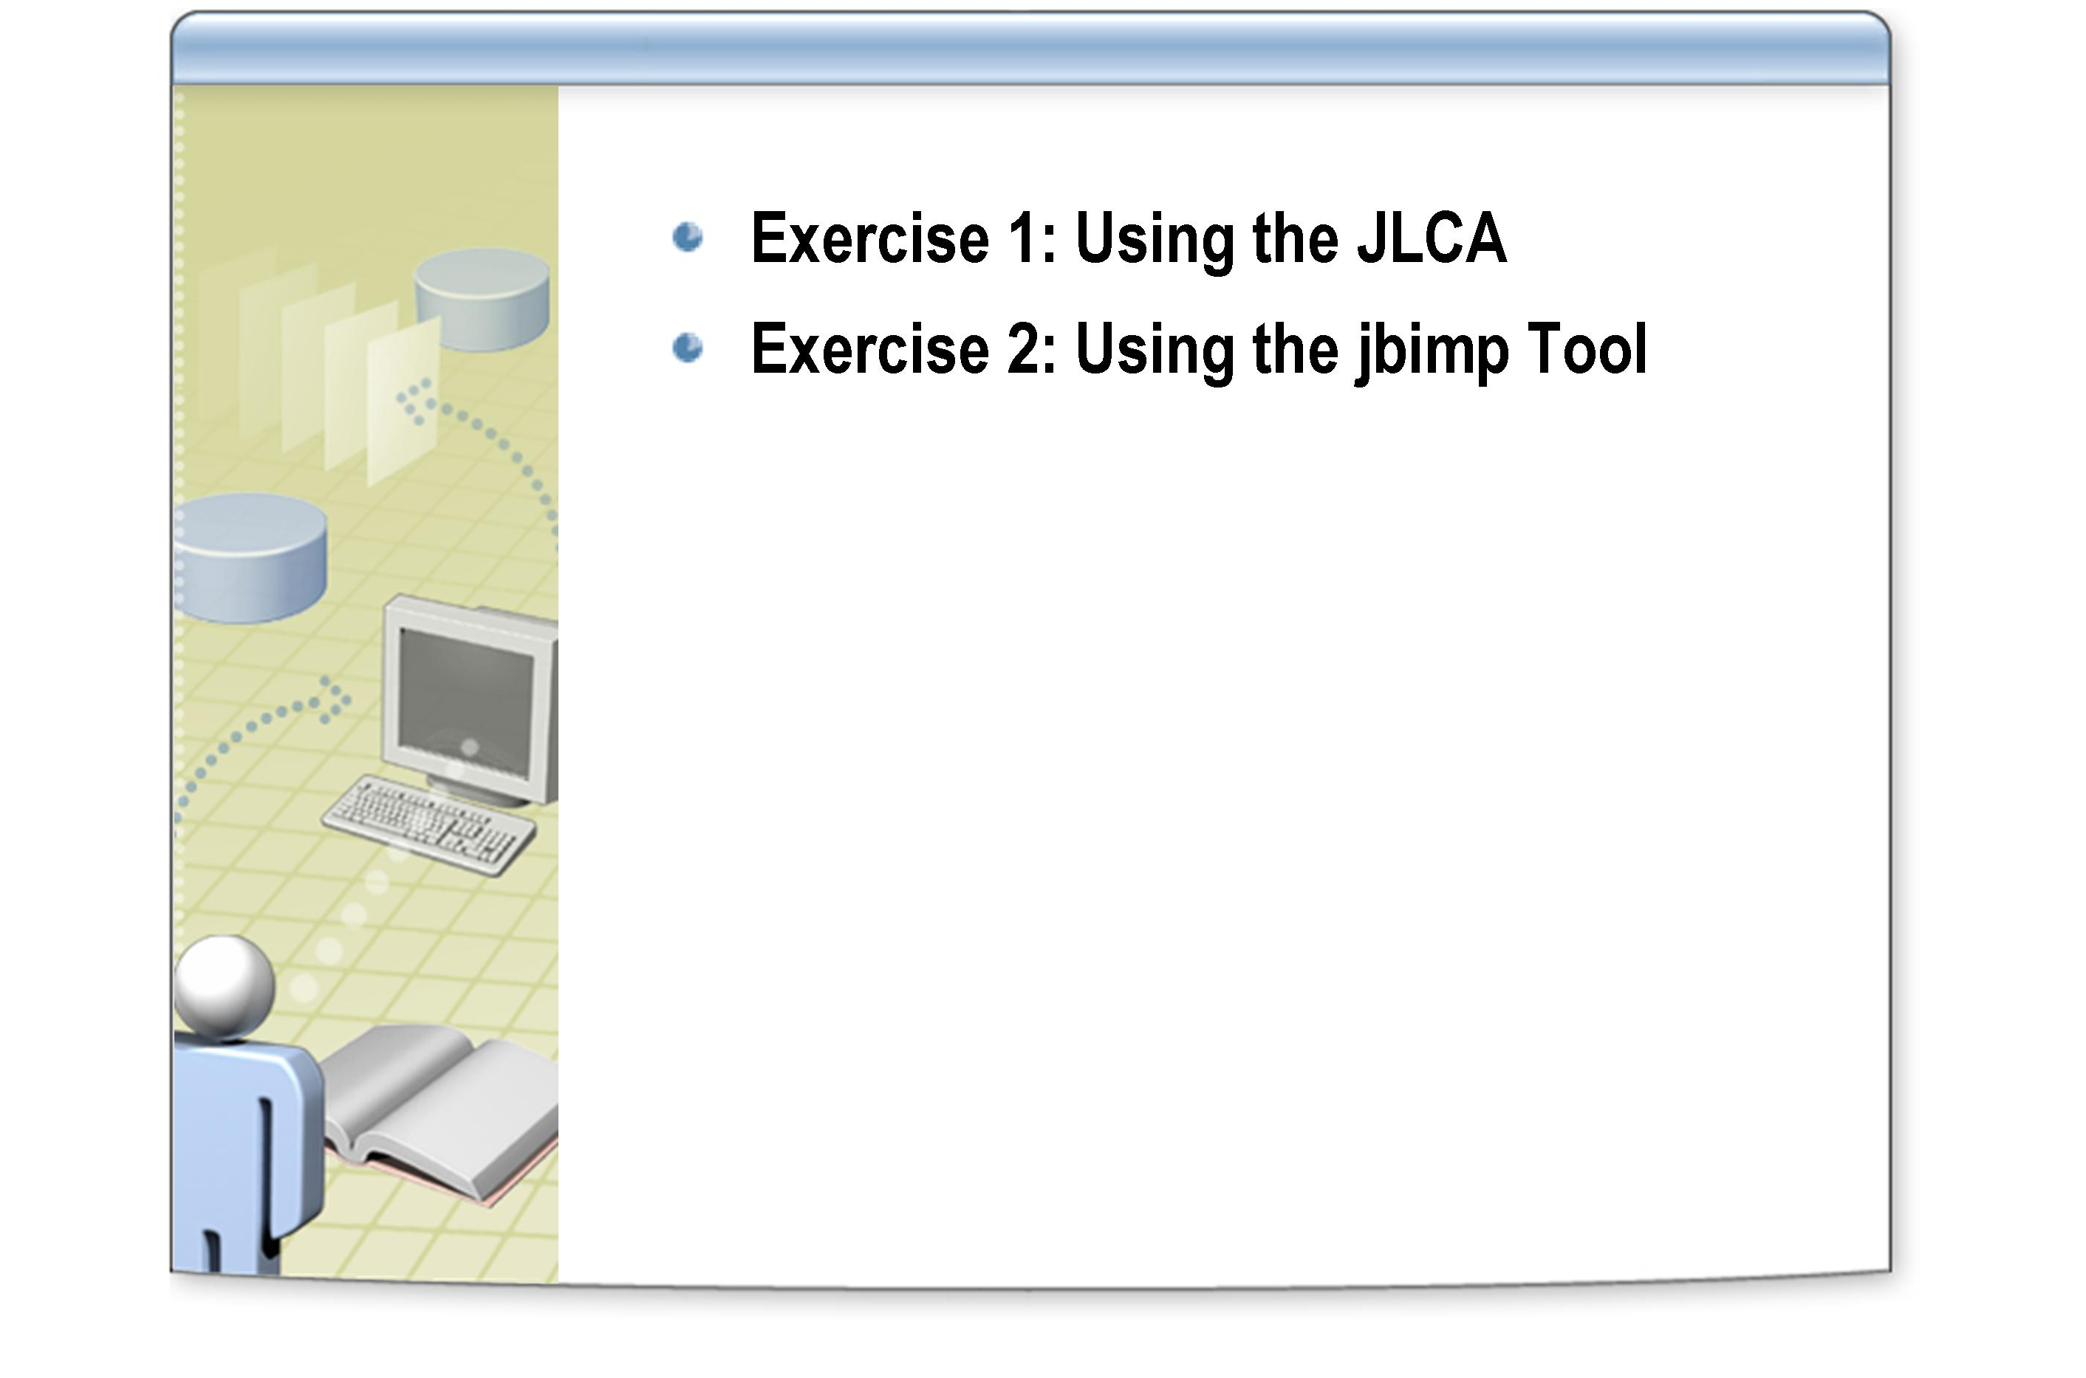

After completing this lab, you will be able to:
Objectives
- Use the Java Language Conversion Assistant (JLCA) to migrate Java code.
- Resolve outstanding migration issues detailed in a JLCA conversion report.

This lab focuses on the concepts in this module and as a result may not comply with Microsoft security recommendations.
Note

The line numbers specified in this lab are provided as a guide only. You may find that some of the line numbers vary depending on how you edit the code.
Note

Before working on this lab, you must have:
Prerequisites
- Experience compiling and running Java applications.
- Experience with the JDK 1.1, including the JavaBeans framework, Java collection classes, JDBC, and AWT.

Northwind Traders have a number of legacy applications written several years ago using Java and the JDK 1.1. You have been asked to migrate the Product Maintenance application to the .NET platform using a Visual Studio .NET automatic conversion wizard.
Scenario

This is the same application that you converted using manual procedures in the previous lab. You should therefore have a good knowledge of the issues involved and will be in a position to appreciate the code generated by the JLCA as well as understand how to resolve any issues that the JLCA is unable to handle automatically.
Note

Log in to the
Hosted Experience
Estimated time to complete this lab: 60 minutes

The Visual Studio Hosted Experience is pre-configured to allow you to run the following lab in a hosted environment. A broadband connection is required.
- Log in to the Hosted Experience
    - Open Internet Explorer.
    - Browse to http://msdn.microsoft.com/virtuallab.
    - Click on the lab group titled “Java to .NET Framework Migration Workshop.”
    - Click on the lab titled “Performing Automatic Code Migration.”
    - Follow the remaining on-screen instructions to start the Virtual Lab experience. Once you have logged in and started the Virtual Lab session you may begin with Exercise 1.

Exercise 1
Using the JLCA
In this exercise, you will use the Java Language Conversion Assistant (JLCA) to automatically convert the Product Maintenance Java application into a .NET application. Some manual coding is required to resolve any outstanding migration issues.

Completed code for the .NET classes in this exercise are available in the C:\JavaMigration\Labs\Lab04\Solution\Products.NET folder.
Tip

- Run the JLCA wizard
    - Open Microsoft Visual Studio .NET 2003.
    - On the File menu, point to Open, and then click Convert.
    - In the Convert dialog box, ensure that the Java Language Conversion Assistant 3.0 is selected, and click OK.

You can create a new Visual Studio solution, or add the project generated by the conversion process to the current solution if another solution is already open.
Note

    - On Page 1 of the Java Language Conversion Assistant Wizard, click Next.
    - On Page 2 of the wizard, click A directory containing the project's files, and then click Next.
    - On Page 3 of the wizard, in the Which directory contains the files you want to convert? text box, type
C:\JavaMigration\Labs\Lab04\Starter\Products
    - Click Next.

It is possible to provide the locations of additional source code files used by the application in the lower text box.
Note

    - On Page 4 of the wizard, ensure that the Visual C# project name is set to Products, select Windows Application from the application type list, and then click Next.
    - On Page 5 of the wizard, in the Where do you want your new project created? text box, type C:\JavaMigration\Labs\Lab04\Products.NET
    - Click Next.
    - On Page 6 of the wizard, click Next to start the conversion process.
When the conversion process is complete, the C# project is displayed in Visual Studio together with a conversion report. Notice that the report lists 85 errors and 5 warnings in the summary at the bottom. You will address these migration issues in the remainder of this exercise.

- Examine Products C# project

- In Solution Explorer, examine the converted project files. The list of files is shown below.
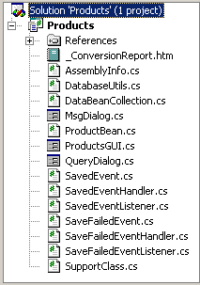
Notice that the JLCA creates a C# class file for each Java class in the original application, together with an additional class named SupportClass.cs. SupportClass contains a number of nested classes that contain supporting functionality for items that could not be directly converted. You will examine this class later in the exercise.

- Examine and resolve key migration issues in the ProductBean class
    - Browse the migration report. Click the + next to the ProductBean.cs entry and examine the conversion issues. The report appears as follows.
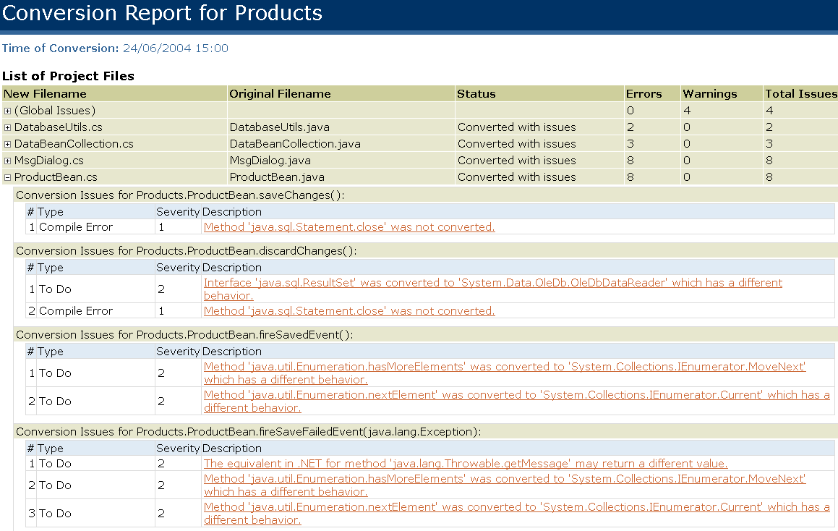
Notice that the majority of issues are concerned with JDBC code and enumerating collections.

    - In Solution Explorer, double-click ProductBean.cs. The class appears in the code view window.
    - Examine the ProductBean class. Note the following points:
  - Properties have been migrated cleanly. For example:
virtual public System.String ProductName
{
get
{
return this.name;
}

set
{
this.name = value;
}

}

  - All properties and methods have been declared as virtual. In C# this means that they are overrideable.
  - Types are specified in full (for example, System.String).
  - JDBC code is converted to OLE DB. For example:
System.Data.OleDb.OleDbCommand temp_OleDbCommand;
temp_OleDbCommand = stmt;
temp_OleDbCommand.CommandText = updateStatement;
temp_OleDbCommand.ExecuteNonQuery();

  - There is no direct equivalent to the JDBC statement.close() method (Dispose() is often used instead). For example:
//UPGRADE_ISSUE: Method 'java.sql.Statement.close' was not converted.
stmt.close();

  - Event handling code is not cleanly converted and remains in its original Java structure. For example:
private void fireSavedEvent()
{
System.Collections.ArrayList listenerCopy;
// No subscribers? Do nothing
if ((savedListeners.Count == 0))
return ;
// Otherwise build a state object holding event information
SavedEvent se = new SavedEvent(this);

  - Similarly, code handling the use of the enumeration is not cleanly converted. For example:

//UPGRADE_TODO: Method 'java.util.Enumeration.hasMoreElements' was converted to 'System.Collections.IEnumerator.MoveNext' which has a different behavior.
for (System.Collections.IEnumerator en = listenerCopy.GetEnumerator(); en.MoveNext(); )
{
//UPGRADE_TODO: Method 'java.util.Enumeration.nextElement' was converted to 'System.Collections.IEnumerator.Current' which has a different behavior.
((SavedEventListener) (en.Current)).handleSavedEvent(se);
}

    - Locate the first UPGRADE_NOTE, on line 77 of the file. This note specifies that the keyword final was removed from the declaration of the serverName variable.
Remove the UPGRADE_NOTE line from the file and add the keyword const to the definition of this variable. Your code should appear as follows:
private const System.String serverName = "localhost";

Note that you can navigate to a particular line number in the source code by clicking Go To on the Edit menu.
    - Change the definitions of the userName and password variables in the same way.
    - Locate the next UPGRADE_NOTE comment, on line 101, above the following line of code:
System.Data.OleDb.OleDbConnection con = null;

The JLCA always converts JDBC code into ADO.NET code using OLE DB. If you wish to use a particular managed provider you must make the changes yourself.
    - Delete the UPGRADE_NOTE line.
    - In the saveChanges method, locate the following comment on line 129
//UPGRADE_ISSUE: Method 'java.sql.Statement.close' was not converted.
    - Delete this comment and the following line containing the stmt.close(); statement.
    - In the discardChanges method, inside the first if block (starting at line 173), verify that the first two lines of code appear as follows:

try
{
// Retrieve the data from the database
System.String queryStatement = "SELECT ProductName, QuantityPerUnit, UnitPrice " + "FROM Products " + "WHERE ProductID = " + id;

System.Data.OleDb.OleDbCommand stmt = SupportClass.TransactionManager.manager.CreateStatement(con);

As mentioned in the previous section, the JLCA generates a custom class named SupportClass.cs to implement parts of the converted functionality. Notice in the above code snippet that to create an OleDbcommand object, the SupportClass.TransactionManager.manager.CreateStatement method is called. If you were manually rewriting the code you could write the following statement instead:
OleDbCommand stmt = con.CreateCommand();

Leave the existing code intact.
    - Locate the next comment at line 179:
//UPGRADE_TODO: Interface 'java.sql.ResultSet' was converted to 'System.Data.OleDb.OleDbDataReader' which has a different behavior.
In certain circumstances, a DataReader can be a suitable replacement for a java.sql.Resultset object. Note that a DataReader is connection-oriented and that for performance reasons, the DataReader is restricted to forward-only, read-only data access. Since you are only reading data, leave the statement as it is and delete the line containing the UPGADE_TODO comment.
    - Locate the next comment at line 198:
//UPGRADE_ISSUE: Method 'java.sql.Statement.close' was not converted.
Delete the line containing the comment and the following line containing the stmt.close(); statement.

The ProductBean class contains some further issues regarding enumerations and event-handling code. The code generated by the JLCA will compile and run, but is probably not the best way to publish and subscribe to events when using .NET. Instead, you should consider manually converting this code to use native .NET events as described in Lab 2 (this exercise will not be repeated here).
Note

- Examine and resolve migration issues in the DatabaseUtils class
    - In Solution Explorer, double-click DatabaseUtils.cs. The class appears in code view.
    - Scroll down through the code. Note that, as in the ProductBean class, the property fields have been converted cleanly.
    - Locate the ConnectionUrl property starting at line 47. Inside the property, find the following code:

return url + serverName + ":" + portNumber + ";databaseName=" + databaseName + ";selectMethod=" + selectMethod + ";";

This statement assumes that the Microsoft JDBC driver for SQL Server is being used. Change this code to use the OLE DB provider, as follows:
return "Data Source=" + serverName +
";Initial Catalog=" + databaseName +
";provider=SQLOLEDB;";

    - Locate the definition of the Connection property starting at line 58. Within this property find the following comment:
//UPGRADE_TODO: The differences in the format of parameters for method 'java.lang.Class.forName' may cause compilation errors.
Note that in ADO.NET there is no need to load a driver as you would using JDBC. Delete the line containing the comment and the following line:
System.Type.GetType("com.microsoft.jdbc.sqlserver.SQLServerDriver");

    - Locate the next comment at line 67:
//UPGRADE_TODO: Change connection string to .NET format.
The subsequent statement creates the database connection as follows:
temp_Connection = new System.Data.OleDb.OleDbConnection(ConnectionUrl + "; User ID=" + userName + "; PWD=" + password);

Delete the line containing the comment, and recode this statement to use Password instead of PWD as follows:
temp_Connection = new System.Data.OleDb.OleDbConnection(ConnectionUrl + "; User ID=" + userName + "; Password=" + password);

    - Read and delete the UPGRADE_NOTE comment at line 75:
    - Delete line 77 containing the following statement:
private static System.String url =
"jdbc:microsoft:sqlserver://";

    - Delete line 79 containing the following statement:
private static System.String portNumber = "1433";

    - Delete lines 84 to 87 containing comments and the following statement:
private static System.String selectMethod = "cursor";

    - Examine the closeConnection method. Notice that the SupportClass manages the closure of the database connection as follows:

SupportClass.TransactionManager.manager.Close(con);

Leave this code as it is.

- Examine and resolve migration issues in the DataBeanCollection class
    - In Solution Explorer, double-click DataBeanCollection.cs. The class appears in code view.
    - Note that the class has been annotated with the [Serializable] attribute as it is a common requirement to be able to save the contents of a collection class to a stream (such as a file), or reinstate a collection from a stream. The serializable attribute helps to provide this functionality.
    - Change the definitions of the serverName, userName, and password variables to use the const keyword, as in the ProductBean class. Delete the lines containing the UPGRADE_NOTE comments.
    - Locate and read the UPGRADE_NOTE comment at line 29. This is the same comment as before regarding the use of an appropriate driver for connecting to the database. Delete the line containing the comment.
    - Locate and read the UPGRADE_TODO comment at line 53. Delete the line containing this comment.
    - Locate the following comment at line 74:
//UPGRADE_ISSUE: Method 'java.sql.Statement.close' was not converted.
    - Delete the line containing this comment and the following line containing the stmt.close(); statement.

- Examine and resolve migration issues in the ProductGUI class
    - In Solution Explorer, double-click ProductGUI.cs. The class appears in design view. Notice that the form appears to be blank. This is because the form and its controls are created dynamically at runtime, and cannot be edited in the design view window.

This is the same for all forms converted by the JLCA.
Note

    - In Solution Explorer, right-click ProductGUI.cs, and then click View Code.
    - Examine the code. Notice that there is a great deal of event handling code and that it has not been converted cleanly.
    - Locate the following comment at line 306:
//UPGRADE_ISSUE: Method 'java.awt.Toolkit.getDefaultToolkit' was not converted.
Delete the comment and the following line of code:

Toolkit.getDefaultToolkit();

    - Locate the following comment at line 449:
//UPGRADE_ISSUE: Constructor 'java.awt.BorderLayout.BorderLayout' was not converted.
Delete the comment and the following line:
new BorderLayout(10, 10);

Note that layout management is partially converted using Windows Forms Anchor and Dock properties.
Note

You have now resolved all the build errors, although the application still requires further work to make it useable.

- Build and run the application
    - On the Build menu, click Build Solution. The solution should build with no errors or warnings.
    - Open a command prompt window and move to the C:\JavaMigration\Labs\Lab04\Products.NET\obj\Debug folder.
    - Run the application by typing Products, and then press ENTER.
The application briefly appears, and then exits. The problem is that the AWT object model and event handling are very different to .NET. You will have to revisit the GUI components and event handling code to resolve these problems.

- Examine and resolve migration issues in the ProductGUI class
    - Return to Visual Studio displaying the code for ProductsGUI.cs.
The GUI code needs significant rework. The most reliable method is to reimplement the GUI using the Windows Forms library, and then migrate the code invoked by the event handlers, as you did in Lab 2. As you have already created a working ProductGUI class in the previous lab, you will reuse it in the next step (a copy of this code is available in the Starter folder for Lab 3).
    - Using Notepad, open the file C:\JavaMigration\Labs\Lab04\Starter\Products.NET\ProductGUI.cs.
    - Replace the contents of ProductsGUI.cs in Visual Studio with the code from Notepad.
    - Rebuild the solution.
    - At the command prompt, run and test the Products application as before.
    - Update a product, and then click the Update button. Notice that the update dialog box looks a little odd. The JLCA has created the dialog in the same way as AWT (rather than using a message box which would be a more logical choice). If you have time, you can manually replace the MsgDialog and QueryDialog classes with code that uses the System.Windows.Forms.MessageBox.Show method, as described in Lab 2.
    - Close the application.

Exercise 2
Using the jbimp Tool

In this exercise, you will use the jbimp tool to migrate .class files to .NET assemblies (.exe). You will compare the contents of the .class files and assemblies using the javap and ildasm utilities, and test the migrated assembly. You will migrate a simple file viewing application.

javap and ildasm utilities display the contents of Java class files and .NET assemblies including metadata.
Note

- Convert FileViewer Java class files using jbimp
    - On the Start menu, point to All Programs, point to Microsoft Visual Studio .NET 2003, point to Visual Studio .NET Tools, and then click Visual Studio .NET 2003 Command Prompt.
This opens a command prompt window with the environment variables configured to allow access to the .NET command line tools.
    - Move to the file viewer folder:
C:\JavaMigration\Labs\Lab04\Starter\FileViewer
    - List the contents of the current directory. Notice that the following .class files are present:
FileViewer$1.class, FileViewer$2.class, FileViewer$3.class, FileViewer$4.class, FileViewer.class, MsgDialog$1.class, MsgDialog$2.class, MsgDialog.class
The class files represent the Fileviewer and MsgDialog classes, together with anonymous classes used for event handling.
    - Issue the following command:
jbimp *.class /out:FileViewer.exe /t:exe
The jbimp tool converts the Java .class files into a single .NET assembly (in this case an .exe file).
    - Run the FileViewer.exe file.
    - Click Browse, and then browse to the following file:

C:\JavaMigration\Labs\Lab04\Starter\FileViewer\FileViewer.java
    - Click Open, and then view the file.
    - Click Browse again, and enter a filename of wrongfile.txt, and then click Open. Note that this file still does not exist, and displays a dialog box which is identical to that shown by the Java version of the application.
    - Click OK to close the dialog box.
    - Click Clear.
    - Close the application, but leave the command prompt open.

- Comparing assemblies using javap and ildasm
    - At the command prompt run the following command:
ildasm FileViewer.exe
The ildasm tool is the Intermediate Language Disassembler tool, and is useful for examine the contents of assemblies compiled using
.NET Framework tools. The following screen is displayed.
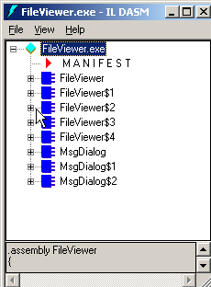
    - At the command prompt, list the .class files in the current directory. Notice that classes in the .NET assembly match the original Java class files.
    - In the IL DASM window, double-click MANIFEST. The manifest is displayed as follows.

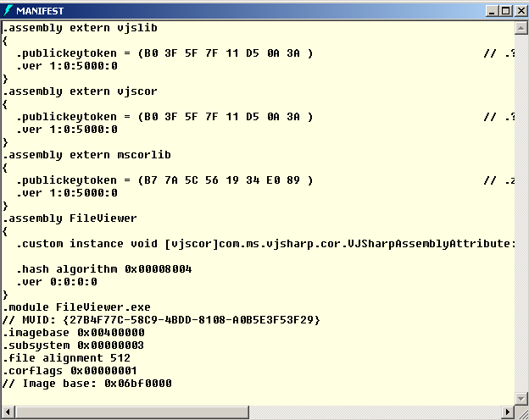
The manifest contains metadata describing the files that make up the assembly, the publicly exported types implemented by the files and the resource or data files associated with the assembly. Close the MANIFEST window.
    - Expand the FileViewer class. Notice that it is a public class which extends java.awt.Frame and has a number of private fields and public methods. Notice that parameter and return types are shown for each method, private members are shown in cyan, public methods are shown in pink, and static members are denoted by 'S'.
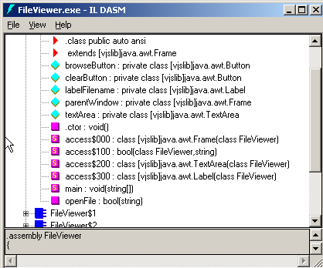

You can display the MSIL for a particular class member by double-clicking the appropriate node.
Note

    - Leave ILDASM open.
    - Due to licensing restrictions, Java software has not been installed in this lab environment. Normally at this step you would run “javap –private FileViewer” to display the private and public members of the FileViewer Java class. Instead, a screenshot of the output is provided below.
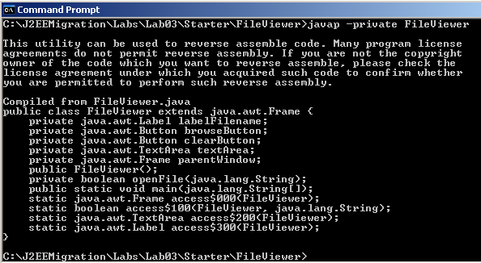
    - To verify that the FileViewer class has been converted correctly, compare the class signature of the class as displayed in ILDASM and javap.
    - Close ILDASM when you have finished.

