Java to .NET Framework Migration Workshop
Migrating JDK 1.4 Applications and Code
INCLUDEPICTURE "../PowerPnt/JAVAMIG_05/Slide_297.jpg" \* MERGEFORMAT INCLUDEPICTURE "../PowerPnt/JAVAMIG_05x/Slide_297.jpg" \* MERGEFORMAT 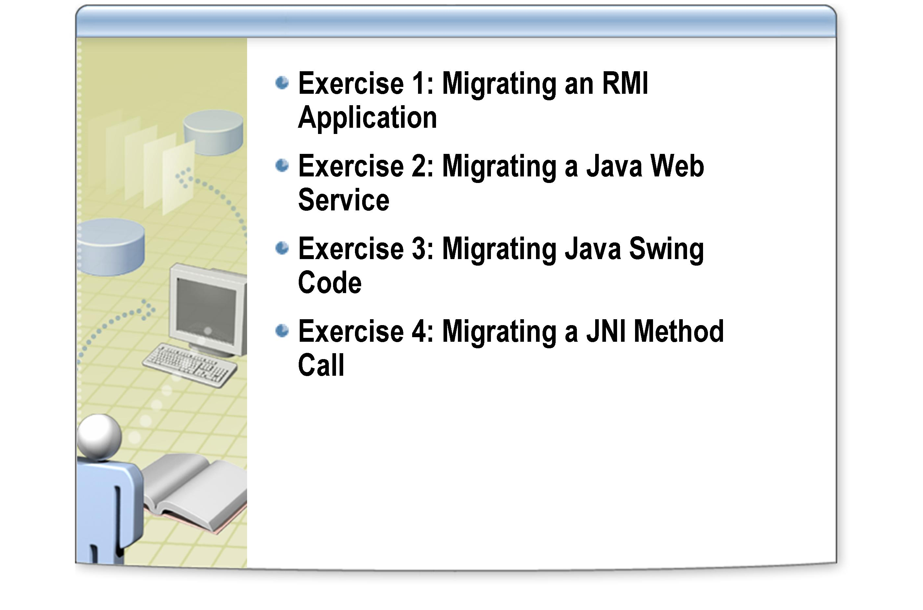

After completing this lab, you will be able to:
Objectives
- Convert Java RMI applications to C# applications that use .NET Framework Remoting.
- Migrate Java Web Services to the ASP.NET Web Services.
- Migrate Java Swing code to Windows Forms.
- Migrate Java code that uses native method calls to .NET Framework unmanaged method calls.

This lab focuses on the concepts in this module and as a result may not comply with Microsoft security recommendations.
Note

The line numbers specified in this lab are provided as a guide only. You may find that some of the line numbers vary depending on how you edit the code.
Note

Before working on this lab, you must have:
Prerequisites
- Experience in building and running Java RMI applications.
- Experience in creating Java Web Services.
- Experience in building Swing user interfaces.
- Experience of invoking native methods from Java applications.

Estimated time to complete this lab: 240 minutes

Log in to the
Hosted Experience

The Visual Studio Hosted Experience is pre-configured to allow you to run the following lab in a hosted environment. A broadband connection is required.
- Log in to the Hosted Experience
    - Open Internet Explorer.
    - Browse to http://msdn.microsoft.com/virtuallab.
    - Click on the lab group titled “Java to .NET Framework Migration Workshop.”
    - Click on the lab titled “Migrating JDK 1.4 Applications and Code”
    - Follow the remaining on-screen instructions to start the Virtual Lab experience. Once you have logged in and started the Virtual Lab session you may begin with Exercise 1.

Exercise 1
Converting a Java RMI Application to a C# Application that uses .NET Framework Remoting
In this exercise, you will convert a simple RMI application into a C# application that uses .NET Framework remoting. The application is a distributed version of the Products application that you have migrated in previous labs. The DataBeanCollection class (managing ProductBean objects) is created in an RMI server called ProductServer. The ProductsGUI application is also an RMI client that requests ProductBean objects from the RMI server.
- Examine the Java RMI application
    - Please Read: Due to licensing restrictions, Java software has not been installed in the Hosted Experience environment – hence, the steps in this section (“Examine the Java RMI application”) will not function. Instead, you should read the steps in this section to familiarize yourself with how the original Java application behaves.
    - Open a Visual Studio .NET Command Prompt window, and move to the following folder:
C:\JavaMigration\Labs\Lab05\Starter\RMI\Products
This folder contains the following source code files:
DatabaseUtils.java
DataBeanCollection.java
MsgDialog.java
ProductBean.java
ProductServer.java
ProductsGUI.java
QueryDialog.java
RemoteProductBean.java
RemoteProductServer.java
SavedEvent.java
SavedEventHandler.java
SavedEventListener.java
SaveFailedEvent.java
SaveFailedEventHandler.java
SaveFailedEventListener.java
ProductsGUI is the Abstract Windows Toolkit (AWT) client, ProductServer is the RMI server and that RemoteProductBean and RemoteProductServer are the remote interfaces for the respective classes.
    - Change to the following directory:
C:\JavaMigration\Labs\Lab05\Starter\RMI
    - Run the following command: type compileandrun.bat

The file is shown as follows:
echo off
cls
javac Products\*.java
rmic Products.ProductServer
rmic Products.ProductBean
start rmiregistry
start java -Djava.rmi.server.codebase=file:Products/ -Djava.security.policy=policy Products.ProductServer
java -Djava.security.policy=policy Products.ProductsGUI

This batch file compiles the classes, generates the necessary remote interfaces, starts the RMI registry, and then uses the ProductServer and the ProductGUI client applications. Note that the policy file called POLICY is used to define the security settings for client and server applications.
    - Run the following command to view the security settings: type policy
The contents of the file appear as follows:
grant {
// Allow everything for now
permission java.security.AllPermission;
}

    - Run the application by running the following command: compileandrun.
After the application has been compiled, two additional command windows will open, running the RMI registry and the ProductServer RMI server.
    - When the Product Maintenance frame appears, verify that the application is functionally the same as in previous labs.

There are some differences in the way in which messages are displayed when changes are saved or exceptions occur. These are primarily due to the fact that the ProductBean instances are now remote objects, and it does not make sense for the event handlers associated with these objects to display GUI frames as they will appear on the server computer rather than the client. Instead, the ProductServer simply outputs text messages to the console (they could also be logged). The client simply displays a success or failure message in the status bar at the bottom of the frame.
Note

    - Close the client application together with the two command prompt windows running the RMI registry and the ProductServer RMI server.

- Migrate the RMI application to the .NET Framework using the JLCA
- Using Visual Studio .NET, start the Java Language Conversion Assistant and create a new solution. (On the File menu, point to Open, click Convert, select the Java Language Conversion Assistant 3.0, click Create new solution, and then click OK).
Proceed through the wizard, using the values in the following table to specify the settings at each stage:

Page | Setting | Value
Source files | A directory containing the project's files | Select
Select source directory | Which directory contains the file you want to convert? | C:\JavaMigration\Labs\Lab05\Starter\RMI\Products
 | Do you need any additional source files to build your project? | Leave blank
Configure your new project | What name would you like for your Visual C# project? | Products
 | What type of application is your project? | Windows Application
Specify a directory for your new project | Where do you want your new project created? | C:\JavaMigration\Labs\Lab05\Products.NET

After the migration completes, the C# project is displayed in
Visual Studio .NET together with a conversion report. The report lists 102 errors and 8 warnings in the summary at the bottom. You will address these migration issues in the remainder of this exercise.

- Examine the Products C# project

- In the Solution Explorer, examine the list of converted project files. The list of files is shown below.
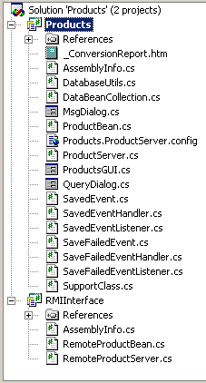
Notice that the JLCA has created two Visual C# projects; one for the migrated RMI client and server code, and another class for the migrated RMI Remote interfaces.

- Examine and resolve key migration issues in the ProductBean class
    - In the Solution Explorer, double-click ProductBean.cs. The class appears in the code view window.
Notice that the ProductBean class has been marked with the Serializable attribute, that it derives from System.MarshalByRefObject, and that it implements the IRemoting.Products.RemoteProductBean interface, as shown in the code snippet below:
[Serializable]
public class ProductBean:System.MarshalByRefObject, IRemoting.Products.RemoteProductBean

    - Locate the first UPGRADE_WARNING on line 20. This note specifies that a System.MarshalByRefObject can only be serialized in its own domain. You can discard this warning. Remove the UPGRADE_WARNING line.
    - Locate the UPGRADE_NOTE, on line 79 of the file. This note specifies that the keyword final was removed from the declaration of the serverName variable. Remove the UPGRADE_NOTE line from the file and add the keyword const to the definition of this variable:

private const System.String serverName = "localhost";

    - Change the definitions of the userName and password variables in the same way, and remove the corresponding UPGRADE_NOTE lines.
    - Locate the next UPGRADE_NOTE comment, on line 103, above the following line of code:
System.Data.OleDb.OleDbConnection con = null;

Note that since you are using SQL Server, it would be more efficient to use a SqlConnection rather than OLE DB. However, in this lab you will not make this change and leave all occurrences of OleDbConnection objects intact. Delete the UPGRADE_NOTE line.
    - In the saveChanges method, locate the following comment on line 131:
//UPGRADE_ISSUE: Method 'java.sql.Statement.close' was not converted.
Delete this comment and the following line containing the stmt.close(); statement.
    - In the discardChanges method, inside the first if block (starting at line 173), verify that the first two lines of code appear as follows:
try
{
// Retrieve the data from the database
System.String queryStatement = "SELECT ProductName, QuantityPerUnit, UnitPrice " + "FROM Products " + "WHERE ProductID = " + id;

System.Data.OleDb.OleDbCommand stmt = SupportClass.TransactionManager.manager.CreateStatement(con);

As described in previous labs, the JLCA generates a custom class named SupportClass.cs to implement parts of the converted functionality. Notice in the above code snippet that to create an OleDbcommand object, the SupportClass.TransactionManager.manager.CreateStatement method is called. If you were manually rewriting the code you could write the following statement instead:
OleDbCommand stmt = con.CreateCommand();

Leave the existing code intact.
    - Locate the next comment at line 181:

//UPGRADE_TODO: Interface 'java.sql.ResultSet' was converted to 'System.Data.OleDb.OleDbDataReader' which has a different behavior.
In certain circumstances, a DataReader can be a suitable replacement for a java.sql.Resultset object. Note that a DataReader is connection-oriented and that for performance reasons, the DataReader is restricted to forward-only, read-only data access. Since you are only reading data, leave the statement as it is and delete the line containing the UPGADE_TODO comment.
    - Locate the next comment at line 200
//UPGRADE_ISSUE: Method 'java.sql.Statement.close' was not converted.
Delete the line containing the comment and the following line containing the stmt.close(); statement.

The ProductBean class contains some further issues regarding exceptions, enumerations, and event-handling code. The code generated by the JLCA will compile and run, but is probably not the best way to publish and subscribe to events when using the .NET Framework. Instead, you should consider manually converting this code to use native .NET Framework events as described in Lab 2. This exercise will not be repeated here.
Note

- Examine and resolve migration issues in the DatabaseUtils class
    - In the Solution Explorer, double-click DatabaseUtils.cs. The class appears in the code view window.
    - Locate the ConnectionUrl property starting at line 47. Inside the property, find the following code:
return url + serverName + ":" + portNumber + ";databaseName=" + databaseName + ";selectMethod=" + selectMethod + ";";

This statement assumes that the Microsoft JDBC driver for SQL Server is being used. Change this code to use the OLE DB provider, as follows:
return "Data Source=" + serverName +
";Initial Catalog=" + databaseName +
";Provider=SQLOLEDB;";

    - Locate the Connection property starting at line 58. Within this property find the following comment at line 64:
//UPGRADE_TODO: The differences in the format of parameters for method 'java.lang.Class.forName' may cause compilation errors.
Note that in ADO.NET there is no need to load a driver as you would using JDBC. Delete the line containing the comment and the following line:
System.Type.GetType("com.microsoft.jdbc.sqlserver.SQLServer Driver");

    - Locate the next comment at line 67

//UPGRADE_TODO: Change connection string to .NET format.
The subsequent statement creates the database connection as follows:
temp_Connection = new System.Data.OleDb.OleDbConnection(ConnectionUrl + "; User ID=" + userName + "; PWD=" + password);

Delete the line containing the comment, and recode this statement to use Password instead of PWD as follows:
temp_Connection = new System.Data.OleDb.OleDbConnection(ConnectionUrl + "; User ID=" + userName + "; Password=" + password);

    - Read and delete the UPGRADE_NOTE comment at line 75
    - Delete line 77 containing the following statement:
private static System.String url =
"jdbc:microsoft:sqlserver://";

    - Delete line 79 containing the following statement, as it is not needed by the OLE DB driver for SQL Server:
private static System.String portNumber = "1433";

    - Delete lines 84 to 87 inclusive, containing comments and the following statement:
private static System.String selectMethod = "cursor";

    - Examine the closeConnection method. Notice that the SupportClass manages the closure of the database connection as follows:
SupportClass.TransactionManager.manager.Close(con);

The above code appears multiple times throughout the converted solution. To avoid repetition it is only discussed here.
Note

Leave this code as it is. If you were manually writing the code however, you would write the following instead:
con.Close();

- Examine and resolve migration issues in the DataBeanCollection class
    - In the Solution Explorer, double-click DataBeanCollection.cs. The class appears in code view.
Note that the class has been annotated with the [Serializable] attribute as it is a common requirement to be able to save the contents of a collection class to a stream (such as a file) or reinstate a collection from a stream. The serializable attribute helps to provide this functionality.
    - Change the definitions of the serverName, userName, and password variables to use the const keyword, as in the ProductBean class. Delete the lines containing the UPGRADE_NOTE comments.
    - Locate and read the UPGRADE_NOTE comment at line 40. This is the same comment as before regarding the use of an appropriate driver for connecting to the database. Delete the line containing the comment.
    - Locate and read the UPGRADE_TODO comment at line 66. Delete the line containing this comment.
    - Locate the following comment at line 83:
//UPGRADE_ISSUE: Method 'java.sql.Statement.close' was not converted.
Delete the line containing this comment and the following line containing the stmt.close(); statement.

- Examine and resolve migration issues in the ProductGUI class
    - In the Solution Explorer, right-click ProductsGUI.cs, and click View Code. The file ProductsGUI.cs appears in the code view window.
The GUI code needs significant rework. The most reliable method is to reimplement the GUI using the Windows Forms library, and then migrate the code invoked by the event handlers, as you did in Lab 2. As you have already created a working ProductGUI class in the earlier lab, you will reuse it in the following steps (a copy of this code is provided in the Starter folder for Lab 3), and adapt it to use .NET Framework remoting.
    - Using the Solution Explorer, right-click the file ProductGUI.cs, and rename this file as OldProductsGUI.cs.
    - On the Project menu, click Add Existing Item. In the Add Existing Item dialog box, move to the folder C:\JavaMigration\Labs\Lab03\Starter\Products.NET, and double-click the file ProductGUI.cs.
You now have two versions of the ProductsGUI class in the project; the original class (in OldProductsGUI.cs) that contains the migrated RMI code, and the new class (in ProductsGUI.cs) that contains the Windows Forms code.
The following steps merge the migrated RMI functionality of the original class, with the Windows Forms functionality of the new class.
    - In the ProductsGUI.cs file, locate the definition of the products variable at line 29:
private DataBeanCollection products;

This variable is redundant as you will be accessing ProductBean objects using the remoting server. Delete this line.
    - Examine the definition of the current variable at the new line 30
private ProductBean current;

This variable holds a reference to the currently displayed product. Modify this definition to refer to the RemoteProductBean interface as follows:
private IRemoting.Products.RemoteProductBean current;

    - Add the following variable to the ProductsGUI.cs file, immediately after the definition of the current variable:
private int numProducts;

    - Copy and paste the definition of the remoteProducts variable from line 375 in the file OldProductsGUI.cs to the file ProductsGUI.cs, after the fetchButton_Click method:
private IRemoting.Products.RemoteProductServere remoteProducts = null;

This variable will be used to reference the remoting server.
    - In the Code View window displaying the OldProductsGUI.cs file, locate the connectServer method, starting at line 625. Copy and paste the method to the end of the ProductsGUI class.
This method contains the code that connects to the remoting server, ProductServer using the RemoteProductServer interface.
    - Examine the two UPGRADE_ISSUE comments in this method. Remoting security is handled in a different manner from RMI security. These comments are inserted to alert you to implement an appropriate security policy using the .NET Framework tools. Delete these two comments and the following line of code:
System_Renamed.setSecurityManager(new RMISecurityManager());

    - Examine the following line of code:
remoteProducts = (IRemoting.Products.RemoteProductServer) Activator.GetObject(typeof(IRemoting.Products.RemoteProductServer), SupportClass.ParseURILookup("rmi://" + "localhost" + "/ProductServer"));

This statement uses the Activator.GetObject method to obtain a reference to the remoting server. The SupportClass.ParseURILookup method is generated by the JLCA to convert the original RMI URI into an equivalent URI that uses the HTTP protocol to communicate with the remoting server running at the specified address.
    - In the OldProductsGUI.cs file, locate the actionPerformed method starting at line 59. This is the migrated event handler for the click event of the Fetch button. Copy the following four lines of code, starting at line 66:
Enclosing_Instance.connectServer();
Enclosing_Instance.current = (IRemoting.Products.RemoteProductBean) Enclosing_Instance.remoteProducts.get_Renamed(Enclosing_Instance.currentIndex);
Enclosing_Instance.current.addSavedEventListener(new SavedEventHandler());
Enclosing_Instance.current.addSaveFailedEventListener(new SaveFailedEventHandler());

The first two statements connect to the remoting server, and return the ProductBean object at the position in the remote collection indicated by the currentIndex variable. (If you have time, examine the get_Renamed method generated by the JLCA in the ProductServer class to see how this works).
The final two statements subscribe to the Saved and SaveFailed events published by the ProductBean object.

Paste these four statements into the top of the try block in the fetchButton_Click method in ProductsGUI.cs, replacing the call to the doFetch method.
    - In the fetchButton_Click method in the ProductGUI.cs file, remove all of the Enclosing_Instance references from the four lines of code copied in the previous step:
connectServer();
current = (IRemoting.Products.RemoteProductBean) remoteProducts.get_Renamed(currentIndex);
current.addSavedEventListener(new SavedEventHandler());
current.addSaveFailedEventListener(new SaveFailedEventHandler());

    - Locate and delete the following statement in the try block in the fetchButton_Click method:
current = (ProductBean)products[currentIndex];

This statement is no longer required as the data is retrieved from the remoting server.
    - Locate the following statement in the try block in the fetchButton_Click method:
lblStatus.Text = "Row 1 of " + products.Count;

Modify this statement to use the numProducts variable instead:
lblStatus.Text = "Row 1 of " + numProducts;

The numProducts variable is initialized by the connectServer method when the client connects to the remoting server.
Note

    - In the OldProductsGUI.cs file, locate the actionPerformed method starting at line 112. This is the migrated event handler for the click event of the Next button. Copy the following three lines of code, starting at line 119:
Enclosing_Instance.current = (IRemoting.Products.RemoteProductBean) Enclosing_Instance.remoteProducts.get_Renamed(Enclosing_Instance.currentIndex);
Enclosing_Instance.current.addSavedEventListener(new SavedEventHandler());
Enclosing_Instance.current.addSaveFailedEventListener(new SaveFailedEventHandler());

Paste these statements into the if block in the nextButton_Click method in ProductsGUI.cs, replacing the line shown below that sets the current variable to the next product in the collection:
current = (ProductBean)products[currentIndex];

    - In the nextButton_Click method in the ProductGUI.cs file, remove all of the Enclosing_Instance references from the three lines of code copied in the previous step:

current = (IRemoting.Products.RemoteProductBean) remoteProducts.get_Renamed(currentIndex);
current.addSavedEventListener(new SavedEventHandler());
current.addSaveFailedEventListener(new SaveFailedEventHandler());

    - Locate the following statement in the if block in the nextButton_Click method:
lblStatus.Text = "Row " + (currentIndex + 1) + " of " + products.Count;

Modify this statement to use the numProducts variable instead:
lblStatus.Text = "Row " + (currentIndex + 1) + " of " + numProducts;

    - Locate the following statement in the nextButton_Click method:
if (currentIndex == products.Count – 1)

Modify this statement to use the numProducts variable instead:
if (currentIndex == numProducts – 1)

    - Repeat the process outlined in steps 15, 16, and 17, copying the three lines of code from lines 169 to 171 in OldProductsGUI.cs into the prevButton_Click method in ProductsGUI.cs. Remove all occurrences of Enclosing_Instance, and update the reference to products.Count.

You do not need to modify the code for the updateButton_Click method.
Note

    - In the Solution Explorer, right-click the file OldProductsGUI.cs, and then click Exclude From Project. This action removes the file from the project but does not delete it from disk.

- Examine and resolve migration issues in the ProductServer class
    - In the Solution Explorer, double-click ProductServer.cs. The class appears in the code view window.
    - Locate the following comments starting at line 28:
//UPGRADE_NOTE: With .NET remoting, you can choose whether to transfer data over HTTP, TCP, or both.
//UPGRADE_TODO: An application can not register the same port number more than once.
//UPGRADE_ISSUE: Server port must be entered instead of '<Port>'.
    - Delete the comments described in the previous step, and replace the text <"Port"> on the next line with the text 1099.

The DefaultPort variable in the SupportClass.cs file generated by the JLCA is set to 1099 by default. If you want to use a different port number, you must also update the DefaultPort variable.
Note

    - Locate the following comments starting at line 32
//UPGRADE_ISSUE: Method 'java.lang.System.setSecurityManager' was not converted.
//UPGRADE_ISSUE: Constructor 'java.rmi.RMISecurityManager.RMISecurityManager' was not converted.
Delete these comments and then delete the following line of code:
System_Renamed.setSecurityManager(new RMISecurityManager());

- Separate the solution into client, server, and remote object projects
You must split the solution into three projects:
  - A client project containing the GUI elements.
  - A server project containing the remoting server.
  - A project defining the remote objects and interfaces, which can be referenced by the client and server projects.

    - In the Solution Explorer, right-click Solution 'Products', point to Add, and then click New Project.
    - In the Add New Project dialog box, name the project ProductServer in the Products.NET folder, ensure that the Console Application template is selected from the Visual C# Project Types, and then click OK.
    - In the Solution Explorer, right-click Class1.cs, click Delete, and then click OK.
    - In the Solution Explorer, cut and paste (not copy) the following files from the Products project and place them in the ProductServer project:
  - ProductServer.cs
  - Products.ProductServer.config
    - Click the Show All Files button at the top of the Solution Explorer window.
The files and folders in the project directory that are normally hidden will be displayed.
    - In the ProductServer project, copy the file Products.ProductServer.config into the bin\Debug folder in this project.
The application configuration file must be in the same folder as the executable that Visual Studio .NET builds when the application is run.
    - In the Solution Explorer, cut and paste (not copy) the following files from the Products project into the RMIInterface project:

  - DatabaseUtils.cs
  - DataBeanCollection.cs
  - ProductBean.cs
  - SavedEvent.cs
  - SavedEventHandler.cs
  - SavedEventListener.cs
  - SaveFailedEvent.cs
  - SaveFailedEventHandler.cs
  - SaveFailedEventListener.cs
  - SupportClass.cs

The RMIInterface project will be referenced by the client and server projects.
Note

    - In the Solution Explorer, double-click the file RemoteProductBean.cs in the RMIInterface project.
    - Add the following statement to the top of the file:
using Products;

The ProductBean class, the DataBeanCollection class, and the various event classes are defined in the Products namespace. The code generated by the JLCA in this project uses unqualified references, so you must bring this namespace into scope to access these classes.
    - In the Solution Explorer, double-click the file RemoteProductServer.cs in the RMIInterface project.
    - Add the following statement to the top of the file:
using Products;

- Add assembly references
    - In the Solution Explorer, in the Products project, right-click References, and then click Add Reference.
    - In the Add Reference dialog box, scroll down to the System.Runtime.Remoting entry, and double-click it.
    - On the Projects tab, double-click the RMIInterface project, and then click OK.
    - In Solution Explorer, in the ProductServer project, right-click References, and then click Add Reference.
    - In the Add Reference dialog box, scroll down to the System.Runtime.Remoting entry, and double-click it.
    - On the Projects tab, double-click the RMIInterface project, and then click OK.

- Build and run the application

    - In the Solution Explorer, right-click the ProductServer project, and then click Set as StartUp Project.
    - On the Build menu, click Build Solution. The solution should build with no errors.
    - On the Debug menu, click Start.
The remoting server (ProductServer) starts, and opens a new console window displaying the message Awaiting clients ….
Open a command prompt window and move to the following location: C:\JavaMigration\Labs\Lab05\Products.NET
    - Run the application by typing Products, and then press ENTER.
    - Click Fetch to retrieve the products. Update a product, and then click Update button. Notice that the Changes saved message (and any error messages) appear in the remoting server console window.
    - Close the application.

Restart your
Hosted Experience
session
This lab is long and may exceed the time allowed by the Visual Studio Hosted Experience. It is suggested that you end your Hosted Experience session after completing Exercise 1, and log on again prior to completing Exercise 2.
- Log in to the Hosted Experience
    - Open Internet Explorer.
    - Browse to http://msdn.microsoft.com/virtuallab.
    - Click on the lab group titled “Java to .NET Framework Migration Workshop.”
    - Click on the lab titled “Migrating JDK 1.4 Applications and Code.”
    - Follow the remaining on-screen instructions to start the Virtual Lab experience. Once you have logged in and started the Virtual Lab session you may begin with Exercise 2.

Exercise 2
Migrating a Java Web Service to the .NET Framework
In this exercise, you will convert a Java Web service to the .NET Framework, and deploy and test it under IIS. The Web service implements a product server, allowing clients to get and save ProductBean objects across HTTP using SOAP.

- Setup productservice Web service
    - Please Read: Due to licensing restrictions, Java software has not been installed in the Hosted Experience environment – hence, the steps in this section (“Setup productservice Web service”) will not function. Instead, you should read the steps in this section to familiarize yourself with how the original Java application behaves.
    - Open a command prompt, and change to the following directory:
C:\jboss-3.2.3\bin
    - To start JBoss, run the following command:
start run –c all
    - When the script has completed, run the following commands:
cd \jboss-3.2.3\server\all\deploy
copy c:\JavaMigration\Labs\Lab05\Starter\WebServices\productservice.wsr

- Examine the Java Web service
    - Please Read: Due to licensing restrictions, Java software has not been installed in the Hosted Experience environment – hence, the steps in this section (“Examine the Java Web service”) will not function. Instead, you should read the steps in this section to familiarize yourself with how the original Java application behaves.
    - Open a command prompt, and change to the following directory:
C:\JavaMigration\Labs\Lab05\Starter\WebServices\ProductService
This directory contains two folders, META-INF and Products. META-INF contains an XML file describing the Web service and Products contains the Web service code.
    - Run the following commands:
cd META-INF
notepad web-service.xml

The file web-service.xml is shown as follows:
<deployment xmlns="http://xml.apache.org/axis/wsdd/" xmlns:java="http://xml.apache.org/axis/wsdd/providers/java">
<service name="productservice" provider="java:RPC">
<parameter name="className" value="Products.ProductServer"/>
<parameter name="allowedMethods" value="*"/>
<beanMapping qname="ns:ProductBean" xmlns:ns="productns" languageSpecificType="java:Products.ProductBean"/>
</service>
</deployment>

The Web service is named productservice and the class implementing the Web service is named Products.ProductServer. Notice that a bean mapping exists for the ProductBean class. This mapping is used to serialize and deserialize the ProductBean between client and Web server.
    - Close Notepad, and then run the following commands:

cd ..\products
dir *.java
The following files are shown:
DataBeanCollection.java
ProductBean.java
ProductServer.java
    - Open the ProductServer.java file using Notepad. The code appears as follows:
package Products;
import java.util.*;

public class ProductServer {

private DataBeanCollection products;

public ProductServer() {
products = new DataBeanCollection();
products.fill();
}

public ProductBean getProductBeanByID(int i) {
return (ProductBean)products.get(i);
}

public boolean updateProduct(ProductBean product) {
products.set(product.getProductId(), product);
return true;
}

public String[] getAllProductNames() {
String[] productNames = new String[products.size()];
for(int i=0;i<products.size();i++)
productNames[i] =
((ProductBean)products.get(i)).getProductName();
return productNames;
}

public int getCollectionSize() {
return products.size();
}
}

The Web service contains four Web methods: getProductBeanByID, updateProduct, getAllProductNames, and getCollectionSize. The method getProductBeanByID returns a ProductBean, which is serialized and deserialized according to the beanmapping in the web-service.xml.

The ProductBean and DataBeanCollection class have been simplified to remove any database code. Hard coded values are provided by the DataBeanCollection class. This is so that you can concentrate on migrating the Web service itself, rather than JDBC code.
Note

    - Open Internet Explorer, and browse to the following address:
http://localhost:8080/jboss-net/services
JBoss shows the following Web services.
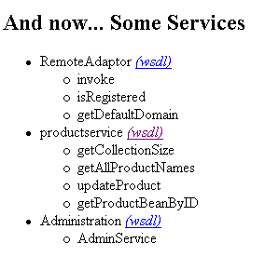
    - Click the wsdl link next to the productservice Web service. The WSDL is shown for the Web service. Definitions are displayed for the four Web methods and the parameter types passed to and from the Web service.
    - Close Internet Explorer.

- Migrate the Java Web service to the .NET Framework using the JLCA

- Using Visual Studio .NET, start the Java Language Conversion Assistant and create a new solution.
Proceed through the wizard, using the values in the following table to specify the settings at each stage:
Page | Setting | Value
Source files | A directory containing the project's files | Select
Select source directory | Which directory contains the file you want to convert? | C:\JavaMigration\Labs\Lab05\Starter\WebServices\ProductService\Products
 | Do you need any additional source files to build your project? | Leave blank or clear anything which appears here
Configure your new project | What name would you like for your Visual C# project? | ProductsWebService
 | What type of application is your project? | Web Application
Specify Web settings | Virtual Root | ProductsWebService
 | Application Domain | Leave blank
 | Context Path | Leave blank
Specify a directory for your new project | Where do you want your new project created? | C:\ProductWebService

When the conversion process is complete, the C# project is displayed in Visual Studio together with a conversion report. An expanded conversion report is shown below.
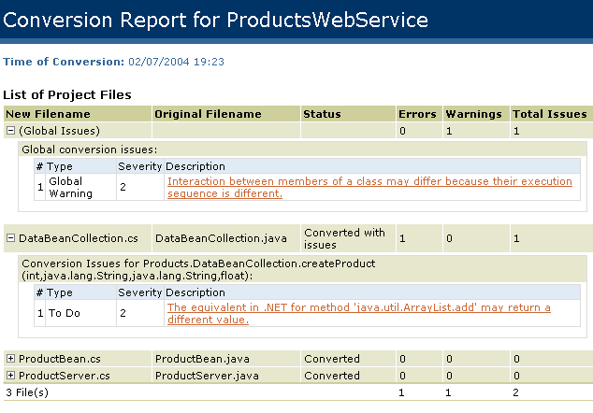
The report details two issues. The first is a global warning, and the second is an ArrayList issue with the DataBeanCollection class. You will resolve both of these issues in the next procedure.

- Examine and resolve key migration issues
    - Examine the files in the Solution Explorer. The Web Service and supporting code have been translated into an ASP.NET Web application. The solution appears as shown below.
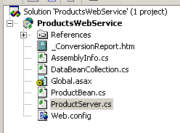
Three C# classes have been created as follows:
  - DataBeanCollection
  - ProductBean
  - ProductServer
Note that these classes are not Web services, but ordinary classes. You will use these classes as library functions, and add your own Web service to the project in order to implement the ProductServer functionality as a Web service. The JLCA does not directly convert Java Web services into ASP.NET Web services because prior to JDK 1.5, Java Web service implementations are application server specific. In the case of JBoss, the Web service is defined by the metadata in the web-service.xml file shown earlier. The JLCA does not convert this file into an equivalent .asmx file, it only converts the Java source code. You must create the .asmx file for the ASP.NET Web service separately and add the converted classes and Web methods to it.
It is also worth noting that the bean mapping entry in the web-service.xml file that indicates how the Java ProductBean class should be serialized is handled transparently by the .NET Framework. ASP.NET will automatically serialize objects as XML documents without requiring any additional information.
    - Examine the conversion report. The following warning is generated against the DataBeanCollection class:
The equivalent in .NET for method 'java.util.ArrayList.add' may return a different value.
    - In the Solution Explorer, double-click DataBeanCollection.cs. Examine the class. The way the ArrayList is being used in the createProduct function is acceptable so you can ignore this warning.
    - In the Solution Explorer, double-click _ConversionReport.htm

The following global issue is shown:
Interaction between members of a class may differ because their execution sequence is different.
    - View the ProductServer and ProductBean classes. Everything has been converted successfully, so you can ignore the global issue.

- Create the productservice Web service
    - In the Solution Explorer, right-click the ProductsWebService project, point to Add, and click Add Web Service.
    - In the Add New Item dialog box, type productservice.asmx in the Name text box, and click Open. The Web service is created and a form is displayed in the designer view window.
    - In the designer view window, click the click here to switch to code view link. The code for the Web service is displayed in the code view window.
    - Delete the following code at the bottom of the class:
// WEB SERVICE EXAMPLE
// The HelloWorld() example service returns the string Hello World
// To build, uncomment the following lines then save and build the project
// To test this web service, press F5

// [WebMethod]
// public string HelloWorld()
// {
// return "Hello World";
// }

    - Open the ProductServer class and copy the contents of the class (omitting the class declaration) and paste it into the ProductWebService class, beneath the following line.

The ProductWebService class should appear as follows:
using System;
using System.Collections;
using System.ComponentModel;
using System.Data;
using System.Diagnostics;
using System.Web;
using System.Web.Services;

namespace ProductsWebService
{
/// <summary>
/// Summary description for productservice.
/// </summary>
public class productservice : System.Web.Services.WebService
{
public productservice()
{
//CODEGEN: This call is required by the ASP.NET Web Services Designer
InitializeComponent();
}

virtual public System.String[] AllProductNames
{
get
{
System.String[] productNames = new System.String[products.Count];
for (int i = 0; i < products.Count; i++)
productNames[i] = ((ProductBean) products[i]).ProductName;
return productNames;
}

}
virtual public int CollectionSize
{
get
{
return products.Count;
}
}

private DataBeanCollection products;

public ProductServer()
{
products = new DataBeanCollection();
products.fill();
}

public virtual ProductBean getProductBeanByID(int i)
{
return (ProductBean) products[i];
}

public virtual bool updateProduct(ProductBean product)
{
products[product.ProductId] = product;
return true;
}
}
}

There are some issues with this code (they are emboldened in the snippet):
  - The namespace is declared as ProductsWebService. The other classes are part of the Products namespace.
  - The getAllProductNames method has been translated into a read only property. This is normally ok, but in this instance we want them all to be methods.
  - The getCollectionSize method has also been translated into a read only property.
  - You have copied the ProductServer constructor across which does not match the new class name.
    - At the top of the file, add the following line:
using Products;

    - Copy the two lines of code from inside the old ProductServer constructor and paste them at the end of the productservice constructor. The code should appear as follows:
public productservice()
{
//CODEGEN: This call is required by the ASP.NET Web Services Designer
InitializeComponent();
products = new DataBeanCollection();
products.fill();
}

    - Delete the ProductServer constructor.
    - Change the name of the AllProductNames indexer to getAllProductNames(), and delete the virtual keyword.
    - Remove the get keyword and the corresponding start and end brackets.
    - Add the [WebMethod] attribute to the getAllProductNames method by placing it on the line above the method declaration. The method should appear as follows:

[WebMethod]
public System.String[] getAllProductNames()
{
System.String[] productNames = new
System.String[products.Count];
for (int i = 0; i < products.Count; i++)
productNames[i] = ((ProductBean)
products[i]).ProductName;
return productNames;
}

    - Repeat this process for the CollectionSize property, turning it into a Web method named getCollectionSize as follows:
[WebMethod]
public int getCollectionSize()
{
return products.Count;
}

    - Add the [WebMethod] attribute to the getProductBeanByID and updateProduct methods, and remove the virtual keyword. The code should appear as follows:
[WebMethod]
public ProductBean getProductBeanByID(int i)
{
return (ProductBean) products[i];
}

[WebMethod]
public bool updateProduct(ProductBean product)
{
products[product.ProductId] = product;
return true;
}

    - In the Solution Explorer, right-click ProductServer.cs, click Delete, and then click OK. This class is no longer required.
    - Build the solution. The project should build without any errors.

- Test the productserviceWeb service

    - Open Internet Explorer, and navigate to the following URL:
http://localhost/ProductsWebService/productservice.asmx
The help page is displayed for the Web service. The top part of the page shows the four methods that are exposed by the service.
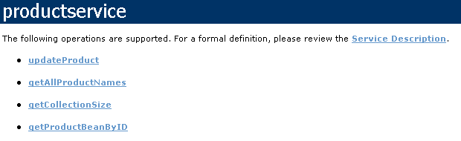
    - Click the Service Description link to view the WSDL for the Web service (this is similar to the WSDL for the Java Web service that you saw earlier).
    - Click Back, and then click the getAllProductNames link.
    - On the getAllProductNames method page, click Invoke. A new browser window opens displaying the product names in SOAP format as follows.
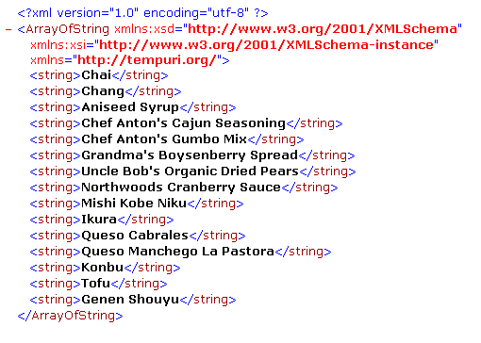
    - Close the browser, and then click Back in the original browser window.
    - Click the getProductBeanByID link. You are presented with the method page requesting a parameter.
    - Type 2 in the i: text box, and then click Invoke. Notice that the third product is returned as the array starts at element zero.
    - Close all open browser windows.

Exercise 3
Migrating Java Swing code

In this exercise, you will convert code that implements a Java Swing user interface to a .NET Framework Windows Forms interface. The GUI will interact with the productservice Web service that you created in the previous exercise. Note that you must complete the Web service exercise before starting this one.

- View the Java Swing GUI
    - Please Read: Due to licensing restrictions, Java software has not been installed in the Hosted Experience environment – hence, the steps in this section (“View the Java Swing GUI”) will not function. Instead, you should read the steps in this section to familiarize yourself with how the original Java application behaves.
    - Open a command prompt window, and move to the following directory:
C:\JavaMigration\Labs\Lab05\Starter\Swing\Products
    - List the Java source files. The following files are shown:
MsgDialog.java
ProductBean.java
ProductEvent.java
ProductListener.java
ProductPanel.java
ProductsGUI.java
QueryDialog.java
The ProductsGUI class and its helper classes have a similar functionality to the AWT application you migrated earlier in the course. The main differences are that:
  - The application has been ported to Swing, making use of PLAF, JMenuItems, a JTree, a JScrollpane, and Swing versions of the AWT components used previously.
  - The application performs all its data access through the productservice Web service.
  - All persistence code (JDBC) has been removed so that you can concentrate on migrating Swing functionality.
  - Changes are not persisted.
    - Run the application by executing the following commands.

cd ..
ant run
The application starts and a Swing form appears. On the Actions menu, click Fetch data. The application displays all products, as shown below.
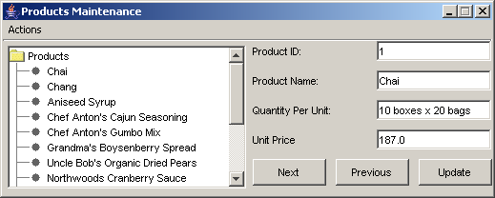
    - Quickly test the interface. Notice that the original functionality has been augmented with a JTree which when double-clicked, can be used for quick navigation between products.
    - Close the application.

- Migrate the Swing code to C#
    - Using Visual Studio .NET, start the Java Language Conversion Assistant and create a new solution.
Proceed through the wizard, using the values in the following table to specify the settings at each stage:
Page | Setting | Value
Source files | A directory containing the project's files | Select
Select source directory | Which directory contains the file you want to convert? | C:\JavaMigration\Labs\Lab05\Starter\Swing\Products
 | Do you need any additional source files to build your project? | Leave blank or clear anything which appears here
Configure your new project | What name would you like for your Visual C# project? | Products
 | What type of application is your project? | Windows Application
Specify a directory for your new project | Where do you want your new project created? | C:\JavaMigration\Labs\Lab05\Swing\Products

When the conversion process is complete, the C# project is displayed in Visual Studio together with a conversion report listing 110 errors and 5 warnings, as shown below.

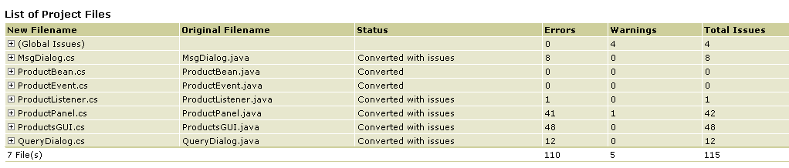
    - In the Solution Explorer, examine the project structure.
Note that the JLCA has migrated the three main JFrame and the two JDialog GUIs to Windows Forms (ProductsGUI, MsgDialog, QueryDialog). Notice also that the JPanel subcomponent (the four text boxes and three buttons shown to the right of the JTree) has been converted into a Windows Forms User Control named ProductPanel.
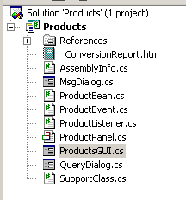
The migrated solution contains 115 issues. You will address these issues in the next section. Note that although this sounds a daunting task, many of the issues are similar in nature, and in some cases identified issues can be ignored with little or no side effects.

- Resolve the migration issues in MsgDialog.cs
    - In the Solution Explorer, right-click MsgDialog.cs, and then click View Code.
    - Scroll through the code reading the UPGRADE migration comments as shown below:
//UPGRADE_NOTE: Field 'EnclosingInstance' was added to class 'AnonymousClassWindowAdapter' to access its enclosing instance
//UPGRADE_NOTE: Field 'EnclosingInstance' was added to class 'AnonymousClassActionListener' to access its enclosing instance.
//UPGRADE_TODO: Class 'java.awt.Frame' was converted to 'System.Windows.Forms.Form' which has a different behavior.
//UPGRADE_TODO: Constructor 'java.awt.Dialog.Dialog' was converted to 'SupportClass.DialogSupport.SetDialog' which has a different behavior.
//UPGRADE_ISSUE: Class hierarchy differences between 'java.awt.Panel' and 'System.Windows.Forms.Panel' may cause compilation errors.
//UPGRADE_TODO: Method 'java.awt.Container.add' was converted to 'System.Windows.Forms.ContainerControl.Controls.Add' which has a different behavior.
//UPGRADE_TODO: Method 'java.awt.Container.add' was converted to 'System.Windows.Forms.ContainerControl.Controls.Add' which has a different behavior.
//UPGRADE_TODO: Method 'java.awt.Container.add' was converted to 'System.Windows.Forms.ContainerControl.Controls.Add' which has a different behavior.
//UPGRADE_TODO: Method 'java.awt.Component.setSize' was converted to 'System.Windows.Forms.Control.Size' which has a different behavior.
//UPGRADE_NOTE: Some methods of the 'java.awt.event.WindowListener' class are not used in the .NET Framework.
These UPGRADE comments contain warnings about hierarchy differences between Java and the .NET Framework, or differences in behavior between the original code and the generated code. In this exercise, these warnings can be safely ignored.

- Resolve the migration issues in QueryDialog.cs
    - In the Solution Explorer, right-click QueryDialog.cs, and click View Code.
    - Scroll through the code, reading the UPGRADE migration comments. Note that the QueryDialog class provides similar functionality to that of the MsgDialog class discussed in the previous section. In the same way, the UPGRADE comments contain warnings about hierarchy differences between Java and .NET Framework or differences in behavior. These warnings can be safely ignored.

- Resolve the migration issues in ProductListener.cs
    - In the Solution Explorer, right-click ProductListener.cs, and click View Code.
    - Locate the following lines:
//UPGRADE_ISSUE: Interface 'java.util.EventListener' was not converted.
public interface ProductListener :EventListener

    - Change the declaration of the interface as follows, and delete the UPGRADE_ISSUE comment.
public interface ProductListener

- To add a reference to the productservice Web service

    - In the Solution Explorer, right-click the Products project, and then click Add Web Reference.
The following dialog box appears.
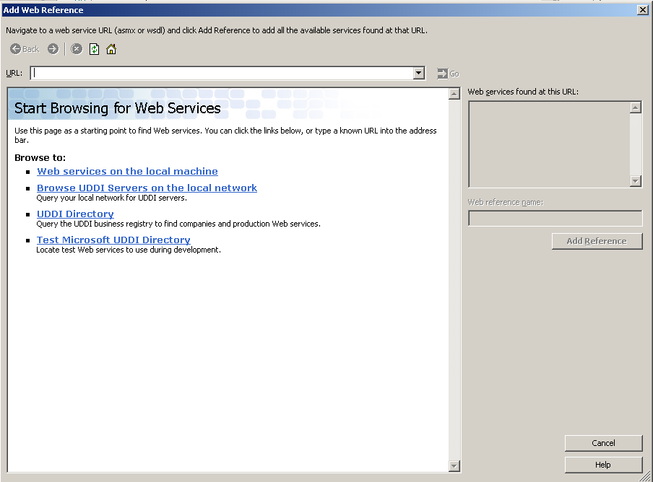
    - In the URL text box, type the following address:
http://localhost/ProductsWebService/productservice.asmx
    - Click Go.
The productservice service description appears as follows.
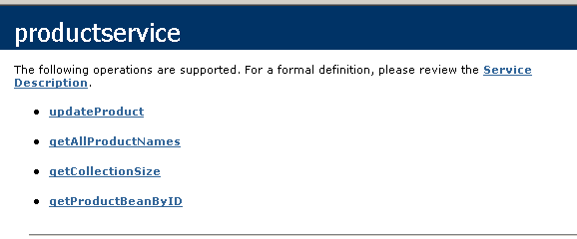
    - In the Web reference name text box, change the name to productservice, and then click Add Reference.
The Web reference is added to the Solution Explorer as a proxy class named productservice. You will use this proxy to reference the Web service and associated server classes in your client code in later sections of this exercise.
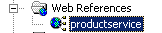

- Resolve the migration issues in ProductPanel.cs

    - In the Solution Explorer, right-click ProductPanel.cs, and click View Code. This class contains the migrated code that implements the panel displaying the text fields and buttons for the ProductsGUI form.
    - Scroll through the code examining the structure and reading the UPGRADE migration comments. Notice the following:
  - The Java anonymous classes implementing listener code (for button clicks, key presses, and so on) have been converted into nested classes named AnonymousClassXXXX.
  - The anonymous classes access the outer class by the provision of a private reference to (line 20):
ProductPanel enclosingInstance;

  - There is no direct equivalent for java.awt.BorderLayout.BorderLayout, line 309:
Constructor 'java.awt.BorderLayout.BorderLayout' was not converted

These are the same issues that you met when migrating the AWT application in earlier labs, and rather than repeat the exercise of resolving these issues you will simply replace the functionality provided by this class.
    - In the Solution Explorer, right-click ProductPanel.cs, click Delete, and then click OK.
    - In the Solution Explorer, right-click the Products project, point to Add, and then click Add Existing Item.
    - In the Add Existing Item dialog box, browse to the following location:
C:\JavaMigration\Labs\Lab05\Starter\Swing
    - Click ProductPanel.cs, and then click Open.
The ProductPanel class appears in the Solution Explorer as a User Control. This control can now be used from the Toolbox in design mode.
    - In the Solution Explorer, right-click ProductPanel.cs, and then click View Code.
    - Scroll through the code and notice the following:
  - An enum named Action has been used in replacement for Java static final constants. At line 27:
public enum Action {Next, Previous, Update};

  - Delegates are used instead of event listeners. The ProductDelegate declaration defines a method signature that can be used as an event handler. In this instance, the handler has to accept two parameters. At line 31:

public delegate void ProductDelegate(object eventSource, ProductEvent pEvent);
private ProductDelegate actionDelegate;

  - The EventDelegate property a reference to the event handler for events raised by the Previous, Next and Update buttons. Line 39:
public ProductDelegate EventDelegate
{
set
{
this.actionDelegate = value;
}
}

  - The updateButton, prevButton, and nextButton controls call the delegated method to respond to button click events. Line 204:
// Setup event handlers
private void updateButton_Click(object sender, System.EventArgs e)
{
actionDelegate(this, new ProductEvent(this, Action.Update));
}

private void prevButton_Click(object sender, System.EventArgs e)
{
actionDelegate(this, new ProductEvent(this, Action.Previous));
}

private void nextButton_Click(object sender, System.EventArgs e)
{
actionDelegate(this, new ProductEvent(this, Action.Next));
}

- View migration issues in ProductsGUI.cs

    - In the Solution Explorer, right-click ProductsGUI.cs, and click View Code.
    - Scroll through the code looking at the structure and reading the UPGRADE migration comments. Notice the following:
  - All Web service client code (referencing org.apache.axis.client and javax.xml packages) requires a manual fix. For example, line 2:
//imports necessary for webservice interaction
//UPGRADE_TODO: The type 'org.apache.axis.client.Call' could not be found. If it was not included in the conversion, there may be compiler issues.
using Call = org.apache.axis.client.Call;
//UPGRADE_TODO: The type 'org.apache.axis.client.Service' could not be found. If it was not included in the conversion, there may be compiler issues.
using Service = org.apache.axis.client.Service;
//UPGRADE_TODO: The type 'javax.xml.namespace_Renamed.QName' could not be found. If it was not included in the conversion, there may be compiler issues.
using QName = javax.xml.namespace_Renamed.QName;

  - The Java anonymous classes implementing listener code have been converted into nested classes named AnonymousClassXXXX. For example, line 16:
//UPGRADE_NOTE: Field 'EnclosingInstance' was added to class 'AnonymousClassMouseAdapter' to access its enclosing instance.
private class AnonymousClassMouseAdapter
{
public AnonymousClassMouseAdapter(ProductsGUI enclosingInstance)
{
InitBlock(enclosingInstance);
}
private void InitBlock(ProductsGUI enclosingInstance)
{
this.enclosingInstance = enclosingInstance;
}
...

  - UPGRADE_ISSUES have been raised when converting the JTree control. The converted code will not compile. For example, at line 40:
//UPGRADE_ISSUE: Class 'javax.swing.tree.TreePath' was not converted.
//UPGRADE_ISSUE: Method 'javax.swing.JTree.getPathForLocation' was not converted.
TreePath selPath = Enclosing_Instance.productTree.getPathForLocation(e.X, e.Y);

  - There is no direct equivalent to Java look and feel. Line 160:

//UPGRADE_TODO: Method 'javax.swing.UIManager.setLookAndFeel' was not converted.
UIManager.setLookAndFeel("com.sun.java.swing.plaf.windows.WindowsLookAndFeel");

  - Menu events are dealt with by the SupportClass with the C# delegate commented out. For example, the "Fetch data" menu item at line 298:
/*
fetchMenuItem.Click += new System.EventHandler(this.fetchMenuItem_Click);*/
SupportClass.CommandManager.CheckCommand(fetchMenuItem);

  - SwingUtilities.invokeLater has not been converted. The following code does not compile, line 467:
//UPGRADE_ISSUE: Method 'javax.swing.SwingUtilities.invokeLater' was not converted.
SwingUtilities.invokeLater(new AnonymousClassRunnable());

- Replace ProductsGUI.cs
In this section, rather than fixing all the issues yourself, you will replace ProductGUI.cs with a pre-written class, and then examine its contents. This is useful so as to see how you can re-architect a Swing application that uses complex controls (such as JTree) using Windows Forms.
    - In the Solution Explorer, right-click ProductsGUI.cs, click Delete, and then click OK.
    - In the Solution Explorer, right-click the Products project, point to Add, then click Add Existing Item.
    - In the Add Existing Item dialog box, browse to the following location:
C:\JavaMigration\Labs\Lab05\Starter\Swing
    - Click ProductsGUI.cs, and then click Open. The file is added to the Solution Explorer.
    - In the Solution Explorer, right-click ProductGUI.cs, and then click View Code.
    - Scroll through the code and notice the following:
  - The handleProductEvent method is declared as the delegated method which catches events raised from the ProductPanel class. At line 40:
productPanel.EventDelegate = new ProductPanel.ProductDelegate(this.handleProductEvent);

  - The JTree component is replaced with a TreeView control. The first node is created at line 42:
TreeNode newNode = new TreeNode("Products");
productTree.Nodes.Add(newNode);

    - The handleProductEvent method handles events raised from the ProductPanel. Notice that the Action enum is used to distinguish events. At line 142:

public void handleProductEvent(object eventSource, ProductEvent e)
{
if (e.Action==ProductPanel.Action.Next){
if (checkForUpdates())
...

    - The application is run by calling Application.Run. At line 190:
public static void Main(string[] args)
{
Application.Run(new ProductsGUI());
}

  - Web methods are invoked by using the productservice proxy class. Notice that the ProductBean class is defined as part of the server application. In the following code snippet (line 257), the getProductBeanByID() Web method is invoked:
//Retrieve a ProductBean from the webservice
private productservice.ProductBean retrieveProductBeanById(int id)
{
productservice.ProductBean pb = null;
try
{
pb = service.getProductBeanByID(id);
}
catch (Exception ex)
{
Console.WriteLine("Problem accessing product " + id);
}
return pb;
}

- Resolve migration issues in ProductEvent.cs
In this procedure, you will change the ProductEvent class to use the ProductPanel enumeration rather than Java static constants.
    - In the Solution Explorer, right-click ProductEvent.cs, and then click View Code.
    - At line 8, change the Action property to type ProductPanel.Action, as follows:
virtual public ProductPanel.Action Action

    - At line 17, change the action field to be of type ProductPanel.Action, as follows:
internal ProductPanel.Action action;

    - Change the ProductEvent constructor to use a parameter type of ProductPanel.Action as follows:
internal ProductEvent(System.Object source, ProductPanel.Action action):base()

    - Build the solution.

- Test the Windows Forms application
    - On the Debug menu, click Start Without Debugging.
The application starts and the ProductsGUI form appears.
    - On the Actions menu, click Fetch data. The products are displayed as follows.
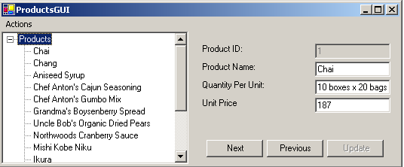
    - Verify that the application operates as before. Close the application when you have finished.

Restart your
Hosted Experience
session
This lab is long and may exceed the time allowed by the Visual Studio Hosted Experience. It is suggested that you end your Hosted Experience session after completing Exercise 3, and log on again prior to completing Exercise 4.
- Log in to the Hosted Experience
    - Open Internet Explorer.
    - Browse to http://msdn.microsoft.com/virtuallab.
    - Click on the lab group titled “Java to .NET Framework Migration Workshop.”
    - Click on the lab titled “Migrating JDK 1.4 Applications and Code.”
    - Follow the remaining on-screen instructions to start the Virtual Lab experience. Once you have logged in and started the Virtual Lab session you may begin with Exercise 4.

Exercise 4
Migrating a JNI Method Call
In this exercise, you will convert Java code that calls a method in a DLL to C#, showing how to call unmanaged code from the .NET Framework.
- View the JNI source code
    - Open a Visual Studio .NET Command Prompt window, and move to the following folder:
C:\JavaMigration\Labs\Lab05\Starter\JNI
This folder contains the following source code files:
JNICaller.java
SystemInfo.cpp
    - Using notepad, examine the Java and C++ source files.
The JNICaller.java class is as follows:
public class JNICaller {
public native void getSystemTime();
static {
System.loadLibrary("SystemInfo");
}
public static void main(String args[]) {
new JNICaller().getSystemTime();
}
}

The JNICaller class declares a native function named getSystemTime() and loads the native library with the statement System.loadLibrary("SystemInfo");
The SystemInfo.cpp library code is as follows:
#include "JNICaller.h"
#include <stdio.h>
#include <time.h>
JNIEXPORT void JNICALL Java_JNICaller_getSystemTime(JNIEnv *env,jobject jobj) {
char tmpbuf[128];
_strtime( tmpbuf );
printf( "The time is: %s\n", tmpbuf );
};

The SystemInfo library contains an exported function named getSystemTime which prints the current system time.

- Compile and run the JNI code

    - Please Read: Due to licensing restrictions, Java software has not been installed in the Hosted Experience environment – hence, the steps in this section (“Compile and run the JNI code”) will not function. Instead, you should read the steps in this section to familiarize yourself with how the original Java application behaves.
    - At the command prompt, execute the following commands in turn:
javac JNICaller.java

javah -jni JNICaller

cl SystemInfo.cpp -I%JAVA_HOME%\include
-I%JAVA_HOME%\include\win32 -FeSystemInfo.dll /LD

The javah command generates a C header library file containing JNI information which is used by the SystemInfo library.
The cl command invokes the Microsoft C/C++ compiler. The -I option specifies the path for JNI header files for the JVM, and /LD specifies that the output is a library (.dll).
    - Run the program by executing the command: java JNICaller
The current time is displayed.
    - Leave the command prompt open.

- Migrate the JNI code to C#
    - Using Visual Studio .NET, start the Java Language Conversion Assistant and create a new solution.
    - Proceed through the wizard, using the values in the following table to specify the settings at each stage:
Page | Setting | Value
Source files | A directory containing the project's files | Select
Select source directory | Which directory contains the file you want to convert? | C:\JavaMigration\Labs\Lab05\Starter\JNI
 | Do you need any additional source files to build your project? | Leave blank
Configure your new project | What name would you like for your Visual C# project? | CSCaller
 | What type of application is your project? | Console Application
Specify a directory for your new project | Where do you want your new project created? | C:\JavaMigration\Labs\Lab05\CSCaller

After the migration completes, the migration report is displayed. An expanded version of the report is shown below.

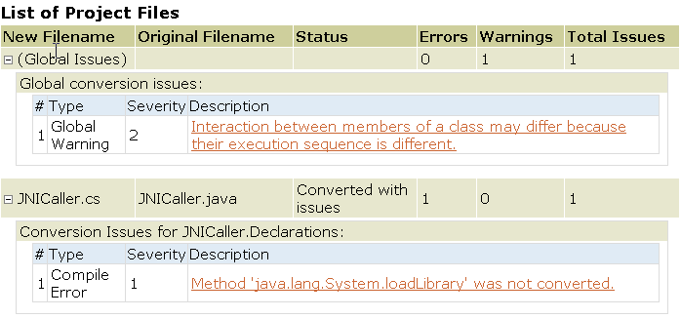

- Address the migration issues
    - In Solution Explorer, double-click JNICaller.cs.
The source code is displayed as follows:
using System;
public class JNICaller
{
public extern void getSystemTime();
[STAThread]
public static void Main(System.String[] args)
{
new JNICaller().getSystemTime();
}
static JNICaller()
{
{
//UPGRADE_ISSUE: Method 'java.lang.System.loadLibrary' was not converted. 'ms-help://MS.VSCC.2003/commoner/redir/redirect.htm?keyword="jlca1000_javalangSystem_3"'
System_Renamed.loadLibrary("SystemInfo");
}
}
}

Notice that there is a single UPGRADE_ISSUE in the static initializer. The JLCA is unable to convert the System.loadLibrary method.
    - Add the following statement at the top of the class file:
using System.Runtime.InteropServices;

Note that the System.Runtime.InteropServices namespace enables interoperability with unmanaged code.
    - Locate the following line:

public extern void getSystemTime();

Add the static modifier to the code as follows:
public static extern void getSystemTime();

    - Add the DllImport attribute above this line of code as follows:
[DllImport("SystemInfo.dll")]
public static extern void getSystemTime();

    - Delete the static initializer together with the enclosed code as shown below:
static JNICaller()
{
{
//UPGRADE_ISSUE: Method 'java.lang.System.loadLibrary' was not converted. 'ms-help://MS.VSCC.2003/commoner/redir/redirect.htm?keyword="jlca1000_javalangSystem_3"'
System_Renamed.loadLibrary("SystemInfo");
}
}

    - Change the following line of code:
new JNICaller().getSystemTime();

to:
JNICaller.getSystemTime();

Because the getSystemTime() function has been declared static, there is no need to instantiate the JNICaller class.
    - Build the project and correct ay syntax errors.

- Modify the SystemInfo C++ library
    - At the command prompt, change to the following directory:
C:\JavaMigration\Labs\Lab05\CSCaller
    - Run the following command: notepad SystemInfo.cpp
You will notice that the C++ class is untouched by the migration process, which has simply copied the file into the new folder. You will have to edit the class manually to remove references to JNI.
    - Delete the first line. It appears as follows:
#include "JNICaller.h"

    - Locate the following line:
JNIEXPORT void JNICALL Java_JNICaller_getSystemTime(JNIEnv *env,jobject jobj) {

    - Replace this code with the following code snippet:

extern "C" __declspec(dllexport) void getSystemTime();
void getSystemTime()
{

    - Your code should resemble the following;
#include <stdio.h>
#include <time.h>
extern "C" __declspec(dllexport) void getSystemTime();
void getSystemTime()
{
char tmpbuf[128];
_strtime( tmpbuf );
printf( "The time is: %s\n", tmpbuf );
};

    - Save the file and close notepad.

- Compile and run the solution
    - Compile the C++ library using the following command:
cl SystemInfo.cpp /LD

    - Build the C# application using the following command:
csc JNICaller.cs

    - Run the application by executing JNICaller.
The current time is displayed.

