Java to .NET Framework Migration Workshop
Deploying a .NET Framework-based Application
INCLUDEPICTURE "../PowerPnt/JAVAMIG_02new/Slide_270.jpg" \* MERGEFORMAT INCLUDEPICTURE "../PowerPnt/JAVAMIG_03/Slide_270.jpg" \* MERGEFORMAT 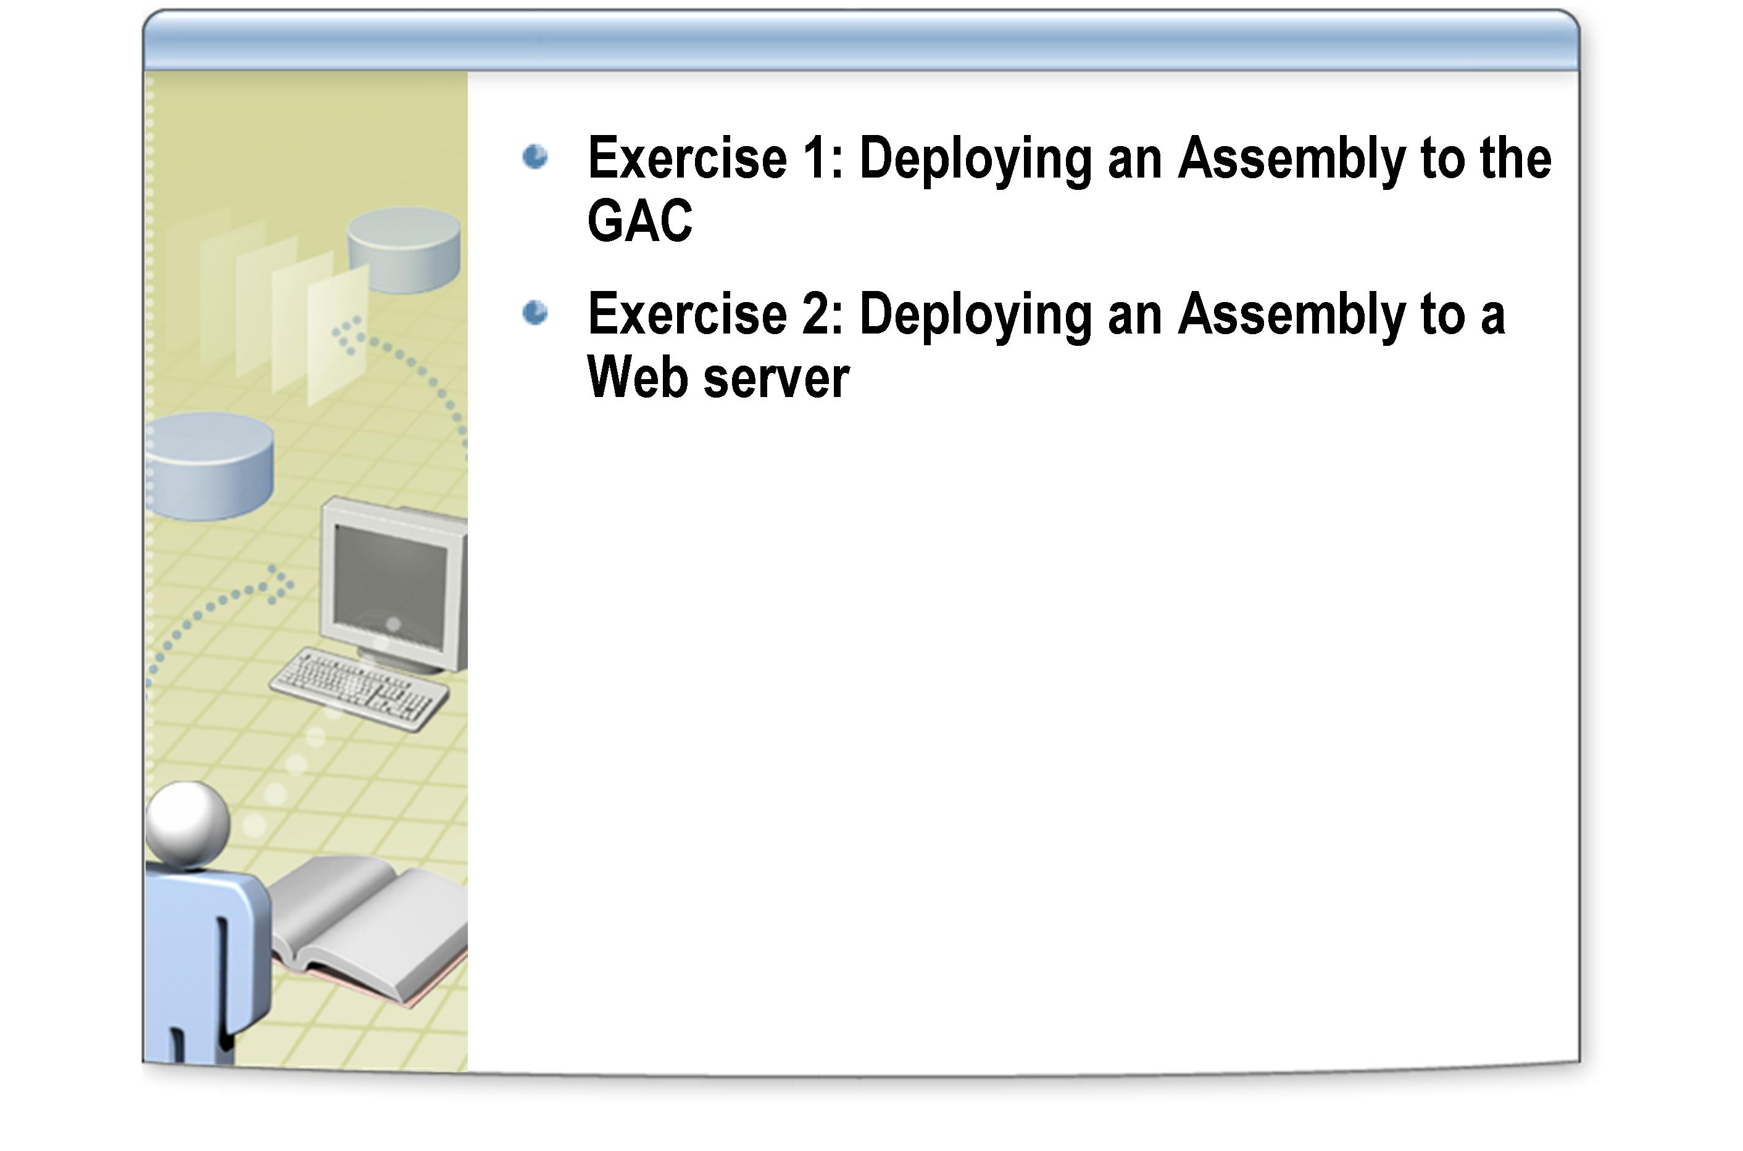

After completing this lab, you will be able to:
Objectives
- Create strongly named assemblies.
- Deploy strongly named assemblies to the GAC.
- Use the .NET Framework Configuration tool to view the contents of the GAC.
- Reference assemblies that are located in the GAC from an application.
- Deploy assemblies to a Web server.
- Access assemblies located on a Web server from an application.
- Use the .NET Framework Configuration tool to view the configuration settings of an application.

This lab focuses on the concepts in this module and as a result may not comply with Microsoft security recommendations.
Note

The line numbers specified in this lab are provided as a guide only. You may find that some of the line numbers vary depending on how you edit the code.
Note

Before working on this lab, you must have:
Prerequisites
- Experience of compiling assemblies and applications using
Microsoft Visual Studio .NET.

Northwind Traders have decided to facilitate reuse of some assemblies. To do this they are going to split the application called Products.NET that you worked with in the previous module into different assemblies, and then make one assembly (the DatabaseUtils assembly) available through the GAC. This will mean that it is available to other applications on the system. A further assembly is to be made more widely available throughout the enterprise by placing it on an Intranet Web site. This will be the ProductBean assembly). The original application will then need to be modified to use the assemblies from these two new locations.

Scenario
A summary of the way this application will use assemblies from the GAC and from the Internet can be seen in the diagram on slide 9 of the notes entitled “Assembly Locations.

Log in to the
Hosted Experience
Estimated time to complete this lab: 60 minutes

The Visual Studio Hosted Experience is pre-configured to allow you to run the following lab in a hosted environment. A broadband connection is required.
- Log in to the Hosted Experience
    - Open Internet Explorer.
    - Browse to http://msdn.microsoft.com/virtuallab.
    - Click on the lab group titled “Java to .NET Framework Migration Workshop.”
    - Click on the lab titled “Deploying a .NET Framework-based Application”
    - Follow the remaining on-screen instructions to start the Virtual Lab experience. Once you have logged in and started the Virtual Lab session you may begin with Exercise 1.

Exercise 1
Deploying an Assembly to the GAC
In this exercise, you will extract the DatabaseUtils class from the Products.NET application and create a separate assembly. You will deploy this assembly to the GAC, and modify the Products.NET application to reference this assembly. Assemblies deployed to the GAC must have a strong name, so you will use the sn tool to generate a key pair and use these keys to sign the assembly when it is built.
- Create a new project for the DatabaseUtils assembly
    - Start Microsoft Visual Studio .NET 2003.
    - On the File menu, point to New, and then click Project.
    - In the New Project dialog box, click Visual C# Projects in the Project Types tree, click Class Library in the Templates pane, type DatabaseUtils.NET for the Name, and type C:\JavaMigration\Labs\Lab03 for the Location. Click OK.
The Class Library template can be used for creating new DLL assemblies.
    - In the Solution Explorer, right-click Class1.cs, and then click Delete.
    - In the Microsoft Development Environment message box, click OK.
    - To import the DatabaseUtils.cs file, click File, and then click Add Existing Item. Browse to C:\JavaMigration\Labs\Lab03\Starter\Products.NET. Select DatabaseUtils.cs, and click Open.
    - Do not close Visual Studio .NET as you will need it later on.

- Create the public/private key pair
    - On the Start menu, point to All Programs, point to Microsoft Visual Studio .NET 2003, point to Visual Studio .NET Tools, and click Visual Studio .NET 2003 Command Prompt.
This action opens a Visual Studio .NET command prompt window. The environment variables are configured to enable access to the various .NET Framework tools.
    - Move to the project directory C:\JavaMigration\Labs\Lab03\DatabaseUtils.NET.
    - At the Visual Studio .NET command prompt, type the following command:
sn –k DatabaseUtils.NET.snk

This command generates a key pair that you can use for signing an assembly, and stores them in the binary file DatabaseUtils.NET.snk.
    - Do not close the command prompt as you will need it later.
    - Return to Visual Studio .NET. In Solution Explorer, double-click the file AssemblyInfo.cs to display it in the code view window. Locate the following line near the bottom of the file:
[assembly: AssemblyKeyFile("")]

    - Modify the line to reference the key file you created in the previous steps by amending it as shown below:

[assembly: AssemblyKeyFile("..\\..\\DatabaseUtils.NET.snk")]

When the assembly is built, the compiler actually runs in the bin\Debug folder of the project, which is why you must specify a path that refers two folders back up the directory hierarchy.
    - Build the solution. The assembly will compile as DatabaseUtils.NET.dll and will be strongly signed.

If you receive a cryptographic failure message when building the application, check that you have not misspelled the name of the key file.
Tip

- Place the assembly in the GAC
    - At the Visual Studio .NET command prompt, move to the C:\JavaMigration\Labs\Lab03\DatabaseUtils.NET\bin\Debug folder.
This folder will contain the assembly DatabaseUtils.NET.dll.
    - Use the GACUtil tool to place the assembly in the GAC by typing the following command:
gacutil -i DatabaseUtils.NET.dll

You will see the message “Assembly successfully added to the cache”.

- View the shared assembly in the GAC
    - To view the assembly in the GAC, you can use the .NET Framework 1.1 Configuration Tool. Click Start, point to All Programs, point to Administrative Tools, and then click Microsoft .NET Framework 1.1 Configuration.
    - In the .NET Configuration 1.1 window, click Assembly Cache under My Computer.
    - In the right-hand pane, click View List of Assemblies in the Assembly Cache.
    - Scroll down the list of assemblies, and you will see the DatabaseUtils.NET assembly in the list. The assembly will have a version number and a public token key.
The version number is incremented every time you compile the application. You can control the version number using the assembly: AssemblyVersion attribute in the AssemblyInfo.cs file in the DatabaseUtils.NET project.
The public key token was taken from the file DatabaseUtils.NET.snk, generated by the sn utility.
    - Right-click the DatabaseUtils.NET assembly, and then click Properties. Note that the codebase property refers to the folder where the assembly was built. Click OK.

You can also use the .NET Framework Configuration tool to add and remove assemblies from the GAC. To add an assembly, click Add in the Action menu. To delete an assembly, right-click the assembly and click Delete.
Tip

    - Close the .NET Configuration 1.1 console.

You can also use Windows Explorer to view the GAC. Navigate to the folder C:\WINDOWS\assembly. However, do not use the Windows command prompt to view this folder. If you want to examine the GAC from the command prompt, use the gacutil –l command.
Tip

- Reference the shared assembly from the Products.NET application
    - In Visual Studio .NET, open the solution C:\JavaMigration\Labs\Lab03\Starter\Products.NET\Products.NET.sln
    - In the Solution Explorer, permanently delete the file DatabaseUtils.cs.
The application will use the class in the DatabaseUtils.NET assembly instead.
    - Rebuild the solution. You will see 15 errors referring to the fact that the type or namespace DatabaseUtils is missing. You will add a reference to the DatabaseUtils.NET assembly in the GAC to fix these problems.
    - In the Solution Explorer, right-click References, and then click Add Reference.
    - In the Add Reference dialog box, click Browse. Move to the folder, C:\JavaMigration\Labs\Lab03\DatabaseUtils.NET\bin\Debug, and select the file DatabaseUtils.NET.dll. Click Open. In the Add Reference dialog box, click OK.
The assembly DatabaseUtils.NET will appear in the list of references in the Solution Explorer.

Although the assembly is in the GAC, you must add a reference to the assembly at the location it was built. One reason for this is that the filename of an assembly does not have to be unique (multiple assemblies in the GAC can have the same filename), so the CLR requires the strong name of the assembly instead which is compiled into the metadata of the assembly.
Note

    - Click the DatabaseUtils.NET reference in the Solution Explorer. In the Properties window, verify that the Copy Local property is set to False.
If the CopyLocal property of a referenced assembly is false, the CLR will attempt to locate the assembly in the GAC. Setting this property to true causes the assembly to be copied into the folder containing the application when it is compiled and handled as a private assembly rather than a sharerd assembly.
    - Rebuild the solution. It will build without any errors.
    - On the Debug menu, click Start to test the application. Verify that the application still functions correctly. Close the application when you are satisfied that the application works.

Exercise 2
Deploying an Assembly to a Web server

In the last exercise, you added one of the assemblies used by the Products.NET application to the GAC. In this exercise, you will take another assembly from Products.NET, and deploy it to a Web server. You will then modify the Products.NET application from the previous exercise to use the assembly from the Web server. Your finished application will then have local assemblies, an assembly that has been deployed to the GAC, and an assembly that has come from a Web server.
- Deploy the assembly to the Web server
    - Using Visual Studio .NET, create a new Visual C# Class Library project called ProductBean.NET and save it in the folder C:\JavaMigration\Labs\Lab03.
    - In the Solution Explorer, delete the file Class1.cs.
    - Add the existing file C:\JavaMigration\Labs\Lab03\Starter\Products.NET\ProductBean.cs to the project.
This is a copy of the same class that you migrated in the Module 2 lab.
    - Add a reference to the DatabaseUtils assembly from the GAC.
The ProductBean class uses the DatabaseUtils class for connecting to the database.
    - Assemblies deployed over the Web require a strong name. At the Visual Studio .NET command prompt, move to the folder C:\JavaMigration\Labs\Lab03\ProductBean.NET and type the following command:
sn –k ProductBean.NET.snk

    - Return to Visual Studio .NET. In the Solution Explorer, open AssemblyInfo.cs and locate the following line:
[assembly: AssemblyKeyFile("")]

    - Modify the line to reference the key file you created in the previous steps by amending it to the following:
[assembly: AssemblyKeyFile(@"..\..\ProductBean.NET.snk")]

    - Build the solution.

- Deploy the assembly to the Web server
- Using Windows Explorer, copy the assembly C:\JavaMigration\Labs\Lab03\ProductBean.NET\bin\Debug\ProductBean.NET.dll to the folder C:\Inetpub\wwwroot.
This action places the assembly into the root directory of the Internet Information Services Web server that will host the assembly.
- Modify the Products.NET application to access the assembly over the Web

    - In Visual Studio .NET, open the solution C:\JavaMigration\Labs\Lab03\Starter\Products.NET\Products.NET.sln
    - In the Solution Explorer, permanently delete the file ProductBean.cs.
    - Rebuild the solution. You will see one error referring to the fact the type or namespace ProductBean could not be found.
As before, you must add a reference to the assembly so the CLR can locate it.
    - In the Solution Explorer, right-click References, and click Add Reference. In the Add Reference dialog box, click Browse, and navigate to the folder C:\JavaMigration\Labs\Lab03\ProductBean.NET\bin\Debug. Click ProductBean.NET.dll, and then click Open. In the Add Reference dialog box, click OK.
    - Using the Properties window, verify that the Copy Local property of the ProductsBean.NET assembly is set to True.

Although the assembly will be deployed over the Web, you need to provide a local reference in order to build the solution. You will change this local reference later, and point to the version of the assembly located on the Web server.
Note

    - Rebuild the solution. It will build without errors.

- Configure the application to use the assembly on the Web server
    - Using the Properties window, set the Copy Local property of the ProductsBean.NET assembly to False.
This will prevent the application from using the local version of the assembly.
    - You now need to create the application configuration file that refers to the assembly on the Web server. In the Solution Explorer, right-click Products.NET, point to Add, and then click Add New Item.
    - In the Add New Item – Products.NET dialog, in the Templates pane, select Application configuration file at the bottom of the pane, set the name to Products.NET.exe.config, and then click Open. You will be presented with an XML configuration file for the application.

Application configuration files have the same name as the application (including the ".exe") but with a ".config" suffix.
Note

    - Replace the contents of the XML file with the following text:

<configuration>
<runtime>
<assemblyBinding xmlns=
"urn:schemas-microsoft-com:asm.v1">
<dependentAssembly>
<assemblyIdentity name="ProductBean.NET"
publicKeyToken=""
culture="neutral" />
<codeBase version=""
href="http://localhost/ProductBean.NET.dll"/>
</dependentAssembly>
</assemblyBinding>
</runtime>
</configuration>

The codeBase element links to the assembly that you placed on the Web server earlier in the exercise. However, you also need to specify values for the version and publicKeyToken attribute values to complete this reference and allow the CLR to locate the assembly.

For more information on the codeBase element, and the other elements in the XML above, see the .NET Framework SDK documentation at http://msdn.microsoft.com/library/default.asp?url=/library/en-us/cpgenref/html/gngrfCodeBase.asp.
Note

The publicKeyToken attribute is used to identify the assembly as the filename is not necessarily guaranteed to be unique. The version attribute is also required as different versions of the same assembly could be located in different places. The application therefore needs to specify which version it uses.
Note

    - In the Solution Explorer, click the ProductBean.NET reference. Locate the Version property in the Properties window. The value will be a string of four numbers separated by periods. Copy this string into the version attribute of the codeBase element in the configuration file.
    - To identify the publicKeyToken value of the ProductBean.NET assembly, switch to the Visual Studio .NET command prompt, move to the folder C:\JavaMigration\Labs\Lab03\ProductBean.NET\bin\Debug. Use the
sn –T command to display the public key token of the ProductBean.NET assembly:
sn -T ProductBean.NET.dll

The public key token will be displayed as a hexadecimal string.
    - Copy the public key token value displayed into the publicKeyToken attribute in the application configuration file in Visual Studio .NET.
    - On the File menu, click Save Products.NET.exe.config As, and save the application configuration file into C:\JavaMigration\Labs\Lab03\Starter\Products.NET\bin\Debug folder with the same name.
    - Using Windows Explorer, run the C:\JavaMigration\Labs\Lab03\Starter\Products.NET\bin\Debug\Product.NET.exe application again. The application will now work as before.

Do not rebuild or run the application from Visual Studio .NET. When the application is rebuilt, Visual Studio .NET will first clear the contents of the Debug\bin folder, including the application configuration file!
Warning

- Verify the application configuration using the .NET Configuration tool
    - Start the Microsoft .NET Framework 1.1 Configuration tool.
    - In the left pane, click Applications, and in the right pane, click Add an Application to Configure.
    - In the Configure an Application dialog box, scroll down and locate Products.NET.exe located in C:\JavaMigration\Labs\Lab03\Starter\Products.NET\bin\Debug, and then click OK.
    - In the left pane, expand Products.NET.exe, and then click Assembly Dependencies. The right-pane will display the assemblies that the application uses (directly, and indirectly through other assemblies).
    - In the right pane, examine the properties of the ProductBean.NET assembly. Notice that the Version and Public Key Token properties contain the values you specified in the application configuration file.
    - Close the .NET Configuration 1.1 tool.

