

Microsoft® Office Live Meeting:
Security and Firewall
White Paper

Microsoft Corporation
Published: February, 2005

The information contained in this document represents the current view of Microsoft Corporation on the issues discussed as of the date of publication. Because Microsoft must respond to changing market conditions, it should not be interpreted to be a commitment on the part of Microsoft, and Microsoft cannot guarantee the accuracy of any information presented after the date of publication.
This white paper is for informational purposes only. MICROSOFT MAKES NO WARRANTIES, EXPRESS OR IMPLIED, IN THIS DOCUMENT.
Complying with all applicable copyright laws is the responsibility of the user. Without limiting the rights under copyright, no part of this document may be reproduced, stored in, or introduced into a retrieval system, or transmitted in any form or by any means (electronic, mechanical, photocopying, recording, or otherwise), or for any purpose, without the express written permission of Microsoft Corporation.
Microsoft may have patents, patent applications, trademarks, copyrights, or other intellectual property rights covering subject matter in this document. Except as expressly provided in any written license agreement from Microsoft, the furnishing of this document does not give you any license to these patents, trademarks, copyrights, or other intellectual property.
© 2005 Microsoft Corporation. All rights reserved.
Microsoft, the Microsoft logo, the Office logo, Outlook, PowerPoint, Visio, MSN, Windows, and Windows Media are either registered trademarks or trademarks of Microsoft Corporation in the United States and/or other countries.
The names of actual companies and products mentioned herein may be the trademarks of their respective owners.
Microsoft Corporation • One Microsoft Way • Redmond, WA 98052-6399 • USA
Contents
Introduction 4
Commitment to Trustworthy Computing 4
Live Meeting Secure Web Conferencing 5
Access Security: Control of the Meeting Environment 6
Meeting Ownership 6
Access Control 6
Open Meeting (Public Sessions) 6
Meeting Key (Optimum Security) 6
Access Control Lists (Maximum Security) 7
LDAP and Central Directory Service Integration (Customized Security) 7
Participation Control 7
Content Control 7
Additional Security and Control Features 7
Schedule Privacy 7
Tracking Who Attended a Meeting 8
Viewing the Current Participants of a Meeting 8
Content Storage: Securely Housing Information 8
Create and Manage Persistent Content 8
Higher Performance 8
Protecting Content 8
Physical Security Measures 8
Software Security Precautions: Nine Layers of Protection 9
Filtering Routers 9
Firewalls 10
Intrusion Detection Systems 10
Systems Level Security 10
Application Authentication 10
Application Level Countermeasures 10
Separate Data Network 10
Authentication to Data 11
Encrypted Data 11
Data Transmission: Encryption and Crossing Firewalls 11
Encryption Technology 11
Firewall Policy 12
What is Firewall Policy? 12
Firewall Policy: Protocols 12
Firewall Policy: Ports 13
Communicating Through Firewalls 13
TCP 13
HTTPS (Port 443) 14
Live Meeting Auto Sensing Technology 14

Introduction

Microsoft® Office Live Meeting is a reliable, secure and scalable solution for delivering real-time Web-based meetings and online collaboration. Architected for secure business communication, Live Meeting gives you the power to work together with colleagues, customers, prospects and business partners, without having to be in the same place. For online meetings, training or events, Live Meeting is the effective meeting solution that enables you to communicate with groups of two into the thousands, without leaving your desk. With everyone participating from their PCs, you can kick off a project, brainstorm ideas, edit files, collaborate on white boards, or negotiate deals more efficiently and cost-effectively than traveling.

Live Meeting provides unique interactive tools, integrates with your existing systems and productivity applications, and incorporates a familiar and easy-to-use interface that help improve remote collaboration and enable effective meetings for companies of all sizes. With Live Meeting’s real-time communication platform that provides proven 99.99% uptime availability and always-on SSL encryption, you can conduct every meeting with confidence.

Commitment to Trustworthy Computing

Microsoft’s commitment to providing more secure computing environments includes a comprehensive approach to building and delivering products with high security in mind, and helping customers configure and deploy them in a continued state of high reliability. Microsoft continues to innovate and deliver on this promise within the context of the Trustworthy Computing initiative (described in more detail on Microsoft's Trustworthy Computing Web site), which provides the policies and assurances that form the foundation for this security mindset.

Trustworthy Computing is necessary to provide an environment that allows the user to feel sure that critical business needs are met without compromising information that must be protected.
The Trustworthy Computing initiative defines four goals that all Microsoft products must meet:
- Security: Microsoft products will be able to withstand attack by malicious people or programs, while protecting the confidentiality and consistency of the data they originate or consume.
- Privacy: Microsoft products will allow customers to maintain full control over their personal information, while being able to ensure and verify that internal information auditing policies can be implemented with accuracy.
- Reliability: Microsoft products will offer robust, reliable, and trouble-free communications and computing services.
- Business Integrity: Microsoft will provide responsible, conscientious support for its products, remaining aware of the customer relationship. Microsoft will behave in a responsive manner to the needs of its customers.

To ensure that the Trustworthy Computing initiative meets these goals, products are designed under four guiding principles, sometimes referred to as SD3+C:
- Secure by design: Products are designed in an environment of security awareness, with a focus on security features built into the product, and undergoing rigorous security testing during development.
- Secure by default: Areas of product functionality will not be enabled by default unless an administrator chooses to implement them. Services that do not need to be running will not run unless required, and administrative functions require proper credentials.
- Secure in deployment: Microsoft understands that products do not exist in a vacuum and must be deployed in diverse enterprises. Administrators need to be able to ensure that their installations will coexist with other systems, providing encryption for sensitive data, and preventing unauthorized entities from accessing important information.
- Communications: Microsoft maintains a commitment to communicating with customers. These communications begin with providing ample product documentation, and continue through a product's lifecycle by communicating information about vulnerabilities, service packs, training opportunities, and upgrades.

Live Meeting Secure Web Conferencing

As a hosted Web conferencing service, Live Meeting recognizes and respects the responsibility it assumes on behalf of its clients to ensure the security of all meetings and associated stored content. A host meeting service must make this security obligation to its customers its number-one priority. Microsoft continues to invest significantly in technology and human processes to help ensure a reliable, secure, and highly scalable service. By focusing significant effort toward addressing the three cornerstones of delivering a secure service—access controls, content storage and data transmission—the Live Meeting service provides its users with a highly enjoyable and secure Web conferencing experience.

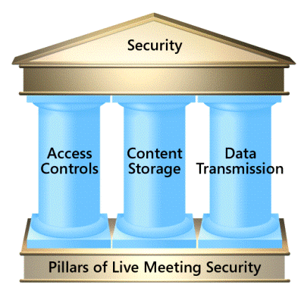

Access Security: Control of the Meeting Environment

All aspects of Live Meeting, from set up to completion, are protected by access security rules. The Live Meeting user interface provides a rich set of features to allow organizations to programmatically manage and control meeting ownership, access, participation, and content. By using these features, companies can establish and enforce their own security policies and procedures at a level appropriate to their needs.

Meeting Ownership
Live Meeting is designed to ensure continued collaboration and ongoing security, not just in the case of a system failure at the Live Meeting Data Center, but also in the event of an emergency failure at the organizer’s computer. Live Meeting maintains the security protocols of the meeting, and either lets the original presenter assume control upon re-entering the meeting, or passes control to a participant who also has presenter privileges. Under this strategy, organizers are assured that control of meeting data and other presenter capabilities do not fall into the hands of just any meeting participant. In this way, Live Meeting maintains ownership security and continued access during worst-case scenarios.

Access Control
Live Meeting offers different levels of Meeting Access Controls with varied degrees of security to address “general public” meetings, as well as highly secure, private sessions. Live Meeting offers users of its Web conferencing services a choice of four increasingly stringent, authentication mechanisms to control access to their meetings, as listed below. Meeting organizers can select the appropriate access control mechanism that is best suited for their particular event, ranging from public forums to ultra-private conferences, or can choose to combine controls so that attendees require different levels of authentication are required of attendees than presenters. The access control options are as follows:

Open Meeting (Public Sessions)
At this minimum-security level, any user in possession of the meeting URL or Meeting ID can attend with no additional authentication required. Therefore, since audience members do not require a Meeting Key or Use account, anyone can attend an open meeting. This mechanism is ideal for public events where a broad range of attendance and participation is welcome.

Meeting Key (Optimum Security)
When more security is needed, presenters and audience members can be required to enter both a Meeting ID and a Meeting Key. The Meeting Key is a string composed of numbers, letters, and symbols of a length defined by the administrator that is either randomly generated or defined by the meeting leader. Audience members and presenters use these keys to establish their level of permission for the meeting. For convenience, Meeting Keys can be replaced with a new key that the meeting leader chooses (up to 64 characters). Additional safeguards can be added to user password and meeting key complexity requirements, which give the administrator some flexibility to ensure that easily guessable passwords and keys are not used in their conference center.

Access Control Lists (Maximum Security)
At the high-security level, meeting organizers can create an Access Control List against which all meeting attendees (presenters and audience members) are cross-referenced before being permitted to attend. The cross-referencing is achieved through the use of unique user IDs, which all meeting attendees (both presenters and audience members) are required to provide, in addition to passwords. This is the most secure access level because meeting organizers are able to explicitly specify who is permitted to attend. These different levels of Access Controls can be applied differently to attendees and presenters to make for the most effective meeting.

LDAP and Central Directory Service Integration (Customized Security)
By taking advantage of the powerful application programming interfaces (APIs) that Live Meeting contains, meeting organizers and participants can be authenticated through their own corporate directory services. After they are authenticated through their own intranet, users can access their Live Meeting accounts to schedule and conduct meetings.

Participation Control
Live Meeting provides a mechanism that allows organizers to monitor and control their meetings in real time. The Meeting Console gives the organizer the ability to dismiss any user from the meeting at any time, without disrupting the course of the meeting. This feature enables meeting organizers to quickly dismiss attendees who should not be present at certain times during the meeting, such as when confidential information is about to be introduced. It also provides a means of quietly ejecting attendees who are proving unruly or disruptive. As an additional security measure, by enabling the Meeting Lobby feature in Live Meeting, presenters can, during the course of the meeting, control who is allowed into the meeting regardless of whether they were previously authorized or not.

Content Control
Presenters retain complete control over their content. Meeting content can be uploaded to secure servers where only the meeting organizer can make changes to it. Content and meeting records can be programmatically saved or deleted at the organizer’s discretion. For example, records of meetings and associated content can be automatically earmarked for deletion when certain conditions are met (for example, after each meeting has concluded, or at the conclusion of meetings scheduled by particular users, and so on).

Additional Security and Control Features

Schedule Privacy
Live Meeting is engineered so that meeting calendars and schedules are never visible to unauthenticated people. This helps ensure that meeting itineraries cannot be sought out or stumbled upon by unauthorized viewers.

Tracking Who Attended a Meeting
Live Meeting provides an audit trail to capture details on every participant who attends a meeting. The Attendance Report lists the name, IP Address, and role of each attendee (that is, presenter or audience member). The Attendance Report displays the exact time each participant arrived, as well as how long they remained connected. Optional fields that can be configured for each attendee to provide include e-mail address and company name. This information can also be listed in the Attendance Report.

Viewing the Current Participants of a Meeting
Live Meeting provides a mechanism to view attendee status in real time, and to disconnect participants, if necessary. The Support Console not only lists the names of the participants, but also the IP Address from which they connected as well as information about their browser and operating system. To eject a participant, the meeting organizer merely has to select the appropriate name from the list and click the Disconnect User button at the bottom of the page.

Content Storage: Securely Housing Information

Create and Manage Persistent Content
Persistent content provides you with the convenience to use and reuse the same presentations after they are uploaded to the service. This can result in significant time savings for the meeting leader. Organizers have the option to selectively delete presentation content at any time, or set up automatic deletion of presentations using the Content Expiration feature. This lets users ensure that all data has been removed form the Live Meeting servers, if it is not being stored for future use, and gives full control over where copies of data reside.

Higher Performance
Uploading your presentation within the Live Meeting service provides higher performance. Since the Live Meeting hosting facilities have very high bandwidth connections to the Internet, your content is distributed and delivered to all meeting participants as rapidly as possible. This architecture also minimizes any potential bottlenecks caused by slow connection rates from individual presenters.

Protecting Content
The Live Meeting Web conferencing service is designed to be a secure and reliable Web conferencing solution. To insure the highest level of security, Live Meeting requires the stringent implementation of security policies within both the physical security measures of the hosting facility, and the software security precautions built into the hosting infrastructure.

Physical Security Measures
Physical security starts with the design of the secure Data Centers located at Live Meeting co-location hosting facilities in the United States and the United Kingdom. State-of-the-art safeguards protect the Live Meeting Data Centers, including 24x7 secured access, motion sensors, video surveillance cameras, biometric controlled access, and security breach alarms. These safeguards are designed to ensure that only authorized Live Meeting operations personnel gain access to these areas.

The contents of any Web presentation, live or recorded, visual or audio, and any presentation materials uploaded to the Live Meeting servers are treated as the intellectual property of the customer. Live Meeting employees and agents do not view these materials except as required to diagnose and support the service, and then only at the specific request of the customer (or as per legal process). In keeping with Microsoft’s commitment to Trustworthy Computing, the Data Centers enforce clear policies to help ensure that any necessary viewing of such content is restricted to the authorized operations and technical staff that support the service. There is a strictly limited number of authorized Live Meeting personnel who have the ability to access customer Web conference sessions, and these personnel are closely supervised.

Software Security Precautions: Nine Layers of Protection
In the world of online security, threats can range from random attempts at penetration, such as those posed by drones and spiders, to targeted efforts to view and possibly usurp proprietary and confidential information. Such threats are real and growing. To combat these risks, nine separate layers of software security collectively protect the Live Meeting infrastructure, serving as a fortification around all customer data.
Figure 1: Nine Levels of Security
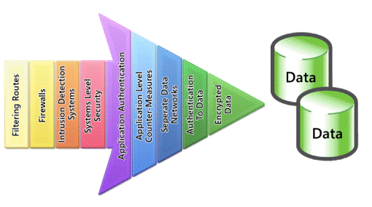

Filtering Routers
Filtering routers reject attempts to communicate to non-routable IP addresses. This helps to prevent common attacks that use “drones” or “spiders” searching for vulnerable servers. Although relatively easy to block, these types of attacks remain a favorite method of hackers in search of weaker defenses.

Firewalls
Firewalls restrict data communication to known and authorized ports, protocols, and destination IP addresses. External access to the Live Meeting infrastructure is restricted to the ports and protocols that are required for the communications between the Live Meeting servers and the meeting participants. The Live Meeting firewall also performs packet inspection, which helps to ensure that the actual contents of the packets contain data in the expected format and conform to the expected client/server communication scheme. This helps to prevent rogue applications from “spoofing” themselves as Live Meeting presentation attendees.

Intrusion Detection Systems
The Live Meeting service uses network-based intrusion detection systems (IDS) to perform real-time monitoring of incoming and outgoing traffic, looking for anomalies in the usual patterns for delivering Web conferencing services. The Live Meeting hosted environment is monitored 24x7 and generates immediate notification of detected inappropriate activity, which is then analyzed and corrective action is taken, if necessary. IDS performs protocol analysis and can be used to detect a variety of attacks and probes, such as port scans and attempts to communicate using inappropriate IP address ranges.

Systems Level Security
The Live Meeting service is designed to help prevent other common types of hacker activity by disabling nonessential services, which have historically been known points of attack. Examples of some of these types of services include Telnet connectivity, sysadmin daemons, and printer services.

Application Authentication
The Live Meeting service enables meeting organizers to enforce the level of participant authentication they feel is needed to protect their meetings. Meetings can be scheduled with a range of access controls, including strict use of Meeting Keys and Access Control Lists, which require individuals to log on using unique user IDs and passwords. All passwords are stored using a one-way hash algorithm, providing an extra level of protection.

Application Level Countermeasures
The Live Meeting service implements countermeasures to help prevent common traps, such as buffer overflows, which have been successfully used by hackers for years to gain access to poorly-secured servers. Application input is bounds checked and any exceptions are caught by the system and handled appropriately. Live Meeting applications run in user mode, reducing access to systems data. These precautions also help to ward off several types of Trojan Horse attacks, which have been launched against publicly-accessible Web sites.

Separate Data Network
The Live Meeting service isolates the actual servers that house data onto a network separate from the rest of the Live Meeting facility. This restricts access to the uploaded data to only a specified set of servers that reside behind the firewall inside the Live Meeting hosting facilities. Direct public access to this portion of the network is not permitted from outside the firewall.

Authentication to Data
The Live Meeting hosting infrastructure requires each connection to the database and file servers to be separately authenticated with authorized Live Meeting IDs and passwords.

Encrypted Data
The Live Meeting service protects uploaded presentations by using 128-bit Advanced Encryption Standard (AES) encryption technology, the standard of the National Institute of Standards and Technology (NIST). AES encryption is one of the strongest standards available today, capable of withstanding brute-force attempts from even sophisticated attackers. All data and passwords are stored in encrypted format the entire time they reside within the Live Meeting hosted environment. Each presentation slide is separately encrypted to help provide for maximum security. The slide data is unencrypted only for participants in the meeting, thus helping to ensure that the content is safe from unauthorized access. Because of the thorough security measures in place at the Live Meeting Data Center, meeting presentations are safe throughout the life of the meeting, from the planning stages through the actual meeting and then as long as the meeting contents are stored at the Data Center.

Data Transmission: Encryption and Crossing Firewalls

There are two key aspects to data transmission: the encryption used to send data over the Internet, and the manner in which data travels through the firewalls of each meeting participant.

Encryption Technology
During a Live Meeting session, content is distributed over the public Internet to the participants of the meeting. All data is transmitted using advanced Secure Sockets Layer (SSL) encryption to help prevent unauthorized interception; this is the same technology that major financial institutions use to safeguard their online transactions.

When uploaded presentation slides reach the Live Meeting Data Center, they are encrypted with 128-bit AES encryption. During conferences these slides are sent over the Internet in their encrypted format and are only unencrypted after they are successfully received by each participant browser, when the presenter shows the slide to participants using the Live Meeting console.

The attendees initiate SSL connections to a Live Meeting Data Center using the HTTPS (HTTP Secure) protocol, which encrypts data sent over that connection. Each participant uses a unique session encryption key to initiate the secure client/server connection. Once attendees establish a secure connection, they receive encryption keys for the AES-encrypted meeting slides over that safer connection. This approach lets Live Meeting take advantage of participants’ proxy servers without exposing meeting content.

Firewall Policy
In order to accommodate the widest range of users, a Web conferencing service must be able to allow participants to connect from corporate environments which are often protected by firewalls. The nature of business communication today requires information workers to interact with people both inside and outside of their organization.

Live Meeting Web conferencing employs unique technology to determine the most efficient communications transport allowed by a participant’s firewall for use during the meeting. This approach reaches the widest number of users possible and involves choosing a communications transport independently for each user—so no one is forced to endure a slower connection because of the configurations of other users’ firewalls.

What is Firewall Policy?
Firewall policies define which packets are allowed into or out of the intranet. Packets coming into the intranet may be blocked because they have potential to expose computers located behind the firewall to attacks from people outside the firewall. Packets inside the firewall may be prohibited from passing outside of it to minimize the risk of sensitive information passing out of an owner’s control.

The most restrictive policy is to deny all transmissions across a firewall; you can accomplish this easily by disconnecting the two networks. Under these conditions, no Internet communications can pass to the intranet, and no intranet communications can pass to the Internet. This is sometimes the policy in extreme high-security networks, such as in the Defense Intelligence Agency. However, this means that users inside the intranet cannot access information on the Internet. For example, they are not able to use a browser to access the Web.

Since such limitations are too extreme for most users, Information Technology (IT) departments that typically manage communication networks usually set more permissive policies. But the permissiveness of these policies varies considerably from organization to organization. Rules typically depend on specific protocols and/or ports as described in the following sections.

Firewall Policy: Protocols
Protocols are the languages of communications. Different protocols can be used to transmit data from one place to another. Certain protocols are more efficient or perform better for certain kinds of communication. Firewalls can also be configured to allow only certain protocols for data transmission. Web conferencing applications commonly utilize HTTP, TCP, or UDP protocols.

- HTTP - IT departments often configure their firewalls to allow only packets that are using approved protocols to pass through. For example, most firewalls allow users to browse the Web, which uses a protocol called Hypertext Transmission Protocol (HTTP).

- TCP - Other technologies such as streaming audio and video, file transfers, and terminal emulators often use different protocols such as Transmission Control Protocol (TCP). A firewall administrator might want to prevent file transfers and would therefore establish a policy that allows only the HTTP protocol.

- UDP - Voice and video over the Internet sometimes utilize the UDP protocol. UDP is sometimes referred to as a “best effort” protocol, which means that the data packets are sent once and not re-transmitted even if they were not successfully received and acknowledged.

Firewall Policy: Ports
Communications, which are written in certain languages or protocols, are targeted for approved locations, known in this context as ports. Ports describe the location to which the data packet will be transmitted at the destination address. Firewalls can limit the port ranges that data is permitted to travel. Firewalls can also have rules applied to restrict the direction (inbound, outbound) that data may travel and which communication channels can be initiated.

By restricting the port, you can limit where communications are able to go. For instance, the standard port for the Web is port 80, and some firewall administrators configure their firewalls to allow HTTP traffic to go only to port 80.

Communicating Through Firewalls
Figure 2: TCP Connection

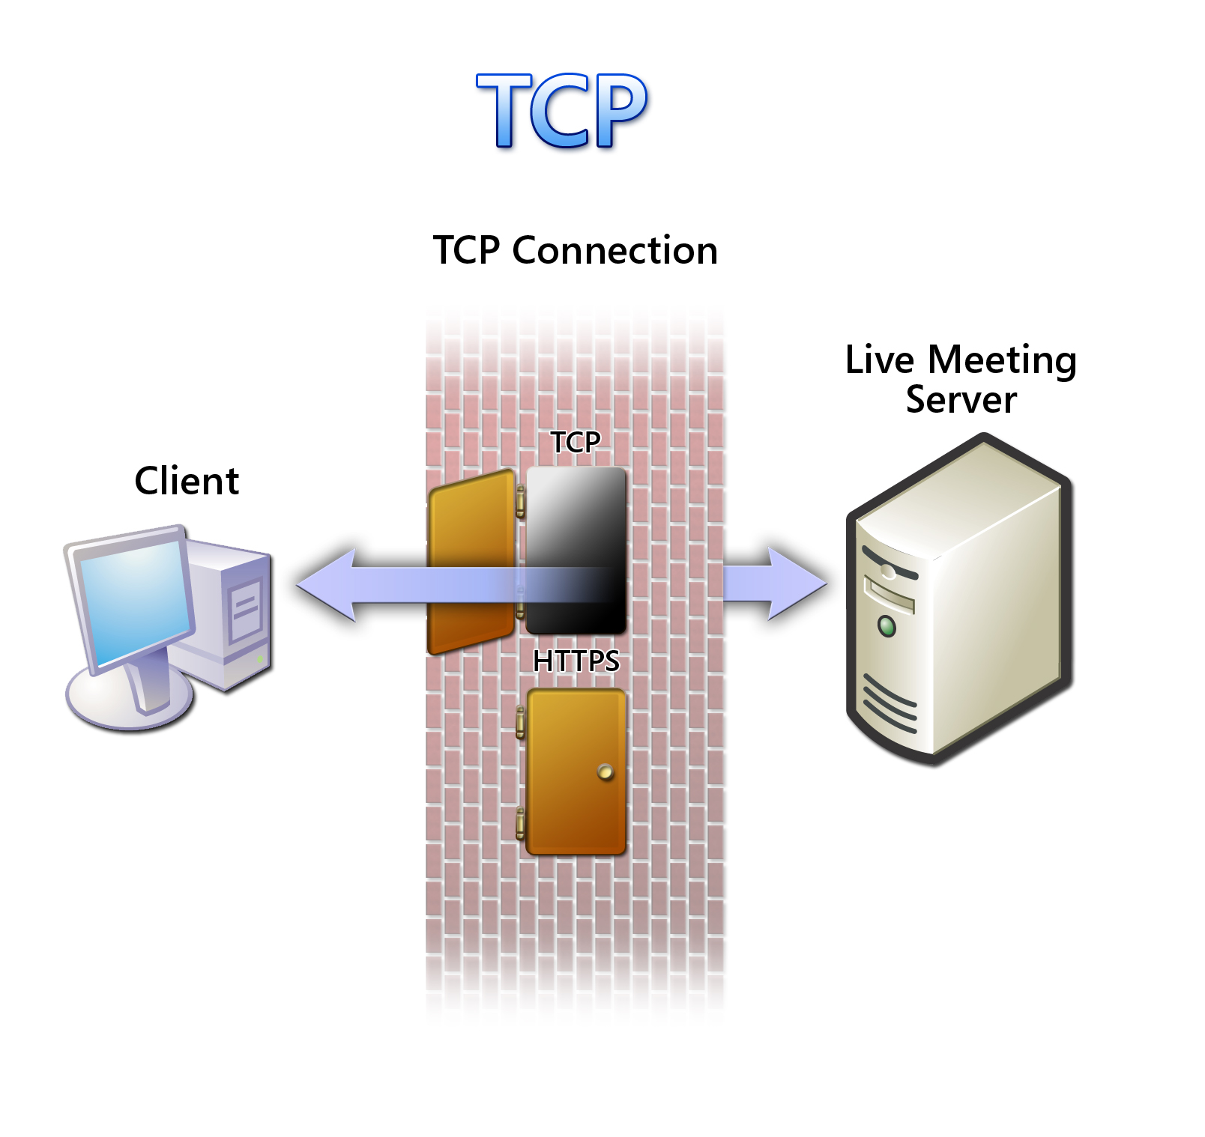
TCP
Some real-time collaboration tools are designed to support T.120 and H.323 standards, which use the TCP protocol. Although T.120 and H.323 are approved by various international standards organizations they are not universally enabled by firewall administrators. For this reason, they will not work across restricted firewalls.

Users who want such products supported can ask their firewall administrators to "punch a hole" in the firewall to allow specific protocols and ports. But most firewall administrators are reluctant to do this without studying the protocols and products in depth to ensure that they will not make their intranets vulnerable to attack. Certifying protocols is often time consuming, even if configuring the firewall is straightforward.

As a result, this approach is usually impractical for events that are not planned well in advance. Because of the performance advantages of direct TCP connections, Live Meeting automatically senses whether this protocol is allowed through the firewall and uses it if allowed. However, Live Meeting does not limit itself to TCP connections and employs alternative approaches when TCP is not allowed.

Figure 3: HTTPS Connection

HTTPS (Port 443)
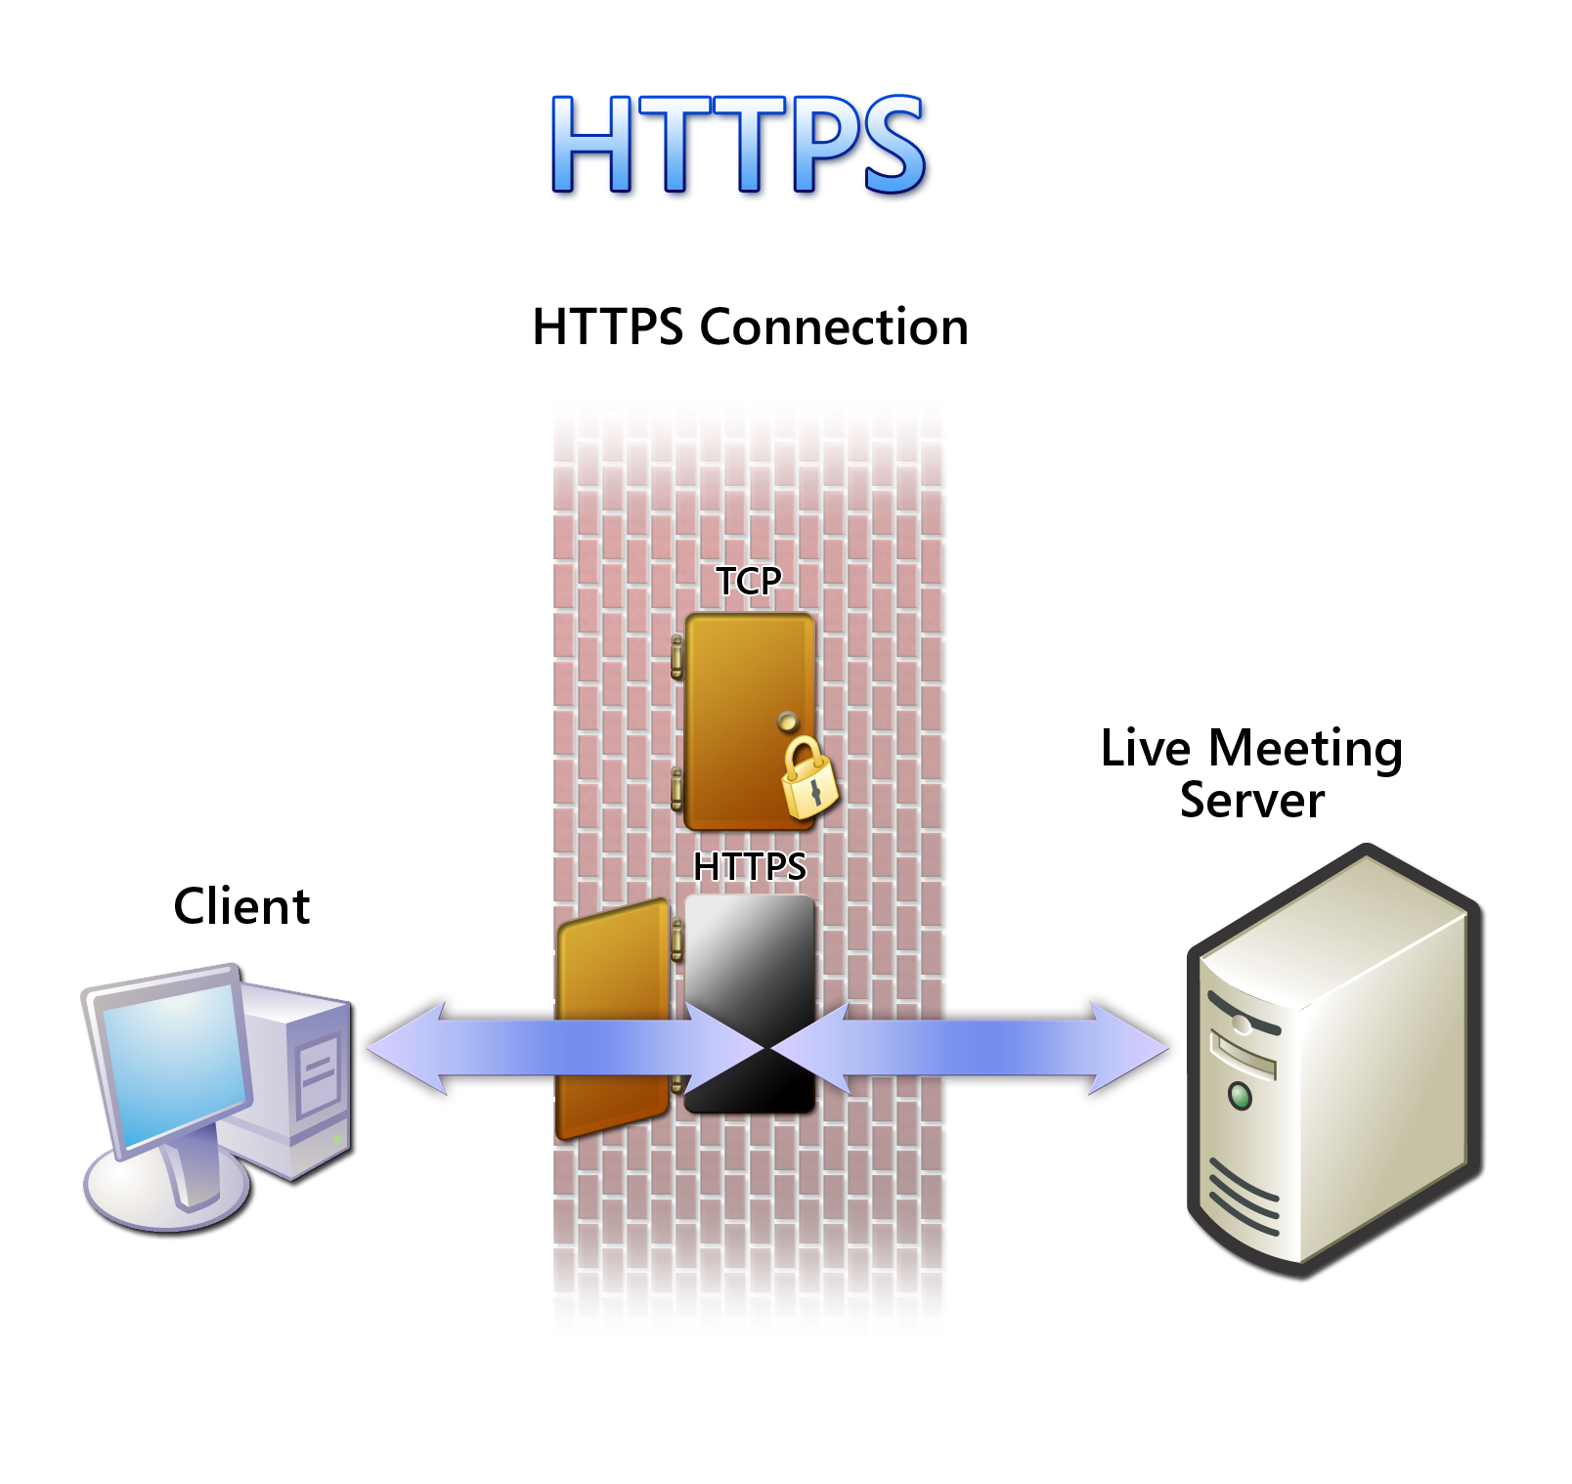
This involves using HTTPS and port 443 tunneling to ensure that communications are allowed through any firewall that supports Web browsing. Tunneling streaming data such as that used in Live Meeting over a protocol like HTTPS is less efficient, and thus adds some performance penalty. Live Meeting supports an HTTPS pass-through mode, but will only use this mode if a direct TCP connection cannot be established.

Live Meeting Auto Sensing Technology
As this paper has discussed, it is possible to choose different protocols to ensure the largest possible reach. However, most users are not aware of their firewall policy settings. Therefore, they are unable to manually select the optimal solution for their unique situations.

Live Meeting provides unique auto sensing technology that automatically detects firewall policies and optimizes client/server communication policies strategically to offer each client the best performance possible. Each participant connecting to the Live Meeting service will use the most efficient method of the previous two options, based on what is permitted by their firewall policy.

