

ISA Server 2004 VPN Deployment Kit
Table of Contents

For the latest information, please see http://www.microsoft.com/isaserver/


Contents:

Chapter 1
ISA Server 2004 and VPN Networking
Chapter 2
How to Use the Guide
Chapter 3
Installing ISA Server 2004 on Windows Server 2003
Chapter 4
Configuring the ISA Server 2004 Firewall as a VPN Server
Chapter 5
Creating Access Policy for VPN Clients
Chapter 6
Configuring the ISA Server 2004 Firewall for Outbound PPTP and L2TP/IPSec Access
Chapter 7
Configuring Windows Server 2003 RADIUS Support for VPN Clients – Including Support for EAP/TLS Authentication
Chapter 8
Configuring the VPN Client and ISA Server 2004 VPN Server to Support Certificate-Based PPTP EAP-TLS Authentication
Chapter 9
Enabling Network Browsing for ISA Server 2004 VPN Clients
Chapter 10
Creating PPTP and L2TP/IPSec Site-to-Site VPNs with ISA Server 2004 Firewalls
Chapter 11
Creating a Site-to-Site VPN with ISA Server 2004 at Local and Remote Sites using IPSec Tunnel Mode
Chapter 12
Allowing Inbound L2TP/IPSec NAT Traversal Connections through a Back-to-Back ISA Server 2004 Server DMZ
Chapter 13
Allowing Inbound PPTP Connections through a Back-to-Back ISA Server 2004 Server Perimeter Network
Chapter 14
Configuring VPN Quarantine



This is a preliminary document and may be changed substantially prior to final commercial release of the software described herein.
The information contained in this document represents the current view of Microsoft Corporation on the issues discussed as of the date of publication. Because Microsoft must respond to changing market conditions, it should not be interpreted to be a commitment on the part of Microsoft, and Microsoft cannot guarantee the accuracy of any information presented after the date of publication.
This white paper is for informational purposes only. MICROSOFT MAKES NO WARRANTIES, EXPRESS OR IMPLIED, IN THIS
DOCUMENT.
Complying with all applicable copyright laws is the responsibility of the user. Without limiting the rights under copyright, no part of this document may be reproduced, stored in, or introduced into a retrieval system, or transmitted in any form or by any means (electronic, mechanical, photocopying, recording, or otherwise), or for any purpose, without the express written permission of Microsoft Corporation.
Microsoft may have patents, patent applications, trademarks, copyrights, or other intellectual property rights covering subject matter in this document. Except as expressly provided in any written license agreement from Microsoft, the furnishing of this document does not give you any license to these patents, trademarks, copyrights, or other intellectual property.
© 2004 Microsoft Corporation. All rights reserved.
The example companies, organizations, products, domain names, e-mail addresses, logos, people, places, and events depicted herein are fictitious. No association with any real company, organization, product, domain name, e-mail address, logo, person, place, or event is intended or should be inferred.
Microsoft, Windows, Windows 2000, Windows 2000 Server, Windows Server 2003, Windows Server System, ISA Server, and ISA Server 2004 are either registered trademarks or trademarks of Microsoft Corporation in the United States and/or other countries.
The names of actual companies and products mentioned herein may be the trademarks of their respective owners.

ISA Server 2004 VPN Deployment Kit: ISA Server 2004 and VPN Networking
Chapter 1

For the latest information, please see http://www.microsoft.com/isaserver/

Contents
Introduction 1
Firewall Policy Applied to VPN Client Connections 3
Firewall Policy Applied to VPN Site-to-Site Connections 5
VPN Quarantine 6
User Mapping of VPN Clients 8
SecureNAT Client Support for VPN Connections 10
Site-to-Site VPN Using Tunnel Mode IPSec 11
Publishing PPTP VPN Servers 13
Pre-shared Key Support for IPSec VPN Connections 15
Advanced Name Server Assignment for VPN Clients 17
Monitoring of VPN Client Connections 18
Conclusion 19

Introduction
VPN networking allows remote access to resources on the corporate network that would otherwise only be available if the user were directly connected to the corporate LAN. A VPN connection creates a “virtual” point-to-point link between the remote VPN user and the corporate network. Applications and services running on the user’s computer treat the VPN link as typical Ethernet connection. The Internet separating the client and corporate network is completely transparent to the users and applications.
One of the major advantages of using a VPN connection, rather than a client/server Web application, is that VPN users at remote locations can potentially access all protocols and servers on the corporate network. Users can access the full range of services on Microsoft Exchange Servers, Microsoft SharePoint Servers, Microsoft SQL Servers and Microsoft Live Communication Servers in the same manner as they do when they are at the corporate location. The remote access VPN user does not need special software to connect to each of these services, and the network and firewall administrator does not need to create special proxy applications to connect to these resources.
ISA Server 2000 was the first Microsoft firewall to provide tightly integrated VPN configuration and management. The ISA Server 2000 VPN integration included easy to use wizards, making it a simple affair to create remote access and site-to-site (gateway-to-gateway) VPN connections to the ISA Server 2000 firewall/VPN server. However, the ISA Server 2000 VPN server required the firewall administrator to spend a good deal of time in the Routing and Remote Access console to fine tune the VPN server configuration.
ISA Server 2004 builds on the successes of the ISA Server 2000 firewall/VPN combination and significantly enhances the VPN components included with the Windows 2000 and Windows Server 2003 Routing and Remote Access Services (RRAS). The ISA Server 2004 firewall administrator can enable, configure and manage the VPN server and gateway components directly from the ISA Server 2004 firewall management console. Only in rare situations will the firewall administrator need to enter the Routing and Remote Access console to configure VPN components.
Comprehensive VPN server and gateway management from within the ISA Server 2000 management interface is only the first of many improvements the ISA Server 2004 firewall/VPN server has over the ISA Server 2000 firewall/VPN, as well as over the Windows 2000 and Windows Server 2003 RRAS VPN. These advantages include:
- Firewall Policy Applied to VPN Client Connections
- Firewall Policy Applied to VPN Site-to-Site Connections
- VPN Quarantine
- User Mapping of VPN Clients
- SecureNAT client support for VPN connections
- Site-to-Site VPN using Tunnel Mode IPSec
- Publishing PPTP VPN Servers
- Pre-shared Key for IPSec VPN Connections
- Advanced Name Server Assignment for VPN Clients
- Monitoring of VPN Client Connections
Added together, this collection of VPN server and gateway features makes ISA Server 2004 the most compelling and unique co-located VPN and firewall solution on the market today. The remainder of this ISA Server 2004 VPN Deployment Kit document discusses each of these new features and capabilities and how these work together to make the ISA Server 2004 VPN solution the VPN of choice for all organizations running Microsoft networks.

Firewall Policy Applied to VPN Client Connections
When a VPN remote-access client establishes a connection with the VPN server, that VPN client acts like a machine that is directly connected to the corporate network. This virtual link to the corporate network enables the remote VPN user access to almost every resource on the corporate network, limited only by the access controls configured on the servers and workstations. This highly-available connection enables the VPN user to access resources that might otherwise not be available.
However, the power to access virtually any resource on a corporate network can be a double-edged sword. In most cases, you do not want users to have a full range of access to corporate resources when they connect via a remote-access VPN connection. Often these users are connecting from computers that are not within your control and may not conform to corporate software and security policies. In addition, these users may connect from computers connected to untrusted networks, such as hotel broadband networks or partner sites.
Only highly trusted users connecting from trusted machines on verified networks should be allowed unfettered access to the corporate network when connected via a remote-access VPN link. These users might comprise the network, security and firewall administrators groups, as well as a collection of highly placed executives. All other users should be locked down so that they can only access a subset of network resources when connected via the VPN link.
For example, many firewall administrators grant users VPN connections so they can use the Outlook 2000/2002/2003 MAPI client to access the full range of services provided to the Outlook client by a Microsoft Exchange Server. While Microsoft Exchange provides a number of methods allowing remote access to Exchange Server resources -- such as the SMTP, POP3, IMAP3 and Outlook Web Access (OWA) services -- users prefer to keep the broad range of options available to them when using the full Outlook MAPI client.
In order to meet employee and management demands, the firewall administrator had two choices:
- Publish the Exchange Server using the ISA Server, a secure RPC Server Publishing Rule
- Use the Outlook 2003/Exchange 2003 RPC over HTTP protocol
- Grant users VPN access to the corporate network
The ISA Server secure RPC Server Publishing mechanism enables remote Outlook MAPI clients to connect to the full range of Microsoft Exchange Server services from any location in the world. However, many firewalls and ISPs have blocked access to the RPC port mapper port (TCP 135), which is required to make the initial secure connection to the Exchange Server using a secure Exchange RPC publishing rule. While this feature was very popular and provided almost ubiquitous, secure access to Microsoft Exchange from anywhere in the world without requiring reconfiguration of the Outlook MAPI client when ISA Server 2000 debuted, this feature has lost much of its utility since the wholesale shutdown of TCP 135 subsequent to the Blaster worm’s appearance on the scene.
RPC over HTTP(S) solves this problem by tunneling (or encapsulating) the RPC connection required by the full Outlook MAPI client to connect to the full range of resources on the Exchange Server inside an HTTP header. This allows the Outlook MAPI client to send requests to the Exchange Server using HTTP. Since all corporate firewalls and ISPs allow HTTP, protocol access isn’t a problem. The primary limitation to the RPC over HTTP solution is that not all organizations are currently using Outlook 2003 and Exchange Server 2003.
VPN connections get around both the above-mentioned limitations. However, providing access is done at the expense of security, as all VPN clients can access the entire network. The ideal solution would be to enforce Access Policy on VPN clients based on user/group so that users access only the servers, and the protocols, they require.
ISA Server 2004 is unique because it is the only VPN server solution that provides this level of access control. When VPN clients connect to the VPN server, those clients are placed on the VPN Clients Network. The ISA Server 2004 firewall treats this network like any other network, and strong user/group-based access controls can be placed on traffic moving between the VPN Clients Network and the corporate network.
Using an ISA Server 2004 firewall/VPN server, you can create an Active Directory group, such as Exchange Users, and then add the user accounts to this group. Then, you can create a firewall Access Policy limiting members of this group to connecting only to the Exchange Server computer. Further, when they connect to the Exchange Server computer, they can use only those protocols required to connect the Outlook MAPI client to the Exchange Server. Although the members of this group are allowed to connect to the Exchange Server machine when connected via remote-access VPN, they cannot use other protocols, such as SMTP, POP3, ICMP, or any other. The firewall policy protects the entire network by preventing all access to any other machine. It also protects the Exchange Server by preventing access to any protocol and services outside of those required to connect the Outlook MAPI client to Exchange.
Remote-access VPN connection to Microsoft Exchange is only one example of how to place strong user/group-based access controls on VPN clients. Other examples include VPN access to perimeter (extranet) networks to other services and protocols for partners. Partners may need access to Web, SMTP, SQL, and other resources. Again, all you need to do is create the user accounts, and create an access policy on the ISA Server 2004 firewall/VPN server that limits what machines and protocols the partners can access and use. Those network devices are then protected from the partner VPN remote-access users.
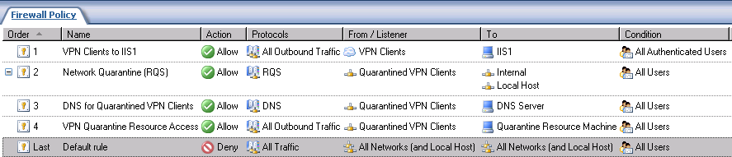
This ability to exert fine-tuned control over traffic moving between the VPN Clients Network and any other network is the one feature, above all others provided by the ISA Server 2004 firewall, that truly sets it apart and above all other firewall solutions in its class. It virtually obviates the need for SSL VPNs (except in circumstances where remote users are behind restrictive firewalls that block all but HTTP and SSL connections outbound) and other proprietary remote-access solutions aimed at providing per protocol, per server, per user/group-access to corporate network resources. Almost all commercial broadband networks at hotels and conference centers allow outbound PPTP and L2TP/IPSec via NAT Traversal, which provides almost universal remote access for your VPN users, without the security hit you typically see with VPN client connections.

Firewall Policy Applied to VPN Site-to-Site Connections
A site-to-site VPN connection connects two or more networks using a VPN connection over the Internet. Connecting networks to one another over a VPN site-to-site link can lead to substantial cost savings when compared to dedicated WAN links that use dedicated circuits. Each site requires a VPN gateway and a relatively inexpensive Internet connection. When the VPN gateways establish connection with one another, the site-to-site VPN link is established. Users can then communicate with other networks over the VPN site-to-site link as they would with another other-routed connection on their own network. The VPN gateways act as VPN routers that route the packets to the appropriate network.
VPN site site-to-site connections use the same VPN technologies as those employed with remote-access VPN connections. In traditional VPN gateway (router) environments, all users had access to the entire network to which their - network is connected. Only local access controls on the servers kept users out of network resources for which they had no permission to access.
Like the situation with the remote-access VPN clients, site-to-site VPN connections allow entire networks the potential to access any resources on the remote network. In most cases, a site-to-site VPN connection is made between branch office and main office networks. Branch office network users may or may not be under the direct control of the network, security and firewall teams at the main office. Providing access to the entire main office network by branch office users can negatively impact the security environment on the main office network.
Unlike other firewalls, the ISA Server 2004 firewall/VPN server can solve this problem by controlling outbound traffic moving through the site-to-site link. Users at the branch office should be limited to only the resources on the main office network that they require and prevented from accessing computer resources that they do not require. And, like the remote access VPN clients, the users at the branch office should only be allowed to use the specific protocols they require on the servers they are allowed to access.
The ISA Server 2004 firewall/VPN gateway helps prevent malicious users on branch office networks from leveraging an “all open” connection to the branch office to launch an attack. Access is limited to a subset of servers and services and those specific servers and services. This makes it much more difficult for attackers at branch office networks to compromise the corporate network. Not only are branch office users limited to specific services and protocols, but the VPN site-to-site connections are exposed to the ISA Server 2004 firewalls sophisticated application layer filters.
VPN site-to-site connections paired with strong user/group-based access control provide a powerful combination of cost-saving and increased security. ISA Server 2004 site-to-site VPNs literally change the face of VPN network security. No longer do firewall and network administrators need to worry about unapproved traffic emanating from branch office networks reaching the corporate network.

VPN Quarantine
The VPN Quarantine (VPN-Q) feature allows you to screen VPN client machines before allowing them access to the corporate network. VPN Quarantine functionality included with ISA Server 2004 is similar to that found in the Windows Server 2003 RRAS. You create a CMAK (Connection Manager Administration Kit) package that includes a VPN-Q client and a VPN-Q client-side script. The client runs the script and reports the results to the VPN-Q server component on the ISA 2004 firewall/VPN server. The VPN client is moved from the “VPN Quarantine” network to the “VPN Clients” network if the script reports that the client meets the software requirements for connecting to the network. You can set different access policies for hosts on the VPN Quarantine network versus the VPN Clients network.
The ISA 2004 firewall greatly extends the functionality of the Windows Server 2003 RRAS VPN-Q because the Windows Server 2003 RRAS VPN-Q does not set policy-based access controls. The RRAS VPN-Q uses simple “port based” access controls, but it would be a stretch to consider port-based access controls as providing any level of serious security. In contrast, the ISA Server 2004 firewall applies strong firewall policy-based access controls over hosts on the VPN Quarantine network and exposes these connections to the ISA Server 2004 firewall’s sophisticated application layer filters.
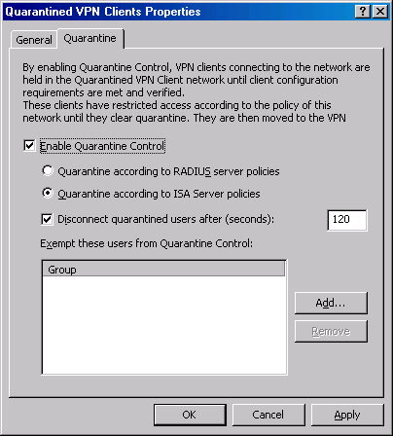
There is some especially good news for ISA Server 2004 firewall administrators who are planning to install the firewall on Windows 2000. When you install ISA Server 2004 on a Windows 2000 machine, the firewall will bring with it VPN-Q functionality. You don’t need Windows Server 2003 to get the VPN-Q feature when ISA Server 2004 is installed on the Windows 2000 machine. While there is a limitation of using ISA Server 2004 VPN-Q policies rather than RADIUS policies, the additional functionality ISA Server 2004 adds to the Windows 2000 RRAS VPN is significant.

User Mapping of VPN Clients
User mapping is used to map virtual private network (VPN) clients connecting to the ISA Server using an authentication method that is not based on “Windows authentication” (such as RADIUS or EAP authentication) to the Windows namespace. When user mapping is enabled and configured, firewall policy access rules specifying user sets for Windows users and groups are also applied to authenticated users that do not use Windows authentication. If you do not define user mapping for users from namespaces that are not based on Windows, default firewall policy access rules will not be applied to them.
The user mapping feature extends the strong user/group-based access controls you place on VPN clients to VPN clients that authenticate using a authentication method other than Windows. This is an important feature. Windows authentication of domain users is only available when the ISA Server 2004 firewall belongs to the domain that contains the users accounts, or to a domain that is trusted by the user accounts domain. If the ISA Server 2004 firewall does not belong to a domain, then Windows authentication is used only for user accounts stored on the ISA Server 2004 firewall machine itself.
In general, you do not want a perimeter ISA Server 2004 firewall to be a member of the user domain. This enhances the level of security afforded to the firewall and the domain, because in the event that the perimeter firewall is compromised, the attacker will not be able to leverage the machine’s domain membership to launch an attack against the Internet network.
User mapping allows you to use RADIUS authentication of domain users and apply user/group based-access control over VPN clients who authenticated using RADIUS. Without the user mapping feature, you would not have access to strong user/group-based access control. Access Policies from the VPN Clients Network to the Internal network would be limited control protocol and server access to all users connecting to the VPN.
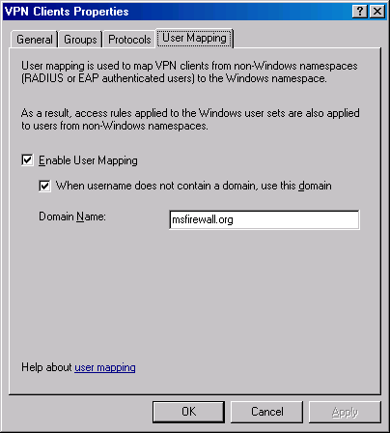
The user mapping feature is unique to the ISA Server 2004 firewall/VPN server and provides another compelling reason for why ISA Server 2004 is the firewall and VPN server for Microsoft networks.

SecureNAT Client Support for VPN Connections
One of the primary limitations to the ISA Server 2000 firewall/VPN servers is, in order for VPN clients to access resources on the Internet, they have to choose from one of the two following options:
- Enable split tunneling on the VPN client
- Install the Firewall Client software on the VPN client machine
Split tunneling is accomplished when the VPN client machine is not configured to use the default gateway on the remote network. The default setting for Microsoft VPN clients is to use the default gateway on the remote network. When VPN clients do not use the default gateway on the remote network, they have the ability to access resources on the corporate network via the VPN connection and resources on the Internet via the Internet connection established by the VPN client machine before the VPN connection took place.
There are serious negative security implications when the VPN client machine is able to access the Internet directly while at the same time being able to access the corporate network via the VPN link. This situation allows the VPN client computer to completely bypass all Internet access policies configured on the ISA Server 2000 firewall for the duration of the VPN connection. Split tunneling is analogous to allowing workstations on the corporate network to have local modem connections. The modem connections completely bypass the ISA Server 2000 firewall policy and allow the host access to the Internet that would not otherwise be allowed by the ISA Server 2000 firewall policies. There is the potential to download worms, viruses and other dangerous content. In a worst case scenario, a malicious user on the Internet would be able to route exploits from an Internet-based host through the machine that is split tunneling and into the corporate network.
An alternate method of allowing VPN clients Internet access while connected to the ISA Server 2004 firewall/VPN server is required because of the significant dangers inherent in split tunneling. A viable alternative is installing the firewall client on the VPN client machine. The Firewall client will forward requests directly to the ISA Server firewall’s internal IP address and not require split tunneling to connect to the Internet. Not only does the Firewall client remove the need to enable split tunneling, it also exposes the VPN client machine to the ISA Server 2000 firewall access policies.
ISA Server 2004 firewall/VPN servers solve the problem of split tunneling and the Firewall client requirement by enabling Internet access for VPN SecureNAT clients. The VPN clients are by default SecureNAT clients of the ISA Server 2004 firewall because they use the firewall as their default gateway. The ISA Server 2004 firewall/VPN server then uses the log-on credentials of the VPN client to exert strong user/group-based access controls, limiting the sites, content and protocols VPN client machines can access on the Internet.
Although the Firewall client software is no longer required on VPN client computers to access the Internet through the ISA Server 2004 firewall machine, you may want to install the Firewall client on VPN client machines if you want to support complex protocols that require one or more secondary connections. SecureNAT clients can use complex protocols requiring secondary connection only when there is an application filter to support the secondary connections. In contrast, Firewall client machines are able to access any TCP or UDP protocol, even those that require secondary connections, without the aid of the Application Filter.

Site-to-Site VPN Using Tunnel Mode IPSec
ISA Server 2000 was an excellent combination of network firewall and VPN server/VPN gateway. VPN remote-access clients could use PPTP or L2TP/IPSec to connect to the ISA Server 2000 VPN server. Similarly, other VPN gateways could connect to the ISA Server 2000 VPN gateway and establish site-to-site VPN links between two geographically disparate networks.
The problem with ISA Server 2000 was that the majority of third-party VPN gateways did not support PPTP or L2TP/IPSec for VPN gateway-to-gateway connections. The third-party VPN gateways required IPSec tunnel mode VPN connections. If you had ISA Server 2000 firewall/VPN servers on each site, it was simple to create a highly secure L2TP/IPSec VPN connection between the sites. However, if you had a third-party VPN gateway at the main office, and you wanted to install an ISA Server 2000 VPN gateway at a branch office, you would not be able to establish a site-to-site VPN connection to the main office VPN gateway because of its lack of support for IETF-ratified VPN protocols for site-to-site links.
ISA Server 2004 firewalls solve this problem by enabling the firewall administrator to use IPSec tunnel mode for site-to-site links between an ISA Server 2004 VPN gateway and a third-party VPN gateway. You can still use PPTP or L2TP/IPSec to create site-to-site links between ISA Server firewall/VPN gateways. ISA Server 2004 enables you to use a lower security IPSec tunnel mode connection to connect to third-party VPN gateways, while enabling you to use a high-security L2TP/IPSec VPN connection when connecting to other ISA Server-based firewall/VPN gateways.
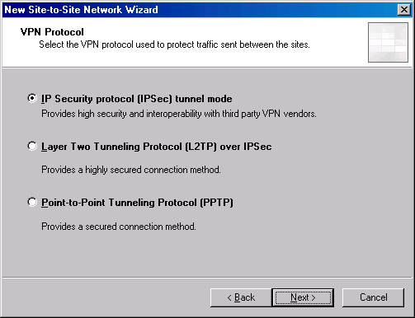
Note that only PPTP and L2TP/IPSec are the only VPN protocols supported for remote access VPN clients. The reason for this is that IPSec tunnel mode is less secure than L2TP/IPSec. IPSec tunnel mode is subject to a number of well-known exploits that can lead to man-in-the-middle attacks. In contrast, L2TP/IPSec required much strong authentication and key generation mechanisms, and therefore, is not open to the same attacks.
IPSec tunnel mode support greatly increases the VPN site-to-site compatibility for ISA Server 2004 and makes it possible to place an ISA Server 2004 firewall/VPN server at any branch of a main office and connect to a third-party VPN gateway.

Publishing PPTP VPN Servers
In ISA Server 2000, Server Publishing Rules were limited to servers that required only TCP or UDP protocols. You could not publish servers that required non-TCP or UDP protocols, such as ICMP or GRE. You could not publish a PPTP server because the GRE protocol is a non-TCP or UDP protocol. The only alternative with ISA Server 2000 was to put these servers on a perimeter network segment and use packet filters to allow the required protocols to and from the Internet.
This problem is solved with ISA Server 2004 firewalls. You can create Server Publishing Rules for any IP protocol using ISA Server 2004, including Server Publishing Rules for GRE. The ISA Server 2004 firewall’s enhanced PPTP filter now supports both inbound and outbound connections. The new inbound access support enables you to publish the PPTP VPN server located behind an ISA Server 2004 firewall.
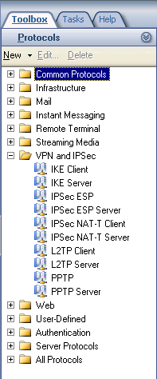
The new PPTP server publishing feature supports scenarios where network and firewall administrators prefer to have a firewall located in front of the VPN server. In a back-to-back ISA Server 2004 firewall configuration, the front-end ISA Server 2004 firewall publishes the PPTP VPN server located on the back-end ISA Server 2004 firewall. The front-end ISA Server 2004 firewall forwards the incoming PPTP connections to the back-end ISA Server 2004 firewall. The VPN connection is terminated at the back-end ISA Server 2004 VPN server, which establishes the VPN link between the VPN client and server. In contrast, in a back-to-back ISA Server 2000 firewall configuration, you would have to perform VPN passthrough to reach the back-end VPN server. This required the user to establish a VPN connection to the front-end ISA Server 2000 VPN server, and then establish a second VPN connection by going through the VPN tunnel already established with the front-end ISA Server 2000 firewall.
PPTP Server Publishing included with ISA Server 2004 greatly simplifies publishing PPTP VPN servers. This feature will be very popular among former ISA Server 2000 firewall administrators who had to create VPN passthrough connections in order to reach the Internal network.

Pre-shared Key Support for IPSec VPN Connections
In a high-security environment, a Public Key Infrastructure (PKI) must be in place so that computer and user certificates can be issued to hosts participating in an IPSec-based VPN connection. Certificates are used for computer authentication for L2TP/IPSec remote access and gateway-to-gateway connections, and for IPSec tunnel mode connections. Certificates can also be used for user authentication for both PPTP and L2TP/IPSec connections.
Deploying a workable PKI is not a simple task, and many network administrators do not have the time or the expertise to implement one quickly. However, these same network administrators would like to benefit from the level of security provided by IPSec-protected VPN connections.
ISA Server 2004 allows you to use pre-shared keys in place of certificates when creating remote access and gateway-to-gateway VPN connections. All VPN client machines running updated L2TP/IPSec VPN client software can use a pre-shared key to create an L2TP/IPSec remote-access VPN client connection with the ISA Server 2004 firewall/VPN server. Windows 2000 and Windows Server 2003 VPN gateways can also be configured to use a pre-shared key to establish site-to-site links.
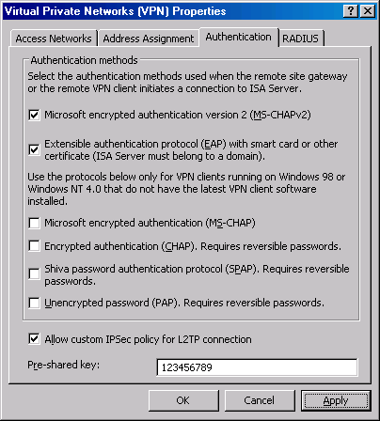
Pre-shared key support for IPSec-based VPN connections should be used with care. The preferred method is to use certificates. A single remote-access server can utilize only one pre-shared key for all L2TP/IPSec connections requiring a pre-shared key for authentication.
You must issue the same pre-shared key to all L2TP/IPSec VPN clients connecting to the remote-access server using a pre-shared key. Unless you distribute the pre-shared key within a Connection Manager profile (CMAK), each user must manually enter the pre-shared key into the VPN client software settings. This reduces the security of the L2TP/IPSec VPN deployment and increases the probability of user error and increased number of support calls related to L2TP/IPSec connection failures.
If the pre-shared key on the ISA Server 2004 firewall/VPN server is changed, a client with a manually configured pre-shared key will not be able to connect using the L2TP/IPSec pre-shared key until the key on the client is changed.
If the pre-shared key was distributed to the client within a CMAK profile, that profile must be updated with the new pre-shared key and redistributed to all the VPN clients. Unlike certificates, the origin and the history of a pre-shared key cannot be determined. For these and many other reasons, using pre-shared keys to authenticate L2TP over IPSec connections is considered a relatively weak authentication method.
Nonetheless, the ability to easily use pre-shared keys to create secure L2TP/IPSec connections to the ISA Server 2004 firewall/VPN server is sure to be popular among firewall administrators. Pre-shared keys are an ideal “stop gap” measure that you can put into place while you’re in the process of putting together your certificate-based Public Key Infrastructure. Once the PKI is complete, you can migrate the clients from pre-shared keys to industrial strength computer and user certificate authentication.

Advanced Name Server Assignment for VPN Clients
The ISA Server 2000 VPN server and gateway was primarily based on the VPN components included with the Windows 2000 and Windows Server 2003 Routing and Remote Access Services. The RRAS VPN services allow you to assign name server addresses to VPN remote-access clients. Proper name server assignment is critical to VPN clients. Incorrect name server assignment can lead to VPN client inability to connect to either Internal network resources or resources located on the Internet.
The ISA Server 2000 VPN server was able to assign name server addresses using:
- Name server addresses that were bound to one of the network interfaces on the ISA Server 2000 firewall machine
- Name server addresses provided to the VPN client via DHCP options. This was available only if the DHCP Relay Agent was installed on the ISA Server 2000 firewall/VPN server
There may be circumstances when you want to assign VPN clients name server addresses that are not based on the network interface configuration on the firewall/VPN server, and you do not want to install the DHCP Relay Agent on the firewall. ISA Server 2000 did not support this scenario.
ISA Server 2004 firewall/VPN servers overcome this problem by allowing you to override the name server settings on the ISA Server 2004 firewall/VPN server and issue custom name server addresses to the VPN clients. This configuration can be done within the ISA Server 2004 management console and does not require you to enter the RRAS console to create the custom configuration.
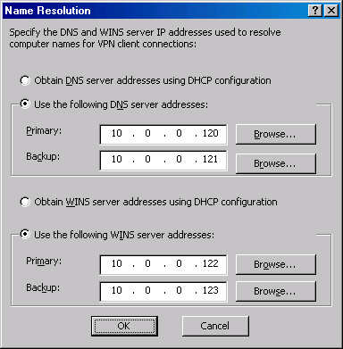

Monitoring of VPN Client Connections
The ISA Server 2000 VPN server was limited by the logging and monitoring capabilities of the Windows 2000 and Windows Server 2003 RRAS VPN. In order to determine who connected to the network via a VPN connection, you had to sift through rudimentary text files or database entries. In addition, since the firewall did not manage the VPN remote-access client connections, there was no central mechanism in place at the firewall to determine what resources were accessed by VPN remote-access clients.
ISA Server 2004 solves this problem by applying firewall policy to all connections to all firewall connections. You can then use the real-time log viewer to view ongoing VPN remote-access client connections. Or, if you log in to an MSDE database, you can query the database using the ISA Server 2004 logging and monitoring feature to view only VPN client connections. With ISA Server 2004 firewall/VPN servers, you not only get complete information about who is connected to the ISA Server 2004 firewall/VPN, you also get information about what resources those users connected to and what protocols they used to connect to those resources.
This ISA Server 2004 logging and monitoring feature far surpasses the logging and monitoring features included with ISA Server 2000, as well as the standalone Windows 2000 and Windows Server 2003 Routing and Remote Access Service VPN.
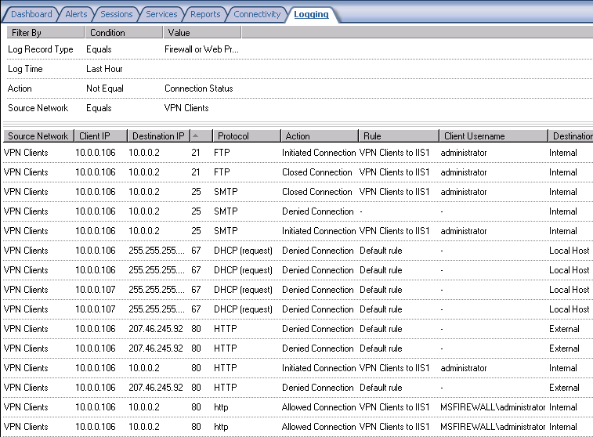

Conclusion
In this ISA Server 2004 VPN Deployment Kit document, we discussed the many improvements and features that the ISA Server 2004 VPN server adds over the ISA Server 2000 VPN server and the basic Windows 2000 and Windows Server 2003 RRAS VPN server components. The new features and capabilities included with the ISA Server 2004 VPN server makes it the preferred VPN server for all Microsoft networks. In the next document in this ISA Server 2004 VPN Deployment Kit series, we discuss basic VPN concepts, describe how to use this Kit and delineate the sample network that is used as the baseline for all documents in the ISA Server 2004 VPN Deployment Kit.

This is a preliminary document and may be changed substantially prior to final commercial release of the software described herein.
The information contained in this document represents the current view of Microsoft Corporation on the issues discussed as of the date of publication. Because Microsoft must respond to changing market conditions, it should not be interpreted to be a commitment on the part of Microsoft, and Microsoft cannot guarantee the accuracy of any information presented after the date of publication.
This white paper is for informational purposes only. MICROSOFT MAKES NO WARRANTIES, EXPRESS OR IMPLIED, IN THIS
DOCUMENT.
Complying with all applicable copyright laws is the responsibility of the user. Without limiting the rights under copyright, no part of this document may be reproduced, stored in, or introduced into a retrieval system, or transmitted in any form or by any means (electronic, mechanical, photocopying, recording, or otherwise), or for any purpose, without the express written permission of Microsoft Corporation.
Microsoft may have patents, patent applications, trademarks, copyrights, or other intellectual property rights covering subject matter in this document. Except as expressly provided in any written license agreement from Microsoft, the furnishing of this document does not give you any license to these patents, trademarks, copyrights, or other intellectual property.
© 2004 Microsoft Corporation. All rights reserved.
The example companies, organizations, products, domain names, e-mail addresses, logos, people, places, and events depicted herein are fictitious. No association with any real company, organization, product, domain name, e-mail address, logo, person, place, or event is intended or should be inferred.
Microsoft, Windows, Windows 2000, Windows 2000 Server, Windows Server 2003, Windows Server System, ISA Server, and ISA Server 2004 are either registered trademarks or trademarks of Microsoft Corporation in the United States and/or other countries.
The names of actual companies and products mentioned herein may be the trademarks of their respective owners.

ISA Server 2004 VPN Deployment Kit: How to Use the Guide
Chapter 2
Published: April 2004
For the latest information, please see http://www.microsoft.com/isaserver/

Contents
Introduction 1
Overview of VPN Networking 2
VPN Protocols 3
VPN Authentication 4
What is a VPN Server? 5
What is a VPN Gateway? 6
Network Services that Support VPN Client and Gateway Connections 8
Dynamic Host Configuration Protocol (DHCP) Server 8
Domain Naming Service (DNS) Server 9
Resolve Internet DNS host names 10
Resolve DNS host names of servers on the Internal network 10
Windows Internet Name Service (WINS) Server 10
Windows 2000 and Windows Server 2003 Active Directory 11
Certificate Authorities (CAs or Certificate Servers) and Public Key Infrastructure (PKI) 12
Internet Authentication Server (IAS) or RADIUS Server 14
TCP/IP Addressing Considerations with VPN Networks 15
Supporting VPN Clients 15
Supporting VPN Gateway-to-Gateway Connected Networks 16
Practice configuring the ISA Server 2004 Firewall and VPN Server 18
The ISA Server 2004 VPN Deployment Kit Lab Configuration 19
ISA Server 2004 VPN Deployment Kit Network Diagram 19
Installing and Configuring the Internal Network Domain Controller 21
Install Windows Server 2003 21
Install and Configure DNS 23
Installing and Configuring Microsoft Exchange on the Domain Controller 25
Installing and Configuring the IIS and Microsoft Certificate Services 28
Install Internet Information Services 6.0 28
Install Microsoft Certificate Services in Enterprise CA Mode 28
Installing and Configuring the Microsoft Internet Authentication Service 30
Installing the Microsoft Internet Authentication Service 30
Configuring the Microsoft Internet Authentication Service 30
Installing the WINS Server Service and Configuring the DHCP Server 32
Installing the WINS Service 32
Configuring the DHCP Service 33
Conclusion 35

Introduction
Welcome to the ISA Server 2004 VPN Deployment Kit! This kit was designed to help you with putting together a working VPN solution using ISA Server 2004 firewall/VPN servers. While this kit isn’t a comprehensive set of documentation of all possible VPN networking scenarios, it will provide you with extensive, step-by-step configuration information on the most popular VPN networking setups.
Firewalls have traditionally been among the most difficult network devices to configure and maintain. VPN server and gateway configurations are even more difficult. This guide walks you through the firewall and VPN server/gateway configurations so that traditionally complex procedures become easy. You will find that when you pair the ISA Server 2004 VPN Deployment Kit and ISA Server 2004, much of the mystery and complexity of VPN server and gateway setup will fade away.
You need to have a basic understanding of TCP/IP and Microsoft networking services in order to fully understand how ISA Server 2004 firewall and VPN servers work. The good news is that you don’t need to be a network infrastructure professional to use ISA Server 2004 as your network firewall and VPN server/gateway. ISA Server 2004 is designed from the ground up to secure your network, and it does so right out of the box.
This chapter of the ISA Server 2004 VPN Deployment Kit will:
- Discuss the basics of VPN networking
- Provide advice on how to use the Guide to configure the ISA Server 2004 firewall and VPN server
- Describe the details of the ISA Server 2004 VPN Deployment Kit Lab Configuration, installing the Windows Server 2003 domain controller and supporting networking services on the domain controller

Overview of VPN Networking
A VPN is an extension of the private network located behind your ISA Server firewall/VPN server. The VPN has two key components:

- A “virtual” network
Computers communicate with directly connected network devices using a layer 2 (data link layer) networking protocol. LAN-based computers on Ethernet networks connect to other network devices using the Ethernet data link layer protocol. Computers connecting to the Internet via a dial-up analog modem connection use the Point-to-Point (PPP) data link layer protocol to create a direct connection with the ISP network over a phone line.
These data link layer protocols establish a network connection between devices that are “directly connected” over a common wire or circuit. It is not possible to create a direct connection between two machines over the Internet because multiple networking devices separate Internet-connected computers.
However, computers can be “tricked” into acting as if they were directly connected by using a “virtual network” protocol, such as the Microsoft Point-to-Point Tunneling Protocol (PPTP) or the Layer 2 Tunneling Protocol (L2TP).
PPTP and L2TP create “virtual” direct connections between a VPN client and VPN server, or between two VPN gateways. This virtual network connection allows a computer connected over the virtual network to send and receive TCP/IP messages in the same way they do on other directly connected networks, such as computers located on the same Ethernet LAN.
- Note:
Virtual networking protocols are referred to as “tunneling” protocols because IP packets moving over the virtual network are encapsulated with the virtual networking protocol header.
- A “private” network
Although a virtual networking protocol can create a virtual “direct link” between hosts participating in the network, data moving between these hosts is not secure. For example, you can connect two machines over the Internet using the Layer 2 Tunneling Protocol (L2TP) virtual networking protocol, and all data moving between the two computers will be readable by anyone with a network analyzer.
The privacy in a virtual private network stems from the encryption protocol used to protect data moving through the virtual connection. The PPTP VPN protocol uses the Microsoft Point-to-Point Encryption protocol (MPPE) to protect data moving through the PPTP virtual networking connection. The L2TP/IPSec VPN protocol uses Internet Protocol Security (IPSec) to encrypt data moving through the L2TP virtual network.
Data encryption (or “privatization”) is critical in virtual networking scenarios because you have no knowledge of the path two virtual networking participants take to communicate. This is why the Internet is always depicted as a “cloud” in network drawings, such as figure 1. Data moving through a virtual networking protocol must be protected by encryption because you can not be sure that a malicious third party is not located on some link between the source and destination.
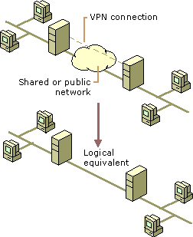

VPN Protocols
The ISA Server firewall/VPN server supports two VPN protocols:
- Point-to-Point Tunneling Protocol (PPTP)
The Point-to-Point Tunneling Protocol is a combination of the PPTP virtual networking protocol and the Microsoft Point-to-Point Encryption (MPPE) protocol. PPTP was the first VPN protocol introduced by Microsoft. The current version of PPTP is 2.0.
The level of security afforded to PPTPv2 connections relates directly to the complexity of the passwords chosen for user authentication. PPTP does not authenticate the VPN client, server or gateway computer. PPTP authentication mechanisms authenticate the user only.
While PPTP provides a good level of security, the future of VPN networking belongs to L2TP/IPSec. IPSec encryption protocols are more secure than the MPPE-based encryption used by PPTP.
- Layer 2 Tunneling Protocol over IPSec (L2TP/IPSec)
The L2TP/IPSec VPN protocol is a combination of the Layer 2 Tunneling Protocol (L2TP) and the IPSec encryption protocol. The IPSec encryption protocol confers several advantages to L2TP/IPSec:
- Certificate-based computer authentication, in addition to password or certificate-based user authentication; two levels of authentication instead of PPTP’s single level
- Protection of data in transit; data changed between source and destination is dropped by IPSec
- User credentials are protected by an established IPSec encrypted tunnel; PPTP protects user credentials inside an encrypted tunnel and depends on the security of user authentication protocol
L2TP/IPSec should be used preferentially over PPTP whenever possible.

VPN Authentication
Connections to a VPN server must be authenticated before permission is granted to access the private network through the VPN link. There are two general categories of user authentication protocols used by ISA Server firewall/VPN servers:
- PPP authentication protocols
PPP user authentication protocols authenticate the connection between a PPP client and PPP server. PPP authentication protocols are the standard for remote-access user authentication. PPP authentication protocols supported by the ISA Server firewall/VPN server include:
- Password Authentication Protocol (PAP)
- Challenge-Handshake Authentication Protocol (CHAP)
- Microsoft Challenge-Handshake Authentication Protocol (MS-CHAP)
- Microsoft Challenge-Handshake Authentication Protocol version 2 (MS-CHAP v2)
To insure the greatest level of security for PPTP VPN connections, allow only MS-CHAP v2 authentication. All Microsoft VPN clients are capable of using MS-CHAP v2. MS-CHAP v2 provides a mutual authentication mechanism that is unavailable with other PPP authentication protocols.
PPP user-authentication protocols authenticate users making PPTP and L2TP/IPSec VPN connections. It is critical that you force MS-CHAP v2 for PPTP VPN connections because the user credentials are not passed through an encrypted channel; tunnel encryption begins after the user is authenticated.
The PPP user-authentication protocol is less of a concern for L2TP/IPSec connections because user credentials by an IPSec encrypted tunnel during authentication. Nevertheless, if PPP user authentication is used by L2TP/IPSec VPN clients, then MS-CHAP v2 should be forced for these connections as well.
- EAP/TLS certificate-based authentication
The Extensible Authentication Protocol (EAP) is an extension to the PPP authentication protocol mechanisms. EAP supports multiple authentication methods beyond those supported by the traditional PPP user-authentication protocols. EAP authentication allows users to authenticate using Kerberos, one-time passwords, user certificates and certificate-based Smart Cards.
The ISA Server firewall/VPN server can allow you to replace password-based authentication with certificate-based authentication. You can do certificate-based authentication with certificates installed on the VPN client computer or with certificates installed on a Smart Card.
The certificate stored on the VPN client computer replaces the user name and password. The calling user does not need to type in any authentication information. Smart Card authentication can leverage two-factor authentication by requiring the VPN caller to use a certificate stored on a Smart Card and a PIN (personal identification number) to validate the Smart Card credentials. The two factors in this example are the physical Smart Card, and the user’s knowledge of the PIN associated with the Smart Card.
Both PPTP and L2TP/IPSec can leverage the EAP/TLS authentication mechanism to present certificates for user authentication.
- Note:
You may have seen the term “SSL VPN” used on the Internet and in the media. These so-called “SSL VPNs” are not virtual private networks. SSL is a session-layer protocol and cannot provide the layer two functionality required of a true virtual private network. SSL (secure sockets layer or transport layer security) does provide data encryption. However, in contrast to what industry pundits and “SSL VPN” vendors advertise, a client piece is required to create the special purpose SSL link to the destination SSL remote-access server. These SSL connections provide a type of remote-access solution allowing proxied access to specific applications on the Internal network. They do not provide true virtual network access.

What is a VPN Server?
A VPN server accepts calls from VPN client computers and allows these VPN client computers access to resources on the Internal network located behind the VPN server. The figure below shows a VPN client connection to a VPN server. The sequence of events is straightforward:
- The VPN client computer establishes a PPP or data link connection with a gateway device that connects the VPN client to the Internet. If the VPN client computer uses a dial-up connection to connect to an ISP, then it uses PPP as its data link layer protocol for the direct link to the ISP’s Internet gateway server. If the VPN client computer is connected to an Ethernet network, such as a hotel network, then it uses Ethernet as its data link layer protocol to connect to the Internet gateway at the edge of the hotel network. If the VPN client connects to the Internet via a wireless connection, then the VPN client computer uses 802.11b or 802.11g to connect to a wireless access point.
- After establishing a data link layer connection to a network or network server that can provide Internet access, the VPN client makes a call to the IP address of the external interface of the ISA Server firewall/VPN server. A virtual data link connection is established to the external IP address on the ISA Server firewall/VPN server.
- The VPN client is able to connect to resources, such as file shares, printers, and other network devices on the internal, corporate network just like any computer that is physically located behind the ISA Server firewall/VPN server. The VPN connection between the VPN client and ISA Server firewall/VPN server acts like a very long Ethernet cable connecting the VPN client to the Internal network.
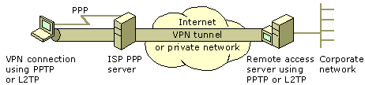
While we usually think of VPN servers connecting a VPN client computer to a private network over the Internet, you can also use VPN servers to create security zones within the Internal network.
The figure below shows a VPN client computer on the Internal network connecting to a VPN server. This VPN server is connected to the same LAN as the VPN client. In this example, the VPN server has an interface on the corporate backbone and a second interface on a highly secured network, such as payroll, finance or research and development. Users not physically attached to the highly secured network can securely access resources on the secure network by creating a VPN link to the VPN server connected to the highly secure network.
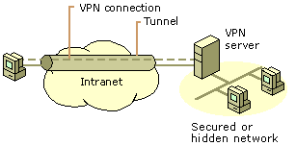
- Note:
VPN Servers can accept VPN connections from hundreds or even thousands of users at the same time. However, each VPN link between the VPN client and VPN server represents a single virtual “cabled” connection between the VPN server and VPN client. The VPN client/server connection does not allow machines that are behind the VPN client or VPN server to connect to resources on the opposite network. You need a VPN gateway to connect entire networks to one another.

What is a VPN Gateway?
In contrast to a VPN Server that allows single VPN client computers to establish connections to the Internal network through the VPN server machine, a VPN gateway allows you to connect entire networks to one another.
- Note:
An ISA Server firewall/VPN Server can act as both a VPN server and a VPN gateway. You can use the same machine to perform both roles. There are no conflicts between the VPN server and the VPN gateway configurations.
The figure below shows two entire networks connected to one another using a local ISA Server firewall/VPN gateway and a remote ISA Server firewall/VPN gateway. These VPN gateway computers act like VPN routers and route packets behind one network to another through a VPN-based demand-dial interface.
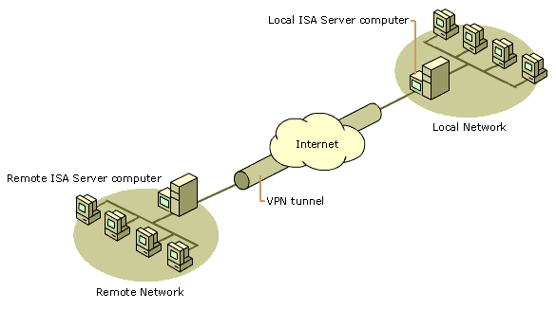
VPN gateways appear as normal IP routers to all hosts on the networks behind the VPN gateways. There can be domain controllers, RADIUS (IAS) servers, certificate servers (CAs), Web servers and all types of client machines at each site. All these machines are able to communicate with machines on the opposite network via the gateway-to-gateway link. The figure below shows this type of setup.
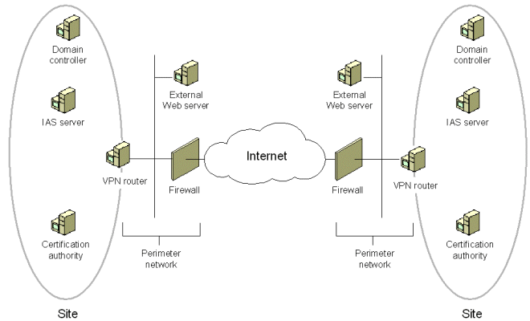
You can also use VPN gateway-to-gateway connections to secure networks on the same LAN. This is commonly seen when departmental LANs are connected to each other over a busy and relatively open corporate backbone. In this scenario, the corporate backbone transports traffic between departmental LANs, between departmental LANs and the Internet, and between untrusted network hosts directly connected to the backbone and the Internet, or connected to the backbone via a wireless link and the Internet.
The figure below is an example of two departmental LANs connected to each other via a gateway-to-gateway link over a corporate Ethernet backbone.
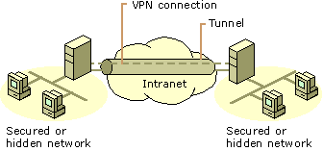

Network Services that Support VPN Client and Gateway Connections
VPN networks require the assistance of a number of network services to provide the best VPN client/server and VPN gateway-to-gateway connection experience. Some networking services are required, some are not required, and some are optional but highly recommended. In this section, we’ll review the following networking services that are used to support VPN networking connections:
- Dynamic Host Configuration Protocol (DHCP)
- Domain Name System (DNS)
- Windows Internet Name Service (WINS)
- Windows 2000 and Windows Server 2003 Active Directory
- Certificate Authorities (CAs) and Public Key Infrastructure (PKI)
- Internet Authentication Service (IAS) or RADIUS

Dynamic Host Configuration Protocol (DHCP) Server
The Dynamic Host Configuration Protocol (DHCP) allows you to automatically assign IP addressing information to VPN clients. IP addressing information the DHCP server can assign to VPN clients includes:
- IP address
- WINS server address
- DNS server address
- Primary domain name
The ISA Server firewall/VPN server can be configured to use a static address pool or DHCP to assign IP addresses to VPN clients and gateways. When you use a static address pool, the IP address pool is configured on the ISA Server firewall/VPN server, and WINS and DNS server addresses are assigned based on the WINS and DNS server address settings on the internal interface of the ISA Server firewall/VPN server.
You can use DHCP to assign VPN clients an IP address, a WINS server address, a DNS server address, and a primary domain name, as well as other DHCP options. In order to fully utilize the information a DHCP server can provide to the VPN client, the ISA Server firewall/VPN server must be configured with a DHCP Relay Agent. The DHCP Relay Agent acts as a “DHCP proxy” between the VPN client and the DHCP server. The DHCP Relay Agent forwards the DHCP messages between the VPN client and DHCP server and back.
The figure below shows the relationship between the VPN client acting as a DHCP client, the ISA Server firewall/VPN server, and the DHCP server on the Internal network. When the ISA Server firewall/VPN server starts up, it obtains a block of 10 IP addresses from the DHCP server. The ISA Server firewall/VPN server delivers IP addresses from this initial block. When the ISA Server firewall/VPN server runs out of IP addresses to deliver to VPN clients, it obtains another block of 10 IP addresses.
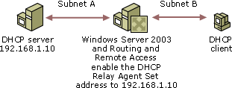

The ISA Server firewall/VPN server’s Routing and Remote Access Service does not obtain any DHCP options (such as WINS address, DNS address and primary domain name) on system start up. Instead, the DHCP Relay Agent relays requests for DHCP options to the DHCP server and returns those options to the DHCP client.

- Note:
You do not need to install a DHCP server on your network to support VPN clients or VPN gateways. The most compelling reason for using a DHCP server to support VPN clients is the ability to assign a primary domain name.

Domain Naming Service (DNS) Server
You must have a DNS server on your Internal network. A DNS server is required if you run a Windows 2000 or Windows Server 2003 Active Directory domain. However, you should have a DNS server on your network even if you don’t have an Active Directory domain. In the absence of an Active Directory domain, the DNS server resolves Internet DNS host names. The DNS server used to resolve Internet DNS host names can be located on a server on the Internal network, or you can configure a co-located caching-only DNS server on the ISA Server firewall/VPN server machine.
DNS servers use other DNS servers to resolve a DNS host name to an IP address. The figure below shows what happens when a DNS client computer (such as a VPN client) sends a request for name resolution to a DNS server for the name www.example.microsoft.com:
- The DNS client sends a request to a DNS server on the Internal network to resolve the name example.microsoft.com.
- The DNS server checks to see if it has the IP address for this DNS host name in its DNS cache. If the IP address is not in the DNS cache, the server then checks to see if it is authoritative (responsible) for the microsoft.com domain. If the DNS server is not responsible for the microsoft.com domain, then the DNS server begins the process of “recursion”. The recursive process involves sending a series of “iterative” queries to DNS servers on the Internet. Because the DNS server sent an “iterative” query request to these Internet DNS servers, the DNS server will accept partial responses to the question, “What is the IP address of example.microsoft.com?” The DNS server sends an iterative query to an Internet Root DNS server.
- The Internet Root DNS server is not authoritative for the microsoft.com domain, but it does know the address of the DNS server responsible for the .com top level domain. The Internet Root DNS server sends the IP address of a DNS server responsible for the .com top level domain to the DNS server.
- The DNS server sends a request to the .com DNS server for the IP address of example.microsoft.com.
- The .com DNS server responds with the IP address of a DNS server responsible for the microsoft.com domain.
- The DNS server sends a query to the microsoft.com domain DNS server to resolve the name example.microsoft.com to an IP address.
- The microsoft.com domain DNS server sends back a response informing the DNS server of the IP address of the DNS server responsible for the example.microsoft.com domain.
- The DNS server sends a request for the IP address of http://www.example.microsoft.com/ to the example.microsoft.com DNS server.
- The example.microsoft.com DNS server sends the IP address of DNS host http://www.example.microsoft.com/ to the DNS server. The DNS server places this result in its DNS cache.
- The DNS server returns the result to the DNS client on the internal network.
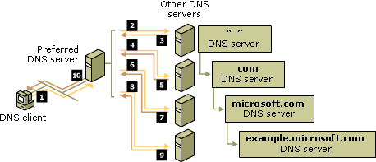
VPN clients leverage internal network DNS servers in two ways:

Resolve Internet DNS host names
VPN clients should be configured to use the ISA Server firewall/VPN server to access the Internet. You set up the VPN clients as Web Proxy and/or Firewall clients. This allows them to connect to Internet resources through the ISA Server firewall/VPN server machine. The Web Proxy and Firewall client configuration allows the ISA Server firewall to resolve names on their behalf. The ISA Server firewall/VPN server should be configured to use an internal DNS server that is able to resolve Internet host names.

Resolve DNS host names of servers on the Internal network
VPN clients need to resolve DNS host names of servers on the Internal network. The only way this can be accomplished is to install and configure a DNS server on the Internal network that resolves DNS host names of Internal network hosts, and then configures the ISA Server firewall/VPN server to provide the address of the DNS server to VPN clients.

Windows Internet Name Service (WINS) Server
A Windows Internet Name Server (WINS) server can be used to resolve names of Internal network computers. In contrast to DNS servers that resolve a DNS host name to an IP address, the WINS server resolves a NetBIOS name to an IP address. The NetBIOS name is often referred to the computer name because the NetBIOS name is a single word, instead of a “dotted” name like DNS host names. In Windows environments, the NetBIOS name is usually the same as the leftmost name or “label” in the FQDN.
A WINS server is not required. The primary reason to install a WINS server on the Internal network is to support network browsing using the Network Neighborhood or My Network Places applet. You should install a WINS server if your VPN clients need to be able to browse the Internal network to access shared resources on file servers.
- Note:
The details of the Windows browser service are beyond the scope of this ISA Server 2000 VPN Deployment Kit article. There are many reasons why the Windows browser service may fail. If you have problems with network browsing, please refer to Microsoft Knowledge Base article “Troubleshooting the Microsoft Computer Browser Service.”
The figure below shows how a WINS server works on a simple three-segment (three subnet) network. Computers on Subnet 1, Subnet 2 and Subnet 3 register their computer names with the WINS server when they start up. The WINS server stores the computer name and IP address of each computer on the network that is configured to use the WINS server. When a computer on Subnet 1 needs to communicate with a computer on Subnet 3, the computer on Subnet 1 asks the WINS server for the IP address of the computer on Subnet 3. The WINS server returns the address and the computer on Subnet 1 sends the request to the computer on Subnet 3.
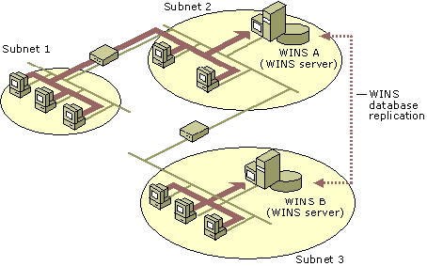
VPN clients can also send requests to the WINS server to find the IP address of a computer based on its computer name, instead of the entire FQDN.
- Note:
WINS servers support VPN clients that are not configured with a primary domain name. If you have a DNS server on the Internal network and a WINS server on the Internal network, you can configure a WINS referral zone that the DNS server can use to resolve unqualified names for VPN clients. Please refer to TechNet article, “Using WINS Lookup,” for more information on how WINS referral zones work and how to configure them.

Windows 2000 and Windows Server 2003 Active Directory
The Active Directory is a centralized database containing domain directory information. Directories contain information about users, groups, computers and network policies. There are a number of advantages to joining all network computers to an Active Directory domain versus not doing so.
Your ISA Server firewall/VPN server leverages the Active Directory database in the following ways:
- User accounts are stored in the Active Directory
- The VPN server component can authenticate VPN users against the Active Directory
- A RADIUS server can be used to authenticate users against the Active Directory
- VPN users can connect to Internet resources via the ISA Server firewall/VPN server after being authenticated by the firewall when the ISA Server firewall/VPN server is a member of the Active Directory domain
- An enterprise CA can be installed on an Active Directory member server computer to simplify the distribution of user and computer certificates for creating L2TP/IPSec VPN connections
- Active Directory-based Group Policy can be applied to VPN clients
There are many other advantages to using Active Directory domains with your ISA Server firewall/VPN server. Please refer to TechNet article “Technical Overview of Windows Server 2003 Active Directory” for a good overview of Windows Server 2003 Active Directory features and enhancements.

Certificate Authorities (CAs or Certificate Servers) and Public Key Infrastructure (PKI)
A Certificate Authority is a machine that can issue certificates to users or computers. Certificates include information about the computer or user and confirm the identity of that computer or user. A certificate typically includes:
- The user or computer name
- The date range for which the certificate is valid
- The public and/or private “key” assigned to that user or computer
- The “digital signature” of the Certificate Authority that issued the certificate
- Locations where the computer can check for the validity of the certificate (Certificate Revocation List)
Certificate Authorities are also known as Certificate Servers. You can use a Windows 2000 or Windows Server 2003 Certificate Server to issue computer certificates to VPN clients and servers that can be used to create L2TP/IPSec VPN connections. User certificates can be issued to users and these certificates can be presented to the ISA Server firewall/VPN server for user authentication.
Certificates and Certificate Servers are part of a wider subject known as Public Key Infrastructure (PKI). The subject of PKI has the potential to become extraordinarily complex. Many VPN and firewall administrators get lost in the details of PKI and give up on using certificates to create secure L2TP/IPSec VPNs and SSL-secured Web sites.
While learning the entire theory and practice of PKI is a long and tedious process, you do not need to be familiar with all the intricacies of PKI for your VPN client to use L2TP/IPSec to connect to your ISA Server firewall/VPN server.
In the context of this ISA Server 2004 VPN Deployment Kit, you need to be aware of the following features and functions of certificates and Certificate Servers in your organization:

- A computer certificate is required to create an L2TP/IPSec connection
Both the ISA Server firewall/VPN server and the VPN client must have a computer certificate installed before they can establish a L2TP/IPSec VPN link. The exception to this is to use a pre-shared key that is configured on the VPN client and server. There are a number of disadvantages to using a pre-shared key to support L2TP/IPSec connections, and pre-shared keys are not recommended.
- A user certificate can be used to provide a high level of security for user authentication to the ISA Server firewall/VPN server
While computer certificates can be used to create a L2TP/IPSec connection between the VPN client and ISA Server firewall/VPN server, user certificates can be used to authenticate users instead of requiring users to enter user names and passwords. User certificates are not required to create L2TP/IPSec connections.
- All machines participating in a certificate-dependent connection attempt must trust the root CA issuing the certificates
The VPN client, the VPN server and the VPN gateway participating in a L2TP/IPSec connection must trust the certificates presented by the opposite device.
For example, when a VPN client attempts to create a L2TP/IPSec VPN connection to the ISA Server firewall/VPN server, the client and server exchange a list of root certificate authorities that each machine trusts. If the client doesn’t trust the certificate authority that issued the VPN server’s certificate, or if the VPN server doesn’t trust the certification authority that issued the VPN client’s certificate, the IPSec negotiation phase will fail and the L2TP/IPSec VPN link will not be established.
The problem is solved by placing the root certificate authority’s self-signed CA certificate into the Trusted Root Certification Authorities node in each machine’s certificate store. This procedure is discussed in detail in ISA Server 2000 VPN Deployment Kit document, “Obtaining a Machine Certificate via Web Enrollment from a Windows Server 2003 Standalone CA.”
- Fragment filtering must be disabled on network devices in the path to the ISA Server firewall/VPN server for the L2TP/IPSec VPN connection
Fragment filtering must be disabled in order to complete the certificate exchange process so that the IPSec security associations can be established. If IP fragments are blocked at the ISA Server firewall/VPN server, or any firewalls or routers in front of the ISA Server firewall/VPN server, the L2TP/IPSec VPN connection attempt will fail.
- Microsoft Certificate Servers can be installed as either standalone or enterprise CAs
If you choose to host your own certificate authorities, you can install either a standalone or enterprise certificate authority. A standalone certificate authority is helpful if you do not have an Active Directory domain or you wish to assign certificates to machines or users that are not members of the Internal network domain. The enterprise certificate authority allows you to automatically deploy machine and user certificates to users and computers.
Please refer to ISA Server 2000 VPN Deployment Kit documents, “Installing and Configuring a Windows Server 2003 Standalone Certification Authority” and “Installing and Configuring a Windows Server 2003 Enterprise Certification Authority,” for more information on installing and configuring a standalone and enterprise CA. Please refer to ISA Server 2000 VPN Deployment Kit documents, “Obtaining a Machine Certificate via Web Enrollment from a Windows Server 2003 Standalone CA,” and “Assigning Certificates to Domain Members via Autoenrollment in a Windows Server 2003 Active Directory Domain,” for more information on how to assign machine certificates to VPN clients and servers.
- Third party certificates can be used for both user and computer authentication
You do not need to issue your own certificates. There are circumstances when using a third party certificate authority is preferred. If you want your users to be able to create SSL or VPN connections from untrusted systems, such as workstations located at a partner site, an airport kiosk, or other public device, you should use a third party certificate authority. Since you have no administrative control over these machines, it is unlikely that your root certificate authority’s self-signed certificate is in the Trusted Root Certificate Authorities machine certificate.
- Note:
Third party certificates are more useful in situations where you wish to allow SSL connections to Web servers on your Internal network. Because of the nature of VPN connections, you usually do not wish to allow untrusted devices full access to the corporate network. For this reason, if you require certificates only for L2TP/IPSec VPN connections, you should consider deploying your certificates using the Microsoft Certificate Server included with Windows 2000 and Windows Server 2003.
- Certificates are about increased security and administrative control. They are not about ease of use or deployment
Certificate deployment to VPN clients and servers can be time consuming, and there may be a number of perceived inefficiencies in the system. It’s important to realize that certificate-based L2TP/IPSec VPN connections and certificate-based user authentication is about increased security, not increased convenience for the user or administrator. However, we believe that the short-term pain of deploying certificates will allow your organization to avoid the long-term risks of a lower security solution.

Internet Authentication Server (IAS) or RADIUS Server
The Microsoft Internet Authentication Server (IAS) allows VPN clients to authenticate using domain credentials when the ISA Server firewall/VPN server is not a member of the Internal network domain. This adds a layer of security to the ISA Server firewall/VPN server solution because if the firewall is compromised in any way, the machine’s domain membership cannot be leveraged to attack the Internal network.
- Note:
Another term commonly used for the Internet Authentication Server is RADIUS server. RADIUS stands for Remote Access Dial-in User Service. IAS/RADIUS servers are in widespread use on the Internet so that the RAS server receiving credentials for a connection request can use another machine located elsewhere to authenticate the request.
There are number of scenarios where an IAS server can be used to “offload” authentication from the machine or network device accepting the authentication request. In the case of the ISA Server firewall/VPN server, the VPN server component forwards the credentials presented to it by the VPN client to the IAS server on the Internal network. The IAS Server forwards these credentials to a domain controller which authenticates the user. The IAS Server also can apply Remote Access Policy to control what users and what types of connections are allowed to the ISA Server firewall/VPN server.
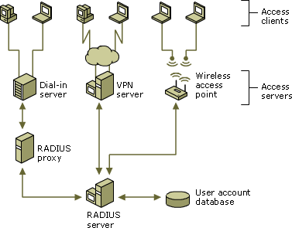
IAS Servers also allow you to centralize Remote Access Policies. For example, suppose you have five ISA Server firewall/VPN servers configured in a network load balancing (NLB) array. You wish to apply the same Remote Access Policies to all of the ISA Server firewall/VPN servers. You could do this manually on each server, or you could configure each of the servers to use an IAS Server on the Internal network. When you configure the Remote Access Policies once on the Internal network IAS Server, the same policies are automatically applied to each ISA Server firewall/VPN server.

TCP/IP Addressing Considerations with VPN Networks
One of the most common reasons for a VPN client/server or VPN gateway-to-gateway configuration to fail is when the IP addressing schemes on the networks involved do not support the VPN connection. It’s important to consider the current IP addressing configuration on the network and configure your VPN server to support VPN client and VPN gateway connections.

Supporting VPN Clients
VPN clients can be assigned two general types of addresses:
- On-subnet network addresses
On-subnet network addresses belong to the same network ID as the internal interface of the ISA Server firewall/VPN server. This is the most common method used to assigned addresses to VPN clients. On-subnet network addresses have the advantage of not requiring you to create special routing table entries to support the VPN clients.
You can create a static pool of on-subnet addresses on the ISA Server firewall/VPN server, or you can use a DHCP server on the Internal network to assign these addresses.
For example, suppose the IP address on the internal interface of the ISA Server firewall/VPN server is 10.0.0.1/16. You would then create a static address pool on the ISA Server firewall/VPN server with a group of addresses in the 10.0.0.0/16 network ID, or you would configure a scope on the DHCP server of the Internal network with a group of addresses on the 10.0.0.0/16 network ID. When the VPN clients connect to the ISA Server firewall/VPN server, they are assigned an address in the configured range. VPN clients will be able to connect to any resource on the Internal network that can research the IP address of the internal interface of the ISA Server firewall/VPN server.
- Off-subnet network addresses
The disadvantage of on-subnet network addressing is VPN clients that enable split tunneling can access resources on the Internal network. This is an undesirable configuration because VPN clients with split tunneling enabled can directly access the Internet without being forced to use firewall policy while connected to the Internal network via the VPN connection. One way you can prevent this problem is to use off-subnet addresses for VPN clients.
For example, suppose the Internal network behind the ISA Server firewall/VPN server is based on network ID 10.0.0.0/8. All segments on the Internal network are assigned subnets of this network ID. Now suppose the VPN client enables split tunneling. When the VPN client connects to the ISA Server firewall/VPN server, the client is assigned the IP address 10.0.0.10/8 (VPN clients are always assigned class-based subnet masks).
The VPN client will be able to access all networks on the Internal network because all networks are subnets of 10.0.0.0/8. For example, the VPN client needs to connect to network ID 10.1.0.0/16, which is a subnet remote from the Internet interface of the ISA Server firewall/VPN server. The VPN client, who is using the default subnet mask, sees the destination network ID as 10.0.0.0/8, so it sends the request via its VPN interface. The VPN clients don’t need to use the VPN interface as the default gateway because the VPN client sees the remote network as being on the same network ID. The VPN client can then use the ISP connection as its default gateway and still connect to all networks on the Internal network.
What would happen if you assigned the VPN clients IP addresses in network ID 172.17.0.0/12? If the VPN client is configured to allow split tunneling, it is using its ISP connect for its default gateway. When the VPN client tries to access resources on network ID 10.1.0.0/16, the VPN client sees the remote network ID as different from the network ID belonging to any of its interfaces, and therefore sends the request to its default gateway. The ISP’s router drops the request for 172.17.0.0./12 because it is a private IP address. The VPN client with split tunneling enabled is stopped from accessing resources on the Internal network.
Regardless of whether you use on- or off-subnet addresses, make sure that VPN clients have some way to obtain an IP address. One of the most common reasons for connection failure is that the VPN client is unable to obtain an IP address.

Supporting VPN Gateway-to-Gateway Connected Networks
Networks connected over the Internet via a gateway-to-gateway link are addressed in the same way any other routed network is addressed. The ISA Server firewall/VPN servers act as VPN routers, routing packets from one private network to the other over the Internet, in the same way that an Ethernet router routes packets from one network ID to another on the Internal network.
There are three basic IP addressing considerations that are important to the success of the gateway-to-gateway configuration:
- All networks must have different network IDs
Each site connected by the gateway-to-gateway link must be on a different network ID. All networks behind each VPN gateway must have different network IDs than the networks that are behind the opposite VPN gateway. You cannot have a 10.1.0.0/16 network at the local site and a 10.1.0.0/16 at the remote network. How would the Internal network routers know whether it should stay within the network or be sent over the VPN gateway to the opposite site?
This is not an optional setting. All network IDs must be different. You cannot allow duplication of network IDs on the sites connected by the VPN gateways.
- Configure static routing table entries
Static routing table entries are configured on the ISA Server firewall/VPN servers to allow proper routing through the VPN interface for packets destined to opposite networks connected by the gateway-to-gateway link. The ISA Server 2000 Local and Remote VPN Wizards automatically create these static routing table entries for you.
- Configure dynamic routing protocols
If you have a large network with many network IDs and multiple paths to each network, you may wish to use a dynamic routing protocol such as RIP or OSPF to allow proper routing of requests through the VPN gateways. Please refer to, “Achieving Site-to-Site Virtual Private Networking and Perimeter Security in a High Availability Environment with Microsoft ISA Server and RRAS,” for more information on how to use dynamic routing protocols in conjunction with your gateway-to-gateway VPN configuration.

Practice configuring the ISA Server 2004 Firewall and VPN Server
The firewall is your first line of defense against Internet attackers. A misconfigured firewall can potentially allow Internet attackers access to your network. For this reason, it’s important that you understand how to configure the firewall for secure Internet access. In the same way, a properly configured VPN server can provide secure remote access to your external users, while an improperly configured VPN server can prevent remote access and potentially open your network up to attacks.
By default, the ISA Server 2004 prevents all traffic from moving through the firewall, and the VPN server component is disabled. This is a secure configuration because the firewall must be explicitly configured to allow network traffic through it. However, this level of security can be frustrating when you want to get connected to the Internet as quickly as possible.
We strongly encourage you to create a test lab and perform each of the walkthroughs in this Kit. You will learn how to configure the ISA Server 2004 firewall correctly and become familiar with the ISA Server 2004’s configuration interface. You can make mistakes in the practice lab and not worry about attackers taking control of machines on your network. On the lab network, you’ll be able to learn from your mistakes instead of suffering from them.

The ISA Server 2004 VPN Deployment Kit Lab Configuration
We will use a lab network configuration to demonstrate the capabilities and features of ISA Server 2004 in this ISA Server 2004 VPN Deployment Kit. We recommend that you set up a test lab with a similar configuration. If you do not have the resources to create a physical test lab, you can use operating system virtualization software to create the test lab. We recommend that you use Microsoft’s Virtual PC software to create your test lab. You can find more information about Virtual PC at http://www.microsoft.com/windowsxp/virtualpc/.
In this section we will review the following:
- The ISA Server 2004 VPN Deployment Kit network
- Installing Windows Server 2003 on the domain controller machine and then promoting the machine to a domain controller
- Installing Exchange Server 2003 on the domain controller and configuring the Outlook Web Access site to use Basic authentication

ISA Server 2004 VPN Deployment Kit Network Diagram
The figure below depicts the lab network. There are 7 computers on the lab network. However, none of the scenarios we will work with in this ISA Server 2004 VPN Deployment Kit requires all the machines to be running at the same time. This will make it easier for you to use operating system virtualization software to run your lab network.
The network has a local network and a remote network. There is an ISA Server 2004 firewall at the edge of the local and remote networks. All the machines on the local network are members of the msfirewall.org domain, including the ISA Server 2004 firewall machine. No other machines on the lab network are members of the domain.
On our lab network, the external interfaces of the ISA Server 2004 firewalls connect to the production network, which allows them access to the Internet. You should create a similar configuration so that you can test actual Internet connectivity for the clients behind the ISA Server 2004 firewalls.
If you are using operating system virtualization software, then you should note that there are three virtual networks in this lab setup. The Internal network (which contains the domain controller) is on a virtual network, the TRIHOMELAN1 machine on a perimeter network is on another virtual network, and the REMOTECLIENT machine is on a third virtual network. Make sure you separate these virtual networks by placing the machines on different virtual switches so as to prevent Ethernet broadcast traffic from causing unusual results.

Table 1: Details of the Lab Network Configuration
Lab Network Details
Setting | EXCHANGE  2003BE | EXTCLIENT | LOCALVPNISA | REMOTEVPN | REMOTECLIENT
IP Address | 10.0.0.2 | 192.168.1.x | Int: 10.0.0.1  Ext: 192.168.1.70 | Int: 10.0.1.1  Ext: 192.168.1.71 | 10.0.1.2
Default Gateway | 10.0.0.1 | 192.168.1.60 | 192.168.1.60 | 192.168.1.60 | 10.0.1.1
DNS | 10.0.0.2 | None | 10.0.0.2 | NONE | NONE
WINS | 10.0.0.2 | None | 10.0.0.2 | NONE
OS | Windows Server 2003 | Windows 2000 | Windows Server 2003 | Windows Server 2003 | Windows 2000
Services | DC  DNS  WINS  DHCP  RADIUS  Enterprise CA | IIS:  WWW  SMTP  NNTP  FTP | ISA Server 2004 | ISA Server 2004 | IIS:  WWW  SMTP  NNTP  FTP

Lab Network Details
Setting | TRIHOMELAN1 | CLIENT
IP Address | 172.16.0.2 | 10.0.0.3
Default Gateway | 10.0.0.1 | 10.0.0.1
DNS | 10.0.0.2 | 10.0.0.2
WINS | 10.0.0.2 | 10.0.0.2
OS | Windows Server 2003 | Windows 2000
Services | DC  DNS  WINS  DHCP  RADIUS  Enterprise CA | IIS:  WWW  SMTP  NNTP  FTP

Installing and Configuring the Internal Network Domain Controller
Other than the ISA Server 2004 firewall computer itself, the second most influential machine used in the scenarios discussed in the ISA Server 2004 VPN Deployment Kit is the domain controller. The domain controller computer will also be used to support a number of network services that are used in the variety of ISA Server 2004 scenarios discussed in this guide. It is for this reason that we will walk through the installation and configuration of the domain controller together.
You will perform the following steps to install and configure the Windows Server 2003 domain controller:
- Install Windows Server 2003
- Install and Configure DNS
- Promote the machine to a domain controller
The machine will be a functioning domain controller by the time you have completed these steps and will be ready for you to install Microsoft Exchange Server 2003.

Install Windows Server 2003
Perform the following steps on the machine that acts as your domain controller computer:
- Insert the CD into the CD-ROM tray and restart the computer. Allow the machine to boot from the CD.
- Windows setup begins loading files required for installation. Press ENTER when you see the Welcome to Setup screen.
- Read the Windows Licensing Agreement by pressing the PAGE DOWN key on the keyboard. Then press F8 on the keyboard.
- On the Windows Server 2003, Standard Edition Setup screen you will create a partition for the operating system. In the lab, the entire disk can be formatted as a single partition. Press ENTER.
- On the Windows Server 2003, Standard Edition Setup screen, select Format the partition using the NTFS file system by using the up and down arrows on the keyboard. Then press ENTER.
- Windows Setup formats the hard disk. This can take quite some time if the disk is large. Setup will copy files to the hard disk after formatting is complete.
- The machine will automatically restart itself after the file copy process is complete.
- The machine will restart in graphic interface mode. Click Next on the Regional and Language Options page.
- On the Personalize Your Software page, enter your Name and Organization and click Next.
- On the Your Product Key page, enter your 25-digit Product Key and click Next.
- On the Licensing Modes page, select the option that applies to the version of Windows Server 2003 you have. If you have per server licensing, enter the value for the number of connections you have licensed. Click Next.
- On the Computer Name and Administrator Password page, enter the name of the computer in the Computer Name text box. In the walkthroughs in this Guide, the domain controller/Exchange Server machine is named EXCHANGE2003BE, so enter that into the text box. Enter an Administrator password and Confirm password in the text boxes. Be sure to write down this password so that you will remember it later. Click Next.
- On the Date and Time Settings page, set the correct date, time and time zone. Click Next.
- On the Networking Settings page, select the Custom settings option.
- On the Network Components page, select Internet Protocol (TCP/IP) from the Components checked are used by this connection list, and click Properties.
- In the Internet Protocol (TCP/IP) Properties dialog box, select Use the following IP address. In the IP address text box, enter 10.0.0.2. In the Subnet mask text box enter 255.255.255.0. In the Default gateway text box enter 10.0.0.1. In the Preferred DNS server text box, enter 10.0.0.2.
- Click Advanced in the Internet Protocol (TCP/IP) Properties dialog box. In the Advanced TCP/IP Settings dialog box, click the WINS tab. On the WINS tab, click Add. In the TCP/IP WINS Server dialog box, enter 10.0.0.2 and click Add.
- Click OK in the Advanced TCP/IP Settings dialog box.
- Click OK in the Internet Protocol (TCP/IP) Properties dialog box.
- Click Next on the Networking Components page.
- Accept the default selection on the Workgroup or Computer Domain page. We will later make this machine a domain controller, and the machine will be a member of the domain we create at that time. Click Next.
- Installation continues and when it finishes, the computer will restart automatically.
- Log on to the Windows Server 2003 using the password you created for the Administrator account.
- On the Manage Your Server page, put a checkmark in the Don’t display this page at logon checkbox and close the window.

Install and Configure DNS
The next step is to install the Domain Naming System (DNS) server on the machine that will be the domain controller. This is required because the Active Directory requires a DNS server into which it registers domain-related DNS records. We will install the DNS server and then create the domain into which we will promote the machine.
Perform the following steps to install the DNS server on the domain controller machine:
- Click Start and point to Control Panel. Click Add or Remove Programs.
- In the Add or Remove Programs window, click the Add/Remove Windows Components button on the left side of the window.
- In the Windows Components dialog box, scroll through the list of Components and click Networking Services. Click Details.
- Place a checkmark in the Domain Name System (DNS) check box and click OK.
- Click Next in the Windows Components page.
- Click Finish on the Completing the Windows Components Wizard page.
- Close the Add or Remove Programs window.
Now that the DNS server is installed, we can add forward and reverse lookup zones to support our network configuration. Perform the following steps to configure the DNS server:
- Click Start, and then click Administrative Tools. Click DNS.
- In the DNS console, expand the server name and click on the Reverse Lookup Zones node. Right click on Reverse Lookup Zones and click New Zone.
- Click Next on the Welcome to the New Zone Wizard page.
- On the Zone Type page, select Primary zone and click Next.
- On the Reverse Lookup Zone Name page, select Network ID and enter 10.0.0 in the text box below it. Click Next.
- Accept the default selection on the Zone File page, and click Next.
- On the Dynamic Update page, select Allow both nonsecure and secure dynamic updates. Click Next.
- Click Finish on the Completing the New Zone Wizard page.
Now we can create the forward lookup zone for the domain that this machine will be promoted into. Perform the following steps to create the forward lookup zone:
- Right click the Forward Lookup Zone entry in the left pane of the console, and click New Zone.
- Click Next on the Welcome to the New Zone Wizard page.
- On the Zone Type page, select Primary zone and click Next.
- On the Zone Name page, enter the name of the forward lookup zone in the Zone name text box. In this example, the name of the zone is msfirewall.org. Enter msfirewall.org into the text box. Click Next.
- Accept the default settings on the Zone File page, and click Next.
- On the Dynamic Update page, select Allow both nonsecure and secure dynamic updates. Click Next.
- Click Finish on the Completing the New Zone Wizard page.
- Expand the Forward Lookup Zones node and click on the msfirewall.org zone. Right click on msfirewall.org and click New Host (A).
- In the New Host dialog box, enter the value EXCHANGE2003BE in the Name (uses parent domain name if blank) text box. In the IP address text box, enter the value 10.0.0.2. Place a checkmark in the Create associated pointer (PTR) record check box. Click Add Host. Click OK in the DNS dialog box informing you that the record was created. Click Done in the New Host text box.
- Right click on the msfirewall.org forward lookup zone and click Properties. Click the Name Servers tab. On the Name Servers tab, click exchange2003be and click Edit.
- In the Server fully qualified domain name (FQDN) text box, enter the fully qualified domain name of the domain controller computer, exchange2003be.msfirewall.org. Click Resolve. The IP address of the machine appears in the IP address list. Click OK.
- Click Apply and OK in the msfirewall.org Properties dialog box.
- Right click the server name in the left pane of the console and point to All Tasks. Click Restart.
- Close the DNS console.
The machine is now ready to be promoted to a domain controller in the msfirewall.org domain. Perform the following steps to promote the domain to a domain controller:
- Click Start and Run.
- In the Run dialog box, enter dcpromo in the Open text box, and click OK.
- Click Next on the Welcome to the Active Directory Installation Wizard page.
- Click Next on the Operating System Compatibility page.
- On the Domain Controller Type page, select Domain controller for a new domain and click Next.
- On the Create New Domain page, select Domain in a new forest and click Next.
- On the New Domain Name page, enter the name of the domain in the Full DNS name for new domain text box. Enter msfirewall.org in the text box and click Next.
- On the NetBIOS Domain Name page, accept the default NetBIOS name for the domain, which is, in this example, MSFIREWALL. Click Next.
- Accept the default settings on the Database and Log Folders page, and click Next.
- On the Shared System Volume page, accept the default location, and click Next.
- On the DNS Registration Diagnostics page, select I will correct the problem later by configuring DNS manually (Advanced). Click Next.
- On the Permissions page, select Permissions compatible only with Windows 2000 or Windows Server 2003 operating system. Click Next.
- On the Directory Services Restore Mode Administrator Password page, enter a Restore Mode Password and then Confirm password. Click Next.
- On the Summary page, click Next.
- The machine now starts to configure itself as a domain controller.
- Click Finish on the Completing the Active Directory Installation Wizard page.
- Click Restart Now on the Active Directory Installation Wizard page.
- Log on as Administrator after the machine restarts.

Installing and Configuring Microsoft Exchange on the Domain Controller
The machine is ready for installing Microsoft Exchange. In this section, we will perform the following steps:
- Install the IIS World Wide Web, SMTP and NNTP services
- Install Microsoft Exchange Server 2003
- Configure the Outlook Web Access Web Site
Perform the following steps to install the World Wide Web, SMTP and NNTP services:
- Click Start and point to Control Panel. Click Add or Remove Programs.
- In the Add or Remove Programs window, click the Add/Remove Windows Components button on the left side of the window.
- On the Windows Components page, select Application Server . Click the Details button.
- In the Application Server dialog box, put a checkmark in the ASP.NET check box. Select Internet Information Services (IIS) and click Details.
- In the Internet Information Services (IIS) dialog box, put a checkmark in the NNTP Service check box. Put a checkmark in the SMTP Service check box. Click OK.
- Click OK in the Application Server dialog box.
- Click Next on the Windows Components page.
- Click OK in the Insert Disk dialog box.
- In the Files Needed dialog box, enter the path to the i386 folder for the Windows Server 2003 CD in the Copy file from text box. Click OK.
- Click Finish on the Completing the Windows Components Wizard page.
- Close the Add or Remove Programs window.

Perform the following steps to install Microsoft Exchange:
- Insert the Exchange Server 2003 CD into the machine. On the initial autorun page, click Exchange Deployment Tools under Deployment.
- On the Welcome to the Exchange Server Deployment Tools page, click Deploy the first Exchange 2003 server.
- On the Deploy the First Exchange 2003 Server page, click New Exchange 2003 Installation.
- On the New Exchange 2003 Installation page, scroll down to the bottom of the page. Under step 8, click Run Setup now.
- On the Welcome to the Microsoft Exchange Installation Wizard page, click Next.
- On the License Agreement page, select I agree and click Next.
- Accept the default settings on the Component Selection page, and click Next.
- Select Create a New Exchange Organization on the Installation Type page, and click Next.
- Accept the default name in the Organization Name text box on the Organization Name page, and click Next.
- On the Licensing Agreement page, select I agree that I have read and will be bound by the license agreement for this product and click Next.
- On the Installation Summary page, click Next.
- In the Microsoft Exchange Installation Wizard dialog box, click OK.
- Click Finish on the Completing the Microsoft Exchange Wizard page, when installation is complete.
- Close all open windows.
The Exchange Server is now installed, and you can create user mailboxes at this point. The next step is to configure the Outlook Web Access site to use Basic authentication only. This is a critical configuration option when you want to enable remote access to the OWA site. Later, we will request a Web site certificate for the OWA site and publish the site using a Web Publishing Rule, which will allow remote users to access the OWA site.
Perform the following steps to configure the OWA site to use Basic authentication only:
- Click Start and point to Administrative Tools. Click Internet Information Services (IIS) Manager.
- In the Internet Information Services (IIS) Manager console, expand the server name, and then expand the Web Sites node. Expand the Default Web Site node.
- Click on the Public node and then right click on it. Click Properties.
- In the Public Properties dialog box, click the Directory Security tab.
- On the Directory Security tab, click Edit in the Authentication and access control frame.
- In the Authentication Methods dialog box, remove the checkmark from the Integrated Windows authentication check box. Click OK.
- Click Apply and then click OK.
- Click on the Exchange node in the left pane of the console and right click on it. Click Properties.
- On the Exchange Properties dialog box, click the Directory Security tab.
- On the Directory Security tab, click the Edit button in the Authentication and access control frame.
- In the Authentication Methods dialog box, remove the checkmark from the Integrated Windows authentication check box. Click OK.
- Click Apply and then click OK in the Exchange Properties dialog box.
- Click on the ExchWeb node in the left pane of the console, then right click on it. Click Properties.
- In the ExchWeb Properties dialog box, click the Directory Security tab.
- On the Directory Security tab, click Edit in the Authentication and access control frame.
- In the Authentication Methods dialog box, remove the checkmark from the Enable anonymous access check box. Place a checkmark in the Basic authentication (password is sent in clear text) check box. Click Yes in the IIS Manager dialog box informing you that the password is sent in the clear. In the Default domain text box, enter the name of the Internal network domain, which is MSFIREWALL. Click OK.
- Click Apply in the ExchWeb Properties dialog box. Click OK in the Inheritance Overrides dialog box. Click OK in the ExchWeb Properties dialog box.
- Right click the Default Web Site and click Stop. Right click the Default Web Site again, and click Start.

Installing and Configuring the IIS and Microsoft Certificate Services
We will use the Microsoft Certificate Server to support L2TP/IPSec and IPSec tunnel mode connections between the remote access VPN client and the ISA Server 2004 firewall/VPN, and for site-to-site IPSec tunnel mode connections. In this ISA Server 2004 VPN Deployment Kit series of documents, we will use an enterprise CA to simplify certificate assignments.

Install Internet Information Services 6.0
The Certificate Authority’s Web enrollment site uses the Internet Information Services World Wide Web Publishing Service. Because Exchange 2003 has already been installed on this machine, we will not need to manually install the IIS Web services. The Exchange 2003 setup routine requires that you install the IIS Web services so that the Outlook Web Access site functions properly. However, you should confirm that the WWW Publishing Service is enabled before starting installation of the Enterprise CA.
Perform the following steps to confirm that the WWW Publishing Service is running on the domain controller:
- Click Start and point to Administrative Tools. Click on Services.
- In the Services console, click on the Standard tab in the right pane. Scroll down to the bottom of the list and find the World Wide Web Publishing Service entry. Double click on that entry.
- In the World Wide Web Publishing Server Properties dialog box, confirm that the Startup type is set to Automatic, and that the Service status is Started.
- Click Cancel and close the Services console.
Now that we’ve confirmed that the WWW Publishing Service is started, the next step is to install the Enterprise CA software.

Install Microsoft Certificate Services in Enterprise CA Mode
Microsoft Certificate Services will be installed in Enterprise CA mode on the domain controller. There are several advantages to installing the CA in enterprise mode versus standalone mode. These include:
- The root CA certificate is automatically entered into the Trusted Root Certification Authorities certificate store on all domain member machines
- You can use the Certificates MMC snap-in to easily request a certificate. This greatly simplifies requesting machine and Web site certificates
- All machines can be assigned certificates using the Active Directory autoenrollment feature
- All domain users can be assigned user certificates using the Active Directory autoenrollment feature

- Note:
You can install the CA in standalone mode, but we will not cover the procedures involved with installing the CA in standalone mode or how to obtain a certificate from a standalone CA in this ISA Server 2004 Configuration Guide series.
Perform the following steps to install the Enterprise CA on the EXCHANGE2003BE domain controller computer:
- Click Start, and point to Control Panel. Click on Add or Remove Programs.
- In the Add or Remove Programs window, click Add/Remove Windows Components on the left side of the window.
- On the Windows Components page, scroll through the list and put a checkmark in the Certificate Services check box. Click Yes in the Microsoft Certificate Services dialog box informing you that you may not change the name of the machine or the machine’s domain membership while it is acting as a CA. Click Yes to continue.
- Click Next on the Windows Components page.
- On the CA Type page, select Enterprise root CA and click Next.
- On the CA Identifying Information page, enter a name for the CA in the Common name for this CA text box. This should be the DNS host name for the domain controller. Ideally, you will have configured a split DNS infrastructure, and this name will be accessible from internal and external locations, so external hosts will be able to check the certificate revocation list. We will not cover the issue of a split DNS infrastructure in this document. You can find more information about designing and configuring a split DNS infrastructure in the ISA Server 2000 Branch Office Kit document “DNS Considerations for ISA Server 2000 Branch Office Networks” at http://www.tacteam.net/isaserverorg/isabokit/9dnssupport/9dnssupport.htm . In this example, we will enter the domain controllers NetBIOS name, EXCHANGE2003BE. Click Next.
- If the same machine had been configured as a CA in the past, you will be presented with a dialog box asking if you wish to overwrite the existing key. If you have already deployed certificates to hosts on your network, do not overwrite the current key. If you have not yet deployed certificates to hosts on your network, choose to overwrite the existing key. In this example, we have not previously installed a CA on this machine, and we do not see this dialog box.
- In the Certificate Database Settings page, use the default locations for the Certificate Database and Certificate database log text boxes. Click Next.
- Click Yes in the Microsoft Certificate Services dialog box informing you that Internet Information Services must be restarted. Click Yes to stop the service. The service will be restarted for you automatically.
- Click OK in the Insert Disk dialog box. In the Files Needed dialog box, enter the path to the i386 folder in the Copy file from text box and click OK.
- Click Finish on the Completing the Windows Components Wizard page.
- Close the Add or Remove Programs window.
At this point, the Enterprise CA is able to issue certificates to machines via autoenrollment, the Certificates mmc snap-in, or via the Web enrollment site. Later in this ISA Server 2004 Getting Start Guide series, we will issue a Web site certificate to the OWA Web site and also issue machine certificates to the ISA Server 2004 firewall computer and to an external VPN client and VPN gateway (VPN router) machine.

Installing and Configuring the Microsoft Internet Authentication Service
In this ISA Server 2004 VPN Deployment Kit we will use the Microsoft Internet Authentication Service as our RADIUS server. The RADIUS server will authenticate remote access VPN client connections.

Installing the Microsoft Internet Authentication Service
The Microsoft Internet Authentication Service server is a RADIUS server. We will use the RADIUS server later in this ISA Server 2004 Configuration Guide to enable RADIUS authentication for Web Publishing Rules and investigate how RADIUS authentication can be used to authenticate VPN clients.
Perform the following steps to install the Microsoft Internet Authentication Server on the domain controller EXCHANGE2003BE on the Internal network:
- Click Start and point to Control Panel. Click Add or Remove Programs.
- In the Add or Remove Programs window, click the Add/Remove Windows Components button in the left pane of the console.
- On the Windows Components page, scroll through the Components list and select Networking Services. Click Details.
- Place a checkmark in the Internet Authentication Service check box and click OK.
- Click Next on the Windows Components page.
- Click Finish on the Completing the Windows Components Wizard page.
- Close the Add or Remove Programs window.
The next step is to configure the Internet Authentication Service.

Configuring the Microsoft Internet Authentication Service
You need to configure the IAS server to work together with the ISA Server 2004 firewall computer so that they can communicate properly. At this time, we will configure the IAS Server to work with the ISA Server 2004 firewall. Later we will configure the firewall to communicate with the IAS server.
Perform the following steps on the domain controller on the Internal network to configure the IAS server:
- Click Start and point to Administrative Tools. Click Internet Authentication Service.
- In the Internet Authentication Service console, expand the Internet Authentication Service (Local) node. Right click on the RADIUS Clients node and click New RADIUS Client.
- On the Name and Address page of the New RADIUS Client wizard, enter a friendly name for the ISA Server 2004 firewall computer in the Friendly name text box. This name is used to identify the RADIUS client and not for operational purposes. Enter the fully qualified domain name of the ISA Server 2004 firewall computer in the Client address (IP or DNS) text box.
- Click the Verify button. In the Verify Client dialog box, the fully qualified domain name of the ISA Server 2004 firewall computer will appear in the Client text box. Click Resolve. If the RADIUS server is able to resolve the name, the IP address will appear in the IP address frame. If the RADIUS server is not able to resolve the name, that indicates that the ISA Server 2004 firewall’s name has not been entered into the DNS. In that case, you can choose to enter the name of the ISA Server 2004 firewall computer into the DNS server on the domain controller, or you can use the IP address on the internal interface of the ISA Server 2004 firewall in the Client address (IP and DNS) text box on the Name or Address page (as seen above). Click OK in the Verify Client dialog box.
- Click Next on the Name and Address page of the New RADIUS Client wizard.
- On the Additional Information page of the wizard, use the default Client-Vendor entry, which is RADIUS Standard. Enter a password in the Shared secret text box and confirm the password in the Confirm shared secret text box. This shared secret will allow the ISA Server 2004 firewall and the RADIUS server to confirm each other’s identities. The shared secret should contain at least 8 characters and include mixed-case letters, numbers and symbols. Place a checkmark in the Request must contain the Message Authenticator attribute check box. Click Finish.
The new RADIUS client entry appears in the right pane of the console.

Installing the WINS Server Service and Configuring the DHCP Server
We will use WINS to aid name resolution and support the Microsoft browser service for VPN remote access clients. We installed the DHCP server service early, so at this point, we want to configure the service to support DHCP options, which can be assigned to the VPN remote-access client machines.

Installing the WINS Service
The Windows Internet Name Service (WINS) is used to resolve NetBIOS names to IP addresses. On modern Windows networks, the WINS service is not required. However, many organizations want to use the My Network Places applet to locate servers on the network. The My Network Places applet depends on the functionality provided by the Windows Browser service. The Windows Browser service is a broadcast-based service that depends on a WINS server to compile and distribute information on servers on each network segment.
In addition, the WINS service is required when VPN clients wish to obtain browse list information for Internal network clients. We will install the WINS server on the Internal network to support NetBIOS name resolution and the Windows browser service for VPN clients.
Perform the following steps to install WINS:
- Click Start and point to Control Panel. Click Add or Remove Programs.
- In the Add or Remove Programs window, click Add/Remove Windows Components.
- On the Windows Components page, scroll through the list of Components and select Networking Services. Click Details.
- In the Network Services dialog box, put a checkmark in the Windows Internet Name Service (WINS) check box. Next, put a checkmark in the Dynamic Host Configuration Protocol (DHCP) check box. Click OK.
- Click Next on the Windows Components page.
- Click OK in the Insert Disk dialog box. In the Files Needed dialog box, enter the path to the i386 folder in the Copy files from text box and click OK.
- Click Finish on the Completing the Windows Components Wizard page.
- Close the Add or Remove Programs window.
- The WINS server is ready to accept NetBIOS name registrations. The ISA Server 2004 firewall, the domain controller, and the Internal network clients are all configured to register with the WINS server in their TCP/IP Properties settings.

Configuring the DHCP Service
The Dynamic Host Configuration Protocol (DHCP) is used to automatically assign IP addressing information to Internal network clients and VPN clients. In the scenarios covered in the ISA Server 2004 VPN Deployment Kit, the DHCP server will be used primarily to assign IP addressing information to the VPN clients network. Note that in a production network, you should configure all machines that do not require a static IP address to be DHCP clients.
The DHCP server service has already been installed. The next step is to configure a DHCP scope that includes a range of IP addresses to assign DHCP clients and DHCP options.
Perform the following steps to configure the DHCP scope:
- Click Start and point to Administrative Tools. Click on DHCP.
- In the DHCP console, right click on the server name in the left pane of the console and click Authorize.
- Click Refresh in the mmc button bar. Notice that the icon on the server name in the left pane of the console changes from a red, down-pointing arrow to a green, up-pointing arrow.
- Right click on the server name in the left pane of the console and click New Scope.
- Click Next on the Welcome to the New Scope Wizard page.
- On the Scope Name page, enter a name for the scope in the Name text box, and enter an optional description in the Description text box. In this example, we will name the scope Scope1 and will not enter a description. Click Next.
- On the IP Address Range page, enter a Start IP address and an End IP address in the text boxes provided. The start and end addresses represent the beginning and end of a range of addresses you want available for DHCP clients. In this example, we will enter the start address as 10.0.0.200 and the end address as 10.0.0.219. This provides twenty addresses for DHCP clients. The ISA Server 2004 firewall will later be configured to allow up to 10 concurrent VPN connections, so it will automatically take 10 of these addresses and use one of them for itself, with the remainder available to assign to the VPN clients. The ISA Server 2004 firewall will be able to obtain more IP addresses from the DHCP server if they are required. You can configure the subnet mask settings in either the Length or Subnet mask text boxes. In our current example, the addresses will be on the same network ID as the Internal network, so we will enter the value 24 into the Length text box. The Subnet mask value is automatically added when the Length value is added. Click Next.
- Do not enter any exclusions on the Add Exclusions page. Click Next.
- Accept the default lease duration of 8 Days on the Lease Duration page. Click Next.
- On the Configure DHCP Options page, select Yes, I want to configure these options now and click Next.
- On the Router (Default Gateway) page, enter the IP address of the internal interface of the ISA Server 2004 firewall machine in the IP address text box and click Add. Click Next.
- On the Domain Name and DNS Servers page, enter the domain name used on the Internal network in the Parent domain text box. This is the domain name that will be used by DHCP clients to fully qualify unqualified names, such as the wpad entry that is used for Web Proxy and Firewall client autodiscovery. In this example, the domain name is msfirewall.org and we will enter that value in the text box. In the IP address text box, enter the IP address of the DNS server on the Internal network. In this example, the domain controller is also the Internal network’s DNS server, so we will enter the value 10.0.0.2 into the IP address text box and click Add. Click Next.
- On the WINS Servers page, enter the IP address of the WINS server in the IP address text box and click Add. In this example, the WINS server is located on the domain controller on the Internal network, so we will enter 10.0.0.2. Click Next.
- On the Activate Scope page, select Yes, I want to activate this scope now and click Next.
- Click Finish on the Completing the New Scope Wizard page.
- In the left pane of the DHCP console, expand the Scope node and click on the Scope Options node. You will see a list of the options you configured.
- Close the DHCP console.
At this point, the DHCP server is ready to provide DHCP addressing information to DHCP clients on the Internal network and to the VPN clients network. However, the ISA Server 2004 firewall will actually lease the addresses until we have enabled the VPN server on the firewall.

Conclusion
In this ISA Server 2004 VPN Deployment Kit document, we discussed the goals of this guide and suggested methods you can use to get the most out of this guide. The remainder of this ISA Server 2004 VPN Deployment Kit provides detailed step-by-step instructions on how to install and configure the domain controller computer on the Internal network, and how to install and configure supporting Microsoft Server services. In the next chapter of this guide, we will go over the procedures required to install Microsoft Certificate Services on the ISA Server 2004 firewall machine.

This is a preliminary document and may be changed substantially prior to final commercial release of the software described herein.
The information contained in this document represents the current view of Microsoft Corporation on the issues discussed as of the date of publication. Because Microsoft must respond to changing market conditions, it should not be interpreted to be a commitment on the part of Microsoft, and Microsoft cannot guarantee the accuracy of any information presented after the date of publication.
This white paper is for informational purposes only. MICROSOFT MAKES NO WARRANTIES, EXPRESS OR IMPLIED, IN THIS
DOCUMENT.
Complying with all applicable copyright laws is the responsibility of the user. Without limiting the rights under copyright, no part of this document may be reproduced, stored in, or introduced into a retrieval system, or transmitted in any form or by any means (electronic, mechanical, photocopying, recording, or otherwise), or for any purpose, without the express written permission of Microsoft Corporation.
Microsoft may have patents, patent applications, trademarks, copyrights, or other intellectual property rights covering subject matter in this document. Except as expressly provided in any written license agreement from Microsoft, the furnishing of this document does not give you any license to these patents, trademarks, copyrights, or other intellectual property.
© 2004 Microsoft Corporation. All rights reserved.
The example companies, organizations, products, domain names, e-mail addresses, logos, people, places, and events depicted herein are fictitious. No association with any real company, organization, product, domain name, e-mail address, logo, person, place, or event is intended or should be inferred.
Microsoft, Windows, Windows 2000, Windows 2000 Server, Windows Server 2003, Windows Server System, ISA Server, and ISA Server 2004 are either registered trademarks or trademarks of Microsoft Corporation in the United States and/or other countries.
The names of actual companies and products mentioned herein may be the trademarks of their respective owners.

ISA Server 2004 VPN Deployment Kit: Installing ISA Server 2004 on Windows Server 2003
Chapter 3
Published: April 2004
For the latest information, please see http://www.microsoft.com/isaserver/

Contents
Introduction 1
Installing ISA Server 2004 2
Viewing the System Policy 8
Backing Up the Post-Installation Configuration 14
Conclusion 16

Introduction
In this ISA Server 2004 VPN Deployment Kit document, you will install the ISA Server 2004 software onto the Windows Server 2003 computer installed and configured in Chapter 2. There are only a few decisions you will need to make while installing ISA Server 2004 software. The most important configuration made during installation is the Internal network IP address range(s). Unlike ISA Server 2000, ISA Server 2004 does not use a Local Address Table (LAT) to define trusted and untrusted networks. Instead, the ISA Server 2004 firewall asks for IP addresses defining a network entity known as the Internal network. The Internal network contains important network servers and services such as Active Directory domain controllers, DNS, WINS, RADIUS, DHCP, firewall management stations, and others. The ISA Server 2004 firewall communicates with these services immediately after installation is complete.
The firewall’s System Policy, controls communications between the Internal network and the ISA Server 2004 firewall. The System Policy is a collection of pre-defined Access Rules determining the type of traffic allowed to and from the firewall immediately after installation. The System Policy is configurable, which enables you to control the limits of the default System Policy Access Rules.
In the document we will discuss the following procedures:
- Installing ISA Server 2004 on Windows Server 2003
- Viewing the System Policy
- Backing Up the Post-Installation Configuration
During installation, you will use:
ISALOCAL
EXCHANGE2003BE
Please start both of these machines and log on as Administrator prior to performing the following procedures.

Installing ISA Server 2004
Installing ISA Server 2004 on Windows Server 2003 is relatively straightforward. The major decision you make during setup is what IP addresses should be part of the Internal network. The Internal network address configuration is important because the firewall’s System Policy uses the Internal network addresses to define a set of Access Rules.
To install the ISA Server 2004 software on the dual-homed Windows Server 2003 machine:
- Insert the ISA Server 2004 CD-ROM into the CD drive. The autorun menu will appear.
- On the Microsoft Internet Security and Acceleration Server 2004 Beta 2 Setup page, click Review Release Notes and read the release notes. The release notes contain useful information about important issues and configuration options. After reading the notes, close the release notes window, and click Read Setup and Feature Guide. You don’t need to read the entire guide right now, but you may want to print it out to read later. Close the Setup and Feature Guide window. Click Install ISA Server 2004.
- Click Next on the Welcome to the Installation Wizard for Microsoft ISA Server 2004 page.
- Select I accept the terms in the license agreement on the License Agreement page. Click Next.
- On the Customer Information page, enter your name and the name of your organization in the User Name and Organization text boxes. Enter Product Serial Number. Click Next.
- On the Setup Type page, select the Custom option. If you do not want to install the ISA Server 2004 software on the C: drive, then click the Change button to change the location of the program files on the hard disk. Click Next.
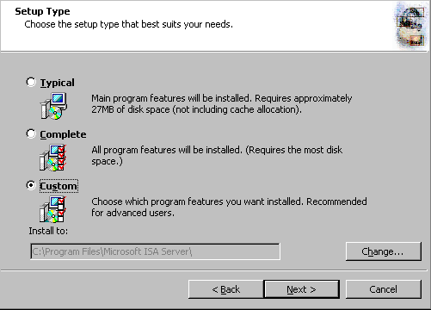
- On the Custom Setup page, you can choose which components to install. By default, the Firewall Services and ISA Server Management options are installed. The Message Screener, which is used to help prevent spam and file attachments from entering and leaving the network, is not installed by default; neither is the Firewall Client Installation Share. You need to install the IIS 6.0 SMTP service on the ISA Server 2004 firewall computer before you install the Message Screener. Use the default settings and click Next.
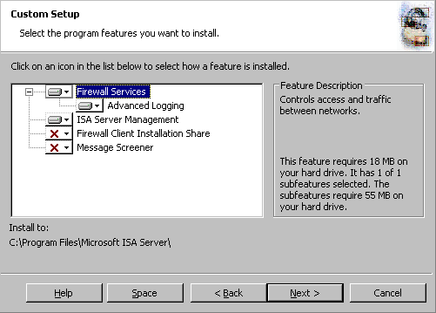
- On the Internal Network page, click Add. The Internal network is different from the LAT used in ISA Server 2000. In the case of ISA Server 2004, the Internal network contains trusted network services with which the ISA Server 2004 firewall must be able to communicate. Examples of such services include Active Directory domain controllers, DNS, DHCP, terminal services client management workstations, and others. The firewall System Policy automatically uses the Internal network. We will look at the System Policy later in this document.

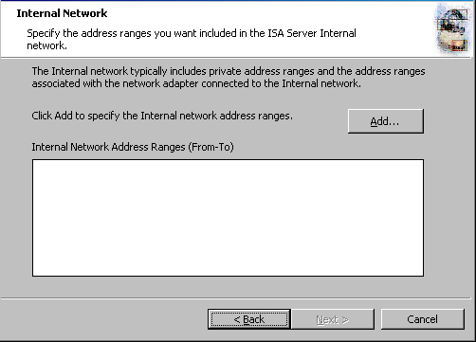
- In the Internal Network setup page, click Select Network Adapter.
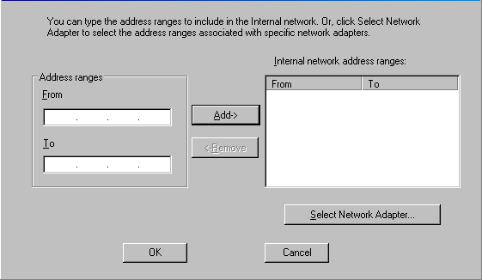
- In the Select Network Adapter dialog box, remove the checkmark from the Add the following private ranges… check box (you may later decide to use these private address ranges for perimeter networks). Leave the checkmark in the Add address ranges based on the Windows Routing Table check box, and place a checkmark in the check box next to the network adapter connected to the Internal network. Click OK.
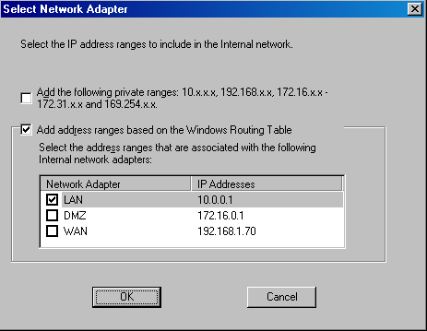
- Click OK in the Setup Message dialog box informing you that the Internal network was defined, based on the Windows routing table.
- Click OK on the Internal network address ranges dialog box.
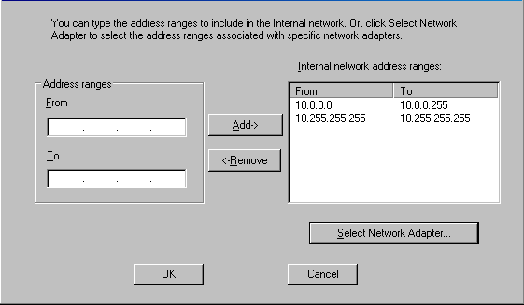
- Click Next on the Internal Network page.

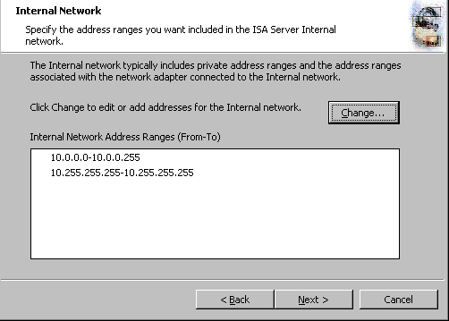
- On the Firewall Client Connection Settings page, place checkmarks in the Allow non-encrypted Firewall client connections and Allow Firewall clients running earlier versions of the Firewall client software to connect to ISA Server check boxes. These settings allow you to connect to the ISA Server 2004 firewall using downlevel operating systems as well as from Windows 2000/Windows XP/Windows Server 2003 operating systems running the ISA Server 2000 version of the Firewall client. Click Next.
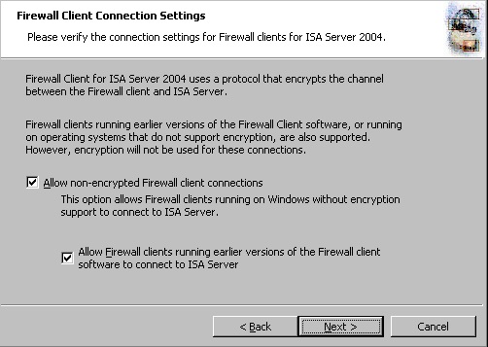
- On the Services page, click Next.
- Click Install on the Ready to Install the Program page.
- On the Installation Wizard Completed page, click Finish.
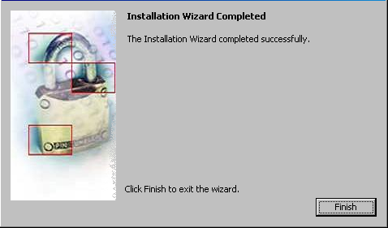
- Click Yes in the Microsoft ISA Server dialog box informing you that the machine must be restarted.
- Log on as Administrator after the machine restarts.

Viewing the System Policy
By default, ISA Server 2004 does not allow outbound access to the Internet from any protected network, and it does not allow Internet hosts access to the firewall or any networks protected by the firewall. However, a default firewall System Policy is installed that allows network management to complete certain tasks.
- Note:
A protected network is any network defined by the ISA Server 2004 firewall that is not part of the default external network.
Perform the following steps to see the default firewall System Policy:
- Click Start and point to All Programs. Point to Microsoft ISA Server and click ISA Server Management.
- In the Microsoft Internet Security and Acceleration Server 2004 management console, expand the server node in the scope pane (left pane) and click on the Firewall Policy node. Right click on the Firewall Policy node, point to View and click Show System Policy Rules.
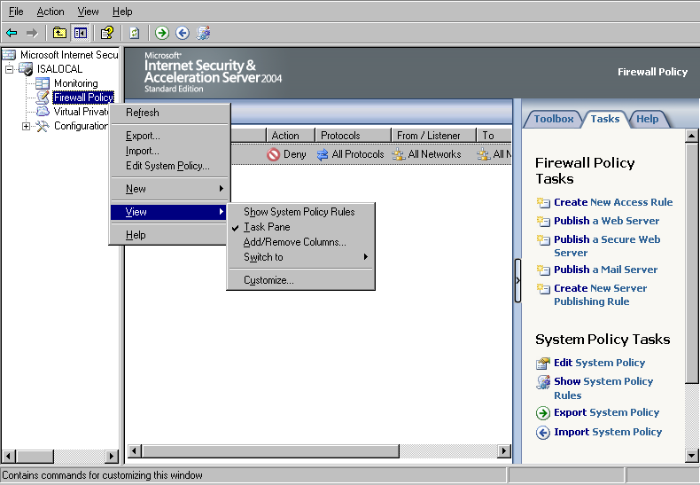
- Click the Show/Hide Console Tree button and then click the Open/Close Task Pane arrow (the little blue arrow on the left edge of the task pane on the right side of the console). Notice that the ISA Server 2004 Access Policy represents an ordered list. Policies are processed from top to bottom, which is a significant departure from how ISA Server 2000 processed Access Policy. The System Policy represents a default list of rules controlling access to and from the ISA Server 2004 firewall by default. Note that the System Policy Rules are ordered above any custom Access Policies you will create, and therefore, are processed before them. Scroll down the list of System Policy Rules. Notice that the rules are defined by:
Order number
Name
Action (Allow or Deny)
Protocols
From (source network or host)
To (destination network or host)
Condition (who or what the rule applies to)

You may want to widen the Name column to get a quick view of the rule descriptions. Notice that not all the rules are enabled. Disabled System Policy Rules have a tiny down-pointing red arrow in their lower right corner. The disabled System Policy Rules will become automatically enabled when you make configuration changes to the ISA Server 2004 firewall, such as when you enable VPN access.
Notice that one of the System Policy Rules allows the firewall to perform DNS queries to DNS servers on all networks.
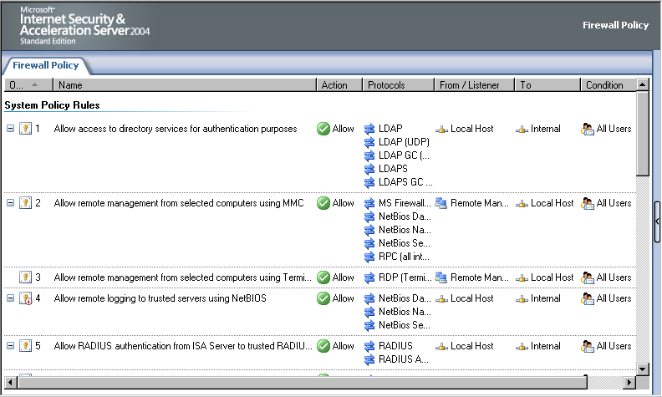
- You can change the settings on a System Policy Rule by double clicking on the rule.
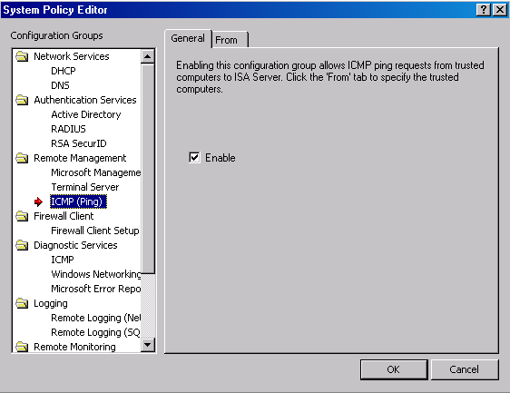
- Review the System Policy Rules and then hide the rules by clicking the Show/Hide System Policy Rules button in the console’s button bar. This is the depressed (pushed in) button seen in the figure below.

The following table includes a complete list of the default, built-in System Policy:
Table 1: System Policy Rules
Order | Name | Action | Protocols | From | To | Condition
1 | Allow access to directory services for authentication purposes | Allow | LDAP  LDAP(GC)  LDAP(UDP)  LDAPS  LDAPS(GC) | Local Host | Internal | All Users
2 | Allow Remote Management using MMC | Allow | MS Firewall Control  RPC(all interfaces)  NetBIOS Datagram  NetBIOS Name Service  NetBIOS Session | Remote Management Computers | Local Host | All Users
3 | Allow Remote Management using Terminal Server | Allow | RDP(Terminal Services) | Remote Management Computers | Local Host | All Users
4 | Allow remote logging to trusted servers using NetBIOS | Allow | NetBIOS Datagram  NetBIOS Name Service  NetBIOS Session | Local Host | Internal | All Users
5 | Allow RADIUS authentication from ISA Server to trusted RADIUS servers | Allow | RADIUS  RADIUS Accounting | Local Host | Internal | All Users
6 | Allow Kerberos authentication from ISA Server to trusted servers | Allow | Kerberos-Sec(TCP)  Kerberos-Sec(UDP) | Local Host | Internal | All Users
7 | Allow DNS from ISA Server to selected servers | Allow | DNS | Local Host | All Networks | All Users
8 | Allow DHCP requests from ISA Server to all networks | Allow | DHCP(request) | Local Host | Anywhere | All Users
9 | Allow DHCP replies from DHCP servers to ISA Server | Allow | DHCP(reply) | Anywhere | Local Host | All Users
10 | Allow ICMP (PING) requests from selected computers to ISA Server | Allow | Ping | Remote Management Computers | Local Host | All Users
11 | Allow ICMP requests from ISA Server to selected servers | Allow | ICMP Information Request  ICMP Timestamp  Ping | Local Host | All Networks | All Users
12¹ | Allow VPN client traffic to ISA Server | Allow | PPTP | External | Local Host | All Users
13² | Allow VPN site-to-site to ISA Server | Allow |  | External  IPSec Remote Gateways | Local Host | All Users
14² | Allow VPN site-to-site from ISA Server | Allow |  | Local Host | External  IPSec Remote Gateways | All Users
15 | Allow Microsoft CIFS protocol from ISA Server to trusted servers | Allow | Microsoft CIFS(TCP)  Microsoft CIFS(UDP) | Local Host | Internal | All Users
16⁷ | Allow Remote logging using Microsoft SQL protocol from firewall to trusted servers | Allow | Microsoft SQL(TCP)  Microsoft SQL(UDP) | Local Host | Internal | All Users
17 | Allow HTTP/HTTPS requests from ISA Server to specified sites | Allow | HTTP  HTTPS | Local Host | System Policy Allowed Sites | All Users
18³ | Allow HTTP/HTTPS requests from ISA Server to selected servers for HTTP connectivity verifiers | Allow | HTTP  HTTPS | Local Host | All Networks | All Users
19⁸ | Allow access from trusted computers to the Firewall Client installation share on ISA Server | Allow | Microsoft CIFS(TCP)  Microsoft CIFS(UDP)  NetBIOS Datagram  NetBIOS Name Service  NetBIOS Session | Internal | Local Host | All Users
20⁹ | Allow remote performance monitoring of ISA Server from trusted servers | Allow | NetBIOS Datagram  NetBIOS Name Service  NetBIOS Session | Remote Management Computers | Local Host | All Users
21 | Allow NetBIOS from ISA Server to trusted servers | Allow | NetBIOS Datagram  NetBIOS Name Service  NetBIOS Session | Local Host | Internal | All Users
22 | Allow RPC from ISA Server to trusted servers | Allow | RPC(all interfaces) | Local Host | Internal | All Users
23 | Allow HTTP/HTTPS from ISA Server to specified Microsoft Error Reporting sites | Allow | HTTP  HTTPS | Local Host | Microsoft Error Reporting sites | All Users
24⁴ | Allow SecurID protocol from ISA Server to trusted servers | Allow | SecurID | Local Host | Internal | All Users
25⁵ | Allow remote monitoring from ISA Server to trusted servers, using Microsoft Operations Manager (MOM) Agent | Allow | Microsoft Operations Manager Agent | Local Host | Internal | All Users
26⁶ | Allow HTTP from ISA Server to all networks for CRL downloads | Allow | HTTP | Local Host | All Networks | All Users
27 | Allow NTP from ISA Server to trusted NTP servers | Allow | NTP(UDP) | Local Host | Internal | All Users
28 | Allow SMTP from ISA Server to trusted servers | Allow | SMTP | Local Host | Internal | All Users
29 | Allow HTTP from ISA Server to selected computers for Content Download Jobs | Allow | HTTP | Local Host | All Networks | System and Network Service
¹ This policy is disabled until the VPN Server component is activated
² These two policies are disabled until a site-to-site VPN connection is configured
³ This policy is disabled until a connectivity verifier that uses HTTP/HTTPS is configured
⁴ This policy is disabled until the SecurID filter is enabled
⁵ This policy must be manually enabled
⁶ This policy is disabled by default
⁷ This policy is disabled by default
⁸ This policy is automatically enabled when the Firewall client share is installed
⁹ This policy is disabled by default
At this point, the ISA Server 2004 firewall is ready to be configured to allow inbound and outbound access through the firewall. However, before you start creating Access Policies, you should back up the default configuration. This allows you to restore the ISA Server 2004 firewall to its post-installation state, which is useful for future troubleshooting and testing.

Backing Up the Post-Installation Configuration
Perform the following steps to back up the post installation configuration:
- Open the Microsoft Internet Security and Acceleration Server 2004 management console and right click on the server name in the left pane of the console. Click the Back Up command.
- In the Backup Configuration dialog box, enter a name for the backup file in the File name text box. Be sure to note where you are saving the file by checking the entry in the Save in drop down list. In this example, call the backup file backup1. Click Backup.
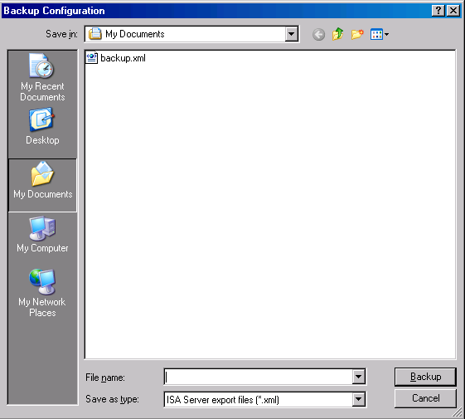
- In the Set Password dialog box, enter and confirm a password in the Password and Confirm password text boxes. The information in the backup file is encrypted because it can potentially contain passwords and other confidential information that you do not want others to access. Click OK.
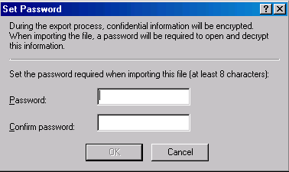
- Click OK in the Exporting dialog box when you see The configuration was successfully backed up.
Make sure to copy the backup file to another location on the network after the backup is complete. The backup file should be stored offline on media that supports NTFS formatting so that you can encrypt the file.

Conclusion
In this ISA Server 2004 VPN Deployment Kit document, we discussed the procedures required to install the ISA Server 2004 software on a Windows Server 2003 computer. We also examined the firewall System Policy that is created during installation. Finally, we finished - with the step-by-step procedures required to back up the post-installation firewall configuration. In the next chapter of the ISA Server 2004 VPN Deployment Kit series, we will enable the VPN remote access server.

This is a preliminary document and may be changed substantially prior to final commercial release of the software described herein.
The information contained in this document represents the current view of Microsoft Corporation on the issues discussed as of the date of publication. Because Microsoft must respond to changing market conditions, it should not be interpreted to be a commitment on the part of Microsoft, and Microsoft cannot guarantee the accuracy of any information presented after the date of publication.
This white paper is for informational purposes only. MICROSOFT MAKES NO WARRANTIES, EXPRESS OR IMPLIED, IN THIS
DOCUMENT.
Complying with all applicable copyright laws is the responsibility of the user. Without limiting the rights under copyright, no part of this document may be reproduced, stored in, or introduced into a retrieval system, or transmitted in any form or by any means (electronic, mechanical, photocopying, recording, or otherwise), or for any purpose, without the express written permission of Microsoft Corporation.
Microsoft may have patents, patent applications, trademarks, copyrights, or other intellectual property rights covering subject matter in this document. Except as expressly provided in any written license agreement from Microsoft, the furnishing of this document does not give you any license to these patents, trademarks, copyrights, or other intellectual property.
© 2004 Microsoft Corporation. All rights reserved.
The example companies, organizations, products, domain names, e-mail addresses, logos, people, places, and events depicted herein are fictitious. No association with any real company, organization, product, domain name, e-mail address, logo, person, place, or event is intended or should be inferred.
Microsoft, Windows, Windows 2000, Windows 2000 Server, Windows Server 2003, Windows Server System, ISA Server, and ISA Server 2004 are either registered trademarks or trademarks of Microsoft Corporation in the United States and/or other countries.
The names of actual companies and products mentioned herein may be the trademarks of their respective owners.

ISA Server 2004 VPN Deployment Kit: Configuring the ISA Server 2004 Firewall as a VPN Server
Chapter 4
Published: April 2004
For the latest information, please see http://www.microsoft.com/isaserver/

Contents
Introduction 1
Enable the VPN Server 2
Create an Access Rule Allowing VPN Clients Access to the Internal Network 10
Enable Dial-in Access for the Administrator Account 13
Test the PPTP VPN Connection 14
Issue Certificates to the ISA Server 2004 Firewall and VPN Clients 16
Test a L2TP/IPSec VPN Connection 20
Monitor VPN Clients 22
Conclusion 24

Introduction
The ISA Server 2004 firewall can be configured as a VPN server. The VPN server component enables the firewall to accept incoming VPN remote-access client calls. The VPN client computer can become a member of a protected network after successfully establishing the VPN connection.
One of the misconceptions regarding VPN technologies has been that it was considered by many administrators to be a security technology. In reality, VPN is a secure remote access technology that secures data in transit, but does not add any security to the connection VPN clients make to the corporate network. The reason for this is that traditional VPN servers allow VPN clients full access to the networks to which they connect. You either had to reconfigure the network infrastructure just to support the security requirements for VPN clients, or you had to have a high level of trust in your VPN users.
In contrast, the ISA Server 2004 VPN server changes the VPN remote access playing field by allowing you to control protocols and servers to which VPN clients can connect. VPN client access controls can be based on user credentials submitted when the client logged onto the VPN server.
You can use the Microsoft Internet Security and Acceleration Server 2004 management console to manage almost every aspect of the VPN server configuration. The firewall manages the list of IP addresses assigned to VPN clients and places those addresses on a dedicated VPN clients network. Access controls can then be placed on communications moving to and from the VPN clients network using Access Rules.
In the following walkthrough you will perform the following tasks to enable and test the ISA Server 2004 VPN server:
- Enable the VPN Server
- Create an Access Rule allowing VPN clients access to the Internal network
- Enable Dial-in Access for the User Account
- Test a PPTP VPN Connection
- Issue certificates to the ISA Server 2004 firewall and VPN clients
- Test a L2TP/IPSec VPN connection
- Monitor VPN Client Connections

Enable the VPN Server
By default, the VPN server component is disabled. The first step is to enable the VPN server feature and configure the VPN server components.
Perform the following steps to enable and configure the ISA Server 2004 VPN Server:
- Open the Microsoft Internet Security and Acceleration Server 2004 management console and expand the server name. Click on the Virtual Private Networks (VPN) node.
- Click on the Tasks tab in the Task Pane. Click Enable VPN Client Access.
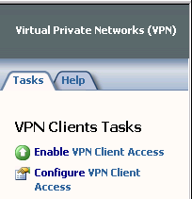
- Click Apply to save the changes and update the firewall policy.
- Click OK in the Apply New Configuration dialog box.
- Click Configure VPN Client Access.
- On the General tab, change the value for the Maximum number of VPN clients allowed from 5 to 10.
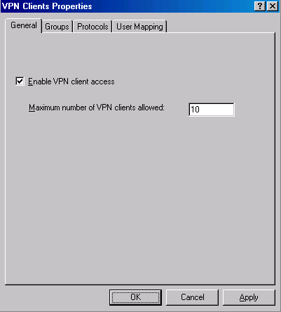
- Click on the Groups tab. On the Groups tab, click Add.
- In the Select Groups dialog box, click the Locations button. In the Locations dialog box, click the msfirewall.org entry and click OK.
- In the Select Group dialog box, enter Domain Users in the Enter the object names to select text box. Click the Check Names button. The group name will be underlined when it is found in the Active Directory. Click OK.
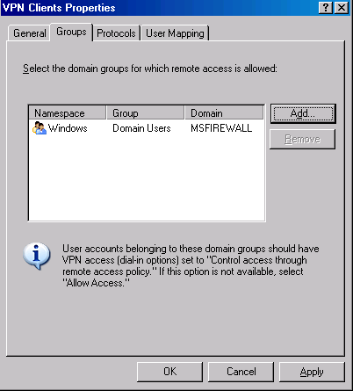
- Click the Protocols tab. On the Protocols tab, put a checkmark in the Enable L2TP/IPSec check box.
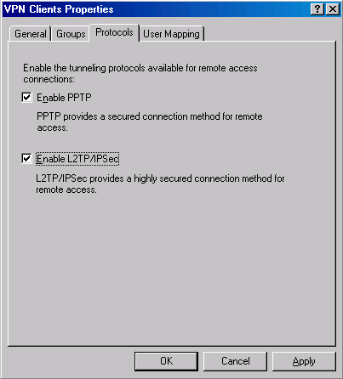

- Click the User Mapping tab. Put a checkmark in the Enable User Mapping check box. Put a checkmark in the When username does not contain a domain, use this domain check box. Enter msfirewall.org in the Domain Name text box. Note that these settings will only apply when using RADIUS authentication. These settings are ignored when using Windows authentication (such as when the ISA Server 2004 firewall machine belongs to the domain and the user explicitly enters domain credentials). Click Apply and OK. You may see a Microsoft Internet Security and Acceleration Server 2004 dialog box informing you that you need to restart the computer for the settings to take effect. If so, click OK in the dialog box.
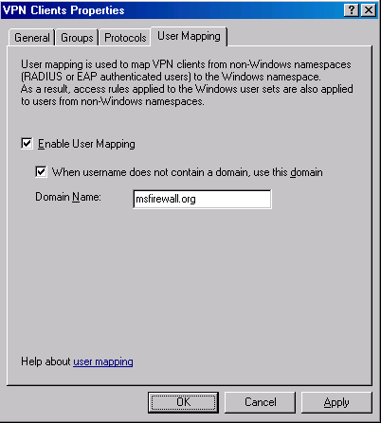
- On the Tasks tab, click the Select Access Networks link.
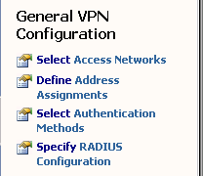
- In the Virtual Private Networks (VPN) Properties dialog box, click the Access Networks tab. Note that the External check box is selected. This indicates that the external interface is listening for incoming VPN client connections.
- Click the Address Assignment tab. Select Internal from the Use the following network to obtain DHCP, DNS and WINS services drop down list box. This is a critical setting as it defines the network on which access to the DHCP is made.
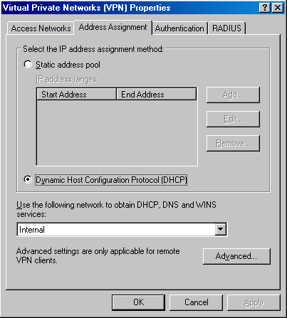
- Click on the Authentication tab. Note that the default setting enables only Microsoft encrypted authentication version 2 (MS-CHAPv2). In later chapters of this ISA Server 2004 VPN Deployment Kit, we will enable the EAP option so that high security user certificates can be used to authenticate with the ISA Server 2004 firewall VPN server. Note the Allow custom IPSec policy for L2TP connection check box. If you do not want to create a public key infrastructure, or, you are in the process of creating one but have not yet finished, you can enable this check box and enter a pre-shared key. Later, in this ISA Server 2004 VPN Deployment Kit, we will use the pre-shared key option to create a site-to-site IPSec tunnel mode VPN link.
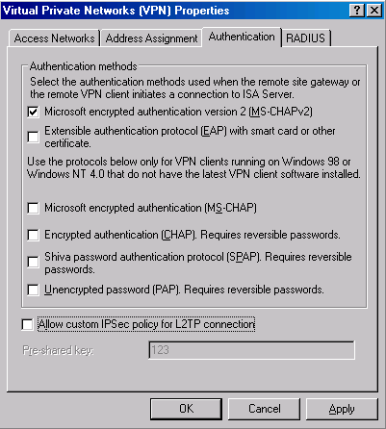
- Click the RADIUS tab. Here you can configure the ISA Server 2004 firewall VPN server to use RADIUS to authenticate the VPN users. Later in this ISA Server 2004 VPN Deployment Kit, we will walk through the procedures for enabling RADIUS authentication. The advantage of RADIUS authentication is that you can leverage the Active Directory (and others) user database to authenticate users without needing to join the Active Directory domain.
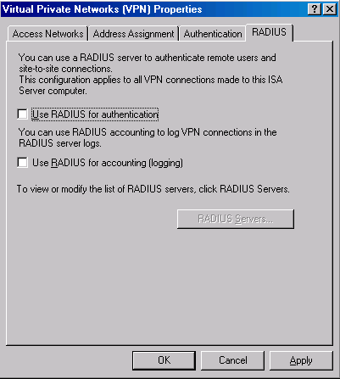
- Click Apply in the Virtual Private Networks (VPN) Properties dialog box and then click OK.
- Click Apply to save the changes and update the firewall policy.
- Click OK in the Apply New Configuration dialog box.
- Restart the ISA Server 2004 firewall machine.
The machine will obtain a block of IP addresses from the DHCP Server on the Internal network when it restarts. Note that on a production network where the DHCP server is located on a network segment remote from the ISA Server 2004 firewall, all interposed routers will need to have BOOTP or DHCP relay enabled so that DHCP requests from the firewall can reach the remote DHCP servers.

Create an Access Rule Allowing VPN Clients Access to the Internal Network
The ISA Server 2004 firewall will be able to accept incoming VPN connections after the restart. However, the VPN clients cannot access any resources on the Internal network because there are no Access Rules enabling this access. You must create an Access Rule that allows members of the VPN clients network access to the Internal network. In contrast to other combined firewall VPN server solutions, the ISA Server 2004 firewall VPN server applies access controls for network access to VPN clients.
In this example, you will create an Access Rule allowing all traffic to pass from the VPN clients network to the Internal network. In a production environment, you would create more restrictive access rules so that users on the VPN clients network have access only to resources they require. We will demonstrate a more restrictive Access Policy later in this ISA Server 2004 VPN Deployment Kit document.
Perform the following steps to create an unrestricted access VPN clients Access Rule:
- In the Microsoft Internet Security and Acceleration Server 2004 management console, expand the server name and click the Firewall Policy node. Right click the Firewall Policy node, point to New and click Access Rule.
- In the Welcome to the New Access Rule Wizard page, enter a name for the rule in the Access Rule name text box. In this example, enter VPN Client to Internal. Click Next.
- On the Rule Action page, select Allow and click Next.
- On the Protocols page, select All outbound protocols in the This rule applies to list. Click Next.
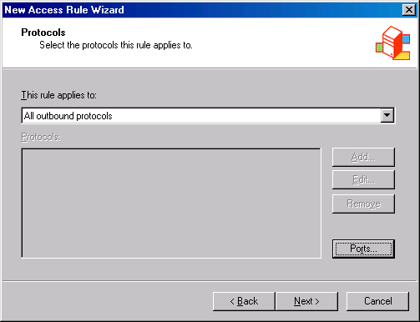
- On the Access Rule Sources page, click Add. In the Add Network Entities dialog box, click the Networks folder and double click on VPN Clients. Click Close.
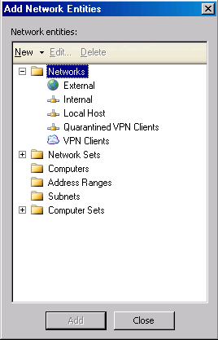
- Click Next on the Access Rule Sources page.
- On the Access Rule Destinations page, click Add. On the Add Network Entities dialog box, click the Networks folder and double click on Internal. Click Close.
- On the User Sets page, accept the default setting, All Users, and click Next.
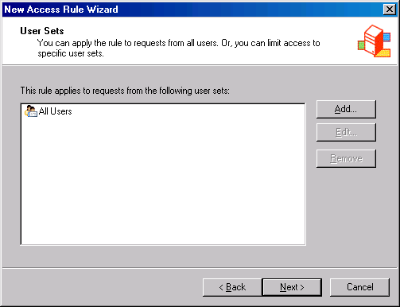
- Click Finish on the Completing the New Access Rule Wizard page.
- Click Apply to save the changes and update the firewall policy.
- Click OK in the Apply New Configuration dialog box. The VPN client policy is now the top listed Access Rule in the Access Policy list.
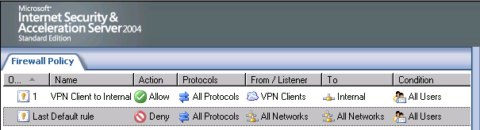

Enable Dial-in Access for the Administrator Account
In non-native mode Active Directory domains, all user accounts have dial-in access disabled by default. You must enable dial-in access on a per account basis for these non-native mode Active Directory domains. In contrast, native-mode Active Directory domains have dial-in access controlled by Remote Access Policy by default. Windows NT 4.0 domains always have dial-in access controlled on a per user account basis.
In our current example, the Active Directory is in Windows Server 2003 mixed mode, so we will need to manually change the dial-in settings on the domain user account.
Perform the following steps on the domain controller to enable Dial-in access for the Administrator account:
- Click Start and point to Administrative Tools. Click Active Directory Users and Computers.
- In the Active Directory Users and Computers console, click on the Users node in the left Pane. Double click on the Administrator account in the right Pane of the console.
- Click on the Dial-in tab. In the Remote Access Permission (Dial-in or VPN) frame, select Allow access. Click Apply and click OK.
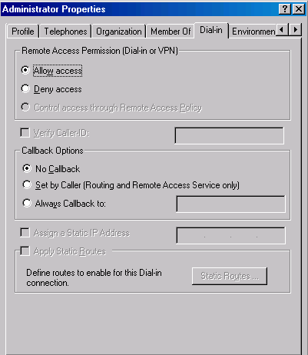
- Close the Active Directory Users and Computers console.

Test the PPTP VPN Connection
The ISA Server 2004 VPN server is now ready to accept VPN client connections.
Perform the following steps to test the VPN Server:
- On the Windows 2000 external client machine, right click the My Network Places icon on the desktop and click Properties.
- Double click the Make New Connection icon in the Network and Dial-up Connections window.
- Click Next on the Welcome to the Network Connection Wizard page.
- On the Network Connection Type page, select Connect to a private network through the Internet and click Next.
- On the Destination Address page, enter the IP address 192.168.1.70 in the Host name or IP address text box. Click Next.
- On the Connection Availability page, select For all users and click Next.
- Make no changes on the Internet Connection Sharing page. Click Next.
- On the Completing the Network Connection Wizard page, enter a name for the VPN connection in the Type the name you want to use for this connection text box. In this example, name the connection ISA VPN. Confirm that there is a checkmark in the Add a shortcut to my desktop check box. Click Finish.
- In the Connect ISA VPN dialog box, enter the user name MSFIREWALL\administrator and the password for the administrator user account. Click Connect.
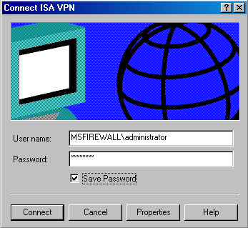
- The VPN client establishes a connection with the ISA Server 2004 VPN server. Click OK in the Connection Complete dialog box informing that the connection is established.
- Double click on the connection icon in the system tray and click the Details tab. You can see that MPPE 128 encryption is used to protect the data and the IP address assigned to the VPN client. Click Close.
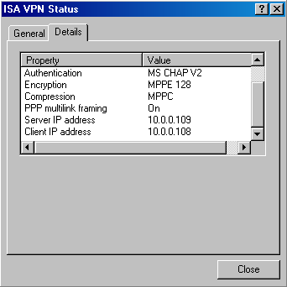
- Click Start and the Run command. In the Run dialog box, enter \\EXCHANGE2003BE in the Open text box and click OK. The shares on the domain controller computer appear. Close the windows displaying the domain controllers contents. Note that we were able to use a single label name to connect to the domain controller because the ISA Server 2004 firewall VPN server assigned the VPN client a WINS server address.
- Right click the connection icon in the system tray and click Disconnect.

Issue Certificates to the ISA Server 2004 Firewall and VPN Clients
You can significantly improve the level of security provided to your VPN connection by using the L2TP/IPSec VPN protocol. The IPSec encryption protocol provides a number of security advantages over the Microsoft Point-to-Point Encryption (MPPE) protocol used to secure PPTP connections. While the ISA Server 2004 firewall VPN supports using a pre-shared key to support the IPSec encryption process, this should be considered a low security option and should be avoided if possible. The secure IPSec solution is to use computer certificates on the VPN server and VPN clients.
The first step is to issue a computer certificate to the ISA Server 2004 firewall VPN server. There are a number of methods you can use to request a computer certificate. In the following example, we will use the Certificates stand-alone MMC snap-in. In order for the stand-alone MMC snap-in to communicate with the certificate authority, we will need to enable an “all open” rule that allows all traffic from the Local Host network to the Internet network. We will disable this rule after the certificate request is complete.
Perform the following steps on the ISA Server 2004 firewall to request a certificate from the enterprise CA on the Internal network:
- In the Microsoft Internet Security and Acceleration Server 2004 management console, expand the server name in the left pane and then click the Firewall Policy node. Click the Tasks tab in the Task Pane and then click Create New Access Rule.
- On the Welcome to the New Access Rule Wizard page, enter a name for the rule in the Access Rule name text box. In this example we will enter All Open from Local Host to Internal. Click Next.
- On the Rule Action page, select the Allow option and click Next.
- On the Protocols page, accept the default selection, All outbound traffic, and click Next.
- On the Access Rule Sources page, click Add. In the Add Network Entities dialog box, click the Networks folder. Double click Local Host and click Close.
- On the Access Rule Destinations page, click Add. In the Add Network Entities dialog box, click the Networks folder. Double click Internal and click Close.
- On the User Sets page, accept the default setting, All Users, and click Next.
- Click Finish on the Completing the New Access Rule Wizard page.
- Right click the All Open from Local Host to Internal Access Rule and click the Configure RPC Protocol command.
- In the Configure RPC protocol policy dialog box, remove the checkmark from the Enforce strict RPC compliance checkbox. Click Apply and then click OK.
- In the Microsoft Internet Security and Acceleration Server 2004 management console, expand the Configuration node and click on the Add-ins node. Right click on the RPC Filter entry in the Details Pane and click Disable.
- In the ISA Server Warning dialog box, select the Save the changes and restart the services option. Click OK.
- Click Apply to save the changes and update the firewall policy.
- Click OK in the Apply New Configuration dialog box.
- Click Start and the Run command. Enter mmc in the Open text box, and click OK.
- In Console1, click the File menu and the Add/Remove Snap-in command.
- In the Add/Remove Snap-in dialog box, click Add.
- In the Add Standalone Snap-in dialog box, select the Certificates entry from the Available Standalone Snap-ins list.. Click Add.
- On the Certificates snap-in page, select Computer account.
- On the Select Computer page, select Local computer.
- Click Close in the Add Standalone Snap-in dialog box.
- Click OK in the Add/Remove Snap-in dialog box.
- In the left Pane of the console, expand the Certificates (Local Computer) node and click on the Personal node. Right click on the Personal node. Point to All Tasks, and click Request New Certificate.
- Click Next on the Welcome to the Certificate Request Wizard page.
- On the Certificate Types page, select the Computer entry in the Certificate types lists and click Next.
- On the Certificate Friendly Name and Description page, enter a name in the Friendly name text box. In this example, enter Firewall Computer Certificate in the Friendly name text box. Click Next.
- Click Finish on the Completing the Certificate Request Wizard page.
- Click OK in the dialog box informing you that the certificate request was successful.
- Return to the Microsoft Internet Security and Acceleration Server 2004 management console and expand the computer name in the left pane and click on the Firewall Policy node. Right click on the All Open from Local Host to Internal Access Rule and click Disable.
- In the Microsoft Internet Security and Acceleration Server 2004 management console, expand the Configuration node and click on the Add-ins node. Right click on the RPC Filter entry in the Details Pane and click Enable.
- Click Apply to save the changes and update the firewall policy
- In the ISA Server Warning dialog box, select the Save the changes and restart the services option. Click OK.
- Click OK in the Apply New Configuration dialog box.
Note that you will not need to manually copy the enterprise CA certificate into the ISA Server 2004 firewall’s Trusted Root Certification Authorities certificate store because CA certificate is automatically installed on domain members. If the firewall were not a member of the domain, then you would need to manually place the CA certificate into the Trusted Root Certification Authorities certificate store.
The next step is to issue a computer certificate to the VPN client computer. In this example, the VPN client machine is not a member of the domain. You will need to request a computer certificate using the enterprise CA’s Web enrollment site and manually place the enterprise CA certificate into the client’s Trusted Root Certification Authorities machine certificate store. The easiest way to accomplish this task is to have the VPN client machine request the certificate when connected via a PPTP link.
- Note:
In a production environment, untrusted clients should not be issued computer certificates. Only managed computers that are members of the domain should be allowed to install computer certificates. Domain members are managed clients and, therefore, under the organization’s administrative control. The computer certificate is a security principle and is not meant to provide free access to all clients who wish to connect via VPN.
Perform the following steps to request and install the CA certificate:
- Establish a PPTP VPN connection to the ISA Server 2004 firewall VPN server.
- Open Internet Explorer. In the Address bar, enter http://10.0.0.2/certsrv and click OK.
- In the Enter Network Password dialog box, enter Administrator in the User Name text box and enter the Administrator’s password in the Password text box. Click OK.
- Click Request a Certificate on the Welcome page.
- On the Request a Certificate page, click advanced certificate request.
- On the Advanced Certificate Request page, click Create and submit a request to this CA.
- On the Advanced Certificate Request page, select the Administrator certificate from the Certificate Template list. Place a checkmark in the Store certificate in the local computer certificate store check box. Click Submit.
- Click Yes in the Potential Scripting Violation dialog box.
- On the Certificate Issued page, click Install this certificate.
- Click Yes on the Potential Scripting Violation page.
- Close the browser after viewing the Certificate Installed page.
- Click Start, and then click the Run command. Enter mmc in the Open text box, and click OK.
- In Console1, click the File menu and the click the Add/Remove Snap-in command.
- Click Add in the Add/Remove Snap-in dialog box.
- In the Add Standalone Snap-in dialog box, select the Certificates entry from the Available Standalone Snap-ins list. Click Add.
- Select Computer account on the Certificates snap-in page.
- Select Local computer on the Select Computer page.
- Click Close in the Add Standalone Snap-in dialog box.
- Click OK in the Add/Remove Snap-in dialog box.
- In the left Pane of the console, expand the Certificates (Local Computer) the Personal nodes. Click on the \Personal\Certificates node. Double click on the Administrator certificate in the right Pane of the console.
- In the Certificate dialog box, click the Certification Path tab. At the top of the certificate hierarchy seen in the Certification path frame is the root CA certificate. Click the EXCHANGE2003BE certificate at the top of the list. Click View Certificate.
- In the CA certificate’s Certificate dialog box, click the Details tab. Click Copy to File.
- Click Next in the Welcome to the Certificate Export Wizard page.
- On the Export File Format page, select Cryptographic Message Syntax Standard – PKCS #7 Certificates (.P7B) and click Next.
- On the File to Export page, enter c:\cacert in the File name text box. Click Next.
- Click Finish on the Completing the Certificate Export Wizard page.
- Click OK in the Certificate Export Wizard dialog box.
- Click OK in the Certificate dialog box. Click OK again in the Certificate dialog box.
- In the left Pane of the console, expand the Trusted Root Certification Authorities node, and click the Certificates node. Right click the \Trusted Root Certification Authorities\Certificates node. Point to All Tasks and click Import.
- Click Next on the Welcome to the Certificate Import Wizard page.
- On the File to Import page. Use the Browse button to locate the CA certificate you saved to the local hard disk and click Next.
- On the Certificate Store page, accept the default settings and click Next.
- On the Completing the Certificate Import Wizard page, click Finish.
- On the Certificate Import Wizard dialog box informing you that the import was successful, click OK.
Disconnect from the VPN server. Right click on the connection icon in the system tray and click Disconnect.

Test a L2TP/IPSec VPN Connection
Now that both the ISA Server 2004 firewall and the VPN client machines have machine certificates, you can test a secure remote-access client VPN connection to the firewall. The first step is to restart the Routing and Remote Access Service so that it registers the new certificate.
Perform the following steps to restart the Routing and Remote Access Service:
- In the Microsoft Internet Security and Acceleration Server 2004 management console, expand the server name and click the Monitoring node.
- In the Details Pane, click on the Services tab. Right click on the Remote Access Service entry and click Stop.
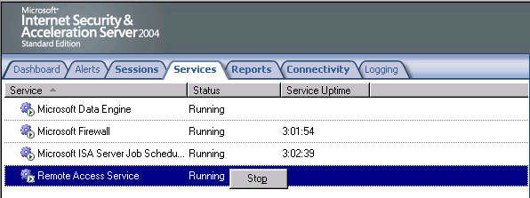
- Right click Remote Access Service entry again and click Start.
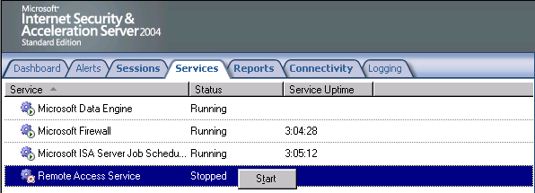
The next step is to start the VPN client connection:
- From the VPN client computer establish a VPN connection in the same way that you have earlier in these walkthroughs.
- Click OK in the Connection Complete dialog box informing you that the connection is established.
- Double click on the connection icon in the system tray.
- In the ISA VPN Status dialog box, click the Details tab. You will see an entry for IPSEC Encryption, indicating that the L2TP/IPSec connection was successful.
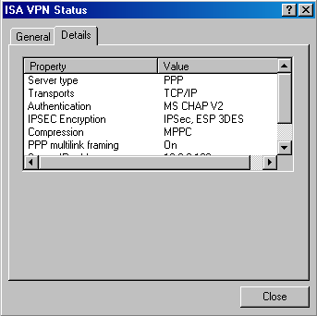
- Click Close in the ISA VPN Status dialog box.

Monitor VPN Clients
The ISA Server 2004 firewall allows you to monitor the VPN client connections. Perform the following steps to see how you can view connections from VPN clients:
- In the Microsoft Internet Security and Acceleration Server 2004 management console, expand the computer name in the left Pane of the console and click the Virtual Private Networks (VPN) node. In the Task Pane, click the Tasks tab. Click Monitor VPN Clients.
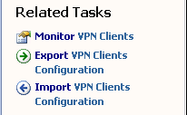
- You are moved to the Sessions tab in the Monitoring node. Here you can see that the sessions have been filtered to show only the VPN Client connections.
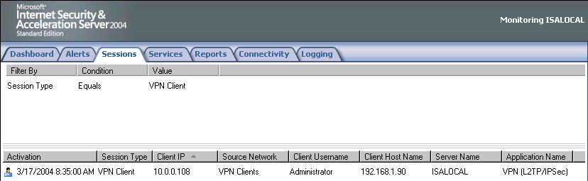
- Click on the Dashboard tab. Here you can see in the Sessions Pane the VPN Remote Client connections.
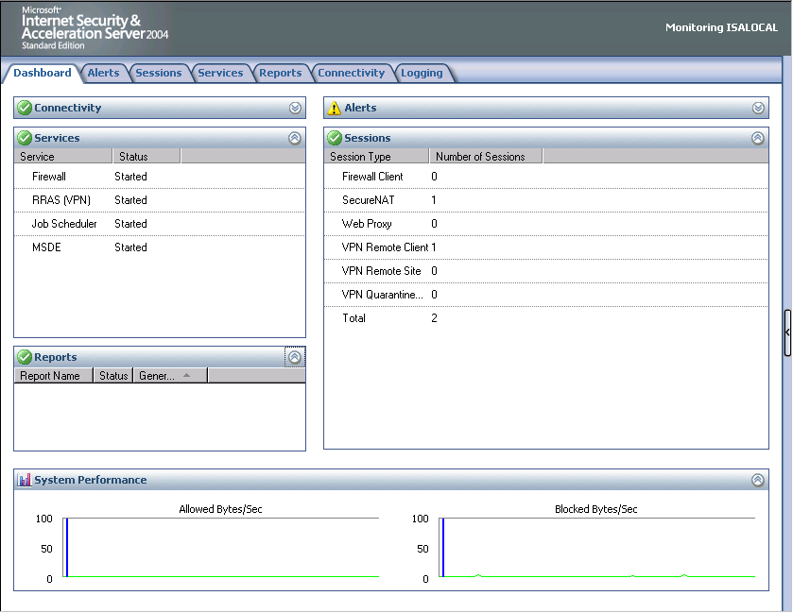
- You can also use the real-time logging feature to see connections made by the VPN clients. Click on the Logging tab and then click the Tasks tab in the Task Pane. Click Start Query. Here you see all communications moving through the firewall. You can use the filter capabilities to focus on specific VPN clients or only the VPN clients network.
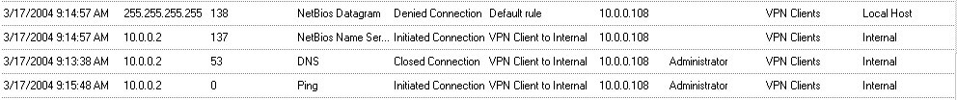

Conclusion
In this ISA Server 2004 Getting Started Guide document, we discussed how to enable the ISA Server 2004 VPN server component and then how to configure the VPN server. We then tested the VPN server functionality by creating a VPN client connection to the server and accessing resources on the Internal network. In the next chapter in this ISA Server 2004 VPN Deployment Kit series, we will discuss how the firewall can be used to publish an array of Exchange Server services.

This is a preliminary document and may be changed substantially prior to final commercial release of the software described herein.
The information contained in this document represents the current view of Microsoft Corporation on the issues discussed as of the date of publication. Because Microsoft must respond to changing market conditions, it should not be interpreted to be a commitment on the part of Microsoft, and Microsoft cannot guarantee the accuracy of any information presented after the date of publication.
This white paper is for informational purposes only. MICROSOFT MAKES NO WARRANTIES, EXPRESS OR IMPLIED, IN THIS
DOCUMENT.
Complying with all applicable copyright laws is the responsibility of the user. Without limiting the rights under copyright, no part of this document may be reproduced, stored in, or introduced into a retrieval system, or transmitted in any form or by any means (electronic, mechanical, photocopying, recording, or otherwise), or for any purpose, without the express written permission of Microsoft Corporation.
Microsoft may have patents, patent applications, trademarks, copyrights, or other intellectual property rights covering subject matter in this document. Except as expressly provided in any written license agreement from Microsoft, the furnishing of this document does not give you any license to these patents, trademarks, copyrights, or other intellectual property.
© 2004 Microsoft Corporation. All rights reserved.
The example companies, organizations, products, domain names, e-mail addresses, logos, people, places, and events depicted herein are fictitious. No association with any real company, organization, product, domain name, e-mail address, logo, person, place, or event is intended or should be inferred.
Microsoft, Windows, Windows 2000, Windows 2000 Server, Windows Server 2003, Windows Server System, ISA Server, and ISA Server 2004 are either registered trademarks or trademarks of Microsoft Corporation in the United States and/or other countries.
The names of actual companies and products mentioned herein may be the trademarks of their respective owners.

ISA Server 2004 VPN Deployment Kit: Creating Access Policy for VPN Clients
Chapter 5
Published: April 2004
For the latest information, please see http://www.microsoft.com/isaserver/

Contents
Introduction 1
Enable and Configure the ISA Server 2004 VPN Server 2
Create a User Account and a VPN Client Exchange Users Group in Active Directory 10
Create a Firewall Group that Includes the VPN Exchange Users Group 15
Create Access and Server Publishing Rules Restricting Access to the Exchange Server 18
Create an Access Rule Allowing Access to the Web Enrollment Site 26
Arrange the Rule Order 29
Establish a VPN connection and Connect to Microsoft Exchange via Secure RPC 30
Establish a VPN connection and Connect to the Web Enrollment Site 32
Conclusion 33

Introduction
An impressive feature of ISA Server 2004 is its ability to apply firewall policy to VPN client connections. Most other firewalls that allow VPN client connections allow the VPN client access to any resource on the network to which the user has local permission. The inability of non-ISA Server 2004 firewalls to force firewall policy on VPN can sometimes lead to disastrous results.
For example, many organizations had not applied the request patch to protect against the MSBLAST worm when it struck corporate networks all over the world. Organizations with ISA Server firewalls protecting them from external attacks were completely protected against MSBLAST, and protection provided by the ISA Server firewalls gave network administrators time to get their systems patched.
The problem was that many corporate networks otherwise protected against MSBLAST allowed VPN connections to the network. Once connected, the VPN clients were able to infect hosts on the corporate network because no firewall access controls were placed on the VPN client machines. ISA Server 2004 VPN servers prevent this type of problem because you can enforce strong access policies on VPN clients. The VPN client connections are allowed access only to the servers and protocols they require to get their work done. VPN users are not able to contact any server they do not have permission to contact, and they can only use the protocols assigned to them when connecting to servers they are allowed to contact.
In this ISA Server 2004 VPN Deployment Kit, we cover in step-by-step detail how to create an access policy allowing only approved users to access a Microsoft Exchange Server using the secure Exchange RPC protocol, while preventing access for all other users. This type of access policy provides an enormous network security boost as the Outlook e-mail client users connecting to the Exchange Server are allowed access only to the Exchange Server. And you choose the users allowed this access. We will also create an access policy that allows all users to connect to a Web enrollment site to obtain a certificate.
The following procedures are required to create these secure access controls on VPN clients:
- Enable and Configure the ISA Server 2004 VPN Server
- Create a user account and a VPN Client Exchange Users Group in Active Directory
- Create a Firewall Group that Includes the VPN Exchange Users Group
- Create Access Rules restricting access to the Exchange Server
- Create an Access Rule allowing access to the Web enrollment site
- Arrange the Rule Order
- Establish a VPN connection and Connect to Microsoft Exchange via Secure RPC
- Establish a VPN connection and Connect to the Web Enrollment Site
MACHINES USED IN THIS DOCUMENT:
ISALOCAL
EXCHANGE2003BE
EXTERNALCLIENT

Enable and Configure the ISA Server 2004 VPN Server
By default, the VPN server component is disabled. The first step is to enable the VPN server feature and configure the VPN server components.
To enable and configure the ISA Server 2004 VPN Server:
- Open the Microsoft Internet Security and Acceleration Server 2004 management console and expand the server name. Click on the Virtual Private Networks (VPN) node.
- Click on the Tasks tab, and click Enable VPN Client Access.
- Click Apply to save the changes and update the firewall policy.
- Click OK in the Apply New Configuration dialog box.
- Click Configure VPN Client Access.
- On the General tab, change the value for the Maximum number of VPN clients allowed from 5 to 10.
- Click on the Groups tab, and click Add.
- In the Select Groups dialog box, click Locations. In the Locations dialog box, click msfirewall.org and OK.
- In the Select Group dialog box, enter Domain Users in the Enter the object names to select text box. Click the Check Names button. The group name is underlined in the Active Directory. Click OK.
- Click the Protocols tab. On the Protocols tab, put a checkmark in the Enable L2TP/IPSec check box.
- Click the User Mapping tab. Put a checkmark in the Enable User Mapping check box. Put a checkmark in the When username does not contain a domain, use this domain checkbox. Enter msfirewall.org in the Domain Name text box. Note that these settings only apply when using RADIUS authentication. These settings are ignored when using Windows authentication (such as when the ISA Server 2004 firewall machine belongs to the domain and the user explicitly enters domain credentials). Click Apply and OK. If the Microsoft Internet Security and Acceleration Server 2004 dialog box informs you that you need to restart the computer for the settings to take effect, click OK.
- On the Tasks tab, click Select Access Networks.
- In the Virtual Private Networks (VPN) Properties dialog box, click the Access Networks tab. Note that the External checkbox is selected. This indicates that the external interface is listening for incoming VPN client connections.
- Click the Address Assignment tab. Select the Internal interface from the list in Use the following network to obtain DHCP, DNS and WINS services. This is a critical setting as it defines the network where access to the DHCP is made.
- Click on the Authentication tab. Note that the default setting enables only Microsoft encrypted authentication version 2 (MS-CHAPv2). Later in this ISA Server 2004 VPN Deployment Kit, we will enable the EAP option so that high security user certificates can be used to authenticate with the ISA Server 2004 firewall VPN server. Note the Allow custom IPSec policy for L2TP connection check box. If you do not want to create a public key infrastructure, or you are in the process of creating one but have not finished, you can enable this checkbox and enter a pre-shared key. Later, we will use the pre-shared key option to create a site-to-site IPSec tunnel mode VPN link. At this time, we will not enable this option.
- Click the RADIUS tab. Here you can configure the ISA Server 2004 firewall VPN server to use RADIUS to authenticate the VPN users. In a later document in this ISA Server 2004 VPN Deployment Kit, we will walk through the procedures for enabling RADIUS authentication. The advantage of RADIUS authentication is that you can leverage the Active Directory (and others) user database to authenticate users without needing to join the Active Directory domain.
- Click Apply in the Virtual Private Networks (VPN) Properties dialog box, and then click OK.
- Click Apply to save the changes and update the firewall policy.
- Click OK in the Apply New Configuration dialog box.
- Restart the ISA Server 2004 firewall machine.
The machine will obtain a block of IP addresses from the DHCP Server on the Internal network when it restarts. Note that on a production network where the DHCP server is located on a network segment remote from the ISA Server 2004 firewall, all interposed routers will need to have BOOTP or DHCP relay enabled so that DHCP requests from the firewall can reach the remote DHCP servers.

Create a User Account and a VPN Client Exchange Users Group in Active Directory
Perform the following steps at the domain controller to create the user account and the VPN Exchange Users group in the Active Directory:
- At the domain controller machine on the Internal network, click Start and point to Administrative Tools. Click on Active Directory Users and Computers.
- In the Active Directory Users and Computers console, expand the domain name, msfirewall.org, and then click on the Users folder.
- Right click the Users folder, point to New and click User.
- In the New Object – User wizard, enter the First name of User1. Leave the Initials, Last name and Full Name text boxes empty. In the User logon name text box, enter user1. Click Next.
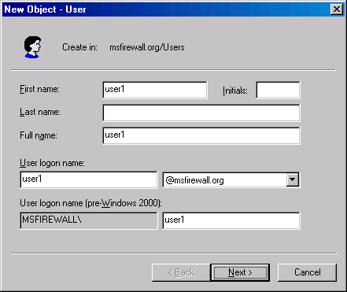
- Enter a password for user1 and confirm the password in the Confirm Password text box. Remove the checkmark from User must change password at next logon and place checkmarks in the User cannot change password and Password never expires check boxes. Click Next.
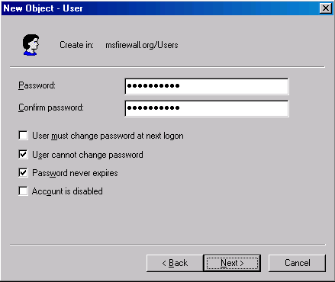
- Accept the default settings on creating an Exchange mailbox page and click Next.
- Click Finish on the last page of the Wizard.
- Right click the user1 user account and click Properties.
- In the user1 Properties dialog box, click the Dial-in tab. Select the Allow access option in the Remove Access Permission (Dial-in or VPN) frame. Click Apply and OK.
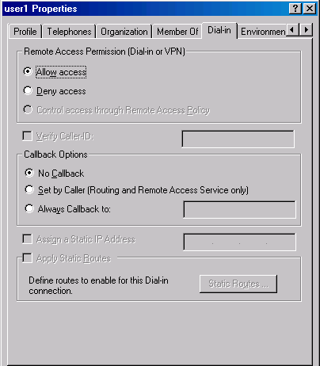
The next step is to create a user group where users have permission to connect to the Exchange Server when connected to the VPN server. We will name the group VPN Exchange Users. Perform the following steps to create the group and add the user1 account to the group:
- In the Active Directory Users and Groups console, expand the domain name, msfirewall.org, and click on the Users folder. Right click the Users folder, point to New and click Group.
- In the New Object – Group wizard, enter a name for the Group in the Group name text box. In this example, enter VPN Exchange Users. Click Next.
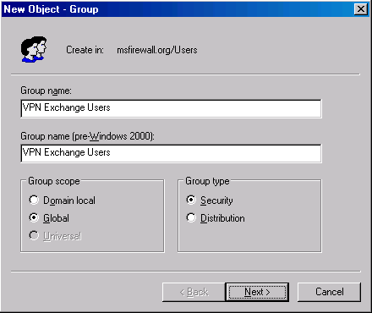
- Do not create a Exchange mailbox for the group. Click Next.
- Click Finish on the last page of the wizard.
- Right click on the VPN Exchange Users group and click Properties.
- In the VPN Exchange Users Properties dialog box, click the Members tab.
- On the Members tab, click Add.
- In the Select Users, Contacts, or Computers dialog box, enter user1 in the Enter the object names to select text box. Click the Check Name button. The user1 entry will be underlined in the Active Directory. Click OK.
- Click Apply and OK in the VPN Exchange Users Properties dialog box.
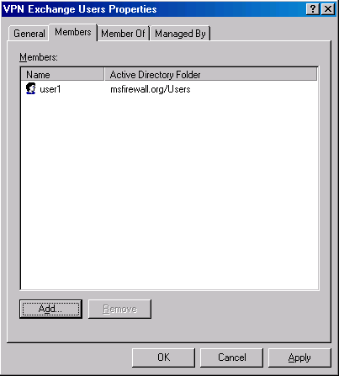

Create a Firewall Group that Includes the VPN Exchange Users Group
The firewall uses custom groups based on entries contained in its local user database or in the Active Directory domain user database. The next step is to create a Firewall Group that contains the VPN Exchange Users group we created in the Active Directory. We will later create an Access Rule that allows this Firewall Group access to the Exchange Server protocols.
Perform the following steps to create the Firewall Group:
- At the ISA Server 2004 firewall computer, open the Microsoft Internet Security and Acceleration Server 2004 management console. Expand the server name in the left Pane of the console and click on the Firewall Policy node.
- Click the Toolbox tab in the Task Pane, and click Users. When the Users section is expanded, click the New menu.
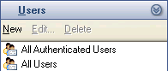
- On the Welcome to the New Users Sets Wizard page, enter a name for the Firewall Group in the User set name text box. In this example, enter VPN Exchange Users and click Next.
- On the Users page, click Add. Click Windows users and groups from the fly-out menu.
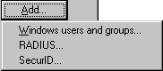
- In the Select Users or Groups dialog box, click Locations.
- In the Locations dialog box, expand the Entire Directory dialog box and click msfirewall.org. Click OK.
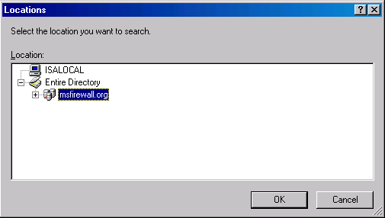
- In the Select Users or Groups dialog box, enter VPN Exchange Users in the Enter the object names to select text box. Click Check Names. The group name will be underlined in the Active Directory. Click OK.
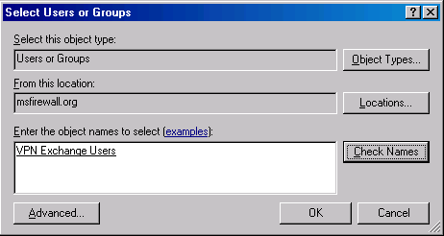
- Click Next on the Users page.
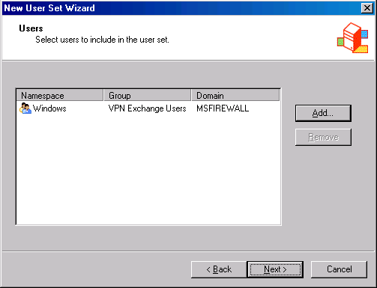
- Click Finish on the Completing the New User Set Wizard page.
- The new group appears in the Users list.
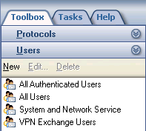

Create Access and Server Publishing Rules Restricting Access to the Exchange Server
We are now ready to create an Access Rule and a Server Publishing Rule restricting access to the Exchange Server when using the full Outlook 2000 MAPI client. The same rule will work for Outlook 2002 and Outlook 2003 clients. The Access Rule allows members of the VPN Exchange Users group access to the DNS and Direct Access (445) protocols. The table below contains the pertinent details of the rule.
Table 1 RPC for VPN Clients Access Rule
Name | Direct Access/VPN Clients
Action | Allow
Protocols | DNS  Direct Access (445)
From | VPN Clients
To | Exchange Server
Users | VPN Exchange Users
Schedule | Always
Content Types | All content types

The Direct Access (TCP 445) protocol is required for directory service access (LDAP conversion) for the Outlook client in this scenario.
The second Access Rule will deny RPC traffic from all users on the VPN clients network except members of the VPN Exchange Users group. This rule prevents users who are not members of the VPN Exchange Users group from connecting to the Exchange Server via Secure Exchange RPC.
Table 2 Deny Rule Blocking RPC Access
Name | Deny RPC All Interface
Action | Deny
Protocols | RPC (all interfaces)
From | VPN Clients
To | Exchange Server
Users | All Users except VPN Exchange Users
Schedule | Always
Content Types | All content types

Perform the following steps to create the Direct Access/VPN Clients Access Rule:
- In the Microsoft Internet Security and Acceleration Server 2004 management console, expand the server name and click the Firewall Policy node.
- In the Task Pane, click the Tasks tab. On the Tasks tab, click Create New Access Rule.
- On the Welcome to the New Access Rule Wizard page, enter a name for the rule in the Access Rule name text box. In this example, enter RPC over VPN Clients and click Next.
- On the Rule Action page, select Allow and click Next.
- On the Protocols page, select the Selected protocols entry from This rule applies to list. Click Add.
- In the Add Protocols dialog box, click the All Protocols folder. Double click the DNS entry.
- Click the New menu in the Add Protocols dialog box. Click the Protocol command.
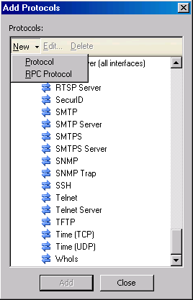
- On the Welcome to the New Protocol Definition Wizard page, enter the name for the Protocol Definition in the Protocol definition name text box. In this example, name the protocol Direct Access (445). Click Next.
- On the Primary Connection Information page, click New.
- On the New/Edit Protocol Connection page, set the Protocol type to TCP. Set the Direction as Outbound. In the Port Range frame, set the From entry to 445 and the To entry to 445. Click OK.
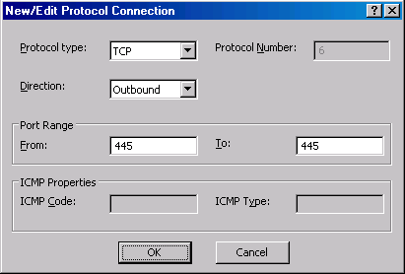
- Click Next on the Primary Connection Information page.
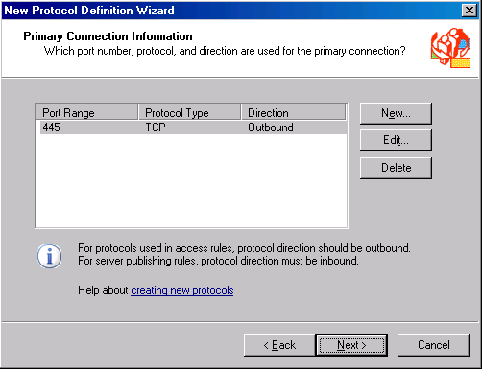
- On the Secondary Connections page, select No and click Next.
- Click Finish on the Completing the New Protocol Definition Wizard page.
- Double click the Direct Access (445) entry that now appears in the All Protocols list, and click Close.
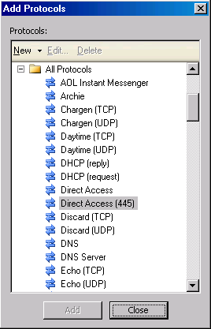
- On the Protocols page, click Next.
- On the Access Rule Sources page, click Add. In the Add Network Entities dialog box, click the Networks folder and double click the VPN Clients network. Click Close.
- On the Access Rule Destinations page, click Add. In the Add Network Entities dialog box, click the Networks folder and double click the Internal network. Click Close.
- Click Next on the Access Rule Destinations page.
- On the User Sets page, click All Users and Remove. Next, click Add.
- In the Add Users dialog box, double click VPN Exchange Users. Click Close.
- Click Next on the User Sets page.
- Click Finish on the Completing the New Access Rule Wizard page.
Now that the Exchange VPN Users group has access to the DNS and Direct Access (445) protocols, the next step is to create the Deny rule to prevent VPN users who are not members of the VPN Exchange Users group from connecting to the Exchange Server via the Secure Exchange RPC protocol.
Perform the following steps to create the Deny RPC All Interfaces Rule:
- In the Microsoft Internet Security and Acceleration Server 2004 management console, expand the server name in the left Pane of the console, and click the Firewall Policy node.
- In the Task Pane, click the Tasks tab. On the Tasks tab, click Create New Access Rule.
- On the Welcome to the New Access Rule Wizard page, enter the name of the rule in the Access Rule name text box. In this example, enter Deny RPC All Interfaces. Click Next.
- Select Deny on the Rule Action page.
- On the Protocols page, choose Selected protocols in the This rule applies to list. Click Add.
- In the Add Protocols dialog box, click the All Protocols folder and then double click the RPC (all interfaces) protocol. Finally, double click the DNS protocol. Click Close.
- Click Next on the Protocols page.
- On the Access Rule Sources page, click Add. In the Add Network Entities dialog box, click the Networks folder. Double click on VPN Clients. Click Close.
- Click Next on the Access Rule Sources page.
- On the Access Rule Destinations page, click Add. In the Add Network Entities dialog box, click the Computers folder. Double click on Exchange Server. Click Close.
- Click Next in the Access Rule Destinations dialog box.
- On the User Sets page, accept the default entry, All Users, and click Next.
- Click Finish on the Completing the New Access Rule Wizard page.
- In the Details Pane of the Microsoft Internet Security and Acceleration Server 2004 management console, double click on the Deny RPC All Interfaces Access Rule.
- In the Deny RPC All Interfaces Properties dialog box, click Add in the Exceptions section. In the Add Users dialog box, double click on VPN Exchange Users. Click Close.
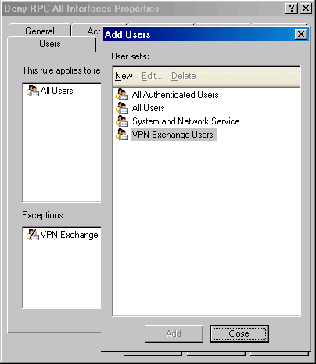
- Click Apply and OK in the Deny RPC All Interfaces Properties dialog box.
Now we’re ready to create the Secure Exchange RPC Server Publishing Rule that allows Outlook MAPI clients to connect to the Exchange Server.
Perform the following steps to create the Secure Exchange RPC Publishing Rule:
- In the Microsoft Internet Security and Acceleration Server 2004 management console, expand the server name and click the Firewall Policy node.
- In the Task Pane, click the Tasks tab. On the Tasks tab, click Create New Server Publishing Rule.
- On the Welcome to the New Server Publishing Rule Wizard page, enter a name for the rule in the Server publishing rule name text box. For this example, enter Secure Exchange RPC. Click Next.
- On the Select Server page, enter the IP address of the Exchange Server on the Internal network in the Server IP address text box. In this example, the IP address is 10.0.0.2 and we will enter that address into the text box. Click Next.
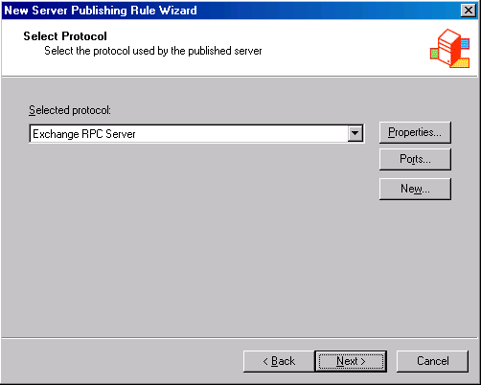
- On the IP Addresses page, put a checkmark in the VPN Clients check box. Click Next.
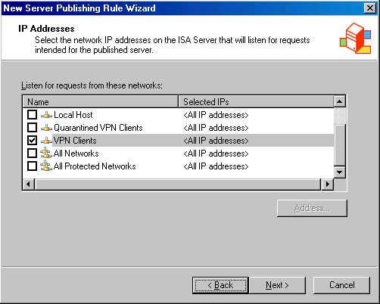
- Click Finish on the Completing the New Server Publishing Rule Wizard page.

Create an Access Rule Allowing Access to the Web Enrollment Site
Although all hosts are denied access to the RPC protocol on the Exchange Server, we want to allow connections to the machine so that all hosts can request certificates on the Web enrollment site, which is located on the same machine. We accomplish this task by creating an Access Rule that allows VPN clients access to the machine using the HTTP and HTTPS protocols. In addition, we will allow all users access to the DNS server protocol, as the DNS server is located on the same machine.
Perform the following steps to allow VPN clients access to the Web enrollment site:
- In the Microsoft Internet Security and Acceleration Server 2004 management console, expand the server name in the left Pane of the console and click the Firewall Policy node.
- In the Task Pane, click the Tasks tab. On the Tasks tab, click Create New Access Rule.
- On the Welcome to the New Access Rule Wizard page, enter the name of the rule in the Access Rule name text box. In this example, name the rule VPN Clients to CA Web. Click Next.
- Select Allow on the Rule Action page.
- On the Protocols page, choose Selected protocols in the This rule applies to drop down list. Click Add.
- In the Add Protocols dialog box, click the Common Protocols folder and double click the HTTP protocol. Next, double click the HTTPS protocol. Finally, double click on DNS protocol. Click Close.
- Click Next on the Protocols page.
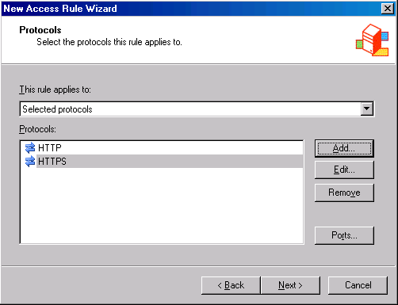
- On the Access Rule Sources page, click Add. In the Add Network Entities dialog box, click the Networks folder. Double click on VPN Clients. Click Close.
- Click Next on the Access Rule Sources page.
- On the Access Rule Destinations page, click Add. In the Add Network Entities dialog box, click the New menu. Click Computer.
- In the New Computer Rule Element dialog box, enter the name of the computer in the Name text box. In this example, enter Web Enrollment Site. Enter the IP address of the Web enrollment site in the Computer IP Address text box. In this example, enter 10.0.0.2 into the text box. Click OK.
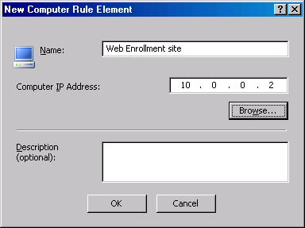
- In the Add Network Entities dialog box, click the Computers folder and double click Web Enrollment Site. Click Close.
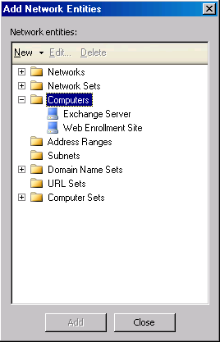
- Click Next in the Access Rule Destinations dialog box.
- On the User Sets page, accept the default entry, All Users, and click Next.
- Click Finish on the Completing the New Access Rule Wizard page.

Arrange the Rule Order
We need to arrange the Access Rules so that they are processed in a sequence to provide Exchange RPC access to members of the VPN Exchange Users group, and yet, not allow other users access to the Exchange Server via RPC in the event of another rule that inadvertently allows members of other groups RPC access.
Perform the following steps to arrange the rule in the desired order:
- In the Microsoft Internet Security and Acceleration Server 2004 management console, expand the server name and click the Firewall Policy node.
- Your goal is to move the rules up or down on the list so that they appear in the order shown in the figure below.
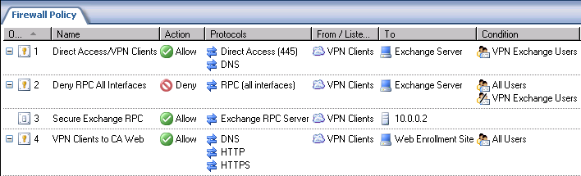
- You can move the rules by clicking on one and then using the up or down arrow buttons in the button bar.
- Click Apply to save the changes and update the firewall policy.
- Save the configuration changes and click OK.

Establish a VPN connection and Connect to Microsoft Exchange via Secure RPC
We are now ready to connect to the Exchange Server from a VPN client machine on the External network. The external VPN client machine is a Windows 2000 Professional computer with Outlook 2000 installed. The Outlook 2000 application is configured to connect to the Exchange Server. However, because the Outlook client must be able to resolve the name of the Exchange Server using DNS, we must make sure that the client operating system is able to fully qualify the Exchange Server’s host name. There are a number of ways this can be accomplished. In this example, we will configure the VPN client machine with a primary domain name that it will append to the unqualified DNS queries. Since the Exchange Server belongs to the msfirewall.org domain, we will configure the VPN client machine to use msfirewall.org.
Perform the following steps to configure the VPN client machine with the proper primary domain name:
- Right click My Computer on the desktop and click Properties.
- In the System Properties dialog box, click the Network Identification tab.
- On the Network Identification tab, click Properties.
- In the Identification Changes dialog box, click More.
- In the DNS Suffix and NetBIOS Computer Name dialog box, enter msfirewall.org in the Primary DNS suffix of computer text box. Click OK.
- Click OK in the Identification Changes dialog box.
- Click OK in the Network Identification dialog box informing you that you will need to restart the computer.
- Click OK in the System Properties dialog box.
- Click Yes in the System Settings Change dialog box
- Log on as Administrator when the machine restarts.
Now that the VPN client machine can fully qualify the Exchange Server’s name, we can establish the VPN connection. The Outlook 2000 application has been configured with an Outlook Profile that connects it to the Administrator account on the Exchange Server. The Exchange Server name in the Outlook 2000 profile is EXCHANGE2003BE. The VPN client machine will be able to use the DNS server address provided by the VPN server to find the Exchange Server.
Perform the following steps to connect to the VPN server and the Exchange Server:
- Create the VPN client connectoid from the Make New Connection icon in the Network and Dial-up Connections window. Use the IP address of 192.168.1.70 for the VPN server.
- Establish the VPN connection with the user account MSFIREWALL\Administrator. The connection will use PPTP because we have not deployed certificates in this scenario.
- Start the Outlook 2000 application. There will be a delay, and you will see a dialog box indicating that Outlook cannot connect to the Exchange Server. The reason for this is that you logged onto the VPN using an account that does not have access to the RPC protocol. Click Work Offline in the Microsoft Exchange Server dialog box.

- Click OK in the Microsoft Outlook dialog box informing you that it cannot open the default e-mail folders.
- Click No in the Microsoft Outlook dialog box asking if you want to open the default File System folder.
- Right click the connection icon in the System Tray and click Disconnect.
Now that we’ve determined that users that are not member of the VPN Exchange Users group cannot connect to the Exchange Server from the Outlook MAPI client, the next step is to show that a member of the group can connect to the Exchange Server.
Perform the following steps to test a successful connection to the Exchange Server:
- Use the same VPN connectoid, but this time log on with the account MSFIREWALL\user1.
- Open the Outlook 2000 client application.
- Outlook 2000 successfully connects. If you look in the log file, you will see entries indicating that the Direct Access (445) allows user1 access to the Exchange Server Publishing Rule and the Exchange Server.
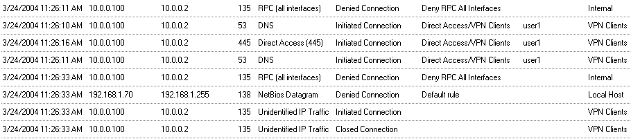
- Close Outlook and disconnect the VPN connection.

Establish a VPN connection and Connect to the Web Enrollment Site
Now we can test whether a user who is not a member of the VPN Exchange Users group can connect to resources on the Internal network using another protocol. In this example, we’ll log in as Administrator (who is not a member of the VPN Exchange Users group) and attempt to connect to the Web enrollment site on the Internal network.
Perform the following steps to test the connection:
- Create a VPN connection using the same VPN connectoid you used in the previous exercise. Log on as MSFIREWALL\Administrator.
- Open Internet Explorer and enter http://10.0.0.2/certsrv into the Address bar. Click Go.
- Log on to the Web site with the User Name of Administrator and the Administrator’s password.
- You will be able to log on to the site and see the Welcome page. If you check the log file, you will see that the VPN Clients to CA Web rule allowed the connection.
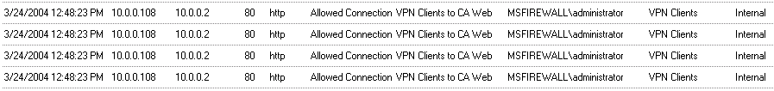
- Close Internet Explorer and close the VPN connection.

Conclusion
In this ISA Server 2004 VPN Deployment Kit document, we discussed how to configure front-end and back-end ISA Server 2004 firewalls to allow incoming PPTP VPN connections to the corporate network. In the next document in this ISA Server 2004 VPN Deployment Kit series, we will look at how to enable and configure the ISA Server 2004 VPN Quarantine features.

This is a preliminary document and may be changed substantially prior to final commercial release of the software described herein.
The information contained in this document represents the current view of Microsoft Corporation on the issues discussed as of the date of publication. Because Microsoft must respond to changing market conditions, it should not be interpreted to be a commitment on the part of Microsoft, and Microsoft cannot guarantee the accuracy of any information presented after the date of publication.
This white paper is for informational purposes only. MICROSOFT MAKES NO WARRANTIES, EXPRESS OR IMPLIED, IN THIS
DOCUMENT.
Complying with all applicable copyright laws is the responsibility of the user. Without limiting the rights under copyright, no part of this document may be reproduced, stored in, or introduced into a retrieval system, or transmitted in any form or by any means (electronic, mechanical, photocopying, recording, or otherwise), or for any purpose, without the express written permission of Microsoft Corporation.
Microsoft may have patents, patent applications, trademarks, copyrights, or other intellectual property rights covering subject matter in this document. Except as expressly provided in any written license agreement from Microsoft, the furnishing of this document does not give you any license to these patents, trademarks, copyrights, or other intellectual property.
© 2004 Microsoft Corporation. All rights reserved.
The example companies, organizations, products, domain names, e-mail addresses, logos, people, places, and events depicted herein are fictitious. No association with any real company, organization, product, domain name, e-mail address, logo, person, place, or event is intended or should be inferred.
Microsoft, Windows, Windows 2000, Windows 2000 Server, Windows Server 2003, Windows Server System, ISA Server, and ISA Server 2004 are either registered trademarks or trademarks of Microsoft Corporation in the United States and/or other countries.
The names of actual companies and products mentioned herein may be the trademarks of their respective owners.

ISA Server 2004 VPN Deployment Kit: Configuring the ISA Server 2004 Firewall for Outbound PPTP and L2TP/IPSec Access
Chapter 6

For the latest information, please see http://www.microsoft.com/isaserver/

Contents
Introduction 1
Create the Outbound PPTP Access Rule at the Local ISA Server 2004 Firewall 2
Create the Outbound L2TP/IPSec Access Rule at the Local ISA Server 2004 Firewall 4
Issue a certificate to the VPN client computer 10
Publish the Web Enrollment Site 12
Enable the System Policy Rule on the Remote ISA Server 2004 Firewall/VPN Server to Access the Enterprise CA 18
Request and Install a Certificate on the Remote ISA Server 2004 Firewall/VPN Server 19
Enable the VPN Server on the Remote ISA Server 2004 firewall/VPN server 21
Create an Access Rule Allowing VPN Clients Access to the Internal Network 27
Enable Dial-in Access for the Administrator Account 30
Create the Outbound PPTP VPN Connection and Monitor the VPN Connection 31
Create the Outbound L2TP/IPSec VPN Connection and Monitor the VPN Connection 34
Conclusion 37

Introduction
Users behind your ISA Server 2004 firewall may need to use a VPN connection to access resources on their own company LANs. This is a common scenario when you have visiting executives or contractors working on site. These users typically bring in laptop computers with pre-configured VPN connections that automatically connect them to the corporate VPN server.
You must configure the ISA Server 2004 firewall to allow outbound access to the VPN protocols their users require. There are two VPN protocols in common use for which you can enable outbound access:
- Point-to-Point Tunneling Protocol (PPTP)
- Layer 2 Tunneling Protocol over IPSec (L2TP/IPSec)
Most VPN servers support PPTP, a secure VPN protocol. The level of security provided by a PPTP connection is highly dependent on password complexity. The more complex the user password, the more secure the PPTP connection.
L2TP/IPSec is currently the standard for secure VPN protocols. The IPSec encryption component provides a higher level of security than the PPTP encryption (which is the Microsoft Point-to-Point Encryption protocol – MPPE). IPSec encryption will not work across NAT boundaries, where a NAT device is located between the IPSec VPN client and IPSec VPN server. Using NAT Traversal (or NAT-T) mechanisms that “wrap” or “encapsulate” the IPSec communication in a UDP or TCP header can solve this problem. Microsoft Windows Server 2003 VPN servers support RFC NAT-T and do not use proprietary NAT-T encapsulation methods.
In this ISA Server 2004 VPN Deployment Kit document, we discuss the procedures required to enable PPTP and L2TP/IPSec VPN clients outbound access to VPN servers on the Internet. Specific procedures detailed in this document include how to:
- Create the outbound PPTP Access Rule at the local ISA Server 2004 firewall
- Create the outbound L2TP/IPSec Access Rule at the local ISA Server 2004 firewall
- Issue a certificate to the VPN client computer
- Publish the Web enrollment site
- Enable a System Policy Rule on the remote ISA Server 2004 firewall/VPN to allow access to the Web enrollment site
- Request and install a certificate on the remote ISA Server 2004 firewall/VPN server
- Enable the VPN server on the remote ISA Server 2004 firewall/VPN server
- Create an Access Rule allowing VPN clients access to the Internal network
- Enable dial-in access for the administrator account
- Create the outbound PPTP VPN connection and monitor the VPN connection
- Create the outbound L2TP/IPSec VPN connection and monitor the VPN connection
MACHINES REQUIRED:
EXCHANGE2003DC
ISALOCAL
INTERNALCLIENT
REMOTEISA

Create the Outbound PPTP Access Rule at the Local ISA Server 2004 Firewall
The first step is to create an Access Rule that allows outbound PPTP connections through the ISA Server 2004 firewall machine. This Access Rule takes advantage of the sophisticated PPTP filter included with ISA Server 2004. The PPTP filter is automatically bound to the PPTP Protocol Definition that you will use when creating this rule.
Perform the following steps to create the outbound PPTP Access Rule:
- At the Microsoft Internet Security and Acceleration Server 2004 management console, expand the server name and click the Firewall Policy node.
- Click the Tasks tab on the Task Pane. On the Tasks tab, click Create a New Access Rule.
- On the Welcome to the New Access Rule Wizard page, enter a name for the rule in the Access Rule name text box. In this example, enter Outbound PPTP. Click Next.
- Select Allow on the Rule Action page. Click Next.
- On the Protocols page, choose Selected protocols in the This rule applies to list. Click Add.
- In the Add Protocols dialog box, click the VPN and IPSec folder. Double click the PPTP entry. Click Close.
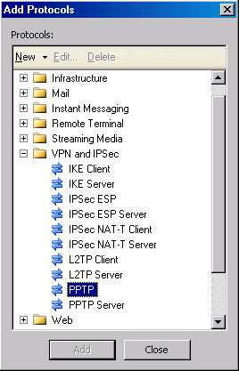
- Click Next on the Protocols page.
- On the Access Rule Sources page, click Add. In the Add Network Entities dialog box, click the Networks folder and double click on the Internal network. Click Close.
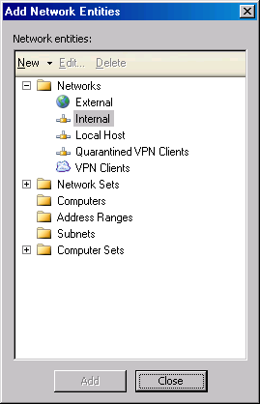
- Click Next on the Access Rule Sources page.
- On the Access Rule Destinations page, click Add. In the Add Network Entities dialog box, click the Networks folder and double click on the External network. Click Close.
- Click Next on the Access Rule Destinations page.
- Accept the default entry, All Users, on the Users Sets page. Click Next.
- Click Finish on the Completing the New Access Rule Wizard page.
- The PPTP Access Rule appears in the Firewall Policy list.
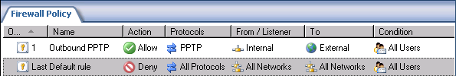

Create the Outbound L2TP/IPSec Access Rule at the Local ISA Server 2004 Firewall
The next step is to create the L2TP/IPSec Access Rule which allows outbound access to Internet L2TP/IPSec VPN servers. Because the VPN client machine is on a private network that uses private network addresses, the relationship between the Internal network and the Internet is NAT. The L2TP/IPSec NAT-T protocol will be required to connect to the L2TP/IPSec VPN server on the Internet.
There is no built-in L2TP/IPSec NAT-T Protocol Definition. However, you can easily create a customer Protocol Definition that contains both UDP 500 Send Receive and UDP 4500 Send Receive. These two protocols comprise the L2TP/IPSec NAT-T protocol.
Perform the following steps to create the outbound L2TP/IPSec Access Rule:
- To make auditing of firewall policy more efficient, we will create a custom L2TP/IPSec NAT-T Protocol Definition. At the Microsoft Internet Security and Acceleration Server 2004 management console, expand the server name and the click the Firewall Policy node.
- Click the Toolbox tab in the Task Pane. Click Protocols.
- In the Protocols list, click on the VPN and IPSec folder. Note that there is no specific L2TP/IPSec NAT-T protocol. We could use two protocols -- IKE Client and the IPSec NAT-T Client -- to create the connection. However, this combination of protocols does not make it clear that the protocol applies specifically to our L2TP/IPSec NAT clients.
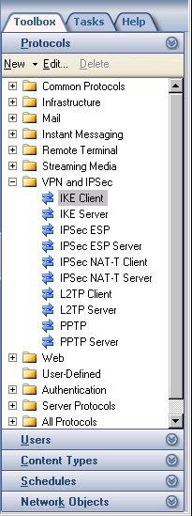
- Click the New menu and then click Protocol.
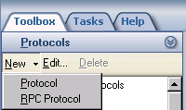
- On the Welcome to the New Protocol Definition Wizard page, enter the name of the protocol in the Protocol definition name dialog box. We will name the protocol L2TP/IPSec NAT-T. Click Next.
- On the Primary Connection Information page, click New.
- In the New/Edit Protocol Connection dialog box, set the Protocol type to UDP. Set the Direction to Send Receive. In the Port Range frame, set the From entry to 500 and the To entry to 500. Click OK.
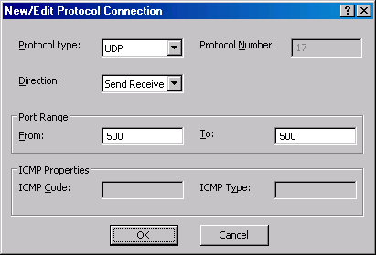
- Click Add on the Primary Connection Information page.
- In the New/Edit Protocol Connection dialog box, set the Protocol type to UDP. Set the Direction to Send Receive. In the Port Range frame, set the From entry to 4500 and the To entry to 4500. Click OK
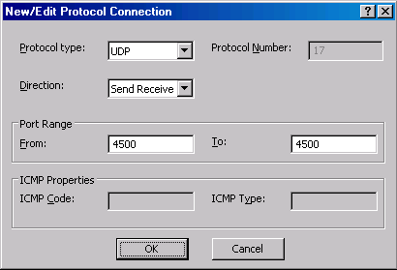
- Click Next on the Primary Connection Information page.
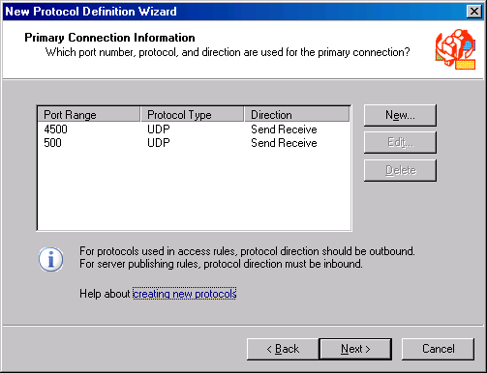
- Select No on the Secondary Connections page. Click Next.
- Click Finish on the Completing the New Protocol Definition Wizard page.
Perform the following steps to use the new Protocol Definition to create an outbound Access Rule for the L2TP/IPSec VPN connections:]
- At the Microsoft Internet Security and Acceleration Server 2004 management console, expand the server name and click the Firewall Policy node.
- Click the Tasks tab on the Task Pane. On the Tasks tab, click Create a New Access Rule.
- On the Welcome to the New Access Rule Wizard page, enter a name for the rule in the Access Rule name text box. In this example, enter Outbound L2TP/IPSec NAT-T. Click Next.
- Select Allow on the Rule Action page. Click Next.
- On the Protocols page, choose Selected protocols in the This rule applies to list. Click Add.
- In the Add Protocols dialog box, click the User Defined folder. Double click L2TP/IPSec NAT-T. Click Close.
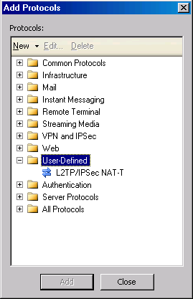
- Click Next on the Protocols page.
- On the Access Rule Sources page, click Add. In the Add Network Entities dialog box, click the Networks folder and then double click on the Internal network. Click Close.
- Click Next on the Access Rule Sources page.
- On the Access Rule Destinations page, click Add. In the Add Network Entities dialog box, click the Networks folder and then double click on the External network. Click Close.
- Click Next on the Access Rule Destinations page.
- Accept the default entry All Users on the Users Sets page. Click Next.
- Click Finish on the Completing the New Access Rule Wizard page.
- The PPTP Access Rule appears in the Firewall Policy list.
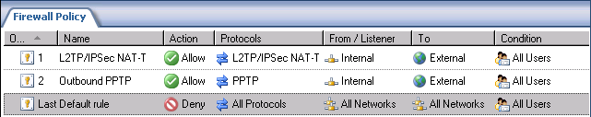

Issue a certificate to the VPN client computer
A computer certificate on the VPN client machine is required to establish the L2TP/IPSec connection with the remote ISA Server 2004 firewall/VPN server. Now that you have finished configuring the local ISA Server 2004 firewall, you can issue a machine certificate to the VPN client machine located behind the ISA Server 2004 firewall machine.
Perform the following steps on the main office ISA Server 2004 firewall to request and install the certificates:
- Open Internet Explorer. In the Address bar, enter http://10.0.0.2/certsrv, and click OK.
- In the Enter Network Password dialog box, enter Administrator in the User Name text box, and enter the Administrator’s password in the Password text box. Click OK.
- In the Internet Explorer security dialog box, click Add. In the Trusted Sites dialog box, click Add and Close.
- Click Request a Certificate on the Welcome page.
- On the Request a Certificate page, click advanced certificate request.
- On the Advanced Certificate Request page, click Create and submit a request to this CA.
- On the Advanced Certificate Request page, select the Administrator certificate from the Certificate Template list. Place a checkmark in the Store certificate in the local computer certificate store check box. Click Submit.
- Click Yes in the Potential Scripting Violation dialog box.
- On the Certificate Issued page, click Install this certificate.
- Click Yes on the Potential Scripting Violation page.
- Close the browser after viewing the Certificate Installed page.
- Click Start, and then click the Run command. Enter mmc in the Open text box, and click OK.
- In Console1, click the File menu and the Add/Remove Snap-in command.
- Click Add in the Add/Remove Snap-in dialog box.
- Select Certificates in the Available Standalone Snap-ins list in the Add Standalone Snap-in dialog box. Click Add.
- Select Computer account on the Certificates snap-in page.
- Select Local computer on the Select Computer page.
- Click Close in the Add Standalone Snap-in dialog box.
- Click OK in the Add/Remove Snap-in dialog box.
- In the left Pane of the console, expand the Certificates (Local Computer) node and then expand the Personal node. Click on \Personal\Certificates. Double click on the Administrator certificate in the right Pane of the console.
- In the Certificate dialog box, click the Certification Path tab. The root CA certificate is at the top of the certificate hierarchy in the Certification path frame. Click the EXCHANGE2003BE certificate at the top of the list. Click View Certificate.
- In the CA certificate’s Certificate dialog box, click the Details tab. Click Copy to File.
- Click Next in the Welcome to the Certificate Export Wizard page.
- On the Export File Format page, select Cryptographic Message Syntax Standard – PKCS #7 Certificates (.P7B) and click Next.
- On the File to Export page, enter c:\cacert in the File name text box. Click Next.
- Click Finish on the Completing the Certificate Export Wizard page.
- Click OK in the Certificate Export Wizard dialog box.
- Click OK in the Certificate dialog box. Click OK again in the Certificate dialog box.
- In the left Pane of the console, expand the Trusted Root Certification Authorities node and click the Certificates node. Right click the \Trusted Root Certification Authorities\Certificates node, point to All Tasks and click Import.
- Click Next on the Welcome to the Certificate Import Wizard page.
- On the File to Import page, use the Browse button to locate the CA certificate you saved to the local hard disk, and click Next.
- On the Certificate Store page, accept the default settings and click Next.
- Click Finish on the Completing the Certificate Import Wizard page.
Click OK on the Certificate Import Wizard dialog box informing you that the import was successful.

Publish the Web Enrollment Site
The remote ISA Server 2004 firewall/VPN server requires a certificate from the same authority that assigned a certificate to the VPN client machine. There are several ways we can accomplish this, but the most expedient method is to publish the Web enrollment site on the Internal network. The remote ISA Server 2004 firewall/VPN server will be able to request a certificate via the CA’s Web enrollment site after you create the Web Publishing Rule.
Perform the following steps to publish the enterprise CA’s Web enrollment site:
- In the Microsoft Internet Security and Acceleration Server 2004 management console, expand the server name and click the Firewall Policy node.
- In the Task Pane, click the Tasks tab. On the Tasks tab, click Publish a Web Server.
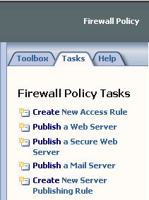
- Enter a name for the Web Publishing Rule on the Welcome to the New Web Publishing Rule Wizard page. In this example, enter the name Web Enrollment Site in the Web publishing rule name text box. Click Next.
- Select Allow on the Select Rule Action page.
- On the Define Website to Publish page, enter the IP address of the enterprise CA’s Web site in the Computer name or IP address text box. In this example, the IP address is 10.0.0.2, so enter that value into the text box. In the Folder text box, enter /*. Click Next.
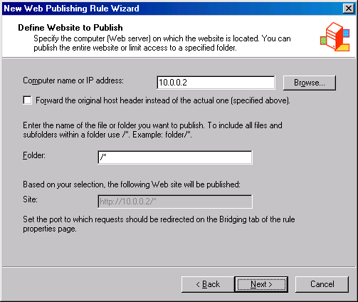
- On the Public Name Details page, select This domain name (type below) in the Accept request for list box. In the Public name text box, enter the IP address on the external interface of the firewall. In this example, the main office ISA Server 2004 firewall’s external address is 192.168.1.70, so enter that value into the text box. Enter /* into the Path (optional) text box. Click Next.
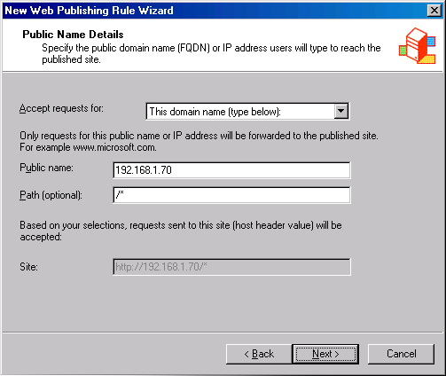
- On the Select Web Listener page, click New.
- On the Welcome to the New Web Listener page, enter a name for the rule in the Web listener name text box. In this example, we will name the listener Listener70, to indicate the IP address you want to accept incoming connections. Click Next.
- On the IP addresses page, put a checkmark in the External check box and click Next.
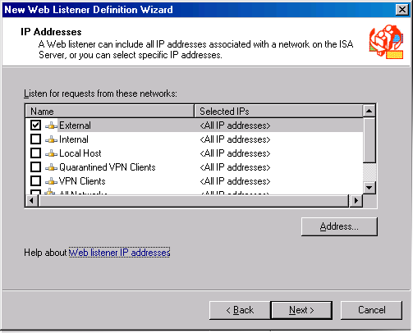
- On the Port Specification page, accept the default settings. Confirm that there is a checkmark in the Enable HTTP checkbox and that the value 80 is in the HTTP port text box. Click Next.
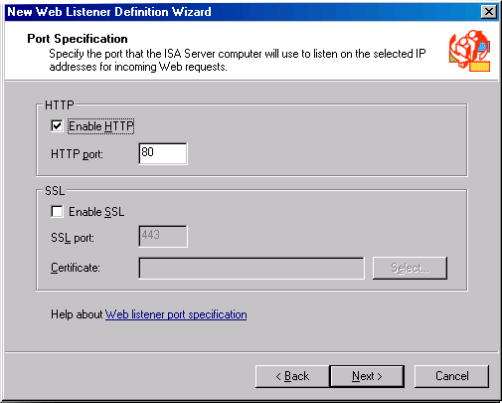
- Click Finish on the Completing the New Web Listener Wizard page.
- Click Next on the Select Web Listener page.
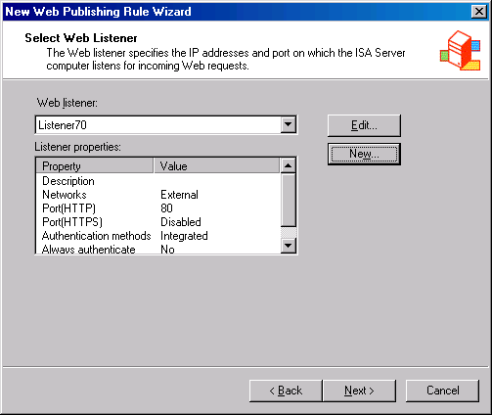
- Accept the default setting All Users on the User Sets page, and click Next.
- Click Finish on the Completing the New Web Publishing Rule Wizard page.
- Click Apply to save the changes and update the firewall policy.
- Click OK in the Apply New Configuration dialog box
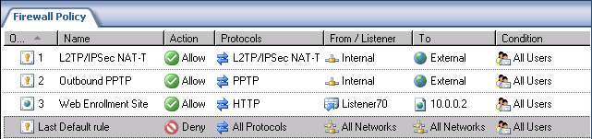

Enable the System Policy Rule on the Remote ISA Server 2004 Firewall/VPN Server to Access the Enterprise CA
The next step is to enable the System Policy Rule that will allow the remote ISA Server 2004 firewall/VPN server to connect to the enterprise CA on the main office network.
Perform the following steps to enable the System Policy rule on the remote firewall:
- In the Microsoft Internet Security and Acceleration Server 2004 management console, expand the server name, and click the Firewall Policy node.
- Right click the Firewall Policy node, point to View and click Show System Policy Rules.
- In the System Policy Rule list, double click on the Allow HTTP from ISA Server to all networks for CRL downloads System Policy Rule.
- In the System Policy Editor dialog box, put a checkmark in the Enable check box on the General tab. Click OK.
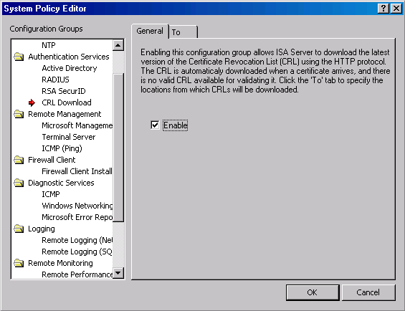
- Click Apply to save the changes and update the firewall policy.
- Click OK in the Apply New Configuration dialog box

Request and Install a Certificate on the Remote ISA Server 2004 Firewall/VPN Server
Now we can request a certificate for the remote ISA Server 2004 firewall/VPN server. After we obtain the certificate, we will copy the CA certificate into the machine’s Trusted Root Certification Authorities certificate store.
Perform the following steps on the branch office ISA Server 2004 firewall to request and install the certificates:
- Open Internet Explorer. In the Address bar, enter http://192.168.1.70/certsrv and click OK.
- In the Enter Network Password dialog box, enter Administrator in the User Name text box, and enter the Administrator’s password in the Password text box. Click OK.
- In the Internet Explorer security dialog box, click Add. In the Trusted Sites dialog box, click Add and Close.
- Click Request a Certificate on the Welcome page.
- On the Request a Certificate page, click advanced certificate request.
- On the Advanced Certificate Request page, click Create and submit a request to this CA.
- On the Advanced Certificate Request page, select the Administrator certificate from the Certificate Template list. Place a checkmark in the Store certificate in the local computer certificate store check box. Click Submit.
- Click Yes in the Potential Scripting Violation dialog box.
- On the Certificate Issued page, click Install this certificate.
- Click Yes on the Potential Scripting Violation page.
- Close the browser after viewing the Certificate Installed page.
- Click Start, and then click the Run command. Enter mmc in the Open text box, and click OK.
- In the Console1, click the File menu, and then click Add/Remove Snap-in.
- Click Add in the Add/Remove Snap-in dialog box.
- Select Certificates from the Available Standalone Snap-ins list in the Add Standalone Snap-in dialog box. Click Add.
- Select Computer account on the Certificates snap-in page.
- Select Local computer on the Select Computer page.
- Click Close in the Add Standalone Snap-in dialog box.
- Click OK in the Add/Remove Snap-in dialog box.
- In the left Pane of the console, expand the Certificates (Local Computer) node, and then expand the Personal node. Click on \Personal\Certificates. Double click on the Administrator certificate in the right Pane of the console.
- In the Certificate dialog box, click the Certification Path tab. The root CA certificate is at the top of the certificate hierarchy in the Certification path frame. Click EXCHANGE2003BE at the top of the list. Click View Certificate.
- In the CA certificate’s Certificate dialog box, click the Details tab. Click Copy to File.
- Click Next in the Welcome to the Certificate Export Wizard page.
- On the Export File Format page, select Cryptographic Message Syntax Standard – PKCS #7 Certificates (.P7B) and click Next.
- On the File to Export page, enter c:\cacert in the File name text box. Click Next.
- Click Finish on the Completing the Certificate Export Wizard page.
- Click OK in the Certificate Export Wizard dialog box.
- Click OK in the Certificate dialog box. Click OK again in the Certificate dialog box.
- In the left Pane of the console, expand the Trusted Root Certification Authorities node and click the Certificates node. Right click \Trusted Root Certification Authorities\Certificates, point to All Tasks and click Import.
- Click Next on the Welcome to the Certificate Import Wizard page.
- On the File to Import page, use the Browse button to locate the CA certificate you saved to the local hard disk and click Next.
- On the Certificate Store page, accept the default settings and click Next.
- Click Finish on the Completing the Certificate Import Wizard page.
- Click OK on the Certificate Import Wizard dialog box informing you that the import was successful.

Enable the VPN Server on the Remote ISA Server 2004 firewall/VPN server
By default, the ISA Server 2004 VPN server component is disabled. You will need to enable the VPN server feature and configure the VPN server components on the remote ISA Server 2004 firewall/VPN server. Remote access PPTP and L2TP/IPSec VPN clients will be able to connect to the VPN server after you enable and configure the device.
Perform the following steps to enable and configure the ISA Server 2004 VPN Server:
- Open the Microsoft Internet Security and Acceleration Server 2004 management console and expand the server name. Click on the Virtual Private Networks (VPN) node.
- Click on the Tasks tab in the Task Pane. Click Enable VPN Client Access.
- Click Apply to save the changes and update the firewall policy.
- Click OK in the Apply New Configuration dialog box.
- Click Configure VPN Client Access on the Tasks tab.
- On the General tab, change the value for the Maximum number of VPN clients allowed from 5 to 10.
- Click on the Groups tab, and click Add.
- In the Select Groups dialog box, click Locations. In the Locations dialog box, click msfirewall.org and click OK.
- In the Select Group dialog box, do not enter any domain names. The remote VPN server does not belong to a domain.
- Click the Protocols tab. On the Protocols tab, put a checkmark in the Enable L2TP/IPSec check box.
- Click the User Mapping tab. Do not enable user mapping. The remote ISA Server 2004 firewall/VPN server does not belong to a domain and does not use RADIUS. Click Apply. Click OK in the dialog box informing you that the computer must be restarted for the setting to take effect. Click OK.
- On the Tasks tab, click Select Access Networks.
- In the Virtual Private Networks (VPN) Properties dialog box, click the Access Networks tab. Note that the External checkbox is selected. This indicates that the external interface is listening for incoming VPN client connections.
- Click the Address Assignment tab. Select the Internal from the Use the following network to obtain DHCP, DNS and WINS services list box. This is a critical setting as it defines the network where access to the DHCP is made. Select Static address pool. Click Add. In the IP Address Range Properties dialog box, enter 10.0.2.0 in the Starting address text box. Enter 10.0.2.255 in the Ending address text box. Click OK.
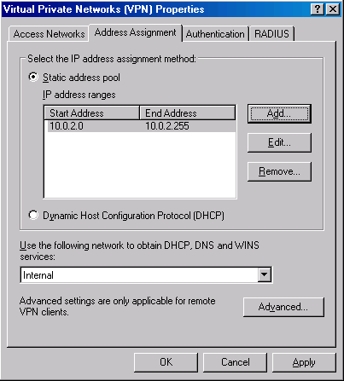
- Click on the Authentication tab. Note that the default setting is to enable only Microsoft encrypted authentication version 2 (MS-CHAPv2). Later, in this ISA Server 2004 VPN Deployment Kit, we will enable the EAP option so that high security user certificates can be used to authenticate with the ISA Server 2004 firewall VPN server. Note the Allow custom IPSec policy for L2TP connection check box. If you do not want to create a public key infrastructure, or you are in the process of creating one but have not yet finished, you can enable this check box and enter a pre-shared key. At this time, we will not enable this option.
- Click the RADIUS tab. Here you can configure the ISA Server 2004 firewall VPN server to use RADIUS to authenticate the VPN users. In a later document in this ISA Server 2004 VPN Deployment Kit, we will walk through the procedures for enabling RADIUS authentication. The advantage of RADIUS authentication is that you can leverage the Active Directory (and others) user database to authenticate users without needing to join the Active Directory domain.
- Click Apply in the Virtual Private Networks (VPN) Properties dialog box, and then click OK.
- Click Apply to save the changes and update the firewall policy.
- Click OK in the Apply New Configuration dialog box.
- Restart the ISA Server 2004 firewall machine.

Create an Access Rule Allowing VPN Clients Access to the Internal Network
The ISA Server 2004 firewall will be able to accept incoming VPN connections after the restart. However, the VPN clients cannot access any resources on the Internal network because there are no Access Rules enabling this access. You must create an Access Rule that allows members of the VPN clients network access to the Internal network. In contrast to other combined firewall VPN server solutions, the ISA Server 2004 firewall VPN server applies access controls for network access to VPN clients.
In this example, you will create an Access Rule allowing all traffic to pass from the VPN clients network to the Internal network. In a production environment, you would create more restrictive access rules so users on the VPN clients network would have access only to the resources they require.
Perform the following steps to create an unrestricted access VPN clients Access Rule:
- In the Microsoft Internet Security and Acceleration Server 2004 management console, expand the server name and click the Firewall Policy node. Right click the Firewall Policy node, point to New and click Access Rule.
- In the Welcome to the New Access Rule Wizard page, enter a name for the rule in the Access Rule name text box. In this example, we will name the rule VPN Client to Internal. Click Next.
- On the Rule Action page, select Allow and click Next.
- On the Protocols page, select All outbound protocols in the This rule applies to list. Click Next.
- On the Access Rule Sources page, click Add. In the Add Network Entities dialog box, click the Networks folder and double click on VPN Clients. Click Close.
- Click Next on the Access Rule Sources page.
- On the Access Rule Destinations page, click Add. On the Add Network Entities dialog box, click the Networks folder and double click on Internal. Click Close.
- On the User Sets page, accept the default setting All Users, and click Next.
- Click Finish on the Completing the New Access Rule Wizard page.
- Click Apply to save the changes and update the firewall policy.
- Click OK in the Apply New Configuration dialog box. The VPN client policy is now the top-listed Access Rule in the Access Policy list.

Enable Dial-in Access for the Administrator Account
The remote ISA Server 2004 firewall/VPN server is not a member of a domain and is not using RADIUS to authenticate remote access VPN clients. In this situation, you can use the local user account database on the remote ISA Server 2004 firewall machine itself. The following procedure details how to enable Dial-in permissions for the Administrator account on the remote ISA Server 2004 firewall/VPN machine.
Perform the following steps on the domain controller to enable Dial-in access for the Administrator account:
- Right click My Computer on the desktop and click Manage.
- In the Computer Management console, expand the Local Users and Groups node and click Users. Double click on the Administrator account in the right Pane of the console.
- In the Administrator Properties dialog box, click the Dial-in tab. Select Allow access. Click Apply, and then click OK.
- Close the Computer Management console.

Create the Outbound PPTP VPN Connection and Monitor the VPN Connection
Perform the following steps to connect to the remote ISA Server 2004 firewall/VPN server using the PPTP protocol:
- Create the VPN connectoid using the Make New Connection wizard in the Network and Dial-up Connections window. Configure the connectoid to connect to the VPN server at 192.168.1.71.
- Open the connectoid and click Properties.
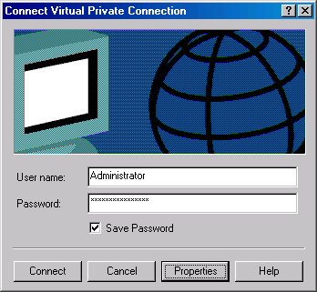
- In the Properties dialog box, click the Networking tab. Select the Point-to-Point Tunneling Protocol (PPTP) from the Type of VPN server I am calling. Click OK.
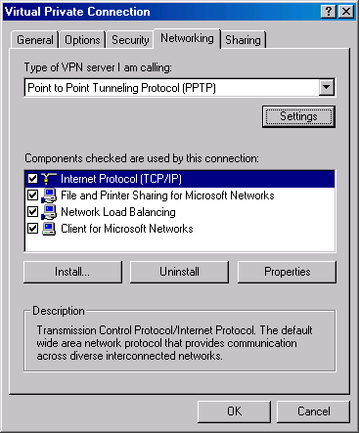
- Establish the VPN connection with the VPN server. Double click the connection icon in the system tray. Click the Details tab in the connectoid’s Connection Status dialog box. You will see the MPPE 128 encryption protocol in use. This indicates that a PPTP connection is being used because PPTP uses Microsoft Point-to-Point Encryption (MPPE) to encrypt data over the PPTP VPN link.
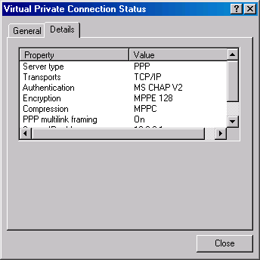
- When you examine the log file entries on the answering VPN server, you will see the PPTP control channel connection (TCP 1723) and the PPTP WAN Miniport connections.
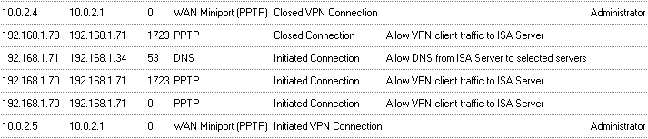
- Disconnect the VPN connection.

Create the Outbound L2TP/IPSec VPN Connection and Monitor the VPN Connection
Perform the following steps to connect to the remote ISA Server 2004 firewall/VPN server using the L2TP/IPSec protocol:
- Use the same connectoid you used in the last procedure. Open the connectoid and click the Properties button.
- In the Properties dialog box, click the Networking tab. Select the Layer-2 Tunneling Protocol (L2TP) from the Type of VPN server I am calling. Click OK.
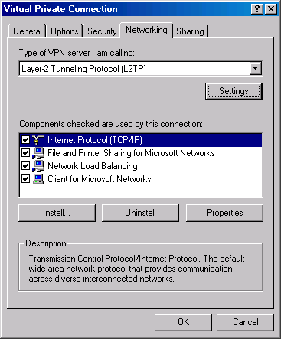
- Establish the VPN connection with the VPN server. After the connection is established, double click the connection icon in the system tray. You will see a reference to IPSEC Encryption. This indicates that the VPN protocol used is L2TP/IPSec.
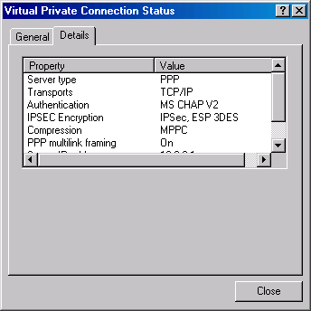
- If you view the logs on the answering VPN server, you will see entries for the WAN Miniport (L2TP) and IKE Client.
- Disconnect the VPN connection.

Conclusion
In this ISA Server 2004 VPN Deployment Kit document, we discussed how to configure the ISA Server 2004 firewall to allow outbound PPTP and L2TP/IPSec NAT-T connections. In the next document in this ISA Server 2004 VPN Deployment Kit series, we will look at how to configure the ISA Server 2004 firewall to support RADIUS authentication and remote access policy.

This is a preliminary document and may be changed substantially prior to final commercial release of the software described herein.
The information contained in this document represents the current view of Microsoft Corporation on the issues discussed as of the date of publication. Because Microsoft must respond to changing market conditions, it should not be interpreted to be a commitment on the part of Microsoft, and Microsoft cannot guarantee the accuracy of any information presented after the date of publication.
This white paper is for informational purposes only. MICROSOFT MAKES NO WARRANTIES, EXPRESS OR IMPLIED, IN THIS
DOCUMENT.
Complying with all applicable copyright laws is the responsibility of the user. Without limiting the rights under copyright, no part of this document may be reproduced, stored in, or introduced into a retrieval system, or transmitted in any form or by any means (electronic, mechanical, photocopying, recording, or otherwise), or for any purpose, without the express written permission of Microsoft Corporation.
Microsoft may have patents, patent applications, trademarks, copyrights, or other intellectual property rights covering subject matter in this document. Except as expressly provided in any written license agreement from Microsoft, the furnishing of this document does not give you any license to these patents, trademarks, copyrights, or other intellectual property.
© 2004 Microsoft Corporation. All rights reserved.
The example companies, organizations, products, domain names, e-mail addresses, logos, people, places, and events depicted herein are fictitious. No association with any real company, organization, product, domain name, e-mail address, logo, person, place, or event is intended or should be inferred.
Microsoft, Windows, Windows 2000, Windows 2000 Server, Windows Server 2003, Windows Server System, ISA Server, and ISA Server 2004 are either registered trademarks or trademarks of Microsoft Corporation in the United States and/or other countries.
The names of actual companies and products mentioned herein may be the trademarks of their respective owners.

ISA Server 2004 VPN Deployment Kit: Configuring Windows Server 2003 RADIUS Support for VPN Clients – Including Support for EAP/TLS Authentication
Chapter 7

For the latest information, please see http://www.microsoft.com/isaserver/

Contents
Introduction 1
Configure the Internet Authentication Services (RADIUS) Server 2
Create a VPN Clients Remote Access Policy 5
Remote Access Permissions and Domain Functional Level 10
Changing the User Account Dial-in Permissions 11
Changing the Domain Functional Level 12
Controlling Remote Access Permission via Remote Access Policy 14
Enable the VPN Server on the ISA Server 2004 Firewall and Configure RADIUS Support 16
Create an Access Rule Allowing VPN Clients Access to the Internal Network 23
Make the connection from a PPTP VPN Client 26
Conclusion 28

Introduction
In network environments where the ISA Server 2004 firewall is used as an edge firewall with an interface connected to the Internet, it is best to not join the firewall machine to the domain. This mitigates the risk of a compromised machine from leveraging its domain members to attack other machines on the network.
ISA Server 2004 firewalls that are not members of the user domain must use a mechanism other than Windows authentication to identify and authenticate domain users. The ISA Server 2004 firewall can authenticate VPN users with the RADIUS (Remote Access Dial-In User Service) protocol. The RADIUS protocol allows the ISA Server 2004 firewall to forward user credentials of a RADIUS server on the Internal network. The RADIUS server then sends the authentication request to an authentication server, such as an Active Directory domain controller, for authentication.
The ISA Server 2004 firewall supports all types of RADIUS servers. Microsoft’s RADIUS server is the Internet Authentication Services server (IAS). The Microsoft IAS server is included with all Windows 2000 and Windows Server 2003 server family products.
In addition to authenticating users, the IAS server can be used to centralize Remote Access Policy throughout the organization. For example, if you have six ISA Server 2004 firewall/VPN servers on your network, you can apply the same Remote Access Policy to all these machines by configuring it once at the IAS server.

In this ISA Server 2004 VPN Deployment Kit document, we discuss the procedures required to allow VPN clients to use RADIUS authentication to authenticate with the Internal network Active Directory domain. Specific procedures discussed in this document include:
- Configure the IAS Server
- Create a VPN Clients Remote Access Policy
- Remote Access permissions and domain functional level
- Enable the VPN Server on the ISA Server 2004 firewall and configure RADIUS Support
- Create a VPN Client Access Rule
- Make the connection from a L2TP/IPSec VPN client
MACHINES REQUIRED:
EXCHANGE2003BE
ISALOCAL
EXTERNALCLIENT

Configure the Internet Authentication Services (RADIUS) Server
We installed the IAS server in Chapter 2 of the ISA Server 2004 VPN Deployment Kit series. If you have not installed the IAS server, please refer to the instructions in Chapter 2. You need to configure the IAS server to communicate with the Active Directory, and then instruct the IAS server to work with the ISA Server 2004 firewall/VPN server machine.
Perform the following steps to configure the IAS server:
- Click Start, point to Administrative Tools and click on Internet Authentication Services.
- In the Internet Authentication Services console, right click on the Internet Authentication Service (Local) node in the left Pane of the console. Click Register Server in Active Directory.
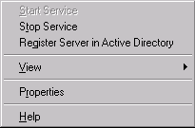
- This setting allows the IAS Server to authenticate users in the Active Directory domain. Click OK in the Register Internet Authentication Server in Active Directory dialog box.
- Click OK in the Server registered: dialog box. This dialog box informs you that the IAS Server was registered in a specific domain. If you want this IAS Server to read users’ dial-in properties from other domains, you’ll need to enter it into the RAS/IAS Server Group for each domain.
- Right click on the RADIUS Clients node in the left Pane of the console and click New RADIUS Client.
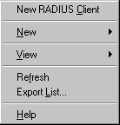
- In the New RADIUS Client dialog box, type in a Friendly name for the ISA Server 2004 firewall/VPN server. You can use any name you like. In this example, we’ll use the DNS host name of the ISA Server firewall/VPN server, which is ISALOCAL. Enter either the FQDN or the IP address of the ISA Server 2004 firewall/VPN server in the Client address (IP or DNS) dialog box. Do not enter a FQDN if your ISA Server firewall/VPN server has not registered its internal interface IP address with your internal DNS server. You can use the Verify button to test whether the IAS Server can resolve the FQDN. Click Next.
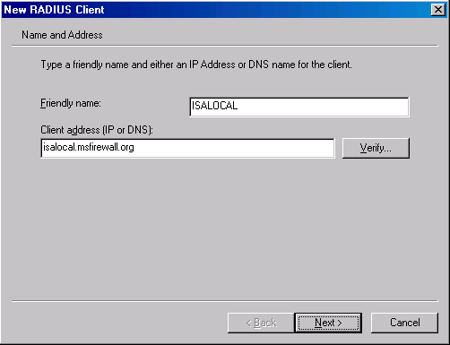
- On the Additional Information page, leave the RADIUS Standard entry in the Client-Vendor drop down list box. Your ISA Server firewall/VPN server will use this setting. Type in a complex shared secret in the Shared secret text box and confirm it in the Confirm shared secret text box. The shared secret should be a complex string consisting of upper and lower case letters, numbers and symbols. Put a checkmark in the Request must contain the Message Authenticator attribute check box. This option enhances the security of the RADIUS messages passed between the ISA Server firewall/VPN and IAS servers. Click Finish.
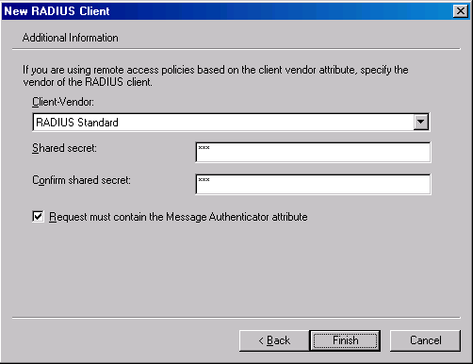

Create a VPN Clients Remote Access Policy
You are ready to create a Remote Access Policy on the IAS Server. Remote Access Policies configured on the IAS Server are enforced against VPN clients calling the ISA Server 2004firewall/VPN server. The Windows Server 2003 IAS server has a Remote Access Policy Wizard that makes it easy to create a secure VPN client Remote Access Policy.
Perform the following steps to create a VPN client Remote Access Policy on the IAS Server:
- In the Internet Authentication Service console, right click on the Remote Access Policies node and click New Remote Access Policy.
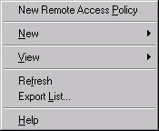
- Click Next on the Welcome to the New Remote Access Policy Wizard page.
- On the Policy Configuration Method page, select Use the wizard to set up a typical policy for a common scenario. In the Policy name text box, type in a name for the policy. In this example, we’ll call it VPN Access Policy. Click Next.
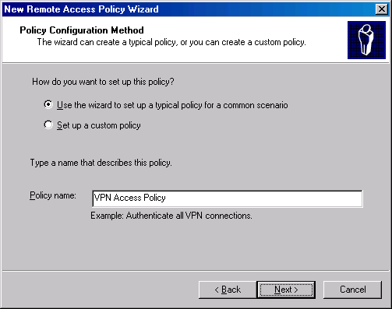
- Select the VPN option on the Access Method page. This policy is used for all VPN connections. You also have the option to create separate policies for PPTP and L2TP/IPSec VPN links. However, to create separate policies for PPTP and L2TP/IPSec connections, you need to go backwards in the Wizard and create two custom policies. In this example, we apply the same policy to all VPN connections. Click Next.
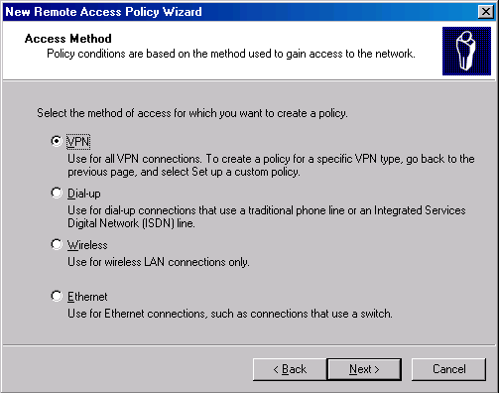
- You can grant access to the VPN server based on user or group. The best access control method is on a per-group basis because it confers less administrative overhead. You can create a group such as VPN Users and allow them access, or allow all your users access. It depends on who you want to give VPN access to the network. In this example, we will select the Group option and click Add. This brings up the Select Groups dialog box. Enter the name of the group in the Enter the object name to select text box and click Check names to confirm that you entered the name correctly. In this example, we will use the Domain Users group. Click OK in the Select Groups dialog box, and then click Next in the User or Group Access dialog box.
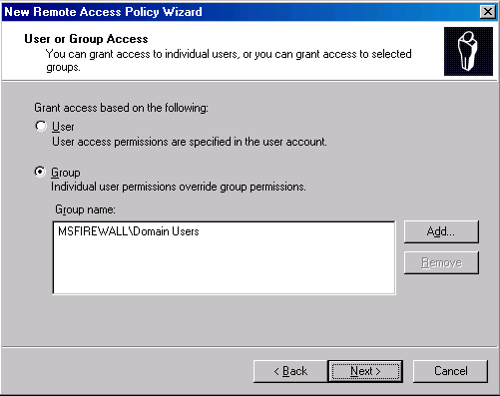
- You can select the user authentication methods to allow on the Authentication Methods page. Both EAP and MS-CHAP version 2 authentication are secure, so we’ll select both the Extensible Authentication Protocol (EAP) and Microsoft Encrypted Authentication version 2 (MS-CHAPv2) check boxes. Click the down arrow in the Type (based on method of access and network configuration) drop down list box and select Smart Card or other certificate. Click Configure. In the Smart Card or other Certificate Properties dialog box, select the certificate you want the server to use to identify itself to VPN clients. The self-signed certificate appears in the Certificate issued to drop down list box. This certificate is used to identify the server when VPN clients are configured to confirm the server’s validity. Click OK in the Smart Card or other Certificate Properties dialog box, and then click Next.
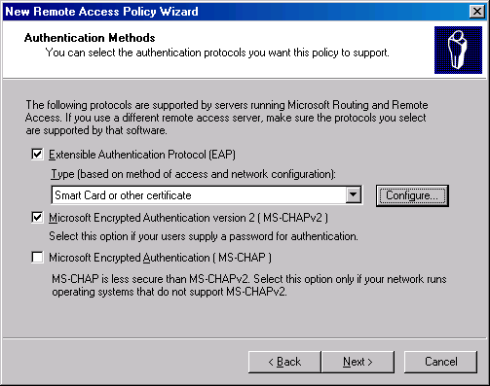
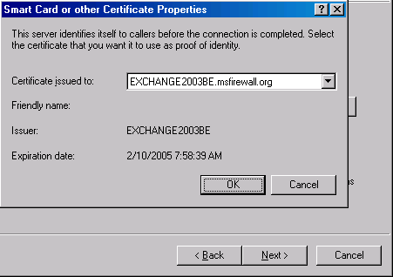
Note:
If you do not see the certificate in the Smart Card or other Certificate Properties dialog box, restart the RADIUS server and start over. The certificate will appear in the dialog box after the restart.
- Select the level(s) of encryption you want to enforce on VPN connections. All Microsoft clients support the strongest level of encryption. If you have clients that don’t support 128- bit encryption, select lower levels, but realize that you lower the level of security provided by the encryption method used by the VPN protocol. In this example, we’ll select only the Strongest encryption (IPSec Triple DES or MPPE 128-bit). Click Next.
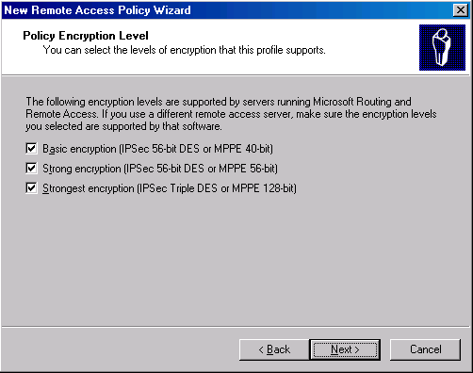
- Review your settings on the Completing the New Remote Access Policy Wizard page and click Finish.

Remote Access Permissions and Domain Functional Level
The new Remote Access Policy requires the connection be a “virtual” or VPN connection. The VPN protocol can be either PPTP or L2TP/IPSec. MS-CHAP v2 or EAP-TLS must be used for authentication, and the client must support the highest level of encryption available for the VPN protocol it uses to connect. The user must belong to the Domain Users group in the domain specified in the Remote Access Policy.
The next step is to configure Remote Access Permissions. Remote Access Permissions are different than Remote Access Policies. When a user calls the ISA Server firewall/VPN server, the parameters of the connection are compared against the Remote Access Policy or Policies defined on the IAS Server. Remote Access Policies are a hierarchical list. The policy on top of the list is evaluated first, then the second-listed policy is applied, then the third and so forth.
VPN connection parameters are compared to the conditions of the policy. In the policy we created above, there were two conditions: the connection type is a virtual connection and the user is a member of the Domain Users group. If the connection request matches both of those conditions, then the Remote Access Permission of the account logging in is determined. Remote access permissions are determined differently depending on the type of domain the user account belongs to.
Windows Server 2003 domains do not use the Mixed and Native Mode designations you might be familiar with in Windows 2000 domains. Windows Server 2003 supports domains of varying functional levels. If all the domain controllers in your domain run Windows Server 2003, the default functional level is Windows 2000 Mixed. All user accounts are denied VPN (Dial up) access by default in Windows 2000 Mixed Mode functional level. In Windows 2000 Mixed Mode, you must configure each user account to have permission to log on to the VPN server. The reason is that user account permissions override Remote Access Policy permissions in Mixed Mode domains.
If you want to control Remote Access Permissions via Remote Access Policy, you must raise the domain functional level of Windows 2000 Native or Windows Server 2003. The default Remote Access Permission in Windows 2000 and Windows Server 2003 domains is Control access through Remote Access Policy. Once you are able to use Remote Access Policy to assign VPN access permission, you can take advantage of group membership to allow or deny access to the VPN server.
When a connection request matches the conditions in the Remote Access Policy and the user is granted access via either the user account Dial-in settings or Remote Access Policy, the connection parameters are compared with a number of settings defined by the Remote Access Profile. If the incoming connection does not comply with the settings in the Remote Access Profile, then the next Remote Access Policy is applied to the connection. If no policy matches the incoming connection’s parameters, the connection request to the ISA Server firewall/VPN server is denied
The VPN Remote Access Policy you created earlier includes all the parameters required for a secure VPN connection. Your decision now centers on how you want to control Remote Access Permissions:
- Allow Remote Access on a per group basis: this requires that you run in Windows 2000 Native or Windows Server 2003 functional level
- Allow Remote Access on a per user basis: supported by Windows 2000 Native, Windows 2000 Mixed and Windows Server 2003 functional levels
- Allow Remote Access on both a per user and per group basis: this requires Windows 2000 Native or Windows Server 2003 functional level; granular user based access control overriding group-based access control is done on a per user basis
Procedures required to allow per user and per group access include:
- Change the Dial-in permissions on the user account in the Active Directory to control Remote Access Permission on a per user basis
- Change the domain functional level to support Dial-in permissions based on Remote Access Policy
- Change the Permissions settings on the Remote Access Policy

Changing the User Account Dial-in Permissions
You can enable dial-in permissions on a per account basis or create Remote Access Policies that can be configured to enable dial-in permissions to entire groups.
Perform the following steps if you want to control access on a per user basis:
- Click Start, point to Administrative Tools and click on Active Directory Users and Computers.
- In the Active Directory Users and Computers console, expand your domain name and click on User.
- Double click on the Administrator account in the right Pane of the console. In the user account Properties dialog box, click on the Dial-in tab. The default setting on the account is Deny access. You can allow VPN access for the account by selecting Allow access. Per user account settings override permissions set on the Remote Access Policy. Notice the Control access through Remote Access Policy option is disabled. This option is available only when the domain is at the Windows 2000 or Windows Server 2003 functional level. Make no changes to the account setting at this time.
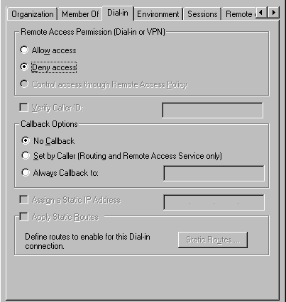
- Click Cancel to escape this dialog box.

Changing the Domain Functional Level
If you want to control access on a per group basis, you will need to change the default domain functional level. Perform the following steps to change the domain functional level:
- On a domain controller in your domain, open the Active Directory Domains and Trusts console. Click Start, point to Administrative Tools and click Active Directory Domains and Trusts.
- In the Active Directory Domains and Trusts console, right click on your domain and click Raise Domain Functional Level.
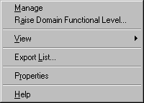
- In the Raise Domain Functional Level dialog box, click the down arrow in the Select an available domain functional level drop down list. Select either Windows 2000 native or Windows Server 2003, depending on the type of domain functional level your network can support. In this example we will select the Windows Server 2003 option. Click the Raise button after making your selection.
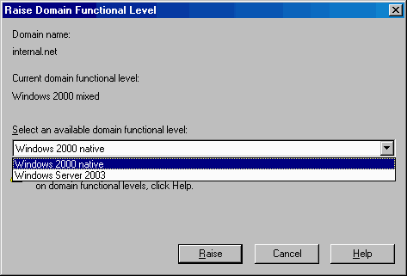
- Click OK in the Raise Domain Functional Level dialog box. This dialog box explains how the change affects the entire domain, and after the change is made, it cannot be reversed.
- Click OK in the Raise Domain Functional Level dialog box informing you that the functional level was raised successfully. Note that you do not need to restart the computer for the changes to take effect. However, the default Remote Access Permission will not change for user accounts until Active Directory replication has completed In this example, we will restart the computer. Restart the computer now and log in as Administrator.
- Return to the Active Directory Users and Computers console and double click on a user account. Click on the Dial-in tab in the user’s Properties dialog box. Notice the Control access through Remote Access Policy option is selected and enabled by default.
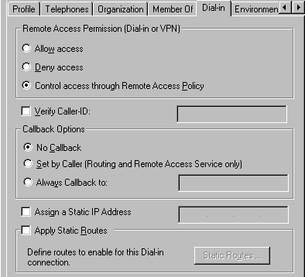

Controlling Remote Access Permission via Remote Access Policy
Now that you have the option to control access via Remote Access Policy, let’s see how VPN access control via Remote Access Policy is performed:
- Click Start, point to Administrative Tools and click on Internet Authentication Service.
- Click on the Remote Access Policies node in the left Pane of the console. You will see the VPN Access Policy you created and two other built-in Remote Access Policies. You can delete these other Remote Access Policies if you require only VPN connections to your ISA Server firewall/VPN server. Right click on the Connections to other access servers Remote Access Policy and click Delete. Repeat with the Connections to Microsoft Routing and Remote Access server Remote Access Policy.
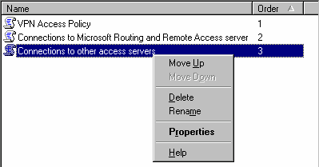
- Double click on the VPN Access Policy in the right Pane of the console. In the VPN Access Policy Properties dialog box, there are two options that control access permissions based on Remote Access Policy:
- Deny remote access permission
- Grant remote access permission
Notice that this dialog box informs you that the user account settings override the Remote Access Permission settings: Unless individual access permissions are specified in the user profile, this policy controls access to the network. Select Grant remote access permission to allow members of the Domain Users group access to the VPN server.
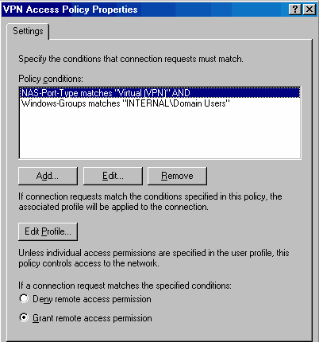
- Click Apply and then click OK in the VPN Access Policy Properties dialog box to save the changes.

Enable the VPN Server on the ISA Server 2004 Firewall and Configure RADIUS Support
With the RADIUS configuration and Remote Access Policies in place, we can now start configuring the ISA Server 2004 VPN server. We will first enable the VPN server and then configure the VPN server to support RADIUS authentication.
Perform the following steps to enable the VPN server and configure it for RADIUS support:
- In the Microsoft Internet Security and Acceleration Server 2004 management console, expand the server name and click on the Virtual Private Networks (VPN) node.
- Click the Tasks tab in the Task Pane. Click Enable VPN Client Access.
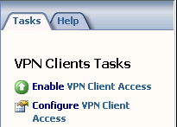
- Click Configure VPN Client Access.
- In the VPN Clients Properties dialog box, click the Groups tab. On the Groups tab, click Add.
- In the Select Groups dialog box, click Locations. In the Locations dialog box, click msfirewall.org and OK.
- In the Select Groups dialog box, enter Domain Users in the Enter the object names to select dialog box. Click the Check Names button. The group will become underlined when it is found in the Active Directory. Click OK.
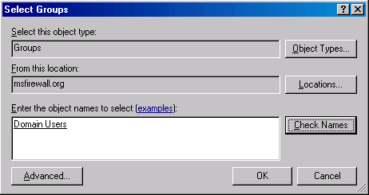
- The domain group appears on the Group tab.
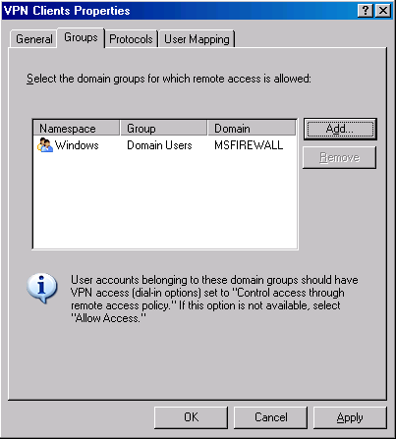
- Click the Protocols tab. Put a checkmark in the Enable L2TP/IPSec check box.
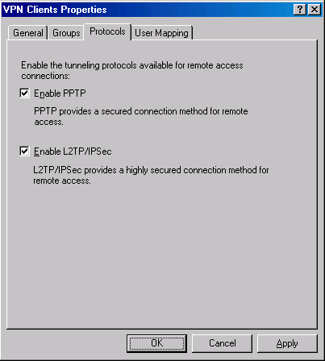
- Click the User Mapping page. Put a checkmark in the Enable User Mapping check box. Put a checkmark in the When username does not contain a domain, use this domain check box. In the Domain Name text box, enter the Internal network domain, msfirewall.org. Click Apply and then click OK.
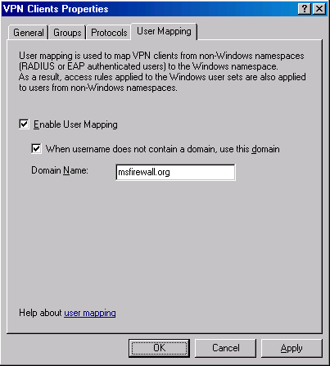
- Click Specify RADIUS Configuration on the Tasks tab.
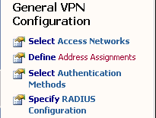
- On the RADIUS tab, put a checkmark in the Use RADIUS for authentication box.
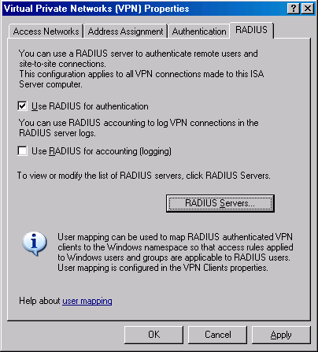
- Click the RADIUS Servers button. In the RADIUS dialog box, click Add.
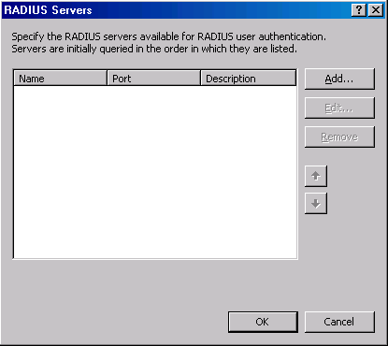
- In the Add RADIUS Server dialog box, enter the name of the IAS server machine in the Server name text box. In this example, the name of the IAS server is EXCHANGE2003BE.msfirewall.org. Enter a description of the server in the Server description text box. In this example, enter the description IAS Server. Click Change.
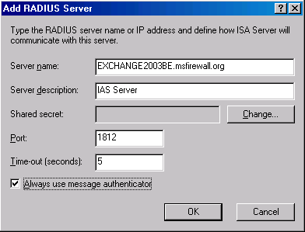
- In the shared secret dialog box, enter a New Secret and then Confirm new secret. Make sure this is the same secret that you entered in the IAS server configuration at the IAS server machine. Click OK.
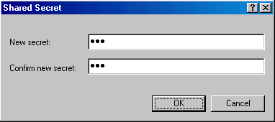
- Click OK in the Add RADIUS Server dialog box.
- Click OK in the RADIUS Servers dialog box.
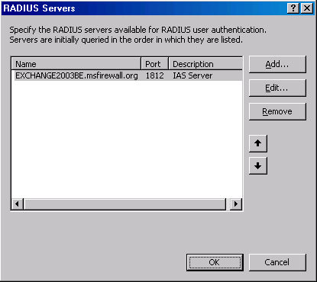
- Click Apply in the Virtual Private Networks (VPN) Properties dialog box. Click OK in the ISA Server 2004 dialog box informing you that the Routing and Remote Access Service may restart. Click OK in the Virtual Private Networks (VPN) Properties dialog box.
- Click Apply to save the changes and update the firewall policy.
- Click OK in the Apply New Configuration dialog box.
- Restart the ISA Server 2004 firewall machine and log on as Administrator.

Create an Access Rule Allowing VPN Clients Access to the Internal Network
The ISA Server 2004 firewall will be able to accept incoming VPN connections after the restart. However, the VPN clients cannot access any resources on the Internal network because there are no Access Rules enabling this access. You must create an Access Rule that allows members of the VPN clients network access to the Internal network. In contrast to other combined firewall VPN server solutions, the ISA Server 2004 firewall VPN server applies access controls for network access to VPN clients.
In this example you will create an Access Rule allowing all traffic to pass from the VPN clients network to the Internal network. In a production environment you would create more restrictive access rules so that users on the VPN clients network have access only to resource they require. We will demonstrate a more restrictive Access Policy in a later chapter in this ISA Server 2004 VPN Deployment Kit document.
Perform the following steps to create an unrestricted access VPN clients Access Rule:
- In the Microsoft Internet Security and Acceleration Server 2004 management console, expand the server name and click the Firewall Policy node. Right click the Firewall Policy node, point to New and click Access Rule.
- In the Welcome to the New Access Rule Wizard page, enter a name for the rule in the Access Rule name text box. In this example we will name the rule VPN Client to Internal. Click Next.
- On the Rule Action page, select the Allow option and click Next.
- On the Protocols page, select the All outbound protocols option in the This rule applies to list. Click Next.
fig10
- On the Access Rule Sources page, click the Add button. On the Add Network Entities dialog box, click the Networks folder and double click on VPN Clients. Click Close.
- Click Next on the Access Rule Sources page.
- On the Access Rule Destinations page, click the Add button. On the Add Network Entities dialog box, click the Networks folder and double click on Internal. Click Close.
- On the User Sets page, accept the default setting, All Users, and click Next.
fig12
- Click Finish on the Completing the New Access Rule Wizard page.
- Click Apply to save the changes and update the firewall policy.
- Click OK in the Apply New Configuration dialog box. The VPN client policy is now the top listed Access Rule in the Access Policy list.

Make the connection from a PPTP VPN Client
All the elements are in place to support RADIUS authentication for VPN clients. In the following exercise you will establish a PPTP VPN connection from an external network client.
Perform the following steps to connect to the VPN server via RADIUS authentication:
- In the Dial-up and Network Connections window on the external network client, create a new VPN connectoid. Configure the connectoid to use the IP address 192.168.1.70 as the address of the VPN server. Log on with the user name Administrator..
- Click OK in the dialog box informing you that the VPN connection is established.
- At the domain controller machine, click Start and point to Administrative Tools. Click Event Viewer.
- In the Event Viewer, click on the System node in the left Pane of the console. Double click on the Information entry with the source as IAS.
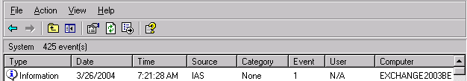
- In the Event Properties dialog box, you will see a Description of the log on request. The information indicates that the RADIUS server authenticated the request and includes the RADIUS specific information sent to the domain controller. Review this information and close the Event Properties dialog box.
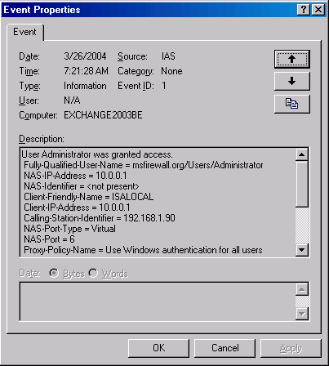
- At the ISA Server 2004 firewall/VPN server machine you can see log file entries specific to this VPN connection. Note the PPTP and the RADIUS connection.
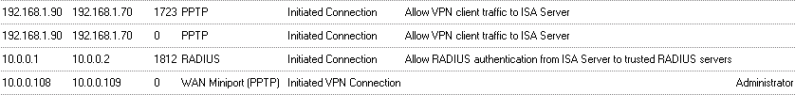
- At the ISA Server 2004 firewall/VPN server, you can see the VPN client session in the Sessions tab in the Monitoring node of the Microsoft Internet Security and Acceleration Server 2004 management console.
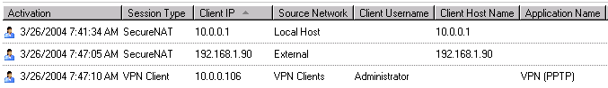
- At the VPN client computer, disconnect the VPN connection.

Conclusion
In this ISA Server 2004 VPN Deployment Kit document, we discussed how to configure the ISA Server 2004 firewall to use RADIUS authentication for VPN clients. In the next document, in this ISA Server 2004 VPN Deployment Kit series, we will look at how to configure the ISA Server 2004 firewall to support RADIUS certificate-based user authentication.

This is a preliminary document and may be changed substantially prior to final commercial release of the software described herein.
The information contained in this document represents the current view of Microsoft Corporation on the issues discussed as of the date of publication. Because Microsoft must respond to changing market conditions, it should not be interpreted to be a commitment on the part of Microsoft, and Microsoft cannot guarantee the accuracy of any information presented after the date of publication.
This white paper is for informational purposes only. MICROSOFT MAKES NO WARRANTIES, EXPRESS OR IMPLIED, IN THIS
DOCUMENT.
Complying with all applicable copyright laws is the responsibility of the user. Without limiting the rights under copyright, no part of this document may be reproduced, stored in, or introduced into a retrieval system, or transmitted in any form or by any means (electronic, mechanical, photocopying, recording, or otherwise), or for any purpose, without the express written permission of Microsoft Corporation.
Microsoft may have patents, patent applications, trademarks, copyrights, or other intellectual property rights covering subject matter in this document. Except as expressly provided in any written license agreement from Microsoft, the furnishing of this document does not give you any license to these patents, trademarks, copyrights, or other intellectual property.
© 2004 Microsoft Corporation. All rights reserved.
The example companies, organizations, products, domain names, e-mail addresses, logos, people, places, and events depicted herein are fictitious. No association with any real company, organization, product, domain name, e-mail address, logo, person, place, or event is intended or should be inferred.
Microsoft, Windows, Windows 2000, Windows 2000 Server, Windows Server 2003, Windows Server System, ISA Server, and ISA Server 2004 are either registered trademarks or trademarks of Microsoft Corporation in the United States and/or other countries.
The names of actual companies and products mentioned herein may be the trademarks of their respective owners.

ISA Server 2004 VPN Deployment Kit: Configuring the VPN Client and ISA Server 2004 VPN Server to Support Certificate-Based PPTP EAP-TLS Authentication
Chapter 8

For the latest information, please see http://www.microsoft.com/isaserver/

Contents
Introduction 1
Configure the Internet Authentication Services (RADIUS) Server 3
Create a VPN Clients Remote Access Policy 6
Remote Access Permissions and Domain Functional Level 11
Changing the User Account Dial-in Permissions 12
Changing the Domain Functional Level 13
Controlling Remote Access Permission via Remote Access Policy 15
Enable the VPN Server on the ISA Server 2004 firewall and configure RADIUS Support 17
Create an Access Rule Allowing VPN Clients Access to the Internal Network 25
Issue Certificates to the ISA Server 2004 Firewall and VPN Clients 28
Issue a Certificate to the ISA Server 2004 Firewall/VPN Server 29
Issue a Certificate to the VPN Client Computer 31
Test a L2TP/IPSec VPN Connection 39
Monitor VPN Clients 44
Test a PPTP VPN Client Connection 46
Conclusion 49

Introduction
In network environments where the ISA Server 2004 firewall is used as an edge firewall with an interface connected to the Internet, it is best to not join the firewall machine to the domain. This mitigates the risk of a compromised machine from leveraging its domain members to attack other machines on the network.
ISA Server 2004 firewalls that are not members of the user domain must use a mechanism other than Windows authentication to identify and authenticate domain users. The ISA Server 2004 firewall can authenticate VPN users with the RADIUS (Remote Access Dial In User Service) protocol. The RADIUS protocol allows the ISA Server 2004 firewall to forward user credentials of a RADIUS server on the Internal network. The RADIUS server then sends the authentication request to an authentication server, such as an Active Directory domain controller.
The ISA Server 2004 firewall supports all types of RADIUS servers. Microsoft’s RADIUS server is the Internet Authentication Services server (IAS). The Microsoft IAS server is included with all Windows 2000 and Windows Server 2003 server family products.
In addition to authenticating users, you can use the IAS server to centralize Remote Access Policy throughout the organization. For example, if you have six ISA Server 2004 firewall/VPN servers on your network, you can apply the same Remote Access Policy to all the machines by configuring it once at the IAS server.
You can significantly improve the level of security applied to your VPN remote access solution by using EAP (Extensible Authentication Protocol) certificate-based user authentication. EAP allows you to extend the number of user authentication methods available to the VPN server. The Microsoft RADIUS (IAS) server also supports EAP. Examples of EAP methods you can use with the ISA Server 2004 VPN server and RADIUS are user certificate authentication and smart card authentication. Smart card authentication requires additional hardware and software not included with the base Windows or ISA Server 2004 products.
You can use the built-in Microsoft Certificate Server included with both Windows 2000 and Windows Server 2003 family products to assign certificates to users in your organization. Users can then configure their VPN client software to present the user certificate to authenticate to the VPN server. User certificate authentication is more secure because the user name and password are not transmitted over the Internet. In addition, the certificate must be installed on the user’s machine, so VPN connections requiring user certificate authentication cannot be made from untrusted machines.
In this ISA Server 2004 VPN Deployment Kit document, we discuss the procedures required to allow VPN clients to use RADIUS authentication to authenticate with the Internal network Active Directory domain. Then, we will configure the ISA Server 2004 firewall/VPN server to accept certificate authentication. Finally, we will issue a certificate to the VPN client and configure the VPN client to present the certificate for authentication.
Specific procedures discussed in this document include how to:
- Configure the IAS Server
- Create a VPN Clients Remote Access Policy
- Configure Remote Access Permissions and Domain Functional Level
- Enable the VPN Server on the ISA Server 2004 firewall and configure RADIUS Support
- Create a VPN Client Access Rule
- Issue Certificates to the ISA Server 2004 Firewall and VPN Clients
- Make the connection from a L2TP/IPSec VPN client
- Make the connection from a PPTP VPN client
MACHINES REQUIRED:
EXCHANGE2003BE
ISALOCAL
EXTERNALCLIENT

Configure the Internet Authentication Services (RADIUS) Server
We installed the IAS server in Chapter 2 of the ISA Server 2004 VPN Deployment Kit series. If you have not installed the IAS server, please refer to the instructions in Chapter 2. You need to configure the IAS server to communicate with the Active Directory, and then, instruct the IAS server to work with the ISA Server 2004 firewall/VPN server machine.
Perform the following steps to configure the IAS server:
- Click Start, point to Administrative Tools and click Internet Authentication Services.
- In the Internet Authentication Services console, right click on the Internet Authentication Service (Local) node in the left pane of the console. Click Register Server in Active Directory.
- This setting allows the IAS Server to authenticate users in the Active Directory domain. Click OK in the Register Internet Authentication Server in Active Directory dialog box.
- Click OK in the Server registered: dialog box. This dialog box informs you that the IAS Server was registered in a specific domain, and if you want this IAS Server to read users’ dial-in properties from other domains, you’ll need to enter this server into the RAS/IAS Server Group in that domain.
- Right click on the RADIUS Clients node in the left pane of the console and click New RADIUS Client.
- In the New RADIUS Client dialog box, enter a Friendly name for the ISA Server 2004 firewall/VPN server. You can use any name you like. In this example, use the DNS host name of the ISA Server firewall/VPN server, ISALOCAL. Enter either the FQDN or the IP address of the ISA Server 2004 firewall/VPN server in the Client address (IP or DNS) dialog box. Do not enter a FQDN if your ISA Server firewall/VPN server has not registered its internal interface IP address with your internal DNS server. You can use the Verify button to test whether the IAS Server can resolve the FQDN. Click Next.
- On the Additional Information page, leave the RADIUS Standard entry in the Client-Vendor drop down box. Your ISA Server firewall/VPN server will use this setting. Type a complex shared secret in the Shared secret text box and confirm it in the Confirm shared secret text box. The shared secret should be a complex string consisting of upper and lower case letters, numbers and symbols. Put a checkmark in the Request must contain the Message Authenticator attribute check box. This option enhances the security of the RADIUS messages passed between the ISA Server firewall/VPN and IAS servers. Click Finish.

Create a VPN Clients Remote Access Policy
You are ready to create a Remote Access Policy on the IAS Server. Remote Access Policies configured on the IAS Server are enforced against VPN clients calling the ISA Server 2004firewall/VPN server. The Windows Server 2003 IAS server has a Remote Access Policy Wizard that makes it easy to create a secure VPN client Remote Access Policy.
Perform the following steps to create a VPN client Remote Access Policy on the IAS Server:
- In the Internet Authentication Service console, right click on the Remote Access Policies node and click New Remote Access Policy.
- Click Next on the Welcome to the New Remote Access Policy Wizard page.
- On the Policy Configuration Method page, select Use the wizard to set up a typical policy for a common scenario. In the Policy name text box, type a name for the policy. In this example, enter VPN Access Policy. Click Next.
- Select VPN on the Access Method page. All VPN connection types will use this policy. You also have the option to create separate policies for PPTP and L2TP/IPSec VPN links. However, to create separate policies for PPTP and L2TP/IPSec connections, you need to go backwards in the Wizard and create two custom policies. In this example, we apply the same policy to all VPN connections. Click Next.
- You can grant access to the VPN server based on user or group. The best access control method is on a per-group basis because it confers less administrative overhead. You can create a group, such as VPN Users, and allow them access, or you can allow all your users access. In this example, we will select the Group option and click Add. This brings up the Select Groups dialog box. Enter the name of the group in the Enter the object name to select text box, and click Check names to confirm that you entered the name correctly. In this example, we use the Domain Users group. Click OK in the Select Groups dialog box, and then, click Next in the User or Group Access dialog box.
- You can select the user authentication methods to allow on the Authentication Methods page. You may wish to allow both Microsoft Encrypted Authentication version 2 and Extensible Authentication Protocol (EAP). Both EAP and MS-CHAP version 2 authentication are secure, so we’ll select both the Extensible Authentication Protocol (EAP) and Microsoft Encrypted Authentication version 2 (MS-CHAPv2) check boxes. Click the down arrow in the Type (based on method of access and network configuration) drop down box, and select Smart Card or other certificate . Click Configure. In the Smart Card or other Certificate Properties dialog box, select the certificate you want the server to use to identify itself to VPN clients. The self-signed certificate appears in the Certificate issued to drop down box. This certificate is used to identify the server when VPN clients are configured to confirm the server’s validity. Click OK in the Smart Card or other Certificate Properties dialog box, and then, click Next.
- Note:
If you do not see the certificate in the Smart Card or other Certificate Properties dialog box, restart the RADIUS server and start over. The certificate will appear in the dialog box after the restart.
- Select the level(s) of encryption you want to enforce on VPN connections. All Microsoft clients support the strongest level of encryption. If you have clients that don’t support 128-bit encryption, select lower levels, but realize that you also lower the level of security provided by the encryption method used by the VPN protocol. In this example, select only Strongest encryption (IPSec Triple DES or MPPE 128-bit). Click Next.
- Review your settings on the Completing the New Remote Access Policy Wizard page, and click Finish.

Remote Access Permissions and Domain Functional Level
The new Remote Access Policy requires the connection be a “virtual” or VPN connection. The VPN protocol can be either PPTP or L2TP/IPSec. MS-CHAP v2 or EAP-TLS must be used to authenticate and the client must support the highest level of encryption available for the VPN protocol they use to connect. The user must belong to the Domain Users group in the domain specified in the Remote Access Policy.
The next step is to configure Remote Access Permissions. Remote Access Permissions are different than Remote Access Policies. When a user calls the ISA Server firewall/VPN server, the parameters of the connection are compared against Remote Access Policy or Policies defined on the IAS Server. Remote Access Policies are a hierarchical list, The policy on top of the list is evaluated first, then the second-listed policy is applied, then the third and so forth.
VPN connection parameters are compared to the conditions of the policy. In the policy we created above, there were two conditions: the connection type is a virtual connection and the user is a member of the Domain Users group. If the connection request matches both of those conditions, the Remote Access Permission of the account logging in is determined. Remote access permissions are determined differently depending on the type of domain the user account belongs to.
Windows Server 2003 domains do not use the Mixed and Native Mode designations you might be familiar with in Windows 2000 domains. Windows Server 2003 supports domains of varying functional levels. If all the domain controllers in your domain run Windows Server 2003, the default functional level is Windows 2000 Mixed. All user accounts are denied VPN (Dial-up) access by default in the Windows 2000 Mixed Mode functional level. In Windows 2000 Mixed Mode, you must configure each user account to have permission to log on to the VPN server. The reason is that user account permissions override Remote Access Policy permissions in Mixed Mode domains.
If you want to control Remote Access Permissions via Remote Access Policy, you must raise the domain functional level of Windows 2000 Native or Windows Server 2003. The default Remote Access Permission in Windows 2000 and Windows Server 2003 domains is Control access through Remote Access Policy. Once you are able to use Remote Access Policy to assign VPN access permission, you can take advantage of group membership to allow or deny access to the VPN server.
When a connection request matches the conditions in the Remote Access Policy and the user is granted access via either the user account Dial-in settings or Remote Access Policy, the connection parameters are compared with a number of settings defined by the Remote Access Profile. If the incoming connection does not comply with the settings in the Remote Access Profile, then the next Remote Access Policy is applied to the connection. If no policy matches the incoming connection’s parameters, the connection request to the ISA Server firewall/VPN server is denied.
The VPN Remote Access Policy created earlier includes all the parameters required for a secure VPN connection. Your decision now centers on how you want to control Remote Access Permissions:
- Allow Remote Access on a per group basis: this requires that you run in Windows 2000 Native or Windows Server 2003 functional level
- Allow Remote Access on a per user basis: supported by Windows 2000 Native, Windows 2000 Mixed and Windows Server 2003 functional levels
- Allow Remote Access on both a per user and per group basis: this requires Windows 2000 Native or Windows Server 2003 functional level; granular user-based access control overriding group-based access control is done on a per user basis
Procedures required allowing per user and per group access include:
- Change the Dial-in permissions on the user account in the Active Directory to control Remote Access Permission on a per user basis
- Change the domain functional level to support Dial-in permissions based on Remote Access Policy
- Change the Permissions settings on the Remote Access Policy

Changing the User Account Dial-in Permissions
You can enable dial-in permissions on a per account basis, or create Remote Access Policies that can be configured to enable dial-in permissions to entire groups.
Perform the following steps if you want to control access on a per user basis:
- Click Start, point to Administrative Tools and click on Active Directory Users and Computers.
- In the Active Directory Users and Computers console, expand your domain name and click on the User node.
- Double click on the Administrator account in the right pane of the console. In the user account Properties dialog box, click on the Dial-in tab. The default setting on the account is Deny access. You can allow VPN access for the account by selecting Allow access. Per user account settings override permissions set on the Remote Access Policy. Notice the Control access through Remote Access Policy option is disabled. This option is available only when the domain is at the Windows 2000 or Windows Server 2003 functional level. Make no changes to the account setting at this time.
- Click Cancel to leave this dialog box.

Changing the Domain Functional Level
If you want to control access on a per group basis, then you will need to change the default domain functional level. Perform the following steps to change the domain functional level:
- On a domain controller in your domain, open the Active Directory Domains and Trusts console. Click Start, point to Administrative Tools and click on Active Directory Domains and Trusts.
- In the Active Directory Domains and Trusts console, right click on your domain and click on Raise Domain Functional Level.
- In the Raise Domain Functional Level dialog box, click the down arrow in the Select an available domain functional level drop down list. Select either Windows 2000 native or Windows Server 2003, depending on the type of domain functional level your network can support. In this example, we will select Windows Server 2003. Click Raise after making your selection.
- Click OK in the Raise Domain Functional Level dialog box. This dialog box explains that the change affects the entire domain, and after the change is made, it cannot be reversed.
- Click OK in the Raise Domain Functional Level dialog box informing you that the functional level was raised successfully. Note that you do not need to restart the computer for the changes to take effect. However, the default Remote Access Permission will not change for user accounts until Active Directory replication and completion. In this example, we will restart the computer. Restart the computer now and log in as Administrator.
- Return to the Active Directory Users and Computers console and double click on a user account. Click on the Dial-in tab in the user’s Properties dialog box. Notice that Control access through Remote Access Policy is enabled and selected by default.

Controlling Remote Access Permission via Remote Access Policy
Now that you have the option to control access via Remote Access Policy, let’s see how VPN access control via Remote Access Policy is performed:
- Click Start, point to Administrative Tools and click on Internet Authentication Service.
- Click on the Remote Access Policies node in the left pane of the console. You will see the VPN Access Policy you created and two other built-in Remote Access Policies. You can delete the other Remote Access Policies if you require only VPN connections to your ISA Server firewall/VPN server. Right click on the Connections to other access servers Remote Access Policy, and click Delete. Repeat with the Connections to Microsoft Routing and Remote Access server policy.
- Double click on the VPN Access Policy in the right pane of the console. In the VPN Access Policy Properties dialog box, there are two options that control access permissions based on Remote Access Policy:
- Deny remote access permission
- Grant remote access permission
Notice that this dialog box informs you that the user account settings override the Remote Access Permission settings: Unless individual access permissions are specified in the user profile, this policy controls access to the network. Select Grant remote access permission to allow members of the Domain Users group access to the VPN server.
- Click Apply and then click OK in the VPN Access Policy Properties dialog box to save the changes.

Enable the VPN Server on the ISA Server 2004 firewall and configure RADIUS Support
With the RADIUS configuration and Remote Access Policies in place, we can start configuring the ISA Server 2004 VPN server. We will first enable the VPN server, and then, configure the VPN server to support RADIUS authentication.
Perform the following steps to enable the VPN server and configure it for RADIUS support:
- In the Microsoft Internet Security and Acceleration Server 2004 management console, expand the server name and then click on Virtual Private Networks (VPN).
- Click the Tasks tab in the Task Pane. Click Enable VPN Client Access.
- Click Configure VPN Client Access.
- In the VPN Clients Properties dialog box, click the Groups tab. On the Groups tab, click Add.
- In the Select Groups dialog box, click Locations. In the Locations dialog box, click msfirewall.org and OK.
- In the Select Groups dialog box, enter Domain Users in the Enter the object names to select dialog box. Click Check Names. The group will be underlined in the Active Directory. Click OK.
- The domain group appears on the Group tab.
- Click the Protocols tab. Put a checkmark in the Enable L2TP/IPSec check box.
- Click the User Mapping page. Put a checkmark in the Enable User Mapping check box. Put a checkmark in the When username does not contain a domain, use this domain check box. In the Domain Name text box, enter the Internal network domain, msfirewall.org. Click Apply and OK.
- Click Specify RADIUS Configuration on the Tasks tab.
- On the RADIUS tab, put a checkmark in the Use RADIUS for authentication check box.
- Click the RADIUS Servers button. In the RADIUS dialog box, click Add.
- In the Add RADIUS Server dialog box, enter the name of the IAS server machine in the Server name text box. In this example, the name of the IAS server is EXCHANGE2003BE.msfirewall.org. Enter a description of the server in the Server description text box. In this example, enter IAS Server. Click Change.
- In the shared secret dialog box, enter a New Secret and then Confirm new secret. Make sure this is the same secret that you entered in the IAS server configuration at the IAS server machine. Click OK.
- Click OK in the Add RADIUS Server dialog box.
- Click OK in the RADIUS Servers dialog box.
- Click the Authentication tab in the Virtual Private Networks (VPN) Properties dialog box. Remove the checkmark from the Microsoft encrypted authentication version 2 (MS-CHAPv2) check box. Place a checkmark in the Extensible authentication protocol (EAP) with smart card or other certificate check box.
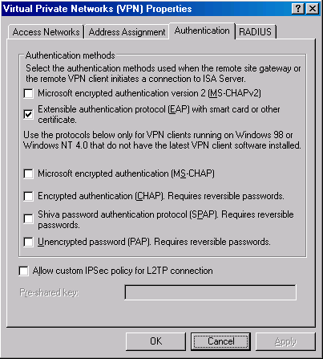
- Click Apply in the Virtual Private Networks (VPN) Properties dialog box. Click OK in the ISA Server 2004 dialog box informing you that the Routing and Remote Access Service may restart. Click OK in the Virtual Private Networks (VPN) Properties dialog box.
- Click Apply to save the changes and update the firewall policy.
- Click OK in the Apply New Configuration dialog box.
- Restart the ISA Server 2004 firewall machine and log on as Administrator.

Create an Access Rule Allowing VPN Clients Access to the Internal Network
The ISA Server 2004 firewall will be able to accept incoming VPN connections after the restart. However, the VPN clients cannot access any resources on the Internal network because there are no Access Rules enabling this access. You must create an Access Rule that allows members of the VPN clients network access to the Internal network. In contrast to other combined firewall VPN server solutions, the ISA Server 2004 firewall VPN server applies access controls for network access to VPN clients.
In this example, you will create an Access Rule allowing all traffic to pass from the VPN clients network to the Internal network. In a production environment, you would create more restrictive access rules allowing users on the VPN clients network access only to resources they require. We will demonstrate a more restrictive Access Policy elsewhere in the ISA Server 2004 VPN Deployment Kit.
Perform the following steps to create an unrestricted access VPN clients Access Rule:
- In the Microsoft Internet Security and Acceleration Server 2004 management console, expand the server name and click Firewall Policy. Right click the Firewall Policy node, point to New and click Access Rule.
- On the Welcome to the New Access Rule Wizard page, enter a name for the rule in the Access Rule name text box. In this example, we will name the rule VPN Client to Internal. Click Next.
- On the Rule Action page, select Allow and click Next.
- On the Protocols page, select All outbound protocols in the This rule applies to drop down list. Click Next.
- On the Access Rule Sources page, click Add. In the Add Network Entities dialog box, click the Networks folder and double click on VPN Clients. Click Close.
- Click Next on the Access Rule Sources page.
- On the Access Rule Destinations page, click Add. In the Add Network Entities dialog box, click the Networks folder and double click on Internal. Click Close.
- On the User Sets page, accept the default setting, All Users, and click Next.
- Click Finish on the Completing the New Access Rule Wizard page.
- Click Apply to save the changes and update the firewall policy.
- Click OK in the Apply New Configuration dialog box. The VPN client policy is now the top listed Access Rule in the Access Policy list.

Issue Certificates to the ISA Server 2004 Firewall and VPN Clients
You can significantly improve the level of security provided to your VPN connection by using the L2TP/IPSec VPN protocol. The IPSec encryption protocol provides a number of security advantages over the Microsoft Point-to-Point Encryption (MPPE) protocol used to secure PPTP connections. While the ISA Server 2004 firewall VPN supports using a pre-shared key to support the IPSec encryption process, this should be considered a low security option and avoided, if possible. The secure IPSec solution is to use computer certificates on the VPN server and VPN clients.
By default, strong access controls lock down the ISA Server 2004 firewall. You need to enable a System Policy Rule that allows the back-end firewall to communicate with the enterprise CA on the Internal network.
Perform the following steps to enable the System Policy Rule on the back-end ISA Server 2004 firewall:
- In the Microsoft Internet Security and Acceleration Server 2004 management console, expand the server name and click Firewall Policy.
- Right click the Firewall Policy node, point to View and click Show System Policy Rules.
- In the System Policy Rule list, double click on the Allow HTTP from ISA Server to all networks for CRL downloads System Policy Rule.
- In the System Policy Editor dialog box, put a checkmark in the Enable check box on the General tab. Click OK.
- Click Apply to save the changes and update the firewall policy.
- Click OK in the Apply New Configuration dialog box.

Issue a Certificate to the ISA Server 2004 Firewall/VPN Server
The next step issues a computer certificate to the ISA Server 2004 firewall VPN server. Perform the following steps on the ISA Server 2004 firewall to request a certificate from the enterprise CA on the Internal network:
- Open Internet Explorer. In the Address bar, enter http://10.0.0.2/certsrv and click OK.
- In the Enter Network Password dialog box, enter Administrator in the User Name text box, and enter the Administrator’s password in the Password text box. Click OK.
- Click Request a Certificate on the Welcome page.
- On the Request a Certificate page, click advanced certificate request.
- On the Advanced Certificate Request page, click Create and submit a request to this CA.
- On the Advanced Certificate Request page, select Administrator from the Certificate Template list. Place a checkmark in the Store certificate in the local computer certificate store check box. Click Submit.
- Click Yes in the Potential Scripting Violation dialog box.
- On the Certificate Issued page, click Install this certificate.
- Click Yes on the Potential Scripting Violation page.
- Close the browser after viewing the Certificate Installed page.
- Click Start and Run. Enter mmc in the Open text box and click OK.
- In Console1, click File menu, and Add/Remove Snap-in.
- Click Add in the Add/Remove Snap-in dialog box.
- Select Certificates from the Available Standalone Snap-ins list in the Add Standalone Snap-in dialog box. Click Add.
- Select Computer account on the Certificates snap-in page.
- Select Local computer on the Select Computer page.
- Click Close in the Add Standalone Snap-in dialog box.
- Click OK in the Add/Remove Snap-in dialog box.
- In the left pane of the console, expand Certificates (Local Computer) ,and then expand the Personal node. Click on \Personal\Certificates. Double click on the Administrator certificate in the right pane of the console.
- In the Certificate dialog box, click the Certification Path tab. The root CA certificate is at the top of the certificate hierarchy seen in the Certification path. Click EXCHANGE2003BE at the top of the list. Click View Certificate.
- In the CA certificate’s Certificate dialog box, click Details. Click Copy to File.
- Click Next in the Welcome to the Certificate Export Wizard page.
- On the Export File Format page, select Cryptographic Message Syntax Standard – PKCS #7 Certificates (.P7B) and click Next.
- On the File to Export page, enter c:\cacert in the File name text box. Click Next.
- Click Finish on the Completing the Certificate Export Wizard page.
- Click OK in the Certificate Export Wizard dialog box.
- Click OK in the Certificate dialog box. Click OK again in the Certificate dialog box.
- In the left pane of the console, expand the Trusted Root Certification Authorities node and click Certificates. Right click \Trusted Root Certification Authorities\Certificates, point to All Tasks and click Import.
- Click Next on the Welcome to the Certificate Import Wizard page.
- On the File to Import page, use the Browse button to locate the CA certificate you saved to the local hard disk, and click Next.
- On the Certificate Store page, accept the default settings and click Next.
- Click Finish on the Completing the Certificate Import Wizard page.
- Click OK on the Certificate Import Wizard dialog box informing you that the import was successful.
Note that you will not need to manually copy the enterprise CA certificate into the ISA Server 2004 firewall’s Trusted Root Certification Authorities certificate store because the CA certificate is automatically installed on domain members. If the firewall were not a member of the domain, you would need to manually place the CA certificate into the Trusted Root Certification Authorities certificate store.

Issue a Certificate to the VPN Client Computer
The next step is to issue a computer certificate to the VPN client computer. In this example, the VPN client machine is not a member of the domain. You will need to request a computer certificate using the enterprise CA’s Web enrollment site and manually place the certificate into the client’s Trusted Root Certification Authorities machine certificate store. The easiest way to accomplish this task is to have the VPN client machine request the certificate when connected via a PPTP link.
- Note:
In a production environment, do not issue untrusted clients computer certificates. Only managed computers, which are members of the domain, should be allowed to install computer certificates. Domain members are managed clients, and therefore, under the organization’s administrative control. The computer certificate is a security principle and is not meant to provide free access to all clients who wish to connect via VPN.
There are several ways you can obtain a certificate from the CA. In this example, we will publish the CA’s Web enrollment site and obtain the certificate from the Web enrollment site.
Perform the following steps to publish the enterprise CA’s Web enrollment site:
- In the Microsoft Internet Security and Acceleration Server 2004 management console, expand the server name and click Firewall Policy.
- In the Task pane, click Tasks. On the Tasks tab, click Publish a Web Server.
- Enter a name for the Web Publishing Rule on the Welcome to the New Web Publishing Rule Wizard page. In this example, enter Web Enrollment Site in the Web publishing rule name text box. Click Next.
- Select Allow on the Select Rule Action page.
- On the Define Website to Publish page, enter the IP address of the enterprise CA’s Web site in the Computer name or IP address text box. In this example, the IP address is 10.0.0.2, so we will enter that value into the text box. In the Folder text box, enter /*. Click Next.
- On the Public Name Details page, select This domain name (type below) in the Accept request for drop down list. In the Public name text box, enter the IP address on the external interface of the firewall. In this example, the main office ISA Server 2004 firewall’s external address is 192.168.1.70, so enter that value into the text box. Enter /* into the Path (optional) text box. Click Next.
- On the Select Web Listener page, click New.
- On the Welcome to the New Web Listener page, enter a name for the rule in the Web listener name text box. In this example, name the listener Listener70, to indicate the IP address that the listener is listening on. Click Next.
- On the IP addresses page, put a checkmark in the External check box and click Next.
- On the Port Specification page, accept the default settings. Confirm that there is a checkmark in the Enable HTTP check box and that the value 80 is in the HTTP port text box. Click Next.
- Click Finish on the Completing the New Web Listener Wizard page.
- Click Next on the Select Web Listener page.
- Accept the default setting, All Users, on the User Sets page, and click Next.
- Click Finish on the Completing the New Web Publishing Rule Wizard page.
- Click Apply to save the changes and update the firewall policy.
- Click OK in the Apply New Configuration dialog box.
Perform the following steps on the VPN client machine to request a machine certificate and install the CA certificate into the VPN client machine’s Trusted Root Certification Authorities certificate store:
- Open Internet Explorer. In the Address bar, enter http://192.168.1.70/certsrv and click OK.
- In the Enter Network Password dialog box, enter Administrator in the User Name text box and enter the Administrator’s password in the Password text box. Click OK.
- Click Request a Certificate on the Welcome page.
- On the Request a Certificate page, click advanced certificate request.
- On the Advanced Certificate Request page, click Create and submit a request to this CA.
- On the Advanced Certificate Request page, select Administrator from the Certificate Template list. Place a checkmark in the Store certificate in the local computer certificate store check box. Click Submit.
- Click Yes in the Potential Scripting Violation dialog box.
- On the Certificate Issued page, click Install this certificate.
- Click Yes on the Potential Scripting Violation page.
- Close the browser after viewing the Certificate Installed page.
- Click Start and Run. Enter mmc in the Open text box and click OK.
- In Console1, click File and Add/Remove Snap-in.
- Click Add in the Add/Remove Snap-in dialog box.
- Select Certificates from the Available Standalone Snap-ins list in the Add Standalone Snap-in dialog box. Click Add.
- Select Computer account on the Certificates snap-in page.
- Select Local computer on the Select Computer page.
- Click Close in the Add Standalone Snap-in dialog box.
- Click OK in the Add/Remove Snap-in dialog box.
- In the left pane of the console, expand the Certificates (Local Computer) node and then expand the Personal node. Click on \Personal\Certificates. Double click on the Administrator certificate in the right pane of the console.
- In the Certificate dialog box, click the Certification Path tab. The root CA certificate is at the top of the certificate hierarchy seen in the Certification path frame. Click EXCHANGE2003BE at the top of the list. Click View Certificate.
- In the CA certificate’s Certificate dialog box, click Details. Click Copy to File.
- Click Next in the Welcome to the Certificate Export Wizard page.
- On the Export File Format page, select Cryptographic Message Syntax Standard – PKCS #7 Certificates (.P7B) and click Next.
- On the File to Export page, enter c:\cacert in the File name text box. Click Next.
- Click Finish on the Completing the Certificate Export Wizard page.
- Click OK in the Certificate Export Wizard dialog box.
- Click OK in the Certificate dialog box. Click OK again in the Certificate dialog box.
- In the left pane of the console, expand the Trusted Root Certification Authorities node and click the Certificates node. Right click the \Trusted Root Certification Authorities\Certificates node, point to All Tasks and click Import.
- Click Next on the Welcome to the Certificate Import Wizard page.
- On the File to Import page, use Browse to locate the CA certificate you saved to the local hard disk, and click Next.
- On the Certificate Store page, accept the default settings, and click Next.
- Click Finish on the Completing the Certificate Import Wizard page.
- Click OK on the Certificate Import Wizard dialog box informing you that the import was successful.
Now that the VPN client computer has a computer certificate, the next step is to obtain a user certificate that the VPN client can present to the VPN server. Perform the following steps to obtain a user certificate:
- Open Internet Explorer. In the Address bar, enter http://192.168.1.70/certsrv and press ENTER.
- Enter Administrator in the User Name text box. Enter the Administrator’s password in the Password text box. Click OK.
- On the Welcome page of the CA’s Web enrollment site, click Request a certificate.
- On the Request a Certificate page, click User Certificate.
- Click Submit on the User Certificate – Identifying Information page.
- Click Yes in the Potential Scripting Violation dialog box informing you that the Web site is requesting a new certificate on your behalf.
- On the Certificate Issued page, click Install this certificate.
- Click Yes in the Potential Scripting Violation dialog box informing you that the Web site is adding one or more certificates.
- Close Internet Explorer.

Test a L2TP/IPSec VPN Connection
Now that both the ISA Server 2004 firewall and the VPN client machines have machine certificates, you can test a secure remote access client VPN connection to the firewall. The first step is to restart the Routing and Remote Access Service so that it registers the new certificate.
Perform the following steps to restart the Routing and Remote Access Service:
- In the Microsoft Internet Security and Acceleration Server 2004 management console, expand the server name and then click Monitoring.
- In the Details pane, click on Services. Right click on Remote Access Service and click Stop.
- Right click Remote Access Service entry again and click Start.
The next step is to start the VPN client connection:
- In the Dial-up and Network Connections window on the external network client, create a new VPN connectoid. Configure the connectoid to use the IP address 192.168.1.70 as the address of the VPN server.
- When you complete the connection Wizard, you will see the Connect dialog box. Click the Properties button.
- In the connectoid’s Properties dialog box, click the Security tab. On the Security tab, select Advanced (custom settings). Click Settings.
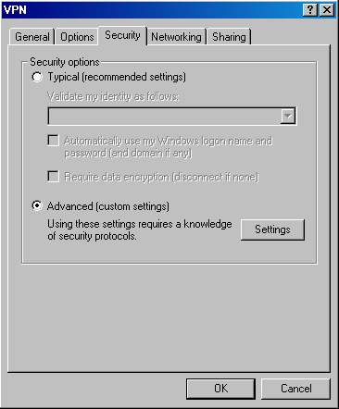
- In the Advanced Security Settings dialog box, select Use Extensible Authentication Protocol (EAP). Click Properties.
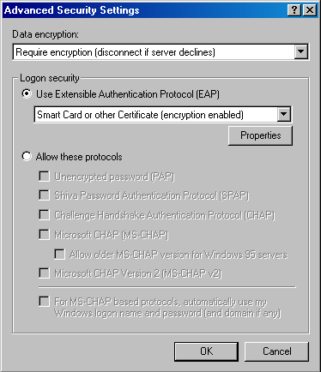
- In the Smart Card or other Certificate Properties dialog box, select Use a certificate on this computer. Place a checkmark in the Validate server certificate check box. Place a checkmark in the Connect only if server name ends with: check box and enter the domain name of the authentication server in the text box. In this example, the domain name of our Active Directory domain controller (which is the authentication server on the certificate) is msfirewall.org, so we will enter that name in the text box. In the Trusted root certificate authority list, select the name of the CA that issued the certificates. In this example, the CA name is EXCHANGE2003BE, so we will select that option. Click OK in the Smart Card or other Certificate Properties dialog box.
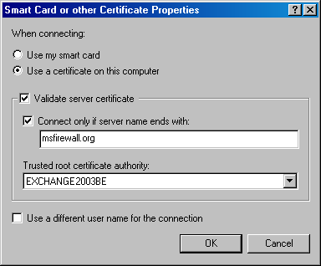
- Click OK in the Advanced Security Settings dialog box.
- Click OK in the connectoid’s Properties dialog box.
- A Connect VPN dialog box appears that contains the name on the user certificate you obtained from the CA. Click OK.
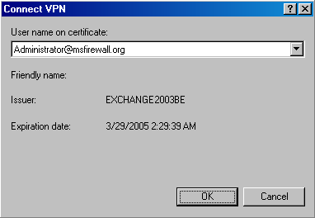
- Click OK in the Connection Complete dialog box informing you that the connection is established.
- Double click on the connection icon in the system tray.
- In the ISA VPN Status dialog box, click Details. You will see an entry for IPSEC Encryption, indicating that the L2TP/IPSec connection was successful.
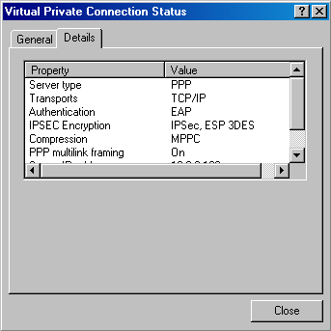
- Click Close in the ISA VPN Status dialog box.

Monitor VPN Clients
The ISA Server 2004 firewall allows you to monitor the VPN client connections. Perform the following steps to see how you can view connections from VPN clients:
- In the Microsoft Internet Security and Acceleration Server 2004 management console, expand the computer name in the left pane of the console and click Virtual Private Networks (VPN). In the Task pane, click Tasks. Click Monitor VPN Clients.
- You are moved to the Sessions tab in the Monitoring node. Here you can see that the sessions have been filtered to show only the VPN Client connections.
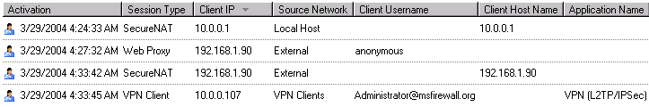
- Click on the Dashboard tab. Here you can see in the Sessions pane the VPN Remote Client connections.
- You can also use the real-time logging feature to see connections made by the VPN clients. Click on the Logging tab, and then, click the Tasks tab in the Task pane. Click Start Query. Here you see all communications moving through the firewall. You can use the filter capabilities to focus on specific VPN clients or only the VPN clients network.

Test a PPTP VPN Client Connection
All the elements are in place to support EAP certificate-based RADIUS authentication for PPTP VPN clients. You can configure the VPN client to use PPTP instead of L2TP/IPSec by configuring the VPN client software to force a PPTP connection. In the following walkthrough, you will force a PPTP connection while still using EAP certificate-based user authentication.
Perform the following steps to connect to the VPN server via PPTP certificate-based user authentication using RADIUS:
- In the Network and Dial-up Connections window, right click on the VPN connectoid you created earlier and click Properties.
- In the connectoid’s Properties dialog box, click Networking. In the Type of VPN server I am calling list, select Point-to-Point Protocol (PPTP). Click OK.
- Double click the VPN connectoid. The user name on the certificate appears in the User name on certificate: drop down list. Click OK.
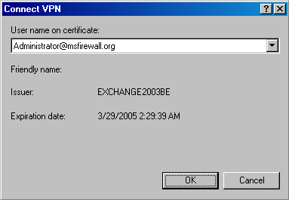
- Click OK in the dialog box informing you that the VPN connection is established.
- Double click on the VPN connection icon in the system tray. In the Virtual Private Connection Status dialog box, click Details. Notice the Authentication type is EAP.
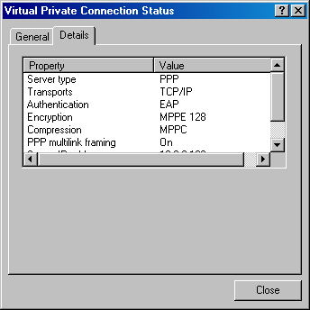
- At the domain controller machine, click Start and point to Administrative Tools. Click Event Viewer.
- In Event Viewer, click on the System node in the left pane of the console. Double click on the Information entry with the source as IAS.
- In the Event Properties dialog box, you will see a Description of the log-on request. The information indicates that the RADIUS server authenticated the request and includes the RADIUS-specific information sent to the domain controller. Review this information and close the Event Properties dialog box.
- At the ISA Server 2004 firewall/VPN server machine you can see log file entries specific to this VPN connection. Note the PPTP and the RADIUS connection.
- At the ISA Server 2004 firewall/VPN server, you can see the VPN client session in the Sessions tab in the Monitoring node of the Microsoft Internet Security and Acceleration Server 2004 management console.
At the VPN client computer, disconnect the VPN connection.

Conclusion
In this ISA Server 2004 VPN Deployment Kit document, we discussed how to configure the ISA Server 2004 firewall to use RADIUS authentication for VPN clients. We then configured the VPN server and VPN client with computer and user certificates that enabled EAP certificate-based user authentication via RADIUS. In the next document in this ISA Server 2004 VPN Deployment Kit series, we will look at how to configure the ISA Server 2004 firewall to support network browsing for VPN clients.

This is a preliminary document and may be changed substantially prior to final commercial release of the software described herein.
The information contained in this document represents the current view of Microsoft Corporation on the issues discussed as of the date of publication. Because Microsoft must respond to changing market conditions, it should not be interpreted to be a commitment on the part of Microsoft, and Microsoft cannot guarantee the accuracy of any information presented after the date of publication.
This white paper is for informational purposes only. MICROSOFT MAKES NO WARRANTIES, EXPRESS OR IMPLIED, IN THIS
DOCUMENT.
Complying with all applicable copyright laws is the responsibility of the user. Without limiting the rights under copyright, no part of this document may be reproduced, stored in, or introduced into a retrieval system, or transmitted in any form or by any means (electronic, mechanical, photocopying, recording, or otherwise), or for any purpose, without the express written permission of Microsoft Corporation.
Microsoft may have patents, patent applications, trademarks, copyrights, or other intellectual property rights covering subject matter in this document. Except as expressly provided in any written license agreement from Microsoft, the furnishing of this document does not give you any license to these patents, trademarks, copyrights, or other intellectual property.
© 2004 Microsoft Corporation. All rights reserved.
The example companies, organizations, products, domain names, e-mail addresses, logos, people, places, and events depicted herein are fictitious. No association with any real company, organization, product, domain name, e-mail address, logo, person, place, or event is intended or should be inferred.
Microsoft, Windows, Windows 2000, Windows 2000 Server, Windows Server 2003, Windows Server System, ISA Server, and ISA Server 2004 are either registered trademarks or trademarks of Microsoft Corporation in the United States and/or other countries.
The names of actual companies and products mentioned herein may be the trademarks of their respective owners.

ISA Server 2004 VPN Deployment Kit: Enabling Network Browsing for ISA Server 2004 VPN Clients
Chapter 9

For the latest information, please see http://www.microsoft.com/isaserver/

Contents
Introduction 1
Assign a WINS Server Address to a VPN Client in the Microsoft Internet Security and Acceleration Server 2004 Management Console Interface 2
Install and Configure the DHCP Relay Agent on the ISA Server 2004 Firewall Machine 5
Join a Domain over a VPN connection and Browse the Network as a Domain Member 9
Configure the VPN Client as a Member of a Workgroup with the Same Domain Name as the Internal Network 14
Conclusion 19

Introduction
A primary reason to setup a VPN server is so VPN clients can access shared resources on the Internal network. A number of methods are available that allow users to access shared resources on the corporate network, including:
- Mapped Network Drives
Users can access network file shares by mapping a network drive to specific share. The user can map the file share to a drive letter himself, or you can map a file share to a network drive via log on script.
- Universal Naming Convention Paths using the Run Command
If the user knows the computer name and share name containing the desired files, he can connect to the resource via a Universal Naming Convention (UNC) path. The UNC path is represented as \\Computer_name\Share_name where the Computer_name is the DNS or NetBIOS name of the computer and the Share_name is the name of the shared resource on that computer. The UNC path is entered into the Run command dialog box.
- Web browser
Network file shares can be mapped to Internet Information Server virtual directories, and users may access files in these virtual directories using a Web browser. You can also use the Windows 2000/Windows Server 2003 WebDAV features to increase flexibility in Web-based file access.
- Network browsing via Network Neighborhood or My Network Places
The most popular method of accessing file shares is via the My Network Places and Network Neighborhood applets. Users click on the domain name and then click on computer names within the domain. The shared resource is accessed within the contents of the computer name.
This ISA Server 2004 VPN Deployment Kit document contains information on how to configure ISA Server firewall/VPN server and VPN client computers to support Network browsing using the My Network Places or Network Neighborhood applets. Specific procedures discussed include how to:
- Assign a WINS server address to a VPN client in the Microsoft Internet Security and Acceleration Server 2004 management console interface
- Install and Configure the DHCP Relay Agent on the ISA Server 2004 Firewall Machine
- Join a Domain over a VPN connection and Browse the Network as a Domain Member
- Configure the VPN Client as a Member of a Workgroup with the Same Domain Name as the Internal Network
If you have not already enabled the ISA Server 2004 VPN Server, please do so now, using the procedures in Chapter 4 of this ISA Server 2004 VPN Deployment Kit.
- Note:
Join a Domain over a VPN connection and Browse the Network as a Domain Member and Configure the VPN Client as a Member of a Workgroup with the Same Domain Name as the Internal Network are mutually exclusive. Select only one of these procedures to test. If you wish to test both procedures, you will have to remove the machine from the domain before testing the workgroup configuration, or use two different VPN client machines and test one as a domain member and the second as a workgroup member.

Assign a WINS Server Address to a VPN Client in the Microsoft Internet Security and Acceleration Server 2004 Management Console Interface
ISA Server 2004 provides a number of options for assigning VPN clients name server addresses. You can use the name server addresses bound to a specific adapter on the ISA Server 2004 server machine, or explicitly configure the name server addresses to be assigned to VPN clients that are different from those assigned to any network interface on the ISA Server 2004 firewall.
Perform the following steps to configure the WINS server address to be assigned to the VPN client:
- In the Microsoft Internet Security and Acceleration Server 2004 management console, expand the server name and click on the Virtual Private Networks (VPN) node.
- In the Task pane, click the Tasks tab. On the Tasks tab, click Define Address Assignments.
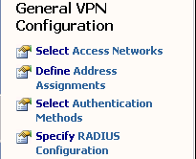
- On the Address Assignment tab, note the entry in the Use the following network to obtain DHCP, DNS and WINS services. The DNS and WINS server addresses assigned to the adapter you select from this list will be assigned to the VPN clients. This is the default setting on the ISA Server 2004 VPN server.
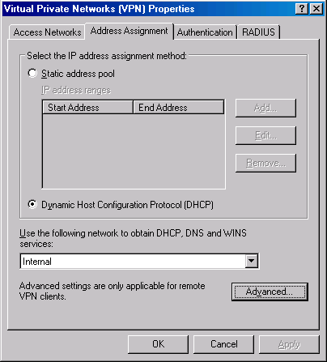
- Click the Advanced button. Select Use the following WINS server addresses. In the Primary text box, enter the IP address 10.0.0.123. This is a bogus value, but it will demonstrate how you can override the WINS address assignment used on any of the network interfaces on the ISA Server 2004 firewall machine itself.
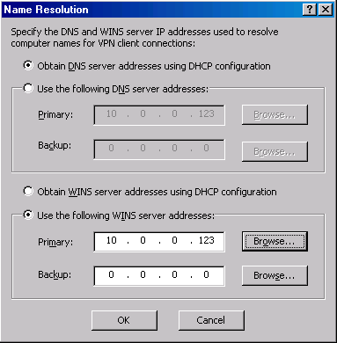
- Click OK on the Name Resolution dialog box.
- Click Apply and OK in the Virtual Private Networks (VPN) Properties dialog box.
- Click Apply to save the changes and update the firewall policy.
- Click OK in the Apply New Configuration dialog box.

Install and Configure the DHCP Relay Agent on the ISA Server 2004 Firewall Machine
An alternate method of assigning WINS server addresses to VPN clients is to use a DHCP Relay Agent. The DHCP Relay Agent listens to DHCP broadcast messages coming from the VPN clients and forwards these messages to a DHCP server you specify in the DHCP Relay Agent Properties dialog box. The DHCP Relay Agent allows you to assign DHCP Options, such as a custom WINS and DNS server address. In addition, you can assign a primary domain name to the VPN clients, which the clients can use for name resolution.
Although the Routing and Remote Access service is started by the ISA Server VPN Wizard, we still have a couple things to do before connecting VPN clients to the network. Perform the following steps to install and configure the DHCP Relay Agent on the ISA Server 2004 firewall machine:
- Click Start, point to Programs, point to Administrative Tools and click on Routing and Remote Access.
- In the Routing and Remote Access console, expand the IP Routing node in the left pane of the console and right click on General. Click on New Routing Protocol.
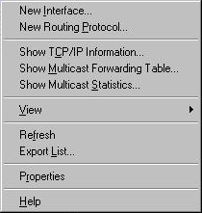
- In the New Routing Protocol dialog box, click on DHCP Relay Agent and click OK.
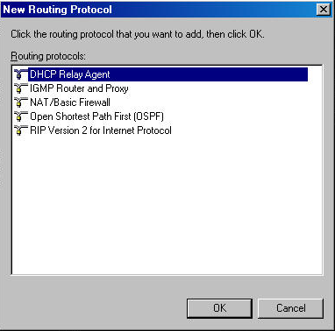
- A new node, DHCP Relay Agent, appears in the left pane of the Routing and Remote Access console. Right click on the DHCP Relay Agent node and click Properties.
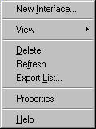
- In the DHCP Relay Agent Properties dialog box, type in the IP address of the DHCP server in the Server address text box, and click Add. Click Apply and OK.
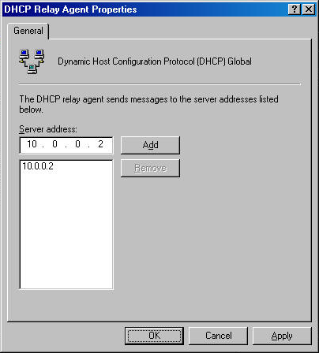
- Right click on the DHCP Relay Agent node in the left pane of the console and click the New Interface command.
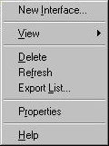
- Select the Internal interface (this is an internal interface used by the Routing and Remote Access Service; it’s not the LAN (internal) interface of the ISA Server firewall/VPN server). Click OK.
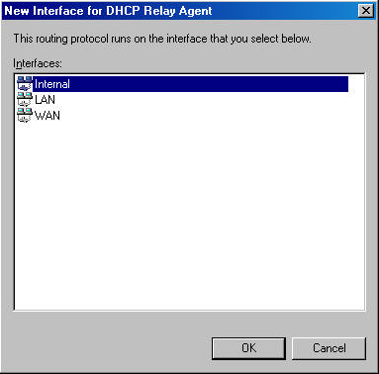
- Accept the default settings in the DHCP Relay Properties – Internet Properties dialog box and click OK.
The DHCP server and DHCP Relay Agent are now ready to use. You can connect your VPN clients to the ISA Server firewall/VPN server, and the clients will now receive the DHCP scope options you configured for their use

Join a Domain over a VPN connection and Browse the Network as a Domain Member
There are no special configuration requirements when the VPN machine and the user are members of the Internal network domain. The domain member VPN client has the following features and capabilities:
- The Primary Domain Name of the computer is set to the Internal network domain
- The user has the option to log onto the machine and network using Dial-up networking
- The user will be able to browse to any machine on the Internal network domain using My Network Places or Network Neighborhood
- When the user logs on to the network via Dial-up networking, the user’s log-on credentials are valid on any domain machine; the user is not challenged for credentials when accessing network resources
- Log-on scripts are delivered to the user when the user logs onto the computer and the network via Dial-up Networking
A computer can be joined to the domain while directly connected to the Internal network, or when it is connected over a VPN link. We recommend that you join the computer to the domain while it is directly connected to the network. However, if this is not possible, you can use the following procedure to join the machine over a VPN connection:

- Create the Dial-up Networking VPN connectoid that connects the VPN client computer to the ISA Server firewall/VPN server. Connect the non-domain member VPN client machine to the ISA Server firewall/VPN server using this connectoid.
- As soon as the VPN link is established, right click on My Computer on the desktop and click Properties.
- In the System Properties dialog box, click on the Network Identification tab. Note the current Full computer name and Workgroup. Click Properties.
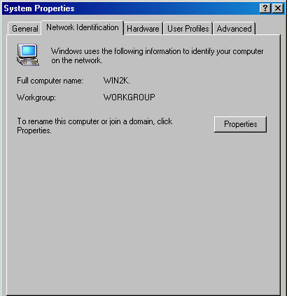
- In the Identification Changes dialog box, select Domain. Enter the name of the Internal network domain in the text box under the Domain option. In this example, enter the domain name msfirewall.org. Note that before the change is made, the Full computer name is WIN2K. This is only a host name; there is no domain name yet. This client will have problems qualifying unqualified requests. This client will have a primary domain name assigned to it after it joins the domain. Click OK.
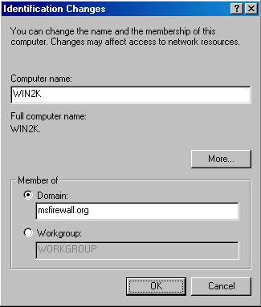
- Type in a domain administrator name and password in the Domain Username and Password dialog box. Click OK.
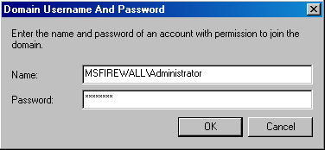
- You will see a Network Identification dialog box saying Welcome to the msfirewall.org after you successfully join the domain. Click OK.
- Click OK in the Network Identification dialog box informing you to reboot the computer for the changes to take effect.
- Notice on the bottom of the System Properties dialog box the comment, Changes will take effect after you restart this computer. Click OK.

- Click Yes in the System Settings Change dialog box. This will restart the computer.
- Log off and then log on again. This time log on with your domain account. Confirm that you are logging on to the domain by confirming that the domain appears in the Log on to drop down list box. Use a domain username and password. These credentials log you on to the computer as a domain user. Put a checkmark by Log on using dial-up connection so that you connect to the domain through the VPN link. In this example, we will log on as Administrator and log on to the MSFIREWALL domain. Click OK.
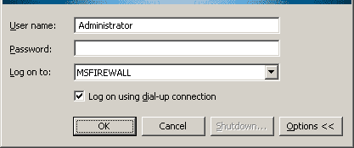
- In the Network and Dial-up Connections dialog box, if there is more than one VPN connectoid configured on the computer, click the down arrow in the Choose a network connection drop down list box, and select the VPN connection that connects you to the ISA Server firewall/VPN server. In this example, the connectoid is named Virtual Private Connection. Click Dial.
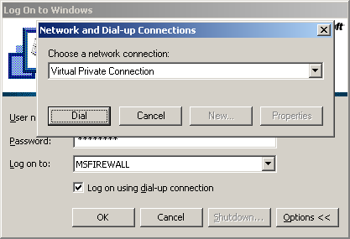
- Enter your domain User name and Password in the Connect Virtual Private Connection dialog box. Click Connect.
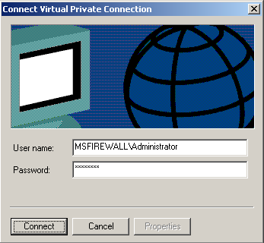
- You will see the VPN connection being established. When the desktop appears, the user is logged on and can access any network resources on the Internal network for which the user has permission. The user will not be prompted for credentials when accessing network file shares. In addition, log-on scripts will be run automatically in the same way they are when the machine is directly connected to the Internal network. The user will also be able to browse the Internal network domains.
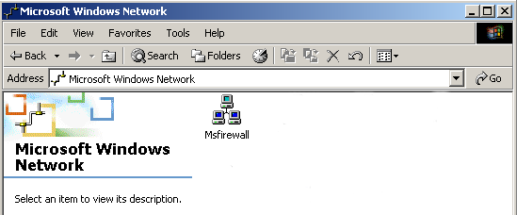

Configure the VPN Client as a Member of a Workgroup with the Same Domain Name as the Internal Network
The VPN client computer that is not a member of the domain has the following default characteristics:
- The user logs into the local machine, not into the domain. The user does not log on using dial-up networking
- The Primary Domain Name of the computer is not automatically set to the Internal network domain name. The non-domain client may have no primary domain name, or a primary domain name that is different from the Internal network domain.
- The user will not be able to browse to machines on the Internal network domain using My Network Places or Network Neighborhood; only when the non-domain member joins a workgroup with the same name as the domain will he be able to browse the domain
- When the user logs onto the local machine, and subsequently, establishes a VPN connection, the user’s log-on credentials are not valid on any machine in the Internal network domain; the user will be challenged for credentials when accessing network resources
- Log-on scripts are not delivered to the user when the user establishes the VPN connection after logging onto the local machine. The user must log on via dial-up network in order for log-on scripts to be automatically applied, and the machine must be a domain member to accomplish this task.
The non-domain computer does not have the wide range of options that are available to the domain member computer. However, you can still take advantage of network browsing on the non-domain member machine. The only requirement is that you make the non-domain member computer a member of a workgroup with the same name as the NetBIOS name of the Internal network domain.
You will need to make the following changes to the non-domain member computer:
- Join the machine to a workgroup with the same name as the Internal network domain
- Configure the machine with a primary DNS suffix so that it can resolve unqualified Internal network host names via DNS queries
Perform the following steps to join the non-domain VPN client machine to a workgroup with the same name as the Internal network domain:
- Log onto the non-domain VPN client computer as an administrator. Right click the My Computer object on the desktop and click the Properties command
- In the System Properties dialog box, click on the Network Identification tab. Note this machine is a member of the workgroup WORKGROUP. The NetBIOS name for the Internal network domain we want this client to connect to is MSFIREWALL. We want this VPN client machine to join a workgroup named MSFIREWALL. Click the Properties command.
- In the Identification Changes dialog box, select Workgroup and enter the NetBIOS name of the domain in the text box under Workgroup. In this example, we will enter the NetBIOS name of the domain into this text box, which is MSFIREWALL. Click OK.
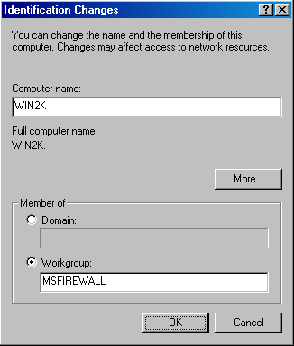
- Click OK in the Network Identification dialog box welcoming you to the new workgroup.
- Click OK in the Network Identification dialog box informing you that you must restart your computer.
- Note on the Network Identification tab that you are informed that Changes will take effect after you restart this computer. Click OK.
- Click No in the System Settings Change dialog box that asks if you want to restart your computer.
- Right click My Computer on the desktop and click Properties .
- Click the Network Identification tab. We need to now add the msfirewall.org domain name to this computer’s name. Click Properties.
- On the Identification Changes dialog box, click More.
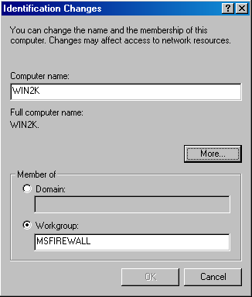
- In the DNS Suffix and NetBIOS Computer Name dialog box, enter the domain name of the Internal network in the Primary DNS suffix of this computer text box. In this example, the domain name is msfirewall.org and we will enter this into the text box. Make sure the Change primary DNS suffix when domain membership changes check box is enabled. This will allow the primary DNS suffix to change if this machine is joined to a domain. Click OK.
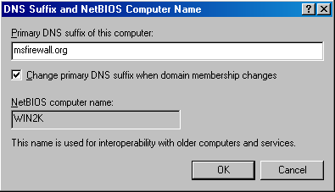
- Click OK in the Identification Changes dialog box.
- Click OK in the Network Identification dialog box that informs you that you must reboot the computer for the changes to take effect.
- Note on the bottom of the Network Identification tab on the System Properties dialog box the comment, change will take effect after you restart this computer. Click OK.
- Click Yes on the System Settings Change dialog box. The computer will restart and the machine will have the new primary DNS suffix and be a member of the MSFIREWALL workgroup. Log on as Administrator.
- Establish a VPN connection with the ISA Server 2004 firewall/VPN server. Double click on the My Network Places icon on the desktop and then double click on Entire Network. Double click on Microsoft Windows Network. You will see the Internal network domain and be able to access machines within the domain.
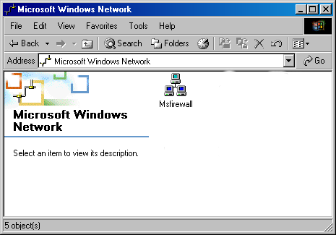

Conclusion
In this ISA Server 2004 VPN Deployment Kit document, we discussed how to configure the VPN client machine to successfully browse resources on the Internal network via the Windows browser service. In the next document in this ISA Server 2004 VPN Deployment Kit series, we will look at how to create site-to-site VPN connections using the PPTP and L2TP/IPSec VPN protocols.

This is a preliminary document and may be changed substantially prior to final commercial release of the software described herein.
The information contained in this document represents the current view of Microsoft Corporation on the issues discussed as of the date of publication. Because Microsoft must respond to changing market conditions, it should not be interpreted to be a commitment on the part of Microsoft, and Microsoft cannot guarantee the accuracy of any information presented after the date of publication.
This white paper is for informational purposes only. MICROSOFT MAKES NO WARRANTIES, EXPRESS OR IMPLIED, IN THIS
DOCUMENT.
Complying with all applicable copyright laws is the responsibility of the user. Without limiting the rights under copyright, no part of this document may be reproduced, stored in, or introduced into a retrieval system, or transmitted in any form or by any means (electronic, mechanical, photocopying, recording, or otherwise), or for any purpose, without the express written permission of Microsoft Corporation.
Microsoft may have patents, patent applications, trademarks, copyrights, or other intellectual property rights covering subject matter in this document. Except as expressly provided in any written license agreement from Microsoft, the furnishing of this document does not give you any license to these patents, trademarks, copyrights, or other intellectual property.
© 2004 Microsoft Corporation. All rights reserved.
The example companies, organizations, products, domain names, e-mail addresses, logos, people, places, and events depicted herein are fictitious. No association with any real company, organization, product, domain name, e-mail address, logo, person, place, or event is intended or should be inferred.
Microsoft, Windows, Windows 2000, Windows 2000 Server, Windows Server 2003, Windows Server System, ISA Server, and ISA Server 2004 are either registered trademarks or trademarks of Microsoft Corporation in the United States and/or other countries.
The names of actual companies and products mentioned herein may be the trademarks of their respective owners.

ISA Server 2004 VPN Deployment Kit: Creating PPTP and L2TP/IPSec Site-to-Site VPNs with ISA Server 2004 Firewalls
Chapter 10

For the latest information, please see http://www.microsoft.com/isaserver/

Contents
Introduction 1
Restore the Machine to its Post-Installation State 3
Publish the Web Enrollment Site for the Enterprise CA 4
Enable the System Policy Rule on the Main office Firewall to Access the Enterprise CA 10
Request and Install a Certificate for the Main Office Firewall 12
Enable the System Policy Rule on the Branch office Firewall to Access the Enterprise CA 15
Request and Install a Certificate on the Branch office Firewall 16
Create the Remote Site at the Main Office 18
Create the Network Rule at the Main Office 23
Create the Access Rules at the Main Office 25
Create the VPN Gateway Dial-in Account at the Main Office 28
Set the Shared Password in the RRAS Console at the Main Office 29
Create the Remote Site at the Branch Office 30
Create the Network Rule at the Branch Office 32
Create the Access Rules at the Branch Office 33
Create the VPN Gateway Dial-in Account at the Main Office 35
Set the Shared Password in the RRAS Console at the Branch Office 37
Activate the Site-to-Site Links 38
Conclusion 39

Introduction
A site-to-site VPN connection connects two or more networks using a VPN link over the Internet. The VPN site-to-site configuration works just like a LAN router; packets destined for IP addresses at a remote site are routed through the ISA Server 2004 machine. The ISA Server 2004 firewall machine acts as a VPN gateway joining two networks over the Internet.
Each site-to-site link can use one of the following VPN protocols:
- PPTP
- L2TP/IPSec
- IPSec tunnel mode
PPTP is the Point-to-Point Tunneling Protocol and can provide a good level of security, depending on the complexity of the password used to create the PPTP connection. You can enhance the level of security applied to a PPTP link by using EAP/TLS-based authentication methods.
The L2TP/IPSec VPN protocol provides a higher level of security because it uses the IPSec encryption protocol to secure the connection. You can use computer and user certificates to provide an even higher level of security to the L2TP/IPSec connection. If you are not ready to deploy a certificate infrastructure, you can use a pre-shared key to create the site-to-site L2TP/IPSec VPN connection.
ISA Server 2004 supports IPSec tunnel mode for site-to-site VPN connections. Only use IPSec tunnel mode when you need to create a site-to-site link with third-party VPN gateways. The reason for this is that third-party IPSec tunnel mode gateways do not support the high level of security provided by L2TP/IPSec, so they must use a weaker VPN protocol. IPSec tunnel mode site-to-site links are useful in branch office scenarios where the main office is still in process of replacing their current VPN gateways with ISA Server 2004 firewall VPN gateways.
In this ISA Server 2004 VPN Deployment Kit document, we will go through the procedures required to create a PPTP and/or L2TP/IPSec site-to-site link between two ISA Server 2004 firewall machines. The ISALOCAL machine will simulate the main office firewall, and the REMOTEISA will simulate the branch office firewall. We will use the L2TP/IPSec VPN protocol to create the site-to-site link, and a pre-shared key will be used to support the IPSec encryption protocol.
You will complete the following procedures to create the site-to-site VPN connection:
- Restore the machine to its post-installation state
- Publish the Web enrollment site for the enterprise CA
- Enable the System Policy Rule on the Main office firewall to access the enterprise CA
- Request and install a Web site certificate for the Main office firewall
- Enable the System Policy Rule on the Branch office firewall to access the enterprise CA
- Request and install a Web site certificate for the Branch office firewall
- Create the Remote Network at the Main Office
- Create the Network Rule at the Main Office
- Create the Access Rules at the Main Office
- Create the VPN Gateway Dial-in Account at the Main Office
- Set the Shared Password in the RRAS Console at the Main Office
- Create the Remote Network at the Branch Office
- Create the Network Rule at the Branch Office
- Create the Access Rules at the Branch Office
- Create the VPN Gateway Dial-in Account at the Branch Office
- Set the Shared Password in the RRAS Console at the Branch Office
- Activate the Site-to-Site Links
MACHINES REQUIRED TO CARRY OUT THESE WALKTHROUGHS:
ISALOCAL
REMOTEISA
EXCHANGE2003BE
REMOTECLIENT

Restore the Machine to its Post-Installation State
You should restore the machine to its post-installation state before beginning the following procedures. Restoring the post-installation state will remove all settings made on the firewall after the post-installation phase.
Perform the following steps to restore the machine to its post-installation state:
- In the Microsoft Internet Security and Acceleration Server 2004 management console, right click on the server name, and click Restore.
- In the Restore Configuration dialog box, locate the backup file you created immediately after installing the ISA Server 2004 firewall software. Select that file, and click Restore.
- In the Password dialog box, enter the password you assigned to the backup file. Click OK.
- Click OK in the Importing dialog box when you see the message The configuration was successfully restored.
- Click Apply to save the changes and update the firewall policy.
- In the ISA Server Warning dialog box, select Save the changes and restart the service(s) and click OK.
- Click OK in the Apply New Configuration dialog box.

Publish the Web Enrollment Site for the Enterprise CA
The branch office ISA Server 2004 firewall will need to obtain a computer certificate from the same CA that issues the main office ISA Server 2004 firewall its computer certificate. There are several methods you can use to obtain the certificate. In this example, we will publish the enterprise CA’s Web enrollment site, and the branch office ISA Server 2004 firewall will obtain the certificate using the Web enrollment site.
Perform the following steps to publish the enterprise CA’s Web enrollment site:
- In the Microsoft Internet Security and Acceleration Server 2004 management console, expand the server name and click Firewall Policy.
- In the Task pane, click the Tasks tab. On the Tasks tab, click Publish a Web Server.
- Enter a name for the Web Publishing Rule on the Welcome to the New Web Publishing Rule Wizard page. In this example, we will enter the name Web Enrollment Site in the Web publishing rule name text box. Click Next.
- Select Allow on the Select Rule Action page.
- On the Define Website to Publish page, enter the IP address of the enterprise CA’s Web site in the Computer name or IP address text box. In this example, the IP address is 10.0.0.2, so we will enter that value into the text box. In the Folder text box, enter /*. Click Next.
- On the Public Name Details page, select This domain name (type below) from the Accept request for list box. In the Public name text box, enter the IP address on the external interface of the firewall. In this example, the main office ISA Server 2004 firewall’s external address is 192.168.1.70, so we will enter that value into the text box. Enter /* into the Path (optional) text box. Click Next.
- On the Select Web Listener page, click New.
- On the Welcome to the New Web Listener page, enter a name for the rule in the Web listener name text box. In this example, we will enter Listener70, to indicate the IP address that the listener is listening on. Click Next.
- On the IP addresses page, put a checkmark in the External check box and click Next.
- On the Port Specification page, accept the default settings. Confirm that there is a checkmark in the Enable HTTP check box and that the value 80 is in the HTTP port text box. Click Next.
- Click Finish on the Completing the New Web Listener Wizard page.
- Click Next on the Select Web Listener page.
- Accept the default setting, All Users, on the User Sets page, and click Next.
- Click Finish on the Completing the New Web Publishing Rule Wizard page.
- Click Apply to save the changes and update the firewall policy.
- Click OK in the Apply New Configuration dialog box.
The next step is to configure the ISA Server 2004 firewall at the main office to access the Web enrollment site.

Enable the System Policy Rule on the Main office Firewall to Access the Enterprise CA
The ISA Server 2004 firewall is locked down by default. You need to create or enable Access Rules to allow the firewall access to any network or network host. We will need to configure the firewall at the main office with an Access Rule that allows it HTTP access to the Web enrollment site. We could create an Access Rule, or we could enable a System Policy rule. In this example, we will enable a System Policy Rule that allows the firewall access to the Web enrollment site.
Perform the following steps to enable the System Policy rule on the Main Office firewall:
- In the Microsoft Internet Security and Acceleration Server 2004 management console, expand the server name, and click Firewall Policy.
- Right click Firewall Policy, point to View, and click Show System Policy Rules.
- In the System Policy Rule list, double click on Allow HTTP from ISA Server to all networks for CRL downloads.
- In the System Policy Editor dialog box, put a checkmark in the Enable check box on the General tab. Click OK.
- Click Apply to save the changes and update the firewall policy.
- Click OK in the Apply New Configuration dialog box.
- Click Show/Hide System Policy Rules (on the far right of the button bar in the MMC console) to hide the System Policy. .

Request and Install a Certificate for the Main Office Firewall
Now we can request a certificate from the enterprise CA Web enrollment site. After we obtain the certificate, we will copy the CA certificate into the machine’s Trusted Root Certification Authorities certificate store.
Perform the following steps on the main office ISA Server 2004 firewall to request and install the certificates:
- Open Internet Explorer. In the Address bar, enter http://10.0.0.2/certsrv and click OK.
- In the Enter Network Password dialog box, enter Administrator in the User Name text box and enter the Administrator’s password in the Password text box. Click OK.
- In the Internet Explorer security dialog box, click Add. In the Trusted Sites dialog box, click Add and Close.
- Click Request a Certificate on the Welcome page.
- On the Request a Certificate page, click advanced certificate request.
- On the Advanced Certificate Request page, click Create and submit a request to this CA.
- On the Advanced Certificate Request page, select the Administrator certificate from the Certificate Template list. Place a checkmark in the Store certificate in the local computer certificate store check box. Click Submit.
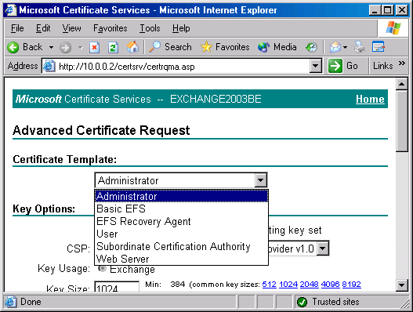
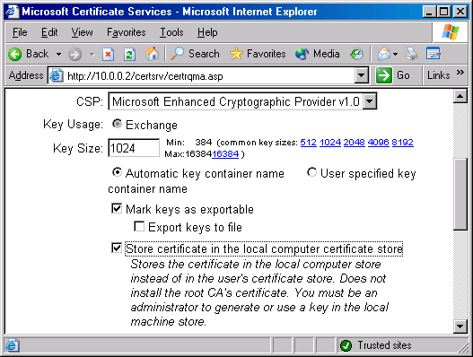
- Click Yes in the Potential Scripting Violation dialog box.
- On the Certificate Issued page, click Install this certificate.
- Click Yes on the Potential Scripting Violation page.
- Close the browser after viewing the Certificate Installed page.
- Click Start Run. Enter mmc in the Open text box, and click OK.
- In Console1, click the File menu, and then click Add/Remove Snap-in.
- Click Add in the Add/Remove Snap-in dialog box.
- Select the Certificates entry in the Available Standalone Snap-ins list in the Add Standalone Snap-in dialog box. Click Add.
- Select Computer account on the Certificates snap-in page.
- Select Local computer on the Select Computer page.
- Click Close in the Add Standalone Snap-in dialog box.
- Click OK in the Add/Remove Snap-in dialog box.
- In the left pane of the console, expand Certificates (Local Computer), and then expand Personal. Click on \Personal\Certificates. Double click on the Administrator certificate in the right pane of the console.
- In the Certificate dialog box, click the Certification Path tab. The root CA certificate is at the top of the certificate hierarchy seen in the Certification path frame. Click the EXCHANGE2003BE certificate at the top of the list. Click View Certificate.
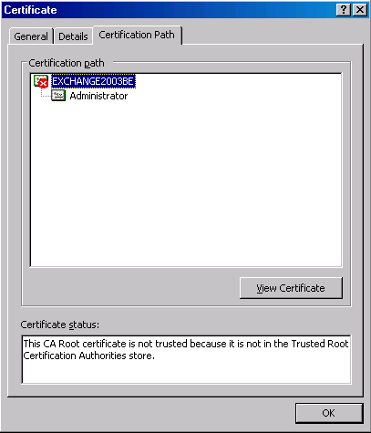
- In the CA certificate’s Certificate dialog box, click the Details tab. Click Copy to File.
- Click Next in the Welcome to the Certificate Export Wizard page.
- On the Export File Format page, select Cryptographic Message Syntax Standard – PKCS #7 Certificates (.P7B) and click Next.
- On the File to Export page, enter c:\cacert in the File name text box. Click Next.
- Click Finish on the Completing the Certificate Export Wizard page.
- Click OK in the Certificate Export Wizard dialog box.
- Click OK in the Certificate dialog box. Click OK again in the Certificate dialog box.
- In the left pane of the console, expand Trusted Root Certification Authorities and click the Certificates node. Right click \Trusted Root Certification Authorities\Certificates; point to All Tasks, and click Import.
- Click Next on the Welcome to the Certificate Import Wizard page.
- On the File to Import page, use Browse to locate the CA certificate you saved to the local hard disk, and click Next.
- On the Certificate Store page, accept the default settings, and click Next.
- Click Finish on the Completing the Certificate Import Wizard page.
- Click OK in the Certificate Import Wizard dialog box informing you that the import was successful.

Enable the System Policy Rule on the Branch office Firewall to Access the Enterprise CA
The next step is to enable the System Policy Rule allowing the branch office firewall to connect to the enterprise CA on the main office network.
Perform the following steps to enable the System Policy rule on the branch office firewall:
- In the Microsoft Internet Security and Acceleration Server 2004 management console, expand the server name, and click Firewall Policy.
- Right click Firewall Policy; point to View, and click Show System Policy Rules.
- In the System Policy Rule list, double click on Allow HTTP from ISA Server to all networks for CRL downloads.
- In the System Policy Editor dialog box, put a checkmark in the Enable check box on the General tab. Click OK.
- Click Apply to save the changes and update the firewall policy.
- Click OK in the Apply New Configuration dialog box

Request and Install a Certificate on the Branch office Firewall
Now we can request a certificate for the branch office firewall. After we obtain the certificate, we will copy the CA certificate into the machine’s Trusted Root Certification Authorities certificate store.
Perform the following steps on the branch office ISA Server 2004 firewall to request and install the certificates:
- Open Internet Explorer. In the Address bar, enter http://192.168.1.70/certsrv, and click OK.
- In the Enter Network Password dialog box, enter Administrator in the User Name text box, and enter the Administrator’s password in the Password text box. Click OK.
- In the Internet Explorer security dialog box, click Add. In the Trusted Sites dialog box, click Add and Close.
- Click Request a Certificate on the Welcome page.
- On the Request a Certificate page, click advanced certificate request.
- On the Advanced Certificate Request page, click Create and submit a request to this CA.
- On the Advanced Certificate Request page, select the Administrator certificate from the Certificate Template list. Place a checkmark in the Store certificate in the local computer certificate store check box. Click Submit.
- Click Yes in the Potential Scripting Violation dialog box.
- On the Certificate Issued page, click Install this certificate.
- Click Yes on the Potential Scripting Violation page.
- Close the browser after viewing the Certificate Installed page.
- Click Start Run. Enter mmc in the Open text box, and click OK.
- In Console1, click the File menu, then click Add/Remove Snap-in.
- Click Add in the Add/Remove Snap-in dialog box.
- Select the Certificates entry in the Available Standalone Snap-ins list in the Add Standalone Snap-in dialog box. Click Add.
- Select Computer account on the Certificates snap-in page.
- Select Local computer on the Select Computer page.
- Click Close in the Add Standalone Snap-in dialog box.
- Click OK in the Add/Remove Snap-in dialog box.
- In the left pane of the console, expand the Certificates (Local Computer) node, then expand the Personal node. Click on \Personal\Certificates. Double click on the Administrator certificate in the right pane of the console.
- In the Certificate dialog box, click the Certification Path tab. The root CA certificate is at the top of the certificate hierarchy seen in the Certification path frame. Click the EXCHANGE2003BE certificate at the top of the list. Click View Certificate button.
- In the CA certificate’s Certificate dialog box, click Details. Click Copy to File.
- Click Next in the Welcome to the Certificate Export Wizard page.
- On the Export File Format page, select Cryptographic Message Syntax Standard – PKCS #7 Certificates (.P7B) and click Next.
- On the File to Export page, enter c:\cacert in the File name text box. Click Next.
- Click Finish on the Completing the Certificate Export Wizard page.
- Click OK in the Certificate Export Wizard dialog box.
- Click OK in the Certificate dialog box. Click OK again in the Certificate dialog box.
- In the left pane of the console, expand the Trusted Root Certification Authorities node, and click the Certificates node. Right click the \Trusted Root Certification Authorities\Certificates node; point to All Tasks and click Import.
- Click Next on the Welcome to the Certificate Import Wizard page.
- On the File to Import page, use Browse to locate the CA certificate you saved to the local hard disk, and click Next.
- On the Certificate Store page, accept the default settings, and click Next.
- Click Finish on the Completing the Certificate Import Wizard page.
- Click OK on the Certificate Import Wizard dialog box informing you that the import was successful.

Create the Remote Site at the Main Office
We will begin by configuring the ISA Server 2004 firewall at the main office. The first step is to configure the Remote Site Network in the Microsoft Internet Security and Acceleration Server 2004 management console.
Perform the following steps to create the Remote Site Network at the main office ISA Server 2004 firewall machine:
- Open the Microsoft Internet Security and Acceleration Server 2004 management console and expand the server name. Click on Virtual Private Networks (VPN).
- Click on the Remote Sites tab in the Details pane. Click on the Tasks tab in the Task pane. Click Add Remote Site Network.
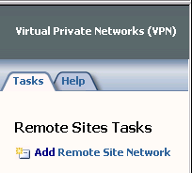
- On the Welcome to the New Network Wizard page, enter a name for the remote network in the Network name text box. In this example, we will name the remote network Branch. Click Next.
- On the VPN Protocol page, you have the choice of using IP Security protocol (IPSec tunnel mode, Layer Two Tunneling Protocol (L2TP) over IPSec and Point-to-Point Tunneling Protocol. If you do not have certificates installed on the main and branch office machines and do not plan to deploy them in the future, you should choose the PPTP option. If you have certificates installed on the main and branch office firewalls, or if you plan to install them in the future, choose the L2TP/IPSec option (you can use the pre-shared key as a backup prior to installing the certificates). Do not use the IPSec option unless you are connecting to a third-party VPN server (because of the low security conferred by IPSec tunnel mode site-to-site links). In this example, we have certificates deployed on the main and branch office servers; therefore, we select Layer Two Tunneling Protocol (L2TP) over IPSec. Click Next.
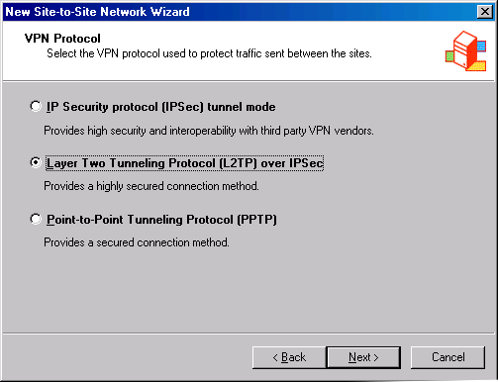
- On the Remote Site Gateway page, enter the IP address on the external interface of the remote ISA Server 2004 firewall machine. In this example, the IP address is 192.168.1.71, so we will enter this value into the text box. Click Next.
- On the Remote Authentication page, put a checkmark in the Local site can initiate connections to remote site using these credentials check box. Enter the name of the account that you will create on the remote ISA Server 2004 firewall computer to allow the main office VPN gateway access. In this example, the user account will be named Main (the user account much match the name of the demand-dial interface created on the remote site). The Domain name is the name of the remote ISA Server 2004 firewall computer, which in this example is REMOTEISA (if the remote ISA Server 2004 firewall were a domain controller, you would use the domain name instead of the computer name). Enter a password for the account and confirm the password. Write down the password so you will remember it when you create an account later on the remote ISA Server 2004 firewall. Click Next.
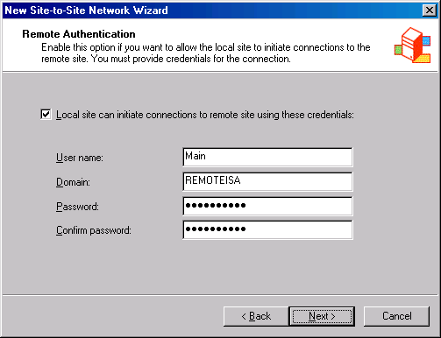
- Read the information on the Local Authentication page, and click Next.
- On the L2TP/IPSec Authentication page, put a checkmark in the Allow pre-shared key IPSec authentication as a secondary (backup) authentication method check box. Note that this pre-shared key is used only if there is a problem with the certificates. That is what the term “backup” implies in this dialog box. For higher security environments, you can bypass this step and use certificates only. This pre-shared key backup feature is helpful when you want the machine to also act as a remote-access VPN server and not all your VPN clients support or have certificates installed; in that case, the clients can use the pre-shared key. Enter a key in the Use pre-shared key for authentication text box. In this example, we will use the key 123. Click Next.
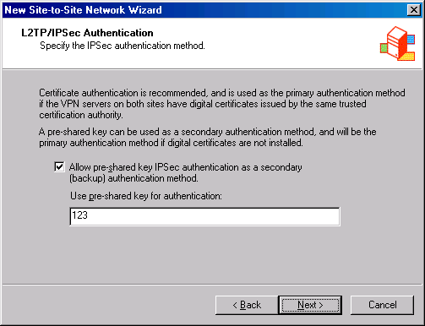
- Click Add on the Network Addresses page. In the IP Address Range Properties dialog box, enter 10.0.1.0 in the Starting address text box. Enter 10.0.1.255 in the Ending address text box. Click OK.
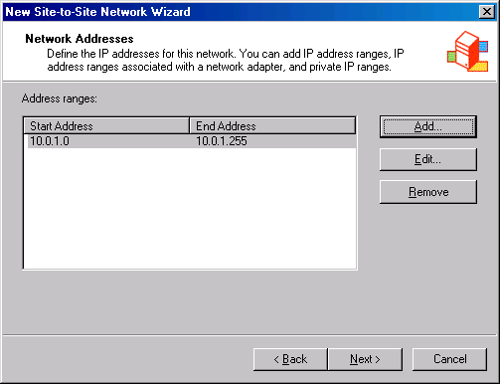
- Click Next on the Network Addresses page.
- Click Finish on the Completing the New Network Wizard page.

Create the Network Rule at the Main Office
The ISA Server 2004 firewall must know what method to use to route packets to the branch office network. There are two options: Route and NAT. A route relationship routes packets to the branch office and preserves the source IP address of the clients who make a connection over the site-to-site link. A NAT relationship replaces the source IP address of the client making the connection. In general, the route relationship provides a higher level of protocol support, but the NAT relationship provides a higher level of security.
Perform the following step to create a Network Rule to control the routing relationship between the main office and branch office networks:
- Expand the Configuration node in the left pane of the console. Click on Networks.
- Click on the Network Rules tab in the Details pane. Click on the Tasks tab in the Task pane. Click Create a New Network Rule.
- On the Welcome to the New Network Rule Wizard page, enter a name for the rule in the Network rule name text box. In this example, we will call the rule MainBranch. Click Next.
- On the Network Traffic Sources page, click Add.
- In the Add Network Entities dialog box, click the Networks folder. Double click on the Internal network. Click Close.
- Click Next on the Network Traffic Sources page.
- On the Network Traffic Destinations page, click Add.
- In the Add Network Entities dialog box, double click on the Branch network. Click Close.
- Click Next on the Network Traffic Destinations page.
- On the Network Relationship page, select the Route relationship.
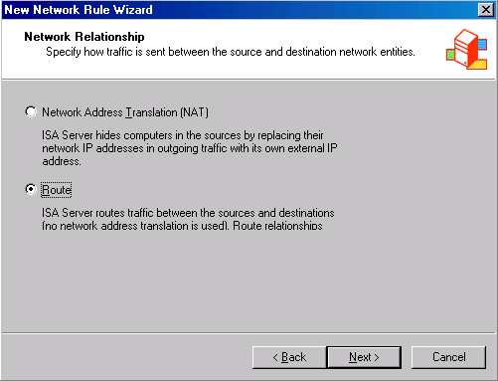
- Click Finish on the Completing the New Network Rule Wizard page.

Create the Access Rules at the Main Office
In this example, we want the clients on both the main and branch office networks to have full access to all resources on each network. We must create Access Rules to allow traffic from the main office to the branch office and from the branch office to the main office.
Perform the following steps to create Access Rules allowing traffic to move between the main and branch offices:
- Click Firewall Policy in the left pane of the console. Click the Tasks tab in the Task pane. Click Create New Access Rule.
- On the Welcome to the New Access Rule Wizard page, enter a name for the rule in the Access Rule name text box. In this example, enter Main to Branch. Click Next.
- On the Rule Action page, select Allow, and click Next.
- On the Protocols page, select All outbound protocols in the This rule applies to list. Click Next.
- On the Access Rule Sources page, click Add.
- In the Add Network Entities dialog box, click the Networks folder, and double click the Internal network. Click Close.
- Click Next on the Access Rule Sources page.
- On the Access Rule Destinations page, click Add.
- In the Add Network Entities dialog box, click on the Networks folder, and then double click on the Branch network. Click Close.
- Click Next on the Access Rule Destinations page.
- On the User Sets page, accept the default entry All Users, and click Next.
- Click Finish on the Completing the New Access Rule Wizard page.
The second rule will allow hosts on the branch office network access to the main office network:
- Click the Tasks tab in the Task pane. Click Create New Access Rule.
- On the Welcome to the New Access Rule Wizard page, enter a name for the rule in the Access rule name text box. In this example we will call it Branch to Main. Click Next.
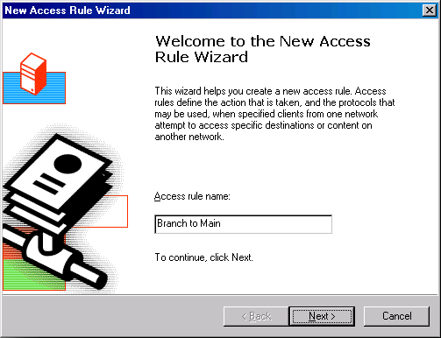
- On the Rule Action page, select Allow and click Next.
- On the Protocols page, select All outbound protocols in the This rule applies to list. Click Next.
- On the Access Rule Sources page, click Add.
- In the Add Network Entities dialog box, click the Networks folder, and double click the Branch network. Click Close.
- Click Next on the Access Rule Sources page.
- On the Access Rule Destinations page, click Add.
- In the Add Network Entities dialog box, click on the Networks folder, and double click on the Internal network. Click Close.
- Click Next on the Access Rule Destinations page.
- On the User Sets page, accept the default entry All Users, and click Next.
- Click Finish on the Completing the New Access Rule Wizard page.
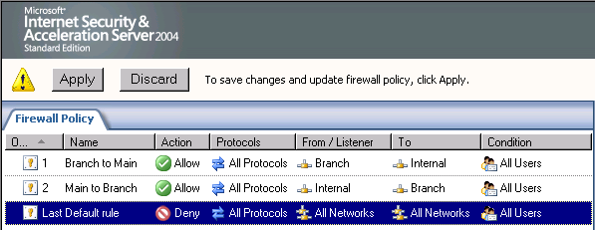
The last step we need to take in the Microsoft Internet Security and Acceleration Server 2004 management console is to enable access for VPN clients:
- Click on the Virtual Private Network node in the left pane of the console.
- Click the VPN Clients tab in the Details pane. Click the Tasks tab in the Task pane. Click Enable VPN Client Access.
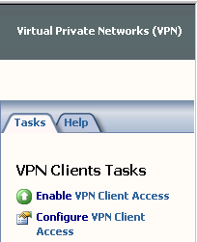
- Click OK in the ISA Server 2004 dialog box informing you that the Routing and Remote Access service must be restarted.
- Click Apply to save the changes and update the firewall policy.
- Click OK in the Apply New Configuration dialog box.

Create the VPN Gateway Dial-in Account at the Main Office
A user account must be created on the main office firewall that the branch office firewall can use to authenticate when it creates the site-to-site connection. This user account must have the same name as the demand-dial interface on the main office computer. You will later configure the branch office ISA Server 2004 to use this account when it dials the VPN site-to-site link.
Perform the following steps to create the account the remote ISA Server 2004 firewall will use to connect to the main office VPN gateway:
- Right click My Computer on the desktop, and click Manage.
- In the Computer Management console, expand the Local Users and Groups node. Right click the Users node, and click New User.
- In the New User dialog box, enter the name of the main office demand-dial interface. In our current example, the demand-dial interface is named Branch. Enter Branch into the text box. Enter a Password and confirm the Password. Write down this password because you’ll need to use it when you configure the remote ISA Server 2004 VPN gateway machine. Remove the checkmark from the User must change password at next logon check box. Place checkmarks in the User cannot change password and Password never expires check boxes. Click Create.
- Click Close in the New User dialog box.
- Double click the Branch user in the right pane of the console.
- In the Branch Properties dialog box, click the Dial-in tab. Select Allow access . Click Apply and then click OK.

Set the Shared Password in the RRAS Console at the Main Office
The pre-shared key you entered into the Microsoft Internet Security and Acceleration Server 2004 management console is not automatically copied to the Routing and Remote Access service. You must configure the Routing and Remote Access service to use the pre-shared key you configured when creating the Remote Site Network.
Perform the following steps to configure the L2TP/IPSec pre-shared key:
- Click Start and point to Administrative Tools. Click Routing and Remote Access.
- In the Routing and Remote Access console, right click on the server name. Click Properties.
- In the server Properties dialog box, click the Security tab. On the Security tab, put a checkmark in the Allow custom IPSec policy for L2TP connection check box. In the Pre-shared Key text box, enter 123. Click Apply, and then click OK.
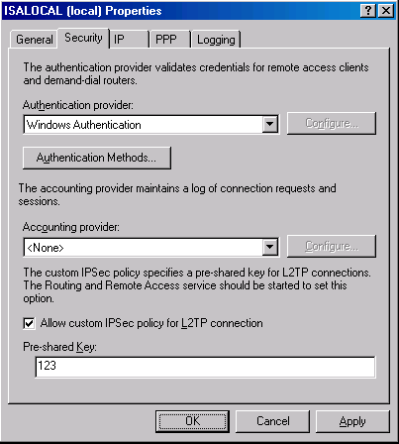
- Close the Routing and Remote Access console.
- Restart the main office ISA Server 2004 firewall machine.

Create the Remote Site at the Branch Office
Now that the main office is ready, we can configure the branch office ISA Server 2004 firewall. The first step is to create the Remote Site Network at the branch office.
Perform the following steps to create the Remote Site Network at the branch office:
- Open the Microsoft Internet Security and Acceleration Server 2004 management console and expand the server name. Click on the Virtual Private Networks (VPN) node.
- Click on the Remote Sites tab in the Details pane. Click on the Tasks tab in the Task pane. Click Add Remote Site Network.
- On the Welcome to the New Network Wizard page, enter a name for the remote network in the Network name text box. In this example, we will name the remote network Main. Click Next.
- On the VPN Protocol page, select Layer Two Tunneling Protocol (L2TP) over IPSec and click Next.
- On the Remote Site Gateway page, enter the IP address on the external interface of the remote ISA Server 2004 firewall machine. In this example, the IP address is 192.168.1.70, so we will enter this value into the text box. Click Next.
- On the Remote Authentication page, put a checkmark in the Local site can initiate connections to remote site using these credentials check box. Enter the name of the account that you will create on the remote ISA Server 2004 firewall computer to allow the main office VPN gateway access. In this example, the user account will be named Branch (the user account much match the name of the demand-dial interface created on the remote site). The Domain name is the name of the remote ISA Server 2004 firewall computer, which in this example is ISALOCAL (if the remote ISA Server 2004 firewall were a domain controller, you would use the domain name instead of the computer name). Enter a password for the account and confirm the password. Write down this password so that you will remember it when you create the account later on the remote ISA Server 2004 firewall. Click Next.
- Read the information on the Local Authentication page, and click Next.
- On the L2TP/IPSec Authentication page, put a checkmark in the Allow pre-shared key IPSec authentication as a secondary (backup) authentication method check box. Note that this pre-shared key is used only if there is a problem with the certificates. That is what the term “backup” implies in this dialog box. For higher security environments, you can bypass this step and use certificates only. This pre-shared key backup feature is helpful when you want the machine to also act as a remote-access VPN server and not all your VPN clients support or have certificates installed; in that case, the clients can use the pre-shared key. Enter a key in the Use pre-shared key for authentication text box. In this example, we will use the key 123. Click Next.
- Click Add on the Network Addresses page. In the IP Address Range Properties dialog box, enter 10.0.0.0 in the Starting address text box. Enter 10.0.0.255 in the Ending address text box. Click OK.
- Click Next on the Network Addresses page.
- Click Finish on the Completing the New Network Wizard page.
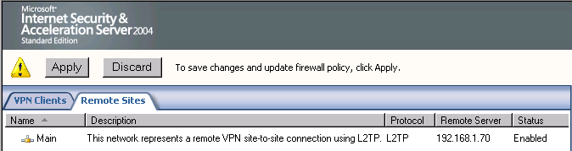

Create the Network Rule at the Branch Office
Just as we did at the main office, we must create a routing relationship between the branch office and the main office networks. We will configure a route relationship so that we can get the highest level of protocol support.
Perform the following steps to create the Network Rule at the branch office:
- Expand the Configuration node in the left pane of the console. Click on the Networks node.
- Click on the Network Rules tab in the Details pane. Click on the Tasks tab in the Task pane. Click p Create a New Network Rule p.
- On the Welcome to the New Network Rule Wizard page, enter a name for the rule in the Network rule name text box. In this example, we will call the rule BranchMain. Click Next.
- On the Network Traffic Sources page, click Add.
- In the Add Network Entities dialog box, click the Networks folder. Double click on the Internal network. Click Close.
- Click Next on the Network Traffic Sources page.
- On the Network Traffic Destinations page, click Add.
- In the Add Network Entities dialog box, double click on the Main network. Click Close.
- Click Next on the Network Traffic Destinations page.
- On the Network Relationship page, select the Route relationship.
- Click Finish on the Completing the New Network Rule Wizard page.
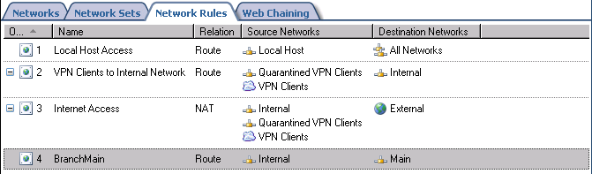

Create the Access Rules at the Branch Office
We need to create two Access Rules, one that allows traffic from the branch office to the main office, and the second to allow traffic from the main office to the branch office.
Perform the following steps to create the Access Rules that allow traffic to move between the branch and main offices:
- Click Firewall Policy in the left pane of the console. Click the Tasks tab in the Task pane. Click Create New Access Rule.
- On the Welcome to the New Access Rule Wizard page, enter a name for the rule in the Access Rule name text box. In this example, we will call it Branch to Main. Click Next.
- On the Rule Action page, select Allow and click Next.
- On the Protocols page, select All outbound protocols in the This rule applies to list. Click Next.
- On the Access Rule Sources page, click Add.
- In the Add Network Entities dialog box, click the Networks folder and double click the Internal network. Click Close.
- Click Next on the Access Rule Sources page.
- On the Access Rule Destinations page, click Add.
- In the Add Network Entities dialog box, click on the Networks folder, and then double click on the Main network. Click Close.
- Click Next on the Access Rule Destinations page.
- On the User Sets page, accept the default entry All Users and click Next.
- Click Finish on the Completing the New Access Rule Wizard page.
The second rule will allow the hosts on the main office network access to the branch office network:
- Click the Tasks tab in the Task pane. Click Create New Access Rule.
- On the Welcome to the New Access Rule Wizard page, enter a name for the rule in the Access Rule name text box. In this example, we will call it Main to Branch. Click Next.
- On the Rule Action page, select Allow and click Next.
- On the Protocols page, select All outbound protocols in the This rule applies to list. Click Next.
- On the Access Rule Sources page, click Add.
- In the Add Network Entities dialog box, click the Networks folder and double click the Main network. Click Close.
- Click Next on the Access Rule Sources page.
- On the Access Rule Destinations page, click Add.
- In the Add Network Entities dialog box, click on the Networks folder, and then double click on the Internal network. Click Close.
- Click Next on the Access Rule Destinations page.
- On the User Sets page, accept the default entry All Users and click Next.
- Click Finish on the Completing the New Access Rule Wizard page.
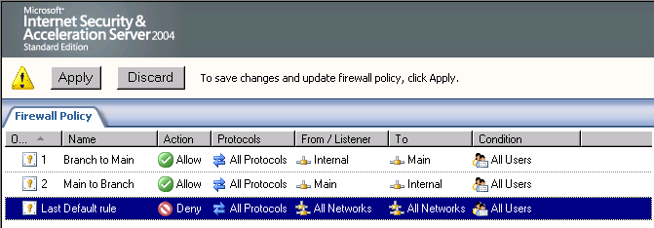
The last step we need to take in the Microsoft Internet Security and Acceleration Server 2004 management console is to enable access for VPN clients:
- Click on the Virtual Private Network node in the left pane of the console.
- Click the VPN Clients tab in the Details pane. Click the Tasks tab in the Task pane. Click Enable VPN Client Access.
- Click OK in the ISA Server 2004 dialog box informing you that the Routing and Remote Access service must be restarted.
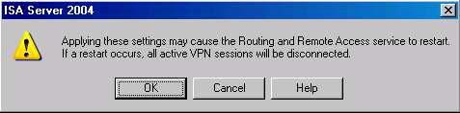
- Click Apply to save the changes and update the firewall policy.
- Click OK in the Apply New Configuration dialog box.

Create the VPN Gateway Dial-in Account at the Main Office
We must create a user account that the main office VPN gateway can use to authenticate when it initiates the VPN site-to-site connection. The user account must have the same name as the demand-dial interface created on the branch office machine.
Perform the following steps to create the account the remote ISA Server 2004 firewall will use to connect to the main office VPN gateway:
- Right click My Computer on the desktop and click Manage.
- In the Computer Management console, expand the Local Users and Groups node. Right click the Users node and click New User.
- In the New User dialog box, enter the name of the main office demand-dial interface. In our current example, the demand-dial interface is named Main. Enter Main into the text box. Enter a Password and confirm the Password. Write down this password because you’ll need to use this when you configure the remote ISA Server 2004 VPN gateway machine. Remove the checkmark from the User must change password at next logon check box. Place checkmarks in the User cannot change password and Password never expires check boxes. Click Create.
- Click Close in the New User dialog box.
- Double click the Main user in the right pane of the console.
- In the Main Properties dialog box, click the Dial-in tab. Select Allow access. Click Apply and then click OK.
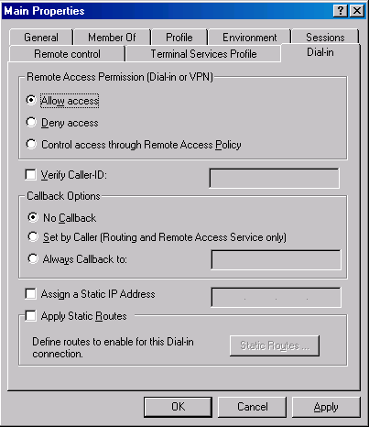

Set the Shared Password in the RRAS Console at the Branch Office
The pre-shared key configured in the Microsoft Internet Security and Acceleration Server 2004 management console is not automatically copied to the Routing and Remote Access service. You must manually configure the Routing and Remote Access service to use the pre-shared key configured in the Remote Site Network configuration.
Perform the following steps to configure the L2TP/IPSec pre-shared key:
- Click Start and point to Administrative Tools. Click Routing and Remote Access.
- In the Routing and Remote Access console, right click on the server name. Click Properties.
- In the server Properties dialog box, click the Security tab. On the Security tab, put a checkmark in the Allow custom IPSec policy for L2TP connection check box. In the Pre-shared Key text box, enter 123. Click Apply and then click OK.
- Close the Routing and Remote Access console.
- Restart the branch office ISA Server 2004 firewall machine.

Activate the Site-to-Site Links
Now that both the main and branch office ISA Server 2004 firewalls are configured as VPN routers, you can test the site-to-site connection.
Perform the following steps to test the site-to-site link:
- At the remote client computer behind the remote ISA Server 2004 firewall machine, click Start, and then click the Run command.
- In the Run dialog box, enter cmd in the Open text box, and click OK.
- In the command prompt window, enter ping –t 10.0.0.2 and press ENTER
- You will see a few pings time out, and then the ping responses will be returned by the domain controller on the main office network.
- Perform the same procedures at the domain controller at the main office network, but this time ping 10.0.1.2.

Conclusion
In this ISA Server 2004 VPN Deployment Kit document we discussed how to use the ISA Server 2004 firewall as a VPN gateway that enables site-to-site VPN links. We configured two ISA Server 2004 firewalls, one at the main office and a second at the branch office. We tested the VPN site-to-site connectivity by pinging from clients on each side to the opposite site. In the next document in this ISA Server 2004 Getting Started Guide series, we will look at how to enable caching on the firewall, and also examine the enhanced logging and reporting features included with ISA Server 2004.

This is a preliminary document and may be changed substantially prior to final commercial release of the software described herein.
The information contained in this document represents the current view of Microsoft Corporation on the issues discussed as of the date of publication. Because Microsoft must respond to changing market conditions, it should not be interpreted to be a commitment on the part of Microsoft, and Microsoft cannot guarantee the accuracy of any information presented after the date of publication.
This white paper is for informational purposes only. MICROSOFT MAKES NO WARRANTIES, EXPRESS OR IMPLIED, IN THIS
DOCUMENT.
Complying with all applicable copyright laws is the responsibility of the user. Without limiting the rights under copyright, no part of this document may be reproduced, stored in, or introduced into a retrieval system, or transmitted in any form or by any means (electronic, mechanical, photocopying, recording, or otherwise), or for any purpose, without the express written permission of Microsoft Corporation.
Microsoft may have patents, patent applications, trademarks, copyrights, or other intellectual property rights covering subject matter in this document. Except as expressly provided in any written license agreement from Microsoft, the furnishing of this document does not give you any license to these patents, trademarks, copyrights, or other intellectual property.
© 2004 Microsoft Corporation. All rights reserved.
The example companies, organizations, products, domain names, e-mail addresses, logos, people, places, and events depicted herein are fictitious. No association with any real company, organization, product, domain name, e-mail address, logo, person, place, or event is intended or should be inferred.
Microsoft, Windows, Windows 2000, Windows 2000 Server, Windows Server 2003, Windows Server System, ISA Server, and ISA Server 2004 are either registered trademarks or trademarks of Microsoft Corporation in the United States and/or other countries.
The names of actual companies and products mentioned herein may be the trademarks of their respective owners.

ISA Server 2004 VPN Deployment Kit: Creating a Site-to-Site VPN with ISA Server 2004 at Local and Remote Sites using IPSec Tunnel Mode
Chapter 11

For the latest information, please see http://www.microsoft.com/isaserver/

Contents
Introduction 1
PART ONE 3
Create the Remote Site Network at the Main Office 4
Create the Network Rule at the Main Office 9
Create the Access Rules at the Main Office 11
Create the Remote Site Network at the Branch Office 15
Create the Network Rule at the Branch Office 20
Create the Access Rules at the Branch Office 22
PART TWO 27
Publish the Web Enrollment Site for the Enterprise CA 28
Enable the System Policy Rule on the Main office Firewall to Access the Enterprise CA 34
Request and Install a Certificate for the Main Office Firewall 36
Enable the System Policy Rule on the Branch office Firewall to Access the Enterprise CA 38
Request and Install a Certificate on the Branch office Firewall 39
Create the Remote Site Network at the Main Office 41
Create the Network Rule at the Main Office 46
Create the Access Rules at the Main Office 48
Create the Remote Site Network at the Branch Office 52
Create the Network Rule at the Branch Office 56
Create the Access Rules at the Branch Office 58
Summary Error! Bookmark not defined.
Conclusion Error! Bookmark not defined.

Introduction
ISA Server 2004 fully supports site-to-site VPN links using IPSec tunnel mode with both third-party firewalls and other ISA Server 2004 firewall systems. This means you can easily bring the ISA Server 2004 firewall into the branch office and demonstrate its superior features and functionality. You can later bring the ISA Server 2004 firewall and VPN server into the main office and use a higher security VPN site-to-site protocol, such as L2TP/IPSec with EAP/TLS authentication.
IPSec tunnel mode is not a high security solution – it’s a compatibility solution. Third-party IPSec tunnel mode site-to-site VPN methods are not as secure as industry standard L2TP/IPsec site-to-site links. For this reason, you want to place an ISA Server 2004 firewall into the branch office, and then after its proven itself, introduce ISA Server 2004 firewall/VPN gateways into the main office to enhance security for your site-to-site links.
IPSec tunnel mode site-to-site links are susceptible to man-in-the-middle attacks. IPSec wasn’t designed to handle the PPP-like functions which are part of the virtual network connection establishment process. In order to handle Point-to-Point Protocol (PPP) functions, such as log-on credential confirmation and encrypted session management, IPSec tunnels use IKE aggressive mode and functions like XAUTH/MODCFG, which are susceptible to well-known man-in-the-middle attacks.
Another problem with IPSec tunnel mode is that it isn’t represented as a logical networking interface over which packets can be routed. Routes cannot be assigned to use the IPSec tunnel mode link, and routing protocols do not operate over IPSec tunnels. Instead, cryptic IPSec policies that are difficult to manage and audit are used for route decisions. These significant limitations provide compelling reasons why you should use IPSec tunnel mode only for downlevel compatibility with third-party VPN servers and gateways.
The figure below shows the topology of the sample network in the examples discussed in this document.
We will detail the following procedures required to create the IPSec tunnel mode site-to-site link that connects to networks using ISA Server 2004 firewalls on each side.
We will go through the entire procedure twice. In Part 1, we will use a shared key. In Part 2, we will use computer certificates. The following procedures are covered in Part 1:
- Create the Remote Site Network at the Main Office
- Create the Network Rule at the Main Office
- Create the Access Rules at the Main Office
- Create the Remote Site Network at the Branch Office
- Create the Network Rule at the Branch Office
- Create the Access Rules at the Branch Office
The following procedures are required in Part 2:
- Publish the Web enrollment site for the enterprise CA
- Enable the System Policy Rule on the Main office firewall to access the enterprise CA
- Request and install a Web site certificate for the Main office firewall
- Enable the System Policy Rule on the Branch office firewall to access the enterprise CA
- Request and install a Web site certificate for the Branch office firewall
- Create the Remote Site Network at the Main Office
- Create the Network Rule at the Main Office
- Create the Access Rules at the Main Office
- Create the Remote Site Network at the Branch Office
- Create the Network Rule at the Branch Office
- Create the Access Rules at the Branch Office

PART ONE
Part 1 of this article focuses on creating an IPSec tunnel mode site-to-site link using a pre-shared key to support IPSec encryption. Pre-shared keys should only be used as a temporary measure. Pre-shared keys are not secure because the key is stored in plain text and is easily retrievable by an intruder. If the pre-shared key is stolen, you must manually change the key on all hosts using it. In contrast, if a certificate is stolen, you can quickly revoke the certificate from a central location.
The advantage of the pre-shared key is that it’s easy to configure and allows us to demonstrate the IPSec tunnel mode site-to-site link without requiring a certificate. In Part 2 of this article, we will repeat the same procedures, except, we will use certificates instead of a pre-shared key.

Create the Remote Site Network at the Main Office
The first step is to create a Remote Site Network representing the network at the Branch office. The Main office ISA Server 2004 firewall will use the Branch office Remote Site Network in routing and Access Rules.
Perform the following steps to create the Remote Site Network at the Main office:
- At the Main office ISA Server 2004 firewall machine, open the Microsoft Internet Security and Acceleration Server 2004 management console and expand the server name. Click on Virtual Private Networks (VPN).
- In the Details pane, click the Remote Sites tab. Click the Tasks tab in the Task pane. Click Add Remote Site Network.
- On the Welcome to the New Network Wizard page, enter a name for the Remote Site Network in the Network name text box. In this example, enter Branch. Click Next.
- On the VPN Protocol page, select IP Security protocol (IPSec) tunnel mode and click Next.
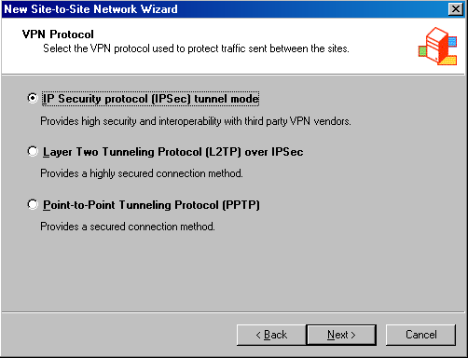
- On the Connection Settings page, enter the IP address of the Remote Site VPN gateway in the Remote VPN gateway IP address text box. In this example, the Remote Site VPN gateway address is 192.168.1.71, so we will enter that value into the text box. Select the IP address on the external interface of the Main office ISA firewall in the Local VPN gateway IP address list. In this example, the external address is 192.168.1.70, so we will select that option. Click Next.
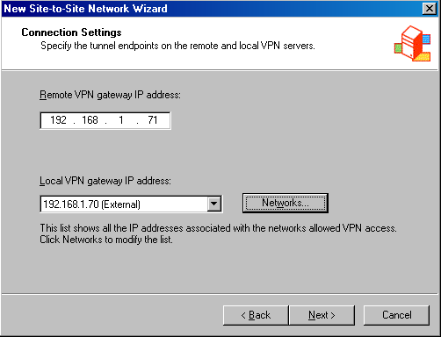
- On the IPSec Authentication page, select Use pre-shared key for authentication. Enter a pre-shared key in the text box. This should be a complex value with mixed-case letters, numbers and non-alphanumeric characters. Note that you also have the option to use a computer certificate. We will cover that option in a future article. Note that pre-shared keys are a low-security option; that is why L2TP/IPSec is always preferred to IPSec tunnel mode. In this example, enter 123 for the pre-shared key, for demonstration purposes only. Click Next.
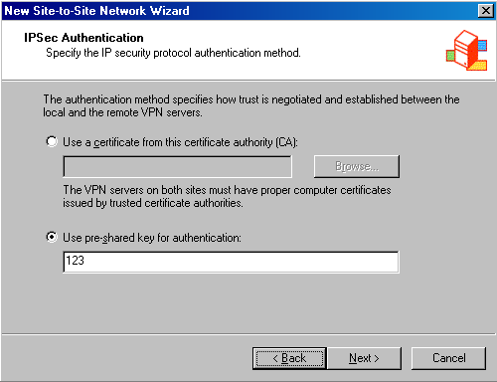
- On the Network Addresses page, click Add. Enter the range of addresses included at the Remote Site Network. In this example, the Branch office uses IP addresses 10.0.1.0-10.0.1.255, so enter those values into the Starting address and Ending address text boxes on the IP Address Range Properties dialog box, and click OK. In addition, we will enter the IP address on the external interface of the Remote Site Network’s firewall so that Web Proxy clients will be able to access the network. In this example, the IP address of the Remote Site Network is 192.168.1.71, so enter that value in the Starting address and Ending address text boxes on the IP Address Range Properties dialog box, and click OK. Click Next.
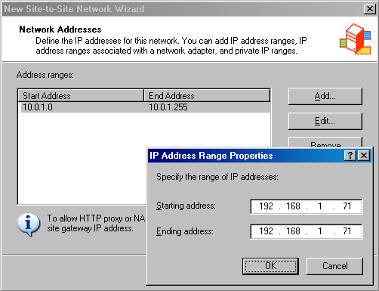
- Click Finish on the Completing the New Network Wizard page.

Create the Network Rule at the Main Office
The ISA Server 2004 firewall needs to know the routing relationship you want to use between the Main and Remote office sites. You can choose either a route or a NAT relationship. In general, the NAT relationship is more secure, while the route relationship is more accessible. The route relationship is more accessible because not all network applications work properly when using a NAT relationship.
Perform the following steps to create the Network Rule that determines the routing relationship between the Main and Branch offices:
- In the Microsoft Internet Security and Acceleration Server 2004 management console, expand the server name and the Configuration node. Click on Networks.
- In the Details pane, click the Network Rules tab. In the Task pane, click the Tasks tab. Click Create a New Network Rule.
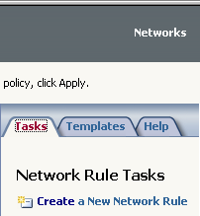
- On the Welcome to the New Network Rule Wizard page, enter a name for the rule in the Network rule name text box. In this example, enter MainBranch. Click Next.
- On the Network Traffic Sources page, click Add. In the Add Network Entities dialog box, click the Networks folder, and then double click the Internal network. Click Close. Click Next on the Network Traffic Sources page.
- On the Network Traffic Sources page, click Add. In the Add Network Entities dialog box, click the Networks folder, and then double click on the Branch network. Click Close. Click Next on the Network Traffic Destinations page.
- On the Network Relationship page, select Route. Click Next.
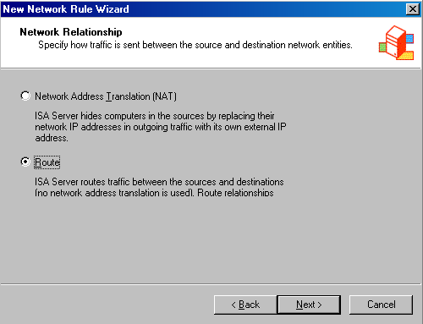
- Click Finish on the Completing the New Network Rule Wizard page.

Create the Access Rules at the Main Office
The Access Rules control what traffic moves between the Main and Branch office sites. If there are no Access Rules, then no traffic will move between the sites, regardless of the fact that you have created a Remote Site Network and Network Rule. In this example, we will allow all traffic to move from the Main office to the Branch office, and all traffic to move from the Branch office to the Main office. In a production network, you would lock down the traffic moving between the sites and institute strong user/group-based access controls. We’ll cover how you can use user/group-based access control in later article on site-to-site VPN networking.
- Note:
This strong user/group-based access control is not available with other popular firewalls that are currently considered industry leaders.
Perform the following steps to create Access Rules allowing traffic between the Main office and the Branch office:
- In the Microsoft Internet Security and Acceleration Server 2004 management console, click on the Firewall Policy node in the left pane. Click the Tasks tab in the Task pane, and then click Create New Access Rule.
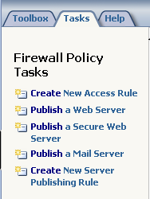
- On the Welcome to the New Access Rule Wizard page, enter a name for the rule in the Access Rule name text box. In this example, enter Main to Branch. Click Next.
- On the Rule Action page, select Allow and click Next.
- On the Protocols page, select All outbound protocols in the This rule applies to list, and click Next.
- On the Access Rule Sources page, click Add. In the Add Network Entities dialog box, click the Networks folder, and then double click on the Internal network. Click Close. Click Next on the Access Rule Sources page.
- On the Access Rule Destinations page, click Add. In the Add Network Entities dialog box, click the Networks folder, and then double click on the Branch network. Click Close. Click Next on the Access Rule Destinations page.
- On the User Sets page, use the default selection, All Users, and click Next.
- Click Finish on the Completing the New Access Rule Wizard page.
We need to create another rule that allows traffic from the Remote Site Network (the Branch office in this example) to the Main office. Instead of going through the New Access Rule Wizard again, I’ll show you a trick that can speed up creating a new Access Rule:
- Right click the Main to Branch rule and click Copy. Right click the rule again and click Paste.
- Right click the Main to Branch (1) rule and click Properties.
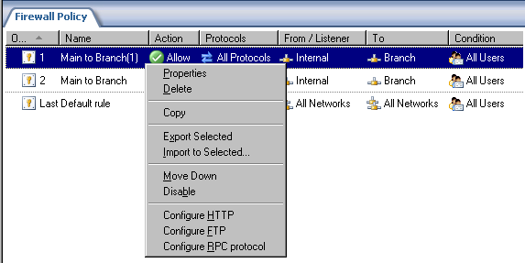
- In the Main to Branch (1) Properties dialog box, click the General tab and enter the name Branch to Main in the Name text box.
- Click the From tab. Click the Internal network and click Remove. Click Add. In the Add Network Entities dialog box, click the Networks folder and double click Branch. Click Close.
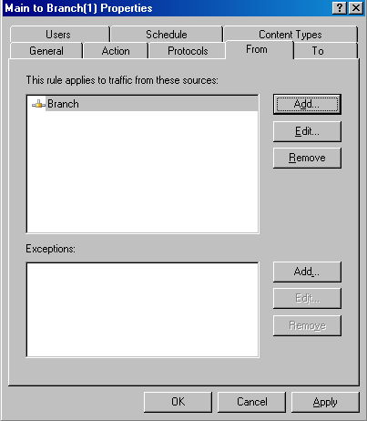
- Click the To tab. Click the Branch network and click Remove. Click Add. In the Add Network Entities dialog box, click the Networks folder and double click Internal. Click Close.
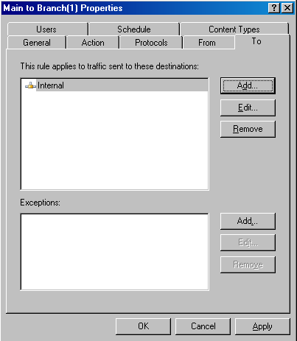
- Click Apply and then click OK.
- Click Apply to save the changes and update the firewall policy.
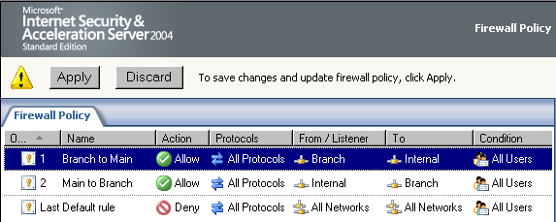

Create the Remote Site Network at the Branch Office
We now need to mirror the settings we created at the Main office. All the procedures are the same, except we reverse the settings to support communications from the Branch office to the Main office.
Perform the following steps to create the Remote Site Network at the Branch office:
- At the Branch office ISA Server 2004 firewall machine, open the Microsoft Internet Security and Acceleration Server 2004 management console, and expand the server name. Click on Virtual Private Networks (VPN).
- In the Details pane, click the Remote Sites tab. Click the Tasks tab in the Task pane. Click Add Remote Site Network.
- On the Welcome to the New Network Wizard page, enter a name for the Remote Site Network in the Network name text box. In this example, enter Main. Click Next.
- On the VPN Protocol page, select IP Security protocol (IPSec) tunnel mode and click Next.
- On the Connection Settings page, enter the IP address of the Remote Site VPN gateway in the Remote VPN gateway IP address text box. In this example, the Remote Site VPN gateway address is 192.168.1.70, so we will enter that value into the text box. Select the IP address on the external interface of the Main office ISA firewall in the Local VPN gateway IP address list. In this example, the external address is 192.168.1.71, so we will select that option. Click Next.
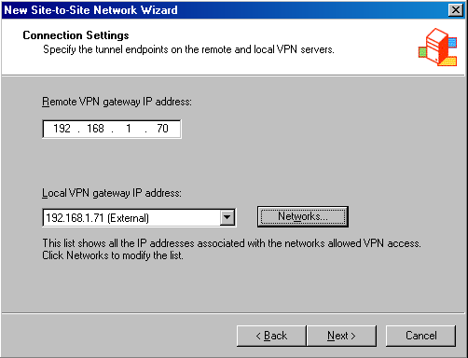
- On the IPSec Authentication page, select Use pre-shared key for authentication. Enter a pre-shared key in the text box. This should be a complex value with mixed-case letters, numbers and non-alphanumeric characters. Note that you also have the option to use a computer certificate. We will cover that option in a future article. Note that pre-shared keys are a low-security option; that is why L2TP/IPSec is always preferred to IPSec tunnel mode. In this example, enter 123 for the pre-shared key, for demonstration purposes only. Click Next.
- On the Network Addresses page, click Add. Enter the range of addresses included at the Remote Site Network. In this example, the Main office uses IP addresses 10.0.0.0-10.0.0.255, so enter those values into the Starting address and Ending address text boxes on the IP Address Range Properties dialog box, and click OK. In addition, we will enter the IP address on the external interface of the Remote Site Network’s firewall so that Web Proxy clients will be able to access the network. In this example, the IP address of the Remote Site Network is 192.168.1.70, so enter that value in the Starting address and Ending address text boxes on the IP Address Range Properties dialog box, and click OK. Click Next.
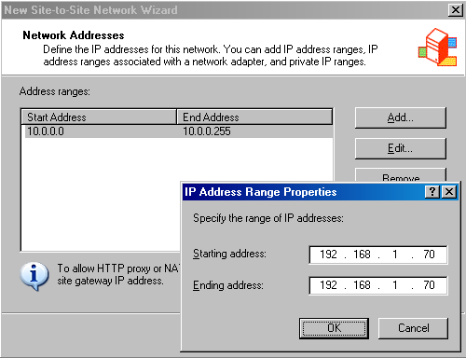
- Click Finish on the Completing the New Network Wizard page.

Create the Network Rule at the Branch Office
Perform the following steps to create the Network Rule that determines the routing relationship between the Main and Branch offices:
- In the Microsoft Internet Security and Acceleration Server 2004 management console, expand the server name, and then expand the Configuration node. Click on the Networks node.
- In the Details pane, click the Network Rules tab. In the Task pane, click the Tasks tab. Click Create a New Network Rule.
- On the Welcome to the New Network Rule Wizard page, enter a name for the rule in the Network rule name text box. In this example, enter BranchMain. Click Next.
- On the Network Traffic Sources page, click Add. In the Add Network Entities dialog box, click the Networks folder, and then double click the Internal network. Click Close. Click Next on the Network Traffic Sources page.
- On the Network Traffic Sources page, click Add. In the Add Network Entities dialog box, click the Networks folder, and then double click on the Main network. Click Close. Click Next on the Network Traffic Destinations page.
- On the Network Relationship page, select Route. Click Next.
- Click Finish on the Completing the New Network Rule Wizard page.

Create the Access Rules at the Branch Office
Perform the following steps to create the Access Rules controlling traffic between the Branch office and the Main office:
- In the Microsoft Internet Security and Acceleration Server 2004 management console, click on the Firewall Policy node in the left pane. Click the Tasks tab in the Task pane, and then click Create New Access Rule.
- On the Welcome to the New Access Rule Wizard page, enter a name for the rule in the Access Rule name text box. In this example, enter Branch to Main. Click Next.
- On the Rule Action page, select Allow and click Next.
- On the Protocols page, select All outbound protocols in the This rule applies to list, and click Next.
- On the Access Rule Sources page, click Add. In the Add Network Entities dialog box, click the Networks folder, and then double click on the Internal network. Click Close. Click Next on the Access Rule Sources page.
- On the Access Rule Destinations page, click Add. In the Add Network Entities dialog box, click the Networks folder, and then double click on the Main network. Click Close. Click Next on the Access Rule Destinations page.
- On the User Sets page, use the default selection, All Users, and click Next.
- Click Finish on the Completing the New Access Rule Wizard page.
We need to create another rule that allows traffic from the Remote Site Network (the Main office in this example) to the Branch office. Perform the following steps to create the rule:
- Right click the Branch to Main rule and click Copy. Right click the rule again and click Paste.
- Right click the Branch to Main (1) rule and click Properties.
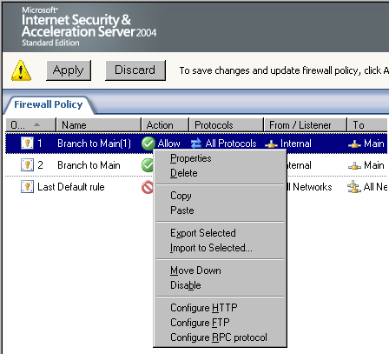
- In the Branch to Main (1) Properties dialog box, click the General tab and enter the name Main to Branch in the Name text box.
- Click the From tab. Click the Internal network and Remove. Click Add. In the Add Network Entities dialog box, click the Networks folder and double click Main. Click Close.
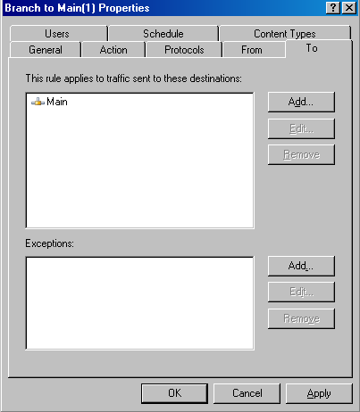
- Click the To tab. Click the Main network and Remove. Click Add. In the Add Network Entities dialog box, click the Networks folder and double click Internal. Click Close.
- Click Apply and then OK.
- Click Apply to save the changes and update the firewall policy.
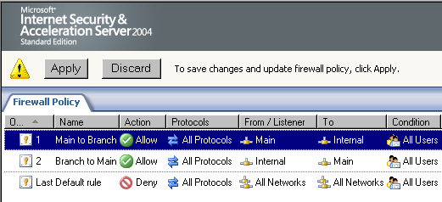
At this point the VPN configuration is complete. You can test by pinging a client on the Branch office network from the domain controller on the Main office network.

PART TWO
Part two of this document will repeat many of the steps performed in Part 1. The exception is that Part 2 is dedicated to using computer certificates to accomplish the IPSec encryption. You should use computer certificates instead of shared keys in a production environment because the shared key is saved in clear text in the Registry and is more easily retrievable by attackers.
You will need to restore the machine to its post-installation state if you have performed the procedures in Part 1 of this article. Restoring the post-installation state will remove all settings made on the firewall after the post-installation phase.
Perform the following steps to restore the machine to its post-installation state:
- In the Microsoft Internet Security and Acceleration Server 2004 management console, right click on the server name, and click Restore.
- In the Restore Configuration dialog box, locate the backup file you created immediately after installing the ISA Server 2004 firewall software. Select that file, and click the Restore button.
- In the Password dialog box, enter the password you assigned to the backup file. Click OK.
- Click OK in the Importing dialog box when you see the message The configuration was successfully restored.
- Click Apply to save the changes and update the firewall policy.
- In the ISA Server Warning dialog box, select Save the changes and restart the service(s) and click OK.
- Click OK in the Apply New Configuration dialog box.

Publish the Web Enrollment Site for the Enterprise CA
The Branch office ISA Server 2004 firewall will need to obtain a computer certificate from the same CA that issues the Main office ISA Server 2004 firewall computer certificate. There are several methods you can use to obtain the certificate. In this example, we will publish the enterprise CA’s Web enrollment site and the Branch office ISA Server 2004 firewall will obtain the certificate using the Web enrollment site.
Perform the following steps to publish the enterprise CA’s Web enrollment site:
- In the Microsoft Internet Security and Acceleration Server 2004 management console, expand the server name and click Firewall Policy.
- In the Task pane, click the Tasks tab. On the Tasks tab, click Publish a Web Server.
- Enter a name for the Web Publishing Rule on the Welcome to the New Web Publishing Rule Wizard page. In this example, enter Web Enrollment Site in the Web publishing rule name text box. Click Next.
- Select Allow on the Select Rule Action page.
- On the Define Website to Publish page, enter the IP address of the enterprise CA’s Web site in the Computer name or IP address text box. In this example, the IP address is 10.0.0.2, so we will enter that value into the text box. In the Folder text box, enter /*. Click Next.
- On the Public Name Details page, select This domain name (type below) in the Accept request for list box. In the Public name text box, enter the IP address on the external interface of the firewall. In this example, the main office ISA Server 2004 firewall’s external address is 192.168.1.70, so we will enter that value into the text box. Enter /* into the Path (optional) text box. Click Next.
- On the Select Web Listener page, click New.
- On the Welcome to the New Web Listener page, enter a name for the rule in the Web listener name text box. In this example, enter Listener70, to indicate the IP address that the listener is listening on. Click Next.
- On the IP addresses page, put a checkmark in the External check box and click Next.
- On the Port Specification page, accept the default settings. Confirm that there is a checkmark in the Enable HTTP check box and that the value 80 is in the HTTP port text box. Click Next.
- Click Finish on the Completing the New Web Listener Wizard page.
- Click Next on the Select Web Listener page.
- Accept the default setting, All Users, on the User Sets page, and click Next.
- Click Finish on the Completing the New Web Publishing Rule Wizard page.
- Click Apply to save the changes and update the firewall policy.
- Click OK in the Apply New Configuration dialog box.
The next step is to configure the ISA Server 2004 firewall at the Main office to access the Web enrollment site.

Enable the System Policy Rule on the Main office Firewall to Access the Enterprise CA
The ISA Server 2004 firewall is locked down by default. You need to create or enable Access Rules to allow the firewall access to networks or network hosts. We will need to configure the firewall at the Main office with an Access Rule that allows it HTTP access to the Web enrollment site. We could create an Access Rule, or we could enable a System Policy Rule that allows outbound HTTP access. In this example, we will enable a System Policy Rule that allows the firewall access to the Web enrollment site.
Perform the following steps to enable the System Policy Rule on the Main office firewall:
- In the Microsoft Internet Security and Acceleration Server 2004 management console, expand the server name, and click Firewall Policy.
- Right click Firewall Policy, point to View and click Show System Policy Rules.
- In the System Policy Rule list, double click on the Allow HTTP from ISA Server to all networks for CRL downloads System Policy Rule.
- In the System Policy Editor dialog box, put a checkmark in the Enable check box on the General tab. Click OK.
- Click Apply to save the changes and update the firewall policy.
- Click OK in the Apply New Configuration dialog box.

Request and Install a Certificate for the Main Office Firewall
Now we can request a certificate from the enterprise CA Web enrollment site. After we obtain the certificate, we will copy the CA certificate into the machine’s Trusted Root Certification Authorities certificate store.
Perform the following steps on the main office ISA Server 2004 firewall to request and install the certificates:
- Open Internet Explorer. In the Address bar, enter http://10.0.0.2/certsrv and click OK.
- In the Enter Network Password dialog box, enter Administrator in the User Name text box and enter the Administrator’s password in the Password text box. Click OK.
- In the Internet Explorer security dialog box, click Add. In the Trusted Sites dialog box, click Add, then click Close.
- Click Request a Certificate on the Welcome page.
- On the Request a Certificate page, click advanced certificate request.
- On the Advanced Certificate Request page, click Create and submit a request to this CA.
- On the Advanced Certificate Request page, select the Administrator certificate from the Certificate Template list. Place a checkmark in the Store certificate in the local computer certificate store check box. Click Submit.
- Click Yes in the Potential Scripting Violation dialog box.
- On the Certificate Issued page, click Install this certificate.
- Click Yes on the Potential Scripting Violation page.
- Close the browser after viewing the Certificate Installed page.
- Click Start and then click the Run command. Enter mmc in the Open text box, and click OK.
- In Console1, click the File menu, and then click Add/Remove Snap-in.
- Click Add in the Add/Remove Snap-in dialog box.
- Select Certificates from the Available Standalone Snap-ins list in the Add Standalone Snap-in dialog box. Click Add.
- Select Computer account on the Certificates snap-in page.
- Select Local computer on the Select Computer page.
- Click Close in the Add Standalone Snap-in dialog box.
- Click OK in the Add/Remove Snap-in dialog box.
- In the left pane of the console, expand the Certificates (Local Computer) node and the Personal node. Click on \Personal\Certificates. Double click on the Administrator certificate in the right pane of the console.
- In the Certificate dialog box, click the Certification Path tab. The root CA certificate is at the top of the certificate hierarchy seen in the Certification path frame. Click the EXCHANGE2003BE certificate at the top of the list. Click View Certificate.
- In the CA certificate’s Certificate dialog box, click the Details tab. Click Copy to File.
- Click Next in the Welcome to the Certificate Export Wizard page.
- On the Export File Format page, select Cryptographic Message Syntax Standard – PKCS #7 Certificates (.P7B) and click Next.
- On the File to Export page, enter c:\cacert in the File name text box. Click Next.
- Click Finish on the Completing the Certificate Export Wizard page.
- Click OK in the Certificate Export Wizard dialog box.
- Click OK in the Certificate dialog box. Click OK again in the Certificate dialog box.
- In the left pane of the console, expand the Trusted Root Certification Authorities node and click Certificates. Right click \Trusted Root Certification Authorities\Certificates, point to All Tasks and click Import.
- Click Next on the Welcome to the Certificate Import Wizard page.
- On the File to Import page, use Browse to locate the CA certificate you saved to the local hard disk, and click Next.
- On the Certificate Store page, accept the default settings and click Next.
- Click Finish on the Completing the Certificate Import Wizard page.
- Click OK on the Certificate Import Wizard dialog box informing you that the import was successful.

Enable the System Policy Rule on the Branch office Firewall to Access the Enterprise CA
The next step is to enable the System Policy Rule that will allow the Branch office firewall to connect to the enterprise CA on the Main office network.
Perform the following steps to enable the System Policy rule on the branch office firewall:
- In the Microsoft Internet Security and Acceleration Server 2004 management console, expand the server name, and click Firewall Policy.
- Right click Firewall Policy, point to View and click Show System Policy Rules.
- In the System Policy Rule list, double click on the Allow HTTP from ISA Server to all networks for CRL downloads System Policy Rule.
- In the System Policy Editor dialog box, put a checkmark in the Enable check box on the General tab. Click OK.
- Click Apply to save the changes and update the firewall policy.
- Click OK in the Apply New Configuration dialog box

Request and Install a Certificate on the Branch office Firewall
Now we can request a certificate for the Branch office firewall. After we obtain the certificate, we will copy the CA certificate into the machine’s Trusted Root Certification Authorities certificate store.
Perform the following steps on the branch office ISA Server 2004 firewall to request and install the certificates:
- Open Internet Explorer. In the Address bar, enter http://192.168.1.70/certsrv and click OK.
- In the Enter Network Password dialog box, enter Administrator in the User Name text box, and enter the Administrator’s password in the Password text box. Click OK.
- In the Internet Explorer security dialog box, click Add. In the Trusted Sites dialog box, click Add, then click Close.
- Click Request a Certificate on the Welcome page.
- On the Request a Certificate page, click advanced certificate request.
- On the Advanced Certificate Request page, click Create and submit a request to this CA.
- On the Advanced Certificate Request page, select the Administrator certificate from the Certificate Template list. Place a checkmark in the Store certificate in the local computer certificate store check box. Click Submit.
- Click Yes in the Potential Scripting Violation dialog box.
- On the Certificate Issued page, click Install this certificate.
- Click Yes on the Potential Scripting Violation page.
- Close the browser after viewing the Certificate Installed page.
- Click Start, and then click Run. Enter mmc in the Open text box, and click OK.
- In Console1, click the File menu, and then click Add/Remove Snap-in.
- Click Add in the Add/Remove Snap-in dialog box.
- Select Certificates from the Available Standalone Snap-ins list in the Add Standalone Snap-in dialog box. Click Add.
- Select Computer account on the Certificates snap-in page.
- Select Local computer on the Select Computer page.
- Click Close in the Add Standalone Snap-in dialog box.
- Click OK in the Add/Remove Snap-in dialog box.
- In the left pane of the console, expand the Certificates (Local Computer) node and the Personal node. Click on \Personal\Certificates. Double click on the Administrator certificate in the right pane of the console.
- In the Certificate dialog box, click the Certification Path tab. The root CA certificate is at the top of the certificate hierarchy seen in the Certification path frame. Click the EXCHANGE2003BE certificate at the top of the list. Click View Certificate.
- In the CA certificate’s Certificate dialog box, click the Details tab. Click Copy to File.
- Click Next in the Welcome to the Certificate Export Wizard page.
- On the Export File Format page, select Cryptographic Message Syntax Standard – PKCS #7 Certificates (.P7B) and click Next.
- On the File to Export page, enter c:\cacert in the File name text box. Click Next.
- Click Finish on the Completing the Certificate Export Wizard page.
- Click OK in the Certificate Export Wizard dialog box.
- Click OK in the Certificate dialog box. Click OK again in the Certificate dialog box.
- In the left pane of the console, expand the Trusted Root Certification Authorities node, and click the Certificates node. Right click \Trusted Root Certification Authorities\Certificates, point to All Tasks and click Import.
- Click Next on the Welcome to the Certificate Import Wizard page.
- On the File to Import page, use Browse to locate the CA certificate you saved to the local hard disk, and click Next.
- On the Certificate Store page, accept the default settings, and click Next.
- Click Finish on the Completing the Certificate Import Wizard page.
- Click OK on the Certificate Import Wizard dialog box informing you that the import was successful

Create the Remote Site Network at the Main Office
The first step is to create a Remote Site Network representing the network at the Branch office. The Main office ISA Server 2004 firewall will use the Branch office Remote Site Network in routing and Access Rules.
Perform the following steps to create the Remote Site Network at the Main office:
- At the Main office ISA Server 2004 firewall machine, open the Microsoft Internet Security and Acceleration Server 2004 management console and expand the server name. Click on Virtual Private Networks (VPN).
- In the Details pane, click the Remote Sites tab. Click the Tasks tab in the Task pane. Click Add Remote Site Network.
- On the Welcome to the New Network Wizard page, enter a name for the Remote Site Network in the Network name text box. In this example, enter Branch. Click Next.
- On the VPN Protocol page, select IP Security protocol (IPSec) tunnel mode and click Next.
- On the Connection Settings page, enter the IP address of the Remote Site VPN gateway in the Remote VPN gateway IP address text box. In this example, the Remote Site VPN gateway address is 192.168.1.71, so we will enter that value into the text box. Select the IP address on the external interface of the Main office ISA firewall in the Local VPN gateway IP address list. In this example, the external address is 192.168.1.70, so we will select that option. Click Next.
- On the IPSec Authentication page, select Use a certificate from this certificate authority (CA). Click Browse.
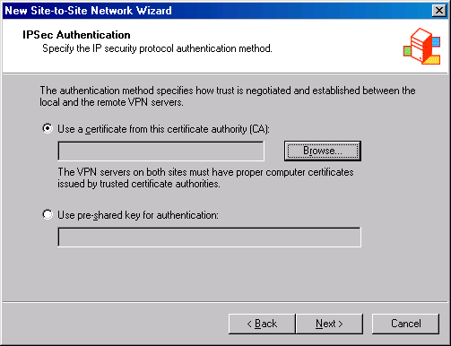
- In the Select Certificate dialog box, select the CA that issued the machine certificate. In this example, the name of the CA is EXCHANGE2003BE. Select that certificate and click OK.
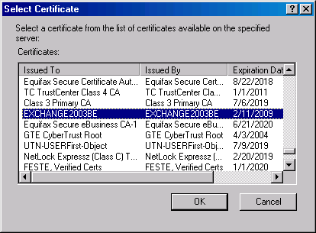
- Click Next on the IPSec Authentication page.
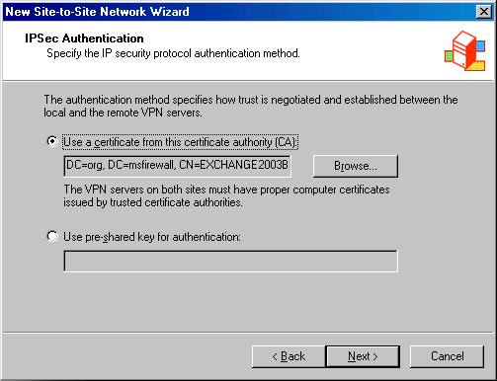
- On the Network Addresses page, click Add. Enter the range of addresses included at the Remote Site Network. In this example, the Branch office uses IP addresses 10.0.1.0-10.0.1.255, so enter those values into the Starting address and Ending address text boxes on the IP Address Range Properties dialog box, and click OK. In addition, we will enter the IP address on the external interface of the Remote Site Network’s firewall so that Web Proxy clients will be able to access the network. In this example, the IP address of the Remote Site Network is 192.168.1.71, so enter that value in the Starting address and Ending address text boxes on the IP Address Range Properties dialog box, and click OK. Click Next.
- Click Finish on the Completing the New Network Wizard page.

Create the Network Rule at the Main Office
The ISA Server 2004 firewall needs to know the routing relationship you want to use between the Main and Remote office sites. You can choose either a route or a NAT relationship. In general, the NAT relationship is more secure while the route relationship is more accessible. The route relationship is more accessible because not all network applications work properly when using a NAT relationship.
Perform the following steps to create the Network Rule that determines the routing relationship between the Main and Branch offices:
- In the Microsoft Internet Security and Acceleration Server 2004 management console, expand the server name and the Configuration node. Click on the Networks node.
- In the Details pane, click the Network Rules tab. In the Task pane, click the Tasks tab. Click Create a New Network Rule.
- On the Welcome to the New Network Rule Wizard page, enter a name for the rule in the Network rule name text box. In this example, enter MainBranch. Click Next.
- On the Network Traffic Sources page, click Add. In the Add Network Entities dialog box, click the Networks folder, and then double click the Internal network. Click Close. Click Next on the Network Traffic Sources page.
- On the Network Traffic Sources page, click Add. In the Add Network Entities dialog box, click the Networks folder, and then double click on the Branch network. Click Close. Click Next on the Network Traffic Destinations page.
- On the Network Relationship page, select Route. Click Next.
- Click Finish on the Completing the New Network Rule Wizard page.

Create the Access Rules at the Main Office
The Access Rules control what traffic moves between the Main and Branch office sites. If there are no Access Rules, then no traffic will move between the sites, regardless of the fact that you have created a Remote Site Network and Network Rule. In this example, we will allow all traffic to move between the Main office and the Branch office. In a production network, you would lock down the traffic that can move between the sites and institute strong user/group-based access controls. We’ll cover how you can user user/group-based access control in a later article on site-to-site VPN networking.
- Note:
This strong user/group-based access control is not available with other popular firewalls currently considered industry leaders.
Perform the following steps to create the Access Rules allowing traffic between the Main office and the Branch office:
- In the Microsoft Internet Security and Acceleration Server 2004 management console, click Firewall Policy in the left pane. Click the Tasks tab in the Task pane, and then click Create New Access Rule.
- On the Welcome to the New Access Rule Wizard page, enter a name for the rule in the Access Rule name text box. In this example, enter Main to Branch. Click Next.
- On the Rule Action page, select Allow and click Next.
- On the Protocols page, select All outbound protocols from the This rule applies to list and click Next.
- On the Access Rule Sources page, click Add. In the Add Network Entities dialog box, click the Networks folder, and then double click on the Internal network. Click Close. Click Next on the Access Rule Sources page.
- On the Access Rule Destinations page, click Add. In the Add Network Entities dialog box, click the Networks folder, and then double click on the Branch network. Click Close. Click Next on the Access Rule Destinations page.
- On the User Sets page, use the default selection, All Users, and click Next.
- Click Finish on the Completing the New Access Rule Wizard page.
We need to create another rule that allows traffic from the Remote Site Network (the Branch office in this example) to the Main office. Instead of going through the New Access Rule Wizard again, I’ll show you a trick that can speed up creating a new Access Rule:
- Right click the Main to Branch rule and click Copy. Right click the rule again and click Paste.
- Right click the Main to Branch (1) rule and click Properties.
- In the Main to Branch (1) Properties dialog box, click General and enter Branch to Main in the Name text box.
- Click the From tab. Click the Internal network and Remove. Click Add. In the Add Network Entities dialog box, click the Networks folder, and double click Branch. Click Close.
- Click the To tab. Click the Branch network and Remove. Click Add. In the Add Network Entities dialog box, click the Networks folder, and double click Internal. Click Close.
- Click Apply and then click OK.
- Click Apply to save the changes and update the firewall policy.

Create the Remote Site Network at the Branch Office
We now need to mirror the settings we created at the Main office. All the procedures are the same, except we reverse the settings to support communications from the Branch office to the Main office.
Perform the following steps to create the Remote Site Network at the Branch office:
- At the Branch office ISA Server 2004 firewall machine, open the Microsoft Internet Security and Acceleration Server 2004 management console, and expand the server name. Click Virtual Private Networks (VPN).
- In the Details pane, click the Remote Sites tab. Click the Tasks tab in the Task pane. Click Add Remote Site Network.
- On the Welcome to the New Network Wizard page, enter a name for the Remote Site Network in the Network name text box. In this example, enter Main. Click Next.
- On the VPN Protocol page, select IP Security protocol (IPSec) tunnel mode and click Next.
- On the IPSec Authentication page, select Use a certificate from this certificate authority (CA). Click Browse.
- In the Select Certificate dialog box, select the CA that issued the machine certificate. In this example, the name of the CA is EXCHANGE2003BE. Select that certificate and click OK.
- Click Next on the IPSec Authentication page.
- On the Network Addresses page, click Add. Enter the range of addresses included at the Remote Site Network. In this example, the Main office uses IP addresses 10.0.0.0-10.0.0.255, so we will enter those values into the Starting address and Ending address text boxes in the IP Address Range Properties dialog box, and click OK. In addition, we will enter the IP address on the external interface of the Remote Site Network’s firewall so that Web Proxy clients will be able to access the network. In this example, the IP address of the Remote Site Network is 192.168.1.70, so we will enter that value in the Starting address and Ending address text boxes in the IP Address Range Properties dialog box, and click OK. Click Next.
- Click Finish on the Completing the New Network Wizard page.

Create the Network Rule at the Branch Office
Perform the following steps to create the Network Rule that determines the routing relationship between the Main and Branch offices:
- In the Microsoft Internet Security and Acceleration Server 2004 management console, expand the server name and the Configuration node. Click on Networks.
- In the Details pane, click the Network Rules tab. In the Task pane, click the Tasks tab. Click Create a New Network Rule.
- On the Welcome to the New Network Rule Wizard page, enter a name for the rule in the Network rule name text box. In this example, enter BranchMain. Click Next.
- On the Network Traffic Sources page, click Add. In the Add Network Entities dialog box, click the Networks folder, and then double click the Internal network. Click Close. Click Next on the Network Traffic Sources page.
- On the Network Traffic Sources page, click Add. In the Add Network Entities dialog box, click the Networks folder, and then double click on the Main network. Click Close. Click Next on the Network Traffic Destinations page.
- On the Network Relationship page, select Route. Click Next.
- Click Finish on the Completing the New Network Rule Wizard page.

Create the Access Rules at the Branch Office
Perform the following steps to create the Access Rules controlling traffic between the Branch office and the Main office:
- In the Microsoft Internet Security and Acceleration Server 2004 management console, click on Firewall Policy in the left pane. Click the Tasks tab in the Task pane, and then click Create New Access Rule.
- On the Welcome to the New Access Rule Wizard page, enter a name for the rule in the Access Rule name text box. In this example, enter Branch to Main. Click Next.
- On the Rule Action page, select Allow and click Next.
- On the Protocols page, select All outbound protocols from the This rule applies to list and click Next.
- On the Access Rule Sources page, click Add. In the Add Network Entities dialog box, click the Networks folder, and then double click on the Internal network. Click Close. Click Next on the Access Rule Sources page.
- On the Access Rule Destinations page, click Add. In the Add Network Entities dialog box, click the Networks folder, and then double click on the Main network. Click Close. Click Next on the Access Rule Destinations page.
- On the User Sets page, use the default selection, All Users, and click Next.
- Click Finish on the Completing the New Access Rule Wizard page.
We need to create another rule that allows traffic from the Remote Site Network (the Main office in this example) to the Branch office. Perform the following steps to create the rule:
- Right click the Branch to Main rule and click Copy. Right click the rule again and click Paste.
- Right click the Branch to Main (1) rule and click Properties.
- In the Branch to Main (1) Properties dialog box, click the General tab and enter the name Main to Branch in the Name text box.
- Click the From tab. Click the Internal network and Remove. Click Add. In the Add Network Entities dialog box, click the Networks folder and double click Main. Click Close.
- Click the To tab. Click the Main network and Remove. Click Add. In the Add Network Entities dialog box, click the Networks folder and double click Internal. Click Close.
- Click Apply and then click OK.
- Click Apply to save the changes and update the firewall policy.
At this point the VPN configuration is complete. You can test by ping the client on the Branch office network from the domain controller on the Main office network.

Conclusion
In this article we went over the procedures required to create a site-to-site VPN link between two ISA Server 2004 firewalls using IPSec tunnel mode. We also discussed the security issues with IPSec tunnel mode and why you should never use IPSec tunnel mode connections for site-to-site links unless you must do so in order to connect to third party VPN servers. In future articles we’ll discuss procedures required for configuring site-to-site links using IPSec tunnel mode with third-party vendor firewalls and how to use strong user/group-based access control to limit what users can access over the link.

.

This is a preliminary document and may be changed substantially prior to final commercial release of the software described herein.
The information contained in this document represents the current view of Microsoft Corporation on the issues discussed as of the date of publication. Because Microsoft must respond to changing market conditions, it should not be interpreted to be a commitment on the part of Microsoft, and Microsoft cannot guarantee the accuracy of any information presented after the date of publication.
This white paper is for informational purposes only. MICROSOFT MAKES NO WARRANTIES, EXPRESS OR IMPLIED, IN THIS
DOCUMENT.
Complying with all applicable copyright laws is the responsibility of the user. Without limiting the rights under copyright, no part of this document may be reproduced, stored in, or introduced into a retrieval system, or transmitted in any form or by any means (electronic, mechanical, photocopying, recording, or otherwise), or for any purpose, without the express written permission of Microsoft Corporation.
Microsoft may have patents, patent applications, trademarks, copyrights, or other intellectual property rights covering subject matter in this document. Except as expressly provided in any written license agreement from Microsoft, the furnishing of this document does not give you any license to these patents, trademarks, copyrights, or other intellectual property.
© 2004 Microsoft Corporation. All rights reserved.
The example companies, organizations, products, domain names, e-mail addresses, logos, people, places, and events depicted herein are fictitious. No association with any real company, organization, product, domain name, e-mail address, logo, person, place, or event is intended or should be inferred.
Microsoft, Windows, Windows 2000, Windows 2000 Server, Windows Server 2003, Windows Server System, ISA Server, and ISA Server 2004 are either registered trademarks or trademarks of Microsoft Corporation in the United States and/or other countries.
The names of actual companies and products mentioned herein may be the trademarks of their respective owners.

ISA Server 2004 VPN Deployment Kit: Allowing Inbound L2TP/IPSec NAT Traversal Connections through a Back-to-Back ISA Server 2004 Server DMZ
Chapter 12

For the latest information, please see http://www.microsoft.com/isaserver/

Contents
Introduction 1
Overview of the Back-to-Back ISA Server 2004 Firewall Network Topology 2
Configure the L2TP/IPSec VPN Client 3
Restore the Back-end Firewall Machine to it Post-Installation State 6
Install the ISA Server 2004 Firewall Software on the Front-End Firewall 7
Configure the Front-End ISA Server 2004 Firewall to Forward L2TP/IPSec Connections to the Back-End ISA Server 2004 Firewall/VPN Server 12
Issue a Machine Certificate to the Back-end Firewall 17
Configure the Back-End ISA Server 2004 Firewall/VPN Server to Allow VPN Remote Access Connections 20
Create an Access Rule Allowing VPN Clients Access to the Internal Network and the Internet 28
Enable Dial-in Access for the Administrator Account 32
Establish a L2TP/IPSec VPN Connection to the ISA Server 2004 Firewall/VPN Server from an External VPN Client Computer 33
Conclusion 34

Introduction
You can enhance security for your VPN remote-access connections by creating a back-to-back ISA Server 2004 firewall configuration. In the back-to-back ISA Server 2004 firewall setup the front-end ISA Server 2004 firewall has an interface directly connected to the Internet and a second interface connected to a perimeter network between the front-end and back-end ISA Server 2004 firewall. The back-end ISA Server 2004 firewall has an interface on the perimeter network between the front-end and back-end ISA Server 2004 firewall and an interface on the Internal network.
The back-to-back ISA Server 2004 firewall configuration creates a perimeter network between the two firewalls. You can place publicly-accessible servers on this perimeter network. The front-end ISA Server 2004 firewall allows external users access to servers on the perimeter network while the back-end firewall blocks the external users from accessing resources on the Internal network.
You can configure the front-end ISA Server 2004 firewall to accept incoming L2TP/IPSec VPN connections and forward those connections to the back-end ISA Server 2004 firewall. The VPN connections are terminated on the back-end ISA Server 2004 firewall. This means that the PPTP VPN connection remains encrypted and secure even when passing between the front-end and back-end firewalls.
We will discuss the following procedures required to create a successful VPN connection through the front-end and back-end ISA Server 2004 firewalls:
- Overview of the Back-to-Back ISA Server 2004 Firewall Network Topology
- Configure the L2TP/IPSec VPN NAT-T Client
- Restore the Back-End Firewall Machine to its Post-Installation State
- Install the ISA Server 2004 Firewall Software on the Front-End Firewall
- Configure the Front-End ISA Server 2004 Firewall to Forward L2TP/IPSec NAT-T Connections to the Back-End ISA Server 2004 Firewall/VPN Server
- Issue a Machine Certificate to the Back-End ISA Server 2004 Firewall/VPN Server
- Configure the Back-End ISA Server 2004 Firewall/VPN Server to Allow VPN Remote-Access Connections
- Create an Access Rule Allowing VPN Clients Access to the Internal Network and the Internet
- Enable Dial-in Access for the Administrator Account
- Establish a L2TP/IPSec VPN Connection to the ISA Server 2004 Firewall/VPN Server from an External VPN Client Computer

Overview of the Back-to-Back ISA Server 2004 Firewall Network Topology
The back-to-back firewall topology varies from what we configured during the lab network setup. You need to reconfigure the lab network so that the REMOTEISA computer acts as a front-end firewall, and then reset the IP addresses on both the REMOTEISA and the ISALOCAL computers to support the back-to-back firewall configuration.
The figure below shows the back-to-back ISA Server 2004 firewall topology.
The table below shows the IP address scheme for the back-to-back ISA Server 2004 firewall configuration.
Addressing | EXCHANGE2003BE | ISALOCAL | REMOTEISA | EXTCLIENT
IP Address | 10.0.0.2 | Int: 10.0.0.1  Ext: 10.0.2.2 | Int: 10.0.2.1  Ext: 192.168.1.71 | 192.168.1.90
Default Gateway | 10.0.0.1 | Int: N/A  Ext: 10.0.2.1 | Int: N/A  Ext: 192.168.1.60 | N/A
DNS | 10.0.0.2 | N/A | 192.168.1.34 | N/A
WINS | 10.0.0.2 | N/A | N/A | N/A
Operating System | Windows Server 2003 | Windows Server 2003 | Windows Server 2003 | Windows 2000

This network topology will allow the external client computer to connect to the front-end ISA Server 2004 firewall. The connection to the front-end ISA Server 2004 firewall will be forwarded to the back-end ISA Server 2004 firewall/VPN server. After the VPN client establishes the connection, it will be able to access resources on the Internal network. In addition, we will configure an Access Rule that will allow members of the VPN clients network to connect to the Internet. This prevents the VPN clients from using their own connection to the Internet to access Internet resources.
In the following walkthrough, we will assume that you will remove the ISA Server 2004 firewall software from REMOTEISA machine and reinstall it according to the procedures outlined in this document. You also have the option to use a new machine with a fresh installation of the Windows Server 2003 operating system.

Configure the L2TP/IPSec VPN Client
You must download and install the L2TP/IPSec NAT-T Update for Windows XP and Windows 2000. Information about the updated VPN client software is located at http://support.microsoft.com/default.aspx?SCID=KB;EN-US;818043#4, Microsoft Knowledge Base Article 818043. Use the Windows Catalog to locate the file. There is also an updated client for Windows 98, Windows NT 4.0 and Windows ME. You can find information on this client at http://www.microsoft.com/windows2000/server/evaluation/news/bulletins/l2tpclient.asp.
Perform the following steps to locate and download the L2TP/IPSec NAT-T update setup file:
- Open Internet Explorer, click the Tools menu and click Windows Update.
- In the left pane of the Windows Update Web page, locate Windows Update Catalog and click on it.
- On the Welcome to Windows Update Catalog page, click the Find updates for Microsoft Windows operating systems.
- On the Microsoft Windows page, select Windows 2000 SP3 in the Operating Systems list. Click the down arrow button next to Advanced search options. In the Contains these words: text box, type 818043. Click Search.
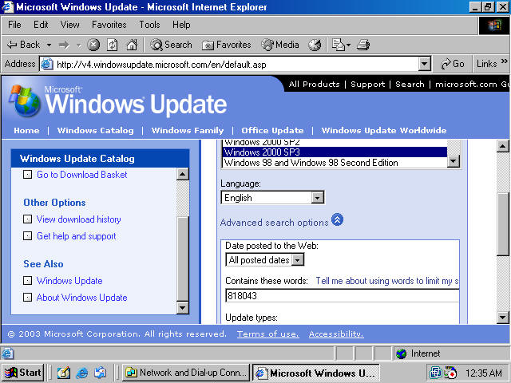
- Click Recommend Updates (1) on the Your search returned 1 results page.
- The 818043: Recommended Update for Windows 2000 entry will appear in the Recommended Updates (1) list. Scroll down to the bottom of the description of the update and click Add. Now click on the green arrow to the left of Go to Download Basket.
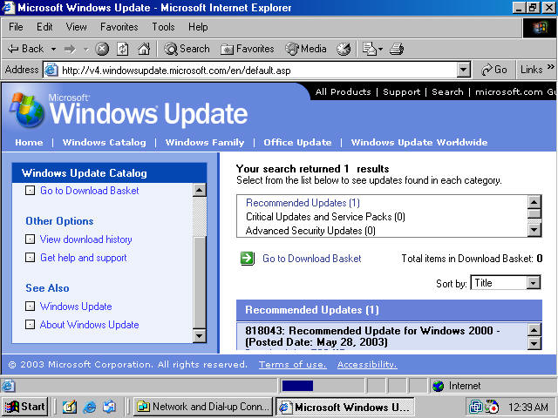
- On the Download Basket page, type a path on the local hard disk where the update will be downloaded. Click the Download Now button after typing in the path.
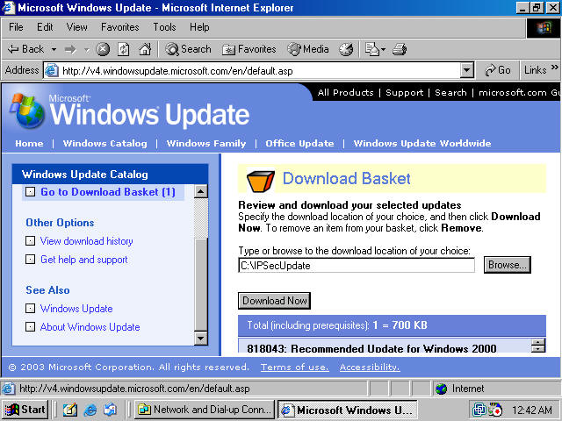

- A Microsoft Windows Update – Web Page Dialog box appears and asks you to accept the license agreement. Click Accept.
- The file is downloaded to the location you indicated. When the download is complete, the Download History page shows the exact location of the file. Make a note of the location of the file, and open the Run command from the Start menu.
- Click the Browse button in the Run dialog box. Navigate to the location of the file and click on Q818043_W2K_SP5_x86_EN.EXE so that it appears in the File name textbox. Click Open. Click OK in the Run dialog box to install the update.
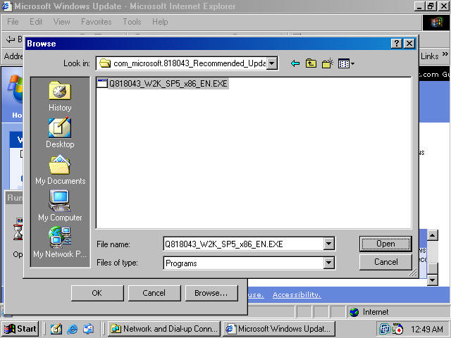
- In the Choose Directory for Extracted Files dialog box, type a path for the extracted files, and click OK.
- Click Next on the Welcome to the Windows 2000 Q818043 Setup Wizard page.
- Read the License Agreement on the License Agreement page, and select I Agree. Click Next.
- Click Finish on the Completing the Windows 2000 Q818043 Setup Wizard page. The computer will restart automatically
Log on to the machine as Administrator. At this point the Windows 2000 VPN client will be able to use L2TP/IPSec in NAT Traversal mode.

Restore the Back-end Firewall Machine to it Post-Installation State
You should restore the machine to its post-installation state before beginning the following procedures. Restoring the post-installation state will remove all settings made on the firewall after the post-installation phase.
Perform the following steps to restore the machine to its post-installation state:
- In the Microsoft Internet Security and Acceleration Server 2004 management console, right click on the server name, and click Restore.
- In the Restore Configuration dialog box, locate the backup file you created immediately after installing the ISA Server 2004 firewall software. Select that file and click Restore.
- In the Password dialog box, enter the password you assigned to the backup file. Click OK.
- Click OK in the Importing dialog box when you see the message, The configuration was successfully restored.
- Click Apply to save the changes and update the firewall policy.
- In the ISA Server Warning dialog box, select Save the changes and restart the service(s) and click OK.
- Click OK in the Apply New Configuration dialog box.

Install the ISA Server 2004 Firewall Software on the Front-End Firewall
In this document, we assume that you have removed the ISA Server 2004 software from the machine that was configured as the REMOTEISA machine, or, you are using a new dual-homed machine as the front-end ISA Server 2004 firewall. This machine will have the L2TP/IPSec NAT-T Server Publishing Rule that forwards the L2TP/IPSec connections to the back-end ISA Server 2004 firewall/VPN server.
Perform the following steps to install the ISA Server 2004 software:
- Insert the ISA Server 2004 CD-ROM into the CD drive. The autorun menu will appear.
- On the Microsoft Internet Security and Acceleration Server 2004 Beta 2 Setup page, click the link for Review Release Notes and read the release notes. The release notes contain useful information about important issues and configuration options. After reading the release notes, close the release notes window and click the Read Setup and Feature Guide link. You don’t need to read the entire guide right now, but you may want to print it out to read later. Close the Setup and Feature Guide window. Click Install ISA Server 2004.
- Click Next on the Welcome to the Installation Wizard for Microsoft ISA Server 2004 page.
- Select I accept the terms in the license agreement on the License Agreement page. Click Next.
- On the Customer Information page, enter your name and the name of your organization in the User Name and Organization text boxes. Enter Product Serial Number. Click Next.
- On the Setup Type page, select the Custom option. If you do not want to install the ISA Server 2004 software on the C: drive, then click the Change button to change the location of the program files on the hard disk. Click Next.
- On the Custom Setup page you can choose which components to install. By default, the Firewall Services and ISA Server Management options are installed. The Message Screener, which is used to help prevent spam and file attachments from entering and leaving the network, is not installed; neither is the Firewall Client Installation Share. You need to install the IIS 6.0 SMTP service on the ISA Server 2004 firewall computer before you install the Message Screener. Use the default settings and click Next.

- On the Internal Network page, click Add. The Internal network is different from the LAT, which was used in ISA Server 2000. In the case of ISA Server 2004, the Internal network contains trusted network services with which the ISA Server 2004 firewall must be able to communicate. Examples of such services include Active Directory domain controllers, DNS, DHCP, terminal services client management workstations, and others. The firewall System Policy automatically uses the Internal network. We will look at the System Policy later in this document.

- On the Internal Network setup page, click Select Network Adapter.

- In the Select Network Adapter dialog box, remove the checkmark from the Add the following private ranges… check box. Leave the checkmark in the Add address ranges based on the Windows Routing Table check box. Put a checkmark in the check box next to the adapter connected to the Internal network. The reason why we remove the checkmark from the Add the following private address ranges check box is that you may wish to use these private address ranges for perimeter networks. The front-end firewall uses the perimeter network between itself and the back-end firewall as its Internal network. Click OK.
- Click OK in the Setup Message dialog box informing you that the Internal network was defined, based on the Windows routing table.
- Click OK on the Internal network address ranges dialog box.
- Click Next on the Internal Network page.
- On the Firewall Client Connection Settings page, place checkmarks in the Allow non-encrypted Firewall client connections and Allow Firewall clients running earlier versions of the Firewall client software to connect to ISA Server check boxes. These settings will allow you to connect to the ISA Server 2004 firewall using downlevel operating systems and from Windows 2000/Windows XP/Windows Server 2003 operating systems running the ISA Server 2000 version of the Firewall client. Note that on a production network, you may wish to disable these settings. Disabling these settings will prevent downlevel Firewall clients from operating on the perimeter network while still allowing you to configure firewall chaining between the downstream and upstream ISA Server 2004 firewall computers later, if you wish. Click Next.
- On the Services page, click Next.
- Click Install on the Ready to Install the Program page.
- On the Installation Wizard Completed page, click Finish.
- Click Yes in the Microsoft ISA Server dialog box informing you that the machine must be restarted.
Log on as Administrator after the machine restarts.

Configure the Front-End ISA Server 2004 Firewall to Forward L2TP/IPSec Connections to the Back-End ISA Server 2004 Firewall/VPN Server
You need to create a Server Publishing Rule that will forward incoming L2TP/IPSec connections to the back-end firewall. ISA Server 2004 includes built-in L2TP/IPSec protocol definitions you can use to publish the server.
Perform the following steps to configure the front-end ISA Server 2004 firewall machine:
- In the Microsoft Internet Security and Acceleration Server 2004 management console, expand the server name and click the Firewall Policy node.
- Right click Firewall Policy, point to New and click Server Publishing Rule.
- On the Welcome to the New Server Publishing Rule Wizard page, enter a name for the Server Publishing Rule in the Server publishing rule name text box. In this example, enter L2TP/IPSec NAT-T. Click Next.
- On the Select Server page, enter the IP address of the external interface of the back-end ISA Server 2004 firewall/VPN server machine in the Server IP address text box. In this example, the IP address is 10.0.2.2, so we will enter that value into the text box. Click Next.
- On the Select Protocol page, click New.
- On the Welcome to the New Protocol Definition Wizard page, enter a name for the protocol definition in the Protocol definition name text box. In this example, enter L2TP/IPSec NAT-T. Click Next.
- On the Primary Connection Information page, click New.
- On the New/Edit Protocol Definition page, set the Protocol type as UDP. Set the Direction as Receive Send. Set the Port Range settings as From 4500 and To 4500. Click OK.
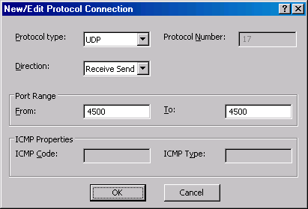
- On the Primary Connection Information page, click New.
- On the New/Edit Protocol Definition page, set the Protocol type as UDP. Set the Direction as Receive Send. Set the Port Range settings as From 500 and To 500. Click OK.
- Click Next on the New Protocol Definition Wizard page.
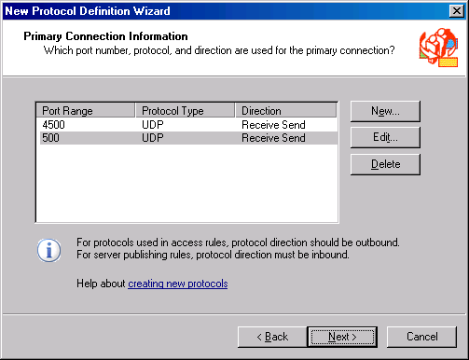
- Select No on the Secondary Connections page
- Click Finish on the Completing the New Protocol Definition Wizard page.
- Click Next on the Select Protocol page.
- On the IP Addresses page, put a checkmark in the External check box, and click Next.
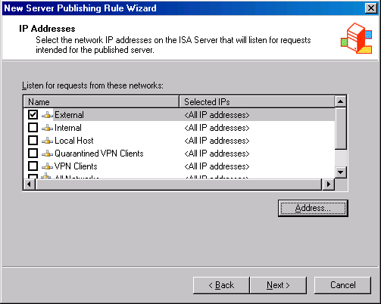
- Click Finish on the Completing the New Server Publishing Rule Wizard page.
- Click Apply to save the changes and update the firewall policy.
- Click OK in the Apply New Configuration dialog box.
The next step is to create an Access Rule that allows the back-end ISA Server 2004 firewall/VPN server outbound access to the Internet. This rule will limit outbound access to the Internet to the external address on the back-end firewall. In a production environment, you would create Access Rules on the front-end ISA Server 2004 firewall that only allow the protocols you have allowed outbound access to on the back-end firewall.
Perform the following steps to create the outbound Access Rule:
- In the Microsoft Internet Security and Acceleration Server 2004 management console, click the Tasks tab in the Task pane. Click Create New Access Rule.
- In the Welcome to the New Access Rule Wizard page, enter a name for the rule in the Access Rule name text box. In this example, enter Outbound from Back-end Firewall. Click Next.
- On the Rule Action page, select Allow and click Next.
- On the Protocols page, accept the default setting, All outbound protocols, in the This rule applies to list. Click Next.
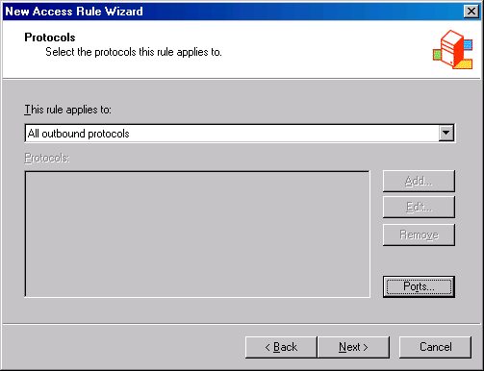
- On the Access Rule Sources page, click Add. In the Add Network Entities dialog box, click the New menu. Click Computer entry in the list. In the New Computer Rule Element dialog box, enter the name Back End Firewall in the Name text box. In the Computer IP Address text box, enter the IP address on the external interface of the back-end firewall. In this example, the IP address is 10.0.2.2, so we will enter that address into the text box. Click OK.
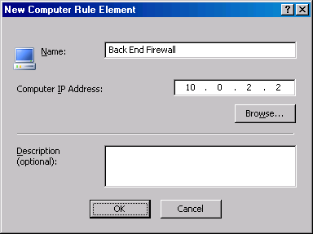
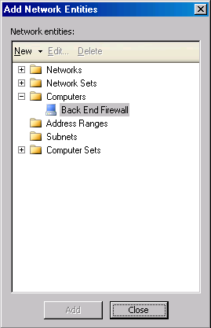
- In the Add Network Entities dialog box, click the Computers folder. Double click the Back End Firewall entry, and click Close. Click Next on the Access Rule Sources page.
- On the Access Rule Destinations page, click Add. In the Add Network Entities dialog box, click the Networks folder and then double click External. Click Close. Click Next in the Access Rule Destinations dialog box.
- On the User Sets page, accept the default entry, All Users, and click Next.
- Click Finish on the Completing the New Access Rule Wizard page.
- Click Apply to save the changes and update the firewall policy.
- Click OK in the Apply New Configuration dialog box.
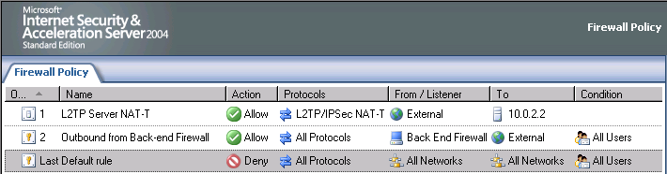

Issue a Machine Certificate to the Back-end Firewall
Now we can request a certificate for the back-end firewall from the enterprise CA Web enrollment site. After we obtain the certificate, we will copy the CA certificate into the machine’s Trusted Root Certification Authorities certificate store.
By default, the ISA Server 2004 firewall is locked down with strong access controls. You will need to enable a System Policy Rule that allows the back-end firewall to communicate with the enterprise CA on the Internal network.
Perform the following steps to enable the System Policy Rule on the back-end ISA Server 2004 firewall:
- In the Microsoft Internet Security and Acceleration Server 2004 management console, expand the server name, and click the Firewall Policy node.
- Right click the Firewall Policy node, point to View and click Show System Policy Rules.
- In the System Policy Rule list, double click on the Allow HTTP from ISA Server to all networks for CRL downloads System Policy Rule.
- In the System Policy Editor dialog box, put a checkmark in the Enable check box on the General tab. Click OK.
- Click Apply to save the changes and update the firewall policy.
- Click OK in the Apply New Configuration dialog box
Perform the following steps on the Main office ISA Server 2004 firewall to request and install the certificates:
- Open Internet Explorer. In the Address bar, enter http://10.0.0.2/certsrv and click OK.
- In the Enter Network Password dialog box, enter Administrator in the User Name text box, and enter the Administrator’s password in the Password text box. Click OK.
- In the Internet Explorer security dialog box, click Add. In the Trusted Sites dialog box, click Add, then click Close.
- Click Request a Certificate on the Welcome page.
- On the Request a Certificate page, click advanced certificate request.
- On the Advanced Certificate Request page, click Create and submit a request to this CA.
- On the Advanced Certificate Request page, select the Administrator certificate from the Certificate Template list. Place a checkmark in the Store certificate in the local computer certificate store check box. Click Submit.
- Click Yes in the Potential Scripting Violation dialog box.
- On the Certificate Issued page, click Install this certificate.
- Click Yes on the Potential Scripting Violation page.
- Close the browser after viewing the Certificate Installed page.
- Click Start, and then click the Run command. Enter mmc in the Open text box, and click OK.
- In Console1, click the File menu, and then click the Add/Remove Snap-in command.
- Click Add in the Add/Remove Snap-in dialog box.
- Select Certificates in the Available Standalone Snap-ins list in the Add Standalone Snap-in dialog box. Click Add.
- Select Computer account on the Certificates snap-in page.
- Select Local computer on the Select Computer page.
- Click Close in the Add Standalone Snap-in dialog box.
- Click OK in the Add/Remove Snap-in dialog box.
- In the left pane of the console, expand the Certificates (Local Computer) node and the Personal node. Click on \Personal\Certificates. Double click on the Administrator certificate in the right pane of the console.
- In the Certificate dialog box, click the Certification Path tab. The root CA certificate is at the top of the certificate hierarchy seen in the Certification path frame.. Click the EXCHANGE2003BE certificate at the top of the list. Click View Certificate.
- In the CA certificate’s Certificate dialog box, click the Details tab. Click Copy to File.
- Click Next in the Welcome to the Certificate Export Wizard page.
- On the Export File Format page, select the Cryptographic Message Syntax Standard – PKCS #7 Certificates (.P7B) option and click Next.
- On the File to Export page, enter c:\cacert in the File name text box. Click Next.
- Click Finish on the Completing the Certificate Export Wizard page.
- Click OK in the Certificate Export Wizard dialog box.
- Click OK in the Certificate dialog box. Click OK again in the Certificate dialog box.
- In the left pane of the console, expand the Trusted Root Certification Authorities node and click the Certificates node. Right click \Trusted Root Certification Authorities\Certificates; point to All Tasks and click Import.
- Click Next on the Welcome to the Certificate Import Wizard page.
- On the File to Import page, use the Browse button to locate the CA certificate you saved to the local hard disk, and click Next.
- On the Certificate Store page, accept the default settings, and click Next.
- Click Finish on the Completing the Certificate Import Wizard page.
- Click OK on the Certificate Import Wizard dialog box informing you that the import was successful.

Configure the Back-End ISA Server 2004 Firewall/VPN Server to Allow VPN Remote Access Connections
By default, the VPN server component is disabled. The first step is to enable the VPN server feature and configure the VPN server components.
Perform the following steps to enable and configure the ISA Server 2004 VPN Server:
- Open the Microsoft Internet Security and Acceleration Server 2004 management console and expand the server name. Click on the Virtual Private Networks (VPN) node.
- Click on the Tasks tab in the Task pane. Click Enable VPN Client Access.
fig1
- Click Apply to save the changes and update the firewall policy.
- Click OK in the Apply New Configuration dialog box.
- Click Configure VPN Client Access on the Tasks tab.
- On the General tab, change the value for the Maximum number of VPN clients allowed from 5 to 10.
- Click on the Groups tab. On the Groups tab, click Add.
- In the Select Groups dialog box, click Locations. In the Locations dialog box, click msfirewall.org and click OK.
- In the Select Group dialog box, enter Domain Users in the Enter the object names to select text box. Click the Check Names button. The group name will be underlined when it is found in the Active Directory. Click OK.
- Click the Protocols tab. On the Protocols tab, put a checkmark in the Enable L2TP/IPSec check box.
- Click the User Mapping tab. Put a checkmark in the Enable User Mapping check box. Put a checkmark in the When username does not contain a domain, use this domain check box. Enter msfirewall.org in the Domain Name text box. Note that these settings will only apply when using RADIUS authentication. These settings are ignored when using Windows authentication (such as when the ISA Server 2004 firewall machine belongs to the domain and the user explicitly enters domain credentials). Click Apply and OK. You may see a Microsoft Internet Security and Acceleration Server 2004 dialog box informing you that you need to restart the computer for the settings to take effect. If so, click OK in the dialog box.
- On the Tasks tab, click the Select Access Networks link.
- In the Virtual Private Networks (VPN) Properties dialog box, click the Access Networks tab. Note that the External checkbox is selected. This indicates that the external interface is listening for incoming VPN client connections.
- Click the Address Assignment tab. Select the internal interface from the Use the following network to obtain DHCP, DNS and WINS services drop down list box. This is a critical setting as it defines the network where access to the DHCP is made.
- Click on the Authentication tab. Note that the default setting is to enable only Microsoft encrypted authentication version 2 (MS-CHAPv2). In later documents in this ISA Server 2004 VPN Deployment Kit, we will enable the EAP option so that high security user certificates can be used to authenticate with the ISA Server 2004 firewall VPN server. Note the Allow custom IPSec policy for L2TP connection check box. If you do not want to create a public key infrastructure, or you are in the process of creating one but have not yet finished, you can enable this check box and enter a pre-shared key. At this time, we will not enable this option.
- Click the RADIUS tab. Here you can configure the ISA Server 2004 firewall VPN server to use RADIUS to authenticate the VPN users. The advantage of RADIUS authentication is that you can leverage the Active Directory user database (and others) to authenticate users without needing to join the Active Directory domain.
- Click Apply in the Virtual Private Networks (VPN) Properties dialog box, then click OK.
- Click Apply to save the changes and update the firewall policy.
- Click OK in the Apply New Configuration dialog box.
- Restart the ISA Server 2004 firewall machine.
The machine will obtain a block of IP addresses from the DHCP Server on the Internal network when it restarts. Note that on a production network where the DHCP server is located on a network segment remote from the ISA Server 2004 firewall, all interposed routers will need to have BOOTP or DHCP relay enabled so that DHCP requests from the firewall can reach the remote DHCP servers.

Create an Access Rule Allowing VPN Clients Access to the Internal Network and the Internet
The ISA Server 2004 firewall will be able to accept incoming VPN connections after the restart. However, the VPN clients cannot access any resources on the Internal network or the Internet because there are no Access Rules enabling this access. You must create an Access Rule that allows members of the VPN clients network access to the Internal network and the Internet. In contrast to other combined firewall VPN server solutions, the ISA Server 2004 firewall VPN server applies access controls for network access to VPN clients.
- Note:
VPN clients should not be allowed to connect directly to the Internet while connected to the corporate network. By default, the Microsoft VPN client software does not allow the VPN client to connect to the Internet, except through the VPN connection. Disabling the VPN client security setting that forces the VPN client to connect to the Internet through its own Internet connection is referred to as split tunneling. Split tunneling should be avoided because of its attendant security risks.
In this example, you will create an Access Rule allowing all traffic to pass from the VPN clients network to the Internal network and the Internet. In a production environment, you would create more restrictive access rules so that users on the VPN clients network have access only to resources they require on the Internal network and the Internet.
Perform the following steps to create an Access Rule that allows VPN clients unrestricted access to the Internal network and the Internet on the back-end ISA Server 2004 firewall:
- In the Microsoft Internet Security and Acceleration Server 2004 management console, expand the server name, and click the Firewall Policy node. Right click the Firewall Policy node, point to New and click Access Rule.
- In the Welcome to the New Access Rule Wizard page, enter a name for the rule in the Access Rule name text box. In this example, enter VPN Client to Internal/Internet. Click Next.
- On the Rule Action page, select Allow and click Next.
- On the Protocols page, select All outbound protocols in the This rule applies to list. Click Next.
- On the Access Rule Sources page, click Add. On the Add Network Entities dialog box, click the Networks folder, and double click on VPN Clients. Click Close.
- Click Next on the Access Rule Sources page.
- On the Access Rule Destinations page, click Add. On the Add Network Entities dialog box, click the Networks folder and double click on Internal. Next, double click on External. Click Close. Click Next on the Access Rule Destinations page.
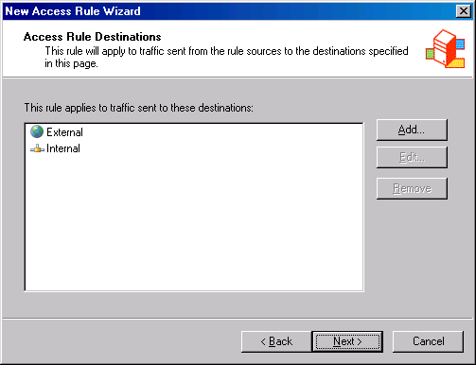
- On the User Sets page, accept the default setting, All Users, and click Next.
- Click Finish on the Completing the New Access Rule Wizard page.
- Click Apply to save the changes and update the firewall policy.
- Click OK in the Apply New Configuration dialog box. The VPN client policy is now the top listed Access Rule in the Access Policy list.

Enable Dial-in Access for the Administrator Account
In non-native mode Active Directory domains, all user accounts have dial-in access disabled by default. You must enable dial-in access on a per account basis for non-native mode Active Directory domains. In contrast, Remote Access Policy controls dial-in access, by default, in native mode Active Directory domains.. Windows NT 4.0 domains always have dial-in access controlled on a per user account basis.
In our current example, the Active Directory is in Windows Server 2003 mixed mode, so we need to manually change the dial-in settings on the domain user account.
Perform the following steps on the domain controller to enable Dial-in access for the Administrator account:
- Click Start and point to Administrative Tools. Click Active Directory Users and Computers.
- In the Active Directory Users and Computers console, click on the Users node in the left pane. Double click on the Administrator account in the right pane of the console.
- Click on the Dial-in tab. In the Remote Access Permission (Dial-in or VPN) frame, select Allow access. Click Apply and OK.
- Close the Active Directory Users and Computers console.

Establish a L2TP/IPSec VPN Connection to the ISA Server 2004 Firewall/VPN Server from an External VPN Client Computer
Perform the following steps to test the L2TP/IPSec connection to the back-end firewall through the front-end firewall:
- Create a VPN connectoid on the VPN client computer on the External network and configure the connectoid to connect to IP address 192.168.1.71. Establish the connection.
- Close the Connection Complete dialog box after the connection is established by clicking OK.
- On the front-end ISA Server 2004 firewall, open the Microsoft Internet Security and Acceleration Server 2004 management console and expand the server name. Click on the Monitoring node.
- In the Details pane, click the Logging tab. Click the Tasks tab in the Task pane. Click Start Query. You will see the L2TP/IPSec connection from the VPN client to the front-end ISA Server 2004 firewall.
- On the Back-end Firewall, open the Microsoft Internet Security and Acceleration Server 2004 management console, and expand the server name. Click on the Monitoring node.
- In the Details pane, click the Logging tab. Click the Tasks tab in the Task pane. Click Start Query.
- At the VPN client computer, open the Web browser and enter www.microsoft.com/isaserver in the Address bar, and press ENTER.
- Return to the back-end ISA Server 2004 firewall and view the Web site connection made by the VPN client machine.
- Close the browser on the VPN client and right click on the connection icon in the system tray. Click Disconnect.


Conclusion
In this ISA Server 2004 VPN Deployment Kit document, we discussed how to configure front-end and back-end ISA Server 2004 firewalls to allow incoming L2TP/IPSec NAT-T VPN connections to the corporate network. In the next document in this ISA Server 2004 VPN Deployment Kit series we will discuss how to allow inbound PPTP connections through a back-to-back ISA Server 2004 perimeter network via PPTP Server Publishing Rules,

This is a preliminary document and may be changed substantially prior to final commercial release of the software described herein.
The information contained in this document represents the current view of Microsoft Corporation on the issues discussed as of the date of publication. Because Microsoft must respond to changing market conditions, it should not be interpreted to be a commitment on the part of Microsoft, and Microsoft cannot guarantee the accuracy of any information presented after the date of publication.
This white paper is for informational purposes only. MICROSOFT MAKES NO WARRANTIES, EXPRESS OR IMPLIED, IN THIS
DOCUMENT.
Complying with all applicable copyright laws is the responsibility of the user. Without limiting the rights under copyright, no part of this document may be reproduced, stored in, or introduced into a retrieval system, or transmitted in any form or by any means (electronic, mechanical, photocopying, recording, or otherwise), or for any purpose, without the express written permission of Microsoft Corporation.
Microsoft may have patents, patent applications, trademarks, copyrights, or other intellectual property rights covering subject matter in this document. Except as expressly provided in any written license agreement from Microsoft, the furnishing of this document does not give you any license to these patents, trademarks, copyrights, or other intellectual property.
© 2004 Microsoft Corporation. All rights reserved.
The example companies, organizations, products, domain names, e-mail addresses, logos, people, places, and events depicted herein are fictitious. No association with any real company, organization, product, domain name, e-mail address, logo, person, place, or event is intended or should be inferred.
Microsoft, Windows, Windows 2000, Windows 2000 Server, Windows Server 2003, Windows Server System, ISA Server, and ISA Server 2004 are either registered trademarks or trademarks of Microsoft Corporation in the United States and/or other countries.
The names of actual companies and products mentioned herein may be the trademarks of their respective owners.

ISA Server 2004 VPN Deployment Kit: Allowing Inbound PPTP Connections through a Back-to-Back ISA Server 2004 Server Perimeter Network
Chapter 13

For the latest information, please see http://www.microsoft.com/isaserver/

Contents
Introduction 1
Overview of the Back-to-back ISA Server 2004 Firewall Network Topology 2
Restore the Back-end Firewall Machine to it Post-Installation State 3
Install the ISA Server 2004 Firewall Software on the Front-End Firewall 4
Configure the Front-End ISA Server 2004 Firewall to Forward PPTP Connections to the Back-End ISA Server 2004 Firewall/VPN Server 9
Configure the Back-End ISA Server 2004 Firewall/VPN Server to Allow VPN Remote Access Connections 13
Create an Access Rule Allowing VPN Clients Access to the Internal Network and the Internet 21
Enable Dial-in Access for the Administrator Account 25
Establish a PPTP VPN Connection to the ISA Server 2004 Firewall/VPN Server from an External VPN Client Computer 26
Conclusion 27

Introduction
You can enhance security for your VPN remote access connections by creating a back-to-back ISA Server 2004 firewall configuration. In the back-to-back ISA Server 2004 firewall setup the front-end ISA Server 2004 firewall has an interface directly connected to the Internet and a second interface connected to a perimeter network between the front-end and back-end ISA Server 2004 firewall. The back-end ISA Server 2004 firewall has an interface on the perimeter network between the front-end and back-end ISA Server 2004 firewall and an interface on the Internal network.
The back-to-back ISA Server 2004 firewall configuration creates a perimeter network between the two firewall. You can place publicly accessible servers on this perimeter network. The front-end ISA Server 2004 firewall allows external users access to servers on the perimeter network, while the back-end firewall blocks external users from accessing resources on the Internal network.
You can configure the front-end ISA Server 2004 firewall to accept the incoming PPTP VPN connections and forward those connections to the back-end ISA Server 2004 firewall. The VPN connections are terminated on the back-end ISA Server 2004 firewall. This means that the PPTP VPN connection remains encrypted and secure even when passing between the front-end and back-end firewalls.
We will discuss the following procedures required to create a successful VPN connection through the front-end and back-end ISA Server 2004 firewalls:
- Overview of the Back-to-back ISA Server 2004 Firewall Network Topology
- Restore the Firewall Machine to its Post-Installation State
- Install the ISA Server 2004 Firewall Software on the Front-End Firewall
- Configure the Front-End ISA Server 2004 Firewall to Forward PPTP Connections to the Back-End ISA Server 2004 Firewall/VPN Server
- Configure the Back-End ISA Server 2004 Firewall/VPN Server to Allow VPN Remote Access Connections
- Create an Access Rule Allowing VPN Clients Access to the Internal Network and the Internet
- Enable Dial-in Access for the Administrator Account
- Establish a PPTP VPN Connection to the ISA Server 2004 Firewall/VPN Server from an External VPN Client Computer

Overview of the Back-to-back ISA Server 2004 Firewall Network Topology
The back-to-back firewall topology varies from that we configured during the lab network setup. You need to reconfigure the lab network so that the REMOTEISA computer acts as a front-end firewall, and then reset the IP addresses on both the REMOTEISA and the ISALOCAL computers to support the back-to-back firewall configuration.
The figure below shows the back-to-back ISA Server 2004 firewall topology.
The table below shows the IP address scheme for the back-to-back ISA Server 2004 firewall configuration.
Addressing | EXCHANGE2003BE | ISALOCAL | REMOTEISA | EXTCLIENT
IP Address | 10.0.0.2 | Int: 10.0.0.1  Ext: 10.0.2.2 | Int: 10.0.2.1  Ext: 192.168.1.71 | 192.168.1.90
Default Gateway | 10.0.0.1 | Int: N/A  Ext: 10.0.2.1 | Int: N/A  Ext: 192.168.1.60 | N/A
DNS | 10.0.0.2 | N/A | 192.168.1.34 | N/A
WINS | 10.0.0.2 | N/A | N/A | N/A

This network topology will allow the external client computer to connect to the front-end ISA Server 2004 firewall. The connection to the front-end ISA Server 2004 firewall will be forwarded to the back-end ISA Server 2004 firewall/VPN server. After the VPN client establishes the connection, it will be able to access resources on the Internal network. In addition, we will configure an Access Rule that will allow members of the VPN clients network to connect to the Internet. This prevents the VPN clients from using their own connection to the Internet to access Internet resources.
In the following walkthrough, we will assume that you will remove the ISA Server 2004 firewall software from REMOTEISA machine and reinstall it according to the procedures outlined in this document. You also have the option to use a new machine with a fresh installation of the Windows Server 2003 operating system.

Restore the Back-end Firewall Machine to it Post-Installation State
You should restore the machine to its post-installation state before beginning the following procedures. Restoring the post-installation state will remove all settings made on the firewall after the post-installation phase.
Perform the following steps to restore the machine to its post-installation state:
- In the Microsoft Internet Security and Acceleration Server 2004 management console, right click on the server name, and click Restore.
- In the Restore Configuration dialog box, locate the backup file you created immediately after installing the ISA Server 2004 firewall software. Select that file, and click Restore.
- In the Password dialog box, enter the password you assigned to the backup file. Click OK.
- Click OK in the Importing dialog box when you see the message, The configuration was successfully restored.
- Click Apply to save the changes and update the firewall policy.
- In the ISA Server Warning dialog box, select Save the changes and restart the service(s) and click OK.
Click OK in the Apply New Configuration dialog box

Install the ISA Server 2004 Firewall Software on the Front-End Firewall

Perform the following steps to install the ISA Server 2004 software:
- Insert the ISA Server 2004 CD-ROM into the CD drive. The autorun menu will appear.
- On the Microsoft Internet Security and Acceleration Server 2004 Beta 2 Setup page, click the link for Review Release Notes and read the release notes. The release notes contain useful information about important issues and configuration options. After reading the release notes, close the release notes window and click the Read Setup and Feature Guide link. You don’t need to read the entire guide right now, but you may want to print it out to read later. Close the Setup and Feature Guide window. Click Install ISA Server 2004.
- Click Next on the Welcome to the Installation Wizard for Microsoft ISA Server 2004 page.
- Select I accept the terms in the license agreement on the License Agreement page. Click Next.
- On the Customer Information page, enter your name and the name of your organization in the User Name and Organization text boxes. Enter Product Serial Number. Click Next.
- On the Setup Type page, select Custom. If you do not want to install the ISA Server 2004 software on the C: drive, click Change to change the location of the program files on the hard disk. Click Next.
- On the Custom Setup page, you can choose which components to install. By default, the Firewall Services and ISA Server Management options are installed. The Message Screener, which is used to help prevent spam and file attachments from entering and leaving the network, is not installed; neither is the Firewall Client Installation Share. You need to install the IIS 6.0 SMTP service on the ISA Server 2004 firewall computer before you install the Message Screener. Use the default settings and click Next.

- On the Internal Network page, click Add. The Internal network is different from the LAT, which was used in ISA Server 2000. In the case of ISA Server 2004, the Internal network contains trusted network services with which the ISA Server 2004 firewall must be able to communicate. Examples of such services include Active Directory domain controllers, DNS, DHCP, terminal services client management workstations, and others. The firewall System Policy automatically uses the Internal network. We will look at the System Policy later in this document.

- On the Internal Network setup page, click Select Network Adapter.

- In the Select Network Adapter dialog box, remove the checkmark from the Add the following private ranges… check box. Leave the checkmark in the Add address ranges based on the Windows Routing Table check box. Put a checkmark in the check box next to the adapter connected to the Internal network. The reason why we remove the checkmark from the Add the following private ranges check box is that you may wish to use these private address ranges for perimeter networks. The front-end firewall uses the perimeter network between itself and the back-end firewall as its Internal network. Click OK.
- Click OK in the Setup Message dialog box informing you that the Internal network was defined, based on the Windows routing table.
- Click OK on the Internal network address ranges dialog box.
- Click Next on the Internal Network page.
- On the Firewall Client Connection Settings page, place checkmarks in the Allow non-encrypted Firewall client connections and Allow Firewall clients running earlier versions of the Firewall client software to connect to ISA Server check boxes. These settings will allow you to connect to the ISA Server 2004 firewall using downlevel operating systems and from Windows 2000/Windows XP/Windows Server 2003 operating systems running the ISA Server 2000 version of the Firewall client. Note that on a production network, you may wish to disable these settings. Disabling these settings will prevent downlevel Firewall clients from operating on the perimeter network while allowing you to configure firewall chaining between the downstream and upstream ISA Server 2004 firewall computers later, if you wish. Click Next.
- On the Services page, click Next.
- Click Install on the Ready to Install the Program page.
- On the Installation Wizard Completed page, click Finish.
- Click Yes in the Microsoft ISA Server dialog box informing you that the machine must be restarted.
Log on as Administrator after the machine restarts.

Configure the Front-End ISA Server 2004 Firewall to Forward PPTP Connections to the Back-End ISA Server 2004 Firewall/VPN Server
You need to create a Server Publishing Rule that will forward incoming PPTP connections to the back-end firewall. ISA Server 2004 includes a built-in PPTP Server protocol that hooks into the ISA Server 2004 firewall’s sophisticated PPTP application layer filter.
Perform the following steps to configure the front-end ISA Server 2004 firewall machine:
- In the Microsoft Internet Security and Acceleration Server 2004 management console, expand the server name and click the Firewall Policy node.
- Right click the Firewall Policy node; point to New and click Server Publishing Rule.
- On the Welcome to the New Server Publishing Rule Wizard page, enter a name for the Server Publishing Rule in the Server publishing rule name text box. In this example, enter PPTP Server. Click Next.
- On the Select Server page, enter the IP address of the external interface of the back-end ISA Server 2004 firewall/VPN server machine in the Server IP address text box. In this example the IP address is 10.0.2.2, so we will enter that value into the text box. Click Next.
- On the Select Protocol page, select PPTP Server from the Selected protocol list. Click Next.
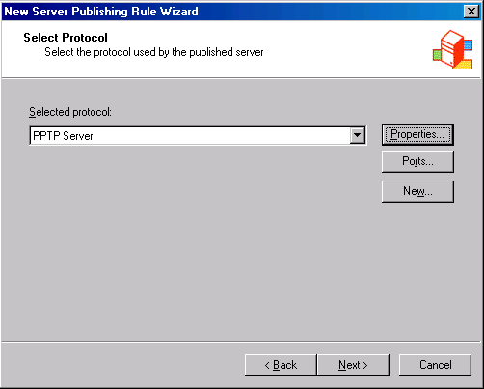
- On the IP Addresses page, put a checkmark in the External check box and click Next.
- Click Finish on the Completing the New Server Publishing Rule Wizard page.
- Click Apply to save the changes and update the firewall policy.
- Click OK in the Apply New Configuration dialog box.
The next step is to create an Access Rule that allows the back-end ISA Server 2004 firewall/VPN server outbound access to the Internet. This rule will limit outbound access to the Internet to the external address on the back-end firewall. In a production environment, you would create Access Rules on the front-end ISA Server 2004 firewall allowing only protocols to which you have allowed outbound access on the back-end firewall.
Perform the following steps to create the outbound Access Rule:
- In the Microsoft Internet Security and Acceleration Server 2004 management console, click the Tasks tab in the Task pane. Click Create New Access Rule.
- In the Welcome to the New Access Rule Wizard page, enter a name for the rule in the Access Rule name text box. In this example, enter Outbound from Back-end Firewall. Click Next.
- On the Rule Action page, select Allow and click Next.
- On the Protocols page, accept the default setting, All outbound protocols, from the This rule applies to list. Click Next.
- On the Access Rule Sources page, click Add. In the Add Network Entities dialog box, click the New menu. Click Computer entry in the list. In the New Computer Rule Element dialog box, enter Back End Firewall in the Name text box. In the Computer IP Address text box, enter the IP address on the external interface of the back-end firewall. In this example, the IP address is 10.0.2.2, so we will enter that address into the text box. Click OK.
- In the Add Network Entities dialog box, click the Computers folder. Double click the Back End Firewall entry, and click Close. Click Next on the Access Rule Sources page.
- On the Access Rule Destinations page, click Add. In the Add Network Entities dialog box, click the Networks folder and then double click External. Click Close. Click Next in the Access Rule Destinations dialog box.
- On the User Sets page, accept the default entry, All Users, and click Next.
- Click Finish on the Completing the New Access Rule Wizard page.
- Click Apply to save the changes and update the firewall policy.
- Click OK in the Apply New Configuration dialog box.
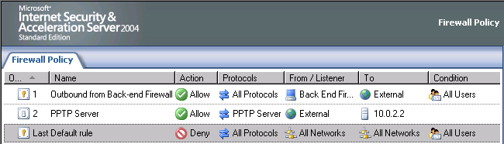

Configure the Back-End ISA Server 2004 Firewall/VPN Server to Allow VPN Remote Access Connections
By default, the VPN server component is disabled. The first step is to enable the VPN server feature and configure the VPN server components.
Perform the following steps to enable and configure the ISA Server 2004 VPN Server:
- Open the Microsoft Internet Security and Acceleration Server 2004 management console and expand the server name. Click on the Virtual Private Networks (VPN) node.
- Click on the Tasks tab in the Task pane. Click Enable VPN Client Access.
- Click Apply to save the changes and update the firewall policy.
- Click OK in the Apply New Configuration dialog box.
- Click Configure VPN Client Access on the Tasks tab.
- On the General tab, change the value for the Maximum number of VPN clients allowed from 5 to 10.
- Click on the Groups tab. Click Add.
- In the Select Groups dialog box, click Locations. In the Locations dialog box, click msfirewall.org and OK.
- In the Select Group dialog box, enter Domain Users in the Enter the object names to select text box. Click Check Names. The group name will be underlined when it is found in the Active Directory. Click OK.
- Click the Protocols tab. On the Protocols tab, put a checkmark in the Enable L2TP/IPSec check box.
- Click the User Mapping tab. Put a checkmark in the Enable User Mapping check box. Put a checkmark in the When username does not contain a domain, use this domain check box. Enter msfirewall.org in the Domain Name text box. Note that these settings will only apply when using RADIUS authentication. These settings are ignored when using Windows authentication (such as when the ISA Server 2004 firewall machine belongs to the domain and the user explicitly enters domain credentials). Click Apply and OK. You may see a Microsoft Internet Security and Acceleration Server 2004 dialog box informing you that you need to restart the computer for the settings to take effect. If so, click OK in the dialog box.
- On the Tasks tab, click Select Access Networks.
- In the Virtual Private Networks (VPN) Properties dialog box, click the Access Networks tab. Note that the External check box is selected. This indicates that the external interface is listening for incoming VPN client connections.
- Click the Address Assignment tab. Select the internal interface from the Use the following network to obtain DHCP, DNS and WINS services drop down list box. This is a critical setting as it defines the network on which access to the DHCP is made.
- Click on the Authentication tab. Note that the default setting is to enable only Microsoft encrypted authentication version 2 (MS-CHAPv2). In later documents in this ISA Server 2004 VPN Deployment Kit, we will enable the EAP option so that high-security user certificates can be used to authenticate with the ISA Server 2004 firewall VPN server. Note the Allow custom IPSec policy for L2TP connection check box. If you do not want to create a public key infrastructure, or you are in the process of creating one but have not yet finished, you can enable this checkbox and enter a pre-shared key. At this time, we will not enable this option.
- Click the RADIUS tab. Here you can configure the ISA Server 2004 firewall VPN server to use RADIUS to authenticate the VPN users. The advantage of RADIUS authentication is that you can leverage the Active Directory user database (and others) to authenticate users without needing to join the Active Directory domain.
- Click Apply in the Virtual Private Networks (VPN) Properties dialog box, and then click OK.
- Click Apply to save the changes and update the firewall policy.
- Click OK in the Apply New Configuration dialog box.
- Restart the ISA Server 2004 firewall machine.
The machine will obtain a block of IP addresses from the DHCP Server on the Internal network when it restarts. Note that on a production network where the DHCP server is located on a network segment remote from the ISA Server 2004 firewall, all interposed routers will need to have BOOTP or DHCP relay enabled so that DHCP requests from the firewall can reach the remote DHCP servers.

Create an Access Rule Allowing VPN Clients Access to the Internal Network and the Internet
The ISA Server 2004 firewall will be able to accept incoming VPN connections after the restart. However, the VPN clients cannot access any resources on the Internal network or the Internet because there are no Access Rules enabling this access. You must create an Access Rule that allows members of the VPN clients network access to the Internal network and the Internet. In contrast to other combined firewall VPN server solutions, the ISA Server 2004 firewall VPN server applies access controls for network access to VPN clients.
- Note:
VPN clients should not be allowed to connect directly to the Internet while connected to the corporate network. By default, the Microsoft VPN client software does not allow the VPN client to connect to the Internet except through the VPN connection. Disabling the VPN client security setting that forces the VPN client to connect to the Internet through its own Internet connection is referred to as split tunneling. Split tunneling should be avoided because of its attendant security risks.
In this example, you will create an Access Rule allowing all traffic to pass from the VPN clients network to the Internal network and the Internet. In a production environment, you would create more restrictive access rules so that users on the VPN clients network have access only to resources they require on the Internal network and the Internet. .
Perform the following steps to create an Access Rule that allows VPN clients unrestricted access to the Internal network and the Internet on the back-end ISA Server 2004 firewall:
- In the Microsoft Internet Security and Acceleration Server 2004 management console, expand the server name and click the Firewall Policy node. Right click the Firewall Policy node; point to New and click Access Rule.
- In the Welcome to the New Access Rule Wizard page, enter a name for the rule in the Access Rule name text box. In this example, enter VPN Client to Internal/Internet. Click Next.
- On the Rule Action page, select Allow and click Next.
- On the Protocols page, select All outbound protocols in the This rule applies to list. Click Next.
- On the Access Rule Sources page, click Add. In the Add Network Entities dialog box, click the Networks folder and double click on VPN Clients. Click Close.
- Click Next on the Access Rule Sources page.
- On the Access Rule Destinations page, click Add. On the Add Network Entities dialog box, click the Networks folder and double click on Internal. Next, double click on External. Click Close. Click Next on the Access Rule Destinations page.
- On the User Sets page, accept the default setting, All Users, and click Next.
- Click Finish on the Completing the New Access Rule Wizard page.
- Click Apply to save the changes and update the firewall policy.
- Click OK in the Apply New Configuration dialog box. The VPN client policy is now the top listed Access Rule in the Access Policy list.

Enable Dial-in Access for the Administrator Account
In non-native mode Active Directory domains, all user accounts have dial-in access disabled by default. You must enable dial-in access on a per account basis for these non-native mode Active Directory domains. In contrast, native mode Active Directory domains have dial-in access controlled by Remote Access Policy by default. Windows NT 4.0 domains always have dial-in access controlled on a per user account basis.
In our current example, the Active Directory is in Windows Server 2003 mixed mode, so we need to manually change the dial-in settings on the domain user account.
Perform the following steps on the domain controller to enable Dial-in access for the Administrator account:
- Click Start and point to Administrative Tools. Click Active Directory Users and Computers.
- In the Active Directory Users and Computers console, click the Users node in the left pane. Double click the Administrator account in the right pane of the console.
- Click on the Dial-in tab. In the Remote Access Permission (Dial-in or VPN) frame, select Allow access. Click Apply and OK.
- Close the Active Directory Users and Computers console.

Establish a PPTP VPN Connection to the ISA Server 2004 Firewall/VPN Server from an External VPN Client Computer

Perform the following steps to test the PPTP connection to the back-end firewall through the front-end firewall:
- Create a VPN connectoid on the VPN client computer on the External network and configure the connectoid to connect to IP address 192.168.1.71. Establish the connection.
- Close the Connection Complete dialog box after the connection is established by clicking OK.
- On the front-end ISA Server 2004 firewall, open the Microsoft Internet Security and Acceleration Server 2004 management console and expand the server name. Click on the Monitoring node.
- In the Details pane, click the Logging tab. Click the Tasks tab in the Task pane. Click Start Query. You will see the PPTP connection from the VPN client to the front-end ISA Server 2004 firewall.
- On the Back-end Firewall, open the Microsoft Internet Security and Acceleration Server 2004 management console and expand the server name. Click on the Monitoring node.
- In the Details pane, click the Logging tab. Click the Tasks tab in the Task pane. Click Start Query.
- At the VPN client computer, open the Web browser and enter www.microsoft.com/isaserver in the Address bar. Press ENTER.
- Return to the back-end ISA Server 2004 firewall and view the Web site connection made by the VPN client machine.
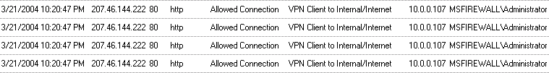
- Close the browser on the VPN client and right click on the connection icon in the system tray. Click Disconnect.

Conclusion
In this ISA Server 2004 VPN Deployment Kit document, we discussed how to configure front-end and back-end ISA Server 2004 firewalls to allow incoming PPTP VPN connections to the corporate network. In the next document in this ISA Server 2004 VPN Deployment Kit series, we will look at how to enable and configure the ISA Server 2004 VPN Quarantine features.

This is a preliminary document and may be changed substantially prior to final commercial release of the software described herein.
The information contained in this document represents the current view of Microsoft Corporation on the issues discussed as of the date of publication. Because Microsoft must respond to changing market conditions, it should not be interpreted to be a commitment on the part of Microsoft, and Microsoft cannot guarantee the accuracy of any information presented after the date of publication.
This white paper is for informational purposes only. MICROSOFT MAKES NO WARRANTIES, EXPRESS OR IMPLIED, IN THIS
DOCUMENT.
Complying with all applicable copyright laws is the responsibility of the user. Without limiting the rights under copyright, no part of this document may be reproduced, stored in, or introduced into a retrieval system, or transmitted in any form or by any means (electronic, mechanical, photocopying, recording, or otherwise), or for any purpose, without the express written permission of Microsoft Corporation.
Microsoft may have patents, patent applications, trademarks, copyrights, or other intellectual property rights covering subject matter in this document. Except as expressly provided in any written license agreement from Microsoft, the furnishing of this document does not give you any license to these patents, trademarks, copyrights, or other intellectual property.
© 2004 Microsoft Corporation. All rights reserved.
The example companies, organizations, products, domain names, e-mail addresses, logos, people, places, and events depicted herein are fictitious. No association with any real company, organization, product, domain name, e-mail address, logo, person, place, or event is intended or should be inferred.
Microsoft, Windows, Windows 2000, Windows 2000 Server, Windows Server 2003, Windows Server System, ISA Server, and ISA Server 2004 are either registered trademarks or trademarks of Microsoft Corporation in the United States and/or other countries.
The names of actual companies and products mentioned herein may be the trademarks of their respective owners.

ISA Server 2004 VPN Deployment Kit: Configuring VPN Quarantine
Chapter 14
Published: April 2004
For the latest information, please see http://www.microsoft.com/isaserver/

Contents
Introduction 1
Explain the Network Configuration 3
Install IIS and Certificate Services on CA1 – the Machine Available to VPN Clients in Quarantine 5
Create a Shared Folder on the CA1 Machine 8
Install IIS on IIS1 – the Machine Not Available to VPN Clients in Quarantine 10
Enable the Administrator Account for VPN Access 12
Install ISA Server 2004 13
Enable the VPN Server Component on the ISA Server 2004 Firewall machine 19
Enable VPN Quarantine Control 27
Configure ISA Server 2004 Access Policy 29
Install the Quarantine Service Listener on the ISA Server 2004 Firewall 36
Install the Connection Manager Administration Kit on the ISA Server 2004 Firewall 37
Create a Sample VPN Client Requirement File and Web Page on the Machine Available to Quarantined VPN Clients 38
Create a Web Page on the Machine Not Available to VPN Clients 40
Create a Quarantine Script and Save it on the ISA Server 2004 Firewall 41
Create the Connection Manager Profile 44
Install the Connection Manager Profile on the VPN Client Machine 53
Test the Connection 54
Conclusion 56

Introduction
The ISA Server 2004 VPN Quarantine feature allows you to pre-qualify VPN clients before those clients are allowed access to resources that are available to non-quarantined VPN client machines. VPN Quarantine allows you to control the “quality” of client connected to the network via a VPN connection by insuring that the VPN client machine meet specific requirements, such as service pack level and updated anti-virus signatures.
VPN Quarantine requires client and server-side pieces to work correctly. The VPN client is configured with a VPN Quarantine script that it runs after making the VPN connection. The script checks for installed software on the VPN client machine. If the machine meets all the requirements set forth in the VPN-Q script, then it sends a message to the server-side component indicating that the system check was successful. At this point, the VPN client machine is moved from the VPN Quarantine Network to the VPN Clients Network. If the client isn’t able to meet the requirements, it stays on the VPN Quarantine Network.
The ISA Server 2004 VPN Quarantine feature allows you to create Access Policies based on the network on which the VPN clients are placed. For example, if the VPN client machine is not able to meet the requirements set forth in the VPN-Q script, it can still access resources that you configure as available to machines that remain in quarantine. Those resources may contain files that give information on how to be removed from quarantine, or may contain automated processes that configure the VPN client with the required software so the next time the VPN client dials into the network, it will pass the VPN-Q check.
If you are an accomplished batch or application programmer, you will be able to fully realize all the power and flexibility provided by the VPN-Q feature. Even If you do not fall within this class, you should continue reading this document to see how the VPN-Q feature works with ISA Server 2004; the exercise will give you a good grounding in how ISA Server 2004 works and perhaps motivate you to seek consultation on creating the required scripts or applications.
In order to demonstrate how the VPN-Q feature works, we will use custom versions of the VPN-Q client component, RQC.exe, and the VPN-Q server component, RQS.exe, both of which can be downloaded from the Microsoft ISA Server 2004 Web site. In the following demonstration, we will create two new servers: a resource server for VPN clients that remain on the VPN Quarantine Network, and a resource server for VPN client that are removed from the VPN Quarantine Network and placed on the VPN Clients network. An Access Rule prevents clients on the VPN Quarantine Network from accessing resources on the server available only to hosts on the VPN Clients Network.
A production VPN-Q solution requires a great deal of planning and development time. The VPN-Q solution performed in this walkthrough will demonstrate why this is so. In this ISA Server 2004 VPN Deployment Kit document, we will go through the following steps to create a successful test environment that demonstrates how VPN-Q works with ISA Server 2004:
- Explain the Network Configuration
- Install IIS and Certificate Services on CA1 – the Machine Available to VPN Clients in Quarantine
- Install IIS on IIS1 – the Machine Not Available to VPN Clients in Quarantine
- Enable the Administrator Account for VPN Access
- Install ISA Server 2004
- Enable the ISA Server 2004 VPN Server Component
- Enable VPN Quarantine Control
- Configure ISA Server 2004 Access Policy
- Install the Windows Server 2003 Resource Kit Tools and Install the Quarantine Service Listener on the ISA Server 2004 Firewall
- Install the Connection Manager Administration Kit on the ISA Server 2004 Firewall
- Create a Sample VPN Client Requirement File and Web Page on the Machine Available to Quarantined VPN Clients
- Create a Web Page on the Machine Not Available to VPN Clients
- Create a Quarantine Script and Save it on the ISA Server 2004 Firewall
- Create the Connection Manager Profile
- Install the Connection Manager Profile on the VPN Client Machine
- Test the Connection

Explain the Network Configuration
We will not follow the basic network configuration used in the other documents in the ISA Server 2004 VPN Deployment Kit. The reason for this change is that we need to add two new servers -- one server to represent a VPN Quarantine resource server and a second server to use as a resource server for VPN clients that are removed from VPN Quarantine.
The following diagram depicts the setup for our VPN-Q test network.
All the machines on the Internal network are located behind the ISA Server 2004 firewall as members of the same domain, msfirewall.org. The VPN client machine on the External network does not belong to the domain.
The table below provides the IP address and operating system and services details for each of the machines on the test network.
Table 1: IP Addressing and Services Details on Test Network
Lab Network Details
Setting | EXCHANGE  2003BE | CA1 | LOCALVPNISA | IIS1 | VPNCLIENT
IP Address | 10.0.0.2 | 10.0.0.3 | Int: 10.0.0.1  Ext: 192.168.1.70 | 10.0.0.4 | 192.168.1.90
Default Gateway | 10.0.0.1 | 10.0.0.1 | 192.168.1.60 | 10.0.0.1 | NONE
DNS | 10.0.0.2 | 10.0.0.2 | 10.0.0.2 | 10.0.0.2 | NONE
WINS | 10.0.0.2 | 10.0.0.2 | 10.0.0.2 | 10.0.0.2 | NONE
OS | Windows Server 2003 | Windows 2003 | Windows Server 2003 | Windows Server 2003 | Windows XP
Services | DC  DNS  WINS  DHCP  RADIUS  Enterprise CA | IIS:  WWW | ISA Server 2004 | IIS:  WWW | NONE
Domain Membership | msfirewall.org | msfirewall.org | msfirewall.org | msfirewall.org | NONE

Install IIS and Certificate Services on CA1 – the Machine Available to VPN Clients in Quarantine
The VPN clients will need to connect to a Web page on the CA1 machine. The Web page provides information about why the VPN client is placed in quarantine and what procedures must be performed so that the machine can be moved from the VPN Quarantine network to the VPN Clients network. We will install a Certificate Server on the CA1 machine so that VPN clients can request computer certificates if they wish to use L2TP/IPSec to make a connection.
Perform the following steps to install Internet Information Service 6.0 (IIS) on the CA1 machine:
- Click Start and point to Control Panel. Click Add or Remove Programs.
- In the Add or Remove Programs window, click Add/Remove Windows Components on the left side of the window.
- On the Windows Components page, select Application Server on the Components page. Click Details.
- In the Application Server dialog box, put a checkmark in the ASP.NET check box. Select the Internet Information Services (IIS) entry, and click Details.
- In the Internet Information Services (IIS) dialog box, put a checkmark in the NNTP Service check box. Put a checkmark in the SMTP Service check box. Click OK.
- Click OK in the Application Server dialog box.
- Click Next on the Windows Components page.
- Click OK in the Insert Disk dialog box.
- In the Files Needed dialog box, enter the path to the i386 folder for the Windows Server 2003 CD in the Copy file from text box. Click OK.
- Click Finish on the Completing the Windows Components Wizard page.
- Close the Add or Remove Programs window.
Perform the following steps install a subordinate enterprise CA on the CA1 machine:
- In the Add or Remove Programs window, click Add/Remove Windows Components on the left side of the window.
- On the Windows Components page, place a checkmark in the Certificate Services check box in the Components list. Click Yes in the Microsoft Certificate Services dialog box informing you that the machine name and domain membership cannot be changed while the machine acts as a CA.
- Click Next in the Windows Components page.
- On the CA Type page, select Enterprise subordinate CA option. Click Next.
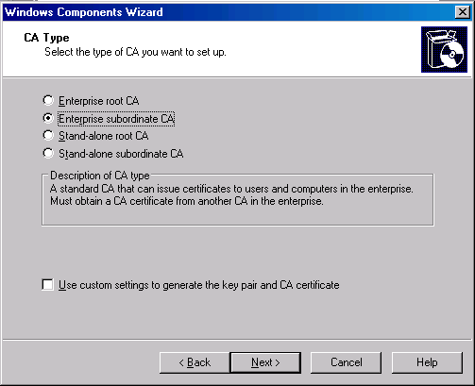
- On the CA Identifying Information page, enter the name CA1 in the Common name for this CA text box. Click Next.
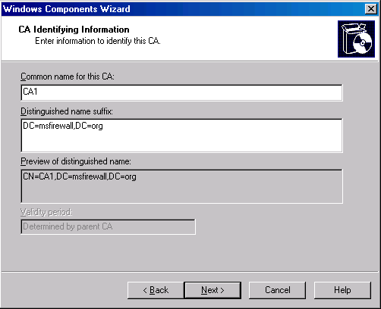
- Accept the default values on the Certificate Database Settings page, and click Next.
- On the CA Certificate Request page, click Browse. Select the enterprise CA EXCHANGE2003BE.msfirewall.org and click OK. Click Next.
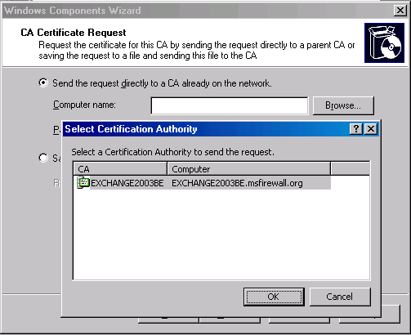
- Click Yes in the Microsoft Certificate Services dialog box informing you that Internet Information Services must be stopped.
- Click OK in the Insert Disk dialog box. In the Files Needed dialog box, enter the path to the Windows Server 2003 i386 folder in the Copy files from text box. Click OK.
- Click Yes in the Microsoft Certificate Services dialog box informing you that Active Server Pages must be enabled.
- Click Finish on the Completing the Windows Components Wizard page.
- Close the Add or Remove Programs window.

Create a Shared Folder on the CA1 Machine
The next step is to create a shared folder on the CA1 machine. We will later place a file in this folder that Quarantined VPN clients can access. The file that we place in this folder simulates an operating system update that a VPN client would need to install before being allowed into the VPN Clients network.
Perform the following steps to create the shared folder:
- Right click on the desktop and point to New. Click Folder.
- Click on the folder, then right click the folder and click Rename. Name the folder Quarantine.
- Right click the folder and click Sharing and Security.
- In the Quarantine Properties dialog box, click the Sharing tab. On the Sharing tab, select Share this folder. Use the default Share name of Quarantine.
- Click the Security tab. Click Add. In the Select Users, Computers, or Groups dialog box, enter Everyone in the Enter the object names to select text box. Click Check Names. The name is underlined when the change is made. Click OK.
- Click Apply and then click OK in the Quarantine Properties dialog box.
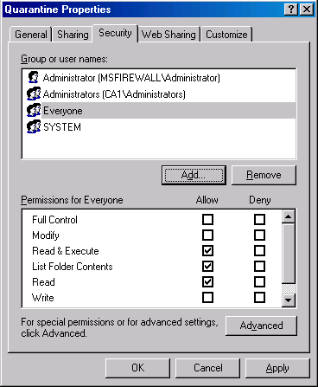
- Go to the domain controller machine. Open Internet Explorer and enter http://ca1.msfirewall.org in the Address bar, and press ENTER. You should see the Under Construction page.
- In the Address bar, enter \\ca1.msfirewall.org\quarantine. You should see an empty folder.

Install IIS on IIS1 – the Machine Not Available to VPN Clients in Quarantine
The IIS1 machine is available to VPN clients that are placed on the VPN Clients Network. This machine is not available to VPN clients placed on the VPN Quarantine network. VPN clients placed on the VPN Quarantine network can test access policy by attempting to connect to the IIS1 machine. If the Access Policies are configured correctly, the VPN clients will not be able to access resources on the IIS1 machine.
Perform the following steps to install IIS on the IIS1 machine:
- Click Start and point to Control Panel. Click Add or Remove Programs.
- In the Add or Remove Programs window, click Add/Remove Windows Components on the left side of the window.
- On the Windows Components page, select Application Server on the Components page. Click Details.
- In the Application Server dialog box, put a checkmark in the ASP.NET check box. Select the Internet Information Services (IIS) entry, and click Details.
- In the Internet Information Services (IIS) dialog box, put a checkmark in the NNTP Service check box. Put a checkmark in the SMTP Service check box. Click OK.
- Click OK in the Application Server dialog box.
- Click Next on the Windows Components page.
- Click OK in the Insert Disk dialog box.
- In the Files Needed dialog box, enter the path to the i386 folder for the Windows Server 2003 CD in the Copy file from text box. Click OK.
- Click Finish on the Completing the Windows Components Wizard page.
- Close the Add or Remove Programs window.
After VPN client machines leave the VPN Quarantine network, they are placed on the VPN Clients network. The IIS1 machine is not accessible to the Quarantined VPN clients, but it is accessible to the non-Quarantined VPN clients. To demonstrate this, we will share the entire hard disk on the IIS1 machine.
Perform the following steps to share the hard disk on the IIS1 machine:
- Right click on the Start button, and click Explore.
- Right click on the C: drive, and click Sharing and Security.
- On the Sharing tab of the Local Disk (C:) Properties dialog box, click New Share.
- In the New Share dialog box, enter ROOT into the Share Name text box. Click OK.
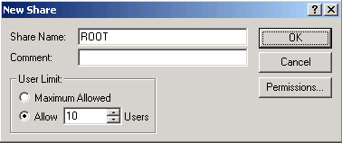
- Click Apply and OK in the Local Disk (C:) Properties dialog box.
Now let’s test connectivity to the browser and the share:
- Go to the domain controller machine. Open Internet Explorer and enter http://iis1.msfirewall.org in the Address bar. Press ENTER. You should see the Under Construction page.
- In the Address bar, enter \\iis1.msfirewall.org\root. You should see a list of the hard disk contents.

Enable the Administrator Account for VPN Access
In non-native mode domains, VPN access is controlled on a per user account basis. The default setting is to disable Dial-in access for domain users. We must enable the Administrator account for Dial-in access before the user can connect to the VPN server.
Perform the following steps to create a VPN user account at the domain controller computer:
- At the domain controller machine, click Start and point to Administrative Tools. Click Active Directory Users and Computers.
- Expand the domain name in the left pane of the console, and click the Users node in the left pane of the console. Double click the Administrator account in the right pane of the console.
- In the Properties dialog box of the Administrator account, click the Dial-in tab. Select Allow access from the Remote Access Permission (Dial-in or VPN) frame.
- Click Apply and then click OK.

Install ISA Server 2004
Installing ISA Server 2004 on Windows Server 2003 is relatively straightforward. The major decision you make during setup is what IP addresses should be part of the Internal network. The Internal network address configuration is important because the firewall’s System Policy uses the Internal network addresses to define a set of Access Rules.
Perform the following steps to install the ISA Server 2004 software on the dual-homed Windows Server 2003 machine:
- Insert the ISA Server 2004 CD-ROM into the CD drive. The autorun menu will appear.
- On the Microsoft Internet Security and Acceleration Server 2004 page, click the link for Review Release Notes and read the release notes. The release notes contain useful information about important issues and configuration options. After reading the release notes, close the release notes window, and click Read Setup and Feature Guide. You don’t need to read the entire guide right now, but you may want to print it out to read later. Close the Setup and Feature Guide window. Click Install ISA Server 2004.
- Click Next on the Welcome to the Installation Wizard for Microsoft ISA Server 2004 page.
- Select I accept the terms in the license agreement on the License Agreement page. Click Next.
- On the Customer Information page, enter your name and the name of your organization in the User Name and Organization text boxes. Enter Product Serial Number. Click Next.
- On the Setup Type page, select the Custom option. If you do not want to install the ISA Server 2004 software on the C: drive, click the Change button to change the location of the program files on the hard disk. Click Next.
- On the Custom Setup page you can choose which components to install. By default, the Firewall Services and ISA Server Management options are installed. The Message Screener, which is used to help prevent spam and file attachments from entering and leaving the network, is not installed by default; neither is the Firewall Client Installation Share. You need to install the IIS 6.0 SMTP service on the ISA Server 2004 firewall computer before you install the Message Screener. Use the default settings and click Next.

- On the Internal Network page, click Add. The Internal network is different from the LAT, which was used in ISA Server 2000. In the case of ISA Server 2004, the Internal network contains trusted network services with which the ISA Server 2004 firewall must be able to communicate. Examples of such services include Active Directory domain controllers, DNS, DHCP, terminal services client management workstations, and others. The firewall System Policy automatically uses the Internal network. We will look at the System Policy later in this document.

- On the Internal Network setup page, click Select Network Adapter.

- In the Select Network Adapter dialog box, remove the checkmark from the Add the following private ranges… check box. Leave the checkmark in the Add address ranges based on the Windows Routing Table check box. Put a checkmark in the check box next to the adapter connected to the Internal network. The reason why we remove the checkmark from the Add the following private ranges check box is that you may wish to use these private address ranges for perimeter networks. Click OK.
- Click OK in the Setup Message dialog box informing you that the Internal network was defined based on the Windows routing table.
- Click OK on the Internal network address ranges dialog box.
- Click Next on the Internal Network page.

- On the Firewall Client Connection Settings page, place checkmarks in the Allow non-encrypted Firewall client connections and Allow Firewall clients running earlier versions of the Firewall client software to connect to ISA Server check boxes. These settings will allow you to connect to the ISA Server 2004 firewall using downlevel operating systems and from Windows 2000/Windows XP/Windows Server 2003 operating systems running the ISA Server 2000 version of the Firewall client. Click Next.
- On the Services page, click Next.
- Click Install on the Ready to Install the Program page.
- On the Installation Wizard Completed page, click Finish.
- Click Yes in the Microsoft ISA Server dialog box informing you that the machine must be restarted.
- Log on as Administrator after the machine restarts.

Enable the VPN Server Component on the ISA Server 2004 Firewall machine
By default, the VPN server component on the ISA Server 2004 firewall is disabled. You must enable the VPN server feature and configure the VPN server components.
Perform the following steps to enable and configure the ISA Server 2004 VPN Server:
- Open the Microsoft Internet Security and Acceleration Server 2004 management console and expand the server name. Click on the Virtual Private Networks (VPN) node.
- Click on the Tasks tab in the Task pane. Click Enable VPN Client Access.
- Click Apply to save the changes and update the firewall policy.
- Click OK in the Apply New Configuration dialog box.
- Click Configure VPN Client Access.
- On the General tab, change the value for the Maximum number of VPN clients allowed from 5 to 10.
- Click on the Groups tab. On the Groups tab, click Add.
- In the Select Groups dialog box, click Locations. In the Locations dialog box, click msfirewall.org and click OK.
- In the Select Group dialog box, enter Domain Users in the Enter the object names to select text box. Click the Check Names button. The group name will be underlined when it is found in the Active Directory. Click OK.
- Click the Protocols tab. On the Protocols tab, put a checkmark in the Enable L2TP/IPSec check box.
- Click the User Mapping tab. Put a checkmark in the Enable User Mapping check box. Put a checkmark in the When username does not contain a domain, use this domain check box. Enter msfirewall.org in the Domain Name text box. Note that these settings will only apply when using RADIUS authentication. These settings are ignored when using Windows authentication (such as when the ISA Server 2004 firewall machine belongs to the domain and the user explicitly enters domain credentials). Click Apply and then click OK. You may see a Microsoft Internet Security and Acceleration Server 2004 dialog box informing you that you need to restart the computer for the settings to take effect. If so, click OK in the dialog box.
- On the Tasks tab, click Select Access Networks.
- In the Virtual Private Networks (VPN) Properties dialog box, click the Access Networks tab. Note that the External check box is selected. This indicates that the external interface is listening for incoming VPN client connections.
- Click the Address Assignment tab. Select the internal interface from the Use the following network to obtain DHCP, DNS and WINS services list box. This is a critical setting as it defines the network on which access to the DHCP is made.
- Click on the Authentication tab. Note that the default setting is to enable only Microsoft encrypted authentication version 2 (MS-CHAPv2). Note the Allow custom IPSec policy for L2TP connection check box. If you do not want to create a public key infrastructure, or you are in the process of creating one but have not yet finished, you can enable this check box and enter a pre-shared key. We will not use a pre-shared key in this exercise.
- Click the RADIUS tab. Here you can configure the ISA Server 2004 firewall VPN server to use RADIUS to authenticate the VPN users. The advantage of RADIUS authentication is that you can leverage the Active Directory (and other directories) user database to authenticate users without needing to join the Active Directory domain.
- Click Apply in the Virtual Private Networks (VPN) Properties dialog box, and click OK.
- Click Apply to save the changes and update the firewall policy.
- Click OK in the Apply New Configuration dialog box.
- Restart the ISA Server 2004 firewall machine.

Enable VPN Quarantine Control
Perform the following steps to enable VPN Quarantine Control of the ISA Server 2004 firewall/VPN server machine:
- In the Microsoft Internet Security and Acceleration Server 2004 management console, expand the server name and the Configuration node in the left pane of the console. Click the Networks node.
- In the Details pane, right click the Quarantined VPN Clients network entry on the Networks tab. Click Properties.
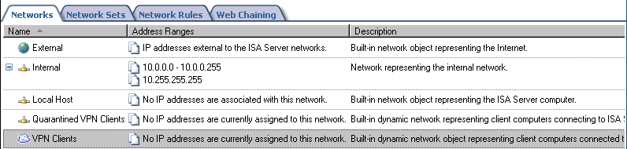
- In the Quarantined VPN Clients Properties dialog box, put a checkmark in the Enable Quarantine Control check box. Click OK in the Microsoft Internet Security and Acceleration Server 2004 dialog box that informs that machines will remain in quarantine unless they meet the requirements to exit quarantine. Select Quarantine according to ISA Server policies. Select Disconnect quarantined users after (seconds) and enter 60 into its text box. Click Apply and then click OK.
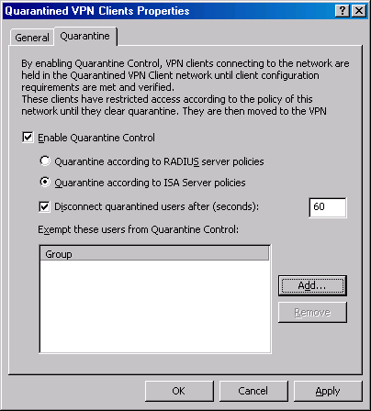
- Click Apply to save the changes and update the firewall policy.
- Click OK in the Apply New Configuration dialog box.

Configure ISA Server 2004 Access Policy
We must create three Access Rules that will allow the VPN clients in the VPN Quarantine and VPN Clients networks access to selected resources. These rules are:
- DNS for All VPN Clients – this rule allows both quarantined and non-quarantined VPN clients to connect to a DNS server on the Internal network
- VPN Quarantine Resource Access – this rule allows quarantined VPN clients access to a Web and File server that contains resources and information that help the VPN client meet requirements for leaving the VPN Quarantine Network.
- VPN Clients to IIS1 – this rule allows machines that have exited the VPN Quarantine network access to files on the IIS1 computer.
Perform the following steps to create the Access Rule that allows both quarantined and non-quarantined VPN clients access to the DNS server:
- In the Microsoft Internet Security and Acceleration Server 2004 management console, expand the server name, and click the Firewall Policy node. Click the Tasks tab on the Task pane. Click Create a New Access Rule.
- On the Welcome to the New Access Rule Wizard page, enter a name for the rule in the Access Rule name text box. In this example, enter DNS for all VPN Clients. Click Next.
- On the Rule Action page, select Allow and click Next.
- On the Protocols page, click Add.
- In the Add Protocols dialog box, click the Command Protocols folder and double click on DNS. Click Close.
- Click Next on the Protocols page.
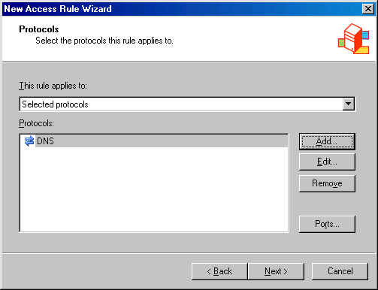
- On the Access Rule Sources page, click Add.
- In the Add Network Entities dialog box, double click VPN Clients and Quarantined VPN Clients. Click Close.
- Click Next on the Access Rule Sources page.
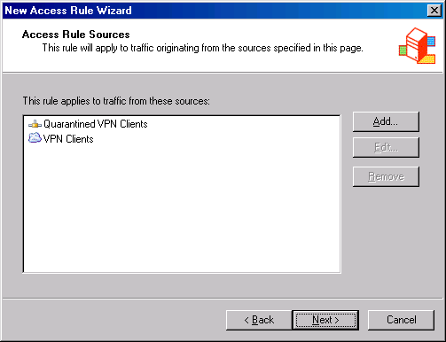
- On the Access Rule Destinations page, click Add.
- In the Add Network Entities dialog box, click the New menu. Click Computer.
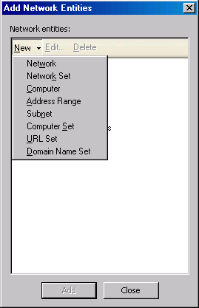
- In the New Computer rule Element dialog box, enter DNS Server in the Name text box. Enter 10.0.0.2 in the Computer IP Address text box. Click OK.
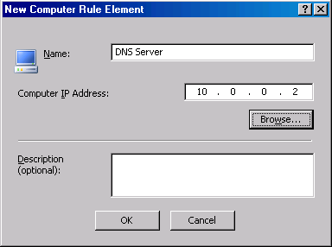
- In the Add Network Entities dialog box, click the Computers folder. Double click DNS Server. Click Close.
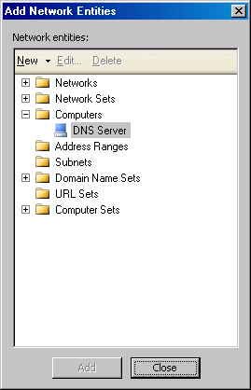
- Click Next on the Access Rule Destinations page.
- On the User Sets page, accept the default entry, All Users, and click Next.
- Click Finish on the Completing the New Access Rule Wizard page.
The next step is to create an Access Rule that allows hosts on the Quarantine network access to the CA1 computer. This rule will enable them to download the file required to move them from the VPN Quarantine network to the VPN Clients network. Perform the following steps to create this Access Rule:
- In the Microsoft Internet Security and Acceleration Server 2004 management console, expand the server name, and click the Firewall Policy node. Click the Tasks tab on the Task pane. Click Create a New Access Rule.
- On the Welcome to the New Access Rule Wizard page, enter a name for the rule in the Access Rule name text box. In this example, enter VPN Quarantine Resource Access. Click Next.
- On the Rule Action page, select Allow and click Next.
- On the Protocols page, accept the default selection, All outbound protocols, and click Next.
- On the Access Rule Sources page, click Add.
- In the Add Network Entities dialog box, double click Quarantined VPN Clients. Click Close.
- Click Next on the Access Rule Sources page.
- On the Access Rule Destinations page, click Add.
- In the Add Network Entities dialog box, click the New menu. Click Computer.
- In the New Computer Rule Element dialog box, enter Quarantine Resource Machine in the Name text box. Enter 10.0.0.3 in the Computer IP Address text box. Click OK.
- In the Add Network Entities dialog box, click the Computers folder. Double click Quarantine Resource Machine. Click Close.
- Click Next on the Access Rule Destinations page.
- On the User Sets page, accept the default entry, All Users, and click Next.
- Click Finish on the Completing the New Access Rule Wizard page.
The last rule we need to create will allow members of the VPN clients network full access to the IIS1 machine. Perform the following steps to create the rule:
- In the Microsoft Internet Security and Acceleration Server 2004 management console, expand the server name, and click the Firewall Policy node. Click the Tasks tab on the Task pane. Click Create a New Access Rule.
- On the Welcome to the New Access Rule Wizard page, enter a name for the rule in the Access Rule name text box. In this example, enter VPN Clients to IIS1. Click Next.
- On the Rule Action page, select Allow and click Next.
- On the Protocols page, accept the default selection, All outbound protocols, and click Next.
- On the Access Rule Sources page, click Add.
- In the Add Network Entities dialog box, double click VPN Clients. Click Close.
- Click Next on the Access Rule Sources page.
- On the Access Rule Destinations page, click Add.
- In the Add Network Entities dialog box, click the New menu. Click Computer.
- In the New Computer rule Element dialog box, enter IIS1 in the Name text box. Enter 10.0.0.4 in the Computer IP Address text box. Click OK.
- In the Add Network Entities dialog box, click the Computers folder. Double click Quarantine Resource Machine. Click Close.
- Click Next on the Access Rule Destinations page.
- On the User Sets page, accept the default entry, All Users, and click Next.
- Click Finish on the Completing the New Access Rule Wizard page.

Install the Quarantine Service Listener on the ISA Server 2004 Firewall
The VPN Quarantine service listener will listen for the results of the script that the VPN client runs after it connects to the VPN server. The next step is to install the VPN Quarantine listener component.
Perform the following steps to install the VPN Quarantine listener on the ISA Server 2004 firewall machine:
- Copy the rqs.exe file to the ISA Server 2004 firewall machine. This file can be obtained from http://go.microsoft.com/fwlink/?LinkId=22611. In addition, obtain configurerqsforisa.vbs and rqsmsg.dll from the same location. Place these files in the root of the C: drive.
- Open the command prompt and change the focus to the root of the C: drive. Enter the following at the command prompt and press ENTER:
Cscript ConfigureRQSForISA.vbs /install key “C:”
- You will see the following print out in the command prompt window.
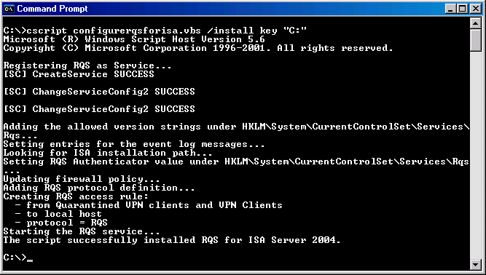
- Close the Command Prompt window.
- Restart the ISA Server 2004 firewall computer.

Install the Connection Manager Administration Kit on the ISA Server 2004 Firewall
Perform the following steps to install the Connection Manager Administration Kit onto the ISA Server 2004 firewall machine:
- Click Start and point to Control Panel. Click Add or Remove Programs.
- In the Add or Remove Programs window, click Add/Remove Windows Components on the left side of the window.
- In the Windows Components page, select Management and Monitoring Tools from the Components list and click Details.
- In the Management and Monitoring Tools dialog box, put a checkmark in the Connection Manager Administration Kit check box. Click OK.
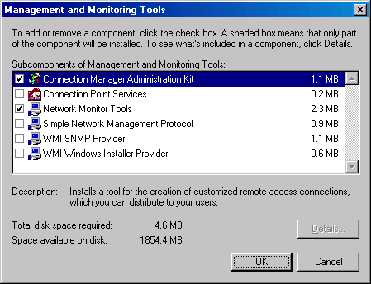
- Click Next on the Windows Components page.
- Click OK in the Insert Disk dialog box. In the Files Needed dialog box, enter the path to the Windows Server 2003 i386 folder in the Copy files from text box. Click OK.
- Click Finish on the Completing the Windows Components Wizard page.

Create a Sample VPN Client Requirement File and Web Page on the Machine Available to Quarantined VPN Clients
We need to create a sample file that represents a hotfix or operating system update the client downloads in order to meet VPN Quarantine compliance. In a production environment, the actual files could be automatically downloaded, or the user could be redirected to a Web page that explains the procedures to be carried out in order to meet compliance requirements.
Perform the following steps to create the sample file that the VPN client will download to meet VPN Quarantine compliance requirements:
- At the CA1 machine, open the Quarantine folder. Right click inside the opened Quarantine folder, point to New and click Text Document.
- Right click the New Text Document.txt file, and click Rename. Name the file access.txt.
- Open the access.txt file, and enter some random words into the file.
- Close Notepad and save the file when prompted.
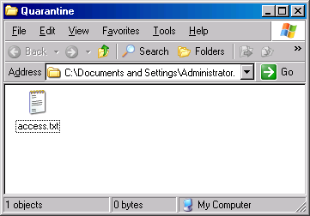
The next step is to create a Web Page that will appear to VPN clients placed in the VPN Quarantine network. This Web page explains to the clients why they are on the Quarantine network and what they need to do to be removed. The page also demonstrates what resources the VPN clients in Quarantine have access to.
Perform the following steps to create the Web page:
- Click Start and then click Run. In the Run dialog box, enter Notepad and click OK.
- Copy the following text file and paste it into Notepad.
<html>
<head>
<meta HTTP-EQUIV="Content-Type" Content="text/html; charset=Windows-1252">
<title ID=titletext>Quarantine</title>
</head>
<body>
<P>Welcome to Example.com. Your computer has been placed in quarantine mode because it does not comply with our network access requirements. Your connection will be terminated in two minutes, at which time you will be prompted to reconnect. When you reconnect, your computer will have been upgraded for compliance, and your session should not terminate after two minutes.</P>
<P>If you feel that you have reached this page in error or if your session continues to terminate after two minutes, please contact the helpdesk.</P>
<UL>
<LI>Click <a href="\\ca1.msfirewall.org\quarantine">here</a> to prove that you can access the file share on the quarantine resource.</LI>
<LI>Click <a href="\\iis1.msfirewall.org\root">here</a> to prove that you cannot access a file share that is not on the quarantine resource.</LI>
<LI>Click <a href="http://iis1.msfirewall.org/test.htm">here</a> to prove that you cannot access an intranet Web site that is not on the quarantine resource.</LI>
<UL>
</body>
</html>
- Click the File menu and click Save. In the Save As dialog box, click the down-arrow in the Save in list and navigate to the c:\Inetpub\wwwroot folder. In the File name text box, enter “quarantine.htm” (make sure to include the quotes around the name). Click Save.
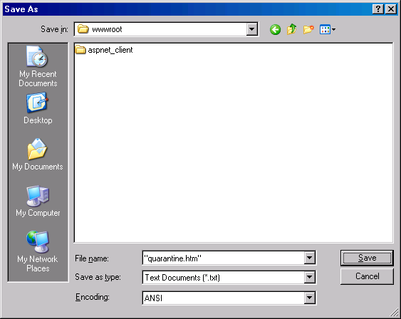
- Close Notepad.

Create a Web Page on the Machine Not Available to VPN Clients
We now need to create a Web page on the machine that will become accessible to VPN clients after they are moved from the VPN Quarantine network to the VPN Clients network. When the VPN clients are on the VPN Quarantine network, they will not be able to connect to this Web page. They will be able to connect to this page after they meet the quarantine requirements.
Perform the following steps to create the Web page:
- Click Start and then click Run. In the Run dialog box, enter Notepad and click OK.
- Copy the following text file and paste it into Notepad.
<html>
<head>
<meta HTTP-EQUIV="Content-Type" Content="text/html; charset=Windows-1252">
<title ID=titletext>Welcome to Example.com</title>
</head>
<body>
<P>Welcome to Example.com. Your computer has been removed from quarantine. You now have full access to the network resources that are accessible to your group.</P>
<UL>
<LI>Click <a href="\\ca1.msfirewall.org\quarantine">here</a> to prove that you can still access the file share on the quarantine resource.</LI>
<LI>Click <a href="\\iis1.msfirewall.org\root">here</a> to prove that you can access a network file share other than the one on the quarantine resource.</LI>
<LI>Click <a href="http://ca1.msfirewall.org/quarantine.htm">here</a> to prove that you can still access the Web site that is on the quarantine resource.</LI>
<UL>
</body>
</html>

- Click the File menu and click Save. In the Save As dialog box, click the down-arrow in the Save in list and navigate to the c:\Inetpub\wwwroot folder. In the File name text box, enter “test.htm” (make sure to include the quotes around the name). Click Save.

- Close Notepad.

Create a Quarantine Script and Save it on the ISA Server 2004 Firewall
The quarantine script contains instructions that are run on the VPN client machine after the client establishes a VPN link with the ISA Server 2004 firewall/VPN server. This script will be included with the CMAK connection profile that will be installed on the VPN client machine. The script will test whether the VPN client machine has the access.txt file on its local hard drive. If the file isn’t located on the hard disk, it will search for the file on the CA1 machine and attempt to download the file. The connection will be dropped and you will be prompted to log on again. The script will test whether the access.txt file is located on the local hard disk, and then, when the file is found, the client will be moved from the VPN Quarantine network to the VPN Clients network.
Perform the following steps to create the Quarantine script file:
- Click Start and click Run. In the Run dialog box, enter Notepad into the Open text box and click OK.
- Copy the following text and paste it into Notepad.
:INITIALIZATION
@echo off
@rem ***
@rem * Define the locations for the source file (remove quarantine if this file exists) and
@rem * the target file (the file to copy if the source file does not exist).
@rem *
SET SOURCE_FILE=c:\access.txt
SET TARGET_FILE=\\ca1.msfirewall.org\quarantine\access.txt
@rem Use %ServiceDir% macro to locate rqc.exe.
SET RQCLOC=%1\rqc.exe
@rem Use %DialRasEntry% macro.
SET CONNNAME=%2
@rem Use %TunnelRasEntry% macro.
SET TUNNELCONNNAME=%3
@rem Use %DomainName% macro.
SET DOMAIN=%4
@rem Use %UserName% CM macro for this value.
SET USERNAME=%5
SET REMOVAL=Key
SET PORT=7250
:VALIDATION
@rem ***
@rem * Check whether files can be copied.
@rem *
echo Checking for %SOURCE_FILE%
if exist %SOURCE_FILE% goto REMOVE_QUARANTINE
@rem ***
@rem * PING the resource to ensure that it is available
@rem * before attempting to access it. (This also helps
@rem * in case of any network delays.)
@rem *
ping ca1.msfirewall.org -n 20 -a
if exist %TARGET_FILE% goto COPY_FILE_TO_LOCAL
goto FILE_NOT_FOUND
:FILE_NOT_FOUND
@rem ***
@rem * File specified in TARGET_FILE could not be detected.
@rem *
echo Unable to locate %TARGET_FILE%
goto EXIT_SCRIPT
:COPY_FILE_TO_LOCAL
@rem ***
@rem * The file does not exist on the local computer. The file will now be copied
@rem * from the server, and the program will exit (leaving the user in quarantine).
@rem *
echo Copying %TARGET_FILE% to %SOURCE_FILE%
copy %TARGET_FILE% %SOURCE_FILE%
goto SHOWQUARANTINEINFO
:REMOVE_QUARANTINE
@rem ***
@rem * The file exists on the local computer. The client now must be removed from
@rem * quarantine.
@rem * Also, to demonstrate how the script works, echo
@rem * the executable, and pause for test review before opening the
@rem * Web site. Do not echo or pause in a production script.
echo %SOURCE_FILE% found!
echo Executing %RQCLOC% %CONNNAME% %TUNNELCONNNAME% %PORT% %DOMAIN% %USERNAME% %REMOVAL%
pause
%RQCLOC% %CONNNAME% %TUNNELCONNNAME% %PORT% %DOMAIN% %USERNAME% %REMOVAL%
IF %ERRORLEVEL%==0 GOTO QUARANTINED_REMOVED
IF %ERRORLEVEL%==1 GOTO QUARANTINED_INVALIDLOC
IF %ERRORLEVEL%==2 GOTO QUARANTINED_INVALIDSTRING
goto QUARANTINE_FAIL
:QUARANTINED_REMOVED
"%ProgramFiles%\Internet Explorer\iexplore.exe" http://iis1.msfirewall.org/test.htm
goto EXIT_SCRIPT
:QUARANTINED_INVALIDSTRING
echo Invalid removal string passed. Request rejected.
goto QUARANTINE_FAIL
:QUARANTINED_INVALIDLOC
echo Unable to contact remote access server. (Is port %PORT% open?)
GOTO QUARANTINE_FAIL
:QUARANTINE_FAIL
echo Quarantine removal failed. Please disconnect, and retry the connection.
echo If the problem persists, please contact HelpDesk at 555-0100.
:SHOWQUARANTINEINFO
"%ProgramFiles%\Internet Explorer\iexplore.exe" http://ca1.msfirewall.org/quarantine.htm
goto EXIT_SCRIPT
:EXIT_SCRIPT
@rem ***
@rem * Exit script.
@rem *
echo Script has completed.
end
- Click File and then click Save As. Save the file with the name of “quarantine.cmd” (with the quotes) to the root of the C:\ drive. Close Notepad.
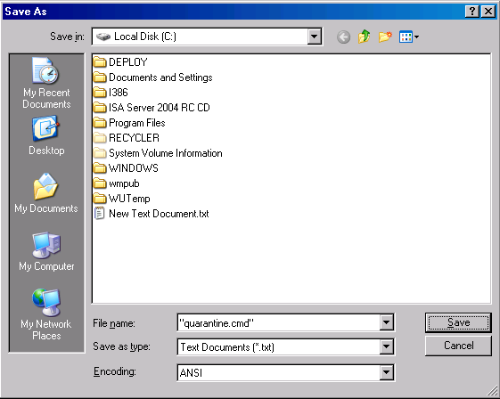

Create the Connection Manager Profile
Now that we have the quarantine script configured, we’re ready to create the CMAK profile. This profile will be used to install the VPN client software onto the VPN client machine. The quarantine script will be included with the VPN client software. The CMAK profile is very simple for the end-user to install: he only needs to double click on the CMAK package and the installation takes place automatically.
Perform the following steps to create the CMAK package:
- Click Start, point to Administrative Tools, and click Connection Manager Administration Kit.
- On the Welcome to the Connection Manager Administration Kit Wizard page, click Next.
- On the Service Profile Selection page, ensure that New profile is checked and then click Next.
- On the Service and File Names page, enter VPN to ISA Firewall in Service name and FWVPN in File name, and click Next.
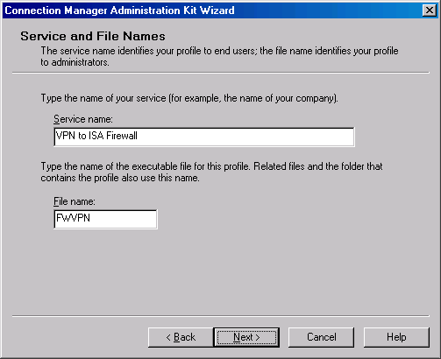
- On the Realm Name page, click Next.
- On the Merging Profile Information page, click Next.
- On the VPN Support page, select the Phone book from this profile check box. In VPN Server name or IP Address, click Always use the same VPN server, type 192.168.1.70 (as shown in the following figure), and click Next.
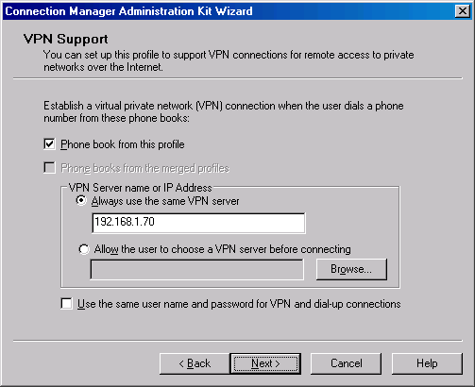
- On the VPN Entries page, click the default entry, and click Edit.
- Click the Security tab. In Security settings section, click Use advanced security settings (as shown in the following figure), and then click Configure.
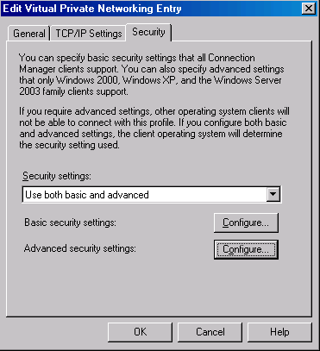
- Under Authentication methods, clear the Microsoft CHAP (MS-CHAP) check box. In the VPN strategy list, select Try Point-to-Point Tunneling Protocol First. Click OK twice to return to the VPN Entries page, and then click Next.
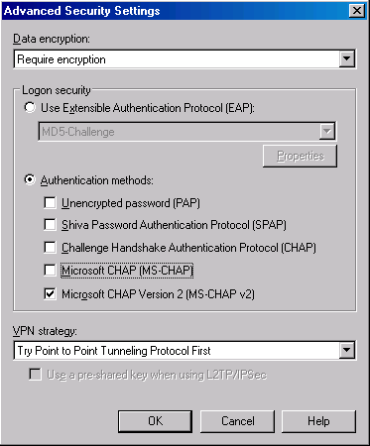
- On the Phone Book page, clear the Automatically download phone book updates check box, and click Next.
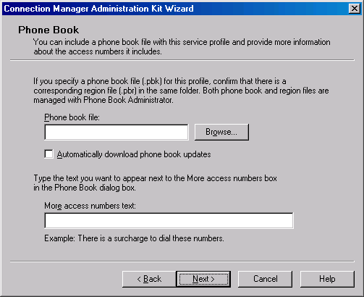
- On the Dial-up Networking Entries page, click Next.
- On the Routing Table Update page, click Next.
- On the Automatic Proxy Configuration page, click Next.
- On the Custom Actions page, click New.
- In the New Custom Action dialog box, type Quarantine policy checking in Description. In Program to run, click Browse and find the quarantine.cmd file in the My Documents folder. In Parameters, enter
%ServiceDir% %DialRasEntry% %TunnelRasEntry% %Domain% %UserName%.
In Action type, click Post-connect. In Run this custom action for, click All connections. Leave both check boxes selected, and click OK.
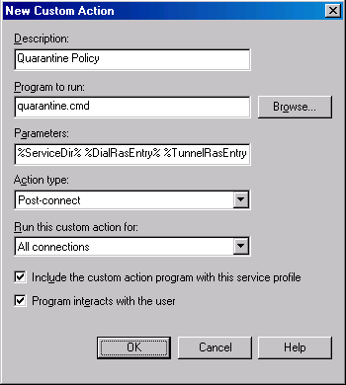
- On the Logon Bitmap page, click Next.
- On the Phone Book Bitmap page, click Next.
- On the Icons page, click Next.
- On the Notification Area Shortcut Menu page, click Next.
- On the Help File page, click Next.
- On the Support Information page, click Next.
- On the Connection Manager Software page, click Next.
- On the License Agreement page, click Next.
- On the Additional Files page, click Add.
- Browse to the rqc.exe, and click Open.
- On the Additional Files page, click Next.
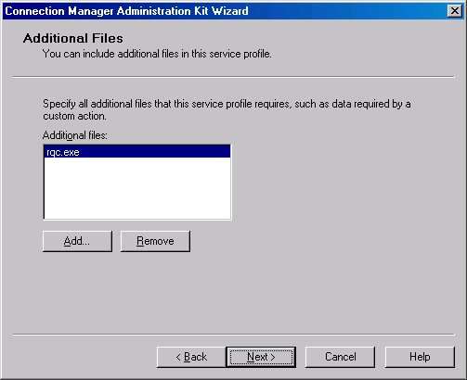
- On the Ready to Build the Service Profile page, select the Advanced customization check box and then click Next.
- On the Advanced Customization page, click Connection Manager in Section name, type Dialup in Key name, and type 0 in Value, as shown in the following figure. Click Apply, and then click Next.
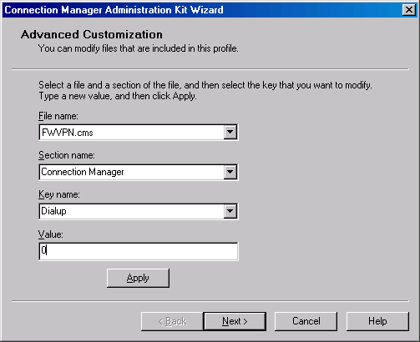
- A command prompt window will open and close as the profile is created. When the Completing the Connection Manager Administration Kit Wizard page appears, click Finish.
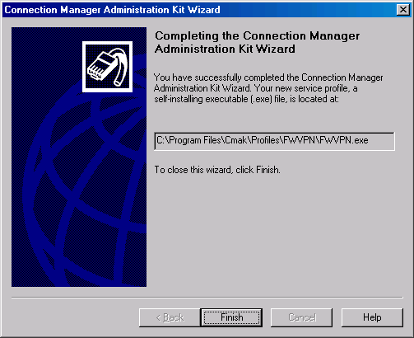
- Copy the FWVPN.exe file to a floppy or network share point available to the VPN client machine.

Install the Connection Manager Profile on the VPN Client Machine
Installing the Connection Manager Profile is simple. Just copy the profile you created with the Connection Manager to the VPN Client machine and then perform the following steps:
- Insert the floppy disk on which you saved the FWVPN.exe into the floppy disk drive of CLIENT1, or copy the file to the VPN client machine from the network share point.
- Open Windows Explorer, and browse to FWVPN.exe.
- Double-click FWVPN.exe. When prompted to install the profile (as shown in the following figure), click Yes.
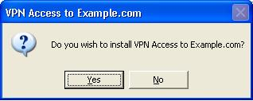
- When prompted for whom to make this connection available, ensure that My use only is selected and then click OK.
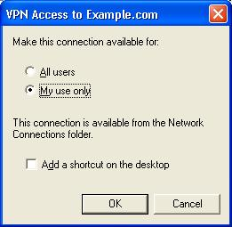

Test the Connection
We’re now ready to test the connection. The VPN client will first connect to the ISA Server 2004 VPN server and be placed on the VPN Quarantine Network. The VPN client will not be removed from the VPN Quarantine network because it does not have the access.txt file located at the root of its C: drive. After the script completes, the file will be copied to the VPN client’s hard disk and the client will be disconnected from the VPN server after the time-out value is exceeded. At this point, reconnect to the VPN server. The client will be initially placed on the VPN Quarantine network, and then the client-side script will determine that the access.txt file is located on the C:\ drive. The RQC.exe component will inform the RQS.exe component on the VPN server that the script ran successfully and the client meets Quarantine requirements. At this point, the VPN client will be moved from the VPN Quarantine Network to the VPN Clients Network.
Perform the following steps to test the VPN Quarantine functionality:
- Right click My Network Places on the desktop, and click Properties.
- Double click on the VPN to ISA Firewall icon.
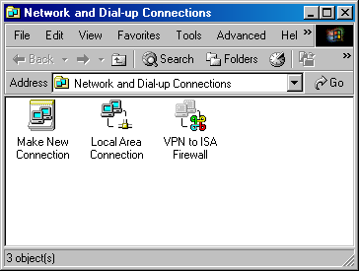
- Enter your user name band and Password in the VPN to ISA Firewall dialog box. The user name is msfirewall\Administrator. Click Connect.
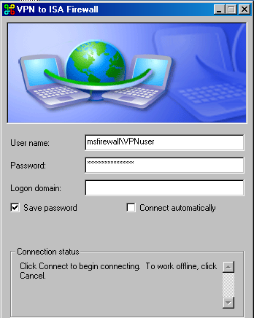
- A command prompt window opens, generated by the quarantine.cmd script. A message appears telling the user “Checking for access.txt….” When the file is not found, another message appears telling the user that the file is being copied to the local computer. As soon as that message appears, the script launches Internet Explorer, and the Quarantine Web page (Quarantine.htm) on the quarantine resource (CA1) appears.
- Click the various links on the Quarantine Web page to make sure that access is restricted to the resources on CA1. You should not be able to reach the intranet Web page or the network file share on IIS1.
- While connected, right-click the notification area shortcut for the connection, and click Status.
- Click the Details tab, and verify that the client connected using PPTP.
- After two minutes, the Quarantine policy will terminate the connection. In the Reconnect dialog box, click Yes.
- When the VPN Access to msfirewall.org connection finishes connecting, the Web page test.htm on IIS1 appears in Internet Explorer.
- Click the various links on the test Web page to verify network access to all resources available to the VPN Clients network.

Conclusion
In this ISA Server 2004 VPN Deployment Kit document, we discussed how to configure the ISA Server 2004 firewall as a VPN server that can quarantine VPN clients that do not meet pre-qualification requirements. The walkthrough in this document provided an example of how the ISA Server 2004 VPN Quarantine feature works using a simple sample script. For more information on the ISA Server 2004 VPN Quarantine feature, please refer to the ISA Server 2004 Help and Solution documents on the ISA Server 2004 Web site (www.microsoft.com/isaserver).

This is a preliminary document and may be changed substantially prior to final commercial release of the software described herein.
The information contained in this document represents the current view of Microsoft Corporation on the issues discussed as of the date of publication. Because Microsoft must respond to changing market conditions, it should not be interpreted to be a commitment on the part of Microsoft, and Microsoft cannot guarantee the accuracy of any information presented after the date of publication.
This white paper is for informational purposes only. MICROSOFT MAKES NO WARRANTIES, EXPRESS OR IMPLIED, IN THIS
DOCUMENT.
Complying with all applicable copyright laws is the responsibility of the user. Without limiting the rights under copyright, no part of this document may be reproduced, stored in, or introduced into a retrieval system, or transmitted in any form or by any means (electronic, mechanical, photocopying, recording, or otherwise), or for any purpose, without the express written permission of Microsoft Corporation.
Microsoft may have patents, patent applications, trademarks, copyrights, or other intellectual property rights covering subject matter in this document. Except as expressly provided in any written license agreement from Microsoft, the furnishing of this document does not give you any license to these patents, trademarks, copyrights, or other intellectual property.
© 2004 Microsoft Corporation. All rights reserved.
The example companies, organizations, products, domain names, e-mail addresses, logos, people, places, and events depicted herein are fictitious. No association with any real company, organization, product, domain name, e-mail address, logo, person, place, or event is intended or should be inferred.
Microsoft, Windows, Windows 2000, Windows 2000 Server, Windows Server 2003, Windows Server System, ISA Server, and ISA Server 2004 are either registered trademarks or trademarks of Microsoft Corporation in the United States and/or other countries.
The names of actual companies and products mentioned herein may be the trademarks of their respective owners.

