Building a Corporate Portal using Microsoft Office XP and Microsoft SharePoint Portal Server 2001
White Paper

Abstract
This paper presents an overview of the advantages of using Microsoft® SharePoint™ Portal Server 2001 to create a corporate portal. It reviews how Microsoft® Office XP can help you quickly and easily customize the default dashboard site to create your own custom portal solution and how Microsoft® SharePoint™ Team Services can add further value to your portal solution. It presents suggestions for using Office XP, SharePoint Team Services, and SharePoint Portal Server to deploy a total portal solution that facilitates finding, creating, and sharing your mission-critical content from a Web browser or Office.
Published: April 2001

Table of Contents
Table of Contents 1
Introduction 1
Creating a Corporate Portal 2
Developing Portal Content 3
Personalizing the Dashboard Site 4
Using SharePoint Team Services 7
Building a Custom Solution using Office XP 8
Appendix A—Creating an Excel PivotTable Web Part 9
Introduction 10
Creating a Web Part from Office XP 10

Building a Corporate Portal using Microsoft Office XP and Microsoft SharePoint Portal Server 2001
White Paper

Published: April 2001
For the latest information, please see http://www.microsoft.com/sharepoint/portalserver.asp

Introduction
This paper presents an overview of the advantages of using Microsoft® SharePoint™ Portal Server 2001 to create a corporate portal. It reviews how Microsoft® Office XP can help you quickly and easily customize the default dashboard site to create your own custom portal solution and how Microsoft® SharePoint™ Team Services can add further value to your portal solution. It presents suggestions for using Office XP, SharePoint Team Services, and SharePoint Portal Server to deploy a total portal solution that facilitates finding, creating, and sharing your mission-critical content from a Web browser or Office.
A portal is a Web site that gathers information from a variety of sources and displays them in a single location. In addition, portals typically provide simple Web publishing and search capabilities to end-users. Portals can be used by entire corporations, such as Microsoft or by departments, such as Marketing, Human Resources, or Sales. Portals, in the form of personalized digital dashboards, can also be used by individuals.
Currently, corporations rely on a set of diverse tools to meet their needs for a corporate portal, a document management system, and an aggregate search solution. SharePoint Portal Server is a flexible portal solution for knowledge workers to easily find, share, and publish information. For Microsoft Windows® and Microsoft® Office users, SharePoint Portal Server delivers a dramatic new value—bringing mainstream corporate portals, document management, content searching, and an easy-to-deploy application to your business.
A portal needs to be easy to set up, and for maximum benefit needs to be tailored to an organization's specific needs. With SharePoint Portal Server, you can deploy an out-of-the-box total portal solution that facilitates finding, creating, and sharing your mission-critical data from a Web browser. Because the dashboard site is comprised of Web Parts, you can customize it for your business needs. Web Parts are reusable Web components that contain any kind of Web-based information. Using Digital Dashboard technology, you can also customize the dashboard site, managing common resources, such as your contacts, calendars, and messages.
Customers can also extend SharePoint Portal Server and add additional Web application functionality. SharePoint Portal Server is designed around industry and Internet standards, such as OLE DB, Microsoft ActiveX® Data Objects (ADO), Extensible Markup Language (XML), and Microsoft Web Distributed Authoring and Versioning (WebDAV). Due to this support of standards, the use of tools like Microsoft® Visual Studio® Professional for Windows® allows you to integrate Active Server Pages (ASP) functionality to the dashboard site.
When used with Office XP, SharePoint Portal Server makes Office Web publishing and content creation simple and powerful. Office XP becomes a great content development tool that takes advantage of the enterprise-wide search engine, powerful document management and easy portal customizability features of SharePoint Portal Server, to make information available throughout an enterprise.
Using Office XP, customers can share and publish information in a corporate portal through Web Parts. These Web Parts and Web applications can be created in Office XP. Using Office XP, you can publish Microsoft Excel 2000 PivotTables®, Microsoft Word documents, or Microsoft PowerPoint® demonstrations as Web Parts in your corporate portal by saving to the dashboard directly from the Office applications. Using SharePoint Portal Server, you can take existing reports and other data from Office or existing Web pages and customize the out-of-box portal to share critical, timely information. With the use of other tools, such as Visual Studio, you can further extend your corporate portal to encompass other content.
SharePoint Portal Server provides key portal features using Digital Dashboard technology. Office XP provides a method for customizing the default portal to suit the needs of your organization. You can build custom Web Parts to further customize your corporate portal.
For information about creating custom Web Parts, see the Digital Dashboard Resource Kit.

Creating a Corporate Portal
SharePoint Portal Server includes a corporate portal with a dashboard site as a centralized location for information. The dashboard site brings together information from throughout the organization and from outside the organization into one dashboard site. The dashboard site provides access to the key information you deem critical to your organization. SharePoint Portal Server allows you to:
- Modify the dashboard site. The dashboard site is composed of multiple dashboards. Each dashboard is composed of customizable Web Parts. SharePoint Portal Server includes roughly a dozen default Web Parts, including a Search Web Part, a Categories Web Part, a Best Bets Web Part, and others. This default dashboard site allows you to deploy a portal solution with the initial framework and common portal features in place.
- Use Web Parts to assist collaboration. You can use Web Parts to add collaborative applications and tasks such as group schedules from Outlook or available discussion groups as building blocks for a wide range of business solutions. Office XP lets you save these Web Parts directly from Office documents.
- Use Active Server Page (ASP) and CDO to add Web collaboration. Develop solutions rapidly. Use Collaboration Data Objects (CDO) to develop applications. CDO is dual-interfaced for programming in C++, Visual Basic ®, Visual Basic Scripting Edition, JavaScript, and Java.
- Build and host native Web applications. SharePoint Portal Server includes built-in services for accessing high-performance Web applications, including XML, WebDAV. It also provides support for ASP, custom data access forms, business logic events and reusable components. With this support, you can build your own native Web applications outside of the SharePoint Portal Server workspace and create a Web Part to link to the application content. For more information about building and hosting native Web applications, see the SharePoint Portal Server Resource Kit.
- Develop applications with commonly available tools. You can extend the dashboard site with development tools such as Microsoft Visual Studio.
- Access information using database technologies. Data access technologies such as OLE DB and ADO enable developers to apply their existing skills and applications when building Web Storage System applications. Your developers can build on existing training and knowledge to create custom solutions for your portal.
- Use XML to link SharePoint Portal Server to other business servers. XML support makes it easy to share data from SharePoint Portal Server with other applications within an organization. XML makes integration with other applications seamless.
For more information about developing custom applications, see the SharePoint Portal Server Resource Kit.

Developing Portal Content
With SharePoint Portal Server, information on your portal dynamically changes as users create, modify, and store files in the workspace. With the document management features of SharePoint Portal Server, users participate in developing content for your corporate portal. Office XP users are ready to work with SharePoint Portal Server out of the box. No additional installations are required.
As an administrator, you focus on access and organization of content instead of spending time preparing content. As users add content, you customize and control what content appears on the portal, how it is organized, and to whom it is available. The process of finding, sharing, and publishing information is shorter and easier because the extra steps of preparing existing content for the Web are eliminated. Used in combination, Office XP and SharePoint Portal Server add value to the customer experience by reducing the time to prepare content for the Web.
For Office users, the productivity benefits of using the two products together are:
- Personal Dashboard and Web Part development. Office XP can save Web Parts directly from the File menu, using the Save As… feature. Office XP users can create a personal dashboard, a customized view of information that is designed to share information across groups.
- Integrated search. Customers have a rich search experience from within Office. They can look across local servers, SharePoint Portal Server computers, Exchange servers, and any Web server, making it simple to find and retrieve information regardless of its location. You can search SharePoint Portal Server workspaces directly from within the Office applications using the Search Pane. During a search, you receive the same results you would receive from conducting a search query on the dashboard site.
- Rich built-in document management. When used in combination with SharePoint Portal Server, Office XP users get a rich, secure, and customizable document management experience. SharePoint Portal Server adds check-in, check-out, publishing and document profiles to the document management process of Office XP. Word, Excel and PowerPoint applications all have built in awareness of SharePoint Portal Server for document management. Using My Network Places, from Office applications, users can check documents in and out of the workspace directly. When opening documents in the workspace from Office applications, SharePoint Portal Server automatically prompts users to check out documents before opening them. In addition, Office XP automatically prompts users to check in documents that they have edited when closing them.
- SmartTags within Office documents. Users can use SmartTags technology within Office documents to directly link to categories and searches within SharePoint Portal Server. Users can also access the profile form for a document directly from Office applications.
- One-touch client install. Office XP and SharePoint Portal Server work together out of the box, with a simple, unified installation process. All Office XP applications are native clients for SharePoint Portal Server.
Together Office XP and SharePoint Portal Server simplify the process of taking information from everyday applications and presenting it on the Web in a central location. Office XP makes creating a Web page as simple as Save As…

Personalizing the Dashboard Site
With SharePoint Portal Server, you can add additional dashboards to the default dashboard site to customize your portal. In addition, you can enable users to create their own personalized dashboards for collaboration. Using Office XP, you can add Web Parts to any dashboard quickly and easily to provide information to all users. The following graphic illustrates saving an Excel spreadsheet as a Web Part.
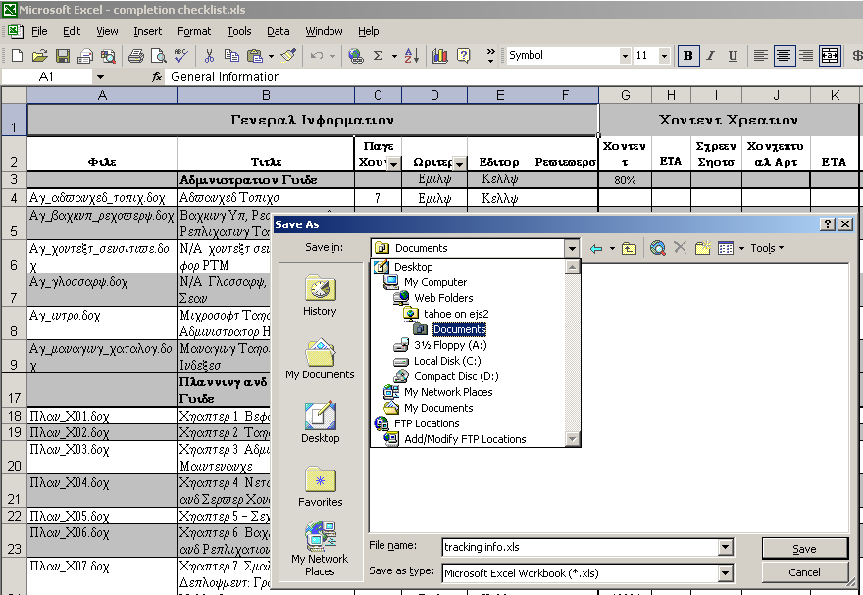
Figure 1 - Saving an Office document as a Web Part.
Office XP users can save Web Parts directly from Office XP with the Save as… feature. Office XP users can also create personal dashboards, customized views of content for sharing across teams, directly from Office.
When a user saves an Office document as a Web Part in a personal dashboard folder, SharePoint Portal Server prompts the user to name and describe the Web Part and to indicate the position on the layout of the dashboard. The graphic below shows the Web Part Settings page.
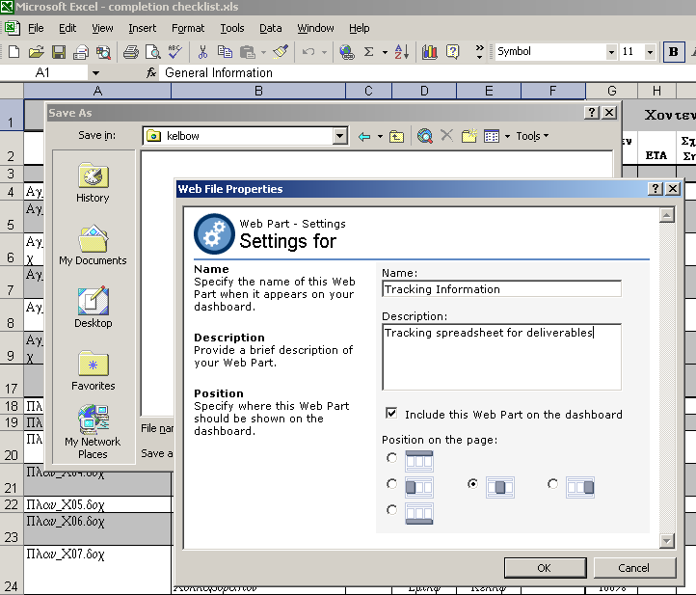
Figure 2 - Saving a Document as a Web Part
Personal dashboards are dashboards that consist of one or more Web Parts of the creator’s choosing. Using the Personal Dashboard Web Part included with SharePoint Portal Server, users can create customized dashboards to organize and present Web content specific to their needs.
For example, a user may want to create a dashboard with information about a specific topic or project, such as a quarterly sales report. Alternatively, a user may want to create a Web site with multiple types of information such as marketing reports on competitors, competitor product information, and stock market information, which they would like to share with others. .
The following graphic shows a personal dashboard with an Excel spreadsheet saved as a Web Part.
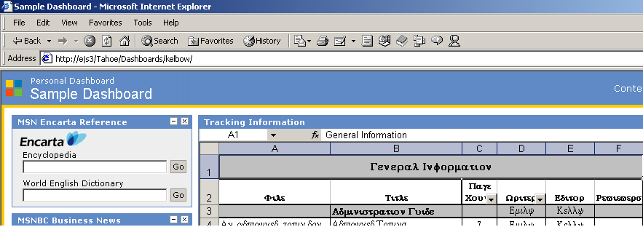
Figure 3 - Personal Dashboard with Excel Spreadsheet as a custom Web Part
After modifying the workspace and dashboard site that comes with SharePoint Portal Server, you further customize your corporate portal by adding additional dashboards and Web Parts such as those available from the Microsoft Web Part Gallery. The example in the above graphic includes a Microsoft MSN® Encarta® Reference Web Part. In addition, you may choose to allow users to create personal dashboards to publish their own project information. Customization can include:
- Adding custom dashboards to the main dashboard site.
- Creating, importing, or removing Web Parts from dashboards.
- Deciding whether to implement the Personal Dashboards feature of SharePoint Portal Server.
- Organizing and modifying content on the dashboard site as you develop it using Office XP.
Office XP adds value to SharePoint Portal Server by providing you with tools that transform Office documents into Web-ready content without the need to reformat and recreate information.

Using SharePoint Team Services
SharePoint Team Services, included with Office XP, gives users the ability to create and contribute to team and project-focused Web sites. SharePoint Portal Server can include documents stored in the document libraries of Web sites created using SharePoint Team Services in the index of a workspace. This makes this content available for searching on the dashboard site.
SharePoint Team Services provides a team Web site solution that allows groups within a business or organization to easily manage activities and work together effectively. SharePoint Team Services allows small teams and ad-hoc groups in any size organization to effectively manage activities via the web. SharePoint Team Services provides a rich, easy to deploy collaborative Web site that tightly integrates with Office XP.
The following table compares SharePoint Team Services and SharePoint Portal Server:
Feature | SharePoint Portal Server | SharePoint Team Services
Enterprise search.
Rich document management functionality.
Customized with Digital Dashboards and Web Parts.
Based on Web Storage System for custom collaboration solutions.
Extensible with Visual Studio and common programming interfaces such as OLEDB, ADO, and CDO.
Departmental/enterprise information portals.
Team collaborative Web sites.
Easy document sharing and team organization.
Available for intranets & for extranets via ISPs.
Integrated Office XP user experience.
Customized using Microsoft FrontPage.
Team templates for easy Web site creation.
Can be used to create Internet Sites as well as Intranet.

SharePoint Team Services helps you manage small team and ad-hoc project Web sites using Office XP. SharePoint Portal Server helps you harness these sites and other types of content across an organization. In addition, SharePoint Portal Server provides an easy-to-deploy corporate portal, enterprise search, and rich document management. Together SharePoint Team Services and SharePoint Portal Server can provide an end-to-end solution that addresses the information sharing needs for organizations of all sizes. SharePoint Team Services enables an organization to provide a solution for workgroup collaboration and communication that requires little in the way of information technology support, while Microsoft SharePoint Portal Server allows enterprises to effectively aggregate corporate knowledge from across SharePoint Team Services Web sites as well as file servers, databases, public folders, and Internet sites.
For more information about using SharePoint Team Services and SharePoint Portal Server together, see the white paper, "Microsoft SharePoint Technologies: Unlocking the Power of Information Sharing."

Building a Custom Solution using Office XP
SharePoint Portal Server provides an out-of-the-box corporate portal with a dashboard site as a centralized location for information, a workspace for document management, and role-based security to ensure secure access to information. Using Digital Dashboard technology, you can customize the default dashboard site and create your own customized dashboards. You can also enable other users to create personal dashboards for their own projects and teams within an organization. With Office XP, users can add Office documents as Web Parts to any dashboard on the dashboard site. Users can create informal, temporary project Web sites using SharePoint Team Services. SharePoint Portal Server can include document libraries from these Web sites in the index, making them available for search queries on the corporate portal.
You can use Office XP and SharePoint Portal Server to provide a powerful and rich portal. This total portal solution centralizes information so that users can search for and share documents regardless of location or format.
Office XP and SharePoint Portal Server simplify Web publishing and content creation. As a content development tool, Office XP takes advantage of the enterprise-wide search engine, powerful document management features and easy portal customizability of SharePoint Portal Server.
Using SharePoint Portal Server, you can take existing reports and other data from Office or existing Web pages and customize the out-of-box portal to suit your own needs. Using Office XP, customers can share and publish information in a corporate portal through Web Parts. With the use of other tools, such as Visual Studio, you can further extend your corporate portal to encompass other content.
SharePoint Portal Server provides the key portal features using Digital Dashboard technology. Office XP provides an easy method for customizing the default portal to suit the needs of your organization. You can also create custom Web Parts to further customize your corporate portal. With Office XP and SharePoint Portal Server, all the tools you need to build a custom portal solution are at your fingertips.
This paper presents the advantages of using SharePoint Portal Server to create a corporate portal. It reviews how Microsoft Office XP can help you customize the default dashboard site to create your own custom portal solution and how SharePoint Team Services can add further value to your portal solution. It presents suggestions for using Office XP, SharePoint Team Services, and SharePoint Portal Server to deploy a total portal solution that facilitates finding, creating, and sharing all of your mission-critical content from a Web browser or Office.
For more information: http://www.microsoft.com/sharepoint/portalserver.asp



Appendix A—Creating an Excel PivotTable Web Part
This appendix walks you through an example of saving an Excel PivotTable as an interactive Web Part for the dashboard site.

Introduction
Saving Office documents as Web Parts dramatically enhances your ability to quickly and easily publish content to your corporate portal. By using SharePoint Portal Server and Office XP together, you can quickly and easily customize your corporate portal to provide the content your users need. With SharePoint Portal Server and Office XP, publishing documents becomes easier.

Creating a Web Part from Office XP
With SharePoint Portal Server, a coordinator can grant individual users the ability to create their own dashboards which are stored on the SPS server.
The following graphic shows a personal dashboard I’ve created.
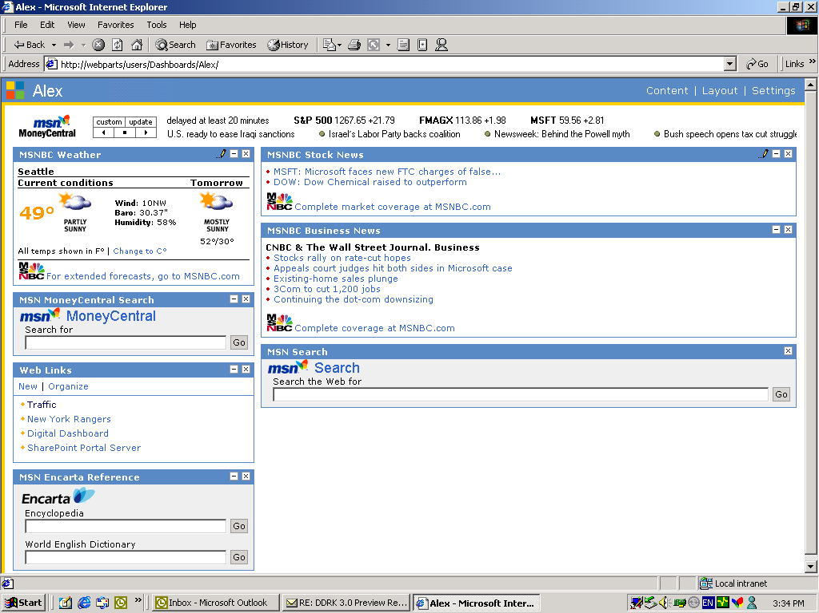
Figure 4—Viewing my personal dashboard

The next step is to save my file as a Web Part from Excel. The steps to Save As Web Page… are almost identical to creating an Office Web Component in Office 2000. First I open my Excel file…

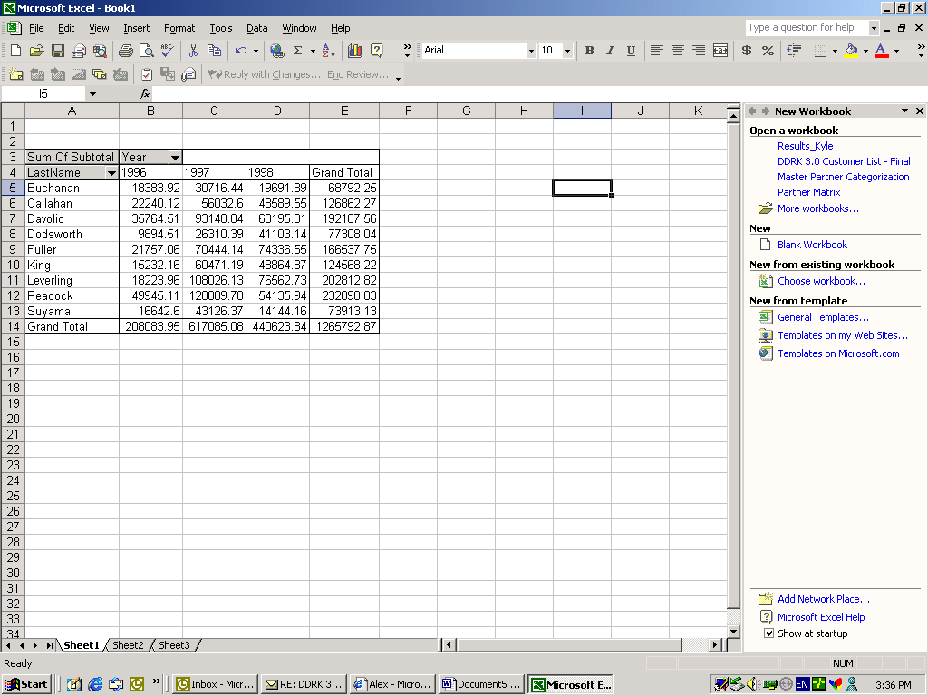
Figure 5-Viewing the Excel PivotTable
Here is my PivotTable in Excel that I created from an OLAP cube.
From the File menu, I select Save As Web Page… The next graphic shows the Save As Web Page… dialog box.
Note You can use Save as Web page… under the File menu of any of the Office XP applications.

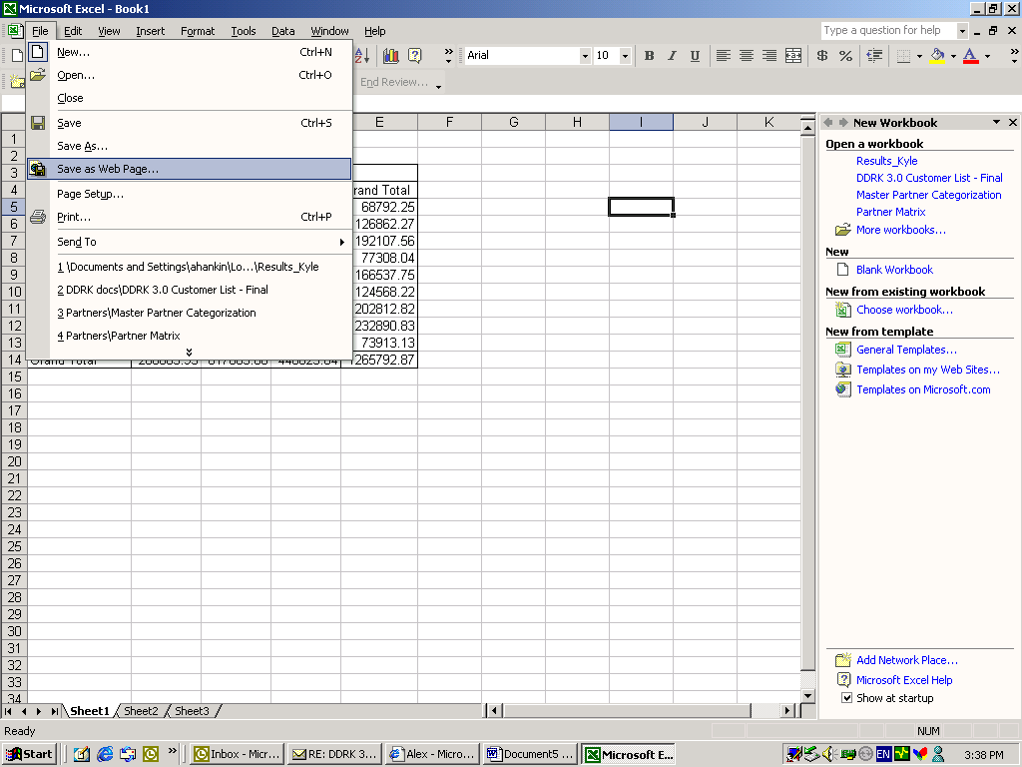
Figure 6 - Selecting the option, Save as Web Page
Selecting this option from Excel launches the Save As Web Page… dialog box.

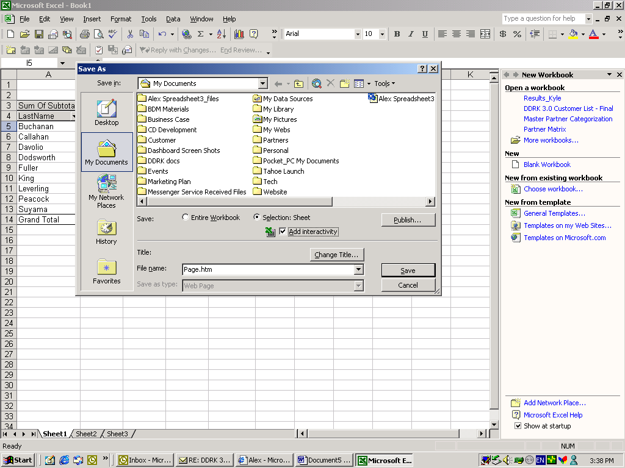
Figure 7 – Adding Interactivity
With an Excel PivotTable, you have the option of selecting interactivity. On the Save As… page, I select Add interactivity so users can manipulate data in the Web Part. Then, I click Publish. Excel displays the Publish as Web Page dialog box, as seen in the following graphic.

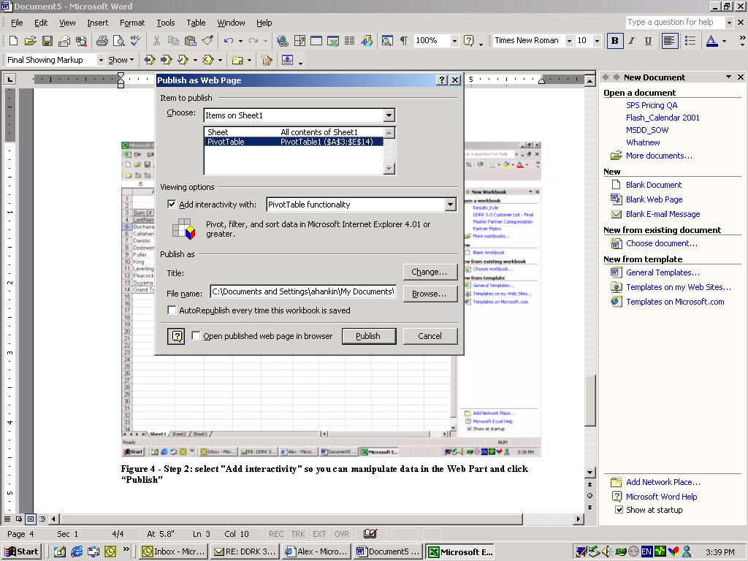
Figure 8 – Publishing as a Web Page
By checking AutoRepublish every time, Excel updates your Web Part each time someone updates the original file. Once I select my viewing options, I click Publish.
Excel returns to the Save As… dialog box again. From here, I browse to my personal dashboard folder using Web Folders.
Note You must be assigned to the role of coordinator or author to save content to a personal dashboard folder.

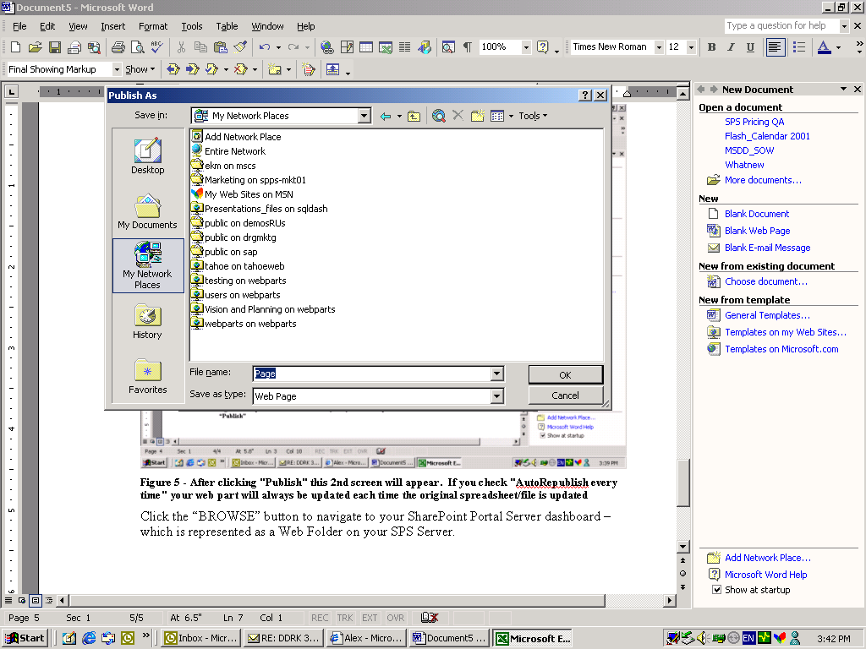
Figure 9- Choosing the Network Place
I click on the Network Place for the appropriate workspace where my personal dashboard is stored.

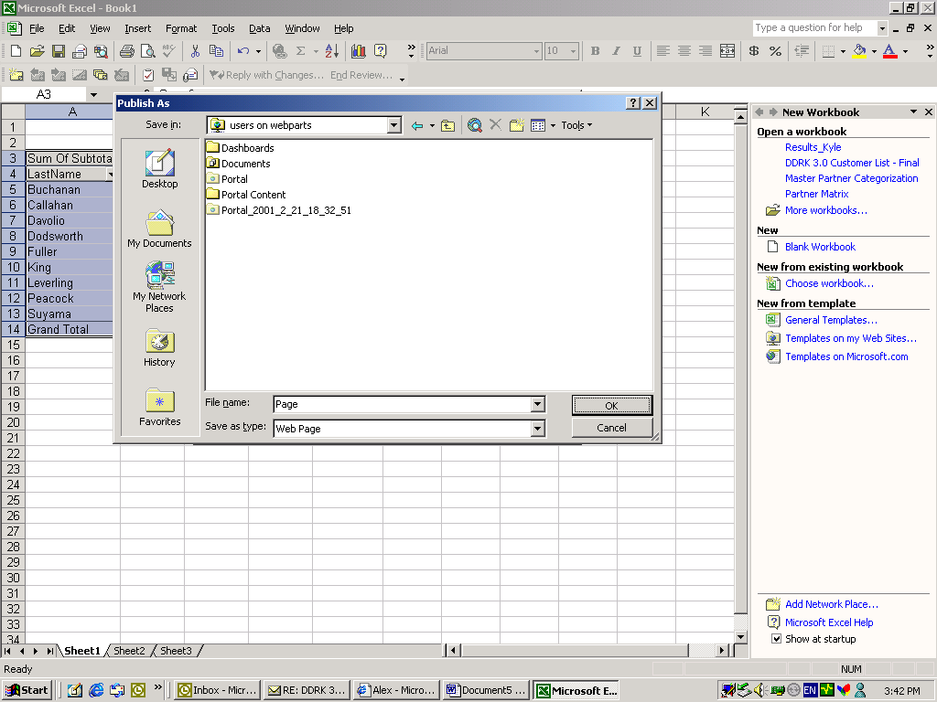
Figure 10–Choosing the Dashboards folder
I click on the Dashboards folder.
Note All personal dashboards are stored under the Dashboards folder.

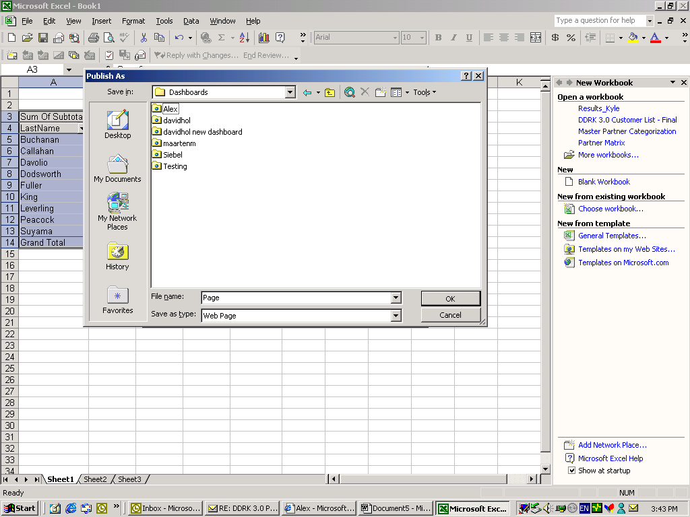
Figure 11–Selecting the personal dashboard folder
I select the appropriate personal dashboard folder. In this case, I choose the “Alex” folder.

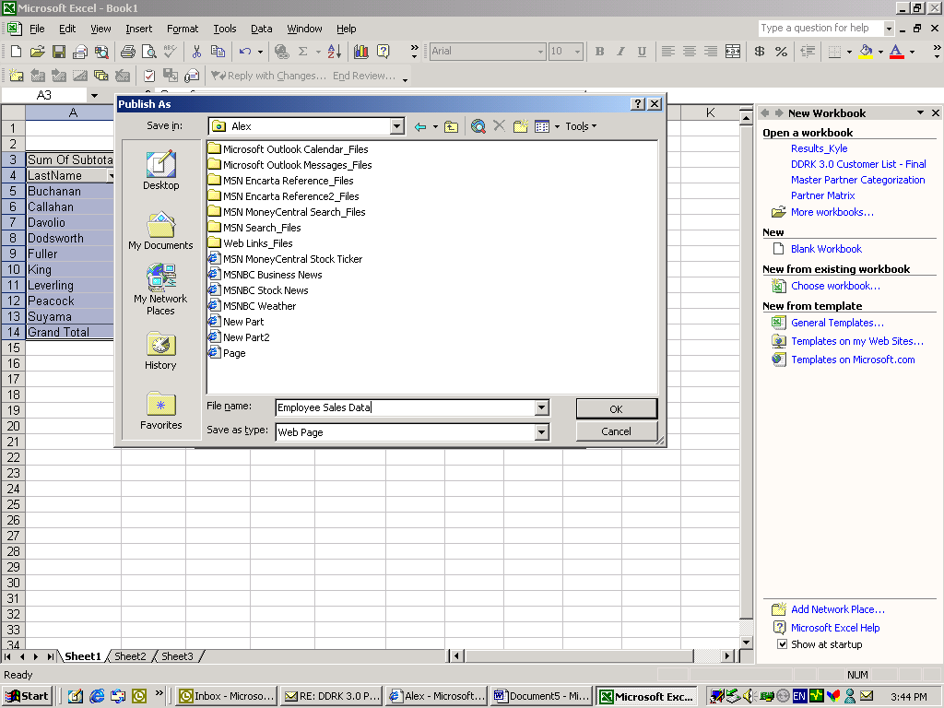
Figure 12 – Naming my Web Part
I confirm the file name for my Web Part and click OK. Excel displays the Publish as Web Page dialog box a second time.

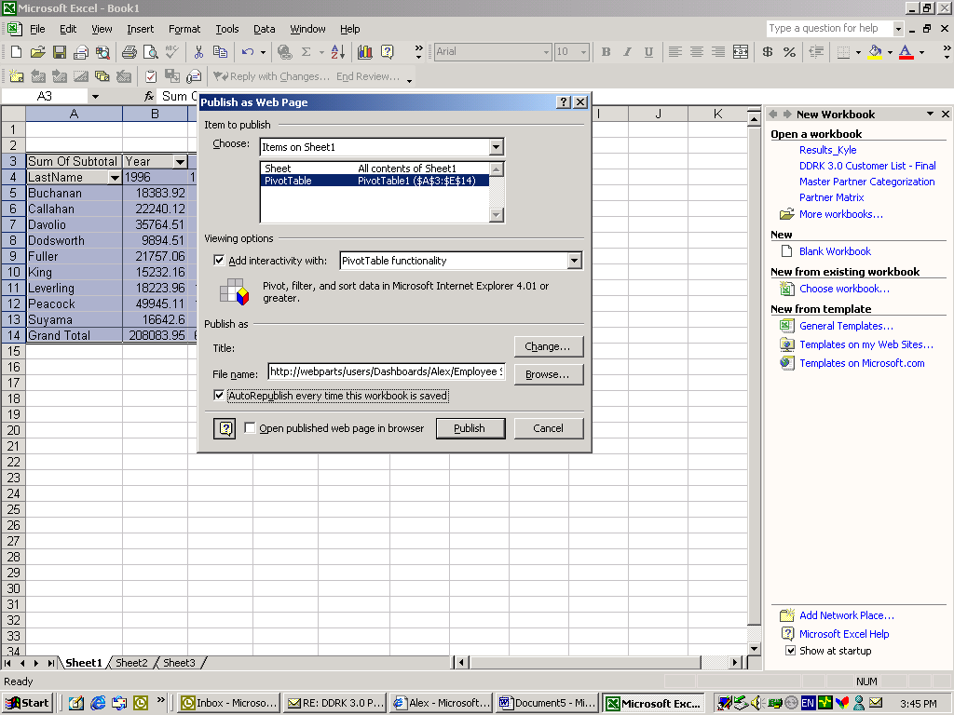
Figure 13-Completing the publishing process
I choose Publish a second time and SharePoint Portal Server displays a Web Part Settings dialog box.

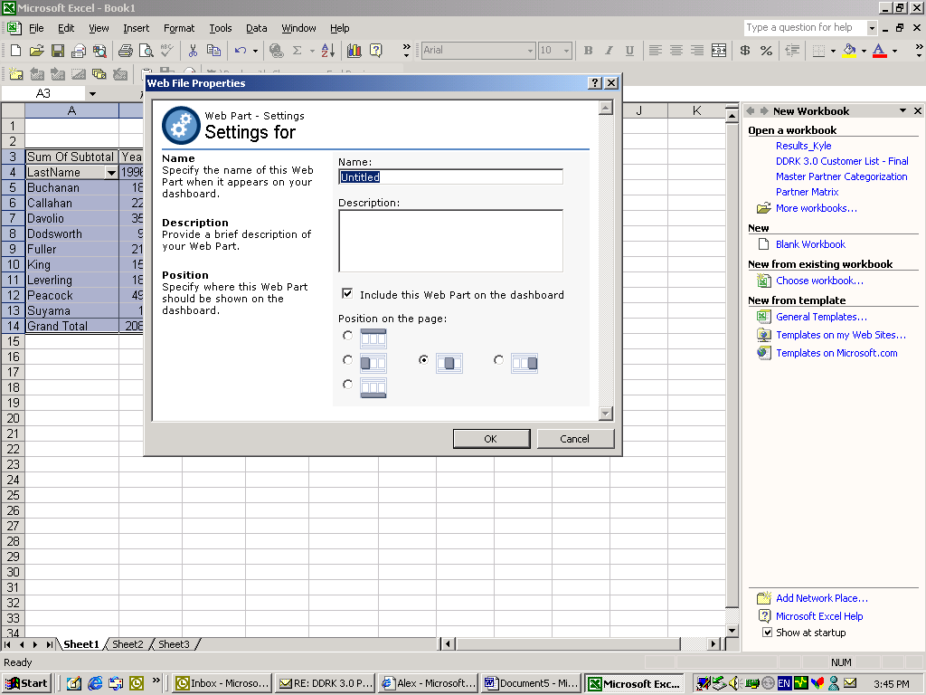
Figure 14–Viewing the SharePoint Portal Server Web Part Settings Page
SharePoint Portal Server and Office XP recognize that I am saving the file to a folder located on a SharePoint Portal Server workspace and not just an ordinary Web folder for Internet publication. SharePoint Portal Server displays a settings page for the new Web Part.

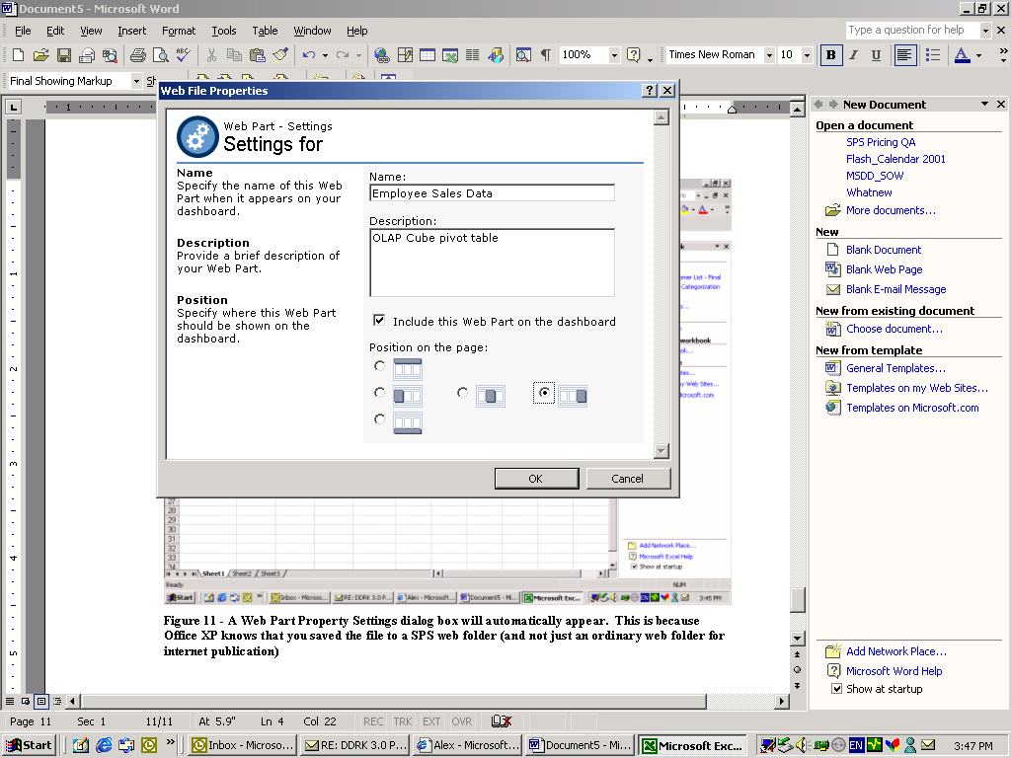
Figure 15–Modifying the Web Part Settings
I provide a name and description for the Web Part and indicate its position on the page. Once I provide this information, I click OK.
The new Web Part displays automatically when I refresh my personal dashboard in the Web browser.

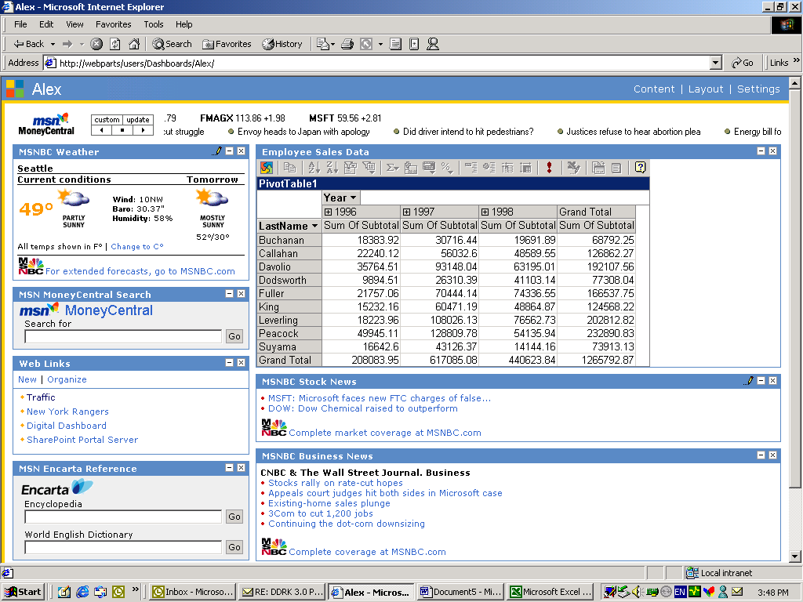
Figure 16–Viewing the Personal Dashboard with the new custom Web Part

Using Office XP, customers can quickly and easily share and publish information in a corporate portal using Web Parts.

The information contained in this document represents the current view of Microsoft Corporation on the issues discussed as of the date of publication. Because Microsoft must respond to changing market conditions, it should not be interpreted to be a commitment on the part of Microsoft, and Microsoft cannot guarantee the accuracy of any information presented after the date of publication.

This White Paper is for informational purposes only. MICROSOFT MAKES NO WARRANTIES, EXPRESS OR IMPLIED, AS TO THE INFORMATION IN THIS DOCUMENT.

Complying with all applicable copyright laws is the responsibility of the user. Without limiting the rights under copyright, no part of this document may be reproduced, stored in or introduced into a retrieval system, or transmitted in any form or by any means (electronic, mechanical, photocopying, recording, or otherwise), or for any purpose, without the express written permission of Microsoft Corporation.

Microsoft may have patents, patent applications, trademarks, copyrights, or other intellectual property rights covering subject matter in this document. Except as expressly provided in any written license agreement from Microsoft, the furnishing of this document does not give you any license to these patents, trademarks, copyrights, or other intellectual property.

The example companies, organizations, products, people and events depicted herein are fictitious. No association with any real company, organization, product, person or event is intended or should be inferred.

© 2001 Microsoft Corporation. All rights reserved.

Microsoft, ActiveX, Encarta, MSN, PivotTables, PowerPoint, SharePoint, Visual Basic, Visual Studio, and Windows are either registered trademarks or trademarks of Microsoft Corporation in the United States and/or other countries.

The names of actual companies and products mentioned herein may be the trademarks of their respective owners.

